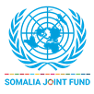 | UN Somalia Joint Fund  Progress report  [Annual: 1 January to 31 December]
Project data

Title | State-building and Reconciliation Support Program (SRSP)- 01000758
SJF Project number
Recipient UN agencies | UNDP, UNSOM (PAMG)
SJF Window | Inclusive Politics
Geographical coverage | Somalia: Federal Level and the Federal Member States
Project duration | 1 June 2023 – 31 December 2027
Total approved budget | USD 27,632,344
Implementing partners | The Federal Ministry of Interior, Federal Affair & Reconciliation (MOIFAR) as the co-signatory from the Federal Government of Somalia, and the following would be the core implementing partners: Office of the Prime Minister (OPM); Federal Ministry of Interior, Federal Affair & Reconciliation (MOIFAR); National Identity and Registration Authority (NIRA) Ministry of Interior Federal Affairs & Reconciliation, Galmudug; Jubbaland Ministry of Interior, Federalism, and Reconciliation(MOIFR); Office of the President/Ministry of Interior, Southwest (OoP, MoI, Southwest State); Office of the President, Ministry of Interior/Reconciliation Hirshabelle (OoP, MoI/R Hirshabelle); Puntland Ministry of Federal Affairs and Democratization (MOIFAD); and civil society organizations including NGOs and INGOs.
No of beneficiaries | Nine government RPs
NDP pillar | SP2: Supporting institutions to improve Peace, Security, Justice, the Rule of Law and the safety of Somalis
UNCF Strategic Priority | Inclusive Politics
SDG | 5,10,16,17
Gender Marker | 2
Disability Marker
Related UN projects  within/outside the SJF portfolio | Constitutional Review Process; Parliamentary Support Project, Electoral Support Project
Focal person(s) per recipient UN entity | Amjad Bhatti  amjad.bhatti@undp.org  +252 614125021

Report submitted by:
 | PUNO | Report approved by: | Position/Title | Signature
1
2

Do not sign until cleared by the SJF Secretariat<Please delete all help text in orange before submitting the report for endorsement.>

Section 1: Executive summary

Brief introduction to the project and situation update/ Context of the reporting period

Somalia is undergoing a critical phase of state-building underpinned by complex and interwoven processes of reconciliation, federalization, constitutional development, and collaborative governance requiring negotiated settlement on the allocation of power and distribution of resources coupled with the urgency of preventive and mitigatory measures for recurrent political and communal conflicts. Responding to these contextual needs/dynamics and building on the key achievements, lessons learned, and institutional partnerships secured through recently concluded Reconciliation and Federalism Support (ReFS) program, a multiyear- successor project has been launched under the title of SOOMAALIYA LOO DHANYAHAY (Inclusive Somalia) aimed at deepening the organic processes of state-building with focus on (a) federal framework, (b) political and social reconciliation and (c) collaborative governance in Somalia.

The State-building and Reconciliation Support Program (SRSP) is primarily an intergovernmental support project engaging FGS and FMS line ministries, departments, and institutions and forging strong interlinkages with civil society, women, youth, minority groups, and conflict-prone communities by pursuing the principles of adaptive and iterative state-building, peace-building and collaborative governance in Somalia. The Project will do so by supporting institutional development and strengthening policy, planning, and programmatic linkages in a strategic and catalytic manner, complementary to other ongoing or planned efforts, shaping the structure and scope of core government functions and context-sensitive service delivery model(s) in a dynamic environment.

Under the overall guidance of the Inclusive Politics Portfolio, the Project is implemented jointly with the UN Mission in Somalia (UNSOM) and UNDP under the leadership of the UNDP Resident Representative and OSRSG to leverage its Good Offices role and convening power to mediate political agreements and build on the National Consultative Council (NCC) insights/agreements and new Government’s strategic directions on state-building, reconciliation, and collaborative governance. The Project has been designed to deepen the strategic, technical, and institutional support to the FGS, FMSes, and civil society actors with the following four integrated thematic Outputs:

Output 1: Improved policy, planning and programmatic linkages for the effective implementation of national reconciliation and collaborative governance at FGS, FMS, and District levels

Output 2: Processes of consensus building on federal framework and mechanism(s) for intergovernmental relations between and within FGS and FMSes are strengthened and the capacity of civil society for policy advocacy and public accountability is enhanced

Output 3: Operationalization of allocation of power is supported and institutional capacity enhanced on ‘functional unbundling’ and development of sector-specific governance frameworks at FGS, FMS and District levels

Output 4: Operationalization/outreach of an inclusive legal identification eco-system sensitive to the social contract is enhanced, and national/regional counterparts are operationally equipped to deliver their institutional mandates effectively and efficiently.

Current Context 2024:
In 2024, Somalia's political landscape remains complex, shaped by ongoing tensions between the Federal Government of Somalia (FGS) and some Federal Member States (FMS), particularly Puntland and Jubbaland. While the government has made strides in reconciliation through the National Reconciliation Framework II (NRF-II), deep-seated political divisions persist, fueled by disputes over resource sharing, electoral processes, and decentralization. The federalization process continues to face roadblocks, with Puntland refusing to participate in national initiatives, signaling a fractured political environment. Additionally, security remains a key concern, with Al-Shabaab still posing a significant threat despite increased counterterrorism efforts. Diplomatic relations have been influenced by regional dynamics, including shifting alliances in the Horn of Africa, as Somalia seeks to balance its engagements with Ethiopia, Kenya, and other international actors.

Economically, Somalia is navigating a fragile financial and governance landscape, with the government continuing efforts to strengthen domestic revenue generation and public financial management. The Somali economy remains heavily reliant on remittances, donor funding, and agriculture, particularly the livestock sector. However, challenges such as climate change-induced droughts, inflation, and a weak banking sector have hindered economic stability. The implementation of financial reforms under the Heavily Indebted Poor Countries (HIPC) Initiative has improved fiscal transparency, but governance challenges, including corruption and limited institutional capacity, continue to impede progress. The decentralization of governance structures remains uneven, with varying levels of service delivery across FMS. While initiatives like the National ID, Functional unbundling, Conflict Navigator, and NRF aim to enhance governance and coordination, the broader institutional framework still struggles with inefficiencies, impacting Somalia’s ability to achieve sustainable development and long-term stability.
Summary of key achievements during the reporting period
- The Somali Government's planning for the national transformation process, initiated in 2023, has been significantly supported by the SRSP involving high officials’ trainings in Malaysia, followed by a Cabinet Strategic Direction workshop with key government officials to identify priorities for Somalia's transformation. These preparatory initiatives led to the establishment of Transformation Labs for strategic planning and subsequently a National Transformation Pan (NTP) has been developed with inputs from international organizations, local groups, civil society, and government agencies.
- With technical support from SRSP, alongside operational assistance from the World Bank and the Government of Pakistan, the National Identity Registration Authority (NIRA) has made significant progress in registering over 90,000 citizens. SRSP also supported a joint assessment identifying the challenges including governance constraints, financial and technical limitations, and disparities in access to technology across federal member states and provided technical solutions to overcome these barricades for an inclusive ID ecosystem in Somalia.
- The National Reconciliation Framework II (NRF-II) was launched in April 2024 after an inclusive consultation process, marking a critical milestone in Somalia’s peacebuilding journey. Supported by the SRSP and chaired by the Prime Minister, the framework secured endorsement from over 300 stakeholders, advancing collaborative governance at Federal, State, and District levels. A five-year NRF Strategic Plan was subsequently developed and validated through extensive stakeholder engagement, ensuring alignment with Somalia's development and peacebuilding objectives. Institutional capacities were further enhanced through targeted Monitoring and Evaluation (M&E) training programs, ensuring the plan's effective implementation.

- With SRSP support, 12 insider mediation interventions were conducted to address inter-clan and intra-clan conflicts across Somalia. These interventions led to significant outcomes, including peace agreements, resource-sharing arrangements, the establishment of conflict management committees, and community-driven development projects. Key successes included reconciliations in Galmudug, Southwest, Hirshabelle, Jubbaland, and Puntland, fostering trust, reducing violence, saving lives, and promoting peace and social cohesion at community level in the targeted areas.

- Land-related conflict management initiatives in Galmudug and Southwest states involved community mediation, resolving disputes, and leading to a peace agreement on long-standing land issues. Local committees were formed to oversee these agreements, fostering community engagement and reducing tensions in both regions.
- The Somalia Conflict Navigator Operational Manual was finalized, establishing a standardized framework for conflict mapping, data collection, and analysis. Developed in collaboration with federal and state actors, youth groups, and civil society, this initiative provides a robust foundation for creating date-driven decision-making support system for conflict-responsive policies, projects and programs and bolstering communal reconciliation and peacebuilding efforts nationwide.
- A self-paced conflict mapping and resolution course, developed in collaboration with the United Nations System Staff College (UNSSC), was officially integrated into Somalia’s national curriculum by the Federal Ministry of Education. Tailored to Somalia’s context, this course will help preparing cohorts of students equipped with conflict mapping and conflict resolution skillsets to perform leading role in Somalia’s peacebuilding.
- SRSP supported convening two NCC Forums, multiple Director General Coordination Forums, and Interministerial Coordination Forums to strengthen federalism and intergovernmental relations. These forums achieved significant progress vis-à-vis constitutional review, resource-sharing frameworks, and collaborative governance. (However, NCC was rendered inactive in the last two quarters of 2024 impacting the momentum of consensus building – detailed analysis is provided in the next sections of this report).
- In support of Somalia's federalization efforts, a series of technical level dialogues and deliberations on functional unbundling were supported leading to the technical options on the functional assignments whereby the critical data was finalized and validated providing a consolidated repository of technical options on allocation of functions/power. A South-South study tour to Kenya informed the development of a draft operational framework for federalization. At the same time, a learning exchange workshop in Nairobi produced critical outputs, including the Federalism Transition Strategy and Monitoring and Evaluation Plan, to guide Somalia’s transition towards a functional federal system.
- The project significantly enhanced institutional and technical capacities by embedding 113 advisors, interns, and enrolment officers within government offices to support core government functions. This effort enabled Responsible Parties (RPs) to fulfill their mandates more effectively, ensuring that governance structures could respond to reconciliation and resource distribution needs. The support provided has been essential for strengthening institutional and technical capacities.
Results in numbers, the number of beneficiaries and feedback from beneficiaries

- Results in Numbers: Beneficiaries and Feedback
  - Number of Beneficiaries Reached
As of the latest reporting period, key quantifiable results include:
- With a contribution of SRSP towards National ID (along with other partners like World Bank and Government of Pakistan), a significant progress has been made by National Identity Registration Authority (NIRA) in registering more than 90,000 citizens with 79% male and 21% female
- 535 participants have benefited from the project’s training and capacity-building interventions, including more than 90 enumerators trained to support data collection for conflict mapping and the Conflict Navigator across all Federal Member States.
- 9 government counterparts at both Federal and State levels supported for the institutional development in delivering reconciliation and governance initiatives in their respective domains.
- Trained 30 District Commissioners of Banadir Regional Administration (BRA) by establishing a District Commissioners’ Coordination Forum aimed at enhancing intergovernmental collaboration.
- Engagement of 300+ stakeholders in reconciliation efforts, including traditional elders, religious leaders, youth representatives, and women groups.
- More than 17 inter-ministerial and DG forums were held during the current reporting period, bringing together over 400 civil servants from the federal and member state governments.
  - Disaggregated Data
The SRSP has prioritized inclusivity, and its interventions are designed to reflect the diverse needs of different population segments. Disaggregated data collected from various program activities include:
- Approximately 40% female, 60% male representation across reconciliation dialogues, policy engagements, and training workshops.
- Over 35% of participants in reconciliation and governance discussions were youth representatives.
- More than 150 elders and religious leaders actively engaged in conflict resolution and mediation efforts.
- Engagement with Beneficiaries
  - Channels of Engagement
- The program has facilitated direct engagements through reconciliation forums, government consultations, training workshops and community dialogue sessions.
- The programme designed structured surveys to better understand beneficiaries' expectations and to assess the impact of conflict mapping and reconciliation interventions.
- Conflict Navigator has been deployed as a data-driven tool to facilitate conflict analysis and support decision-making by both government and community actors.
- Beneficiary Feedback and Incorporation into Program Activities
  - Feedback Mechanisms
- A structured feedback mechanism is in place, allowing beneficiaries to provide input through email communication, inter-personal communication (with and between RPs), community meetings, government consultations, and post-activity evaluations.
- Feedback has been collected through stakeholder workshops and NRF consultation forums, ensuring diverse perspectives are considered.
  - Common Beneficiary Feedback
- Community reports from various government counterparts captured community/grassroots level testimonies that reveal the SRSP's crucial role in saving lives and livelihoods by facilitating conflict resolution interventions both within and between clans.
- Government counterparts emphasized the need for continued capacity-building and institutional support to sustain progress.
  - Incorporation of Feedback into Program Implementation
- Enhanced gender inclusion - Based on feedback, SRSP has increased female representation in mediation and reconciliation discussions, ensuring women’s meaningful participation in peacebuilding efforts.
- Refined Conflict Navigator methodology - Inputs from government counterparts, academia, civil society organizations, and field enumerators led to improvements in the data collection methodology, making conflict mapping more comprehensive.
- The BRA District Commissioners’ Coordination Forum was activated for the first time during this reporting period, partly in response to requests from local governance structures for a more coordinated approach to district-level governance in Mogadishu.

Section 3: Implementation progress by outcome

Progress towards outcomes

OUTCOME STATEMENT

Outcome 1: Create an enabling environment with necessary technical support to the Somali stakeholders for negotiated settlement(s) on the allocation of powers and distribution of resources between FGS, FMS, and Districts by mainstreaming gender and age-responsive reconciliation, stabilization, and state-building processes and plans towards Inclusive and Stable Somalia.

The combined achievements of the four outputs outlined below helped creating an enabling environment for negotiated settlements at political, strategic and community levels, facilitating institutional development, supporting Somali stakeholders to advance reconciliation, stabilization, and federalization processes. This integrated approach ensured alignment with gender and age-responsive principles, furthering the project’s goal of an inclusive and stable Somalia.

OUTPUT 1

OUTPUT 1: Improved policy, planning, and programmatic linkages for the effective implementation of national reconciliation and collaborative governance at FGS, FMS, and District levels.
Under this Output, the Ministry of Interior, Federal Affairs, and Reconciliation (MOIFAR), with support from the SRSP, successfully launched the second generation of the National Reconciliation Framework (NRF-II) in April 2024, emphasizing resilience, inclusivity, and sustainability. The NRF-II is structured around six key pillars addressing reconciliation, trust-building, post-conflict recovery, and capacity development. A five-year strategic plan was validated to guide its implementation, with institutional capacity-building efforts underway. Insider mediation interventions successfully mitigated clan conflicts across federal member states, while land conflict management initiatives and the Somalia Conflict Navigator tool were advanced to enhance evidence-based reconciliation. Additionally, a self-paced conflict resolution course was integrated into the national curriculum, and civil society engagement was strengthened through grants and peer-learning platforms. However, challenges remain, including Puntland's exclusion and Jubbaland’s deteriorating relations with the federal government, which may impact broad-based participation and ownership of the framework.

The National Reconciliation Framework II Officially Launched
Supported by the SRSP, the Ministry of Interior Federal Affairs and Reconciliation (MOIFAR) successfully launched the second generation of the National Reconciliation Framework (NRF) in April 2024 after an inclusive consultation process. The NRF focuses on resilience, inclusivity, and sustainability in reconciliation initiatives. The launch, chaired by the Prime Minister, garnered widespread endorsement from over 300 participants, including representatives from the federal and state governments, CSOs, and international partners. This widespread support highlighted the new NRF's potential to enhance policy, planning, and programmatic connections for its effective implementation to promote peace and reconciliation in Somalia and foster collaborative governance at the FGS, FMS, and District levels. It is important to note that the Puntland State has not been involved in this process. Meanwhile, Jubbaland, which initially participated fully, later found itself in conflict with the Federal Government. This situation could undermine the broad-based participation and ownership that initially characterized this critical document.

In terms of the scope, the (updated) National Reconciliation Framework (NRF) is built upon six foundational pillars, each designed to address specific aspects of the reconciliation process and pave the way for a peaceful and unified nation. These are outlined below.

Pillar 1: Inspiring Common Vision and Hope for a Shared Future
Pillar 2: Dealing With the Past Harm That Occurred at Different Times and Levels
Pillar 3: Strengthening National Cohesion, Prevention, and Resolution of Conflicts
Pillar 4: Building Trust between Society and State Institutions
Pillar 5: Enhancing Post-Conflict Recovery and Reconstruction
Pillar 6: Building Capacity for Peace, Conciliation, and Conflict Management

A Five-Year NRF Strategic Plan Developed and Validated and Institutional Capacities Improved
After the successful launch of the NRF-II, a detailed five-year strategic plan for the NRF was created and validated. With this in place, MOIFAR has focused on enhancing governance and capacity within the country by providing effective training programs for NRF staff and stakeholders. These programs have improved their skills in Monitoring and Evaluation (M&E), which supports the successful implementation of the National Strategic Plan (2025-2029).

Following the above, MOIFAR-FGS organised a two-day validation workshop for the NRF National Strategic Plan, which successfully convened over 120 participants from a wide range of stakeholders. This included traditional elders, scholars, religious leaders, members of the Somali diaspora, women, and representatives from federal institutions, Federal Member States (FMS), civil society organizations (CSOs), academia, and other segments of society. Such diverse participation helped creating spaces for comprehensive and inclusive perspectives on Somalia's strategies for resilience and peace-building.

The primary objective of the workshop was to review and validate the NRF strategic plan/framework, ensuring it aligns with the national development goals and national peace-building agenda. During the workshop, participants engaged in dynamic discussions and consultations, critically examining the content of the framework. They identified its strengths, gaps, and opportunities for improvement. The feedback generated over the two days of validation was incorporated into the final strategic plan document. This validated NRF Strategic Plan will be presented at the first Cabinet Meeting in 2025 for approval. Following approval, the plan will be launched under the leadership of the Prime Minister.

Twelve Insider Mediation Interventions Supported, Addressing Clan and Inter-Clan Conflicts
The SRSP supported rapid response to ongoing communal conflicts and reconciliation efforts, leading to life-saving peace agreements that strengthened social cohesion across the various federal member states. In the Galmudug state (20-26 June 2024), the initial reconciliation between the Dir and Marihan clans led to a halt in hostilities and established arrangements for sharing resources between the conflicting parties. A second round of reconciliation talks (8-11 Nov 2024) built upon the progress made in the first phase. This resulted in a comprehensive peace agreement that laid down the foundation for joint initiatives to enhance social cohesion and development and consolidated the reconciliation between the two clans. Equally important, community reconciliation efforts in Gelinsor between the Sacad and Saleban clans (3-6 November 2024) have been crucial in addressing historical grievances and fostering mutual understanding. These efforts ultimately led to a peace agreement promoting peaceful coexistence between the two clans. Additionally, collaborative community development projects were introduced by the Galmudug State Administration to sustain the peace dividends and ensure that both clans work together toward a shared future.

In the Southwest State, a peace agreement addressing inter-clan conflict in the Berdale district (13 – 18 July 2024) led to the cessation of violence and the establishment of a Joint Committee for conflict management. In Jubbaland, the Phase 2 Luuq reconciliation process took place from November 3 to November 6, 2024. This phase is built on the progress made during Phase 1 of the Luuq community mediation process in 2023. The recent phase resulted in actionable agreements that addressed key areas, including resource sharing, conflict resolution mechanisms, and collaborative community development initiatives. This roadmap includes timelines, the roles of stakeholders, and strategies for monitoring progress, which will help guide ongoing efforts and maintain momentum in building lasting peace.

In Hirshabelle, peaceful settlements were reached concerning conflicts among the Jalalaqsi community--the Hawadle and Abgal clans (10–12 December 2024), the Adale intra-Abgal intra-clan conflict (7–9 December 2024), and the Jawhar community conflict (1-3 December 2024) between Barsane and Alofi (Galje'el). The efforts in all three community reconciliation processes resulted in a peace agreement reached by the parties involved in the conflict.

In Puntland, several key agreements were facilitated: the Carmo Agreement (25 Feb/2024 ) and later Qardo, which enabled communal reconciliation by relocating militias and fostering inter-clan trust; mediation in the Jiicboor settlements (2 October 2024) fostered preliminary agreements between the Leelkase and Sacad clans, reducing the likelihood of immediate conflict; a peace agreement (28 Nov 2024) resolved tensions between the Nuux Yusuf (Muxumud) and Shiidle (Jareer) clans following a clan-related killing; another -agreement (30 Nov 2024) addressed a similar conflict between the Cabdi-Muuse (Dir) and Nuux Yusuf (Muxumud) clans; and a peace accord (28 Nov 2024) in Galkacyo was reached between the Cabdalle Surre (Dir) and Looboge (Shikhaal) clans. These efforts collectively contributed to reducing violence, fostering trust, and promoting long-term reconciliation at communal levels.

Land Conflict Management Initiatives
In the Galmudug and Southwest States, land conflict management initiatives were conducted from November 3 to 6, 2024, in Galmudug and from November 26 to 27, 2024, in Southwest. These efforts led to the resolution of several disputes through community mediation, culminating in a peace agreement that addresses land-related issues. Local committees have been established to oversee these agreements, promoting community engagement and responsibility. Consequently, in both regions, there has been a notable decrease in tensions, and collaborative and fair management of disputes has been encouraged.

Somalia Conflict Navigator Operational Manual Finalized
In the NRF-II , the Somalia Conflict Navigator (SCN), which is in a final stage of the database development, is recognized as a critical tool for the evidence-based decision-making support system informing the implementation of NRF fostering social cohesion through community-led reconciliation at the local levels. As a foundational document to standardize key concepts, definitions, and methodologies of the Conflict Navigator, draft Operational Manual and Date Governance Framework were pretested and finalised in Southwest State. This manual would codify the SoPs for data collection, data triangulation, data analysis, data integration and development for the reconciliation plans at the community, district, regional and national levels.

The Conflict Navigator SWS chapter would be launched in March 2025 contributing to the development of conflict-responsive policies, programs and interventions, enabling a more cohesive and informed approach to peacebuilding and reconciliation efforts.

Integration of Self-Paced Course on Conflict Analysis and Resolution in the National Curriculum
As part of the Peer Learning Program (PLP), the SRSP supported the creation of a self-paced course on conflict mapping, analysis, and management. In collaboration with the United Nations System Staff College (UNSSC), this course is designed to equip Somali stakeholders with essential knowledge and skills for conflict analysis, resolution, and management, tailored to the specific context of their communities.

Previously hosted by UNSSC, the course has now been handed over to the Federal Ministry of Education, Culture, and Higher Education (MoECHE) during the current reporting period, integrating it into the national curriculum. The institutionalization of this conflict analysis and resolution course results from a collaborative effort involving MoIFAR-FGS, MoECHE, the Association of Somali Universities (ASU), UNDP Somalia, and UNSSC. This initiative aims to create a sustainable foundation for conflict resolution, fostering local ownership and significantly enhancing the effectiveness of peacebuilding efforts in the long run.

Refresher Course on the Revised Conflict Navigator Methodology and Tools
A successful refresher course on the Revised Conflict Navigator Methodology and Data Collection took place on 3–4 September 2024 for the conflict navigator enumerators, engaging government ministries, international organizations, and civil society in Southwest State. This training significantly enhanced the participants' skills in data collection through practical, hands-on exercises and advanced conflict mapping methodologies. The outcome was a notable increase in the quality and reliability of data, enabling robust conflict analysis. As a result, policymakers and practitioners gained deeper insights into conflict dynamics, equipping them to implement more focused and effective interventions that address the root causes of conflicts. This strategic impact aligns closely with the project's objectives and contributes meaningfully to conflict resolution efforts in the region.

Pre-District Council Formation Reconciliation Dialogue Led to Successful Council Election
The Southwest State has been facing challenges regarding the formation of the Berdale local council in Bay region. To address this issue, the SRSP supported the Office of the President (SWS) in organizing a successful pre-district council formation reconciliation dialogue between 23 – 25 July 2024. This dialogue resulted in a formal power-sharing agreement endorsed by all key stakeholders. The agreement clearly defined the roles and representation of each clan within the district council, effectively addressing longstanding grievances. This Agreement became a cornerstone of collaborative and inclusive governance, ensuring accountability and transparency in Berdale's political structure. Following this, district council elections were successfully held. The power-sharing model secured equitable representation for all clans, allowing the elections to proceed smoothly. As a result, a functional and inclusive district council was established in Berdale for the first time in years, enabling local governance to operate effectively.

Increased Civil Society Participation
During the reporting period, the SRSP engaged six civil society organizations (CSOs) through low-value grant agreements to implement community reconciliation activities. This initiative aims to leverage stabilization efforts as entry points for addressing local conflicts and developing collaborative community governance models in recently recovered areas. The goal is to bridge the gap between top-down and bottom-up state-building processes.

This selection process was competitive, with 89 proposals received and evaluated. Out of those, 35 were chosen to move forward. A phased approach will be utilized, engaging the highest-ranked CSOs at different stages depending on the availability of funds. The first phase has commenced, with contracts issued to the top six ranked NGOs/CSOs.

Additionally, the SRSP supported the Puntland Research and Development Center (PDRC) for its 2024 Annual Peace Conference, which highlighted the importance of civil society in promoting peacebuilding and reconciliation efforts in Somalia. This support further reinforces the vital role of civil society in fostering peace and reconciliation within the country. The Conference's outcomes contributed directly to the SRSP results framework, showcasing progress on key indicators tied to research and policy advancement on reconciliation and state-building. UNDP’s engagement reinforced Somali-led research and policy initiatives while strengthening multi-stakeholder collaboration.

A Peer-Learning Platform on Somalia Conflict Navigator Established
The project also introduced technical recommendations for the Somalia Conflict Navigator project, co-creating operational and technical frameworks with government counterparts. Additionally, the establishment of a peer-learning platform enabled stakeholders to share knowledge and explore partnerships, including collaborations with organizations like UNSSC, P4P, and the Berghof Foundation. Outputs from this initiative were incorporated into the multi-year SRSP program funded by SJF, ensuring sustainability and catalytic impact in reconciliation and peacebuilding efforts.

Output 2: Processes of consensus building on federal framework and mechanism(s) for intergovernmental relations between and within FGS and FMSes are strengthened, and the capacity of civil society for policy advocacy and public accountability is enhanced.

Progress under this output included convening two NCC Forums, which served as critical platforms for advancing discussions on federalism, governance, and democratization. At least one of these forums was instrumental in achieving consensus on constitutional review and resource-sharing mechanisms, addressing critical governance challenges. In addition to these interventions, a thorough analysis of the NCC is necessary.
The Somalia National Consultative Council (NCC) was intended to facilitate dialogue among the Federal Government of Somalia (FGS) and Federal Member States (FMS) on national issues like governance, elections, and security. However, it has faced significant challenges due to internal divisions, particularly Puntland’s persistent absence and Jubaland’s president’s sudden departure from the recent NCC. Puntland's refusal to engage with the NCC reflects deeper issues in Somalia’s federalism. As the oldest FMS, Puntland has often advocated for decentralized governance. Tensions have escalated over several points:

- The constitutional review process, where Puntland seeks to protect regional autonomy.
- (Perceived) centralization tendencies by the FGS, especially regarding political and security decisions.
- Concerns about the perceived pursuit of FGSs to influence state-level elections.
Puntland's absence has resulted in a lack of broad representation in the NCC, undermining the legitimacy of its decisions and weakening federal models. Jubaland’ s President Ahmed Madobe also left due to disagreements over election models, the FGS’s perceived attempts to weaken regional administrations, and security concerns in contested areas (the Gedo region).

These events have shown that the NCC is proving ineffective in promoting political compromise and lacks conflict-resolution mechanisms, leading stakeholders to act unilaterally. Armed clashes between the FGS and Jubaland state forces further highlight the fragile state of federal relations and raise concerns about how the FGS handles political disputes.

The constitutional review process has been adversely affected, as any amendments made without Puntland and Jubaland’s involvement may lack legitimacy and risk rejection. The ongoing tensions could make the review a unilateral effort by the FGS rather than a collaborative process.

The crisis surrounding the NCC has undermined state-building and reconciliation efforts in Somalia. With rising hostility between Jubbaland and the FGS and Puntland’s lack of involvement, future collaboration becomes increasingly difficult. Instead of fostering national cohesion, deepening political conflicts threaten the country’s unity. The absence of a structured mechanism for dispute resolution prolongs state-building challenges and risks increasing political instability.

In addition to the NCC forums, the Office of the Prime Minister organized Director General (DG) Forums to focus on collaborative governance and further develop the NCC agreements. These DG forums established inter-ministerial technical working groups tasked with generating actionable recommendations on intergovernmental relationships, particularly concerning power allocation and decentralization. These recommendations were linked to Chapter 5 of the Provisional Constitution, providing a structured approach to operationalizing federal principles.

Further, DG and inter-ministerial forums were held across Jubbaland, Puntland, Galmudug, Hirshabelle, and Southwest states. These efforts emphasized enhancing coordination and collaboration among ministries, departments, and agencies at the federal member state levels, fostering a more cohesive and effective governance system. These initiatives collectively contributed to strengthening processes for consensus-building and intergovernmental relations while enhancing civil society’s capacity to advocate for policy changes and hold governance structures accountable.

Supported High-level Political/Policy Dialogues on Issues on the federalism framework and IGR

NCC Summits
During the reporting period, two National Consultative Council (NCC) Forums were organized, taking place in May and October 2024. In the May NCC Forum, all Federal Member State (FMS) presidents, except for the President of Puntland, joined the President of Somalia, the Prime Minister, the Deputy Prime Minister, and the Governor of the Banadir Regional Administration (the Mayor of Mogadishu) in expressing Somalia's commitment to security, combating terrorism, addressing urgent humanitarian issues, and continuing the democratization process. They emphasized the need to expedite the completion of the constitutional review process and adopt relevant legislation. NCC reached a consensus on the allocation of powers. However, operationalization of the agreement will be further discussed during a consultation process on the constitutional review, which will also inform legislative processes The same participants initially attended the October NCC Forum. However, Jubaland President Ahmed Madobe left the meeting prematurely due to disagreements that arose as political leaders sought to reach a consensus on implementing the electoral framework. Jubbaland’ s president, Ahmed Madobe, preferred indirect elections because he deemed direct elections unfeasible. President Hassan Shiek advocated for direct elections, resulting in a deadlock between the two officials, which led to Ahmed Madobe withdrawing from the NCC summit.

High-level Donor Conference
A two-day high-level donor conference, jointly organized from 5-6 February 2024 by OPM, MOIFAR, and MOJCA and chaired by the Deputy Prime Minister, emphasized to the donors how crucial the IP projects, particularly the SRSP, are for achieving progress in Somalia in terms of state-building and reconciliation. This event gave updates to and enhanced collaboration among donors in support of reconciliation and state-building initiatives. Such an event is part of an ongoing dialogue between the UN, donors, and the Somali government to ensure effective resource mobilization and support critical priorities for the country. Members of the international community, including the ambassadors of the United States, the UK, and Norway, also addressed the meeting. International partners commended Somalia's progress and reaffirmed their ongoing commitment to support the Inclusive Politics Portfolio. The discussions on the second day focused on the progress made in 2023 and the plans for 2024, highlighting updates from the State-Building and Reconciliation Project (SRSP) and the Constitutional Review Project (CRP). The government partners also called for continued support from donors for the country’s critical state-building and peacebuilding process.

DG Coordination Forums at the FGS and FMSes levels
During the reporting period, the Office of the Prime Minister organized two Director General (DG) Coordination Forums that focused on collaborative governance and the elaboration of the NCC agreements. These discussions were closely linked to the allocation of power, decentralization, and federalism. The DG forums established inter-ministerial technical working groups that were tasked with providing suggestions on topics related to intergovernmental relationships. These suggestions will be further developed and integrated into the discussions about power allocation, specifically referring to Chapter 5 of the Provisional Constitution.

Additionally, the Director General Coordination Forums were conducted in Jubbaland, Puntland, Galmudug, Hirshabelle, and Southwest State. In the Southwest region, for example, coordination forums have held discussions and activities centered around organizing a study on National Development Plans (NDPs) and State Development Plans (SDPs), with a specific focus on functional unbundling. In Jubbaland State, these forums prioritized aligning policy initiatives and coordinating responses to urgent regional challenges, particularly in the areas of security and development. In Puntland State, sessions were dedicated to aligning and harmonizing plans, programs, and service delivery at the state and local government district levels. Altogether, these efforts aimed to enhance coordination and collaboration among ministries, departments, and agencies within each federal member state.

Inter-Ministerial Coordination Forums on Strengthening Inter-Governmental Relations (IGR)
At least four Interministerial Coordination Forums were organized in conjunction with the DG Forums in the Puntland, Jubbaland, Galmudug, and Hirshabelle States. These efforts have strengthened horizontal intergovernmental relations within each of these federal member states, promoting a unified approach to addressing regional challenges. According to the various government reports, these meetings have improved communication and resource sharing, ensuring that government initiatives are cohesive and responsive to community needs.

High-Level Political and Policy Dialogue on Federalism and IGR
A high-level political and policy dialogue on federalism and inter-governmental relations (IGR) took place in the Southwest State, involving government institutions and civil society. The dialogue focused on governance, security, justice, and social issues, aiming to promote inclusivity and collaborative problem-solving. Women’s participation was noted, reflecting an increasing emphasis on gender equity in decision-making processes. The outcomes of the dialogue demonstrated enhanced inter-governmental relations and the establishment of a shared vision for stability and development in the Southwest State.

Strengthening Capacity and Promoting Interministerial Coordination for the Triple Nexus Initiative
A training session on the Triple Nexus Initiative engaging the various government ministries in the Southwest State to establish an Inter-Ministerial Coordination Committee and a Directors General Working Group. The training focused on the interconnectedness of governance, development, and peacebuilding, with an emphasis on strategic planning and resource allocation. Outcomes of the training included enhanced collaboration and cohesion among ministries, which contributed to the development and launch of the Triple Nexus policy document. This policy established a clear framework for integrating humanitarian, development, and peacebuilding efforts, ensuring alignment of policies and programs across sectors.

SRSP and the National Transformation Process
The SRSP has played a significant role in assisting the Somali Government with its national transformation process, which commenced in 2023. This initiative included several study trips to Malaysia to gain insights from the lab approach implemented there. Following these trips, a high-level Cabinet Strategic Direction workshop was conducted to identify key priorities for Somalia's transformation. The workshop was attended by H.E. the President, Prime Minister, Deputy Prime Minister, 72 Cabinet Ministers, 40 Director Generals, and 30 representatives from the private sector. A vote among participants was held based on priorities outlined in the then NDP-9. The voting results indicated that the primary economic drivers the government should prioritize include agriculture and livestock, fisheries, and oil and gas. The top social drivers identified were education, healthcare, and water and sanitation. Subsequently, the workshop decided to establish Transformation Labs to facilitate strategic planning and implementation in the country.

Currently, the development of a national transitional plan is in progress, involving consultations with various international and UN organizations, local groups, civil society, and government agencies in Somalia. In the Inclusive Politics Lab, the government has launched several initiatives to enhance democracy, improve service delivery, promote reconciliation and social cohesion, and reinforce transformative processes, all of which are aligned with Somalia's federalist structure.

Overall, the project has made significant strides in strengthening consensus-building processes on federalism and intergovernmental relations while enhancing civil society’s role in policy advocacy. However, persistent political disagreements, slow policy implementation, and donor dependency remain key challenges. Addressing these barriers through stronger institutional frameworks, increased accountability mechanisms, and deeper civil society engagement will be critical to sustaining progress and ensuring long-term governance stability in Somalia.

Output 1.3: Operationalization of power allocation is supported, and institutional capacity enhanced on ‘functional unbundling’ and development of sector-specific governance frameworks at FGS, FMS and District levels.
The project advanced the operationalization of power allocation through initiatives such as the inter-ministerial study tour on "functional unbundling" and the Federalism/Devolution Learning Exchange Workshop. These efforts culminated in the development of governance tools, including the Federalism Transition Strategy and Monitoring and Evaluation Plan. By integrating lessons from Kenya and Nepal, Somali stakeholders gained insights into power allocation and federal governance structures. This strengthened institutional capacities to manage power allocation and resource distribution processes effectively, aligning with the project’s emphasis on negotiated settlements. Ultimately, a detailed document that consolidates the work done in this area is the Framework for Unbundling Functions and Competency Assignment. Below is a detailed analysis of this set of documents and milestones.
The outcome of the project’s activities significantly informed the ongoing Constitutional Review process, particularly in relation to Chapter 5, which governs federalism and the devolution of powers. The initiatives undertaken, such as the inter-ministerial study tour on "functional unbundling" and the Federalism/Devolution Learning Exchange Workshop, facilitated knowledge transfer from Kenya and Nepal, enabling Somali stakeholders to refine their understanding of governance structures. These engagements contributed to the development of governance tools, including the Federalism Transition Strategy and Monitoring and Evaluation Plan, which provide practical frameworks for implementing the constitutional provisions on power allocation. By equipping policymakers with technical insights on negotiated settlements and decentralization, the project strengthened institutional capacities to manage power distribution more effectively. Additionally, the Framework for the Unbundling of Functions and Competency Assignment serves as a critical reference document, guiding discussions on how constitutional provisions on power devolution should be operationalized. While the Constitutional Review remains a political endeavor requiring consensus among stakeholders, these technical contributions provide evidence-based recommendations that can shape the review process.

The findings of functional unbundling offer concrete solutions to address the anomalies in the power allocation agreement signed by the National Consultative Council (NCC). The Framework for Unbundling of Functions and Competency Assignment introduces structured guidelines, principles, and methodologies to clarify the distribution of roles between different levels of government. Applying key principles such as subsidiarity, transferability, economy of scale, and spillover effects, the framework helps determine which functions should remain at the federal level and which should be devolved, thereby reducing overlaps and governance conflicts. By categorizing functions as exclusive, concurrent, or residual, it ensures that each level of government operates within a well-defined jurisdiction, minimizing disputes over authority.

A major challenge in the previous power allocation agreements has been the mismatch between the transfer of responsibilities and the allocation of resources. To address this, the framework outlines historical and realistic costing methods for functions, ensuring that power transfers are accompanied by adequate financial and human resources. Moreover, the establishment of Transitional Implementation Plans (TIPs) and Functional Assignment and Competency Teams (FACTs) provides structured oversight mechanisms, ensuring a gradual, phased, or asymmetrical transfer of functions that aligns with governance capacities. Furthermore, a monitoring and evaluation mechanism embedded in the framework ensures that implementation is both sustainable and adaptable. The creation of a Transitional Entity, coupled with structured stakeholder engagement and capacity-building initiatives, further enhances the effectiveness of the devolved governance system.

In essence, the functional unbundling process provides a technical and policy-driven approach to resolving inconsistencies in the NCC power allocation agreement. By establishing clear guidelines and institutional mechanisms, the framework strengthens Somalia’s federal governance structure, ensuring that power devolution is not only constitutionally aligned but also practically implementable and sustainable.

Finalization and Validation of Somalia’s Functional Unbundling Assignments Data
MOIFAR-FGS and OPM, supported by the SRSP, collaborated during the current reporting period to finalize and validate the datasets on Functional Unbundling. From 10-21 March 2024, the Technical Working Group (TWG) led the process of compiling and validating essential data related to unbundling functional assignments within the Federal Government of Somalia. Key stakeholders gathered to consolidate, analyze, and validate the draft data on unbundled functions. The TWG has succeeded in facilitating a thorough review and discussion of the data to ensure its accuracy and relevance for future consultations with subject matter experts regarding the allocation of powers. In addition to the TWG members, H.E. Sadat Alio, the State Minister of MOIFAR, participated in several dedicated sessions throughout this process, including the inception and conclusion sessions.

After successfully validating the data, MOIFAR and OPM presented the combined information to the DGs Coordination Forum and then to the Cabinet Ministers for their approval. This achievement marks a significant step in restructuring the government, paving the way for refining and implementing functional assignments. The validated data will be used to guide future decision-making and policy development, improving governance efficiency and transparency and addressing the diverse needs of Somalia.

South-South Study Tour to Kenya on Functional Unbundling (16-26 May 2024)
During the current reporting period, an inter-ministerial delegation from Somalia, along with representatives from UNDP Somalia, participated in a valuable South-South Study Tour to Kenya. The purpose of this tour was to enhance their understanding and implementation of federalism. The focus of the study tour was on "functional unbundling," which successfully promoted South-South cooperation by enabling participants to learn from the federalization and decentralization experiences of both Kenya and Nepal. This experience led to the development of a draft operational framework for functional unbundling, which focuses on integrating the technical and current political processes regarding the allocation of power, guided by NCC, and informing the ongoing constitutional review process. The tour was structured to maximize learning through a variety of approaches and has registered the following achievements/insights:
      - Interactive Learning Sessions. Presentations by Kenyan and Nepalese teams highlighted their journeys in implementing devolution and federalism. Following these, panel and plenary discussions facilitated a rich exchange of ideas, success stories, and challenges.
      - Field Visit to Machakos County. This visit provided the Somali delegation with first-hand experience of devolution in action, observing how governance is practiced at the county level in Kenya.
      - Working Sessions. These practical sessions allowed the delegation to apply their newfound knowledge to draft essential documents, including unbundled functions, an operational framework, a transition management strategy, and a monitoring and evaluation plan.
      - System Thinking Training. This training session enhanced the delegation’s ability to think systematically and engage in complex conversations about devolution and federalism, focusing on negotiating and implementing outcomes between the Federal Government and Federal Member States (FMS).
Federalism/Devolution Learning Exchange Workshop in Nairobi (2–7 December 2024)
In collaboration with Kenya, the Ministry of Internal Federal Affairs and Reconciliation (MOIFAR) advanced efforts in federalism and devolution by organizing a Federalism/Devolution Learning Exchange Workshop in Nairobi. The event, titled "Strengthening Bilateral Collaboration between Somalia and Kenya on Functional Unbundling: Federalism/Devolution Learning Exchange," was a follow-up to the South-South Cooperation Study Tour held earlier this year. This gathering aimed to build on the lessons learned from the experiences of Kenya and Nepal in devolution and federalism. The focus was on reviewing and refining Somalia’s framework for functional unbundling, fiscal federalism, and intergovernmental relations. Key Kenyan institutions, including the State Department of Devolution, the Commission on Revenue Allocation, and the Council of Governors, provided invaluable technical expertise during the discussions. This initiative strengthened the capacity of Somalia's Core Technical Team (CTT) and Intergovernmental Sectoral Working Groups. Additionally, the collaboration resulted in the joint development of critical guiding documents, including the Federalism Transition Strategy and a Monitoring and Evaluation Plan, to effectively support Somalia’s transition to a functional federal system.

Output 4: Operationalization/outreach of an inclusive legal identification eco-system sensitive to the social contract is enhanced, and national/regional counterparts are operationally equipped to deliver their institutional mandates effectively and efficiently.
The project significantly enhanced institutional and technical capacities by embedding 113 advisors, interns, and enrolment officers within government offices to support core government functions. This effort enabled Responsible Parties (RPs) to fulfill their mandates more effectively, ensuring that governance structures could respond to reconciliation and resource distribution needs. The support provided has been essential for strengthening institutional and technical capacities. However, as donor funding begins to phase out, there are concerns regarding the long-term sustainability of these positions. Since the establishment of these roles in 2019, the project has significantly contributed to enhancing governance structures, facilitating reconciliation efforts, and improving resource distribution. To maintain the capacity gains achieved, it is crucial to have a well-structured transition plan. The government must institutionalize these roles through civil service reforms to ensure that the progress made does not decline once donor support ends. The project plans to discuss this with each of its nine responsible parties, likely starting in January 2026.
Support to IPs/RPs at the FGS and FMS levels for effective and efficient documentation and knowledge management, including secretarial, IT, e-governance, and infrastructural support
The project significantly enhanced the institutional and technical capacities of national and regional Responsible Parties (RPs) of the project, enabling them to fulfill their mandates more effectively and efficiently. This enhancement was achieved by subsidizing the RPs' operational and administrative expenses and securing the essential human, financial, and material resources needed for their ongoing operations.

To further bolster the institutional capacity, the project supported local advisors, experts, and interns, totaling 113 individuals (82 males and 31 females) embedded in the government offices to implement core government functions across all project partners. This technical assistance was provided through 34 professional advisors, 26 interns, and 53 ID enrolment officers working with NIRA. This strategic investment in human resources led to notable improvements in these institutions' administrative, financial, and clerical operations. Additionally, the project financed the salaries of advisors and interns, which supported the project partners and substantially improved the quality and effectiveness of their functions and roles.

Assessment of Somalia’s National Identification and Registration Authority (NIRA) Digital Infrastructure
In August 2024, the digital infrastructure of Somalia's National Identification and Registration Authority (NIRA) underwent a comprehensive assessment. As the nodal agency responsible for providing legal digital identification in Somalia, NIRA plays a pivotal role in enabling inclusive governance, social equity, and economic resilience. While aligned with UNDP’s Model Governance Legal Digital ID framework, this assessment incorporates a contextualized approach to Somalia’s unique challenges and opportunities.
The assessment was conducted with the following key objectives:
    - To evaluate the current state of NIRA in its role as the principal agency for digital identity roll-out, identifying gaps and offering actionable recommendations for improvement.
    - To enhance understanding of shared challenges and opportunities within Somalia’s digital identity ecosystem, ensuring that it upholds individuals’ rights, fosters inclusion, and supports economic growth.
The assessment identified several strengths and challenges within NIRA’s digital identity framework. While progress has been made in establishing a national identity system, several barriers continue to hinder its full-scale implementation:
- Ongoing governance challenges affect policy continuity and hinder the systematic implementation of digital identity programs.
- Financial and technical constraints restrict NIRA’s ability to expand and maintain a robust digital ID system.
- Unequal access to technology and administrative services across Somalia’s federal member states limits the reach and impact of digital identity initiatives.
To address these challenges, the assessment underscores the need for:
- Strengthened data protection protocols to enhance privacy and build public trust.
- Improved civil society engagement mechanisms to ensure inclusivity and transparency.
- Diversified outreach strategies, including SMS campaigns and local radio programs, to increase public awareness and accessibility.
To align Somalia’s digital identity system with broader state-building objectives, the following strategic actions are recommended:
- Establish clear regulatory frameworks for data governance.
- Create an independent oversight body to monitor compliance with data protection policies.
- Strengthen collaboration between NIRA, federal member states, and civil society organizations to ensure regional representation.
- Develop user-centric approaches to cater to marginalized populations, including nomadic communities and internally displaced persons.
- Seek diversified funding sources, including public-private partnerships, to enhance financial sustainability.
- Invest in capacity-building initiatives to improve technical expertise within NIRA.

Section 2: Progress Report Results Matrix

OUTCOME STATEMENT
Outcome 1.1: Create an enabling environment with necessary technical support to the Somali stakeholders for negotiated settlement(s) on the allocation of powers and distribution of resources between FGS, FMS, and Districts by mainstreaming gender and age-responsive reconciliation, stabilization, and state-building processes and plans towards Inclusive and Stable Somalia.
SUB-OUTCOME 1 STATEMENT

Output 1.1: Improved policy, planning, and programmatic linkages for the effective implementation of national reconciliation and collaborative governance at FGS, FMS, and District levels.
INDICATOR |  |  | TARGET | PROGRESS ON OUTPUT INDICATOR
 |  |  |  | REPORTING PERIOD Achievements (YEAR) | Means of Verification | CUMULATIVE ACHIEVEMENT
☑️# of stakeholder consultations on NRF review processes  Target 1: At least 6 stakeholder consultations on NRF review processes |  |  | 6 | 2 | Activity reports by the govt RPs | 6
☑️# of joint conflict mapping and stabilization needs assessment missions and # of action plans on ‘collaborative community governance’ in #of newly recovered areas conducted  Target 2: (a) At least 6 joint missions annually on conflict mapping and needs assessment (324 = 6*12*4.5) and  (b) 6 of action plans on ‘collaborative community governance’ in 6 newly recovered areas (30 = 6*5)  Target 3: Somalia Conflict Navigator developed, established, and activated |  |  | 324 | 0 |  | 1
 |  |  | 30 | 0 |  | 2
 |  |  | 100% | 30% | RPs activity reports | 80%
☑️#of inter-ministerial/inter-governmental coordination mechanisms/forums activated on reconciliation and collaborative governance  Target 4: At least 7 inter-ministerial/inter-governmental coordination mechanisms/forums activated on reconciliation and collaborative governance  Target 5: Support FMSes to develop state stabilization strategies and plans (4 FMSes: GSS, SWS, JLS, and HSH)  - Target 6: Organize quarterly output-level learning sessions (inclusive of a light political economy, drivers of change analysis, program continuity/criticality & contingency and other considerations for adaptation drawn from a review of the theory of change and progress of implementation). |  |  | 378 | 10 | RPs activity reports | 15
 |  |  | 5 | 0 |  | 1
 |  |  | 27 | 2 | RPs activity reports | 2
☑️# of reconciliation conferences organized for the pre-formation of transitional authorities in newly liberated areas  Target 7: reconciliation conferences organized for the pre-formation of transitional authorities in newly liberated areas |  |  | 27 | 2 | RPs activity reports | 3
☑️# of collaborative community governance committees formed, capacitated, and engaged in the newly liberated areas  Target 8: At least 12 per annum community-based governance committees in the newly liberated areas activated, capacitated, and supported (4 FMSes and BRA) |  |  | 48 | 0 |  | 2
☑️# of ‘insider mediation’ interventions conducted addressing clan/inter-clan conflicts  Target 9: At least 1 ‘insider mediation’ interventions conducted monthly in each FMS addressing clan/inter-clan conflicts per regional/district reconciliation plans and the NRF/P  Target 10: At least 1 quarterly peer learning program (PLP) on conflict prevention and stabilization at FMS level – connected with the activation of Somalia Conflict Navigator (SomCon) and formulation of FMS and District reconciliation/stabilization plans with active participation of civil society, women, you and minorities  Target 11: Establish and activate ‘Communities of Practice’ on reconciliation and collaborative governance |  |  | 324 | 12 | RPs activity reports | 16
 |  |  | 18 | 2 | RPs activity reports | 3
 |  |  | 1 | 1 | RPs activity reports | 1
<UNDP ONLY: sources of evidence (as per current QPR)>
Output 1.2: Processes of consensus building on federal framework and mechanism(s) for intergovernmental relations between and within FGS and FMSes are strengthened, and the capacity of civil society for policy advocacy and public accountability is enhanced.
☑️# of high-level political/policy dialogues on issues related to the federalism framework and IGR with the participation of civil society, women, youth, and minority groups.
Target 1:  Target 1.1: | At least 4 National Summits/NCCs on Federalism per annum with effective participation of civil society, women, youth and minority groups.  Support technical engagement dialogues between FGS and FMSes on issues related to federalism |  | 13 | 2 | NCCs commun. | 6
 |  |  | 9 | 2 | NCCs communique (same as the number of NCCs) | 6
Target 2: | At least 4 inter-ministerial meetings on IGR per annum. |  | 13 | 4 | RPs activity reports | 5
Target 3: | Monthly DG Coordination Forums at the FGS and FMSes levels |  | 378 | 7 | RPs activity reports | 17
Target 4: | Peer Learning Programs (PLP) 4 per annum for high level government functionaries on the sectoral planning for the federalized service delivery with effective participation of civil society, women, youth and minority groups. |  | 9 | 3 | South-south cooperation study tour, NRF SP workshop (Nbi), and Devolution learning exchange | 5
Target 5: | Organize semiannual output-level learning sessions (inclusive of a light political economy, drivers of change analysis, program continuity/criticality & contingency and other considerations for adaptation drawn from a review of the theory of change and progress of implementation). |  | 9 | 0 |  | 0
☑️# of agreements on boundary delimitation at FMSes and District levels facilitated with the effective participation of civil society, women, youth, and minority groups.  Target 6: IBFC assisted for the consensus-building and formalization of boundary delimitation of FMSes and the number and names of districts within FMSes - with effective participation of civil society, women, youth and minority groups. |  |  | N/A | 0 |  | 0
<UNDP ONLY: sources of evidence (as per current QPR)>
Output 1.3: Operationalization of power allocation is supported, and institutional capacity enhanced on ‘functional unbundling’ and development of sector-specific governance frameworks at FGS, FMS and District levels.
☑️# of consultative sessions/policy dialogues of inter-governmental technical committees/working groups organized on functional unbundling with the effective participation of civil society, women, youth, and minority groups.
Target 1: | Per annum 4 consultative sessions/policy dialogues of the inter-governmental technical committees/working groups organized on functional unbundling with effective participation of civil society, women, youth and minority groups. |  | 18 | 2 | The functional unbundling and the CTT working group documents | 4
Target 2: | 1 national knowledge network/community of practice is established to bridge the knowledge gap on federalism and state-building. |  | 18 | 0 | RPs activity reports | 0
Target 3: | 2 study tours/exposure visits per annum - with the effective participation of civil society, women, youth, and minority groups. |  | 9 | 2 | RPs activity reports | 5
Target 4: | Engage civil society organizations, NGOs, INGOs, Universities, think tanks for policy advocacy on inclusive state building and participatory federalism – through LVGs - with effective participation of civil society, women, youth and minority groups. |  | Yes | started | 6 LVGs were engaged | started
☑️#of technical/policy papers produced on the value-chain analysis of key sectors
Target 5: | 2 high-quality policy research papers per annum informing the technical dimensions of the political process of federalization and state-building with the effective participation of civil society, women, youth, and minority groups. |  | 8 | 4 | The Model Governance Framework, NRF Strategic Plan, Operational Manual on Conflict Navigator, and Functional Unbundling Transitional Strategy. | 4
Target 6: | Support 2 per annum consultative sessions/policy dialogues on inter-governmental technical committees / working groups on functional unbundling with the effective participation of civil society, women, youth, and minority groups |  | 8 | 2 | The functional unbundling and the CTT working group documents | 4
Target 7: | Organize annual output-level learning sessions (inclusive of a light political economy, drivers of change analysis, program continuity/criticality & contingency and other considerations for adaptation drawn from a review of the theory of change and progress of implementation). |  | 4 | 0 |  | 0
 |  | <UNDP ONLY: sources of evidence (as per current QPR)>
Output 1.4: Operationalization/outreach of an inclusive legal identification eco-system sensitive to the social contract is enhanced and national/regional counterparts are operationally equipped to deliver their institutional mandates effectively and efficiently.
☑️Legal, regulatory, and institutional framework for the national ID to govern the identification system and agencies is in place

Target 1: | Facilitate multi-stakeholder and intergovernmental consultations for necessary consensus-building on the implementation of legal/regulatory framework on national identity and registration authority |  | 9 | 5 | RPs activity reports | 6
Target 2: | Strengthen the institutional capacity of the National Identity and Registration Authority for strategic planning toward inclusive enrollment involving FMSes and district authorities linking with JPLG support and partnership networks at the local levels (6 enrollment centers) |  | 6 | 6 | RPs activity reports | 6
Target 3: | Civic education to enhance the outreach of the National Identity and Registration Authority (1 x 4 campaigns) |  | 4 | 4 | RPs activity reports | 4
Target 4: | Organize NIRA Mgmt study tour and exposure visits following south-south cooperation |  | 1 | 0 |  | 1
Target 5: | Support to 8 IPs/RPs at the FGS and FMS levels for effective and efficient documentation and knowledge management, including secretarial, IT, e-governance and infrastructural support. |  | 8 | 9 | RPs activity reports | 9
☑️% of national identity enrollment  Target 6: NIRA has the capacity in place to increase national identity enrollment form the current five percent focusing on women, youth, and minority region. |  |  | Yes | Yes | NIRA records.  Registration currently stands 90K individuals | Yes
 |  | <UNDP ONLY: sources of evidence (as per current QPR)>

<Insert all outcomes and outputs>

Section 4: Project implementation
Key constraints and challenges and associated corrective actions

The project has encountered various challenges, with financial constraints being the most significant. These issues have impacted the planning process, disrupted the program sequence, and reduced the momentum established during the infancy of the project. The uncertainty surrounding funding has created difficulties in managing stakeholder expectations, adding additional pressure on the project team.
Sensing the funding uncertainties, the AWP for 2024 was revised and adapted, and the scope of the partnership was scaled down from 9 counterparts to only three counterparts with minimal support to the Office of Prime `Minister, MOIFAR, and NIRA. The momentum of project activities in the FMS counterparts, including BRA, was discontinued at least for the first quarter of 2024. This, in turn, created the risk of locked investments, for which a new resource mobilization strategy was developed, with the Government taking the lead and engaging with donors at a bilateral level for the mobilization of adequate resources necessary to resume project activities in the current year. However, it did not bring any immediate results, which necessitated the revision of AWP and further scaling down the scope of partnerships and areas of operation. In light of this, a Project Board meeting was convened to discuss operational challenges and financial constraints, and a revised implementation strategy was presented for the approval of the Board.
In order to mitigate these potential risks, some corrective measures which at the time were seen to be the most appropriate were proposed, including 1) the SRSG convening senior level meetings with the ambassadors/donor countries to ensure their continued financial support to the processes, and 2) adopting an incremental approach to state building adhering to the elements of adaptive management.
Another major challenge that was beyond the project's control arose from the political contests between the Federal Government of Somalia (FGS) and the Federal Member States (FMS), along with other interstate and intrastate conflicts. A key example of this challenge is faced by the NCC, the most critical high-level intergovernmental relationship forum.
The Somalia National Consultative Council (NCC) was intended to facilitate dialogue among the Federal Government of Somalia (FGS) and Federal Member States (FMS) on national issues like governance, elections, and security. However, it has faced significant challenges due to internal divisions, particularly Puntland’s persistent absence and Jubaland’s president’s sudden departure from the NCC. Puntland's refusal to engage with the NCC reflects deeper issues in Somalia’s federalism. As the oldest FMS, Puntland has often advocated for decentralized governance. Tensions have escalated over several points:
- The constitutional review process, where Puntland seeks to protect regional autonomy.
- (Perceived) centralization tendencies by the FGS, especially regarding political and security decisions.
- Concerns about the perceived pursuit of FGSs to influence state-level elections.
Puntland's continued absence has prolonged the lack of broad representation in the NCC, undermining the legitimacy of its decisions and weakening federal models. Also, during this reporting period, Jubaland's President Ahmed Madobe left due to disagreements over election models, the FGS’s perceived attempts to weaken regional administrations, and security concerns in contested areas (the Gedo region).

Although discontinuing support to the NCC is never feasible, the events mentioned above have shown that the NCC might increasingly become ineffective in promoting political compromise and lacks conflict-resolution mechanisms, leading stakeholders to act unilaterally or bilaterally. Armed clashes between the FGS and Jubaland state forces further highlight the fragile state of federal relations.

At the very least, the constitutional review process has been adversely affected, as any amendments made without Puntland and Jubaland’s involvement may lack legitimacy and risk rejection. The ongoing tensions could make the constitutional review a unilateral effort by the FGS rather than a collaborative process.

The crisis surrounding the NCC has undermined state-building and reconciliation efforts in Somalia. With rising hostility between Jubbaland and the FGS and Puntland’s lack of involvement, future collaboration becomes increasingly tricky. Instead of fostering national cohesion, deepening political conflicts threaten the country’s unity. The absence of a structured mechanism for dispute resolution prolongs state-building challenges and risks increasing political instability.

Risk management
Risk management is a critical component of the State-building and Reconciliation Support Programme (SRSP), ensuring the programme remains adaptable and effective in Somalia’s complex operational environment. This analysis reviews key risks faced during the reporting period, categorizes them, assesses their impact, and evaluates mitigation measures. It also highlights changes in the risk landscape compared to the programme’s inception and offers lessons learned for future risk mitigation.

Risk Categories
Risks affecting SRSP are categorized into three main types:
        - Contextual Risks
These risks arise from the broader political, security, and economic environment:
- Persistent disagreements over state-building and democratization processes continue to create barriers to program implementation/effectiveness with special reference to Output 2 aimed at consensus-building on contentious issues.
- Uncertainty about international donor priorities and funding for reconciliation efforts threatens programme continuity.
- Political dynamics have led to shifting focus areas (e.g., elections in the Jubaland state), affecting long-term reconciliation and governance objectives.
        - Institutional Risks
These risks stem from governance structures and responsible partners:
- Weak institutional frameworks and limited technical capacities of government institutions and local partners delay project implementation.
- Lack of collaboration and alignment between federal and state institutions affects the coherence of stabilization and reconciliation efforts.
        - Programmatic Risks
These risks relate to implementation challenges within SRSP itself:
- Gaps in financial and human resources have impacted program execution timelines.
- Ensuring community/women participation and securing sustained engagement from government partners remains a challenge.
- Data collection constraints hinder effective tracking of program impact, limiting evidence-based decision-making.

Risk Trends and Changes
- New or Emerging Risks
Compared to the programme’s inception, notable changes in risk levels include:
- Increased tensions between federal and state governments (especially Puntland and Jubaland) have further complicated programme coordination.
- The growing emphasis on interim security and justice mechanisms necessitates additional risk mitigation strategies.
- Rising global crises have impacted the availability of funding for reconciliation and governance programs.
- De-escalated Risks
Some risks have been effectively mitigated, leading to reduced impact:
- Continued investment in training and advisory support has improved the technical capabilities of key government RPs.
- Regular intergovernmental forums and technical working groups have improved communication and alignment.

Risk Outcomes and Impact
Each identified risk carries specific consequences, including:
- Institutional and bureaucratic challenges have slowed programme execution.
- Political uncertainties and security challenges hinder long-term impact.
- If risks related to donor priorities and financial sustainability are not managed effectively, funding shortfalls could disrupt activities.

Mitigation Strategies and Adaptations
- Key Mitigation Measures
To address these risks, the following strategies have been proposed and implemented):
- Increased engagement with primary stakeholders (federal and regional leaders) to build trust and ensure sustainability.
- Regular reviews and adjustments to interventions based on evolving risks.
- Advocacy efforts to maintain funding support and align priorities with donor interests.
- Improved data collection and reporting frameworks to track program progress and impact.
- Residual Risk Evaluation
Following mitigation measures, residual risks have been assessed to determine acceptability:
- Political instability and funding uncertainties remain high-risk factors requiring continued monitoring.
- Institutional capacity gaps have been reduced but still require ongoing support.
- Internal programmatic risks have largely been mitigated through better coordination and adaptive management.

Monitoring and Accountability
Each risk is actively monitored through:
- Periodic reviews with government, donors, and implementing partners.
- Continuous tracking of political and security developments.
- Clear allocation of risk management responsibilities across SRSP teams and partners.

Lessons Learned and Recommendations
- Continued investment in government and partner capacities enhances program sustainability.
- Adapting interventions to shifting contexts ensures relevance and effectiveness.
- Maintaining open channels of communication with donors helps mitigate funding-related risks.
- Embedding risk assessment in all phases of the project cycle enhances resilience.

Learning impact and new opportunities

Implementing the NRF and related initiatives in Somalia offers a wealth of insights and experiences that can contribute significantly to a best practices database for peacebuilding and reconciliation efforts.
Successes and Key Learnings:
- The efforts to involve a wide range of stakeholders, including government bodies, civil society organizations, traditional leaders, and community members, have been crucial in fostering a sense of ownership and inclusivity and enhancing the relevance and acceptance of peacebuilding initiatives.
- The continuous review and revision process, as seen in the NRF, highlights the importance of being adaptive and learning from ongoing initiatives, ensuring that efforts remain responsive to evolving contexts and challenges.
- Interventions focused on strengthening local governance structures, such as the Community-Based Committees and peace committees, underscore the significance of building local capacities to facilitate and ensure local ownership of peace and reconciliation efforts.
- The initiatives undertaken reveal the effectiveness of adopting holistic approaches that address a broad spectrum of needs. This integrated perspective is essential for addressing the root causes of conflict and fostering comprehensive community recovery and stabilization.

Challenges and Areas for Future Improvement:
- A notable challenge is the limited resources available for the project and uncertainties around continuous funding of project activities. Future efforts could benefit from reliable funding sources.
- While stakeholder engagement has been a strength, there's room for enhancing the representation of marginalized groups, including women and youth, in decision-making processes.

Reflections on Future Approaches:
- Enhancing collaboration between government institutions, civil society, and international partners can strengthen the coherence and impact of peacebuilding efforts.
- Exploring new partnerships and funding mechanisms can address resource constraints and support the implementation of comprehensive peace and reconciliation strategies.
- Strengthening M&E, as well as reporting and communication frameworks and strategies, can provide better insights into the effectiveness of interventions, facilitating learning and adaptation.

Coordination with other UN entities including UNTMIS/UNSOS within and outside the SJF portfolio and alignment with the UNCF

Close coordination between UNDP and PAMG/UNSOM was institutionalized through designated focal points with a clear division of labor. UNDP team has been focused on providing technical assistance, while PAMG/UNSOM was engaged with Somali leaders to ensure political support on contentious issues. Joint political assessments and technical reviews of the concept notes submitted by RPs on reconciliation and federalism-related issues were conducted to ensure the neutrality and compliance of ‘do-no-harm’ principles. The shared approach and joint mechanism to strive for the objectives of reconciliation and federalization worked well, ensuring conflict sensitivity and political responsiveness during the course of action.

In the Somali context, the project is aligned with the United Nations Cooperation Framework's (UNCF) Strategic Priority 1: Inclusive Politics and Reconciliation, making substantial contributions to Outcome 1.1 related to constitutional reform, focusing on facilitating discussion on the federalist model and Outcome 1.2, related to elections, focusing on dialogues on the NCC electoral model. These initiatives have been additionally synergized with Strategic Priority 2 – Rule of Law and Security, highlighting security and justice model, that are directly linked to the federalist mode. In order to deepen technical support base, the project has also established partnerships with UNSSC, UNWOMEN, Data Hub, UNDP Malawi, UNDP Pakistan, UNDP Nepal, UNDP regional offices and headquarter.

Synergies with other programmes (UN and non-UN) working on similar issues

The project implemented its activities in close collaboration with other initiatives under the Inclusive Politics and other UNDP Portfolios, aligning with the broader strategic orientations of UNSOM. Collaborative activities have focused on supporting the Constitutional Review Process, Parliamentary Support, Election Projects, and Rule of Law projects centered on the federalization of the justice and security sectors. The SRSP project has also actively worked with the Joint Justice and Corrections Project (JJCP) strengthening the linkages on issues related to reconciliation and alternative dispute resolution. Similarly, the project has worked closely with the Resilience and Climate Change Portfolio of UNDP, specifically creating thematic linkages between climate security and communal reconciliation. The SRSP is planning to help the RCC portfolio in piloting the Climate Action Plans to be implemented in Hirshabelle in collaboration with the Berghof Foundation. Additionally, the project’s initial learnings have helped develop a joint proposal with IOM on Early Recovery and Local Government. More importantly, the conceptual approach of the project, with special reference to creating linkages between reconciliation and stabilization initiatives by the establishment of ‘foundational governance’, has been incorporated in the strategy of the Early Recovery and Local Government Funding Window recently launched by SJF.

The project has developed meaningful partnerships and coordination with UNTMIS, UNSJF, SSF, UNSSC, UNWOMEN, Data Hub, UNDP Malawi, UNDP Pakistan, UNDP Nepal, UNDP regional offices and headquarters, FCA, NIS Foundation, SIDA (Swedish International Development Cooperation Agency), Berghof Foundation, PDRC, Heritage, Somali Dialogue Platform, Lassfort, London School of Economics (LSE), Bill and Malanda Gates Foundation and a number of Somali civil society organizations. These partnerships have helped deepen technical collaboration and strategic reprofiling of the project.

The project has played a crucial role in advancing Somalia’s National Transformation Initiative (NTP) through strategic seed investments. These investments have not only strengthened institutional governance but also created an enabling environment for attracting private sector funding. One of the most notable outcomes has been the recent partnership with the Bill & Melinda Gates Foundation (BMGF), which has provided a grant of $558,346 to support ongoing reforms led by the Office of the Prime Minister (OPM). SRSP leveraged SJF funding to create programmatic synergies, enabling the mobilization of additional financial support for Somalia’s digital governance initiatives. By leading the assessment of NIRA’s digital infrastructure, SRSP identified key governance and technical gaps, shaping strategic recommendations to enhance the country’s digital ID ecosystem.

SRSP also leveraged SJF funding to create programmatic synergies, enabling the mobilization of additional financial support for Somalia’s digital governance initiatives. By leading the assessment of NIRA’s digital infrastructure, SRSP identified key governance and technical gaps, shaping strategic recommendations to enhance the country’s digital ID ecosystem. Building on these insights, SRSP designed and mobilized a flagship Digital Legal Identity initiative, securing $352,790 for strategic support to NIRA. Additionally, SRSP’s project design attracted $400,000 in supplementary support from GPCR initiatives. These efforts expanded funding opportunities by demonstrating measurable impact and fostering alignment with broader governance and digital transformation goals.

Partnerships
To achieve project results, multi-stakeholder institutional partnerships were deepened by creating an enabling environment and activating coordination mechanisms which led to better planning and implementation of related activities by following counterparts: the Federal Ministry of Interior, Federal Affair & Reconciliation (MOIFAR) as the co-signatory from the Federal Government of Somalia, and the following are the core implementing partners: Office of the Prime Minister (OPM); Federal Ministry of Interior, Federal Affair & Reconciliation (MOIFAR); National Identity and Registration Authority (NIRA) Ministry of Interior Federal Affairs & Reconciliation, Galmudug; Jubbaland Ministry of Interior, Federalism, and Reconciliation(MOIFR); Office of the President/Ministry of Interior, Southwest (OoP, MoI, Southwest State); Office of the President, Ministry of Interior/Reconciliation Hirshabelle (OoP, MoI/R Hirshabelle); Puntland Ministry of Federal Affairs and Democratization (MOIFAD); and civil society organizations including NGOs and INGOs.

Currently, the funding gap is the major issue that requires an effective engagement of partners for the resource mobilization necessary for the continuity of activities initiated in the rollout phase of the project. This would require a broad-based discussion with all partners developing a joint strategy of resource mobilization engaging government counterparts, UNSOM/Good Offices, DSRSG, and RR to convene a series of donors’ meetings presenting the SRSP ‘business plan’ for mobilizing resources to facilitate the ongoing process of reconciliation and state building in Somalia.

Secondly, the national counterparts also need to be engaged in a conversation to double down the political processes of dialogue and consensus-building on key issues, unblocking the agreement on the federal structure of the country, with special reference to the engagement of Puntland and Jubaland in the dialogue process through NCC. The agreements already reached by NCC in the abstention of Puntland need to be brought in discussion for further inputs and amendments/revisions to be made reflecting the consensus on the issues related to allocation of power, electoral model, and resource distribution.
Localization

The project has actively promoted the localization agenda by partnering with national and local civil society organizations (CSOs) to implement peacebuilding and reconciliation initiatives. These partnerships have enhanced grassroots engagement, strengthened local capacities, and ensured sustainable, community-driven interventions. Below is a summary of the CSOs engaged, their roles, and the impact of their partnerships.
Partnered Civil Society Organizations (CSOs) and Their Contributions
- Deegaan Relief and Development Organization (DRDO)
DRDO was selected due to its strong presence in Galmudug and Puntland, with proven experience in youth engagement, conflict resolution, and media advocacy. Their ability to facilitate inter-clan dialogue and community-driven peace initiatives made them a key partner.
Key Outcomes Achieved
- Established a cohesive youth leadership network, "Dan-Wadaag Network," fostering collaboration across Galkayo North and South.
- Conducted youth peacebuilding training, sports-for-peace programs, and media talk shows to promote reconciliation and social cohesion.
- Installed peace billboards to enhance public awareness of conflict prevention.
- Strengthened trust between youth and local administrations, improving collaboration on governance and peacebuilding initiatives.

Sustainability Contribution
DRDO’s efforts lay a foundation for sustained reconciliation and inter-clan cooperation beyond the project’s timeline by empowering local youth leaders and integrating peacebuilding into existing structures.

- Focus on Africa Development Inc. (FOAD)
FOAD was selected for its expertise in mediation, civic engagement, and traditional justice approaches, particularly in addressing clan-based conflicts in Hadamo and Jiroon communities.
Key Outcomes Achieved
- Facilitated a peace agreement between the Hadama and Jiroon clans, including blood compensation settlements.
- Conducted mediation and dialogue sessions that reinforced the Xeer system while incorporating modern conflict resolution techniques.
- Engaged elders and youth in structured discussions, fostering inclusivity in conflict resolution processes.
- Organized community sports events to promote unity and informal dialogue.

Sustainability Contribution
By leveraging traditional conflict resolution mechanisms alongside modern peacebuilding approaches, FOAD ensures long-term community-led reconciliation efforts, reducing reliance on external interventions.

- Somali Women Solidarity Organization (SWSO)
SWSO was engaged due to its extensive experience in gender-sensitive peacebuilding, grassroots reconciliation dialogues, and stabilization efforts across Jubaland.
Key Outcomes Achieved
- Conducted awareness campaigns on the National Reconciliation Framework (NRF) and National Reconciliation Implementation Plan (NRIP), enhancing grassroots understanding of reconciliation processes.
- Engaged women and youth in structured reconciliation dialogues, improving conflict resolution skills.
- Promoted cultural peacebuilding activities through poetry, music, and dance performances, fostering social cohesion.
- Held conflict management meetings that brought together diverse stakeholders to discuss and address ongoing disputes.

Sustainability Contribution
SWSO’s integration of women and youth into peace efforts ensures long-term community resilience. Their approach strengthens local ownership of reconciliation processes, reducing external dependency.

- BAWEDA
BAWEDA was selected for its focus on policy advocacy and capacity-building efforts, particularly in promoting the NRF and NRP at the national and local levels.
Key Outcomes Achieved
- Increased awareness and understanding of NRF/NRP protocols among stakeholders.
- Strengthened collaboration between national and local actors for effective policy implementation.
- Developed community-driven action plans for stability initiatives.

Sustainability Contribution
By institutionalizing NRF/NRP frameworks at the local level, BAWEDA ensures the long-term effectiveness of community-led stability measures.

- Safe Space Somalia
Safe Space Somalia was engaged to leverage media and digital storytelling to promote peace narratives, engage diverse audiences, and amplify community voices.
Key Outcomes Achieved
- Produced six out of ten podcast episodes focusing on peace and reconciliation.
- Secured a venue and initiated preparations for an exhibition on resilience and peacebuilding.
- Launched Twitter Spaces discussions for 100 women participants to engage in dialogue on social cohesion.

Sustainability Contribution
Safe Space Somalia’s digital platforms create lasting resources for peace education and engagement, ensuring continued dialogue beyond the project's duration.

Total Funding Allocated
Since the inception of the project, a total award of USD 180,000 has been signed, covering all tranches of funding. The allocated budget has supported the implementation of localized interventions, ensuring community-led solutions to conflict prevention and reconciliation efforts.
Monitoring and oversight activities

Monitoring activity | Date | Description | Comments  & Recommendations | Corrective actions taken
Field monitoring visit | Throughout 2024 | Field-based project officers have continually monitored project interventions and updated project management on project progress and challenges every week during the weekly project meetings. |  | Challenges and developments reported by the field-based project officers were used for mid-course corrections and for informing management and implementation decisions.
DIM audit
Independent evaluation
Engineering site visit
Stakeholder review consultation

Communication and Knowledge Management

The project team has recorded project activities in written reports, pictures, successes, and achievements through the respective government RPs. The implemented activities and achievements have been broadcasted by National TV like Somalia National TV, as well as on different social media. Selected images of project interventions are included at the end of this report. Additionally, links to social media and mainstream media are provided at the very end after the pictures.

Regarding the project’s contribution to knowledge management, project interventions have led to the generation of a number of significant documents during the current reporting period. These include:
- A Somalia Conflict Navigator Operational Manual standardizing conflict mapping, data collection, and analysis.
- A self-paced conflict mapping and resolution course developed and officially integrated into Somalia’s national curriculum by the Federal Ministry of Education.
- An NRF strategy enhancing policy and operational linkages which is critical for reconciliation efforts.
- A Federalism Transition Strategy and Monitoring and Evaluation Plan, which facilitated knowledge transfer from Kenya and Nepal, enabling Somali stakeholders to refine their understanding of governance structures
- A Framework for the Unbundling of Functions and Competency Assignment, which will serve as a critical reference document, guiding discussions on how constitutional provisions on power devolution should be operationalized.

In addition to the above, the project is planning to invest in the establishment of an online digital library which will serve as a repository for project reports, facilitated peace agreements, and generated knowledge products.

Section 5: Project management

Here we should include a brief description of the Governance arrangements - coordination and oversight of the programme, implementation team structure and funding
Number of project board meetings held |  | 1
Number of UN staff (international/national) funded by the project? How many are field based? |  | Eight, including three internationals and five nationals. Of the three internationals, one is 100% paid by the UNDP, one is 100% paid by the project, and one is cost-shared with other projects. Two national project personnel are likewise cost-shared with other projects.
Describe the coordination and management structures within the programme?
Number of government personnel funded by the project?  What are their functions and where do they work?  Is the capacity injection in line with the Capacity Injection Protocol? |  | The project supports 113 individuals (82 males and 31 females), across all project partners. This recruitment included 34 professional advisors, 26 interns, and 53 enrollment officers. This strategic investment in human resources led to notable improvements in these institutions' administrative, financial, and clerical operations.  Enrollment officers manage and operate IDs registration.  Advisors perform professional advisory services as well as support implementation of the project activities.  Interns provide clerical services to the RPs institutions.
How has the project ensured the visibility of the SJF and SJF donors during the reporting period? |  | Donor visibility was carefully maintained throughout the project, with printed banners featuring donors' logos prominently displayed at numerous workshops, consultations, and capacity-building activities led by the RPs. These visual acknowledgments were extensively shared across social media platforms, and selected events received coverage through local media outlets, further amplifying donor recognition. However, for strategic considerations, the visibility of the UN and donors was selectively withheld on certain activities. This approach ensures both the recognition of donor contributions and the strategic alignment of the project's visibility efforts.
Projected funding needs for next year and the forecasted expenditure.

Section 6: Cross-cutting issues

Gender Equality and Women Empowerment

Gender equality is a fundamental aspect of the reconciliation, capacity-building, and RPs' recruitment processes (interns and advisors) within the SRSP. Women play an integral role in the dialogue and debate in all workshops, bringing diverse perspectives that are crucial for comprehensive reconciliation efforts. The project has set a minimum threshold of 30% for women's participation in project interventions.

Proportion of gender specific outputs in the project | Total number of project outputs | Total number of gender specific outputs
 | 4 | Protection remains a cross-cutting theme in project activities
Proportion of project staff with responsibility for gender issues | Total number of staff | Total number of staff with responsibility for gender issues
 | 8 | 8

Human-rights based approach

- SRSP interventions at Federal, State, and District levels have enhanced human rights and the protection of vulnerable populations.
- The NRF review emphasized inclusivity, local ownership, and sustainability, ensuring vulnerable groups participate in governance, access justice, and shape policies that affect them.
- Efforts to validate functional assignments within the Federal Government improved governance transparency, supporting vulnerable groups' participation.
- In Galmudug and Puntland, SRSP-facilitated peace agreements strengthened governance and economic opportunities, fostering social cohesion and protecting human rights.

Has the programme included a protection risk assessment in its context analysis, including on gender issues, and taken measures to mitigate these risks to ensure they are not exacerbated, or new risks created? | Result
 | Yes
Number of programme outputs specifically designed to address specific protection concerns | Result
 | Protection remains a cross-cutting theme in project activities
A number of programme outputs are designed to build capacity of duty bearers to fulfil their human rights obligations towards rights holders. | Result
 | 4

Leave no one behind

SRSP's interventions embody the "Leave No One Behind" principle by ensuring inclusivity in governance processes, especially for marginalized and vulnerable groups. Through comprehensive reviews of the NRF, strategic governance initiatives, and reconciliation efforts, the program has established a foundation for inclusive, rights-based governance. In the Galgaduud region, for instance, SRSP’s inclusive reconciliation efforts reached 2,500 nomadic families, ensuring their needs were incorporated into resource-sharing agreements, promoting equity and sustainability in peace processes.

Social contract and legitimacy

The SRSP has played a significant role in shaping the key contours of evolving social contract between the state and its citizens by promoting inclusive governance mechanisms. The participatory revision of the NRF has incorporated the perspectives of diverse population groups into governance frameworks, which may help build trust among stakeholders. Initiatives such as the validation of functional assignments and inter-ministerial forums have aimed at improving transparency and accountability, thereby strengthening the relationship between the state and its citizens. By supporting peace agreements and addressing conflicts, the SRSP seeks to meet the needs of various clans and groups, thereby improving peacebuilding and reconciliation efforts and potentially increasing trust in governance structures.

Humanitarian-development-peace nexus

SRSP has implemented an approach that integrates the humanitarian-development-peace nexus to address the root causes of recurring conflicts in Somalia, which encompass gender dynamics and resource-based disputes. An example of this approach is the linkage of reconciliation efforts with long-term peace and development, particularly through the inclusion of nomadic families in resource-sharing agreements aimed at addressing the underlying causes of conflict over natural resources. A training session on the Triple Nexus Initiative in Southwest State brought together government ministries to establish an Inter-Ministerial Coordination Committee and a Directors General Working Group. It emphasized governance, development, and peacebuilding, enhancing strategic planning and resource allocation. The session led to improved inter-ministerial collaboration and the launch of a Triple Nexus policy document, ensuring integrated humanitarian, development, and peacebuilding efforts.

The Somalia Conflict Navigator (SCN) is a critical tool designed to integrate the Triple Nexus approach—humanitarian action, development, and peacebuilding—at both the mapping and planning levels. It serves as an evidence-based decision-support system that enables stakeholders to analyze conflict dynamics, identify key actors, and develop context-specific interventions that bridge emergency response, long-term development, and peace efforts.

At the mapping level, SCN systematically collects and analyzes conflict-related data, incorporating real-time information on social tensions, resource disputes, and inter-clan conflicts. This data helps humanitarian actors understand the root causes of instability, allowing for targeted aid distribution that does not inadvertently exacerbate existing tensions.

At the planning level, SCN facilitates coordinated policymaking by aligning conflict-sensitive development projects with ongoing reconciliation initiatives. It ensures that government institutions, local communities, and international partners work together to implement conflict-responsive policies, strengthen community resilience, and promote sustainable peace. By integrating humanitarian relief efforts with long-term stabilization strategies, SCN enables a holistic, multi-sectoral approach to conflict resolution in Somalia.

This tool also standardizes methodologies for data collection, analysis, and integration, ensuring that reconciliation plans at community, district, and national levels are informed by accurate and up-to-date conflict assessments. As a result, the Somalia Conflict Navigator plays a pivotal role in breaking silos between humanitarian aid, development, and peacebuilding, fostering a more cohesive and strategic approach to governance and stability in Somalia.

Environment and climate security

A joint advocacy with other international partners like European Institute of Peace, P4P, Berghof and others have led to the incorporation of climate security considerations into the revised National Reconciliation Framework (NRF) in response to climate-related conflict dynamics. The revised NRF acknowledges the impact of climate change on conflicts, particularly concerning resources such as land and water. This connection between climate and security highlights the necessity of addressing climate-driven conflicts and promoting reconciliation through sustainable resource management. By focusing on climate-induced conflicts, the SRSP aims to enhance resilience and stability in the long term, aligning its peacebuilding efforts with global initiatives that address climate fragility. Additionally, the SRSP has facilitated community level peace agreements aimed at equitable access to grazing lands and water for nomadic communities, which contributes to reducing tensions and supporting environmental sustainability in conflict-prone areas.
Prevention of corruption

UNDP introduced a new policy that enables reporting of all incidents of fraud and corruption and enhances protection for all those reporting incidents and or witnessing incidents of fraud and/or corruption. This policy is communicated to RPs as part of the Letters of Agreement that governs the implementation and management of this project and other UNDP interventions. Each LoA includes a paragraph that reads as follows:

UNDP has a zero-tolerance policy against fraud and other corrupt practices, including sexual exploitation and abuse, that are inconsistent with the UN Standard of Conduct or involve a loss of UNDP funds. UNDP takes all reports of alleged wrongdoing seriously. UNDP’s Office of Audit and Investigations (OAI) has established an Investigations Hotline and other measures to ensure that persons wishing to report fraud may do so, free of charge, using several different options. Anyone with information regarding fraud against UNDP programmes or involving UNDP staff is strongly encouraged to report this information through the Investigations Hotline: hotline@undp.org. UNDP’s Anti-Fraud Policy and other options for reporting wrongdoing are made available on UNDP’s website: http://www.undp.org/content/undp/en/home/operations/accountability/audit/office_of_audit_andinvestigation.html. UNDP is fully committed to preventing SH and PSEA. With its new policy, it aims to achieve a fundamental culture change. “Raise the bar for would-be perpetrators; Lower the bar for victims to report.”

The new policy enhances protection for all those reporting incidents and or witnessing incidents of SH and PSEA. We stand for a working environment where everyone’s human rights are respected. Complaints can be directly made through the following link - https://wrs.expolink.co.uk/UNDPhelpline

Project sustainability and exit strategy

The Project supports the peaceful resolution of many social and political conflicts. These are normally sustained by binding peace agreements signed between the reconciled communities/clans in the case of social conflict settlements or by political agreements when a political dispute has been settled. Similarly, the Project supports establishing and maintaining national and regional forums and inter-governmental (vertical integration) and intra-governmental (horizontal integration) cooperation networks – the Project uses institutionalization as an approach to sustainability. Equally important, the Project focuses on robustly building institutional capacities of the partner institutions in terms of human resources, expertise, and infrastructure, and long-term planning (e.g., reconciliation plans, conflict maps, etc.) to ensure government counterparts have sufficient in-house capability to discharge their functions and deliver public services with or without the Project.

The project worked with core government institutions in the Federal Government of Somalia and the Puntland, Galmudug, Hirshabelle, Southwest, and Jubbaland States. The project supported mediation and reconciliation initiatives in Somalia, implementing key elements of the National Reconciliation Framework (NRF) and facilitating high-level dialogue on contentious issues linked to Somalia’s peacebuilding and State-building agenda. The Project has also enhanced and strengthened the formal and informal spaces for communication, consultation, and coordination between FGS and FMSs counterparts focusing on the policy issues related to reconciliation and federalism – essential prerequisites to achieving the objective of sustainable development in Somalia.

- List in the below table the training activities undertaken during the reporting period:>

# | Target group |  | Dates | Number of participants |  |  | Title  of the training | Location of the training | Training provider
 | Ministry, District  or UN staff | Others |  | M | F | Total
1 | FGS line ministries, OPM, and BRA |  | May 16 -26, 2024 | 38 | 1 | 39 | Functional Unbundling Study Tour | Nairobi | The Government of Kenya
2 | FGS line ministries, OPM, FMSs (excluding PL) and BRA |  | Dec 2-6 2024 | 20 | 3 | 23 | Federalism/Devolution Learning Exchange Workshop in Nairobi | Nairobi | MOIFAR-FGS
3 |  | Traditional insider mediators and local community | 3-6 Nov 2024 | 49 | 16 | 65 | Capacity-building workshop on the management of land-related disputes GSS | Dhusamareb | MoIFAR-Galmudug
4 |  | Traditional insider mediators and local community | 26 – 27 Nov 2024 | 59 | 9 | 68 | Capacity-building workshops on land conflict management for traditional elders and civil society in Baidoa city | Baidoa | OOP-SWS
5 | SWS MOILGP and MOIFAR-FGS | Civil society, academia, enumerators | 3–4 Sep 2024 | 33 | 12 | 45 | Refresher course of enumerators in SWS | Baidoa and Mogadishu | SWS MOILGP and MOIFAR-FGS
6 | SWS line ministries |  |  | 50 | 10 | 60 | Triple Nexus Initiative | Baidoa | OOP SWS
7 | SWS MOILGP |  | 3-4 Sep 2024 | 33 | 12 | 55 | Governance, conflict resolution, and inclusivity | Baidoa | SWS MOILGP
8 | SWS Line Ministries’ DGs |  |  | 50 | 10 | 60 | Training on the establishment of an Inter-Ministerial Coordination Committee and DGs Working Group for the Triple Nexus Initiative | Baidoa | OOP SWS
9 | Local Councilors, Land Conflict Management Committee, 1st Instant Court | local community in the Badhan district of the Sanaag Region | 1-3 Dec 2024 | 27 | 13 | 40 | Training on Land Conflict Management  For Local Councilors, Land Conflict Management Committee, and 1st Instant Court | Badhan | Puntland MOIFAD
10 | Local Councilors, Land Conflict Management Committee, 1st Instant Court | local community | 3-5 Dec 2024 | 37 | 3 | 40 | Training on Land Conflict Management  For Burtinle Local Councilors, Land Conflict Management Committee and 1st Instant Court | Burtinle district of Nugaal Region | Puntland MOIFAD
11 | Local Councilors, Land Conflict Management Committees, 1st Instant Court representatives, and officials from the Ministry of Public Works | Elders and religious leaders | 8-10 Dec 2024 | 33 | 7 | 40 | Training on Land Conflict Management for  Garowe Local Council, Land Conflict Committee and 1st instant court | Garowe | Puntland MOIFAD
Total number of participants |  |  |  | 429 | 96 | 535

Section 7: Looking ahead: Focus on the future

In addition to the continued support of inter- and intra-clan conflicts, the Project aims to maintain momentum by facilitating inter-state and intra-state dialogues on contentious issues, including support for the National Consultative Council (NCC) to promote consensus on key aspects of state-building, the nature of the federal structure, the allocation of power, and the distribution of resources. Additionally, the Project intends to continue supporting the development of technical instruments designed to improve policy, planning, and programmatic linkages for the effective implementation of national reconciliation and collaborative governance at the Federal Government Somalia (FGS), Federal Member States (FMS), and district levels.

To enhance the dialogue framework and encourage civil society engagement, the Project plans to continue involving Civil Society Organizations (CSOs) through the Low-Value-Grant (LVG) initiative, thereby supporting their active participation in reconciliation, state-building, and stabilization efforts in Somalia. The Project also seeks to provide ongoing technical support to government counterparts, including MOIFAR-FGS, OPM, NIRA, and BRA at the federal level, as well as the Offices of the President and relevant line ministries at the FMS levels involved in state-building, federalism, and reconciliation.

The earlier investments in conflict mapping are set to culminate in the launch and expansion of an inter-governmental Somalia Conflict Navigator, which will inform policy development on conflict prevention and assist in the formulation of regional and district reconciliation plans.

Through the continuation of these critical and strategic activities, the Project envisions a significant impact on the reconciliation and federalization processes, ultimately informing the constitutional review process, which is a key milestone in the state-building efforts in Somalia. The current focus of the Project is to secure the necessary resources for the continuation of planned activities in alignment with the multi-year plan outlined in the approved project document.

Section 8: Human interest story: Voices from the field

Annexes

- Learning products produced by the programe (case studies, reports, research, articles)
- Annual work plan
- Risk Matrix - Risk Matrix.xlsx

Selected Photos of Project Interventions

Galmudug reconciliation workshop
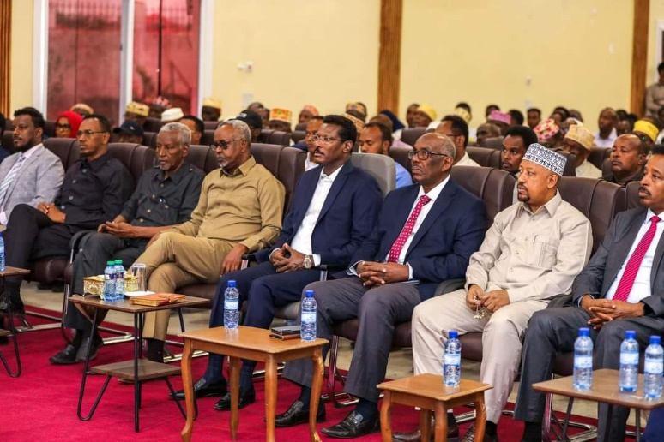 | 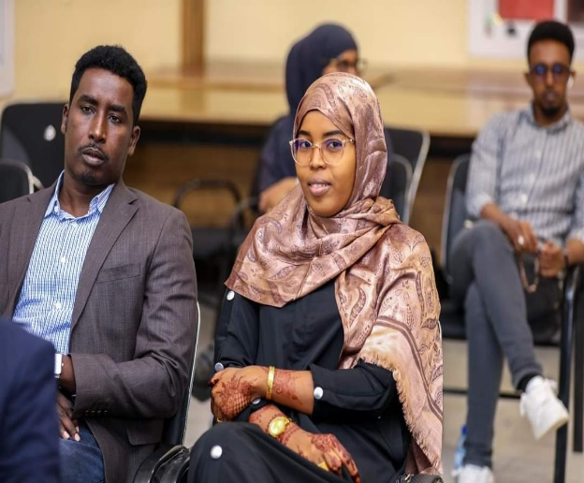
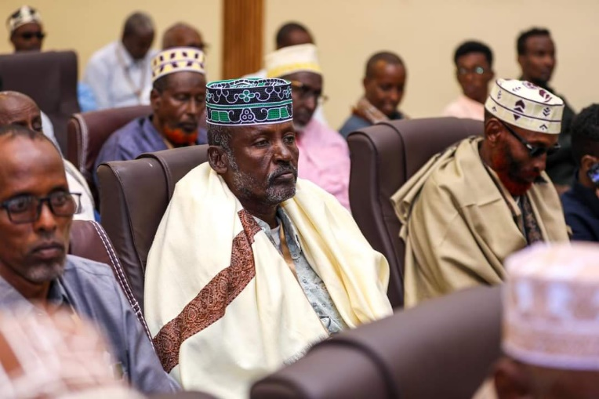 | 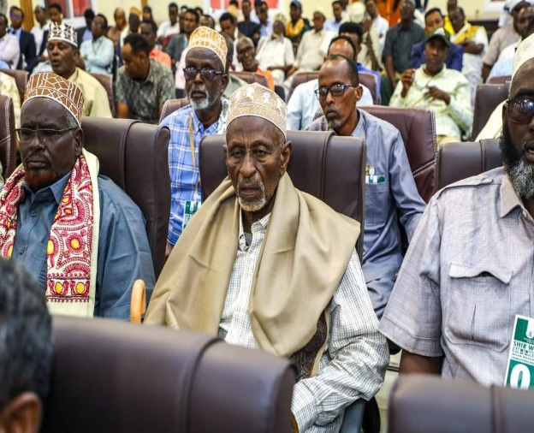

Galkayo Conflict Resolution Conference
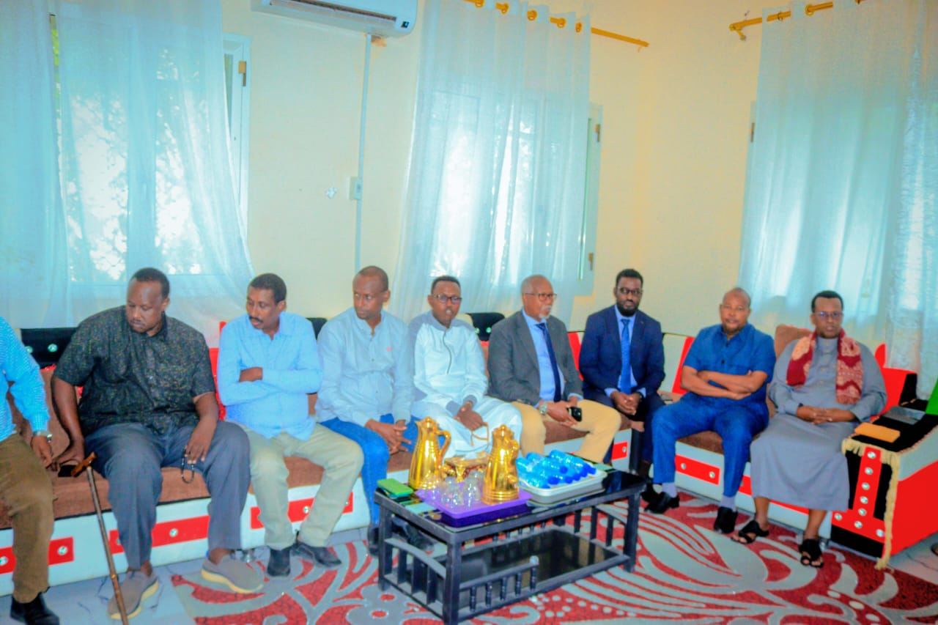 | 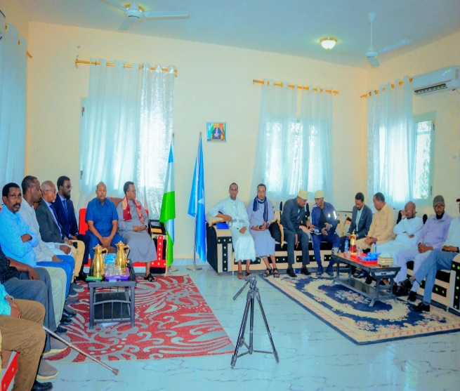

Orientation meeting for the commanders to discuss sending reinforcement forces for stabilization
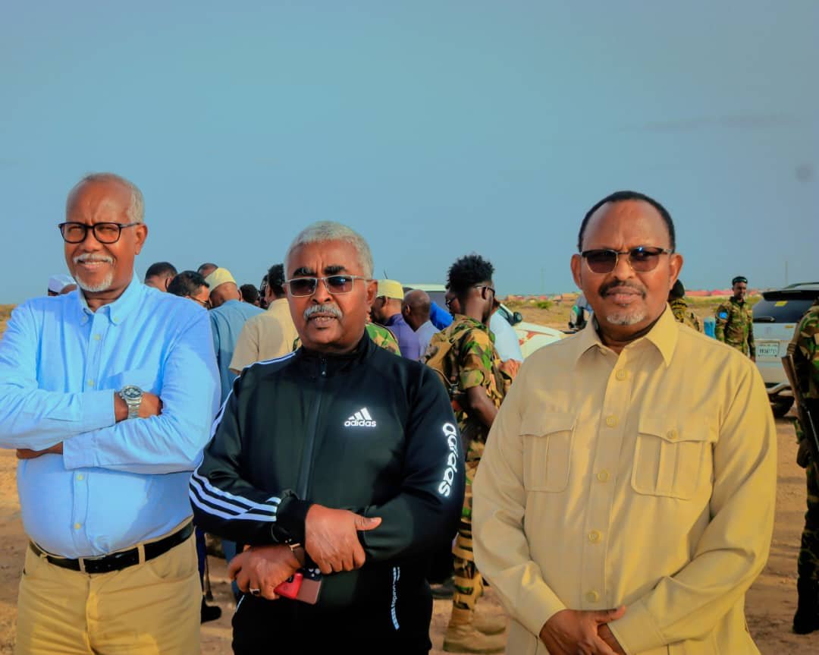 | 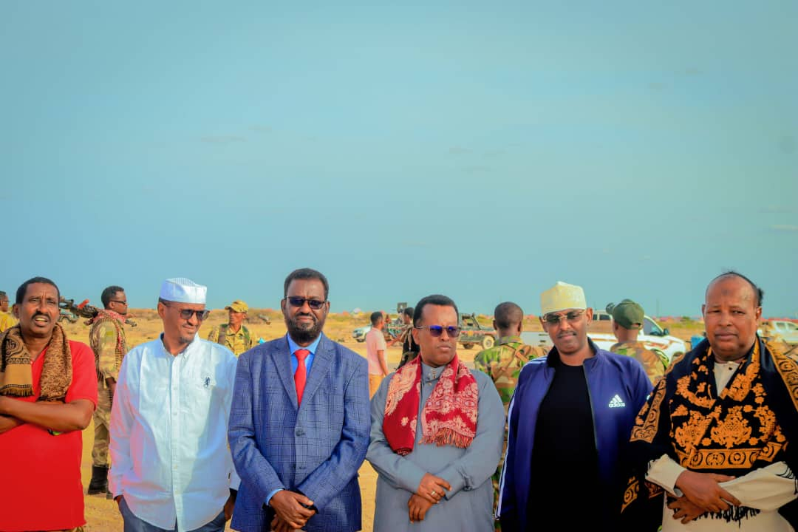

Jiicboor Conflict Resolution Conference: Ministers from Puntland and Galmudug, as well as the community elders of the conflict parties.
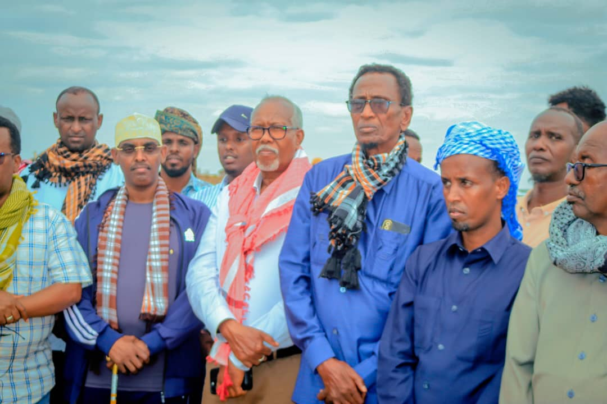 | 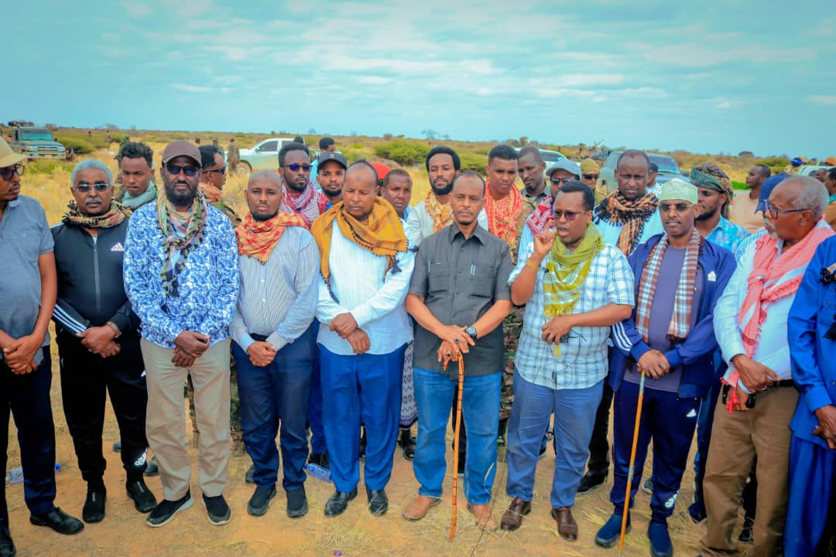
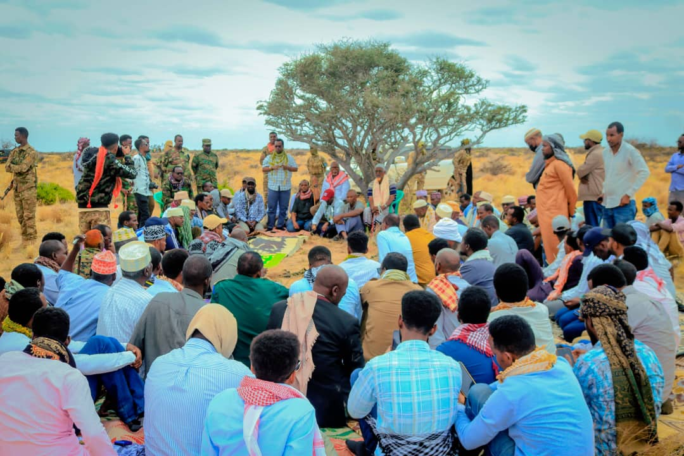 | 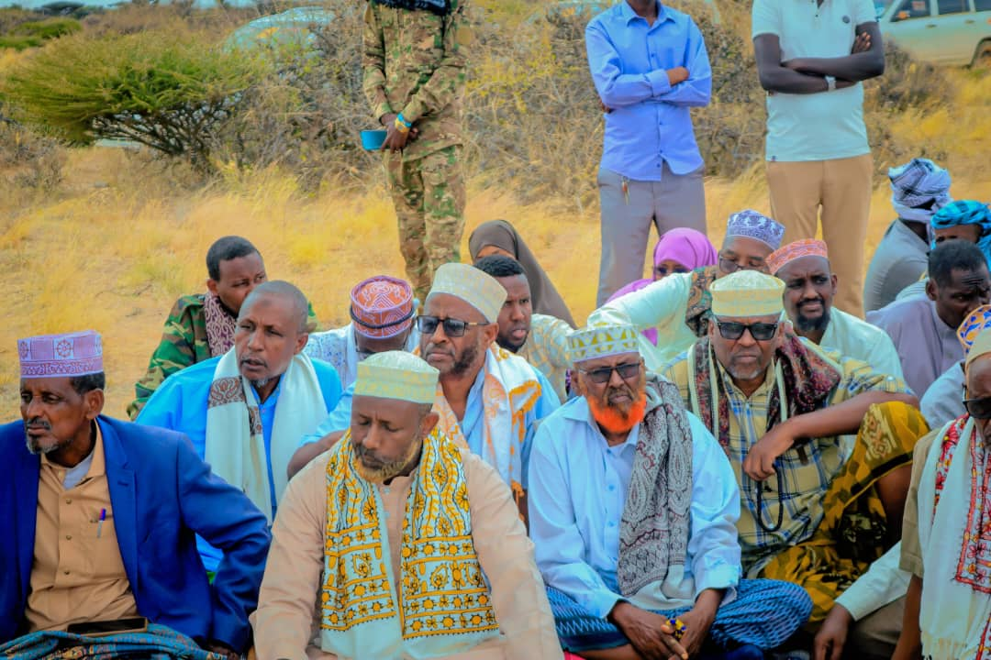
Hido clan militias relocation process
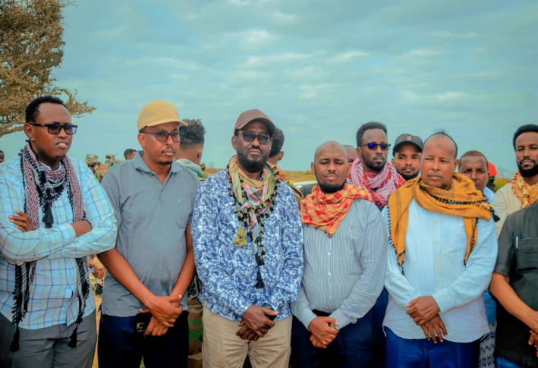 | 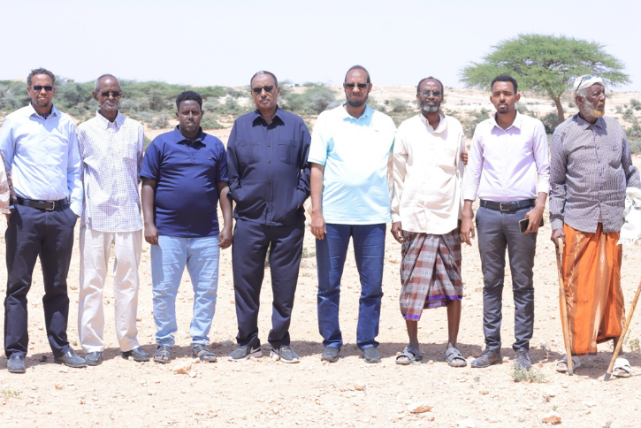
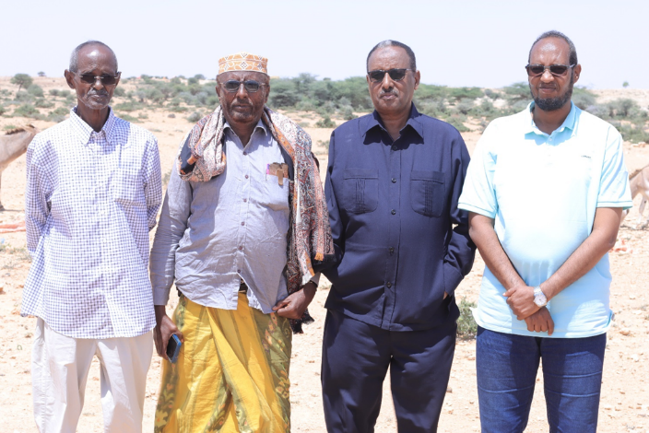

Waaciya Conflict Resolution Conference
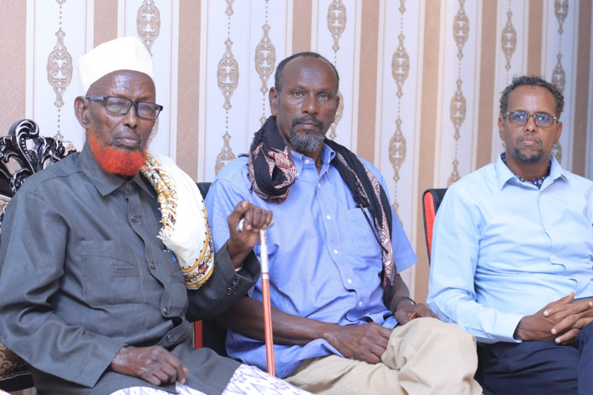 | 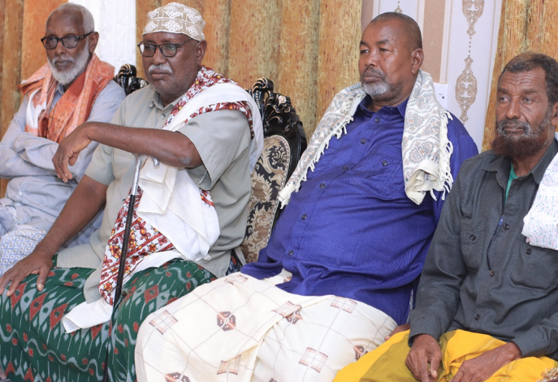
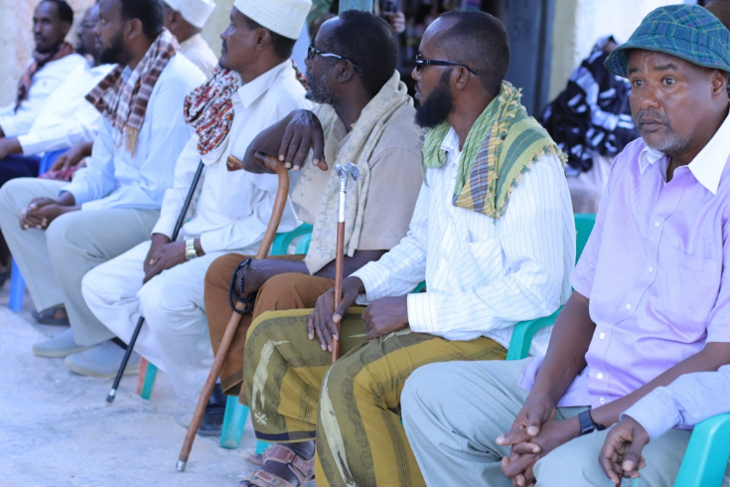 | 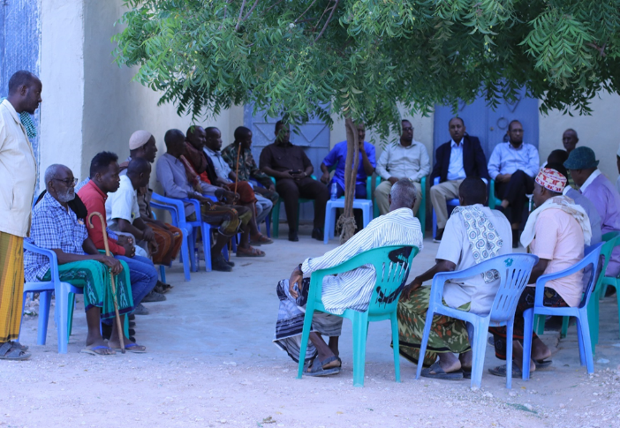

Sheerbi Community Reconciliation Meeting
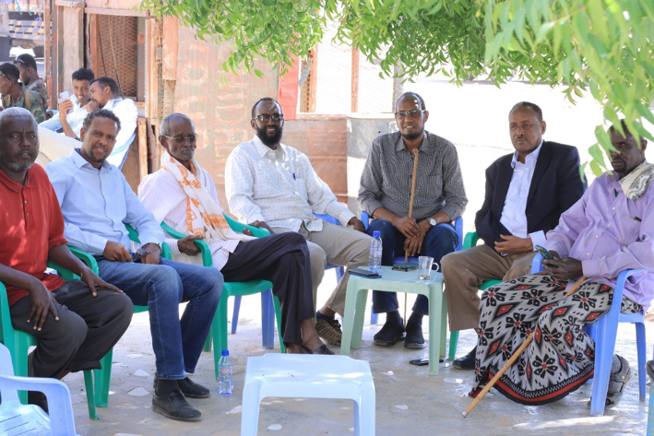 | 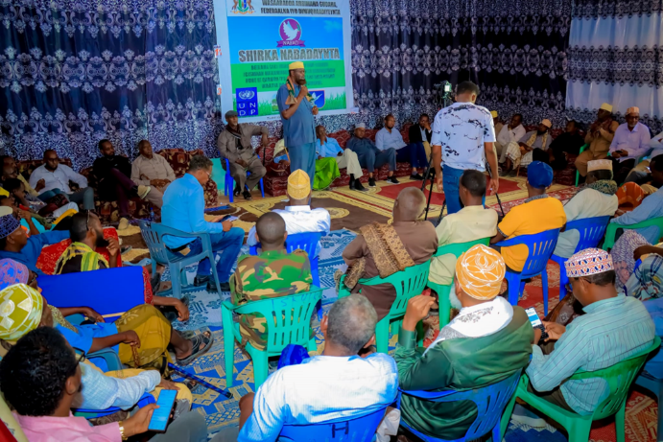
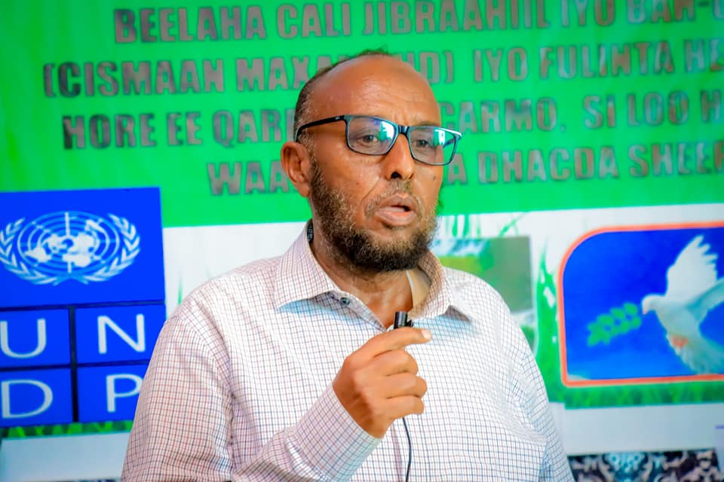 | 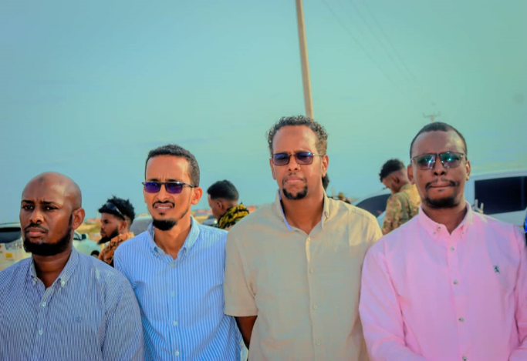

South-South Study Tour to Kenya
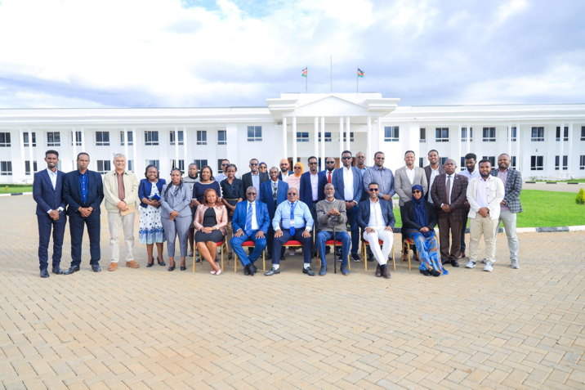 | 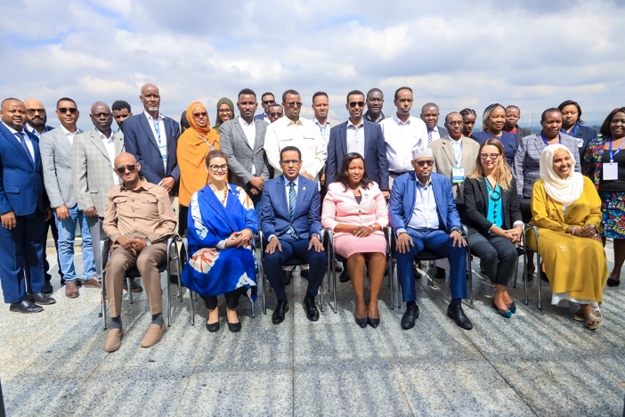
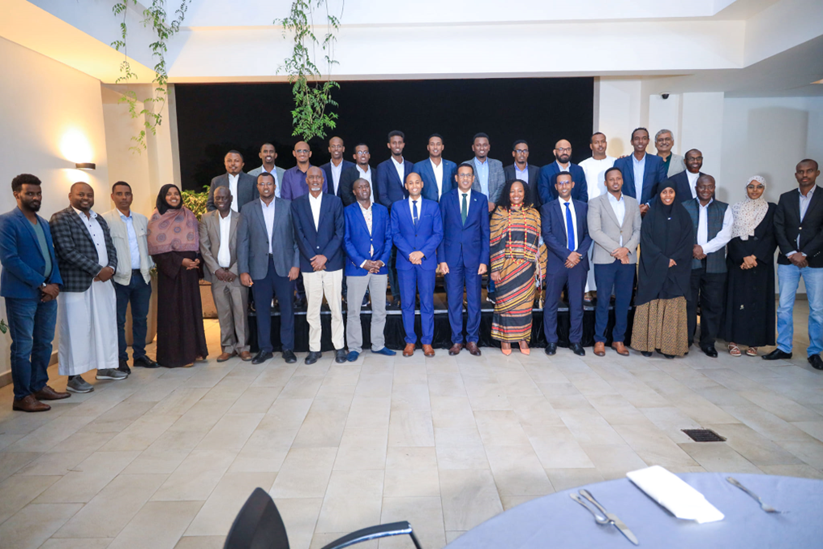

NCC MEETING
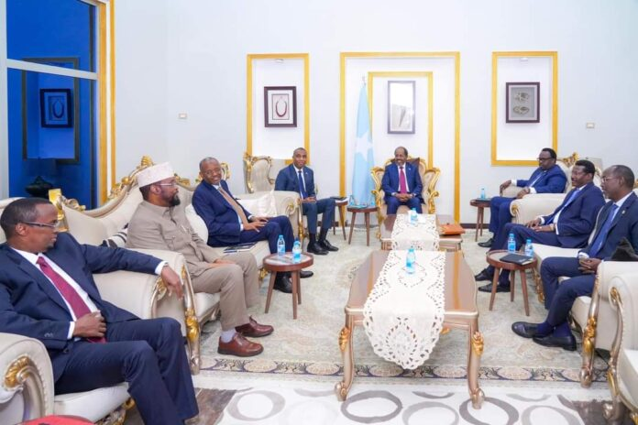

Activities in the Galmudug State
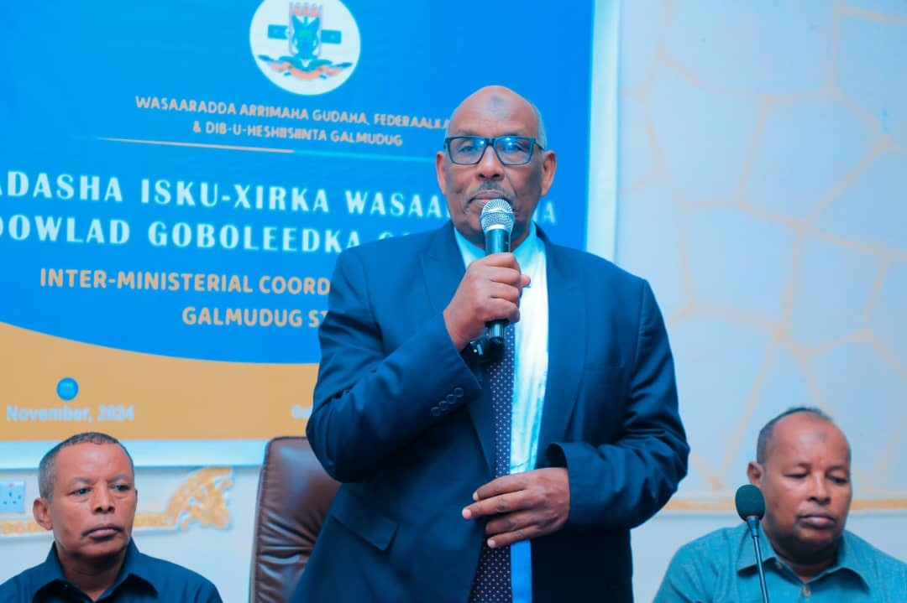 | 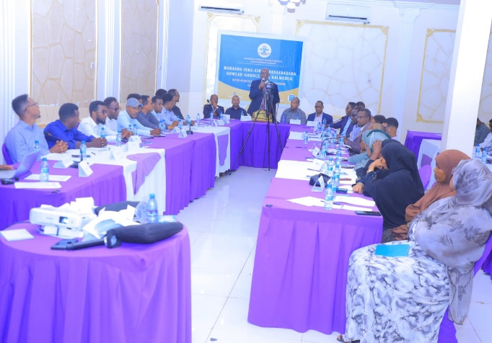
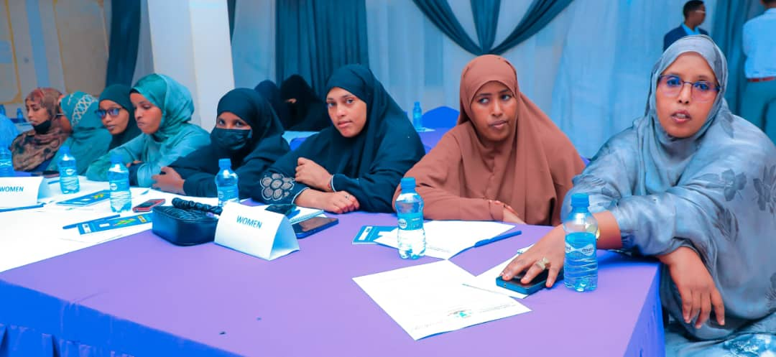 | 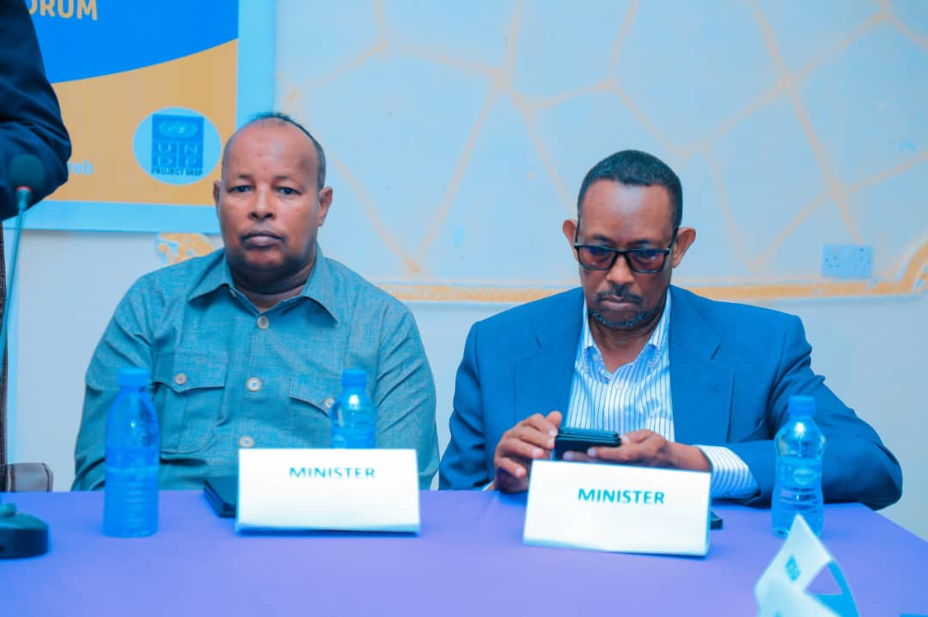
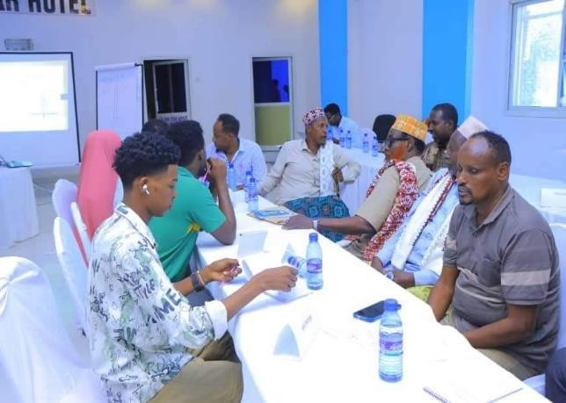 | 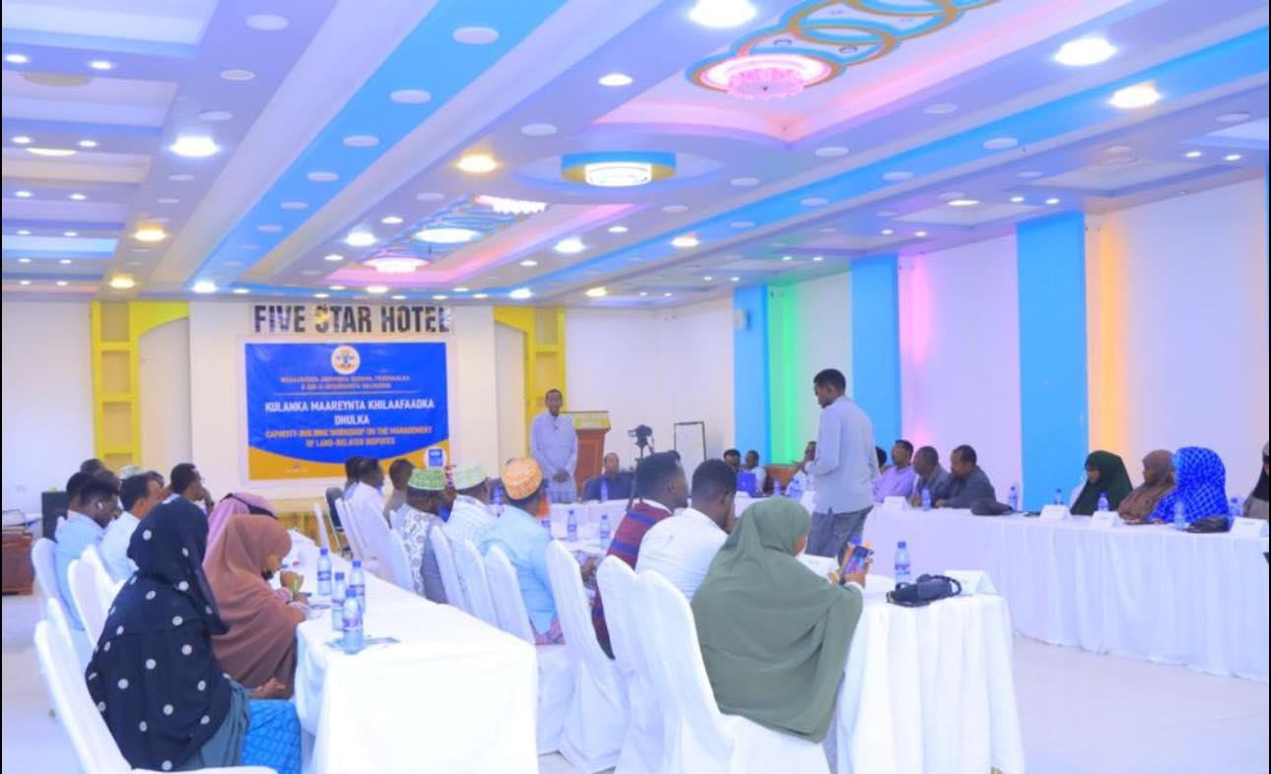
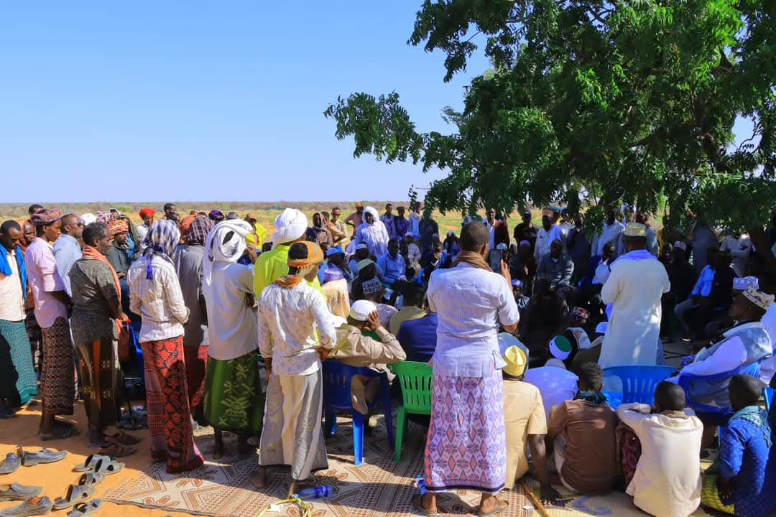 | 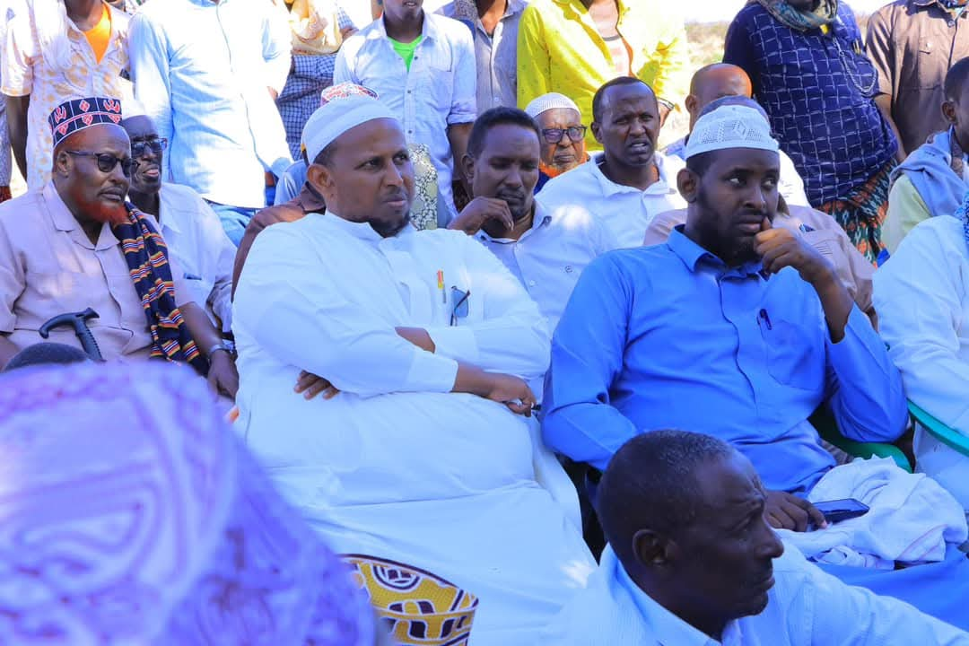
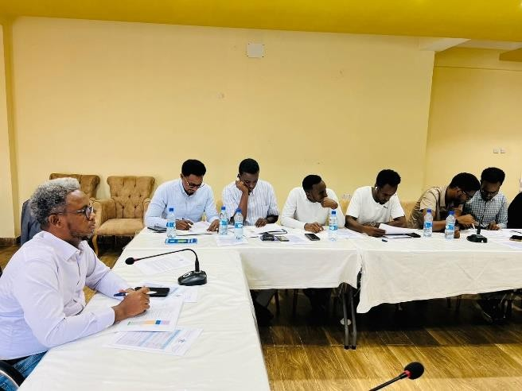 | 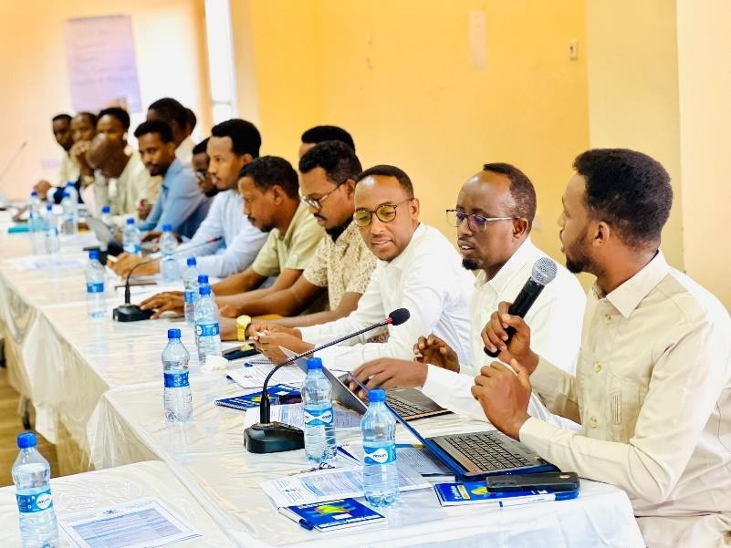
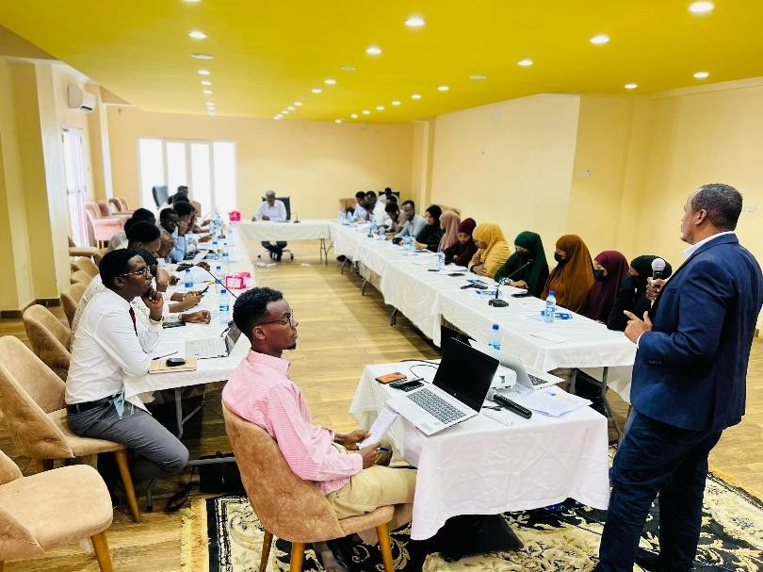 | 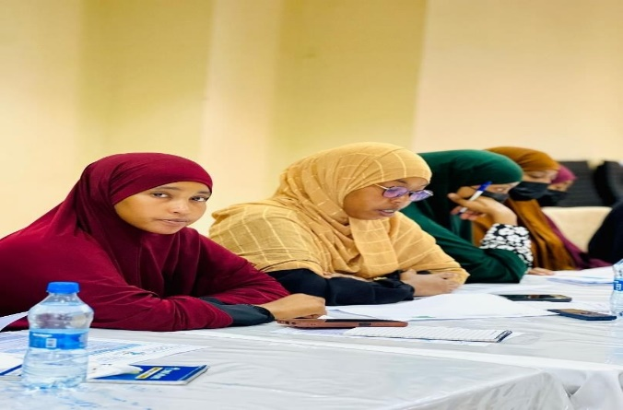
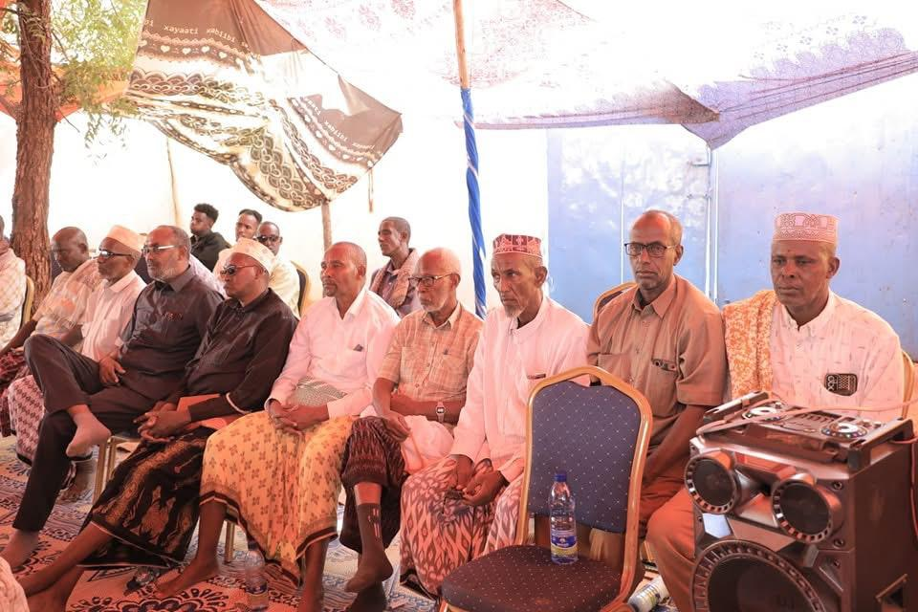 | 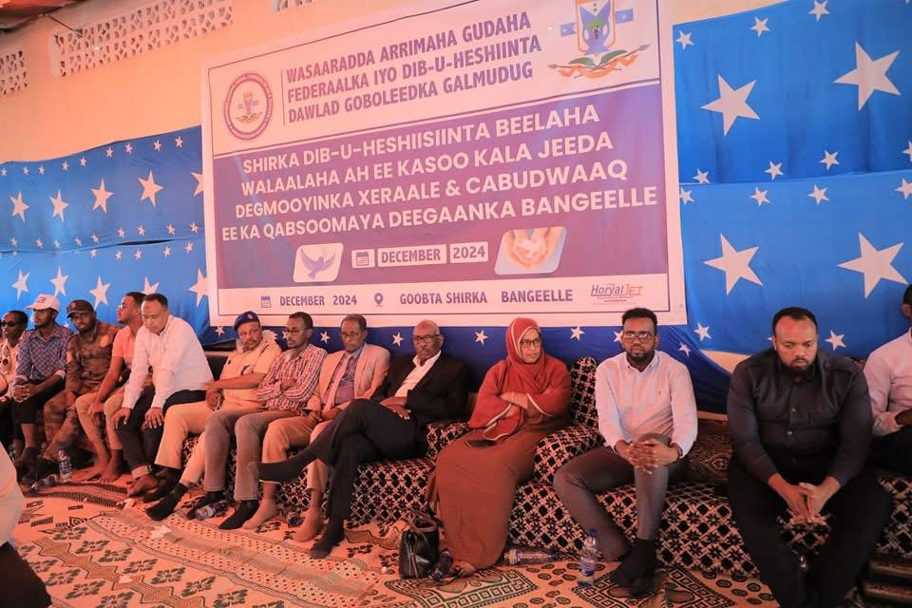
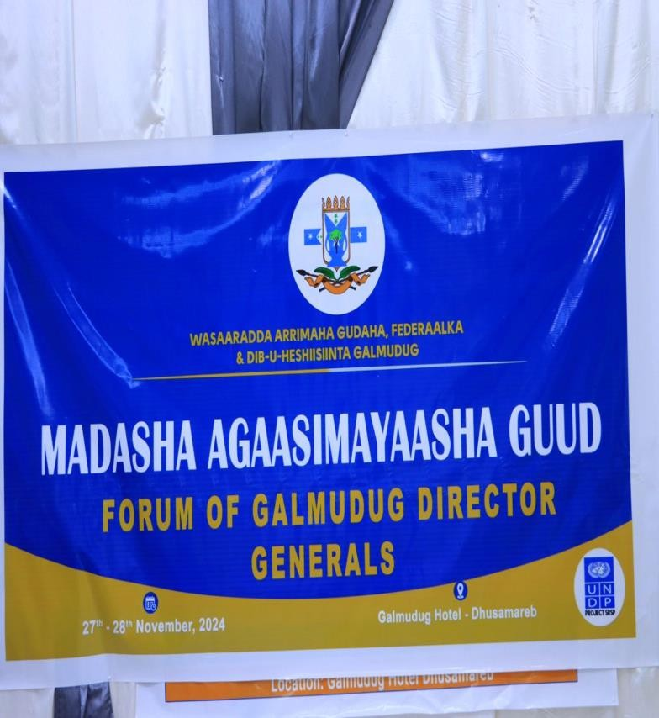 | 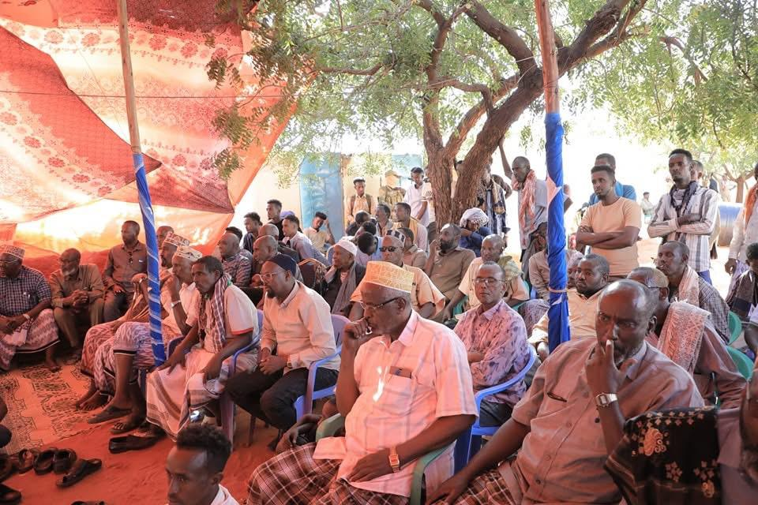

Activities in the Southwest State
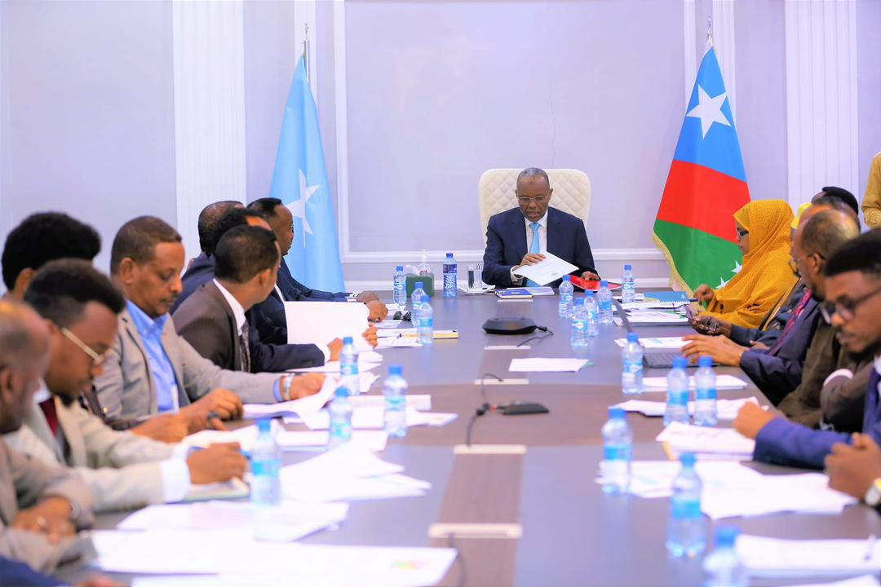 | 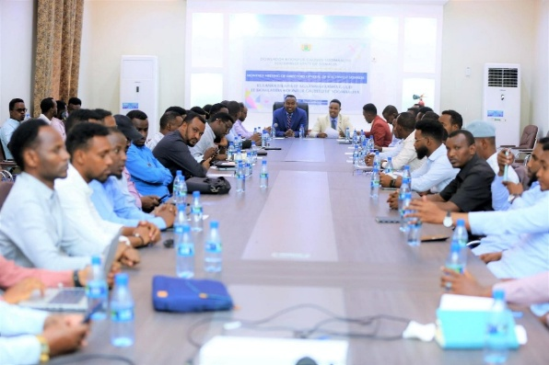
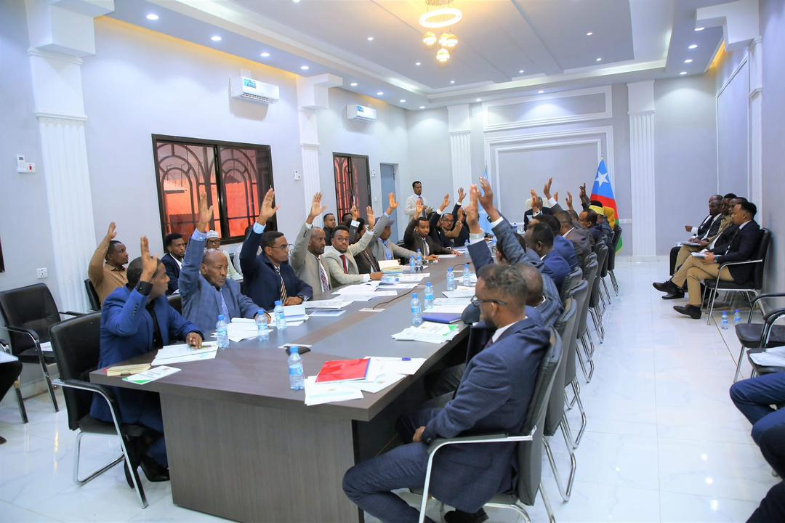 | 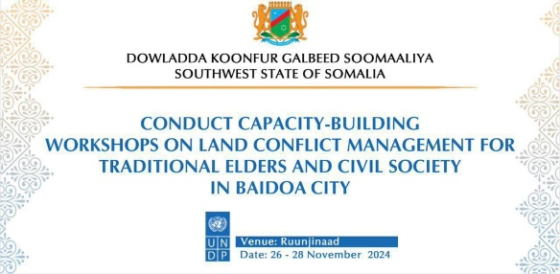
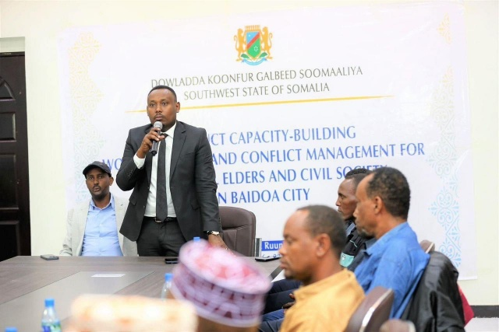 | 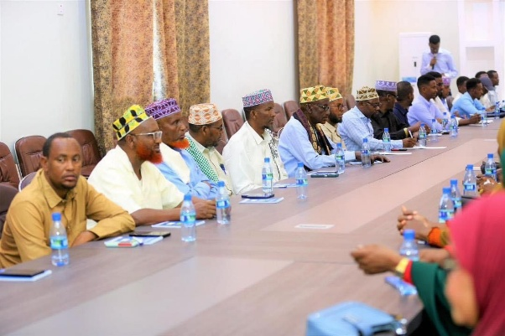
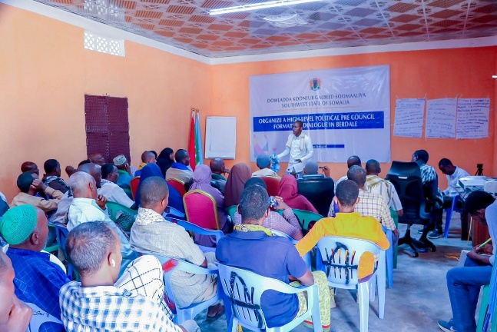 | 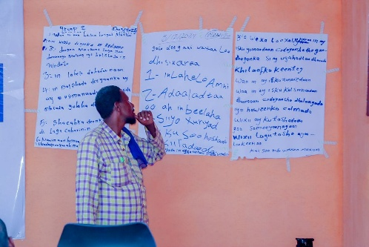
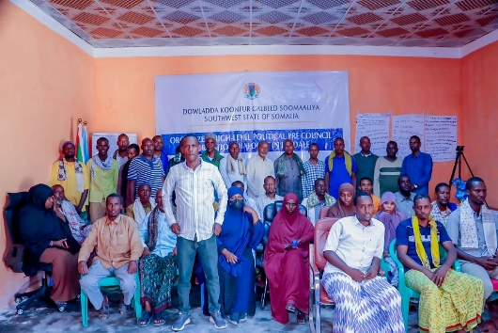 | 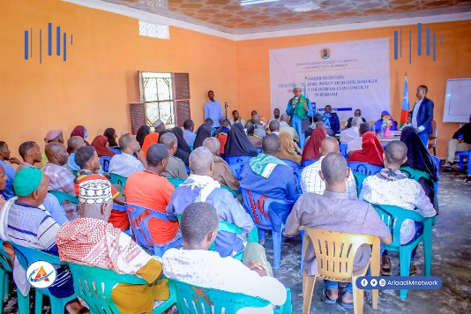
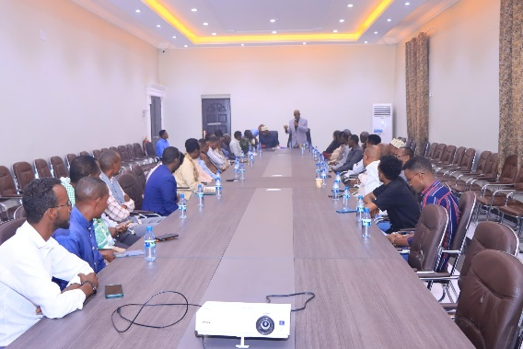 | 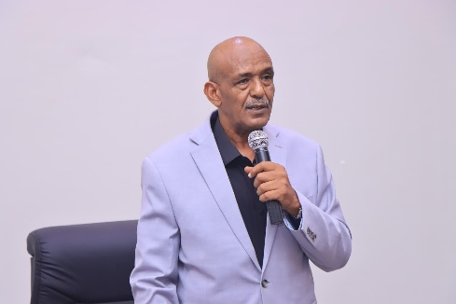

Activities in the Jubbaland State
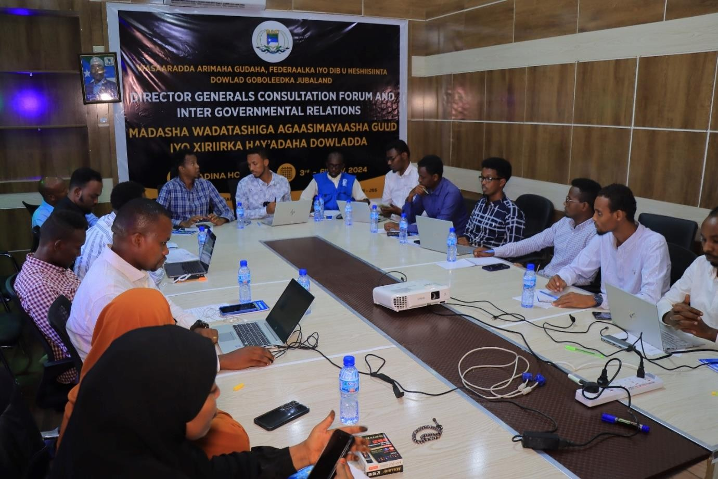 | 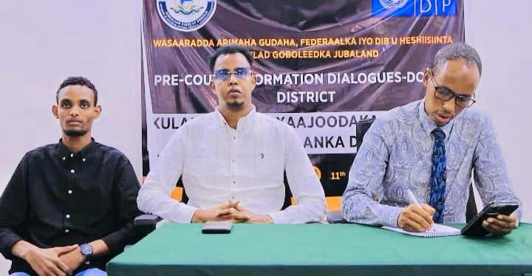
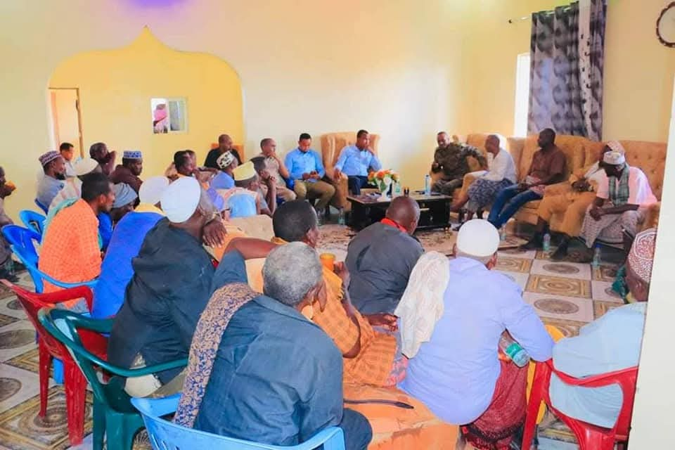 | 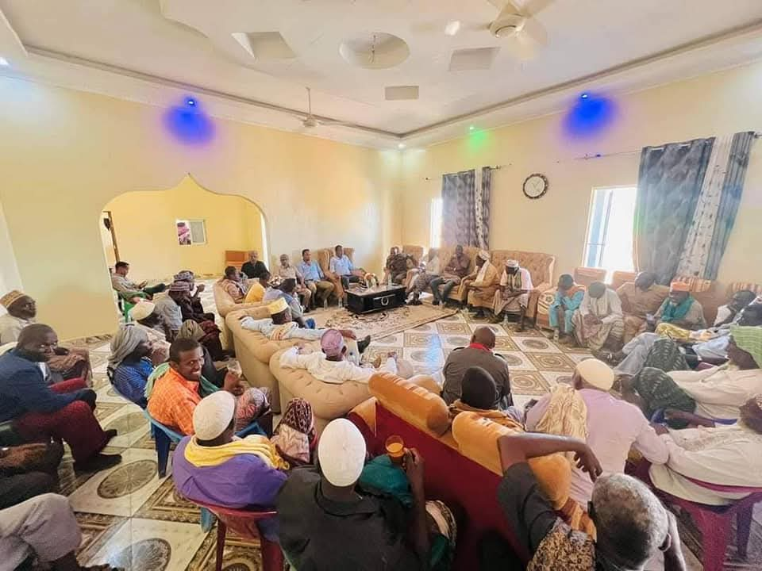
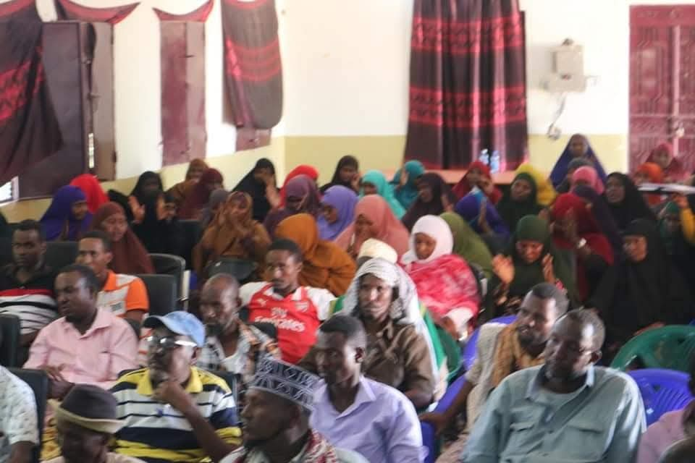 | 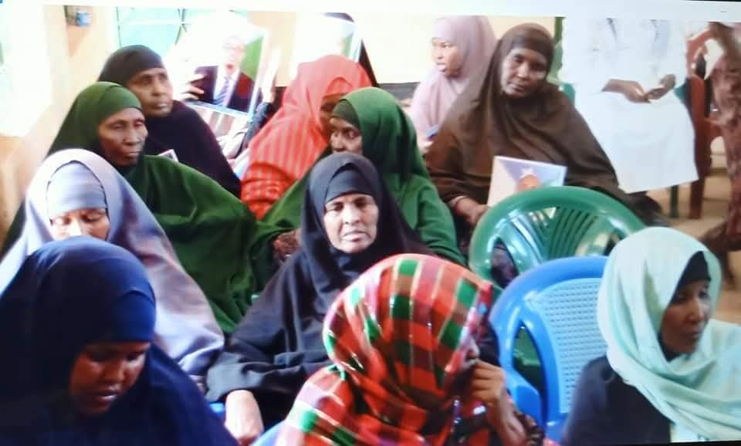
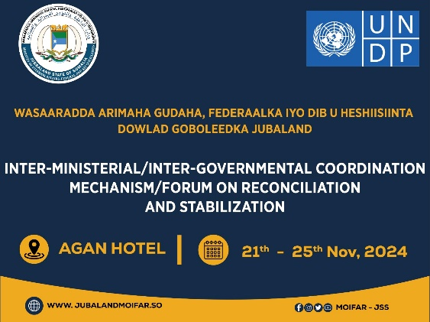 | 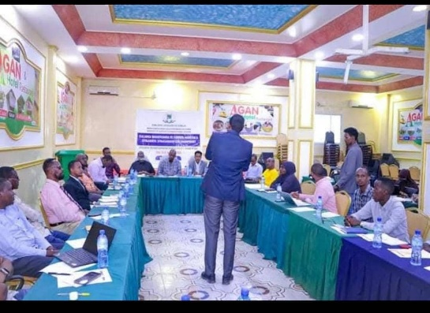
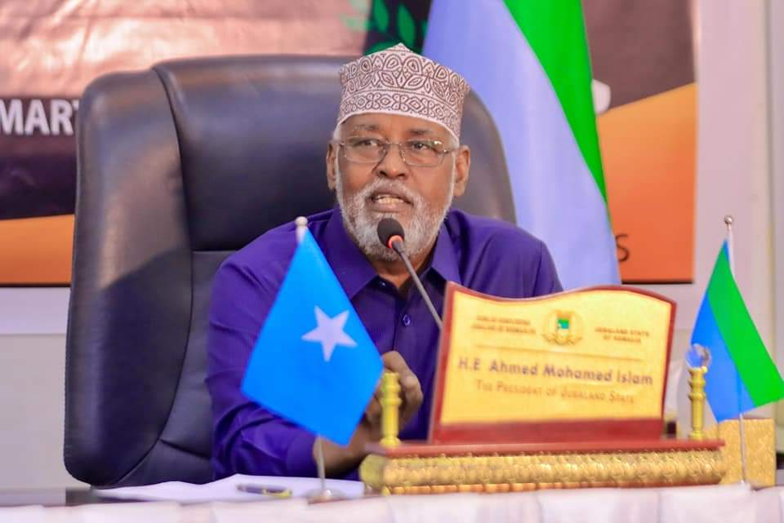 | 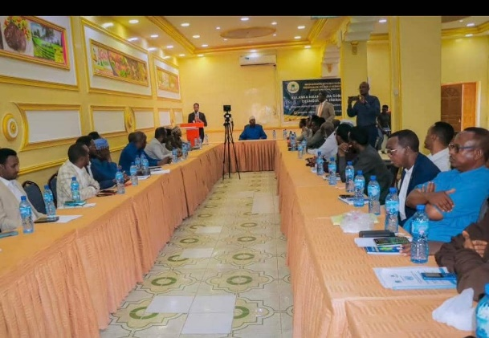

Activities in the Hirshabelle State
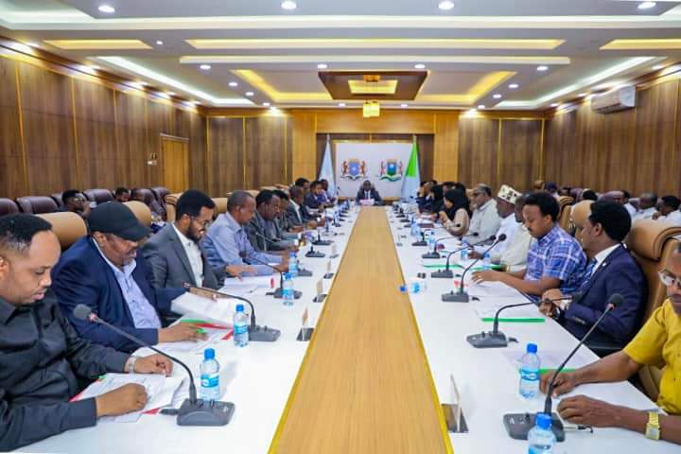 | 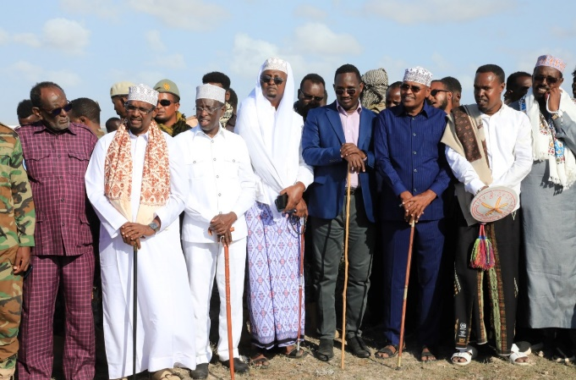
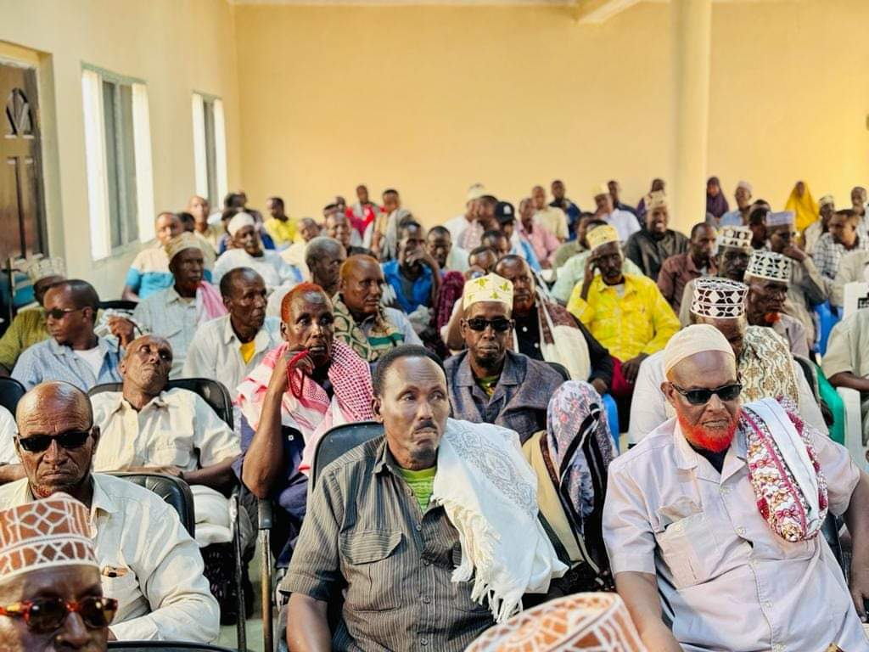 | 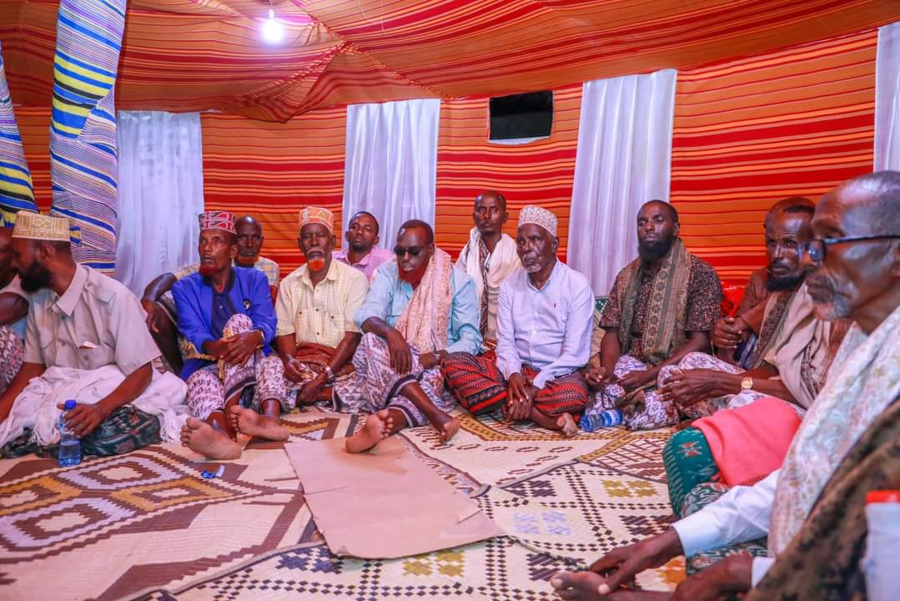
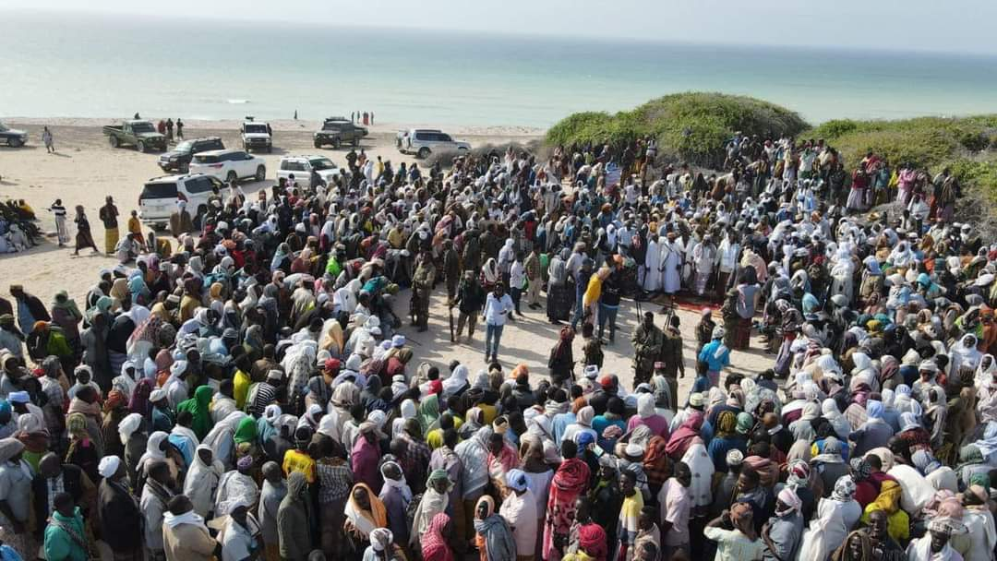 | 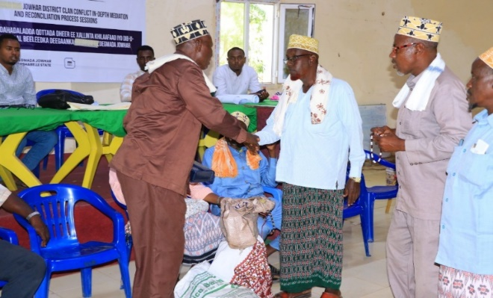
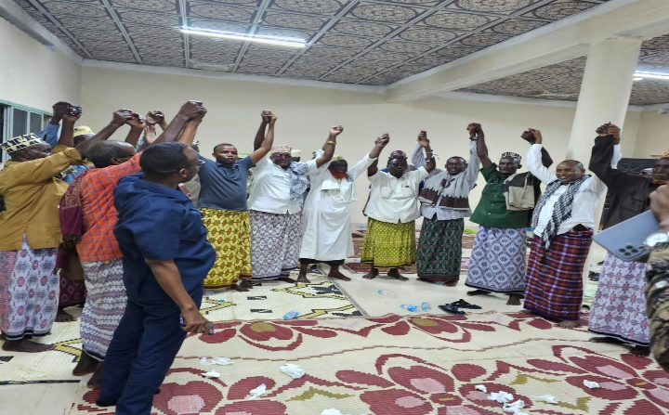 | 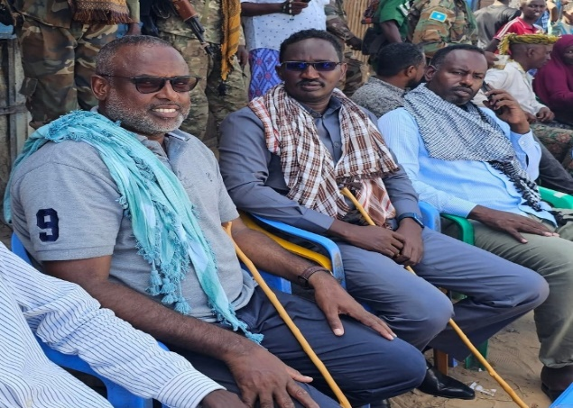

MUUQAALK DUCUMENTARYGA AH.
https://youtu.be/fK5TI7--C2I?si=TP0i1o-14DvF0zV_

MOIFAR SOCIAL MEDIA
https://www.youtube.com/watch?v=v9n83JGVx3M

Galmudug Reconciliation workshop media links
https://youtu.be/xkalld_AP3k?si=iV2f226ctVUG34hV
https://youtu.be/kOBl9WTpMI0?si=hgsJkxvxIfaxDSa4
Mustaqbal media
https://mustaqbalmedia.net/so/raiisul-wasaare-xamsa-cabdi-barre-teendho-dambe-soomaali-laiskuma-dooranayo/
VoA
https://www.voasomali.com/a/xamza-ma-aqbalayno-in-mar-kale-aan-ku-laabano-doorashadii-teendhada-/7593221.html
Risaala TV
https://www.facebook.com/watch/?mibextid=WC7FNe&v=748798557389232&rdid=SPNoNdaoUHqM4vNs
Five TV
https://www.facebook.com/share/v/BW9ow9ScC78P1qa8/?mibextid=qi2Omg
Somali TV
https://www.facebook.com/watch/?mibextid=WC7FNe&v=1914160499031249&rdid=wp6cWXWq3gKRBWm9
SNTV
https://www.facebook.com/watch/?mibextid=w8EBqM&v=749165537205476&rdid=gd1wnwNhR9t2OuQA
SHABEELE TV
https://www.facebook.com/watch/?mibextid=w8EBqM&v=3774675409477130&rdid=xATgyN2BI0cEnkzm
GOOBJOOG
https://www.facebook.com/watch/?mibextid=xfxF2i&v=487875923572194&rdid=PkrJDShnQZCUw4SI
BBC
https://www.facebook.com/watch/?mibextid=WaXdOe&v=838939578052441&rdid=wZqxyDD6oneGjIGb
RTN TV
https://www.facebook.com/watch/?mibextid=qi2Omg&v=7858929107473905&rdid=FOHtYAnxP8nDwxNF

SOUTHWEST STATE
https://www.facebook.com/share/19WDmeTeCV/?mibextid=WC7FNe
https://www.facebook.com/share/1LyPnyfrWP/?mibextid=WC7FNe
https://www.facebook.com/share/p/1ZDwdk6xUn/
https://www.facebook.com/100064382904557/posts/pfbid0qBHQX4M9jKWKeaa5tMRQT2kxWiEZVxWmm19xW2fhJa8vi48muDoQueJYkWU82GLLl/?d=w
https://www.facebook.com/share/p/15mxnKsbgA/?mibextid=WC7FNe
https://www.facebook.com/share/p/18Cm6MgNk5/?mibextid=WC7FNe
https://www.facebook.com/share/17tHbNA8P6/?mibextid=WC7FNe
https://m.facebook.com/story.php?story_fbid=pfbid024wpkfrDKQokqSo4K8YuCLZLtJ5LBQN9cVruq4BzhoBnGnkKZZW1vYXCq3MUh6SuJl&id=100064382904557
https://www.facebook.com/share/p/1D5etQE3yh/
https://www.facebook.com/share/p/YZhnVcwDYoGVmKdd/
https://www.facebook.com/share/p/15FXSQsfXX/?mibextid=WC7FNe
https://www.facebook.com/share/17eK6K4V6C/
https://m.facebook.com/story.php?story_fbid=pfbid0CRHSqp3ywGWVKk38CbraM73MxzBGZ86UdHErqgHbjZB6LpEX4qdJQYsrTbBe8Yjpl&id=100053980920941&mibextid=WC7FNe
https://www.facebook.com/100064382904557/posts/pfbid035ytk6SpCypUapY5THgrns9EyAZVuFVfekarHapXPAaMUQqRCBuWWZ5XsHnDoMeYPl/?d=w
https://www.facebook.com/share/p/17vqqvK6cJ/
https://www.facebook.com/share/p/15GY4bCXj5/
https://www.facebook.com/share/p/15GY4bCXj5/
https://www.facebook.com/share/p/1Aq2H4nT2N/
https://www.facebook.com/share/p/18Jx9pREcu/?mibextid=WC7FNe

JUBBALAND ACTIVITIES
https://www.youtube.com/watch?si=CgcdkF1RLP9SFo1G&v=6Gg4x-wPMKQ&feature=youtu.be
https://youtu.be/TMikt0lX7Lo?si=2jLXw2t2eLrOwZwP
https://youtu.be/AkAujWkuX5E?si=YlrZ4qZjoF0G_PCq
https://www.facebook.com/share/v/1Aio7mzScV/
https://www.facebook.com/share/v/1BCL9UppAE/
https://www.facebook.com/share/v/1BKRzJdScU/

HIRSHABELLE ACTIVITIES
https://www.facebook.com/share/v/1BmeYrGkQe/?mibextid=wwXIfr
https://www.facebook.com/share/v/1815zbUUjq/?mibextid=wwXIfr
https://www.facebook.com/share/v/15Mp3e1dtZ/?mibextid=wwXIfr
https://www.facebook.com/share/v/15hdwWgn7c/?mibextid=wwXIfr
https://www.facebook.com/share/v/15n31Z5GzT/?mibextid=wwXIfr
https://www.facebook.com/share/r/1WyZnss8Bo/?mibextid=wwXIfr
https://www.facebook.com/share/v/19kDwXDocz/?mibextid=wwXIfr
https://www.facebook.com/share/v/14wfmJtHdV/?mibextid=wwXIfr

GCPR-LINKS
https://www.facebook.com/100053980920941/posts/pfbid02RtickaSAzMbcXZicVLp9wsVh4QYip2YfX2rmytq7ga67oF7zgyoSqtGe3DCbmmZAl/?mibextid=WC7FNe
https://www.facebook.com/watch/?mibextid=KsPBc6&v=503579388843483&rdid=qAOZ31t5TxQ3zfgi
https://www.facebook.com/watch/?mibextid=KsPBc6&v=503579388843483&rdid=qAOZ31t5TxQ3zfgi
https://www.facebook.com/100053980920941/posts/pfbid02RtickaSAzMbcXZicVLp9wsVh4QYip2YfX2rmytq7ga67oF7zgyoSqtGe3DCbmmZAl/?mibextid=WC7FNe

