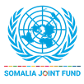 | UN Somalia Joint Fund  Progress report  [Annual: 1 November – 31 January 2025]
Project data

Title | Joint Programme Strengthening Local Governance and Decentralized Service Delivery (Dowlad-kaab Programme)
SJF Project number | 01003198
Recipient UN agencies | UNDP, UNICEF and UN-HABITAT
SJF Window | Community Recovery and Local Governance Window
Geographical coverage | All Federal Member States (FMS), Banadir Regional Administration (BRA) and Somaliland
Project duration | Sept 2024- Aug 2029
Total approved budget | 5 Million (Funded Budget) and 20 Million (Unfunded Budget)
Implementing partners | Ministry of Interior Federal Affairs and Reconciliation, Federal Government of Somalia (MOIFAR –FGS)  Ministries of Interior (Galmudug, Hirshabelle, Southwest, Jubaland)  Banadir Regional Administration (BRA)  Ministries of Public Works, Housing and Reconstruction (Galmudug, Hirshabelle, Southwest and Jubaland)  Ministries of Interior (Somaliland and Puntland)  Ministries of Education and Health (Galmudug, Hirshabelle, Southwest, Jubaland, Somaliland and Puntland)  Office of the Vice Presidents (Somaliland and Puntland)  Association of Local Government Authorities of Somaliland (ALGASL) and Association of Local Government Authorities of Puntland (ALGAPL)  Local Government Institutes  Civil Society Organizations (INTERSOM Relief and Development Organization and Agency for Resilience Initiatives Network)
No of beneficiaries | Millions of People
NDP pillar | NDP 1: Inclusive & Accountable Politics and Reconciliation.  NDP 2: Improved Security and the Rule of Law.  NDP 3: Economic Development.  NDP 4: Social Development
UNCF Strategic Priority | - Social Development  - "Economic Development and Poverty Reduction
SDG | 1, 5, 8, 11, 16, 17
Gender Marker | GEN 2
Disability Marker
Related UN projects  within/outside the SJF portfolio | - Saamyenta (IOM, UNHABITAT, UNDP)  - Joint Resilience Action (FAO, UNICEF & WFP)
Focal person(s) per recipient UN entity

Report submitted by:

 | PUNO | Report approved by: | Position/Title | Signature
1 | UNDP | Shaila Khan | Portfolio Manager, Economic Recovery and Institutional Development
2 | UNICEF | Jose Maria Bendito Prieto | Chief Social Policy
 | UN-Habitat | Sophos Sophianos | Head of Somalia Programmes

Section 1: Executive summary

Brief introduction to the project and situation update/ Context of the reporting period
The Dowladkaab Programme (Joint Programme on Strengthening Local Governance and Decentralized Service Delivery) is designed to enhance the capacity of local governments to effectively meet the needs and rights of citizens. By fostering an environment conducive to inclusive and sustainable governance at the district level, the programme aims to improve the delivery of basic social services, build state legitimacy, and enhance public trust.
Funded by the UN Somalia Joint Fund (SJF), the programme is implemented by three UN agencies—UNDP, UN-HABITAT, and UNICEF—working in partnership with federal and state ministries, under the leadership of the Ministry of Interior, Federal Affairs, and Reconciliation (MoIFAR). The programme emphasizes local ownership and a modular approach to governance, ensuring sequenced and coordinated implementation.
In collaboration with MoIFAR, the Dowlad-kaab Programme leverages key government structures, including the Local Government Institute, Local Government Associations, and relevant Federal Member State ministries to enhance coordination and capacity across all levels of government. This helps clarify the roles and responsibilities of the federal, state, and local tiers of government, ensuring that they act as duty-bearers.
The programme strengthens the core functions of districts by engaging citizens in local planning, public finance management, and budgeting, ultimately better equipping local governments to deliver equitable, inclusive, and accountable services. It focuses on fiscal decentralization, planning, and public finance management, improving taxation, revenue management, and inter-governmental fiscal transfers. This approach aims to increase the use of local resources in service delivery.
By empowering citizens as rights-holders and facilitating access to social accountability mechanisms, the programme builds trust in local governments and supports sustainable, citizen-centered development. Furthermore, it works to make districts more livable and resilient through effective urban planning, enabling them to withstand the challenges posed by urbanization and climate-related shocks.

Summary of key achievements during the reporting period
- The Programme laid the groundwork for the review of the Decentralized Service Delivery Model (SDM) operational manual, aligning it with decentralization policies and frameworks for the Federal Member States (FMS). This revision is set for consultation and validation by February 2025.
- Re-established Sector Decentralization Technical Working Groups (TWGs) in target FMSs (Galmudug, Hirshabelle, Southwest, Jubaland), facilitating sector-specific coordination and collaboration. Key outcomes include agreement on quarterly coordination meetings and a shared understanding of roles and responsibilities.
- Established and held the first District Coordination Forums in four target districts (Adado, Jowhar, Barawe, Kismayo), engaging 80 district-level participants. These forums promoted collaboration and strategic coordination for decentralized service delivery among service delivery actors at district level.
- Successfully conducted a four-day Training of Trainers for 30 participants, followed by state-level orientations for 118 district officials, reinforcing participatory district planning skills and enhancing the local governance capacity of target districts.
- Provided targeted training on decentralized service delivery planning and implementation to 92 district officials across four districts, strengthening their understanding of service delivery frameworks, service delivery processes and standards, and sectoral coordination and oversight.
- Initiated partnerships with CSOs to implement a civic education programme that would directly target 9,320 citizens (50% female), increasing awareness of civic rights and responsibilities and fostering active citizen participation in local governance decision-making and development processes.
- Induction training had been conducted for District Councils (DCs) of 3 districts of Adaado, Barawe, Jowhar, and Kismayo. The training induction is intended to capacitate the council to understand their roles, responsibility, and delineation between standing council and department Directors.
- The quarterly coordination meetings were conducted for four Federal Member State and Ministry of Interior, Federal Affairs and Reconciliation that had been aimed to the Local Government –Interministerial Committee (IMC) mandated government institutions to oversight overlapping of the implementation of LG interventions.
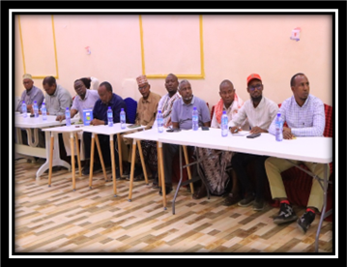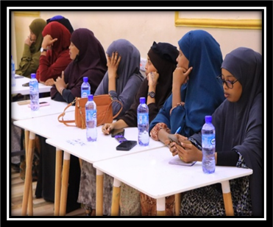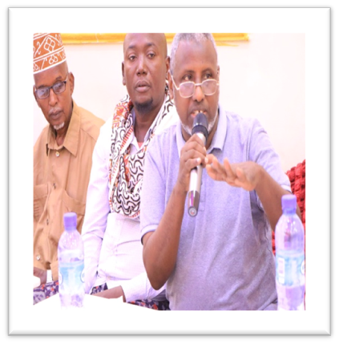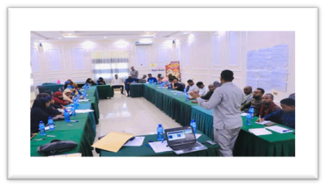

- There had been Participatory Public Planning Expenditure Management (PEM) training for four districts of Hirshabelle-Jowhar, Southwest-Barawe, Jubbaland-Kismayo. and Galmudug-Adado.
- As usual beginning of every project is necessary to conduct baseline survey and capacity assessment exercises to identify existing problems in the intervention areas. Dowlad-Kaab planned to conduct baseline survey and capacity assessment that had been exercised for the four districts of Adado, Barawe, Jowhar, and Kismayo. For the PEM participated 185 participants (M: 131; F: 54) from Adado, Barawe, Jowhar, and Kismayo, in which benefited district councils, department directors, executive secretary of the district and departments’ staff.
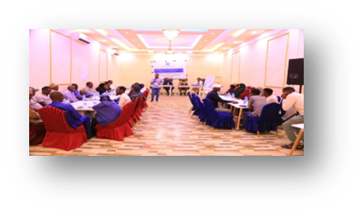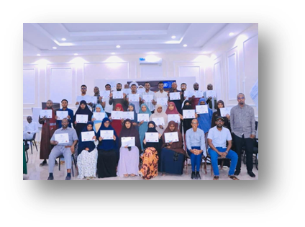
Figure 1 Puplic Expenditure Management (PEM)
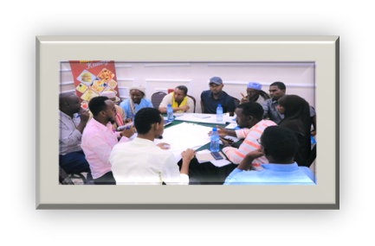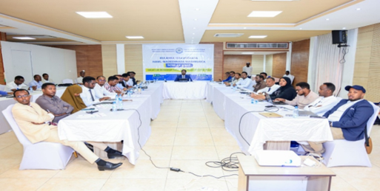

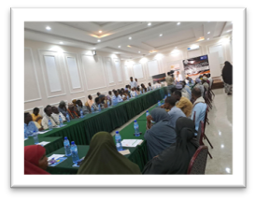
Figure 2: Presentation of baseline survey presentation
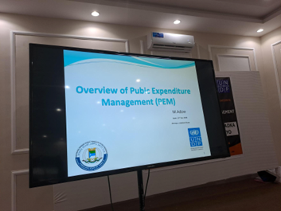
- Ministries of Interior of Federal Member States supported by UNDP hired 4 senior consultants who carried the surveys and capacity assessment using former JPLG programme questionnaire; this has also been reviewed by the three partner UN-agencies of UNDP, UNICEF, and UN-HABITAT. The final reports produced will be used for the Dowlad-Kaab programme intervention, which will undergo a post-evaluation at the end of the programme's lifespan. This evaluation aims to assess the impact of progress on the ground, both in terms of physical site developments and the empowerment of LG cadres. Five capacity-building consultants, along with a Policy Planning and Local Governance (LG) Advisor, were recruited by UNDP in close collaboration with the Federal Member States (FMS), the Municipality of Mogadishu, and MOIFAR-FGS UNDP focal points, and MOILG department of LGs and Administration and Finance department in order to uphold transparency of recruitment processes. These consultants have been deployed to their respective duty stations.
- A high-level engagement workshop on fiscal decentralization is conducted in Mogadishu with MoIFAR, FMS MoILG, MoF and District Administrations representatives to present ongoing fiscal federalism efforts and ensure alignment with the ongoing National Decentralization Policy.
- Supported Association of Local Government Authorities in Puntland (ALGAPL) to strengthening its capacity in gathering and standardizing knowledge products on local governance in Puntland in an effort to create a resource base for local governments.
- Recordkeeping of the local governments in Puntland has been enhanced through tailored training on recordkeeping, knowledge management and data analytics training organized by ALGAPL.
- Towards making targeted capacity injection, ALGAPL’s institutional capacity is thoroughly assessed, with view of its capability in implementing its 2023-2028 strategic plan, promote its self-reliance and operational sustainability.
- An options paper for the Somalia Mayors Forum has been developed through a series of consultation meetings across all levels of government. An option to form Somalia Local Government Association has been chosen, which establishes a platform representing the voice of the local government authorities in Somalia. To achieve this, a two-year transition period is proposed. During this period, the current Mayors Forum will be strengthened, a roadmap for the association will be set and a conducive environment for the association to thrive will be created. This aims to ensure a robust, bottom-up and phased approach to institutionalize the voice of the subnational authorities and local communities, fostering collaboration and effective governance across Somalia.
- Current district budgeting practices of Kismayo, Barawe, Adado and Jawhar were thoroughly assessed, and the findings reveal different capacity levels. This allows the programme to design, implement, and sustain a uniform approach to district budgeting and fiscal performance.
- Domestic revenue mobilization plan is developed for Adado, Jawhar, Kismayo and Barawe in a consultative and participatory approach, marking an effort to unlock the untapped domestic revenue potential, inform intergovernmental fiscal transfers and contribute towards making local government able service delivery
- Strengthened municipal finance of local governments in Adado, Kismayo, Barawe and Jahwar through provision of on-the-job training on local taxation, local governance finance policy and local government financial management manual.
- Towards fiscal discipline and transparency, an internal audit manual based on State PFM is developed for Jawhar and Adado. This manual introduces strong internal safeguards and enhances compliance with the local government financial policy and other regulatory frameworks in place
- The functional capabilities of the public works and taxation departments in Adado, Barawe, and Kismayo have been assessed and now, provision of clear workflows, job descriptions, and an organogram is underway. This ensures that the departments have the minimum operational capacities to deliver mandated services.
- District profiles for Jawhar, Kismayo, Adado and Barawe are completed and after the final reviews are made now, they shall be incorporated into the ongoing District Development Framework (DDF).
- The infrastructure prioritization framework is developed for Adado, Barawe and Kismayo district administrations. This is a critical prerequisite for the local development fund, as it enables districts to identify and prioritize infrastructure projects in a transparent, objective, and evidence-based manner.
The empowerment and functions of the District Councils include administrative, financial management, planning and legislative powers. In addition, the law defines the roles and responsibilities (services to be delivered) of the local councils and the other stakeholders in the local government system. The law also establishes the relationship between the local councils and the state government in particular the Ministry of the Interior as the responsible body for supervising and mentoring the local governments
The direct reached beneficiaries during the reporting period are indicated the below paragraphs:
- The training induction is intended to capacitate the council's understanding of their roles, responsibilities, and delineation between standing council and department directors. 1847 participants (M:1263; F:584) who had come from district councils, department directors and big main village committees benefited from the training. These trainings were benefitted participants from Adado, Barawe, Jowhar, and Kismayo and their constituent villages.
- The Public Expenditure Management (PEM) training was attended by 185 participants (M: 131; F: 54) from district councils, directors of planning, social affairs, district executive secretary, finance and administration, and public works departments, for these trainings were benefitted participants from Adado, Barawe, Jowhar, and Kismayo and their constituent
- The District Development Framework (DDF) workshop was participated by 984 participants (M: 731; F: 253) from MOILGs- DGs, MOPIC, MOH, MOE, WATSAN, MOE (environment), and all departments of the States where district councils, directors of planning, social affairs, district executive secretary, finance and administration, and public works departments attended the workshop. These trainings were benefitted participants from Adado, Barawe, Jowhar, and Kismayo and their constituent villages.
- Supported the reinstitution of Sector Decentralization Technical Working Groups (TWGs) in target FMSs (Galmudug, Hirshabelle, Southwest, Jubaland), with 100 participants (20% female) attending first TWG meetings in Nov-Dec 2024.
- Established District Coordination Forums in target districts (Adado, Jowhar, Barawe, Kismayo) with 80 participants (26% female), promoting coordination and collaboration for decentralized service delivery.
- Conducted a 4-day Training of Trainers (ToT) on District Participatory Planning for 30 participants (23% female) from FMS Ministries of Interior and district officials, followed by state-level orientations for 118 participants (37% female).
- Conducted a training for 92 district officials (42% female) from Adado, Jowhar, Barawe, and Kismayo to enhance and knowledge and skills on decentralized service delivery planning, implementation, and monitoring.
- Initiated a civic education initiative in partnership with CSOs, that would directly target 9,320 citizens (50% female) through forums, public meetings, and media campaigns to promote civic rights, participation, and accountability in local governance.
- A two-day consultation workshop on the fiscal decentralization function of Somalia and alignment with the ongoing fiscal federalism efforts participated by 33 (3F; 30M) participants in Mogadishu. This included representatives from FGS MoIFAR, FMS MoILGs and delegates from Kismayo, Barawe, Jawhar and Adado.
- A five-day Training in recordkeeping, documentation, knowledge management and data analytics was attended by 22 participants (15:F; 7: M) in Garowe. Beneficiaries included sector Ministries, Garowe local government, Puntland State University and most importantly, ALGAPL staff and management.
- A two-day consultation workshop on institutionalization work for Somalia Mayors Forum conducted in Mogadishu with 30 participants (6: F; 24:M) drawn from Kismayo, Jawhar, Adado and Barawe, FMS MoILGs and FGS MOIFAR.
- One-day consultation workshops are held in each Adado, Kismayo, Barawe and Jawhar to present and input domestic revenue mobilization plan for the districts. Participants included 120 participants (42: F; 78: M) representing technical teams at revenue department of the districts, administration and finance, FMS MoILGs local government departments and other municipal staff.
- A four-day on-the-job training on local governance finance policy, local government financial management manual and guide to local taxation training was conducted in Kismayo, Adado, Barawe and Jawhar with 60 participants (22: F; 38:M) drawn from the core departments of the local governments and the FMS MoILGs
- Two-day consultation workshop on the updated internal audit charters was conducted in Adado and Jowhar with 50 participants (13F: 37:M) from the local government officials and staff members
- One-day consultation workshops on the workflows, job descriptions and organogram of the public works and taxation departments of Kismayo, Adado and Barawe. It received 45 participants (11: F; 34:M) from these departments and representatives from the District Executive Committees.
- Two-day training for 80 enumerators (20: F; 60:M) was conducted in Kismayo, Jawhar, Adado and Barawe to support data collection for District Profiles.
- A Three-day consultation workshop on infrastructure prioritization framework for Adado, Barawe and Kismayo was held with a total 75 participants (16: F; 59:M).

Section 3: Implementation progress by outcome

Progress Towards Outcomes

OUTCOME 1: Empowered state institutions at federal, state and district level to effectively spearhead decentralization reforms, enhance adaptive capacities, improve coordination and delivery of social services.

Output 1.1: Legal, policy and regulatory frameworks and structures for decentralization and local governance are in place and enacted.

Engagement workshop with the Federal and State authorities (FGS MoF, MoIFAR, FMS MoF and MoILGs) working on fiscal decentralization to set a pathway for fiscal decentralization strategy development and align ongoing fiscal federalism efforts

The programme collaborated with the Federal Ministry of Interior, Federal Affairs and Reconciliation (MoIFAR) in a bid to advance the ongoing intergovernmental fiscal relations. With the support of the programme, the Ministry mapped out the various stakeholders involved in the fiscal federalism process, from both the donor side and the government side, in order to clearly define who is responsible for what and in which jurisdiction. The mapping is intended to assist the Ministry enhance complementarity, synergies and collaboration among the stakeholders, fostering effective coordination approach towards a seamless fiscal federalism process. In doing so, the Ministry engaged and consulted the FMS MoILGs and District Administration through a high-level consultation workshop that took place in Mogadishu.
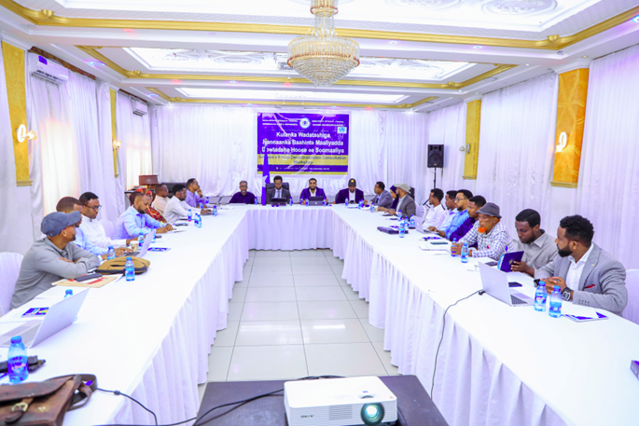
The culminations of these efforts are essential for optimal use of fiscal resources in a coordinated manner. It also enables MoIFAR to represent the voices, priorities and the needs of the FMS MoILGs and the district administrations who were not adequately represented in the existing fiscal federalism structures at federal level. Not only this but adopting such a coherent and consensus-based approach to handle and lead ongoing fiscal federalism efforts paves the way for a unified direction. On the other hand, the outcome of this effort contributes to the ongoing review of the national decentralization policy currently led by UNDP, within Dowlad-kaab framework.

Output 1.2: Strengthened local government capacity with different government levels clearly defined roles and responsibilities to engage citizens and addressing their priorities in service delivery.
Review of the Local Government-led Decentralized Service Delivery Operational Manual

The Dowlad-kaab Programme is reviewing the Service Delivery Model (SDM)operational manual following the adoption of decentralization policies and strategies in the sectors of health, education, and water. This review is taking place within the Federal Member States (FMS), where these policies are fully developed. The revision aims to align the manual with the decentralization legal framework and FMS-specific strategies, while considering local capacities and governance structures.

The updated manual will offer comprehensive guidance on SDM planning, financing, implementation, and monitoring to enhance local service delivery. The updated SDM operational manual will be presented to FMS stakeholders and target districts of the Dowlad-kaab Programme (Adado, Jowhar, Barawe, and Kismayo) for consultation and validation by the end of February 2025.
After this consultation process, the manual will be finalized and rolled out to support the implementation of planned SDM interventions throughout 2025, further strengthening decentralized service delivery mechanisms at the local level.

Output 1.3: Government institutions at all tiers of government demonstrate improved coordination and advocacy for institutionalization and resource mobilization.

Sector Decentralization Technical Working Group at State Level
Since its launch in August 2024, the Dowlad-kaab Programme has helped re-establish Sector Decentralization Technical Working Groups (TWGs) in the FMS of Galmudug, Hirshabelle, Southwest, and Jubaland. These TWGs consist of Director Generals from social sector ministries (including education, health and water) and are chaired by the Ministries of Interior at the FMS level. The primary objective of the TWGs is to support sector decentralization initiatives in alignment with the overarching decentralization policies and legal frameworks. The TWGs are designed to reinforce dialogue, foster commitment to the devolution of basic services to local governments and ensure streamlined coordination and oversight of the decentralized Service Delivery Model (SDM). Additionally, the TWGs serve as the technical arm of the Inter-ministerial Committee on Decentralization (IMC), which includes ministers from interior, health, education, water, women’s affairs, social affairs, planning, and finance. The IMC is chaired by the Office of the Vice Presidents and is responsible for advancing decentralization reforms and making critical strategic policy decisions related to decentralization.
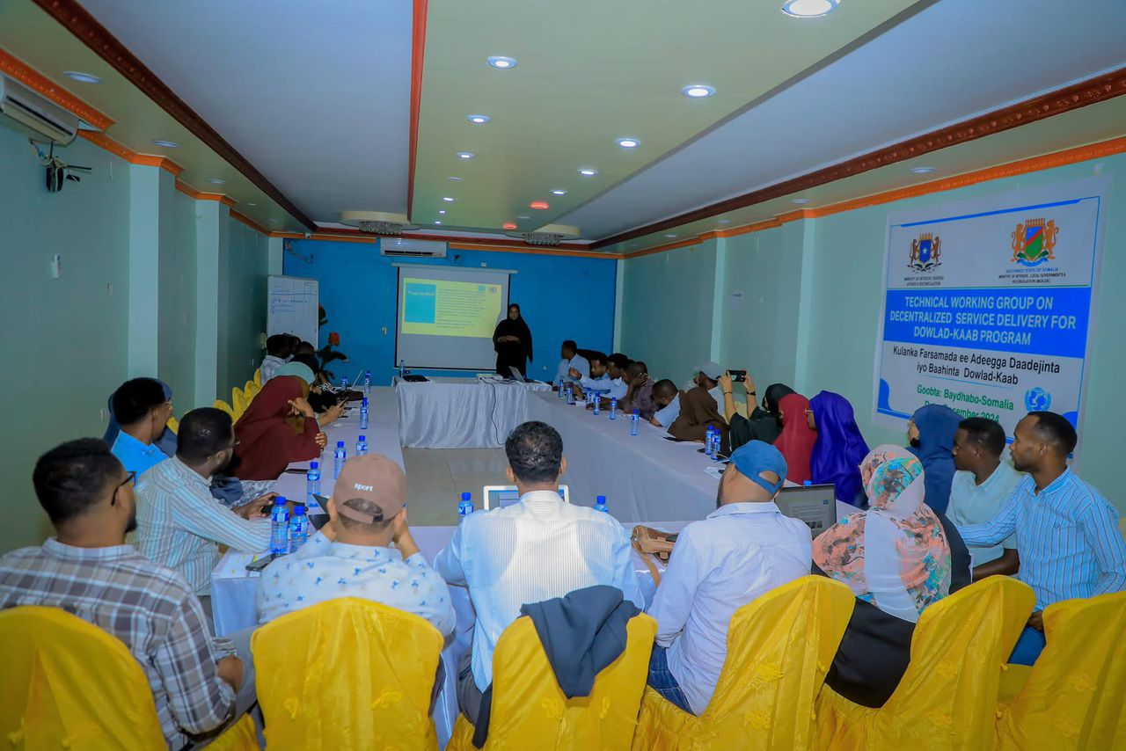
During the reporting period, the four target FMSs held their inaugural TWG meetings. These meetings served as a platform to discuss progress on sector decentralization, address challenges, and plan next steps for accelerating decentralization policies and sector strategies, along with the rollout of the SDM. They also focused on coordination and collaboration with other initiatives, such as the People-Centered Governance Programme and the Somalia Stability Fund, to ensure synergy and complement ongoing efforts.
Sector Decentralization TWG Meeting in Baidoa
The initial TWG meetings also helped establish a shared understanding of the Dowlad-kaab Programme, its service delivery approach, and the challenges and opportunities in service delivery. Participants acknowledged the crucial role of a functional TWG in ensuring the equitable and effective delivery of decentralized services at the local level.
A total of 100 participants (20 per cent female), with 25 participants from each FMS, attended the first TWG meetings held between November and December 2024. Key outcomes included a better understanding and consensus on the different but complementary roles and responsibilities of state and local authorities, an agreement to hold quarterly coordination meetings to track progress and address challenges, and a commitment to advancing sector decentralization reforms. These reforms focus on developing sector-specific strategies and building the capacity of state and local authorities to effectively manage and deliver decentralized functions, particularly in the education and health sectors
Local Government-Led Coordination of District-Level Service Delivery
The programme has supported the establishment of District-level Service Delivery Coordination Forums that bring together key service delivery actors at the district level, including social sector ministries, UN agencies, international and local NGOs, as well as other development partners engaged in service provision at the local level.

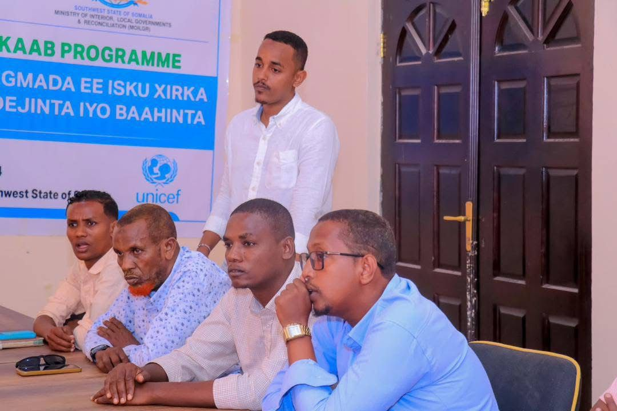
The District Coordination Forum aims to enhance coordination among service delivery actors, align partner-supported programs with state and national strategies, and promote the shift to local government-led implementation. It also provides a platform for open discussions and the exchange of best practices. Chaired by District Mayors and co-chaired by District Social Affairs Directors, the forum focuses on coordinating the planning, implementation, and monitoring of decentralized services. Additionally, it oversees capacity-building and technical assistance to strengthen district-level service delivery and improve monitoring, accountability, transparency, and community involvement in managing key social services like health, education, and water.
District Service Delivery Coordination Meeting in Barawe

Recognizing the critical role of effective coordination, the first meetings were held between October and December 2024 in the four target districts: Adado, Jowhar, Barawe, and Kismayo. In total, 80 participants (26 per cent female), representing district leadership and key departments, including Social Affairs, Planning, and Public Works attended. Participants also included international and local NGOs involved in service delivery, as well as regional and district representatives from social sector ministries.

These forums provided a platform for information sharing, collaborative planning, and addressing challenges related to decentralized service delivery. Key outcomes included the need for capacity-building programs for local government staff that will focus on enhancing skills in planning, budgeting, financial management, and service delivery. The meetings also highlighted the importance of exploring avenues to increase financial resources for local governments, such as improving revenue collection, accessing intergovernmental fiscal transfers, and seeking support from development partners.

Furthermore, the forums underscored the need to enhance citizen participation in local governance and service delivery. Mechanisms such as community forums, public consultations, and social accountability frameworks were identified as key tools for strengthening this participation. Moreover, it was agreed that all development partners in the districts will present their priorities and plans at the next district coordination meeting to explore alignment with district plans and foster coordination and synergies between interventions.

It was also emphasized that, moving forward, partners will adhere to the District Development Framework to ensure a coordinated and sustainable approach to local development. The forums will be convened quarterly, with ad hoc meetings as needed. The Ministries of Interior at the FMS level will provide technical backstopping to ensure that the outcomes are communicated to the State-level TWGs and are aligned with the broader decentralization efforts.

Gathering and documentation of local government laws, directives, policies, strategies, guidelines, training and manuals

In Puntland, the programme partnered with ALGAPL to document and standardize knowledge products by the JPLG III. Towards this cause, ALGAPL is currently engaged in the compilation of existing documentations that are scattered in various institutions at the different tiers of government. The goal is to create a repository containing local governance resources of JPLG, allowing the programme and other local governance actors to contribute to, build upon and existing resources accordingly. In addition, this initiative also assists the Puntland government expand the reach of the local governance knowledge, ensuring that public engagement and access are prioritized. Partly, this intervention represents programme’s intention to strengthen the institutional capacity of ALGAPL to operate sustainably and effectively.

Trainings on recordkeeping, documentations, knowledge management and data analytics

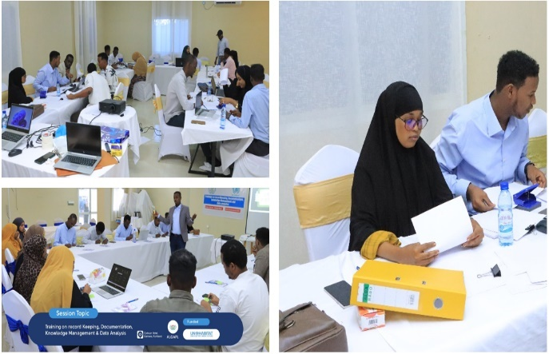
The programme conducted a 5-day training on recordkeeping, documentation, knowledge management and data analytics with 22 participants (15: F; 7:M) in Garowe. Beneficiaries included sector Ministries, Garowe local government, Puntland State University and most importantly, ALGAPL staff and management. Linked to the programme’s knowledge management approach, this training was designed to enhance the knowledge, skills and abilities of the participant. As a result, this training contributes to the effort of Puntland authorities to maintain proper records of the local governance knowledge products. It also fosters a sustainable and well-documented process to update, disseminate and ensure meaningful contribution to Puntland’s commitment to decentralization and better local governance. This is anticipated to prompt ALGAPL to issue directives calling on all local governments to maintain proper records and safeguard accordingly.

Support operationalization of ALGAPL 5-year strategic plan

In close collaboration with ALGAPL, the programme is setting foundations for making informed capacity building interventions. ALGAPL, with the support of VNG international, has developed a 5-year strategic plan for 2023-2028 and now, with the support of the programme, ALGAPL engaged a consultancy to assess the institutional capacity of ALGAPL to implement its strategic plan. This cooperation assists the programme to identify capacity gaps and identify other stakeholders who can assist in addressing the identified gaps, promoting an evidence-based and collaborative approach to strength ALGAPL’s capacity to effectively, efficiently, and sustainably fulfil its commitment to local governance in Puntland.

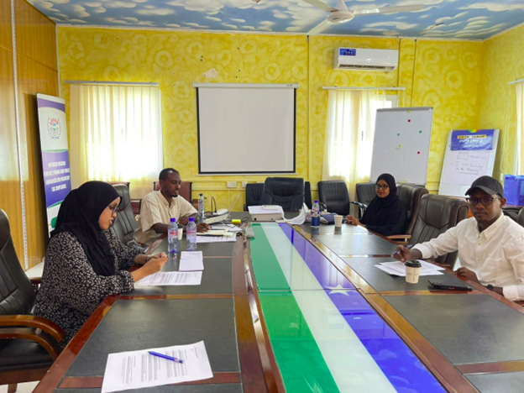

Institutionalization of the Mayors Forum - Option paper through consultative process participated by all States and FGS
The Mayors’ Forum initiative has been a pilot function for Somalia, with two rounds held in Kigali and Mogadishu in 2022 and 2023 respectively. It demonstrated that Somali mayors can significantly contribute to the country's stability, reconciliation, and state building process. With the support of the programme, MoIFAR is now working towards transitioning from a project-based approach to a permanent and government-led platform. An international consultancy was hired to develop an option paper on the various options pertaining to the institutionalization of the Mayors Forum. After extensive consultations with mayors, State FMS, and FGS MoIFAR, a two-day workshop with 30 participants from Kismayo, Adado, Barawe and Jawhar, Federal Member States' Ministries of Interior and Local Governments, and MOIFAR was held in Mogadishu. Participants chose to sustain the Mayors Forum as a transition to a full-fled local government association for the time being. Now, the Federal Minister of Interior, Federalism and Reconciliation with his counterparts will define both the transition period and the roles and responsibilities of the Federal, State and District level authorities during the transition period. The programme will then render technical assistance to MOIFAR in developing a roadmap for this option and offers technical assistance to translate the roadmap into action. This will facilitate inter-district dialogue on key issues like local governance, displacement, urbanization, and service delivery etc. By harnessing the potential of mayors, this option aims to drive significant changes and enable Somalia to participate in sub-regional, regional, and continental local government associations, amplifying the voice of local communities.

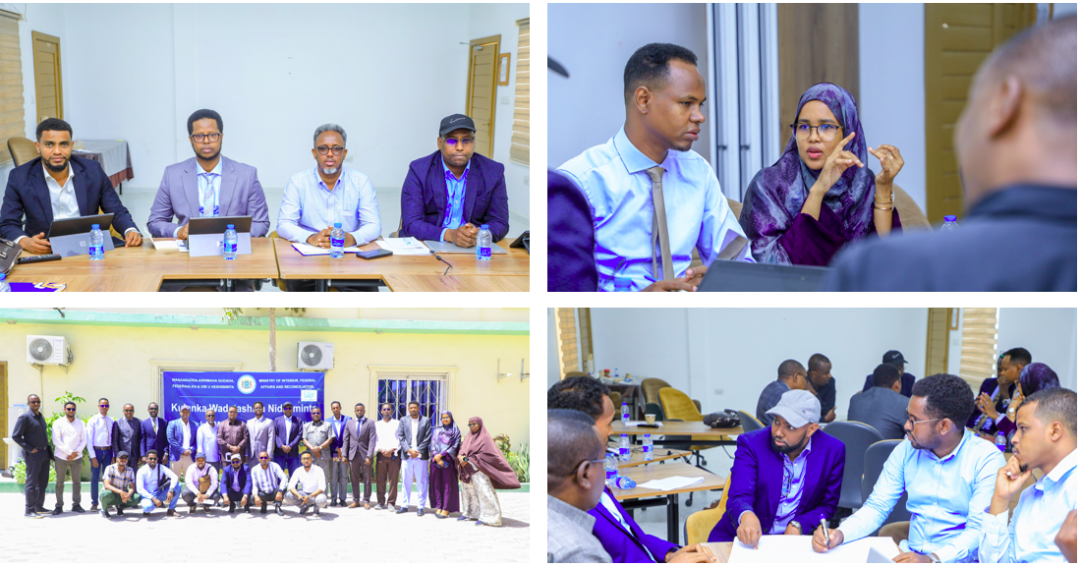
OUTCOME 2: Strengthened local governments to efficiently coordinate functions, design and deliver equitable, inclusive, and accountable services.

Output 2.1: Achieved active citizen engagement and participation process in District/Urban Development Planning and budgeting ensuring people-centered integration in public services.
Training of Trainers on District Development Planning for FMS and District Officials
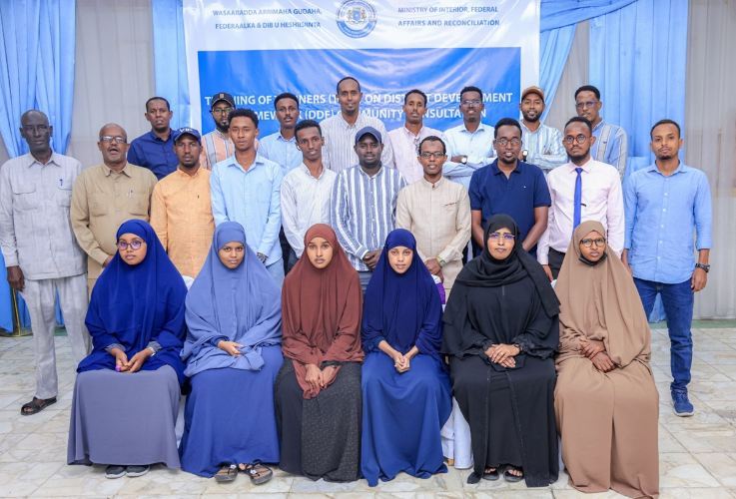
A four-day Training of Trainers (ToT) was held in Mogadishu for representatives from the FMS Ministries of Interior and district officials. The training aimed to reinforce their understanding of the District Participatory Planning approach, and the tools needed for effective community consultations. The ToT was attended by 30 participants (23 per cent female), including core staff from the planning and local government departments of the target FMS Ministries of Interior, local government directors of planning, and the national consultant supporting the implementation of the Dowlad-kaab Programme at state and district levels.
The training sessions were led by national master trainers with experience in facilitating the District Development Framework (DDF) in former Joint Programme on Local Governance (JPLG) districts. The focus was on delivering a comprehensive participatory district planning module, which included tools for community consultations, including those with children. Key elements of the training included gender and child participation checklists, community entry packages, and techniques for gathering community feedback during the DDF process.
Following the ToT, state-level orientations were held to transfer the skills and knowledge to a larger group of district facilitators, who play a crucial role in supporting community consultation for district development planning in the target Dowlad-kaab districts. This is especially important for districts like Kismayo, Jowhar, and Barawe, which currently lack District Development Frameworks (DDFs).
The state-level orientations were attended by 118 participants (37 per cent female), mainly from local government planning and social affairs departments, community committees, and FMS Ministries of Interior and Planning. These sessions emphasized the importance of inclusive and participatory development planning, ensuring that the voices of women, children, and marginalized groups are integrated into the planning process.
This series of training events, culminating in the national ToT and state-level orientations, marks a significant step in promoting decentralization and enhancing local governance planning capacities in the target FMS. Through the successful implementation of the DDF and community consultations, the programme aims to improve development outcomes in the target districts, with active citizen participation guiding the planning process.
These efforts are key to empowering local governments to lead inclusive development planning, that addresses the needs of all community members, especially vulnerable groups.

Output 2.2: Developed robust public finance management systems established by local governments to manage local taxation, expenditure, and auditing and to attract intergovernmental fiscal transfers and external funding.

Assessment of district budgeting practices and their fiscal capacity to inform fiscal interventions of the programme

In partnership with the State Ministries of Interior and Local Government of the FMS, the programme supported an effort to make a thorough assessment of the budgeting practices and the fiscal capacities of Kismayo, Barawe, Adado and Jawhar districts. The assessment in these districts suggest that there is no uniform budgeting process and practices. To address this, FMS MoILG, the district administrations and the programme are working hand in hand to harmonize budget practices in line with Public Financial Management (PFM) and promote participating budgeting approaches. The programme also supports these districts in taking necessary steps to unlock the full potential of domestic revenue mobilization, ensuring a more sustainable and efficient fiscal framework. These include, but are not limited to trainings, policy and regulatory frameworks and institutional development.

Development of local government budgeting guidelines based on State PFM system

In regard to budgeting and budget guidelines, most local governments do not have systems and guidelines that are linked to state PFM. To this end, the program engaged a local consultant to develop contextualized budgeting guidelines for each district. The consultant conducted a desk review and interviewed state concerned ministries and local government authorities to better understand the current budget guidelines used by local governments if they exist. The first draft of guidelines was produced. The validation workshop is scheduled for the third week of February. The budget guideline outlines the purpose and importance of effective local government budgeting, highlighting the legal policy, framework and the scope of the guideline. It also states the budget preparation, process, roles of stakeholders, principles of inclusivity, accountability and transparency among others. The documents explain clearly the budget implementation, monitoring and evaluation, which equips both FMS and FGS MoIFAR exercise their oversight roles on the fiscal performance of the local governments.

Development of domestic revenue mobilization plans

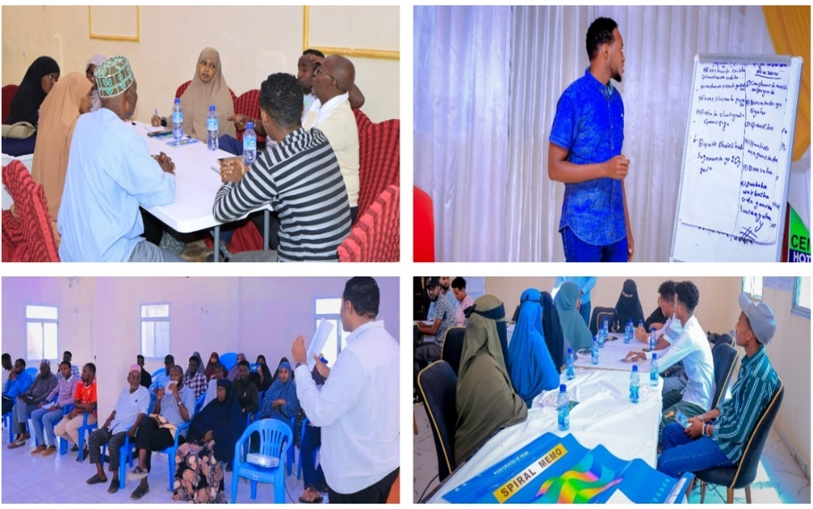
Based on district capacity assessments conducted by UNDP within the framework of Dowladkaab, revenue from domestic sources is currently very weak. To address this, the programme has collaborated with FMS MoILGs and district administrations to introduce mechanisms aimed at unlocking domestic revenue potential. This effort includes the development of a domestic revenue mobilization plan which was introduced with the input from various stakeholders including private sector, Ministries of Finance, and local communities in a consultation workshop held in Kismayo, Adado, Barawe and Jawhar district. The plan is expected to assist districts identify and use untapped revenue streams, identify gaps that hinder informed decision-making, and lay the groundwork for intergovernmental fiscal transfers and other fiscal support to the districts. Additionally, linking domestic revenue mobilization with service delivery will ensure that the generated revenues directly contribute to improving local services, thereby fostering a more effective and responsive governance approach. Each of the four-district hosted one consultation workshop on domestic revenue were 120 (42 F; 78 M) participants from LG, MoIs, MoF and relevant institutions were invited to the consultation workshop.

Trainings on guide to local taxations, local government finance policy and local government financial management manual
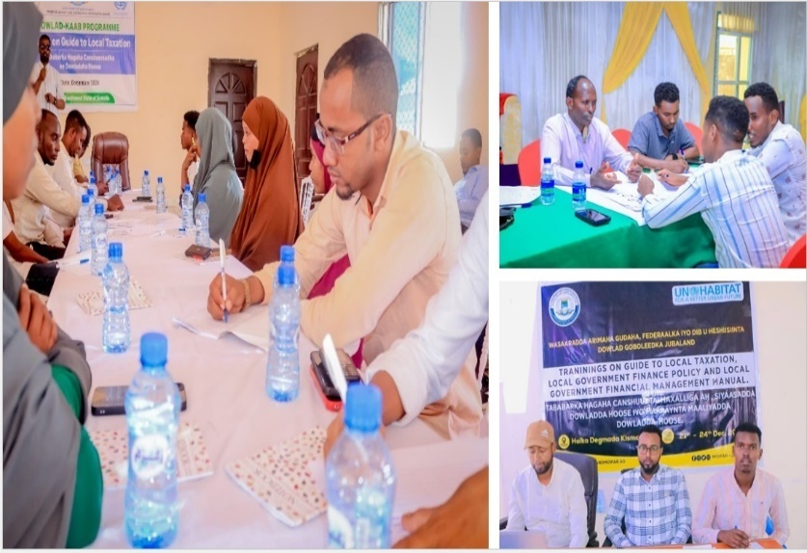
JPLG III has introduced several instruments that are essential to be mainstreamed to local government operations, particularly, in the municipal finance operations because of their high turnover and change of administrations. These included local government finance policy, local government financial management manual and Guide to Local Taxation. Based on these premises, the programme supported FMS MoILG and district administrations to conduct a 4-day training on guide to local taxation, LGFP and LGFM held in Kismayo, Adado, Barawe and Jawhar with the attendance of a core 15 participants from the revenue and administration and finance departments of each of these districts. As a result of this training, it is intended that it will enhance compliance with the established policies and manuals. It will also promote transparency and fiscal discipline, whereby finance decisions are systematic, and policy guided. During the training, 60 (22 F; 38 M) participants from the admin and finance and revenue unit attended the training.

Internal audit manual for the districts based on State PFM systems

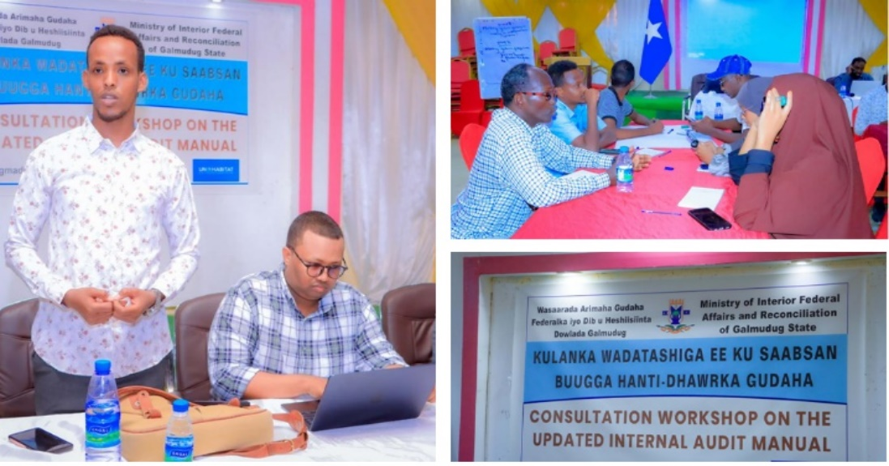
In close collaboration with the FMS MoILGs and the district administrations, an internal audit manual has been developed. The manual is aligned with State Public Financial Management (PFM) systems to enhance fiscal governance in a coherent and harmonized manner. During its development, a two-day consultation workshop was held in Adado and Jawhar, while Kismayo and Barawe are being planned in the last week of February 2025. Additionally, translating the internal audit charters will make them accessible to all relevant stakeholders. These efforts aim to reduce and combat malpractices, ensure compliance and fiscal discipline, and establish strong internal safeguards. By monitoring spending patterns and producing internal audit reports, this manual will provide a solid foundation for external auditing, thereby promoting transparency and accountability in local government financial management.

Support DDF with district profiles

District profiles are essential components of District Development Framework (DDF). To support districts, and have their DDF ready, the programme worked with FMS MoPWLH. A two-day training data collection using KOBO toolbox was conducted as a pivotal step in enhancing the capacity of local officials and data enumerators in taking lead of the profiling exercise. Almost 80 (20F; 60M) were on data enumerators to collect data from districts. Extensive fieldwork was made to gather up-to-date information on each district's socio-economic conditions, infrastructure, resources, and development needs. Data collection has been compiled, collated and drafting is underway to make part of the DDFs. As a result, each district will have a robust foundation for planning and decision-making, ensuring that development initiatives are well-informed and targeted. Also, the DDF will foster a more coordinated and strategic approach to district development, ultimately contributing to successful implementation of the local development fund.

Extensive assessment on district public works and taxation departments - covering all dimensions of the departments' functionality

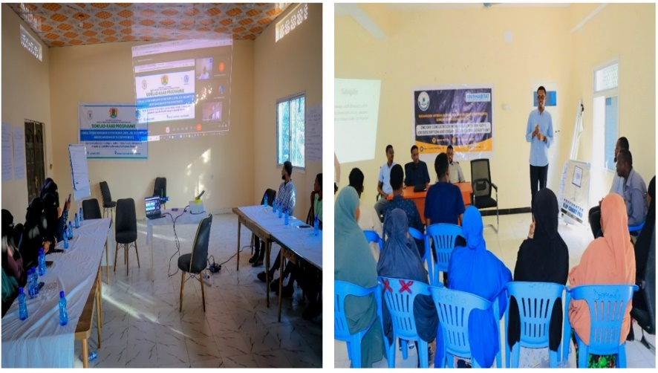
With a focus on building the capacity of local government to deliver basic services and respond to the needs of local residents. The program conducted an intensive assessment of departments of admin and finance and public works in Adado, Kismayo and Barawe. Although most of the districts share similarities, some of them have been working for long time and benefited from the JPLG phase II and III. To this end, the review has uncovered some performance strengths and also weaknesses like lack of adequate staff capacities, inadequate resources, poor structuring of departments thus interfering with performance, lack of adequate knowledge, limited training and capacity-building initiatives, limited commitment to embrace technology in including digitization of revenue collection and fiscal administration and lack of implementation of the previous developed policies, laws, framework for local government. The findings of the assessment will be used to design targeted interventions as the programme implementation evolves. Following the completion of the assessment, a workshop was conducted with the aim of presenting the findings to local authorities and state the Ministry of interior to endorse and present the workflows, job descriptions and organogram of the departments.
The workshop was attended by 15 participants selected from the departments concerned to validate the assessment and discuss the structure and organograms of the departments. A total of 45 (11F; 34M) participants were consulted across the four districts. It is imperative to mention that, for example, that in Jowhar, recommendations will be taken up to programme land governance interventions at district level through Maareynta Programme, which is also funded by SJF.

Support to technical engineering to infrastructure

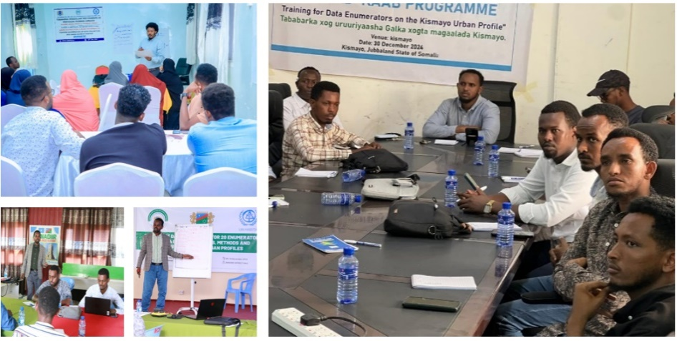
Creating infrastructure prioritization frameworks for districts is essential for ensuring participatory, need-based prioritization and fair resource distribution. With the FMS MoPWHR and district administrations in Adado, Kismayo, Jawhar and Barawe, a three-day consultation workshop was held with 25 representatives from relevant stakeholders to identify, discuss, and agree on key issues for prioritization. Across the four districts, 100 (23F; 77M) participants from the districts, ministry of public work, local engineers and contractors were given a presentation on infrastructure prioritizing framework and distributed guiding questions on how to prioritize construction and development projects in the districts. The main goal of this workshop was to reach a consensus on the critical issues that should guide prioritization, ensuring the effective use of the Local Development Fund (LDF). By including community voices in the decision-making process, the framework will reflect and address the needs and aspirations of local communities. This framework will also promote accountability and transparency, fostering trust and confidence among stakeholders. Furthermore, it will emphasize objectivity and pragmatism in project selection, ensuring that the most impactful and feasible projects are prioritized.

Output 2.3: Empowered local governments to have inclusive, transparent, and accountable systems to deliver decentralized basic services through LGI-led capacity-building.
Decentralized Service Delivery Capacity Building for FMS Social Sector Ministries and Target Districts
The District Capacity Baseline Assessment was conducted in the final quarter of 2024, identifying key capacity gaps in the target districts. The Dowlad-kaab Programme organized a capacity-building training for all target districts, to enhance the understanding and skills of district social affairs and planning department staff, as well as council committees on social affairs and planning, in decentralized service delivery planning, implementation, and monitoring.
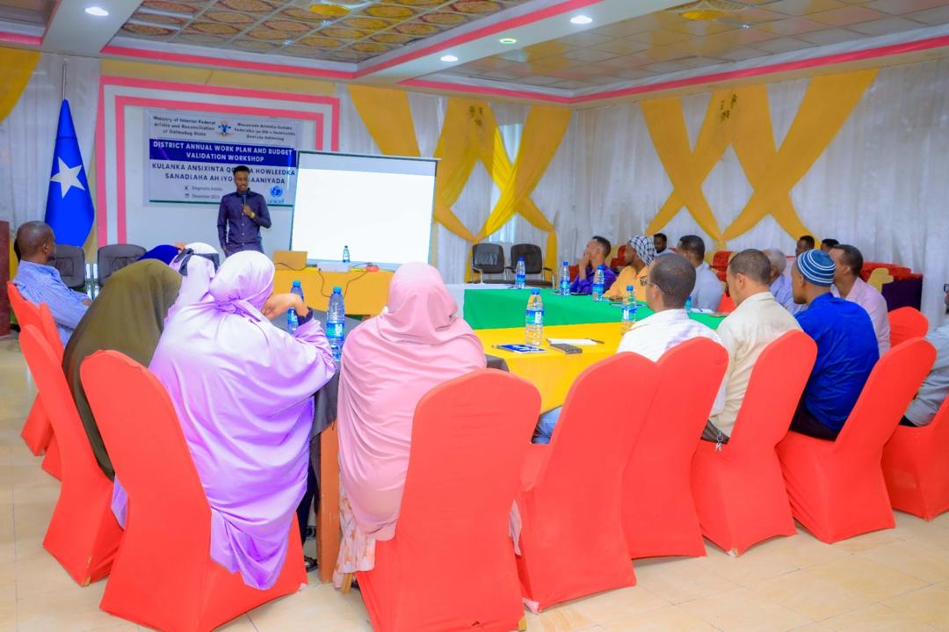
The training was attended by 92 district officials (42 per cent female) across the four target districts. The session provided a comprehensive introduction to key concepts and frameworks related to decentralized service delivery, including the relevant decentralization policies and legal frameworks supporting service provision. A significant emphasis was placed on clarifying the roles and responsibilities of the various stakeholders involved in service delivery at both the district and state levels. In addition to these foundational elements, the training also covered critical aspects of service delivery, including planning and implementation processes, procedures for securing and managing financing for services, sector-specific service delivery standards, and governance and coordination arrangements.
This training is crucial for local governments, as it equips district officials with the knowledge and skills needed to effectively manage decentralized service delivery, ensuring that services are planned, implemented, and monitored in a way that meets the needs of citizens. By strengthening the capacities of local government actors, the training aims to promote better governance, transparency, and accountability in the delivery of public services, particularly in key sectors. It also fosters a deeper understanding of the importance of coordination between state and district authorities, ensuring that decentralized service delivery is both effective and aligned with broader national and state-level strategies.
Through these capacity-building efforts, the Dowlad-kaab Programme is working to empower local governments to take ownership of service delivery processes and to better serve their communities. This training is a vital step towards improving the overall quality of services at the district level, ensuring that they are inclusive, sustainable, and responsive to the needs of all citizens, particularly vulnerable groups.
OUTCOME 3: Empowered citizens to actively engage in local governance processes, benefitting from accessible social accountability mechanisms and efficient redressal systems, ensuring their concerns are promptly addressed.

Output 3.1: Engaged citizens, with a focus on women and marginalized groups to practice their rights and perform their responsibilities as “right holders” vis-à-vis local government as “duty-bearers”.
Local Government-Led Civic Education and Citizen Engagement through CSO
The Dowlad-kaab Programme has established partnerships with Civil Society Organizations (CSOs) experienced in civic education and engagement as part of its broader strategy to empower citizens and raise awareness about their rights and responsibilities in relation to local governments. This initiative is aimed at directly engaging approximately 9,320 citizens (50 per cent female) through a variety of channels, including citizen-council forums, public meetings, consultations, citizen budget forums, as well as awareness campaigns through traditional and social media. Additionally, the programme will facilitate direct dialogue between citizens and local authorities.
The primary goal of this initiative is to educate communities, particularly women, marginalized groups, and youth, about their civic rights and responsibilities, enabling them to voice concerns about issues that impact their daily lives. By fostering an understanding of these rights, the programme seeks to empower citizens to actively participate in local governance and decision-making processes, which is crucial for the development of more inclusive, responsive, and accountable local governments. Civic education, particularly for marginalized groups, ensures that all community members have a voice in shaping the policies and services that directly affect them.
The intervention also aims to strengthen the capacity of local governments to meaningfully engage citizens in local planning, budgeting, and overall development processes. By establishing accessible social accountability and grievance redress mechanisms, the programme enhances transparency and accountability in service delivery at the local level. These measures will not only improve the quality and responsiveness of public services but also build trust between local authorities and citizens.
The civic education programme is currently being finalized with two CSOs—INTEROM and ARIN—who bring proven expertise in civic education and a successful track record of delivering similar programmes during the previous phase of the JPLG. These organizations have an established presence in the target districts (Adado, Jowhar, Barawe, and Kismayo), which allows them to leverage existing networks, relationships, and logistical capabilities to ensure effective and efficient delivery of the programme.
Civic education is a fundamental element in empowering citizens, particularly those from marginalized groups, to become active participants in local development processes. It provides individuals with the knowledge and skills to engage with local governments, advocate for their needs, and hold authorities accountable for their actions. By embedding civic education within the community, the Dowlad-kaab Programme fosters more inclusive governance that reflects the voices and priorities of all citizens, contributing to sustainable and equitable development outcomes at the local level.
Output 3.2: Developed inclusive mechanisms for social accountability and grievance redressal to be accessible and useable by citizens.
As the program began in November 2024, activities under this output have not yet commenced, as available funds have been prioritized to support more urgent activities. These activities are linked to the civic education and engagement initiative, which is set to launch in the next quarter. However, the program has initiated a review of existing mechanisms and will explore feasible options for effective social accountability mechanisms that are fit for purpose and can be easily rolled out to support the target communities.
Output 3.3: Citizens are aware of how resources are utilized, and are able to advocate for equitable allocation and effective utilization of public funds.
Activities under this output have not been undertaken during this reporting period. These activities are prioritized to follow the upcoming civic education scheduled between April and June and are designed to contribute to the budget development discussions, which are part of the District Annual Work Planning slated for October this year.

Section 2: Progress Report Results Matrix

OUTCOME STATEMENT
Outcome 1: Empowered state institutions at federal, state and district level to effectively spearhead decentralization reforms, enhance adaptive capacities, improve coordination and delivery of social services.
SUB-OUTCOME 1 STATEMENT

Output 1.1: Legal, policy and regulatory frameworks and structures for decentralization and local governance are in place and enacted
INDICATOR | TARGET | PROGRESS ON OUTPUT INDICATOR
 |  | REPORTING PERIOD Achievements (YEAR) | Means of Verification | CUMULATIVE ACHIEVEMENT
- 1.1.2. # of FMS with enacted key sub-national frameworks on local governance​  - 1.1.3. # of FMS with policy interventions designed to promote a fair and predictable transfer mechanism  - ​1.1.4. % of proposed decentralization bills successfully enacted into law.​  1.1.5. % of services identified to be decentralized that are effectively decentralized. | Target:  1.1.1: 4 Decentralization policy and 4 sector decentralization strategies and linkages to LGA (Galmudug, Hirshabelle, Southwest and Jubaland)  1.1.2: 6 Inter-governmental fiscal transfer strategy (All FMS) | 2024 | 1.1.1 legal and policy documents on decentralization forum, sector devolution
Output 1.2: Strengthened local government capacity with different government levels clearly defined roles and responsibilities to engage citizens and addressing their priorities in service delivery
- 1.2.1. # Policy dialogue forums on responsibilities and roles in decentralization and service delivery  - 1.2.2. % government officials with clear understanding of their roles and responsibilities  1.2.3. # Districts with DDFs that are aligned with state and national development planning frameworks | Target:  1.2.1 Two policy dialogue forums per state (Galmudug, Hirshabelle, Southwest and Jubaland)  1.2.2 80% clarity (pre and post KAP survey)  1.2.3 All target districts

Section 4: Project implementation
Key constraints and challenges and associated corrective actions
- The absence of approved decentralization policies in the target FMS states has resulted in delays in developing sector-specific decentralization strategies and the full implementation of the decentralized service delivery model. The programme has initiated discussions with FMS authorities to prioritize the approval of decentralization policies by the end of 2025. Additionally, a light-touch approach has been adopted to support SDM implementation, ensuring alignment with the decentralization legal frameworks of the FMS.
- The capacity of local government social affairs departments is currently limited, as evidenced by the District Capacity Assessments conducted. Many districts suffer from incomplete structures and weak operational capacity. While some of these challenges may persist and require sustained efforts to address, the programme has initiated capacity-building training to enhance the knowledge and skills of the Social Affairs Departments, equipping them with the essential tools to plan, coordinate, and monitor district-level service delivery. To ensure sustainability, these capacity-building trainings will be integrated into ongoing training programs and institutionalized within the Local Government Institute, fostering long-term institutional growth and self-sufficiency.

Annex II: Programme Risk Management Matrix
RISK ASSESSMENT |  |  |  |  |  | MONITORING PLAN |  |  | TREATMENT OPTIONS
Risk | Risk drivers | Risk outcome | Likelihood | Impact | Risk Level &Trajectory | Responsibility | Regularity | Sources | Mitigation | Adaptation
Political Instability and Insecurity | Disruptions, conflicts, or changes in government priorities | Considerable delays in project implementation | High | High | Continuous | UNDP, UNICEF and UN Habitat | Monthly | Government’s reports, Media, social media…etc. | UN-FGS High political level coordination and dialogue | Agreements with FGS and direct project beneficiary Federal States on main outputs and delivery timelines
Limited Capacity and Institutional Weakness | Human resources at the government level and the community-based organizations levels and governance structure | Poor and ineffective performance and engagement of project stakeholders | Medium | Medium | Medium | UNDP, UNICEF, UN Habitat and sector ministries (IMC) | quarterly | LGI capacity development reports | Design and implementation of capacity development programs | Capacity needs assessment of project stakeholders and capacity development action plan
Socio-Cultural and Gender Barriers | Cultural norms, and gender disparities | Limited participation of women and marginalized groups in decision making | Medium | Medium | Medium | UNDP, UNICEF, UN Habitat and sector ministries (IMC) | quarterly | Project reports, capacity development reports, progress reports and media | Design and implementation. of public awareness campaigns | Community participation and gender mainstreaming programme plans
Corruption and Mismanagement | inefficient use of resources and project credibility | Difficulties in resource mobilization and poor stakeholders trust | Medium | Medium | Medium | UNDP, UNICEF, UN Habitat and sector ministries (IMC), NGOs and CSOS | quarterly | Annual project audit reports | Audit measures and periodic M&E | M&E project plans
Protection Consideration of project stakeholders | Harm and Abuse of project stakeholders | Weak community participation and buy in by stakeholders | Low | Low | Low | UNDP, UNICEF, UN Habitat and sector ministries (IMC), NGOs and CSOS | Simi-annual | Media, social media, project workshop reports and progress reports | Plans to ensure well-being and safety of project beneficiaries | Frequency of risk assessment carried out of by the project teams

Learning impact and new opportunities
This induction training conducted covered three district related to the responsibilities and roles of the district councils, district department directors, and executive secretary. The content of the training included acts, regulations relating local government law, public procurement, public financial management act, revenue and preparation of annual work plans, district development framework and the processes involved in its development. The training imparted the selected three districts of Adado Galmudug, Barawe-Southwest, Jowhar-Hirshabelle, and Kismayo-Jubbaland with a holistic understanding and key skills required to manage the tasks assigned to the different departments under their control as well as ensure efficiency in service delivery.

Synergies with other programmes (UN and non-UN) working on similar issues

Partnerships

Localization

Monitoring and oversight activities

Monitoring activity | Date | Description | Comments  & Recommendations | Corrective actions taken
Field monitoring visit | December 17 -21, 2024 | -field mission of Dowlad-Kaab programme to supervise ongoing baseline survey and capacity assessment at Adado and Dhusamareb meeting with the MOIFAR-GS team  -To support and participate the annual work plan of 2025 that Adado District LG which was under way | -I am recommending the collection and translation of all LGI curriculum to create a resource center since the Adado district administration is very much committed to building the capacity of district staff and voluntary young graduates. They are the administrators to replace the previous ones who are soon retiring.  - I am recommending orientation workshops to the Ministry of Interiors DGs in order to envisage the UNDP-LOA implementation regulations where they need to understand deeply agreement modalities and relevant matters.
DIM audit
Independent evaluation
Engineering site visit
Stakeholder review consultation

Communication and Knowledge Management
The program recognizes the importance of streamlined and enhanced visibility to showcase its impact, especially in a landscape of reducing funding. During its first quarter of implementation, the program has produced a significant amount of content, including photos, social media posts, and videos, which were shared on government social media platforms (X, Facebook). Banners were strategically placed at all capacity-building and launch events to increase visibility, and media houses were invited to these events, with coverage later aired on local televisions.
Below are links to videos and other content featuring the work and success stories developed during the reporting period (Nov 2024 – Jan 2025).

Section 5: Project management

Here we should include a brief description of the Governance arrangements - coordination and oversight of the programme, implementation team structure and funding
Number of project board meetings held |  | One programme meeting was held in 2024
Number of UN staff (international/national) funded by the project? How many are field based? |  | One international programme coordinator and 3 national staff work for the programme
Describe the coordination and management structures within the programme?
Number of government personnel funded by the project.  What are their functions and where do they work?  Is the capacity injection in line with the Capacity Injection Protocol? |  | Four capacity building
How has the project ensured the visibility of the SJF and SJF donors during the reporting period?

Projected funding needs for next year and the forecasted expenditure. |  | Yes, it is forecasted 5 million

Section 6: Cross-cutting issues

Gender Equality and Women Empowerment

Proportion of gender specific outputs in the project | Total number of project outputs | Total number of gender specific outputs
 | There’s no specific output intended intervention towards gender matters. | There’s no number of specific outputs for the gender
Proportion of project staff with responsibility for gender issues | Total number of staff | Total number of staff with responsibility for gender issues
 | There’s no dedicated staff to support gender | There’s no assigned staff towards issues in the projects.

Human-rights based approach

Has the programme included a protection risk assessment in its context analysis, including on gender issues, and taken measures to mitigate these risks to ensure they are not exacerbated, or new risks created? | Result
 | Yes,
Number of programme outputs specifically designed to address specific protection concerns | Result
 | 9
A number of programme outputs are designed to build capacity of duty bearers to fulfil their human rights obligations towards rights holders. | Result
 | 9

Leave no one behind
Social inclusion is a main principle of Dowlad-Kaab, and it is mandatory that all training and workshops be inclusive. The adult and children’s consultations that were held for the first time in three districts in the FMS ensured the process tools and the outcome were inclusive (the IDPS’ abled differently children) of the consultations. Women and youth were actively engaged in most activities, especially the Public Expenditure Management (PEM) training as well as other training in the FMS and the targeted district councils, department directors in Hirshabelle, Southwest, and Galmudug. Kismayo of Jubbaland has no district council where open meetings of participation were conducted by Ministry of Interior that emphasized the inclusion of marginalized communities such as IDPs, women, and youth in program interventions.
Social contract and legitimacy

Humanitarian-development-peace nexus
The Dowlad-Kaab mainstreams human rights -based approach through strengthening the capacities of the duty-bearers’ structures, systems and approaches to delivering of basic services to the right-holders to meet their obligations. The Programme highlights the contributions to localizing the Sustainable Development Goals (SDGs),

The project promotes participatory planning local government processes and encourages inclusion of all groups in community consultations. The systems for participatory planning and public expenditure management for local governments have been adopted by Galmudug, Jubbaland, Hirshabelle, and Southwest State governments and will be rolled out to new Federal member states.

Accountability and transparency are ensured through strengthening community consultation and engagement in local government planning and budgeting processes. Village representatives and community monitoring groups (which have representation of women, youth and marginalized groups) are invited to take part in selecting the projects to be funded and implemented by the local government as well as verify that previous project is implemented according to plan.
Environment and climate security
Disaster Management The government of FMS flagged drought and frequent floods as a major disaster that needed action to mitigate (contingency plan) or contain as when it happens. To this end, there was DRR manual developed which will guide a survey that will provide the baseline data on vulnerability to disasters and the needs of the communities. This will then lead to the development of a disaster management action plan.
Prevention of corruption
The programme implemented various prevention and anti-corruption mechanisms aimed at ensuring the smooth execution of its interventions through the efficient utilization of the limited resources available. The programme also built upon the previous JPLG developed documents including anti- corruption measures, financial management, internal audit manuals and relevant anti-corruption capacity developments. These mechanisms were maintained at all levels of the government in the federal, state and local government.
In addition, the programme employed internal monitoring tools designed to identify challenges such as bottlenecks and delays allowing the programme team to address inefficiencies early and to take the appropriate actions. Furthermore, the programme adopted robust financial management mechanisms for requesting, disbursing and reporting cash while strengthening national ownership of financial processes. Throughout this reporting period, transparency and accountability were enhanced to ensure that funds are used for their intended purposes. Moreover, the implementing partners were trained in financial management and all reporting tools to further improve transparency, accountability and the effective management of the resources.
Project sustainability and exit strategy

# | Target group | Date | Number of participants |  |  | Title  of the training |  | Location of the training | Training provider
 | Ministry, District  or UN staff |  | M | F | Total
1 | District | 19 - 25 November 2024 | 27 | 13 | 40 | Induction Training |  | Barawe | MOIFAR-SWS/UNDP
2 | District | 25 Nov. up to 8 Dec 2024 | 21 | 12 | 33 | Public expenditure Management (PEM) training |  | Barawe | MOIFAR-SWS/UNDP
3 | MOIFAR-SWS and Ministries | 15-16 December 2024 | 35 | 15 | 50 | LG coordination Meeting and IMC |  | Baidoa | MOIFAR-SWS/UNDP
4 | District | 22-23 December 2024 | 44 | 106 | 150 | Present, discuss and Validate of DDF |  | Barawe | MOIFAR-SWS/UNDP
5 | District | 28-30 December 2024 | 58 | 17 | 75 | Endorsement of Annual work plan and Budget |  | Barawe | MOIFAR-SWS/UNDP
6 | District | 9-11 November, 2024 | 30 | 13 | 43 | LG coordination Meeting and IMC |  | Adado | MOIFAR-GS/UNDP
7 | District | 13 -16 November 2024 | 46 | 9 | 54 | Public expenditure Management (PEM) training |  | Adado | MOIFAR-GS/UNDP
8 | District | 18 -19 November 2024 | 50 | 26 | 76 | Present, discuss and Validate of DDF |  | Adado | MOIFAR-GS/UNDP
9 | District | 25 -26 November 2024 | 97 | 27 | 124 | Endorsement of Annual Workplan & Budget |  | Adado | MOIFAR-GS/UNDP
10 | District | 9 -13 December 2024 | 35 | 15 | 50 | Induction Training |  | Kismayo | MOIFAR-JS/UNDP
11 | District | 25-26 December 2024 | 72 | 18 | 90 | Public Expenditure Management (PEM) Training |  | Kismayo | MOIFAR-JS/UNDP
12 | District | 27 -28 December 2024 | 43 | 7 | 50 | LG coordination Meeting and IMC |  | Kismayo | MOIFAR-JS/UNDP
13 | District | 22 December 2024 | 43 | 7 | 50 | CAP Orientation workshop | Kismayo |  | MOIFAR-JS/UNDP
14 | District | 23 -24 December 2024 | 86 | 24 | 110 | CAP-Priorities selection workshop | Kismayo |  | MOIFAR-JS/UNDP
15 | District | 25 -26 December 2024 | 72 | 18 | 90 | CAP presentation and discussion workshop for -district and IMC | Kismayo |  | MOIFAR-JS/UNDP
16 | District | 27 -28 December 2024 | 43 | 7 | 50 | LG coordination Meeting and IMC | Kismayo |  | MOIFAR-JS/UNDP
17 | District | 06- 12 November 2024 | 31 | 9 | 40 | Induction Training | Jowhar |  | MOILG/HS
18 | District | 09- 11 November 2024 | 24 | 11 | 35 | LG coordination Meeting and IMC | Jowhar |  | MOILG/HS
19 | District | 24- 28 November 2024 | 34 | 13 | 47 | Public expenditure Management (PEM) training | Jowhar |  | MOILG/HS
20 | District | 16- 18 December 2024 | 88 | 62 | 150 | District Council Members Orientation Meeting on the DDF Process | Jowhar |  | MOILG/HS
21 | District | 17- 18 December 2024 | 62 | 48 | 110 | DDF community consultation forum | Jowhar |  | MOILG/HS
22 | District | 24 December 2024 | 29 | 11 | 40 | DDFs consultation and validation workshop | Jowhar |  | MOILG/HS
23 | District, FMS and FGS | 12th – 13th February 2025 | 30 | 3 | 33 | Engagement workshop on fiscal decentralization landscape in Somalia | Mogadishu |  | UN-Habitat and FGS MoFAR
24 | District, FMS and FGS | 10th – 11th February 2025 | 24 | 6 | 30 | Consultation workshop on an optional paper for Somalia Mayors Forum | Mogadishu |  | UN-Habitat and FGS MoFAR
25 | Puntland | 2nd – 6th February 2025 | 7 | 15 | 22 | Training in recordkeeping, documentation, knowledge management and data analytics | Garowe |  | UN-Habitat and ALGAPL
26 | District | Adado: 16th January 2025  Jawhar: 5th January 2025  Barawe:23rd January 2025  Kismayo: 23rd December 2024 | 78 | 42 | 120 | Domestic revenue mobilization plan | Adado, Jawhar, Barawe and Kismayo |  | UN-Habitat and FMS MoILGs in HS, GM, JL and SWS
27 | District | Adado: 5th – 8th January 2025  Jawhar:30th December 2024-2nd January 2025  Barawe: 11th – 14th December 2024  Kismayo: 21st – 24th December 2024 | 38 | 22 | 60 | Local governance finance policy, local government financial management manual and guide to local taxation training | Adado, Jawhar, Barawe and Kismayo |  | UN-Habitat and FMS MoILGs in HS, GM, JL and SWS
28 | District | Adado: 8th – 9th February 2025  Jawhar: 11th – 12th February 2025 | 37 | 13 | 50 | Internal audit manual | Adado and Jawhar |  | UN-Habitat and FMS MoILGs in HS and GM
29 | District | Adado: 29th January 2025  Barawe: 22nd January 2025  Kismayo: 26th January 2025 | 34 | 11 | 45 | Consultation workshops on the workflows, job descriptions and organograms of the public works and taxation departments | Adado, Jawhar, Barawe and Kismayo |  | UN-Habitat and FMS MoILGs in GM, JL and SWS
30 | District | Adado: 29th – 30th December 2024  Jawhar: 22nd- 23rd December 2024  Barawe:5th – 6th December 2024  Kismayo: 30th – 31st December 2024 | 60 | 20 | 80 | Data collection training for District profiles | Adado, Jawhar, Barawe and Kismayo |  | UN-Habitat and FMS MoPWHRs in HS, GM, JL and SWS
31 | District | Adado: 4th – 6th February 2025  Barawe: 21st – 23rd January 2025  Kismayo: 14th – 16th January 2025 | 59 | 16 | 75 | Consultation workshop on infrastructure prioritization framework | Adado, Jawhar, Barawe and Kismayo |  | UN-Habitat and FMS MoPWHRs in GM, JL and SWS
32 | Districts | December 2024 | 97 | 51 | 148 | Training of Trainers on District Development Planning for FMS and District Officials | Mogadishu, Adado, Jowhar, Barawe and Kismayo |  | UNICEF, MOIFAR FGS and FMS MOIs
33 | Districts | January 2025 | 53 | 39 | 92 | Decentralized Service Delivery Capacity Building for FMS Social Sector Ministries and Target Districts | Adado, Jowhar, Barawe and Kismayo |  | UNICEF and FMS MOIs

Kismayo – Jubbaland
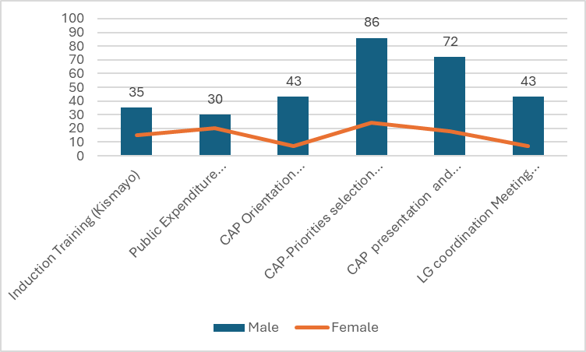
Figure 3 this is data disaggregated of training of Kimayo-Jubbaland

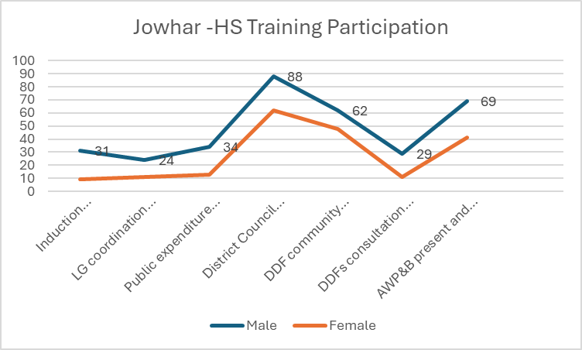
Figure 4: this is data disaggregated of training and meetings of Jowhar-Hishabelle

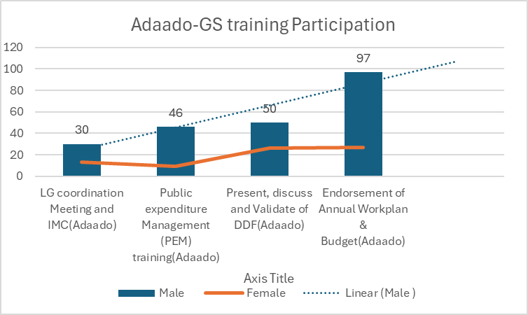
Figure 5: this is data disaggregated of trainings and meetings of Adado-Galmudug

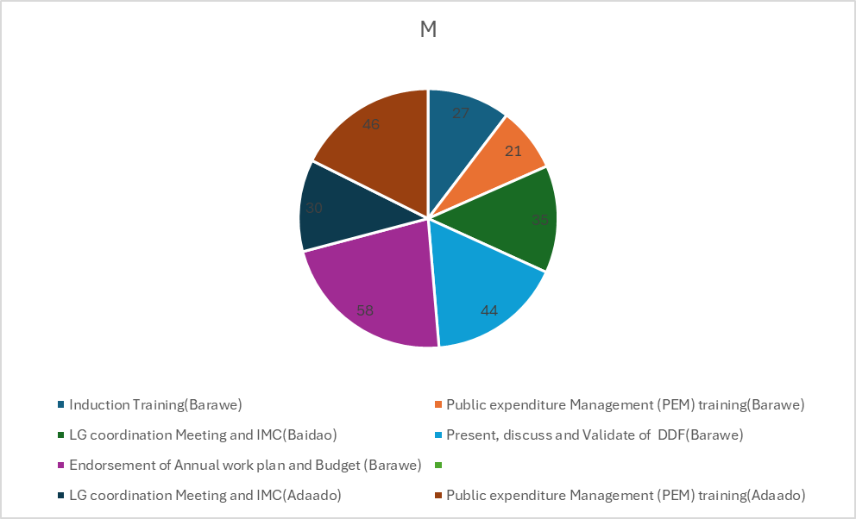
Figure 6: this is data disaggregated of trainings and meetings of Barawe-Southwest

Annexes

- Learning products produced by the programe (case studies, reports, research, articles)
- Annual work planCopy of 024. 09.23 SJF Dowlad-kaab Budget - SJF submission - Original9
- Risk Matrix - Risk Matrix.xlsxProgramme Risk Management Matrix
- Jowhar District Baseline Survey Report (1)
- KISMAYO_Baseline_Survey_CAPACITY ASSESSMENT REPORT_UNDP_MOIFAR_JL
- Baseline Survey and Capacity Assessment_Adado District -Review
- Report on Barawe District Capacity Assesment

