

CONSOLIDATED ANNUAL FINANCIAL REPORT
of the Administrative Agent

Bangladesh Local Government Initiative on Climate Change

for the period 31 July 2016 to 31 December 2024

UN Multi-Partner Trust Fund Office
United Nations Development Programme
GATEWAY: https://mptf.undp.org

May 2025

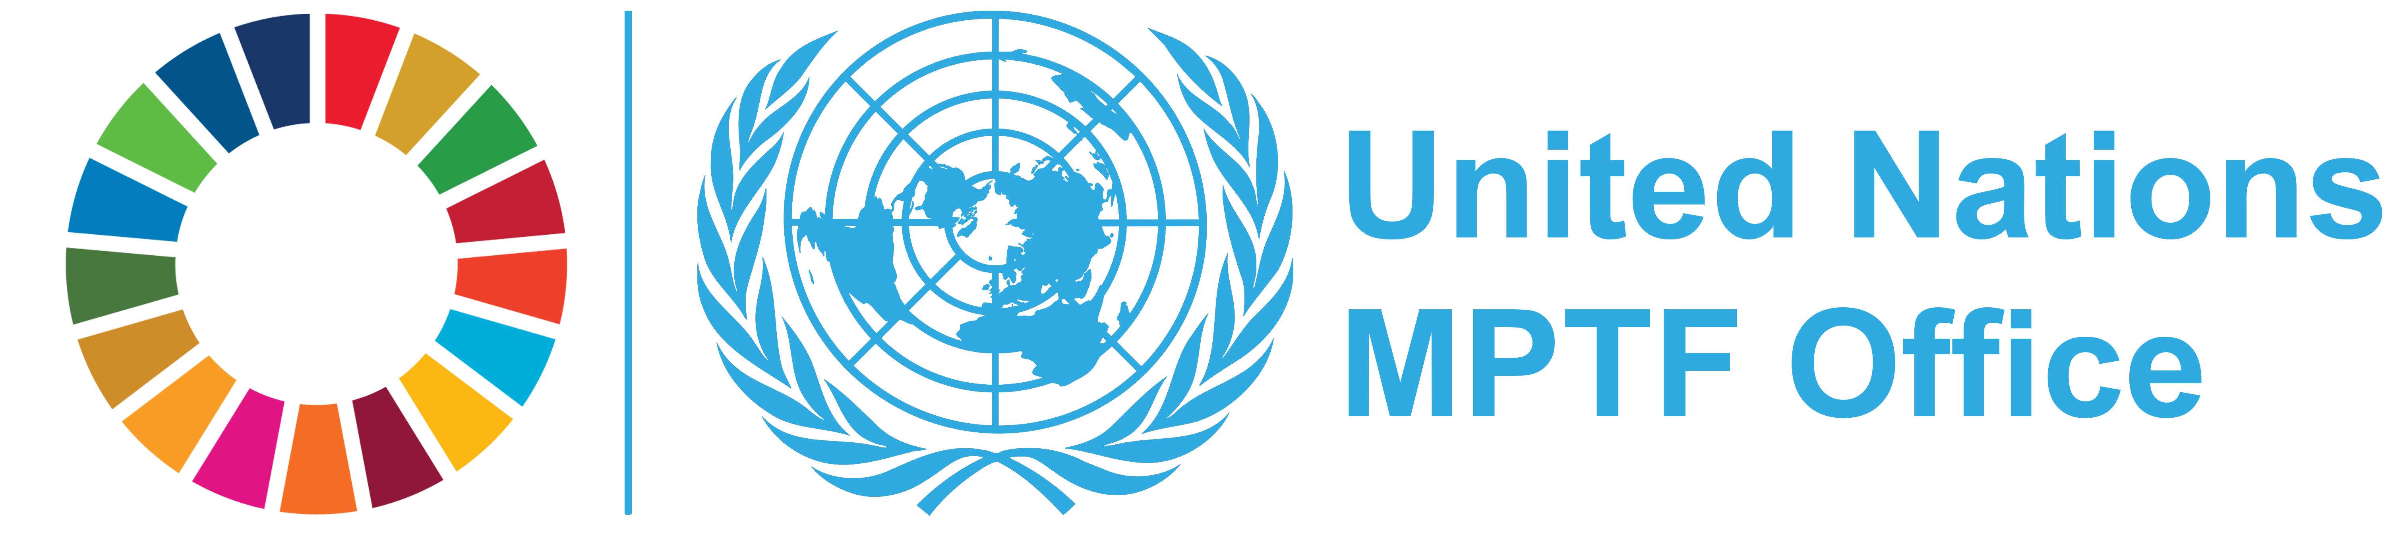

  DEFINITIONS
  Allocation/Total Approved Budget
  Amount approved by the Steering Committee for the Joint Programme. The total approved budget represents the cumulative amount of allocations approved by the Steering Committee.
  Approved Joint Programme
  A Joint Programme including budget, etc., that is approved by the Steering Committee for fund allocation purposes.
  Contributor Commitment
  Amount(s) committed by a contributor to a Joint Programme in a signed donor agreement with the UNDP Multi-Partner Trust Fund Office (MPTF Office), in its capacity as the Administrative Agent. A commitment may be paid or pending payment.
  Contributor Deposit
  Cash deposit received by the MPTF Office for the Fund from a contributor in accordance with a signed donor agreement.
  Delivery Rate
  The percentage of funds that have been utilized, calculated by comparing expenditures reported by a Participating Organization and Non-UN organization against the 'net funded amount'. This does not include expense commitments by Participating Organizations.
  Donor Agreement
  Standard Administrative Arrangement and/or European Commission contribution agreement between contributor/donor and MPTF Office.
  Net Funded Amount
  Amount transferred to a Participating Organization less any refunds transferred back to the MPTF Office by a Participating Organization.
  Participating Organization
  A UN Organization or other inter-governmental Organization that is a partner in a Fund, as represented by signing the applicable legal agreement with the MPTF Office for a particular Fund.
  Joint Programme Expenditure
  The sum of expenses and/or expenditure reported by all Participating Organizations for a Joint Programme irrespective of which basis of accounting each Participating Organization follows for donor reporting.
  Joint Programme Financial Closure
  A Joint Programme is considered financially closed when all financial obligations of an operationally completed Joint Programme have been settled, and no further financial charges may be incurred.MPTF Office will report a Joint Programme financially closed once the financial report(s) has been received and any balance of funds refunded.
  Joint Programme Operational Closure
  A Joint Programme is considered operationally closed when all programmatic activities for which Participating Organization(s) received funding have been completed, and the Steering Committee has approved the final narrative report
  Joint Programme Start Date
  Joint Programme start date as per the programmatic document.
  Transferred Funds
  Funds transferred to Participating Organizations by the Administrative Agent in accordance with the Steering Committee’s request.
  US Dollar Amount
  The financial data in the report is recorded in US Dollars

TABLE OF CONTENTS

Introduction . . . . . . . . . . . . . . . . . . . . . . . . . . . . . . . . . . . . . . . . . . . . . . . . . . . . . . . . . . . . . . . . | 4
1. Sources and Uses of Funds . . . . . . . . . . . . . . . . . . . . . . . . . . . . . . . . . . . . . . . . . . . . . . . . . . | 5
2. Partner Contributions . . . . . . . . . . . . . . . . . . . . . . . . . . . . . . . . . . . . . . . . . . . . . . . . . . . . . . . | 6
3. Interest Earned . . . . . . . . . . . . . . . . . . . . . . . . . . . . . . . . . . . . . . . . . . . . . . . . . . . . . . . . . . . . | 7
4. Transfer of Funds . . . . . . . . . . . . . . . . . . . . . . . . . . . . . . . . . . . . . . . . . . . . . . . . . . . . . . . . . . | 8
5. Expenditure and Financial Delivery Rates . . . . . . . . . . . . . . . . . . . . . . . . . . . . . . . . . . . . . . . . . | 9
6. Cost Recovery . . . . . . . . . . . . . . . . . . . . . . . . . . . . . . . . . . . . . . . . . . . . . . . . . . . . . . . . . . . . | 11
7. Accountability and Transparency . . . . . . . . . . . . . . . . . . . . . . . . . . . . . . . . . . . . . . . . . . . . . . . | 11

INTRODUCTION

manages contributions, and disburses these funds to the Participating Organizations. The Administrative Agent prepares and submits annual consolidated financial reports and financial statements, for transmission to stakeholders.
This consolidated financial report covers the period 31 July 2016 to 31 December 2024 and provides financial data on progress made in the implementation of Joint Programme of the Bangladesh Local Government Initiative on Climate Change. It is posted on the MPTF Office GATEWAY (https://mptf.undp.org/fund/jbd40).

This Consolidated Annual Financial Report of the Bangladesh Local Government Initiative on Climate Change is prepared by the United Nations Development Programme (UNDP) Multi-Partner Trust Fund Office (MPTF Office) in fulfillment of its obligations as Administrative Agent, as per the Joint Programme Document, the Memorandum of Understanding (MOU) signed between the UNDP MPTF Office and the Participating Organizations, and the Standard Administrative Arrangement (SAA) signed with contributors.
The MPTF Office, as Administrative Agent, is responsible for concluding an MOU with Participating Organizations and SAAs with contributors. It receives, administers and

  2024 FINANCIAL PERFORMANCE
  This chapter presents financial data and analysis of the Bangladesh Local Government Initiative on Climate Change using the pass-through funding modality as of 31 December 2024. Financial information for this Joint Programme is also available on the MPTF Office GATEWAY, at the following address: https://mptf.undp.org/fund/jbd40.
  1. SOURCES AND USES OF FUNDS
  As of 31 December 2024, 2 contributors deposited US$ 27,231,933 and US$ 90,997 was earned in interest.
  The cumulative source of funds was US$ 27,322,930.
  Of this amount, US$ 26,981,677 has been net funded to 2 Participating Organizations, of which US$ 23,181,054 has been reported as expenditure. The Administrative Agent fee has been charged at the approved rate of 1% on deposits and amounts to US$ 272,319. Table 1 provides an overview of the overall sources, uses, and balance of the Bangladesh Local Government Initiative on Climate Change as of 31 December 2024.

Table 1 Financial Overview, as of 31 December 2024 (in US Dollars)

 | Prior Years up to 31  Dec 2023 | Financial Year  Jan-Dec 2024 | Total
Sources of Funds
Contributions from donors | 22,026,527 | 5,205,405 | 27,231,933
Sub-total Contributions | 22,026,527 | 5,205,405 | 27,231,933
Fund Interest and Investment Income Earned | 61,327 | 29,670 | 90,997
Total: Sources of Funds | 22,087,854 | 5,235,076 | 27,322,930
Use of Funds
Transfers to Participating Organizations | 21,828,335 | 5,153,342 | 26,981,677
Sub-Total Transfers | 21,828,335 | 5,153,342 | 26,981,677
Administrative Agent Fees | 220,265 | 52,054 | 272,319
Bank Charges | 255 | 70 | 325
Total: Uses of Funds | 22,048,855 | 5,205,466 | 27,254,321
Change in Fund cash balance with Administrative Agent | 39,000 | 29,610 | 68,609
Opening Fund balance (1 January) | 7,725 | 39,000 | -
Closing Fund balance (31 December) | 39,000 | 68,609 | 68,609
Net Funded Amount | 21,828,335 | 5,153,342 | 26,981,677
Participating Organizations Expenditure | 16,967,081 | 6,213,973 | 23,181,054
Balance of Funds with Participating Organizations | 4,861,253 | (1,060,631) | 3,800,622

  2. PARTNER CONTRIBUTIONS
  Table 2 provides information on cumulative contributions received from all contributors to this Joint Programme as of 31 December 2024.
  The Bangladesh Local Government Initiative on Climate Change is currently being financed by 2 contributors, as listed in the table below.
  The table includes financial commitments made by the contributors through signed Standard Administrative Agreements with an anticipated deposit date as per the schedule of payments by 31 December 2024 and deposits received by the same date. It does not include commitments that were made to the Joint Programme beyond 2024.

Table 2. Contributions, as of 31 December 2024 (in US Dollars)

Contributors | Total Commitments | Total Deposits
Government of Denmark | 5,776,466 | 5,776,466
Sida | 21,455,466 | 21,455,466
Grand Total | 27,231,933 | 27,231,933

  3. INTEREST EARNED
  Interest income is earned in two ways: 1) on the balance of funds held by the Administrative Agent (Fund earned interest), and 2) on the balance of funds held by the Participating Organizations (Agency earned interest) where their Financial Regulations and Rules allow return of interest to the AA.
  As of 31 December 2024, Fund earned interest amounts to US$ 90,997. Details are provided in the table below.

Table 3. Sources of Interest and Investment Income, as of 31 December 2024 (in US Dollars)

Interest Earned | Prior Years  up to 31-Dec-2023 | Financial Year  Jan-Dec-2024 | Total
Administrative Agent
Fund Interest and Investment Income Earned | 61,327 | 29,670 | 90,997
Total: Fund Interest Earned | 61,327 | 29,670 | 90,997
Participating Organization
Total: Agency Interest Earned | - | - | -
Grand Total | 61,327 | 29,670 | 90,997

4. TRANSFER OF FUNDS

Table 4 provides additional information on the refunds received by the MPTF Office, and the net funded amount for each of the Participating Organizations.

Allocations to Participating Organizations are approved by the Steering Committee and disbursed by the Administrative Agent. As of 31 December 2024, the AA has transferred US$ 26,981,677 to 2 Participating Organizations (see list below).

Table 4. Transfer, Refund, and Net Funded Amount by Participating Organization (in US Dollars)

  Prior Years
  up to 31-Dec-2023
  Financial Year
  Jan-Dec-2024
  Total
  Participating
  Organization
  Transfers
  Refunds
  Net Funded
  Transfers
  Refunds
  Net Funded
  Transfers
  Refunds
  Net Funded
  UNCDF
  8,312,986
  -
  8,312,986
  2,215,937
  -
  2,215,937
  10,528,923
  -
  10,528,923
  UNDP
  13,515,349
  -
  13,515,349
  2,937,405
  -
  2,937,405
  16,452,754
  -
  16,452,754

  Grand Total
  21,828,335
  -
  21,828,335
  5,153,342
  -
  5,153,342
  26,981,677
  -
  26,981,677

  5.1 EXPENDITURE REPORTED BY PARTICIPATING ORGANIZATION
  5. EXPENDITURE AND FINANCIAL DELIVERY RATES
  All expenditures reported are submitted as certified financial information by the Headquarters of the Participating Organizations. These were consolidated by the MPTF Office.
  Joint programme expenditures are incurred and monitored by each Participating Organization, and are reported to the Administrative Agent as per the agreed upon categories for inter-agency harmonized reporting. The expenditures are reported via the MPTF Office's online expenditure reporting tool. The 2024 expenditure data has been posted on the MPTF Office GATEWAY at https://mptf.undp.org/fund/jbd40.
  In 2024, US$ 5,153,342 was net funded to Participating Organizations, and US$ 6,213,973 was reported in expenditure.
  As shown in table below, the cumulative net funded amount is US$ 26,981,677 and cumulative expenditures reported by the Participating Organizations amount to US$ 23,181,054. This equates to an overall Joint Programme expenditure delivery rate of 85.91 percent.

Table 5.1 Net Funded Amount and Reported Expenditures by Participating Organization, as of 31 December 2024 (in US Dollars)

 | Approved  Amount | Net Funded  Amount
  Participating
  Organization
  Expenditure
  Delivery Rate %
 |  |  | Prior Years  up to 31-Dec-2023 | Financial Year  Jan-Dec-2024 | Cumulative
UNCDF | 10,986,978 | 10,528,923 | 6,358,696 | 1,917,708 | 8,276,404 | 78.61
UNDP | 16,995,913 | 16,452,754 | 10,608,385 | 4,296,265 | 14,904,650 | 90.59

Grand Total | 27,982,891 | 26,981,677 | 16,967,081 | 6,213,973 | 23,181,054 | 85.91

5.2. Expenditures Reported by Category

Joint Programme expenditures are incurred and monitored by each Participating Organization and are reported as per the agreed categories for inter-agency harmonized reporting. In 2006 the UN Development Group (UNDG) established six categories against which UN entities must report inter-agency Joint Programme expenditures. Effective 1 January 2012, the UN Chief Executives Board (CEB) modified these categories as a result of IPSAS adoption to comprise eight categories.

Table 5.2. Expenditure by UNSDG Budget Category, as of 31 December 2024 (in US Dollars)

Category | Expenditures |  |  | Percentage of Total  Programme Cost
 | Prior Years  up to 31-Dec-2023
  Financial Year
  Jan-Dec-2024
  Total
Staff & Personnel Cost | 187,945 | 134,752 | 322,698 | 1.49
Supplies, commodities and materials | 6,367,834 | 610,496 | 6,978,330 | 32.21
Equipment, vehicles, furniture and depreciation | 68,400 | 40,998 | 109,398 | 0.50
Contractual Services Expenses | 4,468,284 | 3,630,939 | 8,099,223 | 37.38
Travel | 289,718 | 108,334 | 398,051 | 1.84
Transfers and Grants | 3,448,879 | 927,247 | 4,376,126 | 20.20
General Operating | 1,024,966 | 357,080 | 1,382,046 | 6.38
Programme Costs Total | 15,856,026 | 5,809,847 | 21,665,872 | 100.00
¹ Indirect Support Costs Total | 1,111,056 | 404,126 | 1,515,182 | 6.99
Grand Total | 16,967,081 | 6,213,973 | 23,181,054 | -

1 Indirect Support Costs charged by Participating Organization, based on their financial regulations, can be deducted upfront or at a later stage during implementation. The percentage may therefore appear to exceed the 7% agreed-upon for on-going Joint Programme. Once Joint Programme are financially closed, this number is not to exceed 7%.

  6. COST RECOVERY
  7. ACCOUNTABILITY AND TRANSPARENCY
In order to effectively provide fund administration services and facilitate monitoring and reporting to the UN system and its partners, the MPTF Office has developed a public website, the MPTF Office Gateway (https://mptf.undp.org). Refreshed daily from an internal enterprise resource planning system, the MPTF Office Gateway has become a standard setter for providing transparent and accountable trust fund administration services.
The Gateway provides financial information including: contributor commitments and deposits, approved programme budgets, transfers to and expenditures reported by Participating Organizations, interest income and other expenses. In addition, the Gateway provides an overview of the MPTF Office portfolio and extensive information on individual Funds and Joint Programmes, including their purpose, governance structure and key documents. By providing easy access to the growing number of narrative and financial reports, as well as related project documents, the Gateway collects and preserves important institutional knowledge and facilitates knowledge sharing and management among UN Organizations and their development partners, thereby contributing to UN coherence and development effectiveness.

Cost recovery policies for the Joint Programme are guided by the applicable provisions of the Joint Programme Document, the MOU concluded between the Administrative Agent and Participating Organizations, and the SAAs concluded between the Administrative Agent and Contributors, based on rates approved by UNDG.
The policies in place, as of 31 December 2024, were as follows:

- The Administrative Agent (AA) fee: 1% is charged at the time of contributor deposit and covers services provided on that contribution for the entire duration of the Fund. Cumulatively, as of 31 December 2024, US$ 272,319 has been charged in AA-fees.

- Indirect Costs of Participating Organizations: A general cost that cannot be directly related to any particular programme or activity of the Participating Organizations. Participating Organizations may charge 7% indirect costs based on UNSDG policy, establishing an indirect cost rate as a percentage of the programmable costs for interagency pass-through pool funds. In the current reporting period US$ 404,126 was deducted in indirect costs by Participating Organizations. Cumulatively, indirect costs amount to US$ 1,515,182 as of 31 December 2024.

Contributors
  
  Government of Denmark
  
  Sida

UN Participating Organizations
 | 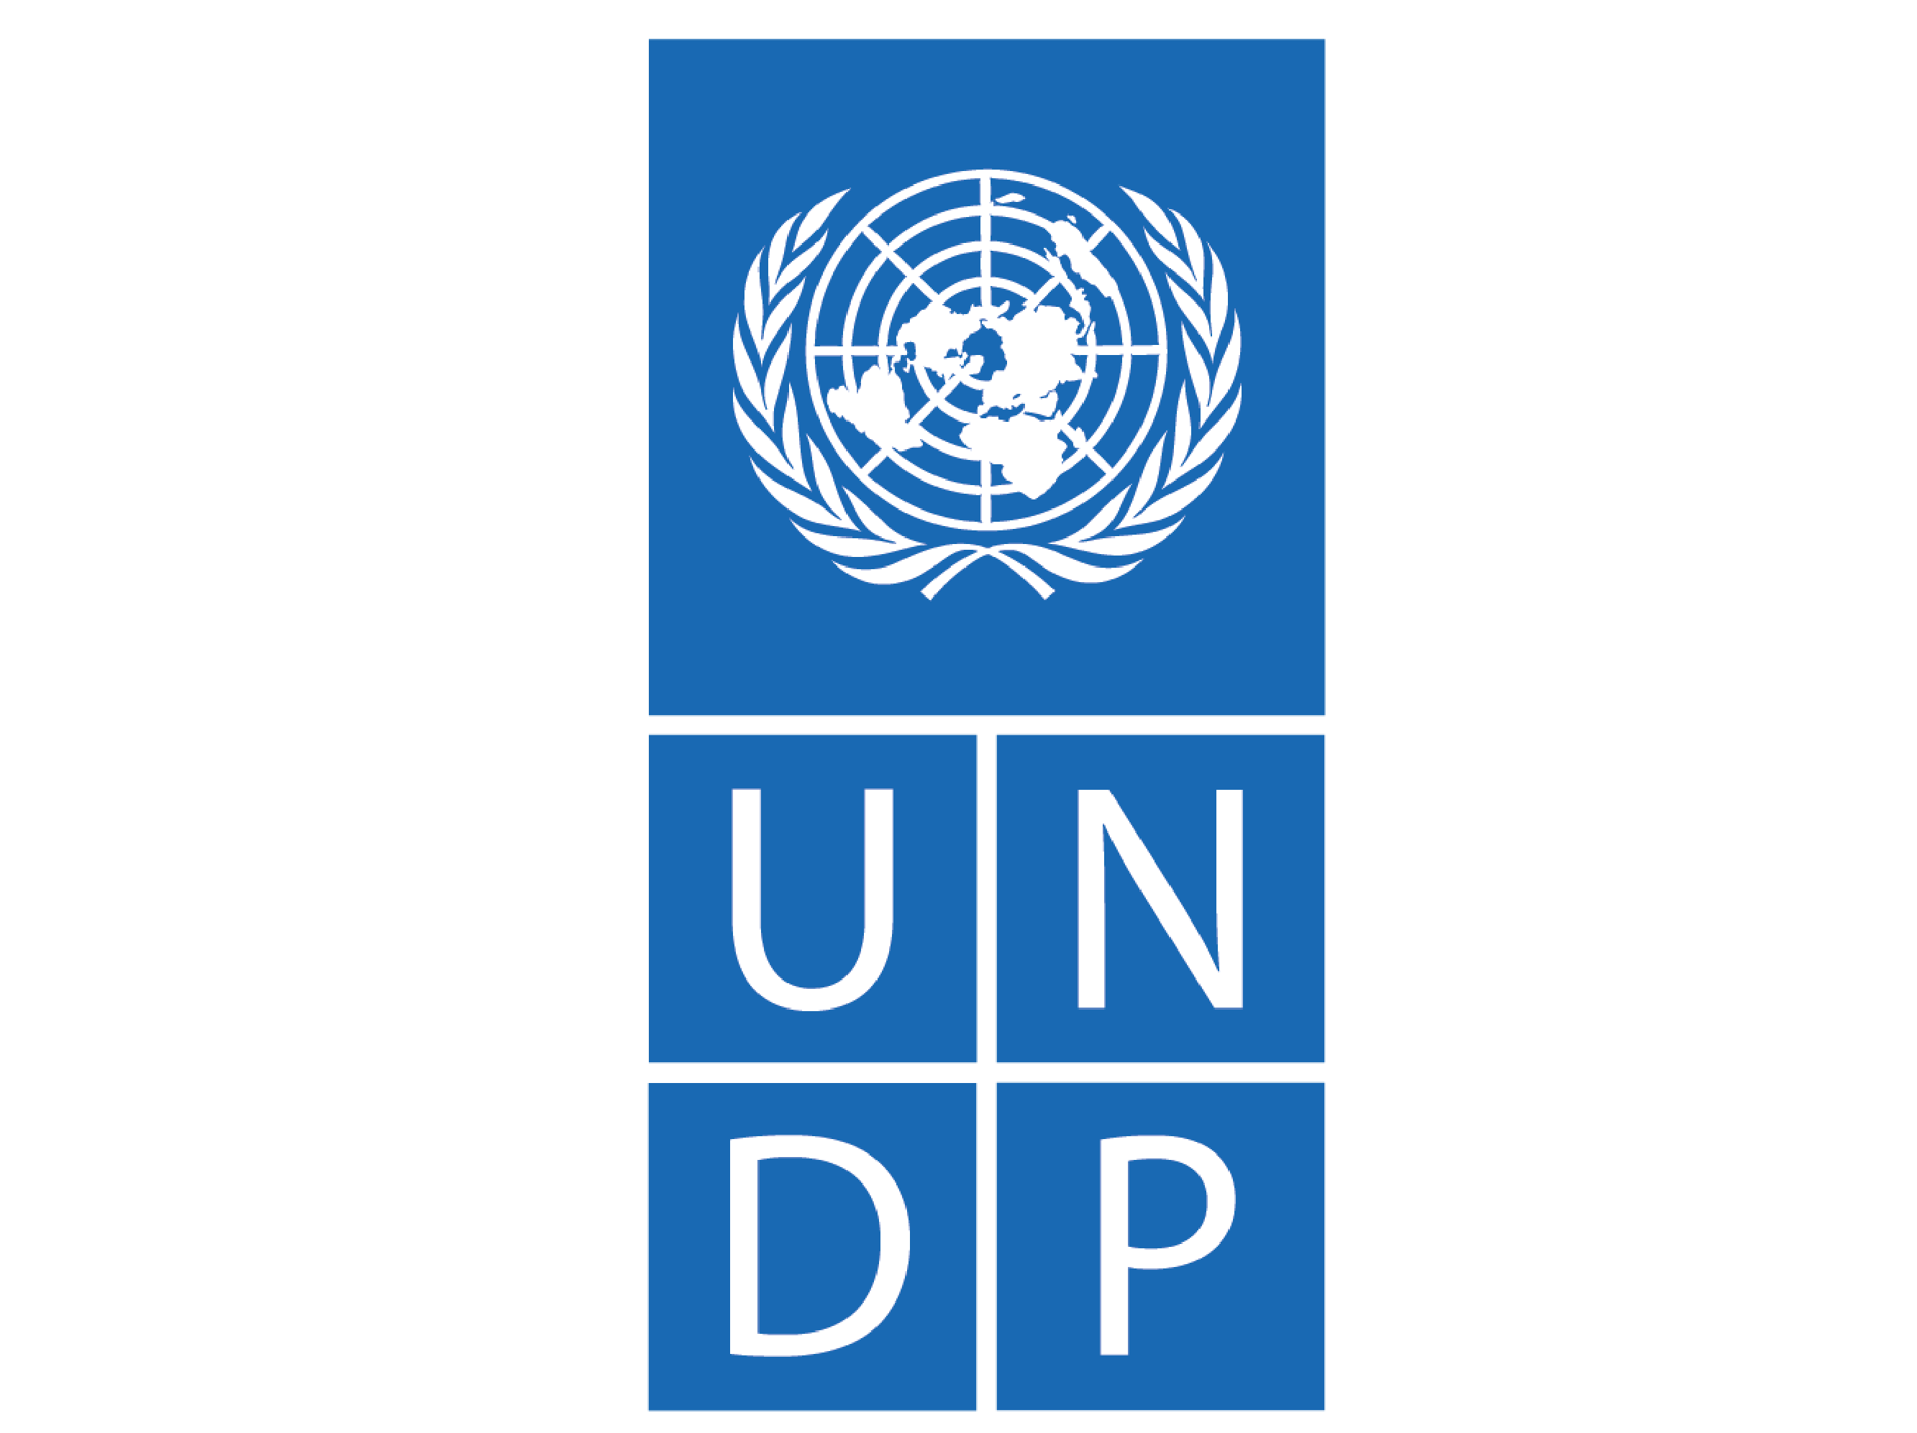 |  | 