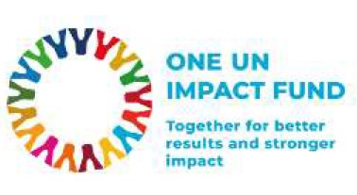 | 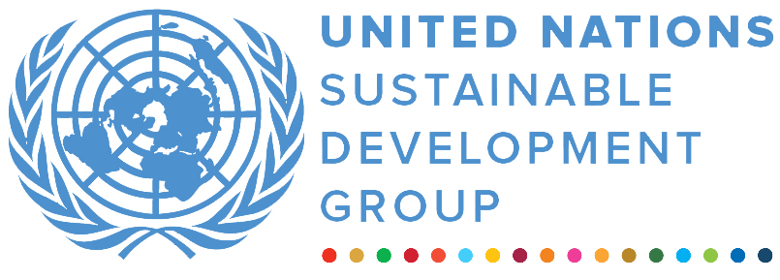 | 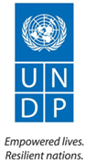
One UN Response to Khoy Earthquake
MPTF OFfice GENERIC finalprogramme NARRATIVE report
REPORTING PERIOD: from March 2023 to April 2024
Programme Title & Project Number |  |  | Country, Locality(s), Priority Area(s) / Strategic Results
- Programme Title: One UN Response to Khoy Earthquake  - Programme Number (if applicable)  - MPTF Office Project Reference Number: |  |  | (if applicable)  Country/Region : Islamic Republic of Iran, West Azerbaijan Province
Priority area/ strategic results

The “One UN response to Khoy earthquake” programme consisted of five projects:
1. Increasing self-reliance through TVET upskilling among the earthquake affected youth and adolescents in Khoy county (led by UNESCO)
2. Enhancing the availability of medical equipment in the earthquake affected area of Khoy (led by WHO)
3. Supporting the access of earthquake affected populations to safe and inclusive education and health services during the recovery phase (led by UNICEF)
4. Building women’s and girls’ resilience to shocks by focusing on health and well-being, including mental, social, sexual and reproductive health: An innovative nexus approach (led by UNFPA)
5. Emergency assistance to vulnerable people affected by the earthquake in Khoy (led by IOM).

Participating Organization(s) |  |  | Implementing Partners
- UNESCO  - UNICEF  - UNFPA  - IOM  - WHO  - RCO |  |  | - Khoy Directorate of Education  - Khoy Department of Health  - Iran Technical and Vocational Training Organization  - Khoy College of Medical Sciences  - Ministry of Health (Khoy Medial University, Tehran Medical University)  - Ministry of Cooperatives, Labor, and Social Welfare (State Welfare Organization, Technical and Vocational Training Organization)
Programme/Project Cost (US$) |  |  | Programme Duration
Total approved budget as per project document:  MPTF /JP Contribution:  - UNESCO:USD 110,000 USD  - UNICEF: USD 220,000 USD  - UNFPA: USD 295,000 USD  - IOM: USD 220,000 USD  - WHO: USD 65,000  - Support to management of the One UN Impact Fund – WHO: USD 34,829 |  |  | Overall Duration (months)  Start Date 31 05 2023
Agency Contribution  - by Agency (if applicable) |  |  | Original End Date 31 12 2024
Government Contribution  (if applicable): 29,000 USD (in kind) |  |  | Actual End date 31 12 2024  Have agency(ies) operationally closed the Programme in its(their) system? | Yes No
Other Contributions (donors)  (if applicable): N/A |  |  | Expected Financial Closure date:
TOTAL: USD 973,829
Programme Assessment/Review/Mid-Term Eval. |  |  | Report Submitted By
Evaluation Completed  Yes No Date: dd.mm.yyyy  Evaluation Report - Attached  Yes No Date: dd.mm.yyyy |  |  | - Name: Raja Gundu  - Title: DEVELOPMENT COORDINATION OFFICER, PARTNERSHIPS AND DEVELOPMENT FINANCE  - Participating Organization (Lead): UNRCO  - Email address: Gundu@un.org

FINAL PROGRAMME REPORT FORMAT

EXECUTIVE SUMMARY

In response to the devastating earthquakes that struck Khoy, Iran, in early 2023, the United Nations launched a coordinated multi-agency recovery effort. Through the One UN Impact Fund and other funding sources, the UN provided critical support across health, education, livelihoods, and protection sectors, reaching over 122,663 individuals. Key achievements include:

- UNESCO trained 83 youth (69 women) in entrepreneurship and provided start-up grants to 52, enabling new businesses and improving local livelihoods.

- UNFPA strengthened sexual and reproductive health services, trained 30 midwives, and supported 650 female-headed households with vocational training and entrepreneurship.

- WHO delivered medical equipment to eight health facilities, benefiting 47,800 people and enhancing local health system capacity.

- IOM provided multi-purpose cash assistance to 6,021 individuals and built national disaster management capacity with 43 NDMO staff trained in disaster response.

- UNICEF restored education and health services, benefiting 8,631 individuals through mobile health posts and rehabilitating 12 schools for 659 students.

This integrated response not only addressed immediate needs but also laid the foundation for long-term recovery, contributing to national priorities and the UN Sustainable Development Cooperation Framework (UNSDCF). The programme demonstrated the power of coordinated UN action, with MPTF funding catalyzing a flexible, inclusive approach to recovery that prioritized vulnerable populations, including women, youth, and persons with disabilities.

Purpose
- The coordinated UN response in Khoy was launched following a series of destructive earthquakes in late 2022 and early 2023 that severely affected West Azerbaijan province. Under the leadership of the UN Resident Coordinator and guided by a rapid multi-agency needs assessment, the programme aimed to provide life-saving assistance and support early recovery in earthquake-affected communities.

- The main objectives included: restoring access to essential services such as health and education; promoting economic self-reliance, especially among women and youth; and strengthening national disaster preparedness capacities. These outcomes align with the UN Sustainable Development Cooperation Framework (UNSDCF) priorities, especially those related to inclusive economic growth, health system resilience, and institutional capacity building.

Assessment of Programme Results

- Narrative reporting on results:

Outcomes: The programme made substantial progress toward its strategic outcomes. UNESCO’s interventions supported the transition from aid to economic self-reliance, especially for women and youth. UNFPA improved access to sexual and reproductive health and protection services and provided livelihood support to female-headed households, addressing both economic and psychosocial resilience. WHO improved diagnostic and emergency healthcare capacity, benefiting nearly 48,000 people. IOM’s MPCA met urgent needs for over 6,000 people, with 88% of households including persons with disabilities. UNICEF’s restoration of education and mobile health services ensured continued access to essential services in remote areas. These outcomes contributed directly to UNSDCF objectives and national recovery priorities, supporting SDGs on health (SDG 3), education (SDG 4), gender equality (SDG 5), and reduced inequalities (SDG 10). Beneficiaries included vulnerable populations such as women, youth, children, and persons with disabilities. Institutional readiness, particularly in TVET and disaster preparedness, was significantly strengthened.

Outputs: Key outputs achieved include:

- UNESCO: 83 trained in entrepreneurship; 52 business start-up grants awarded; 52 TVET staff trained in resilience planning.
- UNFPA: 30 midwives trained; 650 FHHs received vocational training; 36 health facilities equipped.
- WHO: Medical equipment delivered to 8 facilities, directly benefiting 47,800 people.
- IOM: MPCA delivered to 6,021 people; DRR training for 43 NDMO officials.
- UNICEF: 8,631 individuals received mobile health services; 12 schools rehabilitated, serving 659 students (including 28 with disabilities).
Outputs exceeded or closely matched targets in most areas. Variances, such as slightly lower participation in TVET capacity-building, were due to logistical challenges and availability constraints.

Qualitative assessment: The programme was highly successful in achieving its intended results, owing to strong inter-agency coordination and close collaboration with national partners such as the Technical and Vocational Training Organization (TVTO), National Disaster Management Organization (NDMO), Khoy Medical University, and the Directorate of Education. The use of pooled funding mechanisms, especially the One UN Impact Fund, allowed for timely and flexible responses. The visibility and success of the interventions attracted complementary funding and in-kind contributions from national and local actors.

The catalytic role of One UN Impact Fund’s support was particularly evident in the expansion of Multipurpose Cash Assistance (MPCA), rapid deployment of health services, and resilience-building of national institutions. UN coordination improved through shared planning, joint assessments, and harmonized reporting, resulting in a more efficient and impactful response across multiple sectors.

A qualitative assessment has been conducted by each participating agency, with detailed findings documented in their respective project reports.

ii) Indicator Based Performance Assessment:
Using the Programme Results Framework from the Project Document / AWPs - provide details of the achievement of indicators at both the output and outcome level in the table below. Where it has not been possible to collect data on indicators, clear explanation should be given explaining why.

UNESCO
 | Achieved Indicator Targets | Reasons for Variance with Planned Target (if any) | Source of Verification
Outcome 1 Transition from emergency assistance to sustainable livelihoods  Indicator:  Increased access to skills development, disaster risk reduction education, and employment opportunities for earthquake-affected adolescents and youth.  Baseline:  Limited access to tailored TVET, entrepreneurship, and life skills programmes for earthquake-affected youth; minimal integration of DRR education in TVET.  Planned Target:  Improved access to skills training, entrepreneurship support, and disaster resilience education for at least 150 youth and TVET staff. | Near 400 youth, adolescents, trainers, and managers benefitted from skills training, entrepreneurship support, and disaster risk reduction education. | In-kind contributions from the implementing partner, effective and strategic use of financial resources, and the increase in the UN exchange rate together supported the expansion of activities and increase in beneficiaries. | Implementing Partner Report and Field Monitoring Visit
Output 1.1:  Earthquake-affected youths are better prepared for employment and business start-up through TVET training and upskilling.  Indicator 1.1.1  Number of TVET graduates who received entrepreneurship and business start-up training.  Baseline: 0  Planned Target: 84  Indicator 1.1.2  Number of TVET graduates who benefit from the business start-up grants.  Baseline: 0  Planned Target: 20 | 83 TVET graduates trained.  52 trained graduates received grants. | In-kind contributions from the implementing partner, effective and strategic use of financial resources, and the increase in the UN exchange rate together supported the expansion of activities and increase in beneficiaries beyond the planned target. | Implementing Partner Report and Field Monitoring Visit
Output 1.2  The earthquake-affected adolescents are better prepared to deal with post-disaster trauma and get the necessary skills to increase their employability in the future.  Indicator 1.2.1  Number of adolescent students who benefitted from the life skills and entrepreneurship training.  Baseline: 0  Planned Target: 160  Indicator 1.2.2  Number of local trainers who received on-the-job training.  Baseline: 0  Planned Target: 10 | 201 adolescents participated and completed life skills and entrepreneurship training in the summer camps.  10 local TVTO trainers trained | In-kind contributions from the implementing partner, effective and strategic use of financial resources, and the increase in the UN exchange rate together supported the expansion of activities and increase in beneficiaries beyond the planned target. | Implementing Partner Report and Field Monitoring Visit
Output 1.3  TVET managers and trainers are better prepared to deal with disasters.  Indicator 1.3.1  Number of TVET managers and trainers benefited from the post-disaster recovery and emergency response planning training course.  Baseline:  0  Planned Target:  80 | 52 TVET Managers and Trainers trained | All available and registered managers and trainers were trained; no additional participants were available. | Implementing Partner Report and Field Monitoring Visit
WHO
Outcome 2: Medical equipment is provided in the earthquake affected area of Khoy.  Baseline:0  Planned Target: Increased number | Provision of medical equipment in Khoy | Necessary equipment was provided. | Khoy College of Medical Sciences confirmation
Output 2.1  Indicator 2.1.1  Number of functional health facilities supported  Baseline: 0  Planned Target: 12 | 8 | Due to the fluctuations in exchange rates and the high inflation rate in the country, there was a discrepancy between the estimated and actual costs of procurement. As a result, and in order to maximize the use of funds and the effectiveness of the WHO’s response, we adjusted the procurement plan to focus on the most needed equipment. While the original proposal included items such as electrocardiograph machines and fetal heart rate monitors, they were excluded from the final procurement to allow prioritization of life-saving devices such as Automated External Difibrillator (AEDs), mechanical ventilators, and ultrasonography machines. Consequently, the number of health facilities strengthened through this project was adjusted from 12 to 8. | Khoy College of the Medical Sciences
UNICEF
Outcome 3: Supporting the access of earthquake affected populations to safe and inclusive education and health services during the recovery phase  Indicator: 1.1.a Number of affected people receiving effective relief and life-savings assistance disaggregated by age, sex, disability (UNSDCF Indicator 4.2.2.a)  Baseline: 0  Planned Target: 15,880 | 11,177 | Following the needs assessment, the project's focus shifted from urban areas to remote villages. As a result, while fewer people benefited from the services, the impact was significantly greater. The selected locations were more vulnerable and had received less support prior to UNICEF’s intervention, making the assistance provided much more critical and transformative. | Implementing partners’ (IP) reports, UNICEF field visits
Output 3.1  Indicator: Number of learning spaces and/or centers established and/or rehabilitated  Baseline: 0  Planned Target: 14 | 12 | Due to funding constraints and the specific needs of each school, the UNICEF team prioritized the rehabilitation of 12 rural schools, ultimately benefiting 659 children. UNICEF deliberately chose to focus on these rural schools, which were in more urgent need of assistance, even though they served a smaller number of students. | IP reports
Output 3.2  Indicator: Number of functional health facilities supported  Baseline: 0  Planned Target: 2 | 2 | The targeted number of health facilities supported was achieved. | IP reports
UNFPA
Outcome 4: Quality of sexual and reproductive health services for vulnerable groups especially women and girls in Khoy is enhanced
Indicator:
Baseline:
Planned Target:

Output 4.1  Indicator: % of targeted facilitie/smobile clinic(s) with at least one trained midwife who can provide integrated health services for vulnerable groups especially women and girls  Baseline:0  Planned Target: 80 | 95 | The targeted facilities were 18 health houses/posts and 2 hospitals (out of a total of 26 health houses/posts and 2 hospitals in Khoy). The 30 trained midwives are now working in 19 of the targeted facilities (in 18 health houses and in one hospital). | List of participants  -Site visit  -workshop report
Output 4.1 a  Indicator: % of targeted facilities/mobile clinic(s) equipped to provide integrated health services for vulnerable groups especially women and girls have increased  Baseline:0  Planned Target:70 | 100 | 28 health facilities and 8 mobile clinics were targeted for procurement of ICT equipment in consultation with Khoy Medical University. Out of total 36 health facilities/ mobile clinics, all were equipped. | Distribution list
Output 4.2 Quality and access to mental health and social harm services for vulnerable groups especially women and girls in Khoy is improved  Indicator: Number of women and girls who benefit from the quality counseling services, provided by the UNFPA trained counselors, in the SWO counseling facilities in Khoy  Baseline: 0  Planned Target: 2,200 | 0 | Due to the government's sensitivities and restrictions, the Population HQ (Government new approval layer) did not permit UNFPA to implement the training related interventions in the areas of Protection and Mental Health and Psycho-social support among women and girls. This indicator was removed during the revision in May 2024.
Indicator 4.2a: % of targeted SWO social emergency centers equipped to provide mental counseling and other social harm related services for vulnerable groups, especially women and girls  Baseline:No  Planned Target: 70 | 0 | The social harm related facilities of SWO in Khoy (West Azerbaijan Province) were fully equipped to provide quality services to vulnerable groups, especially women and girls | Ministry of Cooperatives, Labor and Social Welfare (MCLSW) reports
Output 4.3: Mental health and social harm related systems are strengthened  Indicator: Number of policy recommendations/briefs on reducing social harms and improving mental and social health of women and girls in natural disaster situations produced  Baseline:0  Planned Target: 2 | 3 | Three policy briefs were produced:  - Policy document on reviewing, analysing, and evaluating the interventions done by disaster relief organizations and challenges they faced to enhance the mental and psycho-social wellbeing of women and girls after the earthquake in Khoy city and recommendations to improve performance,  - Policy document on mental and social health problems of women and girls in natural disaster settings and related recommendations  - Policy documents on the measures taken by various governmental, non-governmental, and public organizations during Khoy earthquake targeting girls, women, and FHHs and assessing challenges related to mental and physical health. | The research final report entitled “Enhancing the mental health and psycho-social wellbeing of women and girls in natural disaster settings” conducted by Tehran University of Medical Sciences.
Output 4.3a: Female headed households in socially vulnerable situations are empowered  Indicator: Number of Female Heads of Households who received vocational life skills training  Baseline: 0  Planned Target: 650 | 650 | 650 Female Heads of Households in Khoy were trained on various integrated vocations (sewing, carpet weaving) and entrepreneurship skills | TVTO final report
IOM
Outcome 5: Capacities of people in the area of disaster resilience, risk reduction and preparedness are enhanced (Intermediate Outcome 4.2 of the DRRM JWP) 1  Indicator: Proportion of most at risk male- and female-headed households provided with required awareness and skills to reduce the risk, prepare for, and respond to disasters  Baseline: To be provided by NDMO in collaborati on with other responsible organisations  Planned Target: To be provided by NDMO in collaboration with other responsible organisations | Not Applicable | Not Applicable | Official report of NDMO in collaboration with the Plan and budget Organisation
Output 5.1  Indicator: Number of people receiving multi-purpose cash  Baseline:0  Planned Target:4,997 | 6,021 | The initial target of 4,997 individuals was exceeded due to a combination of strategic complementarity with a parallel CERF-funded intervention and exchange rate fluctuations. Specifically, an initial caseload of 4,967 individuals was assisted jointly through the CERF and this project. These beneficiaries had already received partial MPCA support under CERF, and this project provided top-up payments to ensure that the total assistance received was fully aligned with the MEB guidance. Because the amount disbursed per individual through this project was lower for this caseload, available resources allowed for the identification and support of an additional 1,054 individuals, who had not previously received assistance. These new beneficiaries received MPCA at the full transfer value in line with the MEB guidance for 2024. As a result, all 6,021 individuals assisted received support that met the MEB thresholds appropriate to their household size and the year of distribution. | Project records, bank transfers records
Indicator 5.1a: Total value of multi-purpose cash distributed in USD  Baseline:0  Planned Target: 167,400 USD | 169,235.65 USD | The total value of MPCA delivered (USD 169,235.65) slightly exceeded the planned USD 167,400 due to savings realized under other budget lines. These savings were reallocated to maximize the direct assistance component of the project. As a result, IOM was able to increase the overall MPCA coverage, including the provision of additional support to high-risk protection cases, while ensuring that all transfers remained in line with the MEB guidance. | Project records, bank transfers records
Output 5.2: Percentage of the government organizations with risk-informed development planning and adjusted organizational structures according to National Disaster Management Law.  Indicator: Number of trainings conducted on DRR topics and the management of equipment  Baseline: 0  Planned Target: 1 | 1 | A two-day training was conducted on 31 October and 1 November 2023 targeting 43 officials from NDMO. The management of the equipment was not part of the training sessions due to the reprioritization of the equipment donation. | Project records
WHO and RCO
Outcome 6: Support to management of the One UN Impact Fund for I.R. Iran
Output 6.1: To guarantee its operation, facilitate a programmatic cycle and support decision-making processes, the Fund is supported by a Secretariat that provides technical, management and administrative support to the Board and Review Committee of the Fund and is responsible for organizing Fund's processes related to programme review, approval, monitoring, evaluation and reporting. The contracting of the contractual personnel and procurement of services for visibility and communications purposes would be carried out by the Office of the World Health Organization in the Islamic Republic of lran (WHO-Iran) for a period of 18 months from the date of signing of this document.  Indicator: Contractual personnel is recruited and communications material is produced  Baseline: 0  Planned target: 1 personnel | 1 | The contractual personnel was recruited by WHO and placed under supervision of the RCO Partnerships Officer in his capacity as Fund Secretary. Communications material for the Fund was printed in March 2025. | WHO confirmation

iii) Evaluation, Best Practices and Lessons Learned
Evaluations and Assessments:
While no final evaluations were possible due to the emergency context and short project timelines, multiple assessments informed the design and implementation of the programs:
- IOM utilized findings from a joint inter-agency needs assessment (March 2023) and an IOM-led field mission to guide targeting and response. Post-distribution monitoring was delegated to the State Welfare Organization due to access constraints.
- UNFPA conducted pre/post training evaluations and a three-month follow-up, demonstrating knowledge retention among midwives. An academic assessment by Tehran University supported policy recommendations on mental and social health interventions.
- WHO conducted two post-delivery monitoring visits and market research to ensure effective procurement under sanctions and currency fluctuation.
- UNESCO relied on continuous field monitoring to ensure activity quality and course correction.
- UNICEF implemented a Rapid Needs Assessment for education and continuous monitoring of health and school rehabilitation activities. A final evaluation is planned post-project.
Challenges and Mitigation:
Common challenges included implementation delays, coordination constraints, procurement bottlenecks, and political sensitivities:
- IOM faced delays in MPCA due to coordination needs with the government. A no-cost extension and phased rollout ensured targets were exceeded despite limited access for monitoring.
- UNFPA experienced logistical and political delays due to the absence of formal implementation agreements, new oversight structures, and economic instability. Adaptive approaches and local project coordination helped mitigate these issues.
- WHO struggled with low supplier participation and volatile pricing due to sanctions. Market research and expedited procurement processes allowed timely delivery.
- UNESCO encountered a three-month delay in partnership finalization due to administrative shifts, but resumed successfully with strong local engagement.
- UNICEF had to change implementing partners mid-project, faced procurement hurdles, and dealt with weather-related construction delays. Flexible partnerships and community involvement helped sustain progress.
Lessons Learned and Best Practices:
Several key insights emerged:
- Early coordination with local authorities and formalized agreements streamline implementation (UNESCO, UNFPA).
- Localized hiring and presence of field coordinators facilitate smoother implementation and enhance trust (UNICEF, UNFPA).
- Targeted interventions in high-need areas are more impactful than dispersed efforts, particularly in politically sensitive contexts (UNFPA).
- Integrated inter-agency coordination and flexible funding mechanisms like the One UN Impact Fund enhanced impact and reach (IOM).
- Digital tools, such as tablets, improved efficiency, service delivery, and data management in remote health settings (UNFPA).
- Proactive procurement planning and supplier engagement are critical in sanction-affected or high-inflation environments (WHO, UNICEF).
These experiences collectively underscore the importance of agility, local engagement, and inter-agency coordination in delivering effective, timely, and needs-based recovery support in complex settings.
Annexure
iv) Good practices

- UNFPA:

Conducting a workshop on “Reproductive Health in Disaster” was the first activity under this project which was implemented by Khoy Medical University. UNFPA-Iran reported the event in its website:
https://iran.unfpa.org/en/news/empowering-midwives-reproductive-health-disasters-training-course-aims-save-lives
The training has significantly increased knowledge and understanding of participating midwives on reproductive health issues during disasters as shown in the graph presented above. Here are some photos and quote from the participant:

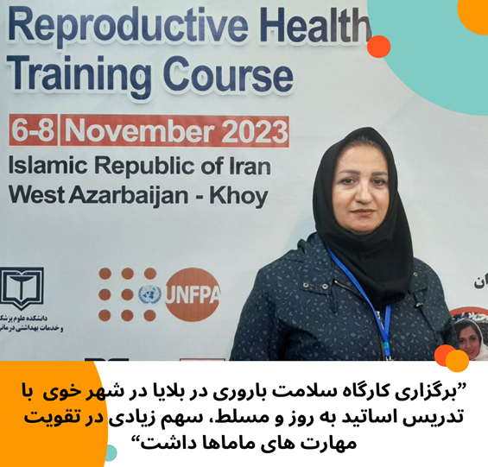

“The facilitators were skillful and knowledgeable and they greatly contributed to increasing my theoretical and practical knowledge”.

Photos of the workshop:
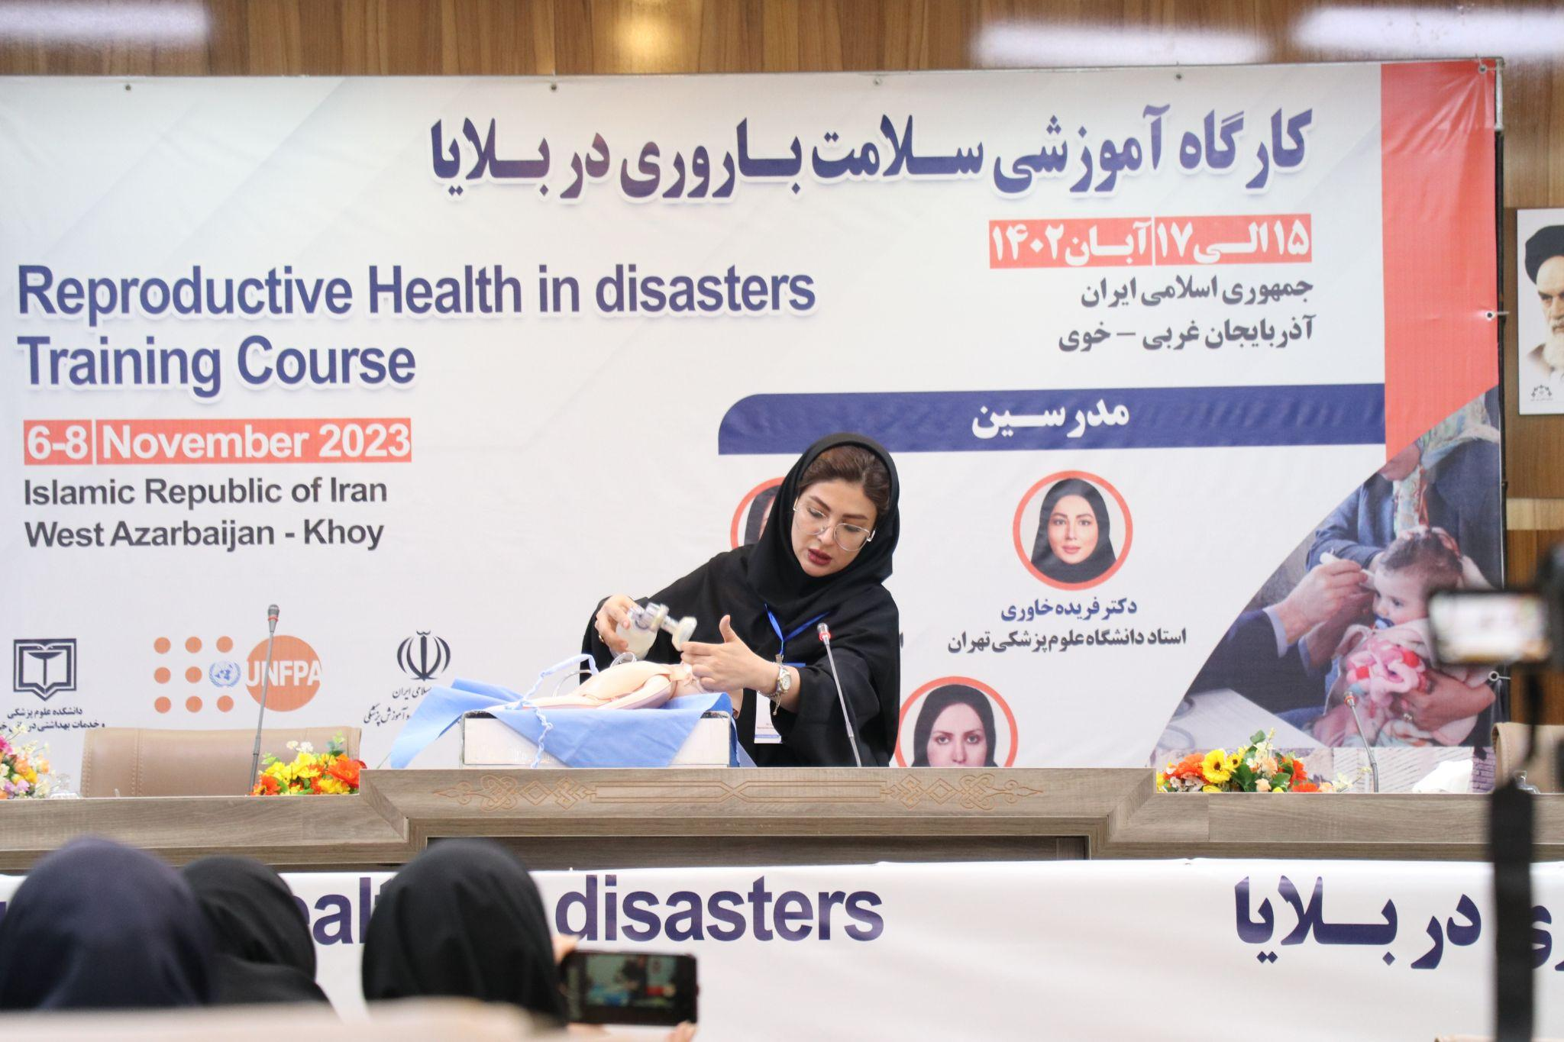
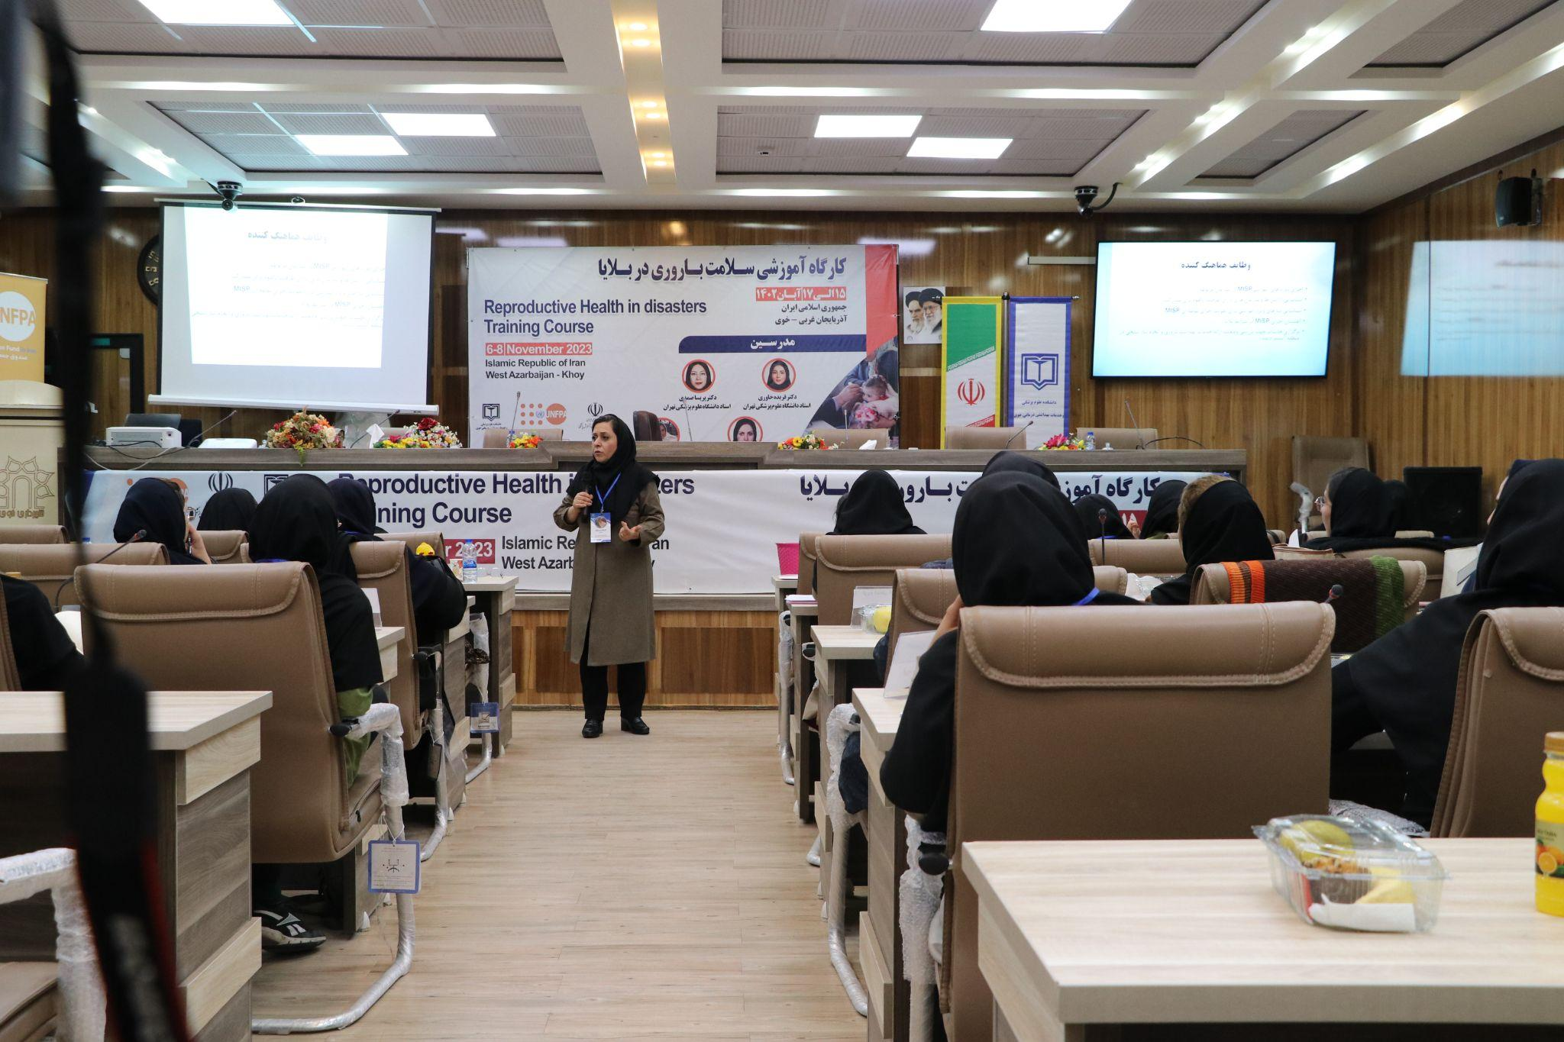

ICT devices were also procured for the health facilities of the district. The pictures are below:
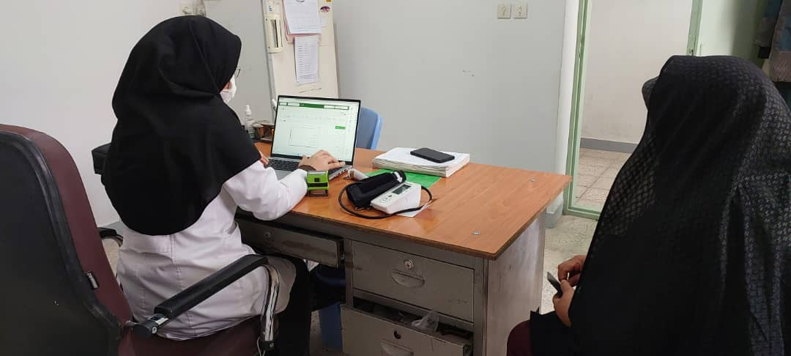
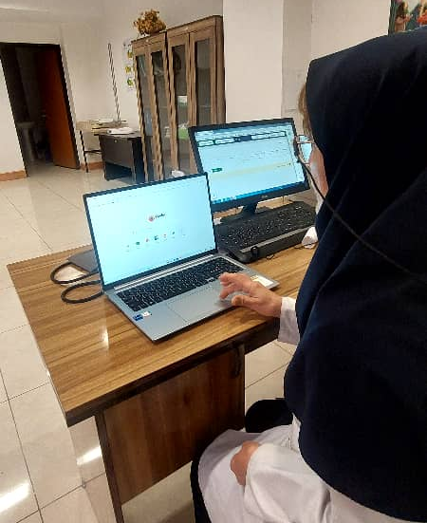

- IOM:
IOM Offers Humanitarian Relief in Earthquake-struck Iranian City of Khoy

In January 2023, a magnitude 5.9 earthquake hit Khoy in Iran’s province of West Azerbaijan, killing three people and injuring hundreds. The earthquake had a devastating impact in the province. In the village of Firouragh, the epicentre of the quake that encompasses around 2,500 households, for instance, the large majority of houses were fully destroyed and required complete reconstruction.

When the earthquake struck, Fatemeh was in the house that she used to live in with her husband and young children, who are 13 and 9 years old. “The tremor shock was so strong that the walls cracked,” she said, recalling how they were rushed to quickly evacuate the building that moments later turned into an uninhabitable place. In the following months, they rented a new apartment, but their economic situation quickly worsened, as Fatemeh was also trying to support her mother, whose house was severely damaged as well.

In response to the deadly earthquake, The United Nations in Iran implemented a multi-agency humanitarian package aid to address the immediate needs of survivors including shelter, medicine, mental health support, and other essential supplies. The Iranian Red Cresent Society and various governmental organizations like the State Welfare Organization (SWO) were also actively involved in supporting the affected populations.
As part of the UN response and after assessing the different needs and conditions of the residents, IOM conducted a Multi-Purpose Cash Assistance programme, a modality of aid where cash or vouchers are provided to beneficiaries to directly purchase and access goods or services. Thanks to the funding provided by the One UN Impact Fund and the UN CERF, IOM supported 4,900 individuals residing in Khoy, assisting them to prioritize their needs and voluntarily decide how to use their resources.

Fatemeh, for example, was very anxious to find shoes and school supplies for her children before the start of school: “My kids were crying every day, as the school year was approaching, and I couldn't afford to buy anything for them,” she said.

IOM staff, who had identified beneficiaries in collaboration with government officials, stayed in close contact with Fatemeh’s family during the various bureaucratic steps required to finalize the bank transfer. “We wanted to make sure that the family could receive the transfer before the start of the school year,” remarked Nima Karimi, IOM Iran project officer who followed the case. “This is a very important moment for children and a difficult time for many families, who have to allocate extra resources for the costs of clothing and school equipment among their other emergency needs.”
Finally, just a few days before the classes began, the family received the cash transferred into their account. “The money arrived just in time to buy them pants, shoes and bags to send them to school. It was a relief,” said Fatemeh.

In addition to immediate relief efforts, IOM is adopting a multifaceted approach to disaster risk reduction and management, in order to support the country's disaster management capacities.
“The impoverished and vulnerable often bear a disproportionate burden of risk and loss,” indicated IOM Iran Chief of Mission, Lalini Veerassamy. “As such, we must ensure that disaster risk reduction measures are inclusive, equitable and effective, both for migrants and for host communities.”
The mission has been actively engaged in collaborative efforts with Iran's National Disaster Management Organization (NDMO), offering technical and capacity-building assistance. Moreover, IOM is designing initiatives addressing the climate change-migration nexus in Iran, where meteorological hazards are expected to increase in frequency and intensity, deepening the vulnerability of communities.

----

The term “programme” is used for programmes, joint programmes and projects.
Strategic Results, as formulated in the Strategic UN Planning Framework (e.g. UNDAF) or project document;
The MPTF Office Project Reference Number is the same number as the one on the Notification message. It is also referred to as “Project ID” on the project’s factsheet page on the MPTF Office GATEWAY.
The MPTF/JP Contribution is the amount transferred to the Participating UN Organizations – see MPTF Office GATEWAY
The start date is the date of the first transfer of the funds from the MPTF Office as Administrative Agent. Transfer date is available on the MPTF Office GATEWAY
As per approval of the original project document by the relevant decision-making body/Steering Committee.
If there has been an extension, then the revised, approved end date should be reflected here. If there has been no extension approved, then the current end date is the same as the original end date. The end date is the same as the operational closure date which is when all activities for which a Participating Organization is responsible under an approved MPTF / JP have been completed. As per the MOU, agencies are to notify the MPTF Office when a programme completes its operational activities. Please see MPTF Office Closure Guidelines.
Financial Closure requires the return of unspent balances and submission of the Certified Final Financial Statement and Report.
Note: Outcomes, outputs, indicators and targets should be as outlines in the Project Document so that you report on your actual achievements against planned targets. Add rows as required for Outcome 2, 3 etc.
The name of the beneficiary has been changed to protect her identity.

