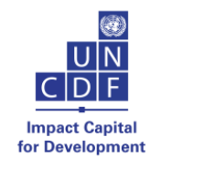

**KAHUZI BIEGA AND KIBIRA FOREST SANCTUARIES**

**PROJECT PROGRESS REPORT**

**December 2024**

Contents

**Project overview** 3

**1.** **General introduction** 4

**2.** **Brief description of the project** 4

**3.** **UNESCO global priorities, priority groups and cross-cutting approaches** 15

**4.** **Involvement and ownership of direct beneficiaries, key partners and other stakeholders** 15

**5.** **Risk assessment and mitigation preventive measures** 16

**6.** **Sustainability and exit strategy** 16

# **Project overview**

**Title**: Kahuzi Biega and Kibira forest sanctuaries

**Project information**

|  |  |  |  |
| --- | --- | --- | --- |
| **Geographic scope / beneficiary country(ies)** | N° 00129846, 00134272 (UNCDF Projects Number) | Global / Region / Sub-region / Country  Burundi | Amount (US dollars) *(Check donor agreement)*  375,000 USD |
| **Donor and financial information** | Donor name*:* United Nations Capital Development Fund (UNCDF), The United Nations Educational, Scientific and Cultural Organization (UNESCO)  Total budget: (UNCDF: US$1,875,000/ UNESCO: US$375,000) | | |
| **Co-financing (if applicable)** | *Amount - Name of co-financing entity(ies)*  UNCDF; UNESCO | | |
| **Approved dates for the project implementation period** | Start date as defined in the agreement: 06/01/2023  Completion date: 05/31/2028 | | |
| **Reporting period** | From : January 2024  Until : December 2024 | | |
| **Contact** | Responsible person (the person who has ultimate responsibility and accountability for the execution of the project, including reporting) (Name, full title, e-mail)  Bandiougou DIAWARA, Head of Natural Sciences Sector [(](mailto:b.diawara@unesco.org)b.diawara@unesco.org)  Dode HOUEHOUNHA, Head of Culture sector [(](mailto:d.houehounha@unesco.org)d.houehounha@unesco.org)  UNESCO Regional Office for Central Africa | | |

# **General introduction**

Burundi has been a UNESCO member state since 1962. It ratified the Convention concerning the Protection of the World Cultural and Natural Heritage in 1982. On 9 May 2007, the country submitted to UNESCO an indicative list of 10 cultural, natural and mixed properties that could be inscribed on the World Heritage List. These properties are:

1. The royal residence of Burundi: the case of Gishora
2. The traditional Rugo of Mugamba
3. The sacred natural landscapes of Muramvya, Mpotsa and Nkiko-Mugamba
4. Gasumo, the southernmost source of the Nile
5. Rwihinda, the bird lake
6. Lake Tanganyika
7. Rusizi nature reserve
8. Kibira National Park
9. Ruvubu National Park
10. Karera Falls and Nyakazu Fault

Among these properties, some are of particular interest for international recognition as a biosphere reserve and possibly as a UNESCO World Heritage Site. These include the Kibira National Park (KNP), the Rusizi National Park (RNP) and the Lake Tanganyika (LT).

Since 2022, UNESCO has been supporting the country in the creation of its first designated sites (Biosphere Reserve, World Heritage Site). It was in this context that a technical assistance mission of information, awareness-raising and co-construction with local stakeholders was carried out from 22 to 29 January 2024.

The study made it possible to identify opportunities and difficulties in implementing the project and to draw up a detailed roadmap for the designation of the two national parks as biosphere reserves. Also, the mission further explores the activation of the World Heritage component in the KNPs and RNPs and, on the other hand, ensure the monitoring of the roadmap of the said project in its biosphere reserve component.

# **Brief description of the project**

The Kahuzi Biega and Kibira Forest Sanctuaries project is financed by the Cartier Foundation as part of the Nature Facility initiative, in partnership with UNCDF. It is part of the implementation of the Memorandum of Understanding signed between UNESCO and UNCDF in February 2023.

To this end, UNESCO is responsible for implementing the following activities:

* **Activity 1.2.1**: Provide technical support, including training, to the Government of Burundi and partners throughout the process leading to the recognition of Kibira National Park as a World Heritage Site and Biosphere Reserve.
* **Activity 1.2.2**: Support data collection and stakeholder engagement to co-construct a shared vision

The results achieved by UNESCO as of December 2024

1. Training and capacity building for the implementation of the World Heritage Convention and the Man and the Biosphere (MAB) Programme

* 5 trainers were trained in three modules: i) the biosphere reserve concept of UNESCO's MAB Programme; ii) the fundamentals of the co-construction of BRs; iii) filling in the proposal form. Co-construction meetings were held in four localities in the Kibira and Rusizi national parks, which are affected by the project to create BRs.
* 30 experts trained, from the Burundi National Commission for UNESCO, sectoral ministries and institutions involved in cultural and natural heritage, and natural sciences, researchers from higher education institutions, media professionals and civil society.

1. Technical assistance for the establishment of World Heritage National Committees and the MAB Programme

* Support for the preparation of draft regulations on the establishment of these committees. This is the first step towards the creation of UNESCO designated sites. These Committees represent entities for consultation, liaison and information, as well as for mobilizing, coordinating and implementing activities and partnerships with all the stakeholders concerned.

1. Missions to assess the state of conservation of Kibira National Park (KNP)

4 field missions have been carried out, resulting in:

* Assessment of the state of conservation of the site and the collection of recent data;
* Draw up of a detailed timetable for the preparation of dossiers for the nomination of the park as a biosphere reserve and for inscription on the World Heritage List, table 1 below.

**Table 1:** Plan for the preparation of dossiers for the nomination of the park as a biosphere reserve and for inscription on the World Heritage List

|  |  |  |  |  |  |  |  |  |  |  |  |  |  |
| --- | --- | --- | --- | --- | --- | --- | --- | --- | --- | --- | --- | --- | --- |
|  | **Activities** | **Periods** | | | | | | | | **Shared activities** | **Specific activities** | **Managers** | **Resources** |
| **N°** |  | **T1 2024** | **T2 2024** | **T3 2024** | **T4 2024** | **T1 2025** | **T2 2025** | **T3 2025** | **T4 2025** |  |  |  |  |
| **1** | New Park boundary: exclusion of the dam zone |  |  |  |  |  |  |  |  |  |  | **OBPE** | **EU/UNDP project** |
| **2** | Updating the regulatory framework |  |  |  |  |  |  |  |  |  |  | **OBPE** | **EU/UNDP project** |
| **3** | Concerted relocation of activities incompatible with protected area status |  |  |  |  |  |  |  |  |  |  | **MINEAGRIE** | **MINEAGRIE** |
| **4** | Updated mapping of the two parks based on new park boundaries and old land-use plans |  |  |  |  |  |  |  |  |  |  |  | **UNESCO** |
| **5** | Information and awareness-raising on the MAB programme and the concept of BR among administrative staff and local communities |  |  |  |  |  |  |  |  |  |  |  | **UNESCO** |
| **6** | Co-construction of zoning (biosphere reserve approach) |  |  |  |  |  |  |  |  |  |  | **OBPE/UNESCO** | **UNESCO** |
| **7** | Inventory of invasive plants and study of control methods, Inventory of plant and animal species |  |  |  |  |  |  |  |  |  |  | **OBPE** | **EU/UNDP project** |
| **8** | Raising community awareness of the consequences of bush fires and pollution |  |  |  |  |  |  |  |  |  |  | **OBPE/ DGEREA** | **OBPE/ DGEREA** |
| **9** | Raising awareness of the environmental code |  |  |  |  |  |  |  |  |  |  | **DGEREA/OBPE** | **DGEREA/OBPE** |
| **10** | Community respect for the corridor through awareness-raising (Rusizi) |  |  |  |  |  |  |  |  |  |  | **OBPE** | **EU/UNDP project** |
| **11** | Inventory of invertebrate fauna |  |  |  |  |  |  |  |  |  |  | **OBPE** | **EU/UNDP project** |
| **12** | Recruitment and management capacity building |  |  |  |  |  |  |  |  |  |  | **OBPE** | **OBPE** |
| **13** | Archiving of studies carried out |  |  |  |  |  |  |  |  |  |  | **OBPE** | **OBPE/UNESCO** |
| **14** | Census of the Human Population of the Proposed Biosphere Reserve |  |  |  |  |  |  |  |  |  |  | **OBPE** | **UNESCO** |
| **15** | Biological characteristics |  |  |  |  |  |  |  |  |  |  | **OBPE / Ministry of East African Community Affairs, Youth, Sport and Culture/ Burundi National Commission for UNESCO** | **International assistance / UNESCO** |
| **16** | Updating of Burundi's Tentative List (KNP - as an extension of Nyungwe NP) |  |  |  |  |  |  |  |  |  |  | **UNESCO** | **UNESCO** |
| **17** | List of main bibliographical references (to be appended) |  |  |  |  |  |  |  |  |  |  | **OBPE** | **EU/UNDP project** |

**Information, awareness-raising and co-construction mission with local stakeholders in the preparation of proposal packages for the Kibira and Rusizi/Lac Tanganyika national parks in Burundi**

A co-construction mission held from 29 April to 08 May 2024 which trained experts on biosphere reserve co-construction exercises in the field particularly in Kayanza, Bubanza, Delta and the Palmeraie.

The mission trained conservators from both national parks and COMNAT on co-construction of biosphere reserves, informed and raised awareness among public actors and local communities about the MAB program and the concept of the biosphere reserve, supported the participatory definition of the vision, function and zoning of biosphere reserve projects and supported pre-filling of biosphere reserve proposal forms.

The mission initiated the process of designating the Kibira and Rusizi biosphere reserves through concertation between the stakeholders and on-site recognition of the three zones essential to biosphere reserves.

The training of experts focused on three modules and a data collection protocol which took place in Bujumbura and lasted 3 days. The first module enabled participants to understand the biosphere reserve concept of the UNESCO MAB Programme and the fundamentals of the co-construction of BRs. The second module focused on the data collection protocol. This covered both the primary data collected during the co-construction phase and the secondary data required in the proposal form. During the presentation of the second module, participants gave their point of view on:

* communities' visions of their area (in the next 10-20 years);
* changes in the way their area is used and managed;
* indicators of changes in their resources;
* the need for communities to protect their area or not;
* the opinion of the communities bordering the park on the biosphere reserve zoning model;
* recurring conflicts in their area and the mechanisms for managing them.

The co-construction of the Rusizi and Kibira biosphere reserves took part in four workshops held on site with the various stakeholders. The consultants closely followed the data collection protocol and intervened at every stage to give clarification on certain questions asked, to reposition the order of certain questions, made illustrations and used diagrams to make it easier for the participants to follow the exchanges.

The third module dealt with the preparation of the biosphere reserve nomination file. With the two conservators and the representatives of the OBPE, discussions on the key elements in the content of the nomination file were made such as three parts of the form, the name to be proposed for the BR, three functions of the BR, criteria for designation as a BR, different approvals, detailed description of the Form and the documents to be attached to the biosphere reserve proposal form.

Practical fieldwork took place over four days. At each site (Kibira and Rusizi) two days of discussions were held with the various park stakeholders based on an interview protocol. The protocol developed during the training served as the basis for the discussions. The discussions were conducted in the local language with French translation provided on the fringes of the debates to ensure that the various stakeholders were fully involved. The modules enabled the trainees to learn the basics about biosphere reserves and defined the data collection protocol.

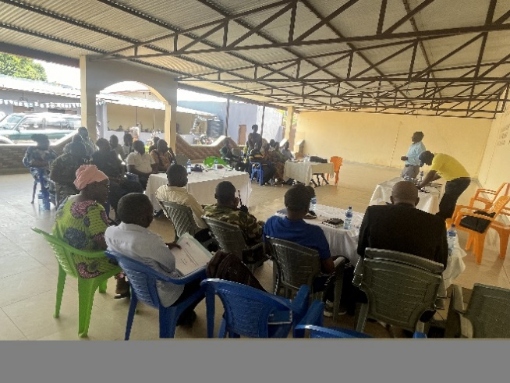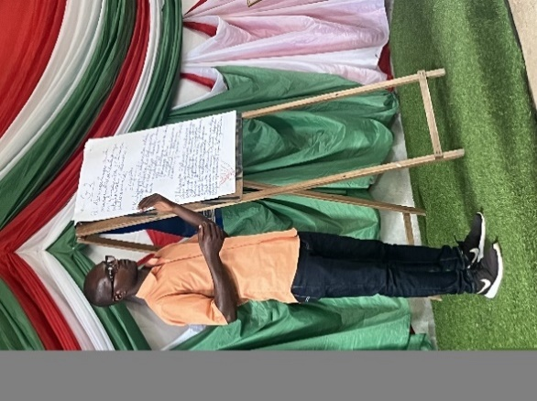

**Co-construction training with local stakeholders and follow-up of the roadmap of the project for the creation of biosphere reserves (KNP & PNR) and consideration of the World Heritage Convention**

In accordance with the roadmap in table 1, another mission took place from the **15-24 July 2024** which combined the training of experts at the UNESCO office in Bujumbura (training and initiation of form filling) with co-construction exercises for biosphere reserves and world heritage sites in the field, particularly in Delta, Palmeraie (Rusizi Park), Teza and Mabayi (Kibira Park). Ultimately, the mission enabled some progress to be made in the co-construction of designated sites, particularly through the triptych of information, awareness-raising and consultation.

The mission:

* Strengthened the capacities of the conservators of the two national parks and COMNAT in the co-construction of biosphere reserves;
* Presented the World Heritage Convention (vision, mission and function);
* Built the capacity of local stakeholders in integrated management (Rusizi National Park should be part of the BR and WH), encourage the development of integrated management plans during visits to the sites.
* Informed and raised the awareness of public stakeholders and local communities about the MAB programme and the biosphere reserve concept, as well as the World Heritage component;
* Supported the participatory definition of the vision, function and zoning of biosphere reserve projects and the World Heritage component;
* Supported the pre-filling of biosphere reserve proposal forms and the World Heritage component.

**A) Activities realized on the biosphere components**

Experts have been trained in four modules which covered the capitalization of cartographic and contextual data, the appropriation of the statutory framework and the Seville strategy, the contribution of UNESCO sites to the identification of solutions to the challenges facing ecological restoration in Burundi and, finally, the start of filling in the biosphere reserve designation form, together with a timetable running until mid-September as seen in annex 4

The working methodology alternated between theoretical sessions in the classroom and practical work in the field which were broken down into 3 levels:

* **Capacity building** for trainers on the co-construction of a biosphere reserve, with emphasis on the World Heritage component in Bujumbura. The first indoor training workshop for trainers, in Bujumbura, lasted 2 days and covered two modules.
* **Information, awareness-raising and co-construction** of biosphere reserves including the World Heritage component in the field by the trained experts, at the rate of two meetings per site. These were the Delta and Palmeraie sites for the RNP and the Teza and Mabayi sites for the KNP.
* **Pre-filling of biosphere reserve proposal forms** considering the world heritage aspect. The second workshop took place in the same premises and consisted of technical support for the participants.

The co-construction exercises at the four sites enabled participants to acquire the basics about biosphere reserves and World Heritage and started filling in the form. The practical fieldwork took place for four days and in each park, 2 days of discussions held with the various park stakeholders based on an interview protocol.

Four training modules were carried out, the first being on consolidating the training of trainers on the MAB Programme. The module entitled ‘**Components of the biosphere reserve designation form’** focused on two essential points: **mapping and documentation**. Regarding mapping and the zoning of BRs, the contours of the three zones of the two BRs were sketched out and highlights were made on the list of spatial units incompatible with the designation of a BR, proposals from stakeholders on the new delimitation (those who agree, giving the arguments put forward, and those who oppose, also giving the reasons) and a sketch of the new boundaries of the two BRs.

Regarding documentation, a distinction was made between descriptive data and data relating to the different functions (conservation, development and logistical support) of the BRs. Each type of data is qualified by its nature, availability and relevance. A member of OBPE was assigned to do documentary research in his office, in the two parks, the university and websites. This enables the team to compile a substantial bibliography which will be very useful in filling in the form.

The second training module entitled ‘**Biosphere Reserves, the Seville Strategy and the Statutory Framework**’ was designed to strengthen participants' capacities regarding the basic concepts of BRs, the Seville Strategy and the Statutory Framework of the World Network of BRs. Regarding the basic concepts, emphasis was laid to the vision, zoning, functions and management methods of BRs to examine them in greater depth and give illustrative examples. The ten key orientations forming the basis of the Seville Strategy were presented and commented on, as well as the ten articles of the Statutory Framework of the World Network of Biosphere Reserves.

The third interactive module focused on the **contribution of UNESCO sites to identifying solutions to the challenges facing ecological restoration** (the case of Burundi). During this discussion, the participants began identifying the main reasons for the ecological disruption in Burundi. These included the rapid and significant development of human activities, climatic hazards, the proliferation of invasive species and the emergence of conflicts.

The participants then discussed the potential contribution of UNESCO sites to identifying possible solutions. These included broad consultation (participatory management approach), regulating uses, strengthening conservation mechanisms, restoring ecosystems, strengthening social cohesion and so on. Brainstorming on the contribution of UNESCO sites to identifying solutions to the challenges facing ecological restoration in Burundi enabled participants to grasp the real issues involved in contextual transformation of the environment and the potential role that UNESCO can play.

The fourth module dealt with **the process of filling in the biosphere reserve designation form**. The consultant and participants worked on points 1 to 4 of Part I of the designation form. The two chief conservators of the parks were assigned to fill in the points worked on.

**Support for trainers in the co-construction exercise with stakeholders**

Regarding the co-construction exercise of the Rusizi and Kibira biosphere reserves and World Heritage sites, the World Heritage Convention was presented, public stakeholders and local communities were informed and their awareness raised about World Heritage and the participatory definition of the vision, function and zoning of the World Heritage component was supported. The minutes of the participants meetings (Annex 13) gave an account of the communities' vision of their reserve and the prospects envisaged. The co-construction process was a pleasant exercise, during which the different points of view were argued, discussed and often amended.

**Assistance to conservators in understanding and using the proposal form**

The initial stage of filling the application form consisted of joint work with the two conservators and two other members from the committee monitoring the completion of points 1 to 4 of the first part of the form. Emphasis was made regarding the application which specified that maximum amount of data must be provided by Burundi, quality control must be ensured by the BR and WH experts appointed by UNESCO and that at the end of the process a national workshop must validate the proposal file before it is sent. The number of copies, annexes and addressee are specified in the form. A schedule highlighting the different tasks and deadline for the completion of the nomination file was prepared and shared with each member of the group. This schedule is found on Annex 16 of this report.

**B) Activities realized on the World Heritage component**

The sessions on the World Heritage component were designed in the form of introductory summaries and practical sessions. In view of the relatively low level of participants in the World Heritage component, focus was made on the core concepts of the World Heritage Convention, the guidelines for the implementation of the Convention, the Outstanding Universal Value (OUV), the indicative list format, the inscription format and guided navigation on the World Heritage Center website.

All the sessions were very interactive and lively, with questions, answers and comments as the presentations progressed. A focus was placed on the indicative lists section with a zoom on Burundi’s indicative list, which was analyzed in a participatory manner in the light of the indicative list format. The results of the exercise showed that as of July 23, 2024, Burundi's indicative list consisted of 10 sites as mentioned in the context of this report.

All 10 assets were listed on 09 May 2007 even though guideline for nomination indicates that States Parties are encouraged to review and resubmit their indicative lists at least every 10 years."

Shortcomings identified on Burundi's indicative list include:

* The format for the submission of an indicative list was not fully respected (lack of EYV justification, lack of clearly drafted listing criteria etc.);
* The non-consistency of the structure of the texts (description, declaration of authenticity and/or integrity, comparison with similar goods, etc.);
* Lack of a regional perspective in case of harmonization beyond Burundi or cross-border goods;
* The relatively large number of items (10) with potential OUV (although the Guidelines do not provide any limit on the number of items to be included in the indicative list.

An exercise to revise the National Indicative List was encouraged which will focus on the number, categories or meanings of sites to define the potential Outstanding Universal Value (OUV) of the selected sites. The Chair of the World Heritage Committee approved on 20 September 2023 preparatory assistance of USD 30000 for the updating of the Tentative List of Burundi. Other information indicates an additional allocation of USD 45000 (extrabudgetary resources), the details of which must be finalized with the Japanese partner. Unfortunately, at the time of the workshop, none of these funds could be mobilized to update Burundi’s indicative list under the supervision of the National Commission for UNESCO. It was concluded that the draft update of the National Tentative List is important and deserves sustained and urgent attention from all parties.

The Guide for the Development and Revision of the World Heritage Tentative List was reviewed, a document published in 2020 by the World Heritage Center and the consultative organizations (ICCROM, ICOMOS and IUCN). Participants selected and commented on the 6-step process, structured around:

* **Prepare:** Understand key concepts of World Heritage, organize to develop or revise an indicative list, gather research results and documentation, evaluate existing studies, analyzes and lists, Mobilize and support stakeholder participation.
* **Propose**: Assess national inventory against World Heritage requirements, Propose or solicit candidate sites for indicative list, Manage Expectations.
* **Assess:** Assess the potential of candidate sites to demonstrate Outstanding Universal Value, Assess the potential of candidate sites through a preliminary comparative analysis/study, Assess the potential of candidate sites to meet the conditions of integrity and authenticitý, Assess the potential of candidate sites to meet the conditions of protection and management, Assess the potential perimeter of delimitation of candidate sites, Encourage support for the inscription of a site on the Tentative List and on the World Heritage List.
* **Harmonize:** Harmonize the indicative list with other indicative lists established at regional and thematic levels.
* **Approve and submit**: Validate, adopt and submit the indicative list to the World Heritage Center, Prepare a communication plan.
* **Revise**: Schedule the updating of the indicative list on a regular basis.

An indicative timetable has been drawn up over a period of six months to revise/update Burundi's indicative list. It was agreed that the update exercise of Burundi’s Tentative List should provide realistic guidance on sites with potential for inscription on the World Heritage List.

**Meetings with local communities**

Four (4) consultation meetings were held with the riparian communities and organizations involved in the management of the Rusizi and Kibira national parks, both of which were also targeted for designation as biosphere reserves. The meetings: (1) provided information on World Heritage, (2) collected information, (3) validated strategic options and (4) discussed the prospects for labeling in UNESCO categories.

The meetings with the local communities were structured in three parts: an introductory part on the objectives of the workshop and World Heritage, (2) questions and answers with the audience and (3) group work involving different segments of local communities. The group work supported the idea of listing Kibira and Rusizi as World Heritage sites, whose challenges and constraints they understand.

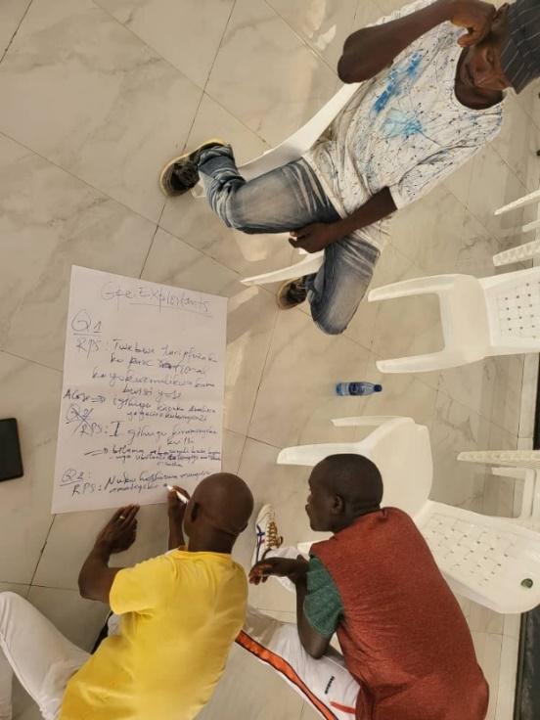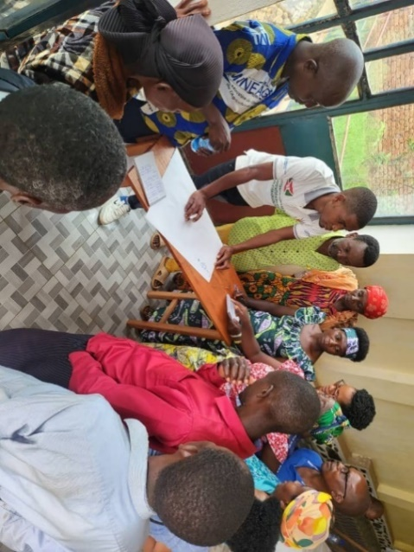

**Group work at Mabayi group work at Palmeraie sector**

**Technical workshop for the validation of the dossiers for the proposal for the creation of the** **Rusizi and Kibira biosphere reserves**

From the 2-6 of December 2024, another workshop held in Bujumbura which validated the proposal dossiers for the creation of the Rusizi and Kibira biosphere reserves. The workshop analyzed the dossiers for the proposal file and sketched out upcoming activities. In advance of the validation mission, several virtual meetings held during August, September, October and November 2024 virtually.

The validation workshop facilitated input during the workshops and ensured that the MAB aspects have been taken into account in the completion of the forms, ensured stakeholder engagement in the creation of Biosphere Reserves, validated the criteria for the designation of biosphere reserves, proceeded with the layout and formatting of the files for the proposal to create the Rusizi and Kibira BRs, carried out the technical analysis of proposal documents and made a planning sketch of upcoming activities.

During the workshop, persons were identified and appointed to fill out the different parts of the form, the form was reread, amended and the proposed text was reoriented. After the completion of the form, a general presentation of the form was made followed by corrections and recommendations. Remote monitoring of the completion of the two proposal forms was done as seen in annex 15 (points not provided in the form).

**Reflection committee on activities to be carried out during the first quarter of 2025 concerning the biosphere reserves under construction of the Rusizi (PNR) and Kibira (PNK) in Burundi.**

**Timeline of future activities in 2025**

|  |  |  |
| --- | --- | --- |
| Period | Person in charge | Activity details |
| As of December 20, 2024 | Bandiougou Diawara | Establishment of a Committee Whatts’app group  Definition of expected activities |
| As of December 2024, | Bandiougou  Virtual Meeting | Holding the group's first virtual meeting  Assignment of tasks |
| As of 31 January 2025 | Amadou Boureima | Draft brochure on the Rusizi and Kibira RBs |
| As of 15 February 2025 | Amadou Boureima | Drafting of a training module for the two curators, the OBPE and the UNESCO MAB committee. |
| End of February | Virtual meeting | Virtual meeting |
| 15 March | Bandiougou and Boureima | Preparation of mission to Bujumbra for training on Biosphere Reserves |

# **UNESCO global priorities, priority groups and cross-cutting approaches**

The project contributes to strengthening the mechanisms for conserving and enhancing these sites, including cooperation and experience sharing with other designated UNESCO sites around the world. In a cross-border context, this dual designation (biosphere reserve and world heritage site) will help promote regional integration, greater social cohesion, sustainable development, innovation and the promotion of peace between peoples. In addition, through the development of tourism activities, this project will help boost the local economy, reduce poverty (SDG 1) and generate jobs for young people.

Overall, the implementation of this project will contribute to several international agendas:

* Kunming-Montreal Global Biodiversity Framework
* The Addis Ababa Action Agenda (AAAA)
* Agenda 2063 of the African Union (AU)
* The 2020-2025 roadmap of the African Adaptation Initiative (AIA)

# **Involvement and ownership of direct beneficiaries, key partners and other stakeholders**

To achieve sustainable management of the natural resources of these protected areas, the project adopts a participatory management approach involving partners and beneficiaries at several levels.

The different beneficiaries

To date, project activities have involved many beneficiaries, including the Burundi National Commission for UNESCO, sectoral ministries and institutions involved in cultural and natural heritage, natural sciences, researchers from higher education institutions, media professionals and civil society players, youth and women's associations and indigenous peoples

Our partners

The partners involved in implementing the project come from a variety of institutions, organizations and administrations, including the government, private sector, civil society/NGOs and UN agencies.

* Bureau of Strategic Studies and Development (BESD)
* Burundi Office for the Protection of the Environment (OBPE)
* The Kibira Foundation
* Burundi Ministry of the Environment, Agriculture and Livestock
* NGOs supporting the protection and conservation of Kibira national parks (Wildlife Conservation Society, UNIPROBA, REPALEF/ANAPAC, etc.).

# **Risk assessment and mitigation preventive measures**

The Kahuzi Biega and Kibira Forest Sanctuaries project is a contribution to the enhancement of the great biological diversity of these protected areas. However, the project's implementation is subject to several anthropogenic risks. The Kibira National Park is home to a fully operational hydroelectric dam project, a seed site and a gold panning site. Recruiting and strengthening the management skills of park staff and reinforcing cooperation between stakeholders will improve park governance. Consideration should also be given to revising the park's boundaries and emphasizing participatory management with the promotion of alternative income-generating activities for the park's inhabitants.

# **Sustainability and exit strategy**

To ensure the sustainability of the project, the capacities of some thirty experts were strengthened for the implementation of the World Heritage Convention and the Man and the Biosphere Programme. Similarly, the roadmap was updated in a participatory manner with stakeholders, to encourage ownership and implementation of future activities.