**Burundi-UNPBF Impact Stories (2023 – 2025)**

1. **Project Identification**

Project name: **"Bakenyezi Dukenyerere Amahoro" Project: Promoting the empowerment and public participation of displaced women, internally displaced women, returnees and host women in Burundi**

Project duration: 28 months (January 1st, 2023, to June 1, 2025)

Place of implementation: Ruyigi Province – Communes of Ruyigi, Butaganzwa, Butezi, Gisuru, Kinyinya, Bweru and Nyabitsinda; and Rutana Province – Communes of Rutana, Giharo, Bukemba, Musongati, Gitanga, Mpinga-Kayove

Funding: United Nations Peace Building Fund (UNPBF)

Main partners:

* + **CSOs:** Concertation des collectifs des Associations Féminines de la Région des Grands-Lacs - COCAFEM), Dushirehamwe, Réseau Femmes et Paix - RFP, Youth Empowerment and Leadership Initiative - YELI
  + **NGOs:** Christian Aid Burundi
  + Local Enterprise Technology: BujaHub,
  + Research Consultants: University of Burundi

Target groups: 19,626 people (60% women, 11,775; 7,851 men) including 4,433 returnees, 787 internally displaced persons and 14,406 hosts in the 7 communes of Ruyigi province and 6 in Rutana province.

1. **Illustrative map of the areas of intervention (13 illustrative municipalities) of Bakenyezi Dukenyerere Amahoro**

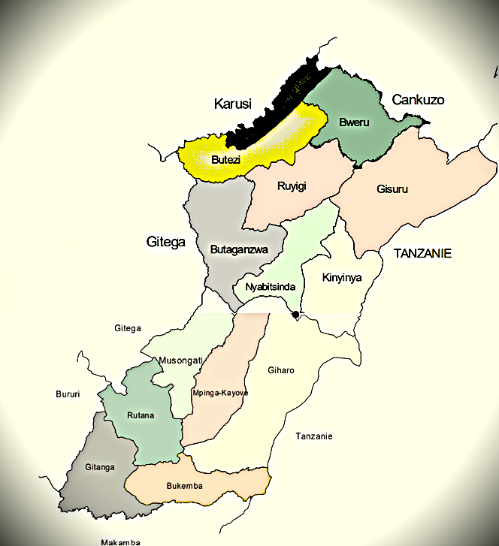

1. **Project Rationale**

The project addressed the systematic exclusion of displaced and returnee women from marginalization in Rutana and Ruyigi. By adopting a three-pillar approach, the project built the capacity of women-led organizations as a strategic tool to make women visible, at the local and national levels, and ensure that they are able to effectively pursue their strategic objectives and catalyse women's leadership as a tool for the promotion of peace. By using the multiplier effects of stronger networks, these organizations not only have built the capacity to reach communities more deeply as individual organizations with strong local relationships to mobilize and engage people locally, including in hard-to-reach areas, but as united collective entities, they have the ability to strategically engage for policy or institutional change. Strengthening women's meaningful engagement, the action supported the most marginalized women, including displaced and returnee women, to structure themselves, identify priorities and shape decision-making processes, informing gender-transformative planning and policy-making processes that meet their needs. The objective was to increase women's participation in decision-making spaces at the municipal and national level, to strengthen institutional equality between men and women, in particular through innovative pre-macro-trend technological strategies. Constructively engage decision-makers and communities to transform patriarchal norms that marginalize women, especially in rural areas, and leverage constructive masculinities as a tool to build knowledge and challenge harmful gender norms within households and promote new approaches to gender equality. At the institutional level, strategic engagement reinforced by an evidence base will help guide development plans to transform gender relations, working closely with those in power at the national level.

1. **Impact / Stories of change from the field**

1. “*I am overwhelmed by the acceptance I have experienced during all the interactions I have had with other network members*”, said Frédiane Mukakarera, an IDP from Gisuru Commune in Ruyigi province. “*To my amazement, all my ideas were taken on board by facilitators*”, she continued to say. Due to the situation of extreme poverty, Frédiane was living as a displaced person, she had been made to believe that she had nothing to share with others in public gatherings. Currently, she feels she is unstoppable. She was also voted as a member of the network leadership committee.
2. During the process of setting up new women networks in Giharo, Gitanga, Bukemba, Musongati and Rutana, excitement was expressed by madame Aulerie Bayisabe, a returnee who was voted to head the newly formed network officially named ‘Abakenyezi tuzamurane’. This was a result of a short competition organized to find a name for the organization. As they went into discussion groups, Aulerie took the stage and proposed the name that was accepted at group level and finally adopted during the plenary discussions. The event proved that host community members, IDPs and all others can trust a returnee to lead them. Mutual trust and acceptance of one another will certainly lead these women to greater heights so said a DPDFS observer from the Ministry of Solidarity.
3. Chartier Bavugamenshi and Spès Bigirimana from Buyaga village in Giharo on one hand, and Emmanuel Ndihokubwayo and his wife Jeanine Ndayisenga from Bayaga village on the other hand had almost similar testimonies. After they appreciated the workshop and the training they received on attitude and mentality change, the two couples were shocked to see how they supported wrong cultural practices that fan exclusion, selfishness, and gender inequalities for such a long time. They confessed to having taken a resolute decision to stop prejudice and embrace progressive cultural values and practices that encourage togetherness and development for all. They subscribe henceforth to values that characterize exemplary families and commit themselves to come out and share the enlightenment that they received by attending the training. According to Jeanine Ndayisenga and her husband, “*it is important that dark times cede to enlightened ones so that the continuity of life does not only experience the bad aspects of life, but also the good ones*”. To them, there is light at the end of the tunnel, so they said.
4. Domithile Nininahazwe is a teacher and a member of the commune development council in Musongati. She is also part of a network together with her colleagues from the same association. Her husband, Mr. Rémy Baranyizigiye, is a retired teacher with keen interest in supporting his wife in her endeavours of speaking for the voiceless. They were invited to attend the networks’ capacity assessment sessions and the consultation meetings as community key people with a wide range of experiences. During the two occasions, the two had remarkable understanding of issues to such an extent the facilitation team always appointed them to lead discussion groups. When the PBF team met them, they appreciated the move of organizing women in networks and helping them acquire a constitution and a leadership structure so that they can be effective. According to the husband “*a group of people without a leadership structure is like sheep without a shepherd*”. They made an assertion that the coming of the PBF is a game changer for women considering that they have been struggling with several issues that will now be a thing of the past.
5. One couple, Nijenahagera Gérard and Niyonzima Pélina, were frank and painted a gloomy picture of their relationship. “We do not support one another. In fact, one can hardly know what the other one is planning or doing. However, we wish to confess that this training was an eye opener because we have now realized our shortcomings and what we have lost”. “We are going to change”, said the husband. “I am going to support my wife in her desire to start a campaign and stand to be elected because her victory is my victory”.
6. In Butaganzwa commune, Diomède Nizigiyimana, a member of the Social Cohesion team in his community confessed that he did not know what to do whenever people came seeking for his help. However, after meeting the consultants sent by Dushirehamwe to help his team develop strategic plans and related critical actions to achieve them, he is convinced he is now a better person. When asked to share his viewpoints, he had this to say: “*I am amazed how skilled I am. It is as if all these things were simply hiding inside me, but I was not able to use them for the betterment of my people. This is because in this role, people assume & believe we are born wise*”. “*I am grateful to Dushirehamwe for making me a better decision maker, and a good servant of the people I lead*” so he said.
7. 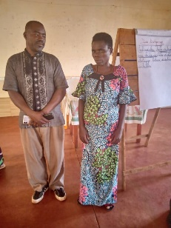The model couple of Barandereka Jean and his wife Habonimana Brandina from Kinyinya commune Kinyinya, Vumwe village had this to say: "*After the training of model couples on the gender transformative practices, we took time to evaluate ourselves on how we live together as a family and how we were able to see what works and what does not work for our household. We then made commitments to correcting all the mistakes so that we could help ourselves and also be an example to other couples"*. We started right away and moved rapidly, because our self-evaluation had indicated that we were far behind. Barandereka Jean continued to say that the major problems that existed in households in the entire neighborhood were related to the lack of dialogue between married couples, management of household resources and the failure for a married person to know the right treatment expected from a spouse. Luckily for us, the project taught us those things. He was quick to say that their success in sensitizing other community members during their outreach programme largely depended on the close collaboration and support received from the local authorities who were willing to see meaningful behaviour change in communities under their authority.
8. 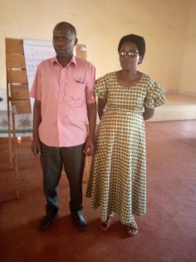The couple of Araje Dieudonné and Niyibigira Jeanine from Kinyinya village of Kinyinya commune shared this: The training of model couples on the transformative gender practices through the "faithful house" approach had profound impact in our household. From the time we started attending training and workshops, we agreed to put our acquired knowledge to the benefit of our neighbours. We were first transformed and then went to transform others. Love has grown in our household. We plan together as a couple and hold discussions on every undertaking that we start. Whenever there is a misunderstanding, we sit together and find solutions. No one thinks of breaking the other like in the past. During our community counselling sessions and households’ visits to resolve community conflicts same things we do in our household We gained knowledge to be able to help other couples in the community. My wife and I have so far helped twenty-four couples, and they are living well together. All 24 couples had almost similar problems such as the lack of trust in each other, drunkenness and domestic violence. Often couples find solutions after our visit. Multiple training/sensitization sessions in the community have helped change the situation
9. 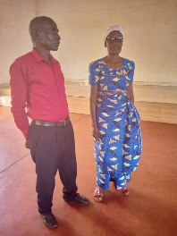The couple of Ntabiriho Fréderic (the man) and Bazikwankana Léa (wife) from Kinyinya commune, Kabanga zone and Nyamusasa hill have a lot they appreciate regarding the training received of the model couple’s approach. They learned transformative gender practices through the "faithful house" approach and were dispatched to go and sensitize others. The couple says that they have acquired new knowledge. Now, before sleeping, they hold a discussion to share what happened during the day and plan for the day ahead. This aspect on its own has brought harmony to the household and has made the couple very productive. Household assets have increased significantly.
10. In a conversation with the monitoring team, Madam Magnifique Ndayizeye who leads the Bukemba network with 299 members had this to say on her newly acquired leadership position: “I feel proud & shocked when I am solicited by community members more that our village head. Initially, I thought the village head would be jealous and start fighting me. However, he started supporting. He is my friend and a colleague with whom we labour together solving people’s problems. We have committed ourselves to being accountable. We want to be just and honest with the people we lead, and our community is happy about it. He has earnestly helped me usher network members requests to the Commune Administrator and most of them have been resolved. I am confident that our continued collaboration will yield even better results in future for the betterment of our community. Magnifique has created a ‘special action group’ made of wise women in the network to deal with special community matters that need privacy and wisdom to handle. Such matters include issues of witchcraft, sorcery, divination, worshiping of spirits and false gods together with sexuality in households.

1. The human impact is also demonstrated through the testimony of women within the networks collected in their joint statement as was presented by Christine Ndayizeye, Makakwe Hill, Musongati Commune: “All human beings are born free, equal and destined to enjoy human rights and dignity equally. The coming in of greedy and power-hungry people brought with them wickedness. They formulated gender norms and cultural practices that are discriminatory and enslave other people who happen to be women. To see that we can as women realize that we have been at the receiving end and can now craft strategies and influence policies formulated to take us out of that quagmire is beautiful and satisfying. We are glad that even the environment we operate in is changing and are now able to secure the support of our former oppressors who happen to be our grandfathers, our fathers, husbands, brothers and brothers-in-law. Now that our eyes are open and we are ready to act, we shall work hard and hold onto our newly acquired position to change the status quo forever. This statement is compilation of various opinions expressed by women who underwent gender-transformative training and workshops during the reporting period throughout project implementation areas.
2. The testimony by Madame Eduige Niyizigama, the women's league chair and member of the Gisuru communal council in Rutana indicates that works speak louder than words and carry more meaning in the campaign process. “The idea of getting myself elected was based on my achievements in my career, the low representation of women and the fact that women have nowhere to complain when they have problems. At school, I was always a students’ representative because I wasn't shy or scared. When I reached senior high school, I became chairperson of the Board of Student Affairs. When I started working, I became a member of the neighbourhood watch committee (Abakanguriramahoro). In the process, I built up trust and confidence. I built good relations by resolving conflicts & facilitating social cohesion. My husband and the people I served provided a strong bridge to help me get elected. I became headmistress of the school and the students’ parents were all my supporters and voters. During the campaign period, I could see that I had an advantage over my competitors. I was well known both by community members and government authorities. Even in my position of authority, I remained loyal to my husband. I organized household activities even though my husband did most of the work, I gave him credit for that. I was always cautious and reasonable in my dealings and believed in God to guide my decision-making”.
3. **Testimony of Nahayo Venantie, teacher and member of the Gisuru municipality**

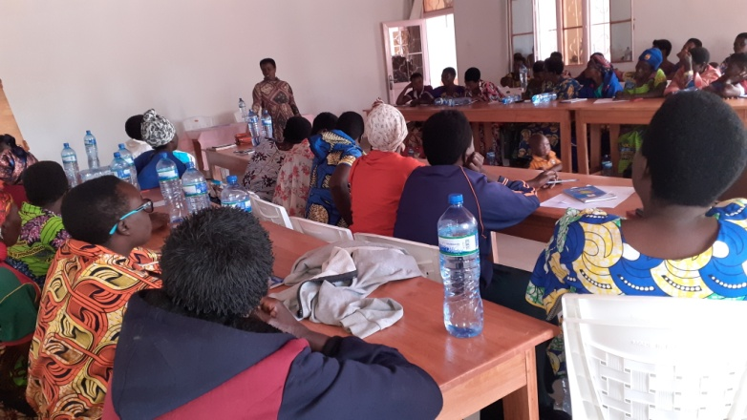"I am a native of Rusengo in Ruyigi commune and I am married to a man who lives in Gisuru commune. Our family is mixed as I come from the Tutsi tribe while my husband comes from the Hutu tribe. We do not share tribes, but love has brought us together, and I am happily married. I am a teacher, and I am a member of the Gisuru municipality council. At first, I wasn't motivated to get elected. I thank my husband for his efforts to make me understand the positive side of joining the local leadership team. He told me that as I am of the Tutsi ethnic group, I am lucky to be elected given that on his native hill of Migende, the Tutsi are very much in the minority. I was scared but as my husband supported me and made me aware, I finally agreed. He had me enrolled on his native hill and he helped me to do the campaign through his friends and colleagues. I was the 5th and at the commune I was proposed on the list of members of the communal council, and I am the vice-president of the council. I was also proposed on the list of parliamentarians as a substitute, and I participated in the parliamentarians' campaign. This time, I hope to be a parliamentarian in the next elections.

At the beginning of my mandate, I was afraid. I didn't have confidence in myself, and I didn't see what to do and now as the president of the municipal council resides in Bujumbura, I can hold a meeting and speak in public. On the hill, as I'm not a native, I didn't see what to do. I didn't have confidence in myself. I had trouble standing in front of others and during the campaign I spoke with fear. I was able to overcome fear and that's why today I'm in front of others. To gain the trust of others, you first need to assert yourself without being arrogant and facilitate the services of the population. My election on the Hill has allowed me to be a true leader who facilitates public conflict. I advise you, my sisters, that in order to be elected to political office, one must improve behaviour in the neighbourhood by facilitating conflicts and providing advice without distinction and avoiding corruption, join political parties, get elected with confidence to win elections, and improve relations with neighbours."

## **Testimony of Gasago Charlotte, member of the Butezi municipal council**

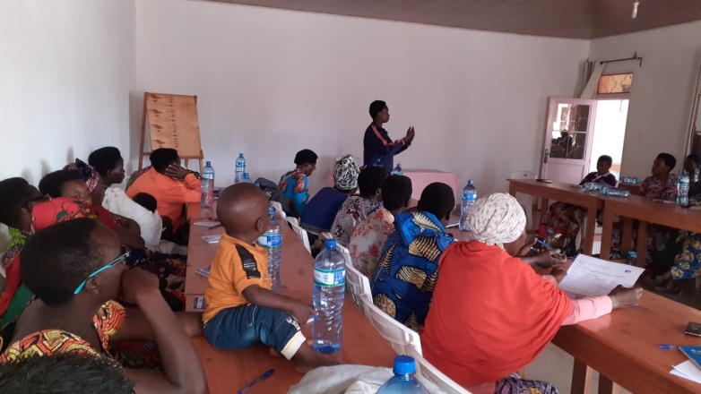"I am the 11th child in the family of 14 children, including 7 boys and 7 girls. I am the director of a school, and I am a member of the municipal council of the Butezi commune. I was elected when I was 28 years old. At that time, I was unemployed, and I was pregnant. I used to be a member of the CNL party, and my husband advised me to change the party. I immediately wrote a letter of application to join the CNDD FDD party and I was officially a member of the party. I was then elected on my native hill. During the election campaign, I would pass through the fields and valleys where people were farming and there, I would sensitize them to adhere to my ideals so that I would be elected. I also went from house to house to ask to be elected. I went to the level of associations to do the campaign. Those who told me that they were thirsty or that they needed soap, I gave them a little money. As I was of the Tutsi ethnic group, there were some who said that the Tutsi had governed badly and had hurt the country. Others said that women are strict and are not used to leading. I put them at ease by answering that we shouldn't go back to the past. My husband gave up on being elected and came to support me in the campaign. In the hill elections, I was the 2nd, and I was on the list of members of the municipal council. There were people who came to tell my husband in vain that I was going to dominate him and be a woman, a man who was a member of the municipal council with whom I would be working. I would like to emphasize that the conditions for being elected are, among other things, to have a good peaceful cohabitation with the husband, to participate in the various meetings by giving opinions and considerations to show presence, to be worthy of one's name (avoid drinking a lot, to come home very early, not to talk much), to improve good relations with neighbours. The example is that I let the neighbours have water for nothing at my house and then I told them to make small contributions to be able to pay to REGIDESO."

## **Testimony of Niyibona Eléonore, permanent executive secretary of the commune of Kinyinya**

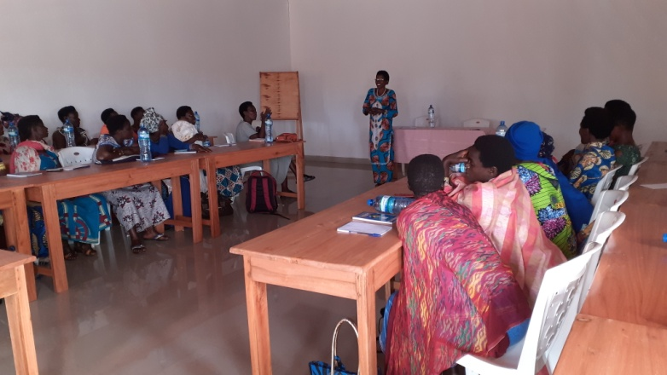"The idea of getting elected came to me in 2009 when I had just finished my university studies at the École Normale Supérieure (ENS). I was an activist in the political party to be recognized and to have chances in office and I was officially welcomed in 2010 into the CNDD-FDD. During this year, I was elected to the municipal council, and I did not have the chance to be elected because I was in last position (30th). However, I was lucky enough to be elected leader of the women affiliated to the CNDD FDD party at the communal level. In 2015, I was again elected as a member of the municipal council, and I was still the leader of the women affiliated to the party. During the campaign, my husband would take me up the hill on his bike and I would go from house to house, and I was elected.

During this period, as a challenge, I did not have the means, and I managed to participate in the various meetings that were often organized in the capital of the province Ruyigi. I was looking for 2000 FBU for catering and 2000 for the bike taxi from Kinyinya to Nyabitsinda and I was walking up Mpungwe Mountain to the Ruyigi center. On my way back I did the same thing, leaving the centre on foot to Nyabitsinda commune and taking a bicycle taxi from Nyabitsinda to Kinyinya commune. At that time, I was pregnant. In my commune, I organized meetings for women affiliated with the party and participated in municipal council meetings in addition to my daily service. In 2020, I was elected again with precarious means, always with the bike that my husband used to carry me up the hill. I was the first on the hill and I occupied the 3rd place in the municipal council. In 2021, I was appointed permanent executive secretary of Kinyinya commune. I was alone at home because my husband was working in Bujumbura and he went up during the campaign to support me. I would have to organize the family because there were times when I didn't have a worker at home and I was preparing everything the kids needed. At that time, I was working at the District Centre of Education (DCE). I should organize how the children go to school, go to eat, do the children's laundry, and participate in party meetings, communal council, and party women and go to the service. If there was a meeting that required a fee, I would notify my husband, who would send me a little money via Lumicash and sometimes I preferred to leave the money for food at home and go to the meeting without money. The other challenge is the jealousy of the men who didn't want me to emerge. They tried to make false accusations against me so that I would be removed from the electoral lists drawn up by the party, but in vain. With the position I currently hold, I have good relations with the population whom I warmly welcome and my supervisor who is the administrator accuses me that I will succeed him. However, I will continue my work despite these false accusations from my supervisor. I advise aspiring women candidates in the upcoming elections to be brave and bold."

## **Testimony of Munezero Lucie, women's league of the communes of Gisuru, Nyabitsinda and Kinyinya**

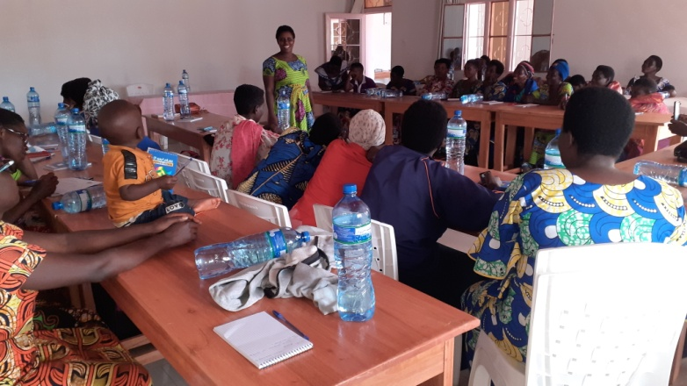 After seeing how some women are mistreated by their husbands, despised, the idea was born in me to get elected so that women are represented in decision-making bodies. Before going to get elected, I asked my husband for permission. Afterwards, I gathered some women around a drink to ask them to campaign for me. My husband also helped me campaign among his friends and colleagues. Some discouraged me, saying that an unemployed person cannot face employees, shopkeepers and senior executives. Some men told my husband to prevent me from getting elected, saying that if I am elected, he will be denigrated and will no longer have a say in his household. I continued because my husband and many of his friends supported me. This is how I was elected leader of the CNDD-FDD women's league in the communes of Gisuru, Kinyinya and Nyabitsinda and we cohabit peacefully with my husband. To be successful in elections, you must join the political party and behave worthy of a woman. My advice to my female colleagues is to put themselves forward for any position because they are capable, to strengthen good cohabitation with their spouse, to get elected after consulting their husband, and to strengthen good relations with those around them and members of society.

## **Testimony by Niyibitanga Diane, Bweru Commune Administrator**

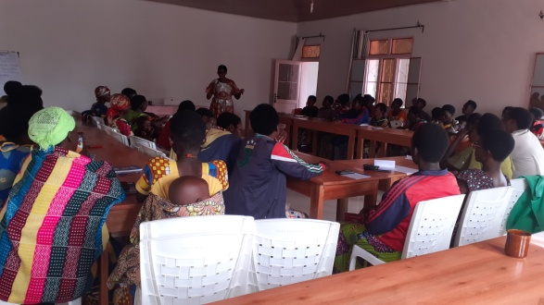“When I was elected commune administrator, I was faced with challenges; the people who were supposed to be my collaborators set traps against me plotting for my failure. These people wanted to disturb me so that I would be branded incapable. They expected to take over my position when I am finally kicked out of the position. However, I have the support of my husband, who was receiving false information to the effect that I was behaving badly, that I was committing adultery with my workmates (the other directors). I was worried about the fact that the children didn't live with me, and also that the commune didn't have sufficient means to meet my needs. I also have the support of the local population. They're all welcome in my home, without distinction or quid pro quo. My efforts also come from the various bodies and associations working in the commune, who congratulate me and encourage me to perform well. My behaviour has enabled me to perform well, namely humility, wisdom, intelligence and asking for advice. I advise you not to be afraid and to have self-confidence, to avoid selfishness, to prepare for the elections by looking for the necessary documents, including your identity card, and to seek your spouse's permission and support. If he or she doesn't agree, go through a third party. Once you've been elected, you'll need to work to satisfy the population. To achieve a satisfactory level of representation for women, it is necessary to raise awareness among women and men, and this can be achieved by associations, networks of associations, women's forums, the media, churches, political leaders and others who carry a voice further afield”.

## **Testimony of Hakizimana Jacqueline, member of the Ruyigi communal council:**

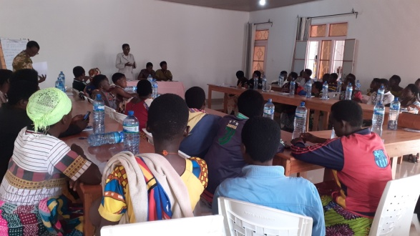“My strategies were to join a political party, associations to get sufficient information and to participate in the various meetings. When I had the idea of getting elected, I told my husband and he agreed. In 2005, I served my first term on the local council. I took an active part in the campaign, and the means came from the household. To keep my husband supporting me, I showed him that political activities can go hand in hand with household activities. I was elected again in 2010. In 2015, I took a rest and resumed in 2020. In that year, I was elected on the hill where I was born. I live in the centre of Ruyigi, and my native hill is Nganji hill in the Rusengo zone. I campaigned despite the distance, which didn't make it easy for me, and I came out first and was then elected to the local council. To succeed, the strategy is to try to understand your spouse, inform him of your plan to get elected, and if he doesn't accept by any means possible, you have to drop the plan. It's also important to improve relations in the neighbourhood through service, humility and self-confidence. As for the work of the local council, we meet once a quarter. We submit questions from the population, and we plan the activities that the secretary, who is the administrator, is going to carry out and the related budget”.

1. **Testimony of Niyizigama Eduige, women's league and member of the Gisuru communal council**

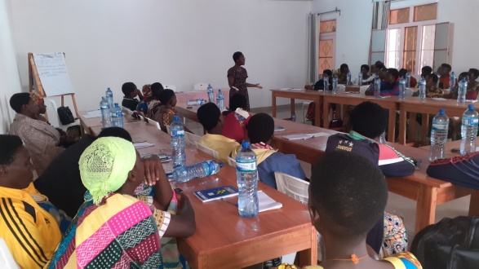“The idea of getting myself elected was based on my achievements in my career, the low representation of women and the fact that women have nowhere to complain when they have problems. At school, I was always a delegate because I wasn't afraid. When I reached the senior cycle at Notre Dame de la Joie school, I became dean and as an association, I was among the Bakanguriramahoro. In terms of neighbourliness, I've built good relations by facilitating conflicts. My husband and the people I served provided a strong bridge to help me get elected. I was headmistress of the school and the parents of the pupils with whom I had good relations supported me. I also used the antennas to campaign. On terrain from the countryside to the hills, I was with competitors who had more means than me. I was with my brother-in-law, my cousin, and the other working in Bujumbura, and despite this observation I came out on top. As well as being a director, I'm a member of the local council and leader of the women affiliated to the CNDD FDD party. I pay my respects to my husband and organize household activities very well. There are times when there are multiple activities requiring travel to Kinyinya, Cankuzo, we agree with my husband to have the necessary means. My advice to aspiring women is to get elected with the support of their husbands. At the congress for women affiliated to the party, I first asked for my husband's support. There are some women who behave badly and start denigrating their husbands by coming home drunk and late without apology. Being in the decision-making bodies, you're still a woman at home, in charge of organizing household activities. Make decisions after consulting others, not forgetting your spouse, who is the main advisor. Work transparently: if you have to draw up a list of the destitute, do so transparently and do not include allies or others with whom you have relations; work in good collaboration with all the staff under your supervision, avoiding creating groupings among your subordinates; above all, trust in God, know how to combine household and public activities. Prepare so that the family doesn't miss anything while you're away from home”.

## **Testimony of Mbonihankuye Violette, Women's League and member of the Butaganzwa municipal council**

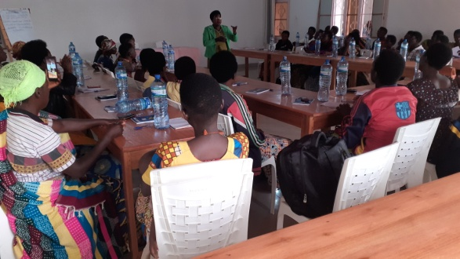“I have four children, three boys and one girl. I am a primary school teacher and a supervisor. I am originally from Gitega. I started running for office when I had my first baby, who was seven months old, in 2012. My husband encouraged me and helped me during the campaign. I was elected on my husband’s home hill in the women’s forum elections and came out on top. At the municipal level, I feared the elections because I was competing with the administrator’s wife at the time and other women who were more intellectually advanced than me. After voting, I hid nearby to wait for the election results. I was vice-president of the women’s forum and was chosen as the leader of the women affiliated with the CNDD FDD party in the area. Luck was starting to smile on me because I had the opportunity to regularly participate in the various meetings. I strengthened my knowledge.” I then learned how to stand and how to deliver a speech in front of the public. Afterwards, the president of the communal women's forum was appointed provincial secretary of the women's forum and I replaced her to be president of the women's forum at the communal level. In 2013, the party appointed me representative of the women's league at the Mugege zonal level until 2020. In 2015, my husband, who was a director for a long time, got elected and prevented me from getting elected on the same hill. I kept asking him to let me get elected and finally he agreed with multiple pleas. I then put my own antennas to campaign. The elections on the hill took place when I had a meeting of the women's forum and a woman hill chief at the time campaigned in my place as a thank you for the support I had given her. My husband was the 1st and I was the 4th and another competing lady was the 5th. At the commune, I was selected as a member of the communal council. My husband helped me to go and get my file from my home in Buraza commune, Gitega province. I was among the people proposed by the commune to be communal administrator but in vain and I remain a simple member of the communal council. As a member of this council and a woman, I am a member of an association of elected women called ACCO Burundi. In the communal council, I actively participate and sometimes we are invited to seminars where we benefit from certain monetary advantages and I am proud of it with my husband. In 2021, I was elected leader of the women affiliated with the CNDD FDD party in the commune. However, problems are not lacking. On the municipal council side, the projects put forward during the hill campaign are not implemented since we must comply with the PCDC program and the population accuses me that I did not advocate for its projects. On the side of the women's league, I deplore the lack of resources to organize meetings with members and to quench thirst after meetings or activities. As advice to women candidates for the 2025 elections, it is necessary to create and consolidate a good understanding with the spouse, have humility, be smart to thwart the maneuvers of competitors, set up antennas everywhere that can facilitate the campaign, carry out income-generating activities and save a part for the next elections, humbly and constantly advocate for women whose husbands prevent them from being elected.”

## **Testimony of Ahishakiye Anastasie, administrator of the Nyabitsinda commune**

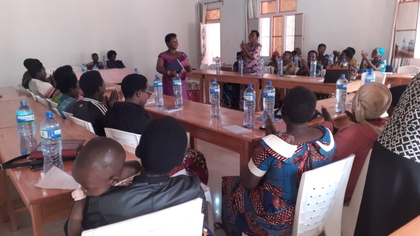"For the 2015-2020 term, I was elected leader of the women affiliated with the CNDD FDD party and I was a school principal. For the 2020 elections, I was not elected. Like any official, I was responsible for organizing the hill elections of members who wanted to be elected to the municipal council and reporting the results to the municipality. These results were sent to the provincial level and that's where the officials within the municipalities were aligned on the list of municipal council members in addition to the others who were elected at the hill level. This is how I was proposed as a council member and then administrator. In these positions, there are no shortage of problems. When it started to be said that the municipality would be led by a woman, people were looking at me and some men were asking my husband if he was ready to give up his wife to other men. My husband, with whom I am on good terms, was not affected by these comments. It is thanks to him that I was able to participate in the various party meetings because I used family means with his agreement. During the campaign I had a 2-year-old child. When I was held up by certain party activities, my husband was notified and came home very early to take care of the children, including the 2-year-old. The Nyabitsinda commune has been successively led by women 3 times and the men did not welcome him well. At first, they scared me and tried to show their discontent by saying that Nyabitsinda had become a commune dedicated to women. As I was already the leader of the women affiliated with the CNDD FDD party and the director of a school, I was used to being responsible and leading a group of people. The beginning is not always easy. The level of education is not the only basis for good leadership, but intelligence allows one to perform better. During the past 4 years, I have tried to improve my performance. First of all, I organized a meeting of the administrators and we clarified the role of each one and the rest was to follow up if each one is doing their role. As an administrator, the other role is to submit the report to the governor on time. I must be active and work to the satisfaction of the population. The advice to give to aspiring women political candidates is: always have hope, participate in the various meetings and hill activities and ask for a voice if you have to say, look for the necessary documents to get elected and on time, improve relations at the neighbourhood level, work for women's rights and facilitate conflicts when needed, seek the trust of the population, never give bribes during the campaign, join associations and fulfil the roles very well there.

## **Testimony of Iradukunda Graciose, member of the Ruyigi municipal council**

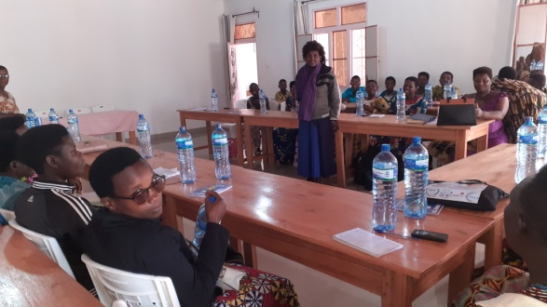I am an agent of Twikangure Microfinance. I started participating in a political party when I was a 13th grade student. I was the dean of the school. The CNDD FDD party asked me to join the party, and I accepted. That's when I took the opportunity to raise awareness among students about electing the CNDD FDD party. At university, I continued to participate in party activities in the province and I was elected deputy representative of CNDD FDD party members native to Bururi province and then party members of the communes of the Bujumbura City Hall studying at universities located in Bujumbura. I was elected representative of women CNDD FDD party members native to Bururi province and those studying at universities located in Bujumbura. In 2017, I got married in Ruyigi province to a husband who did not prevent me from participating in party activities. I responded to local development meetings and activities organized by the elected officials and the party, and sometimes I put forward constructive ideas. During the 2020 elections, while I was unemployed and pregnant, I was elected on my husband's native Gahemba hill. The latter supported me enough in the campaign. I went to the women leaders of the hill to campaign with the other women who constitute a large electorate. I did not forget to mention the men leaders to campaign for me even if they asked me for beer. I was elected first. That's how I became a member of the municipal council. I was not lucky enough to be elected administrator since I occupied 2nd place. Afterwards, I had work and I participate in the various meetings and monitor the hill projects. It is an honour to be part of the decision-making bodies. As challenges, during the elections, I was unable to satisfy everyone who asked me for beer bribes or material benefits. Sometimes the population suggested projects to me to submit to the municipal council, and due to lack of resources, these projects were not given priority. As advice, participate in the various meetings and gatherings, be visionary by submitting constructive ideas and setting an example, do not come home late, do not try to dominate the husband, denigrate him, and improve behaviour in the neighbourhood.

## **Testimony of Nininahazwe Evelyne, member of the Ruyigi municipal council**

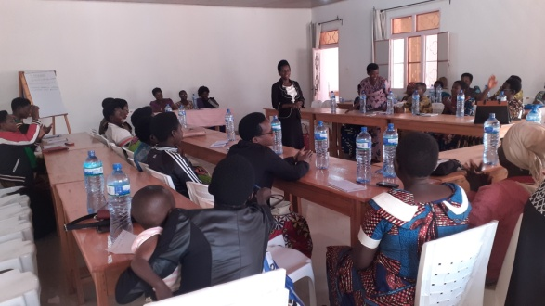I started politics when I was still single and I was always in the bodies at the communal and provincial levels. I will say what is recent. I was elected on the hill and now I am the women's leader in Ruyigi commune. It was not easy because I married a man who works elsewhere in Kirundo province and he was told to withdraw me from the party at the risk of having more means than him. He did not consider these words. Being a teacher, I did not have sufficient means to allow me to campaign and my husband helped me by paying for my guarantee fees and facilitating my travel. With him, we were threatened by the youth of the CNDD FDD to force me to abandon politics. Despite these threats, I continued the activities of the CNL party and if I spoke with the people of the CNDD FDD party, some said that I became a member of the CNDD FDD party. I was even proposed on the list of senators as a result of my courage. I am a woman who is consulted by most people without consideration of political affiliation and I am sure that I was elected by some members of the CNDD FDD party in addition to members of the CNL party. The advice to give is among other things to have good behaviour in the neighbourhood, show that you are capable, be united among us women to elect capable women, join savings and credit associations to prepare yourselves financially for the next elections.

## **Testimony of Sibomana Clôthilde, member of the Kinyinya municipal council**

**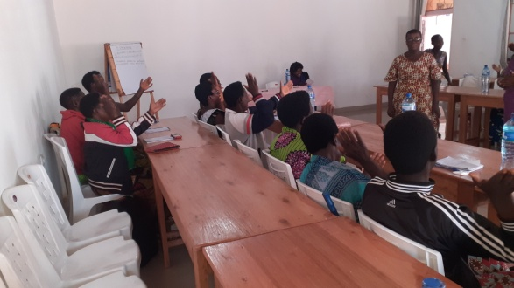** I am the Director of ECOFO, representing the Sangwe cooperative at the hill level. To integrate into the political sphere, I was inspired by my husband and my family who were and still are members of the CNDD FDD political party. In addition, my husband is in the governing body of this party. This influenced me to be an activist in the party and I am proud of it. To be proposed and to be elected, it was not by chance because besides being an activist of the ruling party CNDD FDD, I was Director of ECOFO and representative of the Sangwe hill cooperative and a solidarity fund of my hill. From where I had many opportunities to be close with the population of my hill, to exchange with them on the various political, social, educational, development and other issues. My campaign was easy for me because the majority of my hill already knew my talents and they accompanied me through the households. As challenges, I can mention the lack of means because my relatives asked me for tips at the end of each day of campaigning. Other challenges, some men were against the female candidacy supposedly that once elected, women will no longer respect men. During my term, as a member of the municipal council, I continue to supervise the Sangwe cooperative of my hill and the women's associations of my commune. In collaboration with the elected hill committee, we organize meetings to analyse the progress of the hill development projects that we prioritized during the campaign. I do this supervision throughout the commune because I am a member of the municipal council commission responsible for development. We also continue to welcome other project proposals and grievances that we analyse together and transmit them to the hierarchy if necessary. I conclude by advising my fellow aspiring women to have exemplary behaviour, to participate in the various meetings and in the associations, to give opinions and considerations on community issues to demonstrate their leadership. I also invite them to support each other during the campaign, to avoid tips in search of votes but rather to behave in a model way.

## **Testimony of Akimana Christiane Cécile, member of the Gisuru municipal council**

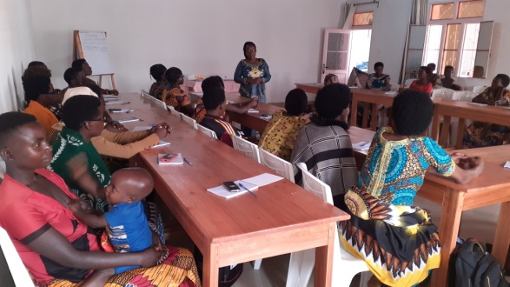I am a teacher and a member of the municipal council from the CNDD FDD party. What prompted me to run for the municipal council was to represent my hill, to help it meet certain development challenges. Supported by my husband who works in Kirundo province and who is often consulted to carry out any project, I launched into the campaign in front of competitors who were more important than me given the positions they held while I was a simple teacher and I was pregnant at that time of campaign. In front of the population, as a social project, I said that I will raise awareness among school-aged children and those who are in school to love school, which is the basis of development. I will also raise awareness among parents whose children have dropped out of school to get them to return. As a strategy to be elected, I strengthened dialogue with my colleagues, my friends, the parents of my students and neighbours to support my candidacy. In the municipal council, I work with the other bodies located on the hill to intervene if there is an issue to resolve and those that are beyond our competence are put to higher levels. However, given that the Kinama hill for which I am responsible is vast, any problem that occurs there is brought to my attention late. To meet this challenge, I try to be in regular communication with local elected officials. I give advice to my colleagues by telling them that during the campaign period, you, the candidates, will present a social project that you will be able to implement otherwise the population risks revolting against you. Ask advice from colleagues and especially your spouses before making decisions. I give you a wink to have behaviour worthy of your names such as: being fair, humble, honest, discreet, having confidence, being true leaders without inclinations and always seeking to uphold women's rights.

## **Testimony of Ntezukwigira M. Chantal, member of the Bweru municipal council**

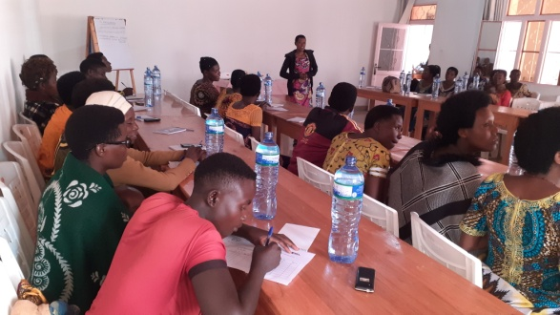“I got the idea to get elected when I noticed that the people in my locality did not want to get elected and after having the agreement of my parents since I am still single. In the middle of the campaign I told the population that I am at their service since I was unemployed. I went from house to house to make people aware to vote for me. There were some who listened to me, others pushed me aside while others spoke to me badly. I came out the winner and that is how I was proposed to the municipal council. Being a member of the municipal council makes me proud since I am still young and single, which happens very rarely. On the hill for which I am responsible, I am not disoriented because of my age, quite simply all the bodies of the hill consult me if needed.”

## **Testimony of Kanyamuneza Janvière, member of the Butaganzwa municipal council**

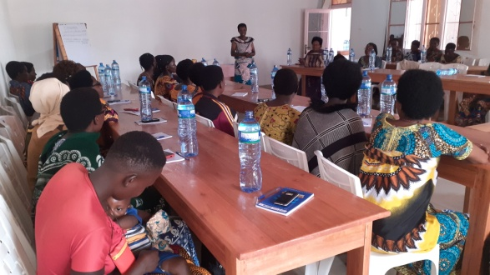"I am a member of the CNDD FDD party in Butaganzwa commune and I am responsible for the ruling party's women's league at the zonal level. As an activist in the ruling party, the idea came to me to get elected to the municipal council. When I spoke to my husband, he accepted. I was first elected as the head of the CNDD FDD party's women's league. During the campaign, I promised the people of our hill that I would help them in whatever way I could. I set up a propaganda committee, including the head of the Imbonerakure and a wise man from the ruling party, who set about seeking votes throughout the hill and in the various hill associations. I also used the strategy of dialogue with the people of the hill by asking them about the most frequently encountered problems and I promised them to propose alternative solutions once elected. They accepted and I was elected and proposed as a member of the municipal council. I facilitate any problem regardless of ethnicity, religion, political party and other. The challenges I face are such that major problems presented to the municipal council may not find solutions and the population of my hill accuses me of not having done enough advocacy and risks judging me incompetent. After the various meetings and development activities, the population always expects me to give them something to drink when I have no means to do so. As advice to give to aspiring women candidates is to be faithful, tell the truth, not be a prostitute, not be a thief, not be a drunkard, live peacefully with your spouse and neighbors, not divulge secrets.

## **Testimony of Semugara Antoinette, Administrator of the Ruyigi commune**

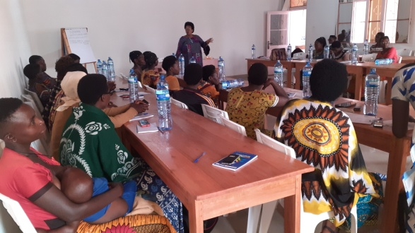 At Murore Secondary School, I was elected dean. After school, I got married and I behaved like Burundian women when it came to respecting my spouse. I informed him every time I left the house and I only went out with him. Afterwards, I wanted to join the Dushirehamwe association, but it wasn't the appropriate time for membership. That's how I joined the Nyubahiriza association and others. I was elected to the association's bodies, and there I learned that there are women elected as administrators and parliamentarians, and it became a dream for me. I finally joined the CNDD FDD party and, with my husband's permission, I actively participated in membership fees, activities, and meetings, expressing opinions and considerations. I joined savings and loan associations to have money to contribute and not always ask my husband for money. During the elections, I was elected on the hill and among the 5 people, I was the first. This required me to overcome fear, to have courage, to have confidence, to strengthen good relations and to have good cohabitation. In the municipal council, I proposed myself as administrator and fortunately I found that the commune was proposed to be led by a Tutsi woman which gave me luck. During the campaign, despite the discouragement from the men and women that I would not be elected, I kept the courage and I continued. I lacked the financial means for the campaign and we should strengthen harmony in the household. In the position of administrator, there were people who set traps for me to fail. There were some who told me that the commune is used to being led by men and that I, as a woman, would not be up to my duties of leading the commune. There were even people who flouted the law and insulted me, especially when I fought against illegal drinks. At first, I was afraid, but little by little, I got used to it. The strategy for improving performance is to evaluate it every day, increase the number of advisors, friends, etc. Because I would like to end my duties in style.

## **Testimony of Sophie Ndihokubwayo, vice-president of the Butaganzwa municipal council**

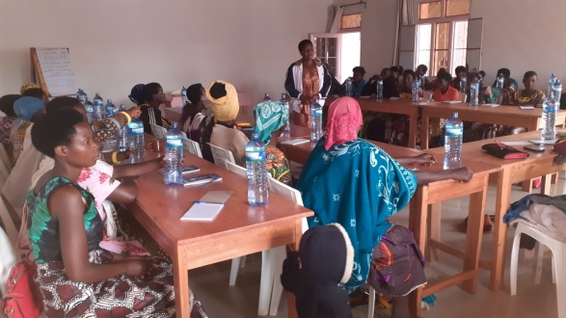 I am a teacher supervisor at ECOFO Kirangara and mother of 7 children including fraternal twins. I am the provincial president of the women's league, vice-president of the municipal council, secretary of the CNDD FDD municipal office and representative of the REFECOM network. In 2000, just after school, I joined the CNDD FDD party where I actively participated in the party's activities and held various positions as follows: From 2005 to 2010, I was appointed vice-president of the women's league. From 2010 to 2015, I was appointed municipal president of the women's league and I was vice-president of the municipal council. From 2015 to 2020: President of the women's league at the municipal level and hill chief. I held these positions at the same time as the everyday job of being a teacher. On Monday, I taught the students and attended the meeting around 10-11 a.m. and in the afternoon I completed the teaching hours. From 2020 to 2023: President of the women's league at the provincial level, vice-president of the municipal council, secretary of the CNDD FDD municipal office, representative of the network of elected municipal women (REFECOM) in Ruyigi provinces. To hold the political office, certain criteria are necessary such as being loyal in society, good family relations, having a minimum budget to facilitate participation in various party activities. The barriers encountered include limited financial means since I am a simple teacher with a small salary, sometimes we are prevented from certain meetings and party activities. The low level of education is also a disadvantage for me. During the elections, competing men gave jugs of beer and unlike me who gave nothing. Being a leader is not easy, women with problems confide in me as if I can be up to solving all their problems. Some consider women politicians as people who spend their time wandering and commit adultery with their fellow politicians. As advice: join the political party, good cohabitation in family and neighbourhood, be honest (have good behaviour), be clean, be courageous and know how to combine political activities and family activities, do income-generating activities or join Sangwe cooperatives on the hills or other savings and credit associations to meet certain needs such as travel, contributions and others. As a parent, I would advise you to put children, especially girls, in school and encourage them to pursue post-university studies. We are governors because we have a level of education. In addition, women in politics must plan births in collaboration with their spouses to be able to easily participate in party activities and in the campaign.

## **Testimony of Florence Ntiharirizwa, member of the Butezi municipal council**

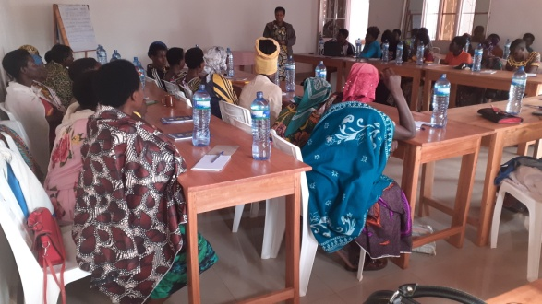I am a teacher at ECOFO Nyankanda and a mother of six children with a newborn. I am a Catholic and a member of the Justice and Peace Commission. In 2005, I joined the CNDD FDD party. In 2010, I was a member of the Independent Communal Electoral Commission (CECI) under the agreement of the CNDD FDD party. In 2015, I was proposed on the blocked list of members of the communal council and I was elected. For this term of 2020 to 2025, I am also a member of the communal council of Butezi and I am also a representative of the elected women of the commune in an association of communes of Burundi. In 2020, we should campaign individually from my husband's native hill called Munyinya because the people of my native hill of Bwagiriza do not know me. In the campaign, I was the only woman, and I was also of Tutsi ethnicity, and I held the second position. The first was appointed to a position in the provincial capital, and I was lucky enough to occupy his position. The strategy I used was to go through the members of the Justice and Peace Commission to campaign for me. In addition, I went through the woman of the Twa ethnic group who helped me campaign in her community. I tried to be a trustworthy person by participating in the various meetings organized and having a patriotic spirit. However, challenges are not lacking. Financial means, sometimes hindrances since I am a teacher, and the low level of education do not make me more comfortable. I conclude my experience by advising my fellow aspiring political candidates to join the political party, have good behaviour, have good cohabitation in family and in the entourage, be courageous, participate in development activities, in cooperatives and savings and credit associations, be a model in the community and birth spacing.

## **Testimony of Habonimana Joselyne, president of the Nyabitsinda Women's Forum**

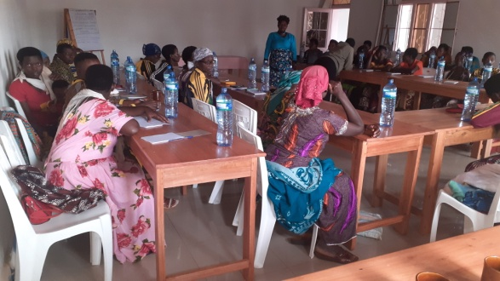I am a mother of five children, including four girls and one boy. I have been a teacher since 2004 and secretary of the CNDD FDD zonal office. Arriving in the Nyabitsinda commune when I was still 19 years old, I joined the CNDD FDD political party and was appointed, from 2005 to 2010, representative of culture, customs and morals in the zone. From 2010 to 2015: the CNDD FDD party appointed me representative of culture, customs and morals in Nyabitsinda commune. From 2015 to 2020: I was elected vice-president of the women's league in the commune and I am a member of the mediators committee in the commune. From 2020 to 2024, I am secretary of the zonal office of the CNDD FDD party in the Nyabitsinda zone, I am president of the women's forum in the commune. I am a cell leader in the administration and a cell representative (ten households) in the CNDD FDD party. To achieve this, it is necessary to have a good cohabitation in family and in society, to be punctual and faithful. I am on good terms with my husband who is an active party activist and who holds a position as a school principal. I give my body and soul to family and community development work. I try to improve my behaviour, to actively participate in the various meetings and in community work. However, I encounter some challenges such as insufficient financial means for travel and contributions, lack of time and low level of education. The advice to give to my colleagues is among others to join the party, to present themselves in development work, to encourage girls to pursue post-university studies, to make contributions requested by the party, to actively participate in the various meetings and to ask to speak when necessary, to strengthen good relations with members of society.

1. **Testimony of Ndayisenga Evelyne, president of CECI in 2010, 2015, 2018 and in 2020 of the Kinyinya commune**

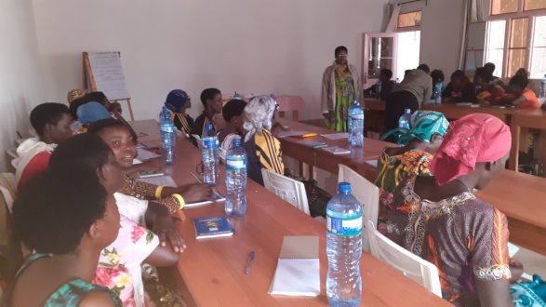 I got married in 2013 and I have 4 children and a pregnancy. It was in 2011 that I officially joined the CNDD FDD party after my university studies in the Faculty of Psychology and Educational Sciences (Department of Educational Sciences). After being informed that in Kinyinya commune, there were still vacant teaching positions, I went to this commune and it was from this year 2011 that I held the position of teacher (professor at LPC Kinyinya) until 2014 in October when I interrupted to join the electoral activities of 2015. The party offered me to be the president of the Independent Communal Electoral Commission (CECI) where there were a lot of activities and intense raids while I was breastfeeding a baby. The work of the CENI was very difficult and demanding. For example, I could travel late with the child and the maid, or even around 2 a.m. so as not to be late for a meeting. After the end of the mandate, I performed my usual teaching duties while continuing to carry out the activities of the CNDD FDD party. By surprise, in 2018, in the elections of the Referendum of the Republic of Burundi, I was again designated as president of the same CECI commission and I was able to carry out all the activities organized by the State in due form in collaboration with the members of the commission. After the end of the 2018 mandate, I resumed teaching activity until September 2019 when I was again designated president of the Independent Communal Electoral Commission (CECI). As organizer of the 2020 elections, the activities were similar to the activities carried out subsequently and these activities gave me a better performance and success. The three mandates I have held show that I, as a woman, am well recognized and appreciated by the surrounding community. However, obstacles are bound to arise. Spending nights and nights during elections for a woman requires exceptional qualities. The advice I give to my fellow women is to encourage women to run for government-organized activities, to enrol all school-age children, especially girls, in school, and finally to belong to a competing political party.

## **Testimony of Niyonkuru Isidora, member of the Bweru municipal council**

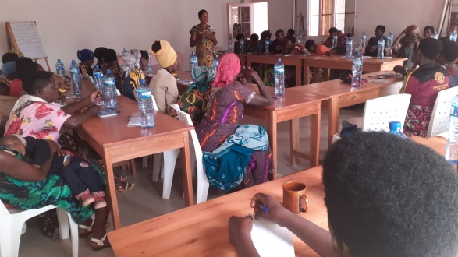I am a mother of 6 children. Upon my return from Tanzania where I had fled with my husband, I joined the CNDD FDD party and thus participated in its activities. I made necessary contributions. In 2015, I was put on the blocked list of members of the municipal council and I was not lucky and I remained a reservist. I was responsible for the women's league at the zonal level. In 2020, after consulting my husband who was at university, I participated in the hill elections and I was the first on a list of 8 people. 7 of the 8 were men including my Director. I was proposed as a member of the municipal council and representative of the elected women in the commune of Bweru. I was responsible for the women's league in Bweru commune until 2023. From then until today, I am responsible for the women's league at the zonal level. I was on the list of senators and I travelled throughout the Ruyigi province in the campaign to become a senator. Since I have been in political office, I have sensitized women to join associations and they have managed to get loans from the bank. The barriers include, among others, the lower level of education, the undeveloped Burundian female mentality, lack of time and financial means. I advise my sisters aspiring political candidates to be exemplary in everything and everywhere, be wise, be faithful, have good conduct, actively participate in elections, sensitize women to get elected to be able to enter institutions.

1. **Testimony of Ms. Ndorimana Brigitte responsible for the league of women members of the CNDD FDD party in Bweru, Ruyigi and Butezi communes**

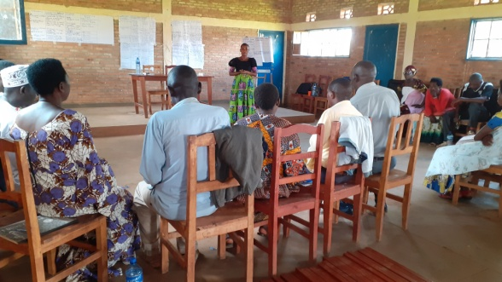 Brigitte Ndorimana, a 34-year-old woman, is pregnant with her second child. She is responsible for the women's league of CNDD-FDD party members in Bweru, Ruyigi, and Butezi communes. As a daily occupation, she is a credit officer in Ruyigi commune. She explains how she was able to emerge from her student days to the present day. She took this opportunity to raise awareness among women and men for the upcoming 2025 elections in order to have more women elected. She said: "When I was in secondary school, I was not allowed to join a political party, but I had the right to vote. I voted for the most active party, the CNDD-FDD. When I arrived at university, I immediately joined the group affiliated with the CNDD-FDD party, where I actively participated in meetings and parties. I was among the service girls during the parties." I went on field trips with others and officially joined the party in 2016 in Mubavu zone, Bweru commune. I was close to the party leaders in Ruyigi province and I actively participated in all party activities. When I defended my report attesting to the end of my university studies, I published it on my status and quickly called for a consultancy. Afterwards, I wanted to return to my home province to continue party activities. I applied for a job and fortunately I was assigned to Ruyigi province as a declarant. I continued to be active in the party and there was a time to set up new bodies for the youth and women's forums. I was chosen as secretary of the youth forum at the provincial level. I continued party activities through awareness-raising, visits and training for young people. In August 2023, new party bodies were chosen. While I was active in youth activities, I was invited the evening before the congress. With my age and experience, I didn't expect any other opportunities. By surprise, I was presented among the candidates to be chosen as head of the women's league. I was elected despite competing against distinguished women with extensive experience and long service in the party. At first, I was a little afraid, but I quickly got used to it. I have already visited the nine districts to raise awareness among women about electing and getting elected in the 2025 elections, and now I am at the hill level.

Children and other household chores should not be an excuse for not holding public office. It's enough to organize and establish good communication between spouses.

I have no problems with housekeeping. My husband and I got married while I was a party leader. I then had a child, and I leave home after reassuring myself that he has everything he needs. I benefit from my husband's support in party activities. In most cases, he makes it easier for me to get around by carrying me on his Yamaha motorcycle, and even now, he comes to pick me up after the session." She continued, "For now, I'm turning to my fellow women here. Everywhere I went, women raised concerns that their husbands were preventing them from getting elected for fear that some elected women would become arrogant and housework would no longer be done properly. I raised their awareness by telling them that the first step is to talk with their husbands about the plan to get elected. If the spouse agrees, the next step is to have self-confidence." Here, there is no reason to fear getting elected because the constant is that the performance of elected women is appreciated. A close example is the female governor of Ruyigi province who had a good provincial office built during her term. This is an activity that enhances her self-esteem. The other step is to take the time to seek out people who support you, and at the end, it is the step of getting elected. I cannot fail to tell you how frustrated I am to see male leaders who abuse their power and who perform for a fee. It is mainly women who are victims. I am sure that women, once elected, facilitate their fellow women. I ask you to go to your hills to raise awareness among other women. For those who think that hill chiefs don't have a good salary even though they work all the time, I assure you that hill chiefs have many opportunities because whenever partners want to intervene in their areas, they are the first to be contacted. They are more in demand and have more advantages in terms of benefiting from useful information and training, sometimes with expenses that can allow them to move forward with household chores.

She advised men to allow their wives to run for office and to strengthen dialogue to communicate whenever necessary and to help each other. She asked them to raise awareness among other men to facilitate their wives' run for office.

1. **Testimony of Mrs. Niyonzima Odette from the commune of Butezi, candidate in the 2025 elections**

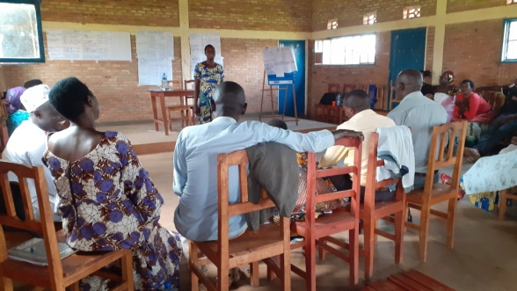Mrs. Niyonzima Odette, president and founder of an association that is a member of the Butezi network, has a 6th grade education and 5 children. She testified that following the activities of the “Bakenyezi Dukenyerere Amahoro” project, she has a great desire to be elected in the 2025 elections. In her own words: “Following the project's activities, which raise awareness of the need to increase women's leadership, I'm thirsty to be a hill leader, and I'm going to start looking for people to support me right now. It's an honour to be a leader and to carry out development activities with the population. I feel up to the task. But I'm worried about a piece of information that says that to be a hill leader, you need to have a 9th grade education. Without this blockage, I'll be competitive for the post of hill leader.

1. **Testimony of Anicet Ntagasumbabahizi and Niyonzima Anne Marie model couple from the Kinyinya commune**

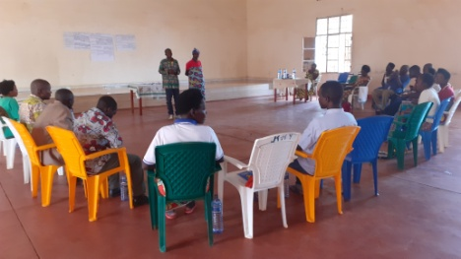 Anicet Ntagasumbabahizi and Niyonzima Anne Marie married in 1989 with 8 children, 6 of whom are still alive, and 12 stepchildren. Their first child is 34 years old and their youngest is 18. Anicet said that since their marriage, they had a bad cohabitation for a few years due to his bad company and poverty. He sometimes hit his wife, accusing her of not giving birth to a boy for her first birth. He apologized to his wife during the session for this behaviour he displayed at the time. Living in conflict in the household is ignorance. He reported that they suffered enormous losses during this period. The family assets were mismanaged. He drank a lot and distributed beer to the wrong people, and the children lived miserably. Following his wishes, the couple agreed to live together peacefully. With this change, Anicet Ntagasumbabahizi and Niyonzima Anne Marie bought a plot of land to build a house, they bought fields to grow rice, beans, corn and peanuts. The children were comfortable, 2 of them were able to continue their studies, one is in the second post-fundamental and the other is in the first post-fundamental. Anicet advises other couples to live together well for the development of their household. Anne Marie confirmed what her husband said and asked other couples to build their homes on the basis of prayer. Then it is necessary to join associations to strengthen knowledge and avoid listening to hearsay and bad company.

## **Testimony of Ndenzako Astère and his wife Habonimana Sylvane, a model couple from Nyabitsinda Commune, Muhwazi zone.**

## Astère said he has been living with his wife for 16 years. They had seven children, six of whom are still alive. Astère used to brew Kanyanga beer to raise money for the family. Three years ago, one day, after getting drunk, he wanted to take advantage of his wife's kindness. He sold his beer and hid the money, claiming that his wife had stolen it. He continued to accuse her until he slapped her. In the morning, local officials came to facilitate the conflict. Astère finally revealed the secret he wanted to unjustly accuse his wife. He said that he had deceived Satan after 12 years of living together happily. Otherwise, the couple has a good life together; they bought a plot of land and livestock, and the husband and wife advise each other. Astère's wife confirmed what her husband had testified and stated that they live together well. Regarding the couples' training they received through the "Bakenyezi Dukenyerere Amahoro" project, the woman reported that they strengthened their skills because, upon returning home after the training, they agreed on certain points that needed to be addressed. So far, they have already eased conflicts in the other five couples.

## **C:\Users\Nkurunziza\AppData\Local\Microsoft\Windows\INetCache\Content.Word\20240315_142011.jpg** **Testimony of a model couple from the Ruyigi commune: Gabriel Nyakamwe, boarding school catechist and Nyahwenda Félicité**

Gabriel Nyakamwe, a boarding catechist, and Nyahwenda Félicité are a model couple in Ruyigi commune. Gabriel said: “I was a widower and remarried this woman. We got married in 2011. My wife has a good relationship with me and with my children from my first wife. She left me 5 children. The eldest in the family died, 3 others got married. The last child from my first wife remains at home. With my new wife, I also have 5 children. We live in good cohabitation and we preach what we live since I am a catechist. Our couple is a model for other households and there are others who come to us with their problems or conflicts. We have already facilitated many conflicts in the neighborhood and the report is given to the focal point of the project.” His wife, Félicité Nyahwera, testified by saying: “I got married at 27 years old. My husband is a catechist and I am from the Catholic movement. At first people said that it would be difficult for us to live in harmony since I was still young while my husband is older than me. Since we got married, we have lived peacefully and the children of the first wife welcomed me well, they respect me and I respect them. We respect each other as a family. My husband continues to work for the development of our household instead of frequenting the cabaret like some men from the hill. People say that my husband does not want to leave me since I am still young. We have a good habit at home: if he leaves, the children and I say goodbye and if he arrives we hug him warmly. Before sleeping, we say a prayer and even the little children know how to pray. We consult each other before making a decision. We are comfortable at home.

1. **The model couples, Habonimana Salvator and Nshimirimana Radégonde of Nyabitsinda, Hagerimana Oscar and Harerimana Jeanine of Butezi, Niyonkuru Gerard and Niyonsaba Eugénie of Ruyigi and Bucumi Zacharie and Ntibesha Frédiane of Kinyinya**

testified that they are role models for others through their peaceful cohabitation, dialogue, and joint management of family property. They also said that they respect each other, support each other in everyday activities, and ask forgiveness if one has made a mistake against the other. As a result of this good cohabitation, they are gradually managing to develop their household by monitoring the children's education, expanding their property to cultivate crops, and purchasing livestock. The training received in the “Mukenyezi Dukenyerere Amahoro” project enabled them to correct certain mistakes they were making, to strengthen their good cohabitation and improve the facilitation of conflicts in other couples.

## **Testimony of Ms. Ndihokubwayo Agnès from Butaganwza commune**

## Ndihokubwayo Agnès is a 33-year-old woman and one of the five female hill chiefs on 39 hills in Butaganzwa commune. The population trusted her from a young age, just a year after her marriage in 2010 when she had her first child. She was elected as a female hill leader. Her leadership was appreciated by the population from 2010 to 2020, and they asked her to be elected during the 2020 elections as hill chief. She did not accept directly because she considered herself incapable because she had small children who needed her constant presence. She was supported and convinced by her husband, who told her to accept the will of the population. She was accepted and elected hill chief. She worked in collaboration with the population on their needs. She brought the population together, who agreed to contribute to find desks for the students. In addition, she rehabilitated the road that had not been passed for 10 years, she built a bridge with logs and planks and now the road passes very well from the commune of Butezi to the CDS Biyorwa. She was proud of her services and the population is proud of them too and this is thanks to the good cohabitation and understanding with her husband who replaced her at home when she was busy with the activities for which she had been elected.

## **Testimony of Ms. Itangishaka Pétronille from Bweru commune**

**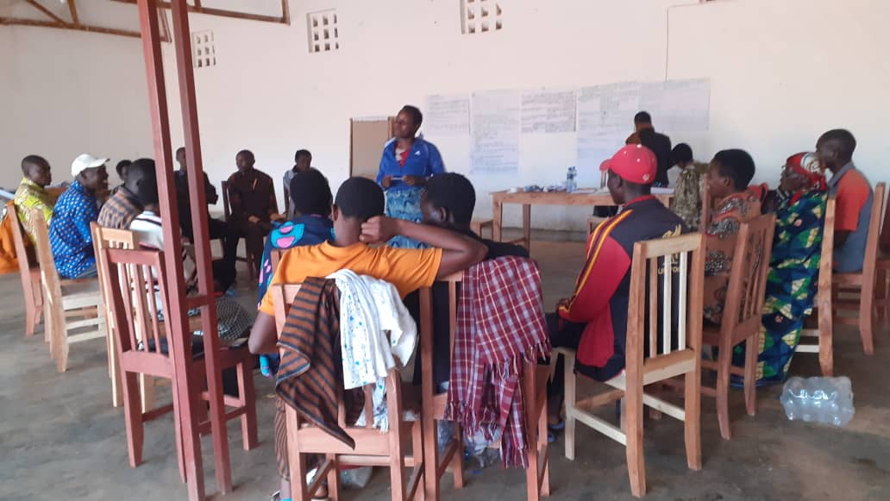** Itangishaka Pétronille (pictured here in front of the participants) is a 45-year-old woman. She lives in Bweru commune and is a member of the Tuzamurane network, supported by Dushirehamwe. She spoke about her leadership development. She said: “I joined the cooperative and was elected treasurer despite myself. Right after, in 2020, I was elected chief of a sub-hill in my absence. I was scared, thinking that I would be unable to bring together the men and women of this sub-hill. I went to the hill chief to tell him that I could not be a sub-hill chief, and I also said that I could not write. But that was an excuse because I had finished the 5th year of primary school. He told me that if I wanted to resign, I had to prepare a pot of beer and invite the people who elected me to resign in front of them.” Regarding the fact that I don't know how to write, he told me that my deputies know how to read and write and will take minutes during meetings. Fortunately, my husband encouraged and convinced me, and I decided to work. I also continued the training organized by Dushirehamwe for the Tuzamurane network. I became dynamic in the network and I managed to get 400,000 BIF from my contributions. I asked my husband what we can do with this money. My husband gave me the freedom to use it. That's how I bought a small ox. We then sold it and bought a plot of land. I continued to contribute and I managed to buy a better breed dairy cow with another person. I affirm that I am progressing and I am no longer afraid thanks to the awareness and training I received."

## **Témoignage d’un couple modèle de la commune Gisuru**

**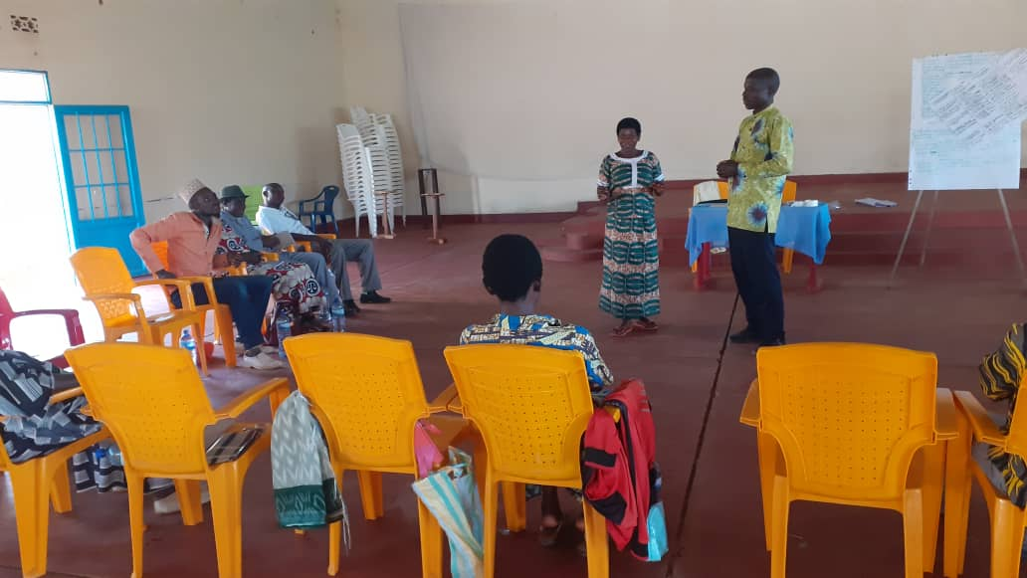** Baraherezimana Oscar and Nduwimana Lucie, who are standing in front of the others in this photo, are a model couple from the Ndemeka area of Gisuru commune. These spouses are all teachers and have five children. The man said, "Our achievements are based on dialogue, and each has the right to sign our accounts. To collect our salaries, the one who has time will make the withdrawals from all the accounts after discussing the allocation of these funds. We manage the children's education jointly. We have the modern cow breeding project, and it is being implemented without any problems. We also have other projects that we manage together successfully thanks to dialogue, which helps us maintain a good cohabitation." Mrs. Lucie affirmed what her husband said.

1. **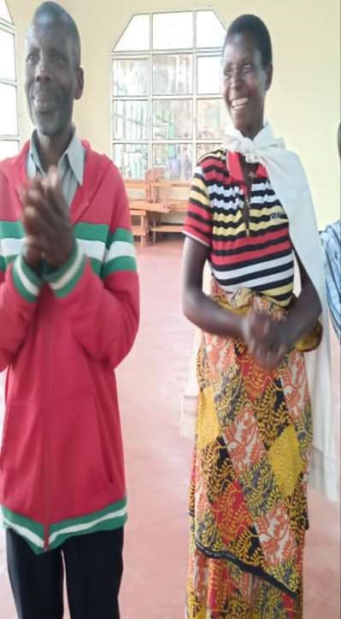According to NIBIZI Audace of the hill of rural Ruyigi**

he stated that the training was very beneficial to him because he learned that the priority in the household is first and foremost the spouse. All other things come to facilitate the psychosocial well-being which is the foundation of marriage. In addition to this, he affirmed his commitment to having frank dialogue with his wife in order to build his marriage well. He further emphasized that he will help other couples in difficulty to promote social cohesion, peace and security at the household and community levels.

1. **NTIRAMPEBA Noëlla from the commune of Ruyigi**

Moved by the testimony of her husband Philbert, she spoke and affirmed that since their marriage, this is the first training received as a couple. For her, it is the most fundamental. Thus, she affirmed that although her couple does not yet have a child after 13 years of marriage, the exchanges experienced during the training will allow her to maintain good relations with her husband by prospecting the blessing of the Almighty because, she says "God Love is always on the side of lovers who are sincere."

**Butaganzwa**

1. The couple Ntibarikure Méa and his wife Ntakarutimana Madeleine affirm the lack of dialogue and communication and affirm that they will correct and discuss often in family. The couple did not do the preparation before having sexual intercourse and affirm that from now on, they will give value to the preparation before the sexual act. The couple affirms that they will always discuss their business and plan everything together.

1. The couple and their wife accuse each other of never discussing the various projects of their household and of the misappropriation of family property. The couple made a decision to discuss regularly as a family and plan together the household projects as well as the various expenses.

**Kinyinya**

1. 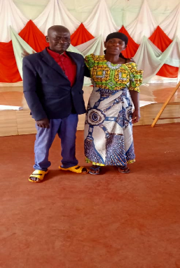With a big smile, the couple KASURAHEBA Dickson and MBONANKIRA Gaudence testified: “Finally we realize that we have committed sexual rape, and that is why we do not feel sexual pleasure, we are going to review how we must prepare ourselves before having sex and above all we are going to initiate a dialogue on this subject of marital relations to improve our understanding.”

**RUTANA**

48. Ndayegamiye Godefroid, Bigina hill, Gitanga area, Gitanga commune, before this training I made all the decisions alone, and I informed my wife for final execution either she puts the signature on the concluded contract or she waits for the delivery of the goods that I bought and she jealously keeps the product. I just realized after the training that this is a bad practice to be banned in family governance.

49. Niyongere Spéciose, a woman with disabilities living on Gihofi Hill, Bukemba Zone, Bukemba Commune, said she learned that women are respectable individuals in Burundian society, both current and past. Our environment is difficult; women must adapt and endure the difficult situations that arise each time. She was touched by the one-on-one couples activity, which will help families improve their future relationships.

50. Nirema Emelynefrom Busoro hill in Commune Bweru in Ruyigi province testifies that she has just received a reinforcement, which will enable her to take part in election 2025, and her husband in the photo is committed to convincing her family, who have a pitiful history of female leadership in their locality.

51. Nduwimana Vénérand from Nyamigina Hill, Kinyinya Commune, Ruyigi Province, a school principal and representative of a political party, residing on Kagoti Sub-Hill, in the Kabanga Zone of Kinyinya Commune, says that the dialogue workshop has greatly edified him. His wife would have had great difficulty convincing him, and now if his wife wants to participate in a meeting, he is ready to do his utmost to replace her in domestic chores and make all necessary arrangements to ensure that nothing is lacking in the family during his wife's absence.

52. A very dynamic woman from Butezi commune, shared the experience of her journey as a leader since the 1960s. She said that it is thanks to her positive actions and behaviour that she has gained the trust of her community and that of the authorities. She also said that women should participate in political parties so that they can access decision-making positions. She expressed it in these terms:

"Women, we are expected to know that our courage is shown in our behaviour and actions. I started from scratch, where I saw it and I have seen a lot. From UPRONA, FRODEBU, and now in the CNDD FDD government, I have always been ahead of others, I have been in the dance group, I have been a leader, I have been a leader of the UFB. Until now, in the current government, they trust me. There is no conflict that can be ignored. I am a leader for the young and the old. That is why they always trust me in my community." (translated from Kinyarwanda)

53. A female hill chief in Bweru commune shared with us her experience of running for office and her firm determination to secure the mandate, given that she was the only female councillor among four men who make up this grassroots body. She emphasized that, for a woman, winning the top spot on the Hill Council is particularly difficult; her fight was very tough. That said, she indicated that her strength lies in the fact that she respects the laws and rules that govern her and takes advice from her superiors whenever possible.

54. A participant from the Butaganzwa commune in Ruyigi province, sharing his experience with peers, reveals that it takes patience and self-sacrifice to support a wife who expresses the need to participate in decision-making bodies. You have to replace her in the supervision of domestic activities, she may be absent from the household for a week or less, and she may also be obliged to travel at night. You must be available to accompany her whenever possible and provide her with transportation and security. He promises to share his experience with peers from the interest groups to which he belongs and asks his colleagues to do the same.

1. A female hill leader in the commune of Bweru shared with us her experience of running for office and her firm determination to win the mandate, given that she was the only female councillor alongside 4 men who make up this grassroots decision-making body. She emphasized that, for a woman, winning the top spot on the Hill Council is particularly difficult, and her fight was very challenging. That said, she pointed out that her strength lies in the fact that she respects the law and rules that govern her and takes the advice of her superiors whenever possible.
2. Niragira Raphael from Shoti hill in Rutana commune, says that dialogue is very important, in the past he had tried to support his wife, but he didn't have enough information to do so. Rumours and false communications are rife about the few women who emerge. Despite these retrograde attitudes, the dialogue session edified me. I'm going to support my wife in the next elections in 2025 by making the necessary means available and participating in the recruitment of potential voters.
3. Mbazumutima Claude, Nyakazu hill, Kiguhu zone, Mpinga Kayove commune, a member of the Batwa community, has pledged to stand in the upcoming 2025 hill elections. The session enabled him to see that he is capable and that there are few hills headed by a member of the Batwa community.
4. **Ndayizeye Christine, colline Makakwe, zone Ngoma, commune Musongati**

the session transformed me, I believed and was convinced that if I was going to get anything from my husband, my weapon was the sexual embargo. After the session, I made a resolution to stop doing this action, which carries enormous risks for the life of the household. Then I got a commitment from my husband that he would be with me in the 2025 elections.

1. **A testimony by Godefroid Ndayegamiye from Bigina Hill, Gitanga zone, Gitanga commune says:**

“before the training, I made all the decisions alone and informed my wife for final execution. She either followed or rejected. Either way, I would move ahead with my opinion unhindered. After the training, I realized that I lost out on her contributions. At times my decision succeeded, but often my decisions were a failure. When that happened, I would keep quiet to hide my shame because she would have been right in refusing to endorse decisions that lack wisdom. Currently, I have resolved to consult her on all things so that the losses in my dealings are kept at a minimum or eliminated completely. I know that my wife is intelligent and able to inspire success. I am grateful to RFP for teaching me how to swallow my pride for my own good”.

1. **Niyongere Spéciose, a woman living with a disability from colline Gihofi, zone Bukemba, commune Bukemba**

declares that she has learned that a woman in Burundi suffers a lot of exclusion. “Our environment is difficult, and women have to adapt and endure the difficult situations that arise each time”. She was touched by the one-to-one couples' mentorship and coaching activity, which will help families to improve their future relationships.

1. **After visiting all the 13 women-led networks and also meeting members of the local authority in both Ruyigi and Rutana province, a collective statement was formulated as follows:**

“All human beings are born free, equal and destined to enjoy human rights and dignity equally. The coming in of greedy and power-hungry people brought with them wickedness. They formulated gender norms and cultural practices that are discriminatory and enslave other people who happen to be women. To see that we can as women realize that we have been at the receiving end and can now craft strategies and influence policies formulated to take us out of that quagmire is beautiful and satisfying. We are glad that even the environment we operate in is changing and are now able to secure the support of our former oppressors who happen to be our grandfathers, our fathers, husbands, brothers and brothers-in-law. Now that our eyes are open and we are ready to act, we shall work hard and hold onto our newly acquired position to change the status quo forever. This statement is compiled from various opinions expressed by women who underwent gender-transformative training and workshops during the reporting period throughout project implementation areas.

1. **Gaining trust and recognition was the topic covered by the Nyabitsinda Commune Social Cohesion Chairman**

A long-time civil servant, who was invited to facilitate the coaching/supporting/mentoring of the newly germinating crop of women politicians. When he received the invitation to come and talk to BDA women, he was intimidated by the profiles of the trainers as they covered multiple topics ranging from financial management, conflict transformation and resolution, fundraising, behaviour change and women empowerment, just to name a few. In his presentation, he encouraged women to “trust themselves and walk the talk”. From his experience, a failure does not become one the day he/she is seen failing. They become a failure the day they “choose to ignore principles designed to propel them to greater heights even when no one is watching”.  The Chairman promised to make himself available for any woman politician who requires guidance at any given time.