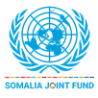 | UN Somalia Joint Fund  Progress report  1 January to 30 June 2023
Project data

Title and Number | SAAMEYNTA-SCALING-UP SOLUTIONS TO DISPLACEMENT IN SOMALIA: 00129672
Participating UN entities | IOM, UNDP, UN-HABITAT, Integrated Office
SJF Window | Climate and Resilience
Geographical coverage | Hirshabelle, Puntland, South-West State
Project duration | 4 Years  14 December 2021 – 31 December 2025
Total approved budget | US$ 18,831,011
Implementing partners | Federal Government of Somalia (FGS), Federal Member States (FMS)
Project beneficiaries | IDPs and host communities
NDP pillar | Social development
UNCF Strategic Priority | Social development
SDG | 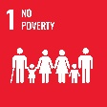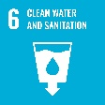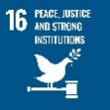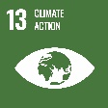
Gender Marker | 2a
Related UN projects  within/outside the SJF portfolio | Midnimo I & II, Danawaadag, RE-INTEG / Youth and Urban Regeneration (YOURS) / JPLG, SURP II
Focal person | Osman M Osman, IOM ososman@iom.int  Karel Boers, IOM kboers@iom.int

Report submitted by:

 | PUNO | Report approved by: | Position/Title | Signature
1 | IOM | Frantz Celestin | Chief of Mission | O.I.C.
2 | UNDP | Lionel Laurens | Resident Representative
3 | UN-HABITAT | Ishaku Maitumbi | Head of Country Programme

Section 1: Executive summary

Brief introduction to the project

The Saameynta (Impact in English) programme is developed to address Somalia’s internal displacement challenges in an innovative manner, seeking durable solutions that are affordable and sustainable by addressing specific interrelated systemic blockages, challenges, and opportunities in three target cities (Baidoa, Bossaso and Beletweyne). The programme is the result of previous programmes that informed on how to best position Saameynta and how it could act as an enabling programme that other durable solutions actors and projects can build upon.

Theory of Change (impact hypothesis): By strengthening capacities (technical and institutional) of local authorities to address urban displacement through capacity-building and support in development of relevant land-related policies; then tenure security for displacement-affected communities (DACs) will be improved, leading to reduced risk of forced eviction. An enhanced normative and institutional framework, as well as a better understanding of the economic context, will lead to the definition of standard operating procedures to secure public-private sector partnership investments in social and public infrastructure and basic services for DACs, resulting in specific actions for securing livelihoods grounded in the local context. Improved coordination and closer consultation mechanisms with national and local authorities will improve citizens’ participation in local governance: engagement of DACs by Saameynta Partners through the community planning process will ensure that their priorities remain an integral part of the District Development Plan. Investments secured from these processes will contribute to the self-reliance and sustainable (re)integration of DACs, and durable solutions at scale in the three target cities.

As an aspirational impact, Saameynta seeks to contribute to: “Promote the sustainable integration of displaced communities in urban areas by empowering governments to leverage value generated by urbanization and urban infrastructure investment and to increase DACs’ self-reliance and access to sustainable basic services in three Somali cities (Baidoa, Bossaso and Beletweyne)”.

The more attainable programme goal of Saameynta is to scale up: “Investments toward mixed-use land development packages and urban public works which will generate land value increments that, combined with advancements in land tenure security and employment, will increase opportunities for self-reliance and access to social services hence contribute to durable solutions at scale in a DAC-inclusive way”.

Situation update / Context of the reporting period

Conflict in Somalia is driven by political, economic, social, and environmental factors, including clan rivalries, political power struggles, armed attacks, Al-Shabaab (AS) presence and land disputes. Climate change exacerbates food insecurity and disrupts livelihoods, leading to instability, displacement, and the proliferation of communal tensions. Displacement is both a consequence and a source of conflict, as 3.8 million internally displaced persons (IDPs) are moving to urban and peri-urban areas pressure fragile societal structures and exacerbate vulnerabilities. While this continues to place the responsibility of addressing internal displacement mainly on international humanitarian organizations, there is a growing sense that governments are beginning to engage more proactively with this issue: finding sustainable durable solutions for DACs, in coordination with all relevant stakeholders (including FGS, FMS, UN-agencies, and NGOs) remains a key priority.

Somalia is planning to shift to universal suffrage voting system: an historic political agreement between the leaders of Federal and States governments aims to reshape the country’s political landscape, dropping the clan-based power sharing system in favour of equal representation and introducing a presidential system with elections every five years at local, regional and federal level. The local council elections will be the first to take place in June 2024, followed by regional parliamentary and leadership elections in November. The leaders have agreed that there will be only two political parties competing across the country.

The impact of insecurity and climate change made the operational context challenging. For instance, AS recent attacks in Galmudug State and Lower-Shabelle region entailed casualties, while the second round of government-led military operation to push back AS is yet to begin in Jubaland and South-West State. A precarious security situation continues, with reports of sporadic armed conflicts and attacks on civilians by AS across the country. Further, in the Hiraan region, the recently dismissed governor organized an election where he was elected as the interim president for Hiraan state for the next two years. However, the newly appointed regional governor held an introductory meeting with some district authorities from the districts in the region where he mentioned he will prioritize the security activities in the region and reignite the offensives against AS.

The current rainy season has improved water and pasture access, but more rain is needed to recover from the worst drought in four decades. Simultaneously, heavy flooding has occurred in Beledweyne, the largest city of Hirshabelle State. During prolonged droughts, vegetation cover diminishes significantly, leaving the land exposed and vulnerable to erosion. Besides, droughts have resulted in hardened and compacted soil, which inhibits the infiltration of water into the ground. This reduced water absorption capacity leads to surface runoff and subsequent flooding. The current humanitarian and security situation hampers the effective implementation of physical activities (i.e., water or housing infrastructures) under the Saameynta programme, however, scoping is planned to investigate the readiness of the local stakeholders to receive service activities (assessments to be made) under Saameynta.

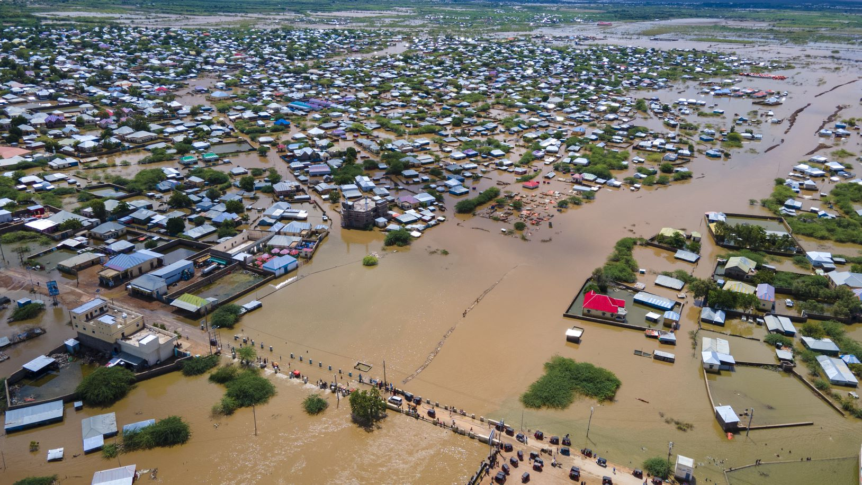
Photo 1. Flooding in Hirshabelle State.
Summary of key achievements during the reporting period

Saameynta is an enabling programme that aims to develop solutions through a structured approach to land management and urban planning, likely to improve infrastructure and residents' living conditions, reduce disputes and increase security over land tenure. Land governance interventions, bolstering a solid land governance framework through legal norms regarding land allocation and demarcation as well as through city strategies, act as a backbone of further programme’s interventions: spatial planning carried out by UN-Habitat, following a participatory model, guides IOM in the provision of service delivery and UNDP in catalysing public investments towards areas and sectors that most need them, thus further leading to a virtuous cycle of improved public services and economic opportunities.
The resilience and resourcefulness of the community, guided by the strategic intervention of the Saameynta programme, have enabled to build local economy from the ground up, capitalising on agricultural traditions and maximising communities’ potential. Women, who have also benefitted from the project, are seeing their businesses grow and prosper: "these loans have transformed our lives," shares one of the women beneficiaries.
Looking ahead, beneficiaries are excited about the additional support promised by the Saameynta programme, which is expected to further expand community's prosperity. To echo the words of Abdisalam, a beneficiary living in Baidoa, "We were once on the brink of devastation, now we are on the road to progress, and it is due to the collective efforts made possible by Saameynta and our resilient community spirit". The programme’s role in the community exemplifies the transformative impact that strategic interventions can have in turning adversities into opportunities.
The interventions under Saameynta have had a positive impact on people's lives, particularly in terms of employment broader socioeconomic benefits such as stimulating local economies and fostering a sense of community growth. One of the primary transformations has been the increase in job opportunities, primarily due to the support to local enterprises in improving their access to credit which has proven instrumental in business expansion. With increased financial resources, businesses have been able to invest in growth – purchasing more inventory, upgrading equipment, investing in technology, or hiring more employees.

The activities implemented have led to meaningful changes within the community, influencing both economic decisions and civic engagement. Through financial feasibility studies, valuable information to individuals and businesses about prospective investment opportunities were provided, having enhanced the understanding of local economic dynamics and potential returns on various forms of investment. A refreshment of these studies will also look into the most meaningful way to provide agri-inputs to the constructed irrigation system. Through the ongoing development of a Citizen Engagement Platform, Government and communities will have a forum to interact: the e-platform will encourage more significant citizens’ participation in decision-making, especially from often-marginalized voices, and at the same time, it will offer to the Government a more efficient means to listen to their constituents. This enhanced dialogue will lead to more democratic and responsive governance, which in turn contributes to community cohesion and development.

Under Saameynta, the right to adequate standard of living for IDPs in Barwaaqo has been enhanced through the construction of water infrastructures (borehole, two elevated water storage with capacity of 40m3 each, water engine, security guard rooms, solar-powered 30 KVA water engine and water kiosks/tap stands), which will provide access to safe water to beneficiaries, based on an hydrogeological assessment conducted in January to evaluate the feasibility of borehole-drilling. This will lead to improved living conditions, also in relation the currently ongoing water, sanitation and hygiene (WASH) initiative, namely providing a micro-irrigation drip system for farming, that will be complemented by the distribution of local agri-inputs as well as agricultural training for DACs as prioritised by the communities in Baidoa. The earlier mentioned feasibility studies will also investigate the specifications that are needed to ensure the most value for money where initial disbursement of drought-resistant seeds will act as a revolving actor.

Adequate housing must provide more than four walls and a roof: where we live influences every aspect of our lives. To find housing solutions for IDPs that are resilient and culturally appropriate, piloted demonstrations of owner-driven durable solution housing models were conducted, with 20 masons and carpenters from Baidoa trained in mudbrick production and housing construction: four housing prototypes (three made out of mudbricks and one of compressed stabilised earth blocks) were constructed and the best typologies were selected through a technical evaluation. The prototypes successfully identified will be used to develop 1,100 houses under Danwadaag – World Bank project.

Saameynta continues to support the operationalisation of the Urban Land Management Law (ULML) through an agreement with the South-West State (SWS) Ministry of Public Works, Reconstruction and Housing (MOPWRH). With the support of Saameynta, the SWS-MOPWRH chaired its inaugural session of the Land Management Steering Committee, supported by members from state ministries and civil society: involving civil society increased participation and empowerment of different sections of the population, and the high degree of cooperation among local and state authorities contributed to a greater trust in these institutions and a sense of inclusion in the political process.

The ULML enabled the creation of Land Departments, which enhanced tenure security for 748 persons in 2022 and 351 people by February 2023 through the issuance of property documents. A scoping mission was carried out by a Global Land Tenure Network (GLTN) expert in April to assess the institutional capacity to operationalise the law, monitor the process of formal land registration and the different registries, and develop the context-specific application of the Social Tenure Domain Model (STDM, a mapping tool to address land governance and tenure security issues through the identification of formal and informal land demarcation interventions). Two trainings were provided to a total of 50 participants (10 women, 40 men), who are mainly focal points providing technical backstopping to the inter-ministerial committee of the SWS. Comprehensive training workshops enabled the focal points to better understand individual articles of the law, its legal scope and areas of application, how it is aligned with the federal legal architecture. A second training was held to identify challenges and develop a detailed roadmap for implementation. The roadmap was approved by the inter-ministerial in May 2023.

The Baidoa City Strategy and Extension Plan was launched by the Mayor and the South-West State President, ensuring the buy-in of a wide range of political actors and development partners. The strategy incorporates durable solution programming and provides a framework for identifying specific actions with the aim of guiding public investment towards urban development, leading to improved living conditions for both IDPs and host communities. The layout of the city, the distribution of public services, and the management of resources are now mapped to contribute to a more organised and systematic urban planning, allowing more IDPs to settle permanently in inclusive, well-served, accessible and risk-reduced areas of the city.

Section 2: Implementation progress by outcome

Progress towards outcomes

OUTCOME-1
Local authorities and DACs enhanced capacities reinforce mutual accountability and plan, leverage, finance and implement durable solutions at scale that reflect collective and area-specific priorities.

Saameynta's comprehensive approach, combining structured land management and urban planning with community-prioritised service delivery and local economic growth, has enhanced the living conditions of displacement-affected communities improved infrastructure investment, and provided more fitting solutions for local conditions. By fostering collaborative relationships among state ministries, local authorities, civil society, and development partners, the project has strengthened local capacity to manage urban development, displacement solutions, and guided public investment for greater social impact. The strong emphasis on the development of the project with and through local authorities enhances their capabilities to handle urban development and displacement issues: this knowledge transfer not only provides immediate assistance, but also helps communities to sustainably manage these issues in the long term. The multi-stakeholder approach ensures that the project meets the needs of a wide range of beneficiaries.

Lessons learnt from Baidoa will guide the programme partners in moving forward to implement activities in the next project location. Saameynta performed a joint scoping mission to Puntland, to primarily establish a coordination mechanism with the FMS, as well as to work with the Puntland FMS and Mayor of Bossaso to identify a suitable location for implementing Saameynta in Bossaso. Having consulted with the different stakeholders active on the ground, including Government officials, durable solution actors and displacement affected communities, it was observed that there is potential for relocation of IDPs to the newly identified durable solution site known as Grible-2: the Bossaso mayor and other government counterparts have shown commitment to facilitate the process of getting permanent lands for IDPs through advocacies and negotiations with private landlords. Saameynta has developed a roadmap that will guide the team in the next steps needed for a successful implementation.

OUTPUT 1.1
Preparatory studies and assessments are produced that include a gender and conflict angle.

A joint assessment mission was conducted in Puntland in May purposely for the identification of a specific target location in Bossaso district to start the implementation of Saameynta’s activities: in consultation with Government authorities and other durable solutions actor, the Grible-2 site (located four kilometres on the East-side of the city) was identified. Existing policies and strategies to support the displaced affected communities were discussed: it was acknowledged that Puntland has a ULML in force, a draft policy on IDPs, a Local Integration Strategy (2018-2022) and a draft Land Dispute Tribunal Regulation, while the Bossaso Municipality endorsed a 2023-2027 District Development Framework (inclusive of district priorities and socio-economic and urban profiles). This informed the team about what support is further needed to complement or expand the current institutional framework, and what can be leveraged to avoid repetitions. Saameynta mapped out the key durable solutions stakeholders and explored collaborative opportunities with relevant organizations to avoid overlapping interventions and services delivery, hence sensitised relevant actors including Government institutions, displacement affected communities and durable solution actors on the Saameynta Programme.
Based on the employment and livelihood analysis performed during the Project Initiation Phase of Saameynta, an update of the economic studies for the targeted cities has started and is expected to finish in November 2023 for Baidoa, entailing a refreshment of the analysis of local economies and an assessment of economically sustainable agricultural products. For what regards the latter, especially when it comes to Baidoa, it is under investigation the current crop production in order to identify the net effect of proposed changes in agricultural production, and whether these may have a beneficial effect over farmers: this will inform the distribution of agri-inputs, planned for the next reporting period.
The Baidoa City Strategy contains an ample section dedicated to urban analysis from a spatial, economic and legal perspective: similar analyses are underway in Bossaso, informed by a participatory process entailing consultations with communities and local authorities, along with social cohesion formative assessments and local economic analyses. When possible, the programme has planned to conduct the latter analyses in parallel also in regard to the third targeted location. Conflict, especially from the perspective of competition for resources, is addressed within the city strategy by proposing strategic actions to minimise the impact of the built environment over the natural one, controlling sprawl and the aggressive consumption of land; by focusing on the blue-green network, prioritising sustainable and resilient infrastructure (for instance, the development of green spaces, parks, the preservation of natural assets and connection with rural areas, which can in return help to reduce urban heat island effects, improve air quality, and provide food security); by implementing efficient water management systems, aiming at addressing water scarcity. For what pertains to women and youth, the strategy prioritises accessibility of key facilities such as health (MCH and primary care) and education (primary schools) to minimize walking distances; it looks at public safety, with walkable and well-lit pathways and public areas that discourage gender-based violence, and at creating recreational spaces for leisure, sports and other activities to provide youth with safe, constructive outlets.

OUTPUT 1.2
Strategies and legal provision are produced that include specific priorities of women, youth and are climate smart.

The Baidoa City Strategy and City Extension Plan was launched by the Mayor in March, providing a map-based analysis of functionality of core urban services and a roadmap that will guide the Government’s towards next years. It will serve as an entry point for other relevant development actors (International Cooperation Offices, NGOs, and other UN Agencies) to steer the urban development of Baidoa in a more coordinated and complementary way.

The SWS Land Law operationalization roadmap was adopted on 18 May 2023 in Baidoa. The joint inter-ministerial approval of the Urban Land Law Roadmap demonstrated their commitment to undertake the new land law which increases security of tenure for all the SWS population, including DAC, as legal defense mechanisms are incorporated to protect DACs from forced evictions.

Based on a formative assessment conducted by the Civic Forum on Human Development Trust (CFHDT) to verify the current status of social cohesion and the mechanisms in place, the Social Cohesion Strategy for South-West State is currently under draft and will be completed in the next reporting period. Saameynta developed a roadmap for supporting State level social cohesion strategies to promote sustainable integration for IDPs, returnees, and host communities in displacement-affected areas of Somalia through evidence-based empirical research, ensuring it is in line with the National Displacement Social Cohesion Strategy currently under validation by the FGS.

OUTPUT 1.3
Institutions, governance mechanisms and tools are developed in the areas of land as well as inclusive and accountable governance.
The SWS State Urban Land and Planning Committee is now fully functional: a technical consultant was hired to the ministry of Public Works support the operationalization of the Urban Land Management Law in SWS. Two trainings were provided to a total of 50 participants (10 women, 40 men), who are mainly focal points providing technical backstopping to the inter-ministerial committee of the SWS. Comprehensive training workshops enabled the focal points to better understand individual articles of the law, its legal scope and areas of application, how it is aligned with the federal legal architecture. A second training was held to identify challenges and develop a detailed roadmap for implementation.
A scoping study was conducted in April in Baidoa to identify technical support for land interventions, including the Social Tenure Domain Model installation: Saameynta has initiated consultations with the Global Land Tenure Network in order to perform a map-based analyses of socio-economic status of DACs through the STDM tools. Engagement with the finance department will start as the STDM model is in place and property registration is updated and expanded: the context-specific application of the STDM is under investigation to carry forward an adaptable approach, likely leading to more appropriate and effective land governance solutions based on the understanding of the local context. The Ministry of Justice in charge of notarial management in now onboard in the SWS Urban Land Committee: land transaction records (Public Notaries are included in the list of targets for tenure security and protection of investments for land) will follow the STDM implementation, expected from August 2023.
A consensus emerged among various stakeholders, including women, youth, the private sector, and local authorities, on the benefits of establishing a digital platform for citizen participation, for expressing their views, raising concerns, and contributing with ideas. This platform not only encourages a more democratic dialogue between the Government and the community, but will also be a vital tool in planning, leveraging, and implementing durable solutions for community development. Additionally, it will serve as an effective mechanism to capture and manage investments, particularly in land resources, thereby further contributing to local economic growth. The Baidoa digital citizen engagement platform is under development expected to finish by July 2023, with training for beneficiaries planned for after the establishment.

Saameynta has started the process of establishing a gender-sensitive monitoring and evaluation mechanism to be endorsed by the SWS Ministry of Planning at the State level, by deploying a tailored version of the SDG Appraisal Tool which is a joint UNHCR-UNDP global endeavour. The tool will serve to Government authorities as a comprehensive framework to assess progress, evaluate impact, and shape interventions that are sustainable and future-oriented, ensuring that initiatives in Baidoa align with the Sustainable Development Goals (SDGs).

Based on experiences learned in Baidoa on the effectiveness and empowerment of DACs and local authorities towards upscaling accountability platforms, the programme is planning to establish a social accountability mechanism at municipality level in Bossaso, aiming to create a direct forum of engagement between DACs and municipal authorities for leveraging skills, knowledge and experience on promoting social cohesion, social accountability and community fund management. For what regards Baidoa, thanks to the revised monitoring indicators developed based on the LORA exercise, it was identified that overall the 84% of the population feels that local authorities are responsive to the needs of DACs, as identified in the Community Action Plan.

OUTPUT 1.4
Technical knowledge of authorities and DAC members is enhanced.

The ULML enabled the creation of Land Departments, which enhanced tenure security for 748 persons in 2022 and 351 people by February 2023 through the issuance of property documents. An institutional capacity injection campaign for the SWS land authorities started in Baidoa in May 2023, aimed at improving staff skills on the law and the roadmap, as well as to improve the awareness of the focal points representing the inter-ministerial committee. STDM implementation, expected to start from August 2023, will include trainings for communities to foster their active involvement in tenure mapping and documentation.

Saameynta identified local masons and carpenters to involve in the construction of the housing prototypes: two trainings were carried out in April and May with a focus on production of mudbricks, testing of soils and basic masonry, followed by an evaluation to plan further activities and detect possible leadership: it was observed that the masons were fit to work on earth construction projects in Baidoa, with experience and practical knowledge in mudbrick production and construction. Saameynta will continue to provide earth construction trainings that focuses mostly on plastering, carpentry (truss production and how to attach carpentry frames to walls), joints between truss and wall, lintel execution, wall connections and how to guarantee stability in line with quality standards.

OUTCOME 2
Strengthened self-reliance and social cohesion of DACs through employment generation, service delivery and additional investments in target sites.

With a deepened understanding of the local economy, the Saameynta programme is primed to devise specific actions that propel inclusive growth, foster self-reliance, and enhance social cohesion. This understanding is vital as it informs interventions targeted at communities affected by displacement as well as local authorities. The interventions under Saameynta have had a significant and positive impact on people's lives: by providing financial resources and guidance to enterprises, they are enabled to scale their operations and consequently create more jobs within sectors such as agriculture, livestock, and business financing, and this increasement in job opportunities directly leads to an improved livelihood for individuals, greater economic stability for communities, and stronger, more resilient local economy.

Regarding promotion of self-reliance through services delivery, DACs and local authorities have been consulted and engaged in piloted demonstration of appropriate owner-driven durable solution housing models, an in the process of piloting community-led water, sanitation, and hygiene intervention in Baidoa. Local authorities and DACs have appreciated the recently constructed water infrastructures in Barwaaqo settlement for human consumptions and are supporting the planned the implementation of drip irrigation schemes.

OUTPUT 2.1
Consultations between authorities and communities improve access to service delivery and livelihoods.

In the second half of 2023, the programme intends to update the existing Integrated District Community Action Plan for Baidoa by conducting community-wide consultations to discuss recently emerged priorities in line with a climate and resilience perspective (such as smart farming, drip irrigation schemes, housing prototypes, etc.). Community based planning, to result in a Community Action Plan, a social cohesion strategy and a city and extension strategy, will initiate in July also for what regards the second targeted location.

OUTPUT 2.2
Community funds and access to livelihoods support and empower DACs to implement community identified priorities secure increased economic self-reliance.

Thanks to the credit facility programme, 4 businesses were established or expanded, leading to job creation and to an overall beneficial effect over the local economy: the programme is expected to further establish or expand 16 more businesses by the end of 2023. To complement this business support development programme, aimed to enhance access to credit facilities for already-established businesses, and the Cash for Work programme, targeting the most vulnerable members of the community, Saameynta has designed a livelihood intervention programme under Output 2.2 to support direct beneficiaries through equipment grants. Engagement with the Rural Education and Agriculture Development Organization (READO), which has experience in livelihood programming and direct access to Displacement Affected Communities, was facilitated to support the implementation this livelihoods programme. READO will conduct beneficiary profiling, business site verification, livelihood support and capacity building interventions (including a MSME model orientation training for 1080 indirect beneficiaries on business management), start-up support to 180 households (100 DACs with businesses and 80 DACs without businesses), and real time monitoring of the distribution of assets and goods (followed by a post distribution monitoring and business development short workshops to gather feedback from beneficiaries).

Regarding the implementation of community led total water, sanitation, and hygiene initiatives, Saameynta has engaged with Express Engineering Consultants ltd to carry out an hydrogeological and geophysical assessment in Baidoa to locate a suitable site for drilling of proposed borehole, delivered in January 2023: it showed that a groundwater potential site was identified in Barwaaqo, hence the water quality in this aquifer is expected to be good (it ranges from low to medium – 3 to 10 cubic meter per hour – due to compaction of the limestone). Thereafter, Golweyn Logistics & Trading LTD company was selected to drill a borehole in the proposed site, and have successfully completed the construction of water infrastructures including the borehole itself and related infrastructures (such as two elevated water tanks, generator and caretaker rooms as well established water kiosks/tap stands and solar-powered 30 KVA Water engine), hence households are expected to benefit water for both human consumptions, and for farming purposes once the drip micro-irrigation scheme and the distribution of agri-inputs in Barwaaqo will be completed in the second half of 2023.

On the piloted demonstration of appropriate owner-driven durable solution housing models, under Saameynta 4 different housing prototypes (including mudbrick with partition, Compressed Stabilized Earth Bricks (CSEB) with partition and mudbrick with extended veranda) have been constructed by 4 different vendors in 5 allocated plots in Barwaaqo 2 site. Once the construction of prototypes was finalised in April, a technical evaluation of the typologies (testing skills of local companies and their capacity to meet deadlines and standards) was carried out, together with a further specialised training to tackle issues observed during former phases. It was recommended to engage with 2 out of the 4 vendors selected, namely Alalle and Runbille, for further phases of the transitional housing construction, and to use mudbrick as construction techniques, because it is easy to produce with lower cost and lower masonry skills needed, therefore has the potential to become owner-driven more expeditiously. Going forward, DAC members are engaged and planned to purchase the materials required for piloting the construction of the first phase of 10 improved emergency shelters that will be upgraded later to transitional shelters using mudbricks produced in the mudbrick production workshop area.

OUTPUT 2.3
Development briefs increase the investment potential of target sites and enhance tenure security for vulnerable IDPs.

The Saameynta Programme intends to support the draft of development briefs, to outline investment opportunities in line with community prioritised projects and inclusive of technical standards and obligations on the development of social services that respond to the needs of DACs and other vulnerable local communities. Saameynta is currently recruiting technical experts for starting the consultations process that will lead to the draft of the development briefs.

Number of beneficiaries and feedback from beneficiaries

Saameynta is an enabler programme which aims to ensure to have a framework in place which will serve as a basis for further action from the Government and other developing partners, reaching a broad range of beneficiaries who will improve their physical, material and legal safety. While most of the actions undertaken in the first year of the project have been more preparatory and strategic in nature, they have been critical in laying a solid foundation for concrete, direct impacts in the months and years ahead. These actions have helped establish the necessary structures, build local capacities, foster key partnerships, and devise targeted strategies, all of which will serve as the springboard for transformative changes expected to directly benefit beneficiaries in the rest of the project.
After the entry into force of the SWS Urban Land Management Law, a Land Department was established in Baidoa. The current priority is to create public awareness and sensitisation on the land law, with a plan to organise six workshops by the end of 2023. This will also help to build trust between communities and government institutions. Moreover, due to the Municipality’s endorsement of the Baidoa City Strategy, a plan focussing on land management was developed to address issues of inclusive urban growth and integration of informal settlements in Baidoa, tackling the fundamental issues directly affecting beneficiaries. This targeted approach provides resources where they are needed most, potentially resulting in significant improvements in beneficiaries' tenure security, access to basic services and adequate housing.

By working in close collaboration with UNIDO, Saameynta supports a credit facilities programme aimed to tackle the limited bank lending to firms for investments and working capital, thus increasing job opportunities thanks to business expansion: during the reporting period Saameynta managed to establish or expand four businesses in Baidoa, and led UNIDO to further invest in the support of four more businesses. Prior to Saameynta’s intervention there were no loans to firms owned by IDPs, and IDPs were not explicitly a target of the credit facility due to their lack of collaterals or absence of social capital (network of people who can act as guarantors): Saameynta catalysed a shift in this paradigm, fostering the incentives and reducing the barriers for IDPs’ employment. As a result, loans were provided to small-scale livestock businesses employing Saameynta’s target communities.

It is too soon to assess how the programme impacted the local economy of Baidoa. However, in partnership with the Business Development Unit of the South-West State Chamber of Commerce and with UNIDO, the actions developed in this reporting period will support training for potential entrepreneurs in the management of finances, the creation of business proposals, and access to finance to boost their business initiatives.

Saameynta provided earth construction training in Baidoa for masons and engineers in two phases to easily upgrade shelters using mudbricks, which can be produced with little technical knowledge and tools. In April 2023, 10 masons from the community were identified, evaluated, and engaged for an 8-days training, focused mainly on earth identification, proper production, key masonry concepts, how to build and testing of the samples from 4 different vendors. In May 2023 the second phase was conducted, focusing on sharing best practices, building a complete shelter using mudbricks and upgrading an emergency shelter through mudbricks into a transitional shelter: a total of 20 participants were trained including the 10 previously engaged masons, 8 additional masons nominated by the construction companies (Alalle and Ruunbile) and 2 carpenters identified by the Saameynta staff. To ensure to have met the beneficiaries’ preferences and expectations, community consultations to evaluate the prototypes have started in June 2023.

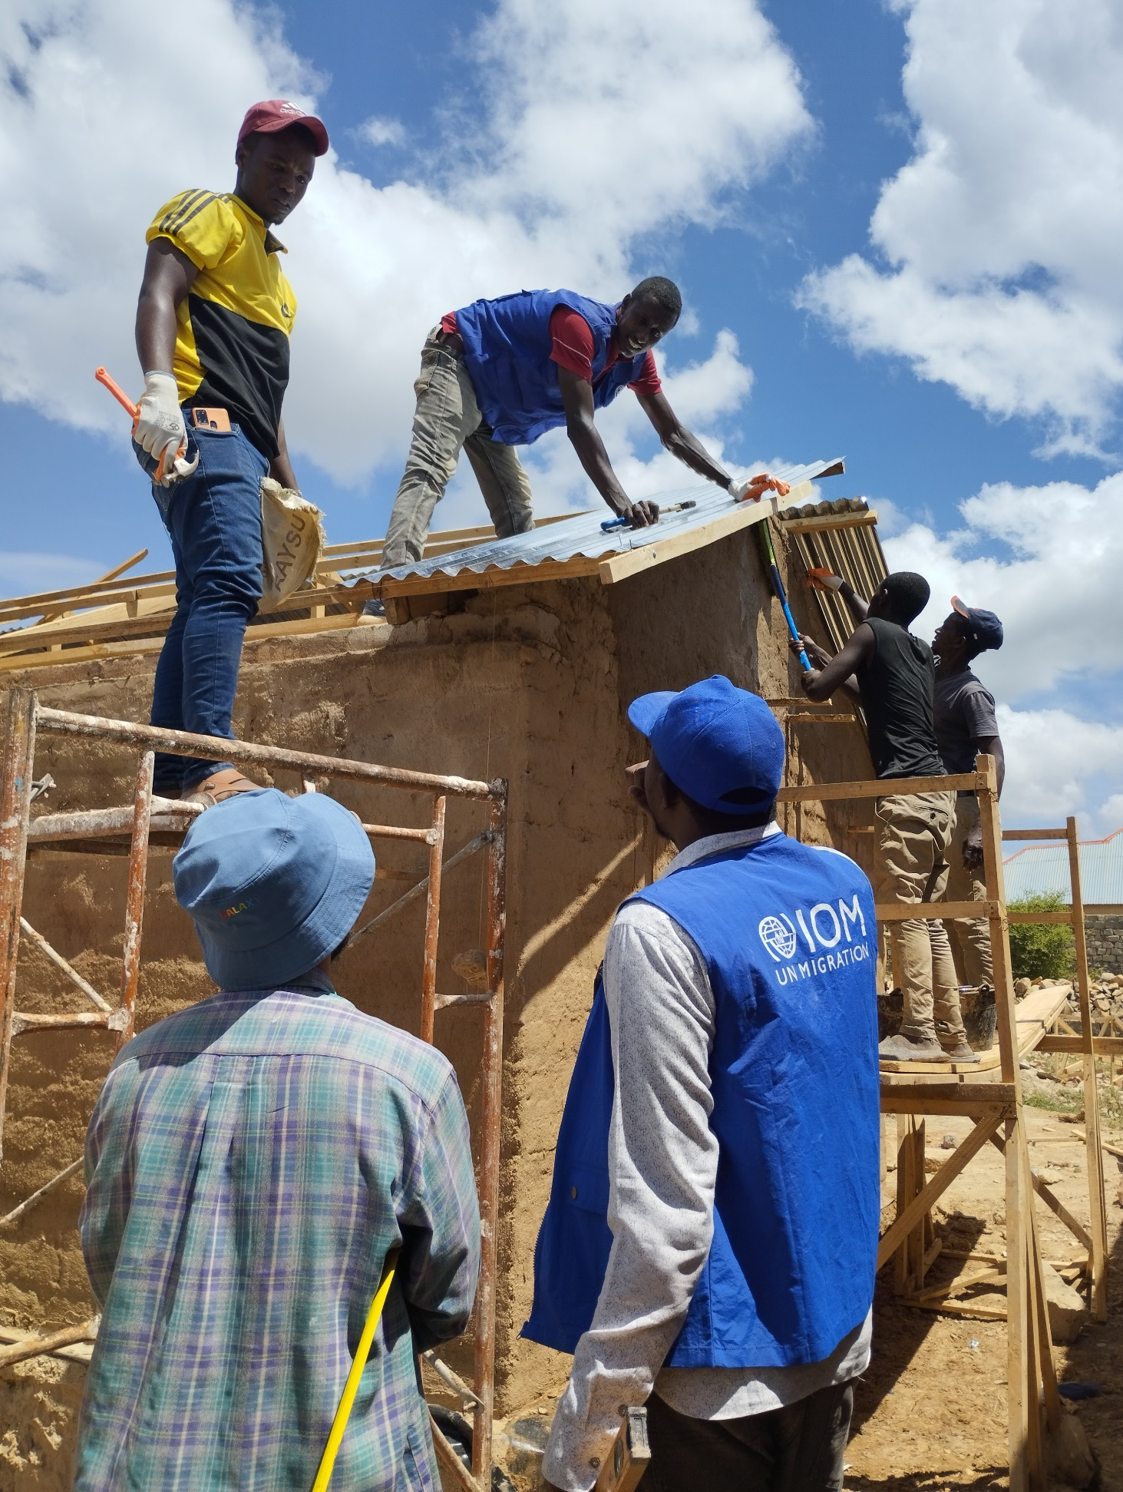
Photo 2. Construction of housing prototypes.

The table below shows disaggregated data on earth construction trainings conducted in April and May 2023:

Role | Number of attendees | Gender
Masons | 18 | M
Carpenters | 2 | M
 | 20 | All male

Golweyn Logistics & Trading LTD company completed the drilling of a borehole and other solar-powered water infrastructures in Barwaaqo: local communities are expected to benefit from water provision for human consumptions, and for farming purposes once the establishment of micro-irrigation schemes is completed.
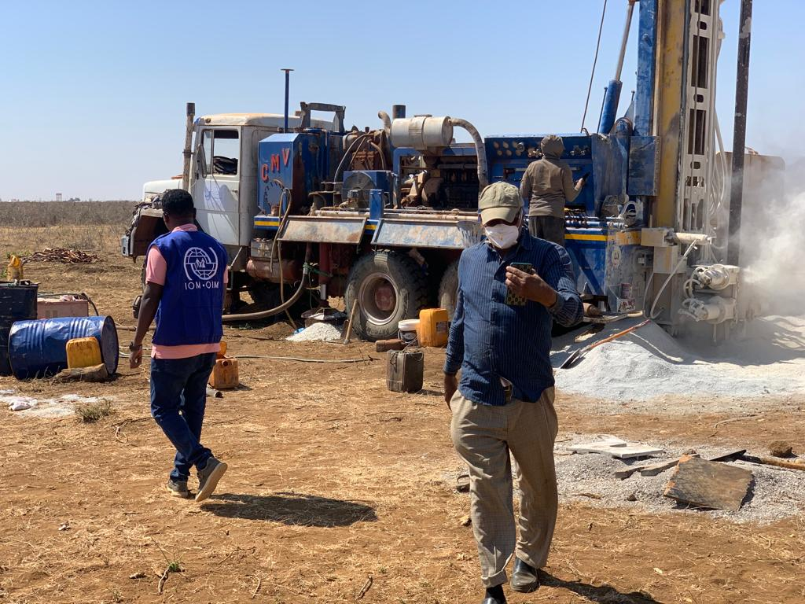
Photo 3. Water infrastructures built in Barwaaqo.

Section 3: Progress Report Results Matrix
OUTCOME STATEMENT
1) Enhanced capacities of local authorities and DACs reinforce mutual accountability to plan, leverage and implement durable solutions at scale that reflect collective and area-specific priorities
2) Strengthened self-reliance and social cohesion of DACs through employment generation, service delivery and additional investments in target sites
SUB-OUTCOME 1 STATEMENT
Enhanced capacities of local authorities and DACs reinforce mutual accountability to plan, leverage and implement durable solutions at scale that reflect collective and area-specific priorities.
INDICATOR | TARGET | PROGRESS ON OUTPUT INDICATOR
INDICATOR | TARGET | REPORTING PERIOD (2023) | CUMULATIVE
Output 1.1: Preparatory studies and assessments are produced that include a gender and conflict angle
# of assessments (including a conflict and gender sensitive analysis) produced to better inform DS programming | 2 | 0 | 1
# of institutional capacity assessments or desk reviews (including a conflict and gender sensitive analysis) produced to improve DS stakeholder capacity to deliver services to inform area-based planning, identify priority areas for capacity strengthening tailored to institutions and support to local authorities | 3 | 0 | 3
# of map-based analysis of functionality of core urban services, including housing demand etc. produced | 3 | 0 | 1
# Area level outcomes formulated and embedded in one urban development roadmap per city | TBD | 8 (per CAP/City Strategy in Baidoa) | 8
Output 1.2: Strategies and legal provision are produced that include specific priorities of women, youth and are climate smart.
# of roadmaps, strategy and policies enabling upscaling of durable solution | 5 | 2 (City strategy – draft Social Cohesion strategy SWS) | 2
# Of by-laws on fit-for-purpose land and property registration in each target location is passed by the authorities | 3 | 0 | 1
# of city extension plans and neighborhood plans are produced that reflect collective durable solutions priorities, including those of women and youth, and are climate-adaptive | 3 | 1  (Baidoa City Strategy and Extension Plan) | 1
Output 1.3: Institutions, governance mechanisms and tools are developed in the areas of land as well as inclusive and accountable governance
# of consul online platforms that are set-up and ready for use | 3 | 0 | 1
# of gender-sensitive monitoring, evaluation and learning mechanisms set-up | 3 | 1 (draft M&E plan SWS) | 1
% of DACs actively participating in government decision making activities on service delivery  (Evidence of responsiveness by local authorities and other service providers to DAC identified durable solutions priorities reflected in the Community Action Plans: % of target population who report local authorities and other service providers are responsive) | TBD | 84% (Baidoa) | 84% (Baidoa)
# of land department staff trained in applying fit-for-purpose land administration tools and completing such processes, of which % women | 90 (15/20% women) | 50 (20% women) | 50 (20% women)
# of recorded land transaction and properties defined by the FFP land admin model | TBD | 0 | 0
# of inclusive social cohesion and social accountability platforms set-up and operational | 3 | 0 | 1
# of land and property registration tools developed and implementation manuals produced | 3 | 0 | 0
# land department or local branch of lands commission functioning in each city | 3 | 0 | 1
Output 1.4: Technical knowledge of authorities and DAC members is enhanced.
# of local authorities and DAC members trained in financial literacy, fund management, saving schemes and investment plans, of which % women | 180 | 0 | 180 (42% Women)
# of admin and finance department are functional and staff is trained in land value capture related transactions and revenue, of which % women | TBD (20% women) | 0 | 0
# of local authorities, DACs, and academia trained in gender-sensitive monitoring, evaluation and learning tools, of which % women | 180 | 0 | 180 (42% women)
# of local authorities and DAC members trained in participatory and accountable governance, including in accessing and using the online “Consul” platform, of which % women | 300 (50% women) per city | 0 | 30
# of local authorities and DAC members trained in effective resolution of land conflict, of which % women | 300 | 0 | 0
# of tenure documents per year issued by municipality to all citizens, including to DACs thanks to the new systems | TBD | 748 in 2022  351 by February 2023 | 1,099
SUB-OUTCOME 2 STATEMENT
Strengthened self-reliance and social cohesion of DACs through employment generation, service delivery and additional investments in target sites.
Output 2.1: Consultations between authorities and communities improve access to service delivery and livelihoods
# of community action plans meetings between local authorities and DAC's per year, of which % participants are women | 2 per year, per city | 0 | 2
# of authorities and DACs in each municipality utilize the online citizen dialogue platform Consul, of which % are women | 600 | 0 | 0
# of service delivery proposals that are put on the consul platform and community action plans per year, of which % reflect priorities specifically of DAC women and youth and of which % are climate-adaptive | 15 | 0 | 0
# of submitted service delivery proposals that are financed and implemented, of which % reflect priorities specifically of DAC women and youth, and of which % are climate-adaptive | 4 (2 for Baidoa, one each for the others) | 0 | 0
# of funding campaigns developed by & launched with communities based on CAPs and Consul | 9 | 0
# of municipal investment forums per year | 9 | 0 | 0
Output 2.2: Community funds and access to livelihoods support and empower DACs to implement community identified priorities secure increased economic self-reliance.
# of community-managed funds established | 30 | 0 | 0
# of businesses and alternative livelihoods established through the fund that are contributing to self-reliance, of which % women or youth | 30 | 8 businesses through the collaboration with UNIDO’s credit facility programme | 8
# of livelihood-initiatives created that have a climate-adaptation focus | 120 (to be reviewed) | 4 businesses established or expanded.  Moreover, Saameynta led to UNIDO’s further investment to establish or expand 4 more businesses. | 4
Output 2.3: Development briefs increase the investment potential of target sites and enhance tenure security for vulnerable IDPs.
# of investor ready packages elaborated that guarantee a form of security of tenure, % of which includes climate-smart technologies | 6 | 0 | 0
% variation of land price due to increased investments based on development briefs (formal and informal land markets) | 50% increment | 0 | 0
# of city development challenges conducted | TBD | 0 | 0
$ value of investment made on development briefs | TBD | 0 | 0
# of local and international forums for private sector investment conducted | 3 | 0 | 0
# of tenure security/ownership documents allocated to DACs as part of the execution of the development briefs, % which women | 4162 households | 0 | 0

Section 4: Project implementation
Key constraints and challenges and associated corrective actions

The precarious electoral, security and political situation in Somalia continues to represent a challenge for the implementation of the programme. Cooperating with multiple levels of the Government made coordination difficult and caused some delays: for example, the Ministry of Interior at Federal level has delayed the selection of its focal point but, through continuous advocacy and follow-up, the Ministry nominated the first female focal point who will ensure quality implementation and monitoring over Saameynta’s workplan.

Eventually, the Saameynta focal points did not receive their monthly renumeration since January to June 2023, due to technical issues related to Government authorities not following the proper recruitment processes and not sending the documents to be submitted as per the Letter of Agreement (LOA) terms: the Government acknowledged that and is signing a letter stating that they did not follow the proper process, then a cumulative payment will be issued. Each IP will cooperate more closely with its focal point to capacitate them to submit monthly reports and timesheets on time, to avoid such delay in the future.

The lead for durable solutions varies in different FMSs: for instance, in South-West State durable solutions were placed under the leadership of the Ministry of Planning, but in Puntland are overseen by the Ministry of Interior. This may create confusion or contestation over the leadership of the programme: to tackle it, Saameynta will cooperate with all the Government institutions through the focal points within the three ministerial counterparts. Government officials were briefed through presentations on what Saameynta is and what are the main outcomes anticipated.

The electoral process in Bossaso (May 2023) and the slow process of council formation, exacerbated by post-electoral violence, have caused delays in some of the planned activities. Council formation is ongoing but expected to be delayed until at least mid-July, by the combined effect of Eid celebrations and political conflict: Saameynta is initiating the activities that can be easily transferred to the new Government once it has settled in (i.e., community-based planning, social cohesion assessment), and will continue to monitor closely the political situation.

For what regards Hirshabelle, the heavy floods hitting Beletweyne in May shifted the focus from development to humanitarian assistance; moreover, the recent tensions between the President of Hirshabelle and the formally deposed Governor of Hiraan region proved to be challenging for what regards security on the ground. Saameynta was therefore forced to postpone its scoping mission and the development of CAP, pending situational recovery: the programme is however investigating the possibility to start delivering service activities, such as social cohesion assessment and economic analysis, that can be conducted in parallel in the second and third targeted location.

Risk management

Type of risk | Description of risk | Mitigating measures
Insecurity | Threats and continuous attacks of non-state armed actors in Somalia hinder project implementations and monitoring of activities. | The Saameynta Programme, leverages existing networks, engaged with rule of law and security actors adopting a careful security approach toward the targeted locations.
Political deterioration | The settings in which the programme operates are very complex and involve many agents with conflicting interests, which interact with each other in non-predictable ways. Some political actors, including the parliaments and other political parties, considered the upcoming political changes of ‘one person one vote’ as a way of extending the term limits of the recent regime: mass reaction from different FMS is observed. | Stakeholder engagement (local government and private sector) was increased: the Saameynta Programme developed good synergies with government stakeholders, hence able to receive early warnings on potential disputes amongst the political actors, emphasising the need of bringing in their perspectives about what changes are occurring and what can be improved.
Environmental shocks | Heavy rainfall in parts of Somalia led to the Shabelle River bursting its banks in Beledweyne district: many people fled their homes, packing their possessions onto the roof of minibuses and donkey carts. | The Saameynta Programme advocated for flood-affected communities in Beledweyne to receive emergency shelter, NFIs and emergency food aid, through cooperation with the Camp Coordination and Camp Management (CCCM) Cluster and implementing partners’ (IPs) internal units (i.e., IOM WASH or Shelter unit).
Evictions | Recent increasement of urbanisation in Somalia and increments in the value of land resulted in landowners kicking out marginalised IDPs to sell the land. | The Saameynta Programme advocated for the prevention of forced eviction and asked local authorities to protect the rights of IDPs. Land governance interventions, including participatory land mapping (through STDM), are planned and carried out with the core aim to curb this phenomenon. Moreover, in the context of the Baidoa Durable Solutions Technical Working Group, Saameynta cooperates with other partners to address several issues including forced evictions.
Loss of institutional memory | The continuity of Government leadership over the durable solutions agenda is weakened because of potential changes in Government representatives. | The Saameynta Programme is flexible to accommodate and understand new political actors, and continue to enhance capacity injection services to local authorities and other government institutions.
Corruption | High risks of different forma of fraud or corruption in Somalia due to weak internal regulations and control, non-standard accounting procedures and limited auditing, government pressure to participate in procurement processes, etc. | Saameynta implementing partners have integrated diligent risk management strategies into the project implementation modality to minimise potential risks, ensure transparency, and maintain accountability in operations. These measures include following the Harmonized Approach to Cash Transfer (HACT) Micro Capacity Assessment (MCA) for working with the government partners. Moreover, Saameynta introduced merit-based recruitment for Saameynta focal points to have more transparent process.
Organizational | UN pools of ideal candidates for the vacant position of are limited and public recruitment processes are lengthy. | Ad-interim project managers were recruited for UNDP and IOM; UN-Habitat is undergoing the recruitment processes.

Learning impact and new opportunities

During the visit to Somalia of Robert Piper, Assistant Secretary-General (ASG) on Solutions to Internal Displacement, Saameynta was confirmed to be in line with the ASG Action Agenda, by representing a model that embraces a development approach focused on integration and resettlement in urban environment through a close partnership with the government.

Interventions for promoting livelihoods and employment necessitated a deep understanding of the local economy and its growth drivers. As part of this effort, Saameynta conducted a comprehensive study of the local economy: it revealed that IDPs are integrated into the local economic system just as their non-displaced neighbours, thus underlining the need to approach the situation holistically from a socio-economic angle. However, due to additional hardships related to their displacement status, there is the need for strategic interventions that address immediate humanitarian needs of IDPs but also build economic resilience and foster sustainable livelihoods. Hence, the focus is on ensuring a comprehensive improvement in the quality of life for all residents of the targeted cities, both displaced and non-displaced.

During the assessment mission in Puntland, the team welcomed potential synergies on services delivery for durable solution interventions: for instances, in Bossaso there are existing technical selection committees for livelihoods and shelter, approved and endorsed by Government authorities, which may prove instrumental to the programme implementation. Having understood how it can complement existing programmes, Saameynta was invited to be part of these committees as well as of the Puntland Durable Solutions Technical Working Group, which is chaired by the Ministry of Interior.

Despite the data collected through the LORA exercise following the revised indicators are useful to capture the situation on the ground and allow to measure impact of durable solutions interventions over the time, Saameynta acknowledged that there are still flows in comprehending the reasons why some phenomena occur: therefore, qualitative methodologies were designed and Key Informant Interview (KII) and Focus Group Discussion (FGD) guides were produced to supplement the quantitative results, for getting an in-depth understanding of integration dynamics. Data collection in Baidoa is going to take place in August, and at the same the team is exploring the possibility to coordinate with Land-at-Scale partners for having a local researcher which will collect data in the future as part of a longitudinal study to be conducted among different countries in the region.

Considering the data for solutions goal of the ASG Action Agenda, Saameynta is going to develop a Durable Solutions Dashboard in cooperation with Danwadaag and IOM DTM, to build a public repository containing the data obtained in each city where the LORA tool has been deployed: the initiative will lead to a more harmonised approach towards data exchange for programming and monitoring. This initiative, together with the shared gender evaluation, will consolidate the strategic partnership with Danwadaag, with the aim to create a shared learning agenda when it comes to durable solutions in Somalia.

To assess whether Saameynta has effectively addressed gender-specific issues, a gender evaluation has been designed and will take place during the next reporting period, potentially to be carried out covering both Saameynta and Danwadaag programmes. The evaluation aims to identify strengths, weaknesses, and gaps in how gendered considerations are operationalized in the durable solutions programming, as well as to provide recommendations to support project management, implementing partners and other practitioners and stakeholders within the project, with the aim of improving the project's gender responsiveness and effectiveness.

Coordination with other UN entities including UNSOM/UNSOS within and outside the SJF portfolio and alignment with the UNCF

The Programme effectively coordinated with other UN agencies to share information and good practices, with the view of constituting urban displacement taskforces to enhance a unified UN-approach on engaging with key government institutions on land allocation. Saameynta coordinated through the Integrated Office with other durable solutions actors for regular consultations (at technical and management level) on leveraging resources and developing synergies over priorities identified in the Secretary-General’s Action Agenda on Internal Displacement.

Saameynta worked with humanitarian partners and mostly CCCM Cluster to ensure that the IDP settlement management is aligned with the city strategies developed under the programme, in particular in Baidoa. Saameynta team is part of the Urban (Re)Integration Taskforce and the Resilient Baidoa Initiative, where the Baidoa City Strategy has been integrated as the base tool for action planning and agenda setting in terms of spatial interventions.

In Baidoa, Saameynta collaborated closely with UNIDO to design comprehensive support packages for local businesses, aimed to strengthen local enterprises including those run by IDPs and women. These packages encompassed an array of services including skill-based training, business advisory services, and access to credit and business financing products. Collaborative efforts were further extended to include partnerships with the International Bank of Somalia and microfinance organizations. This multi-pronged approach ensures that the local enterprises in Baidoa are equipped with the necessary tools to thrive, promoting local economic development and sustainable livelihoods.

Role of the UN Somalia Joint Fund

The Somalia Joint Fund (SJF) continues to have a pivotal role in coordinating with donors, especially now that the Quarterly Review Meetings are not taking place anymore, by mediating the relations among stakeholders and initiating the Steering Committee Review, to be hold in August. The SJF supported Saameynta in its switch from social development to climate and resilience window, the latter aimed at developing climate-smart adaptive solutions for both rural and urban environments in line with the Somali National Durable Solutions Strategy and the National Development Plan. By tackling the risks posed by climate change and disasters and their implications over displacement, Saameynta will start looking at solutions through this window, contributing to the action for providing sustainable and long-term solutions to urbanization and integration of IDPs, and reducing displacement-related vulnerabilities.

The Saameynta Programme will continue to play a role in enhancing effective coordination platforms in terms of advocacy and promotion of joint coordination, to support marginalised displacement-affected communities through resources mobilisations in compliance with the strategic priorities of the Government. FGS stakeholders who continue to co-lead activities related to this intervention include: the Office of the President; Office of the Prime Minister; Ministry of Planning and economic development; Ministry of Public works; Offices of the FMS Presidents; and Civil Society Organizations (in particular women and youth organizations, organizations of the persons with disabilities; minorities etc.); UN-Habitat, IOM, UNHCR, UNDP, and other UN partners; and other international partners.

Synergies with other programmes (UN and non-UN) working on similar issues

Meaningful synergies have been developed with two UN joint programmes – the Productive Sector Development (PSD) and Local Government (JPLG) programmes – to foster enterprise support, citizen involvement, land governance and improving taxation. The joint venture with PSD helped estimating the financial requirements for specific areas that promise to stimulate job creation, allowing to evaluate the necessary financial commitments and to facilitate dialogues with commercial banks, thus enabling the Enterprise Development Unit in Baidoa to provide expert advice to potential borrowers. The synergy with JPLG enabled to leverage experience in operationalising the CONSUL platform, already implemented in Garowe under JPLG; moreover, the two programmes cooperate in relation to local governance issues, in particular municipal finance over urban planning and land administration.

Saameynta developed good synergies with other durable solutions-related programmes. During the assessment mission in Puntland, the Programme coordinated with UNHCR-Durable solutions project at Grible Settlement to identify complementarities and avoid duplications. In Puntland, Saameynta is willing to co-chair the Durable Solutions Technical Working Group (which includes government authorities, UN agencies and NGOs at the FMS level), to reach a holistic approach over durable solutions.

Saameynta coordinated effectively with IOM’s Danwadaag Programme on strengthening Government leadership and capacity to implement durable solutions strategies at FMS and municipal level. The two programmes are cooperating on implementation of common activities in Baidoa (i.e., community matching grants) as well as on monitoring issues (deployment of the LORA tool and more broadly creation of a durable solutions dashboard for data sharing across Somalia), aiming also at developing a shared learning strategy.
Partnerships

Saameynta continues to closely engage with governmental counterparts (as demonstrated by the LOA signed with the Durable Solutions Unit at the FGS Ministry of Planning, or the Agreement of Cooperation with the SWS Ministry of Public Works), in line with a government-led and community-driven approach to durable solutions pivotal to ensure sustainability over time.

The collaboration with the International Bank of Somalia and microfinance organizations has proven integral to provide access to financing and credit for medium and small enterprises, opening avenues for businesses in Baidoa to grow. Establishing strong relationships with the private sector is a fundamental step towards fostering an environment conducive to job creation and investment, to uphold the economic and social rights of IDPs by ensuring that they can benefit from and contribute to the region's development.

To facilitate local investments and enhancement of livelihoods, as well as to fosters a sense of local ownership, it is crucial to involve local stakeholders in the data collection process. Field data obtained directly from farmers can provide valuable insights into crop yields, revenue streams and products or labour costs; data can be cross-referenced with those provided by agricultural input or equipment suppliers on recommended type of inputs, application rates, and associated capital costs.

Saameynta continues to engage with Land-at-Scale and Royal Tropical Institute (KIT) project partners coordinated under the Netherlands Enterprise and Development Agency (RVO) over knowledge management and dissemination. Thanks to KIT’s mediation, the programme supported Government actors in drafting a joint project proposal with the NGO The Hague Academy to receive funding for a one-year training on land governance; the proposal is currently under review by the funding institution (Nuffic).

Monitoring and oversight activities

To capture the evolving situation within the country, the indicators in the Monitoring and Evaluation (M&E) Framework were revised to measure progress over time instead of short-term results: 14 indicators disaggregated by gender and displacement status have been identified to measure (re)integration through the percentage of change in, for example, real household income, access to services or tenure security. Indicator guides were developed, and baseline study for Baidoa was produced taking into consideration the adjustments in the monitoring framework: Saameynta partners intend to complement it with qualitative methodologies to gain insights over underlaying dynamics that may hinder integration, affecting the programme’s impact.

Monitoring activity | Date | Description | Comments  & Recommendations
Annual Project Report (Somalia Joint Fund) | 15 January 2023 | Annual 2022 report drafted and submitted. | On track.
IPs Field monitoring visit | 29 January – 1 February 2023 | Meetings with stakeholders (municipality, private banking and microfinance sector, youth association, academia). | Meetings were disrupted in December in concomitance with state elections and increased violence.
Quarterly Review Meeting | 14 February 2023 | Any quality concerns or slower-than-expected progress discussed by the project board; management actions agreed to address the issues identified. | We are no longer doing QRMs. Instead, the next Joint Steering Committee meeting is planned for August 2023.
Revision of the indicators within the M&E framework | 7 March 2023 | Indicators were revised to better capture progress over time: indicator guides and the baseline study for Baidoa were produced. | Baseline study for the next targeted location to be held in Q3 2023.
Field visit with donors | 13 March 2023 | Field visit to Baidoa with SDC representatives: met with Government authorities, visited the borehole drilling site and the shelter mudbrick making sites. | To organise a field visit with all the donors during Q3/Q4 2023.
Scoping mission over land governance issues | 26 March – 6 April 2023 | UN-HABITAT staff visited Baidoa to identify specific intervention areas for GLTN to support the land administration components in the Saameynta Programme, i.e., assessing the institutional capacity to operationalise the Urban Land Management Law, or issues related to land demarcation and registration. | On track.
Qualitative assessment | 17 April 2023 | Qualitative methodologies (KIIs, FGDs) developed to complement the LORA assessment. | To be deployed in Baidoa in Q3 2023.
Learning events | 24 – 28 April 2023 | Visit from Rebecca Hallin, Saameynta’s partner from KIT, to discuss issues of knowledge management, gender mainstream and climate change in connection to land governance. | TOR for a gender evaluation drafted, pending further fundraising.  Saameynta KM strategy drafted, pending the approval from all the IPs.
Assessment mission in Puntland | 2 – 14 May 2023 | National staff from the 3 IPs conducted a field scoping mission in Puntland to prepare the activities implementation.  Meetings with relevant stakeholders in Garowe and Bossaso (FMS and Municipality officials, other UN agencies operating on the ground), field visit to IDP sites for site identification. | On track.
Stakeholder review consultation | Bi-monthly | During the PMU, all the stakeholders are required to give a full update regarding the implementation of activities. | On track.
Review and Make Course Corrections | Monthly | Monthly meeting among IPs’ PM to share updates, performance data, risks, lessons learnt, etc. | On track.
Gender component evaluation | Mid-term | Consultations with gender experts and KM partners resulted in the development of a Terms of Reference to evaluate the gender component under the Saameynta programme.  Under the current budget, insufficient funds are available to commission the evaluation, fund-raising activities are currently taking place. | Discussed with RVO, to be discussed with Norway and SDC.

Communication activities and Knowledge Management

For what regards visibility, the programme effectively applies quality standards in relation to implementation of activities: during events, trainings, workshops, meetings and fora, all activity-related banners and materials display donor logos, in line with visibility requirements. During the official launch of the Baidoa City Strategy in March, which ensured the buy-in of a wide range of political actors and development partners, the role of Saameynta and its donors through the SJF was emphasised by the implementing partners as well as by Government representatives. Human interest stories were mainstreamed on implementing partners’ public website, and tweets related to progress in the implementation of activities were published through official accounts.

A field visit with Swiss Agency for Development and Cooperation’s representatives was organised in Baidoa in March: it represented an opportunity for donors to have first-hand oversight of some of the activities implemented under Saameynta. Following the successful outcome, a joint visit to the field with Swiss, Dutch and Norwegian donors is planned before the end of 2023.

A communication package was developed and communication material (including photos, videos, stories, etc.) was collected during the reporting period: it will be utilised, in line with the communication strategy, which is currently under draft, to amplify key project messages for reaching a wider audience, including donors, local populations and government authorities. Audiovisual materials, already obtained and to be collected during Key Informant Interviews and Focus Group Discussions upon collection of consent, will be instrumental for the process of realising an informative video about the durable solutions landscape in Somalia, to explain what is the vision of Saameynta and how it contributes to achieve the goals set by the Government: the video-making process has started and should be completed in Q3 of 2023.

To facilitate prompt and transparent communication with donors and other interested actors, a PowerBI webpage has been developed with the aim to give an overview of the programme structure, achievements, and impact of interventions, as well as to promptly share updates on the status of implementation of activities. In the next months, Saameynta partners will also collaborate with IOM DTM, Danwadaag programme and GIST to create a public dashboard for mainstreaming the data collected through the LORA exercise across Somalia, leading to a more harmonised approach towards data for solutions.

Saameynta continues to cooperate with knowledge management partners from Land-at-Scale and the Dutch Royal Tropical Institute (KIT): meaningful outcomes from this partnership are represented by the participation in a thematic study on climate adaptation and land governance, by the attendance to the 2023 LANDac Conference and Exchange, by the possibility (currently under exploration) to participate in a longitudinal study, led by a local researcher and integrated with similar studies conducted in the region, to gain in-depth understanding of impact pathways that can be scaled up. During a visit of a KIT’s partner to Nairobi in April, the Saameynta knowledge management strategy and workplan were finalised to guide the implementing partners when it comes to issues of knowledge generation, dissemination and capitalisation.

Section 5: Project management

Figure 1. Governance arrangements for the Saameynta Joint Programme

Number of project board meetings held | The second Quarterly Review Meeting (QRM) was held in Nairobi in February 2023, with representatives from the Implementing Agencies and representatives from the contributing donors to the SJF (the Netherlands and Switzerland).  The Programme Management Meeting (PMU) has been ongoing since the onboarding of the Programme Coordinator. The Focal Persons from FGS, FMSs, IPs and the Coordination Unit have mandatory participation. The PMU were conducted online.
Number of UN staff (international/national) funded by the project | UNDP: 4 (1 international and 3 national) staff, 4 (2 international and 2 national) consultants  IOM: 6 (2 international, 3 national and 1 intern) staff  UN-HABITAT: 6 (3 international and 3 national) staff – some of these personnel may only be partially charged to the project (shared costs)  Integrated Office: 1 international staff
Number of government personnel funded by the project?  What are their functions and where do they work?  Is the capacity injection in line with the Capacity Injection Protocol? | 6 under LOA between UNDP and MOPIED (Durable Solutions Unit).  3 FGS Focal Persons (MOPIED, MOPWRH, MOIFAR);  3 FMS (South-West State) Focal Persons (MOPIED, MOPWRH, MOIFAR);  1 Social Cohesion Strategy Consultant – contract ended in April 2023;  1 National Programme Officer (Durable Solutions and Urban Resilience) – contract ended in April 2023;  1 MOPIED-SWS DS Director – contract ended in April 2023;  1 Livelihood Expert for the Baidoa Municipality – contract ended in April 2023.  Yes.
How has the project ensured the visibility of SJF donors during the reporting period? | Donors’ visibility logos were applied during meetings, activities, presentations and other events; ensured events are tweeted; representation during high-level meetings, such as the High-Level Somalia National Durable Solutions Conference, LANDac Conference and Exchange, HLPF 2023 (to be held in July), etc.
Projected funding needs for next year and the forecasted expenditure. | USD 5,276,500 (2023 Budget)  The amount is in line with expected and pending donor contributions. The amount will enable SJF to finalise ongoing activities in Baidoa, and to start the implementation in another project location.

Section 6: Cross-cutting issues

Gender equality and women empowerment

The Saameynta programme actively encourages gender mainstreaming in its project activities as well as project reporting: thus, results are gender-disaggregated to show how the projects reach women, young people, and other vulnerable groups. Moreover, Saameynta is currently developing a gender-sensitive monitoring, evaluation and learning mechanism to be endorsed at the FMS level.

The programme will contribute to increase the visibility of gender issues through, among others, enhancing the ‘voice’ of women by providing a safe space to engage, supporting the action perspective (or ‘agency’) by improving access to opportunities, and facilitating a ‘systems approach’, for instance by stimulating common answers and priorities and engaging other actors that influence gender issues to promote behavioural change that positively influences the position of women within the society. For example, during the assessment mission to Puntland, vulnerable women were interviewed and asked on how the relocation processes affected their wellbeing, hence given an opportunity to speak up. Besides that, DACs female leaders have monitored the construction of mudbricks production and the newly constructed WASH facilities in Barwaaqo settlements.

To assess the extent to which Saameynta has effectively addressed gender-specific issues, a gender evaluation has been designed and will take place during the next reporting period. The evaluation aims to identify strengths, weaknesses, and gaps in how gendered considerations are operationalized in the project, as well as to provide recommendations to support project management, implementing partners and other practitioners and stakeholders within the project, with the aim of improving the project's gender responsiveness and effectiveness. It would also seek to understand how Saameynta ensures that gender equality and the empowerment of women and girls are a part of every project endeavour, and how this component in the project has contributed to achieving the project's overall goal of achieving durable solutions for displaced populations in Somalia.

Proportion of gender specific outputs in the project  (designed to directly and explicitly contribute to the promotion of gender equality and women empowerment) | Total number of project outputs | Total number of gender specific outputs
 | 7 | 2  Output 1.1: Preparatory studies and assessments are produced that include a gender and conflict angle;  Output 1.2: Strategies and legal provision are produces that include specific priorities of women, youth and are climate smart.
Proportion of project staff with responsibility for gender issues  (staff members contracted to undertake work for the Joint Programme who have gender related activities included in their terms of reference) | Total number of staff | Total number of staff with responsibility for gender issues
 | 29 | 17  All SJP staff have gender related responsibility in their TOR.

Human-rights based approach

In line with a human-rights based approach which focuses on individuals, Saameynta ensures that its implementation is community-driven in order to strengthen the demand-driven and bottom-up citizen voice and oversight in public service delivery. The programme developed strategies for empowering vulnerable groups within the community by encouraging meaningful participation in the decision-making process, and proactively supported the inclusion of IDPs during the development, review, and updating of integrated community action plans, where community-prioritised projects were raised according to their preferences, thus enhancing IDPs’ civil and political rights. For example, DACs participated in the selection processes of the housing prototypes constructed in Baidoa district, hence their opinions were considered and will be accounted for at the moment of building the houses themselves.

The programme has helped in reducing the vulnerability risk factors for IDPs, particularly those who are at risk of marginalization and discrimination, by identifying the rights at stake in programming and the way in which the programme can contribute to the respect, protection, and fulfilment of IDPs’ rights. By proactively supporting tenure security for IDPs through strengthened actions in the field of land governance, and in the meanwhile providing access to basic services and to livelihood opportunities, Saameynta aims at improving the respect of their socio-economics rights (such as adequate standards of living, housing, education, etc.).

The Joint Programme will build on the expertise of CCCM cluster for what regards the Standard Operating Procedures for relocations of IDPs, ensuring that relocation processes target the most vulnerable members of IDP communities and is consistent with the respect of human rights of the people targeted. Relocation will be contingent to community consultations and individual informed consent, following the principle of ‘do not harm’ (thus being voluntary, safe, dignified, and well-informed).

Has the programme included a protection risk assessment in its context analysis, including on gender issues, and taken measures to mitigate these risks to ensure they are not exacerbated, or new risks created? | Result
 | Yes
Number of programme outputs specifically designed to address specific protection concerns | Result
2

Output 1.1: Preparatory studies and assessments are produced that include a gender and conflict angle

Output 2.2: Community funds and access to livelihoods support empower DACs to implement community identified priorities securing increased economic self-reliance
Number pf programme outputs designed to build capacity of duty bearers to fulfil their human rights obligations towards rights holders. | Result
2

Output 1.3: Institutions, governance mechanisms and tools are developed in the areas of land as well as inclusive and accountable governance

Output 1.4: Technical knowledge of authorities and DAC members is enhanced

Leave no one behind

The Saameynta approach is rooted in the ‘leave no one behind’ principle, explicitly prioritizing actions to support the most marginalised members of communities with the aim of reducing inequalities and fostering integration. Joint planning processes for prioritisation of services and e-citizen platforms will serve as platforms to enhance accountability between DACs and Governments, paying particular attention to groups experiencing different types of vulnerability which will be empowered to make substantive contributions to decision-making. Qualitative methodologies based on Key Informant Interviews and Focus Group Discussions have been designed to better understand systemic dynamics that inhibit full integration of IDPs, and will be deployed in Baidoa in Q3 of 2023.

The Saameynta programme is carrying out a refreshment of economic assessments for the targeted location to identify economic shortcomings, existing business enterprises (small-scale) and opportunities to invest with the help of the donors, the private sector, key non-governmental organisations and UN agencies. In 2023, IDPs will be economically empowered with the provision of business grants, equipment grants and skills trainings to improve their self-reliance. Moreover, there is a plan in place to execute the implementation of Cash for Work to provide safety nets to the most vulnerable groups in the IDP community.

Social contract and legitimacy

The Saameynta programme supported the introduction and development of the Urban Land Management Law in the South-West State, which has now come into force. During the reporting period, a scoping mission was performed to assess specific intervention areas to support the land administration components. Recommendations were made to make the law fully operational, and will be addressed in the next reporting period: current priority is to create public awareness and sensitisation on the urban land law, with a plan to organise around six workshops by the end of 2023. This will also help to build trust between communities and government institutions.

Contentious wider community engagement was initiated amongst the Saameynta partners through promoting social cohesion and social accountability, which is essential to effectively interact in monitoring the implementation of the service delivery plans through the developed social accountability platforms and toolkits. The approach strengthens evidence-based demand for accountability on the implementation of the Integrated District Community Action Plan and other development priorities whilst it challenges public institutions to become more transparent and accountable to citizens.

The Programme has recently concluded the construction of housing prototypes designed to accommodate DACs, having consultative engagement with local authorities and DACs prior to starting the project. The Programme further rolled out mason trainings for the community members and introduced effective accountability system, including a communication pathway for reporting challenges related to mudbrick production and construction of transitional shelter prototypes.

Humanitarian-development-peace nexus

The Saameynta programme aims to support protracted displacement in Somalia, with the focus on three targeted cities where there is mass displacement of IDPs due to severe drought and conflict. It adopts a holistic approach that addresses immediate humanitarian needs (i.e., borehole drilling or cash for work to support the most vulnerable IDPs) while simultaneously working towards sustainable development and long-term peace, through promoting resilience and social cohesion, addressing the root causes of conflicts, and ensuring that development efforts are conflict-sensitive and peace-promoting.

Currently, the programme is working towards the achievement of the humanitarian-development-peace nexus by reducing IDPs needs and risks through the existing recovery and transition interventions that promote the provision of services including resilience, livelihood, education, health, reconciliation, and peaceful community coexistence. With a focus on development, Saameynta also promotes localization by empowering local organizations and the private sectors to invest in the city, hence improving the sustainability of the programme and making it locally owned. By promoting accountability for populations affected by displacement and making sure that durable solutions are at the heart of the urbanisation process through supporting institution building across the project locations, the programme aims at reducing vulnerability of the people in accordance with the National Durable Solutions Strategy.

Environment and climate security

The climate-conflict nexus is at the core of Saameynta work, especially considering the current drought situation in Somalia and the resulting food insecurity that act as key drivers of displacement: on one hand, the consequences of climate change accelerate displacement triggered by environmental degradation, and on the other the subsequent unplanned urbanisation causes irreversible detrimental impact on the urban environment. Saameynta recognises that the core aim of durable solutions for DACs, namely the fact that sustainable integration is intended to be long-lasting, cannot be achieved without incorporating climate resilience considerations: by shifting from a humanitarian towards a developmental approach, durable solutions pertain intrinsically to the field of climate resilience, recognising that successful implementation cannot take place in detachment from environmental consideration.

Saameynta looks at issues of land governance through a climate-conflict lens, for example observing how weak land governance compounds to reducing resilience to natural hazards and increases environmental risk in urban settings, as it decreases the ability to implement infrastructure investments necessary to mitigate environmental risks. It works towards improved urban planning to incorporate long-term climate resilience and to reduce the risks of secondary displacement due to natural hazards, supporting green adaptation strategies such as public and private services for agricultural growth that will increase sustainable livelihoods in the targeted cities. The strong focus on land governance is crucial to building climate resilience as part of durable solutions interventions.

Prevention of corruption

The Saameynta implementing UN agencies practice a zero-tolerance policy to corruption. For instance, IOM has practical procedural procurement processes that promote a good accountability system, compliance, and mechanisms to address fraud-related scenarios, through the Harmonized Approach to Cash Transfer process. Where equipment and other ancillary services are required, direct payment or request for procurement are envisaged to be done through internal processes.

Saameynta will use direct payment to pay for the salaries of all government staff supported by the project: the different FGS and FMS entities have been assessed on their capacity to handle funds and to be able to account for them. The FGS Ministry of Planning, Investment and Economic Development (MOPIED) will manage other funds through the cash transfer modality. Having recently signed a new LOA between UNDP and the line ministries’ Directors General within FGS and FMSs, it is ensured that the recruitment process for Focal Persons within the government funded by Saameynta is competitive and assessed based on merit.

To avert aid diversion and distortion of market, the recently designed livelihood intervention programme to support direct beneficiaries will provide equipment grants (machinery and assets) instead of cash support, procured from domestic markets.

Project sustainability

Following the assumption that durable solutions are by definition Government-led and community-driven, the Saameynta programme aims to empower the existing community and state leadership in place. Saameynta acts as an enabler programme: by supporting laws and policies (i.e., Urban Land Management Law, city strategy, social cohesion strategy, etc.) to be endorsed by the government, as well as socio-economic infrastructures, it ensures to have a framework in place which will serve as a basis for further action, laying the foundation for Government implementation and for future projects that may be designed by other agencies.

In Baidoa, the programme supported the establishment and functionality of the municipality-level Durable Solutions and Urban Resilience Coordination Meeting, that is chaired by the city mayor and invited relevant South-West State institutions, donors, UN agencies, non-UN agencies, local organizations and the private sector to fully participate and exhibit strategic ways of fostering durable and lasting solutions for internally displaced communities, with a focus on promoting institutional stability. Saameynta is supporting the capacity of various relevant government actors through the Federal MOPIED, focusing on capacity building: technical capacity injections were provided, and trainings for Government officials were for example organised in the field of social cohesion and social accountability, and are planned for land governance issues. It also aims to enhance the operationalisation and maintenance of project facilities identified during the development of community action plans, encouraging active and meaningful community participation in the decision-making process through the deployment of a e-citizen engagement platform that will be hand over to the Municipality after the completion of the procurement of materials and training.

Section 7: Looking ahead: Focus on the future

Key components of the implementation of the Saameynta Joint Programme for the second half of 2023 will be:

1. Start the implementation of activities in the next targeted location, which will be Bossaso due to the deteriorated security and humanitarian situation in Beletweyne. In order to create an enabling environment for the official launch in the second targeted location, community-based planning processes and city strategy consultations will start in July, followed by assessments studies (i.e., social cohesion formative assessment, refreshment of economic analysis, etc.), social accountability mechanisms trainings and the LORA baseline study. These activities will be complemented by an inception workshop aimed at discussing the core elements of Saameynta, as requested by local authorities. Where it will be deemed feasible, assessments and consultations will also cover the third targeted location: activities in Beletweyne should start towards the end of 2023.

2. Develop a city strategy for Bossaso through legal, financial, and spatial analysis including administrative and governance systems, planning instruments, municipal finance, as well as an analysis of urban forms, natural and climate risks, urban infrastructure and provision of basic services, and housing with the aim of prioritizing interventions in defining a land use and structure plan.

3. Perform qualitative data collection in Baidoa. Qualitative methodologies guidelines (Key Informant Interviews, Focus Group Discussions) were designed and a data collection and analysis exercise will be performed in Baidoa, in order to attain a more in-depth understanding of quantitative results gathered through the LORA exercise and to better address local dynamics and gaps towards (re)integration.

4. Develop a LORA dashboard (together with Danwadaag and IOM DTM) which will serve as a repository for disaggregated data collected across Somalia through the LORA tool, in order to facilitate access to DS data to trace impact, share information and better inform the design of further programmes.

5. Perform a gender evaluation. To assess the extent to which Saameynta has effectively addressed gender-specific issues, a gender evaluation has been designed and will take place during the next reporting period.

6. Complete the ongoing feasibility assessments of poultry and livestock, labour market needs assessment, and refreshed analysis of local economy (including an assessment of economically sustainable agricultural products).

7. Adopt the e-citizen engagement platform in Baidoa, including the training of Government officials, based on the Integrated District Community Action Plan, which will also be updated to reflect current priorities.

8. Implement the Social Tenure Domain Model in Baidoa (August 2023). Implementation will include trainings for communities and their active involvement in tenure mapping.

9. Launch the Social Cohesion Strategy for Baidoa. It will be endorsed by the Government and followed by training of Government officials.

10. Initiate to implement the livelihood intervention programme under Output 2.2 to support direct beneficiaries through equipment grants, as well as Cash for Work projects and matching grants in Baidoa.

11. Finalise the implementation of solar powered micro-irrigation scheme in Barwaaqo (Baidoa), and subsequently provide agri-inputs and training to farmers following the recommendations provided by the assessment of economically sustainable agricultural products.

12. Design, through a participatory process, a gender-sensitive M&E system to be handed over to MOPIED, to enable FMSs to collect data to measure impact on the ground, inform future strategies, and ensure that actions address the needs of both genders equally.

13. Design development briefs, which will enable to create opportunities for the well-wishers, diaspora community, private sectors, donors, and investors purposely to support the already identified and prioritized projects by DACs in Baidoa district.

Section 8: Human interest story: Voices from the field

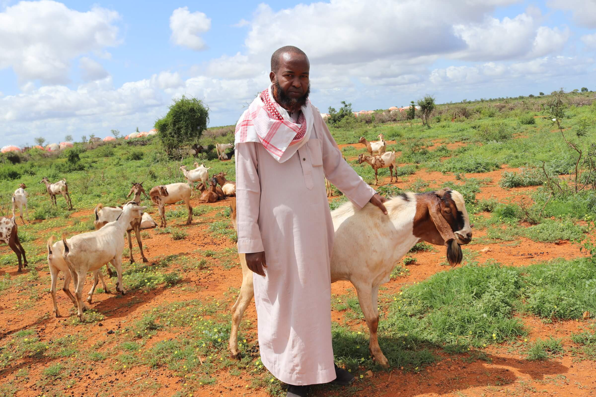 Photo 4. Abdisalam Sheikh Ali in Baidoa.

Everyone knows Abdisalam Sheikh Ali. Not just because he’s a local businessman and community leader, but because he was always ready to lend a hand to his neighbours whenever flooding or drought made life hard – something that happens all too often in his hometown of Baidoa, in Somalia’s South-West State, where climate change has made drought almost 100 times more likely.

Then, in 2020, COVID came and suddenly Abdisalam needed a helping hand himself. During nine months of lockdown, customers disappeared from his hardware store in the city market, and his income went with them, leaving nothing to feed his family, including 23 children.

“We lost everything during the lockdown,” he explained. “I used to be able to feed all the children and pay their school fees, but we’ve been struggling ever since.”

With his shop gone, Abdisalam moved to the outskirts of town and turned to small-scale livestock farming – the traditional livelihood of many in Somalia, where some 4 out of 5 people are involved in agriculture or herding. It was just enough to get by, but always there was the dusty wind in the air and the threat of another drought that could destroy his small herd. A businessman like Abdisalam wanted to do better. He wanted to be secure.

So, he turned to the Baidoa Enterprise Development Unit (EDU), an organisation that offers training and business development support to local enterprises. This EDU is promoted by the Saameynta Joint Programme, a UN multiagency consortium implemented by UNDP, UN-Habitat, and IOM. Saameynta’s main aim is to reduce the number of people living in forced displacement by providing large-scale durable solutions suited to urban environments in three Somali cities.

The Saameynta Joint Programme supports the local economic development of IDPs and host communities to build community resilience, foster inclusive economic growth and enhance livelihood opportunities for IDPs and host communities alike.

After getting support under Saameynta, Abdisalam was in a better position to meeting the conditions required for a loan. “I applied to the credit facility funded by Saameynta to expand my livestock business and invest in more modern technology”, he explained. “Now I supply Baidoa with milk and meat and breed animal for local markets. I am expecting the money to come rolling in this year so I can look after my family and pay back the bank.”

This credit facility provides Sharia-compliant loans and micro-credit for enterprises, benefiting IDPs and host communities: indeed, the funding helped Abdisalam to hire three IDPs and one returnee to work for him. Furthermore, Saameynta partners with UNIDO and the EDU to support capacity-building, skill development and sustainable business models for IDPs and host communities.

Since 2022, UNDP’s funding for the credit facility has supported 24 small businesses with training and business counselling in Baidoa, of which 14 were women owned. Loans totaling USD 300,000 have already been disbursed and a further USD 387,000 is in the pipeline.

In support to existing credit facilities, a further USD 150,000 will be added by the Saameynta Joint Programme in 2023 to support up to 10 additional businesses. The work is funded through the Somalia Joint Fund by the Swiss Agency for Development and Cooperation (SDC), the Government of the Netherlands and the Norwegian Ministry of Foreign Affairs.

Annex I.
Annex II.
Annex III.
Annex IV.
Annex V.
Annex VI.
Annex VII.
Annex VIII.
Annex IX.
Annex X.
Annex XI.
Annex XII.
Annex XIII.
Annex XIV.
Annex VIII.
UNDP Somalia, “From hardware to hard times… and back”.
IOM Somalia, tweet from the official account (7 June 2023).
Annex XV.
Overall Saameynta targets per output and a roadmap for implementation in Bossaso can be respectively found in Annex XVI and XVII.

