

CONSOLIDATED ANNUAL FINANCIAL REPORT
of the Administrative Agent

Liptako-Gourma Regional JP

for the period 20 September 2019 to 31 December 2025

UN Multi-Partner Trust Fund Office
United Nations Development Programme
GATEWAY: https://mptf.undp.org

May 2026

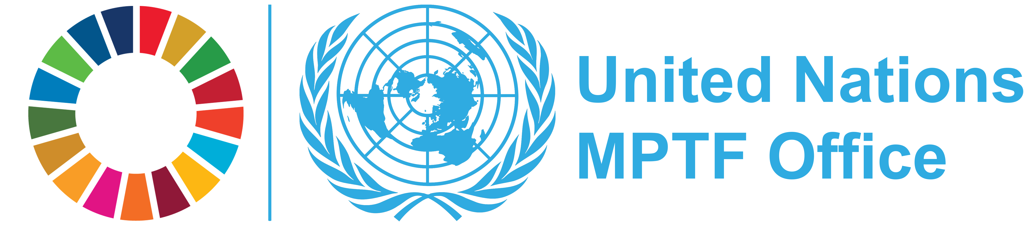

  DEFINITIONS
  Allocation/Total Approved Budget
  Amount approved by the Steering Committee for the Joint Programme. The total approved budget represents the cumulative amount of allocations approved by the Steering Committee.
  Contributor Commitment
  Amount(s) committed by a contributor to a Joint Programme in a signed donor agreement with the UNDP Multi-Partner Trust Fund Office (MPTF Office), in its capacity as the Administrative Agent. A commitment may be paid or pending payment.
  Contributor Deposit
  Cash deposit received by the MPTF Office for the Fund from a contributor in accordance with a signed donor agreement.
  Delivery Rate
  The percentage of funds that have been utilized, calculated by comparing expenditures reported by a Participating Organization or Non-UN organization against the 'net funded amount'. This does not include expense commitments by Participating Organizations.
  Contribution Agreement
  Standard Administrative Arrangement and/or European Commission contribution agreement between contributor/donor and MPTF Office.
  Net Funded Amount
  Amount transferred to a Participating Organization less any refunds transferred back to the MPTF Office by a Participating Organization.
  Participating Organization
  A UN Organization or other inter-governmental Organization that is a partner in a Joint Programme, as represented by signing the applicable legal agreement with the MPTF Office for a particular Joint Programme.
  Joint Programme Expenditure
  The sum of expenses reported by all Participating Organizations for a Joint Programme.
  Joint Programme Financial Closure
  A Joint Programme is considered financially closed when all financial obligations of an operationally completed Joint Programme have been settled, and no further financial charges may be incurred. MPTF Office will report a Joint Programme financially closed once the financial report(s) has been received and any balance of funds refunded.
  Joint Programme Operational Closure
  A Joint Programme is considered operationally closed when all programmatic activities for which Participating Organization(s) received funding have been completed, and the Steering Committee has approved the final narrative report
  Transferred Funds
  Funds transferred to Participating Organizations by the Administrative Agent in accordance with the Steering Committee’s request.
  US Dollar Amount
  The financial data in the report is recorded in US Dollars.

TABLE OF CONTENTS

Introduction . . . . . . . . . . . . . . . . . . . . . . . . . . . . . . . . . . . . . . . . . . . . . . . . . . . . . . . . . | 4
1. Sources and Uses of Funds . . . . . . . . . . . . . . . . . . . . . .. . . . . . . . . . . . . . . . . . . . . . | 5
2. Partner Contributions . . . . . . . . .. . . . . . . . . . . . . . . . . . . . . . . . . . . . . . . . . . . . . . . . | 6
3. Expenditure and Financial Delivery Rates . . . . . . . . . . . . . . . . . . . . . . . . . . . . . . . . . . | 7
4. Cost Recovery . . . . . . . . . . . . . .. . . . . . . . . . . . . .. . . . . . . . . . . . . . . . . . . . . . . . . . | 9
5. Accountability and Transparency . . . . . . . . . . . . . . . . . . . . . . . . . . . . . . . . . . . . . . . . | 9

INTRODUCTION

  This Consolidated Annual Financial Report of the Liptako-Gourma Regional JP is prepared by the United Nations Development Programme (UNDP) Multi-Partner Trust Fund Office (MPTF Office) in fulfillment of its obligations as Administrative Agent, as per the Joint Programme Document, the Memorandum of Understanding (MOU) signed between the UNDP MPTF Office and the Participating Organizations, and the Standard Administrative Arrangement (SAA) signed with contributors.
  The MPTF Office, as Administrative Agent, is responsible for concluding an MOU with Participating Organizations and SAAs with contributors. It receives, administers and manages contributions, and disburses these funds to the Participating Organizations. The Administrative Agent prepares and submits annual consolidated financial reports, as well as regular financial statements, for transmission to stakeholders.
  This consolidated financial report covers the period 20 September 2019 to 31 December 2025 and provides financial updates on projects of the Liptako-Gourma Regional JP, as posted on the MPTF Office GATEWAY (https://mptf.undp.org/fund/4lg00).

  2025 FINANCIAL PERFORMANCE
  This chapter presents financial data and analysis of the Liptako-Gourma Regional JP using the pass-through funding modality as of 31 December 2025. Financial information for this Joint Programme is also available on the MPTF Office GATEWAY, at the following address: https://mptf.undp.org/fund/4lg00.
  This Joint Programme operationally closed on 30 October 2022 and is in the process of being financially closed. Subsequent to Operational Closure, Participating Organization finalize all expenses, financially close their portion of each project/programme and report final expenses along with a final refund (if any) to the MPTFO. Once all Participating Organizations have completed financial closure, any remaining balance will be finalized in line with the MOU and the Joint Programme will be financially closed.
  1. SOURCES AND USES OF FUNDS
  As of 31 December 2025, 2 contributors deposited US$ 9,657,740 and US$ 198,165 was earned in interest.
  The cumulative source of funds was US$ 8,346,937.
  Of this amount, US$ 7,239,553 has been net funded to 8 Participating Organizations, of which US$ 7,239,553 has been reported as expenditure. The Administrative Agent fee has been charged at the approved rate of 1% on deposits and amounts to US$ 96,577. Table 1 provides an overview of the overall sources, uses, and balance of the Liptako-Gourma Regional JP as of 31 December 2025.

Table 1 Financial Overview, as of 31 December 2025 (in US Dollars)

 | Prior Years up to 31  Dec 2024 | Financial Year  Jan-Dec 2025 | Total
Sources of Funds
Contributions from donors | 9,657,740 | - | 9,657,740
Sub-total Contributions | 9,657,740 | - | 9,657,740
Fund Interest and Investment Income Earned | 187,668 | - | 187,668
Interest Income received from Participating Organizations | 1,106 | 9,390 | 10,497
Refunds by Administrative Agent to Contributors | - | (1,508,968) | (1,508,968)
Total: Sources of Funds | 9,846,515 | (1,499,578) | 8,346,937
Use of Funds
Transfers to Participating Organizations | 7,620,796 | - | 7,620,796
Transfers to Participating Organizations for Direct Cost - Fund Secretariat etc | 637,999 | - | 637,999
Sub-Total Transfers | 8,258,795 | - | 8,258,795
Refunds received from Participating Organizations | (488,219) | (519,419) | (1,007,638)
Refunds received from Participating Organizations for Direct Cost | - | (11,605) | (11,605)
Sub-Total Refunds | (488,219) | (531,023) | (1,019,242)
Administrative Agent Fees | 96,577 | - | 96,577
Bank Charges | 321 | - | 321
Total: Uses of Funds | 7,867,474 | (531,023) | 7,336,451
Change in Fund cash balance with Administrative Agent | 1,979,040 | (968,555) | 1,010,486
Opening Fund balance (1 January) | 1,850,327 | 1,979,040 | -
Closing Fund balance (31 December) | 1,979,040 | 1,010,486 | 1,010,486
Net Funded Amount | 7,770,576 | (531,023) | 7,239,553
Participating Organizations Expenditure | 6,662,462 | 577,091 | 7,239,553
Balance of Funds with Participating Organizations | 1,108,114 | (1,108,114) | -

  2. PARTNER CONTRIBUTIONS
  Table 2 provides information on cumulative contributions received from all contributors to this Joint Programme as of 31 December 2025.
  The Liptako-Gourma Regional JP was funded by 2 contributors, as listed in the table below.
  The table includes financial commitments made by the contributors through signed Standard Administrative Agreements with an anticipated deposit date as per the schedule of payments by 31 December 2025 and deposits received by the same date.

Table 2. Contributions, as of 31 December 2025 (in US Dollars)

Contributors | Total Commitments | Total Deposits
Government of Republic of Korea | 1,000,000 | 1,000,000
Sida | 8,657,740 | 8,657,740
Grand Total | 9,657,740 | 9,657,740

  3.1 EXPENDITURE REPORTED BY PARTICIPATING ORGANIZATION
  3. EXPENDITURE AND FINANCIAL DELIVERY RATES
  All expenditures reported are submitted as certified financial information by the Headquarters of the Participating Organizations. These were consolidated by the MPTF Office.
  Joint Programme expenditures are incurred and monitored by each Participating Organization, and are reported to the Administrative Agent as per the agreed upon categories for inter-agency harmonized reporting. The expenditures are reported via the MPTF Office's online expenditure reporting tool. The 2025 expenditure data has been posted on the MPTF Office GATEWAY at https://mptf.undp.org/fund/4lg00.
  In 2025, US$ 531,023 was refunded to Participating Organizations, and US$ 577,091 was reported in expenditure.
  As shown in the table below, the cumulative net funded amount is US$ 7,239,553 and cumulative expenditures reported by the Participating Organizations amount to US$ 7,239,553. This equates to an overall Joint Programme expenditure delivery rate of 100 percent.

Table 3.1 Net Funded Amount and Reported Expenditures by Participating Organization, as of 31 December 2025 (in US Dollars)

 | Approved  Amount | Net Funded  Amount
  Participating
  Organization
  Expenditure
  Delivery Rate %
 |  |  | Prior Years  up to 31-Dec-2024 | Financial Year  Jan-Dec-2025 | Cumulative
ECA | 171,277 | 121,838 | 121,838 | - | 121,838 | 100.00
ILO | 860,289 | 747,849 | 747,849 | - | 747,849 | 100.00
OHCHR | 537,251 | 264,713 | 264,713 | - | 264,713 | 100.00
UNDP | 4,678,875 | 3,700,902 | 3,111,745 | 589,157 | 3,700,902 | 100.00
UNESCO | 558,999 | 505,197 | 505,197 | - | 505,197 | 100.00
UNICEF | 863,999 | 863,999 | 863,999 | - | 863,999 | 100.00
UNODC | 520,000 | 464,057 | 464,085 | (28) | 464,057 | 100.00
UNWOMEN | 755,001 | 570,997 | 583,035 | (12,038) | 570,997 | 100.00

Grand Total | 8,945,692 | 7,239,553 | 6,662,462 | 577,091 | 7,239,553 | 100.00

3.2. Expenditures Reported by Category

Joint Programme expenditures are incurred and monitored by each Participating Organization and are reported as per the agreed categories for inter-agency harmonized reporting.

Table 3.2. Expenditure by UNSDG Budget Category, as of 31 December 2025 (in US Dollars)

Category | Expenditures |  |  | Percentage of Total  Programme Cost
 | Prior Years  up to 31-Dec-2024
  Financial Year
  Jan-Dec-2025
  Total
Staff & Personnel Cost | 1,520,933 | 550,645 | 2,071,578 | 30.61
Supplies, commodities and materials | 325,196 | - | 325,196 | 4.81
Equipment, vehicles, furniture and depreciation | 360,826 | - | 360,826 | 5.33
Contractual Services Expenses | 1,749,079 | - | 1,749,079 | 25.85
Travel | 722,363 | (27) | 722,335 | 10.68
Transfers and Grants | 494,698 | - | 494,698 | 7.31
General Operating | 1,042,878 | (33) | 1,042,846 | 15.41
Programme Costs Total | 6,215,973 | 550,585 | 6,766,558 | 100.00
¹ Indirect Support Costs Total | 446,489 | 26,506 | 472,995 | 6.99
Grand Total | 6,662,462 | 577,091 | 7,239,553 | -

1 Indirect Support Costs charged by Participating Organization, based on their financial regulations, can be deducted upfront or at a later stage during implementation. The percentage may therefore appear to exceed the 7% agreed upon for on-going Joint Programme. Once Joint Programme is financially closed, this number is not to exceed 7%.

  4. COST RECOVERY
  5. ACCOUNTABILITY AND TRANSPARENCY
In order to effectively provide fund administration services and facilitate monitoring and reporting to the UN system and its partners, the MPTF Office has developed a public website, the MPTF Office Gateway (https://mptf.undp.org). Refreshed daily from an internal enterprise resource planning system, the MPTF Office Gateway has become a standard setter for providing transparent and accountable trust fund administration services.
The Gateway provides financial information including: contributor commitments and deposits, approved programme budgets, transfers to and expenditures reported by Participating Organizations, interest income and other expenses. In addition, the Gateway provides an overview of the MPTF Office portfolio and extensive information on individual Funds and Joint Programmes, including their purpose, governance structure and key documents. By providing easy access to the growing number of narrative and financial reports, as well as related project documents, the Gateway collects and preserves important institutional knowledge and facilitates knowledge sharing and management among UN Organizations and their development partners, thereby contributing to UN coherence and development effectiveness.

Cost recovery policies for the Joint Programme are guided by the applicable provisions of the Joint Programme Document, the MOU concluded between the Administrative Agent and Participating Organizations, and the SAAs concluded between the Administrative Agent and Contributors, based on rates approved by UNDG.
The policies in place, as of 31 December 2025, were as follows:

- The Administrative Agent (AA) fee: 1% is charged at the time of the contributor deposit and covers services provided on that contribution for the entire duration of the Joint Programme. Cumulatively, as of 31 December 2025, US$ 96,577 has been charged in AA fees.

- Indirect Costs of Participating Organizations: A general cost that cannot be directly related to any particular programme or activity of the Participating Organizations. Participating Organizations may charge 7% indirect costs based on UNSDG policy, establishing an indirect cost rate as a percentage of the programmable costs for interagency pass-through pool funds. In the current reporting period US$ 26,506 was deducted in indirect costs by Participating Organizations. Cumulatively, indirect costs amount to US$ 472,995 as of 31 December 2025.

Contributors
  
  Government of Republic of Korea
  
  Sida

UN Participating Organizations
 | 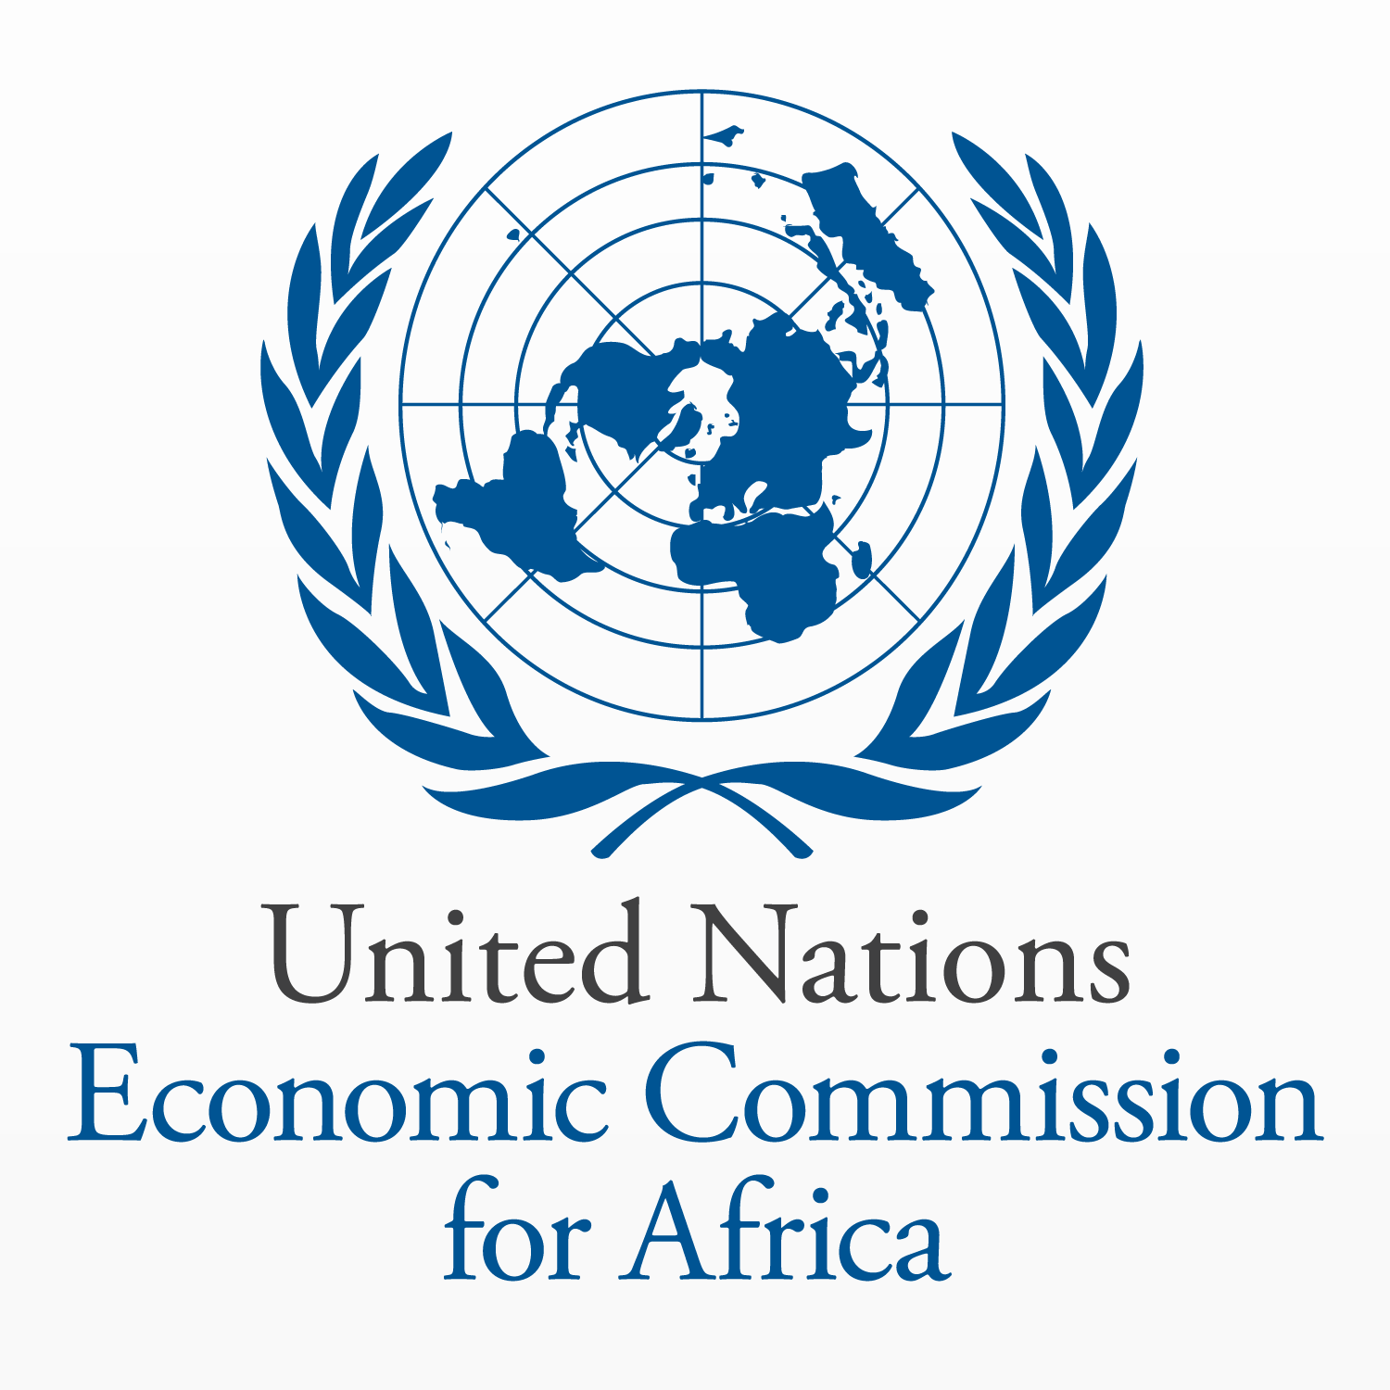 |  |  |  | 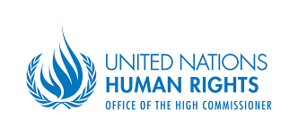 |  | 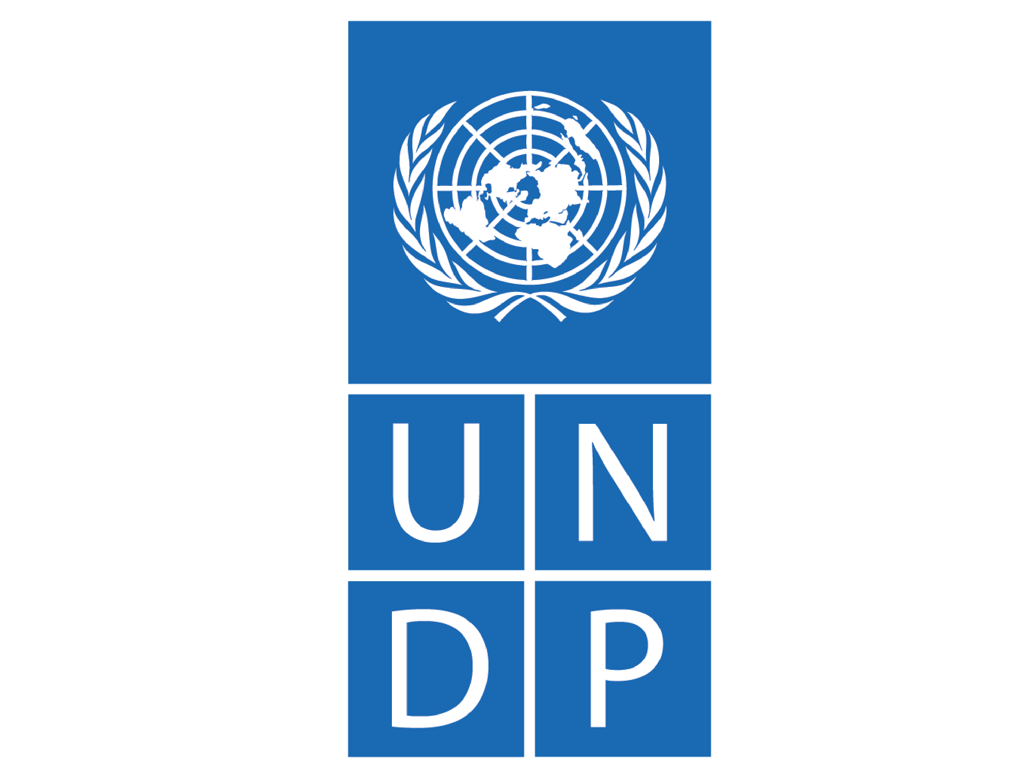
 |  |  | 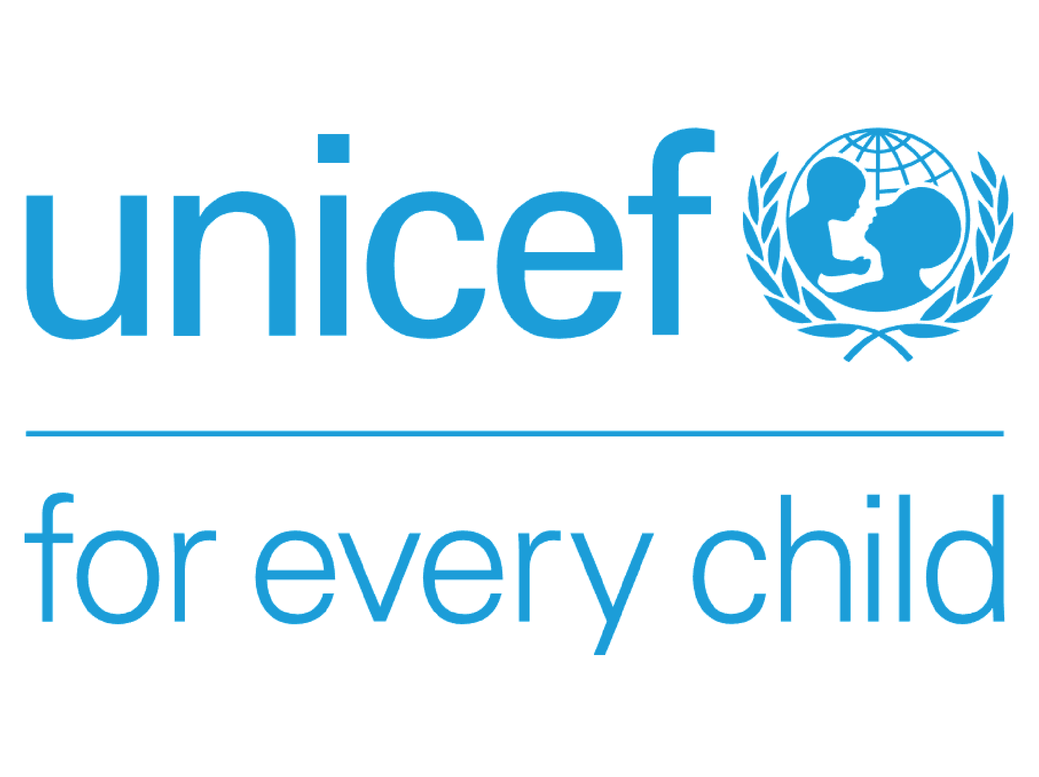 |  | 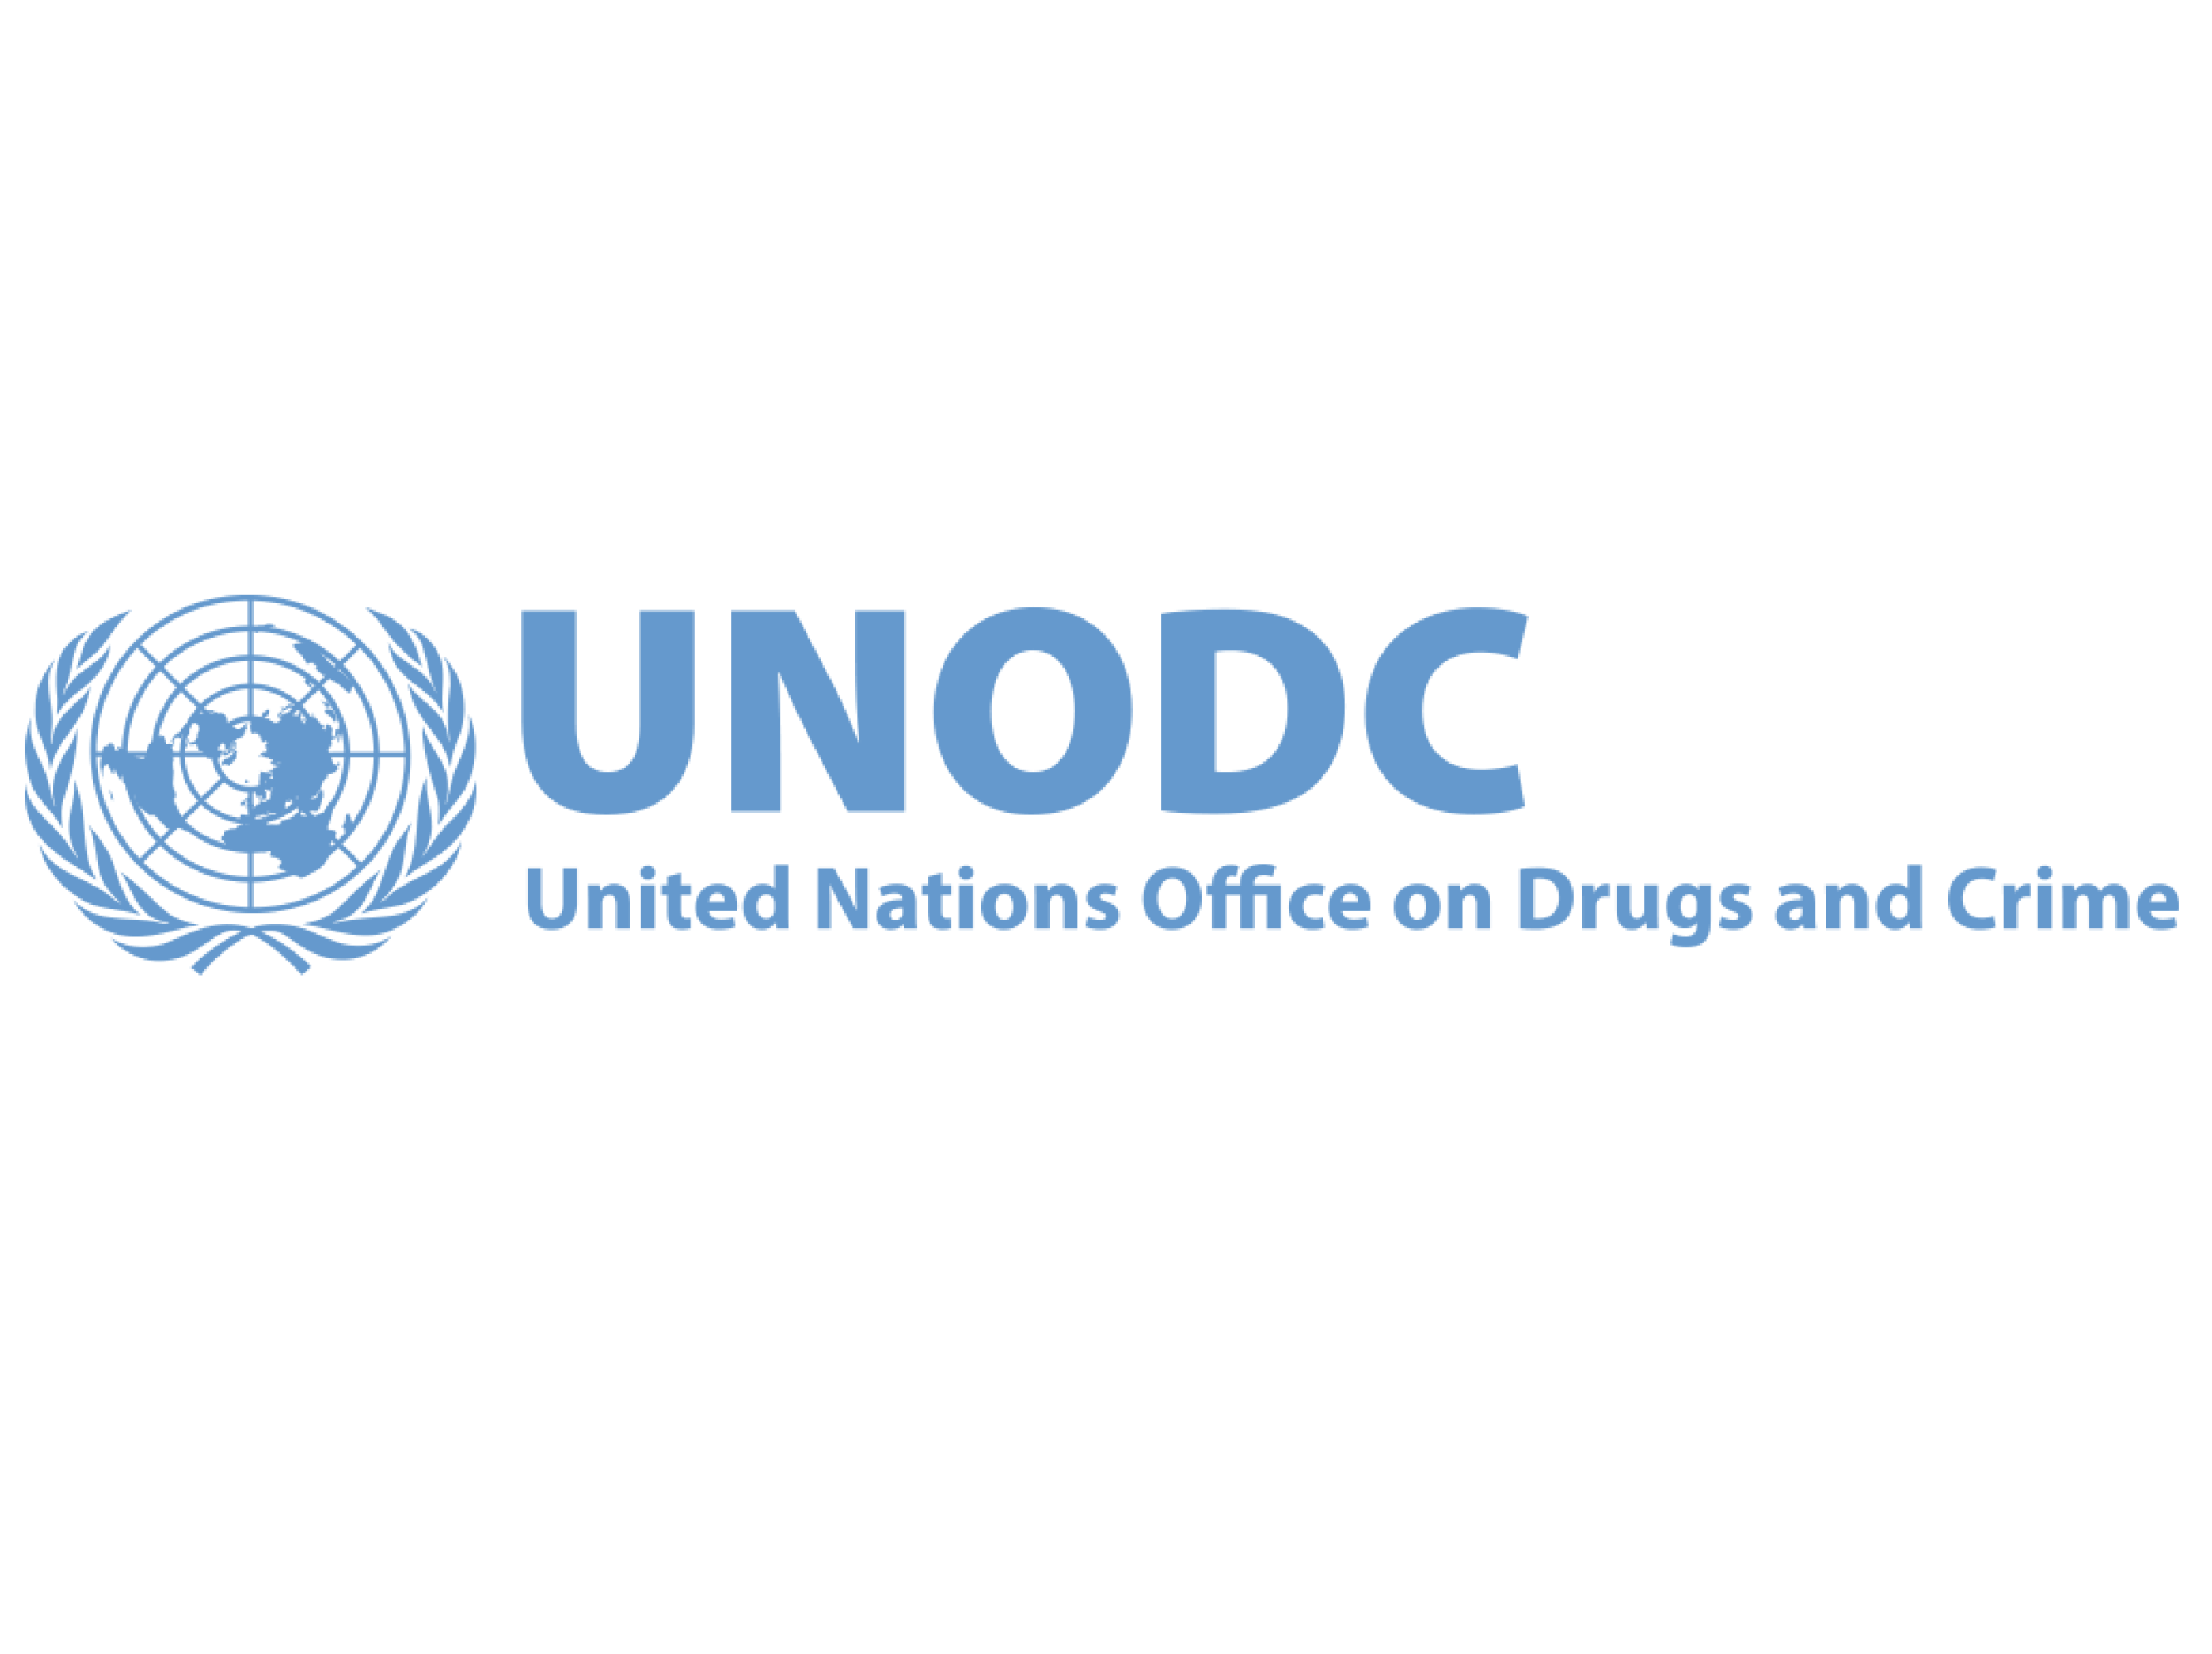 |  | 

