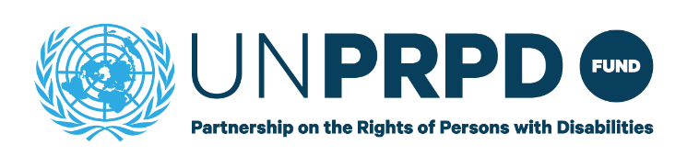
INCEPTION PHASE -END OF PROGRAMME REPORT

Country: | Benin
Duration: | March 2021 December 2021
Budget | 100,000
PUNO and  overall Focal person: | UNDP / Jelena Katic <jelena.katic@un.org>

Please provide a summary of activities carried out relating to the following areas of work. Please include details of stakeholders involved delivering the activities especially participation of organisations of persons with disabilities. Please share any photos or media clips relating to the programme activities.

- Situational Analysis
Did the Country Team complete activities relating to the situational analysis?
Yes/No
Please provide a brief summary of activities relating to developing the Situational Analysis carried out highlighting the lessons learnt and challenges encountered. (max 500 words)
Training was completed, SITAN and full proposal was not completed.

- Training activities
Did the Country Team conduct any Training activities in 2023?
Yes/ No
Please provide a brief summary of Training activities carried out highlighting any lessons learnt and challenges during the delivery process. (max 500 words).
See training report

