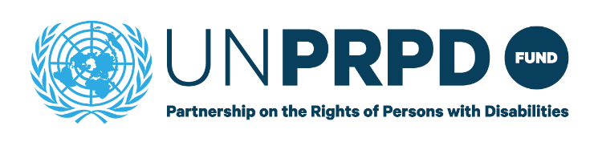
INCEPTION PHASE -END OF PROGRAMME REPORT

Country: | Barbados
Duration: | 1st November 2023 – 31st March 2025
Budget | 70,000
PUNO and  overall Focal person: | UNDP

Please provide a summary of activities carried out relating to the following areas of work. Please include details of stakeholders involved delivering the activities especially participation of organisations of persons with disabilities. Please share any photos or media clips relating to the programme activities.

- Situational Analysis
Did the Country Team complete activities relating to the situational analysis?
YES
Please provide a brief summary of activities relating to developing the Situational Analysis carried out highlighting the lessons learnt and challenges encountered. (max 500 words)
The Country team completed both the Situational analysis and the country brief.
Methods included a desk review of literature, a one day workshop on ‘breaking barriers: inclusion, participation, and freedom from violence for persons with disabilities’, programme induction training, focus group discussions, key informant interviews, and contextual analysis.

Limitations were gaps in representation across interviewees from some ministries and missing key documents such as strategic plans such as regarding education. There was also a lack of disability data, to allow monitoring and evaluation concerning persons with disabilities.

Key findings are:
- Gaps in legislation and weak enforcement mechanisms
- Commitment demonstrated by ratifying UN CRPD
- Persistent stigma
- Inadequate investment and dedicated CRPD budgeting
- Inaccessible environments across sectors including healthcare, education, employment and media
- Fragmentation of efforts across government ministries and agencies requiring a disability focal point and coordination mechanisms
- Fragmented disability data collection
- Inadequate food and nutrition security for persons with disabilities

Detailed information on the findings is provided in the situational analyses full and brief reports

- Training activities
Did the Country Team conduct any Training activities in 2023?
Yes
Please provide a brief summary of Training activities carried out highlighting any lessons learnt and challenges during the delivery process. (max 500 words).
Total of 21 participants 8 male, 13 female,
Training was delivered in two phases, across five days; the first module was in person and the second virtual sessions.
Attendance was approximately 20-25 for persons in the in-person sessions, and 15 persons for the virtual sessions.
Participants ranged from government to OPD and UN entities, and efforts were made to get representation across diverse disabilities.

Challenges:
Challenges included technical difficulties in the virtual sessions. Participants and facilitators both struggled with audio and video disruptions and connectivity issues which impeded communication and hindered effective collaboration. Further, ending the workshop with virtual sessions seemed to impact the return of post-training questionnaires. Time constraints were also a challenge, with exercises taking longer than time allocated and therefore required modification
Establishing lessons learned was challenged by the incomplete pre and post questionnaires.
Key Findings:
An important lesson learned was that the programme should not end with virtual sessions, which also impinged on completion of evaluation questionnaires. The in-person sessions were shown to be more engaging than virtual ones, primarily due to technical challenges.
Sessions on the CRPD and SDGs, as well as inclusive mainstream services, were highlighted as particularly relevant.
Feedback highlighted the need for better preparation of materials for visually impaired participants and adjustments to physical infrastructure to accommodate wheelchair users.
See training report for full details.

