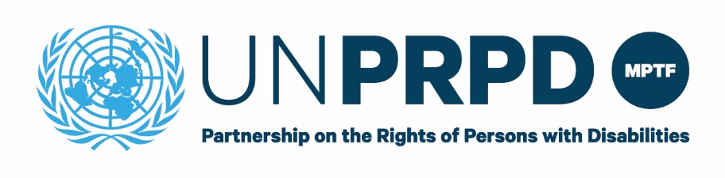
END OF PROJECT REPORT
DISCLAIMER
This publication was made possible thanks to funds from the UNPRPD MPTF however it does not necessarily reflect the official position of the UNPRPD MPTF.
This publication may be freely used for non-commercial, fair use purposes, with proper acknowledgement of partners and UNPRPD MPTF. Any other use must be authorized in writing by the UNPRPD programme following a written request for permission. Any use of the content, in whole or in part, in all hard or soft copy including in any online display, shall include attribution to partners as the original publisher with UNPRPD MPTF funds

Title of Project- Understanding how to use an intersectional approach while addressing disability inclusion
Reporting Period- January-July 2021
PUNOs- United Nations Entity for Gender Equality and the Empowerment of Women (UN Women), Office of the High Commissioner for Human Rights (OHCHR), United Nations Development Programme (UNDP), United Nations Population Fund (UNFPA), United Nations Children’s Fund (UNICEF)
Other Partners-
International Disability Alliance (IDA) Community of Practice
Civil Society Advisory Group- CBM Global, HelpAge International, International Disability Alliance, Sightsavers, Women Enabled International, Women’s Refugee Commission
UN Country Teams- Moldova and North Macedonia

1. Variations in impact and outcome indicators
Using the table format provided below, please provide information on the variations in impact and outcome indicators that took place during the reporting period.

Table 1. Variation in impact indicators

Impact
Enhanced capacity and coherence of UN agencies to support Governments, DPOs and other stakeholders to take an intersectional approach to promote the rights of persons with disabilities in all their diversity across the life course, including in line with the UNCRPD, CEDAW, UDHR, UNDIS and consistent with the commitments of the 2030 Agenda for Sustainable Development to leave no one behind.

Impact Indicators
Indicator* | Start level  (Beginning of the project reporting period)* | Target* | End level  (End of the project reporting period)* | Means of Verification
Increased number of UNCTs integrating an intersectional approach in the implementation of UNDIS scorecard | Reporting on UNDIS has not yet taken place | N/A | N/A | SG report on system-wide progress report on the implementation of the UNDIS  UNDIS/SWAP reporting timeframes didn’t align for the project period; this indicator could be be reviewed in Q1 2022.
* Please provide sex disaggregation here.

Table 2. Variation in outcome indicators
(Add a table for each outcome in the approved project document)
Outcome 1
UN entity programmes increasingly employ an intersectional approach to disability inclusion.

Outcome 1 Indicators
Indicator* | Start level  Baseline  (Beginning of the project reporting period)* | Target level* | End level  End line  (End of the project reporting period)* | Means of Verification
Guidance on intersectionality is available for UN entities and UNCTs and other relevant stakeholders and partner governments | No common UN guidance | Guidance tool available | Draft guidance tool available | Finalized product included in UNPRPD UNCT programming guidance package
Global inter-agency coordination/meeting forum for inter- sectional issues | No forum exists | Inter-agency coordination space/meeting forum established | Forum established, one meeting held and a Teams channel set up for continued dialogue | Meeting minutes
* Please provide sex disaggregation here.

Table 3. Outputs level Progress
Output | Brief Description of Progress | Planned timeline in case not completed
1.1. Guidance toolkit on intersectional approaches to addressing disability inclusion | Final draft toolkit completed July 2021, ready for copy-edit and design processes. | -
1.2. Practices/Case studies on disability inclusive programming using inter- sectional approach documented | 1 policy brief on intersectionality and the rule of law completed in November 2020.  Brief case studies and good practice examples on intersectionality developed and included in toolkit. | -
1.3. ToRs for inter-agency forum developed | Completed in July 2020. | -
1.4 2 meetings of inter-agency meeting forum for intersectional programming | 2 UN interagency meetings were convened:  - Oct 2020 to share initial feedback on work plan and toolkit approach, attended by 7 agency focal points.  - Mar 2021 to validate key findings emerging from the intersectionality desk review and end user survey and provide insights on emerging recommendations. Feedback was positive and toolkit was drafted based on agreed final recommendations. | -
1.5 Consolidated feedback from the field, including based on survey results | Following consultation with UN agency reps, CSAG members, OPDs, government and UNCTs via webinar and key informant interviews, the survey was shared across networks to understand current experiences, needs, resources and tools being used in relation to intersectionality. The survey also captured information regarding stakeholder engagement and preferred formats for the toolkit. 31 completed responses were received from UN and Civil Society Organisations across 20 countries and consolidated, along with desk review findings, into final recommendations for the toolkit. | -
1.6 Develop 1 webinar on the toolkit for dissemination | This was converted to an email circulation and discussion with those who responded. Draft toolkit shared with UN join agencies (end of May), IDA community of practice and Civil Society Advisory Group via email and feedback was integrated in the second draft. | -
1.7 Mapping of potential partners by region for rapid field testing | Mapping and request for initial expressions of interest for rapid field testing from Country Teams completed in April 2021.  Consultations held with 2 identified country teams – North Macedonia and Moldova - to agree on scope and expectations held in late April.  Two way review – of toolkit by CTs and of country planning processes by Intersectionality consultant – conducted in June/July and learnings incorporated into the toolkit second draft. | -
1.8 Disseminate toolkit, including easy-to-read versions, through relevant global and regional inter-agency mechanisms and a diverse range of civil society networks | There has been considerable engagement and interest generated via the Civil Society Advisory Group. The draft toolkit was shared with this group and feedback from 6 CSOs incorporated into the final draft. | -
1.9 Disability movement community of practice (COP) for the project established. | Concept note for partnership with IDA and collaboration with their Community of Practice finalized in Feb 2021.  EOI process for identification of IDA COP and core group members in Feb-Mar 2021.  Engagement and consultations with IDA community of practice through 4 x webinar meetings, WhatsApp group discussion and email throughout Mar – Jul 2021. | -
1.10 Desk review to understand existing intersectionality concepts, resources and gaps and refine scope and priorities for the toolkit. | Scope and desk review analysis framework determined, literature scan completed Dec 2021.  Analysis of desk review and end user survey: discussion of findings, additional analysis required and drawing up key recommendations on next steps completed Jan 2021. | -
1.11 1 validation webinar on desk review and end user survey findings | This was held as a joint presentation between project team and IDA core group in Mar 2021. UN agencies and CSAG members all participated and the proposed approach for the toolkit validated. | -

3. Progress towards specific outcomes
The project has completed all required outputs for the reporting period and outcome 1 will be realized once the resource is fully designed and made available. Progress towards overarching outcomes around interagency coordination as well as collaboration with the disability movement has also been made.
The project also tested a new model for engagement with and accountability to persons with disabilities by partnering with IDA to set up a mentorship-style of initiative whereby people with disabilities, with diverse perspectives and experience, form part of the toolkit development team.

4. Equality between men and women
The project modelled an intersectional approach to the process of toolkit development and worked closely with the disability movement to ensure that perspectives of women and gender diverse persons in particular were central to the project. The project partnered with International Disability Alliance and their Community of Practice in order to offer women with disabilities the opportunity to share and gain skills through mentoring and peer support, as well as engage with the UN and Civil Society Organisations.

5. Full and effective participation of persons with disabilities
Please see above. The project aimed to model an intersectional approach and promoted the leadership of and accountability to diverse people with disabilities in the design and development of the toolkit itself. Full and effective participation of people with disabilities is critical to quality development of this toolkit. Participatory and accessible online meetings, workshops and other channels were central to this engagement and the project team ensured reasonable accommodation needs were met as part of this.

6. Partnership-Building
International Disability Alliance: The project established a collaboration/partnership with IDA and their Community of Practice. Using online meetings, emails and a WhatsApp group, a close working relationship was established between the project team and this advisory group and a space was created for all to share their insights and perspectives on a practical approach to intersectionality guidance that centred on the lived experiences of diverse persons with disabilities.

UN agencies: An inter-agency meeting forum convenes gender, disability, age, youth focal points from UN agencies on a periodical basis to inform development of the guidelines and provide a space to identify entry points for building more synergy and to support UNCTs.
Civil Society Advisory Group: At the global level, a civil society advisory group was been established to contribute to all aspects of the development and dissemination of the tool. The advisory group consists of the following 7 civil society organizations: International Disability Alliance, CBM, Women Enabled International, Women’s Refugee Commission, WaterAid, Sight Savers, and CREA.

7. Promoting ONE UN approach to disability Inclusion
The project aims to address the gap in knowledge and resources on how to systemically integrate an intersection, disability inclusive approach and support UN agencies, particularly UN Country Teams, in this work. By taking a joint programme approach and establishing and engaging with the UN Inter-Agency Forum, it is well-placed to influence engagement of UN agencies and partners at a country level. It will also contribute to a practical understanding of intersectionality and disability inclusion by modelling good practice in its’ engagement with diverse persons with disabilities through the IDA COP.

8. COVID-19
N/A

9. Creation of knowledge products and communications materials.
The Intersectionality Toolkit is an innovative product that may be used by Country Teams to deepen their understanding of and apply an intersectional approach to their work. It aims to provide conceptual clarity, a practical framework and tools for reducing compounded and intersecting inequalities faced by people experiencing diverse and compounded forms of discrimination. Country teams involved in the rapid field testing shared that the guidance was particularly helpful in unpacking the relationship between reflexivity (self-reflection) and broader power dynamics that are always at play at a larger scale in systems, policies and programs.
Understandings and practices relating to intersectionality are fast-evolving and it is further recommended that the toolkit be treated as a ‘living document’ and undergo regular updates as more country teams use the toolkit and concepts and systems progress.

Name of product | Type of product (report, guidelines, assessment etc.) | Purpose and process  Describe what was the purpose of the product who participated in the development of product (OPDs, NGOs, Academia etc) and if the product was tested/ validated. | Link /attachment | Acc. formats | Validation  Has the product been validated. If yes by whom?
[…] | […] | […] | […] | […] | […]
Intersectionality and the Rule of Law | Policy Brief, slides and infographic | […] | […] | […] | […]

- What communications strategies did the project adopt?
- Please list type of communications materials.

Name of Product | Type of Product (Toolkit, Video, Poster, publication etc.) | Purpose | Dissemination | Links/ Attachments | Language | Accessible formats
[…] | […] | […] | […] | […] | […] | […]
[…] | […] | […] | […] | […] | […] | […]
[…] | […] | […] | […] | […] | […] | […]

10. Multi-country engagement/impact
Two countries – North Macedonia and Moldova - were involved in rapid field testing in April-July 2021. The IDA community of practice group was comprised of persons with disabilities from many regions of the world including Tanzania, Mongolia, Uganda, Mexico, Nepal, Lebanon and India.

11. Photos depicting Project related impact and outcomes
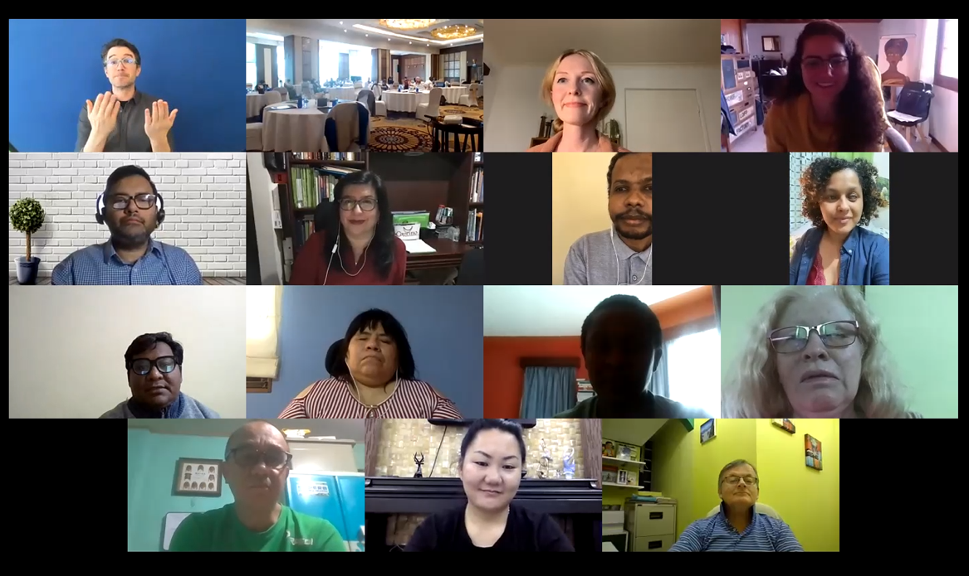
Photo No. | Photo description for use in alternative text for images to enable persons with visual impairments using screen readers to understand and perceive the image. | Consent for Use of Photo obtained (Y/N) | Photo Caption | Photo Credit
1 | Photo shows a grid screen of diverse people participating in a zoom meeting. | Verbal only | Photo of the first UN Women and IDA Community of Practice meeting in March. | […]
[…] | […] | […] | […] | […]
[…] | […] | […] | […] | […]
[…] | […] | […] | […] | […]
[…] | […] | […] | […] | […]
[…] | […] | […] | […] | […]

12. Challenges
The project aims to be intersectional both in process and end product and there has been a strong focus throughout on strengthening collaborative relationships and ensuring meaningful engagement with the disability movement. The partnership with International Disability Alliance and their Community of Practice has been an exciting opportunity for UN Women to lead the way in modelling an innovative and empowering approach to inclusive toolkit development. A key learning is that this takes time; maintaining the project’s commitment to an intersectional approach while also meeting tight deadlines is a challenge. While the end results have certainly made the effort worthwhile, it would be valuable for the UN to consider how systems may provide greater flexibility in future so that similar project partnerships are not discouraged due to procedural barriers.

13. Project follow up and Sustainability
Please provide an overview of initiatives planned by various stakeholders in order to follow up on activities initiated by the project. Please outline how the medium-to-long term sustainability of the work initiated by the project will be ensured after the end of the Project.

Annex 1.
The UNPRPD MPTF approved in June 2020 it’s New Strategic and Operational Framework 2020-2025. As the Fund has now the obligation to report against the new results framework, we are requesting projects to reflect on which Fund’s outcome/outputs/indicators their project is contributing.

REPORTING AGAINST UNPRPD MPTF RESULTS FRAMEWORK
Outcome 1: National Stakeholders are equipped with the knowledge and practical tools for disability inclusive policies and systems | Yes/No | Brief Description
Outcome indicators
1.1 # of stakeholders in UNPRPD supported countries with increased knowledge and capacities to design/reform and deliver inclusive policies and systems (disaggregation by stakeholder Gov/ UN/OPDs/other)
1.2 # of stakeholders in UNPRPD supported countries with strengthened evidence-based knowledge and capacities to assess and respond to gaps in relation to preconditions to CRPD implementation and inclusive SDGS achievement
1.3 # and % of UNPRPD supported countries that have developed and/or strengthened national guidelines, protocols, and/or standards to design and implement policies and systems
1.4 # of stakeholders in UNPRPD supported countries used UNPRPD’s situational analysis to inform their future actions around disability inclusion. (disaggregation by stakeholder Gov/ UN/OPDs)
1.5 # and % of UNPRPD supported countries that undertook multi stakeholder capacity building initiatives on disability inclusive policies and systems
Output 1.1 - Capacity of the national stakeholders is enhanced to develop and implement gender responsive and disability inclusive policies and systems for the CRPD and SDGs implementation | Yes/No | Brief Description
Output Indicators
1.1.1. # of trainings developed and delivered to support national CRPD /inclusive SDG implementation disaggregated by geography (country, regional and global), topic(thematic area, specifics modules on women with disabilities and underrepresented groups needs and rights, and specific modules on instruments for planning and implementation of UN development activities both in development and humanitarian settings).
1.1.2. # of participants (disaggregated Gov (type of ministry)/ UN/OPDs/other) (disaggregated by sex/type of disability/rural urban) participating in capacity building activities funded or provided by UNPRPD programmes
1.1.3. # of OPDs (disaggregated by type umbrella- disability specific- women-other) that benefitted from capacity building activities (type of activities) funded by UNPRPD programmes to strengthen the capacity of organizations of persons with disabilities.
1.1.4. # of OPDs that have been trained to participate in planning and monitoring of national development plans related to UN/government /other
1.1.5. # of capacity building activities (disaggregated by type of capacity building) funded by UNPRPD programmes, directed at women and girls with disabilities on their rights and requirements and/or directed at underrepresented groups of persons with disabilities on their rights and requirements. (Number of participants, disaggregated by age, disability and geographical location.
Output 1.2- Knowledge products are developed and piloted, particularly to address gaps on the preconditions to implement CRPD and disability inclusive SDGs | Yes/No | Brief Description
Output Indicators
1.2.1. #of knowledge products (disaggregated by product: tools, guidelines, protocols, reports) developed, piloted and disseminated to the relevant stakeholders to inform inclusive practices
1.2.2 # of knowledge products developed that address gaps related to inclusion of women and girls with disabilities and underrepresented groups of persons with disabilities
1.2.3. # of actors involved in developing and testing of knowledge products (disaggregated by product tools, guidelines, protocols, reports) disaggregated by actor (GOV/ OPDs (disaggregated by type of representation)/ NGOs/Other)
Output 1.3 - Evidence generation, learning and exchange mechanisms are developed and functional, based on country level experiences, to increase understanding and inform innovative practices. | Yes/No | Brief Description
Output Indicators
1.3.1. # of learning and evidence generated to inform inclusive policies and systems disaggregated by type e.g. situational analysis, thematic reports, peer reviewed evidence evaluations and assessments, learning reports, case studies etc.
1.3.2. # actors involved in learning and evidence generated to inform inclusive policies and systems disaggregated by actor (GOV/OPDs, NGOs, etc)
1.3.3. # of established mechanisms/ instances promoting learning and exchange across countries (disaggregation by region/ group of countries/ theme and participants (disaggregation by sex, disability, representation of OPDs, UN ,GOV/other)
1.3.4. # of reports, case studies and/or other sources of evidence addressing the situation of women with disabilities and underrepresented groups of persons with disabilities disaggregated by disability specific or mainstream and women or underrepresented)
Outcome 2: Gaps in achievement of essential building blocks or preconditions to CPRD Implementation in development and humanitarian (gender equality, data accessibility, support services, etc.) are addressed | Yes/No | Brief Description
Outcome indicators
  - # and % of UNPRPD supported countries with inclusive and non-discriminatory laws, national policy/plan for persons with disabilities.
  - # and % of UNPRPD supported countries with inclusive service delivery systems and processes across the sectors.
  - # and % of UNPRPD supported countries with enhanced or newly established mechanisms supporting formal participation of OPDs to support CRPD implementation.
  - # and % of UNPRPD supported countries with enhanced and or newly established multi-stakeholder national and/or sub-national coordination and monitoring mechanisms established to monitor CRPD and include multi-sectoral representation and representation of OPDs
  - # and % of UNPRPD supported countries that have mechanisms in place to support quality, disaggregated and globally comparable data on disability in line with international standards to inform laws, policies and programmes
Output 2.1 - Legislative and policy frameworks are newly developed, reviewed, or reformed to promote equality and non-discrimination, based on CRPD standards, and are translated into plans as relevant. | Yes/No | Brief Description
Output Indicators
2.1.1. # of newly produced, reviewed, or reformed laws and policies disaggregated by type (disability specific /mainstream) disaggregate by review reformed and developed
2.1.2. # of developed and or adopted national action plan/strategy to ensure that persons with disabilities, have access to quality and affordable services,(disaggregation by service)
2.1.3. # of national strategies and plans with measures in place to ensure disability sensitive budgeting and financial management
2.1.4. # laws and policies (mainstream and targeted) changes addressing rights and inclusion of most marginalized groups (disaggregation women and underrepresented by different groups)
2.1.5. # of laws and policies and plans on VAWG and or SRHR that adequately respond to the rights of women and girls with disabilities (disaggregation by plan-laws-policies and VAWG-SRHR)
2.1.6. # of developed/strengthened multi-stakeholder coordination mechanisms supporting legal, policy and plans changes (disaggregation by stakeholder Gov/ UN/OPDs/other).
2.1.7. # of organizations of persons with disabilities taking part in consultation processes related to legislative and policy changes, disaggregated by kind of organization of persons with disability, constituency represented among persons with disabilities and geographical location.
Output 2.2 –Service delivery systems implementation and processes across the sectors are reviewed/reformed/developed to ensure disability inclusion | Yes/No | Brief Description
Output Indicators
2.2.1. # of reviewed, newly developed or strengthened service delivery systems and processes disaggregated by precondition (add as footnote) type of change (reviewed developed or strengthened) and sector.
2.2.2. # of reviewed, newly developed or strengthened national implementation systems and processes addressing the rights for women with disabilities in particular around Sexual and Gender Based Violence and SRH services.
2.2.3. # of reviewed, newly developed or strengthened national implementation systems and processes addressing the rights the most marginalized groups of persons with disabilities (disaggregation by group (women, underrepresented, etc)
2.2.4. # of supported multi-stakeholder coordination mechanisms supporting targeted services delivery systems and processes changes (disaggregation by stakeholder Gov/ UN/OPDs/other).
2.2.5. #and of organizations of persons with disabilities taking part in consultation processes, disaggregated by kind of organization of persons with disability, constituency represented among persons with disabilities (including Women and underrepresented groups) and geographical representation e.g. national/local.
Output 2.3 National data collection systems, accountability and monitoring mechanisms, and inter-ministerial coordination systems are reviewed/reformed/developed to ensure disability inclusion | Yes/No | Brief Description
Output Indicators
2.3.1. # of strengthen /developed national and/or sub-national coordination and monitoring mechanisms for CRPD implementation in line with article 33
2.3.2. # of OPDs involved in government monitoring and accountability mainstream mechanisms (disaggregation by type of OPDs and type of government mechanism)
2.3.3. # of national mechanisms, institutions, services, programmes, collecting disaggregated data on persons with disabilities (disaggregated by mechanism institution service) according to international standards
2.3.4. # of national coordination, accountability and monitoring mechanisms related to GBV and SRH mainstreaming disability.
Outcome 3: National development and humanitarian plans and monitoring processes include disability mainstreaming | Yes/No | Brief Description
Outcome 3 Indicators
  - % # of UNPRPD supported countries with instruments for planning, implementation and monitoring of UN development and humanitarian activities inclusive of disability (disaggregation by process planning-implementation and monitoring)
  - % # of UNPRPD supported countries with adopted national SDGs plans and budgets that are inclusive to persons with disabilities including women with disabilities and underrepresented groups
  - % # of UNPRPD supported countries with formal participation of persons including women and underrepresented groups with disabilities in mechanisms for planning implementing and monitoring the SDGs and/or UN development and humanitarian Instruments (disaggregation UN instruments and SDGs national plans)
  - % # of UNPRPD supported countries with inclusive national implementation and monitoring of COVID 19 response and recovery plans
Output 3.1 - Disability inclusion is strengthened in instruments for planning and implementation of UN development activities at the country level including in humanitarian settings | Yes/No | Brief Description
Output Indicators
3.1.1. # of Common Country Analysis (CCA) including disaggregated data and analysis of the situation of persons with disabilities. Disaggregated by type of analysis e.g. thematic focus versus cross cutting comprehensive inclusive analysis
3.1.2. #UNSDCF where disability inclusion has been mainstreamed and/or targeted
3.1.3. # of UNSDCF with at least 3 indicators related to disability
3.1.4. # of UNSDCF related financial tools with explicit allocations for disability inclusion
3.1.5. # of joint programmes funded through MPTFs funds where the rights of persons with disabilities have been addressed (disaggregation by disability group) through collaboration with UNPRPD programmes
Output 3.2 - 'Disability Inclusion in National Development and Humanitarian Planning, Implementation and Monitoring mechanisms is strengthened. | Yes/No | Brief Description
Output Indicators
3.2.1. # of national and subnational SDGs implementation plans integrating targeted and mainstream actions towards persons with disabilities.
3.2.2 # of adopted/ implemented COVID 19 inclusive response and recovery plans and frameworks containing systematic mainstreaming of persons with disabilities including the most marginalised.
3.2.3. % and # Humanitarian Response Plans (HRPs) and Humanitarian Needs Overviews (HNOs) addressing persons with disability needs and rights;
3.2.4. # of SDGs implementation data collection, monitoring and accountability processes assessing progress against specific disability-inclusion targets
Output 3.3 - Systematic engagement of OPDs is strengthened/enhanced in the national development coordination mechanisms and accountability frameworks (government/UN/Independent) around SDGs | Yes/No | Brief Description
Output Indicators
3.3.1. # of UN led national and/or regional coordination mechanisms with established consultation processes undertaken to ensure the active involvement of persons with disabilities, including through their representative organizations, in the design, implementation and monitoring of instruments for planning and implementation of UN development activities at the country level
3.3.2. # of governmental coordination mechanisms with established consultation processes undertaken to ensure the active involvement of persons with disabilities, including through their representative organizations, in the planning, implementation and monitoring of SDGs
3.3.3. # of OPDs formally participating in UN supported development processes and national SDGs coordination, planning and implementation processes. (disaggregation by type of OPD and process)
3.3.4. # of identified persons with disabilities including through their representative organizations participating in the State’s formulation/implementation of COVID-19 policy responses affecting them

As relevant and appropriate, kindly please also disaggregate by type of disability, age, ethnicity, rural/urban location.
As relevant and appropriate, kindly please also disaggregate by type of disability, age, ethnicity, rural/urban location.
Please see Quality Assurance Framework Annex 5 UNPRPD photography notes.
Throughout all the Logframe countries will always have to be disaggregated by (disaggregation lower- and middle-income countries, fragile and humanitarian contexts, least-developed countries and countries within the bottom 50 of the Human Development Index

