KOCH ABP SUCCESS STORY 2021-2023
What happened  (In one line) | Koch ABP Partner’s Coordinated Approach Delivers Peace and Stability in Southern Unity
Who did it happen to? | Communities in Koch and neighbouring Counties in Mayom, Guit, Rubkona and Mayendit.
What happened?  (In detail) | The Restoring Peaceful Coexistence for Better Livelihoods Project phase I, operated in silos, negating opportunity to create synergies and consolidate peace dividends. In phase II, drawing lessons from the past, partners strengthened internal coordination; harnessing resources, conducting joint planning and implementation, as well as joint external engagement with project stakeholders. Partners leveraged on each other’s mandates and comparative advantage to break barriers and consolidate peace dividends. With a cohesive team, the ABP embarked on layering the reconciliation, stabilization and resilience interventions, enhancing community peace structures, justice sector mechanism, and community resilience building. Leveraging on UNMISS mandate, state and inter county peace conferences were held with political actors committing to promote peace. This created foundation for community resilience building as communities engaged in various socio-economic activities within Koch and across county borders. As a consequence, youths associated with armed violence were drawn to engage in peace building, and alternative livelihood opportunities, while women engaged in savings mobilizations and small business. With a capacitated justice sector, crimes were reported and the suspects arrested, investigated, tried and remanded at the new police and prison facilities. These initiatives, gradually generated positive outcomes as archrival political actors and armed youths started engaging and interacting, creating stability.
Reaction to what happened? | The Unity State Governor said, “Iam having a tour of all counties to reconnect before the rains begin. My interaction with communities, especially youths in Koch and other counties, they testify of how RSRTF project promoted stability and peaceful coexistence. Koch County that previously was the epicenter of violence in Southern Unity, is transformed into a peaceful community. I visited the Police and Prisons in Koch; the facilities illustrate real development for our people. The project has made an invaluable contribution to the people of Unity State. The state government appreciates and is ready to support expansion of this program to other parts of Unity State”.
How did it happen? | Drawing lessons from the RSRTF projects phase I, where partners operated in silos, the ABP partners embarked on strengthening internal coordination in phase II; characterized by joint planning and implementation, regular ABP steering committee, and ARG engagement, as well as leveraging on partners mandates and comparative advantage while engaging with external stakeholders. With a strong internal mechanism, the ABP was able to layer the reconciliation, stabilization and resilience activities. The reconciliation initiatives created a foundation for stabilization efforts and resilience building, enabling communities to engage, interact and undertake common activities including savings mobilization, community asset creation, small business and inter-county trading; while local authority and the justice sector actors whose capacity was strengthened asserted governance presence through maintaining law and order. This culminated to stability within Koch and with neighbouring counties, with communities engaging in trading and cattle grazing across county borders.
When did it happen? | Between 2021 to 2023.
Where did it happen? | Seven Payams in Koch County, and neighbouring counties including Mayom, Guit, Rubkona and Mayendit.
Why was it needed? | Prior to RSRTF project intervention, Koch County was the epicentre of violent conflicts in Unity State; characterised by cattle raids, revenge killings, rape of women and girls as well as armed conflict between political actors (SPLA-IG and SPLA-IO). The cycle of violent events affected education and general wellbeing of communities as majority migrated and sought refuge at Bentiu PoC.
Which RSRTF result framework does it fall under?  (You can check multiple) | Reconciliation  Violence Reduction ☒  Intercommunal Conflict Management ☒  Stabilization:  Accountability and Rule of Law ☒  Civic Participation and Governance ☒  Resilience:  Peace Incentives/Human Capital Development ☒  Peace Dividends☒
Other information you want to add | The four-year (2019-2023) Reconciliation, Stabilization and Resilience program funded by United Nations Multi Partner Trust Funds in South Sudan was implemented in Koch and neighbouring counties by five consortium partners led by World Relief, including UNMISS, CARE, Mercy Corps and UNIDOR. The project led to general stability and peaceful coexistence between communities in Koch and its neighbours.
Photographs | Below, you have sample images of how the photographs can be. Emulate the same and add the relevant file names in the field below each (Please add multiple). Try to take pictures in landscape orientation.
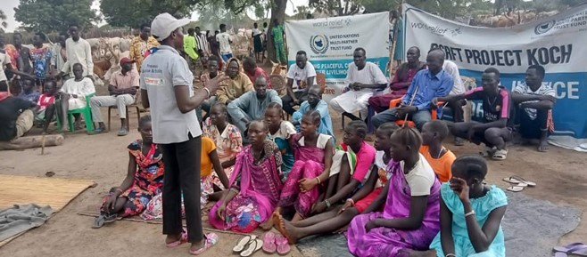  Project Staff facilitating Community peace dialogue at a cattle camp, June 2023. Photo credit @WR |  | 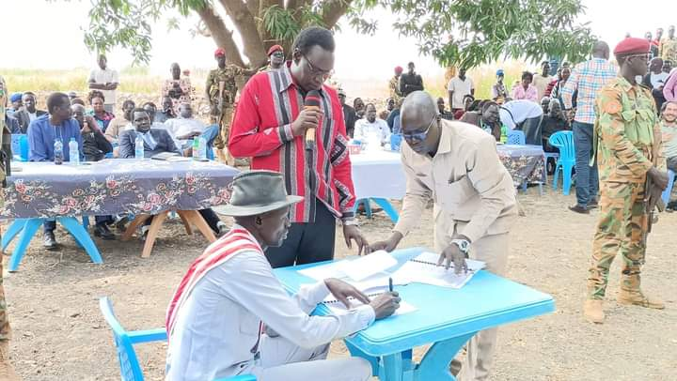  Payam chief signing peace agreement during inter-communal peace dialogue in Guit County, photo credit @ UNIDOR.
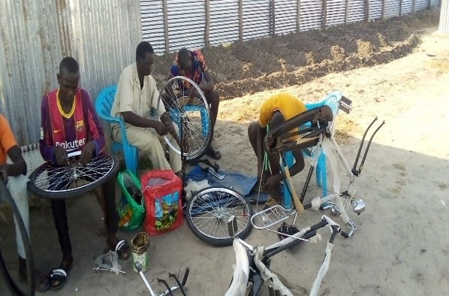  Youths during bicycle repair training session at the vocational skills centre, photo credit @MC |  | 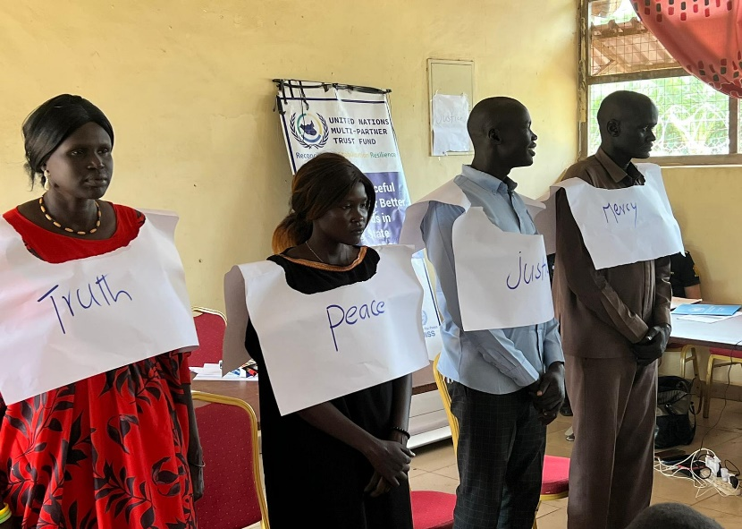  Participants during a civic engagement event, photo credit @UNMISS
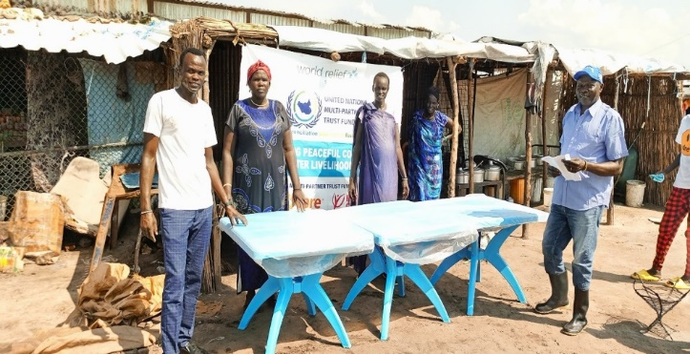  Project participants receiving tables for their tea and food kiosk, Sept 2023, photo credit@CARE. |  | 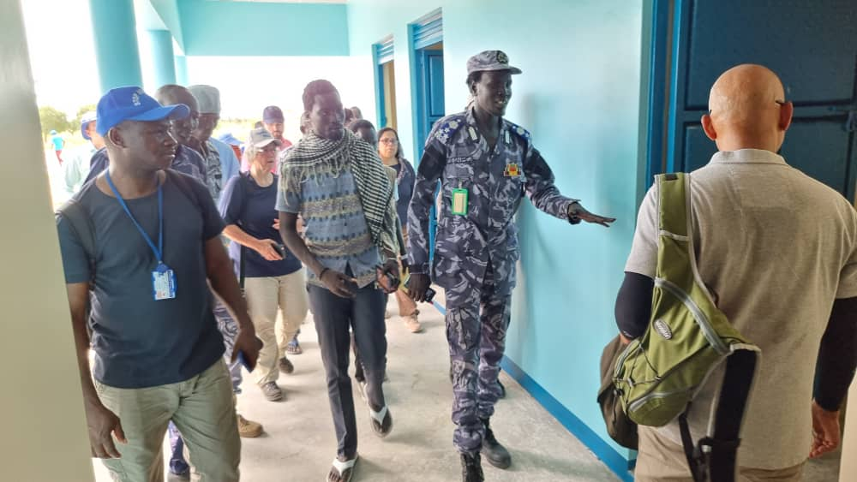  Donor visit to Koch police, Oct 23, photo credit @WR

