**PARLIAMENTARIANS ROUNDTABLE DIALOGUE ON**

**FOOD SECURITY AND NUTRITION IN GHANA**

**HELD AT FIESTA ROYAL HOTEL ON 8TH SEPTEMBER, 2015**

**OPENING**

The workshop was opened with prayer by Amen Amenreynolds Amen, Director of Amen Amen Institute at 10:00 am.

**INTRODUCTION OF CO-CHAIRS**

The Co-Chairs were introduced by Dr. John Azu, the event Facilitator in the personalities of Honourable Kwabena Appiah Pinkrah, Co-Chair, Ghana Parliamentarians against Hunger and Malnutrition Caucus and Professor Agyeman Badu Akosa, National SUN Focal Person.

**WELCOME ADDRESS**

The welcome address was delivered by Honourable Kwabena Appiah Pinkrah, Co-Chair, Ghana Parliamentarians Against Hunger and Malnutrition Caucus who stressed the importance of involving Parliamentarians in Ghana’s SUN implementation process to give it the necessary political clout. He maintained that as law makers, Members of Parliament were in a better position to lobby other arms of government in achieving a hunger-free Ghana by 2025. He also indicated that a survey in 2011 conducted by the Ghana Health Service revealed starling indicators on child malnutrition in Ghana. Again, under nutrition according to Honourable Pinkrah contributes to about 50% of deaths among children under five in Ghana. Due to underweight, 12,000 children under five years die a year. After citing a few incidents on the necessity for all Ghanaian children to have a right to food and which should be a legitimate concern of the Government of Ghana, he welcomed all participants who out of their busy schedules made it a point to attend the Roundtable Dialogue on Food Security and Nutrition in Ghana.

**OPENING REMARKS**

The opening remarks were given by Professor Agyeman Badu Akosa, National SUN Focal Person. He reiterated the need for both Parliamentarians and Civil Society Organizations to help in promoting and protecting all human rights as well as the realization of the right to adequate food which should be a legitimate concern of the Government of Ghana, the international community and civil society. He went on to say that this Roundtable Dialogue would provide additional opportunity for political leaders to make significant contributions towards the attainment of a hunger-free society at the regional and national levels. He also mentioned that the Maputo Declaration enjoins countries in Africa to aspire to achieve a target of at least 10% of the national budget allocation to finance agriculture interventions which is a very important continental commitment. He indicated that Ghana has made valuable efforts to reach this target ten years after the declaration, however, there remains more to be done to achieve the target while looking at the quality of investments accruing from the budgetary allocation to Agriculture. Again, he said this time around, political leaders were becoming more and more conscious of the responsibility to lead the fight against hunger and malnutrition at the regional level and these efforts must be sustained by more determined political leaders to realize this vision at the national level. He also said if Ghana does not take good care of her children, ill-health and non-productivity would drain the national scarce resources so this moment was the right time to act and act promptly.

**PRESENTATIONS:**

***STATEMENT FROM WORLD VISION GHANA***

Our Distinguished Chairman,

Dr. Alhassan Yakubu, Deputy Minister of Food and Agriculture,

Honourable Parliamentarians,

Members of the Diplomatic Corps,

Faith Leaders Present,

Representatives of UN Agencies,

Colleagues from Civil Society Organizations,

Friends from the Media,

Distinguished Ladies and Gentlemen:

It is my pleasure to be part of this forum meant to discuss and advance solutions to end malnutrition and hunger which are among the leading causes of infant and child mortality in this country.

I wish to thank all of you for responding to our invitation to participate in this programme and to support us in our quest to ensure the well-being of children.

World Vision Ghana is a member of the worldwide World Vision family whose “vision for every child is life in all its fullness and our prayer for every heart, the will to make it so”. World Vision started working in Ghana in 1979 pursuing integrated community development interventions. At the moment, World Vision operates in 31 programme areas in the 10 regions in Ghana, targeting 6.4 million children and their families.

Our approach to programming aims to contribute to the well-being of children, especially the most vulnerable. Our development approach focuses on children and seeks to enable their families and local communities to address the underlying causes of poverty. We recognize that the root cause is not just lack of access to the basic necessities of life like water, food or health care, but also include inequities, like gender or ethnic discrimination, or abusive practices like exploitation or domestic violence, that affect a child’s well-being.

World Vision has prioritized the sustained well-being of children, especially the most vulnerable, within families and communities. We aspire, in partnership with the government to ensure that children enjoy good health and are cared for, protected and participating in community life.

According to the GHS, malnutrition is estimated to be the underlying cause of 55 per cent of mortality cases among children under-five years, caused by poor health care and feeding practices, limited access to nutritious food and safe drinking water and lack of adequate health facilities.

It is in this connection that World Vision through the Child Health Now Campaign deems it a great privilege to collaborate with Hunger Alliance of Ghana and the Ghana Civil Society on Scale-Up Nutrition (SUN) among others to find a solution to hunger and malnutrition in this country. SUN is an international movement established in the wake of the 2008 food crisis, when a small group of dedicated nutrition professionals decided it was time to come together and agree on common approaches to tackle child under-nutrition. The vision of SUN is a world without hunger and malnutrition, and the mission is to bring people together to support countries in reaching this goal.

Distinguished ladies and gentlemen, nutrition plays a critical role in human resource development since deficiencies in essential nutrients lead to malnutrition, which affects an individual’s mental and physical state, resulting in poor health and poor work performance. In addition, a hungry, malnourished child may have mild to serious learning disabilities, resulting in poor school performance; a sick, poorly nourished individual will not respond well to treatment, could lose many working hours and may continue to drain family and national resources. Thus, malnutrition may undermine investments in education, health and other development sectors.

Globally, efforts to prevent and control malnutrition and hunger have been in the areas of advocacy, service delivery, institutional capacity building and community empowerment. Programmes for improving nutrition have focused on several interventions, including household food security, a problem that is of major concern to many countries. The organization and process of implementing activities are crucial; in particular, genuine community ownership of progammes, from the initial planning, organization and implementation stage, is a key factor for success. An indicator has facilitated success in many programmes.

The specter of hunger, poverty and malnutrition continues to stare at mankind. It represents a multidisciplinary challenge of no small magnitude and therefore requires a multidisciplinary approach to find a solution. It is in the light of this that World Vision Ghana finds it appropriate to engage with stakeholders including the legislative wing of Government and other policy makers to make hunger a thing of the past in this country. Honorable Chairman, Honorable Deputy Minister, Distinguished Ladies and Gentlemen, World Vision recognizes the huge advances Ghana has made in health, education and the relentless fight it has launched against poverty during the lifespan of the Millennium Development Goals. Whilst recognizing and applauding the huge successes, we are also not oblivious of our inability to attain some of the goals by the close of this year, 2015. In Our Strategic Objective under Food Security indicates that: All children, especially the most vulnerable, and their families, have improved household food security and resilience. We therefore want to see the following improvement in the lives of 1,400,000 adults and children through our programming:

* Improved production and productivity of crops and livestock
* Increased economic opportunities for the youth and women
* Increased resilience to climate change and disaster
* Increased resilience to economic shocks
* All children especially the most vulnerable, live in households with improved food utilization

The new post-2015 development agenda builds on the Millennium Development Goals (MDGs), targets that the world committed to achieving by 2015. Enormous progress has been made on the MDGs, showing the value of a unifying global agenda underpinned by goals and targets to focus political will and action as well as resources and measure progress. It is not surprising however that, hunger and food security falls as number two in the Sustainable Development Goals (SDGs) as: End hunger, achieve food security and improved nutrition, and promote sustainable agriculture, to be launched this month at the UN General Assembly.

Following the adherence to the Maputo Declaration, Ghana developed a policy known as Food and Agricultural Sector Development Policy (FASDEP) which is built on the gains of the Accelerated Agricultural Growth and Development Strategy (AAGDS). The government of Ghana has systematically increased budgetary allocation to the agricultural sector to reach the compliance level with the Maputo Declaration, devoting more than 10% of national budget to agriculture resulting in an average growth rate of 6% of the agriculture sector. We therefore want to congratulate the government for this achievement and call for more resource allocation in this sector to increase food security and resilience.

Hon. Chair, as the declaration on SDG is passed in September, the United Nations will later assess progress of countries, including Ghana, have made, to attain the targets. Ghana has to pass this test for the sake of its children. World Vision is therefore committed to continue supporting the Government and people of Ghana on a sustainable basis towards an improved health status of children. We therefore want to make a call on our Members of Parliament here, to ensure Ghana adopts and implements the National Nutritional Policy. It is very important to remember that no single organization’s efforts can result in the mortality levels we desire to see. That is why your presence here is significant. It is a call to all of us to declare that children cannot continue to die from malnutrition and hunger and we cannot afford to wait any longer.

Thank you very much for your attention and I wish us all a fruitful deliberation.

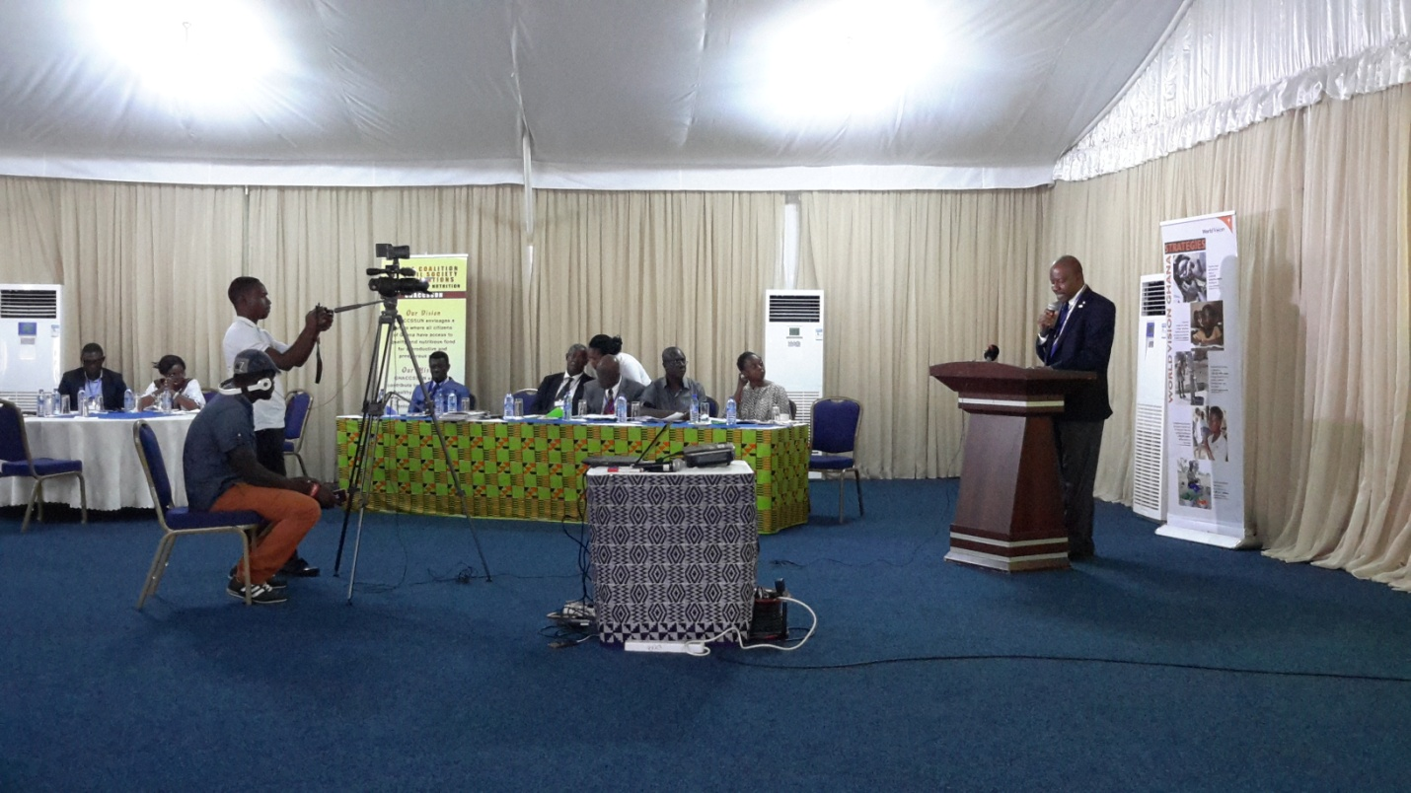

**MR HUBERT CHARLES, NATIONAL DIRECTOR OF WORLD VISION GHANA**

***STATEMENT FROM WORLD FOOD PROGRAMME***

Members of Parliament,

Distinguished Guests,

Ladies and Gentlemen,

It is a great pleasure for me to speak to you today about achieving a hunger-free Ghana. It is very exciting and inspiring to see so much commitment in this room to addressing the urgent issue of good nutrition for all Ghanaians.

Nutrition is one of the most cost-effective investments we can make for Ghana’s economic development. In fact, good nutrition is fundamental to achieving all of Ghana’s sustainable development goals. Yet, malnutrition persists in many forms in Ghana. Malnutrition is found in the new born weighing less than 2.5 kilograms. Malnutrition is experienced by over 800,000 children who are too thin or too short because of lack of enough and the right type of food or repeated illness. And at the same time, ironically every year we are struggling with the growing problem of overweight –both among adults and children alike.

Malnutrition is not always visible, but its effects are. Malnutrition impacts growth, learning and earning. New evidence is finding that up to 16% of GDP can be lost due to malnutrition.

In the face of this challenge, I am pleased that Ghana has joined global initiatives such as the Zero Hunger Challenge and the Scaling-Up Nutrition (SUN) Movement. I am also pleased to see that Ghana is making progress on some important nutrition indicators. Ghana should be recognized for achieving the Millennium Development Goal of reducing, by half, the number of children under 5 years old who are underweight and for reducing the percentage of the population living in poverty. But there is still much work to be done to fully eliminate malnutrition in all its forms in Ghana, particularly by addressing the rural-urban and inter-regional disparities.

Some countries around the world have made real impact and have reduced the rates of chronic malnutrition in children over a very short time. How? These countries have promoted multi-sector integration. They have focused on nutrition sensitive programming across all sectors. Most significantly, they have ensured an enabling policy environment with high level government commitment to solving the nutrition problems in their countries.

Ghana is moving in the same direction as these countries. Ghana has drafted a New National Nutrition Policy. Sectors are contributing to the development of a national multi-sector nutrition action plan. Ghana is working to put in place an effective multi-sector coordination platform. This work needs to be accelerated so that we too can make the rapid progress other countries are witnessing.

One of the reasons why progress on nutrition is so challenging is that nutrition is complex and requires policy changes across many government sectors. Change is needed to ensure that both direct nutrition interventions and nutrition sensitive programming are supported by all sectors. Ghana’s National Nutrition Policy will guide government and development partner’s investment in nutrition. Ghana’s Multi-Sector Nutrition Action Plan will help stakeholders build on what exists already and will provide a means to coordinate actions. It will also help to scale up high impact nutrition-related interventions and accelerate nutrition gains in a more coordinated approach. It will sustain the focus on multi-sectoral approaches even though they are complex to implement.

While the Nutrition Policy and Multi-Sector Nutrition Action Plan will create the legal and operational frameworks for nutrition, to be successful, commitments to nutrition will require accountability and follow-up.

Commitments to ending hunger and malnutrition need to be transformed into deliverable actions and financial investments. Parliamentarians, as elected representatives, have a key role to play in this challenge. It is essential that Ghana invests in nutrition to the best effect.

Under the United Nations Development Assistance Framework, the UN is supporting a wide range of stakeholders and sectors in Ghana to develop policy implement programs and undertake research aimed at eradicating malnutrition and transforming food systems to make nutritious foods available to all. The World Food Program is supporting actions to improve the nutrition of pregnant and lactating women and young children and People Living with HIV. Evidence tells us that focusing on the nutrition of pregnant mothers and babies under the age of two is critical, because during these first 1000 days of child growth and development, the foundation is laid for a healthy and productive life.

WFP is also working to improve school meals, to support farmers along the value chain and improve data on food security and nutrition for timely decision making as well as build resilience through the development of community assets for improved food security and nutrition. WFP is working closely with sister UN agencies in Ghana to bring ministries on board for nutrition, not just at the national and regional levels but also at local government levels. The UN is prioritizing nutrition as a health, education, development, and economic issue. We are looking forward to seeing the National Nutrition Policy approved by Cabinet and to support the Government to implement the National Multi-Sector Nutrition Action Plan.

Ghana hasall the conditions to respond to the Zero Hunger Challenge and make all forms of malnutrition a relic of the past. WFP is committed to working with you and all stakeholders to make this happen in our lifetimes. We believe that when just one Ghanaian child does not reach his or her full potential, because of malnutrition, all of Ghana loses a piece of its future.

Thank you.

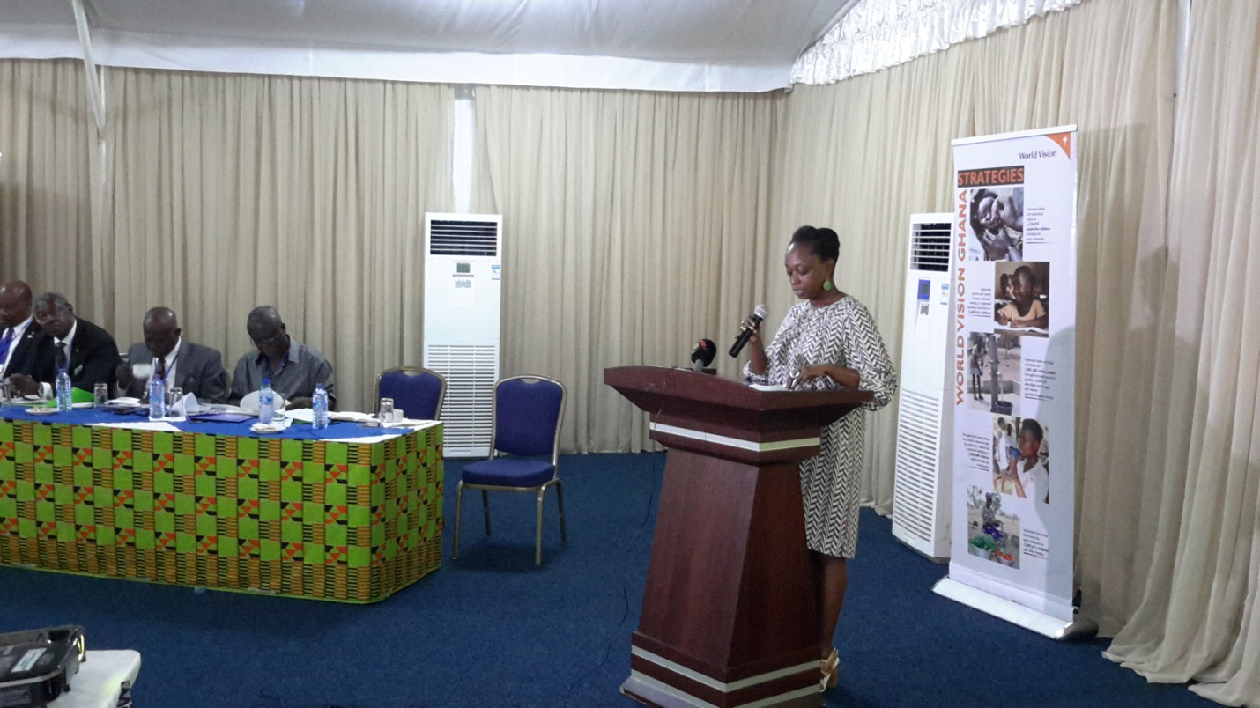

MUTINTA CHIMUKA, COUNTRY DIRECTOR OF WFP GIVING A STATEMENT

***STATEMENT ON THE PARTNERSHIP BETWEEN AMEN AMEN***

***INSTITUTE AND HUNGER ALLIANCE OF GHANA***

Honourable Chair,

Honourable Members of Parliament,

Distinguished Guests,

Officials of United Nations Agencies,

Representatives of Civil Society Organizations,

Representatives of the Media,

Ladies and Gentlemen:

It is once again a privilege that the Amen Amen Institute associates itself with this event. On behalf of the Amen Amen Institute, I wish to congratulate Hunger Alliance of Ghana and other partners for convening this important roundtable dialogue. This provides another opportunity for us as stakeholders to re-examine the status of Ghana’s food security and nutrition policies, plans and strategies and to look into the future with hope that indeed we can overcome hunger and malnutrition which are major obstacles in our development.

Honourable Chair, Amen Amen Institute is indeed open to partnership that promotes food security and nutrition agenda in Ghana. Our partnership with Hunger Alliance of Ghana is therefore based on the shared vision that a hunger-free Ghana is possible and that concerted efforts can achieve tangible improvement in food security and nutrition, reversing the rise in hunger that has seen the increase in the number of undernourished children in the past decade.

Honourable Chair, globally hunger affects over one billion people. The injustice of chronic hunger must be addressed and this can be done through a concerted effort. It is a shared responsibility. We must all intensify our advocacy to make our agriculture policies work and urge government to invest in our agricultural economy. It is established that sustainable development is about promoting economic growth that helps nations and people to develop. The whole purpose of it is to create the conditions where assistance is no longer needed, where people have the dignity and the price of being self-sufficient and for Amen Amen Institute, the place to start this growth is to support growing our agriculture sector. History has thought us that one of the most effective ways how come that most of the unused arable lands on this planet is in Africa and yet that is the continent mostly affected by hunger and poverty. There is no reason why Africans should not be feeding themselves and exporting food to other continents.

Honourable Chair, our association with Hunger Alliance of Ghana is founded on the premise that there is absolutely no reason for humanity to compromise our food security and nutrition which are the foundation of man’s existence. So five years of our partnership, we have supported Hunger Alliance of Ghana through donations and service as a member of the Alliance to make the Alliance and ourselves relevant in the national effort to eradicate hunger and malnutrition completely. We believe in this partnership that the attainment of a hunger-free Ghana is possible in our generation. We shall continue to work with Hunger Alliance of Ghana to create useful platforms that shall instigate national debates and discourse to move our food security agenda forward.

Honourable Chair, we are also here today to make a donation to the Alliance in support of its Annual Stakeholders and Members conference which is likely to be held in December, 2015 as part of its effort to expand its frontiers and increase its coverage and visibility. We wish to renew our commitment to the work of the Alliance and as an Institute, work with the Alliance to constantly remind government that it has the major stake in securing the future of Ghanaians where food security and nutrition are assured and where every Ghanaian has a right to adequate and nutritious food. It is indeed a scar on our conscience to see fellow Ghanaians going to bed hungry without knowing where the next meal will come from.

Thank you very much for your attention.

***PRESENTATION ON THE CURRENT SITUATION AND TREND***

***OF FOOD SECURITY IN GHANA***

**Outline**

* Definition of Food Security
* Current Food Security Situation
* Factors that Contribute to Food Insecurity
* Revised Medium Term Agriculture Sector Plan & Strategies to address food insecurity

**Definition of Food Security**

* **Food security**: the situation in which all people at all times have physical, social and economic access to sufficient , safe and nutritious food to meet their dietary needs and food preferences for an active and healthy life.
* The **four pillars** of food security are
* Availability
* Access - Households lack the means
* Stability - Not available at all times
* Utilization – unable to consume or use

**Food Security Situation**

MDG outcome:- reduce by half the proportion of population suffering from hunger achieved (April, 2013).

Although, Ghana is food secured at the national level, not all households are food secured.

- 21% of small holder farmers in Ghana are food insecure

- 11% of medium Holder Farmers

- 6% of large scale Farmers

Not self-sufficient in all commodities and thus import commodities like rice, meat and fish to meet our demands.

> 3 million Ghanaians were affected or vulnerable to food insecurity

Food Insecurity by Region

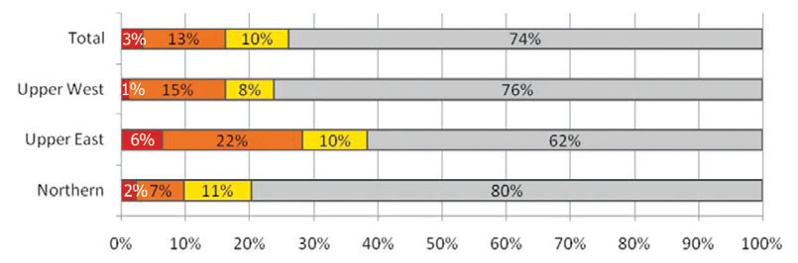



Proportion of Food Insecure Households

Prevalence of Food insecurity

* Rural areas 19%
* Urban areas 4%
* However 15% of urban households are considered ‘mildly food insecure’

Causes of food insecurity in Ghana

* Poverty and unstable food prices
* Dependence on subsistence and rain-fed agriculture
* Majority of livelihoods not being diversified
* High post-harvest losses
* Gender inequality
* Natural disasters

**Programmes of Revised Medium Term Agric Plan 2014-2017**

Programme 2: Food Security and Emergency Preparedness

* 2.1 Promotion of agricultural mechanization
* 2.2 Seed and planting material development
* 2.3 Irrigation development
* 2.4 Development of selected staple crops
* 2.5 Livestock and poultry development for food security and income

Total of 1.438 billion Ghana Cedis (public funds) - 4 years period for implementation

**Strategic Context**

* Worsening Statistics: High prevalence of maternal and childhood anaemia, underweight, stunting (emerging problem of obesity)
* Response to Global Goals, Strategies etc. e.g:
  + MDGs/SDGs
  + CAADP-NEPAD
* Value chain approach (linking food production to consumption)
* The Policy Coordinating and Monitoring Unit of the Office of the President and the NDPC will play key oversight roles during implementation of the plan.
* Collaboration with the private sector to invest adequately

**Interventions to Improve Food Security**

* Social support to poor farm family (Credit-in-kind)
* Establish Farmer Database for targeting
* Facilitate the formations functional FBOs
* Establish More Nucleus Out-grower Schemes
* Support research in breeding bio-fortified, high yielding, disease & drought resistant crops and animals
* Facilitate formation of vibrant value chains
* Expansion of Agric. Mechanization Service Enterprise Centres

***STATEMENT FROM MOFA ON EFFORT BEING MADE BY***

***GOVERNMENT TO REDUCE HUNGER IN GHANA***

Mr. Chairman,

Colleague MPs,

Invited Guests,

Ladies and Gentlemen:

I am honoured to be part of this dialogue session on a subject, which so much concerns my ministry and also a very relevant subject for national development.

Mr. Chairman, hunger and malnutrition is not a condition any government will wish for its citizens and it will have peace to pursue its development agenda as the saying goes “a hungry man is an angry man”. However, according to the latest edition of the annual UN Hunger Report, the number of hungry people in the world has dropped to 795 million – 216 million fewer than in 1990-92 – or around one person out of every nine goes hungry.

In Ghana, the vision of the agricultural sector is to culminate into a structurally transformed economy and evident in food security, employment opportunity and reduced poverty. Mr. Chairman, the Ministry of Food and Agriculture (MOFA) as the lead government agency responsible for the agricultural sector, has a responsibility to keep Ghana in particular and the world as a whole Hunger-Free through the concerted efforts of the sector players and the agriculture community worldwide.

I am happy, Mr. Chairman, to say that, Governments over the years, have worked tirelessly to improve the agriculture sector to meet the demands of the times. We have over the years, improved our crop varieties to increase yields, to be resistant to pests and diseases, to survive the ever changing climate and to improve their nutritional content. Mr. Chairman, the structure and methods of agriculture have also evolved over the years to meet the needs of the time. Ministries were created and collapsed, we have moved from state farms to private commercial farms, from the use of hoe and cutlass to mechanization from rain-fed production to the use of irrigation, open field production to protected cultivation.

Governments have invested into projects to make available the right infrastructure, resources and enabling environment to promote production. Mr. Chairman, governments have to take these steps to first and foremost make available safe and nutritious food to the people, create employment and reduce poverty. I believe we all can attest that our experience with food security for that matter hunger has not been a bad one.

Mr. Chairman, permit me to take you through few examples of some activities the technical directorates (Crops Services, Animal Production, Veterinary Services, Plant Protection and Regulatory Services, Agricultural Engineering Services, Directorate of Agricultural Services, etc.) of my ministry and donor-funded projects as well as public-private partnership initiatives, have carried out to keep Ghana hunger-free and food secured and to ensure food safety and improved nutrition.

We established 89 Agriculture Mechanization Service Centres in 62 districts to enhance land preparations to boost crop yields. Infrastructures for improved seed/planting materials production, processing, storage and marketing have been expanded (to facilitate private sector participation). The Grains and Legumes Development Board (GLDB) produced foundation seeds of selected staple crops to enhance high productivity.

We have been working to expand agriculture-related infrastructure – mainly for irrigation and rural roads. Nucleus outgrower investments in the SADAa zone in particular, under the Ghana Commercial Agriculture Project (GCAP), is expanding area under improved soil water management and irrigation especially for rice total area cropped under formal irrigation was 9,913 hectares in 2012 and 11,136.3 in 2013. For informal irrigation it was 10,138 hectares in 2012 and 10,541.7 in 2013. According to the Department of Feeder Roads, about 2,284 km of road was improved and 3,343 km rehabilitated while 54 bridges were constructed between 2011 and 2013. The NRGP also constructed about 492 km of rural roads in its mandate areas.

We have made efforts to increase access to extension services and agricultural education; 49 information centres were established as at 2013 throughout the country. We are also embarking on e-agriculture to reach out to more farmers with extension delivery. Boating and Nyaaba, 2014, reported that the ratio of extension officer to farmers under METSIP improved to about 1:2,000 from about 1:3,000.

Mr. Chairman, we have tried to improve post-harvest management practices to reduce post-harvest losses. For example, the NRGP has constructed 18 community warehouses with various capacities which have been certified and approved by the GGC in the three northern regions (Northern Region – 6, Upper West – 8 and Upper East – 4) and is constructing another 10 warehouses and 4 pack houses. We also have established a National Food Buffer Company which is to help ensure 6-month of food strategic stocks of our major staples – maize, sorghum, gari etc.

Mr. Chairman, we are also working to promote and develop selected staples and horticultural crops with comparative advantage in the various agro-ecological zones by adopting the value chain approach through the nucleus farm – outgrower concept, block farming schemes and contract farming. This has generally yielded marginal increases in productivity due to the challenge in financing inputs as well as putting in place basic infrastructure such as irrigation, mechanization, storage facilities and distribution systems, however, average yields for smallholder farmers who were supported by the NRGP, have increased by 212.5%, 200% and 160% for maize, soya and sorghum respectively. We have also continued with the fertilizer subsidy to help increase our crops yields.

To increase the interest of the youth in agriculture and protect our crops from failing weather and pest and disease incidences, we are working at introducing the protected cultivation technology which is less tedious and more productive.

Mr. Chairman, my ministry has also been working on livestock and poultry to meet the protein needs of the citizenry, the average annual growth rate in population of cattle, sheep, goats and pigs was estimated at 5.2%, 9.7%, 15.4% and 11.6% respectively. The livestock breeding stations produced 1,117 improved stocks of various species of livestock and supplied them to farmers. 8,000 cockerels were distributed to 500 farmers in 5 regions and 1,500 were supplied to the National Service Scheme in the Ashanti Region. We are supporting large scale cultivation of maize and soyabeans for the formulation of animal feed and mass vaccination against Pest de Petit Ruminant (PPR) in small ruminants and Newcastle disease in poultry.

Mr. Chairman, by my ministries assessment, Ghana is currently self-sufficient in the key staple crops, because of our interventions. Government has also observed with keen interest its bills on some key food items like rice, tomato and poultry and is making frantic efforts to reduce it through local production. I believe that you will agree with me that government has not relented on ensuring food security in Ghana. In fact, food security is a national security issue.

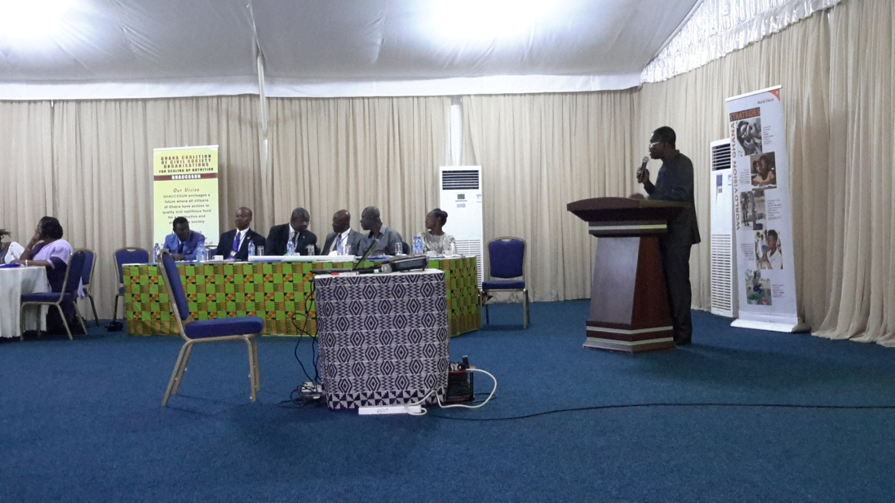

***STATEMENT BY MOFA***

***PRESENTATION ON THE CURRENT SITUATION AND TREND***

***OF NUTRITION IN GHANA***

**Outline of presentation**

* Definition of frequently used terms
  + Nutrition, malnutrition, under nutrition (stunting, wasting, over nutrition (overweight, obesity)
  + Why should malnutrition be of concern to us in Ghana
    - Nutrition situation and trends in Ghana
    - Effects of under nutrition and over nutrition
* How does the National Nutrition Policy address these challenges
* Conclusion

Major nutritional problems in Ghana

* Under nutrition
* Over nutrition and associated diet-related diseases

**Under nutrition**

* + Stunting i.e., being too short for one’s age age
  + Wasting i.e., being too thin
  + Underweight – a combination
  + Micronutrient deficiencies
    - Iron deficiency/anaemia
    - Vitamin A deficiency
    - Iodine deficiency disorders
    - Other micronutrient deficiencies e.g., folic acid, zinc, etc.

**Stunting: Children of the same age**

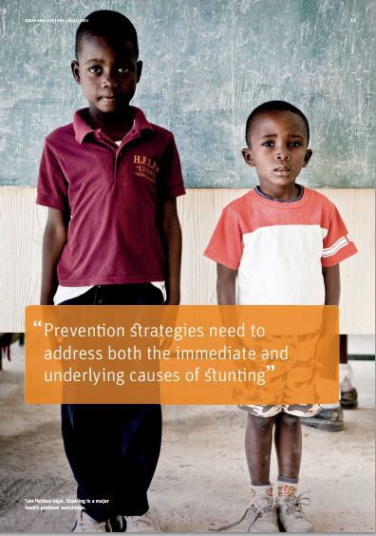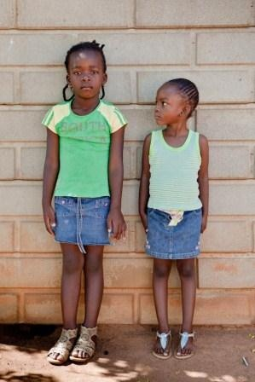

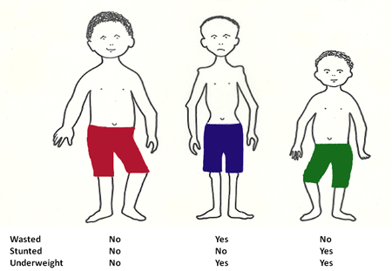

Prevalence of Malnutrition in Ghana

**Children under five years**

Nutritional status 2014 (2011)

Children short for age – 19% (23%)

Children Too Thin i.e., Wasted – 5% (6%)

Children with low weight for age – 11% (13%)

Overweight - 2.6% (2.6%)

Anaemia prevalence – 66% (57%)

Regional disparities:

* Children in Northern, Upper West and Central regions more likely to be stunted than children in other regions:
* children in Upper East Region are more likely to be thin (wasted) than in other regions
* Anaemia is highest in Northern, Upper East and Upper West regions

*Source: DHS 2014(MICS 2011)*

Some reduction in malnutrition rates, but still more than 1 in 5 children in Ghana is stunted….

Target for Underweight is 8% for 2013

**Other micronutrient deficiencies**

Iodized salt consumption at household level:

* Estimated at only 34.5% of households (MICS 2011)

Vitamin A (no recent data):

* Approx 60% of children under 6 years were estimated to have subclinical vitamin A deficiency in 2004

Women of reproductive age (15-49Yrs)

Anemia prevalence – 42.4% (57%) – DHS 2014 (DHS 2008)

Underweight (BMI<18.5): - 9%

* Younger women aged 15-19 – 16%
* Women living in rural areas - 11%
* Highest in Upper East (15%), Northern (12%), and Volta regions (11%)

Overweight:

* 30% of all women are overweight, with 9% of women considered to be obese (BMI ≥30.0)
* Prevalence increases with age
* Highest in Greater Accra (45%)
* Lowest in Upper West (13%), Northern (14%), and Upper East (15%) regions

**Non communicable diseases (NCDs)**

High prevalence of overweight and obesity is paralleled by increasing incidences of diet-related NCDs e.g. cardiovascular disease, diabetes mellitus, and some cancers

In Summary: Malnutrition in women and children in Ghana

* About one in five children are permanently stunted.
* One in 20 children are wasted and could develop severe malnutrition, Kwashiorkor if not attended to and could easily die.
* Seven in 10 children suffer from vitamin A deficiency.
* Seven out of 10 children under 5 are anaemic.
* Two out of 5 women are anaemic.

Ghana faces double burden of malnutrition

* One in three women overweight
* Greater Accra, at least 4 or 5 out of every ten women are overweight

Impact of hunger and malnutrition throughout the life cycle



Consequences of malnutrition

In children

Under nutrition predisposes children to

* increased infection
* impaired physical growth
* Impaired mental development.

Under nutrition have significant adverse consequences, including poor health and death.

One in 13 Ghanaian children dies before his or her fifth birthday. About half of those deaths are a result of under nutrition.

* Children who have under nutrition are more likely to die of illnesses, such as malaria, diarrhea, and pneumonia, and from complications from HIV.
* **Anaemia, stunting, and decreased mental ability from under nutrition result in reduced labour productivity**, which hinders agricultural production and derails progress of development.
* Anaemia can be caused by
  + iron deficiency from poor diets or
  + iron losses from infections like malaria or hook-worm infestation.
* Anaemia will cost Ghana more than 1.9 billion cedis (US $1.3 billion) in decreased worker productivity by 2020. Reducing anaemia by half will instead increase productivity by 505 million cedis (US$353 million) in the same time period.

Vitamin A deficiency (VAD)

VAD reduces immunity.

* Children who lack vitamin A are more likely than healthy children to suffer and/or die from some infections such as measles, diarrhea and malaria. Some infections, particularly measles.
* VAD may increase the risk of getting malaria and of illness during malaria, in some age groups.
* Pregnant women with VAD are more likely to die than healthy women. Pregnancy may make VAD more serious.
* VAD may speed the progression of HIV to AIDS.
* VAD is an additional cause of some anaemias.

Under nutrition have significant adverse consequences, including poor health and underdevelopment.

* Investment in proven, effective nutrition interventions implemented at scale over the next 10 years would:
* **Save 30,000 lives** by preventing underweight
* **Save the lives of more than 25,000 children** by decreasing vitamin A deficiency
* **Prevent permanent brain damage in 500,000 children** by decreasing iodine deficiency
* **Save the lives of more than 4,500 mothers** by decreasing maternal anaemia

Under nutrition reduces Ghana’s agricultural productivity.

* **Agriculture is largest sector of the economy**, employing more than half of the adult population. This demands a productive workforce to improve and sustain productivity in agriculture.
* **Anaemia, stunting, and decreased mental ability from under nutrition result in reduced labour productivity**, which hinders agricultural production and derails progress of development
* Anaemia will cost Ghana more than 1.9 billion cedis (US $1.3 billion) in decreased worker productivity by 2020. Reducing anaemia by half will instead increase productivity by 505 million cedis (US$353 million) in the same time period.
* **Undernutrition impairs cognitive ability and reduces adult productivity, leading to decreased gross domestic product (GDP).**
* Between 2011 and 2020, **955 million cedis (US$668 million) will be lost due to decreased mental ability from iodine deficiency**. Iodine deficiency in pregnancy adversely affects the fetus and causes permanent mental disabilities. In children, iodine deficiency results in poor mental development and affects a child’s school performance, ability to learn, speech, and hearing, leading to lost productivity later in life
* **Three in 10 children in Ghana who are 2 years of age are moderately or severely stunted**, which means they will not reach the height of a healthy child of the same age. Stunting is caused by chronic malnutrition and is permanent after 2 years of age. Stunted children are more likely to start school late, be absent more often, repeat school years, and drop out of school. Between 2011 and 2020, **5 billion cedis (US$3.5 billion) of worker productivity will be lost due to stunting**.
* Pregnant women with iron deficiency anaemia tend to have babies with low birth weight (less than 2.5 kg). **Children with low birth weight and who are undernourished in infancy are at increased risk of poor mental development** and may have decreased attention span in school

**Under nutrition is preventable and reversing current trends can lead to a healthier and wealthier Ghana**

During the next 10 years, investment in proven, effective nutrition interventions implemented at scale would:

* **Prevent permanent brain damage in 500,000 children** by decreasing iodine deficiency
* **Increase the average child’s IQ by 13.5 points** by decreasing iodine deficiency
* Result in **earlier school enrolment, children staying in school for longer, and better school performance**

**Under nutrition is *preventable***

During the next 10 years, investment in proven, effective nutrition interventions would:

* **Save 30,000 lives** by preventing underweight
* **Save the lives of more than 25,000 children** by decreasing vitamin A deficiency
* **Prevent permanent brain damage in 500,000 children** by decreasing iodine deficiency
* **Save the lives of more than 4,500 mothers** by decreasing maternal anaemia
* **Increase the average child’s IQ by 13.5 points** by decreasing iodine deficiency
* Result in **earlier school enrolment, children staying in school for longer, and better school performance**

**Policy Goal**

* The goal of the NNP is to ensure optimal nutrition for all people living in Ghana throughout their lifecycle

**Policy Objectives**

* Policy Objective 1: To increase coverage of high- impact nutrition-specific interventions that ensure optimal nutrition of Ghanaians throughout the lifecycle with specific reference to maternal health and child survival
* Policy Objective 2: To ensure high coverage of nutrition-sensitive interventions to address the underlying causes of malnutrition
* 3 Policy Objective 3: To Reposition Nutrition as a Priority Multi-Sectoral Development Issue in Ghana

**Policy Objective 1**

* Women in Childbearing Age and the New-Born
* Infancy and Childhood
* School-Age Children and Adolescents
* The General Population
* Prevent and Manage Obesity and Diet-Related Non- Communicable Diseases
* Prevent and Manage Acute Malnutrition
* Nutrition in Emergency Situations

**Policy objective 2**

* Health, water, hygiene and sanitation
* Agriculture and food security
* Education
* Social protection and safety nets

**Policy Objective 3**

* Advocacy and Communications
* Institutional Strengthening
* Integration and Coordination
* Nutrition as Priority
* Research
* Monitoring and evaluation

Status of the Nutrition Policy

* Health Sector strategic plan developed
* Strategic plans of other sectors yet to be developed and merged into comprehensive plan
* Cabinet approval

Proven Effective Nutrition Interventions

* Promotion of optimal breastfeeding
* Appropriate complementary feeding
* Improved hygienic practices
* Vitamin A supplementation
* De-worming
* Iron-folate supplements for pregnant and lactating women
* Salt iodisation
* Fortification of staple foods
* Multiple micronutrient powders
* Treatment of severe acute malnutrition† with special foods, such as ready-to-use therapeutic foods
* These interventions are being implemented but not at scale. They need to be scaled up across the length and breadth of the country.

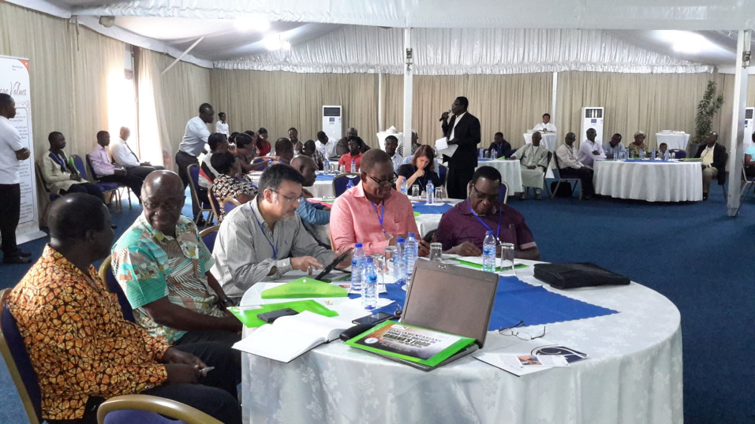

**INVITED MEMBERS IN A DISCUSSION**

**In Conclusion**

Ghana is currently facing the double burden of malnutrition

- Under nutrition in all its forms highly prevalent and

- Over nutrition and its attendant diet-related diseases is gradually increasing

The consequences are detrimental!

There are interventions that have proved effective in reducing or eliminating these problems

* These interventions are implemented in Ghana but not at scale
* Investing in Scaling up these nutrition interventions will
  + Save lives
  + Improve quality of life
  + Improve children’s performance in school
  + Increase productivity
  + Improve health

***DISCUSSION POINTS ON PARLIAMENTARIANS ROUNDTABLE***

***DIALOGUE ON FOOD SECURITY AND NUTRITION IN GHANA***

THE CURRENT PROBLEM

Under nutrition contributes to about 50% of deaths among children under five in Ghana. Due to underweight, 12,000 children under five years die a year. Vitamin A deficiency will further cause the death of about 110,000 from 2011-2020.

If solution for hunger and malnutrition are to be found, then political commitment and strong leadership are required.

GHANA’S NUTRITION GOAL

The goal is to invest in nutrition to improve the key development outcomes in the country, including child survival, educational achievements and ultimately, economic productivity.

GHANA’S COMMITMENT TO THE “SUN” MOVEMENT

Ghana, in the spirit of the SUN movement, is committed to fast-track achievement of the MDG Goal 1c of reducing the proportion of children who are malnourished by two thirds by scaling up proven interventions during the first 1,000 days of the child from conception to the first two years of a child’s life.

GHANA’S NUTRITION OBJECTIVES

* Reduce child malnutrition
* Prevent and control Vitamin A, iron and iodine deficiencies
* Ensure household food security
* Reduce infant, child and maternal mortality

PROCESS INDICATORS TO GUIDE COUNTRIES TO SCALE-UP NUTRITION

* Bringing people into a shared space for action
* Ensuring a coherent policy and legal framework for action
* Rallying around a set of expected results and financial tracking
* Resource mobilization to deliver the key outputs
* Capacity building
* Monitoring and evaluation

WORKSHOP OBJECTIVES

* Provide an opportunity for incubating new ideas on how to accelerate the progress towards the realization of a hunger-free society agenda
* Identify bottlenecks in the adoption of the national nutrition policy
* Provide an opportunity for Members of Parliament to demonstrate their commitment to the fight against hunger, poverty and malnutrition through various strategies to be identified in during the workshop
* Enhance the aspirations of MPs to exercise their oversight responsibilities effectively over food security and nutrition sectors for results

EXPECTED OUTCOME OF ROUNDTABLE

Members of parliament actively influence Government of Ghana policies, plans and budgets and consistently advocate for improved multi-sector and multi-actor coordination, transparency, accountability and alignment of all stakeholders to achieve a Ghana free from hunger and malnutrition.

EXPECTED OUTPUTS

By the end of the event,

* Members of Parliament (MPs) would have understood in clear terms their roles and responsibilities as Parliamentarians in achieving a Ghana free from zero hunger and malnutrition; as discussions will consider the legislative, budget and overview parliament functions.
* A road map and action plan to move National Nutrition Policy’s adoption by MPs
* Increased knowledge and commitment of MPs on Nutrition Policy
* Increased Capacity of MPs to Global Policies- Maputo declaration
* MPs would understand the critical roles they playing analyzing national budget with respect to agriculture, hunger and malnutrition related issues;
* MPs would have renewed their commitment to the fight against hunger and malnutrition in Ghana through cross learning and fruitful deliberations on the current food security and nutrition situation in Ghana.
* MPs would have become champions for change in Ghana’s food security and nutrition agenda and enabled them with evidence-based information and data to advocate for the eradication of hunger and malnutrition in the country.
* At the end of the meeting, Ghana MPs will have agreed to come up with a road map for the way forward.

**SET GOALS – PARLIAMENTARIANS ROUNDTABLE NUTRITION DIALOGUE**

**GOAL: To achieve hunger-free Ghana by 2025**

Objective 1: Provide adequate investment for Food Security and Nutrition

Objective 2: Promote the Right to Food for All

How do we achieve a hunger and malnutrition-free Ghana through policy adoption and implementation?

* Increase coverage of high impact nutrition intervention.
* Powerful statement in Parliament for All Parliamentarians (Priority).
* Carrying the message to constituents’ intervention.
* MPs – Be a champion of Nutrition.
* Media – Cover Champions on Nutrition.
* NGOs and Private sector involvement.

Support

Parliamentary Caucus

Partnership

1. CSOs (GHACCSSUN, WV, Hunger Project, ADRA, Hunger Alliance) to prepare Policy Briefs for Advocacy.
2. Organize Quarterly Parliamentary Press Briefings or FSN with appropriate committees from MOFA, Cocoa Affairs, Hunger Project, ADRA, WV.
3. Collaborate with the Committee to advocate and push for a Right to Food Act in response to a global call for such Legislation such as ECOWAS Zero Hunger Initiative and the UN Secretary General’s Zero Hunger Challenge which support Right to Food legislation.
4. Provide support to MPs to intensify the budget advocacy for funding for Agriculture and Nutrition.
5. MPs at the community level leadership roles:
6. Organization of Farmers’ Fora
7. Organization of Nutrition Campaign with support of CSOs
8. Becoming Nutrition Champions/MPs joining CSOs at the grassroots level.

Finding the entry point into nation development programs

CSA Integrating into the policy process

Meeting the Implementation Challenges

1. Construct communal drying facility for communities.
2. Train communities in nutrient conserving cooking method.
3. Train communities in the utilization of cassava leaves, orange-fleshed sweet potato.
4. Train communities in construction and utilization of micro-cooling technology used for pre-cooling harvested commodities.

CLOSING

The workshop came to a close with prayers by Dr. John Azu at 3:09 pm after which a group picture was taken and departure of participants thereafter.

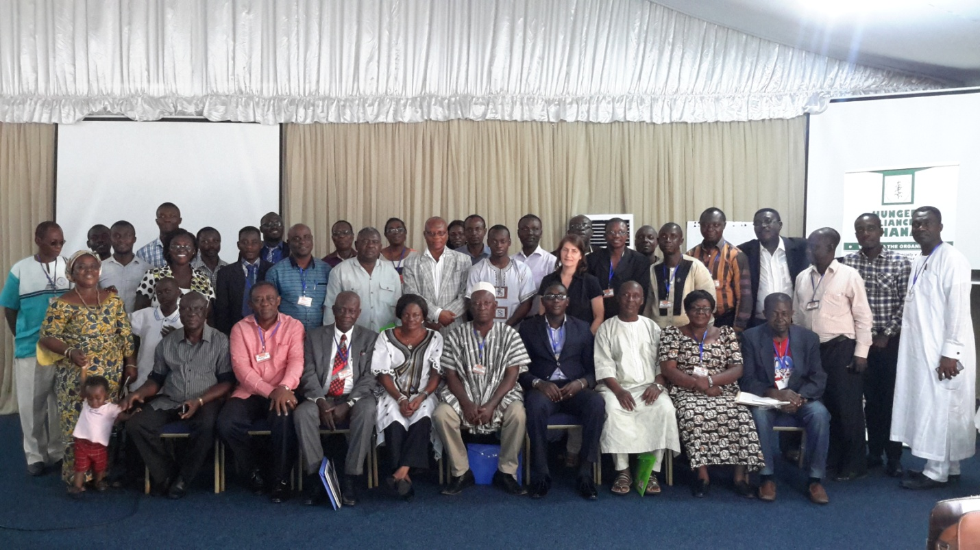

**GROUP PHOTO AFTER THE DIALOGUE**