|  |  |  |
| --- | --- | --- |
|  | SUN Movement  Multi-Partner Trust Fund | UN Logo |

**PROGRAMME1 QUARTERLY PROGRESS UPDATE**

***as of 30th September 2015 (1 July to 30 September 2015)***

|  |  |  |  |  |  |
| --- | --- | --- | --- | --- | --- |
| **Participating UN Organization:** | The United Nations World Food Programme | | | | |
| **Implementing Partner(s):** | Save the Children International | | | | |
| **Programme Number:** | MPTF-Window 2-017 | | | | |
| **Programme Title:** | Formation of Civil Society Forum to augment the implementation of Multi Sectorial Action Plan for Nutrition at ground level in Sri Lanka | | | | |
| **Total Approved Programme Budget:** | US$ 235,400.00 | | | | |
| **Location:** | Sri Lanka | | | | |
| **MC Approval Date:** |  | | | | |
| **Programme Duration:** | 24 Months | **Starting Date:** | 01/01/2014 | **Completion Date:** | 30/06/2016 |
| **Funds Committed:** | US$ 235,400.00 | | | **Percentage of Approved:** | 100% |
| **Funds Disbursed:** |  | | | **Percentage of Approved:** |  |
| **Expected Programme Duration:** | 02 years | **Forecast Final Date:** | 30 June 2016 | **Delay (Months):** | 06 Months |

|  |  |  |
| --- | --- | --- |
| **Outcome** | **Achievement/ Result** | **Percentage of Planned** |
| 1. Independent and sustainable multi-sectoral forum of civil society organizations structured and empowered to advocate for making nutrition as a high priority issue in Sri Lanka | 1. **SUN PF Council Meetings:**   During 3rd quarter two council meetings were held on 16th July and 13th August 2015  *(Annex 1 - Minutes of the meeting).*   1. **Advocacy Plan for Food Security:**   Meeting was conducted on 15th of August 2015 to finalize the Food Security Advocacy Plan *(Annex 2 – Food Security Advocacy Plan).*   1. **SUN PF Board Meeting**:   The 3rd SUN PF Board Meeting was conducted on 27th of August 2015. The Financial Audit Report for year 2014 was approved and a new Director of the Board was appointed *(Annex 3 - Minutes of the meeting).*   1. **SUN PF Orientation Workshop and Membership Drive:**   SUN PF Orientation workshop in Puttalam district was conducted on 30th July 2015. District Secretary, NGO Coordinator, Childfund and VOICE supported by organizing the workshop, which was attended by 82 CBOs members. Among the main topics focused in the workshop were nutrition issues in Puttalam District, CSOs capacity building on how to monitor breast feeding code, use of child health development record to monitor the growth by the mother, and food supplementation*(Annex 4 – Picture of the Workshop).* | 100%  100%  100% |
| 1. Strong civil society alliance supported and monitored the Sri Lanka multi sectoral action plan in accelerating “nutrition specific” and “nutrition sensitive” interventions that with the appropriate budgetary allocation by the government and other stakeholders by 2015. | 1. **Video documentary on nutrition:**   SUN PF developed a video documentary on childhood malnutrition which highlights the importance of good nutrition during first 1000 days of a child’s life and also on the proper feeding practices.     1. **SUN PF News Letter:**   SUN PF conducted two meetings on 12th and 19th August, led by the Communication sub-committee to develop the SUN PF newsletter. It was attended by civil society organizations and members of the civil society alliance. The meeting was attended by officials from the Ministry of Health.   1. **World Breast Feeding Week 2015:**   SUN PF together with the Nutrition Society of Sri Lanka and World Vision Sri Lanka organized an event to mark the World Breast Feeding Week 2015. The event was held on 10th of August. It was attended by the members from the civil society organizations, NGOs, INGOs, UN agencies and State Officials, including the Ministry of Health. SUN PF was invited to do a talk on the importance of Breast Feeding to the Management of Milk Food Companies. This was conducted on 06th of August.   1. **Review of National Nutrition Policy:**   SUN PF conducted follow up meetings with all six sub groups under each nutrition policy objectives. | 100%  50%  100%  100% |
| 1. Civil Society alliance shared global and regional lessons learned, best practices and research outcomes among partners, while capitalization of resources maintained good governance and aid effectiveness. | 1. **Training CSO Members to Monitor Marketing Code of Breast Milk Substitute:**   SUN PF Secretariat conducted a training workshop to increase awareness and to empower people on the marketing code of breast milk substitute. World Vision collaborated with SUN PF to carry out this activity   1. **Case Study to identify knowledge and practices related to breast milk code and other nutrition interventions:**   This was carried out using the Monitoring and Evaluation format developed by the SUN PF. Results from the pilot study were analysed and submitted to global SUN Civil Society Network (Annex 5:Case Study).   1. **Consensus Building Survey of SUN Civil Society Alliance:** SUN PF participated in a Consensus Building Online Survey conducted by the global SUN Civil Society Network. The purpose of this survey was to get civil society contribution for SUN 2.0 (2016-2020). 2. **Teleconference with Global SUN Movement:**   SUN PF had a teleconference with the SUN Movement Network, the thematic discussion was strengthening a culture of effective partnering in the SUN Movement. 2015. | 100%  100%  100%  100% |

|  |
| --- |
| **Qualitative achievements against outcomes and results:** |
| **Result of Outcome -1**  More than 80% of council members participated in the council meetings during the 3rd quarter.  The members of the council acknowledged the work of the SUN PF Secretariat.  SUN PF has increased its membership when it conducted its orientation workshop in Puttalam district. There was a good collaboration between the Government and Civil Societies, District Secretarial played a major role at organizing the workshop; coordinated and invited the Civil Society Organizations and it gave a greater credibility for SUN PF.  Food Security Advocacy Plan has been finalized, this will be used to plan food security related activities in SUN PF Phase 2.  **Results of Outcome -2**  SUN PF developed a video documentary on nutrition with the purpose of increasing awareness for communities and CBOs.  SUN PF, Communication sub-committee has taken the lead to developing the newsletter; The newsletter will be an effective means of keeping the communities informed of updated information relating to health and nutrition and further enable them to raise their issues within a larger forum.  SUN PF together with the National Nutrition Society and World Vision developed a questionnaire to collect useful evidence and information regarding the present situation of enabling the appropriate environment for breast feeding mothers at the workplace. It received a positive feedback from the State and the private sector.  In addition to the planned activities, SUN PF Secretariat was invited to assist in the formation of NCD Alliance in Sri Lanka by World Health Organization. SUN PF Secretariat is now working with WHO to form the NCD Alliance.  **Results of Outcome - 3**  SUN PF conducted an online survey on SUN CSN 2016 -2020 consensus building with council members and key stakeholders. This was a learning experience for all the participants and by the time the group completed the survey, participants were well aware of SUN CSN activities, principals and its engagement etc. This Survey Format will be used to lobby CBOs to join with SUN Civil Society Network.  SUN PF have finalized the phase 1 of National Nutrition Policy Review, a framework has been developed based on the discussions of each policy objectives which were summarized by the key partners. Stakeholder interviews are in process. |

The term “programme” is used for projects, programmes and joint programmes.

**Annex 1**

**Minutes**

12th Council Meeting

Date: 16th July 2015

Time: 15:30 – 17:00

Venue: Conference Hall, Save the Children

Recorded by : Prishantha Welathanthry

**Attendance:**

|  |  |  |  |
| --- | --- | --- | --- |
| No | Name | Organization | Present |
| 01 | Ms. Dilka Peiris(Chair) | World Vision | Yes |
| 02 | Ms. R.P.M. Sandamali | ChildFund | Yes |
| 03 | Mr. Methsiri De Silva | Save the Children | No |
| 04 | Mr. Dave Maurice | Nucleus Foundation | No |
| 05 | Ms. Visakha Thilakaratne | Nutrition Alliance | No |
| 06 | Mr. Chamindha Rajakaruna | Sarvodaya | Yes |
| 07 | Ms. Achala Samaradiwakara | Sewalanka Foundation | No |
| 08 | Mr. Asanga Ranasinghe | Plan International | Yes |
| 09 | Mr. Saman Kalupahana | World Food Programme | No |
| 10 | Mr. Roshan Dala Bandara | ChildFund | Yes |
| 11 | Ms. Kanchana Weerakoon | ECO-V | No |
| 12 | Mr. Sathis de Mel | Arthacharya | No |
| 13 | Dr. Dula de Silva | SUN PF | Yes |
| 14 | Mr. Prishantha Welathanthry | SUN PF | Yes |
| 15 | Ms. L. Madhuwanthi | SUN PF | Yes |

1. **Welcome**

Dr. Dula de Silva welcomed the council members and handed over to Ms. Dilka Peiris to chair the meeting.

1. **Approval of the minutes of the previous meeting**

Previous meeting minutes were approved without any changes.

1. **Membership development activities**

Dr. Dula de Siva briefed that SUN PF has completed its membership activities in 11 district as planned in last year. During first six months it focused on reviewing national nutrition policy, developed tools to monitor breast milk code and food supplementation, visibility activities, and developed proposal for SUN PF Phase 2. She mentioned that SUN PF will continue its membership activities to other 14 districts and will visit Pulttalam district in August to conduct SUN Orientation, membership drive and train CSO on using monitoring format.

1. Follow up of Media training

Dr. Dula de Silva mentioned that due to the resolving of the parliament, SUN secretariat postponed the meetings with media people who did not participate in the workshop which was held on 24th June 2015. This meetings will be conducted after the election.

1. Reflection and Lesson learnt from Good Food Festival

Ms. Dilka Peiris highlighted that fast food stalls at the kids and nutrition zones were effected to activities as it was promoting healthy foods. These this are good lessons

Mr. Roshan Dalabandara mentioned that he has the records of no. of children took part for quiz in the kinds zone (for quiz game conducted by Nutrition Society). The Council members requested to share these information.

1. Way Forward of SUN PF

Dr. Dula de Silva briefed about the SUN PF way forward. She mentioned SUN PF has requested for a no cost extension till June 2016 and the necessary documents has been sent to WFP. She also indicated that SUN PF has conducted a meeting of working group to develop a proposal for SUN PF phase 2. The draft proposal was handed over to Mr. William Lynch, Country Director, Save the Children for his comments and he will be meeting WFP to discuss possibility of getting funding from WFP for phase 2.

1. AOB

**Focus Group Discussions**

Dr. Dula de Silva requested the council member’s support to conduct Focus Group Discussions with communities of their coverage districts to gather evidence whether the communities are aware of National Nutrition Policy and its implementation. World Vision, Childfund were agreed to conduct focus group discussions from districts where they are working. Dr. Dula de Silva mentioned that she will share the questionnaire soon.

**Community Hunger Fighter**

Dr. Dula de Silva proposed a new idea which is to identify a person from a village call community hunger fighter. She mentioned that SUN PF will develop a concept note for this new activitiy.

**Newsletter**

SUN PF is planning to develop a Newspaper for CBOs. The idea for this newspaper is to strengthen the link between SUN CSA and CBOs who have register with SUN CSA.

Ms. Dilka Peiris requested to develop the second issue of the newsletter. Dr. Dula requested council members to send articles to publish. Mr. Roshan Dalabandara agreed to send an article regarding Good Food Festival.

**Annual General Meeting**

Dr. Dula de Silva announced that SUN PF is planning to conduct its Annual General Meeting in August. Before that Project Auditing will be started in August, SUN PF has called quotation for identifying an auditing firm. Ms. Dilka Peiris indicated the Mr. Suresh Bartlett will be assigning a new position from September 2015, she asked SUN PF to have the Annual General Meeting before end of August. Dr. Dula de Silva mentioned that SUN PF will talk with Company Legal Officer to get a date from Mr. Suresh Bartlett.

1. Date for the next meeting

Next meeting will be on 13th of August at 15:30

1. Wrap up

The meeting was closed at 17:00 PM

**Annex 2**

|  |
| --- |
| THe SUN PEOPLE’s FORUM |
| The Advocacy Action Plan for Civil Society Organizations |
| The Food Security Enhancement Programme |
|  |

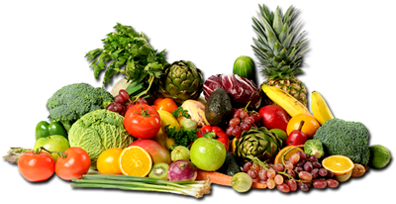

**Background**

Food security is a term defined for the first time at 1974 World Food conference with an emphasis only on supply of food. Later, realizing the fact that access, utilization, stability and nutritive value are also affect the food security, the new definition was developed as “all people, at all times, have access to sufficient, safe and nutritious food to meet their dietary needs and food preference for an active and healthy life”(FAO, 1996). Soil, water availability, climate are the primary factors that affect food production whereas trade, urbanization, infrastructure, energy, land use policies, household income significantly influence accessibility and utilization. Food security including food diversity is related to sustainable development and linked to health through nutrition.

Sri Lanka is ranked 62 out of 105 countries of the Global food security index in 2012. The food insecure community in Northern and Eastern provinces is recorded as 40% in 2012 and 1.1 million people required food assistance in that year (WFP, 2012). According to Census and Statistics, the poverty head count ratio of the country is estimated 6.7% (2012/2013) while highest percentage is recorded from tea plantation sector (10.9%). As a health impact of food insecurity, malnutrition rate of children between 2-5 years of age remains high. Stunting and wasting among children under 5 years of age are 13.1% and 19.6% respectively (UNICEF, 2012) and the low birth weight rate was recorded as 16.5% in 2012.

The government of Sri Lanka has identified food security as a national priority and established Ministry of Food Security with the vision of contributing to create erudite and prosperous nation. It is vital to increase food production as a measure to reduce vulnerability of the country to food insecurity due to external shocks and reduce prices of food items increasing accessibility of low income earners. Sri Lanka blessed with diversified agro-climatic conditions ranging from semi-arid to humid and coastal to mountainous regions increasing its potential to grow a wide range of crops. Proper cropping plans, food processing and preservation, infrastructure facilities to improve physical accessibility and knowledge on proper food consumption patterns are also required prompt attention to improve the food security of the country.

Enhancing food security should be a collective effort of the government, producers, researchers, distributors, NGOs, all international agencies including UN agencies, Civil society organizations and the community. In Sri Lanka Civil Societies are vibrant and an integral part of the rural development. As one of the important sector of the society that manifest interests and will of people, CSOs have the capacity to reach the community, identify their issues related to food security and address them in an effective and acceptable way. The capacity of CSOs in lobbying, convincing the authorities and engage in actively at grass-root level are immensely useful to implement the initiatives to improve food security of the country. Collaboration with diverse set of partners at different levels and building new connections with stakeholders who fight against hunger and poverty will strengthen the civil society organizations and ultimately contribute to the expected outcomes of the food security enhancement initiatives.

**Technical Committee - Food Security**

-          Ms. Achala Samaradivakara,  Team Leader, SevaLanka Foundation

-        Mr. Laksiri Nanayakkara, World Food Programme

-        Mr. Chaminda Rajakaruna, Sarvodaya

-        Mr. Saman Kalupahana, World Food Programme

-        Dr. Dula de Silva, SUN PF

-        Mr. Prishantha Welathanthry, SUN PF

**Key responsibilities entrusted to Food security sub-committee**

1. Organize brainstorming session for partner CBO, NGO specialist on crate a Work plan for Economic and Food Security.
2. Identify the underlying causes of food insecurity at house hold and community level Eg: Food wastage, inadequate food purchasing, infestation of grains etc.
3. Encourage to set up own Home Garden at household level in selected districts and develop sustainable family
4. Raise community awareness of food security including food preservation and storage.
5. Raise Consumer awareness, consumer rights and Traditional Food Habits.
6. Document and share good practices through the program

**Advocacy Plan**

**Pillars of Food Security**

Food security is built in four pillars and each pillar consists of several sub pillars that are interlinked (Figure 1). Analyzing country situation in terms of food security at its pillar and sub pillar level would enable the researcher to grasp all possible reasons leading to food insecurity and to develop strategies to correct minor to major causative and underlying factors. CSO’s approach on enhancing Food security ensures programmatic impact through different activities to address all pillars and sub pillars of food security. Advocacy plan for CSOs was developed with the aim of empowering households, communities to implement sustainable approaches to meet their dietary needs and improve food availability, accessibility, utilization and to ensure stability or sustainability of food security over the time.

**Figure 1: Pillars and sub pillars of Food security**

**Food Availability**

Food availability is the physical existence of food from own production or in the market. National level food availability includes domestic food production, imports, food stocks, food aid and underlying determinants of above factors.

**Food accessibility**

Access to food emphasizes on having sufficient resources to obtain appropriate foods for a nutritious diet. Households’ food accessibility depends on income available to the household, the price of food, access to the market.

**Utilization**

The availability and access to food on their own are not enough and people have to be assured of safe and nutritious food that meets dietary needs. The food consumed has to provide sufficient energy to carry out the consumers physical activities. Safe drinking water and adequate sanitary facilities to avoid spread of disease are also covered under utilization.

**Stability**

Stability is the temporal dimension of food security. Availability, accessibility and utilization “at all times” assure stability of food security. Chronic food insecurity and temporary food insecurity are distinguished based on the time factor to recover food insecurity situations.

|  |  |  |  |  |  |
| --- | --- | --- | --- | --- | --- |
| **No.** | **Household Food Security – Food Availability** | | | | |
| **Issue** | | **Underlying factors** | **Suggestions** | **Suggestions for CSOs** |
| **1** | **Production** | **Low agricultural productivity** | **Unavailability/lack of quality seeds** | **Produce required seeds in the village itself** | **Farmer organization of the village to produce required seeds and establish a seed bank for the village.** |
| **Cultivation of crop varieties which are low yielding or inappropriate to the particular agro-ecological region** | **Better selection of crop varieties.** | **Farmer Organization to organize an awareness programme to get necessary technical support from the Dept. of Agriculture to select high yielding varieties recommended for that particular agro-climatic zone and suitable to the soil type.** |
| **Non availability of water at the correct time and excess water at the unwanted periods** | **Proper maintenance of the irrigation structures in the village.** | **Farmer organization with the support of Agrarian Services Dept. to prepare a maintenance plan for the irrigation structures in the village and continuous monitoring of the progress of maintenance activities.** |
| **Change the cultivation period according to the current rainfall pattern and choose short term varieties** | **FO to get the instructions from Dept. of agriculture on most appropriate period to start the cultivation season.** |
| **Establish a village level water management system.** | **Farmer organization to regulate water supply considering instructions and necessary guidance of Dept. Agrarian services.** |
| **Less fertile/infertile soil** | **Add crop residue to the field, Composting and practice soil conservation methods.** | **FO to organize training programmes on soil conservation methods and composting. Establish a model farm within the village to demonstrate soil conservation and different composting methods.** |
| **Production does not match with the demand. Excess or shortage of certain crops.** | **Develop a cropping plan considering agro-climatic factors, soil factors, price fluctuations and demand.** | **Farmer organization to take the lead to prepare the cropping plan for next two seasons under the technical guidance of Dept. of Agriculture, Dept. Agrarian services and other agencies involved in water management.** |
| **Land fragmentation** | **Separate residential area for farming community.** | **Lobbying the government to enforce law related to fragmentation of agriculture lands.** |
| **Environmental shocks** | **Building Resilience of farming community.** | **FOs to get necessary instructions from Dept. of Agriculture to identify drought and flood tolerant varieties and multiply seeds of those varieties.** |
|  | **Transferring of new technology is not at satisfactory level** | **Periodic awareness programme conducted by Dept. of Agriculture** | **FOs to coordinate with resource persons at technical institutes (Dept. of agriculture, rice research institute, fruit research institute) and organize awareness programs and demonstrations.** |
| **Damages to the production** | **Pest and disease attacks** | **Introduce Integrated pest management methods** | **CBOs to organize awareness programmes on the importance of integrated pest management. Introduce integrated pest management to the model farm.** |
| **Post harvest losses** | **Use crates for transportation of perishables (fruits and vegetables)** | **National level CBOs to provide subsidy to buy crates. Conduct a study with a selected group on the change of income after using crates and present findings to the farming community.** |
| **2** | **Processing** | **Waste of excess food (perishables)** | **Lack of knowledge on food processing techniques** | **Raise awareness on appropriate food processing methods such as drying, blanching, pickling, sugaring, salting and smoking for different types of foods.** | **CBOs to conduct trainings and demonstrations on food processing techniques and explain how it positively affect on family income and nutrition.** |
| **Misbeliefs/taboos on processed foods** | **Demonstrations on food processing methods and awareness on its nutritional value and how it helps to enhance dietary diversity in offseason** |
| **High percentage of damaged grains and pulses** | **Not harvesting at the correct time** | **Awareness raising on indicators of grain maturity.** | **Awareness on indicators of grain maturity (20-25% moisture, 80-85% grains are straw coloured) and less grain damaging processing methods.** |
| **Use of improper machinery for seed processing** | **Use of low powered machinery** |
| **3** | **Storage** | **Wastage of food due to improper storage/lack of storage facilities/unavailability of storage facilities.** | **Unavailability of required storage facilities** | **Awareness on less expensive, traditional food storage methods** | **CBOs to organize training and awareness programmes on proper food storage methods and low cost storage methods (Institute of Post-harvest technology).** |
| **Post-harvest losses at the storage** | **Improper storage facilities** | **Awareness on easy and proper storage methods and maintenance of storages.** |
| **Improper/lack of knowledge on proper storage methods** |
| **Lack of maintenance of storages** |

|  |  |  |  |  |  |
| --- | --- | --- | --- | --- | --- |
| **No.** | **Household Food Security – Access to Food** | | | | |
| **Issue** | | **Underlying factors** | **Suggestions** | **Suggestions for CSOs** |
| **1** | **Affordability** | **Cannot afford to buy preferred food items** | **Less income** | **Increased and stable income for communities depends on weather sensitive livelihoods.** | **CBOs to introduce alternative income sources considering locally available resources and the market. Extend financial support to initiate alternative livelihood.** |
| **Indebtedness** |
| **Income fluctuations** |
| **No alternative income sources** |
| **2** | **Purchasing power** | **Less purchasing power as a result of high unit price of food items.** | **High production cost** | **Minimize production cost by using organic inputs.** | **CBOs to promote application of organic fertilizer, environment friendly pest control methods, manual land preparation methods through awareness programmes** |
| **Less supply compared to the demand during off-season** | **Increase the supply during off-season.** | **Lead the FO to develop a cropping plan for the area considering the demand as one of the factors and issue processed food to the market during the off-season.** |
| **High post harvest losses** | **Selection of suitable containers to transport long distances.** | **Influence the government to re-enforce the law on collapsible plastic crates for the transport of perishables.** |
| **Crop damages due to Environmental shocks** | **Cultivate crop varieties that can withstand environmental shocks.** | **Encourage farmers to cultivate flood and drought tolerant varieties.** |
| **Unfavourable climatic conditions for certain crops** | **Adopt Protected agriculture techniques to control climatic factors and pest attacks.** | **Intervention of National CBOs to provide subsidies on protected agriculture structures** |
| **Government taxes** | **Appropriate taxation for basic food items** | **Lobby and voice** |
| **3** | **Marketing** | **Weaknesses in marketing channels** | **Unavailability of market places for crop and animal based products.** | **Establish a market place with proper storage facilities.** | **CBOs to support in organizing producers and entrepreneurs to start a market place with required storage facilities within the area.** |
| **No proper market to sell the products produced at commercial level.** | **Develop market linkages between buyers and producers.** | **CBOs to intervene on developing market linkages between producers and buyers such as supermarkets and exporters, through forward contracts and buy back systems.** |
|  |  |  |  |  |  |
| **4** | **Equitable distribution** | **Inequal distribution of food items because of the differences of transport facilities** | **Less development of infrastructure systems in the rural areas** | **Improve infrastructure system in rural areas.** | **CBOs to Influence the govt. to construct roads and market places in the area** |
| **Inappropriate distribution of food within the family** | **Pregnant mothers, milking mothers and young girls do not get sufficient food quantities.** | **Improve appropriate food distribution within the family** | **Conduct awareness programmes on nutritional requirement of human being according to their age, gender, health condition, physical conditions, pregnant or lactating.** |

|  |  |  |  |  |  |
| --- | --- | --- | --- | --- | --- |
| **No.** | **Household Food Security - Utilization** | | | | |
| **Issue** | | **Underlying factors** | **Suggestions** | **Suggestions for CSOs** |
| **1** | **Nutritious food** | **Consumption of less nutritious food** | **Lack of nutritious food** | **Increase availability of nutritious food in the area.** | **Awareness programmes on nutritious food types that are less expensive and can be found from the area and encourage the community to cultivate and consume them.** |
| **Lack of knowledge to identify nutritious food** | **Awareness programmes on nutritive value of different food types.** |
| **Not having enough money to buy nutritious food** |
|  |  |  |  |  |  |
| **2** | **Food diversity** | **Less diversity of food consumption** | **Not having access to certain food items (Saltwater fish, meat)** | **Increase the production of locally available food items that belongs to the same food group. (fresh water fish)** | **CBOs to support the communities with inputs to produce food items with same nutritive value.** |
| **Depend only on what they grow in their farmland** | **Encourage barter system to get the food type that is not available in the home garden.** |  |
| **Lack of knowledge on the importance of food diversity** | **Raise awareness on importance of food diversity** | **Awareness programmes on the importance of food diversity, main food groups and the food items that belongs to them.** |
| **Cultural and religious beliefs** | **Encourage to consume other food that that gives similar nutritive value.** |
|  |  |  |  |  |  |
| **3** | **Food safety and quality** | **Consumption of unsafe and poor quality food** | **Unsafe food preparation** | **Awareness raising on safe food preparation and storage methods** | **CBOs to organize and conduct awareness programmes on safe food preparation methods and proper storage methods** |
| **Unsafe food storage** |
|  |  |  |  |  |  |
| **4** | **Clean water** | **Consumption of unsafe water** | **Unavailability of clean water** | **Raise awareness on water purification methods** | **CBOs to conduct awareness programmes on importance of consuming purified water and provide required financial assistance to buy water filters is required.** |
| **Lack of knowledge on water purification methods** |
|  |  |  |  |  |  |
| **5** | **Sanitation** | **Sanitation** | **Not having proper sanitation facilities** | **Provide financial support to construct toilets and raise awareness on proper waste disposal methods.** | **CBOS to financially support communities to build toilets and raise awareness on proper waste disposal methods** |
| **Improper waste disposal methods** |

|  |  |  |  |  |  |
| --- | --- | --- | --- | --- | --- |
| **No.** | **Household Food Security - Stability** | | | | |
| **Issue** | | **Underlying factors** | **Suggestions** | **Suggestions for CSOs** |
| **1** | **Adverse weather conditions** | **Uncertainty in food production due to adverse weather conditions** | **Flood and drought situations lead to crop losses** | **Promote coping up mechanisms.** | **Encourage farmers to cultivate flood and drought resistant varieties, use water efficient irrigation systems, rain water harvesting methods and efficient drainage systems.** |
| **Income fluctuations due to adverse weather conditions** | **Depend only on farming or other climate sensitive livelihoods.** | **Appropriate technology transfer to have production in all seasons** | **CBOS to arrange awareness and training programmes to transfer new technology which enables farmers to cultivate in all seasons** |
|  |  |  |  |  |  |
| **2** | **Seasonality of crops** | **Prices and availability of vegetables fluctuates seasonally** | **Storage** | **Use of appropriate technology** | **Training Farmer organization and other CBOs on new technology on storage and processing.** |
| **processing** |
| **Lack of appropriate technology** |

**Annex 3**

**SCALING UP NUTRITION PEOPLE’S FORUM (GUARANTEE) LIMITED**

**GL 2301**

**DIRECTORS REPORT**

The Directors herewith present to the members their Annual Report together with the Audited Financial Statements for the period ended 31st December 2014.

**PRINCIPAL ACTIVITIES OF THE COMPANY**

1. To formulate a policy for the improvement of nutrition standards in Sri Lanka by creating a platform for the coalition for the civil society organizations enabling them to come together in order to advocate, mobilize, monitor and evaluate national nutrition initiatives in Sri Lanka.
2. Strengthening the capacity of the civil society to influence evidence based decision making and policy formulation related to food security and malnutrition.
3. Advocating for improved governance, increased funding and improved implementation of nutrition and nutrition sensitive actions.

**FINANCIAL STATEMENTS:**

**STATEMENT OF COMPREHENSIVE INCOME**

PERIOD ENDED

31.03.2014

(Rs.)

Donations/Grants received 4,917,337.39

Direct Expenses 3,203,549.31

Administrative Expenses 1,710,034.87

Finance Expenses 3,753.21

Excess of Funds Received over Expenditure (0.00) Provision for income Tax -

Excess of Funds Received over Expenditure after tax (0.00)

**DONATIONS**

The Company has not made any donations for the financial period ended 31st December 2014.

**BOARD OF DIRECTORS**

The Board consisted of the following persons as at 31st December 2014.

Suresh Bartlett

Kaushalya Naveratne

**DIRECTORS REMUNERATION**

The Company has not paid any remuneration/other benefits to Directors during the accounting period.

**DIRECTORS INTERESTS**

No Director of the Company has any direct or indirect interest in any contracts or proposed contracts with the Company during the period ended 31st December, 2014.

**AUDITORS**

The accounts for the year have been audited by A.S. Associates (Chartered Accountants) who being eligible offer themselves for re-appointment as Auditors of the Company in respect of the financial year 2015.

A sum of Rs.22,500/- has to be paid to A.S. Associates as Audit fees for the period ended 31st December 2014.

**AUDITORS REPORT**

The Auditors Report is annexed to the Financial Statements.

**ACCOUNTING POLICY**

During the first year of operation there is no comparison for identification of any change. However, the policies adopted by the Company has deviated from basic principles of accounts as the accounts have been prepared on cash basis and assets have not been capitalized even though the return of them extended over one year of accounting.

BY ORDER OF THE BOARD

…………………………. ………………………………..

DIRECTOR DIRECTOR

…………………………

SECRETARY

Dated this 27th day of August 2015

**Annex 4**

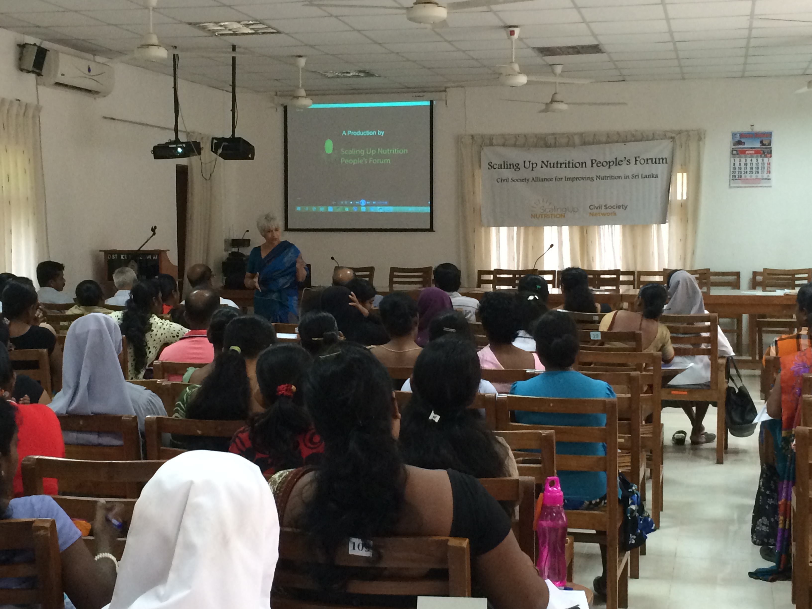

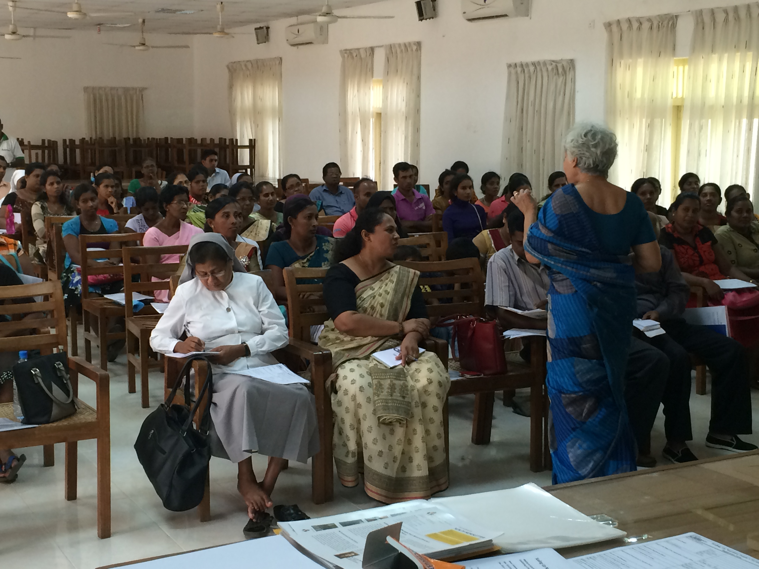

**Annex 5**

**Case Study: Aligning Community Based Organisations to Monitor the Implementation of the Marketing Code of Breast Milk Substitutes and Some Standard Nutrition Interventions, Aimed at Reducing Childhood Malnutrition in Sri Lanka**

**Background**

Sri Lanka is classified as a low middle income country and is on track to reach all the Millennium Development Goals, except nutrition targets. Under five malnutrition remains a public health problem. Sri Lanka reports low birth weight prevalence as 16.5%, under five wasting as 19% and stunting as 14%.[1] The government has launched many initiatives to reduce childhood malnutrition. All the citizens can access free health care services and free education. Primary health care infrastructure reaches almost every village. More than 96% of the children receive ten antigens and Vitamin A during early childhood. Antenatal care for pregnant women and growth monitoring of children under five years is provided through the primary healthcare system. The government produces a fortified, blended food named ‘Thriposha’, which consists of 67% maize, 37% soya, 3% full cream milk powder, vitamin premix and mineral premix. This is given free to undernourished children below the age of five years and to all pregnant and lactating women. Additionally pregnant mothers receive iron and folic acid and Vitamin A mega dose after delivery.

Sri Lanka reports high levels of Exclusive Breast Feeding (EBF) during the first six months of life (76%).[2] The country developed the Marketing Code for Breast Milk Substitutes[3] in 1981. Since then many interventions were carried out to promote breast feeding. Most health staff were trained on infant and young child feeding practices. Maternity leave was increased to 84 working days in the public sector.

Scaling Up Nutrition People’s Forum (SUN PF), the SUN Civil Society Alliance in Sri Lanka recognised the need to align the civil society to enhance the participation of the community in nutrition intervention programmes. The SUN PF Secretariat developed a format for Civil Society members to monitor breast feeding and other nutrition interventions.

**Methodology**

SUN PF Secretariat developed a format to assess the knowledge of mothers and support received by families for EBF, dietary diversity of households and other nutrition interventions.

SUN PF piloted the format in a semi-urban setting of the Wattala Divisional Secretary’s area in the Western Province. World Vision, one of the members of SUN PF organised the mothers group. After a brief introduction, the format was administered to the mothers. The mothers were provided with assistance to fill the forms which were then collected and the data was analysed.

**Results**

Thirteen mothers participated.

Twelve households were male headed and only one was female.

**Information regarding the importance of breast feeding:** The mothers were requested to list from whom they received information on the importance of breast feeding during pregnancy. Mothers could list more than one person. All thirteen mothers stated that they had received information. Eleven mothers stated they received information from the Public Health Midwife, five from their mothers, four from their mothers-in-law and one from a friend.

**Supportive environment for Exclusive Breast Feeding (EBF):** Twelve mothers had received a supportive environment for EBF, whilst one mother had not received any support. The respective levels of support received from various members of family are illustrated in the following chart. Eight mothers reported that they received very good support from their husbands. However, the support received from other members was notably inadequate.

**Supplementary foods received by lactating mothers during the first six months after delivery:** Twelve mothers had received Thriposha and Vitamin A supplements and eight had received iron supplements.

**State assistance to lactating mothers:** Since February 2015, the government launched a programme to provide food stamps to lactating mothers having babies under 4 months. However, only one mother had received food stamps. The questionnaire did not ask for the age of the youngest child. Therefore, it is not possible to find out the eligibility for food stamps.

**Encouragement to have birth spacing:** Eleven mothers informed that they were encouraged to have birth spacing. Ten of the mothers informed they had received advice from either the Public Health Midwife, the Public Health Nursing Sister or the Ministry of Health. Additionally two had received support from their husbands and one from the mother.

**Employment during Pregnancy:** Only one of the mothers informed us that she had held a job during her pregnancy. She worked at a garment industry and had been granted 84 days of paid maternity leave and that her workplace had provided her with breast feeding facilities and an hour off daily for breastfeeding upon returning from pregnancy.

**Advertising:** Only three of the mothers said that they had viewed advertisements promoting designating products under the Breast Milk Code or complementary foods as being appropriate for infants under the age of six months. Two mothers had seen television advertisements for malted milk but not specifically for infants under six months.

None of the mothers or their family received any free samples of infant formula, soya milk, malted milk, condensed milk, feeding bottles, teats or pacifiers. Furthermore, none of the mothers had attended any group demonstrations showing the preparation of infant formula, during pregnancy.

**Discussion:**

SUN PF has started administering this questionnaire in many districts. SUN Global Civil Society Alliance is organising a meeting to discuss advocacy and communication in September 2015 and requested SUN PF to report the use of the monitoring format. We piloted the study using the format, to observe how the Marketing Code of Breast Milk Substitute is implemented in a suburban area in Sri Lanka. Although we collected all the information, only the relevant data was analysed for this particular case study.

92% of the households were male headed. 84% of the group reported receiving information regarding the importance of breast feeding from the Public Health Midwife. Additionally 38% and 30% stated they received this information from their mothers and mothers-in-law respectively. Except for one mother, all the others received different levels of supportive environments for EBF. However, 76% and 62% of the group reported that they received an inadequate level of support from their mothers-in-law and mothers respectively.

Whilst 92% of the mothers received Thriposha and Vitamin A supplements during the first six months after delivery, only 62% received iron supplements.

Save for one mother, none of the others received food stamps, food baskets or any cash from the State or any other organisation during pregnancy or six months after delivery. The questionnaire did not reveal the age of the youngest child. Therefore, eligibility for food stamps could not be identified. The Public Health Midwife was the key informant on birth spacing nd 85% of mothers were encouraged to have birth spacing. Also 15% of the mothers were encouraged to do so by their husbands and 7.5% received encouragement from their mothers. It is noted that only one mother held a job during pregnancy, at a garment factory, where she was provided with 84 days of maternity leave and granted an hour off each day for breast feeding.

Of the group, 77% said that they had not seen any advertisements promoting any designated products as being foods appropriate for infants under the age of 180 days. Furthermore, none of the mothers received any free samples of designated products under the Breast Milk Code. The designated products of the Sri Lankan code are infant formula, soya milk, malted milk, condensed milk, feeding bottles, teats and pacifiers. All the mothers reported not attending any group demonstrations showing preparation of infant formula during pregnancy.

**Conclusion**

The number of mothers that participated was quite low and therefore, it is not accurate to present as percentages. However, the study showed that the most common source of information with regards to breastfeeding is the PHM. The level of support received from families for EBF is notably inadequate and has to be addressed by the civil society. Also 92% of the mothers were unemployed during pregnancy and therefore we could not find how the formal and informal sectors provide space for breast feeding. It is however good to note that infant formulas are not advertised. The format will be amended to state the age of the youngest child and administered to a larger group.

1. UNICEF MRI Micronutrient Survey 2012
2. UNICEF MRI Micronutrient Survey 2012
3. Demographic Health Survey, Sri Lanka 2006