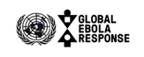

UN EBOLA RESPONSE MPTF
final programme NARRATIVE report
DATE: 31 March 2016

Project Number(s) and Title(s) |  |  |  | Recipient Organization(s)
Project Number(s):  MCA01: 00093252  MCA03: 00093255  MCA09: 00093527  MCA11: 00093971  Title: Strengthen District Level Case Finding, Case Management, Reporting, Logistics Management and Community Mobilization and Engagement – Project #16 |  |  |  | RUNO(s) WHO  Project Focal Point:  Dr. Alex Gasasira  Sekou Toure, Mamba Point, Monrovia  Telephone: +231 77528 1157  gasasiraa@who.int
Strategic Objective & Mission Critical Action(s) |  |  |  | Implementing Partner(s)
SO1: Stop the Outbreak  - MCA01: Identifying and Tracing People with Ebola  SO2 TREAT the infected  - MCA03:Care for Persons with Ebola and Infection Control  SO4 PRESERVE stability  - MCA09: Reliable Supplies of Material and Equipment  - MCA11: Social Mobilization and Community Engagement |  |  |  | WHO, Ministry of Health, County Health Teams
Location: |  |  |  | Sub-National Coverage Area:
Liberia |  |  |  | 6 Districts in Liberia: Bong, Gbarpolu, Grand Cape Mount, Margibi, Monrovia, River Cess
Programme/Project Cost (US$) |  |  |  | Programme Duration
Total approved budget as per project proposal document:  MPTF:  - MCA 1: $5,312,789  - MCA 3: $1,212,945  - MCA 9: $2,574,893  - MCA 11: $552,963  TOTAL: $9,653,590 |  |  |  | Overall Duration 13 months  Project Start Date 1/12/2014
 |  |  |  | Originally Projected End Date 31/5/2015
 |  |  |  | Actual End date 31/12/2015  Agency(ies) have operationally closed the programme in its(their) system | Yes No
 |  |  |  | Expected Financial Closure date: 31/3/16
Programme Assessment/Review/Mid-Term Eval. |  |  |  | Report Submitted By
Evaluation Completed  Yes No Date: dd.mm.yyyy  Evaluation Report - Attached  Yes No Date: dd.mm.yyyy |  |  |  | - Name: Kathryn Weber  - Title: Donor Reporting Officer  - Date of Submission: 31 March 2016  - Participating Organization (Lead): WHO  - Email address: weberk@who.int
 |  |  |  | Signature:

Project Proposal Title: Strengthen District Level Case Finding, Case Management, Reporting, Logistics Management and Community Mobilization and Engagement
Strategic Objective to which the project contributed
Output Indicators | Geographical Area | Target | Budget | Final Achievements | Means of verification |  | Responsable Organization(s).
MCA [ 1 ] | Identifying and Tracing People with Ebola
- Proportion of suspect cases investigated within 24 hours of notification  - Weekly Average of proportion of contacts monitored | Liberia | - > 90%  - > 95% | $5,312,789 | 1. 98%  2. 99% |  | - Weekly update reports  - Indicators for response monitoring | WHO
MCA [ 3 ] | Care for Persons with Ebola and Infection Prevention Control
Number of new healthcare workers infected by district | Liberia | 0 | $1,212,945 | 0 | - Daily and weekly county specific epi reports |  | WHO
MCA [ 9 ] | Reliable Supplies of Materials and Equipment
Incidences of stock out of PPEs | Liberia | 0 | $356,975 | 0 | - Weekly updates and minutes of coordination meetings |  | WHO
MCA [ 11 ] | Social Mobilization and Community Engagement
Proportion of incidences of community resistance resolved | Liberia | >90% | $552,963 | 98% | - Minutes of coordination meetings |  | WHO

PROJECT/PROPOSAL RESULT MATRIX

FINAL PROGRAMME REPORT FORMAT

EXECUTIVE SUMMARY

The Ebola Virus Disease (EVD) outbreak in West Africa has had a devastating impact on Liberia, accounting for a total of 10,673 confirmed cases of EVD and 4,809 deaths nationally. Ebola entered Liberia in March 2014. By May the epidemic had spread to Monrovia, where the majority of the population resides. Within a short time period the geographic coverage of the epidemic expanded to all the 15 counties in the country.

As the outbreak progressed, it became apparent that the nature of the Ebola outbreak required an increased multi-disciplinary approach to provide an integrated response. A lack of district level capacities to control the outbreak, including active surveillance, case finding, contact tracing, case management and community engagement had undermined progress towards outbreak containment at the epicenters of the outbreaks.

To address these gaps, the MPTF project commenced in December 2014 to strengthen capacities at the district level to actively find, investigate and refer new cases, register all potential contacts and monitor them for system development, strengthen data collection, reporting and analysis and promote appropriate messaging for behavior change. Technical assistance was provided to district-level government counterparts in the areas of: surveillance and contact tracing, infection prevention control, supply of infection prevention control commodities, social mobilization and community engagement.

The project deployed 35 epidemiologist who recruited, and trained over 10,090 Contract Tracers/Active Case Finders (ACFs), providing technical assistance and support which as been instrumental in bringing the Ebola cases down to zero in Liberia. Over 8,000 health care workers have been trained in infection prevention and control and safe practices and 728 health care facilities have been stocked with IPC commodities. Ebola messaging and sensitization campaigns have improved community education and actively engaged leaders and the wider community building trust, ownership, and capacity to take decisions and change behavior to prevent the spread of EVD.

Project activities have provided critical support, leading to the break in transmission of EVD in Liberia and WHO subsequently declaring the country Ebola-free on 9th May 2015 and 3rd September.

Background and Situational Evolution

The Ebola Virus Disease (EVD) outbreak in West Africa has had a devastating impact on Liberia, accounting for a total of 10,673 confirmed cases of EVD and 4,809 deaths nationally. Ebola entered Liberia in Lofa County in March 2014. By May the epidemic had spread to Monrovia, where the majority of the population resides. Within a short time period the geographic coverage of the epidemic expanded to all the 15 counties in the country. The epidemic peaked in September and started declining in October 2014 as efforts increased and more partners mounted response activities. By January 2015 Liberia was experiencing the final stages of the main EVD outbreak, with one to two cases reported per day as opposed to up to 50 confirmed cases reported daily during the peak of the outbreak in late September to early October 2014. EVD transmission had ceased in the majority of counties however confirmed cases were still being reported in Margibi and Montserrado counties.

As the outbreak progressed, it became apparent that the nature of the Ebola outbreak required an increased multi-disciplinary approach to provide an integrated response. A lack of district level capacities to control the outbreak, including active surveillance, case finding, contact tracing, case management and community engagement had undermined progress towards outbreak containment at the epicenters of the outbreaks. To address these gaps, the MPTF project commenced in December 2014 to strengthen capacities at the district level to actively find, investigate and refer new cases, register all potential contacts and monitor them for system development, strengthen data collection, reporting and analysis and promote appropriate messaging for behavior change. Technical assistance was provided to district-level government counterparts in the areas of:
- Identifying and tracing people with Ebola
- Care for persons with Ebola and infection control
- Reliable supplies of materials and equipment
- Social mobilization and community engagement

MCA 1: Identifying and Tracing People with Ebola
During the project implementation period, from December 2014- December 2015 Liberia was declared Ebola free on two separate occasions; first on 9 May and then 3 September 2015. After each declaration, a small cluster of cases re-emerged, with six and three cases respectively. Critical to this success has been contact tracing and active surveillance at the district level to build local capacity so communities could own and implement surveillance.

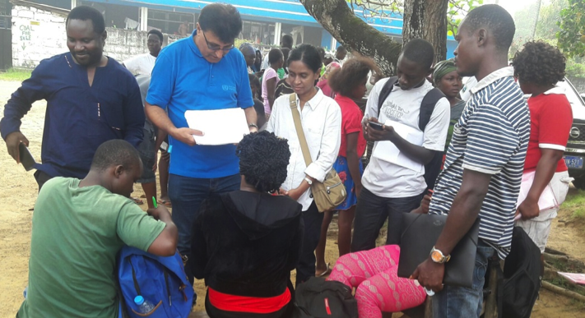
MPTF funding, under a complementary project, supported recruitment, training and deployment of over 10,090 Contract Tracers/Active Case Finders (ACFs) who have been instrumental in bringing Ebola cases down to the zero in Liberia. Support under this project has financed the deployment of 35 epidemiologists to provide technical assistance to support case investigation to ensure all cases were line-listed and provided to the team lead for contact tracing, monitoring, data consolidation and management to provide relevant information to inform district level response strategies. The epidemiologists supported prompt case investigation and appropriate referral of Ebola suspect cases and identification and registration of all potential contacts. They have supported contact tracers in monitoring contacts, identifying those who developed symptoms, and promptly referring them for care. They have also played a critical role in data integration, consolidation, cleaning and analysis to inform the response and supply information for monitoring components of the response efforts.
WHO County Coordinator checking contact tracer forms during November 2015 outbreak

Achievements and Results:
- The break in transmission of the disease in Liberia and declaration of the country by WHO as Ebola-free on 9th May 2015 and 3rd September as well as the successful control of the November/December 2015 outbreak.
- Deployment of epidemiologists in 15 counties in Liberia who recruited, trained and deployed over 10,090 Active Case Finders (ACFs) who were instrumental in bringing Ebola cases down to the zero in Liberia.
- Reduction in the number of cases from over 150 cases per day to the current ‘0’ case in Monrovia, and the entire country.
- Heightened public awareness and cooperation in the fight against the disease through the ACFs and other field personnel outreach work to over 1.5 million people in the county.
- The project helped to institute a culture of continuous surveillance in the communities even during long periods without any confirmed cases and after Liberia was declared EVD-free.
- With the involvement of the communities in the search for the sick, dead, contact tracing and quarantines, the community-based approach also reduced the level of stigmatization and enhanced openness in reporting Ebola cases, and supporting those in need.
- Demographic, risk factor and clinical data was collected and stored in one EVD surveillance system for Liberia, through partnership with MoH and CDC.
- Provision of data processing equipment for county and district surveillance supervisors in target counties.
- Providing technical support and guidance to project implementation with special focus on high transmission areas (Montserrado).

MCA 3: Care for Persons with Ebola and Infection Control
The Ebola outbreak exposed a health system that lacked the necessary infection prevention and control (IPC) measures to care for already infected patients while preventing the spread to other patients, health workers and the broader community. As the project commenced in December 2014, the epidemic was being brought under control and concerted effort was being made to restore essential health services, improve disease surveillance and build a resilient health care system that was better able to withstand the threat of future potential epidemics.

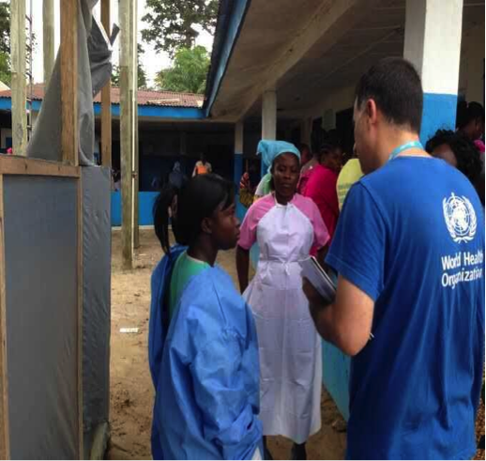
WHO supported the MOH at the district level in revitalizing essential health services to restore gains lost due to the EVD crisis, and provide safe and quality health care services in Liberia. The project directly supported the deployment of 14 IPC experts and purchase of 10 vehicles to support infection prevention control activities in Liberia. The IPC experts ensured infection control at treatment and community care centers through training, mentorship and day to day supervision. This helped to not only stop further transmission of EVD to health care workers providing care for the sick, but also contributed towards outbreak containment.
IPC assessment at Louisiana Clinic in Montserrado County

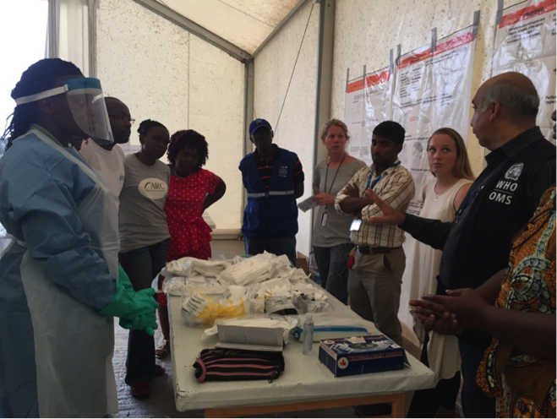
WHO’s support under the project has resulted in better coordination of partners through the establishment of a national IPC task force, development of national IPC standards in non-EVE health care facilities and an associated national IPC tools. WHO began coordinating and undertaking assessments of triage facilities with partner organizations, completing daily assessments until facilities were deemed IPC compliant. To contain cases, an ‘IPC Ring Approach’ was applied to healthcare facilities based in transmission hotspots in Montserrado County and the four bordering counties: Lofa, Grand Cape Mount, Nimba and Bong. WHO supported two different trainings for health care workers to improve knowledge of infection prevention control and safe practices, including “Keep Safe Keep Serving (KSKS)” trainings and later Safe and Quality Services (SQS) trainings which incorporated an IPC component into a wider EVD and infectious disease training. WHO also led the establishment of an IPC database capturing IPC minimum standard tool results to support the ongoing efforts of the national MOHSW, counties, and corresponding partners.
HCWs participate in SQS Training of Trainers

Achievements and Results
- Creation of a secretariat in the MOH to support the IPC Task Force Activities.
- Leadership in establishing an IPC database, capturing IPC minimum standards tool results and making them accessible.
- Standardizing implementation of Ebola HCWs exposure to Ebola risk questionnaire at onset of outbreak, prior to decision making regarding HCWS precautionary observation status
- Established IPC Ring approach for containment of EVD clusters
- WHO conducted KSKS trainings on IPC for health care workers for 2,118 HCWs and 140 Liberian Master Trainers during 2015.
- By the end of 2015 a total of 8,093 health care workers (clinicians and non-clinicians) were trained in SQS.
- WHO supported the development of an IPC minimum standards assessment tool for health care facilities. This became the standardized tool for all implementing IPC partners.
- WHO IPC teams, along with the MoH and IPC partners, reinforced IPC measures at 76 priority health facilities and 28 medicine stores through a ring approach, completing regular IPC assessments in 100% of facilities
- WHO, in collaboration with CHTs and partners, conducted a total of 2,329 health care assessments during 2015.
- Due to the existing strong IPC practices and monitoring system to ensure all facilities with low IPC assessments improved the practices and level of compliance, zero health care workers or patients contracted EVD throughout the outbreak.
- From Q1 to Q4 in 2015, there has been a gradual increase of 15% in HCFs percentage adherence to selected minimum IPC standards (based on triage, waste management and isolation capacity).

Figure 1: HCF’s percentage compliance to selected IPC minimum standards in 2015

The IPC minimum standards indicators included here are applicable for all HCFs (Hospitals, HCCs and Clinics); indicators applicable to one HCF type only were excluded. The three indicators include: triage, waste management, and isolation. For Q1 overall adherence to IPC minimum standards is 47 %, Q4 overall adherence is 62%. Hence there is an incremental increase in IPC adherence of 15% for 2015.

MCA 9: Reliable Supplies of Materials and Equipment
Critical to ending the Ebola outbreak in Liberia was a district-level focus and more integrated response across communities. To this end, WHO supported the MoH in logistical operations across and within all districts to assure the flow of essential materials and supplies for a wide-spread response. WHO worked with partners to develop a network of logisticians and logistics capacity across the most-affected areas of Liberia.

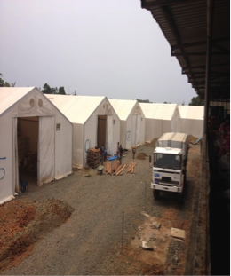
Prior to the outbreak, the regular public health supply chain in Liberia was not robust enough to provide essential PPE to health facilities and most of the health facilities lacked essential IPC supplies in health facilities (i.e. none sterile gloves, alcohol based hand gel, etc). In response to the outbreak, Liberia received a large volume of donations from different donors to support Ebola operations. This added additional responsibility to the Supply Chain System of the MOH to ensure Personal Protective Equipment (PPE) and other IPC supplies were adequately supplied to provide necessary safe guards to health workers to prevent the spread of infection. To achieve this, a supply chain for Ebola response in Liberia was established to organize the management of incoming supplies and to ensure timely, correct provision of PPEs and IPC supplies to all health care workers.
Mobile supply units hold PPE and IPC commodities

WHO’s key objectives under the project included supporting the MoH by providing supplies in any logistics needs in the EVD response and restoration of services, providing technical logistics support to the Ebola outbreak response teams in specific areas, capacity building, and maintaining inventory of all WHO procured and donated supplies. A total of 14 logisticians (10 international and 4 national) were deployed to provide logistics support across all 15 counties. One to two logisticians were deployed per forward loading base (FLB) in Lofa, Nimba, Bong, Grand Bassa and Maryland, which served as supply hubs and to pre-position supplies before last mile distribution. WHO teams developed distribution plans to move the EVD commodities from the central warehouse to FLBs, to mobile supply units (MSUs) and ultimately to health facilities.

The WHO Logistics Team served as the Focal Point in handling all IPC requests from partners and ensuring timely fulfillment. MOH along with WHO and other partners (WFP & JSI) launched last mile distributions to provide IPC materials to health facilities in from February through December 2015. In preparation for project close-out, a supply chain task force, and management team supported a transition from the emergency response supply chain to a regular supply chain system in preparation for project close-out in collaboration with County Health Teams (CHT) in each county, to redistribute any unused materials to health facilities based on need.

Achievement and Results
- Seven distribution rounds were successfully completed throughout the year, providing IPC commodities to 728 health facilities through last mile distribution.

County | 1st | 2nd | 3rd | 4th | 5th | 6th | 7th
Bomi | 22 | 21 | 22 | 22 | 22 | 22 | 22
Bong | 43 | 41 | 44 | 44 | 38 | 44 | 44
Gbarpolu | 15 | 14 | 15 | 15 | 15 | 15 | 15
Grand Bassa | 29 | 27 | 27 | 27 | 25 | 27 | 29
G. Cape Mount | 31 | 31 | 32 | 32 | 32 | 32 | 32
Grand Gedeh | 0 | 23 | 24 | 24 | 16 | 24 | 24
Grand Kru | 20 | 20 | 19 | 19 | 18 | 18 | 18
Lofa | 60 | 58 | 59 | 59 | 59 | 59 | 59
Margibi | 14 | 20 | 20 | 20 | 23 | 26 | 25
Maryland | 0 | 24 | 25 | 25 | 25 | 25 | 25
Montserrado | 66 | 36 | 256 | 243 | 264 | 250 | 284
Nimba | 69 | 69 | 71 | 75 | 75 | 75 | 75
Rivercess | 18 | 17 | 19 | 19 | 19 | 19 | 19
Rivergee | 20 | 19 | 20 | 20 | 20 | 20 | 20
Sinoe | 35 | 35 | 37 | 37 | 37 | 37 | 37
Total (number) | 442 | 455 | 690 | 681 | 688 | 693 | 728
Total (%) | 58% | 60% | 90% | 89% | 90% | 92% | 100%
Figure 2: IPC commodities distributed in 2015

- Assessment and installation of 14 Mobile Storage Units (MSU) has been completed in 14 Counties to improve storage capacity at the county level.
- Expired medical commodities of EVD response identified and removed from stocks ready for destruction.
- Supply chain management orientation workshop provided for 17 supply chain coordinators, 15 county pharmacists & 12 hospital pharmacists.
- Supported the Ministry of Health to successfully manage the inventory of all supplies arriving in the from various donors, strengthening the capacity of the supply chain unit for day-to-day guidance on stock management and distribution planning to all health facilities, ETUs and CCCs countrywide.
- Received, through clearing and forwarding, transported, stored and dispatched all incoming shipments both by air and sea, where a total of 116 shipments mostly IPC supplies were received. (105 containers, 14,896 boxes and 23 pallets).
- Sample transport system has been setup to transport the semen samples of Ebola survivors from Redemption Hospital in Montserrado County and Phoebe Hospital in Bong to Tappita Lab in Nimba.
- Provided regular support and guidance to county health teams on improved resource management and utilization of available resources at the county level, especially in regards to transport.
- Development of the basis of transitioning EVD supplies into regular supply chain system through the EVD supply chain transition task force.

MCA 11: Social Mobilization and Community Engagement
Social mobilization and health promotion have been one of the key pillars of the Ebola response in Liberia. The overall goal is to raise community awareness of EVD, foster community participation in the Ebola Outbreak response and strengthen community engagement in planning, implementation, monitoring and evaluation of agreed Ebola response activities. The core objectives are; 1) Develop appropriate community sensitization programs and messages, 2) Conduct community engagement throughout the country, 3) Undertake KAP studies, and 4) Build capacity of community mobilizers and community leaders. The expected outcome is to empower communities to protect themselves and take appropriate behavioral actions so as to mitigate the impact of the EVD outbreak.

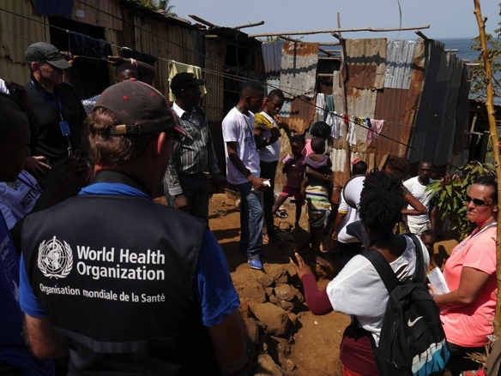
WHO has worked in collaboration with the MoH, Ministry of Education, UNICEF, CDC, UNMIL, UNMEER and other partners to strengthen social mobilization coordination and partnerships, develop guidelines and training materials, develop messaging and IEC materials, promote community mobilization engagement and strengthen social mobilization capacity at all levels. The project has directly supported 5 mobilization experts to lead project interventions.
Community mobilization in Ebola affected communities

The re-emergence of Ebola on two separate occasions during the past after Liberia as initially declared Ebola-free has demonstrate the challenges in maintaining community vigilance for sustainable infection prevention and control behaviors to prevent reemergence of Ebola, and underscore the importance of these interventions.

Achievements and Results:
- Supported the Montserrado County response team and the Montserrado IMS community engagement pillar to plan, implement and coordinate partner support to respond to the EVD outbreak.
- In collaboration with Global communities, Montserrado response team, CDC and UNICEF, WHO supported community engagement and dialogue meetings to mobilize communities to address safe burial practice safes. The communities developed action points to promote safe burials and on steps to strengthen surveillance of dead body management.
- 96 block leaders in Montserrado were supported to strengthen their participation in community response (provided rain boots, scratch cards, refreshments).
- Community engagement session held with the community leadership and other stakeholder to discuss about the triage at the Louisiana Community Health Clinic
- Meetings held with community leaders in New Kru town and Island Clinic community in respect of the decommissioning of ETUs and address the brokering between the community and government counterparts on redressing community concerns.
- Zonal coordination meetings held regularly and community leaders committed to take responsibility to address community health issues (unsafe burial practices, body swabbing, early detection of diseases and reporting.
- 500 Community leaders, active case finders and districts surveillance teams participated in orientation meetings to strengthen their collaboration in community engagement and surveillance. WHO supported the orientation meeting in collaboration with ACF and partners.
- Supported MOH to analyze monitoring data and produce a monitoring report for county level SM activities in EVD response
- A standard messaging guide was updated to include messages on vigilance post EVD and advocacy for ongoing campaigns (immunization, EVD vaccine). WHO contributed technical support in collaboration with MOH, UNICEF and partners.

Delays or Deviations

The project was initially set to end in February 2015, but due to the continued presence of EVD in the country and sub-region and the availability of funding, a No Cost Extension was granted through December 2015. Between February and December 2015, project activities gradually wound down as the epidemic waned and transitioned into the recovery period.

Best Practice and Summary Evaluation:
The project’s interdisciplinary approach to build district level capacities through targeted interventions in the areas of active surveillance and case finding, infection prevention and control, supply chain management and social mobilization and community engagement supported a coordinated and comprehensive response through close collaboration and the GoL and other stakeholders. Emphasis was placed on recruiting and training national staff to support implementation of planned interventions and to closely monitor the response efforts and institute corrective action as the needs arose. These activities helped to enhance district level leadership and coordination capabilities to continue surveillance and recovery activities beyond the project’s implementation.

Support to build district and county level capacity has continued beyond project closure, to promote sustainability of the health workforce. WHO is engaging with the MoH to promote curriculum development and training for Community Health Services and county and district level coordination of community health service activities. As part of the Community Health Services Working Group training modules have been developed to roll-out training on essential skills for health teams. Drafts for guidelines to support county-level coordination of community health service activities, as well as operational guidelines for roll-out of community health services to improve coordination among different stakeholders, are currently under development. Activities such as these help to promote stakeholder coordination to ensure improvements in the health workforce continue to be registered, even as key projects are concluded and official donor support ends in the post-Ebola recovery period.

Lessons Learned:
Interdisciplinary Response: The integration of all project activities including surveillance, infection prevention and control, community engagement, sensitization have been critical in mounting a response and creating a culture of continuous surveillance and behavior change even after the outbreak has ended.

Improved Collaboration Among Stakeholders: MPTF funding was instrumental in encouraging greater collaboration between partners and supporting coordination mechanisms for a more unified response, improving synergy and reducing duplication of efforts. Relationships were built and maintained with beneficiaries and other stakeholders who became involved with WHO in a variety of ways around one shared goal, to benefit both the Ebola response overall and the community members.

Capacity Building: The program has provided opportunities to the local population to develop invaluable new skills and knowledge through training and on the job learning on areas such as disease surveillance and community engagement. It has provided critical support in building knowledge and practices amongst local health care teams, supporting sustainability and long-term capacity beyond the project interventions.

Community Engagement: The crisis demonstrated the crucial role that communities and civil societies can play in responding to an outbreak by engaging the communities and CSOs in taking decisions that affect them in all development interventions. Engagement of local leaders facilitated continuous engagement with communities. This helped in building trust, commitment, and capacity for effective implementation of projects.

Stories on the Ground

Declaration of the End of the Ebola Outbreak in Liberia- 9 May, 2015- After successful completion of the end of the 42-surveillance period, Liberia held a declaration ceremony. The WHO Representative for Liberia presented the Ebola Free declaration statement to the Head of the Incident Management Team who in turn handed it over to the Minister of Health and the President of Liberia. On 11 May 2015, the Government of the Republic of Liberia hosted another ceremony marking the end of Ebola outbreak in Liberia at a colorful event held at the Centennial Memorial Pavilion, Monrovia.

Promoting Hand Hygiene- On 5 May 2015 WHO in collaboration with the MoH and partners commemorated the Global Hand Hygiene Day at Gbarpolu County in Liberia, with the theme of “Strengthening Health Care Systems and Delivery: Hand Hygiene is your entrance door”. The commemoration included health talks were held at schools, hand hygiene campaigns at markets and public places and a seminar on hand hygiene at the community health department in the county capital. More than 1500 students in Bopolu district attended the education forums, and 120 health care workers were trained on the WHO hand hygiene model.

Decommissioning Ebola Treatment Units- During the height of the Ebola Virus Disease Outbreak in Liberia, the government of Liberia with support from partners constructed 21 Ebola Treatment Units (ETUs), as well as five centers in existing healthcare facilities, across the country. After Liberia become Ebola-free WHO began supporting the MoH to decommission some ETUs and repurpose some facilities, while building on efforts made to strengthen the existing healthcare structures through improved infrastructure and human resource capacity. The physical process entailed safely emptying the ETU waste, step-by-step disinfection and cleaning of items, as well as dismantling temporary physical structures. During the process, the government, together with partners, focused on building more permanent infectious disease isolation units offering long-term care for Ebola as well as other diseases with an epidemic potential.

Quarantine Period Ends in Liberia- After the reemergence of Ebola in Liberia in November 2015, the family of the EVD positive cases, 165 people were identified as contacts and the community were placed under quarantine for 21 days.
At the end of the 21-day period, on 11 December a ceremony was held in a local church to celebrate. The ceremony included songs of praise and the opportunity to celebrate a new milestone and the return to normal life for those who had been placed in quarantine over the 21-day period. The Deputy Minister of Health spoke at the event, cautioning against complacency.

IPC Training and Equipment at Redemption Hospital- A year ago, Redemption lacked proper tools, equipment and training to ensure the safety of its health workers and other patients. All of that has now changed. With support from WHO and partners health care workers now have access to necessary personal protective equipment and essential medical supplies, such as equipment to properly dispose of contaminate materials and infected needs, and safely process specimens safely. The equipment has helped make the hospital a safer place for health workers and patients and gradually helped turn the tide of the disease.

Establishing an IPC Taskforce- As part of WHO’s role supporting the government, WHO helped set up an infection prevention and control taskforce in Liberia. This taskforce brought together more than 20 partners, with the aim of harmonizing all protocols into standard operating procedures for infection control in both community and health-care settings. The taskforce also developed a consistent set of guidelines for infection control in all health facilities, which helped such work as calculation of supplies.

Report reviewed by (MPTF M&E Officer to review and sign the final programme report)
- Name: Ellora Guhathakurta
- Title: Planning, Monitoring and Evaluation Officer, MPTF
- Date of Submission: 13/6/2016
- Email address: ellora.guhathakurta@one.un.org
Signature: Ellora Guhathakurta

Refers to programmes, joint programmes and projects.
The amount transferred to the Participating UN Organizations – see MPTF Office GATEWAY
The date of the first transfer of funds from the MPTF Office as Administrative Agent. The transfer date is available on the online MPTF Office GATEWAY.
As per approval of the original project document by the Advisory Committee.
If there has been an extension, then the revised, approved end date should be reflected here. If there has been no extension approved, then the current end date is the same as the originally projected end date. The end date is the same as the operational closure date, which is the date when all activities for which a Participating Organization is responsible under an approved project have been completed. As per the MOU, agencies are to notify the MPTF Office when a programme completes its operational activities. Please see MPTF Office Closure Guidelines.
Financial Closure requires the return of unspent funds and the submission of the Certified Final Financial Statement and Report.
Assuming a ZERO Baseline
Project can choose to contribute to all MCA or only the one relevant to its purpose.

