LIBERIA

2015 Annual Report

Project 10: Accelerating Progress Towards Interruption of Ebola Virus Transmission in Liberia

Project 16: UN Ebola Response MPTF

Mission Critical Action 1
MCA1
Identify and Trace People with Ebola $ 16.9 M
COVERAGE: Country, including district areas
MPTF Project No:  00093218  00093252 | Title:  #10 Interruption of Transmission  #16 Epidemiologist District Management |  | TRANSFER DATE:  23-Dec 2014  6-Feb 2015  19-Dec 2014 |  | AMOUNT:  $11,603,212  $5,312,789 |  | EXPENDITURES  (31 Dec 2015)  $3,655,050 (WHO)  $4,321,586 (UNFPA)  $3,405,254 (UNDP)  Total: $11,381,890  $5,312,789
PRIORITY INTERVENTION PLANNED ACHIEVED RESPONDING AGENCIES
Staff Deployment |  | 10,090  Contact Tracers |  | 10,090  Contact Tracers
 |  | 2,017  Supervisors |  | 2,017  Supervisors |  | UNFPA  UNDP  WHO
 |  | 106  District Monitors |  | 106  District/ Zonal Monitors
 |  | 30  County Coordinators |  | 30  County Coordinators
Epidemiologists |  | 21 |  | 35 |  | WHO
Vehicles |  | 22 |  | 27 |  | WHO  UNDP

Situation Update
The Ebola Virus Disease (EVD) outbreak in West Africa is the largest ever recorded outbreak of Ebola. In total, the Liberia Ministry of Health reported 10,675 cases of EVD and 4,809 deaths nationally, accounting for a 45% mortality rate. In 2014, when the country bore the heaviest brunt of the EVD epidemic, 50% of all cases and deaths in the region were ascribed to Liberia. The EVD outbreak has had a devastating impact on Liberia, resulting not only in widespread illness and loss of lives, but also decimating the health system.
EVD was first reported in Liberia in March 2014 in Lofa County. This first wave of the epidemic appeared to wane, with a brief period of no further reported cases. The second wave of the epidemic rose in May 2014 when EVD cases re-emerged in Lofa and spread to Montserrado County, home to the capital city of Monrovia and where the majority of the population lives. EVD spread widely with eventually all 15 counties in Liberia reporting cases. The EVD epidemic peaked in September and started declining in October 2014 as efforts increased and more partners mounted response activities. By January 2015 Liberia was experiencing the final stages of the main EVD outbreak, with one to two cases reported per day as opposed to up to 50 confirmed cases reported daily during the peak of the outbreak in late September to early October 2014. EVD transmission had ceased in the majority of counties however confirmed cases were still being reported in Margibi and Montserrado counties.
The main focus of transmission at the beginning of 2015 was a cluster of cases in Montserrado, resulting from a confirmed case who died on 5 January. Twenty-one additional confirmed cases were linked to this cluster with the last case admitted to an Ebola treatment unit (ETU) on 18 February 2015. Contact tracing identified 745 individuals who were subsequently monitored for 21 days. A further EVD case was identified on 20 March 2015. No other cases were identified and it was hypothesized that sexual transmission was the source. Following this individual’s death on 28 March and after a 42 day period with no EVD transmission occurring, Liberia was declared EVD transmission free on 9 May.
A period of enhanced surveillance for EVD followed with an average of 50 – 100 patient samples tested per week (Figure 2). Both live persons and dead bodies who fulfilled the suspect case definition had samples taken and tested as part of the enhanced EVD surveillance strategy during which time an oral swab from an individual who had died tested positive on 29 June 2015 in Margibi County. An EVD outbreak was therefore reported under the International Health Regulations (IHR) and intensive investigation activities followed. A further five confirmed cases in Margibi and Montserrado were linked with the initially identified case over a 2 week period during epi weeks 27 and 28. One of these cases died and 143 contacts were identified and monitored for 21 days.
Following the outbreak in Margibi, Liberia again entered a period of enhanced surveillance during which time the number of samples tested for EVD across the country increased and Liberia successfully achieved EVD transmission free status on 3 September 2015.
In October the Liberia Ministry of Health (MoH), with the support of partners, re-established an enhanced EVD surveillance system within the framework of the Integrated Disease Surveillance and Response (IDSR) structure in Liberia in order to ensure the early detection of, and rapid response to, all 14 epidemic prone diseases and conditions identified for enhanced surveillance in Liberia.
On 19 November 2015 a confirmed EVD case was reported in a 15 year old boy in Montserrado County and an EVD outbreak was again declared in Liberia. A further two cases were linked to the alert case, his brother and father, and on serological testing his mother and baby sibling were shown to have been exposed to EVD at some point in the recent past. 167 contacts of these cases were monitored for the 21 day period, 8 of whom developed symptoms that could have been related to EVD but tested negative. The last case in this outbreak was discharged from the ETU and a 42 day countdown period began on 3 December 2015. To the end of epi week 51, 28,164 patient samples have been tested for EVD in Liberia in 2015, 32 (including repeat tests from five individuals) of which were confirmed positive for Ebola Virus Disease (Figure 3).
Regionally, Sierra Leone was declared Ebola-free in human transmission by WHO on 7th November, 2015 and Guinea was declared Ebola-free on 29th December. Liberia is expected to reach Ebola-free status after 42 days of no reported EVD cases on January 14, 2016. Following the declaration, Liberia will move into the Phase III Strategy for EVD surveillance during which WHO recommends 90 days of heightened surveillance, whereby Liberia will maintain surveillance in communities and health facilities following the Integrated Disease Surveillance and Response (IDSR) system with slightly modified IDSR definitions to investigate and test.

Figure 1: Number of Confirmed Ebola Cases per Day, March 2014 to May 2015 (moving average per day in the last 21 days), Liberia, Source: Liberia MoH
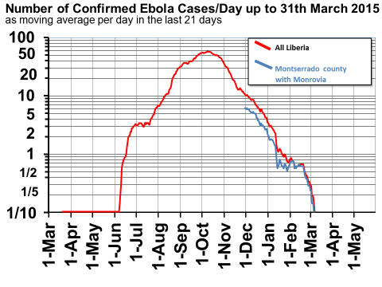
Figure 2: Patient samples tested for EVD, by sample type, Liberia, 2015 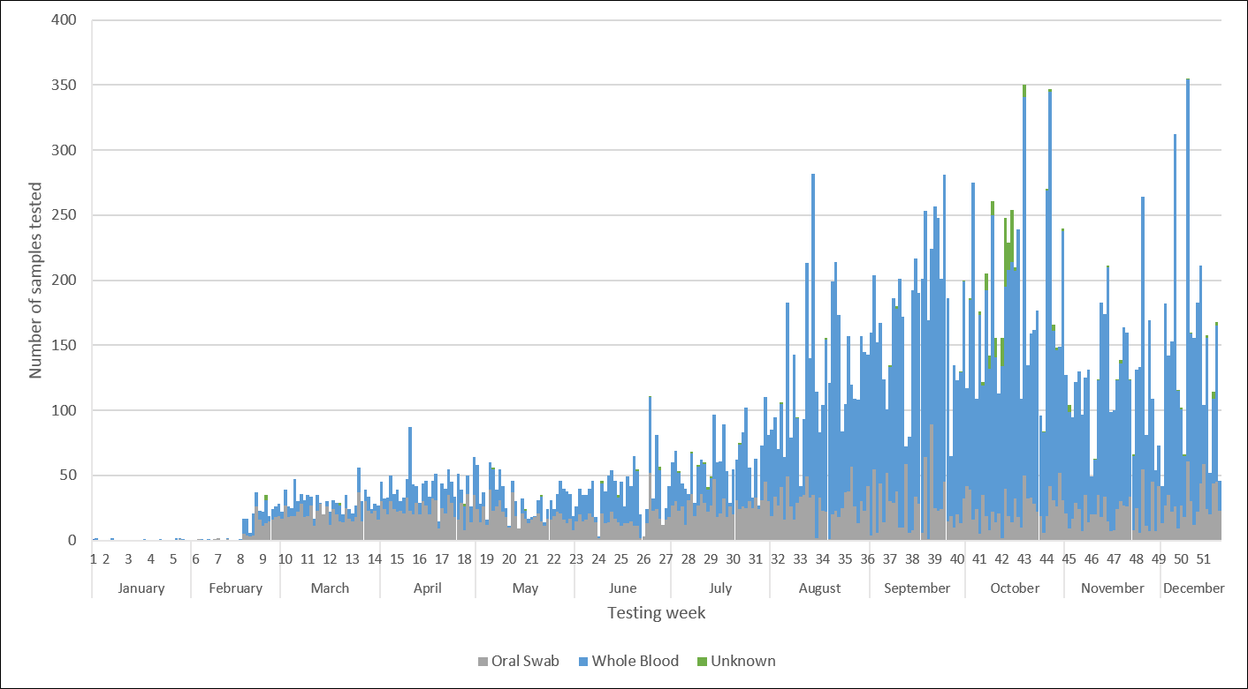

Figure 3: Confirmed Ebola Virus Disease Cases, Liberia, 2015

Figure 4: ACFs’ COMMUNITY DATA SUMMARY: OCT. 2014 TO JULY 31, 2015
Report Date | # of Households Visited | # Sick Discovered | # Sick To ETUs | # Dead Discovered | #Safe Burials Conducted | # Visitors Discovered | # Quarantined | #Completed Quarantine | # Orphans Discovered | #EVD Victims Required Counseling | # EVD Victims Required Food | #EVD Survivors Reintegrated
Oct - Nov 2014 | 36,708 | 463 | 124 | 227 | 169 | 1,017 | 784 | 743 | 294 | 1,336 | 957 | 80
Dec. 2014 | 63,850 | 189 | 119 | 135 | 128 | 823 | 642 | 612 | 119 | 289 | 176 | 76
Jan. 2015 | 260,961 | 392 | 76 | 126 | 87 | 972 | 623 | 554 | 68 | 601 | 563 | 24
Feb. 2015 | 365,876 | 667 | 18 | 54 | 53 | 2,398 | 256 | 255 | 40 | 51 | 621 | 9
Mar. 2015 | 379,654 | 595 | 5 | 25 | 14 | 2,173 | 19 | 17 | 76 | 84 | 45 | 2
April  2015 | 267,345 | 502 | 1 | 9 | 0 | 892 | 0 | 0 | 37 | 92 | 12 | 0
May  2015 | 142,987 | 598 | 0 | 14 | 0 | 523 | 0 | 0 | 0 | 0 | 0 | 0
June  2015 | 132,191 | 581 | 0 | 12 | 0 | 436 | 0 | 0 | 0 | 0 | 0 | 0
July  2015 | 137,327 | 273 | 3 | 11 | 1 | 527 | 19 | 17 | 0 | 0 | 0 | 1
TOTAL | 1,786,899 | 4,260 | 346 | 613 | 452 | 9,761 | 2,343 | 2,198 | 634 | 2,453 | 2,374 | 192

Figure 5: ACFs' Community Data Summary - Oct. 2014 to July 2015

Project Update
The UN Ebola Response Project began in December 2014 with funding from the UN Global Ebola Response Multi Partner Trust Fund (MPTF) through a collaborative effort between WHO, UNFPA and UNDP. The project aimed to enhance the capacity of all 15 counties in Liberia to detect every single chain of EVD transmission in a timely manner through implementing very high quality active surveillance and contact tracing activities. The timely detection of each chain of transmission aimed to allow for timely initiation of activities to interrupt the chains of transmission.
At the time of the project’s commencement (November 2014) Liberia had registered more than 20,000 contacts from over 6,000 reported EVD cases. Liberia had a total of 3,865 contact tracers/active surveillance personnel, but the estimated national need for contact tracers/active surveillance personnel was approximately 14,000. Additionally, the quality of contact tracing and active surveillance in most counties had been sub-optimal due to 1) inadequate numbers of contact tracers, 2) insufficient motivation of contact tracers due to lack of incentives, and 3) insufficient data collection tools, stationery, data management equipment and internet facilities in most counties and districts, and 4) lack of regular performance reviews, feedback and initiation of action to close identified gaps.
As a result of the gaps in contact tracing, there continued to be several undetected chains of EVD transmission in many counties in Liberia. Thus, during the initial phase of programming the single most important priority was identified as closing the gaps in contact tracing and active surveillance so that every single chain of EVD transmission in the country was detected in a timely manner. By ensuring timely detection of all remaining chains of transmission, the Liberian national authorities, with support of international technical partners, could focus on achieving interruption of EVD with a minimum number of secondary infections.
The initial project period was December 2014- May 2015. WHO, UNFPA and UNDP each supported the attainment of project activities in different areas of the country, where the respective UN agency had already been active in supporting the active surveillance and contact tracing. The specific activities included:
UNDP: Supported contact tracing and active surveillance in Montserrado County
- Supported recruitment, training and the provision of incentives for 3,246 contact tracers, 649 supervisors, 22 district monitors and 2 county coordinators
- Provided data processing equipment in Monsterrado
- Ensured high quality monitoring and supportive supervision
UNFPA: Supported contact tracing and active surveillance in 6 counties (Bomi, Bong, Gbarpolu, Grand Cape Mount, Lofa and Nimba)
- Supported recruitment, training and the provision of incentives for 3,967 contact tracers, 793 supervisors, 34 district monitors and 12 county coordinators
- Provided data processing equipment to 6 counties
- Ensured monitoring and supportive supervision
WHO: Supported contact tracing and active surveillance in 8 counties (Grand Bassa, Grand Gedeh, Grand Kru, Margibi, Maryland, Rivercess, River Gee and Sinoe.
- Supported recruitment, training and the provision of incentives for 2,877 contact tracers, 575 supervisors, 50 district monitors and 16 county coordinators
- Provided data processing equipment to 8 counties
- Ensured monitoring and supportive supervision, and overall compliance throughout all 15 counties
MPTF funding for the Liberia Ebola response was originally supposed to end on 30th May 2015. However, since at that time the country had only been declared Ebola-free on 9th May, 2015, the three agencies (WHO, UNDP and UNFPA) in consultation with government, requested for a no-cost extension, considering that ongoing outbreak in neighboring Guinea and Sierra Leone. MPTF initially declined the no-cost extension and requested for the return of the funds to support response in Guinea and Sierra Leone. However, following the detection a new outbreak in Margibi County in June 2015, MPTF agreed to release the funds to support Liberia’s current response, in line with Government’s priorities. The project was extended until December 2015 with the primary goal of early case detection and rapid identification of the sick and dead, and their visitors. The revised project included the following activities for July- December:
- Support the outbreak response activities in Montserrado (active case finders, community engagement, cash incentive of response team and operational fund.).
  - UNDP supported the payment of July incentive to 4,171 active case finders in Montserrado, Refresher training, community engagement, and operational cost.
  - WHO continued support active case finders, starting from August to December 2015, after a reduction of about 50% of original number, from 4,171 to 2,146 active case finders.
  - UNFPA supported incentive payments to 123 Response team in Montserrado, and operational support to 4 response teams.
- Support active case finding in 6 counties (Bomi, Bong, Gbarpolu, Grand Cape Mount, Lofa and Nimba).
  - UNFPA continued supporting the 6 counties by incentivizing the 656 active case finders, 176 supervisors, 42 monitors and 14 coordinators, providing training and operational cost from July-December 2015.

Achievements and Results
In 15 counties in Liberia UNDP, UNFPA and WHO have been working to implement high quality active surveillance, case searching and contact tracing.

OUTPUT INDICATORS
Indicator | Geographic Area | Projected Target  (as per results matrix) | Cumulative Project Results  (quantitative) | Delivery Rate (cumulative % of projected total)
Description of the quantifiable indicator as set out in the approved project proposal
Proportion of Counties that have trained ACFs in all districts | All 15 counties | 15 | 15 | 100%
Proportion of ACFs that have been trained using the recommended national Standard Operating System | All 15 counties | 10,090 | 10,090 | 100%
Proportion of County surveillance offices that have data processing equipment | All 15 counties | 15 | 15 | 100%
Proportion of County surveillance offices that have functioning internet connection | All 15 counties | 15 | 15 | 100%
Proportion of district offices that submit surveillance reports on time including zero (0) reports. | 91 Health Districts | 91 | 91 | 100 %
Proportion of districts offices that have at least one supportive supervision visit from national or County level per week | 91 Health Districts | 91 | 91 | 60 – 70 %
Proportion of Counties that have weekly meetings to review active case finding during the preceding week and have written meeting reports with clearly identified action points | All 15 counties | 15 | 15 | 100 %
Proportion of confirmed EVD cases that were on the contact list prior to becoming symptomatic | All 15 counties | 100 % | All except 2
EFFECT INDICATORS (if available for the reporting period)
Identifying and tracing of people with people: Proportion of Counties with 100% districts implementing active surveillance and effective contact tracing | All 15 counties | 15 | 15 | 100%

Achievements and Impact:
- The first obvious result of the project intervention in collaboration with work of other partners, was the break in transmission of the disease in Liberia and declaration of the country by the WHO as Ebola-free on 9th May 2015 and 3rd September as well as the successful control of the November/December 2015 outbreak.
- Recruitment, training and deployment of over 10,090 Active Case Finders (ACFs) who have been instrumental in bringing Ebola cases down to the zero in Liberia. They led the search for the sick and the dead, ensured they were taken out of the communities or quarantined in order to break the chain of infection.
- The critical role that ACFs have played was evident in the Caldwell outbreak. Through their dedicated work, and that of their supervisors, individuals and affected homes (including the sick, dead and potential contacts that have secretly moved into the communities) were searched for (house-to-house), documented and quarantined within their community for 21 days, when ETUs were full. This greatly contributing to the success in breaking the chain of infection and spread of the disease.

- ACF teams also managed to reach potential cases and contacts, counseled and encouraged them to return to their house e.g. in Caldwell, and peacefully quarantined them for 21 days. While under quarantine, the ACFs visited them daily at a safe distance and provided them with water and food that they have collected from community members. Supplies were later provided by WFP and others partners through the IMS.

- With the involvement of the communities in the search for the sick, dead, contact tracing and quarantines, the community-based approach also reduced the level of stigmatization and enhanced openness in reporting Ebola cases, and supporting those in need.

- ACFs under the project also arranged and facilitated meetings with the Imams and leadership of muslim communities, as in the case of the Imam of Caldwell. Collaboration with the Imam contributed to the development of a strategy that helped in stopping traditional and religious burial practices that was contributing to spread the disease. Through the ACF’s work agreements were reached with Muslims leaders on acceptable ways of handling dead bodies of Muslims. This allowed the carrying out of religious burial prayers and rituals from a distance, and facilitated the peaceful removal of dead bodies for safe burial.

- The vigilance and intervention of the ACFs stopped the outbreak in Popo Beach which became the epicenter, and nearly reversed gains made towards a zero case in the country. The brave and great work of the active case finders in identifying, documenting and tracking most of the cases, save the community and the country. Their efforts were complemented by the contact tracers who tracked many of the contacts, quarantined, treated and supported them where possible.

- Through the work of the ACFs, several factors that were contributing to the spread of the disease were identified and addressed. They included:

  - Lack of feedback to families on the status, laboratory results, conditions and locations of ETU where family members were taken. This led to denial and refusal to bring out sick relatives.
  - Delayed response by the ambulances to reported cases that may have contributed to increase in cases and deaths.
  - Slow response in providing food to quarantined family leading to many escaping from Popo Beach.
  - Little or no education to communities on the possibility of Ebola transmission by EVD survival may have contributed to some of the cluster of cases.
- Reduction in the number of cases from over 150 cases per day to the current ‘0’ case in Monrovia, and the entire country.

- In spite of being declared Ebola-Free, the Liberian Government through the Incident Management System (IMS) continued to maintain high surveillance, while working towards strengthening the health delivery system in the Country, to respond effectively to future epidemics. The ACFs continued their surveillance in the communities.
- Upon notification of a suspected case in Nedowein community, the prompt support provided by the Project Team in Sector 4 of Montserrado County, to the Margibi County Health Team, has been critical in containing the potential spread of the disease in Montserrado and other counties. Contacts who live in Margibi and fled to Monrovia, in Montserrado County were traced, identified and returned to Margibi County to be quarantined. They however left a list of contacts in Montserrado. Similarly, a contact Health Care Worker who could not be located were traced by the ACFs and brought under precautionary observation.
- Through the Community engagement approach, the commitment and co-operation of the leaders and members of the affected communities such as Nedowein and Smell-No-Taste have been attained. The communities are contributing immensely to efforts aimed at breaking the chain of infection. As a result, 9 houses are currently voluntarily quarantined, observed by the community members who notify response teams if any of those quarantined leaves their premises.
- The active follow up by the ACFs on rumours of new cases in Caldwell Community for instance, led to the discovery of a high numbers of visitors from Guinea who were coming to Montserrado for the Ramadan. Though there was no case, the high influx of visitors from Guinea was brought to the attention of the Ministry of Health and measures have been put in place to check on the visitors regularly.
- Some of the female contact tracers are also Trained Traditional Midwives (TTMs) and they have been very instrumental in contributing to an increase in facility based deliveries through referrals and identification of pregnant women in their communities as part of active case searching by household. In January 2015, one county recorded 95% of deliveries being done by skilled birth attendants compared to 75% in December 2014 and there was a 71% increase in pregnant women attending ANC between December 2014 and January 2015. These results are attributable to the role female trained traditional midwives played in restoring community confidence in the health system.

- In some counties contact tracers identified and reported an increase in cases of Sexual and Gender Based Violence (SGBV) involving very young adolescent girls as victims for the month of July with at least 13 cases compared to less than 3 in the previous month.
- There has been a noted increase in assisted deliveries across the six counties as a result of community engagement with leaders to discourage Trained Traditional Midwives (TTMs) from conducting home deliveries. In some instances, leaders have levied fines on TTMs that conduct home deliveries and in some cases incentives like lappers (wrappers) have been provided to TTMs that refer pregnant women to health facilities.
- Community engagement interventions for sustained surveillance that were started as part of the project’s exit strategy had concluded with community inception meetings, community structure mapping and initiated community mobilization and support activities with structures to enhance community led disease surveillance in the counties
- Creation and current availability of a critical mass of experienced youth community volunteers (i.e. over 10,090 Active Case Finders) successfully recruited and trained under the project, who remain as a backup human resource for the country. A number of them are currently supporting other health programmes.

- Heightened public awareness and cooperation in the fight against the disease through the ACFs and other field personnel outreach work to over 1.5 million people in the county.

- The project has helped to institute a culture of continuous surveillance in the communities that though there had not been any new case in the County and the entire Country, the ACFs continued their surveillance in the communities.

- Successful containment of the Nedowein community outbreak through prompt support provided by the Project Team to the Margibi County Health Team.

- Prevention of the potential spread of the disease widely in Montserrado and to other counties.

In addition to the project activities directly targeted at controlling the EVD outbreak, MPTF funding has provided support to the MoH in building national and district level capacity and re-establishing the IDSR system. Results included:
- The IDSR guidelines were redeveloped in a more practical and usable fashion and nearly 1,500 health care workers were trained in the signs and symptoms of the diseases and conditions and how to report and respond to them. This work was undertaken in partnership with MOH DPC department as well as US Center for Disease Control (CDC).

- Successful working groups were implemented and co-led by WHO with MOH for IDSR implementation at the community level.
- An electronic platform for reporting of priority diseases was designed, developed and rolled out in 4 pilot counties. This was led by WHO in collaboration with MOH. This will have a direct impact in the future in the speed of response to epidemic prone diseases therefore minimizing the spread and the number of individuals impacted.
- Development of a toolkit to enable MOH and WHO field teams to work with counties to develop county specific epidemic preparedness and response plans. This work was undertaken jointly with MOH with in-county partner engagement.
- Development of an IDSR surveillance reporting tool to aid in analysis and reporting of priority epidemic prone diseases.
- All counties have collected IDSR data (except Montserrado) for most priority diseases, with some limitations regarding retrospective data collection

Mission Critical Action 3
MCA3
Care for Persons with Ebola and Infection Control $ 10.58 M
COVERAGE: Country, including district areas
MPTF Project No:  000932255 | Title:  #10 IPC District Management |  | TRANSFER DATE:  19-Dec-2014 |  | AMOUNT:  $1,212,945 |  | EXPENDITURES  (31 Dec 2015)  $1,212,945
PRIORITY INTERVENTION PLANNED ACHIEVED RESPONDING AGENCIES
IPC Experts |  | 6  International Staff |  | 14 |  | WHO
Vehicles |  | 10 |  | 10 |  | WHO

Situation Update
The Ebola outbreak in 2014/15 exposed not only a national surveillance system in Liberia that was ill-equipped to detect and respond to the epidemic threat, but also a health system which lacked the necessary infection prevention and control (IPC) measures to care for already infected patients while preventing the spread to other patients, health workers and the broader community. In addition to supporting efforts to get to and sustain zero EVD cases WHO has also supported the MOH at the national and county level in revitalizing essential health services which restored gains lost due to the EVD crisis, and provide safe and quality health care services in Liberia through developing an “IPC culture”. The main IPC priorities through the outbreak included:
- Work in close collaboration with Ministry of Health (MoH) EVD IPC outbreak response team to control outbreaks and prevent reintroduction through implementation of IPC standards
- Safe restoration of essential health care services through monitoring, regulating and enforcing IPC standards in all health care facilities (HCFs)
The IPC Task Force, established and lead by the Incident Management System (IMS) IPC lead in late 2014, was a forum for coordinating EVD response IPC interventions through partners (over 50 at one point), discuss technical and implementation issues. The Ministry of Health IPC Steering Committee was set up in early 2015 to define policy, strategic direction, and technical issues; it included a core group of advisory partners (CDC, JSI, Jpheigo, WHO).

As the EVD crisis highlighted IPC deficiencies, one committee proposal was to create an IPC unit within the ministry. On further evaluation it was however recognized that there was a wider scope of needs; that of systematic health system quality assurance. Hence in June - July 2015 the Quality Management Unit (QMU) superseded the previously proposed IPC unit; QMU will integrate quality and IPC priorities within one unit that will also include diagnostics, service delivery, pharmacy, data systems and potentially other thematic areas (still to be defined). It will have community representative to ensure quality exists at HCF, district, county and national level.
An IPC framework was established both in the community and healthcare facilities. The ‘Keep Safe - Keep Serving’ (KSKS) IPC package was developed to provide guidance and tools to implement IPC in the community and in health facilities. The WHO IPC Team began training health care workers, Liberian master trainers and professionals for partner NGOs on the KSKS model. WHO established and supported the deployment of KSKS master trainers to support IPC development in counties, and subsequent definition of IPC minimum standards, which now stands as an official ministry IPC tool and guideline, which is being utilized by all partners and county health teams in healthcare facility audits, for both public and private institutions. The rapid scale up of IPC strategies at the community level in September 2014 was particularly key to curbing the epidemic, as there was a limited number of ETU beds for patient isolation and it was projected that most EVD cases were occurring in the community.
As more control of the epidemic occurred towards the end of 2014, gradual re-opening of health services and non-health services occurred. WHO’s main goals during this period were to consolidate outbreak control measures and revitalize essential health services, while providing technical advise for non-health services. Emphasis was placed on prompt identification at triage of suspected cases coupled with isolation capacity and standardized referral systems. WHO began coordinating and undertaking assessments of triage facilities with partner organizations, completing assessments on done on a daily basis until facilities are deemed acceptable. Another strategy used to contain cases is the ‘IPC Ring Approach’, applied to healthcare facilities based in areas of intense transmission or hotspots in Montserrado County and the four bordering counties: Lofa, Grand Cape Mount, Nimba and Bong. In addition to reinforcement of triage, this includes having rapid response teams on stand by for increased activity, KSKS refresher trainings, provision of emergency IPC supplies, mentorship, and reinforced external monitoring (by WHO, partners, or MOHSW). WHO has also taken the lead on establishing a IPC database capturing IPC minimum standard tool results to support the ongoing efforts of the national MOHSW, counties, and corresponding partners.
Once outbreak had been brought under control and the need for ETU capacity slowed, WHO has also provided support for the safe decommissioning of 5 Ebola Treatment Units/30 CCCs and the transfer of care to existing health facilities, conducting assessments to ensure the county and referral HCFs were prepared to take over EVD care from ETUs.
In August 2015, as the country transitioned into a restorative phase of this epidemic, WHO and Ministry of Health (MoH) developed a Safe & Quality Health Services (SQS) training package aimed at improving quality healthcare services across the country training that include include Infection Prevention & Control (IPC - standard precautions), EVD management, emergency clinical management, psychosocial support for healthcare workers and patients and introduction to the healthcare workers’ role in disease surveillance. The SQS package is being implemented by partners in the fifteen counties to train a target of 8,411 health care workers (HCWs) over a 5 month period.
Project Update
The MPTF fund provided critical funding early in WHO’s response for the deployment of 14 IPC experts and purchase of 10 vehicles to support infection prevention control activities in Liberia. The initial activities focused on two main areas, 1) the adaptation and discussion of guidance documents to standardize the quality of IPC activities of all partners; and 2) the coordination of IPC interventions in the country to reduce the das and duplication of efforts.
Late into 2015, as funding through MPTF was nearly expended, WHO funding through USAID/OFDA helped to co-fund some of the reported activities and WHO’s broader IPC recovery efforts.

Achievements and Results
- Safe decommissioning of 5 Ebola Treatment Units/30 CCCs in accordance with IPC standards
- HCWs Precautionary Observation Standard Operating Procedure (SOP) developed
- Standardizing implementation of Ebola HCWs exposure to Ebola risk questionnaire at onset of outbreak, prior to decision making regarding HCWS precautionary observation status
- Established IPC Ring approach for containment of EVD clusters
- WHO conducted KSKS trainings on IPC for health care workers for 2,118 HCWs and 140 Liberian Master Trainers during 2015.
- By the end of 2015 a total of 8,093 health care workers (clinicians and non-clinicians) were trained in SQS.
- WHO supported the development of an IPC minimum standards assessment tool for health care facilities. This became the standardized tool for all implementing IPC partners.
- WHO IPC teams, along with the MoH and IPC partners, reinforced IPC measures at 76 priority health facilities and 28 medicine stores through a ring approach, completing regular IPC assessments in 100% of facilities
- WHO, in collaboration with CHTs and partners, conducted a total of 2,329 health care assessments during 2015.
- Due to the existing strong IPC practices and monitoring system to ensure all facilities with low IPC assessments improved the practices and level of compliance, zero health care workers or patients contracted EVD throughout the outbreak.
- From Q1 to Q4 in 2015, there has been a gradual increase of 15% in HCFs percentage adherence to selected minimum IPC standards (based on triage, waste management and isolation capacity).

Figure 6: Number of MST assessments per quarter in 2015

Figure 7: HCF’s percentage compliance to selected IPC minimum standards in 2015

The IPC minimum standards indicators included here are applicable for all HCFs (Hospitals, HCCs and Clinics); indicators applicable to one HCF type only were excluded. The three indicators include: triage, waste management, and isolation. For Q1 overall adherence to IPC minimum standards is 47 %, Q4 overall adherence is 62%. Hence there is an incremental increase in IPC adherence of 15% for 2015.

Mission Critical Action 9
MCA9
Reliable supplies of materials and equipment $2.57 M
COVERAGE: Full, including districts
MPTF Project No:  00093527 | Title:  District Logistical Capacity |  | TRANSFER DATE:  22-Jan-2015 |  | AMOUNT:  $2,574,893 |  | EXPENDITURES  (31 Dec 2015)  $2,574,893
PRIORITY INTERVENTION PLANNED ACHIEVED RESPONDING AGENCIES
Logisticians deployed |  | 15 |  | 14 |  | WHO

Situation Update
WHO supported in the MoH in logistical operations across and within all districts to assure the flow of essential materials and supplies for a wide-spread response. WHO has worked with partners to develop a network of logisticians and logistics capacity across the most-affected areas of Liberia.
EVD transmission in Liberia added additional responsibility to the Supply Chain System of the Ministry of Health (MOH) to ensure Personal Protective Equipment (PPE) and other Infection Prevention Control (IPC) supplies were adequately supplied to provide necessary safe guards to health workers to prevent the spread of infection.
Due to the spike in Ebola cases in last quarter of 2014 several donors, NGOs, multilateral agencies and governments launched procurement of PPE and other IPC materials to support the Ebola affected countries. Liberia also received a large volume of donations from different agencies and governments to support Ebola operations.
The regular public health supply chain in Liberia was not robust enough to provide essential personal protection equipment to health facilities and before Ebola outbreak most of the health facilities did not have essential infection prevention control supplies in health facilities (i.e. none sterile gloves, alcohol based hand gel, etc). Thus, a supply chain for Ebola response in Liberia was established to organize the management of incoming supplies and to ensure right quality and quantity of PPEs and IPC supplies were provided to all health care workers in a timely manner to protect them while performing their duties in the fight against EVD.
WHO Logistics Team was appointed by the Ministry of Health to act as the Focal Point in handling all IPC requests from partners and ensuring its timely fulfilment. About 30 partners have been served those were running ETUs and other programs related to Ebola response. MOH along with WHO and other partners (WFP & JSI) developed a coordination group to launch the last mile distribution exercise. As a result of this coordination group actions first last mile distribution of IPC commodities was launched in February 2015 and health facilities start receiving IPC materials.
Supply chain management team conducted an IPC supplies need analysis for Liberia and based on analysis report future IPC material needs were forecasted until the end of 2015, based on this forecast WHO procured all essential IPC materials. An IPC supply chain transition task force was set with the leadership of IMS, to launch the transition process for all IPC supplies; a transition committee met weekly to discuss the progress on distribution and future plans. Transition plan was developed to ensure the smooth transition of Ebola response supply chain from emergency supply chain system established for EVD response to a regular supply chain system for continuity of IPC/PPE supplies for health system. An IPC quantification task force was also established, led by MOH IPC team, responsible for revising the IPC commodities item list as well as quantification of IPC commodities based on consumption data.
Due to unplanned donations from several partners and countries there was a pile of medical supplies that were slow-moving items because they were not usable for IPC activities. Supply chain management team (WHO, WFP, JSI, MOH) worked along with other partners and County Health Teams (CHT) in each county and identified the needs in other areas of health sectors and distributed these supplies to hospitals and health facilities i.e. labs, maternity wards etc. These actions prevented wastage of valuable medical supplies and also filled supply needs in other areas which were not part of Ebola response.
The logistics also established the fleet management system, developing SOPs for the management of fleet, drivers have been recruited, dozens of broken vehicles have been maintained and deployed to field and vehicles have been equipped with necessary tools and first aid kits.

Achievement and Results
- Several distribution rounds have been successfully completed throughout the year and more than 700 health facilities received IPC commodities through last mile distribution.
Figure 8: IPC commodities distributed in 2015
County | 1st | 2nd | 3rd | 4th | 5th | 6th | 7th
Bomi | 22 | 21 | 22 | 22 | 22 | 22 | 22
Bong | 43 | 41 | 44 | 44 | 38 | 44 | 44
Gbarpolu | 15 | 14 | 15 | 15 | 15 | 15 | 15
Grand Bassa | 29 | 27 | 27 | 27 | 25 | 27 | 29
G. Cape Mount | 31 | 31 | 32 | 32 | 32 | 32 | 32
Grand Gedeh | 0 | 23 | 24 | 24 | 16 | 24 | 24
Grand Kru | 20 | 20 | 19 | 19 | 18 | 18 | 18
Lofa | 60 | 58 | 59 | 59 | 59 | 59 | 59
Margibi | 14 | 20 | 20 | 20 | 23 | 26 | 25
Maryland | 0 | 24 | 25 | 25 | 25 | 25 | 25
Montserrado | 66 | 36 | 256 | 243 | 264 | 250 | 284
Nimba | 69 | 69 | 71 | 75 | 75 | 75 | 75
Rivercess | 18 | 17 | 19 | 19 | 19 | 19 | 19
Rivergee | 20 | 19 | 20 | 20 | 20 | 20 | 20
Sinoe | 35 | 35 | 37 | 37 | 37 | 37 | 37
Total (number) | 442 | 455 | 690 | 681 | 688 | 693 | 728
Total (%) | 58% | 60% | 90% | 89% | 90% | 92% | 100%

- Assessment and installation of 14 Mobile Storage Units (MSU) has been completed in 14 Counties to improve storage capacity at the county level.
- Expired medical commodities of EVD response identified and removed from stocks ready for destruction.
- Supply chain management orientation workshop provided for 17 supply chain coordinators, 15 county pharmacists & 12 hospital pharmacists.
- Supported the Ministry of Health to successfully manage the inventory of all supplies arriving in the from various donors, strengthening the capacity of the supply chain unit for day-to-day guidance on stock management and distribution planning to all health facilities, ETUs and CCCs countrywide.
- Received, through clearing and forwarding, transported, stored and dispatched all incoming shipments both by air and sea, where a total of 116 shipments mostly IPC supplies were received. (105 containers, 14,896 boxes and 23 pallets).
- Sample transport system has been setup to transport the semen samples of Ebola survivors from Redemption Hospital in Montserrado County and Phoebe Hospital in Bong to Tappita Lab in Nimba.
- Provided regular support and guidance to county health teams on improved resource management and utilization of available resources at the county level, especially in regards to transport.
- Assessed ELWA 3 Lab, taking appropriate actions to ensure compliance with required operational standards.
- Establishment of a fleet management system for WCO and field offices.
- Development of the basis of transitioning EVD supplies into regular supply chain system through the EVD supply chain transition task force. Developed the transition plan, development the IPC supplies quantification task force where regular inputs for quantification of IPC supplies for Liberia are being discussed.
- Successfully supported the cold chain logistics and vaccines infrastructure during all the vaccination campaigns carried out in the country.

Mission Critical Action 11
MCA11
Social Mobilization and Community Engagement $ 0.84 M
COVERAGE: Country Level
MPTF Project No:  00093971 | Title:  Social Mobilization |  | TRANSFER DATE:  6-Feb-2015 |  | AMOUNT:  $552,963 |  | EXPENDITURES  (31 Dec 2015)  $552,963
PRIORITY INTERVENTION PLANNED ACHIEVED RESPONDING AGENCIES
Social Mobilization Experts |  | 3 |  | 5 |  | WHO

Situation Update
Social mobilization and health promotion have been one of the key pillars of the Ebola response in Liberia. The overall goal is to raise community awareness of EVD, foster community participation in the Ebola Outbreak response and strengthen community engagement in planning, implementation, monitoring and evaluation of agreed Ebola response activities.
The core objectives are; 1) Develop appropriate community sensitization programs and messages, 2) Conduct community engagement throughout the country, 3) Undertake KAP studies, and 4) Build capacity of community mobilizers and community leaders. The expected outcome is to empower communities to protect themselves and take appropriate behavioral actions so as to mitigate the impact of the EVD outbreak.

WHO has worked in collaboration with the MoH, Ministry of Education, UNICEF, CDC, UNMIL, UNMEER and other partners to strengthen social mobilization coordination and partnerships, develop guidelines and training materials, develop messaging and IEC materials, promote community mobilization engagement and strengthen social mobilization capacity at all levels. The re-emergence of Ebola on two separate occasions during the past after Liberia as initially declared Ebola-free has demonstrate the challenges in maintaining community vigilance for sustainable infection prevention and control behaviors to prevent reemergence of Ebola, and underscore the importance of these interventions.

Achievements and Results
- Supported the Montserrado County response team and the Montserrado IMS community engagement pillar to plan, implement and coordinate partner support to respond to the EVD outbreak.
- In collaboration with Global communities, Montserrado response team, CDC and UNICEF, WHO supported community engagement and dialogue meetings to mobilize communities to address safe burial practice safes. The communities developed action points to promote safe burials and on steps to strengthen surveillance of dead body management.
- 96 block leaders in Montserrado were supported to strengthen their participation in community response (provided rain boots, scratch cards, refreshments).
- Community engagement session held with the community leadership and other stakeholder to discuss about the triage at the Louisiana Community Health Clinic
- Meetings held with community leaders in New Kru town and Island Clinic community in respect of the decommissioning of ETUs and address the brokering between the community and government counterparts on redressing community concerns.
- Zonal coordination meetings held regularly and community leaders committed to take responsibility to address community health issues (unsafe burial practices, body swabbing, early detection of diseases and reporting.
- 500 Community leaders, active case finders and districts surveillance teams participated in orientation meetings to strengthen their collaboration in community engagement and surveillance. WHO supported the orientation meeting in collaboration with ACF and partners.
- Supported MOH to analyze monitoring data and produce a monitoring report for county level SM activities in EVD response
- A standard messaging guide was updated to include messages on vigilance post EVD and advocacy for ongoing campaigns (immunization, EVD vaccine). WHO contributed technical support in collaboration with MOH, UNICEF and partners.

Human Stories
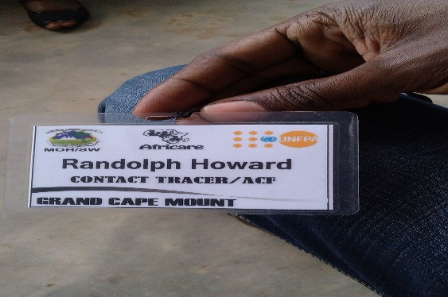
Development of Contact Tracer Database- A contact tracer database was developed by each of the implementing partners to simplify the identification process during payment of their incentives. “The identification tags provided to the contact tracers have helped them knock on doors of various households in communities without being kicked out”….. Randolph Howard, Contact tracer in Grand Cape Mount

Contact Tracer Helps Pregnant Woman Access Care- Yabayah is a small hard to reach community in Fuamah district, Bong county and in late 2015, one of the sixty UNFPA supported contact tracers operating through the REDEP (Reach Every District and Every Pregnancy) system in Fuamah identified a pregnant woman in one of his gazetted households. As required and through training of the contact tracers, he offered her counselling on need to attend ANC as well as encouraged her to deliver at a health facility when the time comes. The contact tracer had noticed hesitation from the pregnant woman but he persisted and continued visiting this household from time to time.
Incidentally, the contact tracer decided to influence her decision to attend ANC through other pregnant women in her community that were more receptive to maternal health services. During one of their community meetings, she went into labor and with her consent, community members rushed her to a nearby Handii clinic in Fuamah. Unfortunately, she could not deliver naturally but the community including the supportive pregnant women managed to take her to Phebe Hospital where she later underwent a C-section surgery and gave birth to a set of healthy twins. To date, this mother of twins is grateful to our contact tracer for not having given up on her for she realized she could have lost her life if she indeed went on to deliver at a TBA’s home.
Success of Community-Based Initiative to break EVD Transmission – Account by Dr. Mosoka Fallah- It is around 6:30 am, the team of community volunteers from Caldwell North Road, headed by Boye Cooper meets and prepare to begin their daily active surveillance. They will cover every house in their block looking for the sick, the dead and potential contacts that have secretly moved into the communities. The team discovers a body of a man who had come to reside with his sister in Caldwell to seek treatment from a herbalist, as two prominent hospitals have rejected him. The team initiates the response for the burial team and the body is picked up and quarantines the contacts, i.e. the couple. However, the couple disobeyed and flees to Chicken-soup Factory Community; several miles from Caldwell. Cooper and his team launch a frantic search and are able to reach them by phone. They counseled and encouraged them to return to their house in Caldwell. They returned and are peacefully quarantined for 21 days. The team provides daily visitation at a safe distance, and provide them with water and food that they have collected from community members. A few days later, the sister of the deceased falls sick and is taken to the Ebola Treatment Unit (ETU). Within the next few days the brother falls sick. However, the ETUs are all filled, but the team remains relentless and provide him with pain killers, oral rehydration salt (ORS) and psychosocial support. The patient is frustrated that he is not been taken to the ETU, but they encouraged him. Miraculously he is recovering at home. The team is still keeping watch over him.
Imagine with me for a second, how a new chain of Ebola infections would have started in Chicken-soup Factory Community if the team had not tracked and returned them to be quarantined. This story, illustrates what is currently occurring in communities in which we have initiated the CBI strategy.
There are over 50 community-based quarantines instituted by these volunteers. They are providing daily messages to the homes and doing active surveillance. They have adopted the CBI strategy and running with it. Just two weeks ago, we were invited by the Soul Clinic Community volunteers to participate in a re-integration ceremony of those they had quarantined. The community welcomes them back with love and they asked us to provide basic education on cases, contacts and the importance of quarantine in reducing the spread of the Ebola. This approach alone reduces the stigma and enhances openness in reporting Ebola cases. Community volunteers are arranging meetings with the Imam of the Muslims of Caldwell to develop strategy that would reduce traditional and religious burials practices that tend to spread the disease. Yes, the road is long as the fight against EVD is a marathon, but with the support of community volunteers and funding from organizations like UNDP, we will win one battle at a time

Declaration of the End of the Ebola Outbreak in Liberia- 9 May, 2015- After successful completion of the end of the 42-surveillance period, Liberia held a declaration ceremony. The WHO Representative for Liberia presented the Ebola Free declaration statement to the Head of the Incident Management Team who in turn handed it over to the Minister of Health and the President of Liberia. On 11 May 2015, the Government of the Republic of Liberia hosted another ceremony marking the end of Ebola outbreak in Liberia at a colorful event held at the Centennial Memorial Pavilion, Monrovia.

Promoting Hand Hygiene- On 5 May 2015 WHO in collaboration with the MoH and partners commemorated the Global Hand Hygiene Day at Gbarpolu County in Liberia, with the theme of “Strengthening Health Care Systems and Delivery: Hand Hygiene is your entrance door”. The commemoration included health talks were held at schools, hand hygiene campaigns at markets and public places and a seminar on hand hygiene at the community health department in the county capital. More than 1500 students in Bopolu district attended the education forums, and 120 health care workers were trained on the WHO hand hygiene model.

Decommissioning Ebola Treatment Units- During the height of the Ebola Virus Disease Outbreak in Liberia, the government of Liberia with support from partners constructed 21 Ebola Treatment Units (ETUs), as well as five centers in existing healthcare facilities, across the country. After Liberia become Ebola-free WHO began supporting the MoH to decommission some ETUs and repurpose some facilities, while building on efforts made to strengthen the existing healthcare structures through improved infrastructure and human resource capacity. The physical process entailed safely emptying the ETU waste, step-by-step disinfection and cleaning of items, as well as dismantling temporary physical structures. During the process, the government, together with partners, focused on building more permanent infectious disease isolation units offering long-term care for Ebola as well as other diseases with an epidemic potential.

Quarantine Period Ends in Liberia- After the reemergence of Ebola in Liberia in November 2015, the family of the EVD positive cases, 165 people were identified as contacts and the community were placed under quarantine for 21 days.
At the end of the 21-day period, on 11 December a ceremony was held in a local church to celebrate. The ceremony included songs of praise and the opportunity to celebrate a new milestone and the return to normal life for those who had been placed in quarantine over the 21-day period. The Deputy Minister of Health spoke at the event, cautioning against complacency.

IPC Training and Equipment at Redemption Hospital- A year ago, Redemption lacked proper tools, equipment and training to ensure the safety of its health workers and other patients. All of that has now changed. With support from WHO and partners health care workers now have access to necessary personal protective equipment and essential medical supplies, such as equipment to properly dispose of contaminate materials and infected needs, and safely process specimens safely. The equipment has helped make the hospital a safer place for health workers and patients and gradually helped turn the tide of the disease.

Establishing an IPC Taskforce- As part of WHO’s role supporting the government, WHO helped set up an infection prevention and control taskforce in Liberia. This taskforce brought together more than 20 partners, with the aim of harmonizing all protocols into standard operating procedures for infection control in both community and health-care settings. The taskforce also developed a consistent set of guidelines for infection control in all health facilities, which helped such work as calculation of supplies.

Photos:

UNDP:
See Links below:
https://www.flickr.com/photos/132967828@N08/albums/72157663612063976
https://www.flickr.com/photos/132967828@N08/albums/72157663684794625
https://www.flickr.com/photos/132967828@N08/albums/72157663611824326
https://www.flickr.com/photos/132967828@N08/albums/72157663611596896

WHO:

https://goo.gl/photos/cK5giEzztjTJw2wh8

UNFPA Photos:
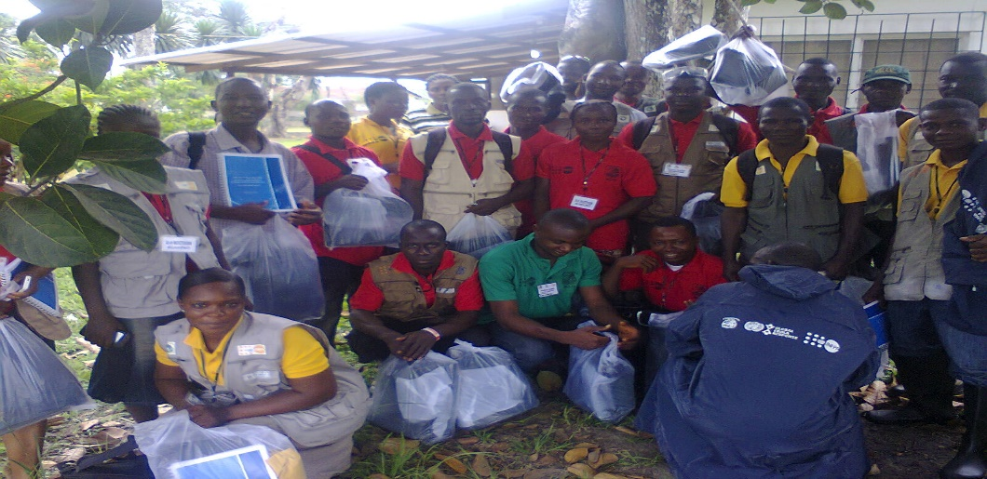
Contact tracers from Bong County receive their service kits and materials after SOP training.

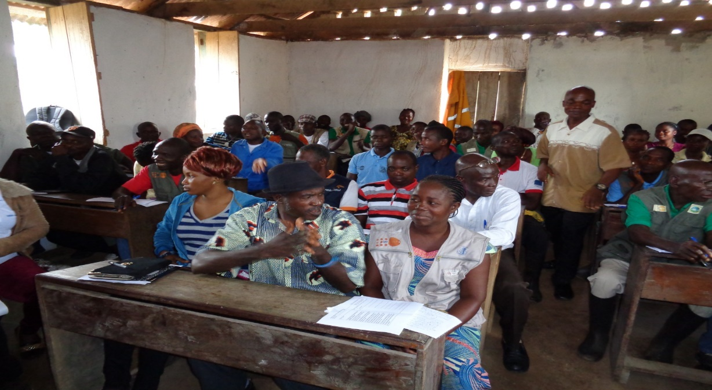
Participants in an ICEBS training in Ganta.

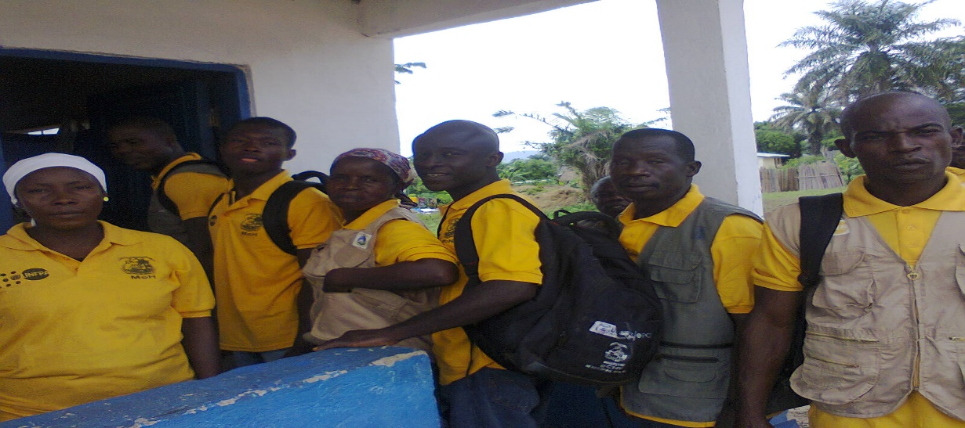
Contact tracers/Active Case Searchers arrive to attend a monthly review meeting in one of the counties

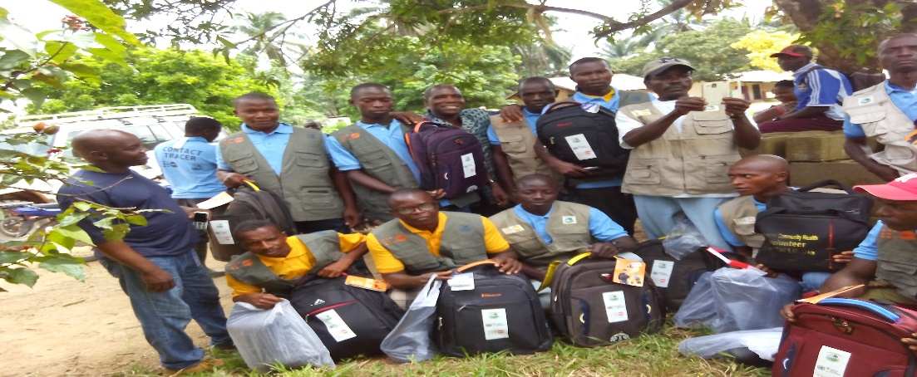
Contact tracers receive their kits for surveillance

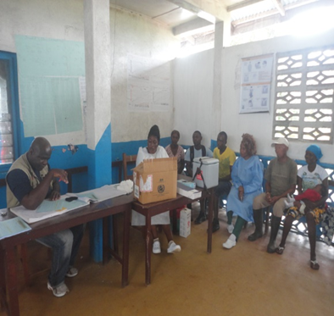

Monitoring visit to Malama Health facility in Bomi County by UNFPA recruited Contact Tracing field Associate

The Indicators should be disaggregated by gender, age and region as and where applicable

