Mission Critical Action #
MCA# $0.00 million
Description
COVERAGE:
MPTF Project No: 000nnnn | Title:  00093136  Title: Ebola Children Protection |  | TRANSFER DATE:  dd-month-yyyy |  | AMOUNT:  $4,000,000 |  | EXPENDITURES  (31 Dec 2015)  $4,000,000
PRIORITY INTERVENTION PLANNED ACHIEVED RESPONDING AGENCIES
Strategic Objective 3 MCA6: Increased children’s access to basic services |  | 12,600 |  | Nationwide: 16,093 (7,277m, 8,816f)  Per the five counties: 13,950 (6,284m, 7,666m)  Bomi 257 (131m,126f)  Bong 528 (317 m, 211 f)  Lofa 2,303 (950 m, 1,353 f)  Margibi 4,436 (1,830 m, 2,606 f)  Montserrado 6,426 (3,056 m, 3,370 f) |  | Ministry of Gender, Children, and Social Protection (MoGCSP), Ministry of Health (MoH), Inter-Religious Council of Liberia (IRCL), Touching Humanity in Need of Kindness (THINK), SEARCH, Helping Hand Liberia (HHL), Samaritan’s Purse (SPIR), Ministry of Youth and Sports (MoYS), Renewed Energy Serving Humanity (RESH), Liberian Association of Psychosocial Support (LAPS)
Strategic Objective 3 MCA7: Increased capacity of the social welfare system to handle cases of children affected by EVD through increased number of workers |  | 200 |  | Nationwide: 220  120 Social Workers  65 Mental Health Clinicians  15 Child Welfare Officers  20 Data Clerks |  | MoGCSP, MoH, IsraAid
Strategic Objective 4 MCA11: Functioning community based child protection networks in the most affected communities identify, support and refer the most vulnerable children affected by EVD |  | 50 |  | Per the five counties: 79 CWCs  Bomi 23  Bong 11  Lofa 5  Margibi 7  Montserrado 33  Survivors acting as referral mechanisms: per the five counties: 1102  National Youth Volunteers acting as referral mechanisms: |  | MoGCSP, HHL, SEARCH, SPIR
Output Indicators
-Number of Interim Care Centres (ICCs) providing care to children on 21 day observation who are separated from their primary care givers  -Number of Foster Carer households providing alternative care arrangements for children who are either "contacts" (needing a 21 day observation period), survivors, or orphans with no one identified to care for them in the community setting  -Number of families who received one-off cash transfers support for caring for orphaned/abandoned children due to Ebola  -Number of children receiving mental health and psycho-social support (MHPSS) |  | -3 more ICCs to be established  -7,500 foster households  -7500 families receiving foster grant  -10,000 children receiving MHPSS |  | Nationwide: 2 ICCs and 1 transit Center  Nationwide:  8,714 children registered as EVD affected of which 8,019 are registered as orphaned by EVD  Per the five counties: 6,882  Bomi-257  Bong-528  Lofa-1,070  Margibi-1,177  Montserrado-3,850  Nationwide: 6,834 children have received the US$150 one-time cash grant  Per the five counties: 5,083  Nationwide:16,093 children receiving MHPSS (7,277 m, 8,816 f)  Per the five counties: 13,950 (6,284 m, 7,666 f)  Bomi 257 (131m,126f)  Bong 528 (317 m, 211 f)  Lofa 2,303 (950 m, 1,353 f)  Margibi 4,436 (1,830 m, 2,606 f)  Montserrado 6,426 (3,056 m, 3,370 f) |  | MoGCSP, MoH, RESH, THINK, LAPS
-Number of Social Workers and Mental Health Clinicians trained and providing family tracing, foster care placement, follow-up of children in care, psychosocial support, community support and distribution of cash allowances and infection control and hygiene items  -Number of Ebola survivors trained and employed as child carers, foster parents, working with social mobilization teams |  | -200 Social Workers & Mental Health Clinicians  -1,200 Ebola survivors |  | Nationwide: 220 workers  120 Social Workers  65 Mental Health Clinicians  15 Child Welfare officers  20 Data clerks  Nationwide: 1200 Ebola Survivors trained |  | MoGCSP, MoH, HHL, SEARCH, SPIR
-Number of counties with strengthened CP and MPHSS coordination, Existence of CP and MPHSS networks coordination structures at national and county level  -Number of Counties with decentralized Child protection Network coordination meetings;  -Functioning Child Welfare Committees in the most affected communities to identify, support and refer the most vulnerable children |  | -1 National  -5 counties  -50 CWCs |  | 11 National Child Protection Network Meetings  35 MHPSS Coordination meetings  25 Child Protection Information Management System meetings  12 Child Protection Network meetings in Counties  CWCs Per the five counties: 79  Bomi 23  Bong 11  Lofa 5  Margibi 7  Montserrado 33  Other Child Protection Referral mechanisms:  Nationwide: 300 National Volunteers active carrying social mobilization messages and referring children in need  Per the five counties: 143 Junior National Volunteers active carrying social mobilization messages and referring children in need  Nationwide: 1,200 survivors trained as child protection advocates and social mobilisers  Per the five counties: 1,102 survivors (585m, 514f)  Bomi-25  Bong-72  Lofa-170  Margibi-184  Montserrado-651 |  | Ministry of Gender, Children, and Social Protection (MoGCSP), Ministry of Health (MoH), Inter-Religious Council of Liberia (IRCL), Touching Humanity in Need of Kindness (THINK), SEARCH, Helping Hand Liberia (HHL), Samaritan’s Purse (SPIR), Ministry of Youth and Sports (MoYS), Renewed Energy Serving Humanity (RESH), Liberian Association of Psychosocial Support (LAPS)

Situation Update
Under the project ‘Supporting the Well-being and Protection of Ebola Affected Children in Liberia’ UNICEF through partners reached 17,318 persons, of whom 16,093 were children, with Psychosocial Support (PSS) and other services for individuals and families affected by EVD. The project targeted the five counties of Lofa, Bong, Bomi, Montserrado and Margibi with some services nationwide as the epidemic spread.
In the year of 2015, UNICEF supported the Ministry of Gender, Children, and Social Protection (MoGCSP to recruit an additional 50 Social Workers and 20 Data Clerks to join other MoGCSP and Ministry of Health (MoH) staff trained and involved in the response. Total staff supported: 120 Social Workers, 65 Mental Health Clinicians, 15 Child Welfare Officers, and 20 Data Clerks. UNICEF supported the training and equipping of these staff in order to provide services to children and families affected by EVD.
In close collaboration with UNICEF and partners, the MoGCSP Children’s Division and the MoH Mental Health Department organized trainings for these staff on Child Rights and Protection, Child Protection Database Management, Alternative Care and Psychosocial Support. The case management trainings focus on utilization of the case management tool to effectively provide services to the most vulnerable affected children. The training package includes use of Child Protection and Family Tracing and Reunification (FTR) forms, communicating with children, the use of the standard referral path for child protection and other case management tools. The trainings in PSS focused on the bottom and mid tiers of the MHPSS pyramid of interventions such as one on one supportive talks, community dialogues in heavily affected communities, and recreation for resilience activities that included structured play activities facilitated by outreach workers to encourage children to express their feelings and encourage social connection.
The trained social workers, mental health clinicians, and child welfare officers provided case management, psychosocial care and support, family tracing and reunification services for child survivors of EVD and children who had lost parents or primary caregivers due to EVD. Data Clerks input data from documentation forms into the Child Protection Information Management System Database (CP IMS) set up to support the MoGCSP management of EVD cases.

Likely most successful of the interventions was the one off cash grant provided to families caring for EVD orphans and survivors, intended to ease the burden of care and support the children in school. Nationwide 6,834 children have received the US$150 one-time cash grant through the MoGCSP and in the five counties, 5,083 have been supported. The data is still coming in on cash grant recipients as 7,000 were targeted through the MoGCSP. Reports from families who received the cash grant indicate that families were able to use the grant to not only support the EVD affected child in school, but also grow a petty trade business that will potentially support that child and others in the household in school for years to come. Not all families have been so successful, as either deep level of poverty or a family crisis left the family with nothing extra and once the cash grant had been spent, the care and education of the children continues to be a struggle for the family. In these cases UNICEF is encouraging community driven support mechanisms, such as Susu (local savings groups) and social cash transfer programs be further engaged to support such families.

The services provided were not new in the scope of social welfare services being provided by the Government, but were targeted toward EVD affected children during the outbreak. Now, post Ebola, while ongoing case management support is being provided to families who are still vulnerable due to the impact of EVD, the services are being expanded to reach all vulnerable children in order to reduce marginalization and promote community wellbeing. The aim is to strengthen communities as a whole, reducing stigmatization towards EVD affected persons, and increase the community ability to take care of their own.
Also, as part of emergency preparedness UNICEF continues to support the MoGCSP and MoH to be prepared to provide case management and PSS support within outbreak settings. Social mobilization activities to fight the EVD continue in all counties with concentration on the most recent EVD affected counties. The Interim Care Center remains on standby and the Transit Center continues to provide care services to other vulnerable children. UNICEF continues to monitor the quality of care and services being provided to the vulnerable children and encourages six months of follow up with families who received the one off cash grant to ensure long term sustainability of the placements. There are still instances of EVD contact children being subject to stigma, discrimination and rejection by the communities, which is also where social workers help to mediate. These children continues to receive follow up and psychosocial support geared towards building resilience. Where there is a need, social workers conduct community dialogues in affected communities to promote acceptance and protection of EVD affected children and their families.
In addition, UNICEF worked through the MoGCSP and NGO partners to recruit and train more than 1,200 survivors to act as community mobilisers and child protection advocates in their communities. The survivors engaged in a range of activities include provision of care for EVD affected children in interim care centers, community mobilization and awareness raising, and outreach support to strengthen child protection structures at the community level.
UNICEF, through its partnership with the Ministry of Youth and Sports, supported the Ministry to recruit, train and deploy 300 national youth volunteers as contact tracers to identify and refer children affected by EVD, provide psychological first aid, and conduct community and social mobilization, spreading messaging for EVD prevention. In addition, 1,200 plus survivors were recruited in partnership with NGOs for a period of six months to support a number of activities supporting EVD affected communities. The range of activities include providing care for EVD affected children in interim care centers, conducting community mobilization activities, and outreach support to vulnerable children, referring EVD affected children for services as appropriate.

These interventions (detailed further in achievements below) are expected to build resilience among the EVD affected children and other vulnerable children and their families to cope and thrive long term.

Achievements and Results
Key Achievements
Alternative care, Case management and PSS support to Children affected by the EVD
- Supported the Ministry of Gender, Children, and Social Protection and the Ministry of Health to increase the capacity and technical skills of 50 new social workers, 15 child welfare officer and 65 mental health clinicians and 20 Data clerks through several trainings including case management, Child protection and Participation, PSS, Alternative care, Data base management, Family Tracing and Reunification and Basic social Welfare skills. This brings the total social workers to 120 and the total number of human resources supporting the VD affected children to 220.
- Two Interim Care Centers (ICC) and one Transit Center (TC) were opened and equipped and functioning during the epidemic and served 145 children. Standard Operating Procedures were written for the care of children in contact with EVD and survivors were trained to provide the care.
- The Hawa Massaquoi Transit Center continues to provide shelter and protection for 25 separated and unaccompanied children as family tracing and reunification services are in process.
- Family tracing and reunification (FTR) services helped to reunify 143 children from the ICC and TC during the epidemic, and Social Workers provided FTR and case management services to children orphaned by the EVD in order to avoid institutionalization of children. Two orphans remain in the Transit Center while the Social Workers continue FTR efforts.
- A total of 16,093 (7,277m, 8,816f) children have received case management and Psychosocial support through one on one supportive talks by the Social Workers, structured recreation for resilience activities facilitated by trained staff, and case management services.
- Out of the above listed number, in the five counties 6,314 (4,829 single orphans, 1,485 double orphans) have been registered as orphans and out of this number, 5,083 (81%) have benefitted from one-time emergency cash assistance in the five counties of focus. All of whom have been placed in family based care. Payment continues for 166 children in Montserrado and Margibi.
- Revitalized and continuing to provide support to the National Child Protection Information Management System that is currently storing the data of all children in need of child protection services, especially children affected by the EVD. Data Clerks were trained and records for more than 4,000 EVD affected children have so far been entered into the database. On-going data entry happening throughout and following the epidemic.
- 10 vehicles, 5 motorbikes, 124 rain gear, 100 bicycles were provided to the MoGCSP to help facilitate the work of the social workers in the counties and to fast track the registration of children in remote communities.
- Bi-weekly technical supervision and coaching visits were made to the MoGCSP to help enhanced the skills of the supervisors and social workers to deliver appropriate case management, psychosocial care and reintegration follow up visits to the EVD affected children.
- 143 national junior volunteers continue to provide sensitization and awareness activities on EVD prevention, prevention of sexual and gender based violence in the five counties. Some also serve as volunteer teachers, nurses and provide guidance in the decision on children in their communities.
Adolescent girls
- 150 adolescent girls and boys in Grand Gedeh continue to conduct awareness and sensitization campaigns to prevent stigma against children who were affected by the EVD, shared messages against sexual exploitation and abuse and promote the importance of remaining in schools. It is expected that this exercise will be rolled out in other counties.
Table No. of Beneficiaries
Women | 678
Girls | 8816
Men | 547
Boys | 7277
TOTAL | 17,318

Human Interest Stories
Name: Chris
Age: 38 years
Status: EVD survivor widower with four children

This story is based on the facts and information obtained by the Inter-Religious Council of Liberia (IRCL) social worker who talked to Chris, a survivor if the Ebola Virus Disease in his late thirties, at his home in Du-Port Road Cow Field Community, Paynesville City, in Montserrado County.

When I got to Chris’ house on the Du-Port Road, I found him sitting in a chair with one leg, bandaged. When I asked him why was he wearing a bandage and he started narrating his story. Sometime September 2014, during the Ebola crisis in Liberia, the virus attacked his home and family. It started with his wife and later he and other members of the family got infected as well. They were taken to the Ebola Treatment Unit/ETU and while going through treatment he sadly lost his wife to the Ebola virus. At the ETU he started feeling pain in his left foot for two days. The leg swelled and burst creating a large sore that lasted for a month. One night In December 2014, long after he had been discharged from the ETU while sleeping on the bed he work up to a horrific discovery that his sore leg had dropped off him and the severed foot was lying lifelessly on the bed.

He became disturbed after this terrible event and his life was never the same. Before he got infected with the EVD, he was a carpenter and a sole breadwinner for family looking after his wife and children. Since the incident, Chris has been seeking medical treatment to cure the sore. Fortunately, in December 2014, Chris was selected among the beneficiaries to receive the $150 one time cash grant from the UNICEF supported programme administered by Liberia’s Ministry of Gender, Children and Social Protection to assist him take care of his children. He use some of the one-time cash grant to seek the initial treatment. Chris has four kids to care of and the constant worry about feeding and sending them to school forced him to contemplate sending them to an orphanage but the community Leaders and social workers discouraged him and referred him to the IRCL.

I visit Chris routinely to talk to him. It is comforting to note that despite all these challenges, all the four kids are going to school as Chris had wished and are staying together as a family under the watch of other family members and the community. Talking to the older daughter who is now 12, she said, “her father was very worried about their fate and did not know what to do to care for them, but now she is happy they are still together because others care.”

My name is Christine Zomomou. I am 14 years old and in the twelve (12th) grade at the SDA School located at Paynesville. I am the oldest daughter of Chris. I am so very happy to be back in school again, through the help of IRCL. I lost my mother during the Ebola crisis in Liberia and my father became disabled losing his foot and could not work again. My father is no longer working and is no longer in a position to pay my school fees. I am still in school up to this today the social worker from the IRCL contacted me and made friends with me. She went and paid my school fees and now I look forward to a better future. I will graduate and start college soon if I can get some money to pay my college tuition.
Name:Morris Kaifa
Age: 15 years
Status: EVD survivor, Student

Morris Kiafa is a 15 year- old boy who survived the EVD virus after his mother came down with the disease. His mother did not survive and died at the ETU. After he received treatment at the ETU and recovered from the virus, Morris did not have any known adult relative that wanted to take care of him and his 6 siblings. They were taken to the Hawa Massaquoi Transit center that provided shelter for children who had survived the virus but had no one to care for them. This is what Morris has to say “I am Morris Kaifa, 15 years of age in the sixth Grade class. I don’t really know what to say because I am too happy to see myself going to school. Because the time my parent died during the Ebola I thought my school business was finished right there, but when I was told by the Social Workers that certain people from the group called Inter Religious Council of Liberia was coming to help to send us to school, buy my school books, copy books, uniform and shoes I started celebrating and rejoicing in my heart and thank God that I will not drop out of school and be like other children that are in the street.

Name: Jemima Cooper
Age: 14 years
Status: Student, Women of Faith

“My name is Jemima Cooper and I am 14 years old. My father died during the Ebola crisis and unfortunately I fell pregnant for one boy in the community. The boy denied the pregnancy and my mother chased me from the house. I didn’t know what to do and wanted to kill myself and then I came in contact with the Women of Faith of Bong County when they saw me in the street. I told them my story and they took me to my Aunty and asked her to take care of me until things could be settled between my mother and myself. The women of Faith group started to talk to my mother and after several months, she finally agreed to take me back in the house. The WOF women helped me and took me back to my mother. They helped me to enrol in school to continue my Education and they followed up on me all the time. The baby father is still not willing to accept the child and I am left alone to support the child. After school I sell small things (petty trading) right in the community market. I tried to study at night and it is difficult but I have to get an education to take care of myself and the baby. I want to thank the WOF in Bong County for all the support they continue to give me. I am back in school and I am happy.”

Bendu Sheriff
Age: 9 years
Status: EVD survivor, Student

Ma Bendu Sheriff is a nine year old orphan who lost both of her parents to the Ebola Virus disease outbreak in Liberia. After the death of her parents there were no known adult relatives willing to care for her. Through the support of the Ministry of Gender Children and Social Protection social workers, she was reunified with her grandmother who is currently caring for her and was later referred to the IRCL for further support. “I was infected by the same Ebola that killed my ma and pa but I survived. Only my grandmother is now caring for me. She is old and doing her best to care for me. When school open I was worried I wouldn’t go to school because my grandmother does not have any helper. I used to sit at home and see all my friends going to school and I felt bad and cried for my parents because they always made sure that I was ready for school. Then the IRCL worker came and visited my grandmother to ask about my wellbeing. I told them that I wanted to go back to school. I am now in school and I am grateful to God for the IRCL people who paid my school fees. I am so happy now that I can now join my friends in school.

Please find two videos posted to youtube (links here)

Helvina's story

Watta's story

Photos

See second document.

Social Workers making their way to an affected family

UNICEF Project Photos 2015
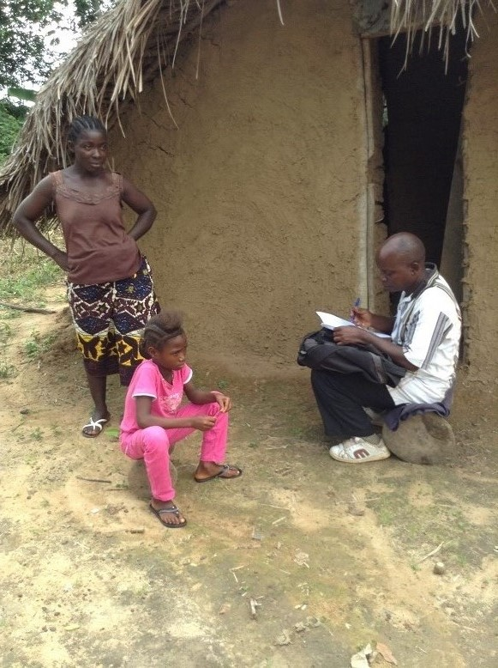
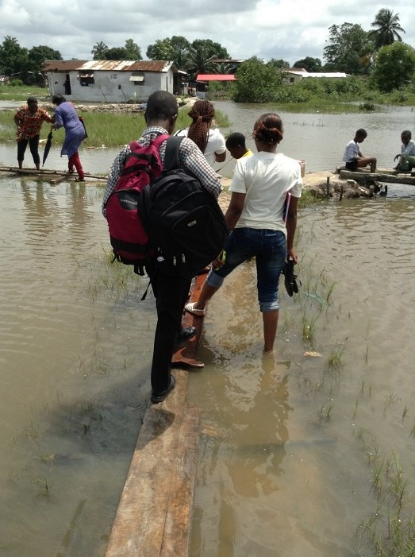

Field Monitoring Social Workers and Donor conducting field monitoring visit to EVD affected Family

Social Worker conducting reintegration follow up visit to EVD affected child.

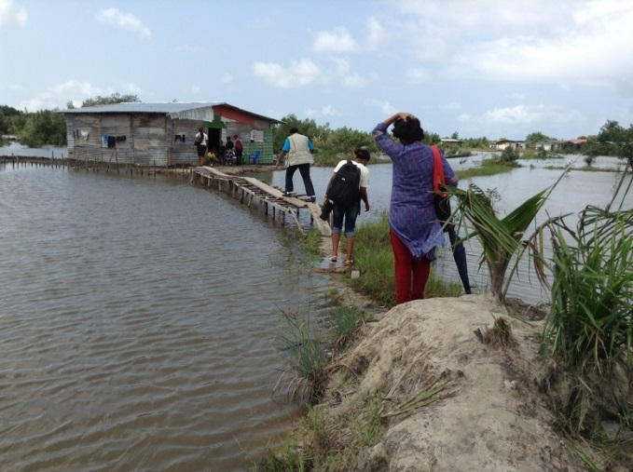

UNICEF, Donor and Social Workers conducting monitoring visit to EVD affected Widow and her children.
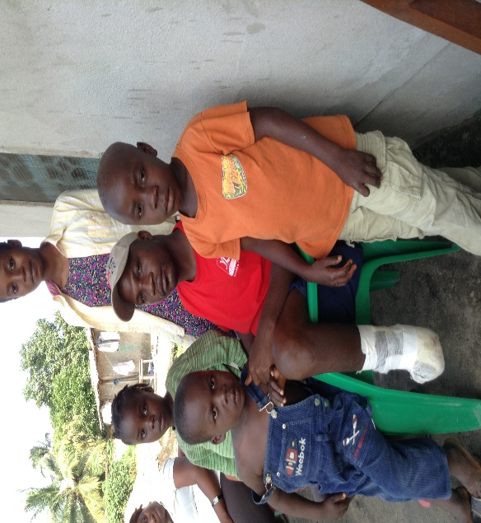
An EVD Survivor and widower with his children during the monitoring visit.

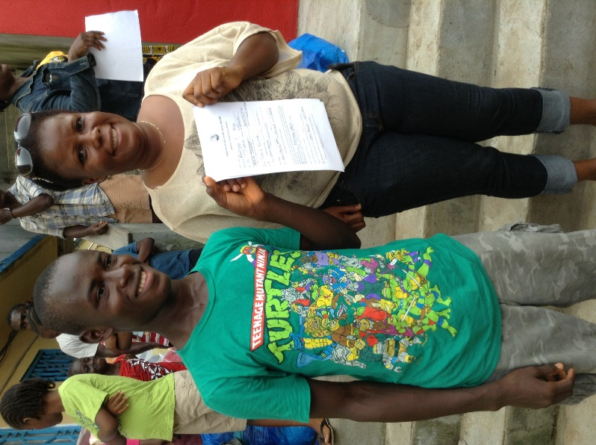
A Young boy being reunited with his Aunt after complete his 21-day Observation at the Interim Care Center
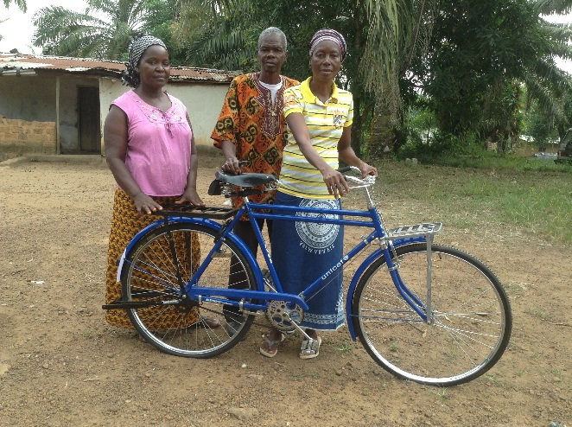
CWC members received bicycles donated (MPTF funded) by UNICEF to help facilitate their work in Bong County.

EVD orphans seen during the Monitoring visit. They are all in school and live with their mother and Grand mother.
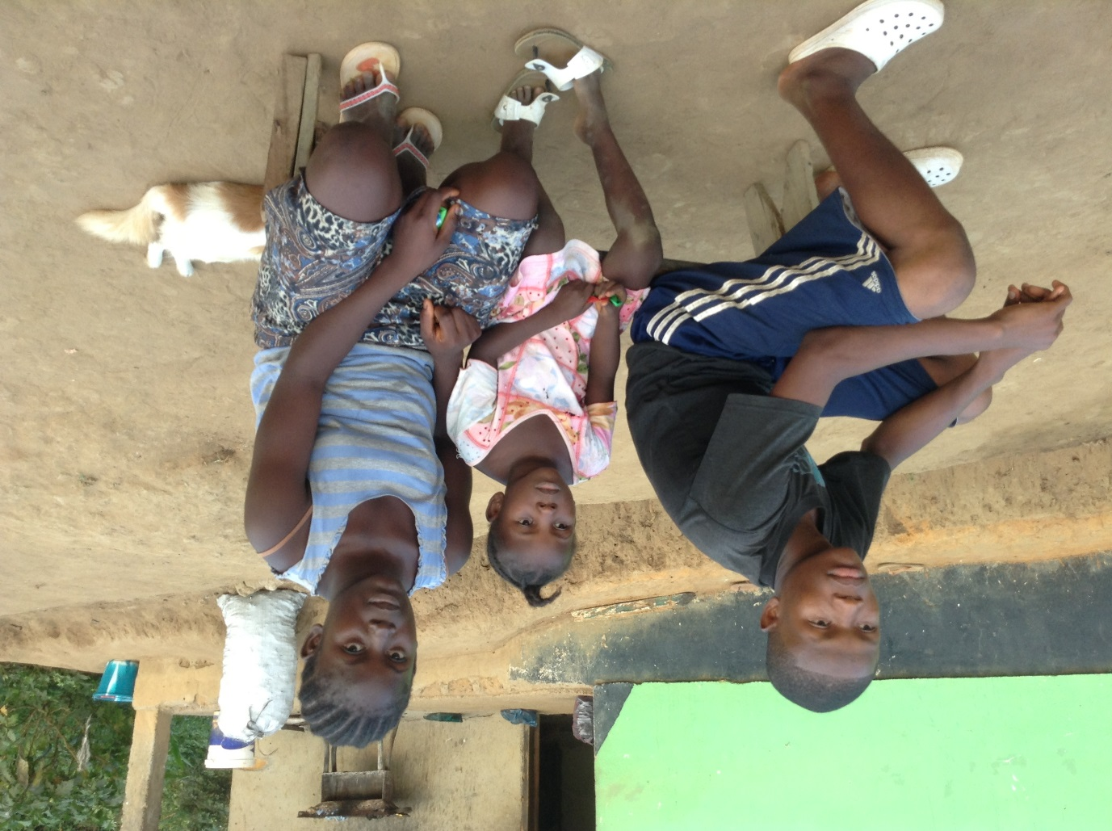
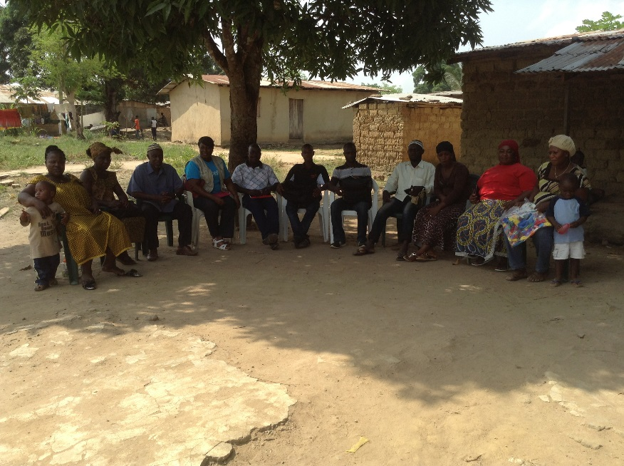
In a community meeting with Religious leaders

The initial planned number of 350 contact tracers was not required as, from other sectors in UNICEF and other partners, many contact tracers were mobilized and recruited. Further, the number of cases was less than anticipated. Although the number of cases has come down, this important work at community level continues.

