Data collection & analysis

Develop key questions to identify:
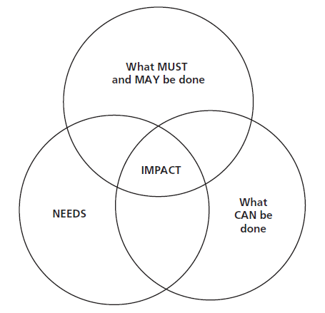
- roles, priorities and USPs of civil society and SUN CSA
- What does success look like (for CSA and for individual members)
- What are the key factors & players influencing success of SUN CSO?
- What are the best strategies to achieve success?

- What MUST be done?
- What CAN be done?
- What are the needs?

Tools:
- PESTLE, SWOT
  - External:identify facts, opportunities, challenges and trends in the areas of politics & power, environment/ecology, socio-economic, technology, economy/funding that influence sustainable improvement of nutritional status, and the role that CSOs can play in improving this.
  - Internal: strength & weaknesses of SUN CSA (and members)
- Issue mapping
Critical issues:
  - Willingness amongst GoL to work in convergence
  - Ability to work from village level up
  - Openness and support of GoL to work with SUN CSA and allow SUN CSA & members to operate
  - Support Development Partners for work of SUN CSA
  - ..
  - ..

Data collection methodologies
- Focus group discussion
- Semi structured interviews
- Surveys
- Desk-top research

