MPTF Funded Projects Risk Analysis
This paper provides risk-analysis of all MPTF funded projects in line with the UN/WB joint risk management strategy for the SDRF funds. While the strategy addresses risks at the fund level that extends across or beyond individual projects, the risks at the project/programme level are managed according to the rules, regulations, policies and procedures of each fund administrator and its recipient agencies. Hence, in addition to the oversight and support to the implementation of the joint Risk Management Strategy, each Fund Administrator Risk Manager may have responsibilities and obligations within his/her respective institution (support to project teams, reviews, etc.).
Following the Joint RM Strategy, the UN Risk Management Unit and the WB developed the MPTF Risk Management Matrix on the basis of which risks affecting the fund and the programmes would be rated taking into consideration the likelihood and the impact.
As the MPTF funded programmes are being implemented in a very fragile environment, managing risks in the Somalia environment is challenging and requires additional measures and efforts.
MPTF Risk Management Matrices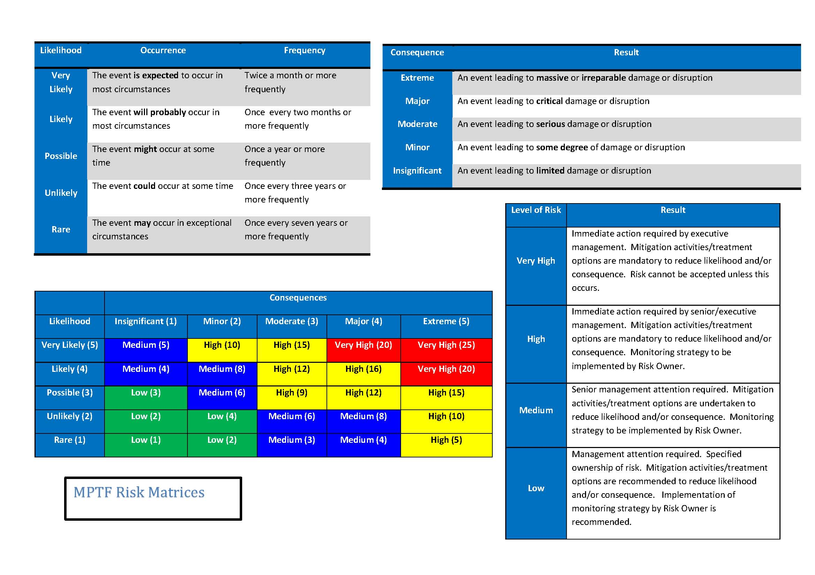
On this ground, we have reviewed and analyzed the risks across MPTF funded programmes and projects.
The main approach used to analyze the risks at the programme and across programmes is the following:
- Review of the risks identified at the time of programme formulation/design stage
- Review updates on the risk monitoring and treatment at the Quarterly reports (Q1 & Q2 of 2016)
- Conducted meetings with the programme managers and other concerned staff
- Conducted meetings with the UNDP Programme management Unit and other programme staff
- Analysed the information related to MPTF programme portfolio

This document reviews the risk analysis, rating and risk treatments across the MPTF Joint Programmes as below:

# | Intervention/PSG | Programme Title
1. | PSG1 | JP State Formation and Federalism
2. |  | JP Constitutional Review
3. |  | JP Electoral Support
4. |  | JP Parliament Inclusive
5. |  | JP Support to Stabilization
6. | PSG 2 & 3 | JP Rule of Law
7. | PSG 4 | JP Youth Employemtn
8. | PSG 5 | JP Local Governance
9. |  | National Window – Service Delivery
10. | Cross Cutting | JP Capacity Development
11. |  | JP Enablers
12. |  | JP Charcoal Reduction and Alternative Livelihoods
Current understanding of programme risks:
- The entire MPTF portfolio is around US$130 million, distributed among different UN agencies with UNDP as the largest Agency managing the joint programmes.
- One of the challenges faced with regard to the risk management is that different UN agencies have different risk appetite and relatively different procedures on assessing, monitoring and managing the risk. However, the risk management principles across the UN agencies remain the same.
- The main risk elements have been identified at the programme design stage in the MPTF programmes and classified by category
  - Contextual
  - Governance/strategy/institutional
  - Programme & operations implementation
Most of the projects have identified, assessed the impact and probability / rated the main risks affecting the programmes – both External and internal risks, and identified the treatment / mitigation measures to address each risk.
- Even though few programmes may not have rated the risks in the project documents, this may be because both the Risk Management Strategy and the risk assessment matrix have been developed in 2015, time when most of the MPTF programmes were operational. Despite this, risks are monitored on a day-to-day bases and update is provided quarterly as part of MPTF quarterly reports.
- Any new risk encountered during the programme implementation is assessed, and mitigation measures are in place.
- In the Somalia context, most of the risks under each category have been rated as ‘high’ or ‘significant’.

In order to further analyze inter-programme risks, a master table has been developed containing risks identified/analyzed at the programme design, rating, mitigation measures and the quarterly updates.
A second matrix was developed to identify the most common risks across all the MPTF programs. The developed matrixes do indicate the following:
- Master table: Programme title, PSG intervention, budget, participating agencies, risk categories, identified risks, rating (not all), risk response/treatment measures and the most recent updates from the MPTF reports. Hence, the RMU, UN Agencies and the managers will be able to read and compare the risks, impact, treatment and the updates across the programs.
- Most common risks’ matrix: Another comparative matrix highlights the risks that may be common across the programs along with the risk rating

What are the most common risks that affect the programme implementation?
Common risks across MPTF funded Programmes and Projects
Risk Category | Risk description | JP State formation – Federalism  (PIP) | JP Constitutional Review | Support to Stabilization Project | JP Support to Electoral Process | JP Parliament Inclusive | JP Rule of Law |  | National Window Strengthen Service Delivery |  | JP Youth Employment | JPLG |  | JP Cap Dev – Strength. Ins. Perf(SIP) |  | JP Charcoal Reduction and Alternative Livelihoods (PIP) | JP Enablers
 |  | PSG 1 |  |  |  |  |  | PSG 2 & 3 |  | PSG-4 |  |  | PSG 5 |  | Cross Cutting
Contextual | Security | High | High | High | High | High | High |  | High |  | no rating | no rating |  | High |  | No rating
 | Political | High | High | High | no rating | High | High |  | High |  | no rating | no rating |  | High |  | No rating | High
 | Env & Economical Shock |  |  |  |  |  | No rating |  | Low |  | no rating |  |  |  |  | No rating
Gov & Strategy | Tension between states and federal | no rating | High | High | no rating | High | High
 | Risk of delay in reaching political agreement, and drafting the legislations |  | No risk rating |  | High | High |  |  |  |  | No risk rating | No rating
 | National Development plan may require adjustment at programme outcome level and relevance to the national strategic framework |  |  |  |  |  |  |  |  |  |  |  |  |  |  | No rating
 | Institutions / systems not established | no rating | high | high | no rating | high | high |  |  |  |  | no rating |  | high
 | Increase in internal political division | no rating | high | high | no rating | high | high
 | Change of Ministers and senior staff at the Ministries |  |  |  |  |  |  |  |  |  |  |  |  | High
 | Delay in establishing the system for fund flow to the regions/district level | no rating | high | high | no rating | high | high |  | high |  | no rating | no rating |  | high
Programme Implementation | Fraud and Corruption/ fiduciary risk | High |  | High |  |  | high |  | high |  | no rating | no rating |  | No rating
 | Lack of capacity of impl partners / high turnover |  |  | No rating | no rating | high | high |  | Low |  | no rating | no rating |  | high |  | No rating
 | Delay in recruitment and procurement | High |  | High |  |  |  |  |  |  |  |  |  | high
 | Insufficient project funding / shortfall in RM / |  |  |  |  | High | No risk rating |  |  |  |  |  |  |  |  | No rating
 | Lack of qualified Human resources and consultants |  |  | Medium |  |  | No risk rating |  |  |  |  |  |  | high
 | Programmes fail in the long run to ensure that sustainable mechanisms and improved capacities are in place with the Government |  |  |  |  |  | high
 | Potential of exclusion of minority groups / Limited engagement with vulnerable groups | No risk rating |  |  |  |  | High
 | Potential adverse on gender equality / risk of 30% women's quota (elections) may not be achieved | No risk rating |  |  | High | High
 | Risk of delay in the project implementation |  |  | High |  |  |  |  | High |  |  | No rating |  | high
 | Insufficient involvement / commitment of key stakeholders |  |  | High |  | No risk rating | High
 | Risk of poor quality of project deliverables |  |  |  |  |  |  |  | Medium |  |  | No risk rating |  | High

Risk rating

The above matrix indicates the most common risks across programmes/projects. It does also include risks that even though that have been analyzed by a limited number of programmes, they are relevant across programmes. Here are some examples:

‘lack’ of capacity of implementing partners’ rated or treated by most of the projects 9 out of 12, still, based on the capacity assessment conducted by different agencies in compliance with the Harmonized Approach on Cash Transfer or other assessment tools. The most of the institutions have been rated as ‘High’ or significant risk. In response, additional mitigation measures have been put in place when doing business with these implementing partners as part of the engagement plan. Whilst discussing with different UN agencies participating in the JP, the apply different assessment tools of their implementing/responsible parties. Several UN agencies – such as WFP, UNICEF, OCHA and UNFPA operate only with low-medium risk partners, while UNDP does apply HACT assessment even when low monetary value agreements are signed (such as micro-capital grants). In the case of ‘high’ risk partner, different cash transfer modalities are put in place to minimize the financial risk.

There are also risks such as ' identified by three programmes’ only with rating. In a fragile environment such as Somalia, low quality of deliverables still remains a risk across programmes.

‘Insuficient programme funding’/’funding shortfall’ - only three programmes have analyzed this risk at the design stage; From the consultations with the programme managers, this issue remains a risk for most of the programmes for the following reasons:
  - The programs have not been able to mobilize the required financial resources indicated in the programme documents required to delivered the programme results;
  - With different participating UN agencies in a joint programme the speed of delivery is different, however, till the 70-80 % of the previous tranche (aggregated) is disbursed/committed, the agency faster in spending the funds is ‘penalized’ and may not be able to implement programme activities undil the threshold of delivery has been met;
  - there have been cases when donors have changed the funding schedule, therefore contribution has been delayed and it has delayed programme implementation.

Risk treatment across risk categories

In response to the identified risk, each programme has elaborated the mitigation measures on the basis of programmes are being implemented under PSG 1-5. Some risks such as ‘security impact’ may require similar mitigation measures in coordination with UNDSS, UN Country team, government and programme team. By comparing the risks and mitigation measures in a master table will allow the programmes to track the best treatment applicable to the specific programme when exposed to the same risks (developing the best practice)

With regard to the ‘fiduciary, risk of fraud, misuse of funds, etc’ each programme sets a number of mitigation measures and oversight mechanisms in order to mitigate the risk. This risk is very much driven by (a) low capacity of implementing partners, (b) lack of internal audits and controls of the government institutions. This risk is addressed at the programme level but at the implementing partner level too by strengthening the control mechanisms and supporting the capacity development of partners (government/civil society/private sector) engaged in the project implementation. In the cases when the risks identified at the partner’s micro-assessment are high/significant, in order to safeguard the resources, the agencies apply a wide magnitude of mitigation measures to safeguard the financial resources and reach the desired results, i.e. small amount of funds is advanced or provided to the government entity/NGO mainly for small scale activities and develop as part of partner risk mitigation capacity development activities and intensified monitoring spot-check and quality assurance activities.

In the project document and regular risk updates in the quarterly report, in most of MPTF programmes reference is made to the initial risk. In order to manage the risk effectively it is very important to make reference to the residual risk, which will help in understanding of the exposure of different programs and better management, monitoring and treat the risk when exposed.

Risk rating in the Somalia context

As mentioned above, each programme has identified the main risks at the design stage. All risks, contextual, governance and strategy and programme & operational implementation make reference to specific exposure or assumption which are relevant to Somalia context. Based on the risk assessment under each category doing business in Somalia exposes the funds and the programs towards high/significant risk, which require extensive attention and monitoring of the risks. Reference can be made to both master table and summary/most common risk matrices.

Some additional observations
- Risk management within MPTF is very complex due to involvement of different UN agencies with different risk appetite and different risk management approaches
- All project documents have reflected initial risk analysis at the formulation stage. However, not all programmes have rated the risks
- Risk ownership and qualitative/quantitative indicators to monitor the risk and mitigation measures have not been identified
- The risk response is not consistent, which may result due to the different context the programmes are operating or due to not being familiar with the MPTF risk matrices and/or joint strategy at the time of programme design. However, improvements have been noticed during the reporting period; including the new risks that the programs might have been exposed during the reporting period.
- All projects provide updating on the risks status in the quarterly reports (PBF funded projects send updates every 6 months).
- Risk updates is not very consistent among different programmes – some put more efforts than the others that just copy/paste from the initial document. Several programmes though do clearly make reference to the risks identified in the prodoc and provide updates which are easy to read
- Some projects may address the risks through different mechanisms, even though it is not reflected in the regular updates

Strengthening risk management of the MPTF funded programmes

  - Services and projects/programmes are increasingly being delivered through partner organization under both UN ad National window. This puts a challenge on the successful risk management. One of the challenges may exist where programme objectives / partner’s objectives overlap (different programs or UN agencies working with the same government partner). In this regard, common risks may be aligned and managed as opposed to where they are fully independent.
  - Another way to improve risk management is to adopt, as much as possible, the good practice established in the risk identification, assessment, monitoring and management related to different programs; One of the challenges that may arise in the case of joint programs is on whether there is reliable and regular information to monitor risk management performance of all those UN agencies or other stakeholders involved in the implementation of joint programs.
  - Allocation of Risk ownership –This is important for the critical risks or the ones that will have a high impact over the programs if occurred, therefore risk management plan shall be incorporated in the project document at the design stage, or in the programme risk log/risk plan to be agreed upon with the main programme stakeholders.
  - External and internal risks – there may be external risks or contextual (security, political and environmental & economic shock) upon which there is little or no control. However, contextual risks are closely managed, monitored and mitigation measures are put in place in order to successfully implement activities.
  - In all the above, it is also to be highlighted that accountability of protecting the financial resources and managing the programme risks remains with the respective UN agencies engaged in the programme implementation (UN window) and the Ministry of Finance (National Window). Therefore, programme/project risk management is integrated in a day-to-day management of the programs and has become an integral part of it. The scale of intensity and monitoring is increased when significant risk materializes.
  - Risk updates – in the case of joint programmes it is recommended that joint risk review meetings among different UN agencies engaged in the programme implementation are conducted and an integral part of performance management arrangements. In the case of the project under national window, UN and the WB are working together with the Ministry of Finance (Project implementation unit) on managing and monitoring jointly the risk
  - Risk communication – sharing risk assessments and analysis will help to avoid different perspectives. An opened dialogue between different stakeholders will help create a common understanding and enable coherence on risk management among different partners. Example of risk management communication are: regular RM working groups PSG/area of intervention; UN/WB/Donor MPTF/MPF working group, UN RM working groups; briefing to SDRF (on fund related risks), and other forums.
  - Establishing the right risk-governance arrangement – Risk governance at the programme level remains with the participating agencies while at the fund level with the SDRF. However, with regard to the risk governance at the programme level clear roles and responsibilities need to be clearly assigned among the participating agencies.

Most of the MPTF risk categories fall within acceptance category above (risk acceptance if the initial risk rating is low), risk mitigation/limitation or risk transfer. Under risk acceptance and risk limitation with mitigation measures, mitigation measures have been put in place in order to manage and monitor the risk (even when it is low).

The last category – risk transfer is one of the mitigation measures where some elements of mitigation have been transferred to a third party – such as monitoring agent, outsourcing human resources, etc. Risk avoidance is also applied as doing business in extremely high risk locations (i.e. areas under al-Shabaab control) are avoided temporarily.

Treatment measures are very much connected to the risk tolerance. While currently most treatment respond to the initial risk, it is recommended that residual risk treatment options are identified and reviewed at the design stage (new programs) or implementation phase (ongoing programmes). In this regard risk tolerance might impose change of action at the programme or agency level.

It is also recommended that integrated risk assessment on the impact over the programs are introduced – meaning that cost, quality and time are taken into consideration while assessing the impact of the identified risks. In the above analysis, different programs have already analyzed the risk impact (time and quality, few of them cost) related to different risks – to be mentioned are Security deterioration impact, delay in the legislations approval/adoption etc. which delays programme implementation, it has a higher cost of doing business, etc; or low capacity having an impact into the low quality of the deliverables, misuse of funds etc).

Additional recommendations:
- Ensure that MPTF risk management methodology is applied across all MPTF funded programmes;
- Share with the programme managers the SDRF funding Joint Risk Management Strategy and the fund risk analysis to allow them a better understanding of the risk management context and enable information comparison among programmes in order to develop the best practice on the risk management at the programme level in line with the RM strategy, and agency procedures;
- Develop capacity of programme staff and other stakeholders on managing the risk
- Update risk rating for each category on 6-months basis
- Ensure coherence among different UN agencies participating in joint programmes and among different programmes, while taking into consideration different risk tolerance and procedures, as well as different level of exposure towards a given risk.
- Keep regular contacts and provide continuous support to joint programmes on the risk management
- Support on the risk monitoring indicators and updates.
- Develop easy to read and update risk update matrix in consultation with the JP PM
- Update the RM matrix and share it with the JP PMs on quarterly basis.

