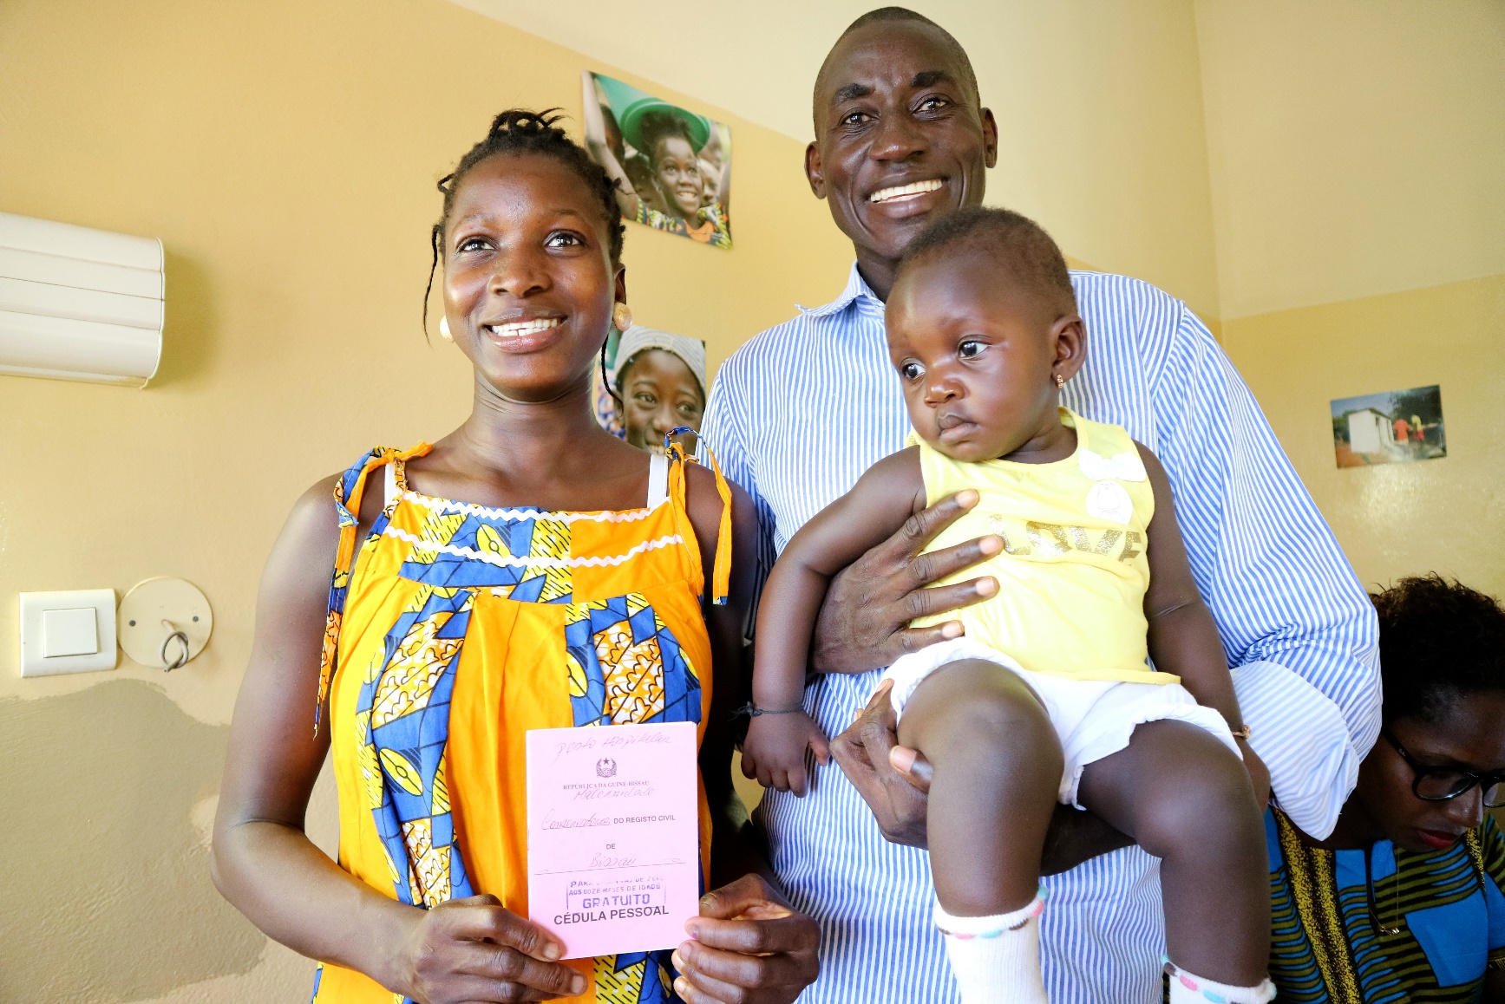
UNICEF Guinea Bissau
©UNICEF Guinea-Bissau/2017/Giacomo Pirozzi
Report of Communication activities
November 2016- November 2017
©UNICEF Guinea-Bissau/2016/Wilson Gama
Peace Building Fund Project:
Promote Access to Protection and Civic Participation through Civil Registration

November 2017

1) Ceremony with Minister of Justice, UNICEF Representative a.i. and Peace Building Fund representatives to hand-over one vehicle to the civil Registration services. Media coverage has been ensured. 19/10/2017
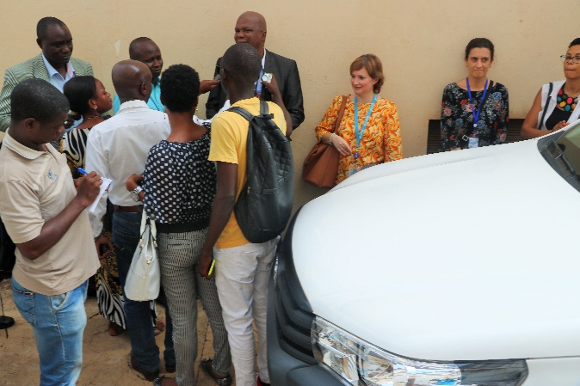
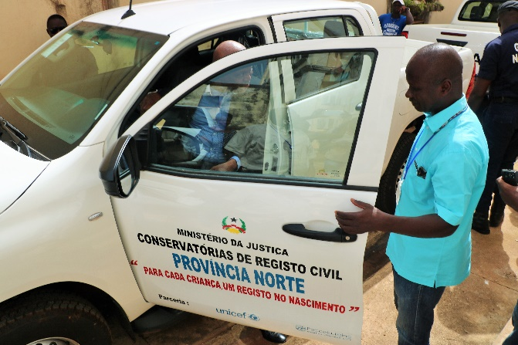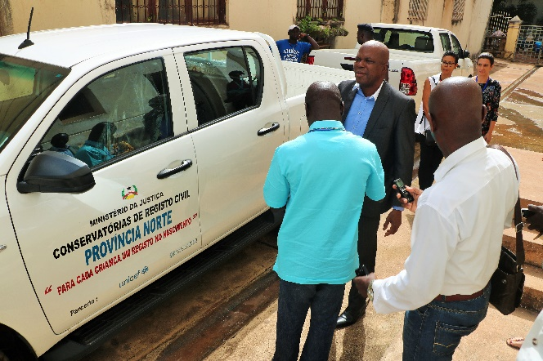

2) Awareness session with MPs on the importance of the Civil Registration – (October 2016)
Media coverage has been ensured.
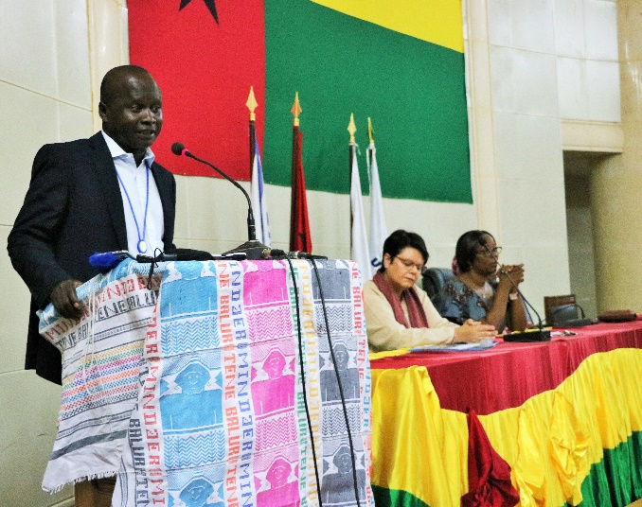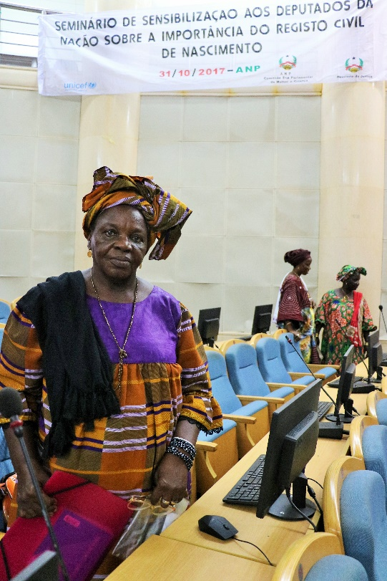
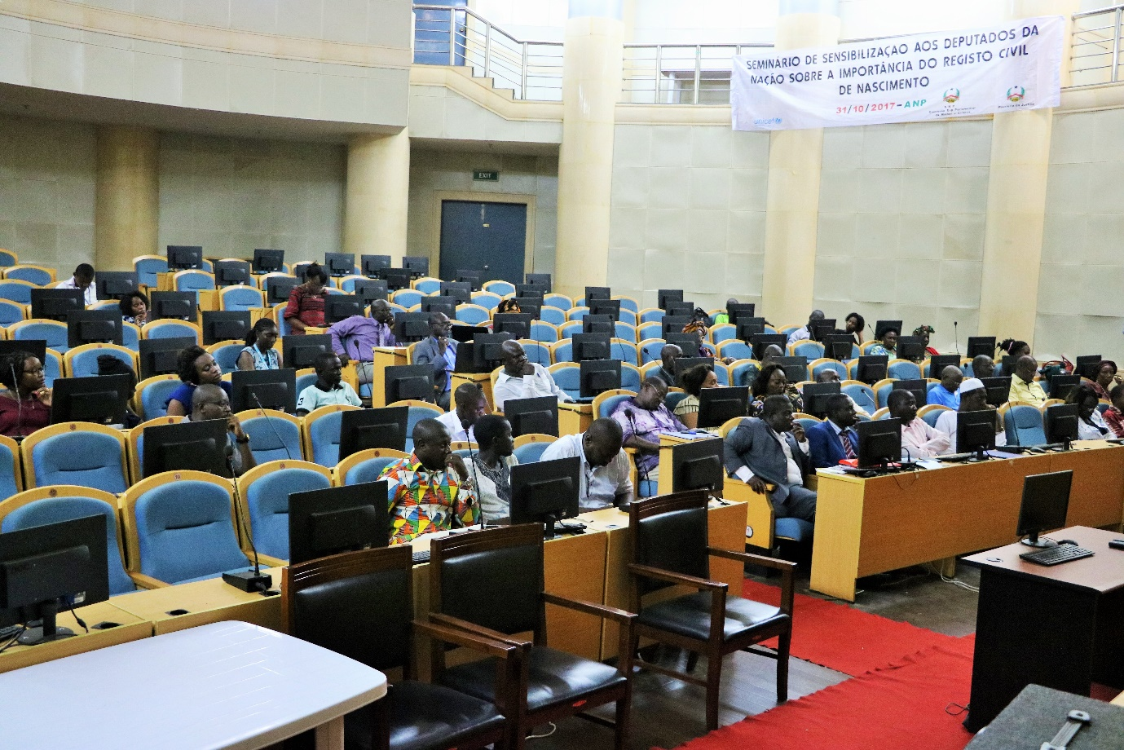

3) Communication material, Posters/Visibility signs (including posters shared in social media)
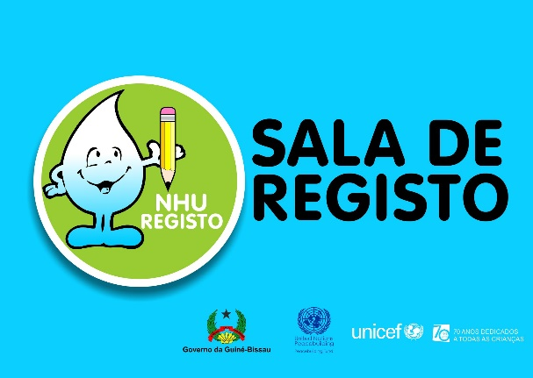
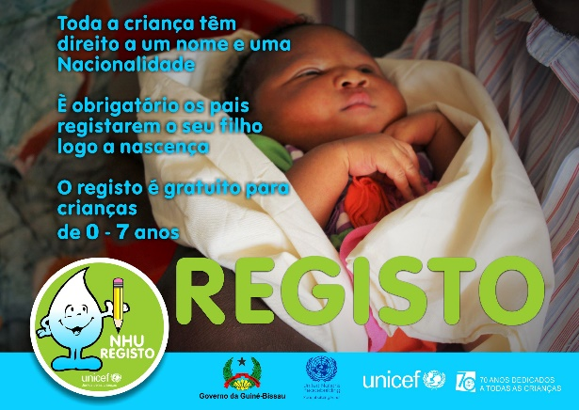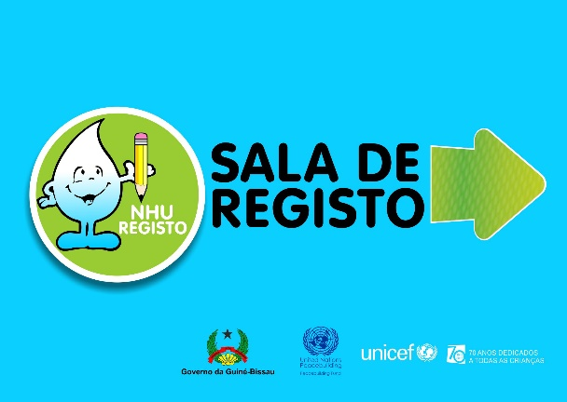

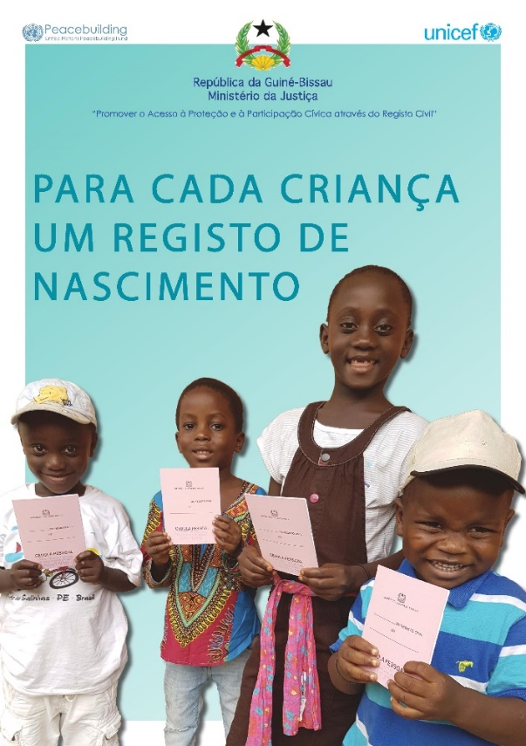
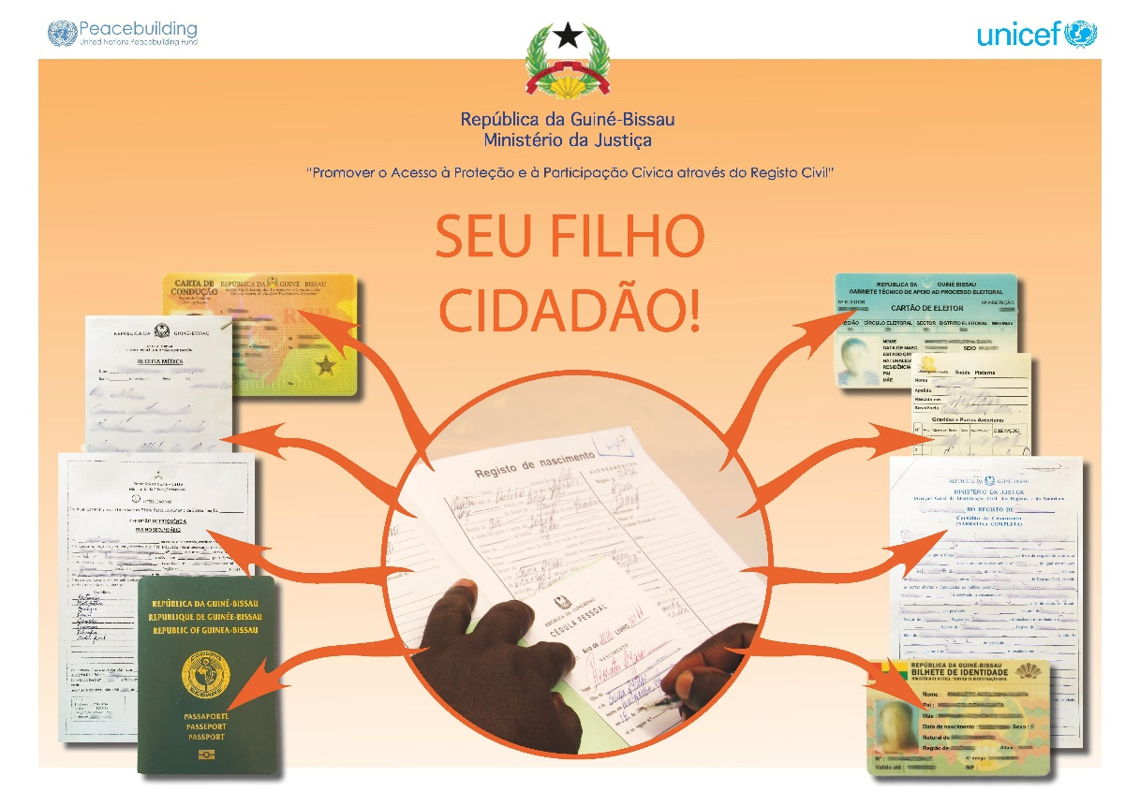

Radio spots
Under the technical support of UNICEF, the Ministry of Justice prepared and aired a weekly radio programe called: “Civil Registration is a Right”. Between March and August 2016, a total of 24 weekly radio programmes have been aired on the national radio (RDN), aiming to inform and sensitize the general public on the importance of the civil registration. Further to this, 2 radio spots have also been prepared and aired nationwide, with a daily frequency, on the importance of civil registration, availability of the services, requirements and benefits of registering children. All the communication mentioned the donor of this project.

Social media posts – on UNICEF Guinea-Bissau facebook page

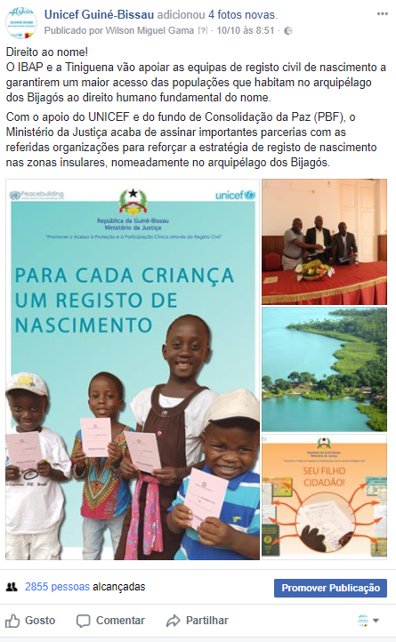
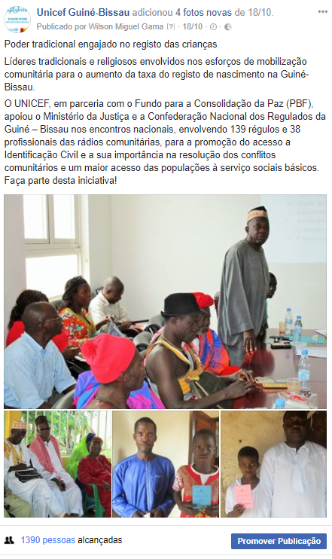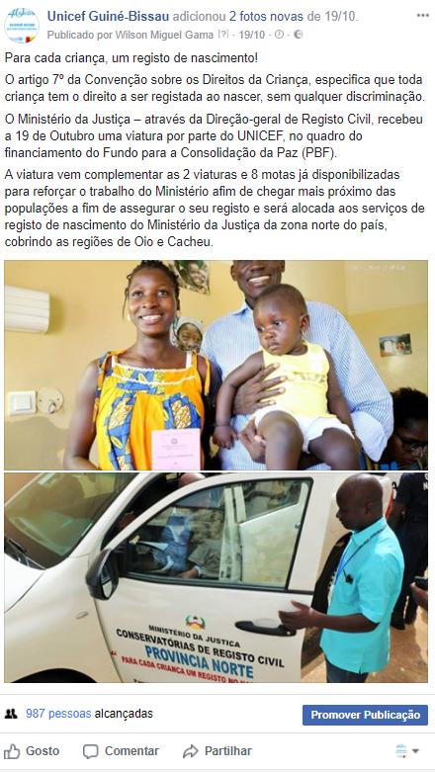

Press clipping
Jornal Ultima Hora

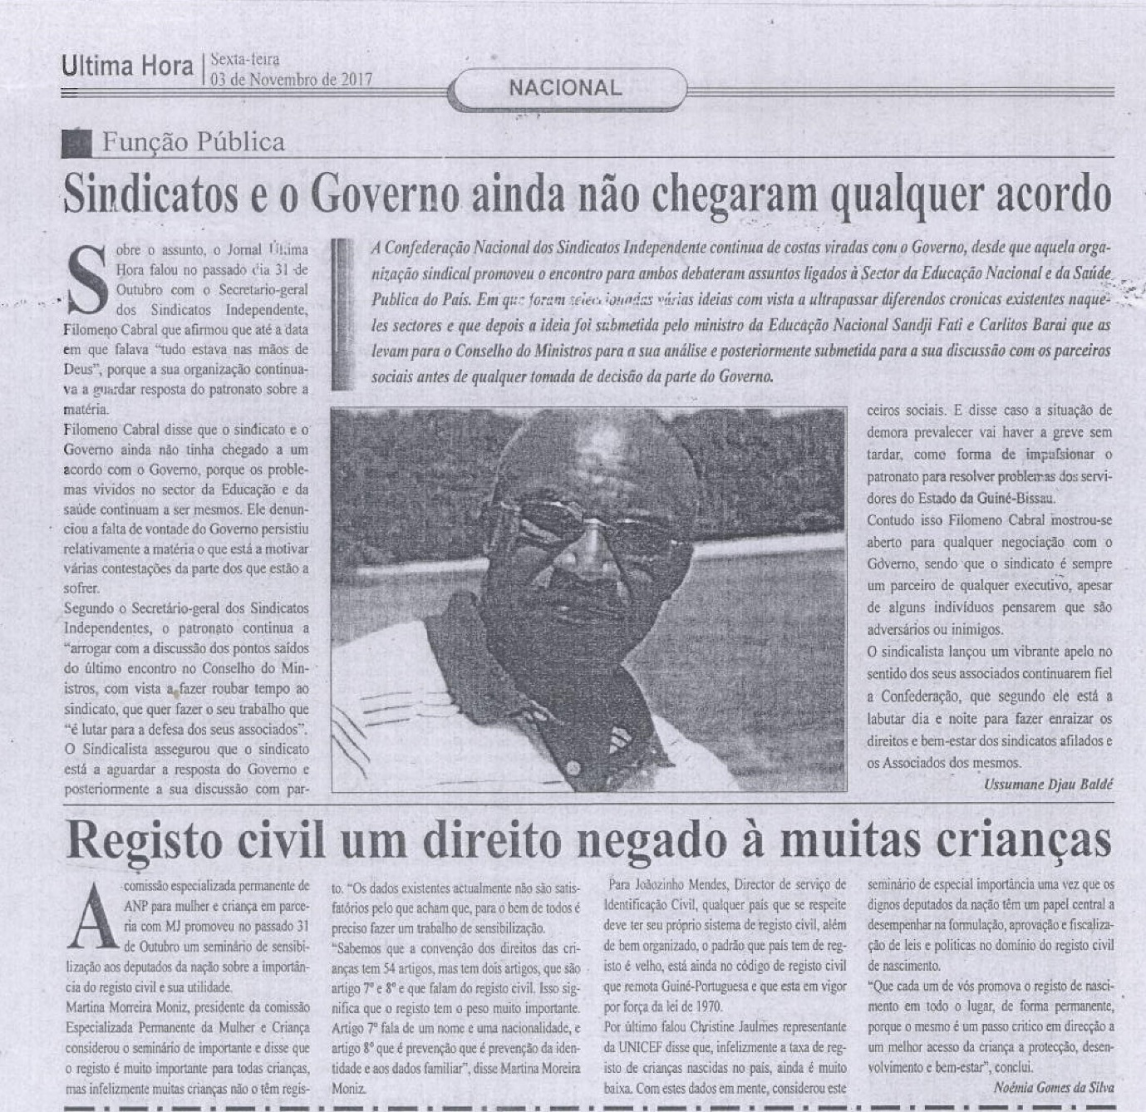

Online media articles
RTP Africa
http://www.rtp.pt/rdpafrica/noticias-africa/gb-primeira-sala-de-registo-civil-de-nascimento-abriu-na-capital_4894
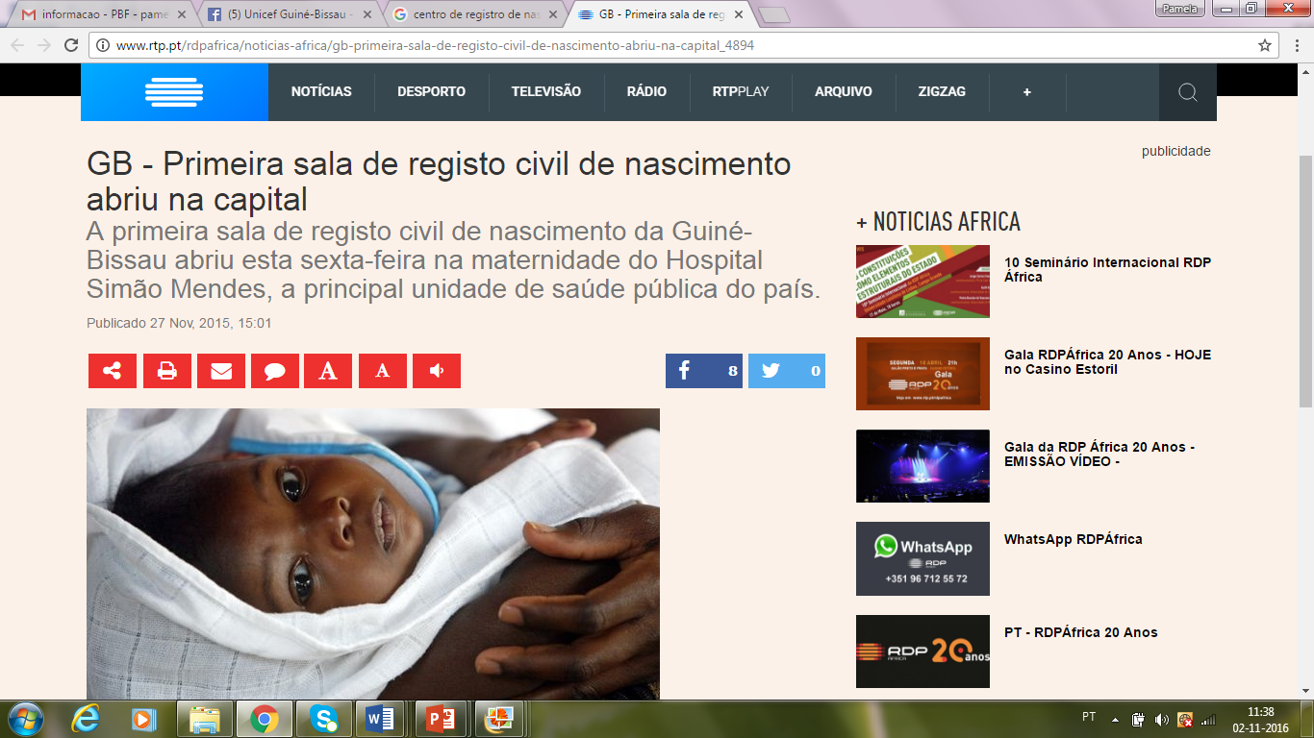
Jornal a Bola
31 October 2017
https://www.abola.pt/Africa/Noticias/Ver/699598
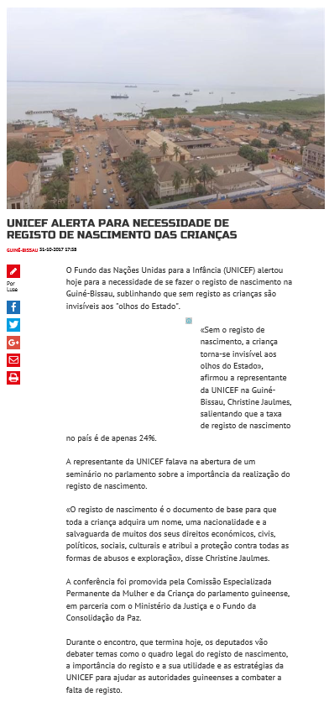

Agência de Notícias da Guiné
1 November 2017

http://angnoticias.blogspot.com.ar/2017/11/identificacao-civil.html
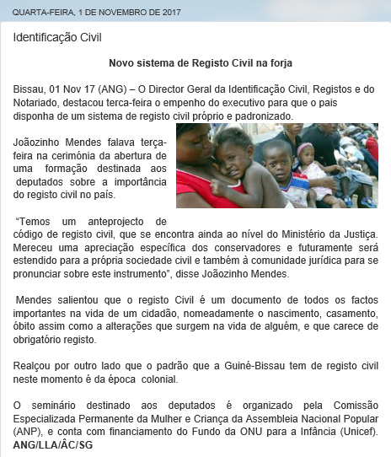
http://angnoticias.blogspot.com.ar/2017/11/registo-civil.html
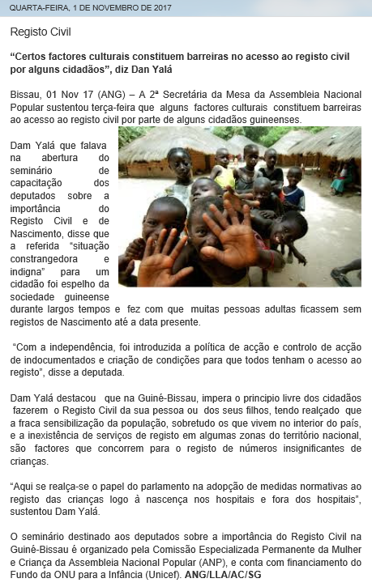

Press Releases
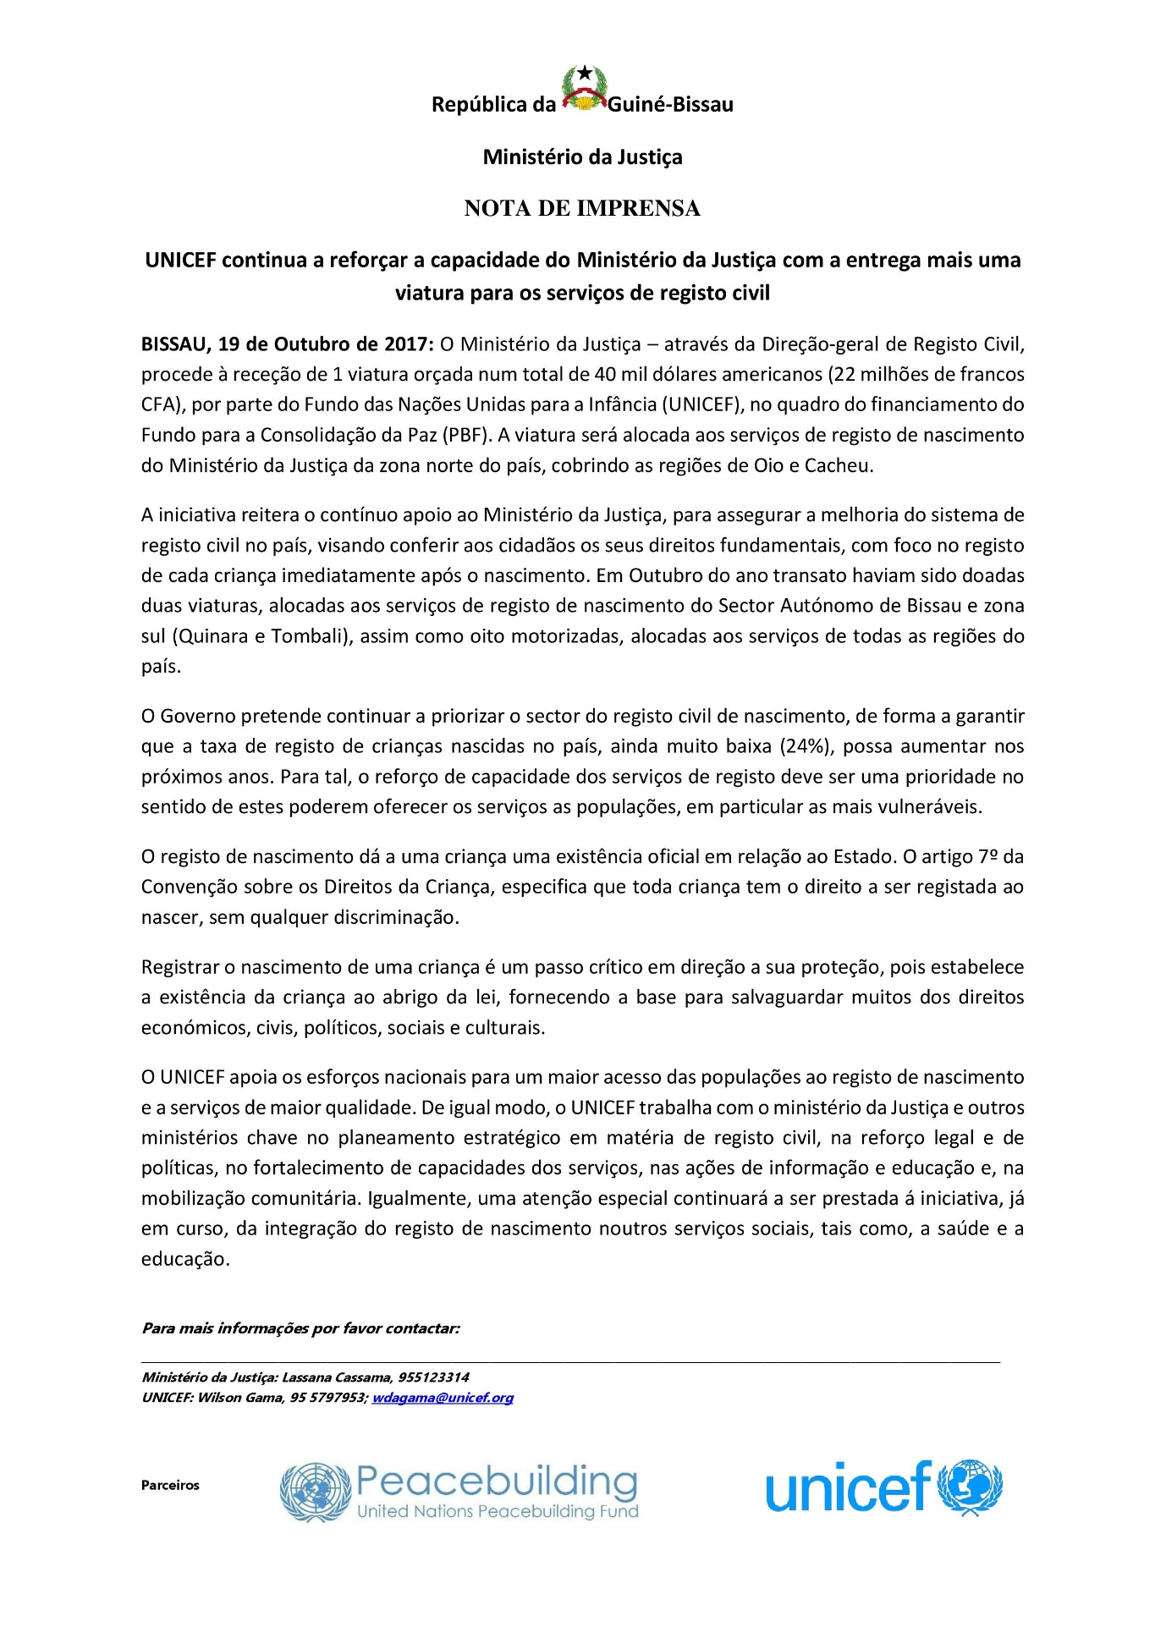

Dissemination of communication tools on the importance of Civil Registration through TV
UNICEF is finalizing the discussions for a partnership with the national television (TGB). One of its key components will be the Birth Registration. In this regard, and in collaboration with the Ministry of Justice and Country Office PBF team, spots, debates, interviews and documentaries around the importance of Civil Registration will be prepared and aired.

Birth Registration Ambassador and support to advocacy and social mobilization plan & campaigns
During the 70th anniversary commemoration on 13th December 2016 in Bissau, and in collaboration with the Ministry of Foreign Affairs and International Cooperation and the Office of the Resident Coordinator, UNICEF Guinea Bissau appointed its new UNICEF National Ambassador: the famous Bissau-Guinean singer Tchuma Bari. The work plan of the national ambassador comprises one component dedicated to Birth Registration, which key activities will focus on the social mobilization and a campaign based on a song to be produced in the second semester of 2017. The Ministry of Justice and Country Office PBF team will be dully involved in the preparation and implementation of this activities.
In October 2017, UNICEF National Ambassador, the singer Tchuma Bari, has been contacted by the Ministry of Justice and UNICEF to discuss her engagement in respect to a social mobilization campaign to be conducted through media. It is expected to have a song, and its respective video clip available before the end of 2017. The PBF Country Office team will be dully involved in the preparation and implementation of these activities.

Support children and youth group’s initiatives to promote civil registration, in particular birth registration, among their peers (through social media, Child Parliament initiatives, among others).
Through its social media, and meetings, UNICEF has been disseminating messages, and content, around the importance of civil registration, aiming to further support children and youth group’s initiatives to promote civil registration, in particular birth registration, among their peers. Throughout the second semester of 2017, a set of Facebook posts around the importance of Civil Registration have also been published through UNICEF social media. The valuable contribution from PBF has been dully acknowledged.

7) Pictures from training of Health workers in the Quinara and Tombali regions and news service facilities.
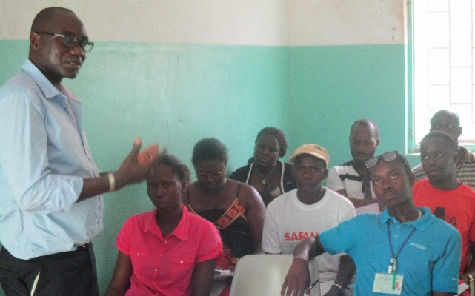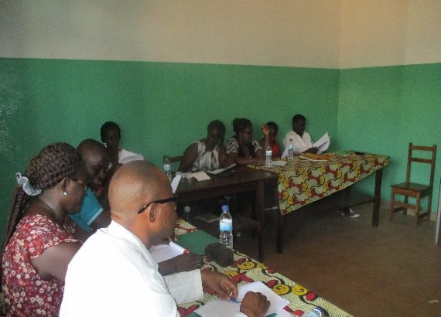
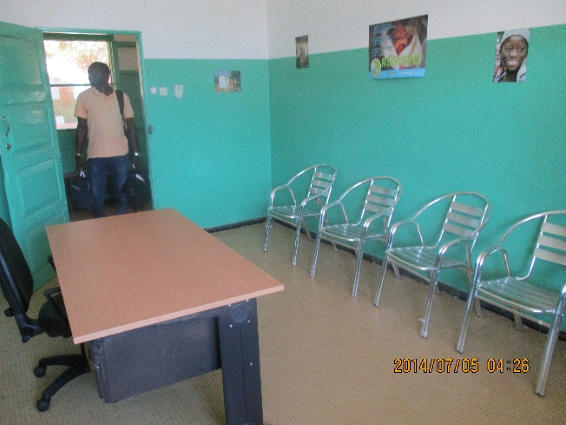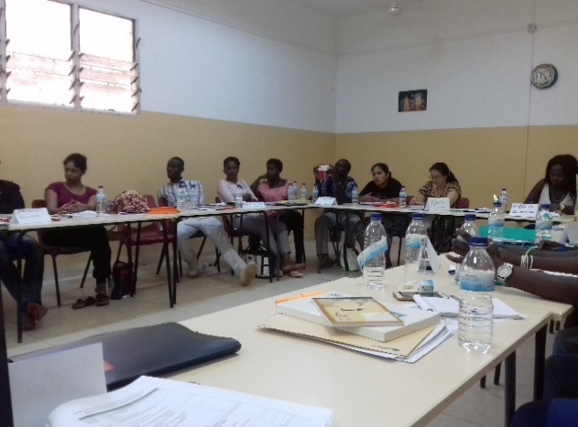

8) Pictures of the birth registration activities with talibe children
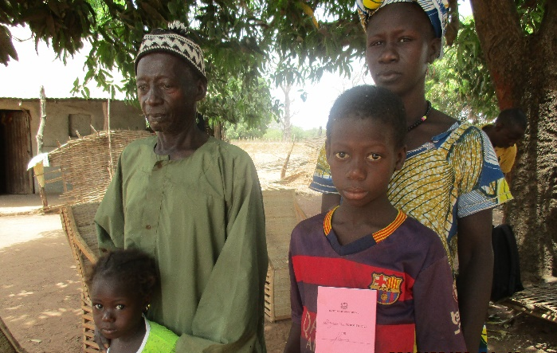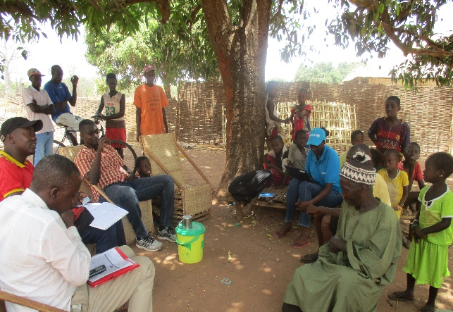

9) Pictures of the Birth registration in child friendly school
