ANNEX 4
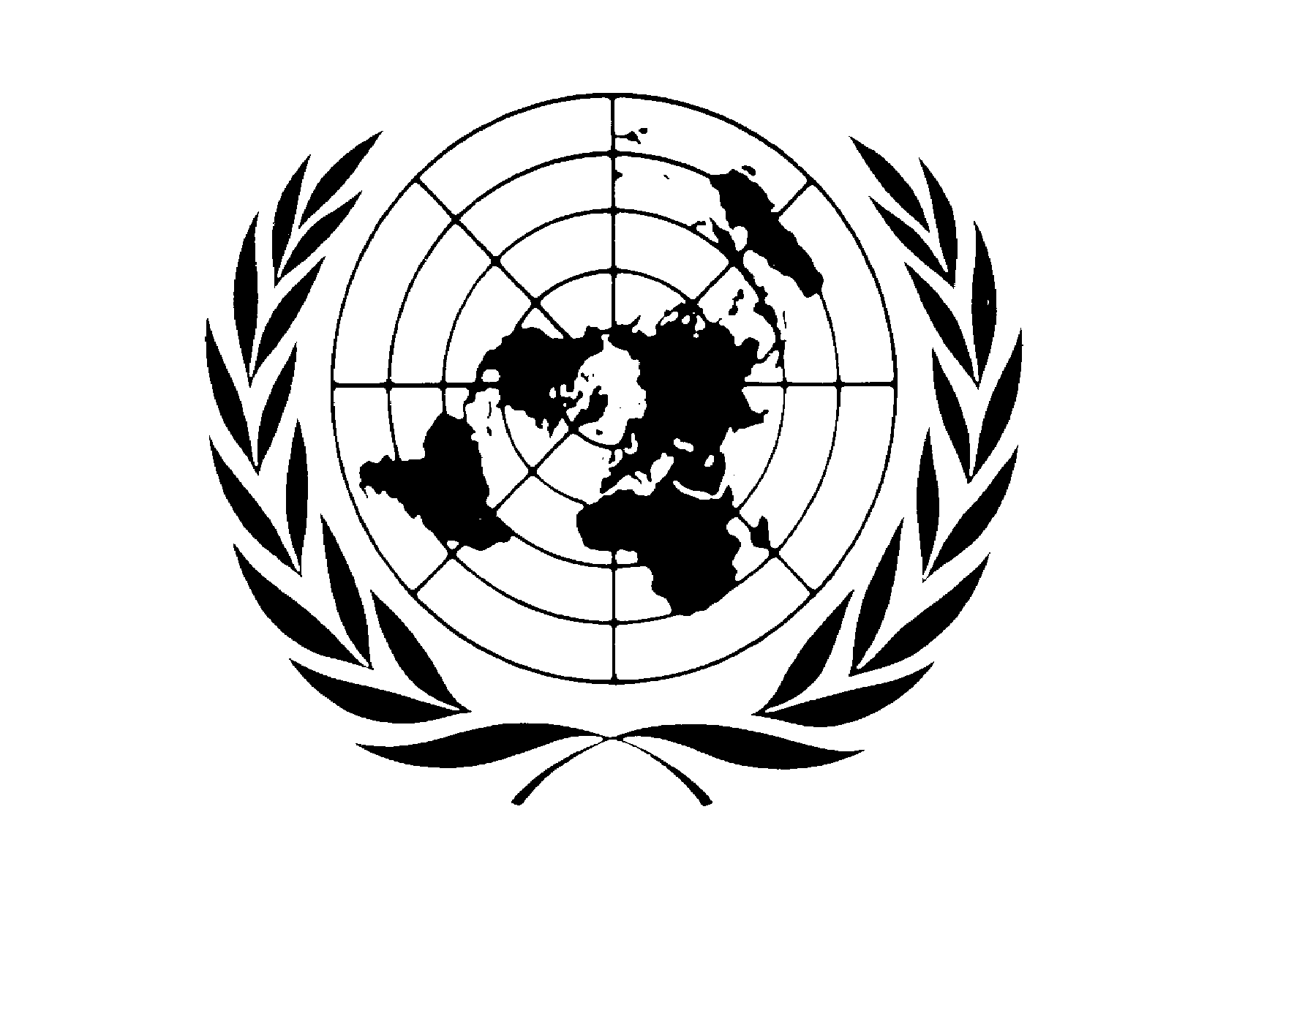
MULTI-DONOR TRUST FUND FOR
UN ACTION AGAINST SEXUAL VIOLENCE IN CONFLICT

FINAL NARRATIVE REPORT COVER PAGE

Participating UN Organization(s):  WHO, UNHCR, UNFPA | Project Title: Psychological interventions for adult survivors of conflict-related sexual violence
Focal Point of Participating UN Organization(s):  Name: Claudia Garcia Moreno  Address:  Telephone:  Email: | Report Number: UNA034
 | Project Location(s): Uganda
UN Action pillar of activity:  Advocacy  Knowledge building  Support to UN system at country level | Reporting Period: May 2014-May 2016
Project Budget: USD $395,900.00

List Implementing Partners:  - Participating UN Organization(s)  - Other International Organization(s)  - National (government, private, NGOs & others) | Project Coverage/Scope:  Specify in which region and/or national coverage/scope of the project

Project Duration/Closed Project:
- Provide the project duration.
- Report on budget revisions and extensions and provide the new dates.
- Indicate if the project has been operationally closed during the reporting period.

Report Formatting Instructions
- Do not put the narrative text into boxes and do not incorporate boxes into the narrative report.
- Attach charts, graphs, etc. as annexes to the report and clearly reference using footnotes
- Number all sections and paragraphs as indicated below
- Format the entire document using 12 point Times New Roman & do not use colours

FINAL NARRATIVE REPORT FORMAT

Purpose
- Provide the main outcomes and outputs of the project
- Explain how the project relates to the Strategic Framework of UN Action Against Sexual Violence in Conflict and to its Terms of Reference
- Indicate the main implementing partners, their roles and responsibilities, and their interaction with the Participating UN Organizations

- Resources
Financial Resources:
- Provide information on other funding resources available to the project, if applicable.
- Provide details on any budget revisions approved by the appropriate decision-making body, if applicable.

- Implementation and Monitoring Arrangements
- Summarize the implementation mechanisms primarily utilized and how they were adapted to achieve maximum impact given the operating context.
- Provide details on the monitoring system(s) used and how you identify and incorporate lessons learned into the project.
- Report on any assessments, evaluations or studies undertaken.

IV. Results
- Describe the main activities undertaken and their achievements.
- Explain any implementation constraints, and the lessons learned from addressing these and knowledge gained in the course of the project.
- Discuss key partnerships and inter-agency collaboration and their impact on the results being reported on.
- Indicate other highlights and cross cutting issues pertinent to the results being reported on.

Purpose
Please provide a brief summary of the project and the Strategic Objective:

This project conducted by WHO in collaboration with the Peter C. Alderman Foundation and UNHCR aimed to develop and pilot a psychological intervention for adult survivors of conflict-related sexual violence. The grant built on previous funding from UN Action which supported a WHO-UNICEF-UNFPA technical meeting in 2011. This meeting recommended the development of manuals on evidence-based psychological treatment for survivors of conflict-related sexual violence.

The strategic objective of this current project was to develop a psychological intervention that would be suitable for the treatment of common mental health problems (anxiety, depression, acute stress) in adult survivors of conflict related sexual violence. A second objective – in line with the conclusions of the WHO-UNICEF-UNFPA technical meeting of 2011 - was to develop an intervention that could be delivered to survivors of conflict related sexual violence in a manner that did not over-target or stigmatize them. A third objective was for the intervention to be more scalable than conventional counselling interventions, which require extensive training and supervision.

Psychological interventions in conflict settings are limited by a number of factors. These include: i) interventions are often resource-intensive, relying on extensively trained and closely supervised lay therapists; ii) access to populations in humanitarian emergencies may be restricted (e.g. specialists supervisors may not be able to travel to the place of intervention delivery); iii) existing manuals mostly require implementers to be trained in different techniques for different problems (e.g. PTSD or depression) or for different populations (survivors of conflict related sexual violence, or survivors of natural disasters). An intervention package designed with the aim of addressing these challenges may be more scalable than existing interventions and provide a psychological component for existing programmes that support survivors of conflict related sexual violence.

To achieve these aims, we looked to develop a transdiagnostic (for multiple psychological problems, e.g. depression, anxiety and PTSD), guided self-help, course based intervention. Guided self-help refers to interventions that seek to equip participants with skills to manage their own distress, and are commonly delivered through books, workshops, or with the assistance of technology (e.g. online interventions). Research has found that the effects produced by guided self-help are surprisingly similar to face-to-face psychological treatment (WHO, 2015), with examples of course based approaches to access harder-to-reach populations having been demonstrated previously (Cuijpers et al, 2009). Such an intervention could reach larger numbers of participants than an individually or small group delivered intervention.

We developed such a course called Self Help Plus (SH+). SH+ is a brief, 5 session intervention (each session is approximately 2- hours) delivered in a large-group workshop format with up to 30 participants, using pre-recorded audio sessions, complemented with an illustrated book. The audio comprises of psychoeducation on topics such as the effects of stress and ways to manage stress, guided practice in a range of stress management techniques (grounding, mindfulness, living by important values) and questions for small group discussions and interaction. It does not need to be facilitated by people with expertise in psychological interventions. Facilitators’ primary roles involve organising and hosting the intervention (e.g. welcoming people to the workshop, playing the audio recording, facilitating discussions). Delivery of SH+ is likely less expensive per person than existing interventions because of the large group size and number of groups which can feasibly be conducted by a facilitator pair. Facilitator training can occur off-site in cases of poor humanitarian access. Rather than creating reliance on outside expertise, SH+ teaches participants how to self-manage their distress.

The intervention is based on cognitive-behavioural therapy, and in particular on guided acceptance and mindfulness-based behavioural therapies (Cavanagh et al, 2014). ACT has been shown to be useful for a range of mental health issues (A-Tjak et al, 2015; Ost, 2014) and has been used successfully in a guided self-help format (Fledderus et al, 2012). Whilst there are no known randomized controlled trials of ACT with survivors of sexual violence, there is growing interest in the effectiveness of this approach for PTSD (Orsillo & Batten, 2005). This approach shows promise because it has been shown to have particular relevance for adult survivors of SGBV due to the techniques used.

Activities conducted during this project included i) the development of a generic English version of SH+ (using additional funds provided by WHO Syria), ii) adaptation of the package for use with South Sudanese refugees in Northern Uganda (Rhino Camp), iii) an initial uncontrolled feasibility pilot to 65 participants iv) an additional SH+ group provided to 26 participants. The project was implemented in Rhino Camp Settlement by the Peter C. Alderman Foundation, an organisation which provides community based mental health services to refugees in Northern Uganda and other countries. Overall, the results of the project showed that SH+ is safe, feasible and shows promise as a potentially scalable psychological intervention for use in humanitarian settings.

Please discuss the expected long-term outcomes of the project (these should be linked to the outcomes that were in the original project proposal):

The results discussed below, suggest that the intervention shows strong promise as a psychological intervention to reduce distress and improve functioning in humanitarian settings with individuals experiencing high levels of adversity, including current partner violence and sexual violence.

Given the positive results from the initial pilot, the next stage is to test SH+ in two state of the art randomised controlled trials (RCTs). This is to ensure the intervention is evidence based and effective prior to its potential release. The first trial - funded by DFID/Wellcome Trust through ELHRA’s R2HC programme - has begun in Northern Uganda, using the same team which conducted the pilot. We are seeking funding for a second RCT with Syrian refugees.

Pending positive results from these trials, WHO will publish SH+ on its highly-visited website and make it freely available for global use, along with guidance for implementing and scaling up the intervention. WHO will work closely with UNHCR and UNFPA to disseminate the intervention. WHO publications are highly valued and respected, especially in the field of mental health. Implementation by governments, international organizations, and NGOs would further extend SH+ dissemination and major humanitarian INGOs have already expressed interest.

- Resources

- Implementation and Monitoring Arrangements

Please discuss if there have been any challenges in carrying out the project during the reporting period and/or lessons learned:

Overall, the evaluation suggested that SH+ is feasible and acceptable to the majority of participants, as demonstrated by the high number of participants who attended the majority of sessions. Qualitative and quantitative data also suggest that it may reduce distress and improve the functioning of participants, including survivors of sexual violence.

The pilot of SH+ also highlighted areas that require further exploration and adaptation prior to the next phase of the project in Uganda. These included:

Changes to the way SH+ is delivered: The initial package (audio script and illustrated book) underwent substantial changes as a result of this pilot. One central change was the role of the facilitator. The original concept was for all content to be delivered by the audio, with the facilitator having very minimal involvement, apart from ensuring safety and supporting individual participants where required. The pilot showed that this approach was not feasible, as many participants found the concept of listening to the audio too novel and required repeating of discussion instructions and explanations for some of the more complex ideas in the course. This led to a revision prior to the pilot groups to make the facilitator more central to the running of the course by having them introduce the course, repeat discussion instructions and run energiser games during the sessions. The facilitator’s role may be conceptualized as similar to a community mobilizer. Observations during the sessions and qualitative interviews with participants suggested that these changes improved group and course cohesion. Further revisions were made to the course after the pilot to make the course easier for facilitators to run and to ensure a more scalable intervention in the future.

The challenge of low literacy in populations: The pilot showed the need to adapt the intervention further to make it suitable for populations with low literacy. Whilst SH+ was originally written with low literacy individuals in mind, the pilot showed that further refinement was required in presentation of the illustrated self-help book and helping people to remember activities to practice during the week, without reliance on written reminders. Revisions were made to the package to address these challenges.

Suitability of the SH+ course for men: Experience during the pilot suggested that the SH+ course was more acceptable to women than to men, with a higher drop-out rate of young men, particularly after the first session. This is consistent with experience elsewhere that suggests that men, especially young men, are less likely to access mental health services. The pilot suggested reasons for drop out included: a) material goods not being provided with the programme, b) a minority of men arriving intoxicated – and being slightly disruptive - at the first session may have led to others not returning, and c) the facilitator lacking confidence in the first session. There is also the possibility that some were former combatants which may introduce further complexity in engaging them in psychological interventions. These findings suggest that additional work is required to better understand the reasons for men dropping out and whether further adaptations are required to the course.

IV. Results

Please discuss the actual outputs achieved during the reporting period:

During the implementation period of this project, the following outputs were achieved:

Development of a generic English language version of the SH+ package: The 5 session audio script and illustrated book was written by an expert in the delivery of self-help versions of acceptance and commitment therapy (ACT), with over 400 professional illustrations completed for the book. The package was extensively reviewed by global experts in psychological interventions in humanitarian settings and low and middle income countries. The package is available for download on request.

Qualitative interviews with South Sudanese refugees to understand culturally specific factors (Phase 1): In this phase of the work, key informant interviews were conducted with stakeholders including community members, village leaders, teachers, elders, traditional and religious leaders to better understand the needs of the refugees and to understand local mental health concepts. Results from this phase of the work were published by Peter C. Alderman Foundation (PCAF, 2015). This report noted that problems of SGBV were identified in a review of literature, PCAF patient data and reporting by some respondents. The study further identified that after inadequate food supply, “overthinking” (the idiom used by South Sudanese to indicate psychological distress) was the most frequently reported problem by community members. These findings support the initial rationale for the project and the development of the SH+ package for South Sudanese refugees.

Adaptation of SH+ for South Sudanese refugees in Northern Uganda (phase 2)
A number of stakeholder meetings were conducted, and a community advisory board was convened with relevant actors from Rhino Camp (local government, humanitarian agencies, and community leaders) to provide guidance and support in the adaptation of SH+. On the basis of this work, SH+ was translated into Juba Arabic, the lingua franca for South Sudanese refugees. This created some challenges as several versions of Juba Arabic – and closely related languages – are spoken in South Sudan. Focus groups with health professionals and local community members were then conducted to gain insight into the comprehensibility, acceptability, and relevance of SH+, and to further refine the translation.

Initial pilot of SH+ (phase 3)
The initial uncontrolled pilot of the programme (without a comparison group) was conducted in a small village on the outskirts of Rhino Camp. Following advice from community groups, experts and ethical review committees, women and men with levels of stress indicative of common mental health problems (e.g. depression or anxiety), were invited to the groups, regardless of their status as survivors of sexual violence. This strategy was adopted to ensure the safety of survivors in a setting where over targeting may lead to unintentional identification.

Participants were invited to the groups if an initial screening suggested they were experiencing clinically significant levels of psychological distress (e.g. symptoms of anxiety and depression). Participants completed a range of measures assessing psychological distress, functioning, disability, psychological flexibility and previous experience of violence, including sexual and other forms of gender based violence.

Only those with high psychological distress and disability were invited to participate in the interventions. Regarding experiences of violence, half of participants reported experiencing gender-based violence (physical violence by intimate partner or sexual violence by any person). Under-reporting of sexual violence among South Sudanese people is expected due to social stigma (OHCHR, 2015).

A team of four female facilitators with experience of providing psychosocial support to South Sudanese refugees were recruited for delivery of the intervention. These facilitators participated in a 5-day training in SH+ with onsite supervision by WHO consultants closely involved in the development of SH+. Facilitators were arranged as pairs and assigned to deliver either the male or female group.

A total of 91 people (59 women and 32 men) were enrolled into the 3 groups (2 women groups and 1 men group). Thirty-seven participants (57%) The majority completed four or more sessions, whilst 10 men dropped out after the first session. The high dropout rate for men will be discussed later in this report. In interviews conducted after the 5-week intervention, participants reported a number of benefits from the programme including reduced “overthinking” about problems, that the course exercises (e.g. breathing, stretching and grounding) helped them to relax and reduce stress, and in some cases reduced alcohol use by participants who had previously reported problematic use. There were further reports of how the programme had helped improve relationships with neighbours and reduced conflict in the community, since all community members participated in SH+ together regardless of tribal affiliation. Quantitative pre and post measures of functioning, psychological distress, self-identified problems, subjective wellbeing and psychological flexibility confirmed the qualitative findings, suggesting significant improvements after the course (see table 1 below). As this was an uncontrolled pilot, these results cannot be assumed to demonstrate effectiveness, but rather suggest the intervention shows strong promise as a psychological intervention to reduce distress and improve functioning in humanitarian settings with individuals experiencing high levels of adversity, including current partner violence.

Post pilot workshop and preparation for substantive RCT
Findings from the pilot were discussed in a planning meeting for the RCT being conducted in Uganda. The meeting comprised of the project management team, PCAF staff, and members of the community advisory board. Lessons learned from the pilot and the proposed methodology for further implementation of SH+ were reviewed and discussed.

Please discuss the impact of the overall project. if it is too soon to report on impact, please note the intended impact of the project upon completion:

The full impact of the SH+ project in Uganda will be realised in the upcoming RCT (funded by DFID/Wellcome Trust through ELHRA’s R2HC programme). Assuming effectiveness is demonstrated, the longer term outcome from this project will be the availability of a scalable psychological intervention that can be adapted for use in multiple countries. In Uganda, the outcome will be the scaling up of SH+ to refugees in Rhino Camp as provided by the Peter C. Alderman Foundation as part of its regular services.

Conservative estimates suggest that SH+ can potentially reach far greater numbers of people for fewer resources than existing evidence based interventions. One facilitator pair could conduct approximately three concurrent 5-week courses, 6 times per year, which would lead to 450 participants receiving the intervention. In comparison, existing evidence based group interventions which are commonly provided to between 5-8 people at a time would reach a maximum of 144 people and would require greater training and supervision of facilitators. Assuming further funding for activities, the number of beneficiaries of the intervention could reach hundreds of thousands of people globally within a few years. The intervention will be particularly suitable to settings where war-related sexual violence has been common as the intervention does not require discussion of the event and can be scaled safely without having specialist mental health services in place.

Below are some illustrative quotes highlighting beneficial impacts of SH+ for some participants.

“In my case, when I begin thinking about bad things, I just look for my book which has the pictures and I get relieved and I get to do my normal house work with my children.” Female, 37 years old.

“The exercises I learnt help me every day because each time I become tired, I do what the grounding exercise told us to do during the workshop and it always relaxes the body and mind.” Female, 33 years old.

“…what I can tell you is this program helped me because, of course when you have thoughts, you will go to drink alcohol and insult people, you don’t stay well, but since I went for the sessions, things that were in my mind now have gone and I stopped drinking alcohol. I stay well.” Male, 30 years old.

Picture 1: SH+ group in Rhino Camp
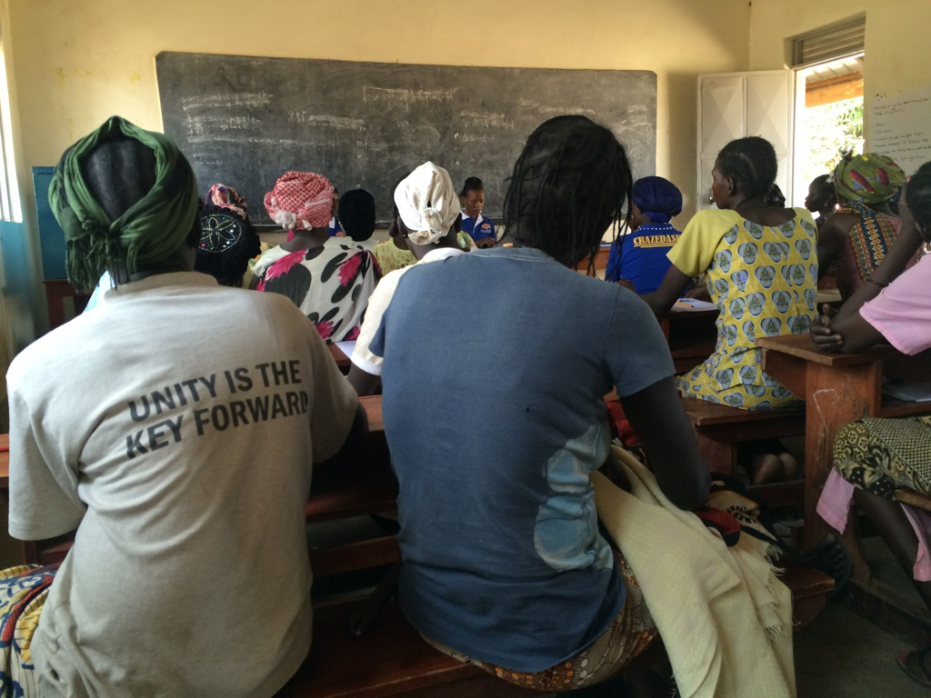

Table 1
Pre- and post- intervention differences on mental health measures within participants of the uncontrolled feasibility pilot (n=65).
Measure | Pre-assessment |  | Post-assessment |  | t | df | CI | P-value
Measure | Mean | SD | Mean | SD
WHODAS¹  (functioning) | 7.98 | 5.14 | 2.63 | 3.94 | 6.69 | 51 | 3.74-6.95 | <0.001
PSYCHLOPS¹**  (self-identified problems) | 14.83 | 4.46 | 8.90 | 5.96 | 4.76 | 40 | 3.41-8.44 | <0.001
PHQ9¹  (depression) | 13.10 | 5.06 | 3.94 | 4.39 | 10.97 | 47 | 7.36-10.20 | <0.001
WHO5²  (subjective well-being) | 8.02 | 5.56 | 13.98 | 5.38 | -6.66 | 52 | -7.76-  -4.17 | <0.001
AAQ2²  (psychological flexibility) | 16.88 | 8.80 | 33.37 | 9.17 | -8.72 | 48 | -20.29 –  -12.69 | <0.001
K6¹  (psychological distress) | 14.15 | 4.47 | 6.73 | 4.24 | 7.62 | 51 | 5.47-  9.38 | <0.001
¹ lower scores indicate better outcome
² higher score indicate better outcome
*Note: Data are unadjusted for dropouts or missing data
** The PSYCHLOPS assesses changes in problems, functioning and wellbeing as defined by participants at baseline assessment.

References
A-Tjak JGL, Davis ML, Morina N et al. A meta-analysis of the efficacy of acceptance and commitment therapy for clinically relevant mental and physical health problems. Psychother Psychosom 2015;84(1):30-6.
Cuijpers P et al. Psychoeducational treatment and prevention of depression: the "Coping with Depression" course thirty years later. Clin Psychol Rev. 2009;29(5):449-58.

Fledderus M, Bohlmeijer ET, Pieterse ME et al. Acceptance and commitment therapy as guided self-help for psychological distress and positive mental health: a randomized controlled trial. Psychol Med 2012;42(3):485-95.
Office of the High Commissioner for Human Rights (OHCHR). Assessment mission by the Office of the United Nations High Commissioner for Human Rights to improve human rights, accountability, reconciliation and capacity in South Sudan - Report of the United Nations High Commissioner for Human Rights. OHCHR, Geneva. Available: http://www.ohchr.org/EN/HRBodies/HRC/RegularSessions/Session31/Documents/A-HRC-31-49_en.doc#sthash.WQ2GBS3T.dpuf
Orsillo, S. M., & Batten, S. V. (2005). Acceptance and commitment therapy in the treatment of posttraumatic stress disorder. Behavior Modification, 29(1), 95-129.
Ost LG. The efficacy of acceptance and commitment therapy: an updated systematic review and meta-analysis. Behav Res Ther 2014;61:105-21.
Peter C. Alderman Foundation. Assessment of Mental Health and Psychosocial Support Needs and Resources of South Sudanese Refugees in Arua, Northern Uganda. PCAF, New York.

Available: https://mhpss.net/?get=67/PCAF-Arua-MHPSS-Needs-Assessment-Report-Final.pdf

World Health Organization. mhGAP Evidence Resource Centre: Comparative effectiveness of different formats of psychological treatments for depressive disorder. Geneva: WHO, 2015.

The term “project” is used for projects, programmes and joint programmes

