|  |  |  |
| --- | --- | --- |
|  | **SUN Movement**  **Multi-Partner Trust Fund** | UN Logo |

# REPORT COVER PAGE

**FINAL NARRATIVE report**

|  |  |  |
| --- | --- | --- |
| Participating Organization:UNICEF Kenya |  | Priority Sector covered: Scaling Up Nutrition Civil Society Alliance |
|  |  |  |

|  |  |  |
| --- | --- | --- |
| Program1 No. MPTF-Window2-018Program Title: Mobilizing Civil Society in Kenya to Champion Scaling up Nutrition |  | Report Number:Final Programme ReportJanuary 1st 2014 - 30th June 2016 |
|  |

|  |  |  |
| --- | --- | --- |
| Reporting Period: 1st January 2014 to 30th June 2016 |  | Program Budget: $280,000 |
|  |  |

|  |  |  |
| --- | --- | --- |
| List Implementing Partners: |  | Program Coverage/Scope: |
| Members of the Civil Society Alliance  (see Annex 1)  World Vision Kenya – Host organization |  | Kenya – six priority counties: Baringo, Kisumu, West Pokot, Machakos, Taita Taveta and Wajir Counties. |

|  |  |  |
| --- | --- | --- |
| Abbreviations and acronyms: |  | Program Duration/Closed Program: |
| ACSM – Advocacy, Communication and Social Mobilization  CIDP - County Integrated Development Plan  CNAP - County Nutrition Action Plan  CSN - Civil Society Network  CSO – Civil Society Organizations  EC - Executive Committee  IEC – Information Communication and Education  MDGs – Millennium Development Goals  MPTF - Multi Partner Trust Fund  NNAP - National Nutrition Action Plan  PANITA - The Partnership for Nutrition in Tanzania  SUN CSA - Scaling Up Nutrition Civil Society Alliance  SDGs - Sustainable Development Goals  UNICEF – United Nations Children Fund |  | Original Duration:  1 January 2014 – 31 December 2015  Program/ Project Extensions:  No Cost Extension approved from 1st January 2016 – 30 June 2016 |

# FINAL NARRATIVE REPORT FORMAT

# FOR COUNTRY LEVEL JOINT PROGRAMS

**Progress Report on Results Achieved as of 30th June, 2016**

# Executive Summary on Key Achievements

Over the two and a half years period of the Multi Partner Trust Fund Project (MPTF) implementation in Kenya - 1st January 2014 to 30th June, 2016 – Scaling Up Nutrition, Civil Society Alliance (SUN CSA) made great strides, in establishing itself as the voice of the civil society in advocating for nutrition issues. The SUN CSA established and strengthened the CSA structures for scaling up nutrition in Kenya including undertaking a mapping of the Civil Society Organizations (CSOs) in all the 47 counties; establishing a governance structure for the CSA; establishing and strengthening of the CSA Executive Committee and registration of the CSA as a legal entity.

The CSA was actively involved in the launches of the Global Nutrition Reports of 2015 and 2016. During the launch of the Global Nutrition Report 2016, SUN CSA played a key role and worked closely with the other SUN Networks to invite Her Excellency The First Lady of the Republic of Kenya to grace the event. SUN CSA was involved in advocacy trainings in Nairobi, Homabay, Turkana, Kilifi and Machakos counties which were among other things geared towards making the participants nutrition champions in their various sectors.

Further, members were engaged in advocacy initiatives and advocacy capacity building activities both at national and county level including facilitating trainings on nutrition reporting for the media fraternity. Proactive engagement in multi-sectoral coordination initiatives was undertaken and engagement with County Executives and County Assemblies facilitated. Advocacy for formulation of nutrition related policy frameworks was supported or influenced including the Draft Kenya Health Policy 2014-2030, Health Bill 2014 and positioning of the Nutrition Unit in the Ministry of Health. Additionally, the SUN CSA participated in the Food Fortification conference and collaborated with other networks in the development of the National Advocacy, Communication and Social Mobilization Strategy.

In a bid to increase journalists’ knowledge of nutrition issues, while at the same time increasing the quality and quantity of media articles, SUN CSA undertook media training sessions in Nairobi, Kilifi, Homa Bay, and Nakuru Counties. During the training sessions, the journalists were also called upon and encouraged to become nutrition champions within their respective Counties.

Learning and good practices were documented and shared within the CSA, nationally, regionally and globally. More so, the CSA played a key role in the identification of nutrition champions or advocates for scaling up nutrition both at national and county levels. Finally, the CSA fostered key partnerships and inter-agency collaborations over the reporting period during which additional financial resources were mobilized for CSA activities aimed at scaling up nutrition.

The CSA Network held its first ever nutrition conference themed ‘Nutrition Sensitive Programming for Scaling Up Nutrition in Kenya’ which brought together all stakeholders within the nutrition sector including Government, Donors, United Nations, Academia and the Business networks.

# Purpose

This section highlights the main outcomes and outputs of SUN CSA’s program implementation during its two and a half years of existence. It also outlines the roles and responsibilities of the main implementing partner, the CSA County Lead Organizations and its interaction with the Participating UN agency - UNICEF, during the period under review.

**Goal of the Project**

To contribute to the national goal of having a healthy Kenya, with human resources that effectively contribute to economic growth and development of the country.

**The specific objectives**

1. Mobilize and organize the civil society in Kenya, working in nutrition relevant fields, to join and engage in the SUN Civil Society Alliance (CSA).
2. Strengthen the Kenyan Civil Society Alliance to engage in the SUN Movement.
3. Develop strong advocacy mechanisms to increase public participation in nutrition programs and interventions.

**Expected results**

**Result 1: Civil Society Alliance established and strengthened to scale up nutrition in Kenya**

* Civil Society Organizations (CSOs) mapping at county level.
* Civil Society Alliance Governance structure established.
* CSA strategy developed.
* CSA member’s capacity built to drive nutrition advocacy initiatives and policy influence at national and county levels.
* Learning and good practices documented and shared within the CSA, nationally, regionally and globally.
* Advocacy for formulation of policy frameworks to support implementation of the National Nutrition Action Plan (NNAP) and the County Integrated Development Plan (CIDP) strengthened.

**Result 2: Effective participation of the CSOs in the SUN movement**

* CSO multi-sectoral coordination fora at national and county levels address key nutrition advocacy agenda.
* Facilitate engagement with County Executives and County Assembly.
* Counties generate discussions and collective action on the National Nutrition Action Plan and County Integrated Development Plans. Coordination with other SUN Networks is strengthened.
* Semi-annual SUN CSA e-bulletin is produced and disseminated for enhanced CSA visibility.
* Kenya SUN CSA is represented in national, regional and international SUN movements for increased visibility.
* Advocate for more nutrition funding in the coming budget for the Ministry.
* Advocate for the recruitment of additional nutritionists in Kenya as of 2013 the country has a total of 230 health facilities with only 21 nutritionists.

**Result 3: CSA advocates for increased commitment and accountability in scaling up nutrition**

The goal of Kenya Vision 2030 is to “transform Kenya into a globally competitive and prosperous nation with a high quality of life by 2030”. Unfortunately, malnutrition is amongst the biggest threats to this Vision 2030 and Kenya’s achievement of the Millennium Development Goals. Malnutrition greatly affects Kenya’s socio-economic development and potential to reduce poverty. Economically, Kenya loses about KShs 147 billion every year due to productivity losses as a result of malnutrition. Vision 2030 and many of the Millennium Development Goals (MDGs) – particularly MDG 1 (eradicate extreme poverty and hunger); MDG 4 (reduce child deaths); and MDG 5 (improve maternal health) and now the Sustainable Development Goals (SDGs) – will not be reached unless the nutrition of women and children is prioritized in the national development programs and strategies.

According to Population Reference Bureau calculation based on the United Nations *World Population Prospects, 2012,* malnutrition among Kenya’s children is a serious problem and exists throughout the country. Each year, more than 70,000 Kenyan children die before their fifth birth day and malnutrition contributes to about half of these deaths. Also according to the KDHS 2014, overall, nutritional status of children has improved since 2008/9 with declines in stunting, wasting, and underweight which currently stand at 26%, 4% and 11% respectively. Malnutrition and poor diets constitute the number-one driver of the global burden of disease. The annual Global Domestic Product (GDP) losses from low weight, poor child growth, and micronutrient deficiencies average 11 percent in Asia and Africa— which is greater than the loss that was experienced during the 2008–2010 financial crisis.

### II. RESOURCES

The SUN CSA approved MPTF program budget was $299,600 (World Vision $280,000 + $19,600 UNICEF) plus a co-funding of $14,000 from World Vision.

Further in 2014, the SUN CSA in collaboration with Kenya AIDS NGOs Consortium and Grassroots Alliance for Community Education (G.R.A.C.E. Africa) won the European Union grant to implement a 3-year Strengthening Civil Society on Maternal Child Health and Nutrition project in which SUN CSA was allocated 60,000 Euros. The CSA also leveraged on funding from Population Reference Bureau of $52,190.

### III. RESULTS

During the programme implementation period, implementation of the SUN CSA activities mainly focused on the three key result areas that have been outlined above with the following accomplishments:

**Result 1: Civil Society Alliance established and strengthened to scale up nutrition in Kenya**

The journey to the establishment of Kenya’s SUN CSA started in 2013 after the Kenya Government committed to Scaling Up Nutrition in October 2012. The idea to establish the CSA was mooted during a brainstorming session that involved five civil societies implementing nutrition and consumer rights programs. A breakthrough was made when a special Nutrition Technical Forum (NTF) meeting was convened in October 2013 to elect the leadership of the SUN CSA during which WV was elected as host organization; ACF as Chair and UNICEF as the Participating UN Organization for the MPTF funding.

By mid-November 2013, the newly-established CSA had developed policy documents and a proposal for funding from SUN Multi Partner Trust Fund (MPTF). In February 2014, Kenya’s SUN CSA received MPTF funding of USD 280,000 to implement its programme: ‘Mobilizing Civil Societies to Champion Scaling up Nutrition in Kenya.’ Its launch followed on 9th May 2014 during the Global Day of Action commemoration.

The SUN CSA finalized its Terms of Reference (ToR) which guides its operations alongside the Strategic Plan. Two Annual General Meetings were held during which new office bearers were put in place. A Memorandum of Understanding among the CSA members was also developed to guide operations with the Host Organization of World Vision.

The 2015 SUN CSA Executive Committee comprised of nine member organizations - Action Against Hunger-Chair; Kenya Red Cross Society-Vice Chair; World Vision Kenya - Host Organization and members: Grassroots Alliance for Community Education (G.R.A.C.E. Africa); Kenya AIDS NGOs Consortium; Concern Worldwide; Save the Children International; Helen Keller International and; Uzima Aid with the last two members as co-opted members of the Executive Committee. Further, the 2016 Executive Committee, which became a board upon registration of the SUN CSA (Board) is made up of elected members of DSW (Chair), International Rescue Committee (Co-chair), and Feed the Children, International Medical Corps, KANCO, Islamic Relief, and Action Against Hunger.

Selected key activities were undertaken towards ensuring that the SUN CSA structures were established and strengthened. These included the establishment and strengthening of the Executive Committee and registration of the CSA as a legal entity. Mapping of the CSOs at the county level was finalized in all the 47 counties in close collaboration with the County Nutrition Coordinators. At the same time, members were also engaged in advocacy initiatives both at national and county levels including the National Nutrition Symposium. The SUN CSA was also represented at national and international health events including the World Breastfeeding Week, the National Nutrition Week 2015 and the Global SUN Gathering 2015 in Milan, Italy and the launch of the 2014, 2015 and 2016 Global Nutrition Reports.

* 1. ***CSOs mapping at county level***

The reporting period saw a mapping exercise for CSOs undertaken in all 47 different counties compiled in liaison with County Nutrition Coordinators and submitted to the CSA Secretariat, the SUN Focal point, Nutrition Sector Coordinator and SUN MOH Coordinator. This was done using already existing and mapped data at the county level. Further analysis of the mapping reports was done and completed during the reporting period, with the aim of mapping data in terms of the scope of work. The sketch map and pivot tables indicating nutrition partners in the respective counties and their interventions were also finalized.

* 1. ***Civil Society Alliance Governance structure established***

During the reporting period, the SUN CSA Executive Committee (EC) continued working closely with the SUN Movement Secretariat towards ensuring that their operations are in line with the SUN Movement principles and Civil Society Network (CSN) guidelines with regard to inclusivity and transparency e.g. initially the CSA EC membership were eight members and was expanded to 11 members with two additional members being co-opted into the Executive Committee. The current EC members are: DSW, Action Against Hunger, International Medical Corps, Feed the Children, International Rescue Committee, Kenya AIDS NGOs Consortium and Helen Keller International (HKI).

The reporting period saw the development rules of engagement to facilitate harmonious operations between the CSA, the host organization and the UN participating organization which was signed by the EC members on behalf of the CSA, by World Vision and UNICEF respectively. This is a governance document that provided guidelines for the management of the overall MPTF project including the CSA Coordinator/Secretariat and MPTF funds, by mainly the EC and the host organization.

At the same time, the SUN CSA undertook a review of the Terms of Reference through a taskforce comprising of five members of the Alliance. The key issues that were looked into include the terms of service for the Executive Committee; the Organizational Structure; communication protocols; roles and responsibilities of the Executive Committee and Secretariat; as well as management of Conflict of Interest. The current structure for the Kenya CSA is as follows:

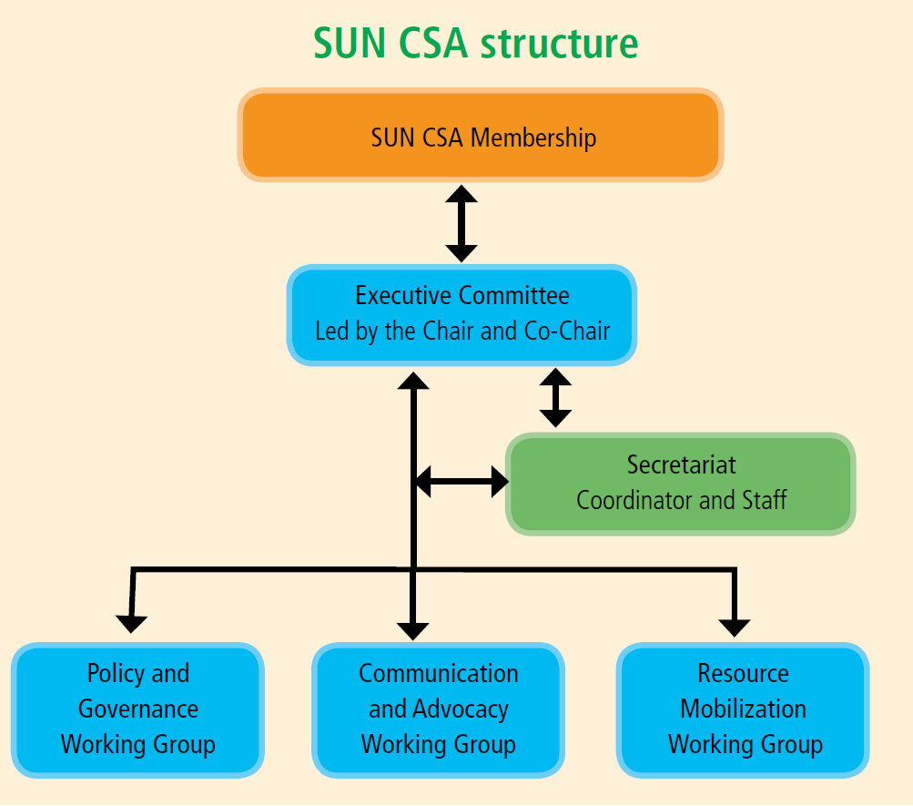

During the reporting period, the SUN CSA also finalized and validated its Constitution and undertook the legal registration of the SUN CSA with the Kenyan Non-Governmental Organizations Coordinating Board was finalized which in essence made SUN CSA a legal entity.

At the same time, the CSA established three sub-committees/taskforces:

* Communication and Advocacy,
* Resource Mobilization,
* Policy and Governance,

These sub committees drew membership from CSA organizations. The resource mobilization committee spearheads mobilization of resources for the CSA, the policy and governance sub-committee addresses the governance issues in the SUN CSA while the communication and advocacy subcommittee spearheads advocacy plans including trainings for the CSA. These sub-committees strengthen the CSA’s structures, resources and strategies to implement its work plan. Since they draw members from the CSA membership, this ensured that there is enhanced ownership and encouraged participation among members during the period under review.

Members of the taskforces are as follows:

**Communication and Advocacy:** Action against Hunger, Save the Children International, Population Services Kenya, Feed the Children, Islamic Relief Kenya, International Rescue Committee, and CISP

**Policy and Governance**: Kenya Red Cross, Helen Keller International, World Vision Kenya, Action against Hunger, Micronutrient Initiative, Consumers Federation Kenya and Global Alliance In Nutrition, CISP

**Resource Mobilization**: Feed the Children Kenya, Grassroots Alliance for Community Education (G.R.A.C.E) Africa and International Rescue Committee, Islamic Relief

During the project period, a Country Directors/Chief Executive Officers (CDs/CEOs) meeting was held during which participants renewed their commitment towards attaining the SUN CSA mission and objectives. Thirty CDs/CEOs attended the meeting. An official handing over to the new board and subcommittee chairs took place at Sentrim Hotel, Elementaita.

* 1. ***CSA strategy developed***

During the reporting period, SUN CSA four-year Strategic Plan 2016-2020 was developed. The strategy document offers a four year strategic direction to the SUN CSA’s operations. The plan clearly reflects the collective aspirations of the SUN CSA member organizations in Kenya while at the same time giving guidance to the future survival of the Alliance in Kenya.

***1.4 CSA members’ capacity built to drive nutrition advocacy initiatives and policy influence at national and county levels***

The SUN CSA conducted a total of 12 advocacy trainings - two national and 10 county level sessions during the implementation period. The trainings were aimed at strengthening civil societies to engage with County Governments and multi-stakeholders in scaling up nutrition**.** In the photo here, are some of the participants who were trained during the advocacy training session that was held in Kisumu County.

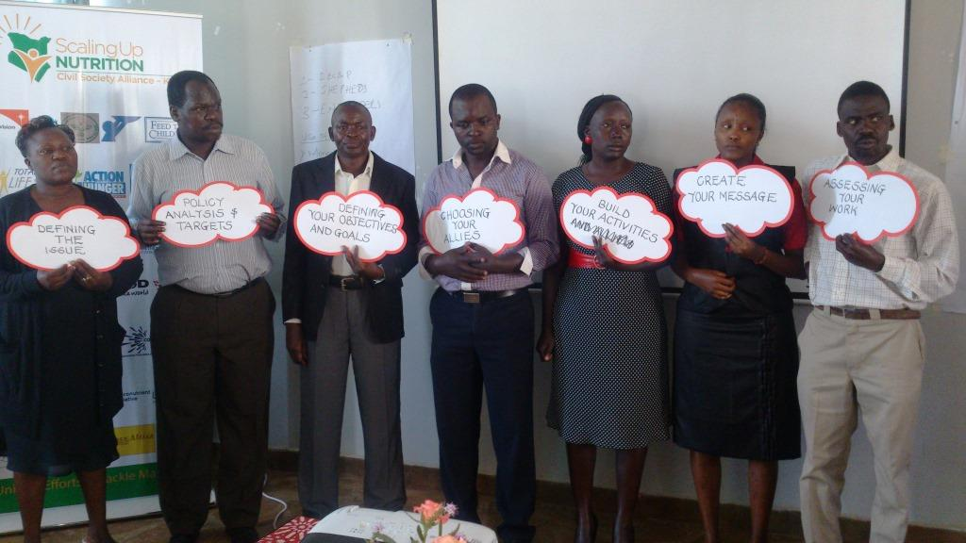

Participants during advocacy workshop in Kisumu

Topics covered were: Introduction to SUN Movement; Advocacy; Advocacy Cycle; Nutrition Advocacy; Power Mapping; Media Advocacy; Advocacy Strategy Development; Advocacy Monitoring and Evaluation; and Building Networks/ Alliances. Led by the facilitators who were trained by ACTION Results Initiative in Zambia in 2013, a total of 200 participants were trained. These participants were constituted of representatives from SUN Government Network, Business Network, UN Network, Business network, media and academia. The participants were mainly drawn from the ministries of Health, Agriculture, Livestock, Fisheries and civil society organizations, both at national and county levels. CSA semi-annual bulletin and other IEC materials were distributed to participants. Members who were trained during various trainings have been involved as facilitators of county nutrition advocacy trainings and spearheading of advocacy initiatives at national and county levels.

During the reporting period, the SUN CSA offered technical support to its members in rolling out county nutrition advocacy trainings targeting the county leadership and civil societies at the county level. These include Baringo, Homa Bay g& Samburu County (supported by World Vision Kenya), West Pokot County (Action Against Hunger), Turkana County (supported by International Rescue Committee, Save the Children and World Vision), Wajir County (supported by Save the Children) Marsabit County supported by Food for the Hungry Kenya), Kilifi county (supported by Self Help Africa), Machakos and Kitui (Kenya Red Cross) and Nairobi County (Feed the Children). AMREF also supported advocacy training at the national level. In total, the CSA trained 200 persons. These trainings were aimed at strengthening civil societies to engage with County Governments and multi-stakeholders in scaling up nutrition. The topics covered under these training sessions included were those covered under the 12 advocacy training sessions highlighted above.

During the project duration, the CSA also participated in the National Food Fortification Conference in Nairobi which took stock of the achievements that have been attained with regard to fortification in Kenya. At the same time, the CSA participated in the development of the advocacy, communication and social mobilization strategy to guide advocacy work in Kenya.

**Result 2: Effective participation of the CSOs in the SUN Movement**

***2.1 CSO multi-sectoral coordination forums at national and county levels have addressed key nutrition advocacy agenda***

One of the key roles of SUN CSA was to facilitate participation of CSA members in multi-sectoral platforms at national and county levels to champion Scaling up Nutrition. During the reporting period, the SUN CSA took part in all the joint All SUN Networks meetings held including SUN Country assessments. The main agenda of the first meeting was sharing the respective networks’ achievements, Terms of Reference and the 2015 priorities during and of which one of the key outcomes was the development of the Kenya SUN movement joint 2015 priorities. On the other hand, the June 2015 meeting focused on the formation of the multi stakeholder platform and sharing of updates from the Nutrition Sector advocacy, communications and social mobilization working group. During this meeting, the SUN CSA had an opportunity to share the semi-annual achievements as well as disseminate the national and county best practices booklets and yearly media monitoring report to all the SUN Networks.

Additionally, during the programme reporting period, SUN CSA participated in the mobilization of Her Excellency, The First Lady of the Republic of Kenya to be the National Nutrition Patron. The Alliance also participated in the National Nutrition Symposium which was organized by all SUN Networks while at the same time, contributing to the Post 2015 Development Agenda through the Kenya Post 2015 CSOs Reference Group.

In the period under review, the SUN CSA took part in the World Breastfeeding Week 2015 whose theme was “Breastfeeding and Work, Let’s Make it Work!” – called for concerted global action to enable women to combine breastfeeding and work in the workplace. In Kenya, the official launch was conducted on 4th August 2015, which was a slight departure from previous years when it was celebrated on 1st August 2015.This was necessitated by the National Polio Campaign launch, which took place on 1st August 2015. Key stakeholders that participated during the commemoration included Ministry of Health, Safaricom Ltd, Central Organization of Trade Unions, Federation of Kenyan Employers, Kenya Private Sector Alliance and members of all the SUN Networks in Kenya. Additionally, some members of the SUN CSA - Save the Children International, Kenya Red Cross, Action Against Hunger, World Vision Kenya and International Medical Corps - were nominated to exhibit their efforts on breastfeeding at the work place support initiatives during the launch including extended maternity leave, flexi working hours, provision of breastfeeding rooms and breast milk storage space and provision of crèches’ with professional nannies to take care of the babies as mothers work.

***2.2 Facilitate engagement with County Executives and County Assembly***

The SUN CSA supported 15 counties - Samburu, Marsabit, Wajir, Kajiado, Taita Taveta, Baringo, West Pokot, Kisumu, Machakos, Mandera, Homa Bay, Nairobi, Kitui, Kilifi and Turkana to engage County Executives and County Assembly Members in Scaling Up Nutrition sensitization workshops. Key topics that were covered during these workshops that targeted County Government officials included county nutrition situation analysis; overview of the County Integrated Development Plans and budgets; review of the county socio-economic development, challenges and strategies (health and nutrition related); and introduction to the SUN Movement.

***2.3 Advocacy for formulation of policy frameworks to support implementation of NNAP and CIDP strengthened***

During the reporting period, the CSA continued following up on the impact of its efforts in influencing the draft Kenya Health Policy 2014-2030, the Health Bill 2014, the positioning of the Nutrition and Dietetic Unit in the Ministry of Health, the positioning of nutrition in the Ministry of Health and Post 2015 Development Agenda. Key recommendations by the SUN CSA on the health policy were included in the revised document, focusing on prioritization of nutrition and leadership of nutrition. At the county level, efforts were made to influence County Governments to increase investment. To date, four county executives have increased their health and nutrition budget allocations. In particular, Taita Taveta County Government provided a supplementary budget of KShs 2 million to bolster the nutrition budget kitty at the county level. In Kisumu, the Vice Chairman of the Health Committee offered an opportunity for the presentation of a nutrition bill while in West Pokot, the Deputy Governor and County Director for Agriculture promised to increase the County’s nutrition and health budget in the subsequent fiscal year. In Baringo County, KShs 4,000,000 was allocated to nutrition in FY 15/16 and subsequently KShs 6 million in FY 16/17 and KShs 12 million in FY 17/18.

* 1. ***Learning and good practices documented and shared within the CSA, nationally, regionally and globally***

The SUN CSA produced two editions of the bulletin that documented good practices which were widely shared. The Alliance also continued engaging via the social media through the Twitter account - *KenyaSUNCSA*1 and Facebook page-Kenya SUN CSA. This has enabled the Alliance to profile its work, while at the same time networking with individuals, organizations and groups in efforts to scale up nutrition.

The SUN CSA further worked closely with local media who documented different stories on nutrition. The SUN CSA facilitated four media visits in May and June 2015 in Baringo, West Pokot, Machakos and Kajiado Counties. At the same time, the Alliance compiled its national and county best practices booklets which were disseminated to stakeholders. The SUN CSA also participated in the development and dissemination of a joint blog on the Global Nutrition Report 2015 and Road to Rio 2016.

* 1. ***Facilitate media training on nutrition reporting***

The SUN CSA conducted several media trainings at national and county level, the approximately 150 journalists who were trained were drawn from West Pokot, Machakos, Kajiado, Nairobi, Homa Bay, Tana River and Baringo counties among others. The training sessions focused on nutrition media advocacy. At the same time, a sensitization workshop on Scaling up Nutrition was held for media editors and senior journalists. These were all supported by the Population Reference Bureau and the MPTF. The training and sensitization sessions saw an increase in the number and quality of nutrition stories being written and aired in the print and electronic media. In the photo, some of the journalists who participated in the training session in Nakuru undertake their group work.

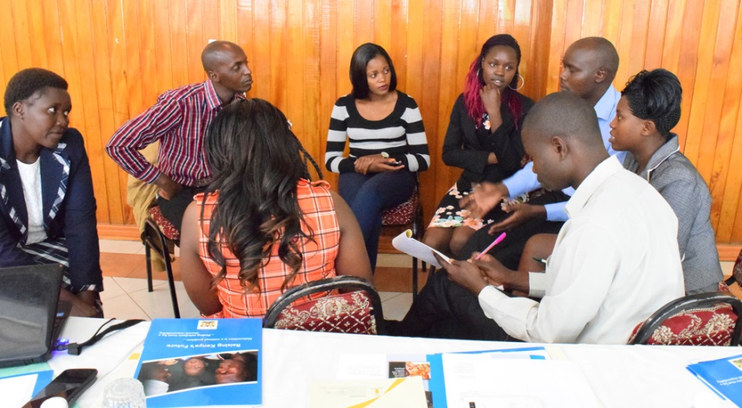

Journalists in group work session during SUN CSA county media training in Nakuru

***2.6 Coordination with other SUN networks is strengthened***

During the period under review, the CSA participated in and contributed to all SUN movement global teleconferences. The SUN CSA participated in the teleconference where the Kenya networks committed to participate in the Financial Tracking of Nutrition Investments across nutrition relevant sectors. Kenya has since completed the exercise and results were included in the Global Nutrition Report 2015, which was launched in September 2015. The SUN CSA also shared on their participation in the Post 2015 Development Agenda through the Kenya Post 2015 CSOs Reference Group.

The SUN CSA participated in the follow up Financial Tracking of Nutrition Investment across nutrition relevant sectors workshop and review of the reports in the period under review. The CSA also participated in the SUN Technical Working Group and contributed to the development of the terms of reference for the working group, development of a position paper on Multi Stakeholder Platform (MSP) establishment and the development of the First Lady’s Advocacy Strategy.

At the same time, the Alliance was represented at the Global Nutrition Report 2014 East Africa Launch which was held in Tanzania as well as National Coordinators Strategy meeting. The meeting was attended by seven countries - Kenya; Uganda; Tanzania; Ethiopia; Rwanda; Malawi and; Burundi. During the launch, deliberations focused on alternative sources of funding for the CSAs and sharing of common challenges and feasible solutions in the region. More so the CSA played a key role in the launch of the Global Nutrition 2015 & 2016 Report in November 2015 and June 2016 respectively during which Kenya’s success as the only country making progress towards achievement of the set nutrition World Health Assembly targets was highlighted. Various SUN Networks further pledged their commitment to support scaling up nutrition in the country during launches. SUN CSA worked in close collaboration with the other networks to invite the First Lady of the Republic of Kenya H.E Mrs. Margaret Kenyatta.

**Result 3: CSA advocates for increased commitment and accountability in scaling up nutrition**

***3.1 Packages for communicating nutrition in a simplified manner developed for specific audiences***

During the project period, the CSA produced Information Education and Communication (IEC) materials for specific audiences; these included SUN CSA profile, key nutrition messages for the Post 2015 Development Agenda, branded folders, T-shirts banners and badges. This increased the CSA’s visibility during national and international forums/events.

Targeted dissemination of the IEC material took place during the World Breastfeeding Week, National Nutrition Week 2014, the launches of the Global nutrition reports in 2014, 2015 and 2016, during the visit of H.E. the First Lady of Kenya visit to Baringo County, national and county level nutrition advocacy trainings, Nutrition Technical Forum and SMAC workshop held in Tanzania in September 2014.

***3.2 Identification of nutrition champions for scaling up nutrition***

Nutrition champions are individuals who exemplify good citizenship, integrity and credibility, and represent a positive role models for Kenyans at the county level. The SUN CSA supported the Nutrition and Dietetics Unit to develop criteria for the identification of nutrition champions in the country. The champions participated in media debates, press conferences and interviews on nutrition in their counties and advocated for scaling up nutrition at different levels. In the picture, Her Excellency The First Lady of the Republic of Kenya, Mrs. Margaret Kenyatta – who is the National Nutrition Patron for Kenya - is taken through the SUN CSA materials during the National Nutrition Symposium in February 2015 by the former SUN CSA coordinator.

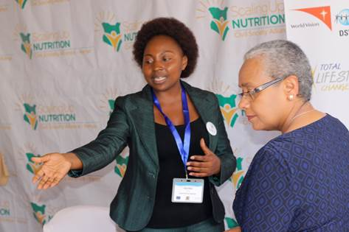

Former Coordinator speaks to First Lady H.E Margaret Kenyatta

The SUN CSA also participated in developing the draft Advocacy Strategy for the engagement of the First Lady of the Republic of Kenya as the National Nutrition Patron under the national SUN Technical Working Group.

Further, the SUN MPTF funded counties were supported to identify nutrition champions to raise the profile of nutrition. SUN CSA members from four of the six counties that are implementing the MPTF project and members implementing the Generation Nutrition Campaign supported the first Nutrition Champions Workshop in Nairobi in December 2015. This was attended by among others Josephine Kachapin - West Pokot County First Lady; Mary Mariach - West Pokot Chairlady, *Maendeleo ya Wanawake* Organisation; Roseline Leiro- Assistant to Baringo First Lady & SUN Secretary; Rukia Mohamed - Wajir County First Lady; Josephine Nkedianye - Kajiado County First Lady; and Paul Mero - Isiolo County Chief Whip. Most of the nutrition champions have also been involved in the launch of the County Nutrition Action Plans (CNAP), in campaigns against child obesity and in the promotion of kitchen gardens farming through mother-to-mother support groups.

In Baringo County, a Multi-stakeholder Forum was formed and embedded onto the County Steering Group chaired by the County Commissioner to enhance sustainability. The forum deliberated issues around inclusion of all partners working on nutrition sensitive and nutrition specific interventions, advocating for more nutrition funding in the coming budget in the key relevant ministries.

The SUN CSA held a meeting with the Health Cabinet Secretary Dr Cleopa Kilonzo Mailu with regard to Kenya’s participation at the World Health Assembly in 2016, which he attended and made various commitments on health.

***3.3 Key partnerships and inter-agency collaboration***

The CSA established relationships nationally and internationally, aimed at ensuring different member organizations support activities financially and technically. The Food Agriculture Organization (FAO) offered financial and technical support for the first county nutrition advocacy training. Nutrition advocacy facilitators for the CSA trainings were drawn from Action Against Hunger, Kenya AIDS NGO Consortium, Grassroots Alliance for Community Education (G.R.A.C.E) Africa, Total Lifestyle Change, Concern Universal, Feed the Children, Food for the Hungry, Save the Children, Kenyatta University. The approach was cost-effective and strengthened the advocacy capacity of CSA members.

During the implementation period, the CSA mobilized resources from the Population Reference Bureau (PRB), a US-based organization implementing advocacy programs in some African countries, mainly on Informing Decision-Makers to Act (IDEA), Communicating Research Results to Policy Makers and Re-energizing Nutrition Worldwide (RENEW). The CSA received US$35,365 from PRB to implement activities at the county level during December 2014 to May 2015 period.

Additionally, there was a strategic collaboration and resource mobilization for the CSA from the Food and Agriculture Organization (FAO) which co-funded the training in West Pokot County. With support from PRB, a multimedia video for the nutrition sector in Kenya was updated after the release of the 2014 Kenya Demographic Health survey. The multimedia video for rallies the county governments to allocate a budget line for nutrition ([https://www.youtube.com/watch?v=Pcw654XYFyU](https://www.youtube.com/watch?v=pcw654xyfyu))

**Key recommendations and Lessons learnt**

* 1. Working with the County Nutrition Coordinators in the mapping of Civil Society Organizations at the county level proved to be more effective as they work closely with these partners. Mapping should be expanded to capture other nutrition sensitive sectors.
  2. The development of the CSA strategic plan is critical and will guide smooth implementation of CSA activities and identification of CSOs from the national to the grassroots level, building their capacity and promoting their role in scaling up nutrition at various levels.
  3. Rigorous mobilization is key in ensuring active participation of the County Governments in nutrition advocacy; this should involve courtesy calls to county leaders prior to the trainings and other advocacy activities at the county level.
  4. The CSA will share periodic updates with other SUN networks as well as key stakeholders. This will be enhanced when the national SUN multi-stakeholder platform is established.
  5. In order to ensure more active participation, there is need to involve more county executives committee members in upcoming advocacy trainings, conduct adequate mobilization among county teams and share periodic updates with officers within counties.
  6. There is need for the CSA to undertake media mapping for both national and local media houses, actively utilize media talk shows and print media columns, as well as encourage members to share articles in media.
  7. The engagement of the CSA in the county budgeting process should start on time to ensure maximum participation, engagement and impact.
  8. There is need to ensure all counties complete and launch the County Nutrition Action Plans (CNAP); and for the CSA to incorporate an overview of the National Nutrition Action Plan in upcoming trainings and to mobilize more County Government officials to participate in advocacy workshops.
  9. To ensure more active participation, there is need to involve more County Executives committee members in upcoming advocacy trainings, conduct adequate mobilization among county teams and share periodic updates with officers in counties.

**Implementation Constraints**

* 1. The establishment of the CSA governance structures was an intensive and challenging process, an issue that greatly contributed to delays in implementation of planned activities. Moving forward, the now established governance structures and rules of engagement will ensure a smooth running of the CSA activities.
  2. The recruitment of the CSA National Coordinator delayed as few suitable candidates were shortlisted in the first round. Re-advertisement of the position was done and the National Coordinator was recruited late June 2014 with a second recruitment in Jan 2016 following a vacancy creation.
  3. Due to the insecurity in Mandera and Wajir Counties, some of the CSA priority counties hampered the roll out of planned nutrition advocacy trainings.
  4. Lean staffing in the SUN CSA Secretariat meant follow though of action points was a challenge, given the National Secretariat has only one staff who receives technical support from various members of the Executive Committee.

### V. FINANCIAL IMPLEMENTATION

The financial report is attached separately

**Annexes**

**Annex1: List of CSA Members**

|  |  |
| --- | --- |
|  | Action Against Hunger (ACF) |
|  | Action Aid |
|  | Africa Online |
|  | AMREF health Africa |
|  | Association for the Physically Disabled of Kenya |
|  | Capacity Kenya |
|  | Catholic Agency for Overseas Development |
|  | CISP |
|  | Concern Worldwide |
|  | Concern Universal |
|  | Consumers Federation of Kenya |
|  | Crown the Child |
|  | DSW |
|  | Feed the Children |
|  | Food for the Hungry Kenya |
|  | Global Alliance for Improved Nutrition |
|  | GRACE Africa |
|  | Health Poverty Action |
|  | Health Unlimited |
|  | Hellen Keller International |
|  | International Medical Corps |
|  | International Rescue Committee |
|  | Islamic Relief Kenya |
|  | Karibuni Kenya |
|  | Kenya AIDS NGOs Consortium |
|  | Kenya Freedom from Hunger Council |
|  | Kenya Red Cross |
|  | Mercy USA |
|  | Micronutrient Initiative |
|  | Mothers to Mothers |
|  | NOPE |
|  | OKOA Foundation for development |
|  | PATH |
|  | PS Kenya |
|  | Save the Children |
|  | Self Help Africa |
|  | Total Lifestyle Change |
|  | Trocaire |
|  | Uzima Aid |
|  | Veterinaries Sans Frontiers-Suisse |
|  | We World Kenya Foundation |
|  | World Friends (Kenya) |
|  | World Vision |
|  | Zamzam Medical Clinic |