UNITED NATIONS DEVELOPMENT PROGRAMME

TRAVEL/MISSION REPORT SUMMARY

 | TRAVEL/MISSION REPORT SUMMARY
REPORT TITLE: Back-to-Office report on “Sustaining peace and improving social cohesion through the promotion of rural employment opportunities for youth in conflict-prone areas” Project, Zorzor, Lofa County.
SUBMITTED BY:  John R. Dennis, M&E Analyst, LMPTF-PBF Joint Secretariat.  Patrick Baysahwala, driver. |  | DATE: September 20, 2019.
TRAVEL DATE: September 19, 2019 | LOCATION: Zorzor, Lofa County
PARTICIPANTS: 44 participants (70% female and 30% male) attended the Community Based Participatory Planning (CBPP) meeting in Zorzor Town, Lofa County. The gathering saw the presence of representatives from the quarters in Zorzor.
- OBJECTIVE/PURPOSE OF TRAVEL:
The LMPTF-PBF Secretariat mission was intended to attend the dialogue meeting of community stakeholders in Zorzor Town, Lofa County, one of the four communities selected to conduct Community Based participatory Planning, aimed at developing an inclusive community action plan which will serve as roadmap to setting up local based alternative dispute mechanisms to resolving land, ethnic and religious related conflicts. The event was in response to Activity 1.2.1 of Output 1.1 of the project. The World Food Programme (WFP) invited the secretariat to observe the four-day (September 17-20) event, which was a precursor to identifying the triggers of conflict prior to full rollout of planned activities.

- EXPECTED OUTPUT OF THE MISSION
- Follow the conduct of the dialogue and gather firsthand information to determine value for money;
- Prepare and submit a Back to Office Report capturing key results.

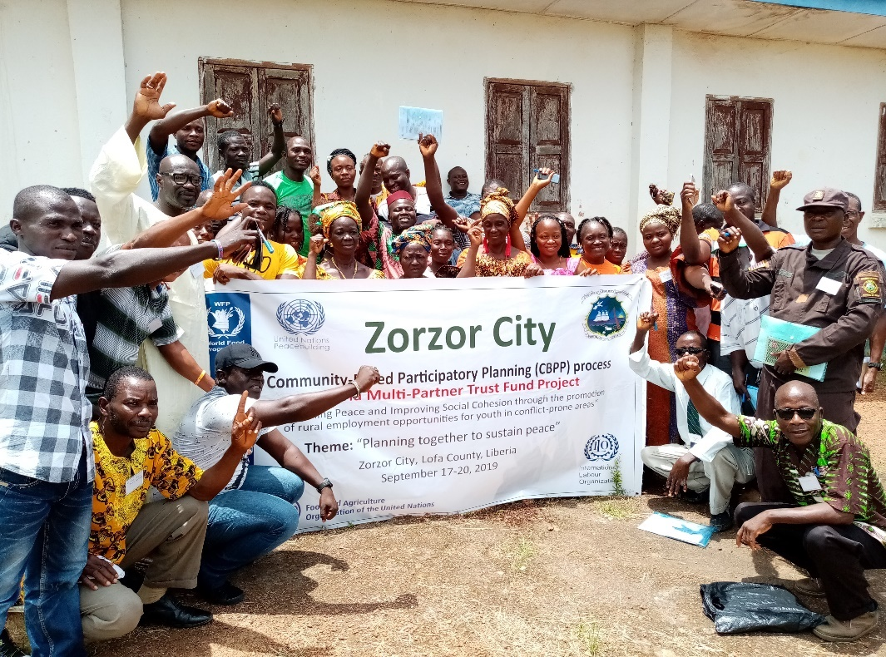
Summary of the key Findings
The LMPTF-PBF Secretariat team attended the final day of the dialogue where a cross-section of community and local stakeholders presented findings of a three-day intensive dialogue on the identification of conflict triggers and proposed conflict resolution mechanisms. The dialogue gathered 44 participants (70% male and 30% female) inclusive of women and youth leaders, representatives of religious community, local security taskforce, representatives from the ministries of Agriculture, Youth & Sports, Education, district and subdistrict levels, county authorities including the city major. The gathering gave renewed hope to the participants in the small auditorium of the youth centre, where they often gather to discuss issues of pertinence. There were five thematic groups: a) Peace & Security b) Food Security c) Health d) Education and e) Infrastructure. As each of the groups came to present, they were cheered by fellow group members creating an environment overshadowed by strong feelings of optimism to have a workable solution to the protracted land and ethnic conflict that has engulfed the second largest town in Lofa County, since the crisis ended in August 2003. The 14-year crisis deeply popularized citizens of that part of Lofa County. Zorzor changed hands many times during Liberia’s war years between LURD rebel group, comprised of mostly the Mandingo ethnic Group and Charles Taylor’s Government forces. Lofa is predominantly consist of the Lorma ethnic group, which is followed by Kpelleh and then Mandingo. The euphoria in the room presented a community ready to implement a project full of enthusiasm.
Figure 1 Optimistic Participants at the end of the dialogue
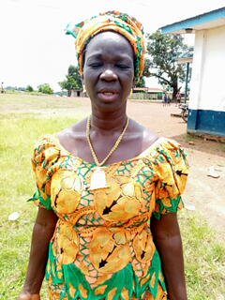
“I prefer eating my dry rice (not very palatable) and go to bed in peace rather than being confronted with continued conflict. I am very much happy that we can sit and frankly discuss solutions to our own problem as a community. We appreciate the Peacebuilding Fund support especially at this period of our country’s history when senatorial election will be held in 2020. The intervention will help to prevent election violence”, said Garmai Gbelee, City Major of Zorzor.

Presentation:

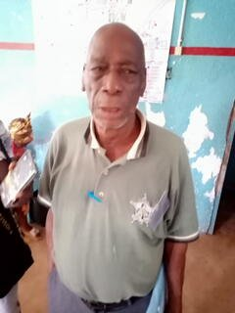
- Peace and Security: The group admitted entrenched religious and ethnic divide in their communities; leading to diverse conflicts including land ownership. A number of solutions to address these conflict triggers was proffered: Strengthen existing peacebuilding structures in Zorzor, establish peacebuilding focal points in each of the six quarters of Zorzor, where the focal points will serve as first response through regular holding of palava hut discussion to popularize peace and conflict mitigation messages working closely with local government authorities, the Peacebuilding Office and other relevant institutions. They recommended continued youth engagement in the development and implementation of peacebuilding strategies, among other things.
Figure 2 County Peace Committee Chair William Howard making a presentation

- Food Security: Lofa County, prior to the crisis, was considered the breadbasket of Liberia. This maxim short-lived after the crisis, with most of its citizens joining the wagon to largely survive on foreign grown food. This group set a target by 2024, food should be available, accessible and affordable for the people of Zorzor. While this may seem ambitious, they were resolute to use this project as a pilot to achieve their goal in the next five years, after the project shall have long ended. Among strategies listed to achieving the goal include: massive awareness on food security, increase agriculture extension services and promote agriculture in high schools (school farms) in all districts of Zorzor. FAO, Ministry of Agriculture, WFP, Ministry of Education and other local and international nongovernmental organizations were listed as partners to support this goal.

- Health: Initial mapping conducted by WFP in collaboration with the community on day one of the workshop elevated poor health as one of the potential conflict triggers in the target communities. The group said the maintenance of peace cannot be discussed in the absence of good healthcare. The community hoped within 5 years Zorzor would have improved healthcare and effective service delivery. To achieve this, they planned to engage partners in healthcare delivery through the submission of proposals and engaging their law makers for government’s urgent attention. To gain donors’ confidence, they promised to carryout community mobilization to secure land for the construction of health centers, ahead of donor support. Currently, Zorzor has one major hospital that is owned by the Lutheran Church. The Government doesn’t have a hospital in the town; but it provides subsidies to the hospital. Given the obvious economic situation faced by the government, the hospital is not exempt from challenges experienced by other health centers across the country.
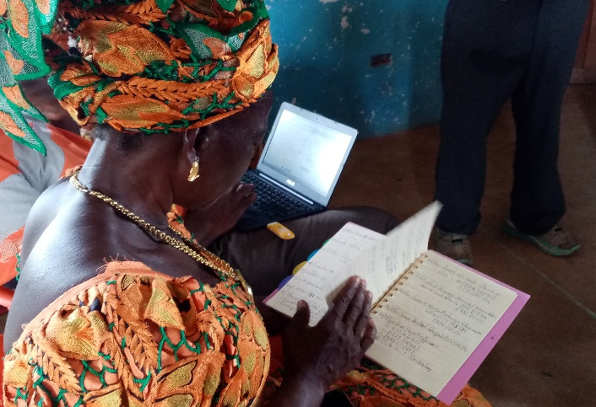
- Education: Lofa County is one of the counties in Liberia that has won the admiration of most Liberians for topping the list of highly educated people. They could not afford to leave out educational reform as one of their action plans. The group believed without quality education, the tendency for violence will continue. As a strategy, they planned to engage and encourage the enrolment of more young people, while at the same time negotiate with community leaderships for the provision of lands to construct additional schools in the next five years. They also believed that educating people to engage in agriculture will support the alleviation of poverty, reduce conflict and increase social cohesion.
Figure 3 The City Major of Zorzor Hon. Garmai Gbelee reviews key points
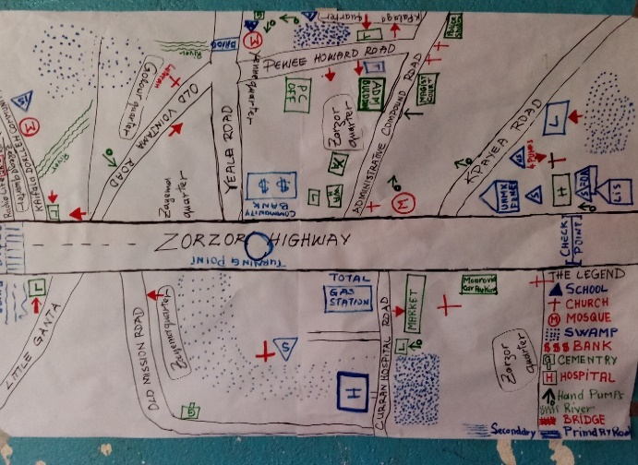
- Infrastructure: This thematic group indicated infrastructure as one of the core areas , which may seem weird for a peacebuilding and food security project, but community mapping conducted to identify conflict triggers substantiated the argument of the beneficiaries. Although the crisis ended about 15 years ago with three democratic elections held, the scars of conflict remain visible with the absence of basic infrastructural development. The war devastated Zorzor, a frequent battlefield showered with bullets up to the cessation of hostilities in August 2003. Among challenges identified, was the rehabilitation of damaged wells and the construction of additional handpumps to address the imperative need for safe drinking water, to avoid conflict over the use of the few existing wells/handpumps. Mapping conducted by the community with the guidance of WFP technical support captured existing resources and potential areas for investment.
Figure 4 Community Resource Profile developed by participants
- Final Decision: It was agreed by participants that their recommendations be consolidated into a Community Action Plan by WFP in accordance with the agreed categories; and a follow up validation session be organized to clear the document.

- Challenges
- While the project has great potential to succeed, coordination between implementing agencies (WFP, FAO, ILO) remains elusive, thereby defeating the modality of joint project. FAO and ILO were not present at such important convergence of community and local stakeholders. This is in violation of the second to last paragraph (p-5) of the prodoc which states: “FAO, WFP and ILO will jointly implement the proposed project in close collaboration with their its implementing partners that
which include, among others, the Ministry of Youth and Sports, Ministry of Agriculture (MOA), the Ministry of Labor, local government representatives and civil society organizations working on bottom-up, alternative land dispute resolution and livelihood support and development”.
- Bad road condition at this time of the year may impede the smooth implementation of the project.

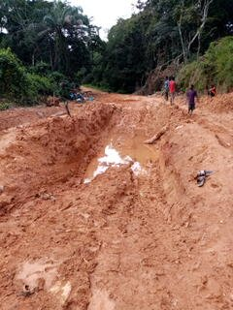
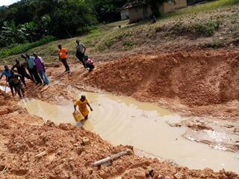
- Lessons Learned
- Various presentations made at the dialogue did not clearly state how incoming interventions will build on existing peacebuilding infrastructures (County Peace Committees, Peace Huts, Early Warning reporters etc) coordinated by the Peacebuilding Office and other relevant institutions. This was raised by the Secretariat and acknowledged by the chair of the County Peace Committee of Lofa County Mr. William Howard, who promised to incorporate it during the validation of the Community Action Plan.

- Recommendations

- FAO, WFP and ILO should complement each other in the spirit of joint implementation. While the agencies are responsible to account for what each has received, they shouldn’t see the implementation of their respective outcome areas as separate projects. If this is not addressed, it may affect the way beneficiaries view the project.

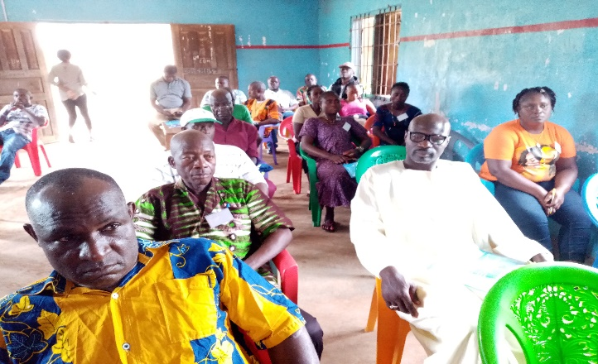
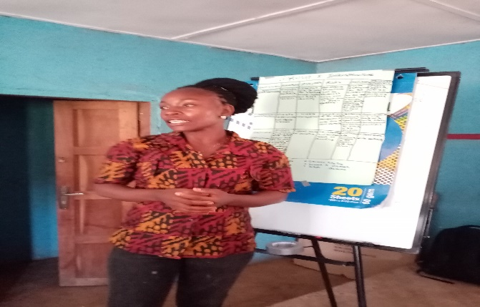
Pictorial of the dialogue

A partial view of participants
A member of the community makes presentation findings

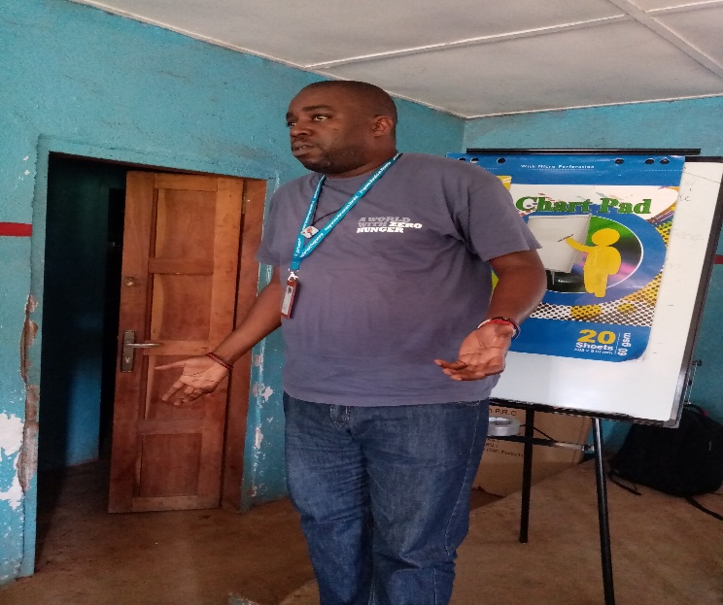

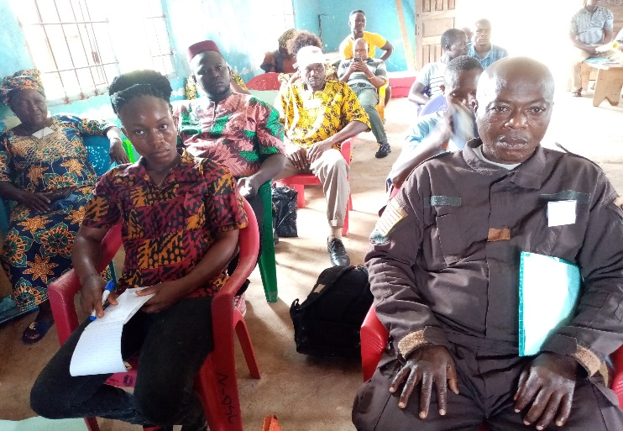

A partial view of participants

Lonnie of FAO makes a point

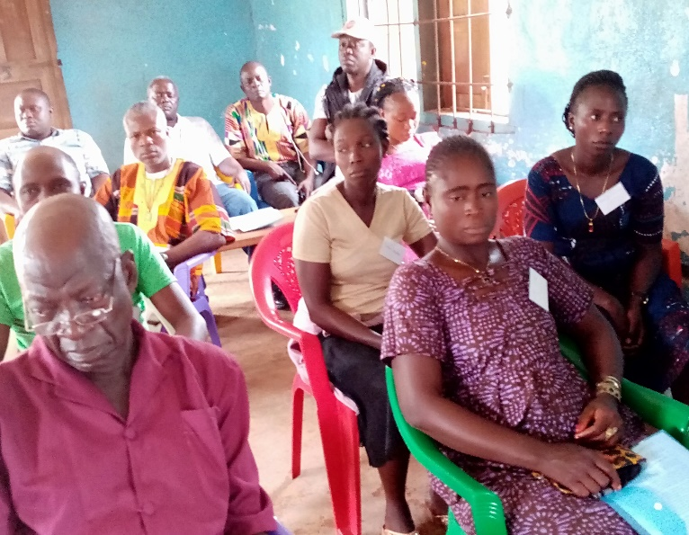
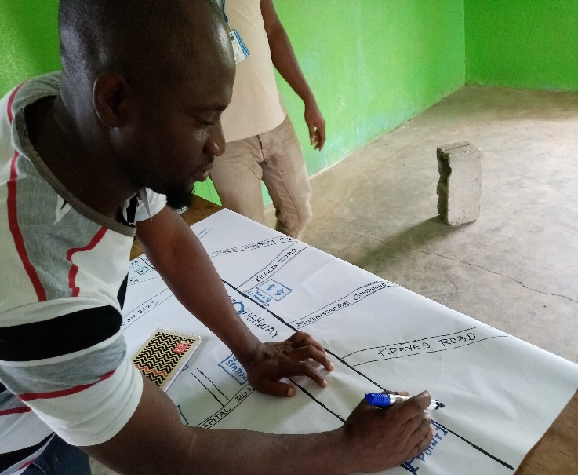

Community and resource profile map being developed by a participant
A cross section of participants

