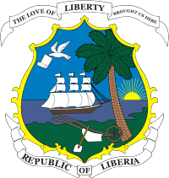
United Nations Development Programme
Cross Border Project Activity Report
June 19 -25, 2018
Maryland County

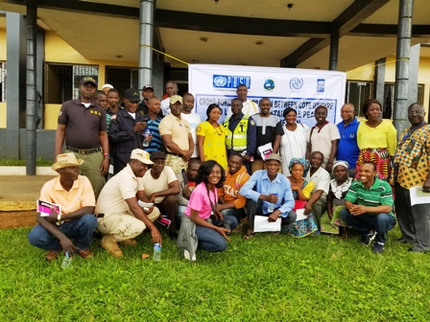
GROUP PHOTO WITH COUNTY AUTHORITIES
AT THE HARPER CITY HALL
HARPER CITY, MARYLAND COUNTY

Table of Contents

Executive Summary ii

Acronyms iii

Background 1
- Implementation Progress 2 -12
- Mission Methodology and Results 13
- Challenges 13
- Recommendation(s) 14

Appendix

- Information Sharing Templates 14
- Field Activity Photos 15

i

Executive Summary

This report highlights major activities under taken by the United Nations Development Programme and partners under the UNDP/IOM Cross-Border Corporation between Liberia and Cote D’Ivoire. This report covers one week long travel and holding of three days of separate activities in Harper and Dukudi (Kpellopo) Border community, Maryland County. The activities include:

- Day 1 –June 21, 2018 – Harper City -- Consultative meeting with Civil Society Organizations (CSOs), Security Agencies, County Authorities, Traditional leaders, youth and women.

- Day 2 –June 22, 2018 –Harper City -- Consultative meeting and discussions with Civil Society Organizations (CSOs) on the modalities of implementing planned cross-border activities.

- Day 3 –June 23, 2018 -- Duokudi (Pedebo) Border Community -- Consultative meeting with security and community members; and Inter-Community sporting between the Joint Security and Communities.

The report also contains challenges and proposed recommended actions or way forward for the attainment of peace and social cohesion in the border communities in the two countries.

ii

Acronyms

CSO Civil Society Organization
UNDP United Nations Development Programme
IOM International Organization on Migration
JCCEM Joint Committee of Chiefs and Elders Meeting
AWP Annual Work Plan
CBO Community Based Organization
CBW Cross Border Women
SEWODA South-eastern Women Development Association
TOR Terms of Reference
LDEA Liberia Drugs Enforcement Agency

iii

Background
Since the signing of the peace treaty in 2003 UNMIL has been in Liberia protecting Liberian authorities and the civilian population from threat of physical violence, and supporting the reform of security and justice institutions, and promoting, protecting and monitoring human rights activities. With UNMIL drawing down, the Liberian government assumed full national security responsibility on June 30th 2016, as per the Security Council Resolution 2239 (2015).

With the fragile situation along the Liberian –Cote D’Ivoire borders, UNMIL and UNOCI established by the United Nations to facilitate the implementation of the respective peace agreements, were requested with UNMIL and PBF Assessed funding to develop programmes to address tension and incidents of violence in communities along these borders. These communities share many social-economic and cultural dynamics, with peace and security in one country influencing developments in the other country.

Considering the mission drawdown in both countries, recent elections in Liberia and the last elections in Cote d’Ivoire, coupled with growing tensions between communities across borders including tension between indigenous and non-indigenous populations, the Presidents of both countries, during the Joint Committee of Chief and Elders Meetings (JCCEMs), called for increased social cohesion along the borders.

In the light of the above, the project - Cross-Border Cooperation between Côte d’Ivoire and Liberia for Sustainable Peace and Social Cohesion - aims to increase cooperation and trust between Ivorian and Liberian border communities through strengthening social cohesion and border security. This remains crucial and most appropriate, especially now that the missions are almost closed, and aligns with its Outcome 1:

- Increased confidence between security forces/agencies and border communities through enhanced capacity of joint local cross border mechanisms, as well as increased intra-/cross-border cooperation Improved social cohesion and peaceful co-existence in cross border communities through cross border community dialogues and reinforcing cooperation between existing local conflict resolution mechanisms strengthened by cross-border cooperative socio-economic stabilization and cultural exchanges.

In fulfilling this task, the project team together with its national partners organized and implemented series of project activities despite of the bad roads, tropical climate and reduce travelling time by jointly organizing a series of meetings, sporting and peace-building activities for the targeted beneficiaries, including member of the security agencies, Ministry of internal Affairs, Women groups, Youths and other key members. These activities were geared to promoting peace and social cohesion amongst members of the security agencies and in project communities within the counties in Liberia.

1
These activities proceeded the joint Liberia-Côte d'Ivoire project review meeting held in May 2018 in Monrovia where the Annual Work Plans (AWP) were reviewed and outstanding activities before the closure of the project were discussed.

The specific objectives of the mission were thus:
- To organize peace and security (meetings) between relevant agencies in Maryland County, especially in the project communities along the borders.
- To establish channels for regular information-sharing (meetings)
- To organize inter-community sports/cultural activities and peace/trust-building campaigns between security agencies/forces and communities in Liberia.
- To support CBOs to organize cross-border cultural exchanges and sporting activities for law enforcement officials and communities.

Implementation Progress
- Day 1 –June 21, 2018 – Harper City -- Consultative meeting with Civil Society Organizations (CSOs), Security Agencies, County Authorities, Traditional leaders, youth and women.

Opening session and welcome remarks

The welcome and opening remarks were made by Maryland County Superintendent, Hon. ------------ Pratt. He thanked the organizers and encouraged participants to put in full time in the discussions to enable them find lasting solutions to the challenges of the county. The Superintendent outline two key challenges affecting the county that if not addressed will destroy the growth and development of the county.

- The influx of illegal aliens, especially Ghanaians who are occupying many parts of the county and carrying on illegal mining activities. He blamed this squarely on the local authorities and warn them to stop harbouring illegal aliens.

- The sale and use of narcotic drugs by youth around Harper City. The Superintendent explained that Harper City currently have three major drugs centers with the ‘Embassy” used as distribution point. He said that his office is currently working with the County Attorney and the Joint Security to engage these drug centers.

Overview of project and meeting objectives

The project overview was provided by Mr. Christopher Fayia of the Liberia Peacebuilding Office. He provided brief history and rationale for the development and implementation of the project in the two border countries.

2
On the objective of the meeting, Mr. Fayia indicated that this project will be ending in August with final closure in October 2018. However, before this final closure there are still activities to be implemented jointly with Cote D’Ivoire but Cote D’Ivoire is not currently prepared as many of their security personnel along the borders are new and need some time to adjust. So this visit was an in-house planning visit so as to review achievements and implementation challenges and make necessary recommendations that both countries can share when a joint meeting is organized.

Special remarks:

Special remarks were made by the Liberia National Police; Liberia Immigration Service (LIS); Liberia Drugs Enforcement Agency (LDEA); Harper City Mayor; Ministry of Justice (County Attorney); Head, Civil Society Organizations and the President, Cross-Border Women. Each of these speakers praised the project for the level of support and the unity it has helped to build between the securities and the local communities. The also buttressed the Superintendent by emphasizing the implication the use of drugs by young people is to the county indicating that some of the streets in Harper are not assessable for free movement after 8:00 pm. They promised to work together to address the challenges.

Discussions
Group work and presentation

Participants were divided into four groups with the below issues and questions for discussion and presentation:

- What impact has this project make to you and the community (from Start to end).
- What sustainability plan can put in place to continue your engagements in the absence of Donor support?
- What are the current challenges and how can they be mitigated at your local level?
- What role can each sector play in complementing each other to increase cooperation and trust along the border?
- Make recommendations to improve social cohesion and security on both sides of the border.

3
Following the groups’ presentation, the most common suggestions and recommendations were compiled as reflected in the boxes below.

What impact has this project make to you and the community (from Start to end) | What sustainability plan can put in place to continue your engagements in the absence of Donor support? | What are the current challenges and how can they be mitigated at your local level? | What role can each sector play in complementing each other to increase cooperation and trust along the border? | Make recommendations to improve social cohesion and security on both sides of the border.
-Improved Security, Chiefs, Community members and CSOs relationship in networking on Cross Border issues.  -Regular meeting  -Logistical support  - Build collaboration and social cohesion between the two countries | -Government should include money in the County Development for Consultative meeting along the borders and support quarterly Cross-border sporting activities.  - GOL take ownership and give political will for the implementation of future action plans. | -Aliens entering the country illegally at the unrecognized crossing- community dwellers provide information to the securities.  -Limited man Power along the borders, therefore GOL should increase security officers at the border points.  -Lack of electricity at border post. Post should be connected to the West Africa Power lines passing in front of the security gate. | -Joint patrols  -Regular joint security meetings.  -Respect of Human rights by all officers across the two countries. | -Encourage cross border trade ( market at both sides of the borders)  -Regular Security meetings ( all actors)  -Cross Border Sporting activities  -Identify and report issues to the relevant sector  -Involve local leaders in investigations  -Awareness raising through radio top shows

4
After the group presentations, brief closing remarks were made by the City Mayor who thanked the participant for the fruitful discussions. The closing prayer was done by one of the participant to climax the day.

Day 2 –June 22, 2018 –Harper City -- Consultative meeting and discussions with Civil Society Organizations (CSOs) on the modalities of implementing planned cross-border activities.

Opening session and welcome remarks

The welcome remark was made by the Head of the Civil Society Organizations, Mrs. Lucy Jappy Momo. She thanked the organizers and pledged the CSOs readiness to support and continue the work of the Cross-Border project. Mrs. Momo also a cross-border business women emphasized how this project has helped to improve trade relationship and social interactions between the two countries.

Overview of project and meeting objectives

The project overview was also provided by Mr. Christopher Fayia of the Liberia Peacebuilding Office. He provided brief history and rationale for the development and implementation of the project in the two border countries.

On the objective of the meeting, Mr. Fayia indicated that this project will be ending in August with final closure in October 2018. However, before this final closure there are still activities to be implemented jointly with Cote D’Ivoire but Cote D’Ivoire is not currently prepared as many of their security personnel along the borders are new and need some time to adjust. So this visit was for in-house planning so as to review achievements and implementation challenges and make necessary recommendations that both countries can share when a joint meeting is organized. In addition, we must work together to finalize the Terms of Reference (TOR) for the CSOs to support Cross-Border activities in enhancing and promoting social cohesion and cooperation between communities in Liberia and Cote D’Ivoire.

Special remarks:

Special remarks were made by the Maryland Youth Association; World African Progressive Organization; Restoring Community Hope; Women Initiative for Sustainable Empowerment; and Women in Cross-Border Trade. Others were the South-eastern Women Development Association (SEWODA); Community Watch Forum; Association of People with Disability; and closing comments again by the Head of the Civil Society Organizations. All of the institutions expressed enormous benefits this project has brought to the county by improving

5
relationships and enhancing social cohesion between the two countries and the communities along the border.

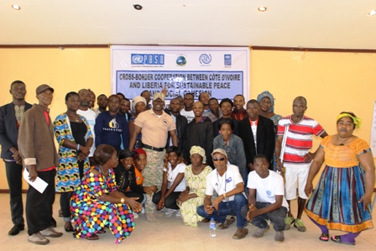
Photo with members of Civil Society Organizations

Discussions

Group Work and Presentation

Participants were divided into four groups with the below points for discussion and presentation:

- Outline the roles of CSOs in Supporting Community Peace Initiatives at the borders.
- Develop 5 count TOR of the things CSOs should do in working with community along the border to improve social cohesion and security.
- What are the challenges that CSOs face in working with community members and security officers in promoting peace along the borders.
- Make recommendations for improving relationships amongst the various Sectors (CSOs, Security, Local Authorities, Media, etc.), that will lead to sustained peace and social cohesion.

6
Following the groups’ presentation, the most common suggestions and recommendations were compiled as reflected in the boxes below.

Outline the roles of CSOs in Supporting Community Peace Initiatives at the borders | Develop 5 count TOR of the things CSOs should do in working with community along the border to improve social cohesion and security | What are the challenges that CSOs face in working with community members and security officers in promoting peace along the borders | Make recommendations for improving relationships amongst the various Sectors (CSOs, Security, Local Authorities, Media, etc.), that will lead to sustained peace and social cohesion
- Promoting networking and Social dialogue  - Developing an efficient monitoring and evaluation system  - Supporting the security sectors  - Implementing activities to enhance peace and social cohesion  - Promoting and rebuilding trust in the society  - Enhancing local participation  - Serving as liaison and sub-contractor for national and international agencies. | - Organize monthly Palava hut discussions/dialogues  - Identify key players in the community  - Improve networking  - Create aware on social and security issues.  - Ensure cooperation, transparency and accountability amongst actors.  - Information Sharing  - Working with Cultural groups in promoting peace  - Collaborating with security and Communities dwellers. | - Lack of efficient monitoring system  - Lack of information sharing and confidentiality  - Lack of resources  - In active response from partner to CSOs  - Poor network connectivity at the borders  - Bad road condition  - Difficulty in getting to local leaders  - Lack of trust between CSOs and Security | - Joint meeting bringing all actors together including those from the Ivorian side  - Partners should continue to organize more training for CSOs.  - Protecting the source of information  - CSOs should give information to security base on facts  - Continue broadcast of peace massages on the media.

7
Specific Tasks for CSOs

The participants and facilitators then brainstormed and finalized the Terms of Reference (TOR) for Civil Society Organizations (CSOs) which will serve as guide for CSOs in the implementation of cross-border activities.

The scope of services of the CSOs shall include the following activities:

- Providing support to the border communities through collaboration and coordination in organizing meetings, sporting, cultural as well as trade fairs.

- Supporting locally established community based structures through coaching and mentoring in facilitating meetings and other activities geared toward enhancing and promoting social cohesion and cooperation.

- Training community facilitators and members of local structures (e.g. village health teams, local council, religious institutions, traditional leaders, schools) on sustainability.

- Integrating activities to transform gender attitudes, behaviours, and relationships in implementing cross-border activities.

- Empowering local communities in sustaining all activities gear toward the promotion and enhancement of peaceful co-existence along the borders with Cote d’Ivoire.

- Providing oversight role and coordination in convening inter meetings /activities and cross-border activities in enhancing, promoting and sustaining peace and social cohesion.

- Submitting regular reports to County Authorities during the county development meetings, and share copies with the County Security Council.

Following this lengthy discussions on the TOR for the CSOs, closing remarks were made by the President of the Cross-Border Women, thanking the participants and organizers for the valuable time the devoted to the discussions. Prayers were then offered by a volunteer and the day two (2) activities were declared closed.

8
- Day 3 –June 23, 2018 -- Duokudi (Kpellopo) Border Community -- Consultative meeting with security and community members; and Inter-Community sporting between the Joint Security and Communities.
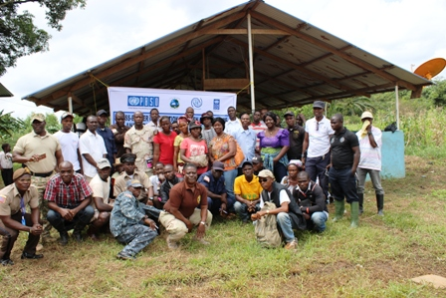
Photo of participants at the Border meeting

Opening session and welcome remarks

This indoor event started with a prayer by a volunteer. The welcome remark was done by the District Commissioner, Hon. _______________, _________________ District. He encouraged participants especially security institutions working along the border to continue engagement meetings even beyond the project as in his words, this will increase trust and enhance social cohesion.

Overview of project and meeting objectives

For the objective of the meeting, Mr. Fayia explained that this was an in-house visit to enable us review the project achievements and implementation challenges and do the necessary planning with recommendations that both Liberia and Cote D’Ivoire can share when a joint meeting is organized. He informed participants that information sharing template will be introduced and finalize at this meeting so that it becomes an information sharing tool for all institutions working at the border.

Special remarks:

Special remarks were made by the LDEA, LNP (Commander and Deputy Commander), LIS, Cross-Border Women and CSOs Head. Others who made special remarks included, the Youth
9
County Chairman, the Duokudi Town Chief, District Commissioner, County Attorney (Representative); and the County Superintendent (Representative). Each of the speakers emphasized the need to have love for County. Saying, if we love Liberia, nothing bad will happen again in this Country because all of us together will be able to solve any imminent threat. Coordination, Coordination and collaboration should be the vehicle through which we promote unity and social cohesion.

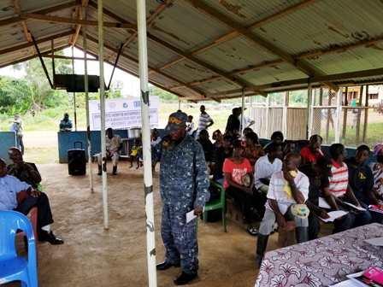
Liberia Drugs Enforcement Agency Border Commander making remarks
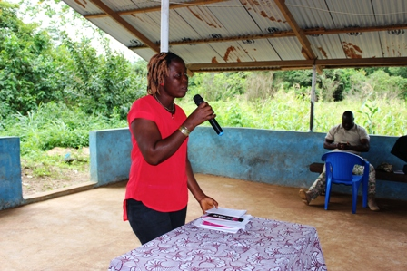
Chairperson, Civil Society Organizations, Maryland County making remarks
10

General Discussions

During the general discussions, the below three issues were put on the floor for comments. Each issue was treated separately by the participants with the following comments generated.

Gaps/challenges (Security and communities) | Sustainability of peace, security and cooperation | Recommendation moving forward
- Lack of electricity at the border post making it difficult to identity people crossing and / or by-passing the check point at night;  - Local communities and leaders hosting aliens, especially Ghanaians crossing illegally;  - Lack of interest by community leaders and some security actors to attend meeting and report on activities;  - Bad roads and weather conditions;  - Lack of network for effective communication at the border; and  - Poor information sharing amongst all actors. | - Joint planning and monitoring by security actors to reduce operational and material cost;  - Constant meetings and engagements by all actors with County Superintendent and or District Commissioner;  - Volunteerism –where citizens go around creating awareness on the need to be peaceful and coexist; and  - Exchange contact numbers with each other for information sharing and quick response. | - Citizens should stop hosting illegal aliens and allow security to do their work without interference and hindrance;  - Encourage and hold rational meetings at the different ports of entry;  - Citizens must use recognized ports of entry and avoid by-passes;  - Road users must recognize the time of closing and opening of border; and  - All local canons plying the Cavalla River must be marked and as well be parked at night at the border post when border is closed.

11
Information Sharing Template

The information sharing template was introduced to the body for discussion and was treated section by section. At the end of the discussions few suggestions were made to include name and contact of sender, and Child Abuse as additional incident type. (See finalized template in appendix I).

Upon the finalization of the Information sharing template, the meeting was adjoined and lunch served in preparation for the sporting activities.

Sporting Activities (Joint Security and Community members)

The sporting/football game was played on a local community field between the joint security and community members. Before the commencement of the game Mr. Christopher Fayia of the Peacebuilding Office pledged L$10,000.00 for the winner and L$2,000.00 for the first scorer. The kick-off was taken by the President of the Cross-Border women. Before the kick-off she encouraged the communities to unity and work together with the joint security to protect our borders and country admonishing them to take the sporting events to other parts of the community as a unifying mechanism.

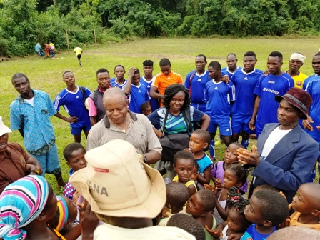
Promoting Social Cohesion through sports
12
Mission Methodology

The mission pursued social cohesion and peaceful co-existence through meetings and sporting activities aimed at encouraging peace exchanges between the communities and security actors in Harper and Duokudi (Pedebo) Border Community with activities taking place at two levels:

In-county- meetings amongst members of the security agencies and local border communities; and Inter-community sports/cultural activities and peace/trust-building campaigns between security forces and border communities.

The participants were security personnel, County Authorities and community members (including youth and women).

Results:
- Social cohesion, trust and peaceful co-existence along and amongst border communities and security agencies enhanced;
- Relationship and collaboration between communities and security apparatus improved;
- Tension and violent conflicts along and among border communities reduced, and the use of peaceful conflict resolution mechanisms for better appreciation and used; and
- Security concerns of the border communities, local authorities and other relevant stakeholders better appreciated to inform subsequent interventions.

Challenges

- Bad road condition;

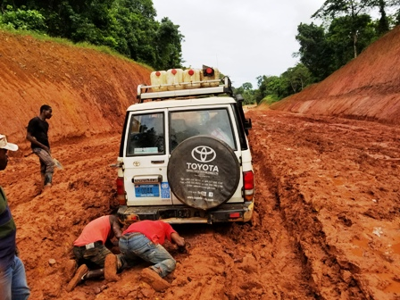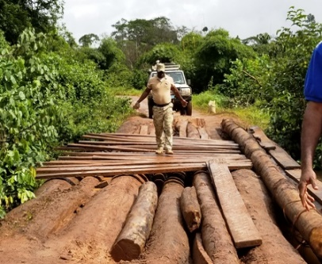

Pleebo –Fishtown Road Gray-Saclepea Bye-Pass

- Lack of electricity at the border post; and
- Poor communication network (GSM) along the border
13

Recommendation(s)

- Engage Cote D’Ivoire so that we hold a joint confidence building meeting before the closure of the project;

Appendixes
- Information Sharing Template

Cross-Border Cooperation between Cote D’Ivoire and Liberia for Sustainable Peace and Social Cohesion

INTER-ORGANISATION INFORMATION SHARING FORM
COUNTY:________________________________
FROM  (Organization) |  |  |  | TO  (Organization):
 | Person:
 | Contact#
INCIDENT (TYPE): |  | NO | LOCATION (District): |  | DATE:
 |  |  |  |  | TIME:
Theft |  |  | SUMMARY DETAILS (Add additional sheets if necessary):
Murder
Domestic Violence
SGBV
Burglary
Small Arms
Land
Narcotics
Illegal mining
Smuggling
Rape
Illegal logging
Human Trafficking
Child Abuse
Others (specify)
Gender Breakdown |  |  | Perpetrators | Male: | Female: | Total:
 |  |  | Victims/ Survivors | Male: | Female: | Total:

14
 | RECOMMENDATION /FOLLOW UP ACTION (Add additional sheets if necessary)
SUBMMITTED BY: |  | Signature |  | Date:
RECEIVED BY: |  | Signature |  | Date:

- Activity Photos

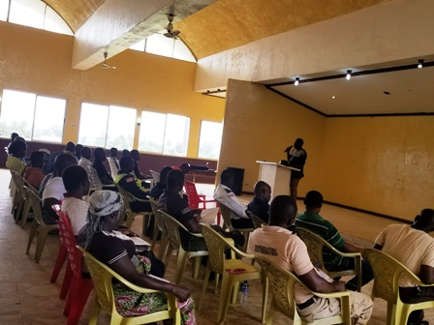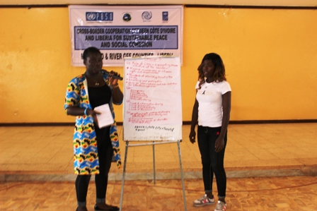
Superintendent Making Remarks Group Presentations

15
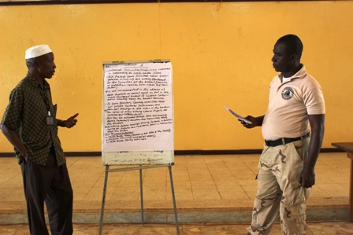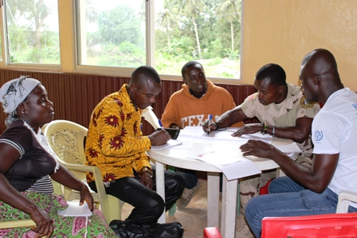
Group Work and Presentation
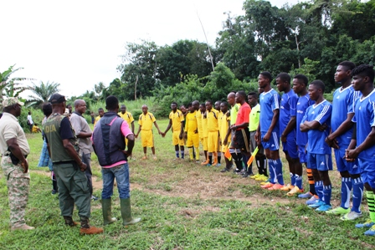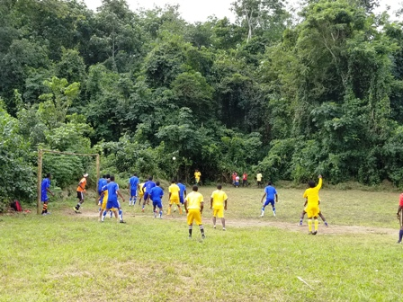
Football match between the Joint Security and Community members

Maryland Team members

- Monkonji Karr – UNDP (Maryland)
- Sarh Manasseh Felee – LIS
- Christopher Fayia – PBO/MIA
- George Yeomah (UNDP Driver)

16

