United Nations Development Group UNDAF Trust Fund

Project: 81968: P1-02

Date and Quarter Updated: Final report (Jan 2012 to 30th Sep 2015)

UNICEF final inputs

Participating UN Organisation: UNDP, UNICEF | PWG: Governance and Human Rights
Government of Iraq – Responsible Line Ministry: Ministry of Interior, Committee Number 80 leads., Ministry of Human Rights, Ministry of Labour and Social Affairs, Ministry of Women’s Affairs, High Committee of Women in KRG. Child Welfare Commission, Family Protection Directorates, Judiciary and Civil Society.

Title | Family Protection, Support, Justice and Security for Survivors of Domestic and Gender Based Violence
Geographic Location | Iraq in Baghdad, Erbil and Basrah
Project Cost | USD 3,967,880
Duration | 42 Months
Approval Date (SC) | 18 Jan. 2012 | Starting Date | 12 March 2012 | Completion Date | 30 September 2015
Project Description | UNDP in conjunction with Iraqi stakeholders finalised the development of the Family Protection, Support, Justice and Security Programme to support the Government of Iraq’s efforts in creating a strategy to ensure that victims of domestic and gender based violence are offered refuge, reintegration and access to justice. Over the past two years UNDP has utilised core funds to increase understanding of the issues and implement limited activities to vulnerable women and children. This project will build on these initial activities and provide comprehensive technical and advisory support combined with extensive capacity development interventions for known key stakeholders, enhance capacity of formal and informal institutions to establish family protection systems and facilitate law enforcement and access to justice for the victims of violence. The project additionally looks towards mechanisms to empower victims, target groups and communities and establish mechanisms that assist reintegration back into their communities. This project will cooperate and build synergy with other UN Country Team agencies based on their respective mandates.

Development Goal and Immediate Objectives
Relevant NDP Goal(s):
9.1.4 Reform the economic and legal institutions to ensure equality in rights and opportunities for men and women (family laws, protection from violence, property ownership, employment, political rights and inheritance).

Relevant UNDAF Priority Area Outcome:
Priority Area 1: Improved governance, including protection of human rights.
Outcome 1.3: Iraq has an improved legal and operational Rule of Law framework for administration and access to justice.
Priority Area 5: Investment in human capital and empowerment of women, youth and children.
Outcome 5.1: The Iraqi state has improved knowledge, attitude and practices regarding the roles and rights of women, youth and children in line with international conventions, the Iraqi Constitution and legislation.
Outcome 5.5: The Iraqi state has institutionalized preventive and protective mechanisms to combat gender-based violence.

UNDP Country Programme Outcome 2:
Enhanced rule of law, protection and respect for human rights in line with international standards.

Outputs, Key Activities and Procurement
Outputs | Output 1: Policy and legislative reform supported for improved access to justice for gender based violence (GBV) survivors.  Output 2: Enhanced law enforcement response to combating GBV and supporting GBV survivors and victims of trafficking.  Output 3: National institutions strengthened to undertake social and economic empowerment and protection of GBV survivors.
Activities | Output 1: Policy and legislative reform supported for improved access to justice for GBV survivors.  1.1 Central Government and Kurdistan Regional Government are provided with legislative and policy support for improved family protection and law enforcement.  1.1.1 Specific advice and training for the core working group on how to address violence against women and children and victims of trafficking provided.  1.1.2 Support the promotion and activities of committee 80 to ensure their impact on the legislative reform in moving forward the agenda of family support, justice and security.  1.1.3 Support the core working group in the development of action plans and annual work and budget plans to further strategy on family support, justice and security.  1.1.4 Support awareness raising activities to promote the KRG strategy and to ensure their impact and moving forward the agenda of family support, justice and security.  1.2 Child Welfare Commission is supported with the development of Child Protection Policy.  Output 2 Enhanced law enforcement response to combating GBV and supporting GBV survivors and victims of trafficking.  2.1 Central Government and Kurdistan Regional government are supported with the referral mechanism for the new Family Protection Directorates, police support units and CSOs .  2.1.1 Targeted training for Police from the Central Government and the Kurdistan Region. Training focuses on SOPs on how to run Family Protection Units (including study tours).  2.1.2 Empowerment of female police officers working in the newly established Directorates through targeted training courses and increased awareness.  2.1.3 Support the establishment of victim support units in police stations (Baghdad) to act as referral centres for the established Family Protection Directorates.  2.1.4 Develop/adapt training material on combating violence against women and children for police officers and social workers working in Directorates to ensure continuous training and sustainability.  2.1.5 Linkages developed between the Directorates and the criminal courts in their areas to ensure chain of evidence, i.e. testimony, preservation of physical evidence, necessary for successful prosecution - work with Criminal Court and the Social Research Department staff for capacity building in following up and handling cases.  2.1.6 Develop advocacy strategy highlighting the role of family support, justice and security.  2.1.7 Assess performance and impact of Directorates.  2.1.8 Organize multi-stakeholder workshops to disseminate lessons.  2.1.9 Support the development of an effective data base for newly established Directorates (design and training).  2.2 Relevant service providers have an enhanced capacity to deal with GBV cases.  2.2.1 Training for police, in particular female police officers, in interview techniques, investigations, forensics, chain of evidence, and how specifically to process cases of violence against women and children.  2.2.2 Trainings and advocacy for Ministry staff, Parliamentary staff, judges, lawyers and judicial staff on gender sensitive/human rights based approach methodology to addressing violence against women and children in relation to the workings of the Family Protection Directorates.  2.2.3 Organize awareness raising workshops on combating violence against women and children and the link with human rights and the rule of law. Encourage target groups to participate in policy reviews and improved legislative frameworks.  2.2.4 Trainings for health care workers, i.e. medical staff, counsellors, psychologists, on dealing with victims of violence. This includes developing of referrals protocols that will support the implementation of the CVAW programme and link up with the Directorates.  2.2.7 Organize trainings on the revised JTI and Police Academy curricula and train ToTs in the respective rule of law institutions on GBV and role of FPDs.  2.3 NGOs working on providing legal aid have an enhanced capacity on family protection and violence prevention.  2.3.1 Initial mapping and capacity assessment of NGOs providing legal aid nationwide to victims of violence. This includes the Iraqi Bar Association.  2.3.2. Support establishment of an effective referral system linking NGOs with Directorates and prosecution services which includes provision of financial and logistical support to NGOs offering legal aid to victims of all forms of GBV.  2.4. Relevant NGOs have an enhanced capacity on child protection issues  Output 3: National institutions strengthened to undertake social and economic empowerment and protection of GBV survivors.  3.1 Development of shelter policy to the development of shelter policy at central and KRG level supported, participation of civil society ensured.  3.1.1 Policy advice and technical support given on shelter policy in both Central Level and the Kurdistan Region and the development of plan of action.  3.1.2 Develop a policy framework based on a situational analysis to facilitate the reintegration of shelter clients back into the community.  3.2 Female shelters and safe houses supported through institutional strengthening and capacity development.  3.2.1 Mapping of NGOs providing shelter or refuges to victims of violence, including advocacy and workshops.  3.2.2 Support to existing NGO managed shelters for victims of violence including a national conference for lessons learned.  3.2.3 Capacity building provided to shelter staff on management, budgets, resource mobilization, etc.  3.2.4 Develop/adapt training material on working with victims of violence for shelter staff (also to GoI).  3.2.5 Specialized training provided to shelter staff on dealing with victims of violence.  3.3 NGOs offering shelter support to women strengthened to provide referral support.  3.3.1 Provision of capacity building, financial and logistical support to NGOs providing support to women and women victim of violence that can act as referral centres.  3.3.2 Develop linkages with on-going UNCT economic empowerment/private sector development programs.
Procurement | Too early in the life cycle of the project.

Tranche funding for the project through the UNDAF Trust Fund

UNDP
Funds Committed | USD $ | % of approved
Funds Utilized | USD$ | % of approved
Forecast final date | 30th September 2015 | Delay (months) | 0
UNICEF
Funds Committed | USD $ 0 | 0 %
Funds Utilized | USD$ $$1,496,982.77 | 100 % of received
Forecast final date | 30th September 2015 | Delay (months) | 0

Quantitative achievements against objectives and results
Output 1.2  Policy and legislative reform supported for improved access to justice for GBV survivors | UNICEF inputs to final report:  National Child Protection Policy for Iraq: The MDTF contributed in development and finalisation of National Child Protection Policy for Iraq. The child-rights based National Child Protection Policy (NCPP) has been finalized and validated by 30 key government representatives from 12 ministries on 22 November 2015. The final policy document was approved by the Iraqi Council of Ministers. UNICEF continues to support the Child Welfare Commission (CWC) to develop an operational plan for the implementation of NCPP.  The NCPP is informed by a country-wide child protection situation analysis, feedback from policy makers, implementers, children and communities. The policy aims to address gaps in existing legislation, service delivery, and child protection issues affecting marginalized and disadvantaged children in host, internally displaced people (IDP) and Syrian refugee communities. The policy recommends a child rights-based system approach to address gaps related to legislation, access to justice, prevention and provision of child protection and GBV service delivery with a specific focus on equity. | UNICEF  100 %
Output 2  Enhanced law enforcement response to combating GBV and supporting GBV survivors and victims of trafficking. | UNICEF inputs to final report:  Legal Assistance  569 boys and girls including cases of sexual abuse were provided with legal assistance through UNICEF implementing partners Heartland Alliance International (HAI), War Child UK (WCUK) and Human Rights Defenders (HRD), Harikar NGO and Family Society for Child Development (FSfCD) organisation throughout the project period.  Capacity building  60 police and security actors on child-friendly legal procedures for children in criminal justice system. In addition,90 social workers form Basra, Erbil and Dohuk were trained on case management for children in contact with law. The capacity building initiatives has contributed in improving quality of child protection services.  Monitoring and Reporting Mechanism  The MDTFcontributed to improve the Iraq monitoring and reporting mechanism (MRM)that gathers information on grave violations of children’s rights in situations of armed conflict., Since March 20112 to September 2015, 1,548 (188 NGO, 1,320 MRM focal person, and 40 facilitators) have increased understanding on MRM and improved reporting of grave child rights violations.
Output 3  National institutions strengthened to undertake social and economic empowerment and protection of GBV survivors. | There is no activity for UNICEF under this output.

Qualitative achievements against objectives and results
The summary below outlines the key achievements during the reporting period:

UNICEF final progress and results achieved

Output 1.2: Child Welfare Commission is supported with the development of Child Protection Policy.

Following are the set of activities completed and result achieved for the development of the National Child Protection Policy for Iraq.
- Situation Analysis
At the inception of the work, two fact finding missions undertaken by a research team from the American University of Beirut (AUB). The outcome of the fact-finding mission established better understanding of the Iraqi context and the views of key stakeholders and policy makers on the content of the policy document In addition, face-to-face interviews were conducted with concerned stakeholders in an effort to complete the situation analysis. Moreover, phone and Skype interviews were conducted with a number of stakeholders to collect information and understand the structure/hierarchy of child care system and services in Iraq.

- Policy Briefs and Options
A workshop was organized with representatives from civil society, government representatives from federal and regional Ministry of Labour and Social affairs and UN agencies with objectives to validate findings of the situation analysis, solicit feedback from key stakeholder organizations on the draft policy brief and agree and chart the next steps towards finalizing the brief for consultation and stakeholder dialogues.

Consultations and information gathered from the above-mentioned meetings and interviews were used to inform the first draft of the policy brief and the consultation protocol. This was followed by the development of a general policy framework based on the initial consultations and in line with priorities identified in the situation analysis.

In a workshop organized in Beirut in September 2014 with representatives of Federal and Regional Ministry of Labour and Social Affairs, the final situation analysis was validated. The representatives have discussed the draft child protection policy framework, drafted an outline of the child protection policy for Iraq (define the main structures, functions, regulations and actions of the policy), and agreed on the road map for advocacy and capacity building of concerned stakeholders and revised timeframe and activities in the plan of action in view of the current situation in Iraq.

- Inclusion of the Kurdistan Regional Government (KRG) in the situation analysis
In July 2014, humanitarian situation in Iraq was deteriorated due to ISIL invasion in certain part of Iraq. Increase number of Internally Displaced Person and Syrian refugees have moved to Kurdistan region. IDP and refugee population were catered in Camps and non-camp area. With the aim of ensuring the inclusion of humanitarian situation inKRG in the Situation Analysis, an extensive desk review of existing research on children’s protection issues in KRG was undertaken by the AUB team. To validate the findings of the desk review and to ensure participation of KRG stakeholders, a mission to Erbil, in theKRI was organized in March 2015. This mission aimed at expanding on the data collected through desk review and atgaining better understanding of the situation of children in the KRG – including Syrian refugees and internally displaced people (IDP) – through discussions with stakeholders. The mission obtained the endorsement of different partners on additional content specific to KRG to be integrated into the Situation Analysis.

d) Training on Consultation Protocol
In May 2015, a 3-day training was conducted in Erbil with 60 participants coming from three main institutions: Kafaat, Save the Children International (SCI) and Popular Aid Organisation (PAO). The objective of the training was to build the capacity of the participants on concepts, principles and methods of stakeholders’ consultation and engagement including data collection so they are better capable of undertaking the consultation and engagement process on the draft child protection policy. The needed data collection tools were developed and finalized during this workshop.

- Data collection
The data collection took place between June and August 2015. In the central and south regions, covering all governorates, Kafaat conducted a total of 10 Focus Group Discussions (FGD) (4 with children and 6 with community members and teachers). Approximately 151 children and adults participated. 26 individual stakeholder consultations with key government officials were conducted. In the Kurdistan Region, Save the Children conducted a total of 4 FGD (2 with children and 2 with adults). Approximately 82 children and adults participated. In total, 14 individual stakeholder consultations with key government officials were conducted. In August 2015, Kafaat and Save the Children shared the results of the consultations which were included in the policy to better reflect stakeholders’ views. Accordingly, a final draft of the NCPP was developed.

- Dialogue/ policy validation meeting
Validation of the NCPP was conducted in November 2015 in Baghdad, and was attended by a variety of stakeholders . The main objective was to deliberate outcomes and strategies proposed in the NCPP document. The dialogue meeting went over the next steps and was able to generate action by those who participated. A pre-circulated policy document and brief were provided to participants one week before the meeting to serve as a starting point for off-the-record deliberations involving those who were involved in or affected by decisions related to this topic, with the goal of sparking insights about and generating action nge. The policy dialogue was characterized by its high-level participants and outputs, most significantly a confirmation of stakeholder approval of the proposed policy’s goals, objectives and strategies. The policy dialogue helped to encourage and integrate unique views and experiences about current context and next steps, enriching the overall policy development process.

The policy was fine-tuned based on feedback from the dialogue meeting and submitted with Child Welfare Commission for final endorsement by Council of Ministers..

- Final endorsement by Iraqi council of Ministers:

The Final National Child Protection policy for Iraq was presented to the Council of Ministers and approved on X. UNICEF continues support to Child Welfare Commission in developing implementation plan and budgetary provision contributed by different ministries.
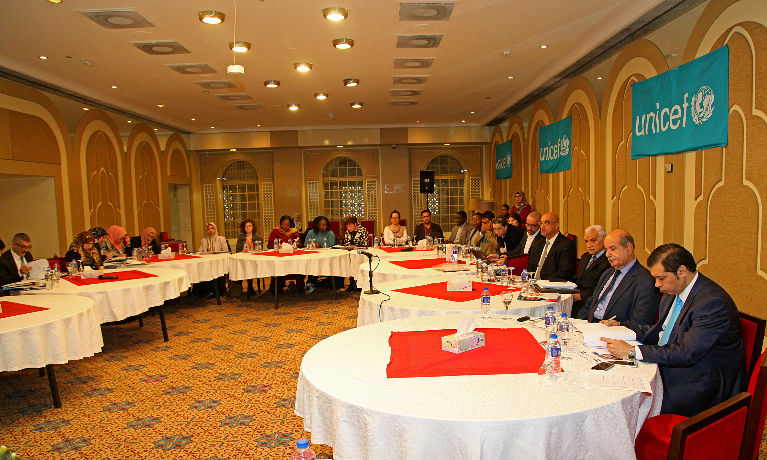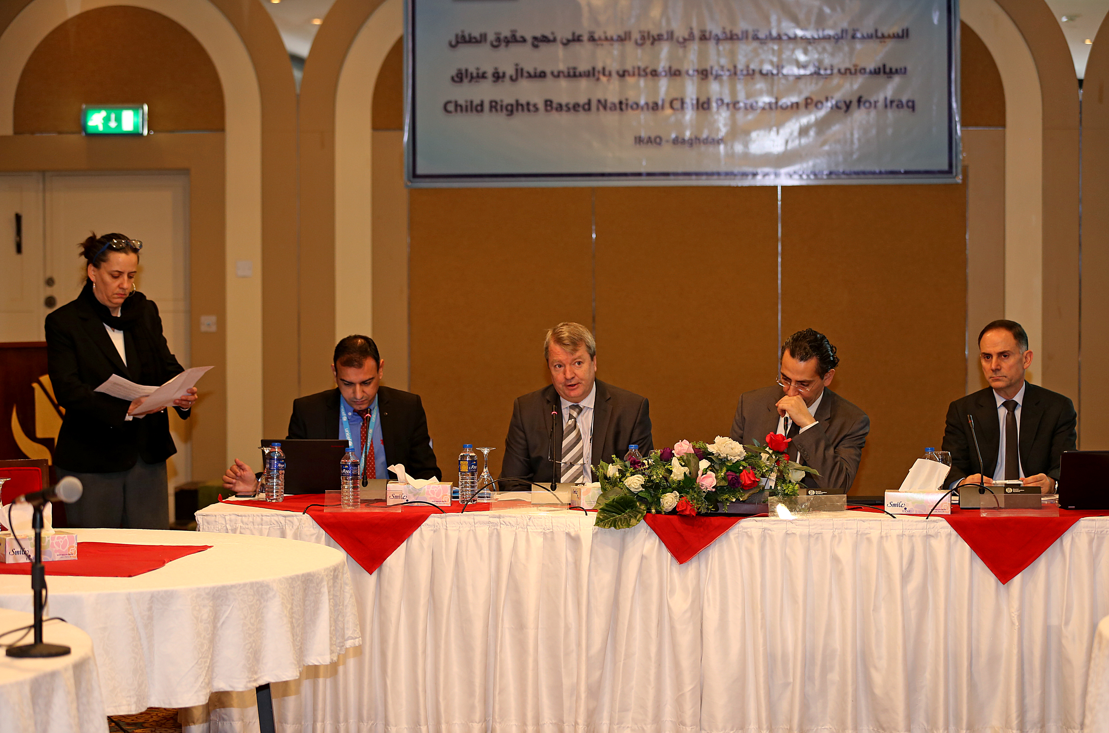
National Child Protection Policy validation workshop, 22 – 23rd November 2015

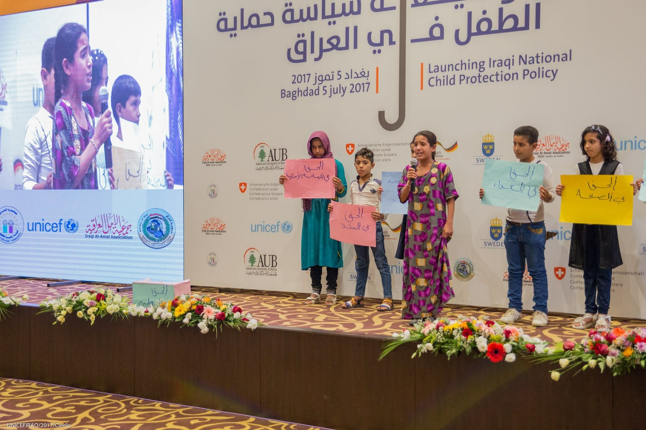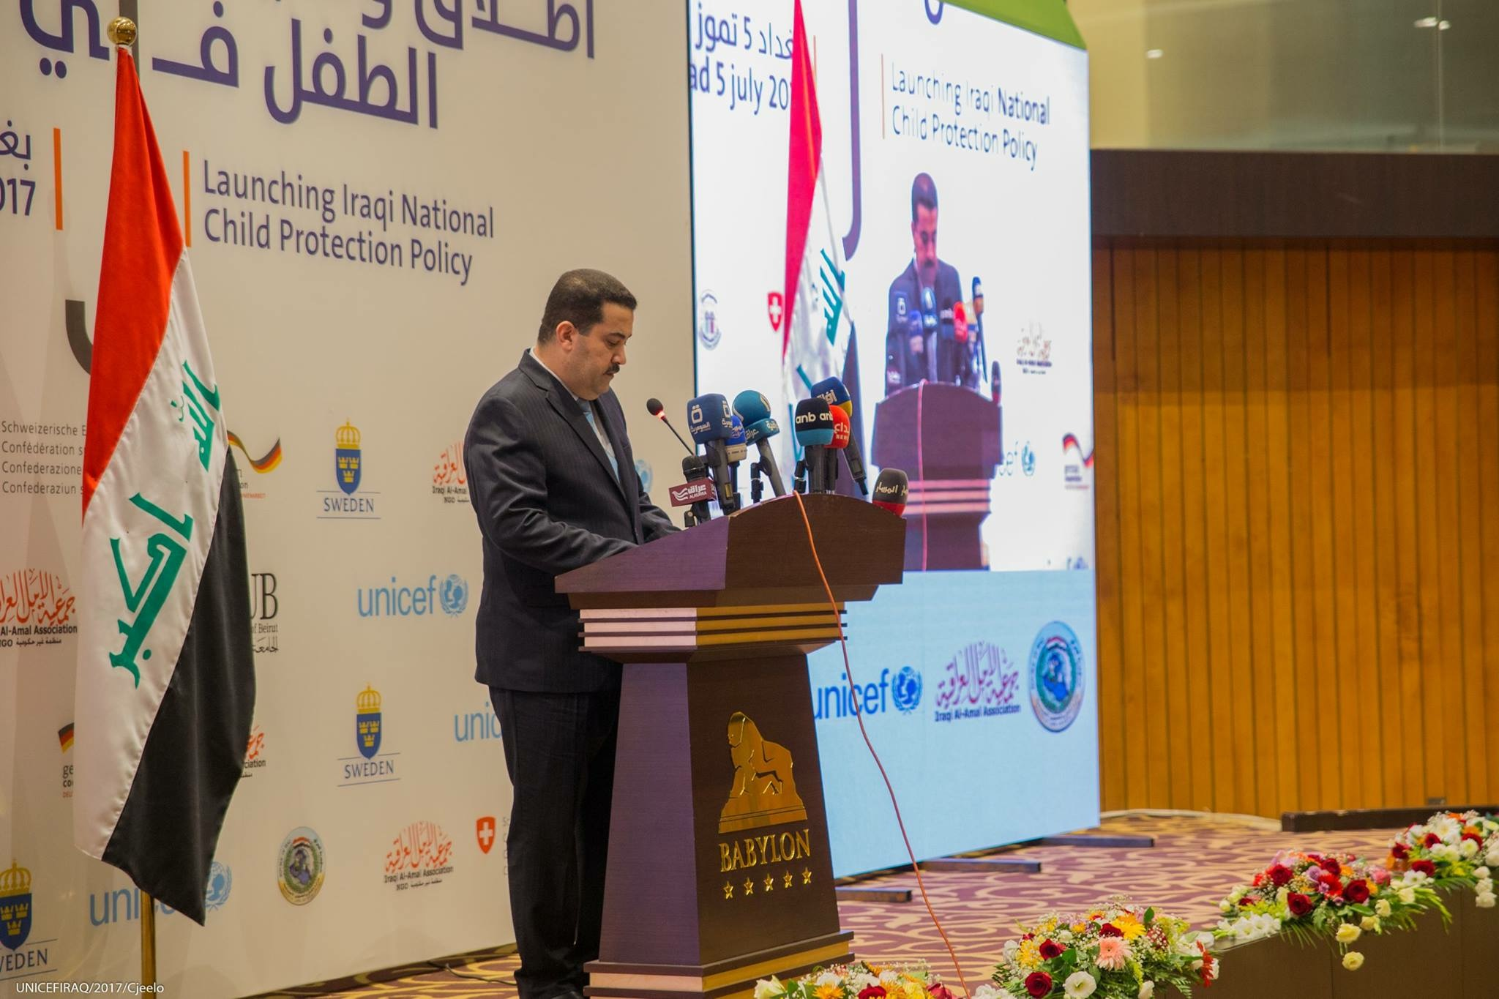
National Child protection Policy launching ceremony, May 2017

Output 2. 1 Central Government and Kurdistan Regional government are supported with the referral mechanism for the new Family Protection Directorates, police support units and CSOs

Linked with MRM network: Increased capacity of 1,548 (188 NGO, 1,320 MRM focal person, and 40 facilitators) contributed to achieve increased number of reports and higher quality of information. During the reporting period, UNICEF and UNAMI were able to reactivate the country MRM task force and to increase participation of new actors. These initiatives contribute to improve the quality of information and county report to the Security Council on children in armed conflict.

Technical support to the Ministry of Labour and Social Affairs (MoLSA) to develop a Social Work degree programme: UNICEF supported Salahaddin University (Erbil) in developing a university degree programme in social work, which has been operational since 2009. As part of continuous technical capacity building, UNICEF supported the university in conducting an evaluation of the degree programme by external/independent researchers. The assessment included interviews of 110 people (with equal gender representation) from university staff, current students, graduates, as well as civil society. The findings, presented on the 15 September 2013, revealed the importance of the programme in improving social services in the KRI. It highlighted the advantages and disadvantages of the current programme, including its contextual emphasis on western values. Another issue showed the necessity of improving the employment system for graduates, enabling them to utilise their knowledge and skills in relevant sectors of the labour market. The Government of Iraq and the KRG is keen to recruit social worker graduates for employment in the social sector ministries and directorates.

Effective referral system linking NGOs with Directorates and prosecution services, support to NGOs to provide legal aid services to survivor of GBV and DV.

During the reporting period, UNICEF and its partners have developed child protection service mapping and referral pathway for child protection specialised services. The referral system contributed to deliver legal aid services to 569 children in Baghdad, Basra, Erbil, Dohuk and Sulaymaniyah. UNICEF implementing partner Heartland Alliance (HAI), focused on implementing provisions of the Juvenile Care Law (JCL) providing for alternatives to detention, and successfully diverted or secured the release of nearly 450 youth from pretrial detention. As part of this focus, HAI conducted two workshops for 73 judges, prosecutors, lawyers and other stakeholders in the juvenile justice system, which led to a better understanding of the benefits of alternatives to justice. As part of these workshops, a committee was formed of lawyers, social workers and police officers in the Soran District in Erbil governorate to agree upon and implement alternatives to detention in 15 specified cases.

The funding also contributed to increased awareness and capacities of Syrian refugee families and communities in Erbil and Sulaymaniyah to protect and prevent juvenile delinquency through various activities. HAI produced and distributed 500 Know Your Rights (KYR) pamphlets. In addition, HAI and its partners identified 84 juveniles and trained them as peer facilitators for KYR presentations. The project educated nearly 1,000 juveniles and their family members in the Districts, and almost 200 Syrian refugee juveniles about juvenile justice and legal rights for children and youth under the JCL and international law through KYR presentations.

In addition, UNICEF closely worked with Juvenile Justice actors to establish three Justice for Children task force in Erbil, Dohuk and Sulaymaniyah to coordinate activities related to children in detention including promoting alternative to detention. The task force played key role in advocating for the appointment of Juvenile police assigned at district level.

Main implementation constraints & challenges
Implementation of the activities were challenges by many factors:
- Security situation: Islamic State in Iraq and the Levant (ISIL) activities has imposed serious limitation to have regular contacts with federal ministries in the policy development process. In Addition, major displacement in the country imposed priority focus on humanitarian response. Access to a range of locations, particularly Baghdad from June 2014 until August 2015 became extremely difficult, rendering it harder to complete planned activates.

- Limited capacity of the local partners who shall be part of the Child Protection Policy consultation; local partners are an extremely relevant resource to operationalize Child Protection services, but lack of adequate staff with experience in policy analysis and policy making. To address this challenge, UNICEF had identified alternative options, partnering with Save the Children International (SCI) to lead National Consultation. UNICEF and SCI have agreed on the next actions to complete the Child Protection Policy consultation process. UNICEF also partnered with Al Kafaat institute to carry out community dialogue on the draft policy document.

