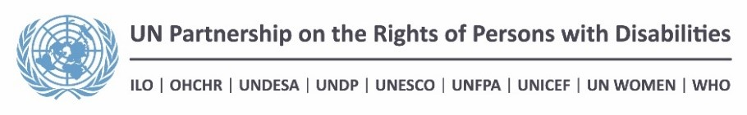

“Strengthening the capacity to use evidence based data to develop
inclusive policies in Bolivia”

END OF PROJECT REPORT

Introduction.

Within the framework of the Joint Programme supported by the UNPRPD between UNICEF, UNESCO, PAHO/WHO, UNFPA and OHCHR, with the support and coordination of the Office of the Resident Coordinator (ORC) in Bolivia, several relevant actions were undertaken to ensure that persons with disabilities, particularly children, adolescents and women, exercise their right of access to justice, to health and education; in addition, it has strengthened the capacity of the national institutions and the national coordinating mechanism, created by Law.
Little by little, in Bolivia, there is a shift towards a right based approach and an understanding of the social model of disability.
Each of the United Nations System (UNS) Agencies participating in the Joint Program, on the basis of their mandates, experience and comparative advantages worked on specific areas pertaining to the implementation of the rights of persons with disabilities in Bolivia. Progress was made in relation to more effective inter-agency coordination, strengthening of administrative databases in terms of disability inclusion and development of institutional capacities for the formulation of specific policies to support persons with disabilities, especially women, children and adolescents, particularly in the areas of health, education and justice. However, the challenge is still very great.

Variations in impact and outcome indicators

Table 1. Variation in impact indicators

Impact
People with disabilities, particularly children and women, can exercise
their rights and have a broader access to services in the areas of justice, education and health.

Impact Indicators
Indicator* | Start level  (Beginning of the project implementation period)* | End level  (End of the project implementation period)*
“Number of recommendations on health, justice and education from the review of the Convention on the Rights of Persons with Disabilities, complied with”.  Goal: A majority of the recommendations complied with. | The recommendations and comments of Bolivia to the Committee have not yet been published. | The recommendations and observations on the first report of Bolivia issued by the Committee on the Rights of Persons with Disabilities (CRPD), were officially published in November 2016.  At the time of the publication of the concluding observations on the initial report of the Plurinational State of Bolivia, the Joint Program was already contributing to the fulfilment of CRPD recommendations and which were noted at that time but which will also be highlighted in the coming second, third and fourth country reports on the progress made. The main recommendations were:  Justice:  Nº 30: The access to justice was strengthened through the formulation and implementation of the Plan of Access to Justice and the Protocol of access to due process for people with disabilities with a gender approach and interculturality.  Nº 41-A/42: The data bases on the situation of violence to women, including the incorporation of the variable of disability in the registration system of the “Integral System of Prevention, Care, Punishment and Eradication of gender-based violence” SIPPASE (for its acronym in Spanish), were strengthened.  Health:  Nº 57 (a) Training sessions aimed at health staff about the rights of people disabilities.  Nº 58(b) Support to the development of a Health Care Protocol, including sexual and reproductive health services for people with disabilities.  Education:  Nº 70: A specific System with the Ministry of Education that collects information about students with disabilities, disaggregated by sex, age, grade, level and type of disability, to contribute to the future development of educational policies based on evidence has been developed and implemented.  At a general level, the Program has contributed, through all of its components, primarily to respond to Recommendation Nº 69 referring to update and improve the information of the situation of persons with disabilities in Bolivia and to Recommendation Nº 70 referring to the collection and updating of data and statistics on persons with disabilities.  Compliance Goal: Support has been provided regarding the implementation of the following recommendations contained in the Report of the Committee on the Rights of Persons with Disabilities to the Plurinational State of Bolivia: 30, 41-a, 42, 57-A, 58-B, 59 and 70.
“Evidence based and inclusive measures (such as protocols and regulations guiding the implementation of the law) introduced by CONALPEDIS (Consejo Nacional de Personas con Discapacidad/ National Council of Persons with Disabilities) to promote the access of services of people with disabilities, with an emphasis on women and children”.  Goal: 100% legal rules and public policy measures adopted by the government have been developed in coordination with CONALPEDIS. | Joint policy measures have still not been introduced. | The Plan of access to justice and the Protocol of access to due process for access to justice for persons with disabilities introduced by Ministry of Justice was approved.  The Institutional Strategic Plan for the CONALPEDIS, where the different strategic lines of work are defined from 2017 until 2020, has been approved.  The Program has contributed to the adoption of the i) Standard inclusive norm for sexual and reproductive health care, ii) the Guide on education for sexuality for persons with disabilities and the iii) Guide for training on standards of care in sexual and reproductive health for people with disabilities.  Goal compliance:  Revision of Laws and regulations:  - Plan of Access to Justice.  - Protocol of access to due process for persons with disabilities.  - Institutional Strategic Plan for the CONALPEDIS 2016- 2020.  - National Technical Norm of comprehensive sexual and reproductive health services for people with disabilities.
* Please provide sex disaggregation here.

Table 2. Variation in outcome indicators
(Add a table for each outcome in the approved project document)
Outcome 1
National information systems in the areas of justice, education and health strengthened through the inclusion of the evidence based data needed to comply with national and international commitments that guarantee the rights of people with disabilities.

Outcome 1 Indicators
Indicator* | Start level  (Beginning of the project implementation period)* | End level  (End of the project implementation period)*
“Number of indicators from the Regional Education Information System on Students with disabilities (Sistema Regional de Información Educativa de los Estudiantes con Discapacidad: SIRIED) integrated in the National Information System on Education (Sistema de Información Educativa: SIE)”.  Goal: 50 percent of SIRIED indicators integrated in SIE. | The education information system has serious weaknesses in the provision of information on students with disabilities. Currently none of the 42 indicators of SIRIED are part of SIE. | The SIE (Education Information System) incorporates relevant and reliable information on students with disabilities. It is composed of 40 quantitative indicators.  Goal compliance: 100%  Of the total of 42 indicators that compose the SIRIED the Educational Information System of the Ministry of Education incorporates a 25.  Therefore, 60% percent of SIRIED indicators integrated in SIE.
The number of disability indicators needed to comply with the recommendations of the International Classification of Functioning, Disability and Health (ICF) of the WHO and the Washington Group on disability that are integrated in the National Health Information System (Sistema Nacional de Información en Salud: SNIS) of the Ministry of Health.  Goal: 50% of disability indicators integrated into SNIS. | At present, the SNIS reflects several core variables on health. Are not fully broken down into relevant indicators to measure disability issues. | The Program has supported the design of instruments of qualification according with ICF model in the medical area, psychology and social work, with their respective coding.  The Ministry of Health is being supported to link the National Health Information System (SNIS) with the Unique Registration System of People with Disabilities through a software that will raise and report information about people with disabilities disaggregated by department, by municipality and by variables of type and degree of disability, sex, national origin, age and cause.  The software will have four priority indicators in the framework of the ICF (physical, sensory, intellectual and multiple), which include grades and percentages of disability, sex and age.  Goal compliance: In progress.  It is expected that the 4 indicators identified in implementation proposal of the ICF in Bolivia are integrated into the SNIS.
Number of disability indicator needed to comply with the recommendations of CRPD and Committee CEDAW integrated in the integrated system to prevent and address gender based violence (SIPPASE) of the Ministry of Justice.  Goal: 50% of disability indicators are integrated in the SIPPASE. | At present, the SIPPASE does not include indicators on disability. | The Integral System of Prevention, Care, Punishment and Eradication of Gender-based Violence (Sistema Integral Plurinacional de Prevención, Atención, Sanción y Erradicación de la Violencia en razón de Género: SIPPASE) takes into account 8 instruments for the implementation of the Law Nº 348, Law to guarantee women a life free of violence; one of which is the Information System for the Registration of Gender-based violence. Since 2016, the System has introduced the variable of disability in the registration of women victims of gender violence, applied in 60 municipalities in the country, which will expand the SIPPASE intervention to people with disabilities in the country.  The Program contributed the development of a validated Guide for SIPPASE users that contains the approach to human rights, gender and disability with basic guidelines for the implementation of the Information System by applying the variable of disability.  Goal compliance: 100%  The National System has incorporated the variable disability on its record.
* Please provide sex disaggregation here.

Outcome 2
The national coordination and compliance mechanism CONALPEDIS is strengthened so that it may fulfil its role to coordinate, monitor, and develop policies which allow Bolivia to comply with national legislation and international commitments on the rights of people with disabilities.

Outcome 2 Indicators

Indicator* | Start level  (Beginning of the project implementation period)* | End level  (End of the project implementation period)*
The Staff within government members of CONALPEDIS have strengthened their capacity to develop inclusive and evidence based political measures and to introduce protocols to promote the rights of people with disabilities, in accordance with Bolivian legislation. A special emphasis will be put on gender.  Goal: At least 60% of key personnel in government institutions that are part of CONALPEDIS enhance their ability to develop evidence-based and inclusive and to introduce protocols. | Policies or protocols have not been developed. | The Program has strengthened the technical capacity of the members of the board of Directors of CONALPEDIS for the elaboration of its Institutional Strategic Plan, which was adopted with a Ministerial Resolution in January 2017.  The General Direction of Persons with Disabilities of the Ministry of Justice, as member of the Board of Directors of the CONALPEDIS, has been strengthened through the technical support for the formulation of the Plan of access to justice and a Protocol of access to due process for persons with disabilities. Likewise, in the area of sexual and reproductive health the Program has been supported to this General Direction to orientate their work with organizations of persons with disabilities through the use of inclusive tools related to the regulations in favor of persons with disabilities, in Braille format and sign language.  The Units of Disability (CONALPEDIS members) and the Units of Health Service and Quality Networks under the direction of the Ministry of Health Promotion have strengthened their technical capacity for the participatory development of the National Technical Norm of Comprehensive Sexual and Reproductive Health Care for persons with disabilities, which was adopted by Ministerial Resolution; and they count with a Training Guide and a Counselling Flipchart that incorporate inclusive tools, such as guidance for the development of skills of health personnel to improve the attention of the sexual and reproductive health of people with disabilities.  The Program has supported the development of a Guide on education for sexuality addressed to people with disabilities and to parents/mothers of families of children and adolescents with disabilities, which has been socialized/presented in 9 departmental meetings with the participation of CONALPEDIS and Municipal Units of Attention to people with Disabilities (Unidades Municipales de Atención a Personas con Discapacidad: UMADIS) and leaders of organizations of persons with disabilities.  The general population has been sensitized on Sexual Rights and Reproductive Rights of persons with disabilities through micro-radio programs disseminated at national level.  In coordination with CONALPEDIS, an Awareness Campaign: “Think Different” (radio spots and micro-TV videos on the rights of persons with disabilities) have been disseminated, in order to sensitize the general population about the importance of exercising their rights.  Compliance Goal: 100% of the Staff Directory of the CONALPEDIS has improved their capacities.  70% of the Technical Disability Units and Units of Health Service and Quality Networks of the Ministry of Health have developed their competencies and worked on a national regulation and tools for the development of skills of health personnel providing services.  In addition, 50% of the staff of the Unidades Municipales de Atención a Personas con Discapacidad (UMADIS) along the country have developed technical skills for their job based on the Guidance of education for sexuality for people with disabilities.
The staff within COBODI have strengthened their capacity of consultation and development of inclusive and evidence based political measures and to introduce protocols according to the Law.  Goal: At least 60% of key staff within COBOPDI have increased their capacity to develop inclusive and evidence based policy measures. | No political measures or protocols proposed by civil society members. | Within the framework of CONALPEDIS assessment, the capabilities of persons with disabilities organizations were included. The gaps identified were taken into consideration in the preparation of CONALPEDIS Institutional Strategic Plan 2016-2020.  In coordination with the CONALPEDIS a virtual course for the development of inclusive public policies in favor of persons with disabilities was developed. Around 30 representatives of the CONALPEDIS UMADIS COBOPDI, the Bolivian Institute of Blindness (IBC), Ministry of Health, Justice and the Ombudsman have participated in the course.  Compliance Goal: 100% of the key members of the COBOPDI has improved their capacities for 'the formulation of inclusive policies and evidence-based.
The staff within COBOPDI have strengthened their capacity to monitor the fulfilment of national and international commitments and to advocate for their fulfilment.  Goal: Bi-annual monitoring report on the progress towards the fulfilment of national and international commitments introduced. | The recommendations and comments on the Bolivian submission to the committee have not been published yet. Reliable data does not exist. | The national federations that are part of the COBOPDI, developed the Alternative Report of People with disabilities in Bolivia presented to the CRPD Committee and which were then reflected in the document of observations and recommendations issued in November 2016.  Compliance Goal: 100% of the Program has supported the presentation of the National Report to the Committee on the Rights of Persons with Disabilities (CRPD).
* Please provide sex disaggregation here.

2. Overall progress

At the beginning of its execution, the Joint Program suffered a delay due to the presidential elections held in October 2014, which resulted in the re-election of President Evo Morales Ayma. In February 2015, there was a change in the cabinet that affected the ministries of health, education and justice. These changes produced a realignment in the plan of implementation of the activities proposed in the Program.
The Plurinational State of Bolivia presented to the Committee on the Rights of Persons with Disabilities (CRPD) its first report on the situation of the rights of persons with disabilities by the year 2013. Only in the year 2016 the CRPD Committee announced to Bolivia its consideration in the 16th session conducted on 17 and 18 August 2016; in November 2016, the CRPD issued the official observations and recommendations.
Despite this delay, which coincides with the implementation of the Program, UN Agencies have worked with the institutions of the State and the civil society organizations of people with disabilities in the context of the Convention on the rights of persons with disabilities, the Political Constitution of the State and the National Law Nº 223 of persons with disabilities for the achievement of our proposed results.
In this context, it is important to mention that the Program has been through a process of generation of trust with key partners of the Ministries of Justice, Education and Health. This relationship had been weakened in past years and sued the Program to generate spaces for dialog, in which the members of each of these institutions return to work in a coordinated way. In general, the results contribute to the achievement of results that have an impact on that "children and women can exercise their rights and have improved access to services in the fields of justice, education and health. In this context, Program interventions have had a direct impact on the implementation of the CRPD recommendations related to the areas mentioned.
There were some limitations to implement the activities related to the strengthening of the CONALPEDIS due to political issues. The Director of the CONALPEDIS is elected by nine ministerial representatives and representatives of the COBOPDI, made up of 9 national federations of people with disabilities. The COBOPDI continues today in the process of restoration, so it could not appoint an official Director of the CONALPEDIS, a responsibility that has fallen in the Ministry of Justice, exercised through an interim Director. The absence of a principal Director with decision-making power and these processes to lead the management of the CONALPEDIS have produced some delay in activities aimed at this result.
Despite the delay, it has been possible to implement the planned activities and thus the Program has strengthened the technical capacity of the CONALPEDIS for the formulation of public policies. An example of this is the CONALPEDIS Institutional Strategic Plan, which was adopted with a Ministerial Resolution in January 2017.

3. Progress toward specific outcomes

Outcome 1
Justice:
The Program in coordination with the Directorate of Persons with Disabilities under the Ministry of Justice has developed the Plan of access to justice and the Protocol of access to due process for persons with disabilities with the objective of offering to the operators and administrators of justice tools that allow them to assure that their action makes possible the full exercise of the rights of the persons with disabilities and to provide to people with disabilities and their families the safety of due process.
The Program has contributed to the implementation of the recommendation related to the Convention on the Rights of People with disabilities (41/42) related to the registration of persons with disabilities who are victims of violence, and the inclusion of this variable in the registration System SIPPASE.
The Information System SIPPASE (Integral System of Prevention, Care, Punishment and Eradication of gender-based violence) has included the variable of disability in its registry process of women victims of gender based violence. For the implementation of that register, an implementation guide was developed containing human rights-based approach, gender and disability with basic guidelines for the implementation of the Information System that were transferred to priority municipalities (Municipal Comprehensive Legal Services only), which will make it possible to extend the intervention of the SIPPASE to people with disabilities, especially women. This will provide useful data ahead of the country issuing the first reports during 2017 including data of women with disabilities that has suffered gender based violence.
Health:
The Program has contributed to the recommendation concerning the adoption of care protocols, including sexual and reproductive health services; based on the adoption of the national standard of care. In addition, the results contribute to the development and adoption of inclusive measures such as the case of the i) National Technical Standard of comprehensive care for sexual and reproductive health for persons with disabilities, ii) the guide on sexuality education for People with disabilities and iii) the Guide on sexual reproductive health training, to be applied during 2017.
The Joint Program has made great efforts to promote the implementation of the International Classification of Functioning, Disability and Health (ICF). However, this process has been slowed down due to the political situation that has led to the mobilization of "a march of persons with disabilities" initiated in the month of March 2016 and extended to August of that same year, which demanded the State of a monthly income/bonus of Bs. 500 and the revision of the disability qualification to be eligible to this economic support.
The Program supported the Early Childhood Development Unit (Unidad de Desarrollo Infantil Temprano: UDIT) of the Ministry of Health in the designing of a Development Follow-up Tool for children from 0 to 6 years, to be used on healthy child control in all the health centers in the country, so parents or other caregivers can detect early warning signs of minor, serious or deficient delays to seek specialist support in early stages.
Education:
The Program has contributed to improve the quality of information on students with disabilities. Indicators for students with disabilities were fully integrated in the educational information System. It has improved capabilities of technicians from the Ministry of Education for the interpretation and inclusion of indicators for students with disabilities in the planning processes of the Ministry of Education.
Technical support was provided for the development of the software application that enables the capture of data for students with disabilities, its teachers and special education centers. These systems were tested in the operating system of registration of media management of 2016 and will be fully implemented in the 2017 school management.
In parallel, the Program provided support to the work of review, consistency analysis and debugging the system information on students with disabilities that the Ministry had captured in previous efforts, which made it possible to reconstruct and debug much of the existing information for the years 2013, 2014 and 2015.
The assistance of the Program also made it possible to conceptualize and design a set of indicators of self-development that, along with a subset of indicators of SIRIED were incorporated into the Educational System of Indicators of the Ministry of Education.
The Ministries of Health and Education have developed and are currently validating a development measurement instrument as well as instruments for the early detection of disabilities. These initiatives are part of a national policy measures and have as central objective to develop capacities in health and education personnel, parents and caregivers for early detection of disabilities.

Outcome 2
The Program has supported the National Committee of Persons with Disabilities (CONALPEDIS) regarding its capacity building through the elaboration of an Institutional Strategic Plan. The plan was approved by ministerial resolution in January 2017.
Members of the General Direction of Persons with Disabilities of the Ministry of Justice, as a member of the CONALPEDIS, have been strengthened, which in turn enhanced the institutional capacities of municipal bodies as UMADIS, SLIMs and others, with respect to the implementation of the Sexual and Reproductive Rights and the integral education of sexuality, in the plans, programs and projects for people with disabilities, as well as realize the importance of the implementation of all the regulation that benefit people with disabilities.
Another member of the board of CONALPEDIS, the Disability Unit of the Ministry of Health, complies with its competencies to define, develop and approve the National technical norm regarding comprehensive sexual and reproductive health services for people with disabilities, supported by the corresponding ministerial resolution; it is the first time that the country has a standard for sexual and reproductive rights of People with disabilities. At the same time, inclusive tools have been generated for the future development of health personnel skills for the application of the established rule for the attention of the sexual and reproductive health of people with disabilities. The elaboration process of protocols for comprehensive sexual and reproductive health care for persons with disabilities, has been a complex process that has had a previous history, but it is not until March 2016 that the competent authority adopts the definition of drafting the final version of the rule that is called Technical Standard of Comprehensive Sexual and Reproductive Health Care for Persons with Disabilities; the validation process of these documents included the participation of responsible (staff) of sexual and reproductive health care of departmental headquarters, 9 representatives of associations and federations of people with disabilities. This process ended on 12 December 2016 when the Minister of Health signed the Ministerial Resolution No. 1241 approving the "Technical Standard of Comprehensive Care in Sexual and Reproductive Health Services for People with Disabilities" and the "Guide to the implementation of the Technical Standard of Comprehensive Sexual and Reproductive Health Services for People with Disabilities". The process has been so intense and long and it is pending the publication of the rule and the application guide.
The Program developed a specialized virtual training course for the implementation of inclusive public policies for Persons with Disabilities. This training was focus to CONALPEDIS and CODEPEDIS staff and to Municipal Units for the Care of Persons with Disabilities (UMADIS) of the whole country.
In August 2016, Bolivia presented its first report to the Committee of the Rights of Persons with Disabilities. The Program has assisted the Bolivian State in this process by organizing and participating in working groups consisting of different ministries, where information of their policies was gathered and structured in order to answer the list of issues observed by the Committee. The Program has also supported civil society organizations with the development of an alternative report to the Committee.

4. Other results

- Spin-off effects.
The Program results planned to have a Protocol for a comprehensive sexual and reproductive health care, however, the achievements went beyond this, because the Program supported the development of a Norm, a Guide for its application and a flipchart for capacity development (pending its publication, dissemination and training). In the same way, while the Program planned to include the disability variable in the SIPPASE and a Guide for its implementation was also developed.

The Program has provided technical assistance to the Public University of San Andrés (Peace) in the elaboration of regulations to facilitate the entry, stay and the completion of studies for students with disabilities.

With the aim of sensitizing civil society on the rights of persons with disabilities and promote the Law 223 was designed and developed a visual material that was broadcast by the public television and social networks.

In addition, the Program has supported the strengthening of capacities of the Bolivian Institute of Blindness, an institution that works in parallel with the CONALPEDIS for persons with visual disabilities.

The Program supported the Ministry of Education for starting the initiative of the introduction of Teacher at Home Program to facilitate access to education for children who are unable to attend school due to illness or disability. These cases apply only when children have a serious illness or disability that does not allow them to move or when they depend on a medical device.

- Participation and partnership-building.
The Program has served as a platform for organizations of persons with disabilities to form part of the formulation, development and implementation of the activities under the joint intervention. Therefore, more of the results were achieved thanks to the active participation of organizations of persons with disabilities from all over the country, the examples are clearly reflected in the consultation process for the elaboration of the Institutional Strategic Plan for the CONALPEDIS and the development of the alternative report to the CRPD Committee by the 5 federations of people with disabilities.

In addition, the participation of the delegates of the people with disabilities has been instrumental and meaningful in the development process of the Technical Standard of Sexual and Reproductive Health Care Services for People with Disabilities, a document that has been based on testimonies and life experiences.

Equally important has been the partnership with the Municipal Units of Care for People with Disabilities (UMADIS), which has generated an articulation between the national level for all the intervention related to education for sexuality of people with disabilities as well as the alliance with the General Direction of Persons with Disabilities of the Ministry of Justice which facilitated the work with local authorities responsible for the implementation of policies for people with disabilities at regional level.

- UN system-wide coherence.
The RCO has provided continuous support to the coordination of the Program; it has been established an interagency dialogue space for accountability and share experiences of the Program that has enabled a more coherent, effective and efficient manner to deliver together.
The UNPRPD Joint Program has been recognized the Program intervention as an example of good practice of coordinated work; it will be positive to replicate this articulation model in the rest of joint programs.

- Knowledge creation.
The program has worked in the development of inclusive documents related to national norms and standards for persons with disabilities, specifically laid down in the national and international regulations in relation to sexual and reproductive health and rights of people with disabilities through an interactive CD in sign language and Braille. In addition, it has published a Guide on Education for Sexuality for People with Disabilities.

The virtual course on development of inclusive public policies in favor of persons with disabilities was an activity that generated an impact in the daily work of the Bolivian Institute of blindness. All its authorities with visual disability at the national level, took the course and according to the evaluations undertaken and the report of the technical responsible who ran the course, with whom they met an evaluation workshop, this was the first course that really was specific to the area of disability and clearly specialized in public policies, which will enable them to work their annual operational plans, strategic plans, programs and projects taking into account everything they learned.

A training seminar was also held for officials of the Ministry of Education in the use of indicators for students with disabilities in the educational process of planning.

- Leveraging effect.
This project has allowed NGOs/DPOs (Disabled People's Organizations) who work in the area of disability, to mobilize more resources within the context of the CPRD observations and recommendations made to the country. Thus, an alliance was formed between Danish Association for Persons with Disabilities (ADD), My Right, Light for the World, Handicap International and together the Federations of People with Disabilities, developed a 2017 Work Plan for the dissemination of these recommendations and seek the assistance of the United Nations system for its implementation.

5. Life stories and testimonies

In order to visualize some testimonies of people with disabilities that were supported by the Program, some interviews with key actors were conducted:

Victor Pajarito, a Social Worker in CONALPEDIS, person with visual disabilities
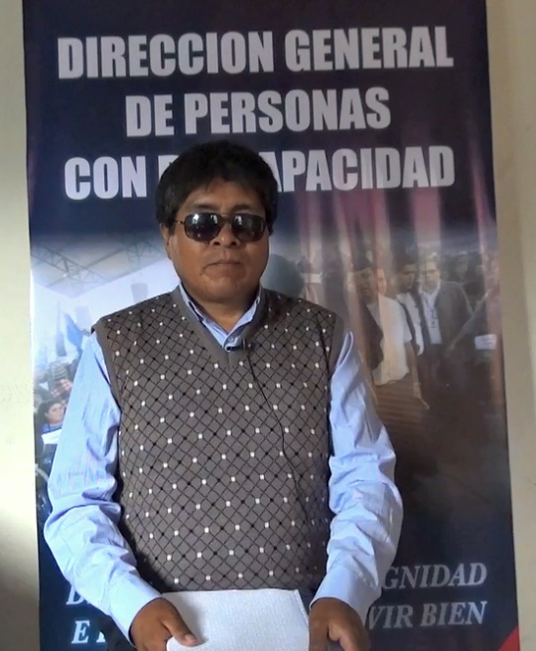“In principle, I would like to thank the Joint Program funded by the UNPRPD for having made a reality to count with a compendium of legislation, this compendium has international and national standards. These norms protect the rights of persons with disabilities, today, in the current government, these rules include us in the field of education, in the field of work and in the field of health to all persons with disabilities. Today, we, the persons with disabilities incorporated within the policies of the government.
At the same time, thanks to the Joint Program, people with visual, auditory, physical and intellectual disabilities, now we have these compendium policies in an accessible format for us. We have compendium in Braille, in sign language and in ink. These compendia have been distributed at national level, what gives the organizations and persons with disabilities the tools to defend their rights to be incorporated within the society as a person”.

José Luis Pozo, Director of Institutional Planning and Technical Resources of the Bolivian Institute of Blindness
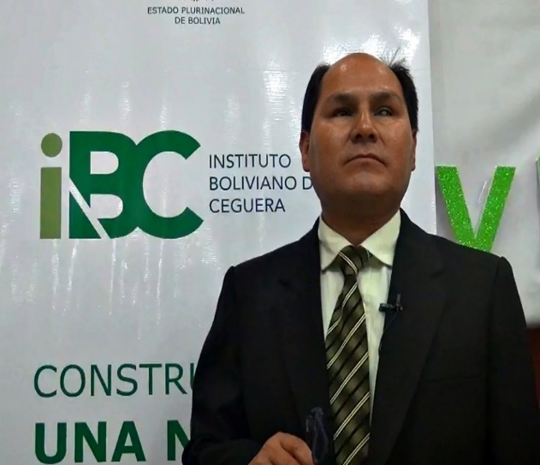“I work in the city of La Paz, in the IBC (Bolivian Institute of Blindness) for a year and three months. We are very happy with the United Nations System for having designed and sponsored the course of public policies in favor of persons with disabilities. This course has had an impact-level for the institutional blindness sector, since our institution participated with seven staff members. In the process, of course we were remarking that this type of learning is what we really need to know to be able to work and begin to improve the what we were doing in the sector of persons with visual disabilities. The Course of Public Policy has helped us a lot in the sense to understand the way that we must put our efforts, perhaps no longer search for isolated projects and palliative for the sector, but begin to build true policies that will structure a systematic work, and the results can generate projects and programs to strengthen and improve the services we provide in the IBC.
Personally, having participate in this course, I have learned a lot, it has been very useful, and we have all the political will and commitment to work with a view to developed public policies for our sector. Already with the resources that we have obtained during the course, we will be able to do it wiser. I want to congratulate United Nations that has had this very timely initiative, for us, from this knowledge, we can work, move and look to develop public policies that will strengthen and improve the services that we carry out on behalf of blind people in Bolivia”.

Jesny Sarsuri, Licensed Social Worker, Departmental Federation of Persons with Disabilities
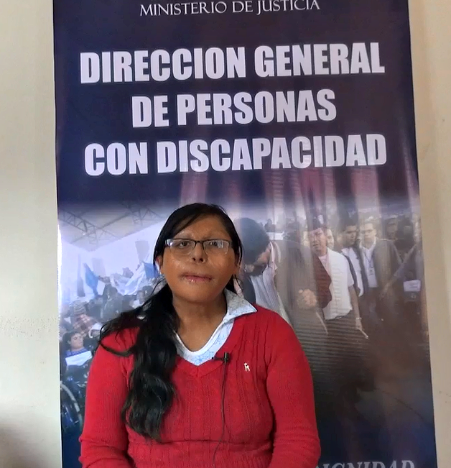“I think it is essential to have a guide on sexuality for people with disabilities as this helps us to prevent a negative health and neglected, in addition to prevent a bad family planning or unwanted pregnancies. Not having this guide will harm our relations with society, because having a bad health, a family not planed, or something that obstructs our health, can be depressing for a person with a disability. A person with a disability needs a lot of guidance in this area. Besides, this guide presented by the Ministry of Justice, is important because it speaks of the Political Constitution of the State, because there is stablished that people with disabilities have the right of being able to access to guidance with respect to the sex education and it is crucial to know that now, people with disabilities, are being integrated and now we are going forward in a more efficient way. By this side, this guide is not only reflecting the disadvantages, but makes a comparison between an excluding approach and a Human Rights approach, this analysis also give us the vision to analyses things that “let us down” as persons and things that we can “improve” as humans. It also encourages us, as people with disabilities, to be more open minded about this issue, since it was a taboo in the past, and there are still some cities and rural communities where it remains a taboo that a person with a disability can easily talk about sexuality or health care as there are many myths and culture influences , but if we speak more often and maintain aware about this theme, I think it is going to improve the society and is going to help the development of persons with disabilities or also improve the care that a guardian for persons with disabilities can provide, whether to their Children, to nephews or to cousins. In this case, it seems that not only people with disabilities do not have much knowledge on what is sex and sexuality, but, on the contrary, parents do not have enough knowledge of this topic, and as I said, this Guide developed through the ministry of justice is important to me because within it, it is also analyze the recommendations of the Convention on the Rights of Persons with Disabilities that is very important for us to continue developing”.

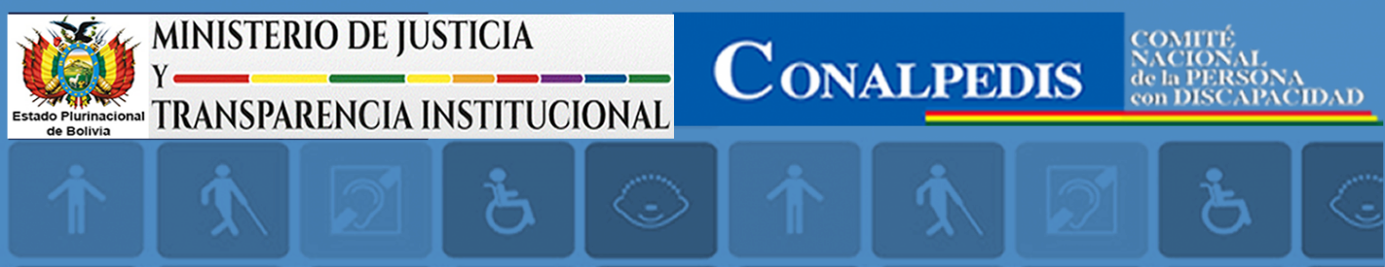

TESTIMONY: Sr. Edwin Juan Soto Morales
Executive Director
CONALPEDIS (National Council of Persons with Disabilities)

1. Could you please tell us, how the United Nations Joint Program: "Strengthening the ability to use
evidence-based data to develop inclusive policies in Bolivia" has helped to the
institutional strengthening of the CONALPEDIS?

The CONALPEDIS prior to the implementation of the project "Strengthening the capacity to use data based on evidence to develop inclusive policies in Bolivia" had deficiencies regarding the defense of the rights of persons with disabilities, considering that we are a decentralized public entity responsible for the formulation of policies, plans, programs and projects in the field of disability.

Since the entity had no experience in the development of public policies and was little visualized as the lead agency in the field of disability, therefore, the project contributed to CONALPEDIS mainly in the strengthening of its human resources through:

- The “INTERNATIONAL WORKSHOP FOR THE DEVELOPMENT OF INCLUSIVE POLICIES IN FAVOR OF PERSONS WITH DISABILITIES" which allowed to rescue experiences of countries such as Mexico and Paraguay denoting the importance of the implementation of public policies in favor of persons with disabilities to ensure their full inclusion and participation in the society.

- The training of public servants at the national level through the program/training: "DEVELOPMENT OF INCLUSIVE PUBLIC POLICIES IN FAVOR OF PERSONS WITH DISABILITIES" which allowed us to count with qualified and prepared staff to generate inclusive public policies in favor of the sector.

The strengthening processes mentioned above, will enable approximately 61,000 people with disabilities to be benefit from the design of inclusive public policies proposals through CONALPEDIS to the Bolivian State.

Following this process, the support provided to the CONALPEDIS led to the elaboration of a diagnosis of the current situation in which was the entity, identifying its shortcomings and weaknesses, but above all, began the construction of our first INSTITUTIONAL STRATEGIC PLAN 2016-2020 framed under the legislation in force, which to date was approved by Ministerial Resolution by our head of sector: The Ministry of Justice and Institutional Transparency.

In the process of raising awareness and stewardship of the entity in the field of disability, awareness campaigns in favor of persons with disabilities were developed, including a video and graphic material of diffusion (folder and texts of the convention on the rights of persons with disabilities and the Optional Protocol, and the recommendation made to the country by the United Nations Committee), all of this, thanks to the support provided by the project.

2. Dou you consider important the support received and what can be noted to continue the consolidation of the CONALPEDIS?

Everything mentioned in the preceding question, shows that the contributions provided through the Joint Program: "Strengthening the capacity to use data based on evidence to develop inclusive policies in Bolivia" to CONALPEDIS, have been of vital importance and allowed the consolidation of an entity with a well-defined work in the medium term with the development of the Institutional Strategic Plan for 2016-2020, as well as count with qualified staff for the development of inclusive public policies that will promote and guarantee the rights of persons with disabilities in Bolivia.

6. Challenges and unforeseen events

The delay in the examination of the first country report on the rights of persons with disabilities by part of the CRPD Committee, almost 3 years, has forced the original project to change their activities in the second year of implementation to achieve the objectives proposed and thus achieved the first observations and recommendations to Bolivia on the exercise of rights of persons with disabilities, in the framework of the CRPD. Despite this fact, progress was made with some results proposed considering the terms of the CRPD, Political Constitution of the State and the Law Nº 223 of Persons with Disabilities.
Another major challenge has been the articulation between the Units of Disability of the different competencies/areas: health, education and justice and coordinate joint efforts in favor of the People with disabilities under the same vision and approach.
CONALPEDIS does not have an official director assigned because there is no agreement in the framework of the COBOPDI, therefore, acts under the authority of the Ministry of Justice, which has led to lack of ownership and leadership within CONALPEDIS in the handling of the thematic.
Another challenge in the implementation of the project, was the visibility and work with fathers, mothers or relatives of people with disabilities on issues of sexual and reproductive rights, aimed to meet the needs and the recognition of sexual and reproductive rights and the promotion of its effective exercise. The measures at the local level with regard to this problematic was adopted with success.
The development of the Technical Standard of Comprehensive Sexual and Reproductive Health Care for Persons with Disabilities, involved a process of forward and reverse until its adoption of the standard and the guide; for this effect, intensified lobbying actions and technical assistance with the responsible bodies and working with delegates of organizations of persons with disabilities were carried.

7. Project follow up

The program has greatly contributed to the exercise of the rights of persons with disabilities, both at governmental and civil society levels. This first stage allowed us to count on all the encouraging results described, opening a new process of implementation of the policies developed to date.

The Institutional Strategic Plan of CONALPEDIS has a planning strategy for the period 2016-2020 which incorporates operational, programmatic and communications levels aligned with the National Development Plan and the Patriotic Agenda that contains 13 National Pillars of actions until 2025; also, it coordinates local, departmental and national levels and that has as partners and allies to other sectoral ministries, the private sector, academia, community organizations and social organizations. This Plan aims to give continuity to the outcomes reached, to continue strengthening the capacities of the institution staff and to improve the articulation and coordination with the actors’ allies identified.

All the counterparts involved in the project, both in the sector of health, justice education, Disabled People Organizations and CONALPEDIS itself, have appropriated all the progress reached with the support of the Program.
All the progress made with the norms and guides for People with disabilities regarding sexual and reproductive health care, must be reinforced and consolidated with its publication, dissemination and training for application. Likewise, with respect to the comprehensive sexual education for People with disabilities still has many challenges, to keep on opening the dimension in the work with them and also with mothers and fathers of children and adolescents with disabilities.
The Ministry of Education has planned for the 2017 the preparation of the first report on students with disabilities taking as starting point the analysis of the indicators generated in the framework of the Program and has expressed interest in applying the good practices identified in the process of implementation of the Information System of Education to replicate it in other levels or sectors.
For the coming years, Bolivian Institute of Blindness objectives are to work in its institutional policy because after more than 50 years of institutional life, they do not have developed their sector policy.
The Bolivian public universities are firmly committed to work on regulations for admission, permanence and exit of students with disabilities to benefit them with employment policies and integrate them as professionals, aspect that needs to be addressed.
People with disabilities face challenges in different areas of their lives. An effective and efficient public policy in favor of promoting the rights of persons with disabilities involves a multidimensional approach. The concurrence of several UN agencies in Bolivia, made this Program a more comprehensive intervention than many others. While significant progress was achieved, many challenges remain, and a second phase is essential to complete and consolidate all this process in Bolivia.

Table 8. Expenditures

Outcome | UNPRPD funds allocated to the outcome | UNPRPD funds spent for the outcome | Non-UNPRPD funds spent for the outcome
- National information systems in the areas of justice, education and health strengthened through the inclusion of the evidence based data needed to comply with national and international commitments that guarantee the rights of people with disabilities. | 156.116 | 155.119
- The national coordination and compliance mechanism CONALPEDIS is strengthened so that it may fulfil its role to coordinate, monitor, and develop policies which allow Bolivia to comply with national legislation and international commitments on the rights of people with disabilities. | 192.982 | 192.831
Indirect Support Costs (7%)
TOTAL | 349.098 | 347.950
Balance USD. 1.148

The program only applies to children with a very severe disability that is often multiple e.g. children with intellectual disabilities that have physical-motor problems that forces them to lie down. In the other cases the policy is always to attend regular school.

