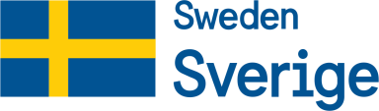
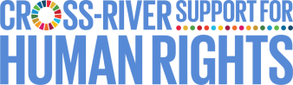
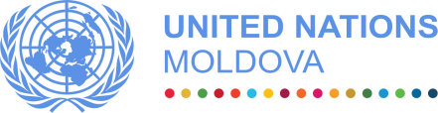

One UN Joint Action to Strengthen Human Rights in the Transnistrian region of the Republic of Moldova (2019-2022)

MPTF OFfice GENERIC ANNUAL programme NARRATIVE progress report
REPORTING PERIOD: 2 july – 31 December 2019

Programme Title & Project Number |  |  | Country, Locality(s), Priority Area(s) / Strategic Results
- Programme Title: Joint Action to Strengthen Human Rights in the Transnistrian Region of the Republic of Moldova  - Programme Number (if applicable)  - MPTF Office Project Reference Number: 00117252 |  |  | (if applicable)  Country/Region Republic of Moldova
 |  |  | Priority area/ strategic result: Governance and Human Rights
Participating Organization(s) |  |  | Implementing Partners
- IOM  - OHCHR  - UNAIDS  - UNICEF  - UNDP  - UNODC |  |  | - NGO “Alliance for Public Health”  - NGO “GenderDoc-M”  - NGO “Initiativa Pozitiva”  - NGO “Interaction”  - NGO “Participation”  - NGO “Resonance”  - NGO “Trinity”  - NGO “UORN Moldova”
Programme/Project Cost (US$) |  |  | Programme Duration
Total approved budget as per project document:  MPTF /JP Contribution:  - IOM: 58,997 USD  - OHCHR: 74,441 USD  - UNAIDS: 75,436 USD  - UNICEF: 59,839 USD  - UNDP: 87,189 USD  - UNODC: 80,073 USD |  |  | Overall Duration 36 months  Start Date 02.07.2019  Original End Date 02.07.2022  Current End date 02.07.2022
Programme Assessment/Review/Mid-Term Eval. |  |  | Report Submitted By
Assessment/Review - if applicable please attach  Yes No Date: dd.mm.yyyy  Mid-Term Evaluation Report – if applicable please attach  Yes No Date: dd.mm.yyyy |  |  | - Name: Alexandru Stratulat  - Title: Programme Manager  - Participating Organization (Lead): UNDP  - Email address: alexandru.stratulat@one.un.org

Acronyms

AIDS | Acquired Immune Deficiency Syndrome
ARV | Anti-retroviral treatment
CBM | Confidence Building Measures
CCM TB/AIDS | Country Coordination Mechanism on TB/AIDS
CRPD | Convention on the Rights of Persons with Disabilities
CSOs | Civil society organizations
FB | Facebook
GFATM | The Global Fund to Fight AIDS, TB and Malaria
HIV | Human Immunodeficiency Virus
HRBA | Human Rights based Approach
HR | Human Rights
IOM | International Organization for Migration
LEA | Law-Enforcement Authority
LPAs | Local Public Authorities
MPTF | Multi-Partner Trust Fund
MSM | Men who have sex with men
NGO | Non-Governmental Organization
OHCHR | Office of the High Commissioner for Human Rights
PCA | Partnership and Cooperation Agreement
PLWH | People living with HIV
PrEP | Pre-exposure prophylaxis
PwDs | People with disabilities
PWUDs | People who use drugs
RAF | Results Assessment Framework
SCDP | Sustainable (Community) Development Platform
SDG | Sustainable Development Goal
SoPs | Standard operating procedures
SW | Sex Workers
TB | Tuberculosis
TN | Transnistrian region
UN | United Nations
UNAIDS | United Nations Programme on HIV/AIDS
UNCT | United Nations Country Team
UNDG | United Nations Development Group
UNDP | United Nations Development Programme
UNICEF | United Nations Fund for Children
UNODC | United Nations Office on Drugs and Crime
UNPF /UNDAF | United Nations - Republic of Moldova Partnership Framework
UORN | Harm reduction and drug users rehabilitation in the North
WHO | World Health Organization
WUD | Women who use drugs

EXECUTIVE SUMMARY

As the report covers only the initiation phase of the Programme, during this period the implementing agencies have undertaken a number of steps towards preparation of the realisation of the expected results, by mobilizing the internal capacities and resources. A number of meetings on various levels of responsibility with the de-facto Transnistrian structures in the area of human rights monitoring, social protection, health, internal affairs and justice were undertaken.
The interaction with the Sustainable (Community) Development Platform (SCDP) was reactivated and steps undertaken to expand its membership to 30 CSOs and 6 initiative groups, representing or working with Programme’s target vulnerable groups - people living with HIV/AIDS, people using drugs Roma, victims of domestic violence etc. Based on the internal need assessment undertaken at the end of the previous phase, the institutional capacity building process was initiated.
In the reported period, the capacities of rights holders were developed in two directions: 1) institutional capacities and 2) thematic knowledge. Thus, over 50 representatives of NGOs from 9 localities from the left bank have increased their capacities in the area of IT literacy, leadership and team motivation and effective communication. Participants included representatives of PwDs, Roma community, organisations working with PLWH, PWUDs, or victims of domestic violence, as well as media.
Also, as a result of the Programme’s interventions, the capacities of the members and partners of the Sustainable (Community) Development Platform to work together and plan joint actions was increased through coordination meetings, organized on the left and right banks of the Nistru River. The capacities of a new vulnerable group were developed by conducting a training on preventive measures of conflict behaviour among adolescents, placed in the “A.S. Makarenko” institution in December 2019.
Additionally, in the reported period representatives of vulnerable groups have improved access to community services. 60 persons had access to PrEP (pre-exposure prophylaxis) on HIV, a doubled result compared to the target. Based on the referral scheme established during the previous phase of the Programme, over 193 PWUD and SW were referred by the de-facto structures to CSOs in Ribnita, Camenca and Bender. Also, through the calls received at the “Trust Line 0800 99800” for victims of domestic violence, supported by the Programme, 19 SOS cases of women victims of domestic violence were opened, and those cases were referred to or managed together with specialised NGOs from Transnistrian region.
The awareness of the population on both banks of the Nistru River, especially the vulnerable groups, was increased on the subjects related to the rights of PwDs, Roma community, people living with HIV/AIDS and victims of domestic violence. This was achieved through organization of two communication campaigns, 21 Facebook posts and two articles/human stories on UNDP Exposure web site. Additionally, the awareness of the duty-bearers have been increased by developing, editing, printing and disseminate 6000 booklets on HIV and LEAs and guiding procedures for police officers in Russian and Romanian languages.
In line with the Programme’s output of increasing the capacities of duty bearers to fulfil their human rights obligations and in preparation for the adjustment of the human-rights-compliant regulatory framework, 50 policy documents in the area of HIV/AIDS were reviewed in a consultative manner and validated by stakeholders on the left bank. Also the first draft of the new National HIV strategy for the period 2021-2025 was developed with the participation of about 150 national stakeholders.
It has to be mentioned that the activities initiated in the reported period, laid the foundation for the results to be achieved in 2020 and were possible due to mobilisation of all agencies’ representative, despite such challenges as lengthy period of employing personnel and delay in transfer of the funds from MPTF to the implementing agencies. The problem of employing the necessary personnel was related to the need to have specific technical expertise (such as human rights and particularities of the vulnerable groups), but also the knowledge of the region and fluent Romanian, Russian and English. Also, among the challenges was the additional requirement, reported by some of the implementing agencies, of having the Programme’s components approved by the de facto “coordination council for technical and humanitarian aid”, preceded by a support letter from the de facto structures.

Purpose

The project is grounded in the United Nations human rights-based norms and standards and pursues strengthening of the effective exercise of human rights by people residing in the Transnistrian region through fostering improvement of the regulatory and institutional frameworks in the area of disability, gender based violence and HIV, PWUDs, Roma and children in conflict with law.
The action is implemented through the UN Multi-Donor Trust Fund being framed around three inter-linked components/outputs (increased capacities of rights holders to exercise their rights (Output 1), increased capacities of duty bearers to fulfil their human rights obligations (Output 2) and enhanced human rights culture in the Transnistrian region (Output 3), which are led by IOM, OHCHR, UNAIDS, UNICEF, UNDP and UNODC. These components have been identified following the assessment of the results of the previous phases of joint action in the region, the 2018 follow-up report of the UN Senior Expert Thomas Hammarberg and discussion with key stakeholders and region’s de-facto authorities. The proposed three components are also based on the comparative advantages of respective UN agencies, as a result of normative and operational capacities, ready-to-go expertise available as a result of competencies of UNCT Moldova. In addition, the identified components are selected outside any political process, consistent with the mandates of the respective UN agencies. They are aiming to advance Moldova’s progress towards the achievement of Sustainable Development Goals 1 (No Poverty), 3 (Good Health and Well-being), 4 (Quality Education), 5 (Gender Equality), 10 (Reduced Inequalities) and 16 (Peace, Justice and Strong Institutions). The result of the Programme are in line with UNDAF Outcome 1 (The people of Moldova, in particular the most vulnerable, demand and benefit from democratic, transparent and accountable governance, gender-sensitive, human rights and evidence-based public policies, equitable services, and efficient, effective and responsive public institutions) and Outcome 4 (The people of Moldova, in particular the most vulnerable, demand and benefit from gender-sensitive and human rights-based, inclusive, effective and equitable quality education, health and social policies and services).

Results

- Narrative reporting on results:

The Programme initiated its activities in late summer of 2019. Despite the short period of implementation, a number of results were achieved, nevertheless. Various meetings and discussions with the de facto authorities secured their active engagement and acceptance of the envisaged activities.

In order to overcome the challenges outlined above and accelerate the implementation of its activities, the Programme’s Support Team composed of Programme Manager, Programme Associate and, later, Communication Consultant closely cooperated with the implementing UN agencies and provided support and advice in the establishing working relations and cooperation with the de facto Transnistrian structures. The implication of Communication Consultant in the awareness-raising activities proved to be essential in ensuring “One Voice” of the Programme and HRBA to the messages and campaigns organized by the Programme. All of these activities were part of the Programme’s Communication Strategy and communication plan for 2019-2022. The goal of the common agreed strategy is to disseminate the information about the Programme’s activities/results, to ensure high visibility of Sweden and UN joint interventions and to contribute to development of a human rights culture in Transnistrian society by raising awareness about human rights issues.

All Programme activities undertaken adhered to Sweden’s and UN’s requirements for visibility. Joint communication products were developed with one common visual identity. Only the UN Moldova logo was used to represent the Programme and was placed to the right of Sweden’s logo. This branding arrangement was reflected in all materials, print or digital. Templates for the Programme for use of all involved agencies have been created: letter heads templates, press-releases, publications, banners, roll-ups.

Significant efforts were made to ensure environmental sustainability of the Programme’s interventions. Though the Programme has not envisaged direct creation of opportunities in the environmental sustainability field, indirectly it contributes to transformation of local enterprises into ones that are environment-friendly. Specifically, the Programme raises the awareness of the public on the Sustainable Development Goals and their importance for the harmonious human development. Additionally, the Programme is encouraging local partners to reduce their waste by signing a specific annex related to environmental sustainability of the Programme activities, implemented by the local partners. Based on UNDP’s “Greening the Blue” initiative, the Programme Manager has encouraged implementing UN agencies to sign similar agreements with their implementing partners. As a result, the providers of catering services, used during the Programme’s events, were not using plastic bottles or cups. Additionally, the recommended menu was as environmentally friendly as possible, thus making them aware of the environmental impact caused by their activity.

The Programme has established working relations and identified synergies with other projects and programmes implemented in the Transnistrian region, mainly with projects in the area of confidence building, implemented by UNDP. This resulted in participation of projects’ beneficiaries in Programme’s activities and vice versa, as well as in provision by the Programme Manager of advice on HRBA and vulnerability aspects of the respective projects. Additionally, the Programme is actively cooperating with OSCE in the area of institutional and general capacity building for CSOs and duty-bearers and a working group was established in this respect, which meets on a regular basis. This ensured that there is no overlap in capacity building activities implemented by the respective international organisations.

There are not only cross-sectoral, but thematic synergies in place. For example, the initiatives undertaken by the Programme in the area of domestic violence are complementing other projects currently implemented by IOM in the Transnistrian region, such as the project “Enhancing confidence building across the Nistru river through combating the domestic violence and gender-based violence phenomena in the Transnistrian region of the Republic of Moldova”, funded by the UK Embassy/CSSF. This project reflects a logical continuation and builds upon the efforts of the previous projects to improve the prevention and response mechanisms to DV, as well as enhancing the protection of the rights of DV victims in line with the international obligations of the Republic of Moldova, and with the UN 2030 Agenda for Sustainable Development. In a similar manner, given its mandate and expertise, OHCHR in 2019 contributed to initiatives and results of other UN agencies with human rights expertise.

Output 1. Increased capacities of vulnerable rights holders to exercise their human rights

Following the initiations of Programme’s activity, immediate steps were taken to re-activate the cooperation with the Sustainable (Community) Development Platform (SCDP or Platform). Contacts were established with the new potential members of the Platform, in line with the intention of expanding its membership to new target vulnerable groups: people living with HIV/AIDS, people using drugs Roma, victims of domestic violence etc.

In order to consolidate the SCDP’s institutional capacity and support it in the process of transition, a number of coordination meetings were organised on both banks with the representatives of these new groups. The current capacity of more than 30 organisations and initiative groups of the Platform to cooperate and work together was consolidated by supporting the process of development of the new SCDP’s strategy and action plan.

Based on the internal capacity assessment conducted SCDP in the previous phase of the Programme, the process of strengthening of the Platform’s members was initiated, ensuring human-rights-based and gender-sensitive approach. 33 women and 18 men from 9 rural and urban localities, representing different vulnerable groups from the Transnistrian region, have increased their capacities in the area of IT literacy, leadership and team motivation and effective communication and are able to better achieve their goals and communicate effectively about human rights and their activity.

Due to delays in mobilisation of the national staff required for the effective implementation of the Programme, a significant number of the results envisaged to be achieved in the reported period, had to be postponed to 2020. However, the related processes were initiated and consultations on various levels of responsibility with the de-facto Transnistrian structures in the area of human rights monitoring, social protection, health, internal affairs and justice were undertaken. Contracts with the new implementing partners were signed and the process of recruitment of necessary expertise by the implementing UN agencies and their partners were initiated.

Thus, two sets of consultancies to conduct a human rights knowledge assessment of civil society organisations and human rights defenders, including members of the SDCP, as well as development of a roadmap on establishing the Roma community mediator system on the left bank of the Nistru river were initiated. Numerous activities were conducted within these two sets of consultancies, but no concrete results were yet achieved in 2019. These processes are the basis for the successful implementation of related Programme’s components. Results of processes started in 2019 will be achieved in 2020.

In line with the Programme’s target of developing communitarian pre-exposure prophylaxis service for men who have sex with men, sex workers, partners of persons living with HIV, 60 persons - 56 on the right bank and 4 on the left bank had access to PrEP (pre-exposure prophylaxis) on HIV in the period from July to December 2019, a doubled result compared to the Programme’s target. 59 persons are men who have sex with men, and one is a sexual worker. It has to be underlined that actually it was very difficult to estimate the target, or the intervention is absolutely new in Moldova, as well as in the Eastern Europe and Central Asia. The Moldovan model is also unique due to the fact that it is a community PrEP, which means that if in all the countries, which implement PrEP, it is strictly linked to the health facility. In Moldova, the doctor is providing it within the NGO and the non-governmental organization is involved to communicate about the service, to support those for enrolment, to support and follow on taking regularly PrEP, as prescribed by the health worker.

About 25 persons, which are participating in this process - health staff in National HIV Units from Chisinau, Balti, Tiraspol, as well as health coordinators and outreach workers from the NGOs, - are involved in provision of the following PrEP community-based services on both banks of Nistru River:
- Referral to HIV, VHC (viral hepatitis C), creatinine testing;
- Information and education (peer to peer) of the new beneficiary on PrEP;
- Facilitation of health consultation of each beneficiary.
- Follow-up of each beneficiary an individual consultation to ensure the beneficiary is adherent to PrEP.

The process of the development and introduction of the PrEP service was a consultative and inclusive one, with the participation of organisations from both banks of the Nistru River. The concept was developed jointly with the National HIV Programme Unit, several NGOs as “GenderDoc-M”, “Initiativa Pozitiva (Positive Initiative)”, ATIS or youth friendly health service from Balti and “Miloserdie” from Bender. During this process it was also possible to leverage resources, via a partnership with “Initiativa Pozitiva” NGO, from a regional project, financed by the Global Fund to fight AIDS, TB and malaria.

The development and piloting of CSOs gender specific services for women, who use drugs, on both banks of the Nistru river was initiated by designing a capacity building exercise for services providers such as CSOs, probation, health, social services, from both banks, based on UNODC Policy Brief recommendations for vulnerable women capacity and UNODC HAS gender standard training material. The extensive training was planned to be conducted in December 2019. However, due to delays outlined above, it was postponed for February 2020. It is planned to be a joined effort of UNODC, UNAIDS and a local CSO UORN (from the North) it will enhance the knowledge of the participants in the fields of gender specific services aspects of harm reduction services both for women in community and in prisons.

In order to improve the service delivery of CSOs in the field of Domestic Violence (DV) related to identification, referral and direct assistance, from July to December 2019, the Programme supported the operationalization of the “Trust Line 0800 99800” for victims of domestic violence. The operators of the Trust Line, administrated by the NGO “Interaction” answered 320 calls related to domestic violence (almost double compared to the same period in 2018), including 199 SOS related calls. This result can be attributed to the fact that women are less afraid of speaking up, and are more willing to address services thanks to people-to-people awareness that women are assisted. The fact that the DV is now wider discussed in Transnistria society including via TV shows, targeted campaigns like 16 Days Campaign of Activism against Gender Based Violence is also contributing to the increased awareness. From the calls received, 19 SOS cases of women victims of domestic violence were opened, and those cases were referred to or managed together with the specialists of other CSOs operating in the field of domestic violence in the Transnistrian region (“Women’s Initiatives”, Centre for Psychological Support “Lada” and Centre “Resonance”). This close and coordinated cooperation contributed to an improved general protection service delivery of the main CSOs, operating in the field of domestic violence in the Transnistrian region. In the field of prevention, various methods were used to promote the services of the Trust Line and raise awareness on domestic violence in the Transnistrian region. During the 16 Days Campaign of Activism against Gender-Based Violence, two half-day information sessions were organized in “Interaction” office, one targeting 25 young people (14 women, 11 men) and one for 11 elderly women to disseminate info and materials on DV issue and on types of services provided via the Trust Line, managed by the NGO “Interaction”.

These efforts were also supported by capacity building activities. Thus, 14 female professionals from the NGO “Interaction” and other NGOs and institutions, including from the right-bank, developed their capacities by participating in a training on prevention of emotional burnout syndrome on 29 November - 1 December 2019. The participants considered the training to be useful and should be held at least once in two years as thanks to the training, professionals fostered their knowledge, skills and habits to preserve and strengthen their psychological health, through mastering the ways of mental self-regulation and activation of personal resources, and through provision of information on the concept of emotional burnout syndrome, its causes, symptoms and consequences.

In contrast with the previous phase, a new vulnerable group’s capacity was developed by conducting a training on preventive measures of conflict behaviour among adolescents, placed in the “A.S. Makarenko” institution in December 2019, though the activities with this group are only at the initial phase of their implementation.

The interventions of the Programme related to scaling-up of the comprehensive package of services for people who inject drugs in prisons are split in two parts: the first set of activities referring to scaling-up HIV testing among prisoners was planned for August 2019 - December 2020 and the second set of activities related to reintegration of prisoners after release in to be implemented from September 2020 - July 2022.

The first part (scaling up HIV testing among prisoners) is a follow up component from the previous project 2016-2018, directed at improving and scale-up the comprehensive package of services for people who inject drugs in prisons. In 2017 an assessment was undertaken in Tiraspol and Glinoe prisons and HIV testing among prisoners was one of the key recommendations. A scaling-up of HIV testing in prisons by June 2020 is envisaged, as a result of these activities. A set of technical documents will be developed and the capacities of NGOs and medical staff in prisons to pilot rapid HIV testing for prisoners will be built. To pilot this intervention the team of consultants will develop a Standard operating procedures (SoPs) regarding testing for HIV in prisons in line with the evidence-based WHO and UNODC recommendation and best practices. Also, an HIV tests and treatment planning and estimation tool will be drafted and approved. It is expected that these documents and capacity building will enhance the cooperation between the Tiraspol AIDS Centre and prisons administration, will cover with testing a bigger share of prisoner both at entering prisons and while detained furthermore, the dialog between prisons, CSOs and AIDS Centre will be re-launching and CSO specialist will help prison authorities to test prisoners for HIV. The positive experience of right bank prisons by implementing rapid HIV testing in prisons will be twined on the left bank. Since 2012, with the support of UNODC and UNAIDS rapid saliva testing through CSOs is implemented in 17 prisons on the right bank.

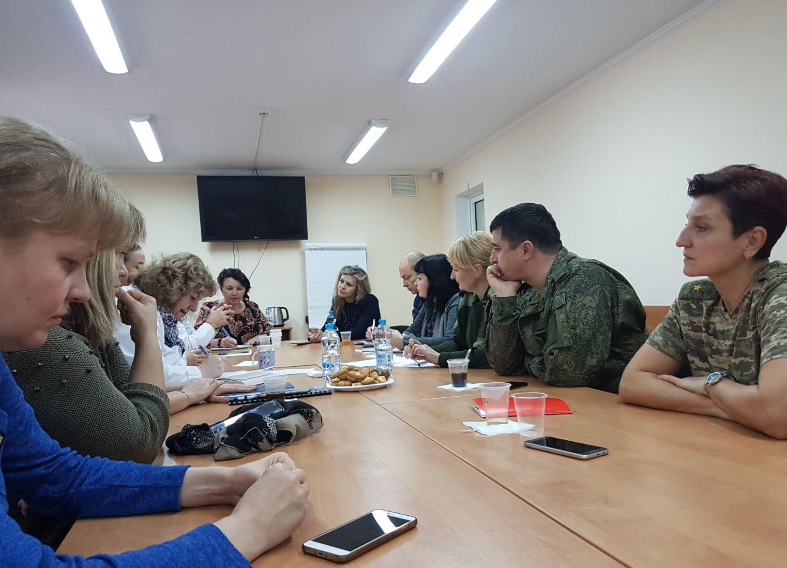

Meeting of the team of experts on HIV testing with prisons stakeholders, Tiraspol 19.11.2019

Th. Hammarberg in his 2012 report and during the meeting with the UN in 2018 has mentioned the necessity to develop services for prisoners who are released, and these services should be integrated addressing the multiple needs of the former offender. The situational analysis on both banks shows that the number of criminal re-offenders remains particularly high amongst PWUD. There are limited and fragmented services regarding rehabilitation or social reintegration of prisoners upon their release. In preparation of this activity, a number of meetings with the NGO representatives and left bank de facto authorities were organised in October-December 2019. Besides the initially planned NGOs to be involved in the Programme, “Initiativa Positiva” and “Trinity”, a new NGO with a high potential has emerged, as a potential partner on the right bank – NDiverto – oriented towards ensuring employment opportunities for former prisoners. This subcomponent envisages mini-grants to NGOs to pilot post release services and address psycho-social needs, employment support, documentation support, medical services referral and accompanying, half-way accommodation, while providing motivational food parcels on a monthly basis for at least 4 months after release.

Output 2. Increased capacities of duty bearers to fulfil their human rights obligations

The implementation of this component required a lot of efforts from the implementing UN agencies, including numerous consultations with de facto authorities related to the components, which require their active engagement and ownership. As a result, commitments were made by the de-facto authorities for their engagement in the drafting of a Human Rights Framework. In this context a de-facto inter-sectorial working group was established and the Programme is actively collaborating with its representatives in the process of development of the Human Rights Framework.

In order to support a human rights compliant HIV regulatory framework and to ensure the national ownership of the envisaged gender specific activities for WUD several meeting with the relevant stakeholders took place from September to December 2019, ensuring that gender specific services will be mainstreamed into the new National HIV Program 2025 and GFATM application 2025.

As part of the efforts directed towards enabling the rights holders living with and affected by HIV to exercise their right to health it is imminent to have an aligned regulatory framework to the international human rights standards in the field. The previous UN intervention in the region was focused on the revision of the Transnistrian HIV-related regulatory framework from a human rights and gender equality perspective. 50 policy documents were reviewed, peer reviewed by UN experts, discussed and validated by stakeholders on the left bank.

A roadmap on advocacy and promotion for adoption of those documents was developed jointly with the local partners. The first three documents were prioritized jointly with the Tiraspol HIV Centre, the NGO “Alliance for Public Health” from Tiraspol, which is the lead NGO to support this activity. A plan on the policies consultations and advocacy for the first year of the project was developed. The related activities will be further implemented in 2020.

The assessment of the relevant de facto regulatory framework in the area justice for children and its compliance with international standards will be initiated in 2020, consultancy being announced.

Based on the positive dialog which was established with police on both banks and results achieved during the previous Programme’s phase in 2016-2018, activities related to the advancement of multidisciplinary-policing approach will focus on further enhancement of cooperation between LEAs and CSOs on both banks and will continue building the capacities of police officers.

In order to further enhance the abilities of the police officer to interact and refer to the corresponding services PLWH and PWUD, during August-December 2019, in cooperation with NGO “UORN” from Balti, 6000 Booklets on HIV and LEAs and guiding procedures for police officers in Russian and Romanian languages were developed, edited, printed and disseminated. A user-friendly booklet should serve as an informative document for police offices and as a referral informative document for drug users that were detained.

Furthermore, although it was planned to subcontract in December 2019 three CSOs, which will be providing harm reduction services on the left bank, will continue providing trainings for police officers and will act as a key partner in the “police-CSO” referral scheme, this activity was postponed. This is due to the fact that the harm reduction service provision implemented by the CSOs on both banks is covered from the Global Fund. In December 2019 PR GFATM recipient has suggested selection of another CSO to provide harm reductions services in Tiraspol. Once the new CSO is selected the mini-grants are to be issued. In the meanwhile, as per the referral scheme established during the previous Programme phase, over 193 PWUD and SW were referred by police to CSOs in Ribnita, Camenca and Bender.

Output 3. Enhanced human rights culture in the Transnistrian region

Recognising the important role of the media in increasing the awareness of public on human rights and in exposing the identified human rights violations to the general public, the Programme has developed and organized a number of media events and campaigns, outlined below.

Aiming to amplify the results of Stigma index 2017 (research) on both banks, which was mainly implemented by people living with HIV, the Programme developed a comprehensive plan on stigma and discrimination reduction and supporting its implementation. The plan focuses on three different distinct public targets: 1) people living with HIV (PLWH) for addressing self-stigma, 2) health staff and 3) the general public.

At the individual level, the project focused on women living with HIV, which according to all researches are more vulnerable and also more stigmatized (Stigma Index 2018). Within this period, it was succeeded to develop the concept of the mentoring program and identify about 40 women living with HIV (compared to the target of 25) to be enrolled in it. The concept looks at the trainings needs of mentors and guidance on providing the mentoring. The service provision is based on peer to peer mentoring. 4 NGOs working with women infected and affected by HIV: two on the right bank and two on the left bank were selected and granted to ensure the mentoring program. Balti, Comrat and Bender and Tiraspol, the most remote and affected localities were chosen. 10 persons were trained as mentors to ensure the mentoring program, as well as 4 women which actually have the management position in the organization, to ensure full support for mentors and mentees. The first 40 women living with HIV are at the mid of their mentoring program (a 160% initially set indicator achievement), as the result of concept development, ToT for mentors, identification of those 40 most vulnerable women living or affected by HIV and the development of their individual mentoring programs. By now, psycho-social individual and groups sessions are realized. UCM leveraged resources from UN Women to complement the mentoring programme with services related to GBV and GE, as well as learning on economic existent opportunities, to be supported during 2020.

On the occasion of the World AIDS Day a social media campaign was developed and run in the period of November 20th - December 5th, 2019. The aim of the campaign was to raise awareness about the impact discrimination and social stigma have on people living with HIV, and how these negative attitudes hamper efforts to stop the spread of the epidemic. This outstanding communication campaign resulted in the coverage of about 20,000 people (including about 7,000 in the Transnistrian region); 40 cities from the both banks of the river Nistru; 6 Ministries, 14 NGOs and 4 Regional Social Centers for PLWH; about 20 media channels covered the events. People were reached through events as a launching press conference, meetings/workshops at the local level, informative sessions for youth, youth quests, “security itinerary” action, red ribbon solidarity action, public testing actions in all 40 localities, testing actions using the mobile clinic, flash mobs and mass media events. Within the campaign a National AIDS conference, which gathered about 150 national stakeholders developed the first draft of the new HIV strategy for the period 2021-2025.

Additionally, a series of posters “Know how talk about HIV to avoid stigma” were disseminated via social media with Problematic versus Preferred word or phrase when talking about HIV and a series of 30 seconds-long videos sharing voices and stories, which can help end HIV stigma. Out of them a 2 minutes long video was produced to start the campaign.

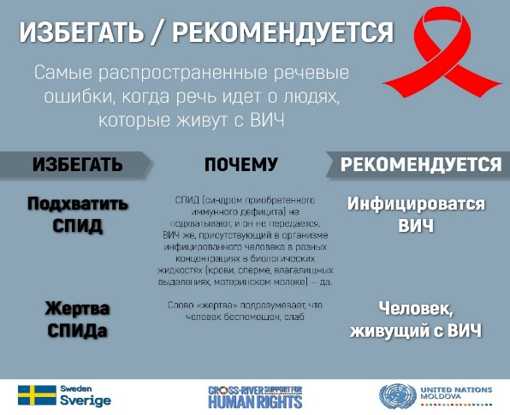
When talking about HIV, certain words and language may have a negative meaning for people at high risk for HIV or those who have HIV.
The aim of the posters created was to raise awareness that everyone can stop HIV stigma by being intentional and thoughtful when choosing his words, and choosing to use supportive - rather than stigmatizing - language when talking about HIV.
Thus, 4 special banners with a specific awareness raising messages were created and widely promoted in social media, more exactly on UN FB page, SCDP’s FB page and UNAIDS FB page.
FB statistics showed the posters campaign was deeply efficient. The posts had 3,9K organic reach, 19 shares and 122 likes.

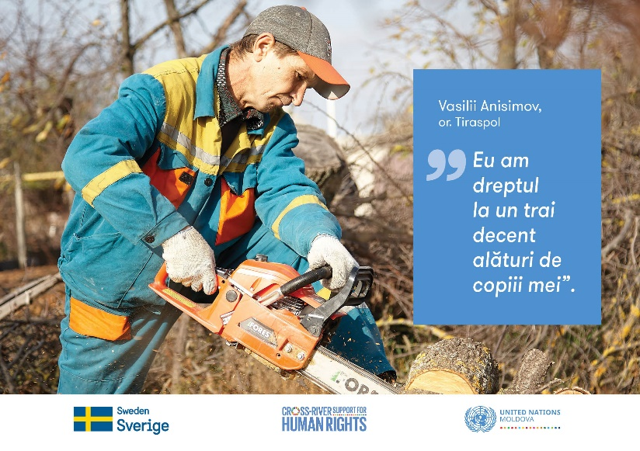
Starting with December 6, the second awareness raising campaign within the Programme was held. The aim of the campaign “I have the right to...” was to raise awareness on the importance of human rights through positive examples of vulnerable groups representatives. The campaign pivotated on positive examples of claiming rights by people belonging to vulnerable groups. Six online posters were created featuring rights holders bringing a change by claiming their rights. The posters were shared on UN FB page as well on SCPD and UNDP FB pages. The posts had 5 K organic reach and 10 shares.

As mentioned above, 4 videos sharing voices and stories that can help end HIV stigma were filmed, edited and distributed during the HIV awareness raising campaign. The general messages focused on the impact discrimination and social stigma have on people living with HIV, and how these negative attitudes hamper efforts to stop the spread of the epidemic.

To have a cross-river and gender-sensitive approach, the main characters of the stories were selected accordingly. One video was shot in Tiraspol, one in Chisinau and the third one in Anenii Noi. All three stories were compiled within one common video and distributed in the begining of the campaign.

One more video was filmed within the second communication campaign related to Human Rights awareness-raising. The two minutes long video shared the voices of ordinary persons from the left bank of Nistru River answering what association “human rights” bring to their mind.

All 5 videos were promoted in social media and ranked in the top of UN Moldova FB page video clips. The videos recorded over 5.9K views on UN Moldova Facebook page. The overall impact of the posts on Facebook is 12.1K organic reach and 85 shares (see the screen capture below).

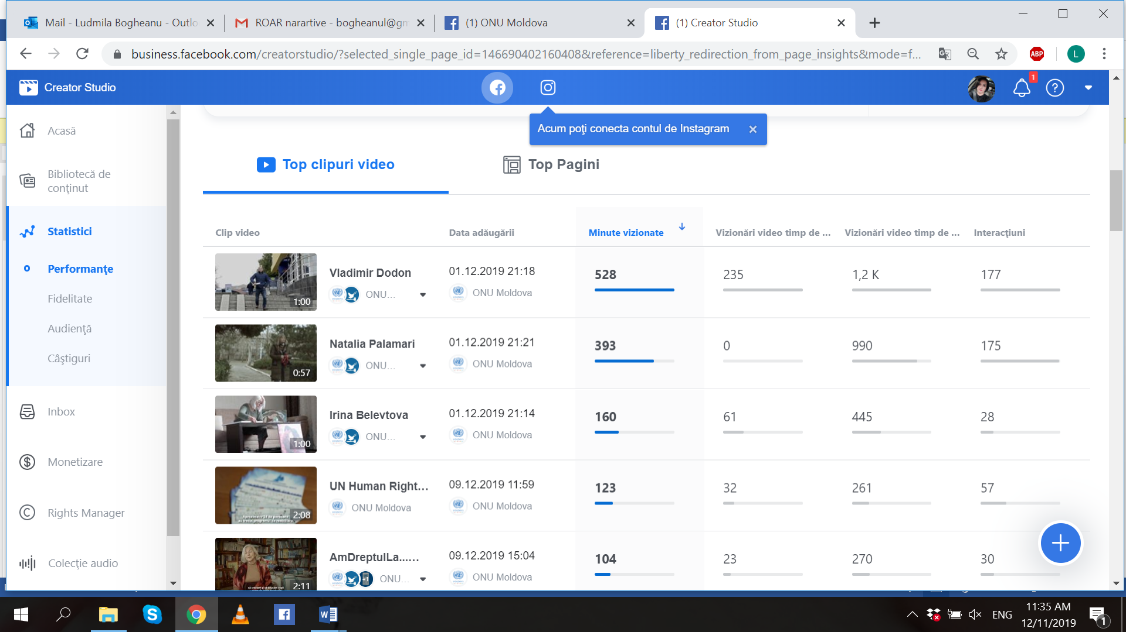

One of the highlights of this component was organization of the first-ever roundtable on the left bank of the Nistru river, at which various aspects of right to health and not only healthcare were discussed. Around 70 representatives of vulnerable groups, de facto structures, high-level representatives of implementing UN agencies, as well as WHO and SDC, participated in the event. It generated active discussions during the event, as well as significant coverage in the local media afterwards. The experience proved to be positive and will be replicated with other occasions during the Programme’s implementation period.

Additionally, two success stories on rights of persons with disabilities were written during the reporting period. One of them is featuring Vitalii Slipcenco from Tiraspol who through his civic activism transforms the urban environment into an accessible one for people with disabilities. Vitalii Slipcenco is a promoter of accessibility of public spaces and is an active member of the Sustainable (Community) Development Platform. As such, Vitalii attended a series of trainings organized by the UN and learned more about his rights and how to promote them.

The second story is about Evghenii Verbanov, a father from the left bank of Nistru River, who created an organization through which the voices of people with severe disability and their care-givers are heard. For many years, he tried to make the voice of his daughter and his family heard. He wanted others to see people with disabilities as they are, equal in rights, worth of opportunities for self-realization, and their care-givers - as people who deserve recognition for the unpaid work they do, day and night. Having heard about the UN human rights trainings, Evghenii went to one of them, and later became an active member of the Sustainable (Community) Development Platform. His organization "From peer to peer” is hiring representatives of vulnerable groups to do household-related and agricultural work, and thus improving their wellbeing. Both stories were pitched in mass media of the both banks of Nistru River.

Additionally, they were published in English, Romanian and Russian on UNDP Moldova Exposure web site (https://undpmoldova.exposure.co/nbsp-nbsp-nbsp-the-way-to-inclusion and https://undpmoldova.exposure.co/from-the-shadow, respectively).

The social media being an important way of dissemination of information, considerable attention was dedicated to maintenance and population of the SCDP’s Facebook page. In the reported period 21 Facebook posts were published and the page has over 550 followers.

Overall, the cooperation with mass-media is satisfactory, though in the reported period, minor impediments have been created by the de-facto authorities for participation of the TV outlets controlled by them, but they have been resolved by consultations with the Transnistrian counterparts. In the following period cooperation will intensify and thematic trainings, press-clubs and brunches with journalist are to be organised.

ii) Indicator Based Performance Assessment:

Since this report covers only the initiation phase of the project (5 months) there is no reporting data for this section of the report. Appropriate reporting on indicators-based assessment will be dully reported upon in the next annual reporting cycles.

iii) A Specific Story

Problem / Challenge faced: Describe the specific problem or challenge faced by the subject of your story (this could be a problem experienced by an individual, community or government).

A young woman (19 years old) had been victim of domestic violence for more than 2,5 years, until she received support from the project. She graduated from an orphan school and she had a son (1,5 years old now). She lost her own documents and also the ones of her child. She did not have any income or financial benefit from the state as single mother, because the child was not registered at the place of residence. Having no place to live by her own, she used to stay, together with the child, in the house of her partner or was hosted by someone else in the rural area. Her partner perpetrated psychological and physical abuse on her for more than 2,5 years even in front of the child and other people. The partner used to drink alcohol and be aggressive against her. She has addressed more than once the law enforcement bodies without any positive result. Additionally, she could not receive and social assistance, since the de facto state system does not provide any kind of assistance for victim of domestic violence and the resources of the de facto state intended for free legal and psychological consultations do not apply for victims of domestic violence.

Programme Interventions: How was the problem or challenged addressed through the Programme interventions?

Someone called the Trust Line 0800 99800 on domestic violence run by the NGO Interaction asking to help the young woman to find a place and to provide her psychological assistance. The young woman together with her child was prepared for placement in the shelter for Graduates from Boarding Schools of the Childhood for the Children Charity Fund, and together with other CSOs, an individual plan was created according to their needs. A part of the rehabilitation and protection aid, she received social, legal and psychological support for several months. The NGO Interaction also sent a letter to the de facto Ministry of Labour and Social Protection to inform about the case.

Result (if applicable): Describe the observable change that occurred so far as a result of the Programme interventions. For example, how did community lives change or how was the government better able to deal with the initial problem?

The individual plan designed for her and the child was fully implemented by the NGO Interaction and other CSOs. The young woman received emergency psychologist consultation and further rehabilitation. She was accompanied to the de facto Ministry of Interior, to the social services and medical facilities. Together with the de facto Ministry of Interior and social services, an assessment of her living conditions was carried out and she was put on list for the social housing. She started receiving a monthly financial benefit that is guaranteed by the de facto state for single mothers with a child. She had the opportunity to be placed together with her child in the Centre for Graduates from Boarding Schools of the Childhood for the Children Charity Fund. The travel expenses were covered, and the lost documents reissued. She stayed in the shelter just the first two days, then she returned to the house of the partner and, after a while, she started again to be hosted by her acquaintances.

Lessons Learned: What did you (and/or other partners) learn from this situation that has helped inform and/or improve Programme (or other) interventions?

- In the Transnistrian region often CSOs are ahead of de facto state structures in providing the necessary comprehensive support to victims of domestic violence. Due to the absence of a Law on the Prevention of Domestic Violence, the de facto state does not have a systematic approach to this issue, while, as highlighted by this situation, violence against women requires a multidisciplinary approach. The only instrument existing at level of de facto state on domestic violence is the Instruction for law enforcement officers to deal with cases of domestic violence developed by the de facto Ministry of Interior together with the NGO Resonance.
- Most of services for victims of domestic violence in the Transnistrian region are provided by CSOs. Not only there is a lack of specialized crisis centres and shelters for victims of domestic violence (only one in the Transnistrian region run by the NGO Resonance in Tiraspol), but also the de facto state social assistance programs and their comprehensive orientation to support families and children are very limited.
- The challenge of the story of a woman coming back to her perpetrator proves again that while the emergency interventions are needed to protect women from immediate violence, when it comes to long-term plans, many women go back to live with their violent partners and this happens very often in real life, which rather reflects a broad issue in the society, where women are economically dependent on men, especially when they have small children; where there is limited resources devoted to women´s empowerment and where traditional gender roles are very much rooted in the society.
- The perception that domestic violence is still a private affair of married couples aggravates the situation of women and children affected by domestic violence. For this reason, awareness raising are essential preventive actions and it is necessary to work with the society as a whole to change social attitudes and tolerance of violence against women.

III. Other Assessments or Evaluations (if applicable)
• During the reporting period, the Programme has initiated two assessments, which are to be finalised in Q1 of 2020. These are:
- Assessment of institutional capacities of the members of the SCDP, conducted with the participation of over 30 organisations.
- Assessment of the level of the human rights knowledge increased of the vulnerable groups and their CSOs in the Transnistrian region of the Republic of Moldova.

Both exercises proved to be more time consuming than initially anticipated. This was due to low capacities of the CSOs involved that required work with either individual organization or small groups of their representatives. They required extensive travel of consultants to the region, even though in the case of the assessment of institutional capacities it was envisaged that an introductory / explanatory meeting with the members of the SCDP will be sufficient for the organisations to fill in the provided questionnaires.

In the following period, it is envisaged to be conducted, as mentioned above, an assessment of the de facto regulatory framework in the area of justice for children.

IV. Programmatic Revisions (if applicable)
• The Programme’s Document included a draft Monitoring and Evaluation Plan. It was envisaged that following the initiation of the Programme’s activity this document will be finalised in a consultative and inclusive manner, with the participation of the representatives of all of the implementing UN agencies. Accordingly, in November 2019 a workshop for the development of the Programme’s Monitoring and Evaluation Plan. It resulted in significant revision of the Programme’s indicators, based on the Programme’s initial assessments and activities.
It is worth mentioning that M&E plan was revised through mobilisation of the internal UN resources and with the assistance of the UNCT M&E Group to conduct this exercise.

V. Resources (Optional)
• As mentioned in the report above, the Programme was faced with the impediments in recruiting necessary personnel for the implementation of activities in a number of areas. A number of positions were repeatedly re-announced and they were not filled in the reporting period. This is, partially, due to a shrinking pool of experts on the local market and, partially, due to specific requirements for the personnel involved in the activities in the Transnistrian region, such sensitiveness to the volatile situation in the region, knowledge of Russian and Romanian language at an advanced level, in addition to other required thematic or technical expertise. It is envisage that this trend will continue and it would be progressively difficult to identify consultant for this type of programmes. They will have to either train their own expert of rely on international expertise, which will require much more funds.

Annex 1: The links to the most relevant media clips, related to the activities of the One UN Joint Action “Cross-river support to Human Rights”.

- https://agora.md/stiri/64470/a-pus-rampe-de-acces-la-policlinica--teatru-si-galeria-de-arta--un-barbat-in-scaun-cu-rotile-are-grija-ca-toate-cladirile-noi-din-tiraspol-sa-fie-accesibile-foto?fbclid=IwAR0QV7ReMI5_X8e8vo9EPyC8hJFccxSXyiPea81f13tv7FCNNOCu_UiQBKw
- http://www.realitatea.md/vitalii-slipcenco-din-tiraspol-transforma-mediul-in-care-traie-te-in-unul-accesibil-pentru-persoanel_103249.html?fbclid=IwAR0uMkNaO57EWhz0RQzS1lB0F5U2XH09TNUVb0UYMk-oL73EcpebM7LjDvc
- http://tvrmoldova.md/social/istorii-de-succes-tiraspoleanul-vitalii-slipcenco-transforma-mediul-in-care-traieste-in-unul-accesibil-persoanelor-cu-dizabilitati/?fbclid=IwAR3OfwWZ0BzMcmjMD0d-i0ySOJag5HoOIDRWNt9wtxDp-dK1Wiai1REDfCc
- https://unica.md/monden/vitalii-slipcenco-din-tiraspol-prin-activismul-sau-civic-transforma-mediul-in-care-traieste-in-unul-accesibil-persoanelor-cu-dizabilitati/?fbclid=IwAR0fsU1XlLe6qerx1Tx6bRHUwcI-B5XWupmNBool6ROZ4kqE5oJoKZ0L8f4
- https://news.yam.md/ro/story/9838171
- https://stiri.md/article/social/onu-sustine-la-tiraspol-programe-in-sprijinul-persoanelor-cu-dizabilitati
- https://www.moldpres.md/news/2019/12/03/19009818
- http://moldova9.com/vitalii-slipcenco-din-tiraspol-prin-activismul-sau-civic-transforma-mediul-in-care-traieste-in-unul-accesibil-persoanelor-cu-dizabilitati/
- https://dr-ecology.blogspot.com/2019/12/blog-post.html
- http://newspmr.com/novosti-pmr/vesti-s-mest/14864
- http://dnestr.tv/8806-gorodskaya-sreda-stanovitsya-bolee-dostupnoy-dlya-lyudey-s-ogranichennymi- vozmozhnostyami.html
- http://ngointeraction.org/main/ru/component/content/article/1-latest-news/5097-2019-12-03-13-12-18
- https://mediacenter.md/publikacii/1448-istoriya-uspeha.html
- https://liktv.org/pomogi-sebe-sam-ljudi-s-ogranichennymi-vozmozhnostjami-dobivajutsja-dostupnoj-sredy/
- https://diez.md/2019/12/24/evghenii-verbanov-un-tata-din-stanga-nistrului-a-creat-o-organizatie-prin-care-face-auzite-vocile-persoanelor-cu-dizabilitate-severa/
- https://news.yam.md/ro/story/9918562
- https://syfeed.com/ro/news-details/evghenii-verbanov-un-tata-din-stanga-nistrului-a-creat-o-organizatie-prin-care-face-auzite-vocile-persoanelor-cu-dizabilitate-severa_26632381.html
- http://moldova9.com/din-conul-de-umbra-evghenii-verbanov-un-tata-din-stanga-nistrului-a-creat-o-organizatie-prin-care-face-auzite-vocile-persoanelor-cu-dizabilitate-severa-si-ale-ingrijitorilor-lor/
- https://radiochisinau.md/evghenii-verbanov-un-tata-din-stanga-nistrului-a-creat-o-organizatie-prin-care-face-auzite-vocile-persoanelor-cu-dizabilitate-severa-si-ale-ingrijitorilor-lor---101090.html
- http://provincial.md/actual/evghenii-verbanov-un-tata-din-stanga-nistrului-care-a-creat-o-organizatie-prin-care-face-auzite-vocile-persoanelor-cu-dizabilitate-severa
- https://www.realitatea.md/-foto--un-tata-din-stanga-nistrului-a-creat-o-organizatie-prin-care-face-auzite-vocile-persoanelor-cu-dizabilitate-severa-si-ale-ingrijitorilor-lor_104037.html
- https://publish.twitter.com/?query=https%3A%2F%2Ftwitter.com%2FUNDPMoldova%2Fstatus%2F1209446042728570884&widget=Tweet

The term “programme” is used for programmes, joint programmes and projects.
Strategic Results, as formulated in the Strategic UN Planning Framework (e.g. UNDAF) or project document;
The MPTF Office Project Reference Number is the same number as the one on the Notification message. It is also referred to as “Project ID” on the project’s factsheet page the MPTF Office GATEWAY
The MPTF or JP Contribution, refers to the amount transferred to the Participating UN Organizations, which is available on the MPTF Office GATEWAY
The start date is the date of the first transfer of the funds from the MPTF Office as Administrative Agent. Transfer date is available on the MPTF Office GATEWAY
As per approval of the original project document by the relevant decision-making body/Steering Committee.
https://www.unodc.org/unodc/en/hiv-aids/new/prison_settings_HIV.html

