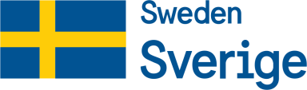
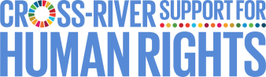
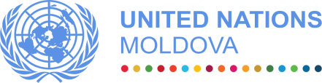

One UN Joint Action to Strengthen Human Rights in the Transnistrian region
of the Republic of Moldova (2019-2022)

MPTF OFfice GENERIC ANNUAL programme NARRATIVE progress report
REPORTING PERIOD: 1 jANUARy - 31 December 2020

Programme Title & Project Number |  |  | Country, Locality(s), Priority Area(s) / Strategic Results
- Programme Title: Joint Action to Strengthen Human Rights in the Transnistrian Region of the Republic of Moldova  - Programme Number (if applicable)  - MPTF Office Project Reference Number: 00117252 |  |  | (if applicable)  Country/Region Republic of Moldova
 |  |  | Priority area/ strategic result: Governance and Human Rights
Participating Organization(s) |  |  | Implementing Partners
- IOM  - OHCHR  - UNAIDS  - UNICEF  - UNDP  - UNODC |  |  | - NGO “Alliance for Public Health”  - NGO “GenderDoc-M”  - NGO “Initiativa Pozitiva”  - NGO “Interaction”  - NGO “Participation”  - NGO “Resonance”  - NGO “Trinity”  - NGO “UORN Moldova”
Programme/Project Cost (US$) |  |  | Programme Duration
Total approved budget as per project document:  MPTF /JP Contribution:  - IOM: 117,464 USD  - OHCHR: 205,487 USD  - UNAIDS: 229,414 USD  - UNICEF: 143,166 USD  - UNDP: 229,100 USD  - UNODC: 217,852 USD |  |  | Overall Duration 36 months  Start Date 02.07.2019  Original End Date 02.07.2022  Current End date 02.07.2022
Programme Assessment/Review/Mid-Term Eval. |  |  | Report Submitted By
Assessment/Review - if applicable please attach  Yes No Date: dd.mm.yyyy  Mid-Term Evaluation Report - if applicable please attach  Yes No Date: dd.mm.yyyy |  |  | - Name: Alexandru Stratulat  - Title: Programme Manager  - Participating Organization (Lead): UNDP  - Email address: alexandru.stratulat@one.un.org

Acronyms

AIDS | Acquired Immune Deficiency Syndrome
ARV | Anti-retroviral treatment
CBM | Confidence Building Measures
CCM TB/AIDS | Country Coordination Mechanism on TB/AIDS
CRPD | Convention on the Rights of Persons with Disabilities
CSOs | Civil society organizations
FB | Facebook
GFATM | The Global Fund to Fight AIDS, TB and Malaria
HIV | Human Immunodeficiency Virus
HRBA | Human Rights based Approach
HR | Human Rights
IOM | International Organization for Migration
LEA | Law-Enforcement Authority
LPAs | Local Public Authorities
MPTF | Multi-Partner Trust Fund
MSM | Men who have sex with men
NGO | Non-Governmental Organization
OHCHR | Office of the High Commissioner for Human Rights
PCA | Partnership and Cooperation Agreement
PLWH | People living with HIV
PrEP | Pre-exposure prophylaxis
PwDs | People with disabilities
PWUDs | People who use drugs
RAF | Results Assessment Framework
SCDP | Sustainable (Community) Development Platform
SDG | Sustainable Development Goal
SoPs | Standard operating procedures
SW | Sex Workers
TB | Tuberculosis
TN | Transnistrian region
UN | United Nations
UNAIDS | United Nations Programme on HIV/AIDS
UNCT | United Nations Country Team
UNDG | United Nations Development Group
UNDP | United Nations Development Programme
UNICEF | United Nations Fund for Children
UNODC | United Nations Office on Drugs and Crime
UNPF /UNDAF | United Nations - Republic of Moldova Partnership Framework
UORN | Harm reduction and drug users’ rehabilitation in the North
WAD | World AIDS Day
WHO | World Health Organization
WUD | Women who use drugs

EXECUTIVE SUMMARY

During the reporting the activities of the Programme were carried out in a significantly revised manner, due to the restrictions imposed on both bank of the Nistru River, as a result of the COVID-19 pandemic. For more than 9 months the activities were transferred to the online space, with very few exceptions, which created a new dynamic in the interaction of the Programme with both its partners and beneficiaries.
The interaction with the Sustainable (Community) Development Platform (SCDP) was intensified, while its membership was expanded. The institutional capacity of the SCDP and its members was strengthened through 17 webinars and online workshops, as well as individual coaching sessions.
In the reported period, the capacities of rights holders were developed in two directions: 1) institutional capacities and 2) thematic knowledge. Thus, over 60 representatives of NGOs from 11 localities from the left bank have strengthened their capacities and learned how to develop and operate an effective and sustainable human-rights-oriented organisation, as well as to communicate in an HRBA compliant manner about their activities and beneficiaries. Participants included representatives of PwDs, Roma community, organisations working with PLWH, PWUDs, or victims of domestic violence, as well as media. 25 media professionals (18 women and 7 men) increased their knowledge on basic concepts and principles of human rights and human rights mechanisms, human rights at risk in the context of the pandemic, gender sensitive communications, and inclusive and non-discriminatory terminology when discussing different vulnerable groups.
Moreover, 30 human rights activists, members of civil society organisations and representatives of four underrepresented groups from 16 left-bank NGOs have developed their capacities in the area of human rights and will be able to share further their knowledge as trainers and human rights advocates.
Also, as a result of the Programme’s interventions, the capacities of the members and partners of the Sustainable (Community) Development Platform to work together and plan joint actions was further increased through implementation of 14 joint initiative (grants) by organisations from the left and right banks of the Nistru River.
Additionally, in the reported period representatives of vulnerable groups have improved access to community services. 192 persons had access to PrEP (pre-exposure prophylaxis) on HIV, more than doubled compared to the previous year. Based on the referral scheme established during the previous phase of the Programme, over 462 PWUD and SW were referred by the de-facto structures to CSOs in Ribnita, Camenca and Bender. Also, through the calls received at the “Trust Line 0800 99800” for victims of domestic violence, supported by the Programme, 31 new SOS cases of women victims of domestic violence were opened, and those cases were referred to or managed together with specialised NGOs from Transnistrian region. 29 persons with disabilities from Slobodzia district received 48 consultations (legal, psychological, employment assistance) and have individual support plans developed. Around 50 women (a double of the target) infected or affected by HIV from the both banks were empowered by raising their awareness on human rights, decreasing self-stigma and increasing their self-esteem through a 1-year mentoring programme.
The awareness of the population on both banks of the Nistru River, especially the vulnerable groups, was increased on the subjects related to the rights of PwDs, Roma community, people living with HIV/AIDS and victims of domestic violence. This was achieved through organization of two communication campaigns, over 160 Facebook posts and two articles/human stories on UNDP Exposure web site, as well as through distribution of 6585 copies of four “an easy to read, easy to understand” leaflets on human rights. As a result of the Media Academy 13 media professionals from the Transnistrian region with mentoring support from UN experts produced and published 11 human rights compliant media products on various topics.
Additionally, the awareness of the duty-bearers has been increased by developing, editing, printing and disseminate 6000 booklets on HIV and LEAs and guiding procedures for police officers in Russian and Romanian languages.
In line with the Programme’s output of increasing the capacities of duty bearers to fulfil their human rights obligations, 3 de facto regulatory acts with implications on the life of PLWH were adopted by the de facto structures on the left bank, thus removing the discriminatory limitation in the area of employment, child adoption and blood donation.
The report on the de-facto legal framework in the Transnistrian region on justice for children in contact and conflict with the law, the first ever exercise of its kind, led to extensive revisions of the regional normative framework and increased the potential of their alignment with international standards.
The assessment of the existing training programmes for professionals that work with children in contact with law was carried out, as well as the abilities of field specialists to provide a qualitative and effective trainings to children placed in “A.S. Makarenko” specialised school were improved.

Purpose

The project is grounded in the United Nations human rights-based norms and standards and pursues strengthening of the effective exercise of human rights by people residing in the Transnistrian region through fostering improvement of the regulatory and institutional frameworks in the area of disability, gender-based violence and HIV, PWUDs, Roma and children in conflict with law.
The action is implemented through the UN Multi-Donor Trust Fund being framed around three inter-linked components/outputs (increased capacities of rights holders to exercise their rights (Output 1), increased capacities of duty bearers to fulfil their human rights obligations (Output 2) and enhanced human rights culture in the Transnistrian region (Output 3), which are led by IOM, OHCHR, UNAIDS, UNICEF, UNDP and UNODC. These components have been identified following the assessment of the results of the previous phases of joint action in the region, the 2018 follow-up report of the UN Senior Expert Thomas Hammarberg and discussion with key stakeholders and region’s de-facto structures. The proposed three components are also based on the comparative advantages of respective UN agencies, as a result of normative and operational capacities, ready-to-go expertise available as a result of competencies of UNCT Moldova. In addition, the identified components are selected outside any political process, consistent with the mandates of the respective UN agencies. They are aiming to advance Moldova’s progress towards the achievement of Sustainable Development Goals 1 (No Poverty), 3 (Good Health and Well-being), 4 (Quality Education), 5 (Gender Equality), 10 (Reduced Inequalities) and 16 (Peace, Justice and Strong Institutions). The result of the Programme are in line with UNDAF Outcome 1 (The people of Moldova, in particular the most vulnerable, demand and benefit from democratic, transparent and accountable governance, gender-sensitive, human rights and evidence-based public policies, equitable services, and efficient, effective and responsive public institutions) and Outcome 4 (The people of Moldova, in particular the most vulnerable, demand and benefit from gender-sensitive and human rights-based, inclusive, effective and equitable quality education, health and social policies and services).

Results

- Narrative reporting on results:

The main highlight of the reporting period was the readjustment of all of the Programme’s activities in line with the rules and restrictions related to the COVID-19 pandemic in 2020. This has required both implementing UN agencies, as well as their partners to rethink the way in which the Programme’s activities were implemented in order to comply with the “new reality”, as well as to ensure the safety of its staff and beneficiaries. Thus, the course of the implementation of the Programme was significantly altered, either by adjusting the content of the previously planned activities or by creating delays in their implementation process. One of the major challenges was related to transfer of the activities to the online format and the restriction to travel to the Transnistrian region and the need to ensure an effective interaction with the Programme’s partners and beneficiaries. Also, the Programme’s played an essential role in facilitating the assessment of the needs of its most vulnerable beneficiaries and the UN and international development partners’ initial response to the COVID-19 pandemic in the Transnistrian region.

In order to overcome the challenges outlined above and accelerate the implementation of its activities, the Programme’s Support Team composed of Programme Manager, Programme Associate and Communication Consultant closely cooperated with the implementing UN agencies and provided support and advice in the use of the new online tools and platforms to ensure the continuity of the Programme’s activities. One particular aspect was related to the organisation of advocacy campaigns and development of the visibility and media products, in the context of COVID-related rules, when face-to-face interviews were limited and restrictions were imposed on movement to and from the left bank of the Nistru River. The Programme’s implementation team has proposed use of less common tools, such as cartoons, photo-audio essays etc. Regardless of the challenges, the Programme has ensured that its awareness-raising and advocacy components were carried out, though in a slightly revised and mostly limited to online space manner. The Sweden’s and UN’s visibility was ensured throughout these activities and in line with their visibility requirements.

Significant efforts were made to ensure environmental sustainability of the Programme’s interventions. Though the Programme has not envisaged direct creation of opportunities in the environmental sustainability field, indirectly it contributes to transformation of local enterprises into ones that are environment-friendly. Specifically, the Programme raises the awareness of the public on the Sustainable Development Goals and their importance for the harmonious human development. In addition to the Programme’s recommendations to local partners to reduce their waste and proposals on how they can be more environmentally friendly, the Programme has envisaged a specific session on the subject, which will be part of its institutional capacity building activities in early 2021.

The Programme has established working relations and identified synergies with other projects and programmes implemented in the Transnistrian region, mainly with projects in the area of confidence building, implemented by UNDP. This resulted in participation of projects’ beneficiaries in Programme’s activities and vice versa, as well as in provision by the Programme Manager of advice on HRBA and vulnerability aspects of the respective projects. Additionally, the Programme is actively cooperating with OSCE in the area of institutional and general capacity building for CSOs and duty-bearers and a working group was established in this respect, which meets on a regular basis. This ensured that there is no overlap in capacity building activities implemented by the respective international organisations.

There are not only cross-sectoral, but thematic synergies in place. For example, the initiatives undertaken by the Programme in the area of domestic violence are complementing other projects currently implemented by IOM in the Transnistrian region, such as the project “Enhancing confidence building across the Nistru river through combating the domestic violence and gender-based violence phenomena in the Transnistrian region of the Republic of Moldova” finalized in March 2020 and its current Phase II “Gender Based Violence Cooperation Across the Nistru river”, funded by the UK Embassy/CSSF. This project reflects a logical continuation and builds upon the efforts of the previous projects to improve the prevention and response mechanisms to DV, as well as enhancing the protection of the rights of DV victims in line with the international obligations of the Republic of Moldova, and with the UN 2030 Agenda for Sustainable Development. Similarly, UN implementing agencies supported each-other’s efforts in various areas of the Programme with specific expertise and knowledge.

It is important to note that the results presented below were achieved in very complex conditions of the COVID-19 pandemic, with the imposed restrictions on meetings and movement across the administrative delimitation line between two banks of the Nistru River. Thus, COVID-19-related protective measures were insured during the implementation of Programme’s activities.

Output 1. Increased capacities of vulnerable rights holders to exercise their human rights

Throughout the reporting period the Programme has continued the cooperation with the Sustainable (Community) Development Platform (SCDP or Platform) with the aim of developing its capacity in advocating for and defending the rights of the most vulnerable. New members were accepted into the Platform, making it more comprehensive and expanding its membership to new target vulnerable groups: people living with HIV/AIDS, people using drugs, Roma, victims of domestic violence etc.

In order to consolidate the SCDP’s institutional capacity and support it in the process of transition, a number of coordination meetings were organised on both banks with the representatives of these new groups. The current capacity of more than 30 organisations and initiative groups of the Platform to cooperate and work together was consolidated by supporting the process of development of the new SCDP’s strategy and action plan. During 2020, a number of new organizations got actively involved in the activities of the SCDP or expressed interest in becoming members. Among them: “Милосердие”, “Добровольцы - это мы!”, “Federation Family in Moldova”, “Femeia Conteaza”, “Медики за экологию”, “Детство дотям”, “Сердце”, “Вместе” and “Большой фонтан”.

Based on the capacity assessment of SCDP’s members conducted by the Programme, over 60 NGO representatives from 11 localities on both banks of the Nistru River have increased their capacities and are better equipped to achieve their goals and communicate effectively about human rights and their activity. This is the result of the institutional capacity development activities, organised by the Programme, which included: webinars, individual coaching, online practical workshops and technical assistance in project proposal development. During 17 online capacity building events following topics were covered: Strategic planning, Organizational development and Management, Team building, Financial management, Accountability, Communication and Visibility, Project Management, Partnerships and Advocacy, Fundraising and Financial Sustainability, Monitoring and Evaluation, IT literacy etc. A human-rights-based and gender-sensitive approach was ensured by adapting the content of the webinars for the level of understanding of participants.

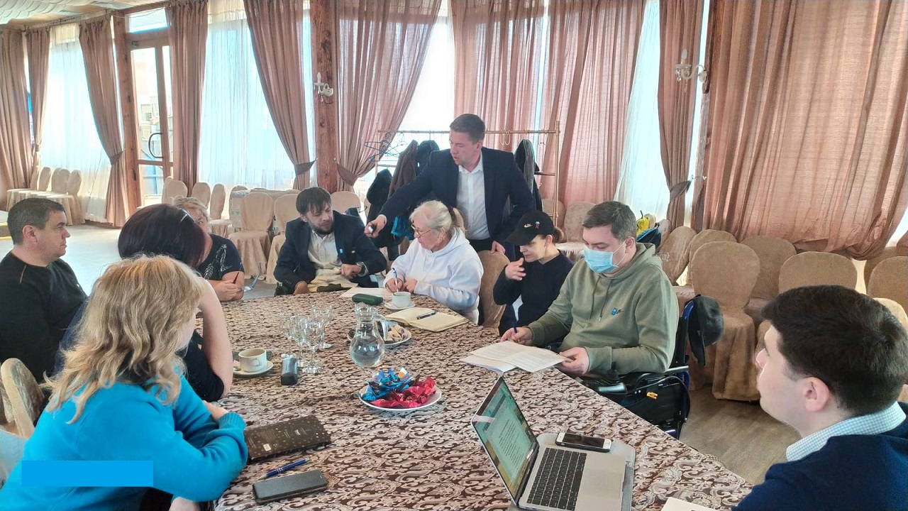
Human rights capacity building needs assessment exercise (focus group) with Programme’s partners conducted in Tiraspol @photocredit: NGO “Participation”

Also, the institutional capacities of the individual organisations were supported through a small grants programme. 14 grants to individual NGOs, as well as consortia of NGOs, from both banks of the Nistru River were awarded. The grants covered capacity building activities, as well as the development and provision of community-based social services to a wide variety of vulnerable groups, including PwDs, PLWH, PWUD, Roma, elderly people, vulnerable women and children.

As described above, the capacities of rights holders were developed in two directions: 1) institutional capacities and 2) thematic knowledge. Thus, 30 human rights activists, members of civil society organisations and representatives of four underrepresented groups (22 women and 8 men) have developed their knowledge and capacities in better understanding the local and international framework in the area of human rights and specific rights of the vulnerable groups. Lively discussion and crucial topics presented in practical exercises gave additional insights on human rights. Based on an intermediary assessment conducted among participants, 70% of participants marked that they had already started to spread and practice their knowledge, which they had obtained during the participation at the first phase of the program: several participants had already conducted thematic trainings for Roma communities and people with disabilities, some participants reported doing legal counselling to the community representatives on discrimination and human rights violations. Also, through a comparative analysis of a pre-programme test and intermediary test, an increase in substantial human rights knowledge was established among participants: overall increase in human rights understanding was marked at 30%, considerable improvement is tracked in such thematic questions as human rights-based approach (increase on 30%), access to information (increase of 25%) and freedom of associations (increase of 19%). More focused training sessions in areas of disability rights, rights of Roma, gender-based violence, rights of persons living with HIV, as well as ToTs are envisaged.

Interview during field visit to Roma community, June 2020 @photocredit: OHCHR

In the area of Roma rights and, specifically, the piloting of the Roma community mediator institution on the left bank of the Nistru, a draft Roadmap and draft Action plan, were developed. A draft analysis of the regulatory framework on the left bank of Nistru river relevant to the rights of Roma and setting up of the system of Roma community mediators was also developed. The analysis details the steps that need to be undertaken to ensure the sustainability of the established institution. Furthermore, thanks to the needs’ assessment in September 2020 a dialogue between the established Roma CSO and de-facto structures was initiated to improve the human rights situation and eliminate discrimination faced by Roma in education, social protection and access to labour market.

In line with the Programme’s objective of social inclusion of vulnerable groups, 29 PwDs received community-based services in Slobozia district on the left bank of the Nistru River. This consisted of 48 consultations (legal, psychological, employment assistance) and development of individual support plan.

In line with the Programme’s target of developing communitarian pre-exposure prophylaxis service for men who have sex with men, sex workers, partners of persons living with HIV, 192 persons had access to PrEP (pre-exposure prophylaxis) on HIV in the period from January to December 2021, a more than doubled result compared to the previous year (from 89 in 2019) (see Diagram 1 - Total number of PrEP beneficiaries, 2019-2020). It is important to underline that communitarian PrEP is a unique model in the region of Eastern Europe and Central Asia, as it is provided through community-based NGOs, ensuring the friendly access of hard-to-reach populations to that service. Out of 192 persons - 35 were from the Left Bank (17 from sero-discordant couples, 9 men who have sex with men (MSM) and 9 sex workers (SW) and 157 on the Right Bank (22 from sero-discordant couples, 128 MSM, 5 SW, 1 transgender and 1 other) (see Diagram 2. Number of PrEP beneficiaries, Right and left banks, 2020).

It has to be mentioned that the number of PrEP beneficiaries in Transnsitrian region significantly increased, from 4 persons in 2019 to 35 in 2020, as a result of one training and one national workshop organized with about 25 participants each from both banks joining health specialists and community workers. It contributed to the development of the capacities and skills requested for the effective achievement of the Community PrEP and made possible the enrollment of two new NGOs from Transnistria region in PrEP delivery - “Alians Zdorovia” from Tiraspol and “Trinity” from Ribnita, which led to the beneficiaries’ boost into the programme.

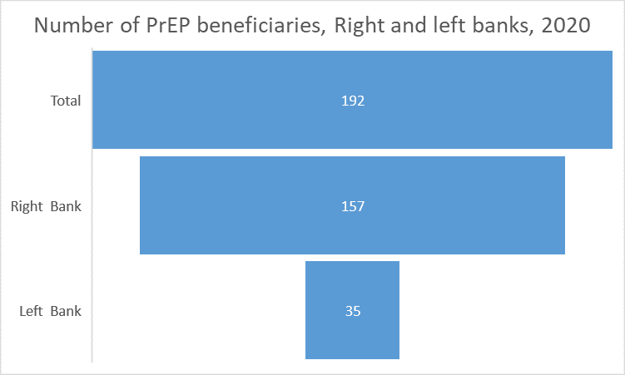
Diagram 1. Diagram 2.

Diagram 3.

In terms of sustainability, jointly with NGOs and national partners efforts it was succeeded to ensure community PrEP services became part of National HIV Program 2021-2025 and also part of the Global Fund to fight AIDS, TB and Malaria (GFATM) grant 2021-2023.

Moldova model was shared on unaids.org portal Delivery of PrEP at home in the Republic of Moldova | UNAIDS, at Quarterly Programme Branch Meeting on 7th of October and with 25 NGOs working in HIV in Kazakhstan.

As a result of the visit of the international expert, Dr. Jean-Michel Molina (France), to Moldova in February 2020, a number of recommendations for the improvement of the Moldova’s PrEP system were made, including on awareness about the system and simplification of delivery and monitoring of the PrEP services. The expert’s report mentioned the high level of collaboration between NGOs and public hospitals to provide PrEP to key populations across the country and the efficient collaboration between both banks of the Nistru River. He also praised the political will to expand the implementation of PrEP. The programme took the necessary steps to promptly implement the expert’s recommendations and an Excel Form for Monitoring and Evaluation of Community PrEP processes was developed.

Also, despite the lockdown, PrEP was delivered at home to about 90 MSM, in order to ensure uninterrupted prevention treatment and an emergency MoHLSP order that described the entire procedure of delivery at home process, as well as the ways to provide protective measures to personal and beneficiaries was developed.

Two online awareness raising events on PrEP were organized online due to COVID restrictions - “PrEParty party - be prepared for your party”. Circa 200 persons had the opportunity to find out more about PrEP and how, where and when PrEP services can be accessed or ask other related questions.

Training “Gender Academy”, 3-6 February 2020, Chisinau @photocredit: Ludmila Boghean

As per Programme’s objectives for 2020, the piloting of gender specific services for women, who use drugs, on both banks of the Nistru river started by building the capacities of the relevant stakeholders and by launching a dialog with the CSOs in order to identify the most suitable placing of the crisis rooms for women. UNODC joined the effort with UNAIDS in organizing Gender Academy for CSOs, medical and social protection specialists from both banks working with women and people who use drugs. Thus, 25 specialists (20 women and 5 men) improved their knowledge and developed their capacities in the in the fields of gender specific services aspects of harm reduction services, as well as applicability and practical aspects of UNODC Policy brief and international recommendations on services for women, who inject drugs.

As a result of Programme’s activity, during March-December 2020, 462 people who use drugs, sex workers (including those that exchange sex for food, drinks or drugs), men who have sex with men, homeless people, women who used drugs and suffer from domestic violence, but also people who consume regularly alcohol were referred by police to CSO and medical services. Due to joint de facto police-CSOs efforts out of all people referred to services all were tested for HIV, viral hepatitis C and Syphilis and 14 people were tested positive to HIV and 41 people were tested positive to HVC and Syphilis. In one case during the training in Dubasari, a participant from the de facto police has reported to the CSO that there is a vulnerable woman working in a farm. On the same day, after the training, they travelled as a joint team to the farm, tested the women and her sexual partners and have referred her to the medical services.

The capacities of the left-bank prisons representatives to test prisoners for HIV was improved by creating a technical working group comprising the representatives of the de facto structures, prisons’ administration, Tiraspol AIDS Centre and specialised local CSOs. The main objective of this technical group was to develop and promote the Standard operating procedure (SOP) and the referral mechanism on HIV testing among prisoners, in line with the evidence-based WHO and UNODC recommendation and best practices, including testing of prisoners for HIV via CSOs. The finalised document was approved by the technical working group and is pending the approval by the de facto structures in the field of justice. Additionally, a memorandum of cooperation and understanding in this field was drafted between multiple Transnistrian CSOs and de facto structures in the areas of health and justice, but its signature is conditioned by the approval of SOP.

Furthermore, under the prison component, there is a scope to pilot by 2022 services of rehabilitation and social reintegration of prisoners upon their release. In preparation of this activity, partnerships were established between the CSOs on both banks of the Nistru River - “Initiativa Positiva” and “Trinity”. Besides them, a new NGO with a high potential, NDiverto, oriented towards ensuring employment opportunities for former prisoners, has emerged on the right bank, as a potential partner. In 2021 mini-grants will be issued to CSOs to pilot post-release services and address psycho-social needs, employment support, documentation support, medical services referral and accompanying, half-way accommodation, while providing motivational food parcels on a monthly basis for at least 4 months after release.

In order to improve the service delivery of CSOs in the field of Domestic Violence (DV) related to identification, referral and direct assistance, during the reported period (January-December 2020), the operationalization of the “Trust Line 0800 99800” for victims of domestic violence was supported by the Programme. 1801 calls including 683 related to domestic violence in the reporting period. 335 of these calls were SOS related, and 31 new SOS cases were opened. This exceeded the target for the period which was to register 1000 calls and assist in 25 SOS cases. SOS cases were provided with material, legal, psychological and/or social support by qualified consultants and/or referred to specialized organizations in the Transnistria region for further support and assistance (NGO “Interaction”, Centre for Psychological Support “Lada”, and Centre “Resonance”).

Both preventive calls and SOS-calls have increased compared to in 2019, potentially as a result of the COVID-19 pandemic. Strict lockdown measures in the Transnistrian region have placed individuals and society under stress, financially, socially and physically, with reports of increased fears, tension, aggression and violence within the household and between family members. This trend is especially high among urban households, where individual space is more limited than in rural areas, thus contributing to greater tensions. The easing of restrictions in June 2020 saw an increase in reported cases as victims had greater opportunity to seek help as their aggressor returned to work. The summer period also eased physical access to support services for victims in need. Psychological and physical violence remain the most frequent forms of violence reported by victims.

Sustained communication and advocacy efforts on DV and gender-based violence (GBV) issues (e.g., the 16 Days of Activism campaign) and the availability of the “Trustline 0 800 99800” in the Transnistria region throughout the project period also contributed to continued awareness raising and growing knowledge of available support services among the population. This can also explain the increased incidence of cases from year to year as victims are more empowered to recognize different forms of domestic and gender-based violence and to know where and how to seek assistance. These efforts were also supported by capacity building activities. Notably, two events were held on the prevention of burnout syndrome, on 30 July 2020 for 10 (8 female, 2 male) specialists of NGO “Interaction” and on 20-21 November 2020 for 13 (all female) professionals from the NGO “Interaction” and others. The trainings focused on strengthening emotional intelligence and emotional competence, as well as on child-parent relationship and personal development as an adult. The participants found the training useful and asked that it takes place regularly as it helped them preserve and strengthen their psychological health through mastering techniques of mental self-regulation and increased their understanding of own emotions and the emotions of others. This contributed to improved collaboration with colleagues, communication with beneficiaries, and timely response to stressful situations.

With a view to consolidate the friendly justice system for children in Transnistrian region, the Report on the de facto normative framework pertaining to justice for children in contact and conflict with the law was developed. The Report closely scrutinizes compliance of the framework with international standards and norms as well as points out the gaps in policies and processes that need to be addressed consequently.
The findings of the report revealed that the de-facto normative framework requires consistent improvements, as well as the need to develop a long-term strategy for child rights in the region.

The package of amendments has been drafted based on the findings of the Report relating to the child justice legal framework, with the targets to adjust the de facto Transnistrian normative framework in the areas of crime, criminal procedures and child rights in accordance with international standards and norms (e.g. extension of criminal liability deadlines in the case of sexual offences against children and provision of free legal aid for child victims of sexual offences; introducing the possibility to change legal representation in criminal proceedings in cases of conflict of interest; reducing time for investigation and trial in cases involving children). There is an in principal agreement from the de facto structures to promote this package of legal amendments and to collaborate in implementation of the medium and long terms recommendations of the Report.

Output 2. Increased capacities of duty bearers to fulfil their human rights obligations

The implementation of this component required a lot of efforts from the implementing UN agencies, including numerous consultations with de facto structures related to the components, which require their active engagement and ownership. As a result, on 11 June 2020, the de-facto leader, Mr. Krasnoselski, approved the establishment of an intersectoral working group for the drafting of the Human Rights Framework, consisting of 10 representatives of de-facto structures. A roadmap for the drafting of the framework, in which CSOs played a crucial role in the drafting process, was submitted for endorsement by the de facto structures. They expressed their commitment to the implementation of the Roadmap and agreed to include CSOs in the process, including members of the SCDP.

As a first step to building the capacity of the institutionalized human rights structures on performing their role to protect, monitor and promote human rights in the region, the Programme has continued its interaction of the Ombudsman structures on both banks of the Nistru river. Initial progress was achieved and a capacity building activity for members of the intersectoral working group was agreed. However, due to the COVID pandemic, the activities had to be postponed for early 2021.

Similarly, the development of a regulatory framework compliant with the Convention on the Rights of Persons with Disabilities was delayed, given delays in recruitment of a consultant and COVID-19. The ToRs for the consultant, who will conduct an assessment and who will develop the recommendations for a CRPD-compliant regulatory framework on the left bank of Nistru River was drafted and the recruitment process will start in early 2021.

Three important HIV-related normative policy documents were amended and approved by the de facto structures:
1. The PLWH from Moldova, including Transnistrian region, now have the right to adopt children. The amendments to the normative framework were approved in the late December and November 2020, respectively. Adjustments on the law related to adoption of children by HIV positive people have been approved by the facto authorities from the health, social and justice sector in Transnistrian region.
2. De facto health structures have adopted a document abolishing compulsory HIV testing for employment and regular health check-ups. The document was registered with the de facto structures in the field of justice.
3. The following concept was excluded from the legal norm in relation to blood donation: “the persons from the risk groups, such as homosexuals, drug users and prostitutes”, allowing all persons to be able to donate blood.

These changes represent a significant progress in HIV de-stigmatization process and are aimed at ensuring equal rights to all, regardless of their HIV status. This was possible due to the extensive multistakeholder policy dialogue and consultations, both formal and informal, involving local partners, de facto structures in the areas of health, justice, social affairs, interiors, AIDS center, specialized NGOs from Transnistrian region. It ensured their active engagement and ownership of the process.

In order to further enhance the abilities of the police officer to interact and refer to the corresponding services PLWH and PWUD, in cooperation with NGO “UORN” from Balti, 6000 Booklets on HIV and LEAs and guiding procedures for police officers in Romanian language were disseminated. A user-friendly booklet should serve as an informative document for police offices and as a referral informative document for drug users that were detained. The Russian version of the booked was finalized and the adapted version of the booklet for the left bank is due in June 2021.

Furthermore, 184 representatives of the de facto police, out of which 22% - women, from Dubasari, Ribnita, Camenca, Tiraspol, Slobozia, Grigoriopol, Bender districts on the left bank of the Nistru River have improved their awareness on TB, HIV and developed their capacities in referral of vulnerable groups to medical and psychosocial services. In the context of COVID-19 the info-sessions were provided as 5 days webinars and an additional online module on communicable diseases and COVID-19 was added. The achievement of this result was possible due to cooperation with left-bank CSOs: Triniti (Ribnita), Miloserdie (Bender) and Alianz Zdoroviya (Tiraspol).

Participants included representatives of the de facto drug control, patrol and public order, minors’ affairs, human resources and traffic control structures. Up to 81% off all participants have significantly improved their knowledge during the trainings, as shown by the online Pre and Post training scoring, answering correctly to 3 out of 4 groups of questions related to safety and security at the workplace, referral mechanisms and interaction with the vulnerable groups. Up to 96% of all participants have reported the information provided during the training as very practical and useful for their daily work.

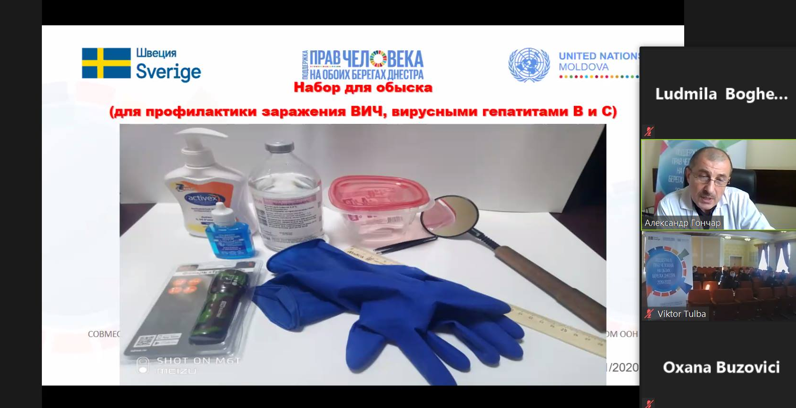
Dr. Alexandr Goncear from AIDS Centre Tiraspol is explaining the prevention measures to HIV during the webinar for the representatives of the de facto police from Tiraspol, 22 October 2020

An Assessment of the existing training programmes for pre-service (law students) and in-service professionals (de facto justice, police and social system professionals) that work with children in contact and conflict with law was performed. The Assessment highlighted the need for cross-sectoral cooperation and the practical role of justice, education, health and social systems, embracing not only the evaluation of the existing training programmes for pre-service and in-service professionals, but also mapping the de facto juvenile justice system in the Transnistrian region. Consequently, training programmes for pre-service and in-service professionals working with and/or for children in contact with law will be developed, with the focus on systematic and coordinated capacity building activities.

To ensure observance of the rights of children in custody, namely children placed in “A.S. Makarenko” specialised school, a wide range of revision and improvement of the internal regulations and procedures of this institution has been proposed by the Programme. As a result, a new Code of Conduct for “A.S Makarenko” staff and adjustments to interior Guidelines for working with children have been developed in cooperation with representatives of the “A.S. Makarenko” specialised school. A comprehensive preparation for release programme for children placed in Makarenko, as well as the training package for “A.S. Makarenko” staff to apply child friendly procedures have been initiated in order to facilitate social rehabilitation and re-integration of children in custody. After final consultation, the developed documents will be submitted for approval to the de-facto structures.

Output 3. Enhanced human rights culture in the Transnistrian region

Around 50 women (a double of the target) infected or affected by HIV from the both banks were empowered by raising their awareness on human rights, decreasing self-stigma and increasing their self-esteem through a 1-year mentoring programme. Additional resources were mobilized from UN Women, which complemented the program with services related to socio-economic empowerment and gender-based violence management. Thus, the mentoring program covered psycho-social, economic and gender related aspects. As a result of the program, a woman from Tiraspol decided to open publicly her HIV status and talk about stigma, discrimination and domestic violence she faced during years. Her story was published on the UNAIDS global website.

In response to the COVID-19 crisis, a focus group with the thematic “Prevention COVID-19 identifying the difficulties and needs of women living with HIV during the quarantine COVID19” was organized in four target regions. An online questionnaire was developed to identify more specific needs and problems faced by women living with HIV and vulnerable to HIV living in rural areas. In response to their immediate needs, in partnership a number of charitable organizations, such as CONCORDIA, OPTIMA FIDE and OGI, as well as with the support of UNAIDS and A.O. “Mamele pentru Viata”, 38 women were provided with food products, detergents and disinfectants packages. Individual psychological consultations were conducted with each woman to relieve stress and increase the level of motivation in improving the quality of life. A short video with a story of a HIV positive women from Balti was published and disseminated on social media.

Also, their capacities to respond to crises were strengthened by organizing online trainings with the thematic “Love yourself”, “Self-sufficiency” and “Social anxiety, causes, effects and exit methods”, “Prevention of self-stigmatization”, “Gender equality”, “Role flexibility”, “Emotional burnout”, “Codependency”, “Better skills for counseling”, “Self-sufficiency”. The online format has highlighted the problems related to technical IT skills of mentors and lack of IT devices and access to the internet for the most vulnerable women. Most of them were trained on how to use the computer and on-line meeting platforms.

In the period May-June 2020, due to the emergency public health situation related to COVID-19, which affected all people, especially those most vulnerable it was decided to support the national campaign “Mobilizing efforts for an effective national response in the context of the COVID-19 pandemic”. The main objectives of the campaign were to create the conditions for an online communication of all the partners in the field in order to solve the existing priority objectives/problems; to increase awareness and availability of the NGO’s specialists and volunteers to provide services in the field of HIV/AIDS, minimize the risks of infection and avoid service interruption and ensure uninterrupted access to TARV in the context of the COVID-19 pandemic, including to migrants located abroad. Also, one of the objectives was to ensure the access to veridic information from secure sources in the context of the pandemic of COVID-19 and conduct an information campaign on reducing the level of stigma and discrimination against people affected by socially dangerous diseases: HIV/AIDS, tuberculosis, COVID-19, etc.

As a result of this national campaign, which involved 19 organizations from both banks of the Nistru River, 894 people living with HIV in the Republic of Moldova received ARV treatment at home. Also, during the reported period there were 14 cases in which the beneficiaries (of which 6 pregnant) requested help in transporting them to medical institutions for investigation/hospitalization or after their discharge from the hospital.

In order to ensure uninterrupted access to ART for migrants abroad, in the context of the COVID-19 pandemic, was analyzed the needs of migrants abroad in the field of ART and identified and built partnerships with organizations providing services in the field of HIV in the countries where the migrants were located. Thus, during the reported period, 125 PLHIV, of which 45 women and 80 men, migrants, abroad, received ARV treatment at home or at the offices of partner organizations. Migrants received ART in the following countries: the Czech Republic, Estonia, France, Germany, Greece, Ireland, Italy, the United Kingdom, Norway, the Netherlands, Poland, Portugal, Romania, Russia, Spain, Turkey, Slovenia and Ukraine.

In order to ensure access to truthful information from reliable sources in the context of the COVID-19 pandemic, the media department analyzed the media space daily and identified truthful information from reliable sources on COVID-19. These materials were adapted according to the specifics of the Republic of Moldova and translated into the languages spoken on the territory of the country (Romanian, Russian). Thus, a total of 86 news items were published (of which 31 national news and 55 international).

Recognising the important role of the media in increasing the awareness of public on human rights and in exposing the identified human rights violations to the general public, the Programme has developed and organized a number of media events and campaigns, outlined below.

Through media awareness raising events on human rights, conducted in the Transnistria region throughout 2020, 37 media professionals, journalists, bloggers and students of journalism faculties increased their knowledge on human rights compliant terminology, inclusive and non-discriminatory messages with a focus on vulnerable groups. They included representatives of the de-facto institutions and media, as well as communication specialists from CSOs and independent media.

During the Human Rights Media Academy, which consisted of five webinars and two coaching sessions in the Transnistrian region, 25 media professionals (18 women and 7 men) increased their knowledge on basic concepts and principles of human rights and human rights mechanisms, human rights at risk in the context of the pandemic, gender sensitive communications, and inclusive and non-discriminatory terminology when discussing different vulnerable groups. The Media Academy combined both theoretical and practical knowledge on human rights concept and principles as well as values and principles of high-quality journalism and practices of reflecting human rights issues through human stories. Broad engagement of independent media and human rights experts and of partner UN agencies brought value-added and diversity to the presented topics, which was highly appreciated and marked by the participants. Participants showed good understanding of the new material presented by the speakers during the review sessions of each modules. 75% of the participants selected the correct answers in the organized polls. In the post-evaluation questionaries, more than 90% of the participants highly appreciated the topics and speakers of the Human Rights Media Academy and ranked is as highly useful and relevant.

100 persons, mostly from vulnerable groups (67% women), predominantly members of the Sustainable (Community) Development Platform, improved their capacity and knowledge on general human rights topics through the activities organized by the Programme. The subjects covered included human rights concept and standards, participation of vulnerable groups, human-rights-based approach, advocacy and strategic planning, as well as thematic areas such as the right to highest attainable standard of health and rights of people with disabilities during COVID-19 pandemic. The information was presented in an accessible manner, including in the easy-to-read format. The participants shared their views with regards to main human rights issues and provided recommendations and possible response measures on the human rights situation in the Transnistrian region during the pandemic. 6585 copies of four leaflets in an “easy-to-read, easy-to-understand” format were distributed to members of the SCDP and OHCHR’s NGO Task Force from both banks, as well as representatives of different vulnerable groups.

On the occasion of World Day of Social Justice, a media campaign to raise awareness on the importance of equal opportunities for all and how social justice can improve the life of vulnerable groups has been run. The campaign #IfICouldChange… was focused on educational opportunities for kids, disability rights, domestic violence and adequate healthcare as social justice issues.

A brunch with journalists was organised in the framework of the campaign. During the event key aspects of human rights and social justice were discussed. The participants exchanged positive experiences, and also got acquainted with good examples - Success Stories of people whose socio-economic rights were violated, but who managed to defeat discrimination and find practical solutions for their problems.
In line with the campaign activities 4 posters sharing voices of people from vulnerable groups facing social inequity were produced. As well 4 max. 1 min long videos sharing voices and stories on the importance of equal opportunities for all and how social justice can improve the life of vulnerable groups were filmed and distributed via social media. Unlike the banners that focused on showing difficulties in terms of social justice for all, the videos show real people, who have benefited from equal opportunities and changed their lives for the better.

One of the video heroes was Alexandru Galatan. He was the conductor and creative director of “Viorica” orchestra from Tiraspol. He is Roma and he was never shy of his ethnicity. According to him, an ethnic Roma person can be successful, especially, if he or she has an education.
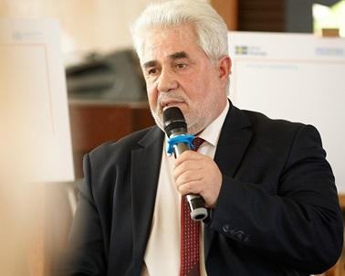
"My father was a blacksmith. I did not like this craft, though. I wanted to be a musician. I knew that a good musician is a well-educated musician. So, I went to school and studied with other children from the community. I felt they treated me differently, but it didn't stop me. On the contrary, it made me ‎even more motivated to finish my studies."
Alexandr Galațan’s story is a bright example of people whose socio-economic rights have been violated, but they have managed to overcome discrimination and find practical solutions for their problems.
See the campaign’s video here: https://bit.ly/2NBpF1h
3 videos were edited within the World HIV Remembrance Day joint implementing agencies call to reduce discrimination against people living with HIV and other key populations. FB statistics showed the posters campaign was deeply efficient. The posts had 15,1 K organic reach, 169 shares and 784 interactions with the posts on the SCPD, UN and UNDP FB pages.
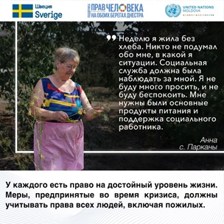
Banner developed as a part of the media campaign on the impact of COVID-19 on human rights (older person) @photocredit: OHCHR

On the occasion of International Roma Day an awareness raising campaign to break down the stereotypes associated to the Roma community, to combat discrimination and to improve the social image of one of the most stigmatized and rejected social groups in Transnistrian region was drafted. Under the slogan Proud to be Roma the campaign was planned to highlight the positive examples of Roma that have been succeeded to get involved in the community saying loudly that they are Roma.
The COVID-19 pandemic urged to change the communications plans and adopt a new approach of talking about human rights and promote the importance of claiming the rights during the pandemic. A range of communication activities and campaigns were organized in the period of April to June, related to COVID-and human rights.
Thus, a communication campaign to extend the information about COVID-19 in Transnistrian region and widespread the #staiacasa message was run. To better promote the #stayhome message, 7 video testimonials sharing voices of prominent cultural figures, local doctors, journalists, as well as vulnerable groups’ representatives, were created and shared on social media.

Within the framework of the information campaign on reducing the level of stigma and discrimination against people affected by socially dangerous diseases: HIV/AIDS, tuberculosis, COVID-19, etc., the life stories of people who have faced socially dangerous diseases (HIV/AIDS, TB, COVID-19) have been published, as well as information materials aimed at reducing the level of stigma and discrimination against people affected by these socially dangerous diseases. AIDS Candlelight Commemoration, in May 2020, was mostly organised on social media.

Also, an infographic campaign to extend the information about COVID-19 in Transnistrian region and widespread the importance of human rights approach in addressing COVID-19-related issues was developed. 16 RO/RU graphic illustrations on human rights impact of COVID-19 have been created and posted on SCPD FB page and UNDP FB page. FB statistics showed the posters campaign was deeply efficient. The posts had 29,2K organic reach, 427 shares and 1300 clicks on the posters on the SCPD and UNDP FB pages.

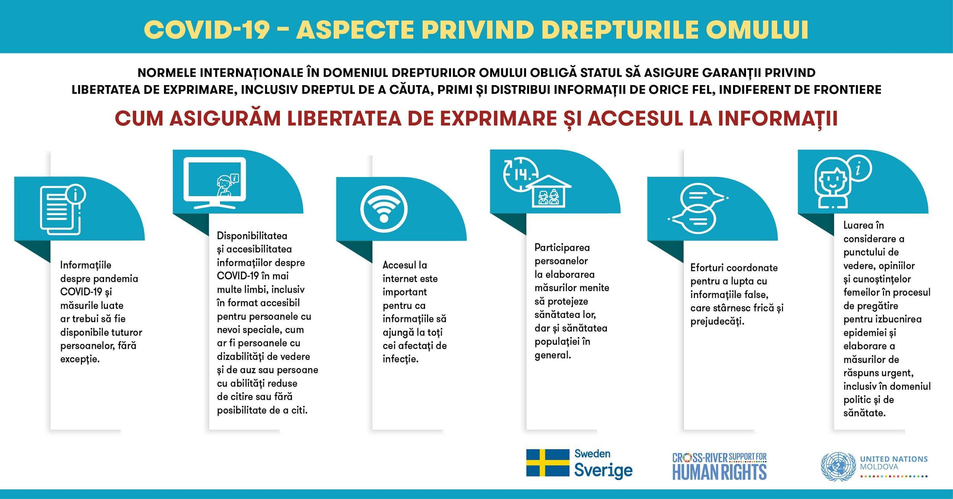

Another COVID-related campaign was the one to spread the HIV pandemic lessons learned in the context of COVID-pandemic. 9 graphic illustrations on HIV and COVID-19 have been created and posted on SCPD FB page and UN FB page. The posts had 9,6 K organic reach, 266 shares and 369 interactions with the posts on the SCPD FB page.

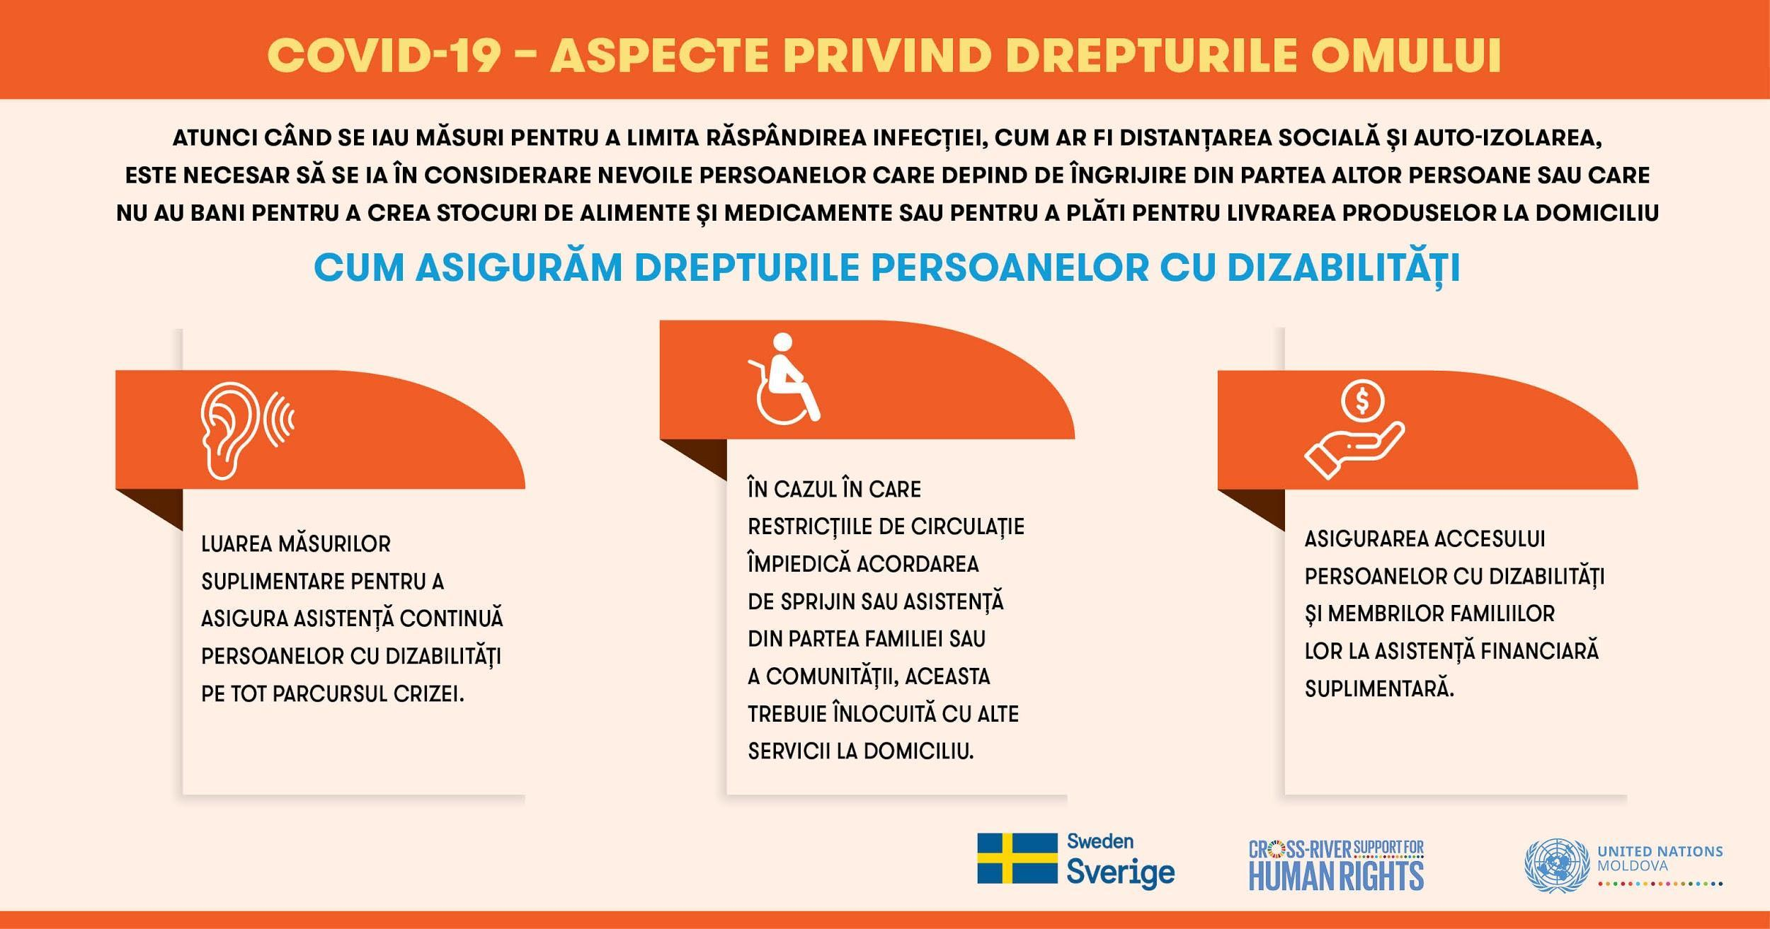

The social media being an important way of dissemination of information, considerable attention was dedicated to maintenance and population of the SCDP’s Facebook page. In the reported period 160 Facebook posts were published, including 39 video spots, and the page has over 670 followers.

Statistical data on social media impact for the media campaign on the impact of COVID-19 on human rights

Aiming to promote the rights of different vulnerable groups through human stories, a media campaign on COVID-19 and impact on vulnerable groups in the Transnistra region was conducted with a special focus on the Roma community, people with chronic diseases, older persons, and women victims of domestic violence. Stories from different people showcased inequalities they faced during the pandemic through a human rights perspective as well as highlighted measures which should be taken by duty bearers to respect, protect and fulfil the right to health, the right to education, the right on social protection, and the right to be treated equally. The posters featured statements of 5 people belonging to different vulnerable groups saying how the measures taken in the context of COVID influenced their life and their rights. The heroes of the posters were:
a. A Roma man, Victor Scripnic, from Tiraspol, father of 4 kids and the only breadwinner in his family who before the pandemic used to collect scrap metal to make a living. During the lockdown, he lost this opportunity of earning money.
b. A 53-years old woman, named Tatiana, HIV positive and sick with cancer. During the lockdown she was denied medical assistance.
c. A 71-years old woman living in rural area, Ana, who during the lockdown had no longer access to essential care and support and was forced to ask neighbours to bring her food or water.
d. A woman, Natalya Eliseeva, parent of a child with intellectual disabilities saying that because of the lockdown and closed school, the right to education that her daughter has, was denied.
e. A young woman, named Daria, who experienced domestic violence while in pandemic.

In an artistic manner, the cartoons raised awareness on how the decision taken in the context of COVID pandemic affected the rights in health and education spheres. The cases of Tatiana and Natalia Eliseeva’s daughter whom the access to health and education had been denied during the lockdown, were the bases of the discussions.

In the framework of this campaign, 8 media products, including 5 posters, 2 comics, and 1 audio photo essay were produced and placed in social media (UN FB page as well on SCPD and OHCHR FB pages) and in local media resources. The campaign had a total organic reach of 21.000 and over 380 Shares. 1.700 times users interacted with the campaign on the Facebook post through feedback, comments, sharing, and clicks. The most visible and impactful campaign item was the comic on health with a total reach of 3.600 being followed by a poster featuring the rights of older persons with 3.200.

The Human Rights Awareness Raising Campaign “Recover Better Together: Human Rights for All", ran from mid-October to mid-December 2020 and was targeting duty bearers and rights holders from both banks. The campaign was funded from the Programme, as well as from OHCHR core budget. Specifically, under the programme activities, 3 video testimonials of people, who explained what issues they faced in execution the right to social protection, freedom of religion and right to labour (the total organic reach amounted to 8059, over 290 shares and 460 impressions) were produced and two online events for youth with an exceptionally high reach among targeted audience were conducted. One of the events was organized in Tiraspol at the Club #19 (run by NGO Apriori), a public lecture on the right to peaceful assembly followed by vivid discussion with participants, who raised questions not only focusing on the peaceful assembly but expressed some concerns on the limitations and restrictions of freedom of expression in the region, while the other - a public lesson for 55 students of VIII-XII grades from Romanian-language educational institutions in the Transnistrian region and from the security zone organized together with the Ombudsperson for Child’s rights benefited from a public lesson on ensuring respect for children's rights in pandemic time, their realization in the context of established restrictions, but also the available remedies.

In order to raise the general public awareness on the subjects related to HIV/AIDS, on World AIDS Day (WAD) in December 2020 a communication campaign was organized on both banks of the Nistru River. The campaigns involved 18 organizations, local national partners from the non-governmental sector; 25 offline activities carried out on the entire territory of the Republic of Moldova (including in the Transnistrian region); 10 localities covered with the offline events during the campaign; 110 publications on social media reflecting the events of the campaigns, as well as info on HIV and COVID-19.

3 press conferences were held during the 2 campaigns with the participation of UCM, Minister of Health, Labor and Social Protection and Parliamentarians from the Commissions on Health, Social Protection and Human rights.

In order to put the HIV-related subject on the agenda of the decision-makers, on WAD 2020 a high-level event was organised in Parliament - a policy dialogue on HIV response sustainability. The parliamentarian control tool and a technical group was created as a result, to further address social contracting.

With a view to promote child rights in the Transnistrian region, a new partnership has been established with the NGO “Association for Independent Press”. The purpose of the collaboration is to enhance mass-media’ capacities from the both banks of the Nistru river to report actively and ethically on child rights through developing training packages and guidance for media on working with children, conducting trainings for journalists, organizing press-clubs on child rights issues and monitoring the media space.

Overall, the cooperation with mass-media is satisfactory, though in the reported period it was very difficult to carry out media-related activities due to COVID-related restrictions and the interaction with mass-media was limited mostly to online space.

ii) Indicator Based Performance Assessment:

 | Achieved Indicator Targets | Reasons for Variance with Planned Target (if any) | Source of Verification
Output 1:  Increased capacities of vulnerable rights holders to exercise their human rights  Indicator 1.1  Number of thematic working groups on human rights of different groups of rights holders established and functional  Baseline:  2 platforms (DV and PWD)  Planned Target:  At least 4 thematic working groups established and capacitated | UNDP  3 thematic working groups established by the SCDP: Legislation, Social Services and Advocacy | Following the internal consultations by the SCDP, it was agreed that it is more efficient to establish working groups based on the theme related to specific domain, rather than vulnerable group, due to uneven representation of the groups in the SCDP. Thus, initially 4 groups were proposed, but only 3 were agreed to be established. The 4th theme, Social enterprises, is currently supported by other donors and it was considered more efficient to redirect the resources to other activities. | Annual project report  Membership lists
Output 1  Indicator 1.2  Number of human rights initiatives, including policy documents, common advocacy campaigns, and individual and collective rights claims and communications, inspired by cross-river exchanges and contacts via various thematic groups submitted/addressed to duty bearers and/or international human rights mechanisms  Baseline:  Total: 1  Policy documents: 0  Advocacy campaigns: 0  Joint claims and comms: 1  Planned Target:  Total: 10  Policy documents: 3  Advocacy campaigns: 1  Joint claims and comms: 4 | OHCHR  Total: 10  Policy documents: 5  (1 regulatory document to start a process of drafting HR Framework and to establish a multisectoral working group; 1 Roadmap on drafting the HR Framework; 1 Concept note of delivering HR Capacity Building program; 1 Roadmap and 1 draft Action plan for establishing the first Roma community mediators’ institution in the Transnistria region; Advocacy campaigns: 2 media campaigns on the impact of COVID-19 on human rights of different vulnerable groups and recovery programs based on human rights as a core  Joint claims and comms: 1 joint statement from Roma community to claim the rights of Roma especially focusing on vulnerabilities faced during the pandemic |  | Regulatory and policy documents, legal acts, reports from media campaigns, actual produced documents; reports
 | UNODC:  Total: 18  Policy documents: 7  Advocacy campaigns: 2  Joint claims and comms: 7 |  | Field visit reports and assessments conducted in the context of UN high level human rights and UN human rights mechanisms visits
Output 1  Indicator 1.3  Number of vulnerable persons from both banks of the Nistru river benefiting from community-based services supported by the programme (disaggregated by vulnerable group and location)  Baseline:  Total: 0  Left bank: 0  Right bank: 0  Planned Target:  Total: 130  Left bank: 107  Right bank: 23 | OHCHR:  Total: 29  Left bank: 29 PwD from Slobodzia district in the Transnistria region  Right bank: 0 |  | Report from CSO
 | UNAIDS:  Total: 192  Left bank: 157  Right bank: 35 | Even in Covid situation, PrEP service was delivered successfully. In the lockdown period, the services were adapted on both banks and it could be provided as “delivery at home” service. | Reports from SCOs  Statistics report of the National AIDS Coordination Unit, with Hospital of Communicable Diseases and Dermatovenerology.
 | UNODC:  Total: 270  Left bank: 124  Right bank: 46 | Awareness of the new services needs to be developed among right holders, which takes time. | Field visit reports, reports from CSOs developing and implement-ting the services, and assessments conducted in the context of UN high level human rights and UN human rights mechanisms visits
Output 1  Indicator 1.4  Number of trained by the program different vulnerable groups from the Transnistrian region on human rights  Baseline:  Total: 1  Planned Target:  Total: 2 | Total: 4 |  | Lists of participants to the trainings  Pre and post training evaluation forms, consultants’ reports
Output 1  Indicator 1.5  Increased institutional capacity of at least 70% of 60 participating CSOs  Baseline:  30 CSOs:  7 - 0-0,5 pct.  4 - 1-1,5  8 - 2-2,5  6 - 3-3,5  4 - 4-4,5  Planned Target:  An increase of at least 0,5 points of institutional capacity increase for at least 20% of involved CSOs | UNDP  18 CSOs (60%) have increased the level of institutional capacities with at least 0,5 points, as follow:  15 - with 0,5 points  3 - with 1 point | Initial assessment of the number of organisations that expressed interest in participation in Programme’s activities was quite high. In practice circa 30 organisations have responded to the assessment exercise and have participated in the institutional capacity building process, thus the new baseline on the number of CSOs was established. | OCAT questionnaire  Evaluation report
Output 1  Indicator 1.6  Number of calls related to domestic violence answered by the Trust Line  Baseline:  310 calls in 2017 related to domestic violence  Planned Target:  At least 300 calls per year  Indicator 1.7  Number of professionals trained with the support of the program who have increased knowledge on burnout prevention  Baseline:  15 participants in 2017  Planned Target:  24 professionals trained throughout the project | IOM  From January to December, 683 calls related to domestic violence, including 335 SOS calls. | This increase may be due to:  - DV has wider coverage in Transnistria mass-media and society including via TV shows, targeted campaigns like 16 Days Campaign of Activism against Gender Based Violence.  - People-to-people awareness that women receive assistance, even though mainly from NGOs, women have more courage to speak up and turn to services.  Both preventive calls and SOS-calls have increased compared to in 2019, potentially because of the COVID-19 pandemic. The easing of restrictions in June 2020 saw an increase in reported cases as victims had greater opportunity to seek help. | Monitoring field visits and communication, reports from the NGO implementing the service
 | IOM  23 female and 2 male professionals trained | The increase was possible due to re-organizing training under COVID-19 circumstances (making it shorter and with limited opportunities for the group to go out of the region). | Agenda, list of participants and trainer’s report.
Output 2  Increased capacities of duty bearers to fulfil their human rights obligations  Indicator 2.1.  Number of new regulatory documents or amendments to existing regulatory documents in the region, including documents on the rights of persons with disabilities and persons living with HIV, developed in line with international human rights standards  Baseline:  Total: 12  PWD: 2  HIV: 7  Planned Target:  Total: 21  PwD: 3  HIV: 10 | OHCHR  PwD: 3 regulatory documents amended on ensuring access for PwD with severe and medium disability to labour market, to receive hearing aids for PwD with hearing impairment from de-facto authorities for free and to ensure accessibility for PwD to de-facto courts |  | Regulatory documents amended or developed, legal acts, reports in official media
 | UNAIDS  HIV: 10 | 3 new regulatory documents have been adopted | Regulatory documents amended or developed, official information from the de facto structures
Output 2  Indicator 2.2 Extent to which normative framework is compliant with international standards on child friendly justice  Baseline: Not compliant  Planned Target: Score 1: Less compliant (Only a few (<30%) are compliant) | UNICEF:  The report on the de-facto legal framework in the Transnistrian region on justice for children in contact and conflict with the law led extensive revisions of the regional normative framework to align with international standards, pending approvall by the de-facto structure from the Transnistrian region. |  | Official information from de facto authorities. Narrative reports and deliverables of international and national experts.
Output 2  Indicator 2.3 Extent to which the modus operandi of A. S. Makarenko institution is compliant with international standards on administration of justice for children  Baseline: Less compliant  Planned Target: Score 2: Partially compliant (Regulatory framework is assessed and proposals for its improvement are developed; the preparation-for-release program is developed and SOPs drafted for work with social service providers; training packages developed and staff trained on applying child friendly and non-violent approaches while working with children in custody) | UNICEF:  The adjustments to the Internal Regulation of “A.S Makarenko” and a new Code of Conduct have been developed. A comprehensive preparation for release programme for children placed in Makarenko, as well as the training package for “A.S. Makarenko” staff to apply child friendly procedures have been initiated |  | Internal regulatory framework. Narrative reports and deliverables of international and national experts
Output 2  Indicator 2.4  Number of protection, promotion and monitoring human rights initiatives of the institutionalized human rights structures in the region  Baseline:  Total: 0  Planned Target:  Total: 1 | OHCHR  Total: 0 | Due to the COVID-19 pandemic de-facto Ombudsperson did not agree to have online meeting before December 2020 and the whole initiative was postponed to start from 2021
Output 2  Indicator 2.5  Percentage of justice and law enforcement professionals able to apply child friendly procedures in cases involving children in conflict with law  Baseline: 0 %  Planned Target: 10% | UNICEF: In progress  The Assessment of the existing training programmes for pre-service (law students) and in-service professionals (judges, prosecutors, police and social workers) that work with children in contact and conflict with law was performed. Based on the findings of the Assessment the development of training programmes for pre-service and in-service professionals have been started. | Capacity development  activities are planned for  the middle of 2021. | Participants list.  Pre and Post evaluation questionnaire. Narrative reports and deliverables of international and national experts.
Output 2  Indicator 2.6  Number of PWUD, PLHIV and people with TB referred to harm reduction services by police on both banks | UNODC:  At least 100 PWUD referred to harm reduction services, including 60 on the left bank and 40 on the right bank.  Reported: 462  Number of police officer trained in referral: 184 |  | Referral form developed and implemented by CSOs on both banks, CSOs and police’s routine reports
Output 3  Enhanced human rights culture in the Transnistrian region  Indicator 3.1  Number of media products employing a human rights-based approach published by the media representatives trained by the program  Baseline:  23 media materials developed within the first phase  Planned Target: At least 30 materials published by left bank media outlets (yearly) | UNDP  More than 400 articles related to human rights were published in the left bank media, with a total coverage of more than 310 K people informed about vulnerable groups and human rights | In the first year 54 media articles were published by left bank media reflecting the Programme activities and campaigns, with a considerable increase in the second year due to the intensification of Programme’s activities and attention brought to the problematic of vulnerable groups by the spread of the COVID-19 pandemic. | Monitoring of media space
Output 3  Indicator 3.2  Number of media outlets able to report actively and ethically on child rights  Baseline: 0  Planned Target: 2 media reports (yearly) | UNICEF In progress  A new partnership was established with NGO “Association for Independent Press” to enhance mass-media’ capacities from the both banks of the Nistru river to report actively and ethically on child rights | The first media report is scheduled for the mid 2021. | Monitoring of media space
Output 3  Indicator 3.3  Number of PLWH covered by self-stigma reduction mentoring program  Baseline: 0  Planned Target: 25 | UNAIDS  50 | More women were involved in the mentoring programme than initially expected | List of events, number of participants, reports from NGOS
Output 3  Indicator 3.4  Number of persons reached by HIV behavior change communication campaigns  Baseline: 60000  Planned Target: 10000 | UNAIDS  10000 |  | Campaigns reports

iii) A Specific Story

Story Nr. 1

Problem / Challenge faced: Describe the specific problem or challenge faced by the subject of your story (this could be a problem experienced by an individual, community or government).

Nadejda Kilar, from Tiraspol, Republic of Moldova, has been living with HIV for several years. Her antiretroviral therapy has suppressed her viral load to undetectable levels, but she faced stigma and discrimination all the time. During pregnancy and childbirth she was isolated. She was kept in an isolation ward, gave birth in a separate delivery room and after giving birth was placed in a special room for women living with HIV - a room with bars on the window.
Also, she had to deal with domestic violence and depression.

Programme Interventions: How was the problem or challenged addressed through the Programme interventions?

When she realized that she could not cope with her financial problems, the violence and her depression, on the advice of a peer consultant at the HIV clinic she attends in Tiraspol she joined the Women’s Mentoring Programme, along with 20 other women living with HIV from different communities in the area. For one year she participated at all the meetings and trainings within the mentoring program and got support from the mentor and coordinator of the program, including individual consultations and support to understand and identify her problems, learn about her rights and got support in the fight against violence and discrimination.

Result (if applicable): Describe the observable change that occurred so far as a result of the Programme interventions. For example, how did community lives change or how was the government better able to deal with the initial problem?

As a result, she decided to open publicly her statute and to be become a positive deviant. She understood that she would not be the same as before and realized that she would not tolerate discrimination or beatings anymore. Now, she looks optimistic in the future.

Lessons Learned: What did you (and/or other partners) learn from this situation that has helped inform and/or improve Programme (or other) interventions?

Often, women in the Republic of Moldova have insufficient access to reliable information about HIV. They still cannot defend their right to health and safe sex. Various forms of violence, including sexual violence, the widespread violation of women’s rights and the controlling behaviour of men further aggravate the situation. All this deprives women of the opportunity to defend their right to health.

The full story here: Hope from Tiraspol | UNAIDS

Story Nr. 2

Problem / Challenge faced: Describe the specific problem or challenge faced by the subject of your story (this could be a problem experienced by an individual, community or government).

A 44-year-old man, Dmitry, with a severe disability living in the Transnistria region of Moldova had limited access to medical services and medicine in the region because of the lack of availability of medical services and assistance for people having such disease, even prior to the COVID-19 pandemic. During the pandemic and following the lockdown it became even more challenging for people with disabilities, especially for those who require permanent medical guidance, to receive medical advice, prescription for free medicine and rehabilitation procedures, and medical consultations, which resulted in an increase of out-of-pocket expenditures for medicine and rehabilitation services.

Programme Interventions: How was the problem or challenged addressed through the Programme interventions?

In April 2020 Dmitry, realizing that there were persons even more vulnerable than him who needed support, started volunteering to deliver food packages and medicine to older persons, who had been recommended to stay at home during the lockdown. In June 2020, he benefited from humanitarian assistance (food and hygienic package) provided to the Community Sustainable Development Platform through UN WOMEN under the MPTF COVID-19 call, as a representative of vulnerable group. The selection of beneficiary NGOs was supported by OHCHR, given its knowledge through a needs assessment that had been conducted.

Dmitry, together with another 1200 persons, representing different vulnerable groups in the Transnistria region became beneficiary of food and hygienic package. It helped Dmitry to make some savings and to use these for the purchase of medicine and medical services during the period of the pandemic. At the same time Dmitry was encouraged to support even further other vulnerable groups and in July took on further responsibilities as a coordinator of volunteers with the NGO “We are volunteers” (member of SCDP), which provides assistance and counselling to older persons.

Result (if applicable): Describe the observable change that occurred so far as a result of the Programme interventions. For example, how did community lives change or how was the government better able to deal with the initial problem?

Through his engagement, Dmitry became aware of a 10-months lasting human rights training programme. He applied and became a participant of the ToT, which started in October 2020, and trains 30 human rights defenders and members of civil society organisations on international human rights standards, human-rights-based approach, mechanisms of advocacy and more. Dmitry was a very active participant of the program, which will conclude in 2021, and says that he has already been able to gain considerable knowledge on human rights, human rights violations and responsibilities of duty bearers. He is determined to apply the knowledge he has gained to promote his and others’ rights to health, work, and a decent standard of living. He also addressed the de facto authorities on a health matter that a PwDs had been raised with him as volunteer of the CSO; a step he undertook given the training that he had been exposed to. He is very eager to become a professional human rights defender and trainer.

Lessons Learned: What did you (and/or other partners) learn from this situation that has helped inform and/or improve Programme (or other) interventions?
- Rights holders from the Transnistria region have a low level of understanding about human rights concept and mechanisms through which they could claim their rights. They also lack pertinent advocacy skills and knowledge on how CSOs could contribute to advancing human rights;
- There is a tendency that the voice and needs of minorities and vulnerable groups from the Transnistria region are not taken into account by df authorities when taking decision in general and especially during the pandemic (often not even acknowledging that there is a problem). Special focus should be placed on vulnerable groups including ethnic minorities and understanding and informing about their needs (via media campaigns, additional surveys) should be a key element of the Programme’s intervention.
- Human rights activists, CSO staff and representatives of vulnerable groups equipped with human rights knowledge, and knowledge of international human right standards and monitoring mechanism at national and international level could become a strong voice in spreading knowledge about human rights among other underrepresented groups and in claiming their rights before duty bearers.

III. Other Assessments or Evaluations (if applicable)
• During the reporting period, the Programme has conducted the following assessments:
- Assessment of institutional capacities of the members of the SCDP
- Assessment of the level of the human rights knowledge among vulnerable groups on both banks of the Nistru River
- Assessment of the situation of Roma communities in the Transnistrian region
- Assessment and a follow-up Report on the de facto normative framework pertaining to justice for children in contact and conflict with the law
- Assessment of the existing training programmes for pre-service and in-service professionals working with children in contact and conflict with the law

IV. Programmatic Revisions (if applicable)
• As mentioned in the report above, the Programme was forced to adjust its activities to the new reality in the COVID-19 pandemic. The major shift was related to the switching of the activities to the online format and adjustment of the capacity building activities accordingly. Also, a number of informational and advocacy campaigns were COVID-19-focused. Specific modules on COVID-19 were introduced in a number of capacity building activities. Should the pandemic persist, the Programme will proposed corresponding revisions in the year 2021.

V. Resources (Optional)
•

The term “programme” is used for programmes, joint programmes and projects.
Strategic Results, as formulated in the Strategic UN Planning Framework (e.g. UNDAF) or project document;
The MPTF Office Project Reference Number is the same number as the one on the Notification message. It is also referred to as “Project ID” on the project’s factsheet page the MPTF Office GATEWAY
The MPTF or JP Contribution, refers to the amount transferred to the Participating UN Organizations, which is available on the MPTF Office GATEWAY
The start date is the date of the first transfer of the funds from the MPTF Office as Administrative Agent. Transfer date is available on the MPTF Office GATEWAY
As per approval of the original project document by the relevant decision-making body/Steering Committee.
Alexandru Galatan passed away in October 2020, as a result of the COVID-related illness.
Organizational Capacity Assessment Tool – excel based ranking scored questionnaire, consisted of categories and subcategories, including a category for each of the specific vulnerable group.

