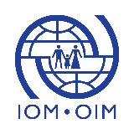  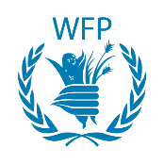 | 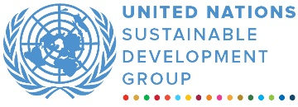 | 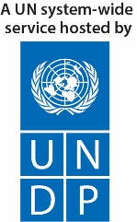
UN JOINT- PROJECT TO ADDRESS COOKING FUEL NEEDS, ENVIRONMENTAL
DEGRADATION AND FOOD SECURITY FOR POPULATIONS AFFECTED BY THE REFUGEE CRISIS
ANNUAL programme NARRATIVE progress report
REPORTING PERIOD: 1 january – 31 December 2020

Programme Title & Project Number |  |  | Country, Locality(s), Priority Area(s) / Strategic Results
- Programme Title: Joint Programme to Address Cooking Fuel Needs, Environmental Degradation and Food Security for Populations Affected by the Refugee Crisis in Bangladesh  - Programme Number: 00115175, 00118760, 00119520 and 00115158  - MPTF Office Project Reference Number:: 00115175, 00118760, 00119520 and 00115158 |  |  | Cox’s Bazar, Bangladesh
Priority area/ strategic results
- Alternative cooking fuel (LPG),
- Livelihoods,
- Self-reliance,
- Forestry and land stabilization

Participating Organization(s) |  |  | Implementing Partners
United Nations (UN) agencies:  - Food and Agriculture Organization (FAO)  - International Organization for Migration (IOM)  - World Food Program (WFP) |  |  | - GoB: Ministry of Disaster Management and Relief (MoDMR), the Economic Relations Division (ERD), the Ministry of Agriculture (MoA), the Ministry of Fisheries and Livestock (MoFL), Ministry of Environment, Forestry and Climate Change, Forest Department (FD), Upazila Nirbahi Officers (UNO) and Union Chairpersons.  - INGOs: United Purpose, Relief International, BRAC, International Union for Conservation of Nature (IUCN)  - LNGOs: Society for Health Extension and Development (SHED), Prottyashi, Shushilan, Centre for Natural Resource Studies (CNRS), Arannayk Foundation (AF)
Project Cost (US$) |  |  | Programme Duration
Total approved budget as per project document:  MPTF /JP Contribution:  - FAO: 5,422,776  - IOM: 28,033,588  - WFP: 5,493,630 |  |  | Overall Duration (months) | 36 months
Agency Contribution  - by Agency (if applicable) |  |  | Start Date (dd.mm.yyyy) | 27.11.2018
Government Contribution  (if applicable) |  |  | Original End Date (dd.mm.yyyy) | 31.08.2021
Other Contributions (donors)  (if applicable) |  |  | Current End date(dd.mm.yyyy) | 31.08.2021
TOTAL: 38,959,921
Programme Assessment/Review/Mid-Term Eval. |  |  | Report Submitted By
Assessment/Review - if applicable please attach  Yes No Date: dd.mm.yyyy  Mid-Term Evaluation Report – if applicable please attach  Yes No Date: 30th March 2021 |  |  | - Name: Patrick Charignon  - Title: Transition and Recovery Coordinator  - Participating Organization (Lead): International Organization for Migration  - Email address: pcharignon@iom.int

LIST OF ABBREVIATIONS
ACMC | Aggregation Center Management Committee
BCC | Behavior Change Communication
BDT | Bangladesh Taka
CM | Community Mobilizer
DAE | Department of Agricultural Extension
DLS | Department of Livestock Services
DoF | Department of Fisheries
EETWG | Energy and Environment Technical Working Group
EOP | End of Programme
FAO | Food and Agriculture Organization of the United Nations
FD | Forestry Department
FFG | Fisheries Farmers Group
FFS | Farmer Field School
FNS | Food and Nutrition Services
FSCD | Fire Service and Civil Defense
FSS | Food Security Sector
GBV | Gender Based Violence
GFA | General Food Assistance
GIS | Geographic Information System
HC | Host Community
HHs | Households
ICT | Information Communication Technology
IGA | Income Generating Activities
IOM | International Organization for Migration
IUCN | International Union for Conservation of Nature
LPG | Liquefied Petroleum Gas
LSP | Livelihood Service Provider
M & E | Monitoring and Evaluation
MPTF | Multi-Partner Trust Fund
NFI | Non-Food Item
REVA | Refugee influx Emergency Vulnerability Assessment
RRRC | Refugee, Relief and Repatriation Commission
rCSI | Reduced Coping Strategy Index
SAFE | Safe Access to Fuel and Energy
SMART | Spatial Monitoring and Reporting Tools
SMSD | Site Management and Site Development
UN | United Nations
UNHCR | United Nations High Commissioner for Refugees
WFP | World Food Program

EXECUTIVE SUMMARY
The SAFEPlus programme was conceived to mitigate the environmental, protection, health and social-economic impacts of the Rohingya crisis. The programme supports 100,000 Rohingya and 25,000 host community (HC) households with cooking fuel (Liquefied Petroleum Gas- LPG), on and off-farm livelihoods support, reforestation of 2,000 hectares of land in host communities, and stabilizing 500 hectares of vulnerable land terrains in the camps. Three UN agencies – the Food and Agriculture Organization (FAO), International Organization for Migration (IOM) and World Food Program (WFP) – are implementing the programme leveraging their comparative advantages in an integrated programming approach.
In the second year (2020) of the SAFEPlus programme, experience and expertise of the three UN agencies was brought together to reach the set targets by minimizing the challenges caused by the Covid-19 pandemic. During the reporting year, the midterm evaluation was also initiated. The evidence of changes and the programme progress have been reflected in the evaluation and monitoring tracking reports. The key findings in the reporting period are given below:
- 48% of the beneficiaries adopted one or more negative food-related coping strategies while the baseline was 70%, and the end of programme (EOP) target was 50%. Average household income increased by 13% (from BDT 13,228, i.e. USD 156.03 in the baseline to BDT 14,950, i.e. USD 176.35).
- Throughout the programme, in order to reduce firewood consumption in 17 targeted camps, 1,001,944 LPG refills were delivered to the host and Rohingya communities.
- The off-farm livelihoods activities benefited 11,837 HHs through asset creation, grants, inputs support, training, and market linkage. The on-farm activities also continued providing support to 1,440 Farmer Field School (FFS) beneficiaries through the provision of improved seeds, training, agro machinery/market linkage and farming techniques.
- Rohingya mentoring support benefited 2,584 beneficiaries through building their capacity on innovative homestead gardening and skills support.
- 100% of the plantation target (2,000 ha planted) to restore degraded forestland was achieved outside the camps while 52% of the target was achieved inside the camps.
- 2,348,725 seedlings have been produced for use in land restoration and stabilization activities in 2020.
- 17 nurseries (including two permanent nurseries) were established in 2020.
- In response to Covid-19, IOM ensured social distancing and hygiene practice in LPG distribution points for both the workers and beneficiaries. IOM and WFP reprogrammed their livelihoods activities to respond to the Covid-19 emergency, provisioning unconditional cash grants for 11,837 HHs. FAO distributed Aman rice seeds among 23,977 marginal and small-scale farmers, out of whom 83% have planted these seeds.
- Eight local Aggregation Centers were established in 2020 in Ukhia and Teknaf sub-districts. Dry season plantation strategies were piloted for the restoration of forestland inside the camp. This is an innovative initiative with the focus to expand the planting season.

Purpose
- To contribute to the overall food and nutrition security, skills development, and resilience of 100,000 Rohingya and 25,000 host community households in Cox’s Bazar.

Results

Narrative reporting on results:
Objective 1: Targeted households, especially women-headed and vulnerable households, have monthly decreased expenditures related to firewood purchase and increased nutritional intake for household members.
Preliminary evidence demonstrates an urgent need for addressing an acute lack of cooking fuel amongst Rohingyas residing in the camps. This scarcity is exacerbated by the near total depletion of wood fuel resources around the camps and a growing competition for resources with the residents of the 10 local unions (village clusters) around which the camps have grown.
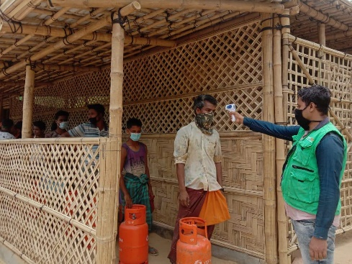

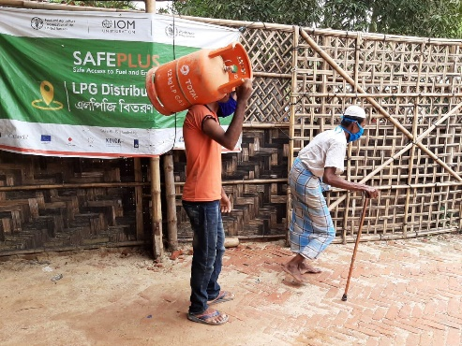
In 2020, the focus was on social distancing, maintaining hygiene practices at the distribution points and supporting the extremely vulnerable individuals through the delivery of LPG cylinders at their camps. © IOM | September 2020
The findings show that Rohingyas are almost completely reliant on the distribution of non-cooked food including rice and pulses, with only few organizations supplying fuel for cooking. In addition to that, firewood collection leads people to venture into unsafe areas where they are left vulnerable to Gender-Based Violence (GBV), elephant attacks, kidnapping, extortion, and trafficking risks.
The LPG supply chain is contracted and managed by the private sector and the project is utilizing the existing WFP SCOPE e-voucher system (a digital beneficiary and transfer management platform that allows beneficiaries to redeem refills using an entitlement card) for Rohingya beneficiaries to access “fuel wallets” on the SCOPE assistance card. Using the cards, beneficiaries will be able to purchase their stove sets and have their gas cylinders refilled at the designated LPG depots. As per the midterm evaluation report, 98% of the households reported decreased monthly expenditure from baseline BDT 630 (USD 7.44) to BDT 201 (USD 2.37) on firewood purchase since the provision of alternative fuel, namely LPG stove sets and gas refills.

Output 1.1: Households, especially female-headed and vulnerable, have improved access to alternative cooking fuel and facilities (IOM).
In 2020, IOM SAFEPlus programme provided 133,421 HHs (104,063 in the camps, i.e. 71,803 men and 32,260 women headed HHs; and 29,358 in the HCs, i.e. 23,486 men and 5,872 women headed HHs) with LPG packages.
Earlier in the year, as a response to the Covid-19 pandemic, the focus was put on social distancing and the provision of handwashing facilities at each distribution point. Community mobilizers (CM) and en-route volunteers were provided with masks and hand sanitizers and special directives on social distancing while queuing in line were introduced.
In February 2020, 200 HHs from Camp 8E were provided with pressure cookers, as part of a new pilot project that aimed to reduce the excessive use of LPG. The pilot project was initiated by energy and environment sector, led by the United Nations High Commissioner for Refugees (UNHCR) and IOM. Danish Refugee Council (DRC) supported this initiative with field- level human resource mobilization and management, data collection and day to day monitoring. The pilot project started in Camp 8E in February 2020, with 30 enumerators and 200 beneficiaries and continued until the end of March 2020. Due to the Covid-19 pandemic, the pilot project was halted until November 2020. Subsequently, 211 HHs in camp 2W were added and distribution continued until January 2021.
In order to ensure efficient usage and to reduce vulnerability to fire, all beneficiaries were trained on efficient cooking methods, health and nutrition practices, fire safety and environmental conservation. In addition, the programme selected 30 community fire prevention volunteers (15 male and 15 female) who were later trained by the Bangladesh Fire Service and Civil Defense (FSCD). These volunteers raised awareness about fire safety and have been trained to be the first responders in the event of fire.
As part of Covid-19 reprogramming, 7,235 hand gloves and 220,552 masks were distributed to beneficiaries, porters, volunteers and CM in Ukhiya and Teknaf to assuage work during the LPG distribution. In addition, UNHCR provided IOM with 4,567 cooking stoves, and 1,223 stoves were used to replace severely damaged ones.
Later in the year, IOM, UNHCR and WFP realigned their beneficiary lists and distributed new SCOPE cards to all Rohingya refugees in the Cox’s Bazar camps. In response to this exercise, it was agreed that an ad-hoc cycle of 15 days duration would be adopted instead of the normal 45 days. This continued until March 2021 to ensure that all beneficiaries received the new SCOPE cards.
As of mid-October 2020, the Bangladesh Government started the construction of fences around the camps. As a result, the LPG team started looking to build specific LPG distribution points in some of the camps, to facilitate access of beneficiaries in the camps to the LPG refills.
Objective 2: Local Agriculturists are engaged in markets and benefiting from income generation.
The HC livelihoods activities are aimed to increase the income and food security of the beneficiaries through capacity building, inputs support, cash grants and market linkage. Both on-farm and off-farm activities were planned in 2020 to bring positive impact on the socio-economic sector in the targeted locations. However, the worldwide pandemic resulted in the programme implementation delays. During the reporting period, the accomplished activities have contributed to increasing the market compatibilities of the local agricultural farmers through providing agricultural inputs, training on improved agricultural practices, climate-resilient nutrition-sensitive production growth and connecting with the market using multiple channels. As a result, 53 per cent of targeted household from HC reported increase in income, from the baseline of BDT 13,228 (USD 156.03) to BDT 14,950 (USD 176.35) (i.e. 13% increase).

Output 2.1: Vulnerable households in host communities are provided with training and means for livelihood activities (IOM, WFP)
The off-farm activities of the programme were jointly implemented by IOM and WFP, in close coordination with the Food Security Sector (FSS) and Livelihoods working group partners. Taking into account the food security, households’ minimum expenditure basket, and the issues of gender and structural limitations in line with the WFP Vulnerability Criteria, the programme has included essential support for the targeted communities. These include the potential assets, the willingness to pursue a livelihood option, the ability to apply knowledge and identify and mitigate risks (including market linkages), and the HH and /or community support. A total of 11,837 HHs were identified through the joint assessments applying the WFP vulnerability criteria.
IOM undertook the following activities for 6,352 beneficiaries in 2020:
- Production and Vocational-based initiatives: 90% female and 10% male participants utilized their skills in tailoring, design, and dressmaking. The project built on their skills and supported them on Group-based production chains. Partnerships with private sector trainers enhanced product brands, and secured market supply chain. These low-cost high demand products also targeted the majority low-income support households.
- Small-scale artisanal production initiatives: This component targeted native tribes, who were severely displaced by the refugee influx, but have continued to maintain traditional production systems. The project identified their capacities, and presents potential production systems as more familiar initiatives for these internally displaced communities to develop alternative sources of income. IOM also supported these artisanal modes of production as the incentive for the communities to shift from their traditionally forest-based subsistence livelihoods. A total of 79 households from two ethnic host communities in the Jaliapalong Union (Ukhiya) are supported in the areas of traditional Loom and Craft production and with linkages to tourism markets.
- Women’s Small-scale agribusinesses: A total of 5,173 women were supported to operate alongside farmers, fishermen as part of the supply chains, in occupations related to drying/packaging and distribution in the fish and vegetable market sectors.
- Retail businesses of beneficiaries’ choices: Provision of cash grants, skill development training and business mentoring package mainly in support of the identified elderly persons and Persons with Disabilities.
Other Complementary Packages supported by IOM:
- Asset Creation: The project assisted the extreme poor in creation of their own household capital base through assets in the form of cows, goats and small-scale poultry. These are used both as collaterals and family savings. Assets in the extreme poor households have had multiple benefits, such as -
- Owning an asset (goats, cows, small-scale poultry farm) immediately changes their social status in the community
- With assistance, parts of the growing capital are sold for household needs (including allowing children to go to school)
- Better interaction with extension services. Women in particular now have access to the Government services in the form of vaccinations for their livestock, direct supplies of improved seeds and leased land.
- Cash Assistance: IOM combined both Conditional and Unconditional cash assistance based on the assessed needs of the beneficiaries, which helped to mitigate pressures in accessing food and nutrition as well as to supplement beneficiary business initiative.
- Capacity Support to the Government Line Departments (complementing Government social safety-nets and local business associations, etc.)
In 2020, WFP provided livelihoods activity which supported 5,485 beneficiaries across two sub-districts identified as vulnerable by the Social Safety Nets Programme of the Ministry of Women and Children Affairs. They received a comprehensive package of training (life skills, entrepreneurship, vocational skills) before receiving a cash grant and monthly subsistence allowance to support their businesses. There have been significant efforts to link the beneficiary’s micro-entrepreneurial ventures with the existing market structures.
The host community beneficiaries were supported through unconditional cash grants of 9,000 BDT (USD 106.16) each to help them recover from the shock of the nationwide pandemic that limited their livelihoods opportunities. The post distribution monitoring observed that 74% beneficiaries invested the cash grants to improve their livelihoods.
Between IOM and WFP support, a total of 11,837 individuals (1,179 Men, and 10,658 Women) received cash grants, training, inputs support and market linkage over the year.

Output 2.2: Local agriculturalists, especially women, have access to innovative climate-sensitive agricultural practices and high-demand and nutrient crops (FAO).
FAO has integrated and strengthened the FFS approach to facilitate an effective farmer’s group learning process in 2020. This person-centered participatory method helped to create an environment conducive for the participants to exchange knowledge and experience in a risk-free setting and utilize field exercises that encouraged direct observation, discussion, and decision making through learning-by-doing. During the reporting period, a total of 1,440 farmers received training on production technologies, integrated pest management, risk reduction in agriculture collective production, and market linkages, contributing to the increased production.
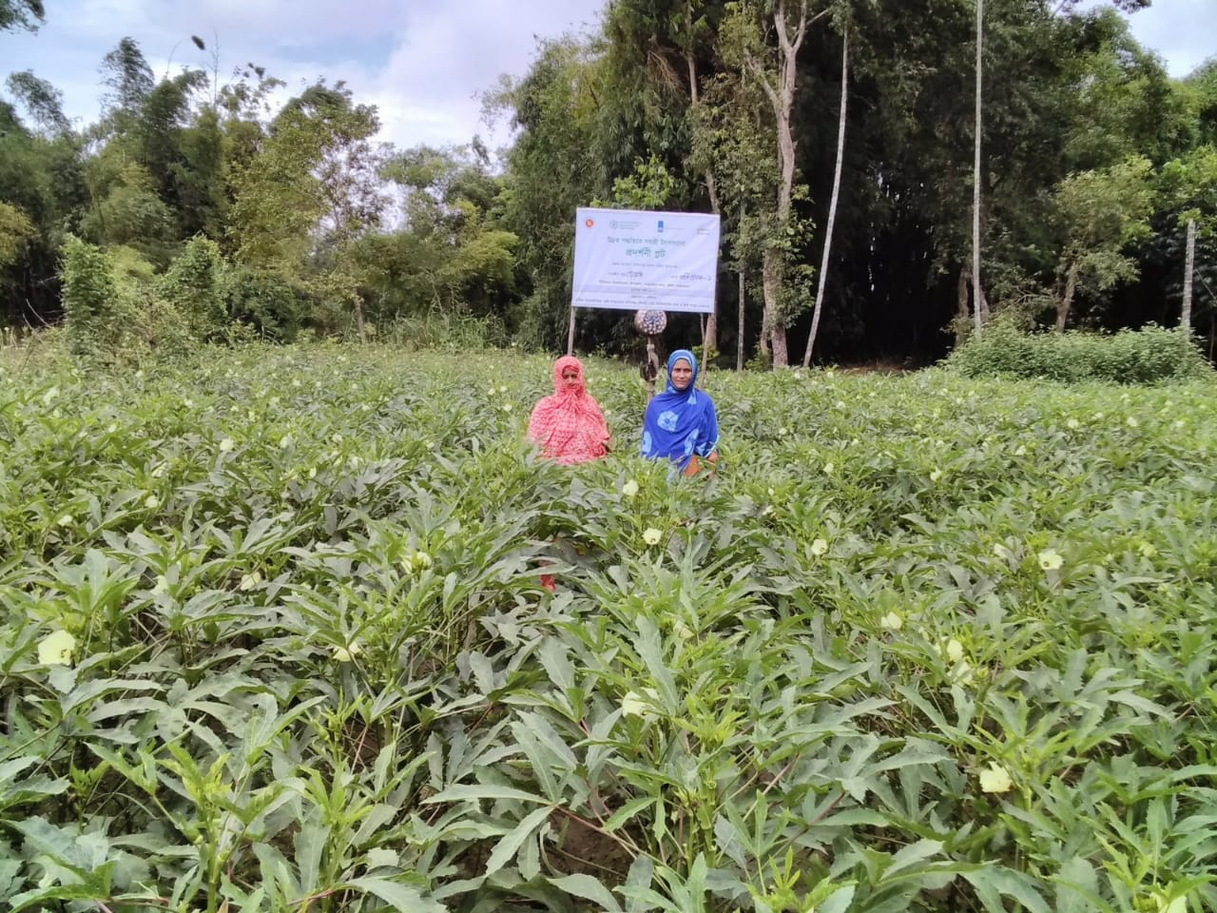
The programme also prioritized gender-sensitive agricultural practices enabling the farmer groups, particularly women, to participate in the agricultural transformation processes. The programme included at least 35% women in the farmer groups. Through the group-based planning exercises, appropriate interventions/practices for the women and men were prioritized and analyzed for implementation. All the farmer groups received agriculture inputs and training on homestead vegetable cultivation, high-value crop production, nursery establishment, integrated farming, and so forth, where women were given priority. The programme provided homestead gardening tools to the groups to encourage women to participate in nutrition-sensitive vegetable productions.
FAO-supported women farmers’ trial plot, FAO, Cox’s Bazar 2020
Output 2.3: Local agriculturalists have access to inputs (seeds, irrigation, and production technology) to develop high demand crops (FAO).
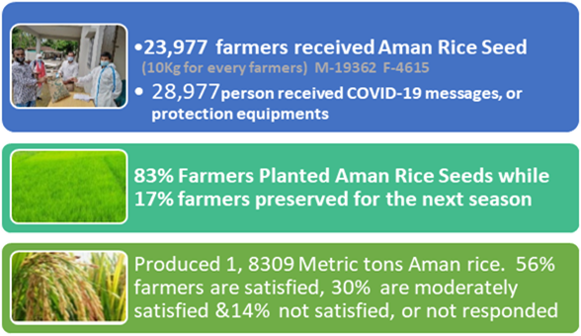
The programme supported the beneficiaries with locally adaptable and need-specific agricultural inputs based on their agro-ecological context to increase production and connection to the markets. The programme also contributed to strengthening agro-mechanization through providing agro-machineries among 28 groups and providing high-quality winter and summer seeds of nine different varieties (i.e. eggplant, okra, Indian spinach, Bitter gourd). Additionally, to support the improved homestead vegetable gardening, the programme provided micro gardening tools and materials, organic fertilizers (vermicompost), sex pheromone traps, irrigation facilities to 1,440 farmer households along with the production technologies. With these improved inputs, beneficiaries produced food for their consumption and sold the surplus, resulting in the income generation. In response to the Covid-19, FAO provided Aman rice seeds among 23,977 vulnerable farmers (i.e. 10 kg for every farmer), and 83% of the farmers planted these rice seeds producing 18,309 metric tons of rice.
Output 2.4: Host community groups are provided with material and training on sustainable fishing technologies (FAO).
FAO supported two categories of Fisheries Farmers Groups (FFG), i.e. aquaculture and dry fish producer, and the marine fish producer, to increase fish production and safe fishing at sea. Both groups of farmers were provided with training on effective group management. While the FFG beneficiaries were provided with skills training on aquaculture, the dry fish group beneficiaries received training on efficient fish drying. All skills training activities were done through the Upazila Fisheries Officer under the Department of Fisheries (DoF). After the training, FFGs were provided with the input support, including 100 kg of fish feed, fishnet for sampling purpose, and PH meter for testing water quality. The project was further supported with fingerling and a water pump. For dry fish groups, the project provided small mesh nets and frames for drying fish. FAO developed a training module on safety in sea and shared it with the Department of Fisheries, Cox’s Bazar. Based on the training module, FAO trained DoF officials so that they could deliver updated messages to the marine fish producers. In 2020, a total of 488 trained marine fish producer/fisher folks were equipped with life jackets, torches, training, and feed.

Output 2.5: Strengthening the collective capacity of agricultural producer groups and enhance income generation through improved market linkages and food security of marginal farmers’ households (FAO).
The programme has a key focus on building the collective capacity of the farmer groups to enable them to increase production and income by adopting integrated approaches. FAO facilitated the establishment of eight Aggregation Centers. The Aggregation Center Management Committee (ACMC) established linkages with 56 farmer groups and have been so far connected to markets through these Aggregation Centers, which helped farmers obtain better prices for their products, connect with buyers, output markets, local buyers, and wholesalers.
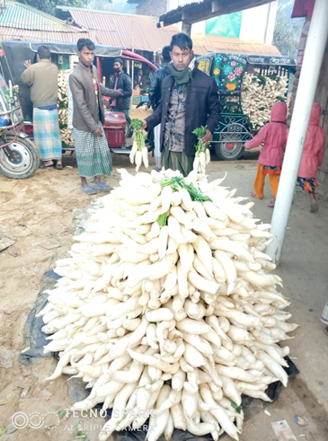
Sirjul is a farmer in Rikhong village in Whykong Union in Teknaf Upazila of the Cox’s Bazar District. He and his family had been struggling to survive. His production was small and the profit margin was low. He joined FAO-assisted farmers group in 2019 and learned how to grow vegetables, high-yielding varieties, the seasonality and the market demand. The farmer and other group members grew vegetables, but the market was far, and therefore they did not get fair prices. FAO assisted in the establishment of the local Aggregation Centers. Sirajul started working as an aggregator as well. He said, “the farmers are getting better prices by selling agricultural products, the transportation cost and other risks have reduced. I have been earning 8,000 BDT from the aggregation which helps to increase income and meet essentials.”

The sample based monitoring follow-up showed that 663 agricultural producer/groups had strengthened thei capacity in terms of operating goups and improved climate resilient agriculture practices utilizing agro mechanization, on farm learning, quality inputs, linkages with input and output markets, which resulted in generating more income. During the reporting period, the project reached 24,988 marginal farmers through group activation, on-farm trainings, improved learning and good practices, awareness of the climate resilience, high yielding vegetable production, agro-mechanization support, providing BCC materials, establishing aggregation centers and connecting with local markets.
Output 2.6: Market actors are motivated to invest in the supply chain benefiting the production and market access for 5 key supply chains
FAO has provided support to the producer groups to establish a direct linkage between growers and buyers, helping farmers to produce demand-based products. Direct connection with market actors also helped get better prices and helped reach agreements in establishing long-term supply chain mechanisms. In the second year of the reporting period, FAO conducted two market linkage workshops/meetings. A total of 45 private sector actors (i.e. input sellers, traders, farmer leaders, and local market committee members) attended the workshop. Twenty one groups reached a formal agreement with five traders to continue the supply of vegetables around the year. The private market actors have benn increasingly showing interest to invest in the two agricultural value chains (vegetable and livestock value chain). The market actors/private companies provided quality inputs (i.e. vegetable seeds, livestock feed), and outputs (purchasing product with better prices) which have contributed to strengthening the performance of the two value chains.
Output 2.7: Government local service provision capacity for technical support to farmer groups is expanded in 4 sub-districts (FAO).
The programme has the mandate to work with the relevant government departments in Cox’s Bazar, including the district and sub-district level offices of the Department of Agricultural Extension (DAE), DoF, and the Department of Livestock Services (DLS). These agencies were trained to improve service provision for the farmer groups across the project locations. During the reporting period, the programme organized a three-day long technical training for 76 government officials from DAE, DoF on improving production technologies, FFS approach, market development, and good agricultural practices. To introduce digital approaches in agricultural practices, the programme also organized training for the government officials on Information Communication Technology (ICT) based agriculture. As a result, the technical capacities of DAE, DoF, and DLS officials were strengthened to provide cascade training and innovative extension service among the local communities. During the reporting period, FAO also provided training to 50 community service providers (i.e. farmer trainers) to promote food and nutrition services among the communities.
Objective 3: Mentoring and Training of Rohingyas
The self-reliance activities faced a long-term delay in the implementation due to the government restrictions on such activities in the camps. However, IOM initiated the implementation in the fourth quarter of the year after receiving the approval from the government and assisted 2,500 rohingya individuals to increase the self-reliance capacity involving them in home gardening. As per the midterm evaluation, 95 % of targeted Rohingya households reported having gained knowledge.
Due to the Covid-19 related restrictions, WFP had to reprogramme some of the existing activities in both the refugee and host communities to achieve the desired goals.

Output 3.1: Rohingyas are mentored in Basic skills (IOM, WFP)
A total of 2,584 Rohingya refugee households were enrolled for self-reliance assistance provided by IOM, WFP and their implementing partners. The partner focused on providing support specific to specializations identified as relevant to the refugees’ coping strategies in their makeshift settlements.
With the support from the partner, the feasible activities for supporting refugees ranged from providing training on improved and environmentally sustainable techniques in vegetable and fruit farming to marketing within the camp economy setting. These activities incorporated training on land management, water systems protection, and environmental awareness schemes. The project contributed in many ways to improving the food and nutrition status and practices among the refugees, as well as creating supplementary sources of income.
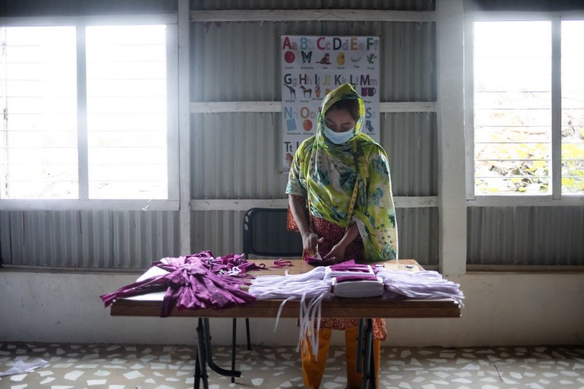
Moyuna is the head of one of the affected families in the camp. As a single mother, she fled Myanmar in 2017 with her two children. Though she receives food assistance and other humanitarian aid, she is unable to buy other basic necessities. There are only few income opportunities for refugees living in the camps, which has increased their vulnerability over the two-and-a-half years in Bangladesh. Since the start of the pandemic, the demand for cloth-masks became high. WFP with the partners started producing reusable cloth-masks involving the affected communities, thus creating opportunity for them to earn an income and meet the demand for cloth-masks.
Moyuna received around US$0.17 per mask she produced, and the masks are distributed to refugees in the camps.
She commented; “People are dying and suffering because of the coronavirus so to help them avoid that situation, I am making these [masks] happily. No matter if I am paid or not, people will be alive and will keep me in their prayers.”
The coordination efforts started in 2019 and in 2020 the agreement was reached. Activities were designed and implemented to build portable skills among the Rohingya refugees. The activities planned for 2020 were training in tailoring, embroidery, vegetable gardening, life skills, arts and craft.
Due to the Covid-19 restrictions, all the regular self-reliance programmes were suspended by the Office of the Refugee Relief & Repatriation Commissioner (RRRC). WFP reprogrammed part of its self-reliance activities to engage beneficiaries in mask-making. The masks were distributed to the community members. 700,000 masks were produced for which raw material was provided from the SAFEPlus grant involving 84 Rohingya beneficiaries.
WFP partnered with ICCO to resume its recycling and up-cycling project in September 2020. Waste disposed from the General Food Assistance (GFA) e-voucher shops, nutrition centres and School Feeding Programme was recycled to produce reusable bags. Rohingya volunteers were involved in waste collection, cleaning, sorting, washing and heat press machine operation and sewing.
Since September 2020, a total of 420,929 packets were removed from several sites. In addition to reusable bags, approximately 809 other products were also produced at the recycling centre, which included pillows, hand fans, tote bags, money bags, dustbins, shelves, card holders hand and hair bands, earrings, pen holders and wallets. The recycling activity successfully engaged volunteers.
Objective 4: Negative environmental impacts are mitigated through land/forest rehabilitation.
The SAFEPlus programme, in collaboration with the Forestry Department (FD), restored degraded plantation sites. FAO provided technical assistance and planting materials to FD that supported stabilizing and restoring the degraded plantation areas. The most significant accomplishment is the achievement of the target for forest land planted outside the camps for land stabilization (achieved 2,000 ha out of 2,000 ha, 100% achieved). Inside the camps, the target completion is 52% (i.e. 259 ha).
Output 4.1: Land stabilization, restoration, and erosion control measures conducted (FAO, IOM, WFP).
Through the satellite imagery analysis in 2018, FAO had identified degraded areas inside the camps and categorized them according to the degradation level. This helped to prioritize degraded land that needed to be restored. By the end of 2020, FAO restored 2,259 ha of degraded forest land, which accounted for 100% of the target outside of the camps and 52% of the target inside the camps. In total, 240 sites were replanted to protect land inside the camps – 190 sites in 2019 and 50 sites in 2020.
During the reporting period, maintenance support and silvicultural operation were done in the plantation sites selected in the previous year through vacancy filling, mulching, and repairing of the fences. This activity contributed to the attainment of faster vegetative coverage inside the camp area and reduced the landslide vulnerability. Moreover, a dry-season plantation model was developed and successfully piloted by FAO to expand the plantation window and enable planting beyond the monsoon season.
Output 4.2: Cash for Work programme support land/forest rehabilitation activities/tree nurseries (FAO, IOM, WFP)
Since the beginning of the project, a total of 2,259 hectares (259 ha in the camps and 2,000 ha in HC) were covered through restoration and land stabilization activity. During the reporting period in 2020, 80,712 cash-for-work days were achieved, bringing the total to 110,531 person days focused on reforestation and maintenance activities throughout the whole project period up to date. The cash for work activity has positively contributed towards improving livelihoods opportunities for the participants.
Output 4.3: Nurseries are producing planting materials (FAO).
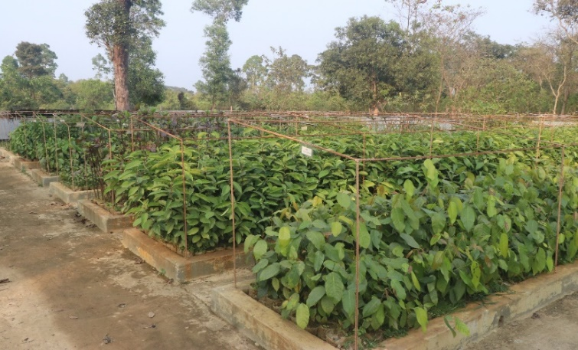
During the reporting period, two permanent nurseries with all modern facilities were established, which were then handed over to the FD for producing native and indigenous tree seedlings. In total, out of the targeted 20 nurseries, 17 nurseries have been established, which include 15 temporary nurseries and two permanent nurseries. In addition to that, 66 nursery owners in Ramu, Ukhiya, Teknaf, and Sadar were brought under the common umbrella of four Nursery Associations. The nursery owners received training on propagation technique, mother tree orchard establishment, grafting technique, plant protection, organizational management, and business plan development. In order to increase the linkage of the nursery owners with the wider market, a web-based platform (www.arannayk.org/NICC) was developed. Moreover, an auditing system was developed jointly with FD and DAE to categorize the nurseries following their performance. With the support of the project, four nursery owners established low-cost propagation houses to produce tree and fruit seedlings in their nurseries. Technical and logistic supports were provided to the nursery owners to increase the production of quality planting materials.
FAO supported FD to establish permanent nursery, Cox’s Bazar 2020

Output 4.4: Slope stabilization and reforestation of damaged areas (FAO).
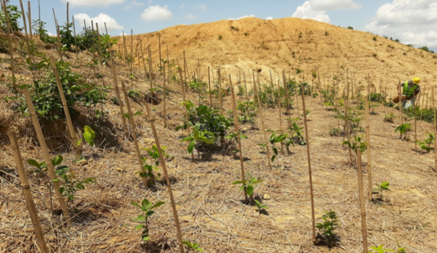
The SAFEPlus programme had planned to restore 2,000 ha of degraded forest land over the entire project period outside the camp. In the reporting period, FAO in collaboration with FD restored 1,529 hectares of degraded plantation sites in different locations under the Cox’s Bazar North and South forest divisions and achieved the project target. 1,490,000 seedlings of indigenous and fast-growing species were also been planted in 2020. FAO, in collaboration with the International Union for Conservation of Nature (IUCN), assessed the floral diversity of the forest areas under the Cox’s Bazar South Forest Division. This document will be of great assistance for the conservationists to choose the right site-specific species for the restoration initiative. During the reporting period, FAO also developed a globally accredited real-time forest monitoring and reporting tool widely known as the Spatial Monitoring and Reporting Tool (SMART) for the forest department to support the improved forest management and monitoring. The SMART Handbook developed by FAO and IUCN will help in the improved management of the forest resources.
Modified Miyawoki System of plantation, Camp-19
Output 4.5: Soil conservation and land stabilization (FAO).
FAO provided technical support and planting materials to stabilize 259 hectares of land inside the camps since the inception of the project following the technical guideline developed for restoring the land area. With the assistance of the UNHCR’s, IOM’s and WFP’s Site Maintenance and Emgineering Project (SMEP) Team, FAO followed both biological and bio-mechanical land stabilization methods in stabilizing gentle and steep slopes. Moreover, the modified Miyawaki system developed by FAO was piloted in Camp 19. The system works better in stabilizing the degraded land and created a patch of forest. In total, 80 communities benefitted from the actions.

Indicator Based Performance Assessment
Results | Achieved Indicator Targets | Reasons for Variance with Planned Target (if any) | Source of Verification
Goal: Contribute to the overall food and nutrition security, skill development, and resilience of 125,000 Rohingya and host community households in Cox’s Bazar.  Indicator: % of targeted households who adopt one or more negative food-related coping strategies  Baseline: 70% (WFP Refugee Influx Vulnerability Assessment, REVA study, Dec 2017)  Target: 50% | Indicator: 48% | Not applicable | Midterm evaluation report
Objective 1: Targeted households, especially women-headed and vulnerable households, have monthly decreased expenditures related to firewood purchase and increased nutritional intake for HH members.  Indicator 1: % of targeted households who report decreased monthly expenditures linked to firewood purchase  Baseline: 0  Target: 80% | Indicator 1: 98% | Not applicable | Midterm evaluation report
Output 1.1: Households, especially female-headed and vulnerable, have improved access to alternative cooking fuel and facilities  Indicator 1.1.1: # of targeted households (disaggregated by sex) with cooking set and LPG provision for 6 months.  Baseline: 0  Target: 125,000 households (40% female) | Indicator 1.1.1: 133,421 HHs (104,063 in the camps, i.e. 71,803 men and 32,260 women headed; and 29,358 in the HCs, i.e. 23,486 men and 5,872 women) received LPG packages from the programme | Not applicable | Indicator 1.1.1 LPG Distribution database
Objective 2: Local agriculturists are engaged in markets and benefiting from income generation  Indicator 2: % of targeted household from host community who report increase in income after participation in the project.  Baseline: 0  Target: 60% | Indicator 2: 53% | Not applicable | Midterm evaluation report
Output 2.1: Vulnerable households in host communities are provided with training and means for livelihood activities  Indicator 2.1.1: # of targeted individuals, (disaggregated by sex) trained in livelihood activities and receiving start-up support  Baseline: 0  Target: 25,000 households (40% Female) | Indicator 2.1.1: 11,837 individuals (1,179 Men, and 10,658 Women) received cash grants, training, inputs support and market linkage over the year. | The programme targeted 11,000 HHs in 2020 and achieved 11,837. | Activity report
Output 2.2: Local agriculturalists, especially women, have access to innovative climate-sensitive agricultural practices and high-demand and nutrient crops (FFS)  Indicator 2.2.1: # of agriculturalists supported in climate-sensitive agricultural practices and high-demand and nutrient crops production, marketing, and management  Baseline: 0  Target: 1,440 agriculturalists (72 groups of 20 members) | Indicator 2.2.1: 1,440 agriculturalists (male 934 & female 506) supported. 72 groups formed comprising of 1,440 agriculture farmers. Out of the total number, 35% are female. The farmers received training and agricultural inputs and received training on high-value nutrient crops in 2019-20. | Not applicable | Indicator 2.2.1: Farmers Activity report, training module, schedule, participant list, etc.
Output 2.3: Local agriculturalists have access to inputs (seeds, plantings, irrigation, and production technology) to develop high demand crops  Indicator 2.3.1: # of agriculturalists supported with inputs (seeds, plantings, irrigation, and production technology)  Baseline: 0  Target: 1,440 agriculturalists (72 groups of 20 members) | Indicator 2.3.1: 1,440 farmers (male 934 & female 506). Out of the total targeted, 35% are female. In 2019, they received seeds and micro-gardening kits. In 2020, the 1,440 farmers received vegetable seeds, irrigation, and agro-mechanization support service from the project. | Not applicable | Indicator 2.3.1: Activity reports
Output 2.4: Host community groups are provided with material and training on sustainable fishing technologies  Indicator 2.4.1: # of individuals provided with fishing material and training.  Baseline: 0  Target: 200 | Indicator 2.4.1: 988 individuals (in 2019, 500 individuals and in 2020, 488 individuals received support service (i.e. life jacket, torch, training, and feed) | Indicator 2.4.1: Exceeded target due to increased demand for the activity | Indicator 2.4.1: Activity report
Output 2.5: Strengthening the collective capacity of agricultural producer groups and enhance income generation through improved market linkages and food security of marginal farmers households  Indicator 2.5.1: # of agricultural producer groups have strengthened capacity and enhanced income generation  Baseline: 0 Target: 800  Indicator 2.5.2: # of marginalized farmers  Baseline: 0  Target: 25,000 | Indicator 2.5.1: 663 groups with strengthened collective capacities and increased income  Indicator 2.5.2: 24,988 farmers received agricultural support services (i.e. seeds, livestock and fisheries feed, agro machinery, life jackets, micro gardening kits, training and awareness messages (male 15,184 & female 9,804) | Indicator 2.5.1: Due to Covid-19 prevalence and several months of lockdown, the market system was affected, and the process got delayed | Indicator 2.5.1: Monitoring follow-up findings and training reports, MIS database  Indicator 2.5.2: MIS database, Master roll of agricultural inputs, and training report
Output 2.6: Market actors are motivated to invest in the supply chain benefiting the production and market access for 5 key supply chains  Indicator 2.6.1: # of supply chains supported by the market actor’s investment  Baseline: 0  Target: 5 | Indicators 2.6.1: 2 supply chains supported | Indicator 2.6.1: Due to Covid-19 prevalence and several months of lockdown, the market system was affected, and the process got delayed. | Indicator 2.6.1: Activity reports
Output 2.7: Government local service provision capacity for technical support to farmer groups is expanded in 4 sub-districts  Indicator 2.7.1: # of farmer trainers employed in FNS  Baseline: 0  Target: 30  Indicator 2.7.2: # of FNS relevant knowledge institutions supported directly activities  Baseline: 0  Target: 50 | Indicator 2.7.1: 50  Indicator 2.7.2: 76 officials | These two indicators already achieved the targets | Indicator 2.7.1: M&E reports  Indicator 2.7.2: Activity reports
Objective 3: Mentoring and Training of Rohingyas  Indicator 3: % of targeted Rohingya households who report having gained knowledge  Baseline: 0  Target: 60% | Indicator 3: 95% | Not applicable | Midterm evaluation report
Output 3.1: Rohingya are mentored in basics  Indicator 3.1.1: # of Rohingyas who received mentoring  Baseline: 0  Target: 30,000 | Indicator 3.1.1: 2,584 individuals received self-reliance mentoring support in 2020. The target was 9,000 individuals. | Due to Covid-19 restrictions inside the camp, it was not possible to engage most of the beneficiaries in the mentoring activity | Programme report
Objective 4: Negative environmental impacts are mitigated through land/forest rehabilitation  Indicator 4: # of hectares of forestry land protected or rehabilitated Baseline: 0  Target: 2,000 | Indicator 4: 2,259 ha (679 ha in 2019 and 1,580 ha in 2020) | Not applicable | Indicator 4.1: GIS analysis, field survey
Output 4.1: Land stabilization, restoration, and erosion control measures conducted  Indicator 4.1.1: # of sites replanted to protect land inside the camps  Baseline: 0  Target: 100 | Indicator 4.1.1: 240 sites (190 sites covered in 2019 and 50 sites covered in 2020) | Indicator 4.1.1: Due to the smaller size of the sites, more sites were covered. | Indicator 4.1.1: Activity reports
Output 4.2: Cash for Work programme support land/forest rehabilitation activities/tree nurseries  Indicator 4.2.1: # of Cash for Workdays supporting land/ forest rehabilitation activities/ tree nurseries  Baseline: 0  Target: 158,400 cash-for-work days | Indicator 4.2.1: 80,712 cash-for-work days were achieved in 2020 and the total achievement is 110,531 cash-for-work days for both years. |  | Cash for Work attendance records
Output 4.3: Nurseries are producing planting materials  Indicator 4.3.1: # of jobs supported in agricultural chains  Baseline: 0  Target: 200  Indicator 4.3.2: # of women reached by intervention  Baseline: 0  Target: 40% or 80 individual | Indicator 4.3.1: 115 jobs supported through establishing 17 nurseries (15 temporary nurseries in 2019 and two permanent nurseries in 2020).  In addition, 66 nursery owners were trained, and a website of nursery association also established.  Indicator 4.3.2: 30% female reached, 35 individuals. | Indicator 4.3.1: Due to the smalled size of the nurseries, less human resources were required | Indicator 4.3.1: activity report  Indicator 4.3.2: activity report
Output 4.4: Slope stabilization and reforestation of damaged areas (community wise targeting) (2,000 ha)  Indicator 4.4.1: # of hectares planted for slope stabilization  Baseline: 0  Target: 2,000  Indicator 4.4.2: # of planting materials produced  Baseline: 0 Target: 1,500,000 | Indicator 4.4.1: 2,000 ha (471 ha in 2019 & 1,529 ha in 2020)  Indictor 4.4.2: 2,348,725 seedlings (858,725 in 2019 and 1,490,000 in 2020) | Indicator 4.4.2: Target has been achieved and exceeded. The target was inadequate to cover hectares of degraded forest land. The hectares of land identification | Indicator 4.4.1: GIS, field survey  Indicator 4.4.2: activity report, procurement papers
Output 4.5: Soil conservation and land stabilization (2,500 ha)  Indicator 4.5.1: # of hectares of land stabilized  Baseline: 98  Target: 500 ha  Indicator 4.5.2: # of communities and households benefiting from the actions  Baseline: 0  Target: 100 community groups | Indicator 4.5.1: 259 ha (appx)  Indicator 4.5.2: 80 communities | Indicator 4.5.1&2: Due to the establishment of infrastructure and development programmes, land available for planting inside the camps has become scarce. This has impacted the progress under this activity. The project accelerated efforts to identify more land to be planted with support from Energy and Environment Technical Working Group (EETWG), Site Management and Site Development (SMSD) team and others working inside the camps during the upcoming planting season. | Indicator 4.5.1: GIS maps and field survey data  Indicator 4.5.2: Activity reports.

Challenges and Lessons Learned

Problem / Challenge Faced:
- By 2019, Cox’s Bazar had lost 6,164 Hectares of forest lands to refugee settlements, and 1,837 acres to firewood collection. The result was not only the intense competition between refugees and local populations over dwindling sources of energy for HHs consumption (mainly agricultural crop residues, processed animal manure, and wood from remaining forests), but also high expectations for the Government to mitigate tensions through rapid shock responses to local communities, short to medium term solutions to meet the energy demands and measures towards restoration of the environment.
- Planned field activities implementation faced challenges due to the Covid-19 outbreak and changing context. The changes resulted in delays in implementation and the need for reprogramming of activities.
- Monsoon driven plantation created challenges to meet the targets.
- Securing adequate land inside the camps for plantation was not available to achieve the programme goal.
- Covid-19 restrictions meant that several activities (categorized as not ‘critical’ activities) were halted temporarily.
Programme Interventions:
- Cash assistance as immediate shock response (with accompaniment to diversify livelihoods outside of the traditional forest environments) enabled host communities to adopt new skills and livelihood options. FAO, IOM and WFP in collaboration with the District authorities supported improvement of agricultural assets, facilitated land on lease to native tribes for food production, and complementary assets transfer in the form of animal rearing to boost HH capital base. The programme also enhanced the traditional skills in loom and craft production for the elderly men and women.
- Integrating alternative communication strategies, telecommunication, programme services, e-modalities (i.e. e-training, awareness building, online extension service, virtual meetings, mobile messaging), maintaining social distancing, organizing small groups wise activities, have contributed to reducing the impact of Covid-19 on activities.
- The project has encouraged the farmers and provided quality inputs, link with input suppliers, establishing Aggregation Centers, and creating a market linkage to reduce the gaps in demand and supply chain, and address market volatility.
- FAO team has piloted dry season plantation inside the camps. This is an innovative initiative contributing to shifting the plantating pattern beyond the monsoon season.
Results:
- The provision of LPG to influence positive choice on energy in favour of environmental protection is evidenced by the shift among the host communities from using firewood to LPG, which they are able to source from their own income from off-farm IGAs.
- FAO’s complementary on-farm support improved the extension services and made more inputs available (such as seeds, farming implements) and leased land to diversify homestead food production and marketing to refugee communities in and around Ukhiya and Teknaf refugee settlements.
- Investments in the restoration of the forest lands in camps and around host communities within the forest catchments areas made a substantive contribution to reverse the impacts of disasters on livelihoods and assets. The populations living close to the forests no longer experience massive destruction of vegetations and the loss of food production that are caused by the climate change, landslides and other factors.
Lessons Learned:
- Impact of the unconditional cash assistance: mitigating the economic effects of Covid-19 and contributing to the long term recovery of poor HHs from being locked in a low-level equilibrium. The SAFEPlus targeted most destitute, ultra-poor segment. Therefore, the Unconditional cash support brought relief to HHs rangng from very low levels of asset ownership to identifying supplementary sources of income to sustain family needs.
- The innovative home gardens as an option for livelihoods and adaptive capacities of refugees in camps not only provided families with better economic prospects but also contributed to regenerating small agricultural biodiversity in over 150 hectares of swamps and abandoned lands in the selected camps.
- Farmers Group Modalities: Working through a group approach is one of the best ways for proper resource utilization and management, production and income generation as well as a great multiplier to generate funds through savings practice at the community level.
- Market development: Balancing local market demand and supply chain is essential to reduce market volatility and private investment is required to strengthen the supply chain.
- Digital data gathering and alternative communication strategies: Integrated alternative communication strategies, telecommunication, programme services, e-modalities (i.e. e-training, awareness building, online extension service, and virtual meetings) and digital data gathering using digital devices are good for data collection, management, information sharing, and reporting.
- Social cohesion among the natural resource-dependent communities and the local government officials and social cohesion between Rohingya and host communities are important to achieve more resilience and sustainability of development.
- Clear communication strategies in liaison with internal and external stakeholders has been extremely helpful.

Other Assessments or Evaluations (if applicable)
- WFP conducted a tailored social cohesion assessment to measure the impact of resilience building activities on the social cohesion levels. This included measuring the impact on inter-community, intra-community relations, trust levels and accountability. It was found that livelihoods activities had most impact on social cohesion with 98% of the respondents stating that the programme had infused positive change in the relationships, which woud be sustainable over time.
- 85% of livelihoods, 62% of the cash for work and 65% of the Self Reliance participants in the host community mentioned that the income generated through the programme participation had improved their ability to help others and in turn improved their relationships with the community members. As compared to the non-participants, the participants showed greater trust levels and participation across social platforms.
- Floral Diversity Assessment and development of SMART Guideline for the Hilly and Plain land forest to ensure better management and sustainability. FAO, IUCN, and FD collaborated on it.
- FAO piloted Dry season planting mechanism inside the camp and is waiting to get the assessment results. It would help in expanding SAFEPlus environmental restoration initiatives beyond the monsoon plantation season.

Programmatic Revisions (if applicable)
• No revisions

Resources (Optional)

The term “programme” is used for programmes, joint programmes and projects.
Strategic Results, as formulated in the Strategic UN Planning Framework (e.g. UNDAF) or project document;
The MPTF Office Project Reference Number is the same number as the one on the Notification message. It is also referred to as “Project ID” on the project’s factsheet page the MPTF Office GATEWAY
The MPTF or JP Contribution, refers to the amount transferred to the Participating UN Organizations, which is available on the MPTF Office GATEWAY
The start date is the date of the first transfer of the funds from the MPTF Office as Administrative Agent. Transfer date is available on the MPTF Office GATEWAY
As per approval of the original project document by the relevant decision-making body/Steering Committee.
If there has been an extension, then the revised, approved end date should be reflected here. If there has been no extension approved, then the current end date is the same as the original end date. The end date is the same as the operational closure date which is when all activities for which a Participating Organization is responsible under an approved MPTF / JP have been completed. As per the MOU, agencies are to notify the MPTF Office when a programme completes its operational activities.
FAO is leading all on-farm livelihoods activities (crop, livestock, and fisheries production) including strengthening supply chains through potential market linkages, forestry, and land stabilization. IOM is leading on the distribution of LPG while WFP is scaling up its well-developed livelihood and market linkage programming for host communities affected by the influx, alongside self-reliance approaches that increase income opportunities for the Rohingya households. In order to support the implementation, joint reporting mechanism, evaluations and coordination of the inter-agency initiative with relevant government counterparts and humanitarian actors, IOM undertakes the role of the consortium manager/coordinator.
UN Exchange rate for March 2021 used, i.e. 1 USD= 84.776
Assessment of fuel wood supply and demand in displacement settings and surrounding areas in Cox’s Bazaar District, 2017
UN Exchange rate for March 2021 used, i.e. 1 USD= 84.776
The results of this pilot project will be shared on a national level to advocate and raise fund to assist all refugees in the camps.
UN Exchange rate for March 2021 used, i.e. 1 USD= 84.776
UN Exchange rate for March 2021 used, i.e. 1 USD= 84.776
National Parliamentary Committee Report on the environmental crisis due to the refugee influx in Cox’s Bazar; 2019)

