**Annex 2: Photos with captions on victim’s and survivor’s related activities**

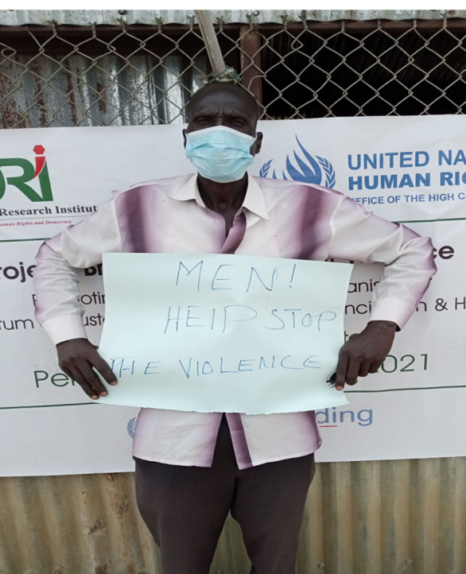

**A victim and survivor of conflict advocating for peace. He is a member of one of Bentiu’s established networks under the project “Breaking the Cycle of Violence” funded by the Peacebuilding Fund.**

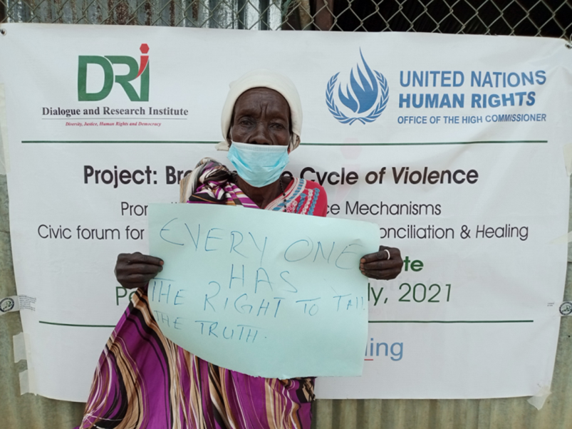

**A victim and survivor of conflict advocating for peace. She is a member of one of Bentiu’s established networks under the project “Breaking the Cycle of Violence” funded by the Peacebuilding Fund.**

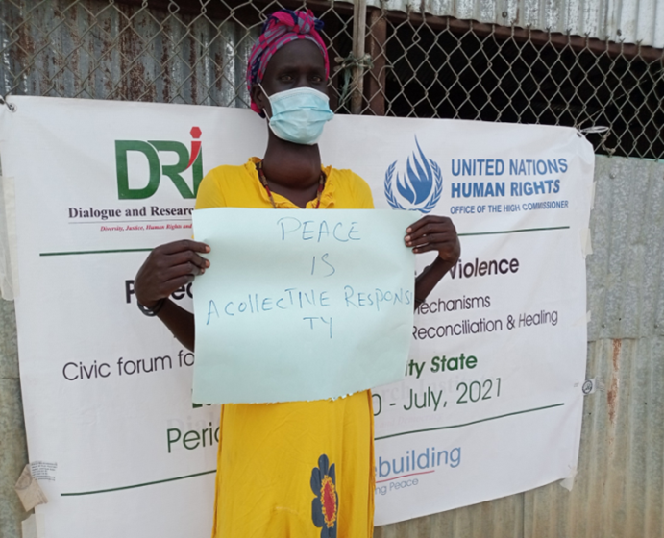

**A victim and survivor of conflict advocating for peace. She is a member of one of Bentiu’s established networks under the project “Breaking the Cycle of Violence” funded by the Peacebuilding Fund.**

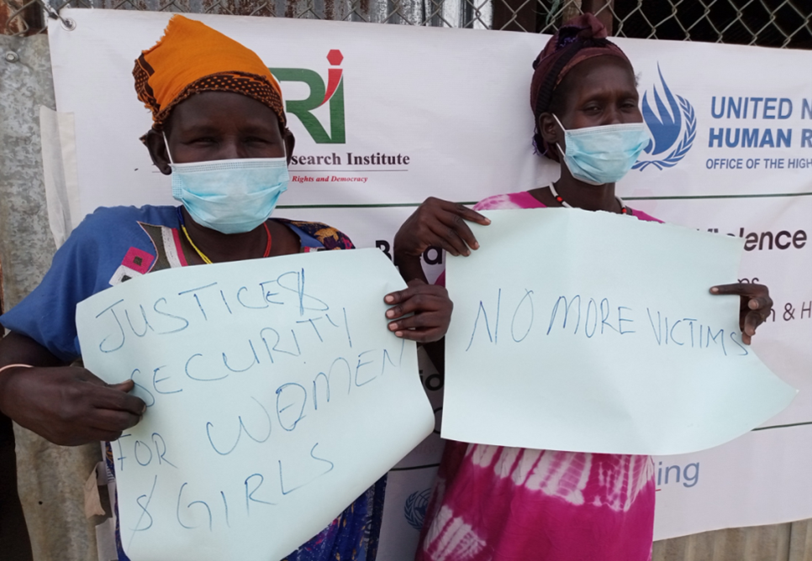

**Two victims and survivors of conflict advocating for peace. They are members of one of Bentiu’s established networks under the project “Breaking the Cycle of Violence” funded by the Peacebuilding Fund.**

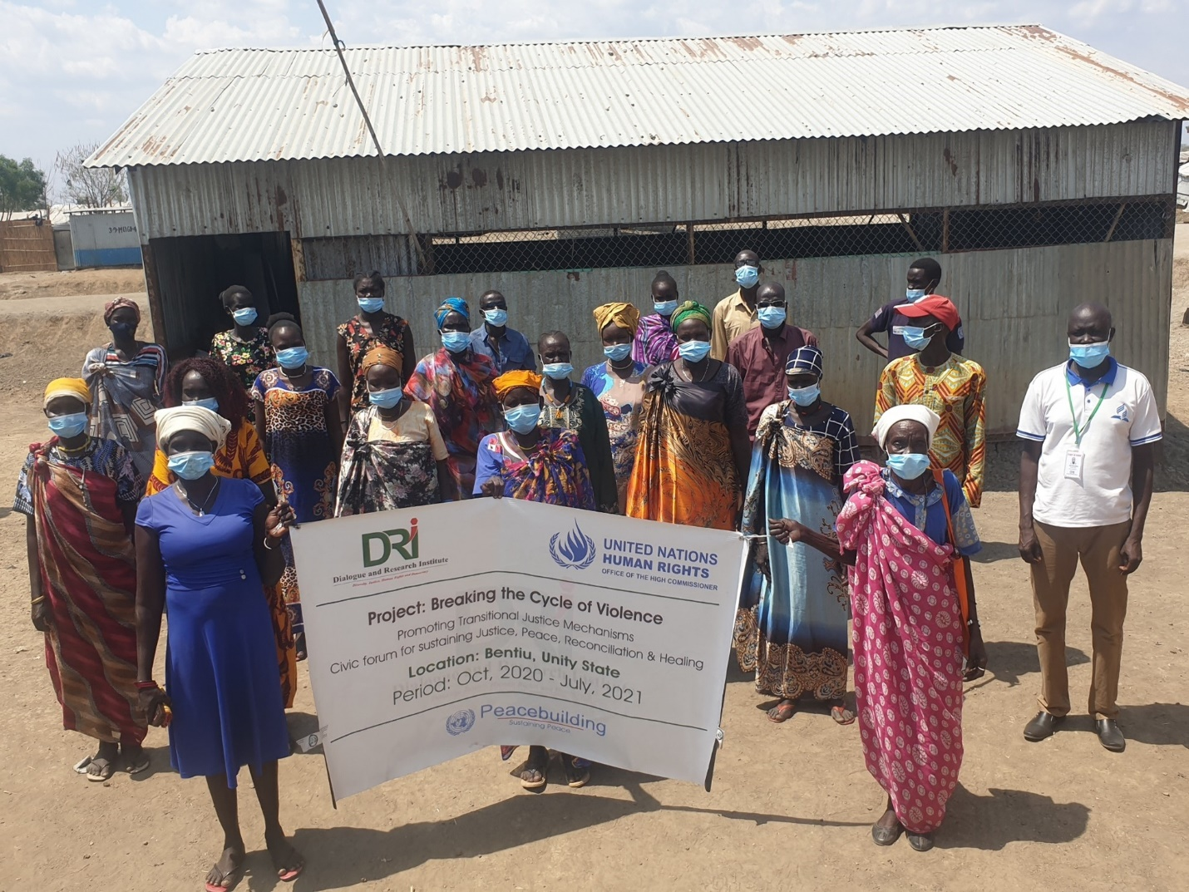

**Victims and survivors of conflict from Bentiu’s established networks under the project “Breaking the Cycle of Violence” funded by the Peacebuilding Fund.**

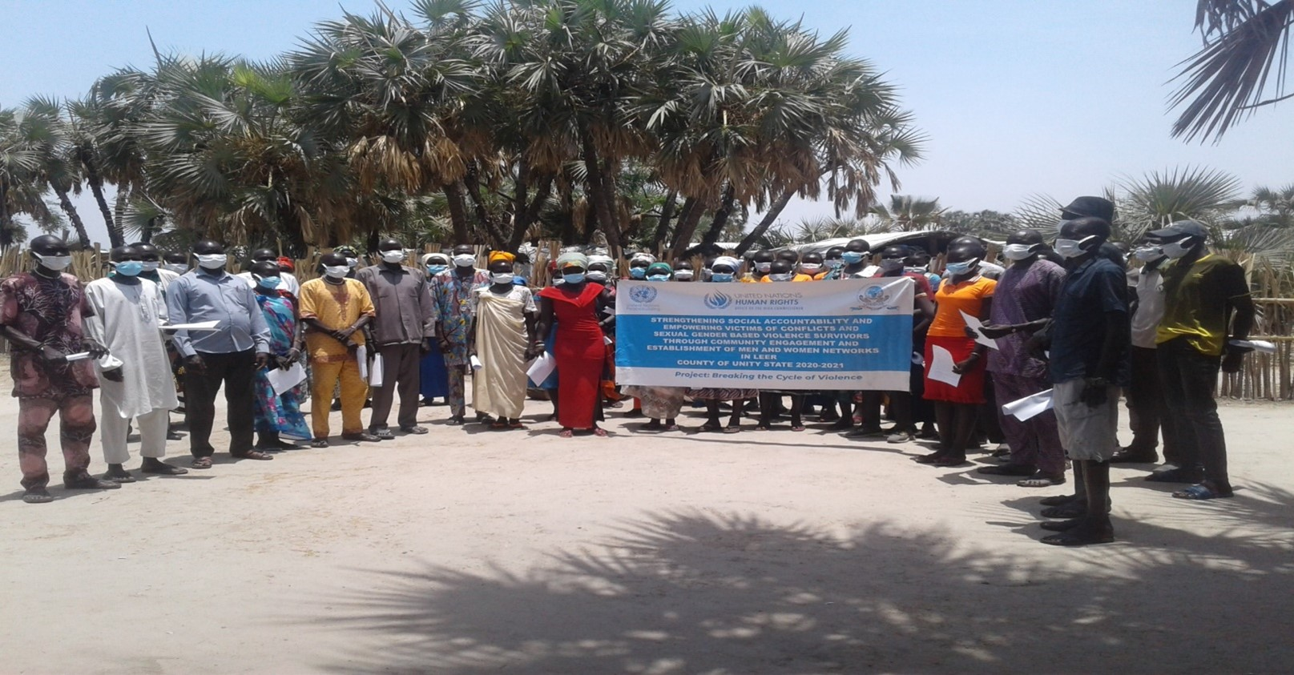

**Dialogue on victim’s and survivor’s transitional justice issues in Tochriah IDP camp, Leer County. Project: “Breaking the Cycle of Violence”, funded by the Peacebuilding Fund.**

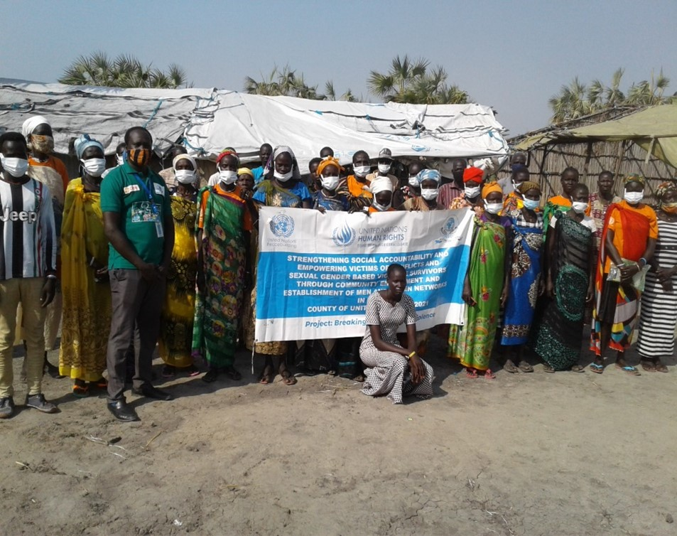

**Group photo after Leer’s survivor network members organized an event on peace and reconciliation - topic selected by the members. Project: “Breaking the Cycle of Violence”, funded by the Peacebuilding Fund.**

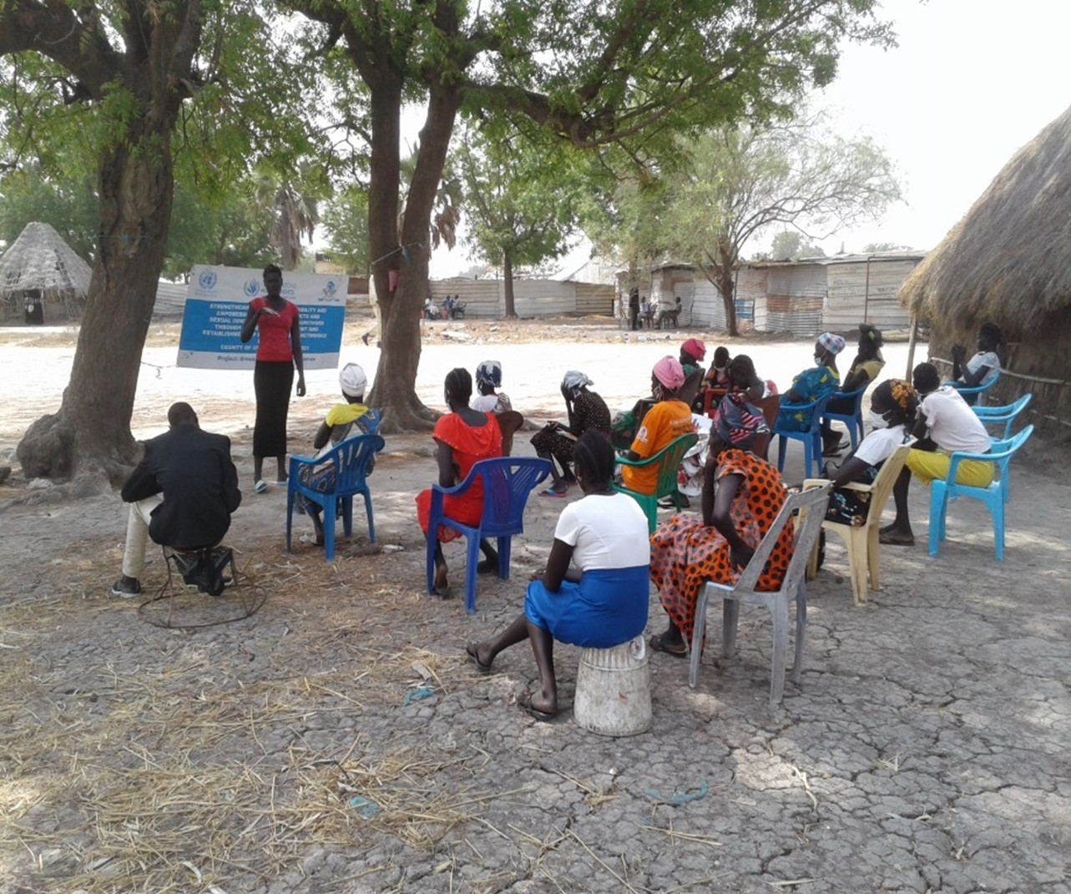

**Survivors network meeting for Nyandiar & Paluot payams, Leer County. Project: “Breaking the Cycle of Violence”, funded by the Peacebuilding Fund.**

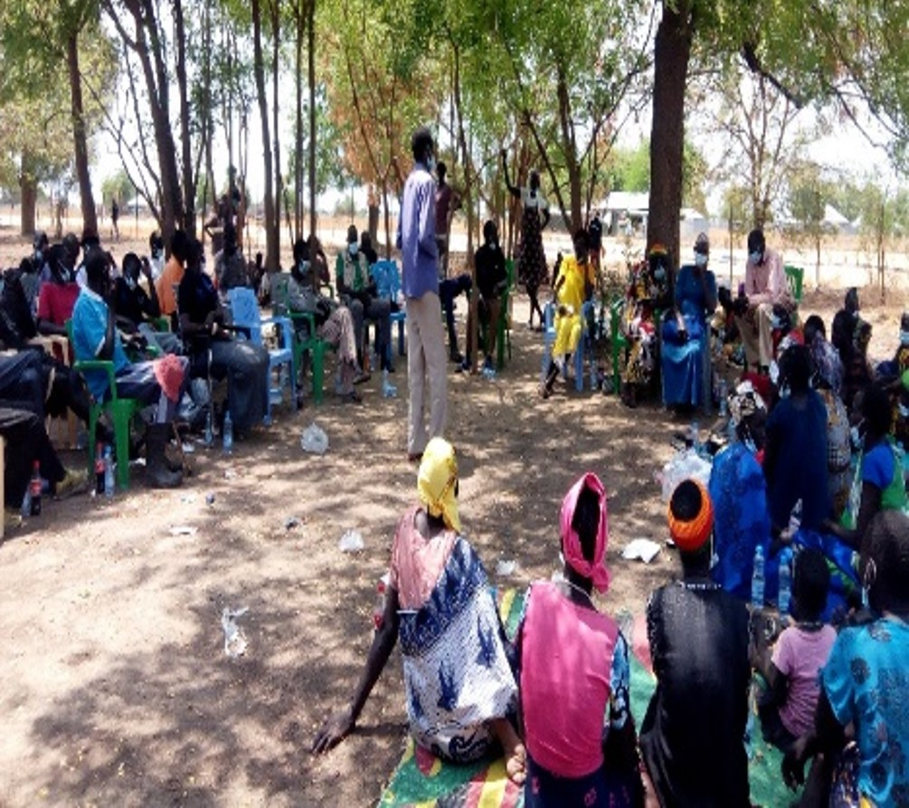

**Survivors from Bor’s established networks participate on a dialogue on conflict related sexual violence, building their capacity and skills to raise their voices. Project: “Breaking the Cycle of Violence”, funded by the Peacebuilding Fund.**

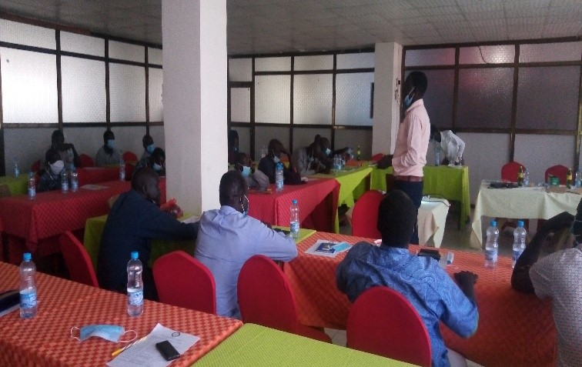

**The chairperson of Jonglei’s Transitional Justice Forum gives welcoming remarks to customary and formal justice actors during a Transitional Justice training in Bor. Project: “Breaking the Cycle of Violence”, funded by the Peacebuilding Fund.**

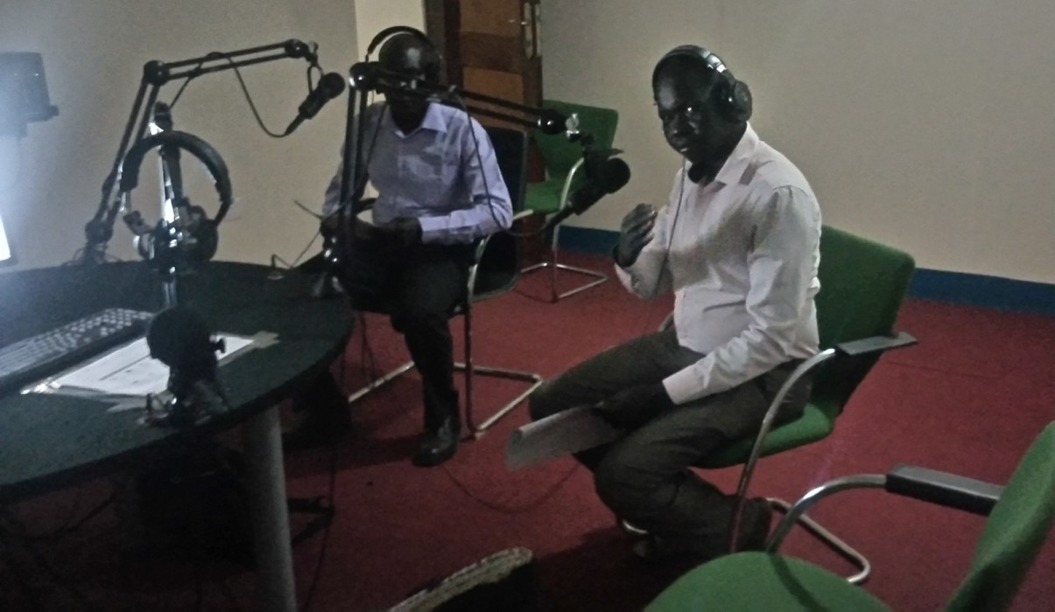

**South Sudan Law Society’s Legal Officer (light blue shirt) and the Deputy Chairperson for Jonglei’s Youth Association (white shirt) talk on Radio Jonglei 95.9 FM about Transitional Justice. Project: “Breaking the Cycle of Violence”, funded by the Peacebuilding Fund.**

**Annex 3: Summary of training on justice for children in Bor, carried out by the partner War Child Holland**

**WCH/UNICEF training on justice for children in Bor**

War Child Holland in collaboration with UNICEF and Jonglei State Ministry of Justice conducted 4-days training and consultative workshop on justice for children with 28 government staffs (22 male, 8 female) from police, court, prison administration and gender, child and social welfare, education and  health ministry and national defense force to improve children’s access to justice services, strengthen coordination among stakeholders on children in contact with the law and enable the enforcement of Child Act 2008 at local level.

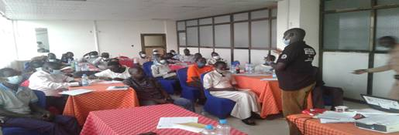

Justice for Children training, War Child Holland, Bor Town, March 11, 2021