Joint Programme

ONE UN SUPPORT TO THE NATIONAL INSTITUTE OF STATISTICS OF RWANDA FOR DATA GENERATION AND USE OF EVIDENCE BASED PLANNING

MPTF OFFICE ANNUAL PROGRESS REPORT
REPORTING PERIOD: 1 JANUARY – 31 DECEMBER 2020

Programme Title & Project Number |  | Country, Locality(s), Priority Area(s) / Strategic Results
- Programme Title: One UN support to the National Institute of Statistics of Rwanda for data generation and use of evidence-based planning  - Programme Number: 00120073  - MPTF Office Project Reference Number: 00120073 |  | Country/Region  RWANDA
Priority area/ strategic results:
UNDAP II, result area 3: Transformational Governance

Participating Organization(s) |  | Implementing Partners
- Organizations that have received direct funding from the MPTF Office under this programme: UNFPA  - All UN agencies under the Joint Programme on Data: UNFPA, UNWOMEN, UNICEF, WHO |  | - National Institute of Statistics of Rwanda (NISR)
Programme/Project Cost (US$) |  | Programme Duration
Total approved budget as per project document: $5,648,550  MPTF /JP Contribution: $622,108  Agency Contribution (core):  - UNFPA: $678,663  - UNICEF: $124,296  - UNWOMEN: $146,819  - WHO: $64,000  TOTAL: $ 1,635,886 |  | Overall Duration (60months)  Start Date: 11.02.2020  End Date : 30.06.2023
Programme Assessment/Review/Mid-Term Eval. |  | Report Submitted By
Assessment/Review  Yes No  Mid-Term Evaluation Report  Yes No |  | Name: Mark Bryan Schreiner  Title: UNPA Rwanda Country Representative  Participating Organization (Lead): UNFPA  Email address: schreiner@unfpa.org

ACRONYMS AND ABBREVIATIONS

DHS Demographic and Health Survey
DP Development Partner
EICV Enquete integrale sur les conditions de Vie des menages
GBV Gender-based Violence
GIS Geographic Information System
JP Joint Program
MIGEPROF Ministry of Gender and Family Promotion
MINECOFIN Ministry of Finance and Economic Planning
MPTF Multi Partner Trust Fund
NISR National Institute of Statistics in Rwanda
NSDS National Strategy for the Development of Statistics
NST National Strategy for Transformation
UNDAF United Nations Development Assistance Framework
UNDAP United Nations Development Assistance Plan
UNFPA United Nation Population Fund
UNICEF United Nations Children's Fund
WHO World Health Organization
UN WOMEN United Nations Entity for Gender Equality and the Empowerment of Women.

EXECUTIVE SUMMARY

The Joint Programme on Data is a five years support to the National Institute of Statistics of Rwanda in line with the UNDAP II. It outlines the continued support of the UN Agencies in capacity building of the national and subnational institutions in conducting high quality data collection, data analysis and dissemination; which are instrumental to tracking the progress in realizing the results as set in the National Strategy for Transformation (NST1) and for evidence-based policy and decision making.

Over the reporting period (January-December 2020), the programme focused on supporting the capacity building of national statistical systems to prepare and undertake national data collection and dissemination as follow:
- Integrated Household Living Conditions Surveys (EICV 2019-2020): Technical and financial support were timely provided to NISR to ensure the successful conduct of high quality data collection and analysis.
- 2019-2020 Rwanda Demographic and Health Survey Conducted: NISR was supported to successfully conduct 2019-2020 data collection using computers assisted personal interviews, data analysis and toward the end of the year, a workshop was conducted for the dissemination of the key indicator report in December 2020. The detailed analysis and report writing are ongoing, the dissemination of full DHS6 is planned in the second half of 2021.
- Rwanda Population and Housing census (RPHC 2022): The JP on data extended its support to NISR in ensuring the best technical and financial support is provided to implement the preparation phases of the census including the expertise in GIS, procurement of the advanced IT equipment such as computers and tablets.
- Strengthened Civil Registration and Vital Statistics System: In a bid to maintain the Civil Registration and Vital Statistics System online, continuous financial and technical support were provided to ensure monthly internet subscription, and the capacity building for stakeholders.
- Capacity building for data analysis, dissemination and Use: Technical and financial support has been provided to NISR to building capacity of data users through engagement with universities on infographics, lecturers/researchers, journalists, and reading data with children,

Activities under the JP on data are funded through various sources including the Multi Partner Trust Fund and agencies contributions. In 2020, only UNFPA received funds through the MPTF, participating UN Agencies under the Joint Programme on data (UNFPA, UN WOMEN, UNICEF and WHO) maintained their presence and contribution to the NISR steering committee using core funds. Despite the movement restrictions and other preventive measures imposed by COVID-19, the Joint program on data intensified its resource mobilization efforts to fill the gap created by adherence to prevention measures.

Purpose

The purpose of the Joint Programme on data is to increase the technical and financial capacity of Government institutions and civil society organizations at the national and subnational level to generate, disseminate and use quality disaggregated data aligned to the SDGs to inform policies and programmes in development and humanitarian settings. The Joint programme on data contributes to the achievement of the UNDAP II results 3: Accountable governance and in particular Outcome 6 and Output 1 with 2 indicators 6.1.2 and 6.1.3:

UNDAP Outcome 6: By 2023, people in Rwanda participate more actively in democratic and development process and benefit from transparent and accountable public and private sector institutions that develop evidence based policies and deliver quality services.

UNDAP II Outcome 6.1. Government institutions and civil society organizations at the national and sub national level have increased technical and financial capacity to generate, disseminate and use quality disaggregated data aligned to the SDGs to inform policies and programmes in development and humanitarian settings.

By ‘Delivering as One’, UN agencies in Rwanda seek to strengthen national and sub-national capacities to provide high-quality policy advice and technical assistance and support the collection and analysis of disaggregated data. Considering the data requirement in SDGs, the key focus of the Joint program on data is to support key national data collection exercises including the 2022 Population and Housing Census, the Integrated Household and Living Conditions (EICV 2019/2020), Demographic and Health Survey 2019/2020 and the gender statistical reports. Participating agencies are: UNFPA, UNICEF, WHO, and UN WOMEN.

Results
During the reporting period, the Joint program on data collaborated with the National Institute of Statistics to reinforce sectoral Management Information Systems and administrative data systems (indicator 6.1.2) such as the Civil Registration and Vital Statistics (CRVS) system also providing Technical Assistance to NISR to monitor Sustainable Development Goals (SDGs) indicators for which data is available and monitored (indicator 6.1.3) to ensure those systems are fully functional and producing timely, quality data, Refugees ID Registration fully functional.
Despite the challenging and complex environment created by COVID-19 pandemic planned activities and allocated resources were implemented, despite some delays as highlighted below:
Outcome 6: By 2023, people in Rwanda participate more actively in democratic and development process and benefit from transparent and accountable public and private sector institutions that develop evidence- based policies and deliver quality services.

Output 6.1: Government institutions and civil society organizations at the national and sub national level have increased technical and financial capacity to generate, disseminate and use quality disaggregated data aligned to the SDGs to inform policies and programmes in development and humanitarian settings

Indicator 6.1.1: Number of main national data collection exercise supported

- The Population and Housing Census (PHC) preparatory phases progressing well
Throughout the year 2020, The UN worked closely with the NISR in the preparation phases for the 2022 Rwanda Population and Housing Census (RPHC 2022). Having a Census Project Document approved, the Joint programme on data extended its support to NISR’s staff capacity building in the Geographical Information System (GIS) mapping in preparation for the Census enumeration areas which started in the last quarter of 2020. With support from SIDA through the MPTF, the UN supported the census preparatory activities including the census mapping exercise and upcoming pilot census in Aug. 2020. Census enumerators were swiftly recruited, trained, and deployed for field activities. In addition, advanced tools and IT equipment such as tablets and computers were procured to facilitate the census mapping. The draft Presidential Order was submitted for Cabinet approval and review by the Law reform commission. Once approved, the presidential order will allow for the establishment of the management and coordination structures to oversee the conduct of the Census 2022. The Joint programme on data has maintained its leadership role, presence, and resource mobilization efforts in the NISR steering committee to ensure that adequate assistance is timely provided. As the lead agency on Data, UNFPA’s convening role and strong partnership with DPs was instrumental in resource mobilization efforts. The strong leadership and support from the Resident Coordinator was also key in getting buy-in amongst DPs and in joint resource mobilization efforts in support of the Census preparatory activities.

- The 6th Rwanda Demographic and Health Survey (RDHS6) was successfully conducted.
DHS Tools (questionnaires) were refined to capture more health and demographic data for increased policy decision making, and data collection using Computer-Assisted Personal Interviewing (CAPI) was successfully concluded, despite slight disruption, due to people’s movement restrictions imposed by the COVID-19 pandemic. Throughout the process, the Joint programme on data maintained its comparative advantage in support of data generation through provision of technical assistance and allocation of additional funding from the MPTF to cover the budget increase and ensure protection of the data enumerators and adherence to the COVID-19 prevention measures. The DHS6 key indicators report was successfully launched and disseminated on 3rd December 2020 and the detailed (thematic) analysis is ongoing and expected to be finalized by mid- 2021. In that regard additional financial and technical support were provided by the ONE-UN to strengthen the capacities of NISR staff and sector stakeholders in thematic analysis requiring specialized skills such as Early Childhood Development (ECD) Index and Nutrition.

- Design and implementation of EICV 2019/2020 supported
The Joint programme on data supported the design and implementation of the 6th Integrated Household Living Conditions 2019/2020 survey that determines the poverty profile of the population. Data collection started well but was interrupted by the movement restrictions caused by the infection and prevention controls measures to contain the COVID-19 pandemic. NISR had collected enough data to carry out some of the analysis except those that may require trends monitoring. Towards the end of the year, the UN provided technical assistance to NISR through the recruitment of a consultant to analyze and build the capacity of NISR staff for future analysis. The report to be released in 2021 will have partial information on households living conditions and may be not the poverty profile. The full or complete EICV survey cycle is every 3 years, the next one is expected to be 2023/2024.

- Gender statistical reports
Under the 2030 Agenda for the Sustainable Development Goals (SDGs), Member States committed to ensure “no one will be left behind”, with gender equality established as a stand-alone goal and a central fundamental to achieving an inclusive and sustainable development agenda by 2030. Ensuring the translation of these commitments into effective action requires disaggregated data to address all the vulnerable groups, particularly women and girls. Within this framework and in line with its mandate to lead, promote and coordinate efforts to advance the full realization of gender equality, women’s rights and opportunities, UN Women in partnership with the National Institute of Statistics of Rwanda (NISR) produced a gender thematic report from the labour force survey (July 2020) with updated data on labour force participation rate of women and men, unemployment, informal and formal employment rate, unpaid care work, gender pay gap, and other economic activities by women and men. In addition, the Joint programme on data in partnership with the Ministry of Gender and Family Planning (MIGEPROF) have produced the ‘’Rapid Gender Assessment on the Impact of Covid-19 on women and men in Rwanda’’ (December 2020) with data ranging from the impact of Covid-19 on economic activities, businesses, ICT use, access to health services and gender based violence. Data from the two publications are contributing to support the Government of Rwanda, Civil Society Organizations, development partners, academia in their programmatic work, advocacy as well as reporting vis-a-vis the national and international commitments such as the SDGs. Particularly, the results from the rapid gender assessment on the impact of Covid-19 on women and men in Rwanda are facilitating the decision making on the socio-economic interventions aiming to support the recovery plan of the government as well as the ONE UN and other development partners support in this context.

Indicator 6.1.2: Sectoral MISs and administrative data systems fully functional

- CRVS system was strengthened
The Joint programme on data supported the strengthening and implementation of the Civil Registration and Vital Statistics system by providing internet connectivity to 49 health facilities, 416 sectors and 30 district statisticians. Capacity building for key stakeholders across the sectors and at a decentralized level was provided and has contributed to enhanced communication and coordination among the key actors. These have helped maintain the system online and supported field monitoring activities. The strengthened CRVS system has eased the registration processes and enhanced access to identity documents. Childbirth registration was reinforced for all and about 99% of newborn refugee babies in Rwanda were issued with birth certificates. Refugees are now accessing civil registration services through the national online registration system, including birth, marriage, and death registration. A 2018-2019 verification exercise has informed a reduction in numbers of persons of concern at a level of about 70% in urban areas and 10% in camps. This important data allows the government and its partners to have efficient plans as well as for reference in provision of ID cards to all eligible individuals aged 16 years and above. About 53% of persons of concern have valid identity documents.

Indicator 6.1.3: % of SDG indicators for which data is available and monitored

- Framework of Health SDGs Indicators with missing data was developed.
The Joint programme on data provided technical assistance for health SDGs Monitoring in March 2019. As a result, a Framework of Health SDGs Indicators with missing data was developed. This will serve as a basis for further work to generate missing data in this area. Moreover, the capacity of central level staff from the NISR, Ministry of Health and Rwanda Biomedical Center to analyze and synthesize CRVS data was developed via a five-day training on the use of World Health Organization (WHO)’s tools for mortality data analysis in December 2019.

- 23 indicators fully matching between NISR and DESA indicators switched on the One UN Rwanda website

Furthermore, UN Rwanda started an initiative with DESA to monitor and display SDGs on the One UN website. In 2018, NISR worked with the United Nations Statistics Division (UNSD) expert group to review and select among 244 SDGs indicators those that were relevant for Rwanda to report on. This resulted in the domestication of 199 SDG indicators by the government of Rwanda. NISR conducted an analysis and comparison of both DESA and NISR SDGs data to select the set of indicators to be displayed on the One UN Website as part of the DESA initiative. Of the 195 indicators (Global SDG Indicator Database), only 82 indicators could be compared with NISR indicators. NISR expressed concern about the potential to have variation in data references due to the discrepancies in sources or metadata between the Global SDG indicators database and those of NISR for the same indicators. This work started in 2020 is continuing with possibly an initial display 23 indicators fully matching between NISR and DESA indicators. The National Institute of Statistics of Rwanda and DESA are working together to review all indicators, differences in methodologies between global data reported by custodian agencies and national data compiled by NISR should be reviewed and explained on the basis of the respective metadata. The SDG data disseminated by UNDESA are global indicators; if switched on in UNINFO, Rwanda could have comparable SDGs data across countries. While the global indicators have been adopted by the UN General Assembly in its 2017 resolution and therefore cannot be modified, UNDESA can facilitate the dialogue between custodian agencies and NISR on methodological issues and metadata to understand differences between values presented in international data series and those in the national data series.

- Data analysis, dissemination, and data use

The joint Program on Data provided technical and financial support to NISR to build capacity of national and sub-national Government and Civil Society Organizations staff in data analysis, dissemination, and data use targeting high school teachers, university lecturers and researchers, students, journalists, and other data users. Under the support of ONE UN, NISR in partnership with Rwanda Education Board (REB) was able to train 60 journalists from 23 leading media houses in Rwanda on evidence-based storytelling. As a result of the training, 65 high school teachers were trained on how to read statistics with students in classrooms.
The fifth infographics and graphics design skills enhancement were supported and coaching, and mentorship workshop was conducted with the Joint Program on Data support and 26 young people (18 boys, 8 girls) from five universities participated in the competition. Despite the fact that the number of participants had to be limited this time to meet the COVID-19 restriction measures set by the Government, the outcome of the infographic product had similar quality to last year.
Indicator 6.1.4: Number of national development strategies and frameworks that have integrated the Demographic Dividend (DD) study recommendations.

Under the JP on data, UN agencies supported NISR in continued engagement and advocacy for inclusion of the findings and recommendations of the Demographic Dividend study in development partners’ fora focusing on human capital development, socio-economic development and transformational governance.
New evidence is regularly integrated following the government planning cycles to update key policy frameworks; harnessing the demographic dividend remains a priority in the National Strategy for Transformation 2017-2024. These national frameworks have integrated the DD study recommendations: Health Sector Strategic Plan 2018-2024, Education Sector Strategic Plan 2018-2024, NST1 2017-2024 and Private Sector Development and Youth Employment Strategy 2018-2024. The new evidence from 2019-2020 DHS6 key indicators report and the Integrated Household and poverty profile 2019-2020 will be used to update various policy development frameworks especially adjusting targets due to COVID-19 disruptions and impact.

- Challenges
The implementation of sectoral information systems to monitor Health and other SDGs is costly and therefore require considerable resources mobilization. More efforts are still needed to strengthen coordination, monitoring and evaluation systems for SDGs and in addressing the prevailing data gaps across sectors. The 2022 Census is at a critical stage with the pilot phase preparations activities. The Presidential Order is urgently needed to provide the framework for 2022 Census management and coordination structures that will facilitate communication and resources mobilization.
Vital statistics, which include births and deaths, are linked to over 80% of the SDGs targets and therefore critical for SDGs monitoring. Mortality data are now collected in a standardized way at hospital level since 2018 in Rwanda. However, nearly 60% of deaths are thought to happen in the community. The scale-up of the CRVS system has started using verbal autopsy, but the procurement of hardware and the training are costly.
- Resources

Programme benefited from additional resources or interventions from other partners.

The funding received through the MPTF to support for NISR were catalytic to ensure a coordinated and coherent UN support to reinforce sectoral MISs and administrative data systems such as DHS 2019/2020 and 2022 Census preparatory activities. UN participating agencies in the JP on data worked through the NSDS steering committee to support NISR in refining and implementing its NSDS3 strategy in collaboration with other development partners and using other sources of funds to amplify their contributions to the JP on data for data generation and use of evidence based planning for transformational governance. The reports/publications produced in partnership with the National Institute of Statistics of Rwanda (NISR) such as the “Rapid Gender Assessment on the Impact of Covid-19 on women and men in Rwanda’’ (December 2020) in partnership with the Ministry of Gender and Family Planning (MIGEPROF) have produced data ranging from the impact of Covid-19 on economic activities, businesses, ICT use, access to health services and gender based violence. The new evidence from DHS2019/2020, EICV 2019/2020 and the upcoming 2022 Census reports just to name a few, will be critical for evidence based policy planning for the next generation of government plans such as the second National Strategy for Transformation.
ii) Indicator Based Performance Assessment:

 | Achieved Indicator Targets | Reasons for Variance with Planned Target (if any) | Source of Verification
Outcome 6: By 2023, people in Rwanda participate more actively in democratic and development process and benefit from transparent and accountable public and private sector institutions that develop evidence based policies and deliver quality services.  Output 6.1. Government institutions and civil society organizations at the national and sub national level have increased technical and financial capacity to generate, disseminate and use quality disaggregated data aligned to the SDGs to inform policies and programmes in development and humanitarian settings  Indicator 6.1.1:  Number of main national data collection exercise supported  Baseline:4th Population and Housing Census, 2014/2015 DHS, 2013/2014 EICV, Gender statistics report  Planned Target:5 (2022 Census Project Document; EICV; 2019/2020 RDHS, Gender statistical reports), | The 2019-2020 DHS data collection was successfully completed and the data analysis is ongoing , the Key indicator report is available, and the final report will be ready before June 2021.  The 2022 PHC approved project document available, and preparation phases are ongoing  The 2019-2020 EICV data collection was successfully completed, and data analysis is ongoing. the final report will be available before June 2021  The 2019 Gender statistics report is available | COVID-19 has imposed movement restrictions country wide and consequently affected the ongoing data collection exercise.  In addition, the COVID-19 prevention measures have led to increase in the allocated budget | NISR website  http://statistics.gov.rw/publication/demographic-and-health-survey-20192020-key-indicators  Source NISR:  http://statistics.gov.rw/publication/national-gender-statistics-report-2019
Indicator 6.1.2:  Sectoral MISs and administrative data systems fully functional.  Baseline: No  (CRVS, GMIS, HMIS and ID registration for refugees in place but not fully functional).  Planned target: Yes  (CRVS, GMIS, HMIS fully functional and producing timely, quality data, Refugees ID Registration fully functional). | The CRVS is online and now functional at hospital level and recorded 87% of births and 31% of deaths in 2019. First Rwanda Vital statistics report released during the reporting period. | The high proportion of deaths (nearly 60%) occurring outside the hospitals requires the scale-up of techniques such as verbal autopsy to strengthen the CRVS system nationwide. | 2019 NISR Vital Statistics  https://www.statistics.gov.rw/publication/rwanda-vital-statistics-report-2019
 | HMIS (health management information systems) is functional with some missing indicators especially those on adolescents and youth
Indicator6.1.3: % of SDG indicators for which data is available and monitored.  Baseline: 23%  Planned target:70% | 70% of indicators to monitor the health-related SDGs with data were available | More efforts are still needed to strengthen coordination, monitoring and evaluation systems for SDGs and in addressing the prevailing data gaps across sectors. | SCORE report  https://www.who.int/data/data-collection-tools/score/dashboard#/
Indicator 6.1.4: Number of national development strategies and frameworks that have integrated the Demographic Dividend (DD) study recommendations.  Baseline :0 (2017).  Planned targets: 4 sector frameworks (HSSP, ESSP, NST1, PS DYE). | These national frameworks have integrated the DD study recommendations: HSSP IV, ESSP 2018-2024, NST12017-2024 and PS DYE 2018-2024 |  | Health Sector Strategic Plan IV:  http://www.minecofin.gov.rw/fileadmin/templates/documents/NDPR/Sector_Strategic_Plans/Health_.pdf  Education Sector Strategic Plan 2018-2024  http://www.minecofin.gov.rw/fileadmin/templates/documents/NDPR/Sector_Strategic_Plans/Education.pdf  NST12017-2024 http://www.minecofin.gov.rw/fileadmin/National_Strategy_For_Trsansformation_-NST1.pdf  Private Sector Development and Youth Employment Strategy  http://www.minecofin.gov.rw/fileadmin/templates/documents/NDPR/Sector_Strategic_Plans/PSD_YE.pdf

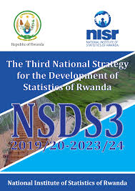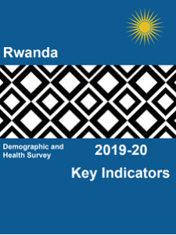

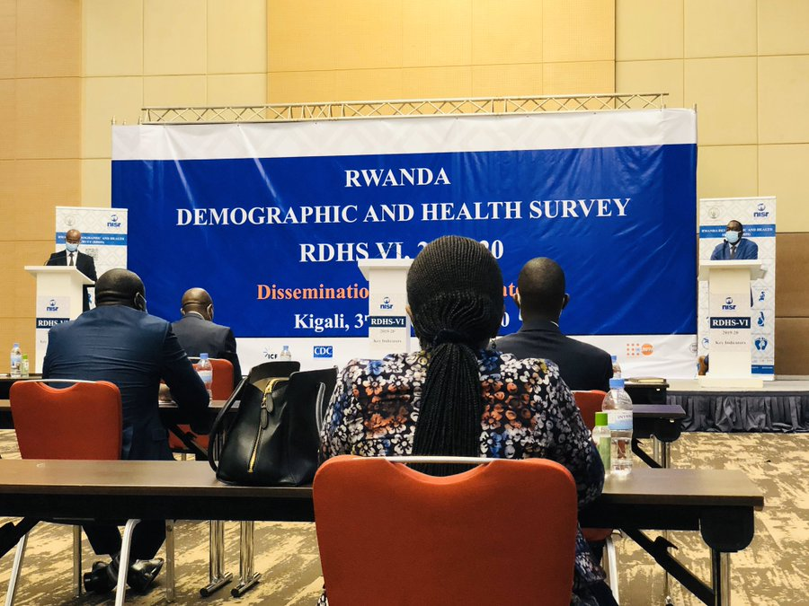

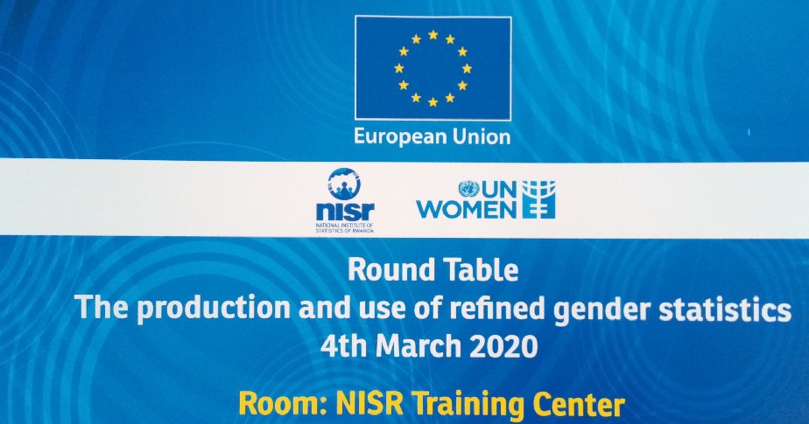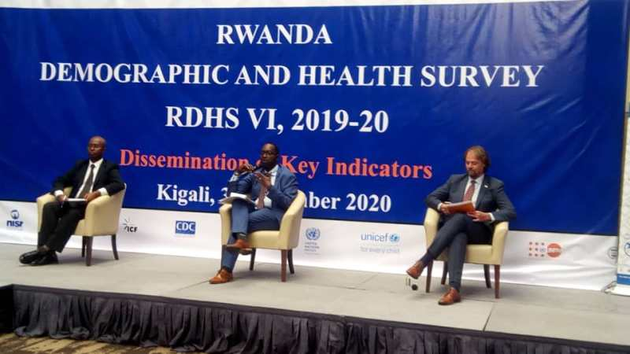

Strategic Results, as formulated in the Strategic UN Planning Framework (e.g. UNDAF) or project document;
https://www.primature.gov.rw/index.php?id=2&no_cache=1&tx_drblob_pi1%5BdownloadUid%5D=842

