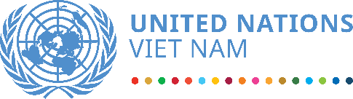

**2020 UN COUNTRY ANNUAL RESULTS REPORT**

**VIET NAM**

March 2021

**UNITED NATIONS COUNTRY TEAM IN VIET NAM**

20 UN entities including 15 resident and 5 non-resident agencies, funds and programmes comprise the United Nations Country Team (UNCT) in Viet Nam, chaired by the UN Resident Coordinator, the designated representative of the UN Secretary General for development operations in the country.

|  |  |
| --- | --- |
| The UNCT in Viet Nam is working towards Viet Nam’s achievements of the 2030 Agenda and SDGs as well as national development agendas through the One Strategic Plan 2017-2021 (OSP). The UNCT coordinates closely with the Government of Viet Nam (GOVN) at strategic level in implementing OSP through the Delivery as One UN-GOVN Joint Steering Committee.  OSP represents the programmatic and operational framework for delivering UN support to the Government and people of Viet Nam and establishes how the UN will deliver as one. The OSP 2017-2021 has four focus areas, shaped by the five central themes of Agenda 2030 (People, Planet, Prosperity, Peace, and Partnership), with nine related outcomes and with direct contributions to the 17 SDGs.  (    In 2020, the UNCT with support from four Results Groups, four cross-cutting Thematic Groups, the Programme Management Team, the Operation Management Team, and other inter-agency working groups conducted the Common Country Analysis, OSP Evaluation, CF development, and tremendous actions to respond to COVID-19, to support Viet Nam’s regional and global roles and visibility, and to remain the achievement of intended OSP results. | **UN Resident Agencies:**  FAO, IFAD, ILO, IOM, UNAIDS, UNDP, UNESCO, UNFPA, UN Habitat, UNICEF, UNIDO, UNODC, UNV, UN Women and WHO  **UN Non-Resident Agencies:**  ITC, IAEA, UNCTAD, UNE, OHCHR |

**KEY DEVELOPMENT PARTNERS**

**OF THE UN DEVELOPMENT SYSTEM IN VIET NAM**

**(Chart from UNInfo – draft, to be recategorized)**

The UN in Viet Nam continued to broaden its partnership in 2020. Key development partners of the UN included a wide range of Viet Nam’s government agencies at both central and local levels, international financial institutions, civil society and the private sector, the EU and bilateral development partners.

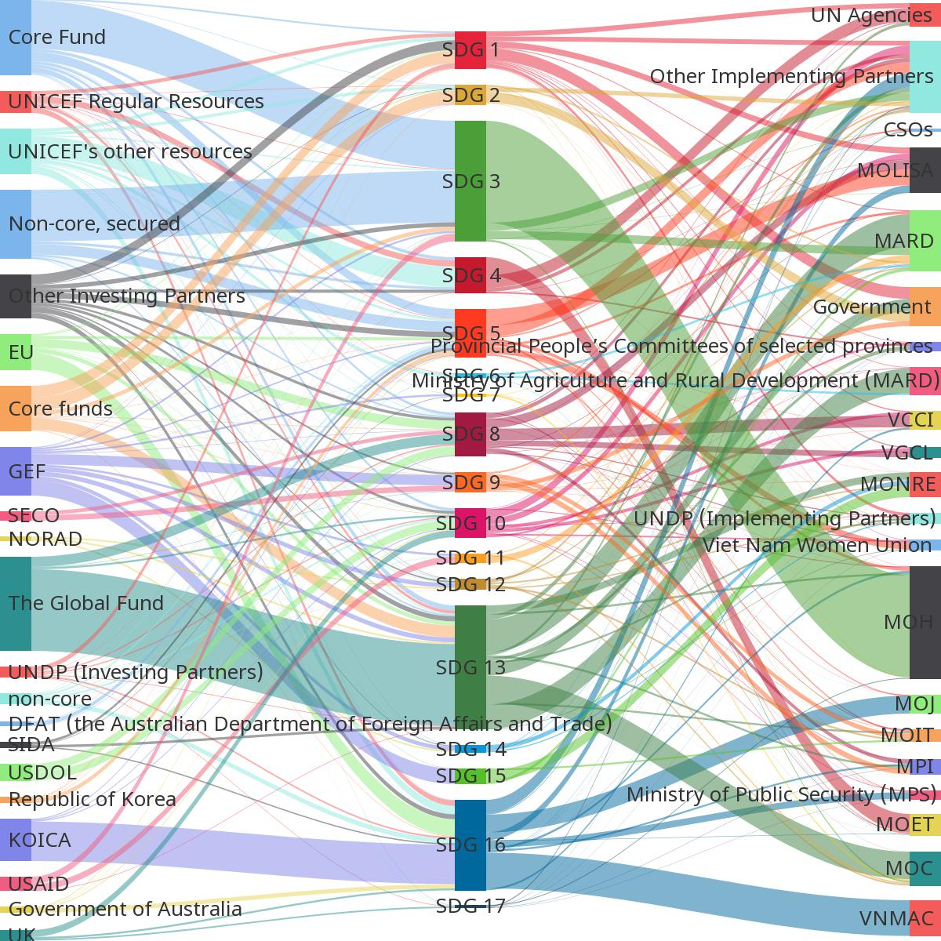

The UNCT continued to work closely with relevant ministries and public agencies, predominantly with MOH, MPI, MOH, MOET, MOCST, MOLISA, MOIT, MOHA, MPS and MOD, MONRE, MARD, Vietnam Women’s Union, Youth Union as well as the numerous committees of the National Assembly and research institutions. The UNCT in close cooperation with MOFA in supporting Viet Nam’s dual role in 2020 as the Chair of ASEAN and a non-permanent member of the UN Security Council as well as Viet Nam’s more active role in South-South Cooperation.

With the UNRC as co-chairs to the Informal Ambassadors Group on Development Cooperation, Development Partners Groups, Informal Ambassadors Group on Gender Policy, Disaster Management Group (DMG), the UN could partner with the broad development partner community (including CSOs) in 2020 to pursuit strategic direction and policy influence on crucial development issues such as the country’s NDC, Energy Transition Strategy, COVID-response support plans, floods response plans and the formulation of the Socio-Economic Development Strategy 2021-2030.

EU continued to be a key partner to the UN in many areas of cooperation such as justice and legal empowerment, renewable and energy transition, forest law enforcement, food security and natural disaster mitigation and response in agriculture, trade and decent work, and enhancement of labour rights. In 2020, the UN also worked in synergy with the World Bank in social protection that aims to result in greater coverage of vulnerable or marginalized groups in Viet Nam. The UN in Viet Nam ensured active collaboration with UN regional and global entities including UNESCAP and UNDESA/UNSD, especially on improving the national statistics system’s strategy and capacity.

Given the country context with the emerging of Vietnamese private sector, the UN has increased its efforts in open new dialogues to mobilize and engage Vietnamese private sector in contributing to the SDGs implementation in Viet Nam, through both contributing resources and incorporating the UN principles of responsible business in their business operation. A first time ever partnership agreement between the UN and a Vietnamese private corporation (SOVICO), was signed in September 2020. Strongly backed up by the Government, this result sets a good practice for the UN to open the strategic dialogue with Vietnamese private sector and is expected to attract their peers in the process.

**CHAPTER 1: KEY DEVELOPMENT IN VIET NAM AND REGIONAL CONTEXT**

2020 saw major challenges caused by COVID-19, severe drought in the Mekong Delta and unprecedented floods in the Central Region, which negatively affected Viet Nam’s economy, particularly the service and manufacturing sectors. The GDP growth rate of 2.91 was at the lowest level over the 2011-2020 decade, with the second quarter rate at almost zero which is the lowest in three decades. The unemployment rate reached the highest level over the last 10 years also in the second quarter of 2020. The ongoing drought, water shortages and saltwater intrusion posed a significant risk to 685,558 people in the Mekong Delta region, affecting 13 out of 63 provinces. Floods in the Central Region caused economic losses estimated at more than $1.5 billion with more than 340 deaths and missing, 819 injured, and thousands of houses and ha of crops damaged. Vulnerable populations have been disproportionately affected including among other persons with disability, sex workers, people who use drugs, people living with HIV, LGBTIQ persons and migrants. Nevertheless, region-wise and global-wise, Viet Nam was one among the countries with the highest growth and one of 10 countries with lowest employment rate globally. The country joined the high human development category in 2020 with the Human Development Index of 0.704, ranking 117 out of 189 countries globally.

* 2020 Population: 97.6 million people
* 2020 GDP Growth Rate: 2.91 per cent
* 2020 Unemployment Rate: 2.48 per cent
* 2019 HDI: 0.704, 117/189 countries, high-level

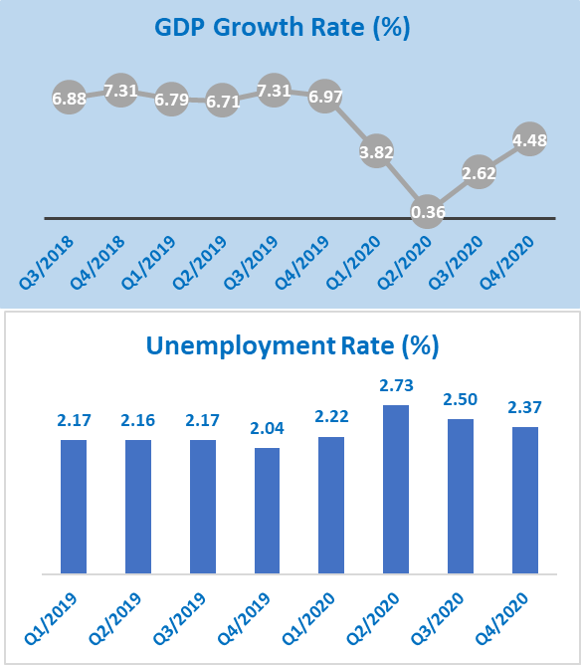

Viet Nam demonstrated their strong leadership, solidarity, and capacities to response to public health emergency. With quick and effective response to the developing COVID-19 pandemic from the outset, Viet Nam was among few countries which has been able to literally control COVID-19 and not allow COVID-19 to be sustained wide community transmission in country. The country kept the spread of infection and death at minimum with 1,150 cases and 35 deaths by the end of 2020.

2020 was also the year for Viet Nam to prepare the country’s next 10-year Socio-Economic Development Strategy (SEDS) 2021-2030 and 5-year Socio-Economic Development Plan (SEDP) 2021-2025 which set development directions in the coming period and would be approved in the 13th National Communist Party Congress in February 2021. The Congress would also usher in new leadership for the country. The anti-corruption fight continued, with a series of new high-profile cases being brought to court.

Viet Nam played a dual role as the Chair of ASEAN and a non-permanent member of the UN Security Council. In June 2020, the National Assembly approved the ratification of the European Union Vietnam Free Trade Agreement (EVFTA) and the EU – Viet Nam Investment Protection Agreement (EVIPA), opening a wide corridor to better connect the EU and Vietnam. In the framework of the 37th ASEAN Summit in November 2020, Viet Nam together with 14 other countries signed the Comprehensive Partnership Agreement region (RCEP), contributing to accelerating the process of building the ASEAN Economic Community to 2025.

Although being viewed as dynamic and emerging economy with huge potential of igniting a fourth industrial revolution, there remains a number of vulnerable communities (e.g. ethnic minority groups) that have been left out, especially in the COVID-19 context. Contact-intensive services are still in the downturn with millions of people, particularly women and workers in small and informal businesses, having decreased or no income. There are concerns on access to basic services (including in health and education) for the most vulnerable groups. Although Viet Nam has begun to recover on the domestic front, the medium-term recovery remains contingent on a number of factors, such as the re-opening of international borders, the recovery of major trading partners, the resulting impact on public finances and, most unpredictable, characteristics of the post-COVID-19 global trading landscape. Air pollution and waste, especially plastic and water pollution, reached alarming levels. For example, Vietnam is among the top 10 countries in the world with the worst air quality. Viet Nam’s HIV epidemic remains a public health threat with rapid increase of new infections among men who have sex with men and women infected by intimate partners. Viet Nam projected that the country would struggle to meet 10 SDGs (SDG 3, 5, 6, 7, 8, 9, 10, 11, 15 and 16) and be not likely to meet two SDGs (SDG12 and 14) by 2030.

While the Asia and Pacific region has a more important position globally and is considered a crucial driving force of the world economy, there are potential factors of instability due to competition and disputes over territory and resources, particularly regarding the South China Sea and freshwater along the Mekong River. Competition among countries in becoming financial and innovation center has been increasingly large.

**CHAPTER 2: UN SOCIO-ECONOMIC RESPONSE TO THE COVID-19 PANDEMIC**

Throughout 2020, the UN in Viet Nam worked closely with the GOVN and people of Viet Nam in containing the initial and successive outbreaks of COVID-19 and the fight against the pandemic, focusing on vulnerable population under the principle of leaving non one behind.

**Key Results in 2020**

* UN Viet Nam’s costed COVID Socio-Economic Response Plan (SERP) with USD 5 million repurposed for COVID response
* Over 450 health workers and 250 CSO members trained in integrated health and nutrition interventions, COVID-19 preparedness and response.
* UN Social and Economic Impact Assessment of COVID-19 (SEIA) in Viet Nam
* About 1 million doses of COVID-19 vaccines to be coming to Viet Nam in April 2021

In the early days of first COVID-19 outbreaks, test-kits and epidemiological surveillance trainings were quickly provided from the UN (WHO and FAO) to MOH to help the country quickly detect initial cases and timely monitor the situation.

The UN also quickly together mobilized funds from the UN COVID-19 Response and Recovery Multi-Partner Trust Fund (one million US dollars) and the Australian Government (1.5 million US dollars) to form two joint programmes on “Mitigating the Socio-Economic Impact of COVID-19 in Viet Nam on the Most Vulnerable Groups and Supporting More Resilient Policies and Systems” and “Supporting Interventions to Eliminate Violence against Women and Children in Viet Nam under COVID19 Emergency”.

In July, the UN in Viet Nam produced its COVID-19 Socio-Economic Response Plan (SERP) based on HQ guidance, especially the UN Framework for the Immediate Socio-Economic Response to COVID-19, consisting of five pillars. The SERP helped the UN Agencies focus on projects and programmes assisting recovery efforts of the GOVN and people of Viet Nam, with USD 5 million repurposed for COVID response.

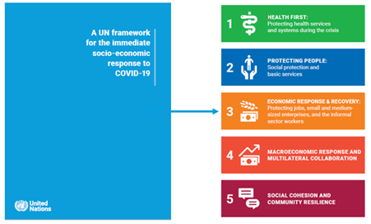

In September 2020, the UN published the UN Social and Economic Impact Assessment of COVID-19 (SEIA) in Viet Nam [https://vietnam.un.org/en/95127-un-assessment-social-and-economic-impact-COVID-19-viet-nam](https://vietnam.un.org/en/95127-un-assessment-social-and-economic-impact-covid-19-viet-nam). This report is the joint product of a series of UN empirical, evidence-based assessments of the social and economic impacts of COVID-19 over the second and third quarter of 2020, with a view to understanding the actual and potential future impacts of COVID-19 on the overall socio-economic development of the country, focusing on the most vulnerable population groups and especially those at risk of being left behind. This assessment is also the basis for the UN in Viet Nam’s strategic policy recommendations to the Government of Viet Nam as it sought to formulate and finalize its Socio-Economic Development Strategy (2021-2030) and Socio-Economic Development Plan (2021-2025). The SEIA was presented to the Prime Minister at the UNCT’s meeting with him in October 2020, where the PM along with other senior officials expressed sincere appreciation for UN support to the GOVN’s fight against COVID-19.

A Pandemic Prevention Task Force (PPTF) has been formed among UN (led by FAO, WHO), US, Germany, NGOs (PanNature, WCS, WWF) during 2020, aimed to advocate for minimizing the risk of pandemic virus spillover to humans from wildlife trade and consumption. Responding to PPTF’s position paper, the Prime Minister invited PPTF (led by the UNRC) to a courtesy meeting with him on 8 February 2021 at which the PM confirmed the GOVN’s full support to the group’s advocacy work.

Through the COVAX Facility (led by Gavi, the Vaccine Alliance, WHO and CEPI), the UN led by UNICEF worked with manufacturers and partners on the procurement of COVID-19 vaccine doses, as well as freight, logistics and storage towards the delivery of a first shipment of 811,200 doses of #COVID19vaccines to Viet Nam expectedly in April 2021.

**CHAPTER 3:**

**UN IN VIET NAM SUPPORT TO NATIONAL DEVELOPMENT PRIORITIES**

**3.1. OSP RESULTS BY OUTCOME**

**OUTCOME 1.1. POVERTY AND VULBERABILITY REDUCTION**

***By 2021, all people benefit from inclusive and equitable social protection systems and poverty reduction services, which will reduce multi-dimensional poverty and vulnerabilities***

**Expanded, more inclusive and equitable social protection**.

Through the Joint Programme on Social Protection and LNOB and other UN projects, the UN in Viet Nam significantly contributed to the GOVN preparation and issuance of important policy documents including (i) the draft Decree on Social Assistance (Decree 136), (ii) the draft National Programme on Social Work 2021-2030, (iii) the draft Decree on Social Work, and (iv) the approved National Progamme on Child Protection 2021-2025. These policies and programmes aim to expand social protection coverage for its vulnerable population including children (especially the 0-3 years old group), older persons and people with disabilities, to strengthen the social care system reflecting GOVN’s recognition of social service and social workers as an integral part of the social protection landscape in Viet Nam, and to promote the multi-sectoral child protection approach to address violence against children.

An assessment of the implementation of Decree 136 on social assistance and costing policy options for regular cash transfers for older persons (OP) and older persons with disabilities (OPWD) was implemented by the ILO and UNFPA. This research provided the GOVN with evidence for revising Social Assistance regulations and proposing a roadmap to achieve the GOVN’s targets of 45% and 60% coverage of old-age income security in 2025 and 2030, respectively. The Assessment Report also recommends linkages between shock responsive mechanisms and regular cash transfers.

A comprehensive Gender Impact Assessment of Social Insurance in Viet Nam was completed by the ILO in partnership with the Viet Nam Women’s Union, providing an overview of the gender gaps in social protection outcomes, particularly pensions, arising from labour market inequalities and suboptimal social insurance regulations. It makes key recommendations for increasing adequacy and narrowing down gender gaps in coverage and benefits.

Under the framework of the Master Plan on Reform and Development of Social Assistance 2017-2025 and a Vision to 2030, the first nation-wide rapid assessment on social assistance needs of children and families in Viet Nam affected by COVID-19 was commissioned by UNICEF, highlighting the acute needs of families with children and calling for an urgent expansion of cash assistance and aiming to strengthen the national social assistance system to be more shock-responsive and to enhance the resilience of children and families in Viet Nam to climate and economic shocks, disease outbreaks and pandemics.

UNICEF collaborated with FAO to assist MOLISA to initiate a feasibility analysis on the delivery of cash assistance for children in emergencies, exploring options for effective delivery mechanisms to transfer cash to children and their caregivers.

The UN led by UNDP made a breakthrough pilot support in digitalizing the GOVN cash transfer program management and delivery in 2020 which will be scaled up to the national scale in the following years.

**Enhanced capacity for National Targeted Programmes (NTPs) and national policies**

In 2020, the GOVN proposed to the National Assembly three new NTPs for the next five and ten-year periods, including the Sustainable Poverty Reduction (SPR), the New Rural Development (NRD), and the Socio-Economic Development of Ethnic Minority and Ethnic Minority Areas (SEDEMA) NTPs.

The UN jointly supported the GOVN’s effort through many activities, such as the UNDP-supported assessment of the National Assembly Resolution on Accelerating Sustainable Poverty Reduction’s 5-year implementation which identified key shortcomings, lessons and recommended solutions for designing the new NTPs. This together with other UN policy advices and UN-supported policy dialogues contributed to the issuance of NA Resolution 120/2020/QH14 in June. The NA Resolution approved the investment plan for the SEDEMA NTP 2021-2030 (with an approximately USD 6 billion budget for the first phase 2021-2025) and enabled the GOVN development of the other two NTPs’ investment plans to be considered by the NA in 2021. The resolutions also provided strategic directions guiding the design of NTPs, including more focus on multidimensional poverty (MDP) reduction in ethnic minority and remote communities, raising the MDP thresholds to allow more vulnerable people access to NTPs support, and providing greater space for local innovation and strength.

The UN in Viet Nam (led by UNDP and UNICEF) continued to provide technical support to the GOVN’s revision and approval of the national multidimensional poverty standards for 2021-2025, including the MDP child poverty lines, to be applied in the new NTPs. By doubling income poverty threshold and adding new indicators for non-income deprivations in nutrition, employment and skills, social protection support will be expanded to over 7.5 million vulnerable Vietnamese.

Furthermore, the UNDP introduced digital tools and updated procedures for identifying the MDP households, allowing online MDP self/e-registration and e-verification and the creation of MDP sex-disaggregated e-database for more efficient and transparent delivery and monitoring of MDP policy and program support. Business models based on e-commerce and e-payment introduced by UNDP helped vulnerable Ethnic Minority women-led cooperatives in Bac Kan and Dak Nong provinces sustain and expand their business by effectively addressing the COVID-19 induced disruption of supply chains and diversifying markets of their products, scaling up the AAA governance approach in the new NTPs design.

The UN’s recommendations on gender mainstreaming has been included in the final draft of the NRD NTP 2021-2025 with UN Women‘s support and collaboration with MARD and VWU. A policy brief on gender responsive budgeting was produced by UN Women, advocating for gender responsive implementation of the SEDEMA NTP 2021-2030.

**OUTCOME 1.2. EQUITY IN HEALTH**

***By 2021, all people, particularly the most vulnerable, benefit from inclusive and equitable health systems, services and the promotion of healthy environments.***

Assisting the GOVN in fighting against COVID-19 and ensuring equity in accessing health services and benefits in the COVID context were the top priority of the UN work in Viet Nam in 2020, through closely collaborating with MOH and the National Steering Committee for COVID-19 Prevention and Control, as well as national and international development partners. While the COVID-related key results are detailed in Chapter 3, this part highlights many other important health-related results produced by the UN system.

**COVID-19 prevention, control, and response**.

The UN supported MOH and other GOVN partners to conduct rapid assessments, to issue guidelines, and to organize various trainings. More specifically, UNFPA worked to prevent COVID-19 transmissions and SRH service disruption, focusing on mountainous provinces and migrant workers. UNAIDS, UNODC and WHO supported the development of the guidance on provision of methadone maintenance therapy (MMT), the introduction of take-home multi-dose MMT and antiretroviral therapy (ART), ensuring uninterrupted access to essential HIV services.

**642 health workers** receiving training courses on COVID-19 and Medway Community Healthcare (MCH) 🡪 **210,400 visits** for SRH services

**64 fetus monitors** provided for 56 district hospitals in 9 mountainous provinces to prevent COVID 19 transmission.

**MCH247-“Mẹ con vui khỏe”** (i.e. Healthy and Happy Mother and Baby) s-phone application facilitating tele-SRH service provision in COVID-19 context

Factsheet on PLHIV and COVID-19 to **2000 People Living with HIV/AIDS, 90,000 prisoners**

A Technical Brief on Impact of COVID-19 on Maternal Health and Family Planning in Vietnam

**Delivery of health-related services**

**848,000 newborns (412,128 girls)** receiving early essential newborn care

**1,170,000 children (568,620 girls)** being fully immunized

**144,000 people** **(1,100 pregnant women, 124,500 under-5 children of which 60,507 girls)** receiving antenatal care, micronutrient supplementation and infant and young child feeding counselling, screening and treatment of severe acute malnutrition.

**> 2 million under-18 children (978,000 girls)** benefiting from hand sanitizers, soaps, ceramic water filters, water tanks and awareness messaging on infection prevention and control of COVID-19.

**54,000 people** living with HIV reached for enhanced IEC

**1,500 people** living with HIV and other key affected populations benefited from the emergency health/HIV/STIs and subsistence support

**>2,000 Commen Health Stations of 36 provinces** implementing a new public health approach for NCD management

UNICEF assisted the GOVN to procure and distribute personal hygiene items for health facilities, communities and schools. UNICEF also supported the MOH’s strengthening of the cold chain at provincial level for the Expanded Programme on Immunization through co-financing from GAVI which will be extended to the district level in 2021. Also with UNICEF technical assistance, MOH obtained GAVI support to deploy IPV second doses and Rota vaccines through the routine immunization programme over the next five years. UNAIDS worked with community-led organizations of HIV key populations to provide emergency health/HIV/STIs services, enhanced IEC on HIV and COVID-19 and emergency subsistence support.

WHO, UNAIDS and UNODC jointly provided innovative supports on HIV/AIDS to Viet Nam. Examples could be highlighted including a national guideline on HIV interventions, HIV pre-exposure prophylaxis (PrEP) target setting for HIV key populations, a 5-year national plan for PrEP scale-up until 2025, a guideline on behavioral interventions among MSM and transgender women in the context of unsafe sex drug use and HIV, a new national guideline on the use of ART for HIV prevention and treatment, and UN guidance on prevention of mother-to-child HIV transmission in prison setting.

With UNICEF’s support, the sector partnership on WASH was enhanced by the operation of the sanitation working group, which helped plan and coordinate WASH support for COVID-19 responses, and organize the Sanitation for All Finance Ministers’ Meeting.

**Strengthened key regulations, national strategies and action plans**

The revised HIV Law was approved by the National Assembly with UN support and will come into effect by mid-2021, ensuring greater and more sustainable access to HIV services for all people in need. With WHO, UNFPA and UNICEF’s technical support, the National Action Plan for Reproductive Health period 2021-2025 and the National Program on Reducing under five Child Mortality until 2030 were approved following the life-cycle approach to address population specific health needs of young children, mothers and older people. The National Strategy to End the AIDS Epidemic by 2030, the National Strategic Plan for Malaria Prevention and Elimination for 2021-2025, the National Guidelines on HBV and HCV Testing and Treatment, the National Guideline on Dengue Surveillance, Prevention and Control were also endorsed by the GOVN in 2021 following WHO’s recommendations. WHO also supported the development of a National Action Plan on Health Care for Older People and to effectively manage and control communicable disease and public health security issues. In addition, WHO advocated and supported the country to implement innovative public health approach for NCD management through strengthening institutional capacity of public health system at all level of care, developing simplified and effective tools and, finally, legalizing this new approach with the development of National Action Plan for NCD prevention and control 2021-2025.

UNFPA, UNICEF and WHO jointly supported the MoH to develop a national action plan on maternal, neonatal and child health for the period 2021-2025 with a vision towards 2030. The action plan prioritized addressing disparities in maternal and child health status amongst vulnerable populations including ethnic minority, migrant populations and those who live in disadvantaged regions.

UN support to sub-national integrated planning continued, with 58 provinces developing and implementing plans for integrated early childhood development and 20 doing so for the triple elimination of mother-to-child-transmission of HIV, syphilis and hepatitis B.

**Improved data and evidence for effective policy advocacy and policy making**

In 2020, data on nutrition was enhanced with UNICEF technical support to the National Survey on Nutrition by MOH which revealed reductions in stunting among under-5 children but growing inequities (e.g. the national stunting rate is 19.6 per cent versus 37.4 per cent in the Northern Mountains). With UNICEF support, MOH added severe acute malnutrition (SAM) indicators to the Health Statistics Yearbook and proposed an article to provide therapeutic products for SAM treatment in the draft amended Law on Examination and Treatment. It also finalized a basic nutrition package, including integrated management of acute malnutrition interventions to be paid by local budget or health insurance.

The ongoing UNFPA-funded investment case study on HPV vaccination in Viet Nam, through estimating costs and benefits of different investment scenarios and analyzing investment returns will provide strong evidence to scale up the HPV vaccination program as well as policy recommendations on the national roll out of HPV vaccination in Viet Nam during the period 2021-2030.

**UN-Supported Surveillances**

Surveillance System for Antimicrobial Consumption (AMC) System and Antimicrobial Resistance (AMR) with the use of big data

Environmental Surveillance for Poliovirus (ES) in Viet Nam

Acute Flaccid Paralysis (AFP) Surveillance for Poliovirus

With support from WHO, the country generated evidence to monitor health trends and to serve decision-making process on a wide range of areas, particularly through strengthened multi-source surveillance and risk assessment. Valuable data on rehabilitation was published through the Situation Assessment of Rehabilitation in Viet Nam (approved by MOH in 2020). Through conducting the Global School-based Student Health Survey and the STEP survey, evidence was generated for NCD risk factor monitoring and support NCD management at the primary care level.

**OUTCOME 1.3. EQUITY IN QUALITY EDUCATION, TRAINING AND LEARNING**

***By 2021, all people, particularly the most vulnerable, benefit from inclusive and equitable quality education systems, services, and expanded life-long learning opportunities***

**Improved national policy/plan and programmes for inclusive and equitable quality education for all**

The UN led by UNESCO and UNICEF, together with other development partners, provided its joint support for MOET in producing an education sector analysis report to be finalized in Quarter 1 of 2021 that will become a basis for developing a new 10-year Education Development Strategic Plan (EDSP) 2021-2030 by mid-2021. UNESCO and UNICEF also conducted a rapid situation analysis on the effects of and responses to COVID-19 on the education sector in Asia including a Viet Nam country case whose its findings are expected to feed into, among others, the development of the EDSP 2021-2030 to make the plan more crisis sensitive.

In enhancing GOVN education officials’ capacity, the UN Viet Nam (UNFPA and UNICEF) provided joint technical and financial support to MOET in developing the guidelines for teachers on integrating comprehensive sexuality education (CSE) in pre-school programs and selected relevant subjects of national education curriculum, to ensure the national CSE was aligned with international standards.

The publication of the Viet Nam National Child Labour Survey, conducted in 2018, was officially launched in December 2020 with ILO’s support. The NCLS 2018 identified the existing issues of child labour which fed into the production of the above education sector analysis report.

**Enhanced capacity of teachers and GOVN educational officers**

The UN enhanced the teaching and educational management capacity though, such as, UNESCO-supported trainings on school counseling and career orientation program, UN Women’s activities to strengthen MOET’s capacity on prevention of school-related gender-based violence and discriminations, UN Women-MOET commemoration of the National Action Month on GE and GBV and 16 Days of Activism with the communication event on safe campus. The draft online self-learning program by UNFPA on comprehensive sexuality education, integrated in the vocational training curriculum, was developed and piloted with 20 mentors and 170 student in three vocational training schools in Dien Bien, Kien Giang and Khanh Hoa provinces. Noticeably, UNICEF supported the GOVN to develop a Transferable Skills and Digital Literacy Framework and facilitated the participation of leading tech companies, academia and youth representatives during the development process in 2020. This framework will set competency standards and promote digital literacy and transferable/life skills curricula for pre-school to upper secondary, as well as technical and vocational education and training.

**633 (280 female) and 210 (89 female) lower secondary teachers and educational officers** enhanced their capacity on school counseling and career orientation program, respectively, in Ha Giang, Ninh Thuan and Soc Trang

**300 GOVN officers, lecturers and students (180 women)** equipped with knowledge of safe campus

**OUTCOME 2.1. LOW CARBON, CLIMATE, AND DISASTER RESILIENCE**

***By 2021, Viet Nam accelerates its transition to sustainable development and green growth towards a low-carbon economy and enhances its adaptation and resilience to climate change and national disasters, with a focus on empowering poor and vulnerable groups***

**Strengthened institutional capacity to systematically collect, analyze, manage, use and disseminate sex and age disaggregated information on climate change and disaster risk.**

This can be reflected through, for example, the results of (i) UNDP-MARD Green Climate Fund (GCF)-funded project’s disaster risk trainings and assessments, (ii) UNDP-MOC needs assessment study identifying the need to build over 100,000 resilient houses in 28 coastal areas which are being used as critical entry points for MOC’s development of New Housing, (iii) the First National Press Award for Disaster Risk Reduction (DRR) and climate change adaptation (CCA) organized by the GOVN and UNDP, (iv) UNICEF-MPI Climate Landscape Analysis for Children (CLAC) informing the development of socio-economic development plans and other climate change-related policies with a more child-centred approach, (iv) UN Women and FAO’s joint support to Ca Mau and Gia Lai provinces in collecting gender-sensitive data on vulnerabilities and hazards, (v) UN Women’s Policy Brief on Gender Mainstreaming and Social Inclusion in NDC and Policy Brief on Gender Mainstreaming in National Action Plan of Climate Change, and (vi) IFAD’s support for communes and districts in Ben Tre and Tra Vinh provinces to prepare and implement annual climate- informed, participatory market oriented socio-economic development plans (SEDPs);

**5,448 community members (49% women) and 2,146 local government officials (35% women)** benefiting from community-based disaster risk management trainings and community-base disaster risk assessments

First National Press Award for Disaster Risk Reduction (DRR) and climate change adaptation (CCA) engaging **602 journalists, reporters and collaborators from over 120 media agencies, producing 900 media entries**

**Enhanced policy and legislative documents on disaster risk reduction**

A number of important policy and legislative documents on disaster risk reduction were reviewed, developed and endorsed in 2020 with the UN’s significant contribution. These includes: (i) the amended Law on Natural Disaster Prevention and Control (with UNICEF support) which was game changer for children in Viet Nam, bringing a major shift from response to disaster risk reduction and prevention, empowerment of communities and the role of Community Disaster Prevention Force in disaster management, allocation of budget for data and contingency planning, and awareness raising including in ethnic minority languages; and (ii) the development of Ninh Thuan SEDP 2021-2025, with UNICEF support, which integrates child focused indicators to guide the budget allocation and specific interventions to protect children from natural disasters.

**Strengthened partnership**

The UN continued to strengthen partnership especially with CSOs and the private sector in sustainable development, climate change and DRR work. A business network was established, with UNDP support, to work with the GOVN and development partners to discuss appropriate policies to enhance the role of businesses in building resilience. UNDP also conducted a study on the role of the private sector/businesses in disaster risk reduction (which included policy level recommendations to address the gaps in the revision of the DRR law) and is working with the GOVN and other partners to identify specific entry points for global insurance companies to delivery climate and disaster risk insurance products in Viet Nam as part of the UN support to the GOVN in developing climate and disaster risk financing strategies. A “Network of Women Pioneering in Climate Change Adaptation and DRR” was established with UN Women’s support, having the membership of 25 woman-led CSOs and producing various good-practice papers and trainings on gender - climate change issues and increasing CSO role, gender mainstreaming in DRR/CC, advocacy efforts to mainstreaming gender in climate change policies including NDC and the National Adaptation Plan, and a toolkit to measure women's contributions in emission reductions from the solid waste sector.

IFAD facilitated private companies and farmers organizations to co-finance for value chains of commodities and upscale agricultural practices that are resilient to climate change; supported for infrastructure schemes including roads, dykes, irrigation canals, drainage systems and water supply systems to mitigate climate impacts; Financed for poor and smallholder farmers in replication of climate change adaptation (CCA) models through innovative approaches such as farmer-to-farmer and enterprise-to-farmer extensions.

UNDP moderated the session on Sustainable Development: Challenges and Opportunities, at the ASEAN Forum on Sub-Regional Development – Converging Mekong subregional cooperation with ASEAN Goals, chaired by MOFA, which included key interventions on the need of ASEAN countries to continue to cooperate to find innovative solutions to identify and enact multiple-win options to accelerate SDG agenda.

**Systematical investment in disaster risk reduction initiatives and actions to build resilience of the most vulnerable groups.**

In supporting the country’s fighting against the historical floods and landslides in the Central Coast, there were many initiatives carried out with the UN’s support. These include (i) typhoon resilient houses designed and constructed by UNDP in collaboration with MARD and MOC, particularly in Quang Binh, Quang Nam and Quang Ngai provinces; (ii) the formulation of a recovery plan for central Viet Nam in cooperation with MOFA; (iii) promoting the application of digital tools such as KoBo as innovative approach to engage households/beneficiaries; and (iv) the child-friendly communication messages provided by UNICEF in close coordination with VNDMA for those affected by the storms, floods and landslides in Central region and other regions on disaster risk reduction, recovery and preparedness.

**A crowdfunding initiative** with Dan Tri Newspaper, aiming to **build 100 resilient houses** for the flood and storm affected vulnerable households in Quang Binh province

**Child-friendly communication messages** on disaster risk reduction, recovery and preparedness, **reaching 4 million people**

**World Children Day 2020 Campaign:** **500 short videos** by kids on creative ideas to address climate change and environmental problems. **200,000 children** in Ho Chi Minh City participated in clean up actions in their communities

Following the GOVN’s request, the UN mapped its past and on-going supports to the Mekong River Delta region which was followed by four concept notes proposing key priority areas for UN-GOVN cooperation in the region, including (i) Supporting Sustainable Energy Transition in the Mekong Delta (jointly led UNDP and UNIDO), (ii) Building Resilience to Droughts, Saltwater Intrusion and Climate Change in the Mekong Delta (jointly led by UNDP and IFAD), (iii) Strengthened Capacity and Resilience of Children, Families and Communities in the Mekong Delta to Cope with Climate Change Risks Through Safe and Clean Community Approaches (jointly led by FAO and UNICEF), and (iv) Smart and Sustainable Aquaculture through Effective Biosecurity and Digital Technology (led by FAO) that were identified in the paper. These were shared with and reviewed by MOFA for possible cooperation.

Other DRR initiative were UNICEF’s ‘‘Kids Meet Gods’’ digital application and campaign on World Children Day 2020 to strengthen awareness of children on climate change, environment and natural disasters, and a comprehensive national guideline on Safe, Clean and Green community model and tools to support the newly established Community Disaster Prevention Force and empower the communities, families and children to participate in local disaster risk reduction efforts and plans.

**Strengthened cooperation with multiple stakeholders on disaster risk reduction** (the Sendai Framework chapter on international cooperation and global partnership)

With the RC as one of the co-chairs of the Disaster Management Group (DMG), the UN in Viet Nam partnered with UN OCHA, GOVN agencies, other development partners, CSOs and the private sector coordinatively responded to the successive floods and storms in central. A Flood Response Plan was formulated for Viet Nam and launched at the Green One UN House in October, calling for US$40 million and aimed at meeting the needs of the 177,000 most vulnerable flood-affected people. As of December 2020, almost US$17 million funded by 20 UN agencies, development partners and NGOs were mobilized for planned support, of which USD3 million was from UN CERF. In 2020, UNDP as vice-chair of the technical working group on private sector engagement in disaster risk reduction, contributed effectively to the partnership on disaster risk reduction, chaired by the Ministry of Agriculture and Rural Development (MARD), participated by key development partners (ADB, WB, JICA), INGOs and UN agencies.

**Response to Flood in Central Viet Nam**

Flood Response Plan aiming at supporting **177,000 people** with **USD17 million** mobilized by end 2020 (UN CERF: USD3 million)

**3,323 houses** repaired and **3,500 households** provided with gender-responsive household kits

**101 communes in 24 districts of 05 provinces** provided with knowledge on typhoon resilient housing methods and gender-sensitive household kits

Life-saving support to **3,232 vulnerable households**; Nutritional screening to **125,000 under-5 children**; 900 emergency ECD kits to schools, reaching **45,000 school children**; Dignity kits for **3,400 children**

Cash grants for food and basic non-food needs to **7,106 households** (25,218 people, 52.3% women); Conditional cash for livestock production recovery to **1,273 households** (5,587 people, 49% women)

Cash grants to **315 vulnerable women-headed households** in Quang Tri province

**1 million Aquatab tablets, 800 jerry cans and 300 LiveStraw water filters, and trainings** for enhancing capacity of healthcare workers to cope with flood and landslides.

Through the DMG as well as the UN internal Disaster Risk Management Team (DRMT) led by the UNRC, the UN was able to provide timely responses to the drought and saltwater intrusion in early 2020 in Viet Nam. UN agencies in coordination with VNDMA, development partners and INGOs, led two joint needs assessments in the Mekong Delta which was followed by the launch of the Viet Nam Emergency Response and Recovery Plan for Drought and Saltwater Intrusion in March 2020, resulting in significant assistance (USD1 million) from the UN agencies, INGOs and development partners. The UN also coordinated with VNDMA conducted a socio-economic impact assessment in 5 provinces in central region and the Mekong Delta, focusing on the impact of drought, saltwater intrusion and the COVID-19 pandemic (UNDP), shared international best practices and facilitated exchange with other countries on children and disaster risk reduction (UNICEF).

**Response to drought and saltwater intrusion in Mekong Delta**

**900 water tanks** and livelihood support to **2,000 households**.

**1,000 Litter-water tanks, soap, hand sanitizers and water filters** to **1,100 marginalized families and their children**

**Strengthened legislation, standards and capacity for low carbon development**

UN Agencies supported the Government of Viet Nam to complete its updated Nationally Determined Contributions (NDC) which was submitted to UNFCCC secretariat in September 2020. The ambition on reduction of future GHG emissions has increased in the revised NDC, but only modestly from NDC1 (1% - equivalent to 21.2m tones of CO2eq). With the UN support, the NDC includes details on co-benefits of considering gender equality and risk reduction for vulnerable groups and is one of the most child focused NDCs in the world.

Up to the approval of the NDC in July 2020, UNDP continued its support to MONRE on the development of four out of five chapters of the NDC, CGE modelling for economics of mitigation options, and co-benefits screening tool. The UN Bottlenecks Assessment and solutions to accelerate implementation of Paris Agreement in Viet Nam Report, led by UNDP, completed in 2019 was utilized as a key advocacy tool by the UN to encourage the Government of Viet Nam to raise its ambition in the revised NDC. UNDP also (i) launched Viet Nam Climate Promise (promoting for social inclusiveness and a whole of society in approach in the NDC process, focusing on the private sector and youth), (ii) rolled out the online and offline Youth4Climate initiative nationally in coordination with MONRE, HCMC and youth-led CSOs, (iii) developed a Special Report “Youth for Climate Action in Viet Nam and roadmap for strengthening youth engagement in the COP26 and the upcoming NDC cycle 2021-2025”, (iv) launched the Climate Business Index (<http://cbi.undp.org.vn>), (v) engaged public-private partnership to support green transportation, (vi) conducted capacity and awareness raising in issuing green bonds, and (vii) provided technical support to the National Assembly and MOC for the inclusion of energy efficiency provisions in the revised Law on Construction. UNDP as co-chair with the MOIT of the Energy Efficiency (EE) Working Group of the Viet Nam Energy Partnership Group (VEPG) continued to coordinate and support the implementation of the Viet Nam National Energy Efficiency Programme (VNEEP III) through formulation of National EE Action Plan and discussion on financing energy efficiency at scale.

**Reduction of 65,007 tCO2** by UNDP-supported project on energy efficiency in buildings

**Regeneration of 1,939 hectares of mangrove storm-surge buffer zones** in all 5 coastal provinces 🡪 **2,700 people (45% female)** better protected from storm surges and a **reduction of 146,534 tCO2** (UNDP’s GCF project)

**Annual electricity savings of 34,422 kWh**, **energy saving of 4,088 ktoe, reductions of 34,856 ktCO2** by UNIDO Industrial Energy Efficiency project

**77 enterprises** adopting EnMS plan, **14 enterprises** getting EnMS ISO 50001, and **139 enterprises** implementing SO (UNIDO Industrial Energy Efficiency project)

UNIDO supported the promotion of the pyrolysis technology and the development of a market for biochar (the by-product) and successful implemented the Industrial Energy Efficiency (IEE) project and the Global Eco-Industrial Parks Programme.

Technically supported by FAO’s Forest & Farm Facilities (FFF), the Vietnam Farmers Union (VNFU) and forest and farm leaders piloted ten tree production systems that provide environmental benefits and enable communities to diversify into tree-based products and services. FAO in collaboration with GIZ promoted the use of legal and sustainable timber products in domestic market through trainings and providing training materials on timber verification for custom clearance which was compiled the Due Diligence System (DDG), a core part of the EU-Viet Nam Voluntary Partnership Agreement (VPA) on FLEGT. The iTwood system has been established and updated for use by households, enterprises and traders, while mapping survey of rubber plantation owners was completed for Binh Phuoc and Tay Ninh provinces.

**OUTCOME 2.2. SUSTAINABLE MANAGEMENT OF NATURAL RESOURCES**

**By 2021, Viet Nam has enhanced sustainable management of natural capital, biodiversity and ecosystem services, and improved the quality of the environment, while contributing to the implementation of multilateral environmental agreements**

**Improved policy framework for effective and efficient natural resources management (NRM).**

UNDP supported the GOVN in contributions to the Ramsar Convention on Wetlands of International Importance especially as Waterfowl Habitat is an international treaty for the conservation and sustainable use of wetlands. With UNDP support, the Tam Giang – Cau Hai Wetland Conservation Area (TG-CH WCA) of an area of 2,071.5 ha (17,945 ha buffer zone and 69,684 ha linked landscapes of the WPA) was established in Thua Thien Hue province, along with various policy support at national level aiming at having more inclusion of priory wetland sites on the list of the Ramsar Convention.

UNDP supported the technical design, consultation, and pilot of the tourism entrance fee collection, which is expected to be operationalized in 2021, aiming at replicating the sustainable financing schemes in marine protected areas nationwide. The UNDP-led Ending Plastic Pollution Innovation Challenge, which was launched in 2020, contributed greatly the implementation of National Action Plan on Marine Plastic Litter.

UNDP and UNEP succeeded in advocating the inclusion of the new concept on circular economy in the revised Law of Environment Protection (LEP) which was approved in 2020 and the Central Party resolution in early 2021. In addition, through collaboration with LEP revision team, UNEP supported strengthening institution arrangement for implementation of the revised LEP.

UNESCO provided technical assistance to MONRE on Marine Spatial Planning and Blue economy and contributed to the Resolution 36-NQ/TW on the National Strategy on Ocean economy development to 2030, vision 2045.

**Strengthened Viet Nam’s compliance to multilateral environmental instruments**

The UN support was delivered through the UNDP’s capacity-building support for the implementation of the Nagoya Protocol on Access to Genetic Resources and the Fair and Equitable Sharing of Benefits Arising from their Utilization (ABS) to the Convention on Biological Diversity. In relation to that, UNDP supported MONRE and MARD in formulating two guiding circulars (Circular No. 07/2020/TT-BNNPTNT, and Circular 10/2020/TT-BTNMT) for the implementation, monitoring and reporting procedure of ABS-related policies. To support the implementation of the Stockholm Convention and the Minimata Convention on Mercury, with UNDP support, Vinachemia (MOIT) launched the Green Chemistry Cell at the Decision 04/QD-HH dated 06 August 2020, which is expected to create better enabling environment and promote awareness on Green Chemistry in Viet Nam. Two facilities were selected to demonstrate the application of green chemistry with expectation to reduce up to 3 tons of new persistent organic pollutants (POPs) under Stockholm Convention.

**OUTCOME 3.1. ECONOMIC GROWTH**

***By 2021, Viet Nam’s growth policies and institutions support a new economic model, which is inclusive, sustainable and more productivity-led, reaping gains from trade liveralization, international integration and migration***

**A more inclusive growth model enhancing the resilience of vulnerable groups**

The UN continued to support Viet Nam’s development of the next 10-year SEDS and 5-year SEDP. In addition to seven analytical papers provided to the GOVN in 2019, the UN continued to provide a UNDP-led policy paper on institutions and AAA governance as well as the Joint UN COVID-19 social economic impact assessment. These all contributed to the SEDS which was approved in early 2021, embarking on (i) innovation for enhancing productivity and competitiveness as a key driver of the country’s development in the next ten years and (ii) the important role of public investment as a key in economic recovery in the short term.

The national 5-year review of SDG progress was conducted with the UN’s support in providing technical support for the drafting process (UNDP), materials and comments to different versions through the UN SDG Working Group, evidences and data on LNOB (UNDP, UNICEF, UNFPA, UN Women, UNESCO, FAO, RCO), as well as other publication and advocacy supports.

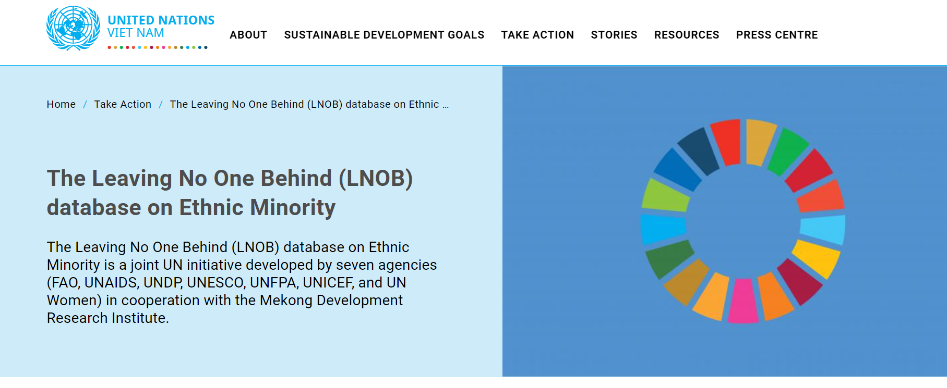

<https://vietnam.un.org/en/107534-leaving-no-one-behind-lnob-database-ethnic-minority>

In the country context of emerging domestic private sector, the UN promoted and increased its efforts in mobilizing and engaging Vietnamese private sector in contributing to SDGs implementation in Viet Nam, through both contributing resources and incorporating the UN principles of responsible business in their business operation. A significant achievement was the historic record agreement between the UN (UNESCO, UNIDO, and UN Women) and SOVICO Group, a giant Vietnamese private business on 27 September 2020, resulting in the issuance of the Resolution and Action Plan on Creative City Vision by Ha Noi Party Committee and People’s Committee, respectively.

The Report “COVID-19 Socio-economic Impact on Vulnerable Households and Enterprises: a gender sensitive assessment” of UN Women and UNDP provided a gender-sensitive assessment of COVID-19 Socio-economic Impact on over 900 Vulnerable Households and 900 MSMEs in Viet Nam (<https://vietnam.un.org/en/resources/publications>). This served as inputs to the GOVN’s efforts in refining actions and their implementation to protect livelihoods of vulnerable households, support MSMEs in recovering their operations and ensuring continued employment for workers, and eventually to achieve the SDGs in the ‘new normal’ of living safely with COVID-19. The UN work on gender equality was also reflected through a gender analysis for ethnic minority population, and the five-year review of the implementation of the Scheme “The minimization of child marriage and consanguineous marriage in EM areas” from 2015 to 2020, which provide policy options for Viet Nam to strengthen gender responsive policies in ethnic minority regions toward the SDG targets in 2030.

**Strengthened capacities, institutions, and policies to promote favorable, transparent and fair business environment for sustainable enterprise development**

A number of important legal documents were issued with UN support in 2020, including the amended Enterprise Law 2020 and Investment Law 2020 which create more favorable conditions for business registration and operation. Following the amendments, the UN (UNIDO) contributed to the development of two new GOVN decree (No.01/2021/ND-CP and No. 122/2020/ND-CP) to guide business registration and inter-agency coordination. The UN (UN Women) also supported the revision of Decree No. 39/2018/ND-CP that regulates some articles of the Law on Supporting SMEs utilizing a gender lens.

UNESCO continued to support the cultural and creative industries in Viet Nam, through a series of capacity building programmes and thematic trainings for 110 SMEs in tourism sector in Ninh Binh Province on responsible tourism and establishing SMEs-Authorities partnerships. UNESCO promoted cultural film industry through, for example, a situation analysis of Vietnamese domestic film industries as input to the revision of the Law on Cinema and various trainings for independent film makers. A program on the cultural and creative industries was approved by the Prime Minister thanks to UNESCO support and coordination with MOCST.

UN Women expanded its partnership with VWU on economic empowerment for women in the context of climate change and disaster risks, calling for start-up ideas with more than 700 initiatives submitted.

**Improved competitiveness and productivity of informal and formal sector businesses towards more compliance with recognized standards and trade agreements**

Both UNIDO and UCTAD joined efforts to provide policy recommendations to the GOVN for better compliance with the international standards, including WTO rules and regulations in the areas of trade development, competition, foreign direct investments and business linkages with domestic companies. In addition, UNIDO provided technical assistance to strengthen the standards and quality compliance capacity of SMEs in the fruit sector to facilitate their access to export markets.

FAO and UNIDO continued their support to Viet Nam’s economic growth through the agency’s technical support for the development of agro value chain. While FAO promoted smart Farming for the Future Generation - Optimize vegetable value chains through innovative and sustainable technologies, UNIDO promoted the scaling-up of the Centers of Excellence (COE) approach in the Northern Mountainous, Central Highlands and Mekong River Delta provinces. These efforts have contributed to the implementation of Viet Nam’s National Target Programme on New Rural Development and the Agricultural Restructuring Plan (ARP) for food security and income generation.

ILO through the Sustaining Competitive and Responsible Enterprises (SCORE) Programme and in collaboration with business associations like VCCI, public private sector development agencies like the SME Technical Assistance Centers (SME TAC) under MPI, Center of Supporting Industries (CSID) and Vietnam Industry Agency (VIA) under MOIT supported 250 enterprises and suppliers to improve productivity and working conditions, aligned with MPI Circular Nr. 06/2019 which aims to develop a National Consultant Network of enterprise consultants.

**OUTCOME 3.2. INCLUSIVE LABOUR MARKET**

***By 2021, a fairer, inclusive labour market ensures decent work and opportunities for all, particularly for excluded groups and disadvantaged geographic areas***

During 2020, the UN, led by ILO and UN Women in partnership with MOLISA, VWU, Trade Union, CARE International, GIZ and an NGO Nutrition Network (SUN) made substantial contributions to the GOVN’s issuance of Decree #145/ND-CP in December 2020 to guide the implementation of the 2019 Labour Code’s chapters relating to dialogue at workplace, labour dispute settlement, and female workers and gender equality. The Decree, for the first time, includes a clear definition of sexual harassment, a comprehensive definition of workplace, an illustrative list of identifiable behaviours of sexual harassment, and the responsibilities of employers in addressing sexual harassment cases at the workplace. Additionally, provisions on breast feeding policies, the organization of kindergartens and childcare for employees, tax reduction policies for companies that use many female workers and the promotion of gender equality and the improvement of working conditions and reproductive health care for female and male workers were also included[1].

A great achievement of Viet Nam in ensuring decent work for all with the UN (ILO)’s support was the country’s ratification of ILO Convention 105 on abolition of forced labour in June 2020, in close collaboration with the GOVN and the EU delegation in Viet Nam[2].

Various studies were produced by the UN system in 2020 regarding employment and labour market. These include (i) the UN Women report “Vietnam and COVID-19: Impact on the private sector”, (ii) the ILO quick impact assessment of COVID-19 pandemic on key economic sectors including tourism, garment, electronics, seafood-processing, and wood-processing industries[3], and (iii) the UN Women Study report “Capacity Building Needs Assessment for workers in the Ready-Made-Garment (RMG) sector in Viet Nam”. These reports assisted employers to be well prepared in supporting their workforce during post-COVID, served as inputs supporting the practical implementation of ILO Convention 98, 100, 105 and 111, and provided findings on gender equality challenges and needs in different sectors.

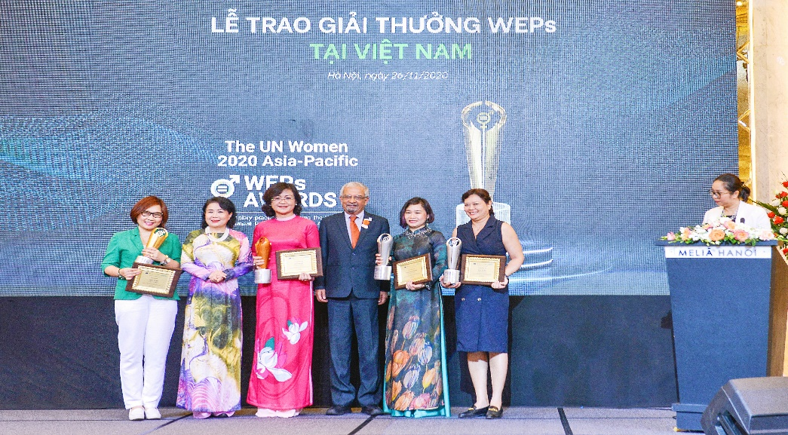 UN Women WEPs Awards Ceremony

The first-ever National Women's Empowerment Principles (WEPs) Awards 2020 was organized by the UN (led by UN Women) and Viet Nam’s Women Entrepreneurs Council of VCCI to recognize companies and business leaders’ exceptional championship of gender equality and support for the WEPs. Nine Vietnamese companies received the award, of which five companies winning the highest awards went on to represent Viet Nam in the Regional WEPs Awards of the Asia-Pacific.

UN Women supported the Viet Nam Women’s Academy (VWA) to develop a textbook on “Gender in Economics and Management” for the Bachelor of Arts and Master degrees, with comprehensive knowledge and skills to analyze and solve gender issues in the field of economics and management. Academic students who are well trained on gender in economics and management will become future knowledgeable workers and entrepreneurs who are the real engine of sustainable growth and development of economy and society.

**250 enterprises** raising awareness and sharing good practices on enterprises practicing gender equality and women’s empowerment in workplace, marketplace and communities

**71 companies** committed to support WEPs with **169,520 female and male employee beneficiaries**

<https://www.weps.org/companies>

**OUTCOME 4.1. DECISION-MAKING, RESPONSIVE INSTITUTIONS**

***By 2021, participatory and transparent decision-making processes and accountable institutions are strengthened, with policies and implementation mechanisms that are responsive to all people, particularly vulnerable groups, women, youth and children***

**Connecting the experiences of vulnerable groups to inform COVID-19 response and recovery: Greater participation of people, through surveys and public consultations, was achieved by connecting people’s feedback to the development of policies and interventions.**

In 2020, in responding to COVID-19, a number of rapid impact assessments and surveys were conducted by various UN agencies (in particular UNAIDS, UNDP, UNICEF, UN Women). These included a gender-sensitive assessment of the impact on vulnerable groups and enterprises, and assessments with a focus on persons with disabilities, children and families, and sex workers (community-led), all of which focused on socio-economic impacts. Citizens’ opinions of government responses were also assessed, through PAPI. Each of the assessments had the common goal and result of connecting people’s experience and opinions to the development of policies and interventions. Findings from most these assessment surveys also contributed to the formation of of the UN Social and Economic Impact Assessment of COVID-19 in Viet Nam, published in September 2020 to strengthen the GOVN’s response and recovery efforts.

**Creating platforms for people’s direct participation in decision making: Consultations hosted and convening of CSOs and other stakeholders in the development of key laws.**

A number of key laws and other legal documents continued to be developed during the pandemic with UN agencies’ leveraged convening role and technical support through (i) providing platforms for open and participatory dialogues and consultations especially among affected communities, vulnerable groups, government agencies, business and civil society groups – a rare practice in Viet Nam, and (ii) strengthening their alignment with international standards and protection of marginalized groups.

The UN (especially UNAIDS, UNDP, UNICEF, UNFPA and UNODC) focused in particular on the revision and adoption of the Youth Law, the Law on Drug Prevention and Control, the Law on Contract-Based Vietnamese Overseas Workers, the GOVN resolution on peacekeeping, and the National Action Plan on Anti Human Trafficking (NAP). The UN also contributed to the implementation of the Law on Anti-Corruption’s new provisions, strongly advocated for the need of a National Action Plan on Responsible Business Practice in Viet Nam, worked with relevant actors to achieve the Hanoi Declaration on Strengthening Social Work Towards a Cohesive and Responsive ASEAN Community, and supported the launch of the Methadone Take-home Doses and Harm Reduction Service Package for People Who Use Stimulants for community-based organizations.

The UN provided joint comments on the draft amendments of the HIV Law, Drug Law and the Law on the Handling of Administrative Violations. These efforts helped to ensure more progressive laws that better protect the rights of children, drug users and persons affected by HIV, and that are more aligned with international standards.

The UN also maintained support to the GOVN’s reporting on compliance with and implementation of its international obligations, including under CEDAW, CRC, CRPD, ICCPR and UPR. These efforts included the development of indicators for ICCPR follow-up, an analysis of access to justice in employment and vocational training in line with the CRPD, and a review of the gaps in the legal framework in relation to the ICCPR (in particular in the context of COVID-19). The UN advocated with the National Assembly for the inclusion of a gender dimension in the resolution on Viet Nam’s engagement in UN peacekeeping operations, which was approved for adoption unanimously, reinforcing the country’s commitment to global peacekeeping.

Another platform created was the Child Protection in Emergencies Working Group, comprising UNICEF and international NGOs (Plan International, World Vision, Child Fund and Save the Children) for information sharing and coordinated plans to support the GOVN in responding to child protection in emergencies.

The UN also worked on various public awareness campaigns, such as a UNFPA-led communication campaign on changing social norms toward son preference and under valuing of girls (to combat gender bias sex selection (GBSS), supported by MOH and MOLISA. A total of 1,500 participants directly participated in GBSS communications, with video clips reaching 6,821,009 views in a Tik Tok competition with high media coverage. Greater empowerment of community networks and organizations for improved access to justice were achieved through social media campaigns, such as #BeTheForceForChange on the occasion of Zero Discrimination Day and International Women’s Day (convened by UNAIDS and UN Women with participation of seven UN agencies), a UN Women-led 16 days of activism campaign to advocate and strengthen the national response in eliminating gender-based violence in Viet Nam (with a reach of 6,651,500), a UN Free & Equal campaign #SaferHomesforLGBTIQPeople coordinated by the HRTG (see below), and community engagement on the rights, experiences and contributions of women migrant workers.

**OUTCOME 4.2. HUMAN RIGHTS PROTECTION, RULE OF LAW AND STRENGTHENED ACCESS TO JUSTICE**

***By 2021, the protection of human rights is strengthened with improvements to the justice system, greater adherence to the rule of law, more equitable access to justice, increased gender equality and effective prevention of all forms of discrimination and violence***

**Functions and capacity of the rule of law institutions supported, including to strengthen the protection of human rights and improve access to justice and redress**

Through campaigning, awareness raising and direct support to victims and government agencies, protections and services for victims of violence were strengthened, including through preventative, rehabilitative and redress mechanisms. Capacity building and guidance on legal aid and legal redress mechanisms developed for government agencies ensured services sensitive to the needs and rights of marginalized and vulnerable groups, including women, children and persons with disabilities.

In 2020, the UN enhanced the capacity of legal aid providers, grassroots mediators and justice personnel – who often deal with vulnerable persons in contact with the law – through the development and piloting of training materials and guiding documents.

**Building justice sector capacity**

**8 sets of training materials** and **4 sets of guiding documents** developed and piloted

**>1235 legal practitioners and 260 judges** trained.

**Specialist Interview Equipment** provided to Family and Juvenile Courts

**121 child victims and 116 women survivors of violence** receiving qualified legal aid from legal aid officers trained in 2020.

**100s of children and women** avoiding trauma and re-victimization during prosecution and trials.

Partnerships with key actors in the justice sector were strengthened and contributed towards establishing strong future legal practitioners in order to provide better services to vulnerable groups, with the immediate result of child victims and women survivors of violence receiving qualified legal aid.

Equipping the Family and Juvenile Courts with specialist equipment for interviewing purposes will allow hundreds of children and women to avoid trauma and re-victimization during prosecution and trials. Support to the Supreme People’s Court on judgment drafting and a code of conduct improved capacity of judges and judicial integrity. The support also led to four new precedents being promulgated and six precedent commentaries being published, which provide transparent legal arguments and reasoning on how cases are decided. Many activities were undertaken in the context of migrants, in particular migrant women, with nearly 200 MOFA diplomats obtained better understanding about violence against women.

In response to the COVID-19 pandemic, the UN (including UNAIDS, UNFPA, UNICEF, UNODC and UN Women) focused on vulnerable groups. For example, the UN and MPS developing educational material targeting prison officials, prisoners and families, which were widely distributed and used in trainings that reached around 110 prisoners who have worked and stayed in these facilities from July to December 2020. In a separate project, the capacity of officers from law enforcement, justice and anti-corruption agencies was built regarding transparency, prevention of corruption in public procurement, anti-money laundering, and the prevention and response to corruption risks in the context of COVID-19. Quang Ninh province was supported by the UN to launch Anh Duong House – the one-stop-shop center to provide integrated essential services to GBV survivors during the lock-down period of April 2020. The hotline in operation since 2019 offered a critical service until the center’s launch. To tackle the increased risks of GBV, a joint UN project of UNFPA, UNICEF and UN Women also provided timely support to women and children at high risk of violence amid the pandemic, achieving outstanding results.

**COVID-19: Eliminating violence against women and children**

**3,894 Dignity Kits** distributed to GBV survivors/women at risk   
**>10 million people** made aware of violence against women & children and support services   
**3 shelters** established

**COVID-19: protecting persons deprived of liberty and combatting corruption**

Educational material for **54 national prisons and 6 compulsory education/reformatory centers**

**330 leaders and health care officials** trained in the facilities

**150 law enforcement, justice and anti-corruption officers** trained

**110 prisoners** reached

**MAIN CHALLENGES**

The unprecedented pandemic of COVID-19 combined with a series of intense natural disasters presented great challenges to the UN’s programmes and operations in 2020. Several UN-supported activities (especially those require physical participation) were postponed and delayed during COVID-19 outbreak due to social distancing and the substantial shortage in GOVN human resources which were mobilized for COVID-19 response.

Despite Viet Nam’s strong direction towards expanded, more inclusive and equitable social protection, poverty and vulnerability reduction, the country is facing limited fiscal space for reform which could hinder the expansion of assistance and the coverage extension for income security, particularly for most vulnerable people. Furthermore, legal framework development as well as actual implementation tend to work in silo fashion, leading to uncoordinated and fragmented implementation of the direction. Regarding social protection, the GOVN’s focus on poor and near-poor groups may lead to further categorical social protection schemes design, which will negatively influence the life-cycle and universal approaches.

Provision of emergency supplies was identified as one priority of the UN work in 2020 due to three emergencies (COVID-19, drought in Mekong Delta, and floods in the central coastal region) which struct Viet Nam. Regardless of the procurement method, there were genuine difficulties in getting supplies to target beneficiaries in a timely manner. These included insufficient commitment of GOVN agencies to activate emergency protocols to fast-track administrative procedures; the heavy dependence on offshore supplies with long transit times, and the limited capacity of local suppliers to quickly produce and deliver supplies; and the limited flexibility of internal UN processes and procedures even during emergencies.

Despite much progress made towards HIV/AIDS control, HIV epidemic remains a public health threat in Viet Nam. Declining new infections among people who inject drugs and female sex workers risk being offset by rapid increase of new infections among men who have sex with men and women infected by intimate partners. The progress was uneven among provinces and sustainability challenges remain significant especially for prevention which heavily depends on external funding. There was increasing political orientation for more punitive approaches related to drugs and administrative sanctions adversely impact access to harm reduction and HIV prevention services among people who use drugs.

In the COVID-19 context, education is one the most affected sector due to social distancing. Thus, the UN intervention was required to be adjusted for more innovative approaches/solutions including IT solutions to support quality and undisrupted education systems. In 2021, Viet Nam will develop the country’s new 10-year Education Development Strategic Plan (EDSP) 2021-2030 which is expected to set out breakthrough directions to intensively reform and leverage the education and training sector in the context of IT revolution and unexpected natural and pandemic disasters. This is a great challenge as well as opportunity for the UN in 2021 to identify creative and meaningful supports, in addition to the on-going development of the education sector analysis report, to this important document.

The limited awareness of natural disasters among children, families, communities, and local authorities remains a challenge to support effective risk reduction measures, preparedness, and response and building resilience in communities.

Regular social assistance policies in Viet Nam are fragmented and lack an emergency clause to ‘flex’ the existing schemes to covariant risks such as climate change, economic crisis and pandemic. On the other hand, Viet Nam’s existing emergency cash assistance focuses mainly on short-term emergency relief immediately after natural disasters through in-kind aid and some cash. It is barely child sensitive nor shock responsive due to limited local capacity to assess damages and identify people’s needs. It is based on a highly rigid framework that hinders timely assistance including for early action. Limited delivery system, inadequate level of support, weak coordination across stakeholders etc. are also among challenges.

Lack of sex, age and disability aggregated data is a key challenge in providing sufficient evidence to policies makers for more targeted and gender responsive policies and programmes to leave no one behind.

With the large openness and deeper international integration, Viet Nam is more fragile by global and regional socio-economic fluctuations. Although the COVID-19 has been controlled relatively well in Viet Nam, but the pandemic situation remains complicated in most parts of the world, causing disruptions and stagnancies in most of domestic industries especially in service and manufacturing sectors. Viet Nam’s labor productivity is still at a low level at the same time with higher requirements for human resources in the IR4.0. These puts a great challenge for the country in implementing its dual goal of both fighting against COVID-19 and gaining economic growth.

The COVID pandemic presented unique challenges to the protection of human rights, and disproportionately impacted on vulnerable groups in society, especially the poor and near poor, women, children, ethnic minorities, migrants, persons with disabilities, persons living with HIV, drug users, sex workers and prisoners. Discrimination, stigma and violence being reinforced during COVID-19 have exacerbated situations and the pandemic also made new groups vulnerable.

The GOVN’s focus on successfully controlling the spread of COVID-19 did not always put human rights obligations at the core of response and recovery measures. Due to the pandemic, Implementation and reporting commitments under some major UN human rights mechanisms were also put on pause.

During 2020, a number of ministries underwent organizational restructuring, coupled with the preparations for the 2021 national election, which delayed a number of projects’ implementation.

**LEAVING NO ONE BEHIND - HIGHLIGHTS**

**Gender Equality Marker (GEM)**

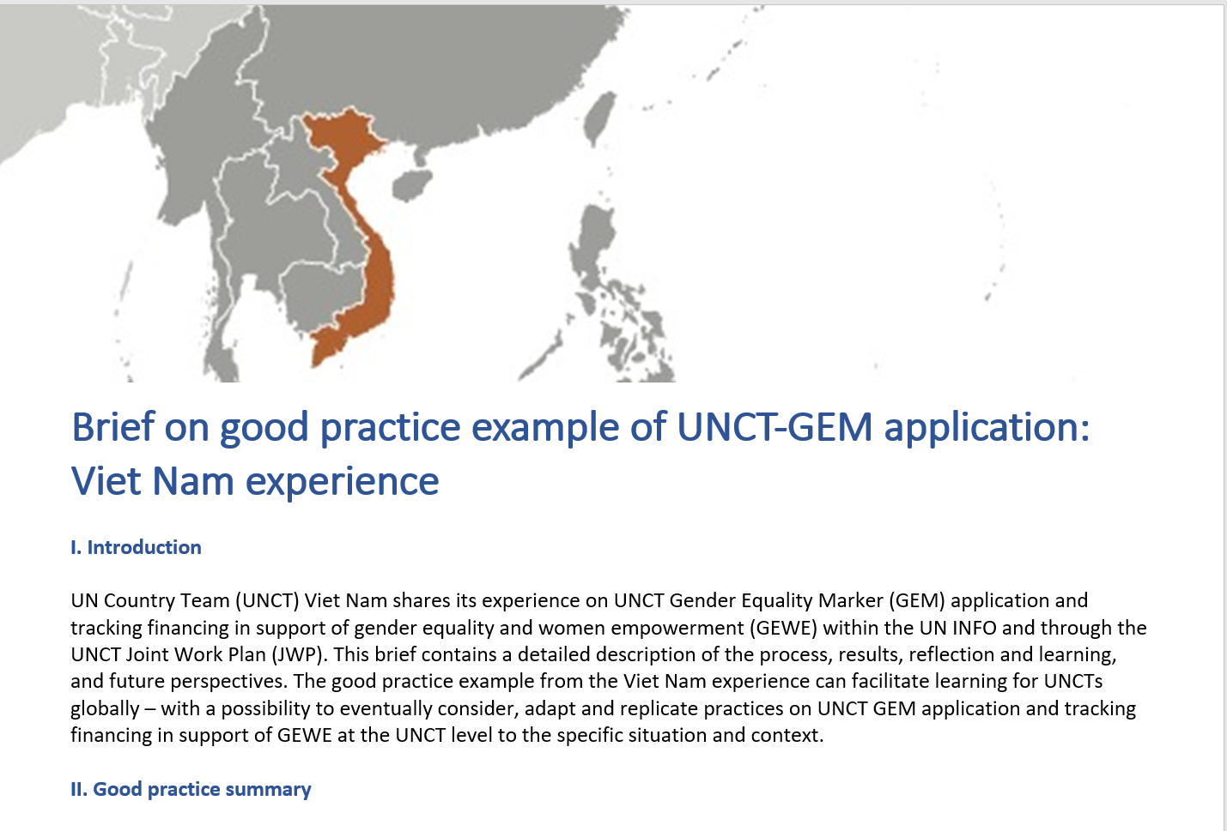

The UN in Viet Nam continued its successful application and mainstreaming of the Gender Equality Marker (GEM) into the UN INFO platform (the UN online tool for planning, monitoring, and reporting the UN work) to track the UN work and finance for gender equality and women’s empowerment (GEWE), which has been highlighted as a good practice globally by UN Women Headquarters.

**UN Disability Inclusion Strategy (UNDIS) and Action Plan**

In 2020, the UN in Viet Nam became one of 10 UN Country Teams selected to participate in a targeted roll-out of the UN Disability Inclusion Strategy (UNDIS), which provides the foundation for sustainable and transformative progress on disability inclusion through all pillars of the work of the UN. Earlier in the year, the UN in Viet Nam had been one of seven UN Country Teams selected to use the UN Secretary General’s accountability scorecard tool to measure the level of disability inclusion in its activities. On the basis of that baseline assessment, the UN in Viet Nam developed an Action Plan to progress the implementation of the UNDIS. Through the Strategy, the UN system will systematically embed the rights of persons with disabilities (PWDs) into its work, both externally, through programming, and internally, through its leadership, operational and organizational culture, and will build trust and confidence among PWDs to ensure that they are consulted and valued; their dignity and rights are respected, and that, in the workplace, they find an enabling environment in which to fully and effectively participate on an equal basis with others. While the UN has already made progress in just a few months – improving its ranking in 4 out of 14 indicators – there is still much that can be done to strengthen the UN in Viet Nam’s approach and meet or even exceed the requirements under UNDIS.

**Promoting Rights of LGBTIQ**

UNAIDS and UNESCO led joint UN work on the 2020 UN Free & Equal campaign for promoting rights of LGBTIQ persons including support for a national community led LGBTIQ summit, reaching 143,799 people in person and on social media. UNAIDS convened a UN Viet Nam campaign for Zero Discrimination with the participation of 7 UN agencies to mark the 2020 Zero Discrimination Day. The social media campaign, named "#BetheForceforChange" aimed to call for solidarity with groups of women and girls most vulnerable to discrimination in Viet Nam and protection of their rights.

**Youth**

With the UN’s active advocacy and policy advice inputs, a number of important legislations were promulgated and developed in 2020 to promote the rights of youth and adolescences, including the Youth Law 2020 approval, the National Strategy on Youth 2021-2030 development.

Through conducting many campaigns and events in coordination with MOHA, MONRE, the Central Youth’s Union, CSOs, Saigon Innovation Hub, HCMC’s Association for the Protection of Children’s Rights HAPCR, Change Viet Nam and other organizations, the UN, especially UNFPA and UNICEF, enhanced the voice of youth and children and their participation in policy making process, promoted youth’s engagement in climate change actions and environmental protection, strengthening youth’s capacity against violence, as well as promoted innovations by youth. The following campaigns and events can be highlighted: the Youth-led UN75 Online Youth Forum, the Virtual International Youth Day 2020 on “The Viet Nam we want in 2030 - Youth Act for Clean Environment”, the “Good Deeds for Children” photo contest, the one-month campaign “For a Green, Clean and Safe Vietnam for Every Child”, the writing and drawing contest “Children’s rights – Our rights”.

**3.3. SUPPORT TO PARTNERSHIP AND FINANCING THE 2030 AGENDA**

In 2020, the UNCT and each of its agency members continued to expand partnerships with traditional and new partners in and outside of Viet Nam to help advance the SDGs, leverage financing for the 2030 Agenda, and support Viet Nam’s dual role as non-permanent member of UN Security Council (UNSC) and Chair of ASEAN.

The UN led a great effort with member states and development partners to support the GOVN to successfully host a High-Level Women, Peace and Security (WPS) Global Event on “Strengthening Women’s Role in Building and Sustaining Peace: From Commitment to Results” in December to commemorate the 20th anniversary of the UNSC Resolution 1325 and the WPS agenda, which was included in the top ten highlights of Viet Nam in 2020 by the Deputy Prime Minister cum Foreign Minister. This event brought in 400 participants including three UN-USGs, numerous ministerial-level officials and experts from over 80 countries and of all continents. Core member states joined the UN-led support of the WPS event included Australia, Canada, Germany, Finland, Norway, Sweden, Switzerland, UK and the US. It resulted in an Outcome Document called “Hanoi Commitment to Action” with 75 member states as co-sponsors for the Government to submit to the President of the UN Security Council in February 2021 for acceleration of the WPS actions in the coming decade.

The UNCT supported Viet Nam’s increasingly active role in South-South Cooperation (SSC) through the organization of the Buenos Aires Plan of Action (BAPA) anniversary and the utilization of UNOSSC financial resource to document the experience of and lessons learned from Viet Nam in addressing the impacts of COVID-19, which could be shared in the framework of SSC.

The UN paid great efforts to secure the attendance of the Secretary-General at the 11th ASEAN-UN Summit, where the ASEAN-UN Plan of Action for 2021-2025 was adopted, and at the opening segment of the 15th East Asia Summit in November 2020. A first-ever ASEAN Women Leaders’ Summit was held with the SG’s Special Advocate for Inclusive Finance for Development, Queen Maxima, in attendance, which the UN in Viet Nam helped secure. The RC attended all three events as part of UN Delegation. Throughout 2020, the UN engaged in or supported ASEAN-related activities, such as: Sustainable Development High-Level ASEAN Regional Conference; ASEAN Youth Summit; ASEAN Inter-Parliamentary Union (AIPA) meeting on Education and Culture; ASEAN Forum on Migrant Labour; and Role of Women in Peacekeeping.

Given Viet Nam’s development status as a Medium Income Country but with limited public resources and the downsizing ODA trend, it is becoming more difficult to access to bilateral ODA at the country level. The UN continued to advocate and support Viet Nam in accessing to global funds. With the UN support, Viet Nam succeeded in getting approval for its proposals from the global Joint SDG, resulting in new Joint Programmes (including on social protection, INFF, the Rights of Persons with Disabilities, and COVID-19 impact) with the total funding of USD 11.4 million. Under the leadership of the RC, the UN in Viet Nam was also successful in obtaining USD 3 million from CERF for rapid response to storms and floods in Central provinces.

The UNCT achieved significant results in partnership with the private sector. A historic record agreement between the UN and SOVICO Group, a Vietnamese private business signed on 27 Sept 2020. The agreement was built on an initiate led by UNESCO and participated by UNHABITAT and UNIDO to support the visioning exercise and strategic development of Hanoi capital city with key interventions contributing directly to the SDG8, 9 and 11. This partnership will also support the City’s vision of a Creative City, requiring the coordinated government policies and programmes to support the creative and cultural industries, led by UNESCO. UNFPA has built a strong partnership with Merck Sharp & Dohme (MSD) in the on-going project called “Advocacy and policy support for scale-up of the HPV vaccination programme in Viet Nam” during 2019-2021.

Inclusive partnership with CSOs was emphasized by the UNCT in various areas including maternal care, ethnic minority, youths, LGBTIQ, disaster risk reduction, climate change, gender, etc. With the strong partnership with the GOVN and CSO/NGOs, the UN jointly advocated for the rights of youths including LGBTIQ for their comprehensive development and responsibilities through different campaigns and advocacy event. UNFPA mobilized USD 1.2m from MSD-for-Mothers to implement innovative interventions to reduce maternal mortality in ethnic minority regions of Viet Nam. The UN led by UNICEF and UNDP in cooperation with Viet Nam’s Disaster Management Authority (VNDMA) conducted a socio-economic impact assessment in five provinces on the impacts of drought, saltwater intrusion and COVID-19 to vulnerable households, cooperatives and SMEs, to address the dual challenges from and solutions to Covid and natural disasters when the population is hit by both. The UN, led by UN Women and UNEP, and in partnership with GIZ and CCWG, provided technical support to the Ministry of Natural Resources and Environment (MONRE) to strengthen Gender Responsiveness of Viet Nam Nationally Determined Contribution to Paris Agreement, resulting in the inclusion of details on co-benefits of considering gender equality and risk reduction for vulnerable groups in the updated NDC. ILO and UNWOMEN together with development partners, including CARE International, GIZ, and the EU, provided intensive technical assistance to MOLISA for the formulation of the guiding Decree 145/ND-CP issued by Government of Viet Nam on 14th December 2020 to guide implementation of the 2019 Labour Code which embedded new means for protecting workers’ rights.

The UN supported the GOVN in establishing the Migration Health Working Group (MHWG), an inter-ministerial and inter-sectoral working group which enables the GOVN to manage migrant-related health issues. The UN through of the Ethnic Minority Working Group (EMWG) with UNDP as co-chair has built a strong partnership with the GOVN, the National Assembly (NA), and international development partners supported the development of the new National Targeted Program on Social Economic Development in Ethnic Minority and Mountainous Areas. With support by the Education Sector Group (ESG) that consists of development partners active in the education sector in Viet Nam, led by UN Viet Nam (UNESCO and UNICEF), MOET successfully secured the grant (USD500,000) from the Global Partnership for Education (GPE).

The partnership between UNICEF, UNDP, MOJ and the EU Delegation to Viet Nam was further bolstered through the signing of a two-year extension of the EU Justice and Legal Empowerment Programme (EU JULE), which aims at enhancing the capacity of legal aid providers and grassroots mediators, or justice personnel who often deal with vulnerable persons in contact with the law. This partnership helped secure coordinated action in the justice sector until November 2022. In December 2020, a number of UN Agencies who are members of the UN Human Rights Thematic Group, including UN Women and UNFPA, jointly participated in two major events on UPR organised by MOFA in partnership with UNDP.

In partnership and with funding support by Australia with interventions to help eliminate violence against Women and Children in Viet Nam under COVID 19 emergency context, UNFPA, UNICEF and UN Women jointly implemented and provided support to women and children at high risk of violence amid COVID-19, achieving outstanding results.

**3.4. RESULTS OF THE UN WORKING MORE AND BETTER TOGETHER: UN COHERENCE, EFFECTIVENESS AND EFFICIENCY**

**UN “Fit-for-Purpose” Coordination Architecture for Effective Delivery of OSP Results**

The UN “fit-for-purpose” coordination architecture for implementing the OSP was established in 2017 and revised in 2019 in line with the UN Development System (UNDS) reform. The current architecture includes a Joint GOVN-UN Steering Committee (JSC) as the highest-level coordination structure between the GOVN and the UN, the UN Country Team consisting of Heads of UN Agencies, a Programme Management Team, four Joint Results Groups, four cross-cutting Thematic Groups, as well as other inter-agency working groups for OSP implementation.

In 2020, the UN jointly developed **2020 and 2021 Joint Workplan** with numerous actions by individual agencies or jointly by multiple agencies to deliver expected OSP outputs and outcomes and, especially, to respond to COVID-19 impacts in Viet Nam. The **UN Info database** continued to be updated with both programmatic and financial information which were published through the UN Info public dashboard tool embedded on the **UNCT Website**. The UN Viet Nam’s experience in integrating the Gender Equality Marker (GEM) and innovative tags into the UN Info to capture both UN technical and financial contributions to Gender Equality and Empowerment of Women was highlighted as a good example for sharing globally with other countries.

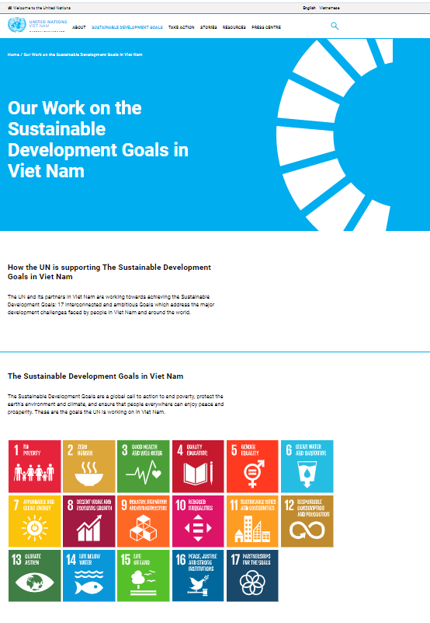

<https://vietnam.un.org/>

The UN together provided significant support to the GOVN’s development of the next 10-year Socio-Economic Development Strategy **(SEDS),** the next 5-year Socio-Economic Development Plan **(SEDP), the draft IR4.0 National Strategy to 2030,** focusing on inclusive and sustainable growth, with due consideration to building forward better post-COVID-19. The UN through its SDG Working Group continued to enhance the **SDG mainstreaming** in the new SEDS and SEDP, and sectoral development strategies and plans, including the new 10-year Education Development Strategic Plan 2021-2030 and annual plans. Further, the UN jointly supported **SDG reporting and advocacy**, and the development of the first National SDG Report to be launched in 2021. With regard to **SDG monitoring**, the UN supported the GOVN in important data collection and analysis including support to the General Statistics Office of Viet Nam in developing Viet Nam’s Statistics Development Strategy for 2021-2030.

The UN paid a great effort in working with the GOVN (through the UN-GOVN DaO Joint Steering Committee, high-level policy roundtables with the GOVN, and the interaction with MPI and MOFA leaders) and other stakeholders to implement **the OSP Evaluation** and to develop **the CCA and UNSDCF 2022-2026** which are all to be completed in 2021.

**Strategic Joint Programmes (JPs) in 2020**

The UN continued emphasizing the importance joint work and made substantive effort to increase the number of JPs in 2020. A total of 14 JPs (USD26.5 million) were in implementation in 2020, of which seven were new ones (USD11.7 million), covering all four OSP strategic areas, including five JPs, supported by global funds, on social protection, INFF, mitigating socio-economic impact of COVID-19, rapid response to storms and floods, and the Rights of Persons with Disabilities.



**Joint Communication for Coherent Policy Advocacy**

The UN conducted various public awareness campaigns such as a social media campaign #BeTheForceForChange on the occasion of Zero Discrimination Day and International Women’s Day (convened by UNAIDS and UN Women with participation of seven UN agencies), a UN Women-led 16 days of activism campaign to advocate and strengthen the national response in eliminating gender-based violence in Viet Nam (with a reach of 6,651,500), a UN Free & Equal campaign #SaferHomesforLGBTIQPeople, a UNFPA-led campaign on changing social norms toward son preference and under valuing of girls (with 1,500 participants directly participated in GBSS communications, with video clips reaching 6,821,009 views in a Tik Tok competition with high media coverage), and various community engagement on the rights, experiences and contributions of women migrant workers.

Commemorating the 75th anniversary of the UN was a significant part of UNCT effort in 2020, utilizing the $27,000 funding from the UN75 Secretariat. Among others, the UNCT organized a Press Briefing with Senior Editors and Journalists on Viet Nam Press Day, and an International Youth Day livestreaming with a focus on climate change and the environment, promoting the UN75 Global Survey nationwide. In October 2020, the UN Day Reception was held, which was physically attended by about 300 people, including the DPM/FM, which in effect was also a celebration of the successful containment of COVID-19 in Viet Nam. The top photos from the photo contest on the ‘Future I Want’, another UN75 initiative, were exhibited at the UN Day Reception.

**UN Viet Nam in Collaboration with UN Regional and Global Level.**

The UN in Viet Nam worked with the Issue-Based Coalition (IBC) on climate change mitigation on a Roundtable COP26 event with the GOVN, which was hosted by the UK with useful inputs from the IBC (especially UNEP and ESCAP).

In terms of data-related work, the UN in Viet Nam had a close collaboration with ESCAP in supporting the national statistics system. The UN (led by RCO) coordinated UN support from the country, regional and HQ levels (UNDESA/UNSD), particularly in providing advice/inputs to the ongoing National Statistical Strategy. RCO, ESCAP and the WB (HQ and country level) were in initial discussion on reactivating the partnership between Viet Nam’s General Statistics Office and Development Partners. RCO also planned to discuss support for the national statistics office in implementing some specific and important tasks such as the development of statistics services and harmonized data collection programmes (as proposed through RCO discussion with GSO) with ESCAP and UNSD.

**UN Viet Nam Operating As One**

The UN in Viet Nam’s Business Operations Strategy (BOS) for 2018-2021 was signed off by the Resident Coordinator following clearance by the UNCT in August 2020, and has since been implementing it well in alignment with BOS 2.0. The UN in Viet Nam has achieved the full occupancy rate (100%) of the GOUNH, leading to significant cost-efficiency gains resulting from cost avoidance or reduction of per desk cost by almost 25% between 2018-2020. It is currently projected that the potential cost avoidance or savings under BOS 2018-2021 would be about USD 1.5 million. The UN in Viet Nam has renamed the GOUNH Common Services Unit (CSU) as the GOUNH Common Back Office (CBO). The CBO continued providing high-quality service to all 15 UN entities in 2020 with efficiency and effectiveness, as expressed in the positive results of the All-Staff survey and client satisfaction with an average rating of 4.9 out of 5.

**3.5. OSP EVALUATION AND LESSONS LEARNED**

**3.6. FINANCIAL OVERVIEW AND RESOURCE MOBILIZATION**

**2020 Budget and Expenditure**

In total, the UN in Viet Nam was able to mobilize approximately USD83 million, equivalent to 95 per cent of the total planned budget for 2020 of about USD88 million, which was significantly higher than the mobilized amount of each of the last three years of 2017, 2018, and 2019. Most of the UN mobilized budget (80%) came from non-core funding sources.

Outcome 1.2 on Equity in Health and Outcome 3.2 on Inclusive Labour Market mobilized more than the planned amounts. This partly reflects the UN great effort in resource mobilization despite the overall decline in grant ODA in Viet Nam but is partly because of more funds available for COVID-19 response. The largest shares of the UN budget in 2020 went to Outcome 1.2 on equity in health (24.0 per cent), Outcome 4.2 on human rights protection and justice and Outcome 2.1 on low-carbon, climate, and disaster resilient development (about 20 per cent each).

**Table 2020 UN Financial Overview (USD)**

|  |  |  |  |  |  |
| --- | --- | --- | --- | --- | --- |
| **Focus Areas** | **Outcomes** | **2020** | | | |
| **Total Required** | **Available** | **Gap** | **Expenditure** |
| **FA1** | Outcome 1.1 | 4,496,810 | 4,179,825 | 316,985 | 3,811,624 |
| Outcome 1.2 | 18,902,683 | 19,925,884 | (1,023,202) | 19,113,510 |
| Outcome 1.3 | 5,676,321 | 4,041,810 | 1,634,511 | 3,738,586 |
| **FA2** | Outcome 2.1 | 18,029,952 | 16,878,478 | 1,151,474 | 15,944,423 |
| Outcome 2.2 | 6,196,342 | 5,522,407 | 673,935 | 4,793,030 |
| **FA3** | Outcome 3.1 | 7,585,382 | 6,178,273 | 1,407,109 | 3,163,274 |
| Outcome 3.2 | 1,526,505 | 1,694,140 | (167,635) | 1,694,140 |
| **FA4** | Outcome 4.1 | 7,879,014 | 7,357,368 | 521,646 | 6,934,841 |
| Outcome 4.2 | 17,632,002 | 17,407,996 | 224,006 | 15,385,320 |
| **TOTAL** | | **87,925,011** | **83,186,181** | **4,738,830** | **74,578,748** |

Regarding expenditure, by the end of 2020, UN agencies delivered USD74.6 million, resulting in a disbursement of 89.7 per cent against the total available budget of USD83 million. This is considered a very high delivery rate despite all challenges in terms of GOVN ODA procedure and difficulties in ODA mobilization.

In 4 years from 2017 to 2020, the UN was able to spend USD280 million out of USD302 million mobilized or achieve an average annual delivery rate of 93 per cent, accounting for roughly 66 per cent of the OSP’s total five-year estimated budget of USD423 million. The UN plans to mobilize and spend about USD90 million in 2021; thus, fully reaching the budget target of USD423 million by the end of 2021 (the OSP final year) is challenging. Nevertheless, being aware that the UN’s added value in providing technical and advisory support, the financial target should not be viewed as only one indicator to evaluate the UN contribution.

By mainstreaming the Gender Equality Marker (GEM) into the UN Joint Work Plan and the UN INFO platform, the UN is able to track its budget to directly support gender equality and empowerment of women (GEEW). In 2020, the UN in Viet Nam invested about 23 per cent or USD20 million of its budget for GEEW. Especially, approximately 52 per cent of the UN COVID-response budget was allocated to gender equality, clearly showing that the UN puts women and girls at the center of its efforts to support the recovery from COVID-19.

**UN Viet Nam SDG Fund**

|  |  |
| --- | --- |
| **Table…: Financial Overview, as of 31 December 2020 (in US Dollar)** | The UN Viet Nam SDG Fund (SDGF) was established at the end of 2018, based on the rebranding of the One Plan Fund (OPF) and as the result of the UN in Viet Nam’s consultation with the GOVN and the Multi-Partner Trust Fund Office (MPTFO). This aims to provide a local pooled fund, mirroring global efforts on the Joint SDG Fund, to better support SDG acceleration and OSP implementation.  Expenditures of USD106,444 were reported as of 31 December 2020, according to official financial reporting provided by the Headquarters of the Participating UN Organizations. These funds covered contractual services and general operating expenses for those who provided coordination assistance to the UNCT and different substantive inter-agency groups (including Results Groups) supporting Viet Nam’s SDG implementation and acceleration. |

**CHAPTER 4:**

**UNCT KEY FOCUS FOR NEXT YEAR**

**COVID**

**Humanitarian – Emergency Response**

**CCA**

**OSP Evaluation**

**CF development: 4 areas……, architecture, ….**

**Finalization of OSP: Fund mobilization, partnership (including with regional/HQ level)**

**Focus on Joint Programmes**

**ASEAN, UN Security Council, SSC**

Viet Nam is in a great need of strengthening partnerships across the whole-of-society and resource mobilization to meet the SDGs and propel into Upper Middle-income country status by 2030. The country’s current financing landscape exhibits limited public resources, sharp declining share of Official Development Assistance (ODA) to GDP from approximately 4 per cent of GDP in the 1990s to 1.35 per cent in 2019, as well as low domestic private investment and capital channelled into sectors that help accelerate the 2030 Agenda. This poses significant challenges for financing sustainable, inclusive development and the SDGs in the years ahead. Having policy and regulatory frameworks that will better match private incentives to public goals to increase flow of private capital domestic resource mobilization (DRM) capabilities will require partnerships with multilateral institutions, such as the UN, and other development partners. The UN, in this regard, can play a more strategic and influential role to support and facilitate with leveraging multilateral expertise and convening power through different types of partnerships on climate change, clean energy, social policy innovation, strengthening of health systems, education and skills development as well as innovative finance to capture both domestic and foreign private finance. There is also a role for the UN to play in supporting climate-related green infrastructure development. South-South cooperation has also emerged in recent years as an increasingly efficient source of knowledge transfers, especially with countries that have undergone similar poverty reduction as Viet Nam has and the UN can partner to further support.

1. <https://thuvienphapluat.vn/van-ban/lao-dong-tien-luong/Nghi-dinh-145-2020-ND-CP-huong-dan-Bo-luat-Lao-dong-ve-dieu-kien-lao-dong-quan-he-lao-dong-459400.aspx>
2. <https://ilo.org/hanoi/Informationresources/Publicinformation/Pressreleases/WCMS_747233/lang--en/index.htm>
3. <https://www.ilo.org/hanoi/Whatwedo/Publications/WCMS_757929/lang--en/index.htm>