Delivering Results Together Fund (DRT-F)
2015 Annual Report Template

Country Submitting Report:
Reporting Time Period: | 1 January 2015 - 31 December 2015
Total Funds Allocated by DRT-F in this Reporting Time Period: | USD
Title(s) of Policy Initiative(s) Supported by DRT-F:  Total Fund Allocation to Specific Agencies for this Reporting Period | Policy Initiative 1. Counter-Trafficking and Migration Policy and Practice in Ethiopia |  | TOTAL USD
 | Agency | Date of Transfer | USD
 | IOM | March 2015 | 316,796
 | ILO | March 2015 | 202,104
 | UNHCR | March 2015 | 130,100
 | UNODC | March 2015 | 71,000
 | AA fee
 | TOTAL | 720,000 | (total to match that in DRT-F allocation letter)
 | Policy Initiative 2. title |  | TOTAL USD
 | Agency | Date of Transfer | USD
 | AA fee
 | TOTAL
Report Submitted By: | Name: Maureen Achieng  Title/Agency: Chief of Mission & Representative to the AU/IGAD/UNECA, IOM Special Liaison Office, Addis Ababa  Date: 31 March 2016  Email: machieng@iom.int

POLICY INITIATIVE 1: TITLE…
- DRT-F OUTCOME LEVEL REPORTING: “Delivering as One countries achieve nationally agreed upon priorities contained in One Programmes through coordinated UN support in line with international norms and standards”.
- For each policy initiative, please describe, briefly and concretely, progress made against the proposed policy activities agreed to be implemented in the funded DRT-F proposal. (Make reference to progress made against bullet point activities in the DRT-F funded proposal - ½ page per initiative) (Please only report on those activities in the DRT-F proposal. It is not a report against all done under the related UNDAF/One Programme outcome or output. DRT-F probably only provided a small portion of funds towards this output/outcome.)

Outcome 1: Government, local community, humanitarian agencies and International Development partners have an improved understanding of the risks associated with irregular migration, onward movements (refugees) vulnerabilities

Output 1.1 Undertake a comprehensive assessment on migration trends and onward movements (refugees), migrants and refugees needs and vulnerabilities

Activities:
    - Further advocate the issue of migration profiling among relevant government offices and ensure continued ownership, regular updating and maintenance of the profiling exercise

IOM: IOM was tasked with a number of activities ranging from hiring a consultant to develop a migration profile for Ethiopia to advocate and raise awareness on the concept among key actors, especially from Government. In order to ensure the sustainability of this process, it was also decided to lay the foundations of an institutional structure composed of government focal points in charge of reviewing the various drafts and to update the migration profile document in the future.

Accordingly, on 18-19 November 2015, IOM invited senior government officials drawn from different line ministries, the House of Peoples’ Representatives, Non-Governmental Organizations (NGOs), Civil Society Organizations (CSOs), Intergovernmental Authority on Development (IGAD) in Eastern Africa and other International Organizations (IOs) to attend two consecutive national consultative workshops on Migration Profile Exercise and National Coordination Mechanism on Migration (NCMM) for Ethiopia. The events were well-attended by more than 35 representatives from line ministries, other government agencies such as the National Bank and Central Statistics Agency, members of parliament, NGOs/CSOs and IOs.
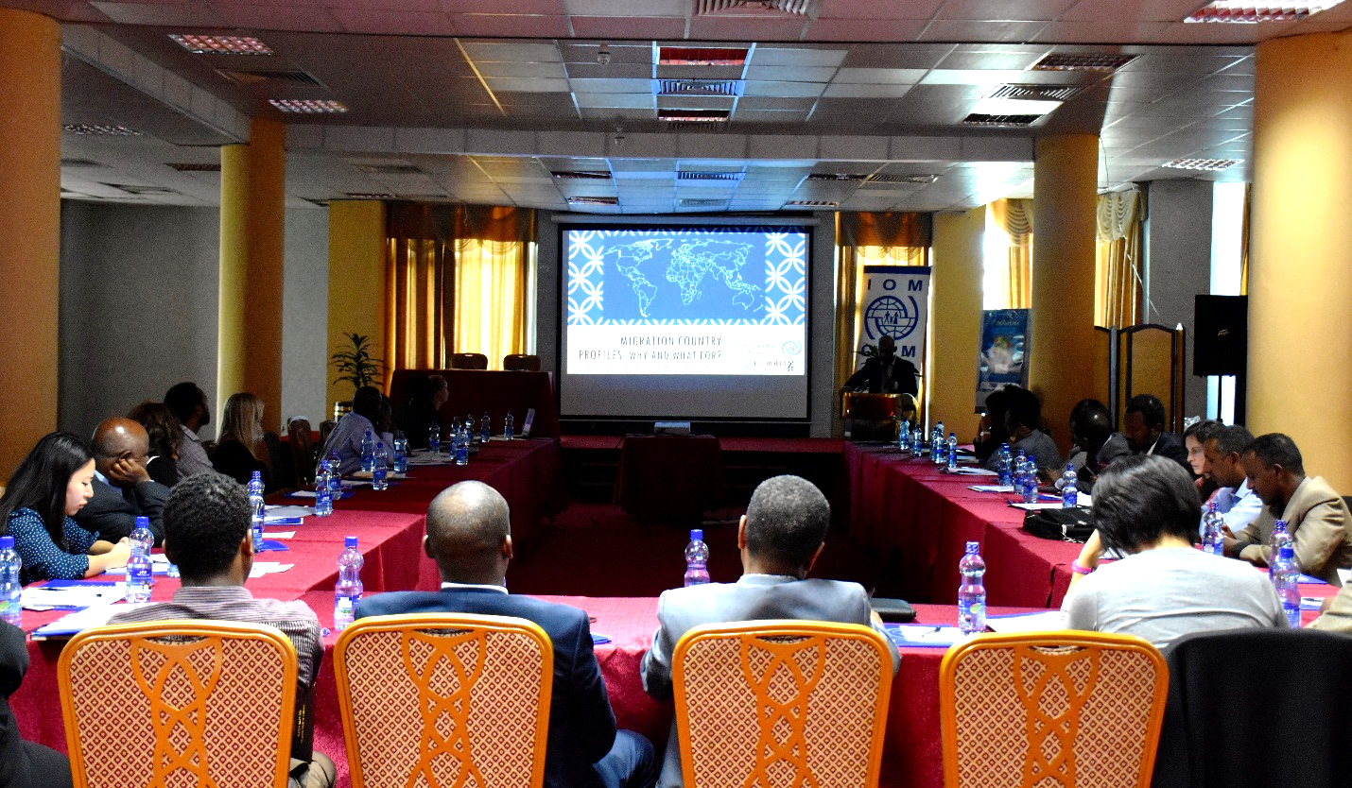
Event 1 was dedicated to a session on migration profiles with presentations on the concept and the way forward. This enabled IOM to achieve a broad consensus among participants on the need for a Migration Profile for Ethiopia. Some were especially appreciative of having been consulted at the early stage of the process. This is a positive point that will help promote Government ownership of the process. Furthermore, during the workshop participants identified agencies to form a Technical Working Group (TWG) to spearhead and review the progress of the migration profile exercise.
Event 2 was focused on the establishment of a National Coordination Mechanism on Migration in Ethiopia. The assembly of participants commented the draft Terms of Reference (ToR) and determined the mandate of the mechanism. It was decided that the overall structure should be co-led by the Ministries of Foreign Affairs, Labour and Social Affairs as well as Justice.

Image 1: Presentation by IOM on the Migration Country Profile, November 18th, 2015 (IOM)
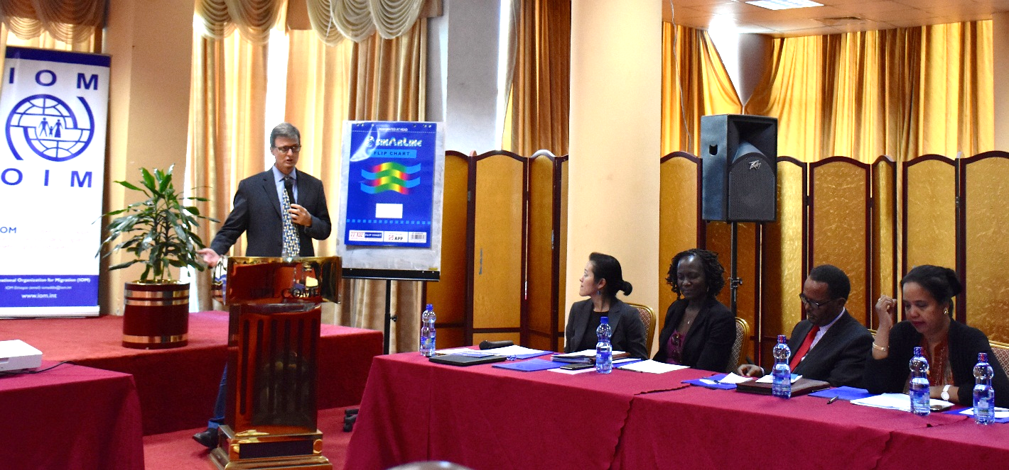
Image 2: Opening Remarks by the Head, UN Resident Coordinator’s Office, November 18th, 2015 (IOM)
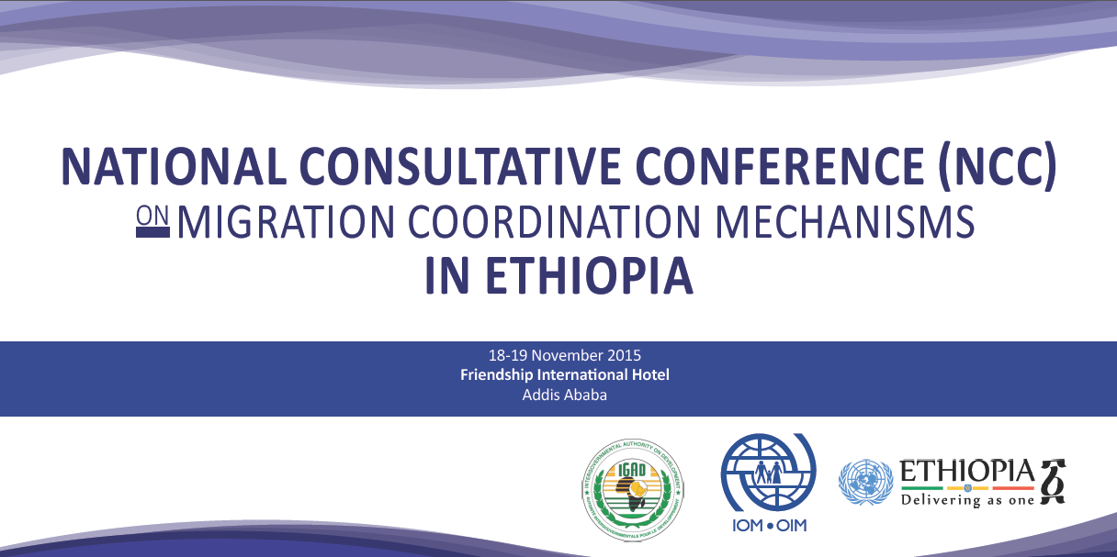

Image 3: Event banner
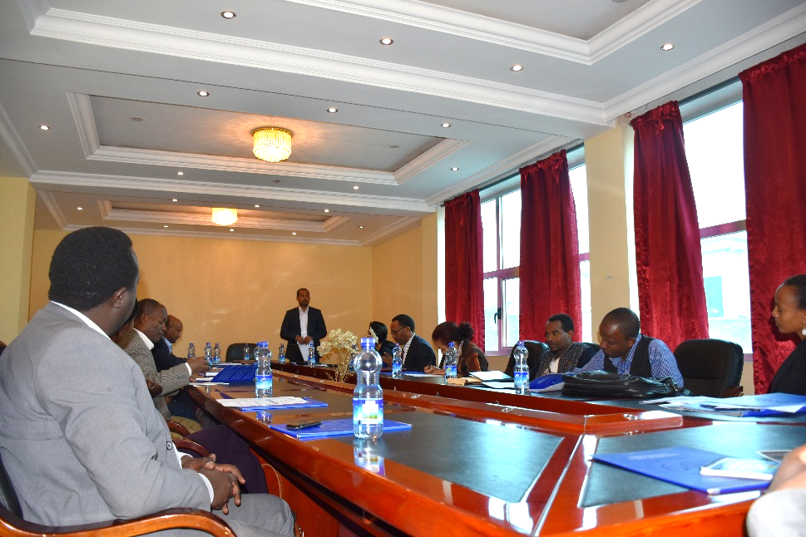
Following these events, on 10th December, 2015 IOM organized a follow up meeting that brought together major government stakeholders identified to make up the TWG to further discus on the practicalities of the Migration Profiling exercise. The participants discussed in detail on the understanding of the concept of migration profiles. The Technical Working Group also agreed on its mandate to review and update the progress of the migration profiling exercise. The TWG members have chosen Ministry of Justice (MoJ) to lead them.

During the reporting period, the consultant conducted field visits to migration hotspot areas for data collection. The data collection process faced challenges in some regional states due to security issues and restructuring within relevant government sources. The draft report reflecting an early findings of the exercise will available within the first quarter of the next reporting period.
Image 4: Follow-up meeting of the TWG on Migration Profile for Ethiopia, December 10th, 2016 (IOM)

    - Conduct Stakeholder analysis

The stakeholder analysis was finalized by the consultant and will be reflected in the report of the first phase.

    - Establish a technical working group involving major stakeholders that will work with GoE's leadership

Potential Technical Working Group (TWG) members were identified on the consultative workshop held in November 2015. Furthermore, the interested parties were invited to a meeting on 10th December 2015 and together determined the mandate of the TWG. The draft report will be reviewed and validated by the TWG during the next reporting period.

    - Conduct assessment of secondary movements of refugees in Ethiopia.

Based on UNCT’s work plan and UNHCR’s National Strategy to Address Trafficking and Smuggling, terms of Reference on the “Study on Trafficking, Smuggling and Secondary Movements of Refugees in and out of Ethiopia” were drafted and finalized in April, 2015. A bidding procedure was initiated and the Request for Proposals was issued on April 20th, 2015. The bid was widely announced and proposals were submitted for review in May 2015. . The proposed study aims at i) analyzing major causes and routes for secondary movements that lead to the situation of trafficking and smuggling in Ethiopia and the region; ii) assessing the vulnerability of refugee population who engages in secondary movements and/or becoming victims of trafficking vis-à-vis their ethnicity, age, gender, origin, geographical area of residence in Ethiopia; iii) studying the existing mechanisms for identification and referral of and assistance to refugee victims of trafficking in Ethiopia; iv) providing recommendations to UNHCR for its future policy and intervention with regard to reducing trafficking and onward movements among refugees and providing assistance to victims of trafficking. After reviewing the applications, the Danish Refugee Council was selected to conduct the study, which was expected to start in July 2015. Nonetheless, the Government Administration for Refugees and Returnees Affairs (ARRA) only gave its approval to start the study in October. DRC required six months to conduct the study, including research, field mission and data analyses. Hence, UNHCR requested a non-cost extension of the implementation period until April 2016. During the reporting period, DRC conducted field missions to Tigray and Afar regions and collected data from all refugee camps. Key stakeholders interviews were also conducted with INGOs, UN agencies and government authorities. A report with preliminary findings was submitted in January 2016 in which DRC confirms that the study is being conducted according to the agreed timelines and deliverables.

  - Produce a Migration Profile for Ethiopia

    - Drafting the report/ developing migration profile

IOM has identified and hired a consultant to conduct the Migration Profile exercise. The selected individual is an Ethiopian national with solid experience in both research and migration management practice, which has been deemed ideal considering the extensive ground work required for the task. IOM has clear guidelines framing the elaboration of Migration Profiles which the consultant is contextualizing to fit local settings. Therefore, in order to optimize resources and not to hinder quality of the report, it was decided to adopt a three-phased approach whereby two phases will be covered by the present project:
- The first phase on which the consultant is currently working, consists of a rapid assessment of the existing migration data collection/analysis/sharing mechanisms in Ethiopia. The rapid assessment shall also assess the impact of migration using solely available data as well as the migration governance structures and will formulate recommendations to be followed in the second phase. This phase was initiated early November 2015 and will run until the beginning of April 2016 while expected to be finalized in January. Delays occurred in the field data collection missions due to the Oromo protests and to the high number of locations to be visited in Oromia region. With regard to this, IOM and the consultant will discuss and revise the list of data collection locations in order not to jeopardize the timeliness of the second phase that should be initiated and finalized within the next reporting period. The TWG is well-established and has had the occasion to meet several times (see above).
- The second phase shall consist of a comprehensive assessment based on the findings and recommendations of the rapid assessment to fill in the identified data gaps. It should start and run all throughout the next reporting period. At the end of this phase, a Migration Profile report will be made available to the Government of Ethiopia and all other stakeholders. IOM has been coordinating activities with UNHCR that is conducting an assessment of secondary movement of refuges hosted in Ethiopia, of which the findings will be incorporated in the final comprehensive MP report.
- The final phase of this exercise shall consist of capacity building activities aiming at sustaining the Migration Profiling exercise in the future and enable the Government to carry out regular update of the document. This will be done through enhancing the knowledge base on migration, development of training modules and training provision on data collection/management, analysis and reporting as well as MP development, strengthening the capacity for policy development basing on this MP, developing Government’s mechanisms and capacities (human and infrastructural) to develop the MP (basing on the already established TWG and steering committee) and promoting the country ownership of the MP. This phase is planned to be funded under another project as in requires substantial additional investment. Synergy with a similar initiative of IGAD is planned to be concretized under the form of funding for this final phase. This should start after this project’s lifetime and run up to mid-2017 or later.

    - Validate contents and launch the report

Contents of the preliminary report are planned to be validated on early in the next reporting period while contents of the final comprehensive report should be validated at the end of the project’s period.

    - Develop training modules - on collection and usage of migration data - specifying standard data collection methodology and tools

This activity belongs to the third phase of the comprehensive Migration Profiling exercise. It should therefore be conducted as part of another project (see activity 1.2.1)

1.2.4 Train government and other relevant stakeholders on collection and usage of migration data.

This activity belongs to the third phase of the comprehensive Migration Profiling exercise. It should therefore be conducted as part of another project (see activity 1.2.1)

Outcome 2: To help Vulnerable migrants and refugees realize their protection rights and protect them against the risks to their lives, physical safety and security: ensure that quality protective services are in place for those migrants and refugees who are stranded, apprehended and/or detained along the migratory route, including supporting their assisted voluntary return where appropriate

2.1. Provide quality, migrant-friendly services for vulnerable migrants - stranded, apprehended and/or detained along the migratory route, including their assisted voluntary return.

2.1.1 Organize workshops to design specialized support packages for vulnerable groups including victims of trafficking, refugees, UAMs, and women

This activity will be implemented in the next project period.

2.1.2 Through the referral systems, provide mid-term assistance to vulnerable migrants and refugees, including shelter, psychosocial counseling, legal aid, family reunification, specialized services to victims of trafficking and unaccompanied and separated children.

During the reporting period, this project’s trained staff have screened and identified 694 vulnerable returnees who benefited from the referral systems, which included to UNICEF, Agar Charitable Association (partner local NGO) and to several Offices of Labor and Social Affairs in woredas of origin particularly within the Southern Nations, Nationalities’ and People’s Region. IOM also provided post-arrival assistance to vulnerable deportees from the Kingdom of Saudi Arabia after they were referred by the Bureau of Labor and Social Affairs of Addis Ababa City Administration.

- Referral of Unaccompanied Minors to UNICEF and MoWCYA

IOM provides Assisted Voluntary Return and Reintegration Assistance to vulnerable Ethiopian migrants who are stranded in different parts of the world. After their return, they usually have different needs based on their vulnerabilities. Among the returnees, IOM provides assistance to Unaccompanied Minors (UAMs) in the form of family tracing and reunification in collaboration with the Ministry of Women, Children and Youth Affairs (MoWCYA) as well as UNICEF.

Using this referral system, 441 UAMs were referred to UNICEF and MoWCYA to be assisted with family tracing and reunification. This networks works as follows: IOM first communicates the planned date of return of UAM returnees as well as their biodata to UNICEF and BoWCYA for family tracing through social workers assigned by Bureaus of Women, Children and Youth Affairs (BoWCYAs) and funded by UNICEF. In the meantime, IOM provides accommodates the minors in its transit centre and provides them with Once the family is traced and approves to take back their child, UAMs are escorted by social workers to their places of origin and reunited with their family which is provided with a small reinsertion grant.

UAMs Assisted with Voluntary Return, Family Tracing and Reunification
No | Country | Male | Female | Total
1 | Yemen | 134 | 1 | 135
2 | Djibouti | 124 | 1 | 125
3 | Yemen emergency | 112 | 8 | 120
4 | Malawi | 42 | 0 | 42
5 | Tanzania | 7 | 0 | 7
6 | Puntland | 5 | 0 | 5
7 | Zimbabwe | 5 | 0 | 5
8 | Zambia | 2 | 0 | 2
Total |  |  |  | 441
Table 1 Number of Unaccompanied minors assisted with family tracing and reunification

- Referral of Victims of Trafficking through the Network of Victim Assistance Service Providers (NoVASP)

A Network of Victim Assistance Service Providers (NoVASP) has been formed by IOM under other projects. The network was created with the aim to strengthen the collaboration and coordination among different NGOs providing rehabilitation and reintegration support, government organizations having initial contact with returnees and law enforcement bodies. During the project period, IOM has referred 66 Victims of Trafficking (VoTs) – 56 female and 10 male – using the NoVASP. These VoTs were identified by IOM and referred to Agar Ethiopia Charitable Organization where they were provided with rehabilitation and reintegration support. Among these VoTs were returnees from Yemen from where they were evacuated after the outbreak of the conflict in March 2015. Other VoTs were deportees from the Kingdom of Saudi Arabia and from different Middle Eastern countries. There was also one returnee from South Africa who fled the xenophobic attacks of April 2015.

Country of Return | Number of VoTs
Kingdom of Saudi Arabia | 27
Yemen | 21
Lebanon | 10
Kuwait | 3
United Arab Emirates | 2
Sudan | 1
Oman | 1
South Africa | 1
Total | 66
Table 2: Countries of return of victims of trafficking

- Referral of Deportees from Kingdom of Saudi Arabia by the Addis Ababa city Government Bureau of Labor and Social Affairs

Using this referral system, 68 deportees from the Kingdom of Saudi Arabia were referred to IOM by the Addis Ababa City Administration Bureau of Labor and Social Affairs in August 2015. These deportees were provided post-arrival assistance in the form of onward transportation grants to cover their subsistence costs on their way to their final destination.

- Referral of returnees from Malawi to the Southern Nations and Nationalities Region’s Bureau of Labor and Social Affairs

In addition to this, IOM has referred 387 returnees from Malawi to the Southern Nations and Nationalities Region’s Bureau of Labor and Social Affairs in order to facilitate their reintegration in their communities of origin.

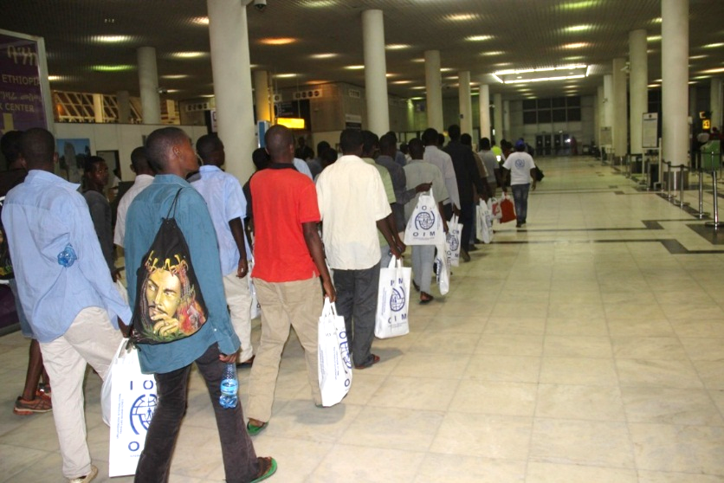
Image 5: Ethiopian returnees from Malawi arrive at Bole International Airport, Addis Ababa, Ethiopia

- Assisted Voluntary Return Assistance to Ethiopians Stranded in Djibouti

Every year, thousands of Ethiopians make the dangerous journey on the Eastern Migratory Route that crosses Djibouti onwards to Yemen with the Kingdom of Saudi Arabia often being the intended final destination. During their journey, migrants are often exposed to exploitation, violence and sexual abuse and lack access to food, safe water, shelter and medical care. In late March 2015, a 10-country coalition led by the Kingdom of Saudi Arabia launched a military campaign against Houthi opposition forces causing severe deterioration of the security conditions in Yemen. Despite this, Ethiopian irregular migrants have kept on crossing the Red Sea en route to Yemen.
32 Ethiopian stranded irregular migrants including 3 Unaccompanied or Separated Migrant Children (UAMC) were provided with lifesaving assistance and proposed Assisted Voluntary Return and Reintegration services in IOM Emergency Migration Response Center based in Obock (Djibouti). In Djibouti, IOM provided these vulnerable migrants with emergency shelter, water, food, NFIs, medical assistance, as well as medical screening to check fitness to travel, and facilitation of travel document issuance in collaboration with the Ethiopian Embassy in Djibouti. Upon finalization of this procedure, the returnees were driven to Galafi – a town on the Ethio-Djiboutian border – and handed over to IOM Ethiopia’s staff (one operational and one medical staff) who escorted them back to IOM Addis Ababa’s Transit Centre.
The project also provided for the post-arrival assistance in Ethiopia including transportation, overnight accommodation at IOM Ethiopia’s Transit Centre in Addis Ababa, reinsertion assistance and onward transportation to their final destinations. The returnees were also provided with transportation to local bus stations to continue their travel to their respective places of origin. Furthermore, UAMC were provided with family tracing and reunification support in collaboration with UNICEF and MoWCA.

TYPE | Sex |  | Each Total
 | M | F
Unaccompanied Migrant Children | 3 | 0 | 3
Adult | 29 | 0 | 29
Total # of returnees assisted | 32

- 19 returnees from Kingdom of Saudi Arabia were referred from Ethiopian Red Cross Society

19 returnees from the Kingdom of Saudi Arabia were referred to IOM by the Ethiopian Red Cross Society. Upon arrival the returnees had no means to cover their transportation costs to their final destination. The project provided accommodation and onward transportation assistance to these returnees.

Description | Number of returnees
Unaccompanied Migrant Children | 441
Victims of Trafficking | 66
Kingdom of Saudi Arabia – BoLSA | 68
AVR from Malawi | 387
AVR from Djibouti | 32
Kingdom of Saudi Arabia - ERCS | 19
Total | 1,013
Total number of vulnerable migrants (including victims of trafficking, UAMC, etc.) assisted under the project since its start

2.2 Provide capacity-building to government and other service providers for the provision of protective services to particularly vulnerable migrants and refugees

    - Enhance institutional capacities of government for effective Migration Management

ILO: ILO has provided awareness rising workshop on human trafficking, the workshop brought together participants from Prime Minister Office, Ministry of Labour and Social Affairs, Addis Ababa Bureau of Labour and Social Affairs (BoLSA), and other regional BoLSA’s, CETU, etc. The main purpose of the workshop was to raise awareness to combat human trafficking and to advocate for a policy framework to regulate human trafficking through creating partnership and developing cooperation between different line ministries and social partners and to enhance and deepen understanding on issues relating to human trafficking; and to share information on current trends, good practices and lessons learned in addressing trafficking.

In addition, ILO undertook a Migration cost survey to assess migration costs incurred by low-skilled workers. Developing a migration cost database contributes toward formulating sound policy recommendations to reduce migration costs that occur at any stage of the labor migration cycle. The database provides analytical underpinnings for a global target to reduce recruitment cost as part of a Sustainable Development Goal (SDG). Reduction of migration costs paid by workers would benefit all parties involved and consequently increase the amount of remittances to migrant family households. It would also improve the work and living conditions of migrant workers, which would reduce the vulnerability, and enhance the welfare of migrant workers in destination countries The analysis of these data contributes to setting a global target to reduce migration costs. The surveys could provide possible benchmarks for reducing recruitment costs as a Sustainable Development Goal.

ILO supported study tour for the Ministry of Labour and Social Affairs (MoLSA) and the Ministry of Foreign Affairs (MOFA) to South Korea and Vietnam with an objectives to learn from the experience and practices for effective labour administration and labour exchange programmes. This study tour was instrumental in showcasing elements for improvement for the Ethiopian government on the area of labour migration governance.

2.2.2 Enhance the capacity of relevant institutions & personnel working on migration in Ethiopia including employers, Private Employment Agencies, workers, community, and religious leaders

ILO: The ILO undertook a study on Promoting and protecting the human rights of women and girl migrant workers in transit in the context of south-south migration with an objective to examine the experiences of women and girl migrants in transit (both women who seek employment as domestic workers abroad and those who find employment as domestic workers in transit). This study is aimed to contribute to the development of an operational definition of transit migration for economic migrants; contribute to the development of a governance framework for transit migration for economic migrants in South-South contexts; examine the working and living conditions of MDWs in transit destinations; contribute to an improved understanding of the recruitment complex; and provide an analysis on the interaction between policies and the knowledge and awareness of MDWs.

    - Build the capacity of labour inspectors for improved monitoring of Private Employment Agencies

ILO: To be conducted in the next reporting period.

2.2.4 Establish a referral mechanism to ensure systematic and timely access to adequate services

IOM: IOM is currently liaising with the Ministry of Women and Children Affairs and will finalize this activity within the next project period.

2.3 Provide technical assistance on implementation of trafficking laws/relevant legal provisions.

2.3.1 Provide technical assistance on implementation of trafficking laws/relevant legal provisions. (Training law enforcement, prosecutors, judiciary)

UNODC: In 2015 UNODC assisted the Government of Ethiopia in drafting a new Trafficking in Persons and Smuggling of Migrants Legislation which aimed to implement the Trafficking in Persons and Smuggling of Migrants Protocols to the UN Convention against Transnational Organized Crime. A drafting team of representatives of the Ministry of Justice, Ministry of Labour and Social Affairs, Federal Police has been set up. UNODC with support of IOM, ILO and UNHCR trained the drafting team on Ethiopia’s obligations from the Protocols. UNODC additional facilitated drafting sessions for the team and organized an exchange with the Government of Djibouti as well. The Parliament of Ethiopia on 6th July 2015 passed a law entitled “A Proclamation to Provide for the Prevention and Suppression of Trafficking in Persons and Smuggling of Migrants”, which is composed of seven parts, fifty articles and one preamble: Part One – General Provisions; Part Two – Criminalization, including TiP and SoM; Part Three – Prevention, Investigation and Procedures; Part Four – Human Trafficking Fund; Part five – Coordination and Cooperation; Part six – Victim Protection, Repatriation and Compensation; Part Seven – Miscellaneous Provisions on 6 July 2015. The law implements most provisions of the two UNTOC Protocols.

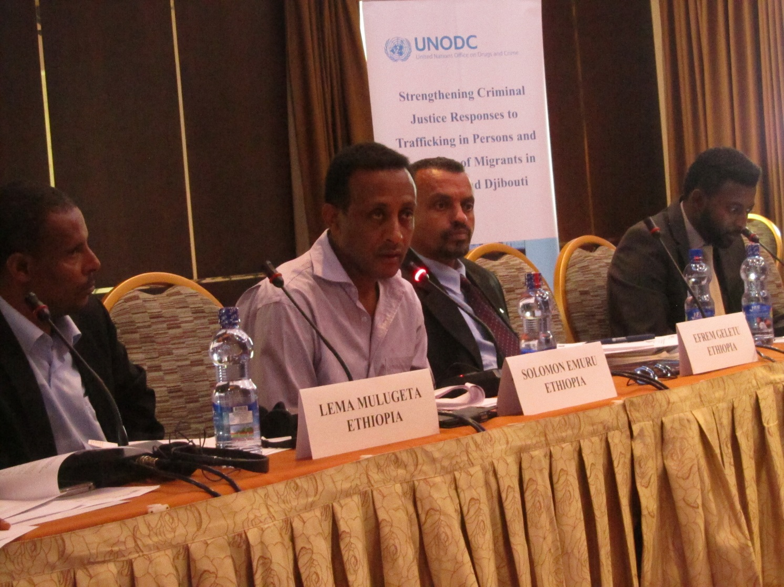
The drafting team

In order to support the implementation of the legislation UNODC assisted the Justice Organs Professionals Training Centre to adapt the UNODC Anti-Human Trafficking Manual for Criminal Justice Practitioners (2008) to the Ethiopian context. UNODC developed 11 modules on the Ethiopian legislation, prevention, witness protection, etc., which will accompany the Manual. The training modules have been tested in two training of trainers (ToT) sessions in September 2015.
In total 70 trainers with law enforcement or justice background from Addis Ababa and all regions in the country have been trained between 7 and 16 September 2015. The training sessions covered the newly adopted Trafficking in Persons and Smuggling of Migrants legislation which was drafted with UNODC assistance.

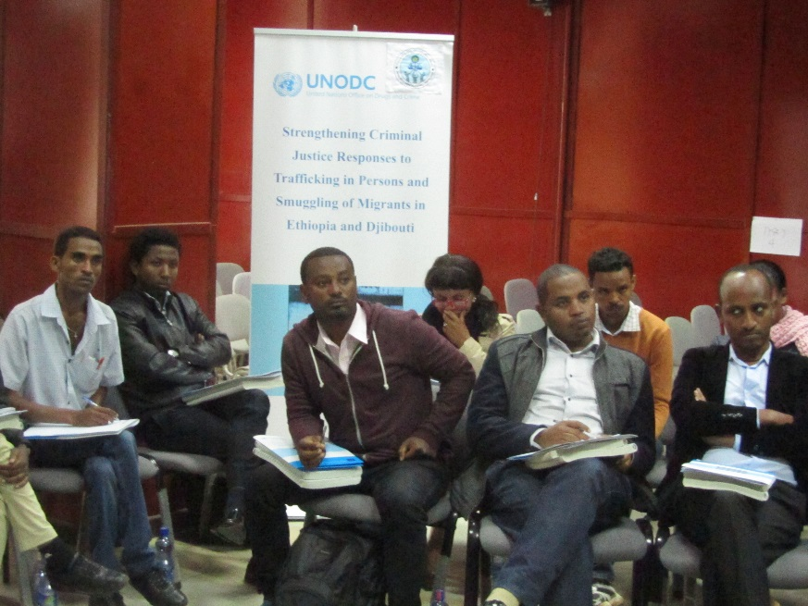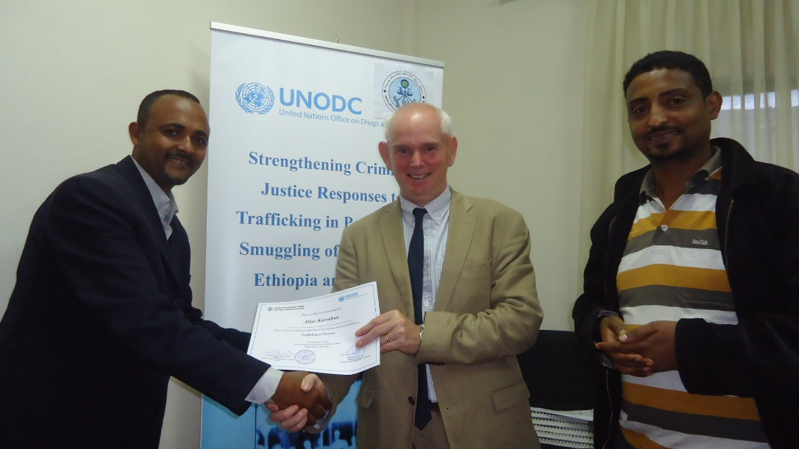

2.3.2 Trainings for ARRA and refugees on trafficking and smuggling – JIJIGA

UNHCR: In October 2015, a 2-day training on Refugee Protection, Trafficking and Smuggling was conducted in Jijiga to 40 law enforcement agents (police, security agents, ARRA, judges and public prosecutors) and UNHCR local protection staff. The sessions were conducted by UNHCR and addressed the legal framework on refugee protection, trafficking and smuggling; protection at sea; UNHCR’s national strategy; practical tools to identify victims of human trafficking and case studies.

2.3.3 Trainings for ARRA, partner staff and refugees on trafficking and smuggling – SHIRE

UNHCR: In June 2015, a 2-day training on Refugee Protection, Mixed Migration and Trafficking was conducted in Shire to 40 law enforcement agents (police, security agents, ARRA, judges and public prosecutors) and UNHCR local protection staff. The sessions were conducted by UNHCR, ICRC and CVT and addressed the legal framework on refugee protection, trafficking and smuggling; ethics in detention; UNHCR’s national strategy; practical tools to identify victims of human trafficking and case studies. This was the first training held by UNHCR to local authorities in Shire.

2.4 Provide training to criminal justice and law enforcement authorities as well as to immigration officers, border guards and airport staff for enhanced identification, investigation and prosecution of trafficking and smuggling cases.

2.4.1 Provide training to criminal justice agencies for enhanced investigation and prosecution of trafficking cases.
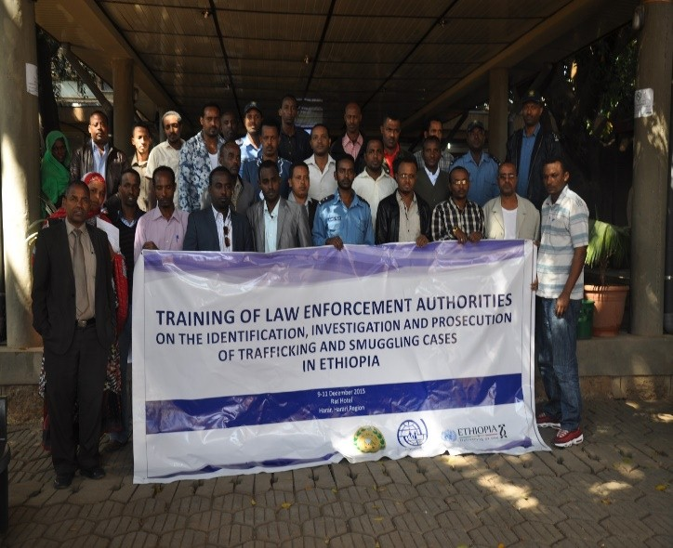
IOM: In close cooperation with the Ministry of Justice (MoJ) and the Federal Police Commission, IOM organized and facilitated joint training sessions of judges, prosecutors and police officers on the investigation human trafficking/smuggling cases and on relevant components of proclamation No. 909/2015. These sessions took place in the towns of Kombolcha and Harar which are both located in high-risk areas for human trafficking, smuggling of migrant and irregular migration. A total of 62 (57 male, 5 female) participants drawn from 11 zones and 18 woredas of the regional states of Amhara, Oromiya, Somali and Afar as well as of Harar and Dire Dawa City Administrations. The training sessions were respectively held on 16-18 November 2015 in Kombolcha and on 9-11 December 2015 in Harar.

The training gave the opportunity for trainees to acquire key investigation techniques; to familiarize themselves with victim-friendly protection approaches; to be able to conduct risk assessment and manage risk while investigating TiP, to screen and interview potential victims of trafficking; to assess and discuss the challenges posed by the prosecution of TIP cases; to identify and cooperate with other stakeholders; to become knowledgeable of key international and national anti-TiP legal frameworks including the recent Proclamation No. 909/2015 on the “Prevention and suppression of Trafficking in Persons and Smuggling of Migrants”.
Image 6: Harar Trainees in December 2015 (IOM)
Furthermore, these training sessions were strategically important as they provided a platform for judges, prosecutors and law enforcement officers based in source and transit regions for irregular migration and human trafficking to exchange ideas and discuss further collaboration in the prosecution of the perpetrators of human trafficking crimes. IOM conducted a pre- and post-training knowledge assessment of all participants and the results showed a 34% increase in awareness on the topics covered.

Trainees’ Occupation and their area of duty |  | Harar  9-11 Dec 2015 |  |  |  |  |  | Kombolcha  16-18 Nov 2015
 |  | Harari | East Hararghe | West Hararghe | Somali | Afar | Dire Dawa | S/ Wollo | N/ Wollo |  | N/Shoa |  | Oromo Special Zone |  |  | Wagi | Bahir Dar |  | Total
Judge |  | 1 | 1 | 1 | 2 | 2 | 2 | 3 | 1 |  |  |  | 1 |  |  |  |  |  | 14
Public Prosecutor |  | 1 | 1 |  | 2 | 2 | 2 | 2 | 1 |  | 1 |  | 1 |  |  | 1 |  |  | 14
Police Investigator |  | 3 | 1 | 1 | 3 | 3 | 6 | 5 | 4 |  | 4 |  | 3 |  |  |  | 1 |  | 24
Total |  | 5 | 3 | 2 | 7 | 7 | 10 | 10 | 6 |  | 5 |  | 5 |  |  | 1 | 1 |  | 62

2.4.2 Provide local NGOs and relevant gov't offices with trainings and awareness raising on migrants and refugees’ rights, needs and vulnerabilities to encourage 'migrant-friendly' and gender sensitive service provision, victim identification, referral and assistance (including shelter and medical support);

IOM: This will be conducted in the next reporting period.

2.4.3 Support GoE to develop a migration policy and internal and external operational frameworks

2.4.4 Initiating discussions for GoE to develop a migration policy

2.5 Strengthen cooperation between law enforcement, criminal justice authorities and victim assistance agencies

2.5.1 Organize coordination meetings between law enforcement, criminal justice authorities and victim assistance agencies

IOM & UNODC: To be conducted in the next reporting period.

Outcome 3: Vulnerable migrants, refugees and asylum seekers have attained full reintegration, improved livelihoods and reduced vulnerabilities (including for potential migrants and source communities) through community-based socio-economic reintegration and rehabilitation support, regular migration and community stabilization programs and demonstrate greater willingness to assert and uphold human rights

3.1 Conduct labour market and livelihoods assessments report produced for both refugee and Ethiopian communities to inform targeted livelihoods reintegration support

3.1.1 Conduct livelihoods and labour market assessment in Amhara, Oromia, and Tigray regions

ILO: This will be conducted in the next reporting period.

3.1.2 Conduct livelihoods and marker assessment for urban refugees in Addis Ababa and develop urban livelihood strategy (consultant).

UNHCR: A consultant started the study in April 2015 and finalized the assessment in October 2015. The final report is expected to be submitted in November 2015.

3.2 Support socio-economic activities targeting specific drivers and underlying causes of irregular migration and onward movements

3.2.1 Design quick-impact community & livelihoods support packages

IOM: IOM, in collaboration with the Federal Micro and Small Enterprise Development Agency (FeMSEDA), has started to design an Income Generating Activity (IGA) information material destined to returnees. This information material will assist returnees in the identification of profitable business opportunities in the country and specifically in their respective regions of origin. The document will clearly explain legal procedures and will contain a mapping of micro financing institutions and income-generating opportunities. FeMSEDA has assigned two staff – one expert from FeMSEDA and one staff from Bureau of Labour and Social Affairs – to prepare the information material. Data collection from four major source areas for irregular migrants was finalized. The final document will be delivered within the next reporting period.

3.2. 2 Provide Vulnerable Returnees and potential migrants with long-term socio-economic reintegration support

ILO: ILO provided support for returnees who own viable business to further promote sustainable income through development of their capacity. This business enterprise capacity development was intended to respond to long-term potential business challenges, strengthen economic self-reliance and encourages future integration of returnees.
ILO has provided psychosocial reintegration support for 245 men, women and children returnees. This comprehensive psychosocial support to return migrants have supported the returnees to enable them to successfully reintegrate with their respective communities.

3.2.3 Conduct career counselling and occupational guidance

ILO: The ILO conducted an assessment on national employment services provision and labour market information collection and utilization in Ethiopia. The assessment objective were to enhance and strength employment services provision and the labour market information system in Ethiopia as well as contribute to the improvement of employment services provision and labour migration governance.

The ILO in collaboration with Addis Ababa BoLSA and Ethiopian Employers Federation (EEF) organized a job fair in Addis Ababa for migrant returnees. The overall output of this event was effective job matching and successful placement of returnees in income generating positions throughout the private and non-private sector. Three hundred plus returnees were able to secure potential employment the same day.

3.2.4 Provide skills and/or livelihood training programmes (technical and vocational, basic business, basic accounting, and life skills trainings)

IOM: This will be conducted in the next reporting period.

ILO: The DRT/F project under the leadership of the ILO and in partnership with its existing EU funded project have provided training for 878 (200 male and 677 female) in Basic Business skill and Life Skills for seven and a half days. Moreover, 400 of the trainees were provided with Business Development Services (BDS). From the mentioned participants, the majority have started doing business.

ILO provided ToT Training in Entrepreneurship and Motivational Skills for Technical Vocational Education and Training (TVET) Teachers and Experts in Oromia Region. These TVET teachers went on to train migrant returnees in six woredas in the Oromia region. This training built the capacity of the TVETs and helped returnees to acquire entrepreneurial mindset, identify and recognize opportunities; assess the feasibility of ideas as well as familiarized them with basic economic and financial concepts and steps in business startup and expansion.

3.2.5 Provide livelihoods and vocational training programmes for Eritrean refugees at risk of trafficking and smuggling – SHIRE

UNHCR: UNHCR Shire has allocated reasonable amount of funding (some came from Delivering Results Together Fund (DRT-F)) to Norwegian Refugee Council (NRC), Opportunity Industrialization Centre for Ethiopia (OICE) and Innovative Humanitarian Solutions (IHS) for the provision of various vocational skills training which later on would possibly be attached with small income generation activities based on the feasibility of the area once the training is finished. So far, a total of 250 refugees have benefited from vocational and livelihoods trainings in areas of food processing, metal work, furniture making, electrical building installation and IT support with age bracket of 15-24 years old amongst which 50% of the graduates will receive start-up kits when they graduate. Besides, NRC is providing skills training on livelihoods/business management skills training to 300 refugees in Mai-Aini, Adi-Harush and Hitsats camps with which 100% of the graduates will get start-up kits based on the nature of the areas they are dealing with. NRC is also constructing market centers in the three camps to enable the graduates engage in the Income Generating Activities (IGA) as their livelihood. Moreover, OICE is providing skills training for 431 refugees in areas of tailoring, electrical installation, plumbing and hair dressing in Mai-Aini camps while IHS is currently constructing the training center in Shimelba refugee camp.

3.3 Economic opportunities, youth employment, social services and community infrastructure are improved in areas prone to economically-induced migration, refugee camps or in areas in need of development to prevent both irregular movements and to sustain the return of migrants.

3.3.1 Provide individualized assistance to returned migrants including effective referral services focusing among others on temporary shelter, medical services, food, psycho-social counselling and livelihood opportunities

IOM: IOM has identified a local NGO (Association for Women Sanctuary and Development (AWSAD)) that is currently running shelter and providing rehabilitation and reintegration support to vulnerable returnees. The shelter provides accommodation, medical support, referrals to hospitals, counseling services and reintegration assistance through provision of technical and vocational training to Victims of Trafficking (VoTs). An implementation agreement will be signed in the next project period which will enable 50 VoTs to be provided with rehabilitation and reintegration support in the next project period.

ILO:

3.3.2 Provide opportunities for returned migrants to meet with others who have shared similar experiences so as to help each other in the readjustment and reintegration process

ILO: This will be conducted in the next reporting period.

3.4 Conduct trainings of service providers and implementing partners (Technical Vocational Education and Training TVET), Micro and Small Enterprises (MSE) offices, Micro Finance Institutions (MFIs), Banks etc).

3.4.1 Enhance the capacity of TVET's, F/REMSEDA and MFIs to effectively respond to returnees through training

ILO:

3.4.2 Establish a coordination mechanism of TVET's, F/REMSEDA, MFI's and other relevant partners to respond to the needs of potential and returned migrants

IOM: The FeMSEDA/BoLSA team assigned to develop an Income Generating Information Material has collected information on the current state of collaboration between TVET institutions and F/ReMSEDA as well as on the challenges encountered in responding to the assistance needs of returnees. This set of data will be reviewed on the occasion of a workshop to be held in the next reporting period.

ILO: This will be conducted within the next reporting period.

3.5. Governments have the necessary skills, knowledge, and mechanisms to assess and project labour market supply-demand dynamics and to use this information to inform educational training and labour mobility policy and programming.

3.5.1 Provide Capacity-building and other technical assistance to government on how to effectively respond to labour market supply-demand dynamics nationally & internationally

ILO: This will be conducted within the next reporting period.

3.5.2 Support institutions such as MoLSA, BoLSAs, the Ethiopian Employers Federation (EEF) and Chamber of Commerce in ensuring referrals to job-placement services and job matching.

ILO: This will be conducted within the next reporting period.

Outcome 4: National and interregional migration management actors demonstrate effective coordination, dialogue, and cooperation to facilitate the protection of vulnerable migrants, refugees, and asylum seekers, and promote safe migration through improved law enforcement and migration management.

4.1 National capacity to jointly respond to migration and security challenges, such as transnational organized crime is strengthened and upholds the human rights of migrants and refugees

UNODC: UNODC made progress in reaching output 4.1. “National capacity to jointly respond to migration and security challenges, such as transnational organised crime is strengthened and upholds the human rights of migrants and refugees”. In particular, progress has been made in activity 4.1.4 which calls on UNODC to help “… implement a witness protection programme”.

4.1.1 Conduct border management assessments, legislative and policy review and development

4.1.2 Rehabilitate/upgrade of detention premises and/or holding facilities to help improve service delivery and to enhance the living conditions of detained migrants, refugees, and victims of trafficking and other vulnerable migrants.

4.1.3 Train border officials and provide equipment to facilitate migrant protection-sensitive border management, through proper identification, reception, profiling, referral, and reporting mechanisms

4.1.4 Train law enforcement agencies - police, public prosecutors and immigration officials on proper investigation techniques and methods for collecting and organising relevant data to enhance their ability to arrest and prosecute traffickers and smugglers (including those operating inside refugee camps); implement a witness protection programme.
UNODC: UNODC organized a study visit for the Ministry of Justice to the EUROPOL. The study visit provided an opportunity for the Ministry to learn about the witness protection practices in Europe and to meet and network with EUROPOL as well as the German Witness Protection Agency. Due to the covert nature of witness protection, there is only little information available publicly about the legislations and practices of other countries. Meetings with other agencies is key to gain experiences in the field. Future activities will include the drafting of the organogram and Terms of References of the Ethiopian/Agency of Unit based on the good practices shared by Europol and the German Witness Protection Agency.

4.1.5 Provide technical assistance and advocacy, training and equipment (including for the promotion of alternatives to detention) and law enforcement.

4.2. Government officials and the private employment agencies (PEA) have improved knowledge and understanding on labour migration management and irregular migration needs.
4.2.1 Undertake assessment on the challenges faced by PEA's to operate within the ambit of Proclamation 632/2009
ILO: This will be conducted in the next reporting period.

4.2.2 Revise the code of conduct of the PEA's in line with the revised Proclamation
ILO: This will be conducted in the next reporting period.

4.2.3 Establish a coordination mechanism between the Government and PEA's
ILO: This will be conducted in the next reporting period.

4.3 National and regional coordination capacity between government and other stakeholders is further enhanced.

4.3.1 Organise coordination meeting with government and other stakeholders (federal and region level anti-TIP/smuggling councils)
This will be conducted in the next reporting period.

4.4. Platforms and mechanisms are established/strengthened for internal and external information-sharing, dialogue, and cooperation between key countries along the migratory route, to protect migrants and refugees' rights, address irregular migration, trafficking, smuggling and promote regular migration

4.4.1 Increase awareness about the benefits of legal migration and the risks involved in irregular migration

IOM: In order to reinforce the capacities of the national community conversation program and to strengthen awareness raising efforts at local level, a series of two-day refresher trainings for community conversation groups that have expressed difficulties in ensuring the continuity of their sessions was held from within December 2015 by IOM in:
- Amhara Region : Kemissie town (Dec. 8-9/2015) and Dessie town (Dec. 11-12/2015) a total of 113 participants (74 male, 39 female) covering 4 zones, 19 woredas, and 40 kebeles engaged in CC sessions;
- SNNP Region: In Sodo town (Jan. 4-5/2016), for a total of 37 participants (36 male, 1 female) covering 3 zones, 6 woredas and 25 kebeles engaged in CC sessions ;
- Oromia Region: Jimma Zone (Dec. 06-07/2015) and Arsi Zone (Dec. 10-11/2015), for a total of 92 participants (79 male, 13 female) covering 63 kebeles (32 in East Arsi Zone and 31 in Jimma Zone).
Altogether, these training sessions have covered a total of 3 Regions, 12 Zones, 45 woreda and 127 kebeles. A total of 242 participants (male 189, female 53) took part in the sessions among whom model facilitators, woreda focal persons, BoLSA heads and focal persons. Different types of IEC materials were also distributed to the participants such as posters (500), brochures (2000), t-shirts (200), Bags (200) and community conversation manuals (200).
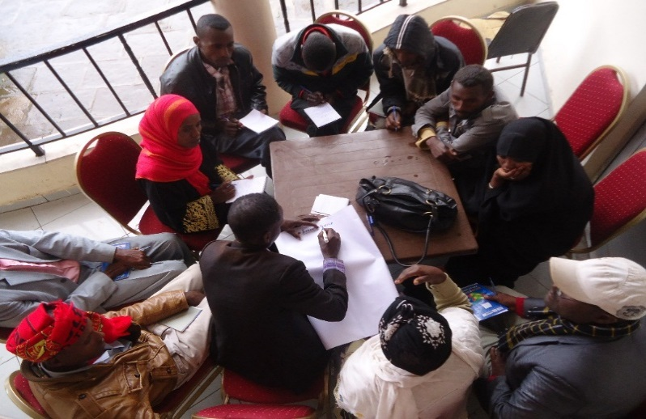
The first day of the training mainly focused on familiarizing participants with organization and way to conduct CD activities. The major topics addressed were: introductory activities, basic facilitation skills and techniques, practical organization of CD process. The second day mainly focused on familiarizing CD Facilitators with basic CD topics on trafficking in persons, people smuggling & irregular migration practices as well as exploring and looking for solutions to combat such practices through collaborative action by utilizing community assets. Successful CD facilitators were also invited to share their experience and bring tangible answers to the difficulties expressed.

Image 7: Training in Arsi, December 2015 (IOM)
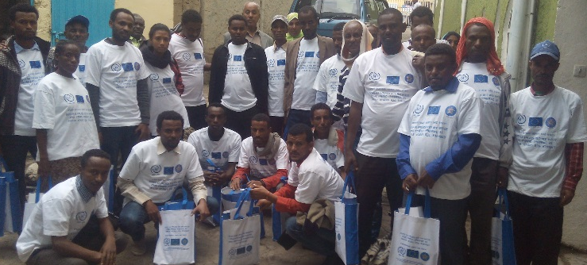
Image 8: Training in Dessie, December 2015 (IOM)

4.4.2 Migrants are adequately prepared prior to departure with relevant information and substantive training

ILO: This will be conducted in the next reporting period.

4.4.3 Conduct workshop in Shire with partners re: trafficking and smuggling of Eritrean refugees.

UNHCR: In December 2015, a joint training on Secondary Movement, Smuggling and Trafficking was held by UNHCR and IOM for law enforcement agents, partners and ARRA staff. The training aimed at strengthening coordination mechanisms and information sharing amongst stakeholders in Shire. An additional training session was also held in December to partners and ARRA on identification of specific needs of refugees, case management and referral systems, particularly to victims of human trafficking.

4.4.4 Conduct regional workshop with partners re: trafficking and smuggling of Eritrean refugees.

UNHCR: On May 19th and 20th, UNHCR held a Workshop on Refugee Protection, Trafficking and Mixed Migration to its protection staff from all offices in the country as well as partner NGOs. The workshop consisted in two-day training and presentations by UNHCR and IOM, as well as working group discussions on recommendations for awareness raising activities, child protection, promotion of solutions and identification, referral, assistance procedures and other aspects related to the work in areas of mixed migration and trafficking. Inputs from participants informed the development of an action plan to implement the strategy in 2015-2016.

4.4.5 Conduct training workshops for government officials (mainly police, judiciary, MOLSA, MOWCYA, Immigration, and education), NGOs, CSOs. Focusing on irregular migration and labor migration management (MoLSA officials and PEAs)

ILO: This activity depended on the enactment by the GoE of the new labour migration management proclamation which has been planned to occur in the beginning of year 2008 EC.

4.4.6 Update the labor migrant’s pre-departure training curriculum

ILO: This activity depended on the enactment by the GoE of the new labour migration management proclamation which has been planned to occur in the beginning of year 2008 EC.

4.4.7. Conduct TOT targeting MOLSA government officials and private employment agencies

ILO: This activity depended on the enactment by the GoE of the new labour migration management proclamation which has been planned to occur in the beginning of year 2008 EC.

4.4.8 Establish labor attaché positions in the Ethiopian diplomatic missions abroad

ILO: This activity depended on the enactment by the GoE of the new labour migration management proclamation which has been planned to occur in the beginning of year 2008 EC.

4.4.9 Facilitate/Organize study tours/ bilateral exchanges for Government officials and regional events on migration management (e.g. IOM/UNHCR Mixed Flows follow-up conference, Regional Committee on Mixed Migration, IGAD framework and AU COMMIT, the Sanna’a Conference and the outcome document (Sanna’a Declaration).

UNODC: UNODC organised a study visit for representatives of the Ministry of Justice (due to a last minute cancellation only the Head of the Legal Study, Research and Drafting Directorate participated) to Europol headquarters in The Hague. The high-level official could learn about how Europol, the German Witness Protection Agency, UK and the International Criminal Court surmounts challenges in witness protection, and forge contacts for future reference. Participants of the visit have held presentations on their respective systems and practices and answered questions regarding the agency structures, challenges with biometrics, vetting and training of officers, etc. Europol also invited Ethiopia to join the training initiatives and attend the next High Level Witness Protection Expert Conference and to join the Europol Network on Witness Protection. This study visit facilities the proper implementation of the existing Ethiopian legislation on witness protection, as in particular Ethiopia lack exchange with other countries in this field.

In addition, for each policy initiative, report against the DRT-F outcome indicators. Only list those that have been completed and delivered with partial/full DRT-F funds that are contained in the DRT-F proposal. Not all indicators below will apply to all policy initiatives in all countries. At the outcome level, DRT-F is concerned with national policy results.
Outcome 1: Delivering as One countries achieve nationally agreed upon priorities contained in One Programmes through coordinated UN support in line with international norms and standards
Outcome Indicators | Number/Title | Brief description
Government plans/policies developed and/or operationalized with UN policy support | Put actual number of and name of plan(s)/policy/(ies) | What is the significance of this UN contribution to this plan/policy? Please clarify in simple terms how the UN assisted through DRT-F to develop/operationalize the listed government plan/policy. Was it through drafting/developing a new plan/policy, revising an existing one, support in operationalizing the plan/policy etc?
National legislation reflects greater compliance with international norms and standards linked to UN policy support | Put actual number of and name(s) of legislation | Please clarify in simple terms how the legislation reflects greater compliance. What type of support was provide?. Is new/ revised legislation adopted? Is there strengthened implementation of legislation?
National policy informed through improved joint data collection and analysis done with UN policy support | Put actual number of and name(s) of national policies with joint data collection and analysis | How was national policy informed? What type of joint data collection and analysis was done? New? Revised? This could be any DRT-F funded policy activities that are related to data collection, electronic platforms, statistics, real time monitoring etc. Any tool to be used by government to increase the quality of data to inform policy making. i.e. it is not a UN baseline study or assessment report. Those would be included below at the output level under “joint studies/reviews”.

- How have the policy activities above contributed towards the realization of the associated Output(s) and Outcome(s) in the One Programme? In the DRT-F proposal, policy activities were listed under an associated One Programme output and outcome. Use these to report against. Focus on real results and the importance of UN support in national policy development and implementation, including compliance with international norms (as appropriate). (Max. 1/4 page per initiative)

Outcome 1: Government, local community, humanitarian agencies and International Development partners have an improved understanding of the risks associated with irregular migration, onward movements (refugees) vulnerabilities
IOM: A comprehensive assessment on migration trends and onward movement (refugees) is on good track to be finalized. The government is strongly involved in the monitoring and review process and has acquired knowledge on the concept of migration profile namely thanks to the events organized as part of this project under this outcome. Furthermore, the release of the final Migration Profile Document will enable IOM and GoE to launch a third capacity-building phase that will be funded under other projects and will help maximize the potential of the Migration Profile Document for policy planning and establishment of a viable and sustainable migration data-collection mechanism in Ethiopia. By the end of the migration profiling initiative, the UN will have established a viable knowledge management system on migration in Ethiopia, thus enabling all stakeholders involved in migration management and counter trafficking (government, local community, humanitarian agencies and international development partners) to regularly update and enhance their understanding of the migration trends and challenges and to plan and design their future initiatives basing on sound and reliable data.

UNODC: The activities undertaken above have clearly contributed to the outputs and outcomes in the joint program. For instance, under outcome 1, the main objective is to improve understanding of risks associated with irregular migration and onward movements of refugee’s vulnerability. Undertaking an assessment of secondary movements of refugees in Ethiopia and producing migration profile for Ethiopia will help to analyze major causes and routes for secondary movements that lead to trafficking and smuggling in the country and the region; and make comprehensive, reliable migration data available to support evidence based policy making to government and other stakeholders. This will contribute towards improving the understanding of governments, local communities, international development partners which would help in providing recommendations in future policy and intervention in reducing trafficking and onward movements among refugees. Yes […] UNHCR, UNODC and IOM worked closely in the capacity building of government officials, providing joint trainings mainstreaming the areas related to the core mandate of each agency. Moreover, all UNCT agencies actively contributed to the Migration Profile of Ethiopia, including through coordination meetings amongst consultants currently carrying on the research activities.

Outcome 2: To help Vulnerable migrants and refugees realise their protection rights and protect them against the risks to their lives, physical safety and security: ensure that quality protective services are in place for those migrants and refugees who are stranded, apprehended and/or detained along the migratory route, including supporting their assisted voluntary return where appropriate

IOM: The activities implemented by IOM so far have clearly contributed to output 2.1 as more than 1,000 vulnerable (stranded, apprehended or detained) returnees were provided with AVRR assistance. The operationalization of a national referral mechanism of victims of trafficking and other vulnerable migrants as well as other activities destined to building the capacity of service providers are further contributing to outcome 2 as this mechanism will persist after the project’s life. Furthermore, the activities conducted under output 2.4 have clearly contributed to outcome 2 as prosecutors, judges and law enforcement officers have been trained on human trafficking investigation techniques and sensitized on the protective attitude to adopt while assisting vulnerable migrants. Moreover, as part of the other projects it is implementing, IOM has been able to conduct such activities in other regions of Ethiopia, thus increasing the overall potential impact on the present outcome.

UNODC: Under outcome 2, training conducted for partner staff and refugees on trafficking and smuggling will contribute in protecting the rights of vulnerable migrants and refugees who are stranded, apprehended and detained among the migratory routes. By providing capacity building to law enforcement agents, government officials and partners, it helped to ensure providing quality services to migrants and refugees in facilitating protection sensitive border management through identification, reception, profiling, referral and reporting mechanisms.

Outcome 3: Vulnerable migrants, refugees and asylum seekers have attained full reintegration, improved livelihoods and reduced vulnerabilities (including for potential migrants and source communities) through community-based socio-economic reintegration and rehabilitation support, regular migration and community stabilization programs and demonstrate greater willingness to assert and uphold human rights

IOM: The design of quick impact packages will be key in helping FeMSEDA identifying viable reintegration schemes for returnees. It will however be more feasible to assess the extent of its impact during the next reporting period. The information collected on the state of collaboration among all reintegration actors will also be crucial in the design of solutions to the challenges identified in the reintegration of returnees, thus improving the overall impact of livelihood enhancement and reintegration programs.

UNODC: Under outcome 3, the main objective is to ensure that returnees have improved livelihoods. The trainings and the BDS services being provided will and have resulted in some of them initiating micro enterprises which will improve their livelihood. Furthermore, lack of coordination mechanism has been identified as one of the main challenges by returnees, hence bringing all relevant bodies together will help us agree on way forward for better coordination.

Outcome 4: National and interregional migration management actors demonstrate effective coordination, dialogue, and cooperation to facilitate the protection of vulnerable migrants, refugees, and asylum seekers, and promote safe migration through improved law enforcement and migration management.

IOM: The activity carried out under output 4 (4.4.1) has contributed to the outcome as the country-wide community conversation platform established by IOM and GoE was reinforced and will continue to impact the decisions made by communities. Outcomes of the platform will also provide feedback to the government structures working in prevention and prosecution aspects of combatting human trafficking and smuggling. In addition, this will help the potential migrants in Ethiopia to find local solutions to the challenges they encounter or to opt for safer regular migration options.

UNODC: Similarly, under outcome 4, the policy activity carried out (activity 4.4.8) has directly contributed to the implementation of an international obligation applicable to Ethiopia. The study visit organized by UNODC to Europol, a leading institution with much experience in the field of witness protection, will facilitate the implementation of Ethiopia’s witness protection legislation. A contribution to this output is made, because stronger witness protection should increase national capacity to respond to transnational organized crime, while upholding human rights. The same goes for outcome which envisages national actors facilitating the protection of vulnerable migrants. Finally, Ethiopia has an international obligation to ensure witness protection, under article 24 of the United Nations Convention against Transnational Organized Crime.

The above mentioned policy initiatives contribute towards the associated outputs and outcomes in the funded proposal. Through those activities a broader impact was achieved such as helping vulnerable migrants and returnees to realize their protection rights and protecting them against the risks of irregular migration through trainings and BDS support which have resulted in some of them initiating micro enterprises which will improve their livelihood; awareness raising on trafficking highlighting their vulnerabilities to inform policy makers and enforcement agencies; assessing elements of labour migration i.e. cost of migration to inform policy of the affordability of regular migration and its impact on the rise of trafficking and irregular migration; and equipping the GoE through experience sharing with other countries on effective labour migration governance to decrease vulnerabilities faced by Ethiopian migrant workers in destination counties. Furthermore, returnee support for full reintegration and improved livelihood through psychosocial support and capacity development.

- DRT-F OUPUT LEVEL REPORTING “DaO countries receiving DRT-F funds demonstrate strengthened UN coordination to facilitate integrated policy support to national governments.”

- Have DRT-F funds contributed towards a strengthened UNCT focus on integrated policy work? Please answer yes or no. If yes, provide some examples of how. If no, please share why. (Max. ¼ page)
Yes.
Funding of this initiative has enabled the four agencies working in the areas of countering trafficking in persons, smuggling of migrants and secondary migration of refugees and asylum seekers to pursue an integrated policy response to the challenges. In addition, the initiative has enabled the preparation of a country migration profile for Ethiopia which will serve as a basis for all agencies working in the area of migration to work together and initiate efforts towards integrated policy.
- Have DRT-F funds contributed towards strengthened UN coordination, including implementation of core elements of the SOPs relating to One Programme and One Budget? Please answer yes or no. (Max. ¼ page) If yes, provide some examples of how. If no, please explain why. i.e. how did the UNCT and results group come together to identify policy priorities, develop proposals etc. As the DRT-F requires submission of the annual CBF, AJWP, resource mobilization strategy etc, has this requirement led to any consultations between the UNCT and review of compliance with the SOPS etc? Improvements to these core elements? This question may be answered by implementing agencies or the RCO may be better able to provide a holistic overview.

Output 1: Delivering as One countries receiving DRT-F funds demonstrate strengthened UN coordination to facilitate integrated policy support to national governments
Output Indicators | Number/Title | Brief description
Number of joint studies/reviews conducted with recommendations on strengthened national policy in line with international norms and standards | 1: Migration Profile Document for Ethiopia will be available in the next project period  2: Survey of migration costs of Ethiopian regular migrant returnees from Saudi Arabia  3: Assessment on national employment services provision and labour market information collection and utilization  4: Promoting and protecting the human rights of women and girl migrant workers in transit in the context of south-south migration  5: National Study on Secondary Movements, Trafficking and Smuggling of Refugees in and out of Ethiopia | When the document will be available, the UN will have entirely contributed to the design of the first ever Migration Profile document for Ethiopia which is to become a widely used tool for policy planning and design in migration management. This document will be a reference for all stakeholders working in migration management and counter trafficking as well as other fields such as economic development. It will be crucial in the advocacy for the formulation of a comprehensive migration policy in the country.  Through these studies the UN has contributed to the national policy though providing information on the cost of regular migration and its correlation with the rise of irregular migration. The second study mentioned contributed to the improvement of employment services provision and labor migration governance. The third study will contribute to the development of a governance framework for transit migration for economic migrants in South-South contexts and provide an improved understanding of the recruitment complex to put in place policies in transit counties for the protection of migrants  The study will support the Government of Ethiopia, UN agencies and relevant stakeholders to understand the phenomenon of secondary movements of refugees in Ethiopia, including the main reasons, profiles, routes, challenges and gaps in terms of assistance and response. The study will be the basis for the advocacy with the Government on the development of national policies to address irregular migration of refugees, strengthening the areas identified as the main drivers of secondary movements
Number of Results Groups engaged in the development of this joint policy initiative funded by DRT-F | Indicate number of results groups developing and overseeing this DRT-F funded policy initiative | List groups. How have they been engaged? i.e. monitoring and reporting?

Policy Initiative 2:
Repeat above for each funded policy initiative.

