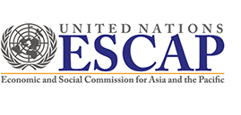 | 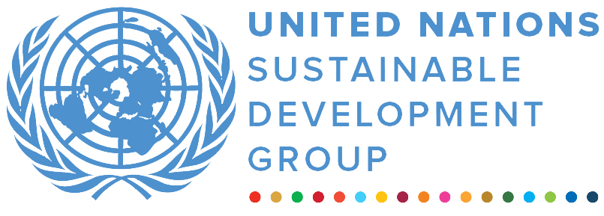 | 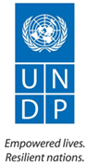
United Nations Road Safety Fund
MPTF OFfice GENERIC finalprogramme NARRATIVE report
REPORTING PERIOD: from 04.2019 to 10.2020
Programme Title & Project Number |  |  | Country, Locality(s), Priority Area(s) / Strategic Results
- Programme Title:  Strengthening Speed Management in the Philippines  - Programme Number (if applicable) N/A  - MPTF Office Project Reference Number:  00115702 |  |  | (if applicable)  Country/Region  Philippines
Priority area/ strategic results
Addressing speed management for improving road safety
Participating Organization(s) |  |  | Implementing Partners
- Organizations that have received direct funding from the MPTF Office under this programme  United Nations Economic and Social Commission for Asia and the Pacific (ESCAP) |  |  | - National counterparts (government, private, NGOs & others) and other International Organizations  Global Road Safety Partnership (GRSP) and  ImagineLaw, Inc., Land Transport Office, Philippines and Department of Transportation, Philippines
Programme/Project Cost (US$) |  |  | Programme Duration
Total approved budget as per project document:  MPTF /JP Contribution:  - by Agency (if applicable)  USD 198,546 |  |  | Overall Duration (months) 18  Start Date (dd.mm.yyyy) 30.04.2019
Agency Contribution  - by Agency (if applicable) |  |  | Original End Date (dd.mm.yyyy) 30.04.2019
Government Contribution  (if applicable) |  |  | Actual End date(dd.mm.yyyy)  31.10.2020  Have agency(ies) operationally closed the Programme in its(their) system? | Yes No
Other Contributions (donors)  (if applicable) |  |  | Expected Financial Closure date: ?
TOTAL: USD 198,546
Programme Assessment/Review/Mid-Term Eval. |  |  | Report Submitted By
Evaluation Completed N/A  Yes No Date: dd.mm.yyyy N/A  Evaluation Report - Attached  Yes No Date: dd.mm.yyyy N/A |  |  | - Name: Weimin Ren  - Title: Director, Transport Division  - Participating Organization (Lead): ESCAP  - Email address: weimin.ren@un.org

FINAL PROGRAMME REPORT FORMAT

EXECUTIVE SUMMARY
- In ½ to 1 page, summarise the most important achievements of Programme during the reporting period and key elements from your detailed report below. Highlight in the summary, the elements of the main report that you consider to be the most critical to be included in the MPTF Office Consolidated Annual Report.

- summarise the most important achievements of Programme during the reporting period and key elements from your detailed report below.

While speeding has been one of the major causes of road crashes, enforcement of speed limits has been a neglected activity in the Philippines. Until the commencement of this project, speed enforcement was not a part of the enforcement practices of Government authorities, including the Land Transport Office (LTO) and the Philippine National Police (PNP). In addition, enforcement authorities (other than Highway Patrol Group) had limited awareness of the basic principles of speed enforcement as well as the technology required for measuring speed.
In this regard, the project has been successful in providing speed enforcement best practice training as well as awareness building for speed enforcement officials and related stakeholders in the Philippines through the following activities:
At the beginning of the project, a Memorandum of Agreement was signed between the Local Transportation Office (LTO) and the Department of Transportation (DOTr) to establish a working arrangement with implementing partners, Global Road Safety Partnership (GRSP) and ImagineLaw, as well as the PNP and the Metro Manila Development Authority (MMDA), in order to build capacity of government officials to strengthen speed enforcement in the Philippines; and
Developed an effective speed enforcement package and training of trainers that was delivered by the GRSP international road policing experts to a core group of national officials. This core group of trainers then rolled out that training at the district level to promote sustainability of a systematic approach to training. The speed enforcement package was disseminated across the country to strengthen speed limits enforcement in line with international best practices, with the ultimate aim of reducing speeding and speed-related crash deaths and serious injuries.

- Highlight in the summary, the elements of the main report that you consider to be the most critical to be included in the MPTF Office Consolidated Annual Report.

Through this project, enforcement officials in the Philippines received comprehensive knowledge on speed enforcement techniques to reduce speed related road crashes and their severity level, were familiarized with speed measurement devices, and trained to independently perform effective and speed limit enforcement. The training of the law enforcement personnel to enforce speed limits using modern techniques especially through use of speed detection devices has been innovative in the national context in the Philippines. The technical capacity of a core group of national level police to train relevant enforcement officers has been enhanced and now police personnel are utilizing the knowledge to enforce speed in the country. The stakeholder engagement component of the project was helpful in awareness building among stakeholders in the Philippines as the speed enforcement training package helped to ensure sustainability and institutionalization of speed management following project completion and the week-long social media campaign which focused on speed management and included videos, photos, and articles highlighting the progress that was made during the project and key messages relating to unsafe speeds.

Purpose
- Provide a brief introduction to the programme/ project (one paragraph).

The purpose of the project was to reduce speed related road crashes and their severity levels in the Philippines by improving road user behavior. To achieve this, the project included best practice speed enforcement training via Train the Trainer methodology. The
speed enforcement training was developed and delivered to a core group of national enforcement officials who then rolled out that training at the Local Transportation Office (LTO) district level.

- Provide the main objectives and expected outcomes of the programme in relation to the appropriate Strategic UN Planning Framework (e.g. UNDAF) and project document (if applicable) or Annual Work Plans (AWPs) over the duration of the project.

The main objective of the project was to strengthen and improve the enforcement activities related to speed management. This project aimed to address the lack of systematic speed enforcement training in the Philippines. The expected accomplishments during the project implementation period were:

- to enhance capacity of a core group of national level police to train relevant enforcement officers at Local Transportation Office (LTO) district level to conduct effective speed enforcement; and
- to institutionalize best practice speed enforcement operations among enforcement agencies in the Philippines.

Assessment of Programme Results
- This section is the most important in the Report and particular attention should be given to reporting on results / and changes that have taken place rather than on activities. It has three parts to help capture this information in different ways (i. Narrative section; ii. Indicator based performance assessment; iii. Evaluation & Lessons learned; and iv. A specific story).

- Narrative reporting on results:
From 30 April 2019 to 31 October 2020, respond to the guiding questions, indicated below to provide a narrative summary of the results achieved. The aim here is to tell the story of change that your Programme has achieved over its entire duration. Make reference to the implementation mechanism utilized and key partnerships.

- Outcomes: Outcomes are the strategic, higher level of change that your Programme is aiming to contribute towards. Provide a summary of progress made by the Programme in relation to planned outcomes from the Project Document / AWPs, with reference to the relevant indicator(s) in these documents. Describe if final targets were achieved, or explain any variance in achieved versus planned results. Explain the overall contribution of the programme to the Strategy Planning Framework or other strategic documents as relevant, e.g.: MDGs, National Priorities, UNDAF outcomes, etc . Explain who the main beneficiaries were. Highlight any institutional and/ or behavioural changes amongst beneficiaries at the outcome level.

The project was able to introduce and institutionalize a new practice of speed management among speed enforcement agencies in the Philippines. The first result of the project was to identify existing weaknesses of speed enforcement practices, which helped in building awareness among enforcement officials and prepared for changes. The project enabled the enforcement officials from the Local Transportation Office (LTO), Philippine National Police (PNP), the Metropolitan Manila Development Authority (MMDA), Quezon City Department of Public Order and Safety, and Pasig City Traffic and Parking Management Office to start developing training plans for their respective agencies. Speed enforcement in the Philippines has become more automated and systematic as enforcement officials are now able to detect the correct speed using ‘Lidar’ speed guns and apply roadside apprehension techniques. A speed enforcement package developed for sustained use of best-practice approaches was formally adopted by the LTO, who indicated their willingness to continue its use into the future. The stakeholder engagement forum and the week-long social media campaign and press conference were helpful to promote knowledge exchange amongst agencies and increase awareness. The campaign concluded with a major press conference to launch the speed enforcement package and publicize a Declaration of Commitment of stakeholders to speed enforcement. This declaration featured high-level officials from key government agencies in the Philippines and global road safety stakeholders.

- Outputs: Outputs are the more immediate results that your Programme is responsible for achieving. Report on the key outputs achieved over the duration of the Programme , in relation to planned outputs from the Project Document / AWPs, with reference to the relevant indicator(s) in these documents. Describe if final targets were achieved, or explain any variance in achieved versus planned results. If possible, include the number of beneficiaries. Report on how achieved outputs have contributed to the achievement of the outcomes and explain any variance in actual versus planned contributions to the outcomes.

The status of the different outputs/activities of the project are listed below:

  - Partnership Building: A Memorandum of Agreement (MoA) between Department of Transportation, Local Transport Office and ImagineLaw (the main Implementing Partner of ESCAP- GRSP) was endorsed to establish a working arrangement that allowed GRSP and ImagineLaw to engage with these agencies and the Philippine National Police – Highway Patrol Group (PNP) and the Metro Manila Development Authority (MMDA), in order to build capacity for speed enforcement. The signing of the MOA took place on 25 July 2019, and was accompanied by a press conference, which gathered significant coverage.

In addition, a core group of key national level trainers on speed enforcement was established and consisted of enforcement officials from the LTO, PNP, MMDA, Quezon City Department of Public Order and Safety, and Pasig City Traffic and Parking Management Office.

2. Speed enforcement Train the Trainer module developed and delivered: The first element of the workshop was a capacity assessment of current speed enforcement practices conducted by GRSP experts in July 2019. Development of national training using the results of the capacity assessment was held on 7 and 8 October 2019. A total of 53 enforcement officials from the above-mentioned core group were in attendance. During the training participants were trained on the use of speed guns and guided on developing training plans for their respective agencies.

3. Local Transportation Office (LTO) district level speed enforcement training: ImagineLaw conducted meetings with local trainers to help develop training plans for district level speed enforcement. ImagineLaw also secured speed guns for LTO training in Region IVA and Region V which are two of the 16 regions in the Philippines. GRSP conducted two district level speed enforcement training workshops, first the Region IVA training held on 25-26 November 2019 in Batangas City, then the Region V training held on 28-29 November 2019 in Naga City. These workshops trained 97 enforcement officials. The workshops consisted of classroom sessions on speed enforcement best practices, practical exercises on speed detection and apprehension, and recommendations to local trainers to improve training plans.

4. Coaching and Mentoring: Following the national-level Train-the-Trainer workshop on 7 and 8 October 2019, LTO's internal trainers organized a follow-up workshop on 17 and 18 February 2020 which aimed at improving the quality of internal training. The workshop allowed GRSP experts to assess LTO trainers’ ability to deliver practical training on speed enforcement.

5. Documentation: The documentation included finalization of a suite of technical resources including: a) speed enforcement package and other related documents b) highlight reels – videos, c) photos and d) articles related speed management. The above were rolled out nationwide during the national stakeholder engagement activities and then handed over to the appropriate authorities.

- National stakeholder engagement: Stakeholder engagement encompassed two key elements: 1) GRSP developed a stakeholder engagement package, which included the speed enforcement training package and other key materials that was formally handed to the LTO in October 2020. This package will help to ensure sustainability and institutionalization of speed management following project completion; and 2) Imagine Law, with support from GRSP and ESCAP, conducted a week-long social media campaign focused on speed management from 28 September – 2 October 2020. This coordinated campaign, titled ‘Safer Speeds Now: Saving Lives Through Speed Enforcement’ included videos, photos, and articles highlighting the progress that was made during the project and key messages relating to unsafe speeds. 755,126 people were reached through Facebook, and an extra 60 through Facebook live for the press conference. In addition, 16,424 people were reached through Twitter as well as 197 zoom participants. The campaign finished with a major press conference to launch the speed enforcement package and publicize a Declaration of Commitment of stakeholders to speed enforcement. This declaration featured high-level officials from key government agencies in the Philippines and global road safety stakeholders

- Qualitative assessment: Provide a qualitative assessment of the level of overall achievement of the Programme. Highlight key partnerships and explain how such relationships impacted on the achievement of results. Explain cross-cutting issues pertinent to the results being reported on. Has the funding provided by the MPTF/JP to the programme been catalytic in attracting funding or other resources from other donors? If so, please elaborate. For Joint Programmes, highlight how UN coordination has been affected in support of achievement of results.

As per the qualitative assessment, the implementation of the project has been “Very Successful.” The Expected Accomplishments were achieved successfully. The new speed management practices at the enforcement agencies in the Philippines were institutionalized and enforcement has been improved. The campaign culminated in the signing of a Declaration of Commitment to speed enforcement amongst the stakeholders, who were high-level officials from key government agencies in the Philippines and global road safety stakeholders. This is expected to make the results of the project sustainable.

The partnership among ESCAP, GRSP and ImagineLaw was very effective and joint activities were productive because of a combination of the role of ESCAP to facilitate partnerships, international technical expertise of GRSP and the local knowledge of ImagineLaw Inc.

As a result, the stakeholders including the Local Transportation Office (LTO), Philippine National Police (PNP), the Metropolitan Manila Development Authority (MMDA), Quezon City Department of Public Order and Safety, and Pasig City Traffic and Parking Management Office have expressed strong commitment to the new practices established under this project for the speed management in the Philippines.

ii) Indicator Based Performance Assessment:
Using the Programme Results Framework from the Project Document / AWPs - provide details of the achievement of indicators at both the output and outcome level in the table below. Where it has not been possible to collect data on indicators, clear explanation should be given explaining why.

 |  | Achieved Indicator Targets | Reasons for Variance with Planned Target (if any) | Source of Verification
Expected Accomplishment 1  Enhanced capacity of a core group of national level police to train relevant enforcement officers at Local Transportation Office (LTO) district level to conduct effective speed enforcement.  Indicator:  MoA in place, A core group established, Module developed ready for delivery in the Philippines  One train-the-trainer delivered at the national level (target 50 trainees) |  | All relevant targets achieved:  MoA in place, a core group established, module developed ready for delivery in the Philippines, one train-the-trainer delivered at the national level (target 50 trainees)  Actual number of persons trained- 57  (see attachment 1, 2 and 3) | Not applicable | Information collected from the Local Transportation Office (LTO), Department of Transportation (DOTr) and related agencies
Activity 1  - Partnership Building:  Memorandum of Agreement (MoA) between Department of Transportation, Local Transport Office and ImagineLaw Indicator 1.1  MoA in place |  | The Indicator target achieved:  MoA in place  (see attachment 1 and 3) | Not applicable | Information provided by GRSP and ImagineLaw Inc.
Activity 2  - Core Group  Establishment of a core group of key national level trainers on speed enforcement  Indicator 1.2  Core Group established and trained |  | The Indicator target achieved:  Core Group established and trained- 57 persons identified and trained  (see attachment 2) | Not applicable | Information provided by GRSP and ImagineLaw Inc.
Activity 3  Speed enforcement Train the Trainer module developed by GRSP  Indicator 1.3  Module developed ready for delivery in Philippines  Indicator 1.4  1 x Train the Trainer (ToT) delivered at national level; target 50 trainees. |  | The Indicator target achieved:  Module developed ready for delivery in Philippines  A total of 53 enforcers from the LTO, PNP, MMDA, Quezon City Department of Public Order and Safety, and Pasig City Traffic and Parking Management Office were trained  (see attachments 2, 4) | Not applicable | Information provided by GRSP and ImagineLaw Inc.
Activity 4  - Coaching and Mentoring Following GRSP delivery of the national level Train-the-Trainer workshop and subsequent supervision of 2 LTO district level trainings, GRSP International Road Policing Expert will conduct a “coaching and mentoring” site visit  Indicator 2.1  2 Local Transportation Office (LTO) district trainings run by national staff and supervised by GRSP; target 120 trainees, 1 roadside observation/coaching session by GRSP. |  | The Indicator target achieved:  2 Local Transportation Office (LTO) district trainings run by national staff and supervised by GRSP; Total enforcement trainers and officials trained 157  1 roadside observation/coaching session by GRSP was replaced with a follow up workshop training.  (see attachments 3, 5, 6 and 7) | Speed measurement devices were not delivered to the LTO. So, to strengthen capacity to deliver effective internal training, it was decided by GRSP to conduct a follow up workshop to LTO's internal trainers.  The change did not negatively impact the project's goals. The modification allowed GRSP experts to assess the LTO trainers and deliver practical training on speed enforcement. | Information provided by GRSP.
Expected Accomplishment 2  Institutionalize best practice speed enforcement operations among enforcement agencies in the Philippines.  Indicator: Documentation done, stakeholder engagement package delivered, social media public and stakeholder engagement campaign conducted.  Indicator:  A suite of stakeholder engagement package finalized and used. Social media public and stakeholder engagement campaign conducted. | All relevant targets achieved:  A suite of stakeholder engagement package was finalized and used. Social media public and stakeholder engagement campaign conducted. All the related documentation was done.  (see attachment 4 and 8) |  | Not applicable | Information collected from the Local Transportation Office (LTO), Department of Transportation (DOTr) and related agencies
Activity 5  - Documentation:  Global Road Safety Partnership (GRSP) will work with local partners to document enforcement training and roadside enforcement activities and will publicize enforcement exercises to encourage other LGUs to enact and enforce speed limit ordinances, and to encourage road user compliance with speed limits. This documentation will also include finalizing the suite of technical resources which will be developed under the project and rolled out nationwide during the National Stakeholders Workshop.  Indicator 1  Documentation done and all the products handed over to the local authorities for future use. | The Indicator target achieved:  Documentation was done and all the products were formally handed over to the local authorities.  (see attachment 4 and 8) |  | Not applicable | Information provided by GRSP and ImagineLaw Inc.
Activity 6  National Stakeholders  a) Development of a stakeholder engagement package  b) Social media public and stakeholder engagement campaign  Indicator 1  Stakeholder engagement package delivered  Indicator 2  Social media public and stakeholder engagement campaign conducted | The Indicator target achieved:  Indicator 1  Stakeholder engagement package delivered  (see attachment 4)  Indicator 2  Social media public and stakeholder engagement campaign conducted  (see attachment 8) |  | Not applicable | Information provided by GRSP and ImagineLaw Inc.  Information collected from the Local Transportation Office (LTO), Department of Transportation (DOTr) and related agencies

iii) Evaluation, Best Practices and Lessons Learned
- Report on any assessments, evaluations or studies undertaken relating to the programme and how they were used during implementation. Has there been a final project evaluation and what are the key findings? Provide reasons if no programme evaluation have been done yet?
Evaluation
No formal project evaluation was conducted by the ESCAP secretariat. The monitoring and evaluation (M&E) activities were conducted in line with the requirements of the ESCAP Monitoring and Evaluation Policy and Guidelines 2017. ESCAP held quarterly project progress meetings with GRSP. The ESCAP secretariat monitored the implementation progress in the Philippines through informal video conferences and participated in consultation with the stakeholders.

- Explain challenges such as delays in programme implementation, and the nature of the constraints such as management arrangements, human resources etc. What actions were taken to mitigate these challenges? How did such challenges and actions impact on the overall achievement of results? Have any of the risks identified during the project design materialized or were there unidentified risks that came up?

Challenges

One challenge encountered during the project implementation was the impact of the COVID-19 pandemic and the mitigation measures imposed by authorities in the Philippines, including quarantine and restrictions on gathering of people. As a result, the planned national stakeholders workshop (activity 6), had to be replaced with a national stakeholders engagement. The above change was approved by the UN Road Safety Fund secretariat prior to the implementation of the activity. The modified activity was successfully implemented from 28 September – 2 October 2020.

- Report key lessons learned and best practices that would facilitate future programme design and implementation, including issues related to management arrangements, human resources, resources, etc. Please also include experiences of failure, which often are the richest source of lessons learned.

Key lessons learned
One lesson learned from this project is that in addition to the improvement of the speed enforcement system in the Philippines, awareness building among key stakeholders about speed management was very important.

Best practices

Despite being a pilot project in the Philippines, activities implemented through this can be used as a model or good practice for future activities of the same type. The implementation of this project has created favorable conditions for additional road safety activities.
The inclusion of two different approaches of speed management in the project, specifically: a) speed enforcement; and b) awareness building among stakeholders, is considered to be a best practice in design and implementation of the project.
This project is a good example of a partnership between public entities and the private sector. The policy advocacy and awareness building were conducted by the private sector in aspects of speed management, specifically by the local partner ImagineLaw Inc. Moreover, the authority, related decision making and implementation of speed management enforcement remained with Government agencies. Therefore, both the private sector and the public sector worked together towards the improvement of the speed management system in the Philippines under this project.
In 2020, the local implementing partner- ImagineLaw Inc. received the Prince Michael International Road Safety Award in recognition of its policy advocacy efforts that led to the issuance of Joint Memorandum Circular No. 2018-001 by the relevant Government Departments including the LTO and the DOTr.

The good experience of this project in the Philippines was that strong and visible speed limit enforcement not only affects average speeds, it also improves compliance with other traffic rules (drink driving, use of safety belt, reckless driving etc.). The project garnered considerable media attention, including 20 news articles, multiple stories on television news and significant social media coverage. Examples include:
- https://www.carmudi.com.ph/journal/international-road-safety-experts-train-traffic-enforcers-on-speed-enforcement/?fbclid=IwAR345hgg6_6jV81U1UaTJkvOALGkPFYmrFJKLfBiy8VTruJR-XiPDsepzYs
- https://www.youtube.com/watch?v=ZO1Cqe8ixQc&feature=youtu.be&fbclid=IwAR0coUpaf2PNv8MN7QUnueqCfbLqGHJC5qeSvY7zZM9WNMpABY56bt2BoQo

The project has been able to enhance capacity of the enforcement officials in the country through a systematic approach. This project activities were adopted by the local authorities and the best practice speed enforcement operations have been institutionalized.

iv) A Specific Story (Optional)

- This could be a success or human story. It does not have to be a success story – often the most interesting and useful lessons learned are from experiences that have not worked. The point is to highlight a concrete example with a story that has been important to your Programme.
- In ¼ to ½ a page, provide details on a specific achievement or lesson learned of the Programme. Attachment of supporting documents, including photos with captions, news items etc, is strongly encouraged. The MPTF Office will select stories and photos to feature in the Consolidated Annual Report, the GATEWAY and the MPTF Office Newsletter.

Problem / Challenge faced:
During the implementation of the Strengthening Speed Management in the Philippines project, significant challenges were introduced with the onset of the COVID-19 pandemic. At the time, the remaining activity was an in-person national stakeholder forum, where key representatives from the Government were discuss the adoption of the speed enforcement training packages for wider use throughout relevant agencies, with the project team encompassing United Nations ESCAP (UNESCAP), the Global Road Safety Partnership (GRSP) and Imagine Law, and bring national attention to the need to reduce speed on the roads.

With the arrival of the pandemic, the in-person stakeholder forum became impossible to implement given local restrictions on travel and gatherings and the project team had to consider alternatives given the importance of engaging these key stakeholders and raising the importance of lower speeds.

Programme Interventions: How was the problem or challenged addressed through the Programme interventions?

With an in-person workshop impossible, the project team turned to a broader stakeholder engagement initiative, a week-long online campaign titled ‘Safer Speeds Now: Saving Lives Through Speed Enforcement,’ which included a range of presentations on the key risks of unsafe speeds and the evidence-based solutions as well as the development of a comprehensive speed enforcement stakeholder engagement package to be provided to the Land Transportation Office (LTO). The online campaign culminated with an online national stakeholder forum, which included presentations from UNESCAP, GRSP, Imagine Law, LTO, police and other key stakeholders, and a Declaration of Commitment to addressing unsafe speeds from a vast range of national and international stakeholders.

Result (if applicable): Describe the observable change that occurred so far as a result of the Programme interventions. For example, how did community lives change or how was the government better able to deal with the initial problem?

As a result of the adoption of an online stakeholder engagement strategy, the campaign reached more than 755,000 people and gained significant press coverage and involvement from senior government stakeholders who showed a strong interest in continuing to address speed management in the Philippines. In addition, the project team was able to successfully deliver a comprehensive speed enforcement stakeholder engagement package to the LTO, who accepted the materials and highlighted their commitment to utilizing in their ongoing work.

Lessons Learned: What did you (and/or other partners) learn from this situation that has helped inform and/or improve Programme (or other) interventions?

The key lessons learned were the importance of strong relationships among the project team and the need for detailed local knowledge of the environment and stakeholders. UNESCAP, GRSP and Imagine Law had developed strong communication and partnership structures throughout the project, and when presented with a challenge, such as the pandemic, the teams were able to work from a position of trust to identify, develop and implement a solution. The ability to pivot quickly based on this mutual trust was key.

Please find two related photos:
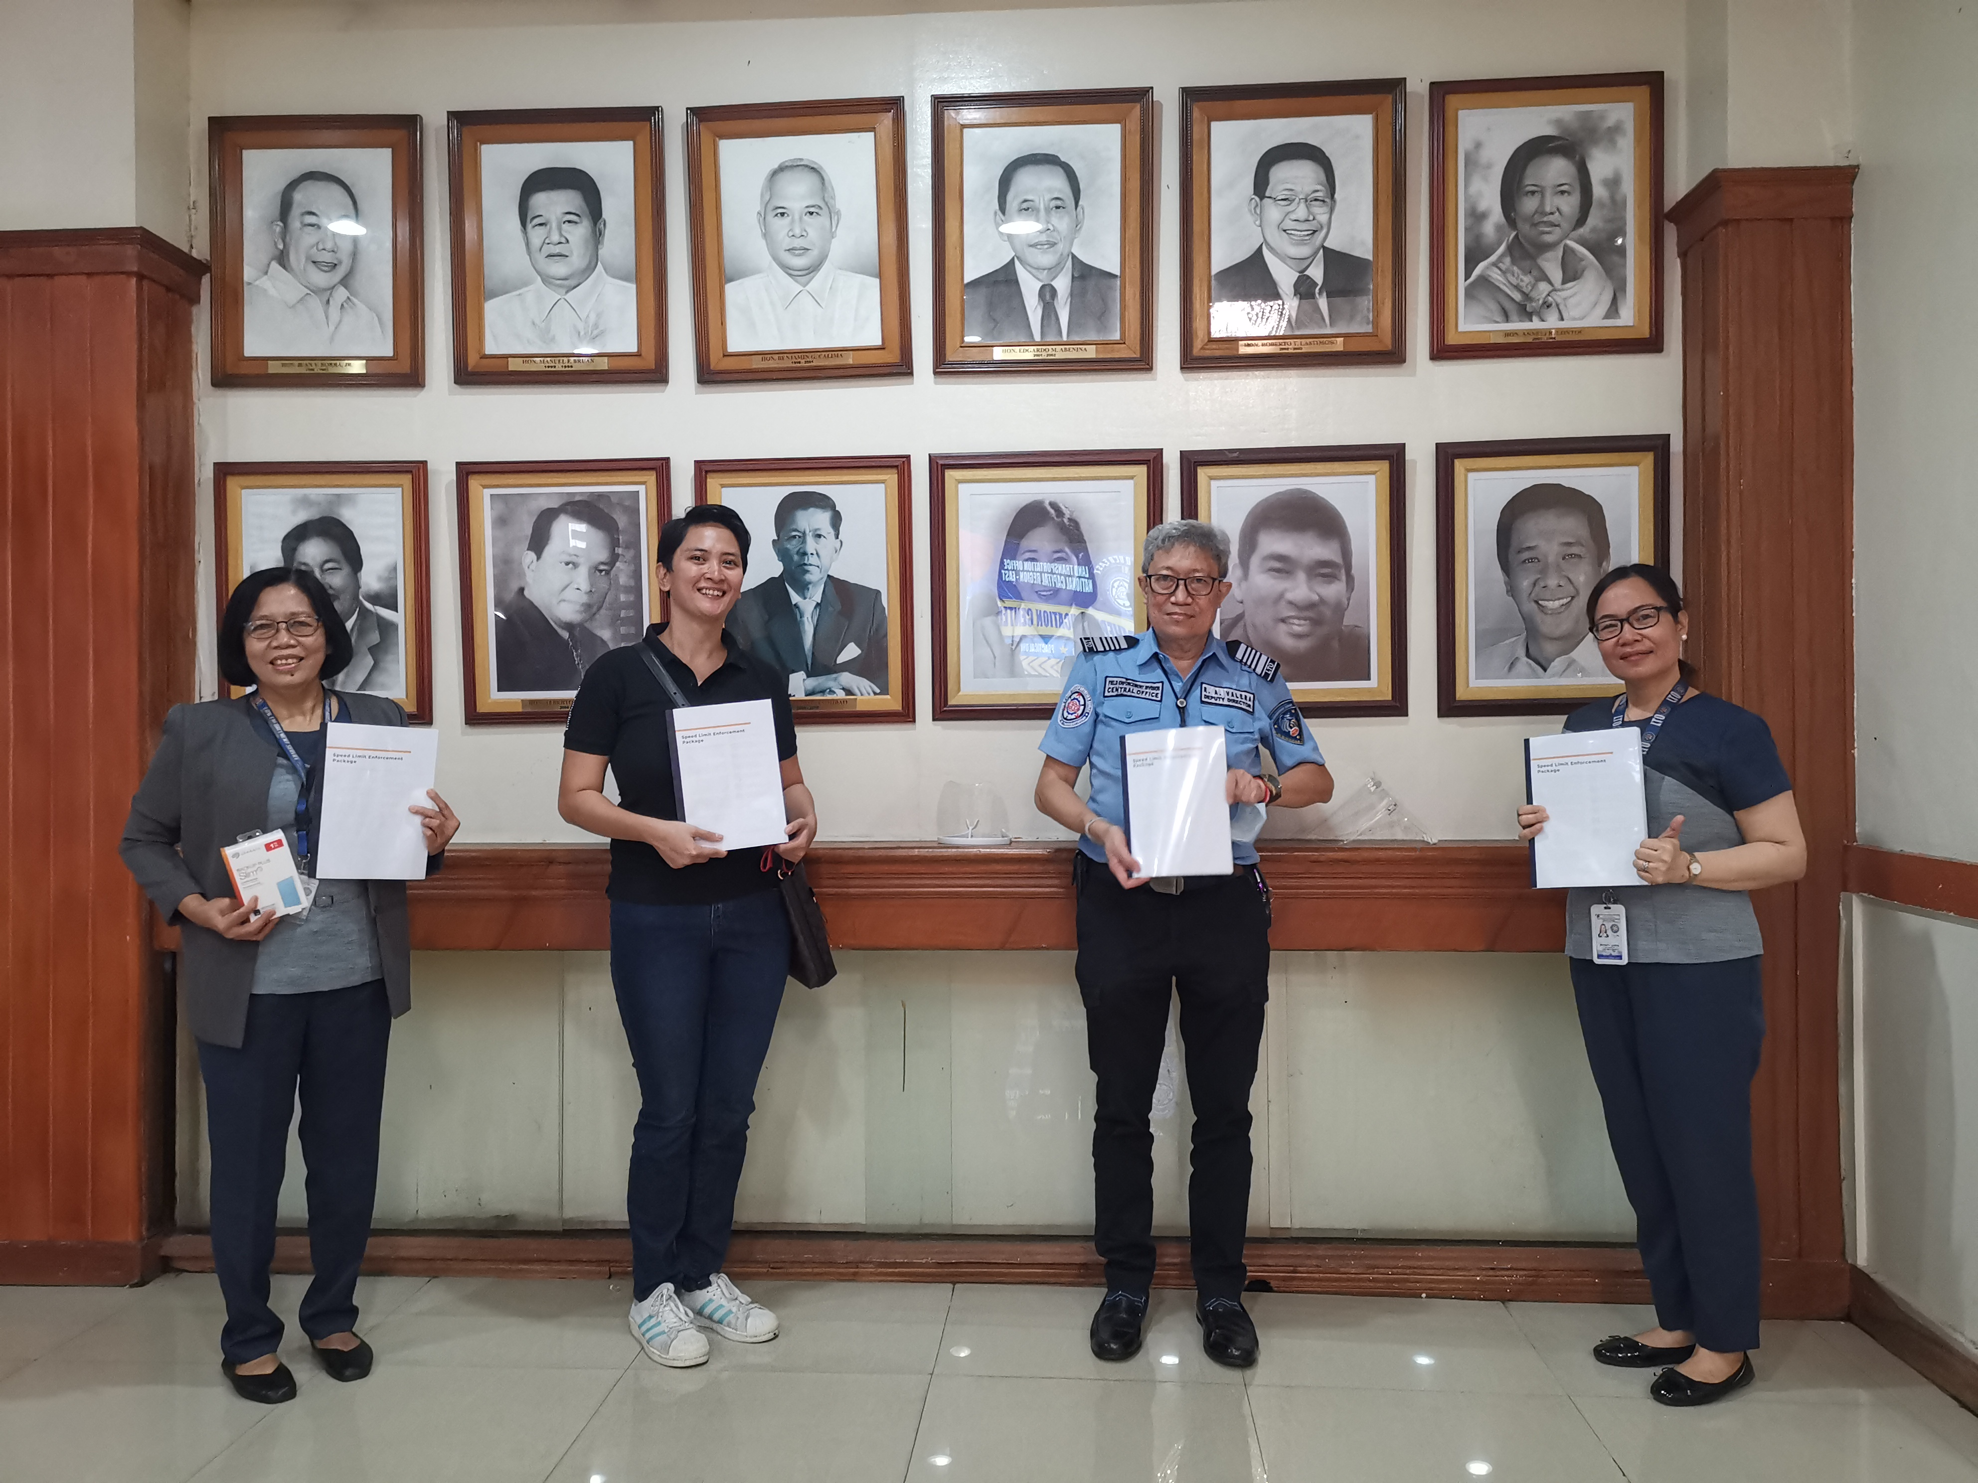

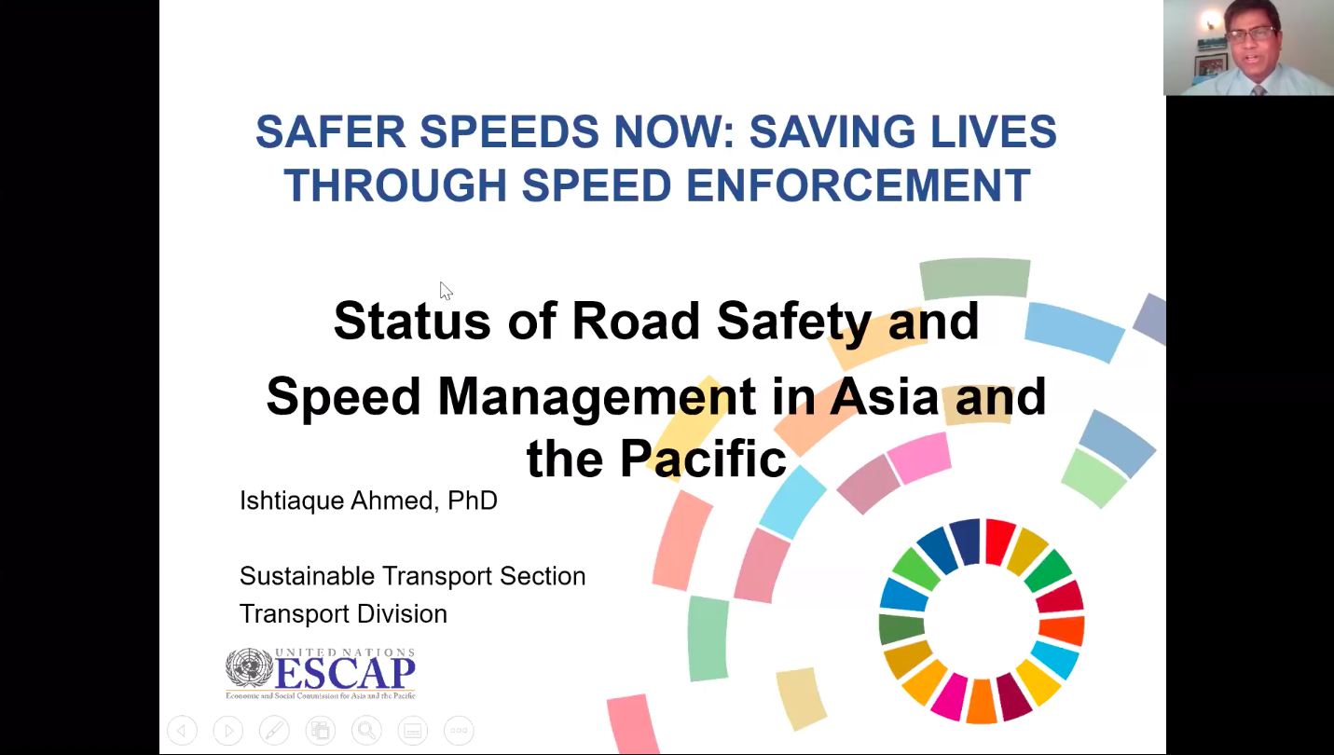

The term “programme” is used for programmes, joint programmes and projects.
Strategic Results, as formulated in the Strategic UN Planning Framework (e.g. UNDAF) or project document;
The MPTF Office Project Reference Number is the same number as the one on the Notification message. It is also referred to as “Project ID” on the project’s factsheet page on the MPTF Office GATEWAY.
The MPTF/JP Contribution is the amount transferred to the Participating UN Organizations – see MPTF Office GATEWAY
The start date is the date of the first transfer of the funds from the MPTF Office as Administrative Agent. Transfer date is available on the MPTF Office GATEWAY
As per approval of the original project document by the relevant decision-making body/Steering Committee.
If there has been an extension, then the revised, approved end date should be reflected here. If there has been no extension approved, then the current end date is the same as the original end date. The end date is the same as the operational closure date which is when all activities for which a Participating Organization is responsible under an approved MPTF / JP have been completed. As per the MOU, agencies are to notify the MPTF Office when a programme completes its operational activities. Please see MPTF Office Closure Guidelines.
Financial Closure requires the return of unspent balances and submission of the Certified Final Financial Statement and Report.

