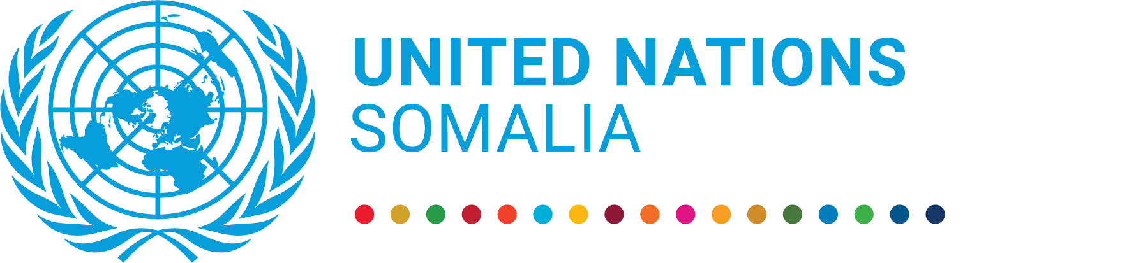 |  | UN Somalia Joint Fund  Progress report  1 January to 31 December 2021
Somalia Joint Justice Programme

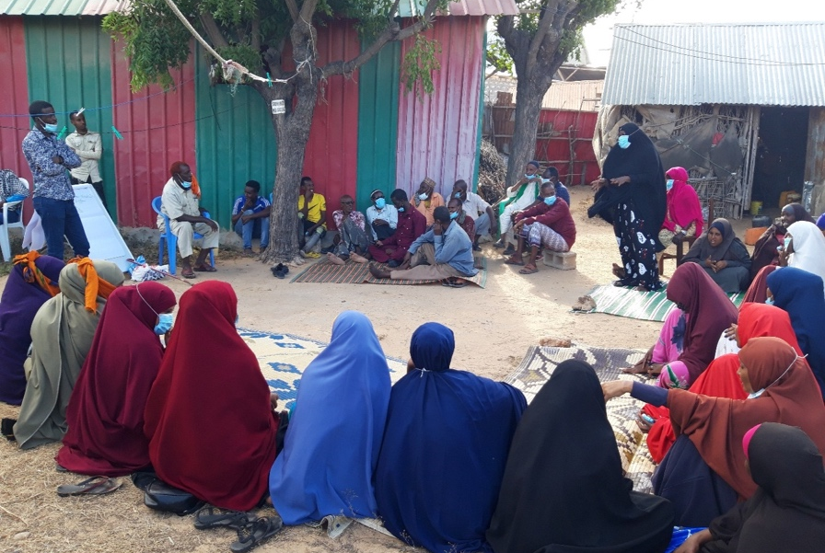 | “Through the people sitting here in this dialogue session, I got my land back after it was out of my hands for close to 30 years”  Amina Abdi speaking to a Community Conversation group about her struggle to reclaim her family’s land
Key achievements during the reporting period

- 9,267 beneficiaries, including 5,122 women, were able to access justice through the programme’s support for legal aid, ADR centres and mobile courts.
- 6,375 community members (of which 3,373 women) were engaged in Community Conversations sessions to find local solutions to shared issues of justice, security, and land use.
- Specialized SGBV units at AGOs in Puntland and Mogadishu handled a total of 127 SGBV cases for women.

Project data

MPTF Gateway ID | 00112621
Geographical coverage | Somalia
Project duration | 01 August 2018 to 31 December 2021 (extended to 31 December 2022)
Total approved budget | 25,209,013.00 USD
Programme funding level | MPTF = 21,556.960 USD  DFID through UNOPS = 585,000 USD
Estimated delivery rate | 99.6%
Participating UN entities | UNDP, UNSOM Joint Justice and Corrections Section, UN Women and UNICEF (and IDLO as non-UN agency)
Implementing partners | Ministries of Justice (FGS & FMS), Supreme Courts (FGS & FMS), ADR Centres, Legal Aid providers, Attorney General Offices in Puntland and Mogadishu, Puntland University, University of Mogadishu
NDP pillar | Pillar 2: ‘To achieve a stable and peaceful Federal Somalia through inclusive political processes, establishing unified, capable and accountable security institutions and establishing independent, accountable and efficient justice institutions.
UNCF Strategic Priority | Strategic Priority 3: All Somalis benefit from Peace, Security, and the Rule of Law, including Justice.  Strategic Priority 4: Effective and accountable institutions that respond to needs and rights of all Somalis.
SDG | 5, 16
Gender Marker | 2
Related UN projects  within/outside the SJF portfolio | Women, Peace and Security programme
Focal person | Doel Mukerjee, doel.mukerjee@undp.org; Damian Klauss, klauss@un.org

Report submitted by: Rob Frost, UNDP

 | PUNO | Report approved by: | Position/Title | Signature
1. | UNDP | Jacqueline Olweya | Resident Representative OIC
2. | UNICEF | Mohamed Ayoya | Representative
3. | UN Women | Sadiq Syed | Country Programme Manager
4. | UNOPS | Tim Lardner | Country Director
5. | UNSOM | Marco Carmignani | Director, ROLSIG

Section 1: Executive summary

Brief introduction to the project
The Somali formal justice system faces a great deal of challenges, including a generally low level of capacity, a lack of political coordination on a federal justice structure, inconsistent application of laws and a lack of basic administrative and management procedures. This, coupled with weak accountability, oversight, and institutional independence, means that communities appear to have little confidence in state justice institutions which they perceive as corrupt and partial. Traditional justice mechanisms provide an important alternative but tend to be discriminatory particularly against women, youth, and minority clans.
Recognising these challenges, the programme aims to contribute to sustainable security, peace, and development by strengthening RoL actors to increasingly deliver to justice system users and community justice services in a human rights compliant manner.
As part of the state building and federalization process, the programme will focus on laying out the foundations of a formal justice system that offers increasingly professional and standardized justice services as a basis for its gradual expansion. This includes a clear legal framework particularly on judicial organization, establishment key justice institutions at FMS and FG levels, definition of policies and procedures for selection, discipline, and career of justice personnel as well as court administration and case management. It will also seek to increase access to justice for the most vulnerable women, youth, and children as well as members of minority clans through an integrated justice system that includes courts and AGO and alternative dispute resolution mechanisms. Emphasis will be placed on bringing changes within the traditional justice system mechanisms to enable it to maintain relations among clans while also protecting individual rights.

Situation update / Context of the reporting period

During 2021, the security situation across Somalia was tense and volatile, primarily due to the political disputes and frequent terror attacks by Al-Shabaab and other non-state armed groups. The electoral impasse led to protests, riots, and armed clashes in Mogadishu, and subsequently occupied much of the attention of the federal government for the remainder of the year, resulting in a reduced focus on justice issues. However, the FMS were less affected by the political difficulties.
Somalia was also faced with the continuing COVID-19 pandemic, which continued to impact the implementation of the programme. Disruption to humanitarian and development assistance because of COVID-19 has exacerbated acute and chronic needs of particularly vulnerable persons, whilst movement restrictions such as stay-at-home orders, curfews, and school closures imposed in response to COVID-19 have also heightened the risk of SGBV, domestic violence and female genital mutilation.

Highlights of the project during the reporting period

- The Community Conversations initiative further expanded its reach, engaging 6,375 community members, including 3,373 women, to find local solutions to shared issues of justice, security, and land use. The sessions empowered communities to identify and explore their shared concerns, and to develop strategies for dealing with these issues, both in the community and in partnership with local authorities.
- The programme continued to support Access to Justice, particularly for rural and marginalised communities, through the provision of legal aid, ADR centres, and mobile court services, reaching a total of 9,351 beneficiaries during the reporting period, including 5,195 women.
- Training in principles of Non-Violent Communication (NVC) was piloted in the Baidoa ADR centre to improve resolution of disputes disputes by increasing understanding of needs and engaging women leaders in a more active role.
- Specialized SGBV units at AGOs in Puntland and Mogadishu handled a total of 127 SGBV cases for women.

Summary of key achievements during the reporting period

6,375 community members (of which 3,373 women) were engaged in Community Conversations sessions, providing them with a much-needed space to discuss concerns and trauma, both individual and societal, and discuss solutions through working together.

9,351 beneficiaries, including 5,195 women, were provided with access to justice services because of the programme’s support for ADR centres, legal aid, and mobile courts. In the ADR centre in Baidoa, a pilot model of Non-Violent Communication (NVC) was introduced to improve resolution of disputes by increasing understanding of needs and engaging women leaders in a more active role. Beneficiary feedback reported an improved capacity to address disputes within the community using NVC principles.

The SGBV units at the Attorney General’s Offices in Mogadishu and Puntland further strengthened their capacity to coordinate justice chain institutions, improve technical cooperation with the FMS and prosecute SGBV cases. A total of 127 SGBV cases were by the units during the reporting period, and the Puntland AGO office developed and launched an online database management system to track Gender-Based Violence cases based on the GBV guidelines and protocols in Puntland.

Detailed studies were conducted to reflect upon and analyse the impact of two core activities, namely the Community Conversations and the NVC training in Baidoa ADR, and to identify key recommendations for informing future programming. The findings and recommendations from these reports were published online (see Narrative section).

Reflection, planning and stakeholder consultations for the next phase of the JJP were initiated to ensure that lessons learned are captured from the current phase to inform the design of an improved programme with deeper transformational impact. Two comprehensive independent evaluations were conducted to support this process and analyze the success of the first phase.

Section 2: Progress Report Results Matrix

OUTCOME STATEMENT
Enhanced and accountable justice institutions operating in according with the justice model, increasingly deliver affordable justice services in key population centres in cooperation with location populations. These institutions provide a visible and effective justice presence in support of security transition, facilitates the peaceful resolution of disputes, and build trust and demand for federal and State-provided justice services. Judicial authority and independence are provided for in revised legislation including the constitutions
SUB-OUTCOME 1 STATEMENT
Adequate services are provided to vulnerable people based on community participation in justice reform
Output 1.1: The justice chain, including policing, is strengthened through community-oriented approaches
INDICATOR | TARGET 2021 | PROGRESS ON OUTPUT INDICATOR
 |  | REPORTING PERIOD  (2021) | CUMULATIVE
# of decisions derived from consensus within the community | 50 decisions | No data | Master trainers and community facilitators in each FMS location selected for the pilot project (Baidoa, Dhusamareb, Garowe, Jowhar, and Kismayo) trained on community conversation methodology. Community Conversations sessions conducted across all 5 locations throughout 2020/21.
# of people disaggregated by gender, age, and vulnerability, actively involved in community conversation sessions | 1,800 beneficiaries | A total of 6,375 people (F:3,373, M:3,002) participated in the community conversation sessions.  Programmatic support for Community Conversations ceased in Q3 2021. | A cumulative total of 9,913 people (F:5,369, M:4,544) have participated in the community conversation sessions.
UNDP ONLY: reports from community conversation sessions
Output 1.2: Improved access to justice and human rights through a multi-track approach
# of beneficiaries disaggregated by gender, age, and vulnerability, receiving legal aid services  Level of satisfaction with services provided based on representative sample drawn from the cases (of total cases) disaggregated by gender, age, and vulnerability | 10,000 beneficiaries (50% women, 50% IDPs) | 4,513 beneficiaries received legal representation or paralegal services (F:2,900, M:1,613).  Programmatic support for legal aid services ceased in Q3 2021. | A cumulative total of 17,461 beneficiaries received legal aid services (F:11,744, M:5,717)  A representative sample of 121 legal aid beneficiaries were interviewed and indicated an average level of satisfaction of 8.2 out of 10. 96.7% of respondents indicated not encountering any problems while using the legal aid services.
# of beneficiaries disaggregated by gender, age, and vulnerability, receiving services from the ADR centres  Level of satisfaction with services provided based on representative sample drawn from the cases (of total cases) disaggregated by gender, age, and vulnerability | 1,500 beneficiaries | 4,278 beneficiaries received services from the ADR Centres (F: 2,033, M:2,245) | A cumulative total of 12,982 beneficiaries received services from the ADR Centres (F: 5,657, M:7,325).  A representative sample of 203 beneficiaries of ADR services were interviewed and indicated an average level of satisfaction of 8.2 out of 10. 98.5% of respondents indicated not encountering any problems while using the mobile court services.
# of beneficiaries disaggregated by gender, age, and vulnerability, receiving services through mobile courts  Level of satisfaction with services provided based on representative sample drawn from the cases (of total cases) disaggregated by gender, age, and vulnerability | 500 beneficiaries | 560 beneficiaries received services through the mobile courts (F:262, M:298).  Programmatic support for mobile court services ceased in Q3 2021. | A cumulative total of 2,025 beneficiaries received services through the mobile courts (F: 888, M:1,137)  A representative sample of 126 beneficiaries of mobile court services were interviewed and indicated an average level of satisfaction of 8.8 out of 10. 97% of respondents indicated not encountering any problems while using the mobile court services.
2 pilot projects based on community-based response to SGBV, and juvenile cases developed through the community dispute resolution centre and implemented in two locations in Baidoa and Kismayo | Project concept developed based on emerging practices | Non-violent Communication (NVC) model pilot launched in Baidoa ADR centre with training course conducted by certified NVC trainer. | Convergence between community based social norms change programmes and Alternative Dispute Resolution mechanisms have been initiated in 2020.
Strategy on providing justice to recovered areas developed and implemented in one location | N/A - not supported by programme in 2021 | N/A - not supported by programme in 2021 | Concept note for bringing justice to the recovered areas developed and shared with the strategic partners and donors.
SUB-OUTCOME 2 STATEMENT
Drawing from community consensus, key justice institutions are strengthened to deliver on the priorities identified in the community dialogue with enhanced sustainability
Output 2.1: Basic principles for a justice model agreed upon by FG and FMS
# of FMS Rule of Law Working Group | 2 working groups | 2 ROL WG meetings took place in 2021 | Concept of Rule of Law Working Group revised with support from donors and UN to ensure stronger delivery on coordination and strategic planning  2 ROL WG meetings took place in 2021
# Basic principles agreed upon | N/A - not supported by programme in 2021 | N/A - not supported by programme in 2021 | The Justice and Corrections Model paper has been approved by the FGS Cabinet in 2018, and the JCM is still pending agreement and approval. 5 technical workshops have been concluded between the FGS and FMS judiciary (in Puntland, Jubbaland, South West, Galmudug and HirShabelle) for further discussions on the Justice and Corrections Model (JCM) and Judiciary Service Commission. The Supreme Court and FGS MOJ have also conducted 7 consultations in the FMS (Puntland, Jubbaland, South West, Galmudug, HirShabelle, and Banadir) on the JCM.
Public expenditure review of the justice sector including propositions for sustainable financing model of the justice sector | N/A - not supported by programme in 2021 | N/A - not supported by programme in 2021 | Concept note on financial analysis of the justice sector developed and awaiting comments from RoL Working Group
Output 2.2: Institutional and technical capacities of key justice institutions are established and informed from the community dialogue
Model information desks (information desk needs identified by the community in outcome 2) | N/A - not supported by programme in 2021 | N/A - not supported by programme in 2021 | Information desks established and operational for Banadir Regional Court, Banadir Appeal Court, and the Supreme Court. Guides for court users have been developed and finalized.
# courts with manual case filing system and case flow and standardization system with ability to record disaggregated data per type of cases (including SGBV) | N/A - not supported by programme in 2021 | N/A - not supported by programme in 2021 | At least 7 courts in 3 FMS have manual case management systems, with others in different stages of development.  Electronic case management system operational in Banadir (in all 14 Banadir district courts), with disaggregated data. Case information sharing protocols established.
Judicial training institute designed to strengthen the capacity of judicial officials to deliver justice | N/A - not supported by programme in 2021 | N/A - not supported by programme in 2021 | In 2019, consultations were undertaken, and progress made on the Strategy and Charter for the establishment of the Judicial Training Institute, institutional options, the judicial training programme master plan, as well as the selection of national trainers. The first phase of the Judicial Training of Trainers had concluded.
Model for specialized AGO units established on SGBV and serious crimes (capital crimes) | Ongoing support for SGBV units in PL and Mogadishu | 27 SGBV cases were handled by the AGO SGBV Unit in Mogadishu and 100 SGBV cases were handled by the AGO SGBV Unit in Puntland. | FGS AGO in Mogadishu fully functional and handled cumulative 211 SGBV related cases.  AGO Puntland SGBV unit established and handled 277 SGBV related cases.
Model of juvenile justice system established in Puntland | N/A - not supported by programme in 2021 | N/A - not supported by programme in 2021 | Cumulative from Federal and Puntland is 879 children diverted (F:102, M:777).
# of law students benefitting from the programme | 180 law students | 236 (F:80, M:156) students benefitted from the legal scholarship programme during the reporting period, continuing from previous scholarship awards. No new scholarships were awarded during the reporting period.  173 students (F: 56, M: 117). received legal scholarships to study at Mogadishu University. 63 students (F: 24, M: 39) received legal scholarships to study at Puntland State University. | A total of 236 (F:80, M:156) students have been granted legal scholarships.
Develop & finalize a roadmap for transfer of high-risk cases to the civilian courts through a stakeholder consultation | N/A - not supported by programme in 2021 | N/A - not supported by programme in 2021 | FGS MOJ produced a draft road map for the transfer of cases from military to civilian courts, which was discussed formally at a stakeholders’ consultation.  Roadmap for the Transfer of Serious Crimes Cases from Military Courts to Civilian Courts was developed and reviewed (2 September 2019).  The roadmap is awaiting presentation to the Council of Ministers by the Federal MoJ.
# of bar associations established, and functional with % of women lawyers registered | N/A - not supported by programme in 2021 | SBA membership in 2021 stands at 256 registered lawyers (F: 45; M: 211 – 17.6% women). | - Workshops have also been conducted in various FMS locations (Baidoa, Garowe, and Kismayo).  - Capacity injection for SBA was undertaken, with the recruitment of staff and interns for the Secretariat, and Regional Coordinators for Puntland, Jubbaland and Southwest, along with the set-up for SBA offices in Garowe, Kismayo and Baidoa.  - SOPs were developed for the SBA in finance, procurement, human resources, asset management and ICT.
# of laws monitored by PLDU | N/A - not supported by programme in 2021 | N/A - not supported by programme in 2021 | 46 laws, policies, legislations drafted/reviewed in 2019. 12 laws, policies, legislations drafted/reviewed in 2020.
Output 2.3: Programme Management
# evaluations conducted | N/A - no evaluation planned | Evaluation conducted May-July. Final evaluation conducted Oct-Dec and report will be completed Q1 2022. | The mid-term evaluation completed. Evaluation conducted May-July 2021. Final evaluation in progress
# of project monitoring visits per quarter, which specifically looks at access to justice for women clients | at least 1 per quarter, dependent upon COVID-19 restrictions | 1 field monitoring mission and 1 TPM mission conducted | Limited due to COVID-19 restrictions. 2 TPM missions conducted in 2020, 1 field monitoring mission and 1 TPM mission conducted in 2021
# PSCs held during programme implementation | 2 PSCs held | 3 PSCs held | 7 PSCs held
# annual UN Global Focal Point arrangements for Rule of Law’s retreat |  | N/A | 1-day meeting
Bossaso courts |  | Design process completed and  procurement process commenced | Design process completed and  procurement process commenced

Section 3: Narrative reporting on results

Progress towards outcomes

OUTCOME STATEMENT - Enhanced and accountable justice institutions operating in according with the justice model, increasingly deliver affordable justice services in key population centres in cooperation with location populations. These institutions provide a visible and effective justice presence in support of security transition, facilitates the peaceful resolution of disputes, and build trust and demand for federal and State-provided justice services. Judicial authority and independence are provided for in revised legislation including the constitutions

OUTPUT 1.1 - The justice chain, including policing, is strengthened through community-oriented approaches
The Community Conversations sessions continued throughout the year and concluded in Q3, engaging 6,375 community members, including 3,373 women, in the community-led discussions to identify, reflect upon and find local solutions to shared issues of justice, security, and land use. The community conversations follow a cycle of different stages: building trust, identifying concerns, exploring concerns, making decisions, implementing decisions, and ‘reviewing/reflecting’ on actions taken. Communities identified common concerns, which included sexual and gender-based violence (SGBV) issues, high rates of crime, land disputes, and the lack of effective and trustworthy local justice and police services. The community facilitators then encouraged the participants to further explore these shared issues to unpack the root causes and discuss actions to address their concerns. An increasing number of participants, particularly vulnerable ones, started to submit individual cases to the sessions, particularly land or domestic disputes. Solutions found together with the community reinforced social cohesion and reduced division along clan lines. In other sessions, participants in community conversations sessions discussed solutions to broader issues of security and justice, such as agreeing methods of improving interactions and communication between the community and police, engaging with the police to patrol specific areas, or engaging with local youth gang leaders to reduce crime.
As part of the programmatic support for the community conversation process, it was decided to provide training to the implementing partners and master trainers on Nonviolent Communication by an NVC certified trainer Each group of master trainers except for Baidoa underwent an online training of 6 to 9 hours depending on the availability of the participants. The training aimed to increase the master trainers’ facilitation skills, confidence, and capacity to explore deeper and sensitive issues relating to justice, security, and land.
A comprehensive study was conducted to analyse the outcome of the Community Conversations, evaluate the impact and challenges encountered, and identify lessons learned and recommendations for the next phase. The report, available to view here, highlighted the positive impact of creating a space for community members to discuss concerns and trauma, both individual and societal, and discuss solutions through working together. While the power imbalances and bias embedded in Somali society were still often reflected in the sessions, for example, women participants’ reluctance to contribute at first, changes occurred over time with more participation from women as well as minority clans. These are encouraging signs that community conversations can provide a space for transformative changes to occur. Individual cases with a strong power imbalance between the parties were demonstrated to be solved satisfactorily by the communities, indicating that the community conversations could serve as a framework for a new social contract to emerge. However, the sessions revealed a deep reluctance to discuss certain issues, for example the influence of some clans in the judiciary, for fear of creating tensions or backlash.

OUTPUT 1.2 - Improved access to justice and human rights through a multi-track approach
Access to Justice in Somalia, particularly for the marginalized, has continued to be supported by the programme through the provision of Alternative Dispute Resolution (ADR) centre, mobile courts, and legal aid services, reaching a total of 9,351 beneficiaries in 2021 (F:5,195, M:4,156). 4,513 beneficiaries received legal representation or paralegal services (F:2,900, M:1,613), 4,278 beneficiaries received services from the ADR Centres (F: F: 2,033, M:2,245), and 560 beneficiaries received services through the mobile courts (F:262, M:298). Programmatic support for legal aid and mobile courts ended in Q3.
The capacity of ADR centres to provide alternative justice was increased through training of staff and resolution committees; most notably in Baidoa, where a pilot model of Non-Violent Communication (NVC) was introduced with the aim of creating social change through the awakening of compassion and empathy. Traditional justice mechanisms can often be discriminatory, particularly against women and members of minority clans. Training was implemented to mitigate and prevent discriminatory practices, enhance their knowledge about human rights, and encourage social transformation through changes in attitudes and behaviour. The NVC training has triggered many changes in the ADR centre with, for example, an increased participation of women in the resolution of cases or the questioning of certain social norms. A comprehensive study was conducted on the transformative impact of the Nonviolent Communication (NVC) model on the functioning of the Alternative Dispute Resolution (ADR) centre in Baidoa and a report was developed, available here. The study concluded that the NVC training model brought change at several levels: at the personal level, through increased awareness of unconscious bias, such as clan or gender discrimination, and the capacity to communicate needs more effectively; in the functioning of the ADR centre, through improved understanding of empathetic dispute resolution and greater involvement of women members; and at the social level, by establishing the foundations for social change in regard to norms on clan and women’s roles, although further and deeper work is needed to fully prompt social change.

OUTPUT 2.1: Basic principles for a justice model agreed upon by FGS and FMS
Due to the reduction of programme funding in 2021, most activities in support of output 2.1 were deprioritised.
The Rule of Law Strand 2C Working Group met on 23 March 2021 and discussed:
- Rule of Law Support Evaluation
- Justice Sector Strategic Plan development process and funding gap
- Brief update from MOJ FMS
- Brief update on COVID-19 on Impact assessment

OUTPUT 2.2: Institutional and technical capacities of key justice institutions are established and informed from the community dialogue
AGO SGBV Units
Support for the SGBV units in Puntland and Mogadishu Attorney Generals’ Offices continued in 2021, with a combined total of 127 cases handled (Mogadishu 27, Puntland 100).
Prosecutors in the Mogadishu AGO were provided with training on charging (& drafting charge sheets), interviewing skills, marshalling evidence, and trial preparation, to enable them to better handle SGBV cases. The 4 prosecutors in the SGBV unit were further mentored in legal skills, prosecutions skills and tactics, handling victims, and use of evidence. 27 cases were handled by the Mogadishu AGO SGBV Unit prior to the conclusion of support in August but reporting from Madina Hospital at the SGBV Task Force meeting reported a total of 171 cases of SGBV in Q1&Q2, indicating a significant underreporting of SGBV cases to the police and subsequent prosecution.
The Puntland AGO launched an online database management system, developed by a local software firm, to improve the tracking and management of SGBV cases based on the GBV guidelines and protocols in Puntland. The system enables the safekeeping of records and confidential information; allows service providers to better understand the GBV cases being reported; help produces quality GBV client/incident data; eliminates bias and subjectivity used in classifying and defining types of GBV; and automatically produces statistical tables and charts on survivor profiles, alleged perpetrator profiles, incident trends and referral pathway tracking. Training and mentoring were also conducted in Puntland AGO to enhance the capacity and knowledge of prosecutors on the data management system, GBV protocols, guidelines for improving the case management system, prosecutions, sentencing, and the tracking and management of SGBV cases.
Legal Scholarships
The programme has continued supporting the professionalization of the justice sector, through the ongoing education of legal professionals in university. 173 students (F:56, M:117) continued legal scholarships at Mogadishu University and 63 students (F: 24, M: 39, among which 21 from Jubbaland and 22 from minority groups) continued scholarships at Puntland State University.
Somali Bar Association (SBA)
The SBA Secretariat collected membership statistics, showing 256 registered lawyers (F: 45; M: 211) as at 31 August2021, a 14.8% increase from 2020 numbers and 12.5% in the number of female lawyers. Of these lawyers, 120 are in Mogadishu (F: 15; M: 105), 77 in Puntland (F: 24; M: 53), 12 in Jubaland (F: 0; M: 12), 36 in Southwest (F: 5; M: 31), and 11 in Galmudug (F: 1; M: 10). As Hirshabelle lacks a Bar Association, verifiable data on the number of lawyers in this State is unavailable. Though significant, both rises demonstrate slower growth in SBA membership than was experienced in 2020, during which total membership rose by 22% and membership of women lawyers rose by 60%. Of the five (5) women lawyers who joined the SBA in 2021, four (4) are in Southwest and one (1) is in Galmudug.
Data collection capacity of the SBA has seen notable progress in 2021 because of capacity strengthening support provided by IDLO embedded staff in the SBA Secretariat. Consequently, the SBA now collects data on Somali lawyers, disaggregated by gender and region, in addition to securing the data through its database. The SBA is now able to collect data on its membership also in Galmudug (which, along with Hirshabelle, did not provide verifiable data on SBA membership in 2020).

Number of beneficiaries and feedback from beneficiaries

- A total of 9,351 beneficiaries were provided with Access to Justice in 2021 (F:5,195, M:4,156).
- A total of 6,375 community members (F:3,373, M:3,002) participated in the community conversation sessions in 2021
- The AGO SGBV Units in Mogadishu and Puntland collectively handled 127 SGBV cases in 2021.
- Beneficiary feedback was sought through interviews, surveys, and focus groups. A comprehensive study of the impact of Community Conversations was supplemented by a Third-Party Monitoring mission (report available here), which interviewed participants to provide feedback on the sessions. An earlier TPM mission surveyed a representative sample of beneficiaries of ADR centres, legal aid, and mobile courts to quantify their level of satisfaction in the services, averaging around 8.5 out of 10 (see RRF output 1.2)

Section 4: Project implementation

COVID-19 Response

The COVID-19 pandemic has continued to pose a challenge to implementation, largely through the need to maintain social distancing and constraints on travel or large gatherings. The programme continued to adapt through alternative working modalities and was able to push ahead with most activities – conducted in-person where possible and safe, and conducted virtually when the risk was assessed to be too great. Rule of Law Working Group meetings and PSC meetings continued to be held entirely or partly online.

Key constraints and challenges and associated corrective actions

The significant reduction of funding for the programme for 2021 necessitated a refocusing on core activities relating to service delivery. Consequently, support for other activities, particularly those falling under Output 2, was reduced, or removed for 2021, resulting in a reduced scope of programmatic activities and impact. The funding reduction also necessitated the cessation of support from Q3 onwards for some service delivery activities, such as legal aid and mobile courts.

The delay of elections in early 2021 and the resulting political disputes and insecurity, whilst not directly affecting the programme, drew the attention of the federal government and resulted in a reduction of focus in other areas, including justice issues. The political dispute has continued throughout 2021, reducing the ability to implement in partnership with the federal government and creating uncertainty over longer-term planning. However, the work in the FMS has been largely unaffected by this.

Risk management

Type of risk | Description of risk | Mitigating measures
COVID-19 transmission in Somalia | Staff exposure to the virus and inadvertently be a vector for the disease in Somalia, limited medical capacity may be overwhelmed, global travel restrictions resulting in limited freedom of travel outside the country including for medical reasons should the need arise | - Reduce footprint of staff at duty station, by implementing work from home / telecommuting arrangements for both international and national staff, with international staff leaving for their home or otherwise chosen location.  - Prioritization of activities related to supporting Somalia in its response to COVID-19, as well as recovery efforts.  - Mobilizing alternative modalities for implementation, such as online meetings and capacity-building activities
Insecurity | The Programme intended to support access to justice for the newly recovered areas, which at times remain difficult to access | lack of access to the district prevented the Programme to extend the mobile court activities to these areas. The Programme continues to monitor the security situation in close collaboration with the local MoJ to assess when mobile courts can be extended to these areas.
Increase in internal political divisions | An increase in internal political divisions will have detrimental effect on all activities and interventions under the Joint Programme. | While keeping track of all political developments, the Joint Programme will continue to build strong relationships with all local and FMS partners, with a focus to support a harmonized approach to RoL development across Somalia.
Interference with judiciary | Compromise or influence of the justice system if independence of the judiciary is interfered with by the executive | The Programme supported the justice and correction model to ensure the independence of the judiciary as well its roles and responsibilities to enable proper functioning of the justice system. The Programme also supported the intended activities of the judiciary to make sure that it receives support as an independent institution, thereby contributing to improving the transparency and accountability of the judiciary. The JCM is not yet endorsed by the national security council (NSC).
Corruption in the public sector | UN RoL activities undermined because of corruption | Strengthen oversight mechanisms and M&E
Community disinterest | Community conversation project and community-based interventions in general will not work and result in perpetuation of the status quo | Build and maintain strong relationships with NGO and master trainers who are supporting the initiative, to ensure regular communication and progress checks, as well as team reflections to address any anticipated or actual issues that arise in a timely manner. Consult with colleagues who have implemented similar models for other programmes for lessons learned.
Lack of interest in women’s empowerment interventions | The limited interest of justice and judiciary for women's empowerment interventions | Together with partners, it was agreed that 30% of the positions under this programme would be reserved for the recruitment of female candidates. The letters of agreement work as a mitigation strategy to ensure that women’s interests are represented in the justice and judiciary.
Quality of judicial documentation and work at FMS | High quality of judicial documentation at FMS capitals needs to be ensured. | During January to June 2019, the Programme supported the standardization and systematization of case files procedures and protocols in Jubbaland, South West State, Galmudug and HirShabelle to ensure that judicial documentation is improved and of high quality. Also, as part of enhancing the quality of the judiciary documents and capacity, a training needs assessment was conducted to support the judiciary in its capacity-building planning related to achieving harmonized, consistent, and high-quality trainings and documentation procedures.
Elections | Potential of dramatic changes to the political landscape can impact the Joint Programme implementation. Depending on the preparations for the elections the Joint Programme may have to realign its priorities especially the locations for the programme implementation | The Joint Programme may have to re-prioritize activities. Possible mitigation measures include a committed focus on technical capacity development of institutional counterparts.

Learning impact

As the reduction of funding resulted in the conclusion of some core activities, 2021 provided an opportunity for reflection and learning from the progress made, and the challenges encountered, so far in the programme. Key lessons learned on the Community Conversations and ADR centre initiatives were documented in the respective comprehensive reports mentioned above. Two independent evaluations, in Q2 and Q4 respectively, were carried out to provide all stakeholders with an assessment of the overall performance and relevance of the JJP, including progress made towards achievement of the objectives, identification of lessons learned, and provision of recommendations for future design and implementation of Phase II of the JJP.

It was noted by the programming team that community-based interventions early in the justice chain were the most effective, both in terms of impact and cost, in providing access to justice for marginalized populations. Increasing access to justice at the community level, rather than exclusively through formal institutions, can tackle the deeper causes of injustice and do so more sustainably than a costlier system reliant on international funding. However, for community-based justice initiatives to be truly effective, the processes must be inclusive of all community members, regardless of gender, clan affiliation, etc., which is ensured through a considered design of community interventions, careful selection of representatives, and inclusivity training for facilitators to ensure that all voices are heard.

Coordination with other UN entities including UNSOM/UNSOS within and outside the SJF portfolio

The smooth integration of UNDP and UNSOM for delivery of access to justice has been a key factor in the results achieved so far. UNDP’s programming team across the FMS have enabled effective coordination with national partners, whilst UNSOM’s Justice Technical Specialist has provided expertise in delivering access to justice.

Synergies with other funds (UN and non-UN) working on similar issues

Limited synergies with other programmes exist during the current phase, but close linkages are planned between the next JJP phase and the Women, Peace and Security programme on areas such as the inclusion of women law graduates in government institutions.

Partnerships

The programme continued its partnerships with the University of Mogadishu and Puntland State University to provide scholarships for legal students, to help develop the next generation of legal professionals in Somalia. The partnerships with ADR centres have been effective in making progress towards the mainstreaming of alternative justice systems, through provision of both resources and specialized NVC training.
The programme also partnered with a series of local NGOs to facilitate the implementation of Community Conversations across the FMS. The NGOs played a key role in mobilizing the community and the local authorities; however, their responsibilities would need to be redefined to enable communities to take over and organize sessions based on their needs.

Monitoring and oversight activities

Monitoring Activity | Date | Description & Comments | Key Findings / Recommendations
Justice team field visit to Baidoa ,Southwest state of Somalia | 31 January- 4 February 2021 | Team visit objective(s)  - Spend time at Baidoa ADR centre and see how it functions  - Briefing from the ADR coordinator  - Exchange session with women leaders  - Exchange session with traditional elders  - Attend an Introductory session of Nonviolent Communication  - Participate community conversation session to document progress, challenges, and best practise | - Need to harmonize efforts of UNDP and IDLO regarding ADR centers in Southwest  - To engage the trained women leaders and traditional elders as TOTs to others including IDLO new groups  - To provide transport facilities at the centre will be very useful for outreach purposes – conflict prevention and awareness assisted a lot in lowering cases coming to the centre the few months the centre had transport facilities  - To give the CCE facilitators a practical training instead of online as this could have improved their approach and misconception, they have for CCE – from teaching to facilitator  - Since community traditional elders and women leaders are willing to support, if focus could be shifted to securing a land for ADR centre instead of provision of an operational cost – for the purpose of sustainability and community ownership
PSC Meeting | 12th February 2021 | Programme Steering Committee meeting - virtual | - Approval of AWP for Jan-April 2021  - Explanation of budget constraints and impact upon activities  - Extension of JJP until Dec 2021  - Planning commenced for next iteration of JJP
Technical Programme Meeting | 10th May 2021 | Technical Programme Steering Committee meeting | - Recommend approval of JJP WP until July 2021  - Recommend rehabilitation of Bossaso prison
PSC Meeting | 26th August 2021 | Programme Steering Committee meeting | - Progress update for PSC members  - Approval of ToR for evaluation  - Update on development of new JJP phase
TPM mission | Q1&Q2 2021 | TPM mission to interview Community Conversation participants in Garowe and Baidoa | Available to view here
Evaluation | May-July 2021 | Third-Party Monitoring Evaluation contracted by the EU | Available to view here
Final Evaluation | Oct-Dec 2021 | Independent Final Evaluation | Available to view here

Communication activities

UN Women Somalia produces newsletters programmes including the joint justice programme interventions. The newsletter covers key success stories from the fields, in particular activities around women’s access to justice, ending SGBV and effective prosecution of SGBV related cases.

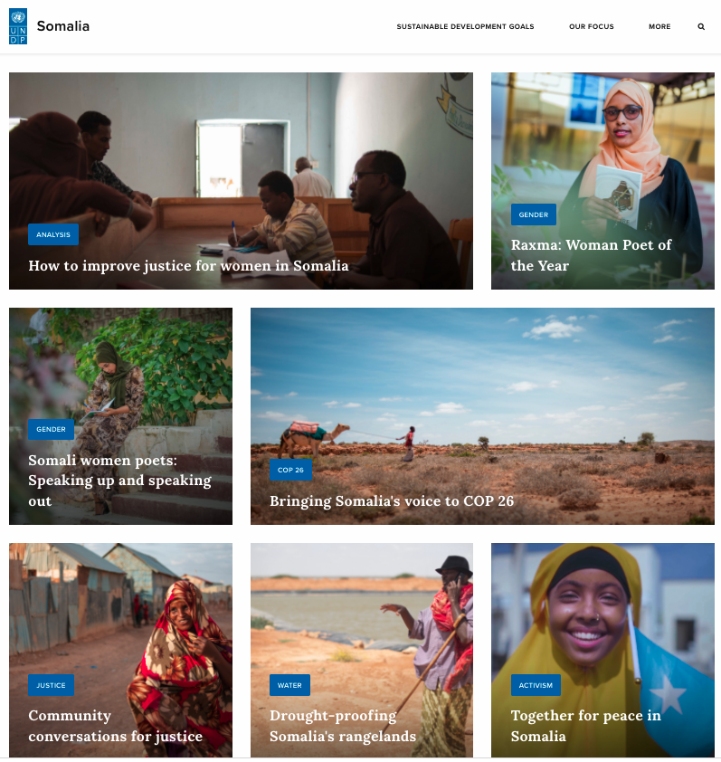
The two comprehensive reports, on Community Conversations and the Baidoa ADR centre respectively, were published on the UNDP in Somalia website (right), including beneficiary interviews. Beneficiary human interest stories and photos were also captured to highlight the impact of the interventions.

Regular updates, highlights and profiles were shared via Facebook, Twitter, and Instagram to increase awareness of programming and the impact of donor funds. Human interest stories in the justice sector were filmed and presented in videos shared via UNDP’s YouTube channel, such as the story of the female coordinator of Baidoa ADR Centre, available here.
Section 5: Project management

Number of project board meetings held | 3
Number of UN staff (international/national) funded by the project | 14
Number of government personnel funded by the project? | 30
How has the project ensured the visibility of SJF donors during the reporting period? | The contribution of SJF donors has been highlighted in each workshop, publication, and communication activity
Projected funding needs for next year | N/A

Section 6: Cross-cutting issues

Gender equality and women empowerment

The Joint Justice Programme mainstreams gender throughout all its activities, ensuring that gender markers and concerns are articulated in the description of the activities and that gender-sensitive indicators are in place. The programme implementation has specifically focused on access to justice and participation in justice reform for women and vulnerable groups and the transformation of social norms.
Steps have been taken to promote the inclusion and active participation of women in all activities, and to encourage leadership of women. For example, in the alternative dispute resolution mechanisms, the programme enhances access to justice for women by increasing and ensuring their participation and addressing their issues in the ADR centres. The training of ADR members on Nonviolent Communication has created a deeper connection between women leaders and male elders and enabled the elders to better understand women’s concern while solving disputes.
Gender equality and women’s empowerment have been promoted through the Community Conversations initiative, encouraging participants to challenge deep-seated biases and gender power dynamics. The community facilitators were selected on the basis that they are representative of local communities and specifically include women leaders, minority clans and youth. Through the initiatives, UNDP has empowered women to vocalize their justice needs and to participate more meaningfully in community-based approaches to justice – for example, TPM feedback from female community conversations participants in Baidoa reported they have coordinated with other women networks to identify cases of GBV to help the victims and link them to the police to seek justice
In relation to sexual and gender-based violence (SGBV) specifically, support to SGBV prosecutorial units continues to contribute to the number of rape cases being prosecuted. Since the onset of COVID-19, particular attention has also been focused on monitoring the trends regarding sexual and gender-based violence with the establishment of the SGBV task force in Mogadishu

Proportion of gender specific outputs in the project | Total number of project outputs | Total number of gender specific outputs
 | 2 | 0
Proportion of project staff with responsibility for gender issues | Total number of staff | Total number of staff with responsibility for gender issues
 | 14 | 11

Human-rights based approach

The Joint Justice Programme follows human right principles in its implementation. The human rights-based understanding of access to justice underpins the interventions that aim to improve the equal access to justice for all. This includes not only access, but also effective justice that incorporates both procedural and substantive justice. Furthermore, the programme considers the intersectional impacts of discrimination, and is alive to the clan as well as gender-based issues that perpetuate the existing power dynamics and social structures. The programme’s support boosts the institutional capacity of AG offices to promote access to justice for victims of sexual and gender-based violence and address protection challenges relating to women and girls. One of the main responsibilities of the Specialized Units is effective data collection and management on SGBV cases while focusing on the use of specialized prosecution services to reduce the existing gaps that affect female access to justice and to increase the effectiveness of case management through early and speedy investigation and prosecution of SGBV cases.

Has the programme included a protection risk assessment in its context analysis, including on gender issues, and taken measures to mitigate these risks to ensure they are not exacerbated, or new risks created? | Result
 | Yes
Number of programme outputs specifically designed to address specific protection concerns | Result
 | No
Number pf programme outputs designed to build capacity of duty bearers to fulfil their human rights obligations towards rights holders. | Result
 | 2

Leave no one behind

The Community Conversations initiative has contributed to the reduction of exclusion through empowering communities to come together to identify and explore their security and justice concerns, and work with local authorities to address those concerns. Beneficiaries, and the most marginalized within those communities, reporting improved access to community-led justice solutions through greater interaction and engagement between different social groups. Equally, the provision of legal aid, mobile courts and ADR centre services has reduced exclusion by improving the ability of the marginalized, whether by poverty, gender, geography, or clan, to access the justice system.

Social contract and legitimacy

The Community Conversations initiative, through enabling marginalized elements of communities to better engage and voice their views, have improved the capacity of communities to identify their shared concerns and cooperate with local authorities and institutions to address these concerns, thereby strengthening the social contract. The functioning of federal and state institutions has been enhanced through capacity building.

Humanitarian-development-peace nexus

N/A

Environment and climate security

N/A

Prevention of corruption

UNDP uses an Internal Control Framework, supported by Harmonised Approach to Cash Transfer (HACT) assessments and financial spot checks conducted with partners to ensure fiduciary responsibility and assess risk, to counter the risk of corruption.

Project sustainability

# | Target group |  | Dates | Number of participants |  |  | Title  of the training | Location of the training | Training provider
 | Ministry, District  or UN staff | Others |  | M | F | Total
1 | Women Lawyers and Women Leaders |  | January 2021 | 0 | 20 | 20 | Legal empowerment, women’s rights and Islam | Garowe | Ministry of Justice Puntland
2 | Jubaland MOJ |  | March 2021 | 2 | 1 | 3 | Non-violent communication training | Kismayo and Baidoa | UNDP ROLs through NVC consultant
3 | CCE NGO- community facilitators and master trainers |  | March 2021 | 4 | 0 | 4 | Non-violent communication training | Kismayo and Baidoa | UNDP ROLs through NVC consultant
4 | SWS MOJ -ADR Centre |  | 26-31 May and 6-8 June 2021 | 30 | 30 | 60 | Non-violent communication training | Baidoa -Southwest state Somalia | UNDP ROLs through NVC consultant
5 | Ministry of Justice JL |  | 10-13 August 2021 | 19 | 17 | 36 | Gender responsive training and customary law of Somalia | Kismayo | MoJ JL
6 | Ministry of Justice PL |  | 23-26 August 2021 | 0 | 30 | 30 | Training on Legal empowerment, counseling, psychosocial and referral pathways | Garowe | MoJ PL
7 | Ministry of Justice PL |  | September 2021 | 18 | 22 | 40 | Training on gender responsive Judiciary authority manual | Garowe | MoJ PL
8 | Ministry of Justice FGS |  | 4-6 September 2021 | 6 | 1 | 7 | ToT on NVC and design & systems thinking, to develop trainers for justice month workshops | Mogadishu | UNDP
9 | Ministry of Justice SWS |  | 4-6 September 2021 | 30 | 0 | 30 | Training on Legal empowerment, counseling, psychosocial and referral pathways | Baidoa | MoJ SWS
10 | Ministry of Justice JL |  | 13-14 September 2021 | 12 | 16 | 28 | Training on Legal empowerment, counseling, psychosocial and referral pathways | Kismayo | MoJ JL
11 | SWS Justice Stakeholders |  | 21-26 September 2021 | 23 | 9 | 32 | Justice Month Consultation and training on Nonviolent communication and design & systems thinking methodologies | Baidao | MoJ FGS & UNDP
12 | AGO Puntland |  | 25-30 September 2021 | 5 | 5 | 10 | Training on gender-based violence service providers in the Gender Based Violence Information database management system. | Garowe | AGO Puntland
13 | Jubbaland Justice Stakeholders |  | 26 September - 01 October 2021 | 20 | 6 | 26 | Justice Month Consultation and training on Nonviolent communicationand design & systems thinking methodologies | Kismayo | MoJ FGS & UNDP
14 | Ministry of Justice SWS |  | 27-28 September 2021 | 30 | 30 | 60 | Gender responsive training and customary law of Somalia | Baidoa | MoJ SWS
15 | AGO Puntland |  | 2-4 October 2021 | 11 | 9 | 20 | Training for SGBV procedures and data collections | Garowe | AGO Puntland
16 | Puntland Justice Stakeholders |  | 24-29 October 2021 | 16 | 14 | 30 | Justice Month Consultation and training on Nonviolent communicationand design & systems thinking methodologies | Garowe | MoJ FGS & UNDP
17 | Galmudug Justice Stakeholders |  | 03-09 November 2021 | 24 | 9 | 33 | Justice Month Consultation and training on Nonviolent communicationand design & systems thinking methodologies | Dhusamareb | MoJ FGS & UNDP
18 | Hirshabelle Justice Stakeholders |  | 07-12 November 2021 | 19 | 7 | 26 | Justice Month Consultation and training on Nonviolent communicationand design & systems thinking methodologies | Jowhar | MoJ FGS & UNDP
19 | Banadir Justice Stakeholders |  | 7-13 December 2021 | 19 | 8 | 27 | Justice Month Consultation and training on Nonviolent communicationand design & systems thinking methodologies | Mogadishu | MoJ FGS & UNDP
Total number of participants |  |  |  | 288 | 234 | 522

Section 7: Looking ahead: Focus on the future

The keyy priority is the design of a new phase of the JJP, incorporating the lessons learned and independent recommendations from the first phase to develop an improved programme. Justice Month consultations with stakeholders in all FMS and Benadir were conducted to identify justice sector priorities for a new phase, and the finding will be documented in a report to be shared in Q1 2022. The recruitment of consultants is in progress to develop a political economy analysis and to assist in the finalization of justice sector strategy of the government. The development of a new framework will include greater focus on gender-specific outputs and indicators, and increase monitoring of community and beneficiary-level impact.

Section 8: Human interest story: Voices from the field

- Community Conversations session in Kismayo
Amina Abdi is a 42-year-old mother of 7 children from a minority clan in the Kismayo and Lower Jubba region of Jubbaland. As a respected women leader in her IDP camp, Amina was selected to be a participant in the Community Conversations session conducted by HDC in her location. Realizing the subject matter and key discussions in the community dialogue directly affect her life, Amina volunteered to share her story with the other participants, including influential community representatives and community facilitators.
During the 1990-1992 civil war in Somalia, Amina’s father was killed, and she and her family fled to Kenya. At the time Amino was 11 years old. Amina and her little sister grew up in the Dadab refugee camp in Kenya with their mother, living there for many years. Amina’s little sister was fortunate enough to get a sponsor from a relative to relocate to the USA and now lives in Washington DC. Their mother died in 1999 in the refugee camp. Amina also met her husband and father of her 7 children in the Dadab refugee camp. After living in Dadab refugee camp for many years, Amina and her family decided to relocate and return to Kismayo town.
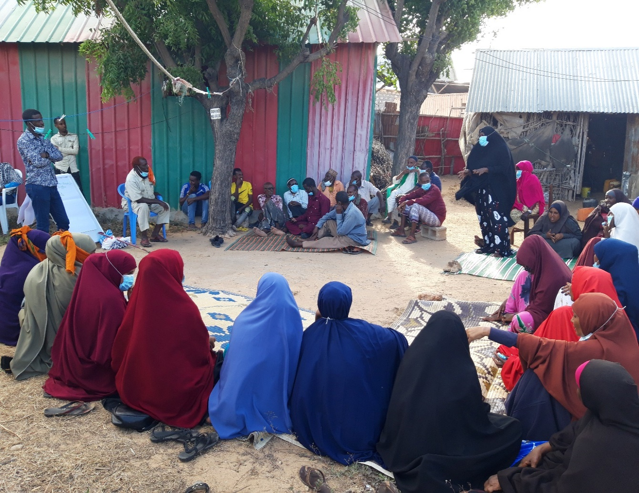
Photo: Amina narrating how she got back her land during one of the community sessions

Prior to the civil war, Amina’s family lived in small two-bedroom house built by their father, but Amina had received information that another family from the dominant clan were living on her family’s land while she was still in Dadab. She was determined to get back her land regardless, confident that witnesses would support her claim, and returned to Kismayo, initially staying in an IDP camp in Kismayo.
Once Amina had shared her story, the community members agreed to lobby on her behalf to get back her land. The community interviewed witnesses and confirmed that the land belonged to Amina’s family. Community representatives, supported by local ‘ULAMAS” (religious leaders) from the local mosque, began to negotiate with clan elders from the family that were now staying on Amina’s land.
Through this community mobilization and activism, and with support of local elders and religious leaders, Amina successfully got back her family’s land, 30 years after they were forced to flee from conflict. Amina said “The HDC community dialogue was a blessing in disguise for me; through the people sitting here in this dialogue session and community mobilization, I got my land back after it was out of my hands for close to 30 years.”

- Mobile Court Missions for vulnerable groups in Qardo, Puntland
On 15 May 2021, Nasteho Omar Siyat presented a case to the mobile court team at Libah Har village in Qardo District. She accused Abdikarim Nour Abbas, her former husband, of divorcing her and refusing to pay a dowry. The court called the accused, heard the evidence from both sides, and ruled in favour of Nasteho. Abdikarim was ordered to pay Nasteho a dowry amounting to $400. Nasteho was not charged by the mobile court for the case.
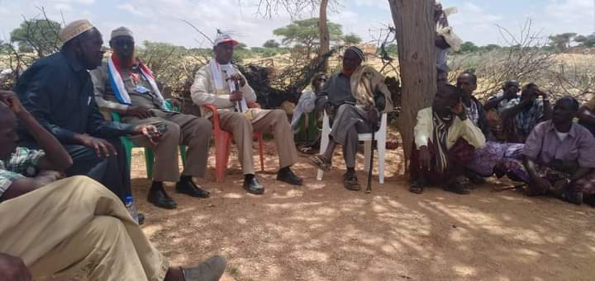
As Libah Har Village is around 50km from the capital of Qardo district, it would have been very difficult for Nasteho to access a justice service without the mobile court. She would have incurred significant costs for transport, lodging and accommodation, and lawyers during the trial period, rendering the claim for a dowry pointless. The mobile court enabled her to access justice without the time, expense, and possible danger of travelling to an existing court.

Photo- Mobile court mission team listening to Nasteho’s case in Qardo, Puntland

It has not been practical or informative to quantify decisions taken the community as the conversations take the form of discussion, reflections, coordination and ongoing actions rather than decisions. A comprehensive report, available here, provides much more detailed information regarding the outcomes of the community conversations sessions.
The trainer is certified by the Center for Nonviolent Communication. She was already hired by the programme to provide training on NVC for some ADR centers.
Baidoa town experienced serious internet connection problems at that time and it was not possible to organize any training with the trainers there.

