TITLE: UNEMPLOYMENT & UNDEREMPLOYMENT: youth in crisis

SUMMARY
The study explored the level of employment among young people, monthly pay/earnings and expenditure level in terms of dependency. Although more than half (63.7%) of the respondents reported that they are employed while 36.3% reported unemployed, our analysis revealed that majority of those employed are self-employed (74.3%) and working in the agriculture sector as small-holder farmers. Even in this sector, it is understood that they face major challenges such as lack of access to adequate farming materials and finance to embark on large scale production; thus, limiting their ability to transform their lives. There is equally low level of employment by the Government which employs only about 6.8% of the respondents compared to 18% by the private sector. 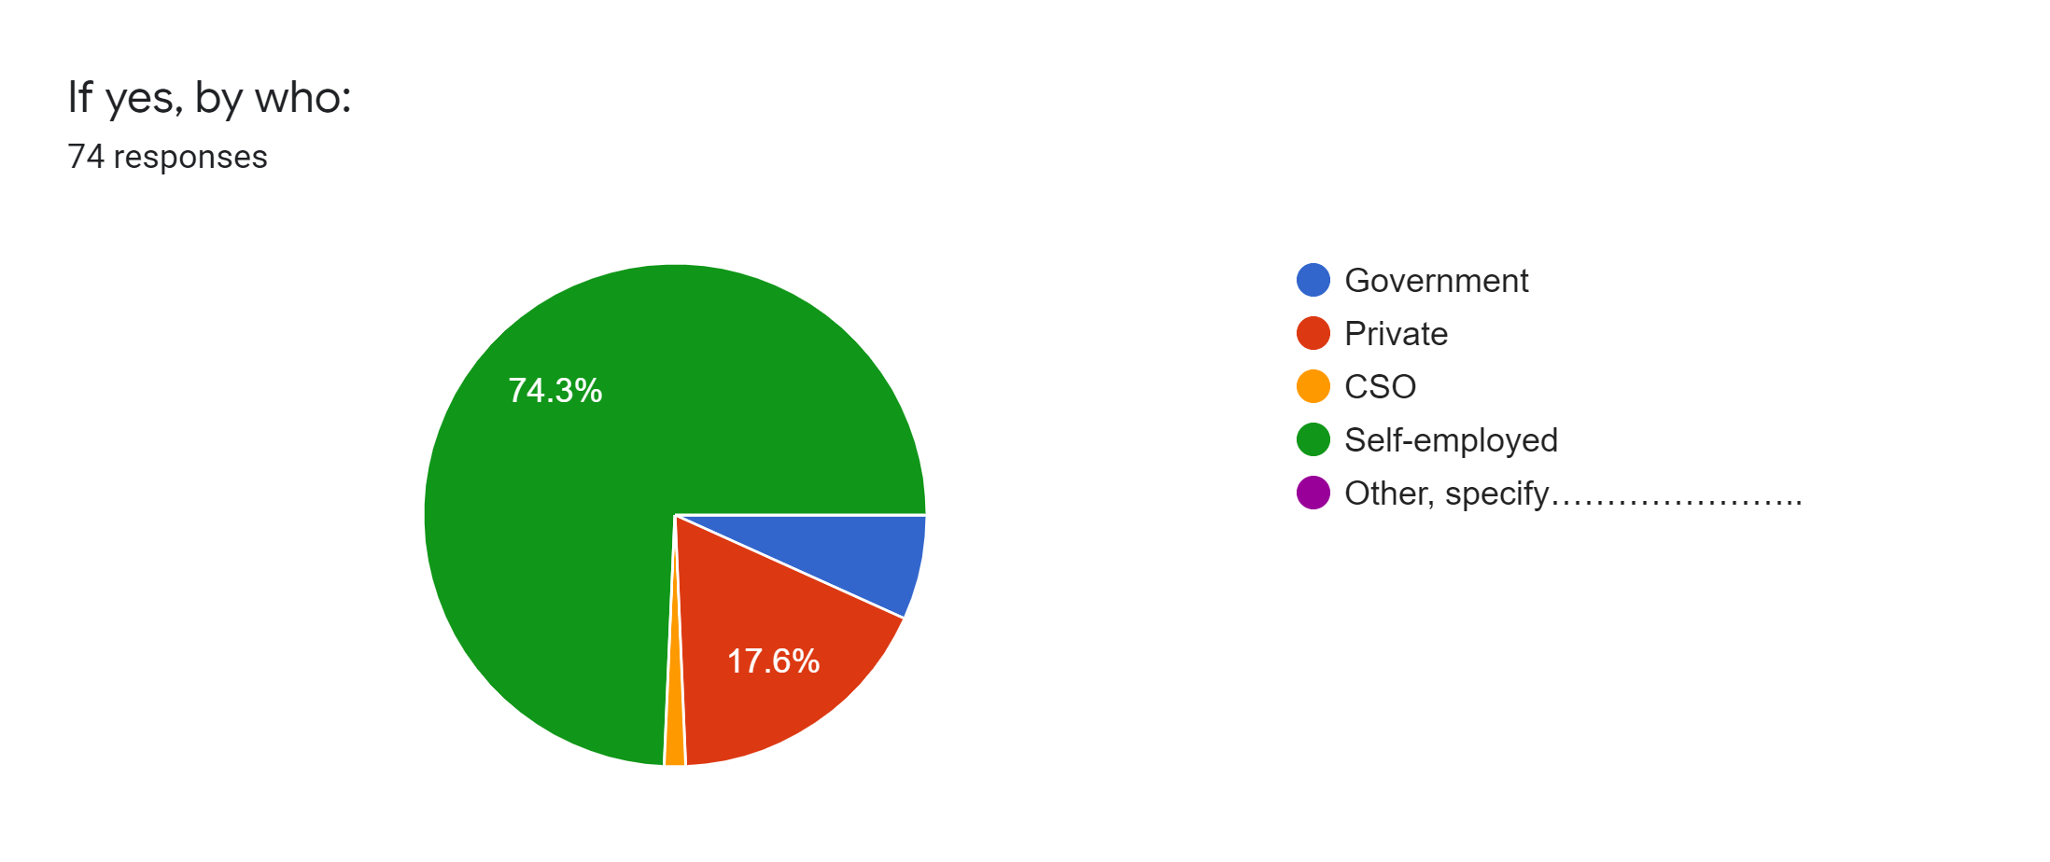
For those who reported unemployed, 85.3% of them are in such status because they either lack job opportunities or the required level of education and skill. This is linked to the centralisation of job opportunities institutions and advance educational institutions in urban Gambia. 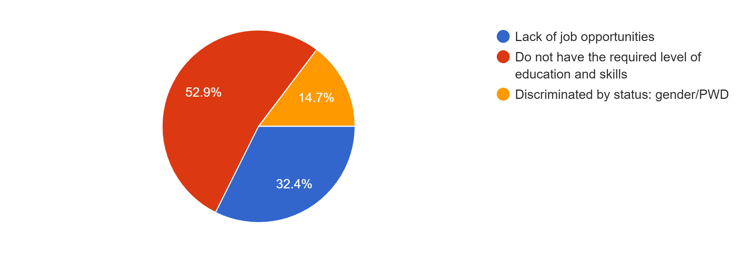

In terms of monthly earnings, the study revealed the indication of high underemployment through the low levels of earnings among youth. About 84.5% of the respondents have a monthly earning of just about D5000 and below. Despite these low monthly earnings, about 79% of the respondents reported that they have about 4 to 13 people depending on them for their sustenance. Their underemployment is in consistent with job dissatisfaction. Our surveyed revealed that 25.3% of respondents do not like their current job but are sticking around due to lack of other options or choices (63.2%).
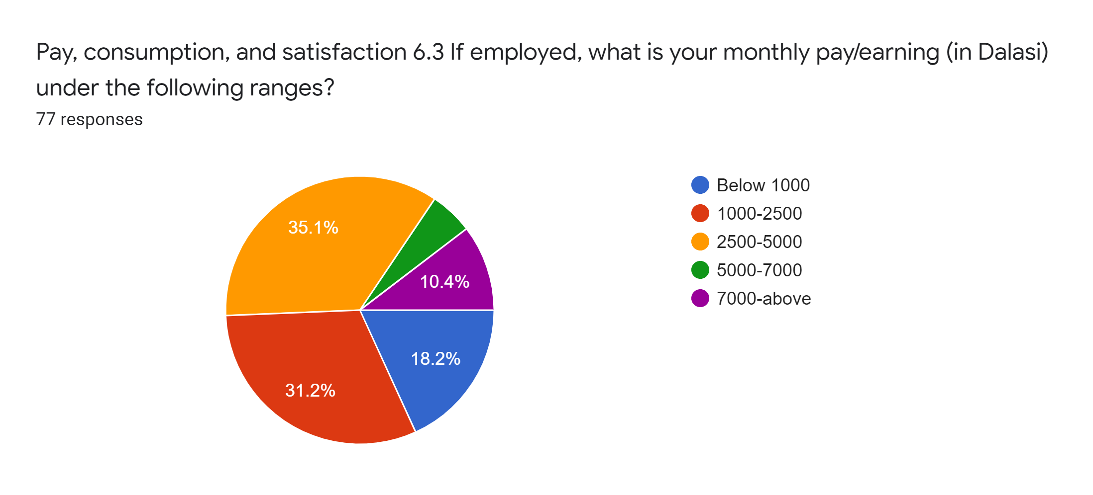
INTRODUCTION
The youth in The Gambia still face issues of unemployment and underemployment. The youth in The Gambia are affected by the country’s employment challenges which included a saturated public sector, a small private sector to absorb labour, limited employable skills and capacities among youth, as well as low investment levels. This pushes youth on the fringes of underemployment which appears to be their major employment issue. And this continues to affect their ability to provide for and sustain themselves and their family, and to make savings and profitable investments in building a better future for themselves.

RECOMMENDATIONS
- The Gambia Government should introduce a minimum wage across all sectors of employment that commensurate a desirable level of living standards.
- There is need to create an attractive environment for regulated investments in the private sector including investments in agriculture.
- The Gambia Government should create a youth enterprise development fund to enable young entrepreneurs access finance for entrepreneurship development.
- The entire education curricular should be reviewed, and further decentralised to promote skills-based education in various fields; and upgrade Technical and Vocational Education Training (TVET) institutions to equip youth with more practical knowledge and skills preparing them for the labour market.

