High-level Meeting Report

Cross-Border Engagement to Strengthen Social Cohesion and Border Security - Phase II
Acronyms
AFL Arm forces of Liberia
CBO Community Based Organization
CPC Community Peace Committee
CSC County Security Council
CSO Civil Society Organization
DSC District Security Council
ECOWAS Economic Community of West African States
EU European Union
GOL Government of Liberia
IOM International organization of Migration
NCSCL National Civil Society Council of Liberia
LIS Liberia Immigration Service
LNP Liberia National Police
LRRRC Liberia Rehabilitation Repatriation Reintegration
MIA Ministry of Internal Affairs
MOJ Ministry of Justice
NSA National Security Agency
PBF Peace Building Fund
PBO Peace Building Office
SEWODA Southern Eastern Women Development Association
UN United Nations
UNRC United Nation Resident Coordinator
UNHCR United Nation High Commissioner for Refugees
UNDP United Nation Development Programme

Summary
This report covers outcomes of the Joint Cross- Border Project Phase II high-level meeting which took place from the 18th -22nd of 0ctober,2021. The meeting was convened in two major sessions, the technical session, and the high-level meeting. This report also highlights key activities ranging from presentations, the development of resolutions, the technical sessions that included preparatory meetings and country-focused group reviews, live testimonies about cross border concerns and experiences, to a cultural dance performance. In the technical session country-focused group reviewed the project progress, presented key challenges, lessons learned and recommendations. Also, during the technical sessions, two PowerPoint presentations were made by the Project Coordinator and the PBO senior programme manager. Other remarks were made by the Secretary General of the National Civil Society Council of Liberia (NCSCL), staffs of UNDP Liberia and Ivory Coast and the Deputy National Security Advisor of the National Security Agency. A guideline for the Country group review was also presented by the Executive Director of PBO, Ministry of Internal Affairs. The country-focused group was divided into four (4) groups with each group representing either one of the two countries. Each country focused group was presented a set of questions to get their views and stimulated discussions about the project’s progress and results. The High-level meeting served as a platform to inform heads of national security institutions, the National Civil Society Council, representatives of community-based organizations, regional and international partners (ECOWAS, MRU, AU and UN) local authorities of Nimba County of the Government of Liberia and Cote d’Ivoire about the project’s implementation and progress updates, the challenges and lessons learnt including recommendations. The formal presentations were made by the United Nation Resident Coordinator, IOM’s Chief of Missions for UN- Ivory Coast, Assistant Resident Coordinator for UN-Liberia along the ministers of Interior and Internal Affairs. A total of hundred (100) plus participants attended the meetings. Institutions represented at the high-level meeting were, UNDP, IOM, PBO Secretariat, CSOs/CBOs, national security agencies, youth groups, internal affairs county officials, cross-border market women and other CBOs/CSOs, community members along Liberia-Cote d’Ivoire borders. The meeting was organized and coordinated by the PBO secretariat, IOM, UNDP in collaboration with the two Governments, Liberia, and Cote d’Ivoire.

- Introduction

On the 18-22, October 2021, IOM, and UNDP, PBO in collaboration with the Government of Liberia staged a high-level meeting in Sanniquellie, Nimba County at the Administrative Building.
A total of hundred (100) plus participants which include Local authorities, community residents, security officers and officials of the two countries attended the meeting. The overall objective of the meeting was to assess participants to generate their views of the cross-border project progress and key results, achievements, challenges, lesson learnt, and recommendations as well as building synergies amongst the relevant actors and stakeholders as well as to inform UN and Government actors about the overall r consolidated results of the of the cross- border project.
Institutions represented at the meeting are as follows:
- Arm forces of Liberia
- County Security Council
- District Security Council
- ECOWAS
- Liberia Immigration Service
- Liberia National Police
- Ministry of Internal Affairs
- National Civil Society Council of Liberia
- National Fire Service
- National Security Agency
- Women for Positive Action
- Peace Building Office
- SEWODA
- IOM-Liberia
- IOM-Ivory Coast
- UNDP- Liberia
- UNDP-Ivory Coast
- UN Women

  - Opening Remarks and Presentations
D. Emmanuel Wheinyue, Programme Officer, Office of the Minister, Internal Affairs served as the moderator and presided over both sessions of the high-level meeting. He formally opened the first session (the technical session) of Day 2 of the meeting by welcoming all the participants from the various institutions of the two countries. He invited the Project Coordinator Mr. Emmanuel Bawoh to conduct a PowerPoint Presentation on the outcomes and activities of the cross-border Project. Mr. Bawoh provided an overview in a power point presentation on the outcomes and key activities of the cross-border project (cross-Border Engagement between Ivory Coast and Liberia to Reinforce Social cohesion and border security). He discussed a brief of background of two (2) projects (Phase I (2017-2018) & Phase II – the current ongoing project were approved by PBS. He provided the fundamental causes that led to the development of phase I of the Joint Cross border project such as ethnic diversity, political crises, inter-community crises, porosity of the borders and land harmonization which led to the extension of phase II to other parts of Liberia and Ivory coast. Presenting the phase II project, he furthered elaborated that said project helped to reduce long standing issues and concerns such as, land disputes, inter-communities’ conflicts, harassment for cross border traders including women who are engage in cross border trades as well as promoting the rights of women and reduce the intimidation of cross border women traders. The presentation covered the two counties and their communities (Ivory Coast- Danane, Gbinta, Doba, Pekan, Daobly and Liberia – Loguatuo, Buutuo, Bhai and Gleo Tempo) where the project has been implemented. Under the two outcomes, the presenter listed several key activities that were implemented.
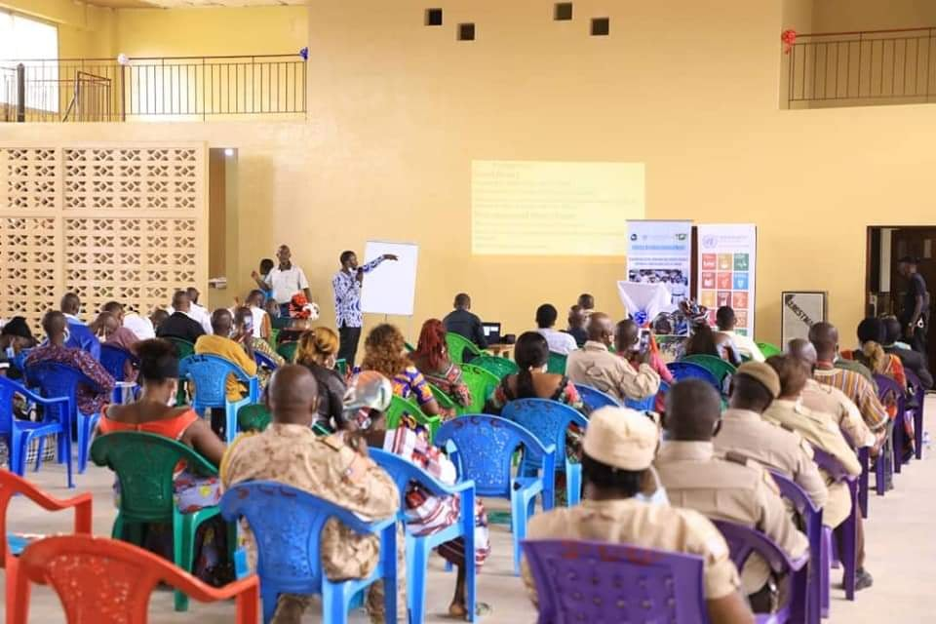
Figure 1: Cross- border Project Coordinator Mr. Emmanuel Bawoh presenting on the outcomes and activities of the cross- border project
Remarks by Secretary General, National Security Council of Liberia
Opening remarks were also made by Mr. Jeremiah Swen- Secretary General of the National Civil Society Council of Liberia. He suggested henceforth information should be transcribe or translated in both English and French anytime there is an occasion as such and encourage CSOs and CBOs to take ownership to strengthen strategic partnership at borders between the two countries. He furthered noted that CSO plays a pivotal role in the engagement of peace and security, and he thanked the participants for honoring the meeting.
Remarks by the UNDP-Cote d’Ivoire Programme Specialist
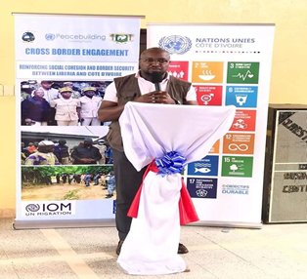
Mr. Giscurd Kouassi- Governance Programme Specialist of UNDP- Ivory Coast thanked the participants and stressed the need for both countries to be committed the project for the sustainability of the project for peace and security after UNDP and IOM shall have left.
Figure 2 Giscurd Kouassi- UNDP- Cote d’ Ivoire Programme Specialist making remarks during the technical group session

James Monibah- the Country Team Lead for Rule of law and Governance thanked the special invitees and honorable officials of and reiterated the need of sustainability of the project and both countries commitment for the promotion of peace and social cohesion. He stressed the importance of border security especially for people living along the borders.
Remarks by the Deputy Security Advisor, National Security Agency
Remarks were made by Attorney, Samuel Dakina, Deputy National Security Advisor to the president of Liberia. In his deliberations, He expressed his gratitude on behalf of the president and the government of Liberia. He stated that he was happy because this project comes at a time when border security needs to be strengthened. He recalled that when the national security strategy was developed, a nationwide tour was instituted recording and considering all the security issues that concerns community dwellers working along with citizens at both borders’ communities to ensure security and social cohesion. He acknowledged both countries of their commitment towards the project and provided historicity of how the project came about and mentioned the law reform with regards to the restructuring of the security sector, the legislature, enacted a law on National Security and intelligence as well to establish the county Security Council in each of the 15 counties. He also noted that the initiative provided the opportunity for the citizens to participate in security Governance in their respective counties and communities and furthered disclosed a joint border patrol exercise that took place recently about a month ago involving both countries security personnel at which time he stated that they were actively involved in the engagement of the discussion of issues affecting border residents.
Mr. Christopher Fayia – Senior Program Manager- Peacebuilding office (PBO) did a power point presentation on phase II of the cross-border project highlighting the key achievements, lesson learned and recommendations as well as challenges faced during the implementation of the project.
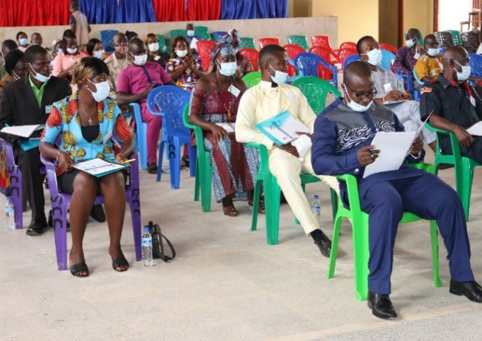
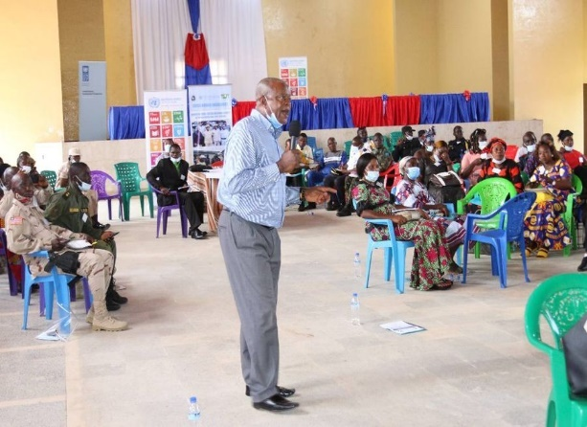

Figure 3 &4: Mr. Fayia presenting on the cross-border project outputs and achievements; Participants including the executive Director of MIA

- Technical session -Group work: Country focused group Review, Discussions, and Presentations
Participants comprising of Security personnel from the LIS, LNP, AFL and the National Fire Service including local authorities, representatives of the border communities from both countries and citizens of the Sanniquellie were placed into four (4) plenary groups representing Liberia and Ivory Coast on the cross-border project. Prior to that exercise, Mr. Edward Mullah, the Executive Director of the PBO, Ministry of Internal Affairs provided guidance for such exercise instructing that each country represented group should review the cross-border Project progress and state the achievements, challenges lesson learned and make recommendations. He further presented sets of questions for each group to respond to. In response to the questions Each group shared the experiences and discussed the achievements of cross- border project so far, the challenges encountered, the lesson learnt and recommendations which were that consolidated into two country focus group.
2.1 Liberia/Ivory Coast focus Group Review Feedback/Responses
Outcomes of the Liberia and Ivory Coast Focus Groups review outlined key achievements, challenges, lesson learnt and recommendations of the Cross-Border Project. Each group provided information based on their level knowledge and experiences of the cross-border intervention and the type of results achieved. During the exercise, the country focused groups were able to list several achievements that the project made in border communities, the challenges encountered during the project implementation including lesson learned as well as proffering recommendations to address such challenges that each country has been faced with. Please see the annex below for more detailed information recorded in a matrix.

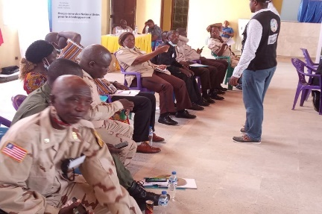
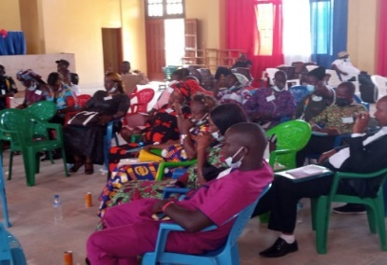
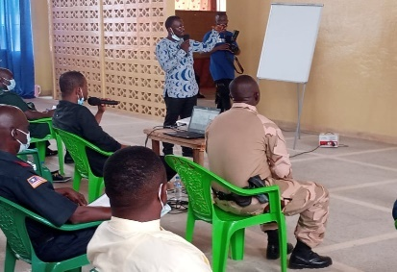

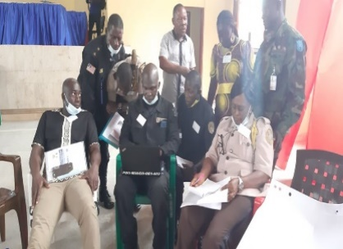
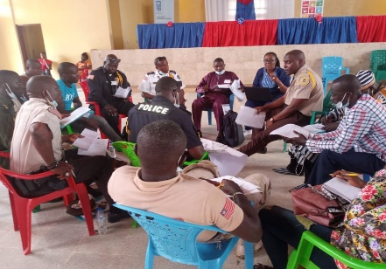
Figure 5-10: L-R Country focus group review the during technical working session and a displayed Banner of the cross-border high-level meeting
2.2 Key Observations made by Participants at the End of day one Meeting
Key observations were made by some of the participants during the first day of consultation of the technical session. The LNP Police commander of Grand Gedeh (Moses Gbaryan) was concerned that there was not a security personnel attending the technical session on the side of the Ivorian. The secretary General of the National Civil Society Council of Liberia, Mr. Jeremiah was concerned that he did not see his counterparts, NCSCL representatives of Cote d’Ivoire to participate, but only IOM and UNDP staff. He also mentioned that there should have been immigration officers or gendar-marines from the border to attend the high-level meeting since it had a lot to do with cross border issues. One of the Ivorians present at the meeting was also concerned that the Liberian plenary group discussions on challenges and recommendations mentioned were not quite in line with the project activities and result. He furthered concluded that the program did not do much with interpretation of the two-official languages which placed a huge stress on him as spokesperson representing the delegation. One of the participants (a Liberian) stated that the bathroom was not gender sensitive, men and women should have separate rest rooms while another person stated that the program did not commence on time as planned by the organizers.
- Outcomes of the High-Level Meeting

The high-level meeting commenced immediately at the arrival and installation of high-level delegation from UN and Officials of Liberia and Cote d’Ivoire Governments. The high-level meeting brought together security actors, civilians, international and regional institutions, civil society organizations, and the UN. The UN delegation included, the UNRC, UNDP, IOM representatives (Chief of Missions and program manager). The meeting was also attended by top Government Officials of the two countries, the Ministers of Interior and Internal Affairs. The Liberia UN delegation included, the Assistant UN Resident Coordinator, Civil Society Secretary General, UNDP, and IOM -Liberia, representatives from ECOWAS and the MRU secretariat were also present at the meeting. The superintendent of Nimba County, Sanniquellie City broke kola nuts and give it to the city mayoress which handed it over to the elders, and the elders than gave the Kola nuts to the Minister of internal affairs which in turn delightfully handed it to Ivorian Minister of Interior as a traditional way of welcoming highly esteemed guests. He then welcomed the guest and stated that the kola nut was a symbol of clear heart stating that the citizens of Nimba were very happy to have received him and his entourage.

  - Presentations and Special Remarks

Mr. Christopher Fayia projected a joint country report on the Cross-border project showcasing the project achievements, the challenges, lesson learnt, and recommendations made by both countries.

Remarks by the UNDP Deputy Resident Representative
Special remarks were made by Madame Violet Baffour, UNDP Deputy Resident Representative on behalf of the UN Resident Coordinator in Liberia and acknowledged the following officials of the high-level delegation; the Minister of Internal Affairs, Hon. Varney Sirleaf-Republic of Liberia and the Ministère de l’intérieur et de la sécurité, Republique de la Côte d’Ivoire, Hon. Vagondo Diomandé, the Resident Coordinator of the UN in Côte d’Ivoire, M. Philippe Poinsot, the Resident Representatives of UNDP and IOM in Côte d’Ivoire, Representative of ECOWAS. She also acknowledged the Superintendent and Traditional Council of Chiefs and Elders, the Executive Director of the Peace Building Office including Representatives of Government, civil society, the media and local communities of Liberia and Côte d’Ivoire,
In her deliberations, she conveyed regrets from Mr. Niels Scott, the Resident Coordinator of Liberia, who was currently out of the country and noted that the Cross-border Project, funded by the UN Peacebuilding Fund, had made great progress in the following areas; convening cross-border events between mirroring communities; organizing community peace committees; ensuring holding of the County Security Councils meet regularly in Liberia; strengthened social cohesion and peaceful coexistence between bordering communities; and, most importantly, the holding of this high-level meeting which reaffirms the political leadership of Côte d’Ivoire and Liberia’s commitment to peaceful co-existence between the two countries.

She then extended thanks to the high representatives of Côte d’Ivoire and Liberia for their political leadership and strong demonstration of their commitment. She furthered thanked the local leadership in the counties, as well as the security sector in both countries for their support and demonstrated commitment since the beginning of this project, stating that they continue to play a strong role in the successes that is achieved to date and also noted that in celebrating the progress, it is imperative to also recognize and be committed to addressing some of the challenges, particularly issues affecting border traders of whom majority are women, harassment, and cross-border farming, which often fuels conflicts. She elaborated that in implementing the recommendations from the Technical Committee, it is important that the structures which have been effective in promoting social cohesion and fostering peaceful dialogues between the communities should be maintained by the governments of Liberia and Côte d’Ivoire, in that peaceful co-existence and social cohesion has a multiplier effect which builds trust, strengthens social contact, promotes stability in the communities, and improves cross- border trade. She then charged both countries to reflect and reaffirm their commitment to peace and peaceful co-existence in the communities at all political level noting that in the absence of peace, women and children suffer the most, because women constitute majority of those who are involved in cross- border trade and so therefore, women’s leadership and participation is critical in these processes. She then reaffirmed the commitment of the United Nations system in working with the two countries for lasting solutions at the political and community levels to promote peace and sustainable development and quoted the late Kofi Annan, former Secretary General of the United Nations “There can be no peace without development, there can be no development without peace.

Remarks by Coted’ Ivoire UN Resident Coordinator

Special remarks were also made by M. Philippe Poinsot, the Resident Coordinator of UN- Côte d’Ivoire. In his brief remarks he thanked the Liberian authorities for hosting the high-level meeting annually particularly to Hon. Varney Sirleaf of internal Affairs and extended his gratitude to the United Nations delegation headed by his excellency Mr. Vagondo Diomandé of Interior for putting his time and resources to join us here in Sanniquellie. He further noted that the presence of the two ministers is strong pursuit of interest in the sustainability of peaceful coexistence and security between the two countries. He stated that their presence has shown strong testimony of your interest in peace consolidation in and between two respective countries. He further noted that their presence echoes the number one priority of the Secretary General of the United Nations, namely conflict prevention and their great efforts ensuring peaceful coexistence and cooperation because the number one priority of working with the UN mainly in conflict prevention an regional peace and security issues are key instruments to prevent conflicts to identify lasting solutions to conflicts, and to strengthen states resilience as they face many new challenges and threats. The project that brought us together today cross-border exchanges between Liberia and Cote d’Ivoire to strengthen Social Cohesion and border Security was financed by the United Nations Peacebuilding Fund. He further elaborated that he has seen improvements from Maryland and Tabu, Toulepleu to Nimba and Grand Gedeh now than when the Project first started, there have been newly built infrastructures and renovation of border ports, the establishment of community Peace Committees to settle disputes in border communities between Liberia and Ivory Coast, the project also provided trainings to 500 persons to strengthening their capacities in conflict management and resolutions. He stated that he has confident that national authorities of Liberia and Cote d’Ivoire will keep up in their achievements and support to the current project. He further stressed the need for strong governance system at both countries border ports and should be highly prioritize. Lastly, he noted that he read the recommendations from the technical committee that the two countries should remain committed consider those recommendations outlined by the technical committee to address those challenges and strengthen social cohesion and border security.
Figure 11: UNRC Mr. Philippe Poinsot

Remarks by the Officer in Charge and Resident Representative, ECOWAS

Mr. National B. Walker , Officer-in-Charge, ECOWAS Commission, presented warm greetings and heartfelt felicitations from the office of the President of ECOWAS Commission in Liberia. In his deliberations, he stated he will use the opportunity to thank the government of Liberia and Cote d’Ivoire for organizing this high-level cross border meeting to enhance and institutionalize cross border cooperation at the local and national levels which is used to promote social cohesion and strengthen coordination amongst various actors including border security ports. On behalf of the delegates that participated in the consultation in the last three days which led to the crafting of these excellent recommendations which will serve the relevant commissions and directories in Cote d’ Ivoire and Liberia. He further stated that since 1975, the ECOWAS has been promoting cooperation and regional integration as a viable tool for achieving and accelerating the sustainable development for West African countries. The ECOWAS authorities of heads of states and Governments reaffirms commitment to improving the west African integration process while enhancing the effectiveness of the integration in its totality and noted that this gathering here today is contributing immensely to the regional integration process that are evolving for the good of the sub-region. He stressed that while recognizing the regional integration bonds of the sub-region, there is a need to stress the importance of cross border activities. It is crucial to know that cross-border areas have long been a concern for peace, security, and regional stability this is so because border communities are areas that allow exchanges between citizens of bordering countries basically due to self- value, cultural and ethnic relationship are seen in the case of Liberian nationals. It is important to indicate that ECOWAS is deeply concern with free movement especially land border is a key concern, apart from ECOWAS Article 4 and 91 of the Dakar protocol authorize people to limit their freedom of movement for reasons of health and public order, to prevent COVID-19, ECOWAS Article 59, encourages and promotes free movement and return of people at free will and encourages peaceful coexistence. ECOWAS commission is glad that this meeting host credible participation from among the relevant security forces, development and peacebuilding actors of Liberia Actors and Cote d’Ivoire that their purpose here reassures the ECOWAS board, the ECOWAS certified protocol of free movement will soon be achieve, and stated that he is absolutely sure that the quality of participation at this meeting and the transfiguration of the recognition of the contribution will establish will establish a foundation toward the hosting and management of our borders.

Remarks by the Minister of Internal Affairs

The Minister of Internal Affairs, Hon. Varley Sirleaf addressed the high-level delegation as follows, “My Brother, My General, My Minister of Interior of Cote d’Ivoire General Vagondo Diomandé. This is someone that we become so close, and I appreciate that he is here today. To begin with, the Resident Coordinator of UN-Cote d’Ivoire, my sister Marianna, IOM-Cote d’Ivoire, Resident Coordinator of UNDP Cote d’Ivoire, Ambassador to Monrovia, Cote d’ Ivoire, general of the gendarmerie, Cote d’Ivoire, Hon. Prince O. Togba, Representative of District #2, Nimba County, Deputy Minister Alias Collins, Minister of Internal Affairs, Violet, Baffour- Assistant resident Coordinator of UNDP who has come to represent the UNRC for Liberia, Mr. Nathaniel B. Walker, officer -in-charge of ECOWAS. Jeremiah Swen, National Civil Society Council of Liberia, the security apparatus (LNP, LIS, Fire Service) and all our citizens who have come from the various counties, Nimba, Grand Gedeh and Monrovia, the leaders of the city of Sanniquellie, we recognized you.
Figure 12: Hon. Varley Sirleaf addressing the High-level Meeting
Let me seize the opportunity to thank my big brother, Minister of interior for co-hosting this very important high-level meeting for this time. We are extremely grateful to you and your delegates here today. We are also profoundly grateful to our international partners especially representatives of the UN family here, EU and ECOWAS for taking the time out of their busy schedules, the Government Representatives and all who are here to support the Government of Liberia and the Republic of Cote d’Ivoire. Let me also recognize our patronage for their splendid performance over the last two days making sure the process, procedures, presentations, and documentation are being put in place to enable the high-level meeting take place successfully here in Sanniquellie.

Let me do some retrospective analysis that gives us the opportunity to come here this time. Liberia and Cote d’Ivoire over the last couple of years have been impacted by civil violence, civil unrest, disruption of socio-economic activities, each country had successful democratic elections with some challenges and fallouts but most importantly, the governance process of both countries always remain intact. I want to take this time to thank his excellency President Alassane Ouattara of Cote D’Ivoire for the great country of Cote d’Ivoire for the development that is taking place there is encouraging refugees to return home. Let us thank his excellency President George Manneh Weah of Liberia for keeping the peace that was passed unto to him when he took over the oath office during the Inauguration in 2018. These challenges tend to impact reintegration and rehabilitation for affected population including youth at risk and thereby undermining civil trust and social cohesion. So that these challenges including the closure of the borders between Liberia and Cote d’Ivoire as well as mistrust between border communities, refugee’s situation and some of the instances increase in difficulties to them residents that live near the border. Cote d’Ivoire has become exemplary all those difficulties have been addressed by President Ouattara which we are very grateful. In the mist of these challenges, Government have demonstrated commitment and political to work together to resolve political tensions, cross-border undertakings, reconciliation initiatives at cross border projects and the council of chiefs /Elders that was held before. The idea of a small joint council of chiefs and elders was brought on board to bring peace along the border in 2013, in Grand Gedeh Liberia, and 2016 in Kilpo-Cote d’Ivoire to see how we can narrow the gap between the Governed and Governance. The government of Liberia is happy of the warm relationship and cooperation existing between our two countries. We look forward to exploring an in dept way that will further strengthen the institutional and technical capacities for our local community structures and mechanisms for improve oversights and accountability for our borders. These structures and mechanisms include, the county security council, the Early Warning, Early Response Mechanisms systems, the County Peace Committees and Women Peace Hut needs to be decentralized in border communities to continue the effort of bringing peace between the two countries. We sincerely believe that strengthening the capacity of these localized structures and mechanisms will compliment efforts of national security apparatus and enable the effective border security and promote peace, and reconciliation as well social cohesion. This is very important in the wake of porous borders that Liberia go through presidential elections 2023.

I have been informed by the technical team that phase II of the cross- border project is jointly being implemented by IOM/UNDP for partnership with the Government which aims to address inter-community tension, inter-community ethnic diversity, border voter registration, election outcomes, on either side of the border of the two countries.
Distinguished ladies and Gentlemen, we have acknowledged that the project have made progress in addressing some of the problems.

In conclusion, your excellency distinguished ladies and gentlemen, the government of Liberia is pleased with the existence of peace achieved so far throughout this joint venture. However, we are concern with the sustainability and extension of the intervention into other parts of the border communities and while we acknowledged that this intervention is in alliance to the national policies of the two countries, we want to take this project very key and important aligning to the two countries vison.

I believe that the intervention is analeptic and call on the other partners to see the greater value and dividend to supplement the efforts of the Peacebuilding Fund in two countries in recovery such as Liberia and Cote d’Ivoire assume peacebuilding priorities in our countries and finally the Government of Liberia, People of Liberia and the Government of Cot d’Ivoire can assume support to his important project.”

Remarks by the Minister of Interior, Cote d’Ivoire

In response to his colleague, the Minister of Interior, Mr. Vagondo Diomandé, thanked Mr. Sirleaf for such an honor bestow on him and his delegates. In his deliberations, He mentioned the status of the Burkinabe with Liberia and their leaders in neighboring countries. He noted that securing the border of the countries is crucial to having peaceful coexistence. He then congratulated his colleague, the Minister of Internal Affairs for the level of work done for his institution. He also recognized the government of Liberia efforts for the work done at the various border ports and the participation of international partners have yield good results and admonished the government again for contributing towards the peaceful coexistence at the borders.

Gowning Ceremony

After The minister of Internal Affairs deliberations, he gowned the Members of the high-level delegation to begin with he called on his colleague, Mr. Vagondo Diomandé, the minister of interior, cote d’Ivoire and gown him in appreciation of the collaboration that promote peaceful coexistence. And gowned the two UNRCs of both countries, Madame Violet Baffour, M. Philippe Poinsot, IOM chief of Missions Cote d’ Ivoire and the Head of the gendarmerie, Cote d’ Ivoire.
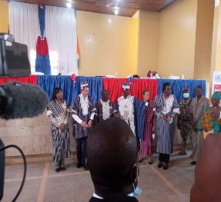
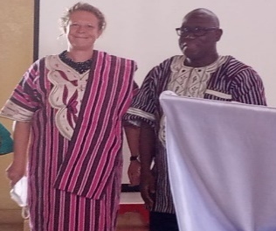

Figure 13-16: the Minister gown the member of the high-level delegation, the Minister of Interior, IOM Chief of Mission the UNRCs and other high-ranking officials of Cote d’Ivoire and Liberia

- Live Testimonies

- Conclusion

The high-level meeting ended, with a several group photos taken and a cultural dance performance. The high-level meeting was necessary to inform the Governments of Liberia and Cote d’Ivoire, Heads of National Security Institutions, ECOWAS/MRU/AU authorities, Civil Society Leaders local communities’ leaders of both sides to discuss core issues and review the progress of the cross- border project. The high-level meeting served as platform to rekindle the commitment of the two countries towards ensuring social cohesion and border security at the target communities between Liberia and Cote d’Ivoire.

Annex 1
Areas of Observations | Liberia Country-Focus Group | Cote d’ Ivoire -Country Focus group
Progress/Achievement
 | - Computer literacy skills built for security officers enhanced database management system  - Strengthened collaboration between members of the CPCs and security officers in project border communities  - The intervention has increased women’s participation in leadership and conflict resolution/mitigation processes in project communities.  - CPCs are trained in conflict mediation and demonstrating ownership of resolving localized conflicts of lower magnitudes  - Monthly coordination/dialogue meetings of county security councils have improved  - cross-border security services and relationships have improved compared to several years ago  - The cross project acquired 120 acres of land surveyed and deeded for the use of the joint security at the border point.  - the project has established confidence and trust built between both security  - Mitigated fear among citizen when they saw both securities take border patrol together.  - Problems were identified and recommendations were made after the cross-border patrol exercise  - Improvement in relationship/social cohesion among bordering communities  - Social cohesion has helped to reduced tension, disputes, tension, cross border movement as well as criminal rate at bordering communities | - The realization of the project emanated from consolidated contributions and pivotal roles of both leadership and communities’ dwellers from districts/townships in the successful outcomes of the project.  - As such the key achievements were  - Work was divided into five groups including the civilian and the security personnel(military) 8 meetings were staged on the finalization of the project  - Four (4) major joint border patrols with our Liberian counterpart  - This high-level meeting was organized by IOM/UNDP  - This high-level meeting was organized by IOM/UNDP  - A total of 120,000 was used to fight COVID-19 at the border points  - 280 members of the CPC were trained to fight Covid at the to the various border points  - 160 security forces were trained
Challenges
 | - computer training sessions for security officers did provide adequate computers to the number of officers enrolled  - Participant’s selection was not based on satisfied criteria and the IOM-IP unilaterally selected the training participant  - CPCs lack the needed logistics such as transportation and communications for effective performance deliveries  - High tariff charged on goods by both border security at border points  - Harassments and intimidations of petty traders by Ivorian security are impeding cross-border trade  - Lack of standardized time set for crossing by ferries and canoes owned and operated by Cote d’Ivoire government often caused goods to spoil  - training environment /training center was quite small for the number of security personnel enrolled  - lack of feeding and accommodation for security personnel caused some of the participants to discontinue the training  - Mistrust and conflict ensued between the security commander and the IOM-IP | - The closure of borders due to the Covid-19 crisis.  - The application of barrier measures banning mass gatherings at community level.  - The language barrier does not facilitate communication, especially between civil servants and administrative authorities.  - The non-coverage of the border area by the telephone network.  - The porosity of the border with many illegal crossings.  - The absence of joint development projects destroys the achievements of the project.  - Maintaining lasting collaboration between security forces and neighboring populations.  - Youth unemployment in the face of illegal activities such as illegal gold mining and smuggling.  - The effective fight against the Covid-19 and Ebola pandemics while preserving the family, commercial, economic, and cultural exchanges that link border populations.
Lesson Learnt
 | - Bad road hinders movement during the border patrols  - Poor communication network was observed  - Communication was organized | - The rehabilitation of community infrastructure as well as socio-cultural and sporting activities contribute to the promotion of joint work and community rapprochement.
Recommendations
 | - IOM-IP should work with head of security to select beneficiaries of the computer training and other capacity building training in the future  - Computer training should adapt of TOT approach to enhance sustainability given that trained security personnel are often rotated by their commanders  - Joint committee of both border security personnel should meet to discuss and agree on specific time for the ferry and canoe to cross to enable easy travel and prevent spoil of perishable goods  - when it comes to the processing of land Government should take full ownership in acquiring the land than project  - Government and IP should improve on roads leading to bordering points  - Government and partners including IPs should improve on border security officers’ residential area  - More days been allotted for further joint border patrol to enable the border patrol team visit in all communities  - There should be a strong monitoring system put in place at both counties, Grand Gedeh and Nimba.  - There should a regular joint border patrol beyond the cross-border project | - Support peace consolidation projects with vigorous development projects capable of meeting the existential needs of the populations.  - Seriously examine the issue of extortion of funds from neighboring populations when they pass through the border post by security agents.  - Match official entry points between the two countries on the one hand, and on the other hand make high-traffic illegal crossings official to avoid bypassing official posts;  - Increase the efficiency of border officials by improving their working conditions (construction of offices with dormitories for all official entries and exits)  - Bring border communities out of isolation due to poor roads and their lack of telephone network coverage.  - Engage in tripartite discussions between the States (Liberian, Ivorian, and Burkinabe) on infiltration for the purposes of exploitation of the Liberian forest bordering on the Ivory Coast.  - Establish a continuous system for monitoring and producing studies on changes in the perception of trust and security.  - Extend the project activities beyond the border to consider the interior localities.  - Consolidate the achievements of the project through the appropriation and continuation of interventions financially supported by the two States.

