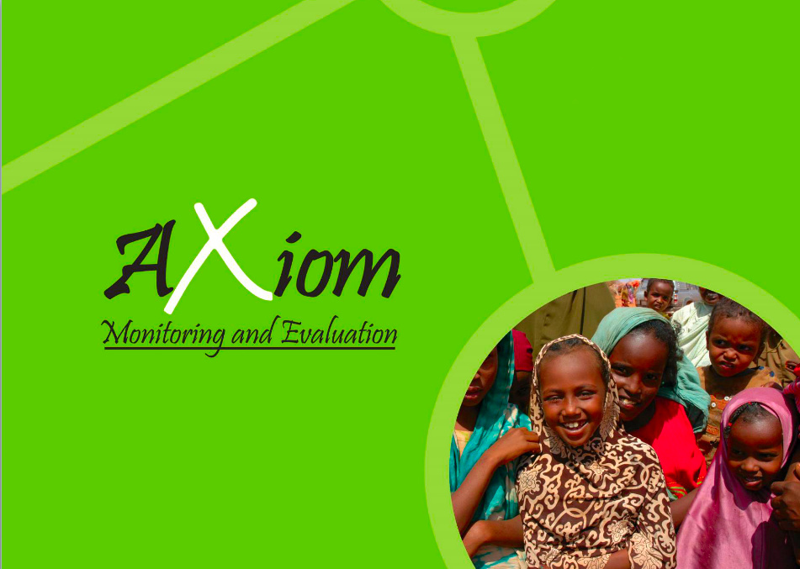

Registered in France, Kenya, and Somalia

END-TERM EVALUATION REPORT

Dhulka Nabaada (The Land of Peace): Supporting Land Reform in Somalia

United Nations Human Settlements Programme

Draft Report Submission: July 2021
Revised Report Submission: August 2021

AXIOM MONITORING AND EVALUATION

Table of Contents
ABBREVIATIONS 3
EXECUTIVE SUMMARY 4
I. INTRODUCTION 7
II. FINAL EVALUATION SCOPE AND OBJECTIVES 9
III. METHODOLOGY 10
Desk review 10
Limitations 10
IV. DEMOGRAPHIC CHARACTERISTICS 12
V. OVERALL FINDINGS 13
i. Relevance 13
ii. Effectiveness 15
iii. Monitoring and evaluation 23
iv. Coherence 24
v. GENDER 25
VI. EFFICIENCY 27
VII. OUTCOME/IMPACT 30
VIII. GAPS AND CHALLENGES 35
IX. SUSTAINABILITY 36
X. LESSONS LEARNT 38
XI. CONCLUSION AND RECOMMENDATIONS 39

ABBREVIATIONS

ADR Alternative Dispute Resolution
CC Community Conversation
CDRC Community Dispute Resolution Centre
CFW Cash for Work
CAP Community Action Plans
CPA Certificate of Provisional Acceptance
DC District Commissioner
FAO Food and Agriculture Organization
FGD Focus Group Discussions
FO Field Observation
GEWE Gender Equality and Women Empowerment
HLP Housing, Land and Property
HR Human Resource
IDP Internally Displaced Person
ILO International Labour Organization
IOM International Organization for Migration
JJP Joint Justice Programme
IP Implementing Partner
KII Key Informant Interviews
LA Local Authority
M&E Monitoring and Evaluation
MoI Ministry of Interior
MoJ Ministry of Justice
MoPWH Ministry of Public Works and Housing
NDP National Development Plan
NRC Norwegian Refugee Council
ODK Open Data Kit
PBF Peacebuilding Fund
SMART Specific, Measurable, Achievable, Relevant and Time-based
SWS South-West State
SWOT Strengths Weaknesses Opportunities and Threats
TOR Terms of Reference
TPM Third- Party Monitoring
UNCF United Nations Sustainable Development Cooperation Framework
UNDP United Nations Development Programme
UN-Habitat United Nations Human Settlements Programme
UNHCR United Nations High Commissioner for Refugees
UNSOM United Nations Assistance Mission in Somalia
UNICEF United Nations Children’s Emergency Fund

EXECUTIVE SUMMARY

The Dhulka Nabaada project aimed to support land reform by addressing land issues in Kismayo, Jowhar, Baidoa and Dhusamareb districts in Somalia through strengthening the government’s capacity to lead land policy development and dispute resolution mechanisms and by providing infrastructure support and development of information management systems to support the development of a land tenure database.

This report follows the requirements of the Terms of Reference (TOR) issued. The evaluation is based on a detailed examination of the key evaluation criteria questions including a) Relevance of the project; b) Effectiveness; c) Coherence; d) Efficiency; e) Impact; and f) Sustainability. The report further provides key lessons learnt and actionable recommendations for future projects.

Key findings
- Relevance
The project was relevant to the needs of the government and beneficiaries. The project was aligned to the priorities of the government, primarily the National Development Plan (NDP). One of the main reasons behind this is that the project promoted peacebuilding by addressing land disputes and land conflict drivers. The beneficiaries’ needs and priorities were addressed through the land dispute committees and ADR centres which offered alternative solutions to conflict resolution.

The project's Theory of Change (ToC) assumed that by facilitating an integrated justice framework guided by a clear land rights policy and building the capacity of relevant institutions on policy formulation and implementation, then communities would have better access to land resolutions mechanisms. In addition, if the infrastructure for land administration processes were put in place and by building the capacity of local authorities on information management and coordination of land issues, then there would be improved land administration service delivery by the local authorities to communities.

The TOC was grounded on evidence as it identified the gaps in access to justice on land services and the conflict drivers. For instance, the lack of clear land laws and policies was a conflict driver. The baseline evaluation carried out by IOM which is further discussed in the main report confirms that the majority of the respondents in Kismayo and Baidoa, believed that the lack of land offices was a significant problem. 62% of the respondents from the baseline survey went further to confirm that the lack of a land management system in the districts contributed to land disputes. The project addresses these gaps by developing a land policy and setting up infrastructures in Baidoa and Kismayo. However, the level of relevance of the land policy cannot be measured at this stage since the land policy is pending approval. Although the project contributed to addressing certain conflict drivers, it did not establish a comprehensive focus on reducing factors such as corruption.

- Effectiveness
Under Outcome 1, the project has been effective in ensuring increased access to justice, remedial and adjudication of land issues. The project was successful in establishing and training land dispute committees which have been effective and have had some positive effects on land disputes resolution. The committee members received training on land dispute management and conflict resolution which has improved their conflict resolution skills. Surveys with beneficiaries found that 91% of respondents interviewed during the end-term evaluation noted that the land dispute committees established were effective in addressing land disputes. This is in comparison to 66% of respondents during the mid-term evaluation who reported that the land dispute committees established were effective in addressing land disputes.
The community conversations and dialogue forums conducted by the project were effective and have had a good impact on the project target locations by improving the relationship between the community and the governing authorities as well as building cohesion amongst community members. The conversations also educated the community on land dispute resolutions and land policy and improved the community’s involvement in land issues. 86% of respondents interviewed during the end-term evaluation believe that the project, through capacitating the community and holding the conversations, helped address social dynamics and power relations on underlying land and justice issues. Another 86% of respondents interviewed felt that there has been adequate citizen participation on land issues since the implementation of the project. This is in comparison to 80% of respondents interviewed during the mid-term evaluation who believed that the project, through capacitating the community and holding the conversations, helped address social dynamics and power relations on underlying land and justice issues, and 76% of respondents who felt that there had been adequate citizen participation on land issues since the implementation of the project.
The project held high-level forums on land, conflict and state-building in all four project locations with various stakeholders including the relevant government ministries, implementing agencies and LAs. Issues discussed in the high-level forums included land registration and acquisition, causes of land disputes and conflicts and how to resolve them and address security issues arising from land disputes. Government officials also received training on land policy development as well as land dispute and conflict resolution. The training helped increase the communities trust in the government's abilities to solve land disputes. Project beneficiaries stated that the community relationship with the governing authorities has also improved compared to the findings during the mid-term evaluation.
The project developed a land tenure and property rights policy that provides clear guidelines on land management issues that reduce land conflicts and disputes in the targeted project locations. The policy is, however, still waiting for parliamentary approval in South West State (SWS), Jubbaland and Dhusamareb.
Under Outcome 2, during the mid-term evaluation, the Kismayo Land Authority and Baidoa Land Commission buildings were still under construction but the offices are now completed and in use. 53% of the respondents during the end-term evaluation from Kismayo and Baidoa report the construction of the offices for the land commission was relevant and 8% felt it was very relevant. On the level of trust in the resolution of land disputes, during the mid-term evaluation, 38% of respondents from Baidoa and Kismayo reported that they had high trust in the resolution of land disputes, 25% and 24% had very high and moderate trust respectively and 13% reported they had low trust. In the end-term evaluation, 66% representing a majority of the respondents now have moderate trust, 27% have high trust, 5% have low trust and 2% have very high trust. Although there is a decrease in the number of survey respondents in the end-term evaluation who have very high trust, more respondents report moderate trust in comparison to the mid-term which still highlights positive perceptions amongst beneficiaries.

- Efficiency
There was moderate level of coordination between the implementing agencies. This is a result of mixed feedback from the various stakeholders in the different project target locations. The COVID-19 pandemic was reported to have been the main cause of delay during the implementation of the project due to restrictions in movement. The pandemic affected activities such as community conversations and dialogue forums which were key activities of the project.
In the opinion of the evaluation team, the project provided good value for money as the activities were implemented effectively and efficiently. The one major delay noted, was the adoption of the land tenure and land rights policy by the parliament in SWS, Jubbaland and Hirshabelle due to COVID-19 and lack of political will, but this is not under the control of the implementing agencies. It is also important to note that the project only received 70% of the total allocated budget for the implementation of project activities.
- Coherence
The project complemented the work of other programmes implemented by other UN agencies. These programmes include the Joint Justice Programme (JJP) Midnimo, Saameynta and Danwadaag projects. The programmes centered on the delivery of basic services to increase access to justice, peace and state-building and displacement issues. Under the JJP programme which UNDP and other partners implemented, UNDP utilized part of the programme's resources to support activities under the ADR centres, community conversations and mobile courts. Land committees established under the Midnimo project were integrated under the JJP project in Baidoa and Kismayo. These synergies enabled sharing of skills, resources and access to other forms of justice. Most importantly, these projects maximized the efforts of Dhulka Nabaada to promote peacebuilding.

- Outcome
One of the project's most significant impacts has been the establishment and training of the land dispute resolution committees. This is because the land dispute committees have been diligent in their duties and helped to resolve land disputes and reduce land conflicts in the different target locations based on feedback from the project beneficiaries. 39% of respondents interviewed during the end-term evaluation stated that they had a land dispute and 66% of them noting that the land dispute were resolved by the land dispute committees. This is in comparison to the mid-term evaluation where 14% of the respondents interviewed, stated that they have ever had a land dispute, 43% reported that their land dispute was solved by the land dispute committees.
The construction of the land offices in Kismayo and Baidoa and the provision of information management systems to improve the land management system in the two districts will have a great impact. The impact of an improved land management system and a fully operational land department is not visible at the moment since this impact is very forward-looking. There is an increase in the percentage of surveyed respondents with moderate trust in the management of titles in Baidoa and Kismayo. In the end-term evaluation, 60% of surveyed respondents have moderate trust, 31% high level of trust, 3% have very high trust and only 6% have low trust. In comparison to the mid-term evaluation, 49% of the respondents had high trust in the management of land titles, 20% moderate trust, 11% very high and 13% had low trust.
- Gaps and Challenges
A land policy has been developed but not yet approved, therefore, the impact of the policy cannot be assessed at this stage of reporting. The findings continue to show that the policy has been delayed due to COVID-19 and lack of political will. The project, however, did acknowledge during project design and in the ToC that the nature of the project demanded political support and will. To mitigate this risk, the government ministries were thus involved from the onset in the project design. The project was setting up a digital database system in Kismayo and Baidoa. However after the appointment of a new mayor in Baidoa and a shift in government policy and priorities resulted in a modification of the deliverable, from a digital automated online platform to a manual offline but electronic system built on Microsoft Excel infrastructure. Even though the deviation constituted a huge setback, the ultimate outcome represents an alternative solution driven by local priorities. This shift also points out some of the project's challenges which result from staff turnover in key government departments/ministries and to a degree of inefficiency occasioned by operational dynamics beyond the project’s control. There were challenges during the implementation of the project due to COVID-19, some of the activities involving social gatherings were stopped.

- Sustainability
Some project aspects such as trainings and capacity building provided to the different stakeholders have imparted knowledge and this will play a key role in ensuring the sustainability of the project. The project constructed and completed two land offices in Baidoa and Kismayo, although the evaluation was only able to visit the office in Baidoa, the land office in Kismayo and four ADR centres in the four project locations the centres were fully functional, operational and in good working condition. The sustainability of the infrastructures built by the project will mainly depend on the government and local authority's goodwill to ensure the maintenance and running of the infrastructures.
- Lessons learnt
The end-term evaluation reveals some lessons learnt that were useful during the project implementation: a) Government involvement in the project design was crucial to the relevance of the project; b) To improve project results, coordination among the project partners is important to bring clarity during the implementation of the project; c) The project’s ToC was well defined to address the conflict drivers and respond to the needs of the community and government; and d) There was a need for a well-structured Monitoring and Evaluation (M&E) system to ensure there is coordination in reporting.

- Recommendations
The main recommendations which are explained in more detail in the main report include: a) To eliminate traditional barriers to women’s access to land there should be continued awareness on women’s land rights; b) Embarking on the provision of land titles eases land dispute resolution processes and will increase the communities confidence in the government to manage land issues; c) Establishing a central M&E framework for monitoring project results; d) Creating awareness on the existence of the mobile courts and ADR centres to reduce land disputes and provision of incentives to promote sustainability of the work of the mobile courts and centres; e) Holding a high-level forum to discuss the importance of the land policies on Somalia national development; f) Improve internal communication channels within agencies to ensure effective coordination at the ground level; g) Setting up of an information management system to address staff turn-over; and h) During the design and implementation of future projects, there should be greater clarity on exactly which activities are implemented in each district and by which agency in order to monitor more easily the progress of the projects in all planned target areas.

- INTRODUCTION
Figure 1: Project implementation locations

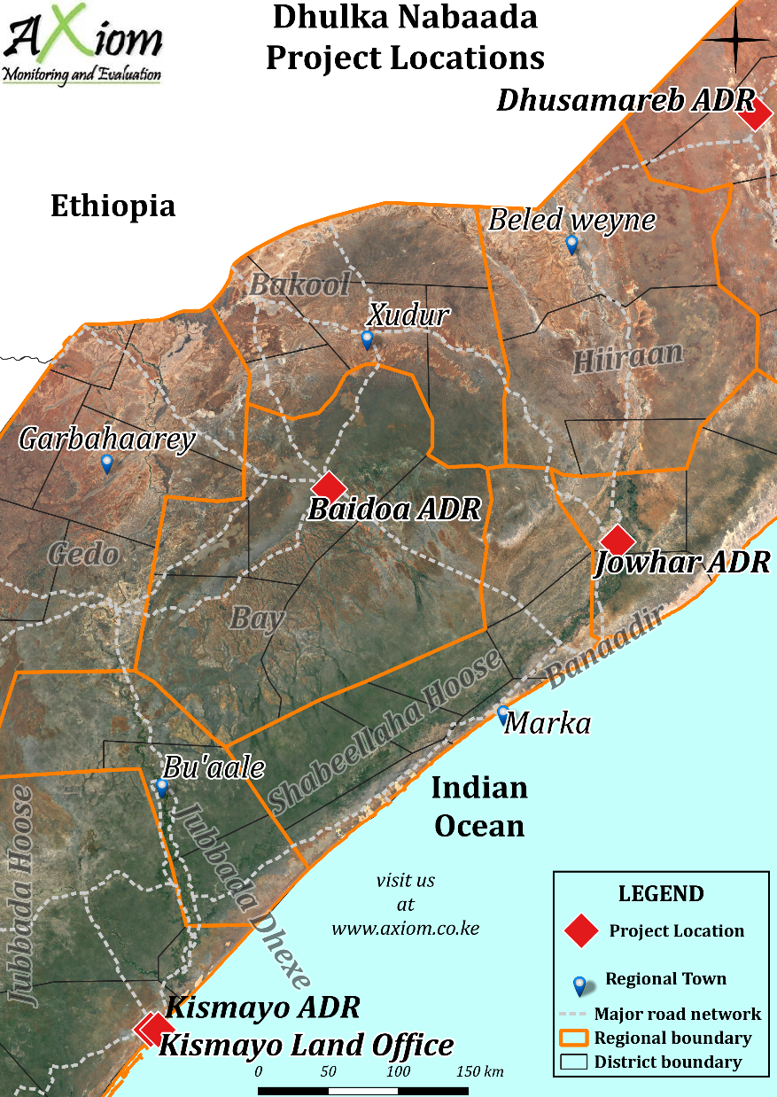
The interwoven nature of Somalia’s land dispute can be retraced from its protracted history of conflict decades ago. According to Food and Agriculture Organization (FAO), most land in Somalia is pasture area with only 20% and 13% left for forest cover and cultivation, respectively. This creates a causality for conflict for control of the natural resource. However, the land dispute today has evolved due to multiple factors aside from the need to cultivate.

Over the post-war years, Somalia’s political uncertainty coupled with a weak land enforcement framework and enhanced federal oversight capacity aggravated issues on land grabbing, allocation, corruption as well as management. Consequently, this has contributed to the internal displacement of over 2.5 million people across the country, according to the UNHCR 2021 report. Today, the land dispute dynamics in Somalia emanate from a convergence of various multi-causalities. To begin with, there is the issue of land grabbing (Dhul-boob) from vulnerable individuals and public land as well as the issuance of duplicated and counterfeit title deeds by elites and government due to the lapse in protection and clarity in land registration. The land conflict takes a different perspective relating to land reclaim by Somalis returning from diaspora owing to displacement due to the civil war. Many of the displaced returnees abandoned their land and properties and migrated to seek refuge elsewhere leading to the dispossession of their proprietorship. Decades later, this land was inherited, further complicating an already-rife situation. Therefore, with no title deeds and registration records, these returnees have little chance of substantiating ownership or repossessing their rightful land as is the case in Juba Valley. The limitation in land management and oversight at the federal level further complicates the opportunities for recourse by returnees, IDPs and marginalized clans on land re-ownership, conflict and dispute resolution mechanisms.

Other factors that compound the complex challenges related to land management in Somalia include the lack of land demarcation in the rural regions across Somalia. Agricultural land across these regions could form a pretext for disputes and inter-clan clashes among pastoralist communities on access to water, grazing and cultivation land. In some areas such as Galkayo between Puntland and Galmudug, the tensions remain historical yet in recurring cycles of violence that at times lead to the displacement of people.

In the rural regions, such as in Hirshabelle state, land conflicts are arbitrated by community elders owing to limitations in access to the formal justice system. Alternative land reform platforms have had a preference over the federal system due to guaranteed land protection, speedy arbitration and their minimal corruption has elevated armed militia courts as the preferred system among vulnerable groups and marginalized clans across Somalia. Nonetheless, attributes such as the lack of formality and dependence on a patriarchal approach of arbitration limit the effectiveness of customary alternative justice systems among vulnerable groups such as female-led households and marginalized clans. Moreover, their preference has made land recovery from armed militia the more challenging as is the case in South West State and parts of Hiraan in Hirshabelle state where most of the land in the rural areas is controlled by armed militia.

The federal government manages public land while privately-owned land, which forms the majority, is controlled through customary and traditional laws further complicating the situation as customary and federal laws often clash in enforcement. Nonetheless, access to justice at the federal level has become increasingly constrained for marginalized clans and individuals due to corruption creating a judicial loophole for stronger clans and private interest groups to grab public land. Therefore, land disputes in Somalia emanate from a multi-factorial set of challenges that negatively affect different vulnerable groups. Such as the reliance on customary land mediation, at the expense of the federal process, impedes holistic arbitration as well as access to justice for women returnees and land complaints as it remains patriarchal. The inadequacies in financial and institutional capacity for the federal land management system counters not only efforts relating to good governance, sustainable land reform, equal access to justice and dispute resolution mechanism but also the successful repatriation of returnees, peacebuilding and resilience enhancement across communities in Somalia.

- FINAL EVALUATION SCOPE AND OBJECTIVES

This evaluation assessed the performance of the project by carrying out an in-depth assessment of the impact of the project in the targeted districts. The evaluation also sought to provide The United Nations Peacebuilding Fund (PBF) background information relating to where project activities were implemented and why the project was implemented in those target locations. This evaluation also assessed how conflict sensitivity was adopted.

The specific objectives of this end-term evaluation were to:
- Assess the relevance of the project in terms of;
- Addressing critical drivers of land conflict and adopting relevant peacebuilding strategies in targeted areas; and
- Alignment with Somalia national frameworks such as Somalia National Development Plan (NDP) and the UN Sustainable Development Cooperation Framework (UNCF).
- Evaluate how effective the project was in achieving both outcomes and whether the interventions have reduced land conflict in the target districts, through extensive evaluation methodologies including beneficiary perception surveys.
- How effective was the project implemented by UN agencies in achieving complementarity and successful area-based/joint planning for enhanced impact?
- Evaluate the project's efficiency, including its implementation strategy, institutional arrangements, management and operational systems and value for money;
- Assess whether the project promoted gender equality and women empowerment by adopting a specific focus on women’s participation and role in peacebuilding processes;
- Document good practices, innovations and lessons emerging from the project; and
- Provide actionable recommendations for future programming.

Furthermore, PBF requested the evaluation team to look into how the project had a catalytic effect and the level of implementation across all districts/regions.

- METHODOLOGY

The evaluation employed a mixed methodology of quantitative and qualitative research tools. This included KIIs, FGDs, case studies, FOs and perception surveys which were conducted in the targeted project locations.

Desk review
This consisted of an analysis of project documents including progress reports, training reports and field reports provided by the project partners to extract information about the activities. This information was later used during the development of the tools and data collection plan. The documents also provided a clear framework of persons to be interviewed and set a clear direction on which partner was implementing specific activities and in which districts.
Qualitative and quantitative methods
KIIs were semi-structured and used to obtain information from stakeholders on the progress of the project, impact, lessons learned and general questions were developed as per the evaluation criteria questions. Contacts of the key informants including the LA, Ministry officials, women leaders, land dispute committee members, elders, community facilitators and District Commissioner (DC) were provided by the IPs.
FGDs were conducted with men, women and youth in each of the districts. The questions were open-ended to allow respondents to discuss the impact of the project, pending gaps and as well as information of what beneficiaries believed should have been improved. Due to COVID-19, the evaluator employed all appropriate measures including social distancing to ensure the safety of its staff and the community.
Case Studies were conducted with direct beneficiaries of the project who received direct assistance from the ADR centres and mobile courts from the various districts. These stories are aimed at showcasing the general impact of the project on the lives of the beneficiaries.
FOs were carried out at the ADR centres and Kismayo Land Authority Building to verify the activities carried out at the facilities during the implementation of the project and the operation of the centres and courts after completion of the project. High-quality georeferenced photos, including the date, time and location for each centre and land building are provided in this report as additional evidence.
Perception surveys were conducted with a sample of 421 beneficiaries (231 men and 190 women) to gather opinions from the beneficiaries on changes in access to justice on land matters and access to land services. The final evaluation survey findings were compared with the mid-term evaluation to measure change.

Table 1: Data Collected
DISTRICT | KII | FGD | FO | CASE STUDY | SURVEY
Baidoa | 15 | 3 | 1 | 1 | 82
Jowhar | 9 | 3 | 1 | 1 | 117
Kismayo | 16 | 3 | 2 | 1 | 162
Dhusamareb | 8 | 3 | 1 | 1 | 60
Total | 48 | 12 | 5 | 4 | 421

Limitations
Some limitations were identified during the data collection process. The evaluation team had a major challenge to obtain the contacts of key participants in the various districts. No interviews were conducted with the MoI and Ministry of Planning in Baidoa as their contacts were not provided. To mitigate this challenge, extensive effort was made by the evaluation team to follow up through email and contacting the IPs by phone to obtain the contact details. Also, the project had different IPs with each partner implementing different activities, obtaining contacts from the various beneficiaries was a challenge as there was no coordination. No IP was interviewed in Jowhar which was a major limitation during reporting because numbers of those trained in the districts could not be verified unlike the rest of the districts.
Some respondents were reluctant to proceed or even participate in the interviews which affected access to the Baidoa land authority building where field observations at the building could not be conducted. Some of the respondents from the various districts were unfamiliar with the project while others had very little knowledge about the project. This is because some of the respondent’s engagement in the project was minimal. Also, since the project was concluded in January 2021, the beneficiaries recall of the project could be poor. The project involved several government ministries, the planning process of arranging for interviews was difficult as it entailed conducting several follow-ups with the participants to partake in the interviews.
The number of people targeted in the mid-term and end-term evaluation is different. During the mid-term survey, only 81 people from Baidoa and 159 from Kismayo were interviewed, surveys in Jowhar and Dhusamareb were not carried out due to the unavailability of beneficiary lists. The final evaluation survey covers Kismayo, Baidoa, Jowhar and Dhumsareb districts. The same beneficiaries for Baidoa and Kismayo who were interviewed in the mid-term evaluation were again interviewed in the end-term evaluation. However, the number of beneficiaries in Kismayo and Baidoa has slightly increased in the survey as per Table 2 above. Nevertheless, the overall sampling in the two districts is close enough to the sampling at the mid-term to be able to draw comparisons. Such considerations have to be factored in particularly where comparisons between the mid-term and end-term have been drawn. Since no survey findings from Jowhar and Dhusamareb were collected during the mid-term survey, there will be no comparisons drawn. In addition, the list of beneficiaries for Dhusamareb was only provided by UNDP. The TPM was only able to survey 60 respondents from Dhusamareb instead of the planned 100, this is because the unresponsive rate in the district was high compared to the other locations. Nevertheless, findings from Jowhar and Dhusamareb are still important to understand the level of implementation, particularly since the evaluation team found minimal implementation in Jowhar at mid-term and Dhusamareb was not even included as a target district initially.

- DEMOGRAPHIC CHARACTERISTICS

Overall, there were 421 respondents interviewed, 162 in Kismayo, 82 in Baidoa, 117 Jowhar and 60 Dhusamareb. There was a total of 190 female and 231 male interviewed. The majority of the respondents were of an average age of 37. Out of the 421 sampled, 29% had no education, 27% had completed primary education, 16% had completed secondary education, 13% had quranic education, 10% had higher education and 4% had vocational training.

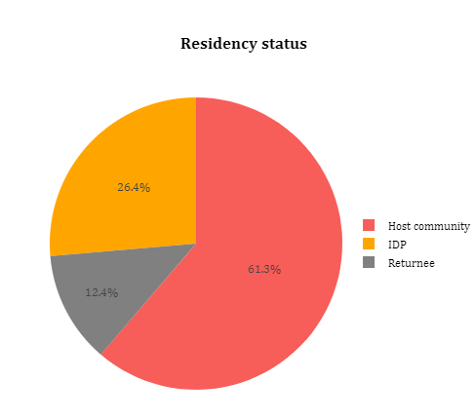
Overall, 61% of the respondents who represent a majority of those interviewed were from the host community, 26% were IDPs and 12% were returnees and only 14% were IDPs. At the district level, 46% of respondents from Kismayo were IDPs, 35% host community and 19% returnees. In Baidoa, 77% were from the host community, 16% IDPs and 7% returnees. In Jowhar, 68% were from the host community, 20% IDPs and 12% returnees. In Dhusamareb, 97% were from the host community and 2% returnees and IDPs.
Figure 2: Overall residency status
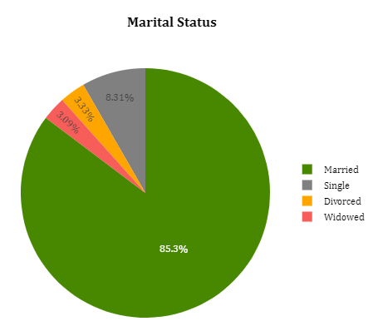
Overall, 85% of the respondents are married, 8% are single and 3% are widowers and widows and divorced.

Figure 3: Marital status
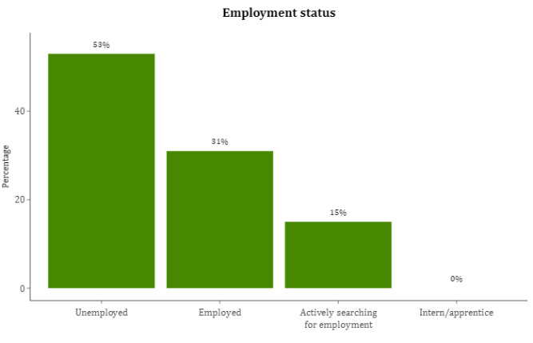  Figure 4: Employment status | Overall, 53% of the respondents mentioned that they were unemployed, 31% were employed, 15% were actively looking for work and only 1% were interns. In Kismayo, 53% are unemployed, 26% are employed, 20% were seeking employment and 1% were interning. In Baidoa, 55% are unemployed, 27% are employed and 18% searching for employment. In Jowhar district, 64% are unemployed, 25% are employed and only 11% are searching for employment. In Dhusamareb, 63% are employed, 28% are unemployed and only 8% are searching for employment. The final survey findings, therefore, show that the majority of the employed respondents are from Dhusamareb. The average household monthly income in all districts is USD 130.

- OVERALL FINDINGS

- Relevance

Land conflicts in the target districts are caused by a lack of land documents including titles, mechanisms for land dispute resolution, clear land laws and policies and rampant corruption with systems marred with clan favouritism and that favour the wealthy. Land conflicts also emanate from inheritance issues due to lack of wills which in most cases deny female members a right to inherit land. After repatriation of returnees and displaced persons, land conflicts as well arise in the process of repossessing land lost to local members of the community. The unavailability of a land management system has created opportunities for duplication and production of unauthentic documents.
These conflicts spill over on the relationship between the host community and displaced community members, creating a lack of trust and social cohesion. This situation is exacerbated by a lack of knowledge on land issues, peaceful resolution of land disputes and land dispute resolution processes to reinforce cohesion between the host community and displaced persons.
Land dispute resolution, on the other hand, was a challenge due to gaps in the management of land and the lack of an aligned authority or system to solve land disputes in the community. The lack of title deeds further complicated the resolution of disputes. Moreover, the unavailability of a land information management system to register title deeds made it difficult to verify ownership of title deeds when land disputes arose. Community members relied on informal systems for the resolution of disputes due to a lack of trust in the local courts.
To address these land conflict drivers, the project focused on increasing access to justice through developing a legal policy to ensure coherent resolution of disputes and setting up appropriate infrastructures for the government officials to operate in. Figure 5 below shows the project's ToC.
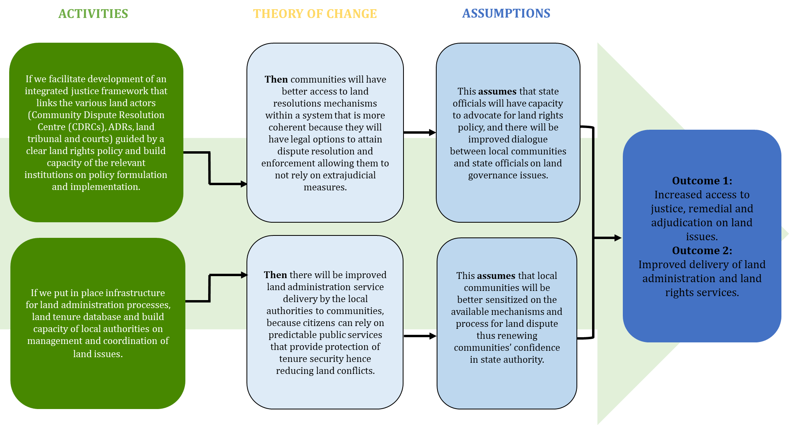
Figure 5: Theory of change and assumption
The project's ToC was correct in addressing some of the conflict drivers. The project established ADR centres composed of traditional elders and women leaders from diverse clans and mobile courts to adjudicate land disputes. In addition, the project capacitated community elders and women leaders in resolving disputes and conflicts. Key government ministries including the MoPWH, MoJ and MoI were trained on addressing conflict drivers. Community conversations and dialogues on pathways of resolving land disputes and how to lodge complaints and access justice, sensitized the community on how to address conflicts. In addition, the incorporation of minorities, women, youth and IDP representatives into the land dispute resolution committees created an avenue for fair resolution of disputes.

The mistrust that existed between the community and local courts was in part addressed, through the establishment of ADR centres, construction of land offices and establishment of the land community dispute resolution committees. This is because some community members in all project locations still prefer their land disputes resolved by elders since they are more trusted and the process is considered effective. The community also had a lack of trust in the LA, this was addressed through the training sessions held between the LA and the community.
The project was developed on the priorities of the NDP. This was in line with Somalia's peacebuilding priorities for peace and stability by curbing land disputes. The priorities of the government were to also develop policies that govern land administration. This was addressed through the development of the land law policy, creation of land dispute committees and ADR centres. The ADR centres were particularly important to the government to improve trust and confidence of the community in the government to address land disputes and manage land. The community conversations and dialogues held by the project brought different community groups and community officials together which promoted collaboration between the community and the government.
The beneficiaries across all districts considered the project to be relevant to their needs and priorities due to its contribution to reducing land disputes. The involvement of community members including traditional and women leaders in ADR centres from different clans had a significant role in not only resolving land disputes but also building trust, this likewise encouraged minority groups to seek justice. Most importantly, through the ADR centres, the project created alternative solutions to conflict resolution which are affordable.
“The project was implemented when it was critically needed by the community. The rate of disputes drastically increased and the quality of justice decreasing daily because of the biased nature of the people involved in dispute resolution like the court and elders. It was very relevant to implement the project to allow justice to be served.”
FGD Youth, Baidoa

Regarding the involvement of beneficiaries in the design of the project, some beneficiaries confirm no participation in this phase. The participation of the beneficiaries in the implementation of the project is very evident, in fact, FGD beneficiaries report satisfaction with their level of engagement during implementation. The participation of elders in the various project phases is evident through their engagement in the ADR centres and selection of various groups such as community facilitators. IPs consulted government ministry officials who assisted in the development of action plans that was reflected in the project design. Moreover, in consultation with the IPs, Jubbaland MoPWH was also responsible for the project proposal development. The MoJ in Hirshabelle assisted in the development of the project activities too.
The project targeted districts and beneficiaries that needed the most support in access to land resolution mechanisms and land service delivery. Looking at the context of Baidoa district for instance, due to rural to urban migration there was an upsurge of population and an influx of displaced persons, both key factors that cause land disputes. The district had no master plan and land registration collapsed in 1991; since that time, there were no dedicated offices for land issues and parties often entered into informal land agreements leading to land conflicts necessitating the need to implement the project in Baidoa. Land title acquisition and capacity building for the land dispute resolution committee were highly needed in the district. A government representative further noted that the project targeted the right beneficiaries, due to many IDP settlements and the rapid settlements expansion that led to more land disputes and conflicts. Therefore, the project targeted the right beneficiaries in Baidoa.
In Dhusamareb, the project worked in the district and surrounding areas that had faced recurrent land disputes and conflicts and needed land conflict resolution mechanisms. In Jowhar and Dhusamareb, land issues and conflicts in the regions were rampant as well. The project set up measures to ensure that land rights and land disputes were amicably solved. Hence the project focused on both beneficiaries and the district that needed support on land issues and conflicts.
Due to the nature of land issues, a conflict sensitivity approach was mainstreamed in the project. Key stakeholders including local leaders, police, land dispute resolution committees and community members were convened to amicably air their concerns. In addition, the project still considered traditional systems of land ownership and clan boundary systems. Foremost, the involvement of elders in ADR centres was a necessary approach to ensuring conflict sensitivity.
- Effectiveness
Outcome 1: Increased access to justice, remedial and adjudication on land issues through an integrated framework of the various mechanisms guided by clear policy and legislation ensuring coherence in the resolution of disputes.
- Capacity development of the federal government and member states to influence land rights
The project was effective in ensuring increased access to justice, remedial and adjudication on land issues. This is through an integrated framework of various legal mechanisms that are guided by policies and legislation, to ensure coherence in the resolution of disputes.
The project was successful in developing a land tenure and property rights policy in Baidoa, Jowhar and Kismayo but the policies are still pending approval and adoption by parliament. The policy shed light on the governance of land issues in the districts. As well as, provides guidelines on land management issues that reduce land conflicts and disputes in the state.
In Kismayo, it was noted that the project helped the MoPWH and the LA to develop a land tenure and land rights policy for the benefit of the community in Kismayo and Jubbaland at large. In Jowhar, it was stated that the project developed the land tenure and property rights policy outlining the policies, principles and procedures of managing and handling land issues and laws in Hirshabelle state to enhance the provision of justice to the community in the state. In Dhusamareb government representatives confirmed that the project had not developed a land tenure and property rights policy.
Table 2: Districts where land tenure and rights policy have been developed
District | Land tenure and rights policy developed
Baidoa | Yes
Dhusamareb | No
Jowhar | Yes
Kismayo | Yes

In Baidoa, NRC stated that the project held 1 high-level forum on land conflict and state-building in the district. UNDP noted that 2 high-level forums on land, conflict and state-building were held in Kismayo and 1 in Dhusamareb. Government representatives in Jowhar stated that they were not aware of the high-level forum on land, conflict and state building because they had not participated in this activity.

Table 3: High level forums conducted by the project
District | Number of high-level forums held | Topics discussed
Baidoa | 1 | - Land acquisition processes
Dhusamareb | 1 | - Land disputes and conflict resolution
Jowhar | No numbers reported | None reported
Kismayo | 2 | - Land disputes and conflict resolution  - Emerging security issues

In Dhusamareb, the evaluation team verified that 8 government officials (4 men and 4 women) received training on policy development. In Baidoa, Jowhar and Kismayo no numbers were provided by the IPs on government officials who had received training on policy development. However, according to the PBF- Dhulka Nabaada project- annual report 2020, a group of officials from Jubbaland, South West State, Hirshabelle and Mogadishu were trained on how to develop a land policy. In total, 28 officials were trained, (22 male and 6 female), the evaluation team verified that 8 government officials were trained in Dhusamareb. Government representatives from Baidoa confirm that they received training on basic legal and policy development. The training targeted ministries, departments and government agencies to educate the leading director generals, departmental directors on the basic concepts and processes of legal and policy drafting to encourage them to kick start proposals for key legislations. The high-level forums on land, conflict and state-building and the trainings of government officials on policy development have been effective. In Baidoa and Jowhar, it was noted that a number of legislations had been prepared and proposed at the state level after government officials received trainings from the project. It was further stated that government officials received trainings on urban land management. This helped to improve their understanding of land issues and they can now handle land disputes effectively. In Kismayo, the trainings have helped the MoPWH to plan the towns well. As a result of the training received, the MoPWH in Kismayo is planning to develop a master plan for big towns in the district.
- Citizen participation
In Baidoa, a total of 20 community facilitators (17 men and 3 women) were trained on land issues. In Dhusamareb and Kismayo, 30 community facilitators were also trained on land issues. No numbers were reported on community facilitators trained by the project in Jowhar. According to the community facilitators from the various districts, they used the knowledge gained from the training to conduct community conversations to educate the community on land-related conflicts and to build social cohesion and trust amongst the IDPs and the host communities.
Table 4: Community facilitators trained by the project
District | Number of community facilitators trained | Training received
Baidoa | 20 | - Joint justice program  - Security management
Dhusamareb | 30 | - Conflict resolution  - Community engagement  - Land dispute resolution
Jowhar | No numbers were reported | - Justice program  - Security management
Kismayo | 30 | - Land dispute resolution

In Baidoa, 2 community conversations were held between government officials and the community. In Dhusamareb, it was reported that 1 community conversation had been conducted by the project. In Kismayo, 16 community conversations had been held by the project. In Jowhar It was reported that 10 community conversations had taken place as a result of the project.
Table 5: Number of community conversations conducted by the project
District | Number of community conversations conducted | Topics discussed
Baidoa | 2 | - Land acquisition  - Land dispute resolution mechanisms  - Land tenure documentations
Dhusamareb | 1 | - Land disputes and conflict resolution
Jowhar | 10 | - Land disputes and conflict resolution
Kismayo | 16 | - Land disputes and conflict resolution

The community conversations were important and impactful in the various project target locations. In Baidoa it was noted that due to the community conversations and dialogues the community started following due processes and legal channels of acquiring land. The community conversations also helped to establish a connection and relationship between the community and land the service department of Baidoa municipality. Project beneficiaries noted that the community conversations had improved interaction and engagement within the different community groups like IDPs, host communities and returnees as well as government officials. The conversations improved the knowledge of the community on access to justice, security and land issues. To further improve the community's and government official's knowledge on land issues, it was proposed that the project should have also prioritized the establishment of training centres that provide land management courses and on land issues.
In Kismayo, it was noted by project beneficiaries that the community conversations enabled them to understand community rights and the use of judicial systems. Additionally, in Kismayo and Jowhar these conversations have helped to improve the community trust and confidence in the local government. In Dhusamareb, the community conversations have been effective because they enabled community members to learn that they can contribute to the peaceful resolution of land disputes. The evaluation found there were no specific women group conversations held, but women groups were mainstreamed in all project conversations and discussions together with their male partners.
- Establishment of an integrated justice system
1 land dispute tribunal committee was established in Baidoa, 2 in Dhusamareb, while no numbers were reported in Jowhar and Kismayo on the land dispute and tribunal committees established by the project. Project beneficiaries noted that the project provided trainings to the land dispute committee in Baidoa. This has enabled them to resolve land issues, reducing the number of cases forwarded to the formal justice sectors in the district i.e. courts.
“Land dispute committees are very effective in resolving land disputes because most of the cases are resolved by them without reaching the government and the citizens are appreciative of their excellent work.”
KII traditional leader Baidoa

In Jowhar, project beneficiaries stated that the project established a land dispute committee in the district, to solve land disputes. They also noted that the project established the ADR centre for the land dispute committee to operate from which has helped the communities in the area. In Kismayo, project beneficiaries also report that the project formed land tribunal and dispute committees and capacitated them, making them very effective in resolving land disputes in the community.

Table 6: Dispute committees established by the project
District | Number of land dispute tribunal committees established | Trainings received
Baidoa | 1 | - Conflict resolution
Dhusamareb | 2 | - Land dispute management
Jowhar | No numbers reported | - Conflict resolution  - Identifying root causes of land disputes  - Documentation of land disputes  - Types of disputes
Kismayo | No numbers reported | - Land dispute resolution

In all the districts, it was reported that as a result of the establishment and training of the land dispute and tribunal committees, the committees had been effective in solving land disputes. In Kismayo, for example, members of the land dispute tribunal committee noted that they had helped resolve a land dispute involving a widow. The woman was residing in a piece of land that she inherited from her late husband. Her land was grabbed by 4 men, the widow reported this to the land dispute committee members. With the help of the LAs, the committee was able to hear both sides of the case from all parties involved and the widow successfully got back her land.

The survey findings also confirm the effectiveness of the land dispute committees. 91% of the respondents believe that the committees formed by the project have been effective in addressing land issues, compared to 66% during the mid-term evaluation.
Mid-term | End-term
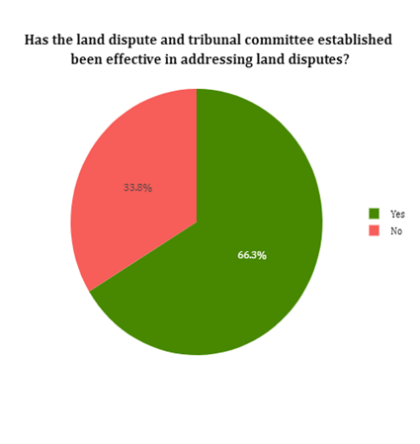 | 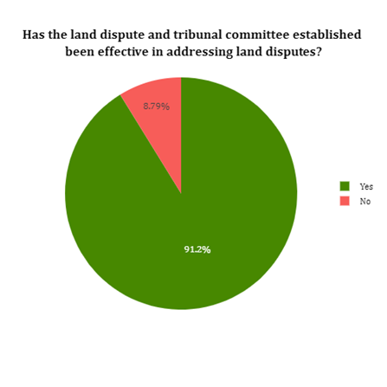
Figure 6: Perception of the effectiveness of the land dispute and tribunal committees.
In Baidoa, 2 religious leaders, 6 traditional leaders and 9 women leaders received trainings as a result of this project. In Dhusamareb, UNDP stated that the project had provided trainings to 4 religious leaders and 4 women leaders. While in Kismayo, 10 religious’ leaders, 10 traditional leaders and 10 women leaders received trainings as a result of this project. Women leaders confirm receiving training on land dispute resolution mechanisms and management. The trainings helped support other women in their land and family disputes.
Table 7: Religious, traditional and women leaders trained by the project
District | Number of religious, traditional and women leaders trained | Trainings received
Baidoa | 17 (2 religious’ leaders, 6 traditional leaders and 9 women leaders) | - Land dispute and resolution mechanisms  - Land policies
Dhusamareb | 8 (4 religious leaders and 4 women leaders) | - Land disputes and conflict resolution  - How to support women on land issues and disputes
Jowhar | No numbers reported | - Land and family dispute management
Kismayo | 30 (10 religious’ leaders, 10 traditional leaders and 10 women leaders) | - Land dispute resolution

It was noted that as a result of the trainings provided to the women leaders, religious and traditional leaders, women membership in the Baidoa land dispute committee and at the ADR centre effectively improved conflict and dispute resolution in the area. The local authorities in Kismayo also noted that women leaders were now part of the land dispute committees, helping to solve land disputes in the district.

Outcome 2: Improved delivery of land administration and land rights services through the institutionalization of appropriate infrastructure and information management systems, thus rebuilding the community’s confidence in local authorities.
The MoI, Jubaland Land Authority and Baidoa Land Commission were consulted to identify gaps and provide recommendations for the construction of the land authority/commission offices. The Jubbaland Land Authority prioritized the construction of a seven-room office for the Land Dispute Committees, an engineers’ operational boardroom and a public conference room. The land authority further proposed the installation of solar power, air conditioning system and provision of furniture. The Baidoa Land Commission prioritized the construction of a five-roomed office with latrines, water and elevated tank, conference room, air conditioner, solar system and the provision of furniture.
FOs of the Kismayo land office confirm the construction of the land offices begun in November 2019 and ended in March 202O. Equipment including computer desktops, Backup-UPS, Printers, toner cartridges, projector, office chairs, 6 office tables, conference tables, conference chairs with armrest, office cupboards, plastic chairs and a reception desk was provided in the land offices. The handing over of the offices to the Jubbaland Land Authority was done after the completion of the offices in March 2020. IOM constructed 7 rooms, latrines and one public conference room and installed a 100 litres elevated tank and a solar system but no engineer’s operational boardroom was set up. The construction was to a quality standard. The offices are used by 30 staff, at the time of data collection 15 people were at the offices receiving land services. Indicating that the land offices were still actively operational. The number of people seeking land services in the offices, however, reduced due to COVID-19 and the closure of the land offices after the enforcement of the lockdown. In fact, from January 2021 to May 2021, only 7 land disputes had been addressed through the formal system. Due to a lack of access to the Baidoa Land commission building, FOs of the land offices were not carried out. The project documents provided by IOM and the Baidoa LA however confirm the completion of the Baidoa Land commission offices. The project also provided equipment including computers, cabinets, printing machines and projectors to the Baidoa land commission offices.
During the mid-term evaluation, the Kismayo and Baidoa offices were still under construction. The end-term evaluation findings confirm the completion of the offices which are currently in use. Also, the completed infrastructure has been beneficial to the Kismayo and Baidoa authorities and equally to the community. The end-term survey findings further emphasize the relevance of the constructed buildings. 53% who are the majority of the respondents from Kismayo and Baidoa report the construction of the offices for the land commission was relevant, 8% felt it was very relevant and only 1% reported it was not relevant. In general, the construction of the offices was important for the community.
The images below show photos of the Kismayo and Baidoa land offices. (Photos of the Kismayo land building were collected during field observations. Since the evaluation team did not visit the Baidoa land office due to accessibility challenges, photos of the land building were obtained from IOM project documents.)
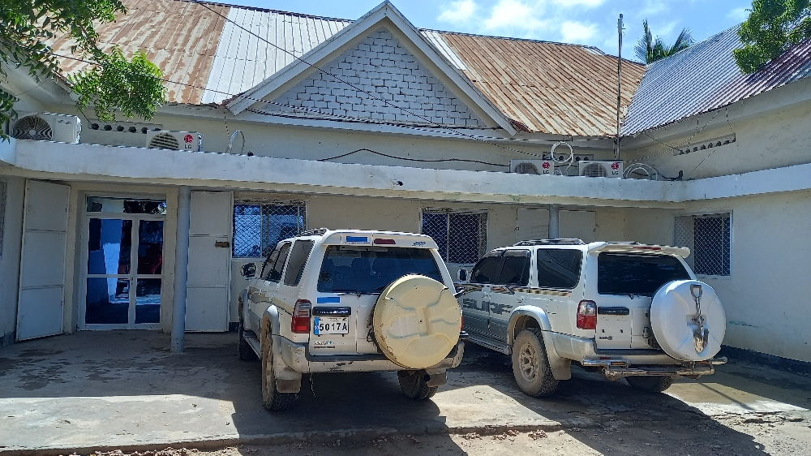 | 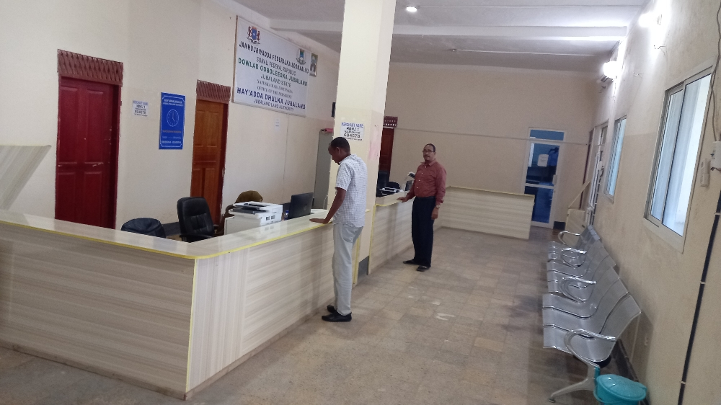
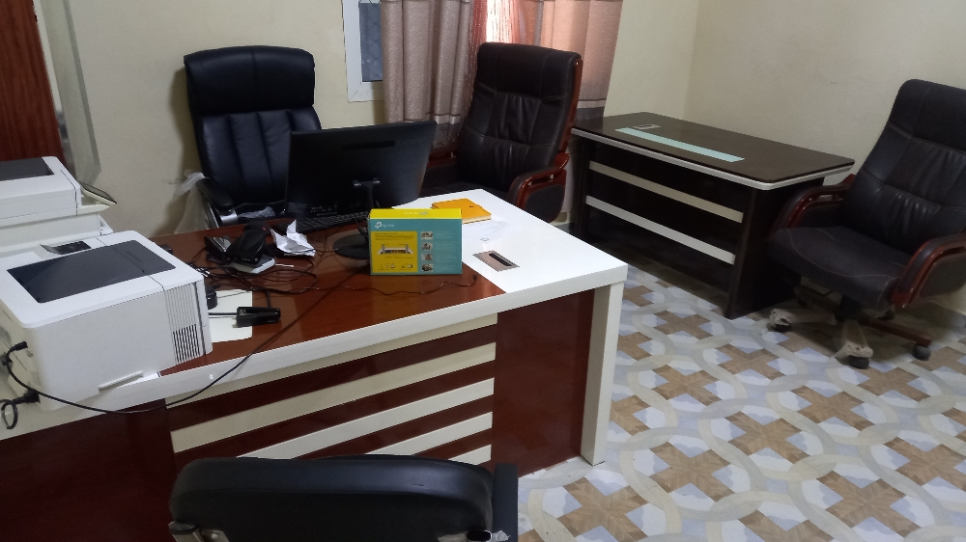 | 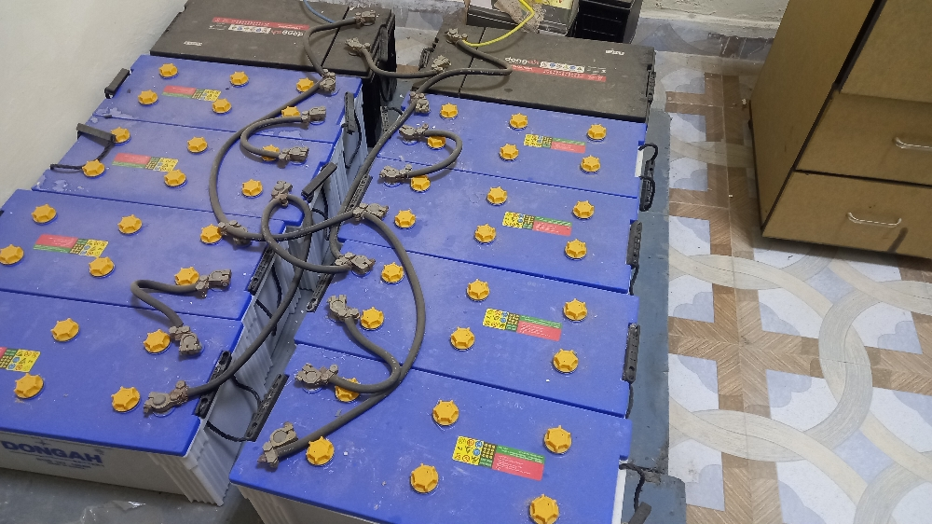
Figure 7: Kismayo land offices
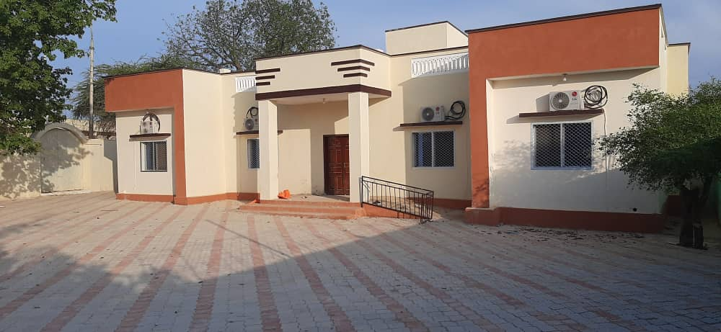 | 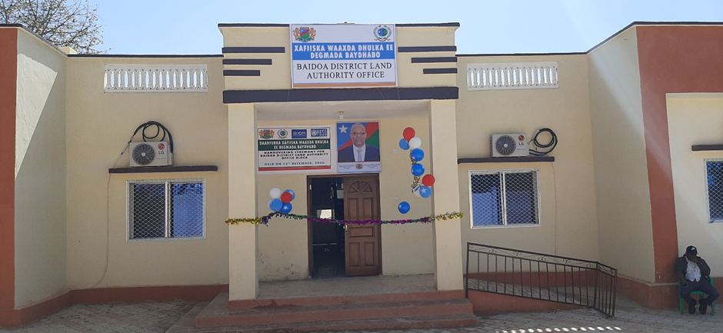
Figure 8: Baidoa Land offices
To facilitate the construction of the land offices, 60 (36 men and 24 women) CFW beneficiaries from Baidoa and Kismayo were selected by the LAs with priority given to IDPs, the host community and returnee refugees. Each beneficiary received $6 daily for a duration of 3 to 6 months. The income received by the beneficiaries was a great source of financial income that helped improve their livelihoods.
The project established information management systems in the land offices where registration, issuance of title deeds and payment of land taxes was recorded. The staff received training on the use of the digitized management system and actively used the system to provide land services. This highlights the effectiveness of the training provided by the project to the Jubbaland land authority officials. In Baidoa, an excel online database platform was developed but the electronic system was dropped in favour of a manual offline but electronic system built on Microsoft Excel after the new mayor took office.
Despite this challenge, the construction of the land offices is a good step towards ensuring that the community has access to better land services. The setting up of the digital information management in Kismayo provided value for money since the Jubbaland Land Authority uses a digital system for operations and the staff has enough capacity to use the digital system. Providing a better platform for the documentation of land conflicts. Otherwise, the same cannot be reported for Baidoa district as a shift in government policy and priorities resulted in a modification of the deliverable, from a digital automated online platform to a manual offline electronic system built on Microsoft excel. In addition, 81% of the survey respondents from Jowhar, Kismayo, Dhusamareb and Baidoa in the end-term evaluation report that vulnerable and disadvantaged people are effectively utilizing justice and remedial systems. A comparison between the mid-term and end-term survey findings indicates that more survey respondents in the end-term survey believe that disadvantaged people were utilizing justice systems. As shown in Figure 9 below, 71% of the survey respondents indicated that disadvantaged people were utilizing justice and remedial systems. During the end-term survey, 77% believed that disadvantaged people used the justice system.
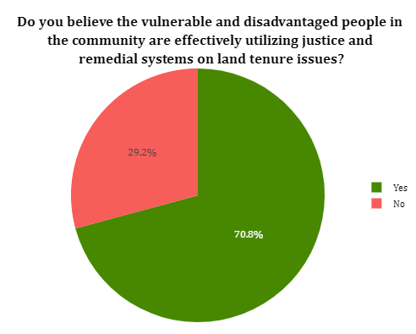  Figure 9: Mid-term survey findings for Baidoa and Kismayo | 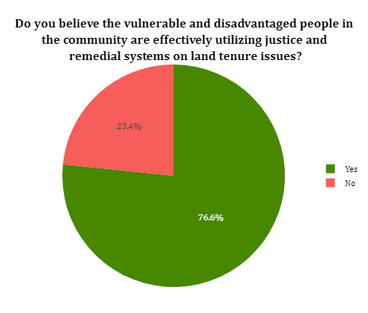  Figure 10: End-term survey findings for Baidoa and Kismayo
The project also carried out two infrastructural capacity assessments in Baidoa and Kismayo which indicated limited staff and staff capacity. To mitigate this gap, 56 male and 17 female community and district stakeholders from Baidoa, received land dispute resolution mechanisms training on resolving local disputes. In addition, 20 Baidoa local municipality staff received training on the manipulation of land management systems. 3 staff from Baidoa land services department and 80 participants including line ministry officials, religious leaders, women groups, district officials and officials from the governor’s office from Kismayo were trained on cadastral surveys trained. 24 technical staff from the land authority and land court officials from Kismayo also received training on land governance, use of land resources and natural resources and political and security dynamics on land issues.
As a result of the implementation of the project, the LAs from the various districts confirm that land cases were addressed through the formal justice system however they are not certain of the number of the cases referred. The evaluation team can verify that cases were referred to the formal/court system and some of the cases were executed but the evaluation team cannot ascertain the percentage of the cases executed by the court or the number of the cases referred to the formal system. This is because the project proposed the means to verifying the percentage of land disputes addressed through the formal justice system or court decisions executed was through judicial/court records. The evaluation team requested the implementing partners the court records but the documents were not provided. The evaluation team as well notes an issue with regards to the project results framework particularly on the means of verification of outcome indicators. The project partners should ensure that all documents proposed for verification of outcome indicators can be accessible to agencies or evaluators. In addition, factors such as confidentiality should be considered since documents such as judicial/court records contain confidential information.
Though some land disputes were executed through the formal/court system, the process was reported to be time-consuming and there is still a lack of an adequate documentation system for verifying documents, making resolution processes difficult. Hence, the reliance on informal land dispute mechanisms through elders is still preferred among some community members due to its effectiveness. The process is quick, free, just and elders are more trusted.
Overall, the project assumed that: a) After the construction of the infrastructures, setting up of the land data tenure database and capacity building of the local authorities, the local communities confidence in the state authority will be renewed; b) There would be improved trust in the management of titles and c) Improved trust in the adjudication of land disputes. FGDs with beneficiaries show that due to the project there is more trust in the adjudication of land disputes. The end-term evaluation findings also confirm these findings. During the mid-term evaluation as shown in Figure 11 below, 38% of respondents from Baidoa and Kismayo reported that they had high trust in the resolution of land disputes, 25% and 24% had very high and moderate trust respectively and 13% reported they had low trust. In comparison to the end-term evaluation, 66% who represent a majority of the respondents now have moderate trust, 27% have high trust, 5% have low trust and 2% have very high trust. The overall comparison between mid-term and end-term shows that after the implementation of the project, more respondents have moderate trust in the resolution of land disputes.
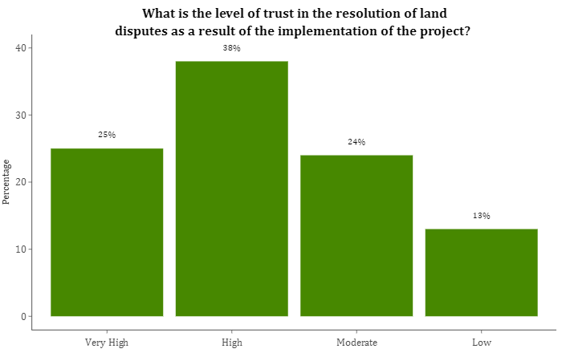  Figure 11: Mid-term survey findings in Baidoa and Kismayo | 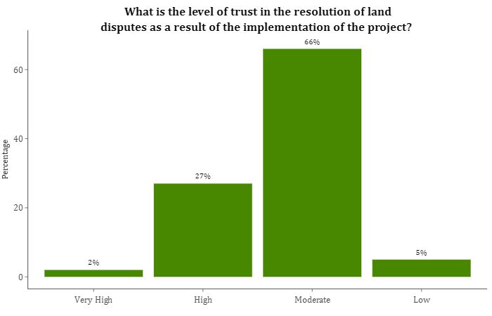  Figure 12: End-term survey findings in Baidoa and Kismayo

Further analysis of the survey findings, also shows more respondents have moderate trust in the management of land titles as a result of the project. In Figure 13 below, 49% of the respondents during the mid-term survey had high trust in the management of land titles. 20% had moderate trust, 11% very high and 13% had low trust. In comparison to the end-term evaluation, 60% who represent a majority of the respondents have moderate trust, 31% have high trust, 3% have very high trust and only 6% have low trust. The survey, therefore, show more respondents have moderate trust in the management of titles.
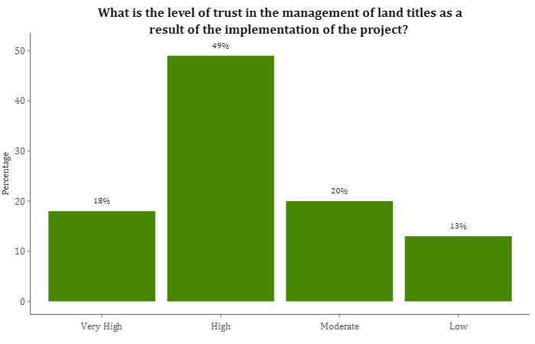  Figure 13: Mid-term survey findings in Baidoa and Kismayo | 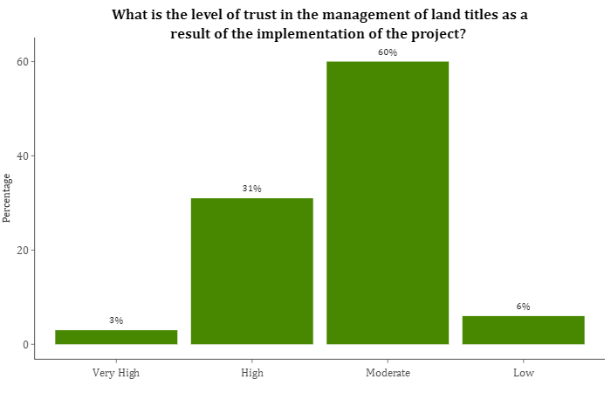  Figure 14: End-term survey findings in Baidoa and Kismayo

A comparison between the end-term and mid-term surveys also shows that more respondents agree they have confidence in the state land management system. In the mid-term evaluation, 42% of respondents strongly agreed, 36% agreed, 13% disagreed and 10% strongly disagreed. There is a decline in the number of respondents who strongly agree in the end-term evaluation, also no respondents strongly disagree. There are however more respondents in the end-term evaluation who agree (63%) who represent a majority of the survey respondents.
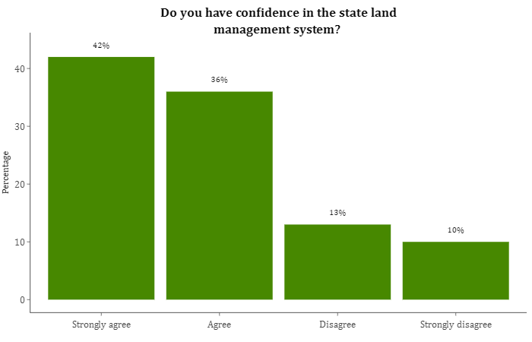  Figure 15: Mid-term evaluation findings for Baidoa and Kismayo | 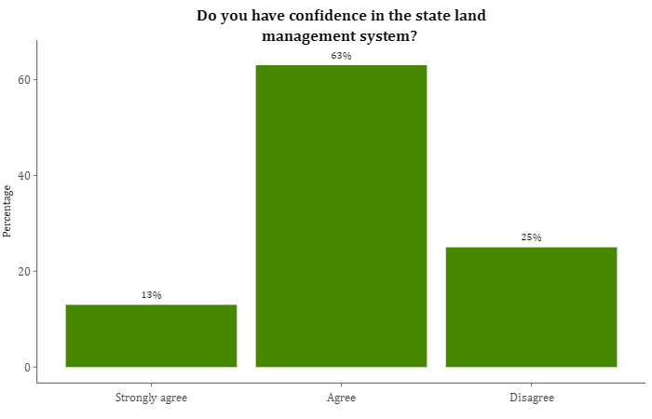  Figure 16: End-term evaluation findings for Baidoa and Kismayo

- Monitoring and evaluation
Based on the project document, UNDP was to act as the fund manager of the M&E component. The project consolidated semi-annual progress reports, indicating that the partners collaborated in various stages during implementation to report on the progress made. However, the evaluation team notes gaps in reporting. For instance, in the progress annual report of 2020 specific indicators in the project results framework are not reported against such as the number of land dispute committee members trained on management of disputes cases.

Each agency also had its internal M&E systems where they prepared activity progress reports and used a structural reporting matrix to track project activities. Regular grant status reviews were carried out during the implementation and project meetings were held to revise implementation strategies to accommodate context realities. Data was also collected and reported bi-weekly and interim and annual reports were prepared. Monitoring tools such as Open Data Kit (ODK), KoBo and questionnaires were also used for reporting. Project documents further confirm that agencies were independently doing their reporting and monitoring.

The evaluation team notes, challenges in reporting particularly in some training reports. The training reports do not show which activity in the logframe was being implemented, hence it is a challenge to determine which performance indicator was being implemented. Based on the projects logframe, the activities were to be disaggregated by gender, however, some of the training lists were not disaggregated. This made it difficult to determine how many of the trainees were women or men for purposes of reporting.

The IOM M&E unit conducted a baseline evaluation in February 2020 to obtain baseline values in Baidoa and Kismayo only on the perceptions of the community members on access to land services, the relevance of the construction of the land offices and potential impacts of the construction of the land offices. This is because IOM’s priority was on the development of the land offices. This baseline report captured data to inform the results and design of the Dhulka Nabaada project, however, the baseline did not sufficiently capture all the key outcome indicators. Based on the project’s results framework, specific indicators on the percentage of people who have confidence in the state land management system, the level of trust in the management of titles and trust in the adjudication of land disputes were to be reported against through a perception survey. The baseline survey carried out by the IOM unit does not capture indicators on the level of trust in the management of titles. Ideally, all M&E efforts need to be joint efforts when it comes to collecting baseline data, to ensure all key indicators are collected in all areas, and not just those pertinent to specific agencies.

At the ground level, project partners involved the government and beneficiaries in monitoring the project activities and results. Beneficiaries acted as oversight supervisors in collaboration with the LA, to monitor the project activities. In addition, beneficiaries report giving feedback about the project indicating the level of satisfaction from the services they received. 4 community-based M&E teams were also appointed to monitor the construction of the land authority buildings. The government also provided quality control during the construction of the land offices, received weekly progress reports from contractors and district authorities on the project activities and ensured Ministry staff monitored the project to ensure that the project indicators were fulfilled.

Lessons learnt from previous projects such as the Joint Justice programme was incorporated in the Dhulka Nabaada project. This programme projected a need to scale up access to justice and address community mistrust of courts. During project design, community conversations were incorporated in the Dhulka Nabada project to create an open forum to discuss justice, security and land dispute matters at the community level and invite government institutions to address the issues.
Before the implementation of the project, a programme baseline survey was to be carried out to establish benchmarks and to inform the operationalization of all the project activities (a survey different from the one conducted by IOM) this programme survey was not carried out because of delays in carrying out the assessment. A mid-term evaluation was thus carried in August 2020 by Axiom ME to report on the progress of the project and the potential impact of the project as the project was already mid-implementation by the time Axiom ME was contracted. From the mid-term evaluation report majority of the indicators were still in progress or had not been initiated. The report also found there was poor coordination among consortium partners and insufficient planning from inception which otherwise affected the M&E aspect of the project. Although the IPs held monthly meetings to track project results, the end-term evaluation process still confirms challenges on coordination processes among the agencies. It should be noted that there has been a major turnover of UN-Habitat staff under the Dhulka Nabada project which could have been a contributing factor in the problems encountered on coordination and information sharing.
- Coherence
The project paved the way for complementariness and synergy with other organizations and programmes. During project implementation, UN Women trained women from the ADR centres on literacy and numeracy. The JJP programme implemented by UNDP, United Nations Assistance Mission in Somalia (UNSOM), Joint Justice and Corrections Section, UN Women and United Nations Children’s Emergency Fund (UNICEF) focused on the delivery of basic services to increase access to justice and guarantee better protection of rights. The project also contributes to sustainable security and peace. JJP complemented the Dhulka Nabaada project by establishing Community Dispute Resolution Centres (CDRCs) comprising of a women’s community centre and ADRs in Kismayo and Baidoa and in Federal members states. The CDRCs would also host the land committees. The Dhulka Nabaada project complements the community conversations on security and justice also organized under the JJP programme. The mobile courts were also interlinked with JJP. Since the 2nd tranche of funds from PBF was not provided, UNDP used JJP funds to implement these activities under the Dhulka Nabaada project.
IOM, UN-HABITAT and UNDP implemented the Midnimo project where priorities were identified through the community action plans funded by PBF. Land committees established under the project were also integrated under the CDRCs established by the JJP project in Baidoa and Kismayo. The Midnimo project aimed at contributing to peace and state-building by strengthening government structures and institutions at the federal, regional, district and community level for accountability and transparency to respond to the needs of the people.
The Dhulka Nabaada project complements other upcoming projects such as the Saameynta project, a Swiss-funded project that will be implemented by UNDP and IOM and UN-Habitat as participating agencies. The project seeks to scale up solutions to displacement in Somalia by reducing the number of people residing in displacement areas. Before the implementation of the four-year project, a 6-month assessment would be carried out to pave way for the full implementation of the project. Dhulka Nabaada also complemented the Housing, Land and Property (HLP) component of the Danwadaag project implemented by IOM, Concern Worldwide and NRC.
In general, the JJP and Midnimo projects enabled sharing of technical skills and funds from the various projects to boost the outcomes of the Dhulka Nabaada project. Moreover, supplementary funds from the JJP project were leveraged to support the ADR activities, community conversations and mobile courts. The ADR centres and mobile courts solved and managed different disputes- land disputes, debt cases, marital disputes and livestock disputes. The support received in ADR centres and mobile courts under the JJP project did not only have a major impact on the resolution of land disputes but also the resolution of other disputes that the Dhulka Nabaada project was not targeting. The catalytic effect of the JJP project has been felt, as it has provided the community access to other forms of justice.

- Gender Equality and Women Empowerment
The project pointed out during the project design efforts to have Gender Equality and Women Empowerment (GEWE) this was by mitigating barriers to women’s access to justice. Specific activities were also targeting women only, for instance, community conversations were to be held with women only, but this was not implemented by the agencies.
The project identified the most vulnerable female-headed households and prioritized them during the cash for work activities. In addition, every activity had a significantly large number of women participants. The project also supported women by conducting training sessions on land rights issues thus advocating for gender equality and women empowerment by improving their understanding and capacity on land rights. 30 women were actively involved in dispute resolution activities in the ADR centres, this provided a space for women’s participation in the decision-making table on land disputes and land inheritance. As a result of this, community members started reporting disputes as they felt free to approach and share their issues with the women at the centre.
"Women are now involved in the decision-making bodies. For example, the female actors at the ADR centres are empowered to take part in traditional customary decision-making processes."
KII- Ministry of Justice, Baidoa

The inclusion of women has also effectively facilitated inclusive conflict resolution in the area as it has enhanced access to justice and advocacy of women's rights on land issues. As a result of this, women’s dignity, honour and property have been slightly safeguarded at the cultural level. This was very minimal before project implementation.
In regards to women’s ability to own and inherit land, more respondents during the end-term evaluation agree that women can own and inherit land in comparison to the mid-term evaluation. As shown in Figure 17 below, 41% of the sampled 103 female respondents during the mid-term evaluation strongly agreed that women’s ability to own and inherit land had improved in the district, only 39% agreed and 20% disagreed. During the end-term evaluation as evident in Figure 18, 62% agree, 19% strongly agree and 19% disagree.
The evaluation team further broke down the findings by districts as shown below:
- Of the sampled female respondents from Kismayo, 60% agree the ability for women to own and inherit land has improved. 22% disagree and 17% strongly agree;
- Of the sampled female respondents from Baidoa, 66% agree the ability for women to own and inherit land has improved. 22% strongly agree and 12% disagree;
- Of the sampled female respondents from Jowhar, 72% agree the ability for women to own and inherit land has improved. 20% disagree and 7% strongly agree; and
- Of the sampled female respondents in Dhusamareeb, 6% strongly agree women’s ability to own and inherit land has improved, 59% agree, 29% disagree and 6% strongly disagree.

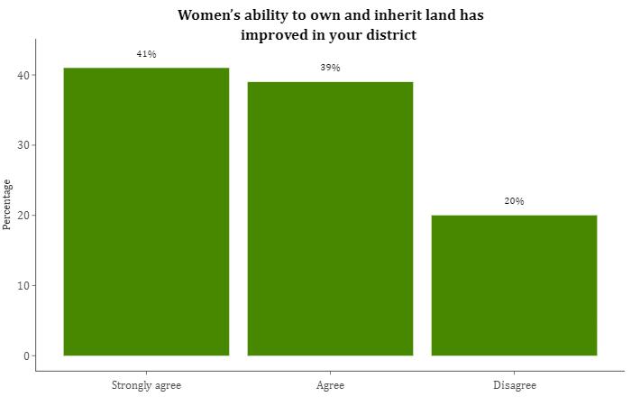  Figure 17: Mid-term evaluation findings for Kismayo and Baidoa | 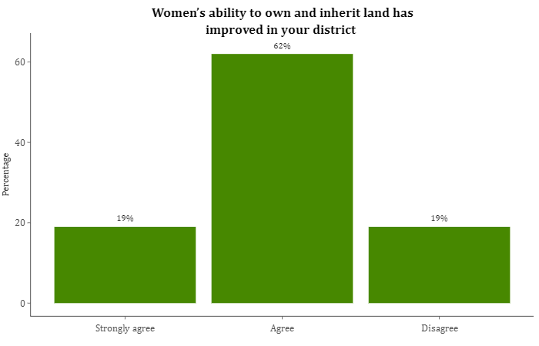  Figure 18: End term evaluation findings for Baidoa and Kismayo

Although women have better access to land and property rights and opportunities at the decision-making table, cultural beliefs hinder women from accessing opportunities. In addition, the project took appropriate measures to promote gender equality across the project results, however, some gaps were still identified that would hinder compliance on women’s rights. This includes a lack of sufficient knowledge in the community on the rights of women to access and own land.
Further, a comparison of the level of trust in the resolution of land disputes between men and women revealed that women have more trust than men. From Figure 19 below, 42% of sampled 190 female respondents have high and very high trust in the resolution of land disputes after the implementation of the project, 56% have moderate trust and only 2% low trust. On the other hand, only 28% of the sampled 231 male respondents have very high and high trust, 54% have moderate trust and 7% have low trust.
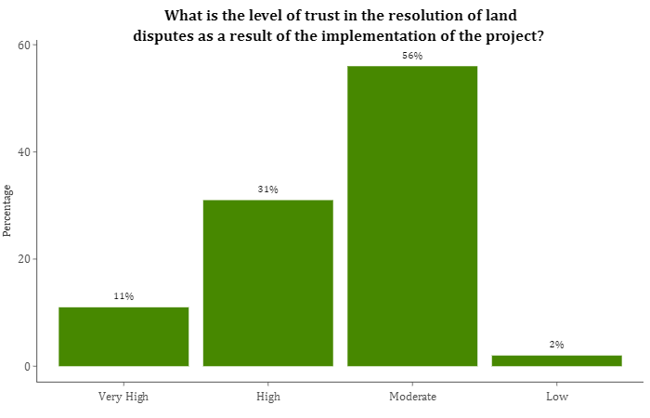  Figure 19: Female respondents from the 4 districts- End-term evaluation | 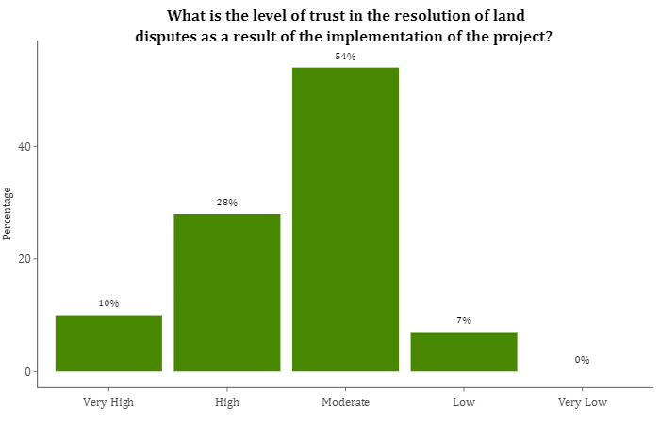  Figure 20: Male respondents from the 4 districts- End-term evaluation

- EFFICIENCY

The overall staffing, planning, management and accountability measures within the project were termed as good and sufficient for the implementation of project activities by the various implementing partners. It was noted that in regards to staffing the project staff were hired in accordance with the rules and regulations of the UN recruitment process. The planning for the project was based on the Specific, Measurable, Achievable, Relevant and Time-based (SMART) framework, the current situation of Somalia and an effective well-prepared plan.
There were, however, delays during the implementation of the project Most of the project beneficiaries in Baidoa, Dhusamareb, Jowhar and Kismayo noted that there was a slight delay in the project implementation that was mainly brought about by the COVID-19 pandemic. This is because the pandemic restricted interactions with community members and project stakeholders. Government representatives in Baidoa and Dhusamareb noted that there was a delay in the actual kick-off of the project. This is because the ministry received the letter of agreement later than they had anticipated.
Some delays in the approval of the annual project work plan were reported to have been occasioned by the nature of implementing partners internal business process which can take a long time. It was also noted that there was a gap in funding due to the global economic shutdown occasioned by the emergence of the COVID-19 pandemic. Slight delays of approvals to embark on implementing project activities, amongst implementing agencies were also reported to have caused a slight delay in implementation of the project. . It was further stated that there was a delay in the procurement of land surveying tools as they were not available in Somalia. The tools had to be procured from Denmark and this took a long time. There was also a delay in identifying a suitable site for the construction of Baidoa land authority office. This was because of the limitation of government-owned spaces in the district. In Kismayo, both the government representatives and IPs reported that no delays were experienced during the project implementation.
There was moderate coordination between the implementing agencies. This is a result of mixed feedback from the various stakeholders in the different project target locations. In Baidoa, it was noted that at the onset of the project, there was poor coordination among the implementing agencies of the project that resulted from poor information sharing, something also found in the mid-term evaluation of the project. This was reported to have improved due to coordination meetings which were held to share information to avoid duplication of activities, provide updates on activities and challenges were addressed in union.
The same sentiments were echoed in Dhusamareb where it was noted that the level of coordination and communication of the top-level management between the implementing partners was very high and they worked together efficiently and effectively. It was however, noted that there was low-level coordination and information gap among the implementing agencies at the field level.
In Kismayo, there were mixed opinions regarding the coordination amongst implementing agencies during the project implementation. Based on feedback from IOM and UNDP, the coordination between the various implementing partners was effective and efficient throughout the project. This was contrary to the sentiments of NRC that stated that the coordination with other implementing agencies was poor in the district. UN-Habitat noted that in general the level of coordination between the implementing agencies is not good but under the Dhulka Nabaada project the implementing agencies were coordinating on an activity basis in the implementation of project activities.
In Baidoa, Dhusamareb, Jowhar and Kismayo, based on feedback from the various stakeholders there was good coordination between the implementing agencies and the government. In Baidoa, implementing agencies stated that the coordination with the government was efficient. The government ministries were committed to supporting project implementation and effectively coordinated with IPs of the project, thus no challenges were experienced. The coordination from the government side was led by the ministry of planning and economic cooperation of SWS together with other line ministries and LAs. In Dhusamareb the level of coordination with the government was good as they worked together effectively during the implementation of the project. Government representatives noted that they worked together effectively as the government oversaw the implementation of project activities. In Kismayo, the level of coordination with the government was also good and efficient. It was stated that the project was well coordinated with the government especially with the line ministries and the local government. The coordination was efficient and there were no challenges encountered during the project implementation. As already highlighted under the relevance section, the MoPWH was involved in the development of the project proposal. Therefore, the general coordination of the government was efficient and there were no challenges encountered during the project implementation.
Regarding the effectiveness of the project against the costs allocated, the final financial report confirms that the project was allocated a total of USD 1,802,064 for project implementation amongst all the implementing agencies. It is important to note that this was not the original budget allocation, all the agencies received only tranche 1 (70%) except IOM that received 73%. The breakdown of the budget allocation against expenditure per implementing agency is indicated in Table 8 below.
Table 8: Budget allocation vs expenditure per implementing agency

 | UN-HABITAT | IOM | UNHCR | UNDP
Tranche 1 | 418,377 | 495,923 | 215,682 | 672,083
Expenditure | 403,617 | 708,460 | 308,117 | 672,083
Difference | 14,760 | (212,537) | (92,435) | -
Over/Under expenditure | Under expenditure | Over expenditure | Over expenditure | The exact budget allocated was spent
% of usage | 96% | 143% | 143% | 100%

Table 9 below further breaks down how each implementing partner spent the funds that had been allocated to them.
Table 9: Implementing agencies budget lines
* The areas highlighted in red show areas where the expenditure is greater than the allocated amount for the respective category.

 | UN-HABITAT |  | IOM |  | UNHCR |  | UNDP
 | Tranche 1 | Expenditure | Tranche 1 | Expenditure | Tranche 1 | Expenditure | Tranche 1 | Expenditure
Staff and other personnel | 95,200 | 158,933 | 139,082 | 131,921 | 114,072 | 133,162 | 108,472 | 178,173
Supplies, Commodities, Materials | 3,500 | 29,040 | 12,600 | 17,514 | - | - | 24,998 | 442
Equipment, Vehicles, and Furniture (including Depreciation) | 2,100 | - | - | - | - | - | - | 6,265
Contractual services | 215,740 | 154,440 | 223,440 | 376,448 | - | 72,000 | - | 268,445
Travel | 11,991 | 7,184 | 4,620 | 22,323 | - | - | 58,330 | 7,911
Transfers and Grants to Counterparts | - | - | 34,125 | 30,547 | 87,500 | 82,798 | 364,054 | -
General Operating and other Direct Costs | 62,475 | 27,615 | 49,613 | 83,360 | - | - | 72,261 | 166,880
Indirect Support Costs (must be 7%) | 27,370 | 26,405 | 32,444 | 46,347 | 14,110 | 20,157 | 43,968 | 43,968
 | 418,377 | 403,617 | 495,923 | 708,460 | 215,682 | 308,117 | 672,083 | 672,083
 | There is over expenditure in some budget lines such as staff and personnel and supplies. Nevertheless, overall expenditure did not exceed the allocated budget which points to re-adjustment of budget lines during implementation. |  | The expenditure on contractual services is higher than the allocated budget. Overall, there is over expenditure. |  | There is over expenditure mainly due to the Contractual services which was not catered for during budget allocation. |  | All amount allocated is exactly what was spent. However, note that no budget was allocated for contractual services but there was expenditure on this budget line. Additionally, there was no expenditure on the budget line allocated to transfers and grants.

A further breakdown of the financial budget shows that most of the expenditure was under outcome 2 (as shown in Figure 21 below) which focused mostly on infrastructure development and the setting up of the information management system.
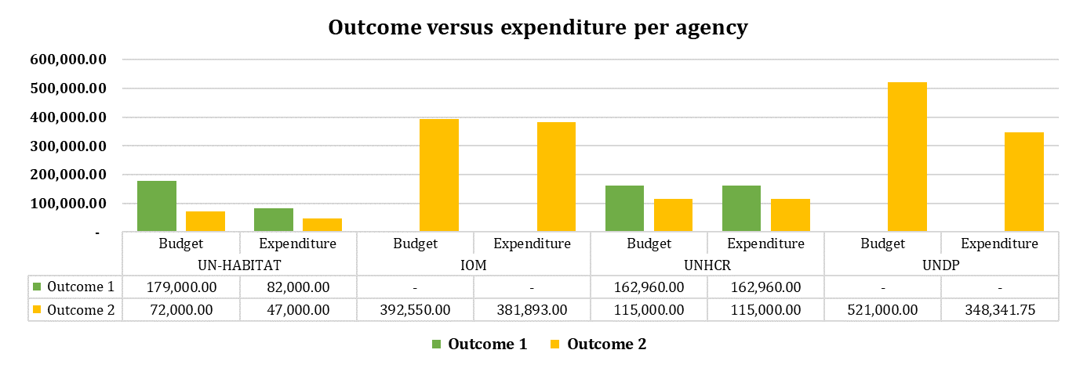
Figure 21: Outcome versus expenditure

In addition, the financial report indicates that of the total budget provided for implementation of the activities in outcomes 1 and 2, UN-Habitat, UNDP and IOM did not spend all the financial resources towards the implementation of the activities as evident in Figure 22 below. UNHCR on the other hand utilized all its resources towards the implementation of project activities. Figure 22 below, further gives a clear overview of the outcomes each agency was implementing. All agencies were implementing activities under outcome 2 while only UNHCR and UN-Habitat implemented activities under outcome 1.

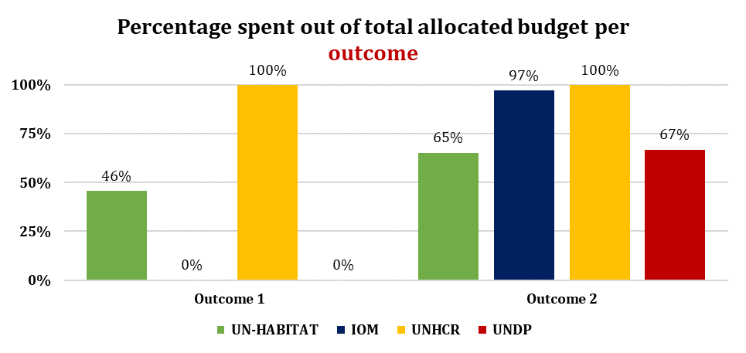
Figure 22: Percentage spent out of the total budget per agency

Responses from project beneficiaries indicate that the project has been effective in implementing the project activities as planned. Project activities under outcome 1 such as the establishment and training of the land dispute resolution committee, community conversations and dialogue forums, training of community facilitators and the training of government officials on land dispute resolution and land policy development were reported to have had the most impact.
This is because all these activities have played a big role in reducing land conflicts and disputes in the targeted locations. The activities under outcome 1, were more community-based in terms of awareness to the community about land issues. This means that these activities involved a lot of interactions amongst implementing agencies, government, local authorities and project beneficiaries. Therefore, this can explain why these activities had the most impact on the communities.
Outcome 2 activities impacts were not so pronounced compared to activities under outcome 1. This could be because under outcome 2 some activities were high level and more specific, i.e., setting up a functional information management system and the construction land offices in Kismayo and Baidoa. The effectiveness and impact of these activities may have not been pronounced but with a fully functional office and a proper land management system we expect that this will set a clear direction on the management of land documents and delivery of land services. The impact of this outcome will be great long after the project given the government maintains the infrastructures set up, to ensure sustainability. It is important to note that in Baidoa the project did not manage to operationalize the originally planned digital automated online platform. This is a result of the change in the mayor’s office. When the new mayor was appointed the original plans for the land management system were shelved. The previously developed land registration electronic system was dropped in favour of a manual offline electronic system built on Microsoft Excel.
In the opinion of the evaluation team, the project provided good value for money as the activities were implemented effectively and efficiently. The project activities implemented have helped to increase access to justice, remedial and adjudication on land issues though some project activities such as the approval of the land policies are pending. The project has also improved the delivery of land administration and land rights services through the institutionalization of appropriate infrastructure and information management systems, thus rebuilding the community’s confidence in LAs.
- OUTCOME/IMPACT

The project has increased access to justice, remedial and adjudication on land issues and resolution of disputes. According to the KIIs and surveys with project beneficiaries, one of the impacts of the projects is the establishment and training of the land dispute resolution committees. This is because the land dispute committees have been diligent in their duties and helped to resolve land disputes and reduce land conflicts in the different target locations. In Baidoa, and Jowhar beneficiaries stated that the biggest change brought about by the project was the establishment of the land dispute committee that has been fair and transparent in resolving land issues. They noted that their trust in the committee in resolving land issues has immensely increased due the trainings provided by the project. The project moreover, has improved the trust of the community in the settlement of land disputes in the district. This is a result of the project creating the land dispute committee and the ADR centre that effectively contribute to land dispute resolution activities for the community in Baidoa and Jowhar.

There has been a perceived great change in dispute resolution mechanisms, as the minority, women and youth all have access to a fair process of resolving disputes.

Mid-term | End-term
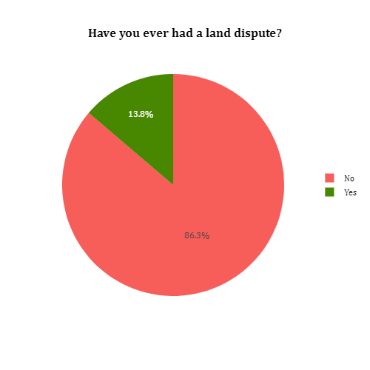 | 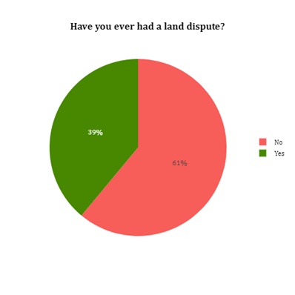
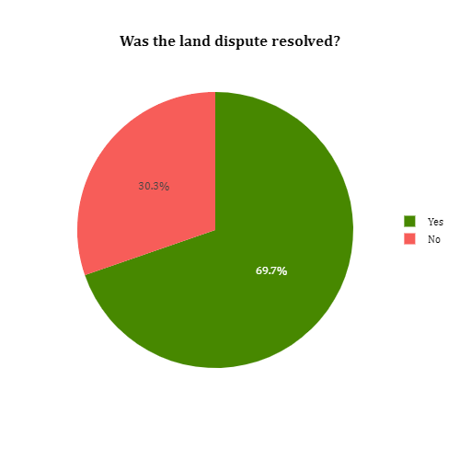 | 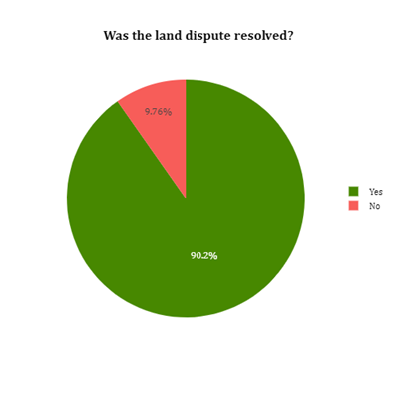
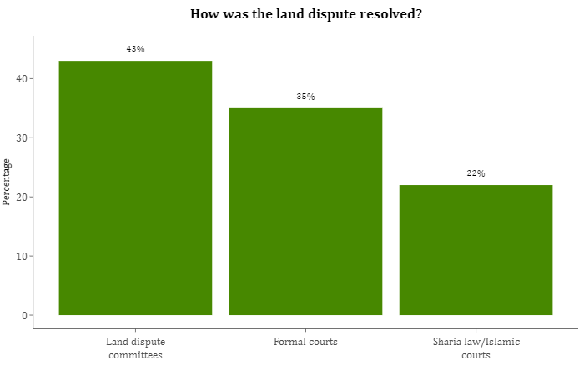  Figure 23: Perceptions on land dispute resolution | 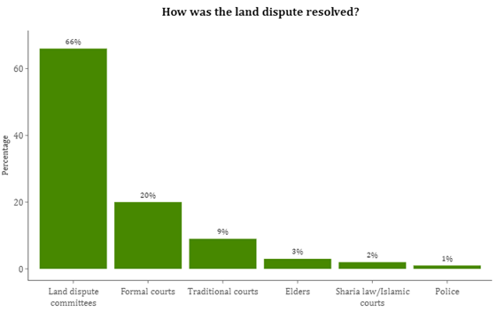

The fact that the community has trust and believe in the impartiality and ability of the land dispute committee bodes well for the future. It shows that the impacts of the work of the committees will continue to be felt for a long time as long as they continue to serve the communities in a just manner. This is because they have already gained the trust of the community and received capacity building and trainings to aid in discharging their duties.
The community conversations and dialogue forums conducted by the project have also had a great impact on the project target locations. The community conversations and dialogue forums have helped to improve the relationship between the community and the governing authorities as well as build cohesion amongst community members. The community conversations educated the community on land dispute resolutions and land policy, and improved community involvement in land justice.
The project trained community facilitators in the 4 target locations on land issues justice, security, conflict resolution, community engagement and land disputes resolution. According to community facilitators they used this knowledge gained from the trainings to conduct community conversations to educate the community on land-related conflicts and to build social cohesion and trust amongst the IDPs and the host communities.
In Jowhar, beneficiaries noted that one of the impacts of the project was that it enhanced and improved engagement between the government institutions and the community on land, justice and security issues through community conversations and dialogues forums. In Dhusamareb, it was noted that one of the impacts brought about by the project was the improved relationship between the government institutions and community. The project had a catalytic effect as it created social cohesion among the different community groups due to the community conversations and dialogues held. This was because the project provided a platform where the government and the community could interact and exchange ideas on issues of land. In Baidoa, it was mentioned that the project improved the relationship between the community and the governing authorities by acting as a mediator between the community and the government.

Mid-term | End-term
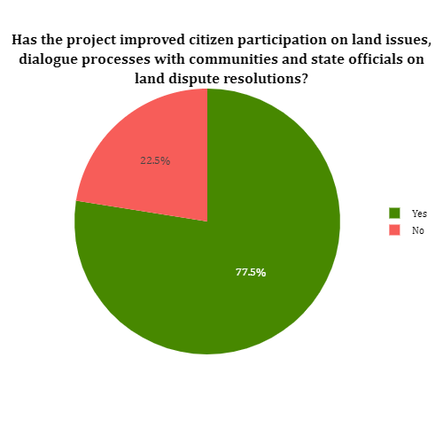 | 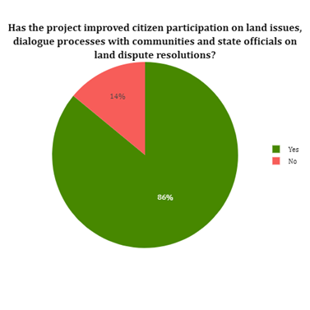
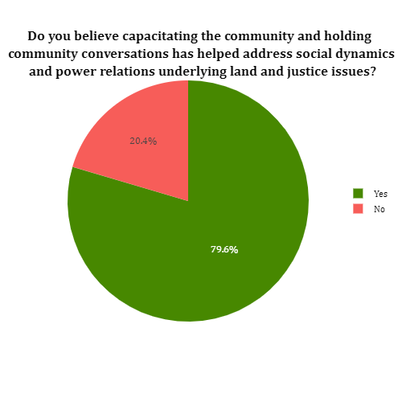  Figure 24: Perception on community conversations in addressing social dynamics and power relations underlying land and justice issues. | 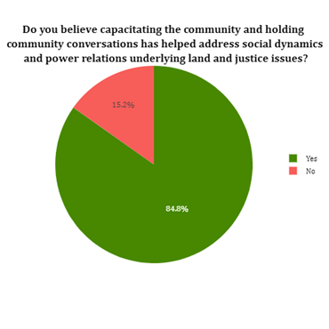
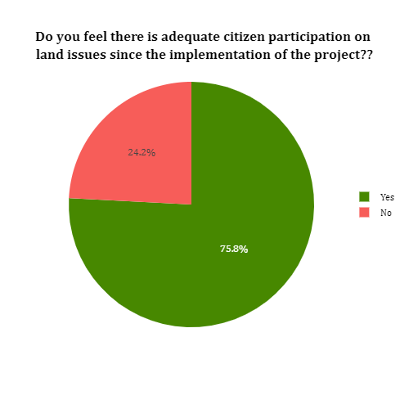  Figure 25: Perception on increased citizen participation on land issues | 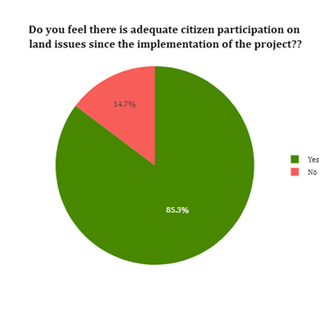

The project has also been successful in conducting high-level forums held on land conflict and state-building in all 4 project target locations. The forums discussed matters on land acquisition and how to reduce and solve land issues and conflicts within the project target areas. Government officials in the targeted project locations have been trained on policy development. According to the PBF-Dhulka Nabaada project- annual report 2020, a group of officials from Jubbaland, South West State, Hirshabelle and Mogadishu were trained on how to develop a land policy. This training has helped to increase the communities trust in the government's abilities to solve land disputes in the project target areas. Project beneficiaries stated that the community relationship with the governing authorities has improved. This is a result of the government being capacitated to provide justice on land matters by the project. It was stated that the improved relationship between the ministry/department of justice with the community has encouraged the community to seek legal redress from the courts unlike before. This in turn has led to a reduction in land disputes in the project target locations. The project improved relations between the government and the community by conducting forums and community meetings to discuss community issues and how the local authorities could handle these issues.
The community conversations and dialogue forum combined with the training and capacity building (specifically on land policy development as well as land dispute and conflict resolution) conducted by the project have improved the trust of the community towards the government. This is because the community had the opportunity to interact with the government and understand their position regarding administering justice on land disputes and conflicts. The community also believes that training and capacity building has given the relevant authorities the ability and capability to resolve land dispute cases in a fair and transparent manner. With the improved relationship and renewed trust from the community, the government has the opportunity to increase access to justice, remedial and adjudication on land issues through an integrated framework of the various mechanisms guided by clear policy and legislation ensuring coherence in resolution of disputes.
“Trainings, community conversations and dialogue forums for the community and government officials helped enhance government official’s capabilities on land management issues and interaction with community groups”. KII MoPWH, Baidoa
The construction of land offices in Kismayo and Baidoa by the project and the and provision of computers to improve the land management system in the 2 districts will have a great impact. The provision of computers means that land registration and acquisition matters will be handled and stored digitally and this will ease operations in the land offices more so in Kismayo. In Baidoa, it is important to note that NRC did not manage to operationalize the originally planned land database management system. This is as a result of a change in the mayor’s office, when the new mayor was appointed the original plans for the land management system were shelved. The impact of an improved land management system and a fully operational land department is not visible at the moment. However, it has been stated by different project stakeholders that community members now have trust in the government’s ability to solve land issues and disputes, therefore it is expected that community members will visit the land offices for issues and disputes. With a fully functional office and a proper land management system, the project expects a greater reduction of land disputes and conflicts in the 2 districts. Moreover, the construction of Baidoa land department office and providing it with equipment will help speed up its activities for the community.
The project has also contributed to the strategic outcomes identified in the NDP, land legislative agendas and policies. This is because the project deals with injustice, grievances and land disputes. In Baidoa, government representatives stated that the project provided social services like promoting access to land services which has contributed to improved economic development. This is because the government will be able to generate more revenue from the land registration and land service provision to the community. In Kismayo, it was noted that the project has contributed to the plans of the Somalia national development plan by providing support in solving land disputes. The project also provided technical training to the respective Ministries and local authorities in Jubbaland thus building their capacity on land legislative agendas and policies. In Kismayo for example, government representatives stated that as a result of the capacity building and training on urban land management, the MoPWH in Kismayo is planning to develop a master plan for big towns in the district.
- GAPS AND CHALLENGES

The project developed land law policies that are pending approval due to COVID-19 delays and lack of political will. Due to these delays, it is then difficult to assess the effectiveness of the policy. In a more technical sense, an evaluation of the policy will demand time, resources, assessing its gaps after adaptation and efficiency of the government to apply the policies. The ToC of the policy cannot be assessed at this level of reporting. There is still a lack of a clear framework or strategy from the IPs for the sustainability of the land law policy.
Land conflict drivers are deep-rooted, in the opinion of the evaluation team to address these drivers requires a longer project implementation period and continuous professional development of government land officials and land dispute committees on land conflict resolution processes. The project was appropriate in targeting districts that needed the project the most. In Baidoa district, for instance, rural to urban migration has been a cause of land conflicts, to address this driver of conflict would demand high-level engagement of the government and urban planning measures put in place. This should be coupled with financial support and continuous monitoring of grassroots stakeholders in the ADR centres and the land dispute committees.
The project was to initiate a land database management system in Baidoa but this was not realized after the new Mayor in Baidoa took office during the implementation of the project. The municipality, therefore, went back to using a manual offline electronic system built on Microsoft Excel. The theory of change considered that the setting up of the land tenure database system would then improve land administration service delivery. Though efforts were made by the IPs to promote the use of the digital system this activity in Baidoa was not fully implemented as initially planned. This finding also highlights a key problem with government staff turnover that has the potential to negatively affect any positive plans or achievements expected under future similar projects.
The role of the mobile courts was to identify cases to be processed through the formal justice system or through the dispute resolution committee and solve disputes. However, there is still a lack of knowledge from the community of its existence and its role. This shows that there was a gap in disseminating information of the court. The operation of the mobile courts is costly; thus, the courts may not function effectively without assistance from projects. Since the courts operate in different locations insecurity and transportation facilitation is a challenge. The fundamental purpose of the CDRCs was to resolve land disputes through the land dispute resolution committees. They however do not receive any compensation, which presents a lack of motivation to solve the land disputes. The land committees do not resolve complicated land cases involving returnees and the host communities are referred to court due to their complex nature. It was further confirmed that after the completion of the project, there were no ongoing activities in the CDRCs.

The impact of the ADR centres is already evident but a major impediment that hinders the effective resolution of disputes is still poor land documentation and proper land information systems. Two other factors that hamper the efficiency of the centres to operate are lack of incentives and logistical support, particularly when visiting the contesting parties. This raises the dilemma over the sustainability and effectiveness of the ADR centres to operate independently. The lack of incentives for ADR centres operational staff should be seen as a potential gap in the fair resolution of land conflicts but most importantly what would be the potential effect on the community’s confidence in the ADR centres to address land conflicts. The ADR centres also lack an enforcement body.

During the implementation of the project, COVID-19 was a major challenge that affected coordination among the project partners, particularly on information sharing. To mitigate this challenge, IPs maximized the use of online platforms. Activities involving social gatherings were stopped and the work plan was amended to reflect the new changes. There were lengthy processes in project sites due to limited government-owned and managed land, particularly in Baidoa. To mitigate this gap this called for constant communication with government stakeholders to expedite the process.
- SUSTAINABILITY

The project has put in place sustainability measures to ensure that the activities implemented by the project will continue.
Sustainability due to trainings received from the project
It was noted that the project had put in place measures and strategies to ensure sustainability after the IPs exit. UNDP noted that the project had empowered government institutions by building their capacity in delivering services as well as taking ownership of the infrastructures built by the project. The project also enabled elders and women leaders in acquiring the necessary skills to continue working in conflict resolution platforms.

In addition, the project established and trained the land dispute resolution committees to ensure that land reforms continue even after the project period has elapsed. Members of the land dispute committees formed by the project stated that they will continue their work after the project ends. This is because they have been trained and would want to work for their people until they get a government that can exercise its power by maintaining law and order in the entire country. In Dhusamareb, land dispute committee members stated that they were still working in the district and providing support to the local communities. They stated that they had not faced any challenge yet, that has hindered their work.
The project also trained community facilitators on land conflict resolution. The community facilitators stated that they are capable of continuing their work as they have received training from the project. This in turn has enabled them to effectively continue with their work even after the project elapsed. The community facilitators have gained extensive experiences from their engagements with the different groups of the community and built rapport with the community groups they have engaged with.
Government representatives also stated that the knowledge and skills gained on land management issues like land registration, land acquisition and issuance of title deeds provided by the project will contribute to the sustainability of the project. The project trained ministry staff that were engaged with land and justice issues and developed a land tenure and land rights for the development of the land dispute settlement system in the project target locations. Technical knowledge received by the government official is good for the sustainability of the project, but the government needs to ensure that they play a key role in ensuring that land disputes are solved fairly and transparently. This will help build community trust in the government's abilities to provide justice on land disputes in a fair and just manner. The government should also lobby parliamentarians to adopt the land tenure and land rights policy developed by the project to ensure the sustainability of the project.
The project trainings and capacity building provided to the different stakeholders have imparted knowledge on the stakeholders and this will play a key role in ensuring the sustainability of the project.
Sustainability due to community ownership
The government, local authorities and the community's participation in the project has fostered increased commitment and ownership of the project results for sustainability beyond the project period to a large extent. In Baidoa, the district authority has established the Baidoa land department that is taking lead in managing and providing land service delivery for the community in Baidoa. The district authority appointed the director to the department and other staff to run the department effectively. The local authority in Baidoa, noted that he played a big role during the implementation of the project, as he was involved in organizing the land dispute committee meetings and keeping the records. It was further noted that the local authorities took part in facilitating training activities carried out in the district. In Dhusamareb, Kismayo, Baidoa and Jowhar it was noted that the government's involvement in the project has enhanced the communities' trust in the government institutions to resolve land disputes.

Project beneficiaries also stated that they have confidence in the ability of the government to provide access to justice on land services because they believe that the government has the power to influence any matter regarding the citizens and that they can serve the community in a just way. Some project beneficiaries although were hesitant about the government’s ability to provide access to justice and therefore sustain the project because the government lacks the structures and capacity required to provide these services.
As reported during the mid-term evaluation combined community dialogues and discussions on land matters inclusive of all members of the community members including women have enlightened the community on issues of land rights and ownership specifically for women, where the project has made deliberate efforts to make it easy for them to own and inherit the land. This will go a long way in ensuring that even after the project the community will know that women have the right to own and inherit land just like any other person in the community.

Sustainability due to policies and systems implemented by the project

The project as reported was successful in developing a land tenure and land rights policy in 3 districts of Baidoa, Jowhar and Kismayo although the policies are pending approval from the various district parliaments. The bills have taken some time to be adopted, but if adopted this will ensure that the project's activities are sustainable long after the project has elapsed. This is because the policies outline the principles and procedures of managing and handling land issues. The project has also established a land information management system that will ensure the local authorities have a digital land management system that will make it easy to trace and locate all the necessary land documents in one place. This will ensure that there is an electronic record of all land transactions thus reducing fraudulent land transactions leading to conflicts and land disputes. In Baidoa, it is important to note that NRC did not manage to operationalize the originally planned land database management system. This is as a result of a change in the mayor’s office, when the new mayor was appointed the original plans for the land management system were shelved. With the coming of the new District Commissioner in Baidoa district, the previously developed land registration electronic system was dropped in favour of a manual offline electronic system built on Microsoft Excel. This has the potential to negatively affect the sustainability of the project. A land management system will be better suited to ensure sustainability compared to the paper-based system favoured by the municipality in Baidoa

Sustainability due to the infrastructure provided/constructed by the project

The project provided desktop computers and projectors in Baidoa and Kismayo, this has helped with operations in the land department offices. The municipality in Baidoa concluded that they lacked the capacity and infrastructure to operationalize an electronic land management or vital information management system. Therefore, in Baidoa, the equipping of the land offices with desktops and projectors alone may not be enough to ensure the sustainability of the project. The sustainability of the infrastructures built by the project will mainly depend on the government and local authority's goodwill to ensure the maintenance and running of the infrastructures.
The project also urged and encouraged the government institutions to raise funds for them to become self-reliant and continue providing services initiated by this project, including the maintenance of the structures implemented by the project.
- LESSONS LEARNT
There appears to be overarching lessons learnt, good practices, activities that should have been otherwise prioritized by the implementing partners and activities that should have been scaled up. These lessons learnt as are follows.
- Government involvement in the project design is crucial
The government's involvement in the project design was an important step. It not only ensures that the project is aligned to the priorities of the government but most importantly that the government takes ownership of the project to ensure project sustainability. The causes of land disputes in Somalia are complex, interventions seeking to address land conflicts, therefore, demand the intervention of government stakeholders. The Dhulka Nabaada project was able to do this well, it involved key government stakeholders involved in issues of land and security such as the MoJ, MoI and MoPWH. Moreover, the findings reflected that these government institutions were involved in the planning stage of the project and the level of coordination between the implementing agencies and government agencies was good.
- Coordination among project partners is paramount
Proper coordination strategies are not reflected among the IPs. During the monitoring and evaluation stages of the project, there were challenges in obtaining information from the various partners, it was unclear where some partners were operating. Also, due to high levels of staff turnover in UN-Habitat, there was a lack of a strong focal point. This reflects on the lack of planning or coordination among the partners. The monthly meetings held among the partners were however important to track the project activities.

- Defined project theory of change
The project's theory of change is well linked to the conflict drivers and needs of the community. Though the land policy has not been approved, it creates a framework for land adjudication and management. The lack of mechanisms for land dispute resolution was a major conflict driver, the project created specific avenues for dispute resolution such as land dispute committees. The construction of the land offices has created a strong foundation for the government to provide land services to the community. The evaluation acknowledges gaps in the project, however supporting land reform in Somalia needs years of continuous engagement with government stakeholders, community members, IPs and coherence with other programmes. The project should have prioritized the establishment of training centres that provide training on land issues and land management to improve knowledge on land issues for government officials and the community.

- Defined monitoring and evaluation strategies
The implementing partners employed internal and external monitoring and evaluation measures to track the project, however there is a lack of clarity in reporting. In the project annual report 2020 shared by the IPs, some indicators in the log frame are not complete. IOM carried out a baseline evaluation in January 2020 in Kismayo and Baidoa only, baseline values for other locations were not collected. Under the JJP programme, UNDP conducted a Third-Party Monitoring (TPM) on legal aid, mobile courts and ADR services provided. The agencies seem to have been collecting data independently. Although a mid-term evaluation was carried out, the evaluation only collected data in Jowhar, Kismayo and Baidoa districts as no activities at the time had been implemented in Dhusamareb. This negatively reflects on the reporting of the IPs.

- CONCLUSION AND RECOMMENDATIONS

The project had two main outcomes, the first to “Increase access to justice, remedial and adjudication on land issues through an integrated framework of the various mechanisms guided by a clear policy and legislation ensuring coherence in the resolution of disputes”; and second to “Improve delivery of land administration and land rights services through the institutionalization of appropriate infrastructure and information management systems, thus rebuilding the community’s confidence in LAs”.

These outcomes have been achieved through various parameters. The land disputes committees and ADR centres have been of great impact to the community by resolving disputes. The evaluation particularly records the great effectiveness of the committees. From the project, we see a catalytic effect where the project also created social cohesion among the host communities and IDPs due to the community conversations. There is also improved relations and confidence in the LAs and government officials from the different community groups. The end-term survey findings record more respondents from Baidoa and Kismayo who have moderate trust in the resolution of land disputes and trust in the management of land titles During the mid-term evaluation, only 24% had a moderate level of trust in the resolution of land disputes, in the end-term evaluation, 66% report moderate trust. On the management of land titles, 20% had moderate trust in the mid-term evaluation while 60% report also moderate trust in the end-term evaluation. There is a similar increase in those who have confidence in the states land management system. At the mid-term evaluation, only 34% agreed they had confidence while 63% agree to have confidence in the state's land management system.

The evaluation team notes great value for money from the project achievements. Despite these positive results, two major impediments have influenced the project's ToC, these include; the lack of approval of the land policy and the Baidoa municipality opting to use a manual offline but electronic system built on Microsoft Excel.

The overall sustainability of the project results is pegged on the government and other key stakeholders of interest such as the land dispute committees to ensure that the resolution of land disputes services is fair and transparent. Moreover, the political will to ensure that the land policy is approved.

Based on the findings of the evaluation, the following are the key recommendations:

Provide land titles to ease the land dispute resolution process.
With land management systems and land policies put in place, the government through the support of project partners and donors should embark to provide land documents (title deeds) to mitigate challenges in the resolution of land disputes due to lack of documentation. The government should create awareness of the role of the land offices and the need for title deeds to attract more community members to seek services at the land offices. The provision of these land documents will not only ease the land dispute resolution process but also increase the community’s confidence in the government to manage land issues and land titles.

Improve the project's M&E systems by creating a central M&E strategy.
As evident in the findings, there was a gap in coordination among the IPs. Where projects are implemented by several partners, a central M&E strategy and communication strategy should be developed by the lead agency in collaboration with the partners. This will provide a clear framework for the implementation of activities and monitoring of activities to track the project results and impact. In addition, all reports developed should be gender-disaggregated where trainings are provided and indicate the performance indicator. This provides clarity to external monitoring agencies during desk review as well as reporting. In addition, the project proposed the use of judicial reports and judicial/ court records to verify the percentage of cases addressed through the formal justice system and court decisions related to land disputes executed. These records are not easily accessible. Future projects can propose the use of a digital system to track cases, where this system is not available, a paper-based system should be used for recording cases that have been executed during or addressed through the formal justice system during the implementation of the project.

Increasing level of awareness of the work of mobile courts and ADR centres through awareness raising workshops.
The project findings are clear that there is still a lack of knowledge from some community members on the work of the mobile courts and ADR centres. The frameworks have proved to be accessible to all community groups, the minority, women, youth and different clans. There is a need to maximize the use of these frameworks to ensure that more land disputes are resolved, hence promoting peacebuilding.

Provide incentives to key stakeholders involved in the resolution of land disputes through creating sustainable sources of income.
The lack of incentives for ADR and mobile court operational staff has been highly reported as a limitation. The courts are an important fraction in addressing land disputes; their importance cannot be omitted. The provision of incentives should not be viewed as a measure for motivation but more importantly as a pathway for sustainability and communities’ access to a formal justice system for adjudication of land disputes. The lack of incentives also creates room for bribery. Due to lack of financial resources from either the government or project partners, this recommendation may be a challenge to achieve however there is a greater call to ensure that this gap is addressed as a measure to ensure that the project's outcomes remain sustainable. The government should find means of raising funds through the services provided at the land offices. The fees imposed on the services provided should however be reasonable to ensure that members of the community can afford the fees.

Hold high-level forums to discuss the importance of passing the land policy.
There is a lack of political will to approve the land policy, further deliberations should be made to discuss the overall importance of the passing of the land policies in the districts. The forum should also be a gateway to further deliberate on the challenges faced to enforce the land policies.

Creating awareness on women’s land rights to improve compliance on women's rights through radio and social media platforms.
Land injustices for women are caused by traditional and societal norms. The project provided avenues for awareness on women’s issues and included their participation in key platforms such as the ADR centres and land dispute committees. The efforts of the project are therefore recognized. However. there is still a need for more involvement of women in ministries such as the MoJ and to create more awareness of women’s land rights. This can be achieved through carrying out awareness through radio and social media platforms on women’s land rights at all levels of the community through the support of the local authority and religious leaders.

Improving communication channels at the field management level.
There was poor coordination among the IPs at the field level. This shows that there was a communication or management gap between the high-level officials and staff at the field. Implementing agencies, therefore, need to put in place stringent communication channels to ensure adequate coordination and information sharing. This should be coupled with stronger internal monitoring systems.

Setting up of an information management system to allow skills and information sharing.
During the project design, the project did acknowledge high staff turnover as a risk. The end-term evaluation findings have also confirmed this challenge. This is a consistent challenge that needs to be mitigated for future projects. The evaluation team, therefore, proposes that one of the ways that this risk can be mitigated is by creating an information management system that can be used to inform agencies and new government officials of projects implemented. The implications of staff turnover cannot be foreseen, as already established in the findings, however, project partners should not train cyclical staff but train permanent staff to ensure that there is skills transfer.
During the design and implementation of future projects, there should be greater clarity on exactly which activities are implemented in each district and by which agency to monitor more easily the progress of the projects in all planned target areas.
The findings confirm that some activities were not implemented in certain locations, for instance, the land tenure and property rights policy was not developed in Dhusamareb. During the mid-term evaluation, Dhusamareb was not even included as a target district but the final evaluation of the project later confirmed that some activities were implemented in the district. To mitigate these gaps and to ease monitoring of activities, the implementing partners should detail exactly which activities and outputs are expected to be implemented and by which agency (this is especially important as multiple agencies are collaborating on particular activities, while others are working more independently on other activities).

https://www.americanbar.org/content/dam/aba/directories/roli/somalia/roli-somalia-access-land-rights-research-report-01-2020.pdf/
http://www.fao.org/gender-landrights-database/country-profiles/countries-list/land-tenure-and-related-institutions/en/?country_iso3=SOM/
http://www.fao.org/gender-landrights-database/country-profiles/countries-list/land-tenure-and-related-institutions/prevailing-systems-of-land-tenure/en/?country_iso3=SOM/
https://reliefweb.int/report/somalia/unhcr-somalia-factsheet-february-2021/
https://reliefweb.int/sites/reliefweb.int/files/resources/34013FB1A4970B76492575900009D650-Full_Report.pdf/
Project Document
https://berghof-foundation.org/library/conflict-assessment-report-hirshabelle-state-somalia/
http://www.fao.org/gender-landrights-database/country-profiles/countries-list/customary-law/discrepanciesgaps-between-statutory-and-customary-laws/en/?country_iso3=SOM/
https://www.americanbar.org/content/dam/aba/directories/roli/somalia/roli-somalia-access-land-rights-research-report-01-2020.pdf/
https://www.usaid.gov/sites/default/files/documents/1860/ADRReport.pdf/
Project Document
FGD men; LA Baidoa; District representative, Kismayo; FGD men, Jowhar
KII- Community facilitators, Baidoa; Jowhar; Dhusamareb
KII-LA, Kismayo; Land dispute committee member, Dhusamareb
KII- UNDP- Kismayo: MoJ and Land dispute committee member, Jowhar; MoJ, Dhusamareb
UNDP- Baidoa
FGD men; women; Baidoa
KII- Land dispute committee member, Baidoa; KII- Community facilitator, Baidoa; Jowhar
Project document; KII- UN-Habitat
KII- MoPWH, Baidoa
KII- MOJ, Jowhar
FGD men; Ministry of Justice, Baidoa
FGD women, Baidoa
FGD men, women and youth Baidoa; FGD men, Kismayo; FGD men and women, Jowhar; FGD Youth, women, Dhusamareb
FGD men; women; youth Baidoa: FGD women, Jowhar: FGD men, Kismayo
KII- MoPWH, Baidoa
KII- MoPWH, Kismayo
KII- MoPWH, Baidoa
UNDP- Baidoa
Ibid; UNDP, Baidoa
Ibid
Ibid
KII- IP, UNDP, Dhusamareb
KII- MoJ, Jowhar
KII- MoPWH, Kismayo
KII- IP, NRC, Kismayo
KII-IOM- Baidoa
KII-NRC, Baidoa
KII-UNDP- Baidoa
KII- MoPWH, Kismayo
KII- MoPWH, Jowhar
KII- Government representative, Dhusamareb
KII- NRC, Baidoa
KII- UNDP, Kismayo; UNDP, Dhusamareb
KII- MoI, Dhusamareb; KII- Government representative, Jowhar
KII- UNDP, Dhusamareb
PBF-Dhulka Nabaada Project-Annual Report 2020
KII- MoJ, Baidoa
KII DG, Ministry of Justice; KII Departmental director for production, MoA, Jowhar
KII, DG MoPHW, Baidoa
KII, Admin, finance and HR director, MoPHW, Kismayo
Ibid
KII- IP - NRC, Baidoa
KII- IP, UNDP, Dhusamareb
KII- Female, Community facilitator, Dhusamareb
KII-IP, NRC, Baidoa
KII- IP, UNDP. Dhusamareb
KII Community facilitator 1, Jowhar
KII-IP, NRC, Baidoa
KII-IP, NRC, Baidoa
FGD, Women, Baidoa
Ibid
FGD, Male beneficiaries, Kismayo
KII Community facilitator 2, Kismayo; KII Community facilitator 1, Jowhar
KII Community facilitator 1, Dhusamareb
KII- IP, NRC, Baidoa; KII IP, UNDP, Kismayo
KII- IP, NRC, Baidoa
KII- IP, UNDP, Dhusamareb
FGD, Male beneficiaries, Baidoa
FGD Male beneficiaries, Jowhar
Ibid
FGD female and male beneficiaries, Kismayo
KII Community facilitators, Baidoa, Dhusamareb, Jowhar, Kismayo
KII Community facilitator, Kismayo
Ibid
Ibid
KII- IP, NRC, Baidoa
KII IP, UNDP, Dhusamareb
KII-IP, UNDP. Kismayo
KII- women leader, Baidoa; women leader, Dhusamareb; women leader, Jowhar; women leader, Kismayo
KII-, MoPW, Baidoa
KII LA, Mayor, Kismayo
PBF- Dhulka Nabaada project progress report, November 2019
KII- MoPWH; IOM- Kismayo; FOs
FOs
Certificate of Provisional Acceptance (CPA)– Construction of Baidoa Land commission Offices
KII- IOM; MoPW, Baidoa; Dhulka Nabaada project annual report, 2020; KII-NRC, Baidoa
KII- LAs, Baidoa
IOM project photos
KII- LA, Baidoa; Traditional leader, Kismayo
KII- LA, Baidoa; Kimayo
FOs
KII-LA, Kismayo; FOs
NRC; KII- Former DC of Baidoa
KII-IOM, Baidoa
KII-NRC, Baidoa
Ibid; Attendance sheets and reports for cadastral staff training
KII-IOM- Kismayo
KII- LA, Baidoa; LA, Jowhar; LA, Kismayo
KII-DC, Baidoa
FGD men; youth; KII- LA Baidoa: FGD youth, Kismayo: KII- Traditional leader; Jowhar
FGD men, women, Baidoa; FGD Men, Kismayo
Dashboard
Project progress report- November 2019 and June 2020
KII-NRC, Baidoa
KII-NRC, Baidoa
KII-IOM, Kismayo
Dhulka Nabaada - PBF project document
Meeting Minutes on Dhulka Nabaada, August 27, 2019
KII-IOM, Baidoa
KII-IOM, Kismayo
KII- Ministry of Public Works, Baidoa and Kismayo; KII- Ministry of Justice, Kismayo
KII-UNDP, Baidoa
Dhulka Nabaada PBF project documents
KII-UNDP, Baidoa; KII- Ministry of Public Works, Kismayo
2019 Joint Justice Annual report
UNDP project documents
Initiation Plan Template- UNDP
NRC, Baidoa
TPM Q1 Q2 Beneficiary survey report- UNDP project documents
Dhulka Nabaada - PBF project document
KII-IP IOM, KII-Secretary of the Mayor, Baidoa, Field Report Dhusamaareb
KII-IP NRC, Baidoa
KII-Local Authority Former D.DC, KII-Traditional Leader, Baidoa,
FGD-Men Beneficiaries, KII –IP UNDP, FDG Youth beneficiaries , KII-Community Facilitator, KII- Government MPW DG, Baidoa, FGD-Youth, Women Dhusamaareb
FGD-Youth Beneficiaries, Baidoa, FDG-Men, Jowhar, KII-Community Facilitator, Jowhar
KII-Government MPW DG, Baidoa, KII-Traditional Leader, Jowhar
KII-Land Dispute Committee, Baidoa, KII-Land Dispute Committee-Jowhar
KII- Women leader, Jowhar
KII- MoJ, Baidoa; MoPWH, Jowhar
KII IP, UNDP, IOM, Baidoa; KII IP IOM, UN-HABITAT, Kismayo
KII IP, UNDP, Dhusamareb
Ibid
KII Community facilitators 1&2; KII, DG, Ministry of Public Works; KII, LA; KII land dispute committee members, Baidoa; KII, Land dispute committee member; KII community facilitator 2, Dhusamareb; KII, Traditional leader, women leader, ADR member, Community facilitator 2 Jowhar; KII Community facilitator 2, Land dispute committee member
Ibid
KII, DG, Ministry of Justice
Ibid
Ibid
KII, IP, NRC, Baidoa
Ibid
KII, IP, IOM, Baidoa
KII IPs IOM, UNDP, NRC; KII DG, Ministry of Justice; KII Admin, finance and HR Director, Ministry of Public Works
KII -IP, UNDP, Baidoa; IOM, Baidoa
KII-IP, UNDP, Dhusamareb
Ibid
KII IP, NRC, Kismayo
KII IP, UN-HABITAT
KII-IP, UNDP, IOM, Baidoa
KII- IP, UNDP, Baidoa
Ibid
KII-IP, UNDP, Dhusamareb
KII, Government representative, Dhusamareb
KII IP, IOM, Kismayo
Ibid
KII IP, NRC, Baidoa
Ibid
FGD, Women Baidoa
KII- MoPWH, Baidoa
KII - MoPWH, Baidoa
FGD, Men, Baidoa
KII-Community facilitator 2 Baidoa
KII-IP, NRC, Baidoa; Community facilitator, Jowhar
KII- Community facilitator 1, Baidoa; Community facilitator, Jowhar
KII- 2 Community facilitators, Dhusamareb; Community facilitator, Jowhar; Community facilitator, Kismayo
FGD, Women, Jowhar
KII- Community facilitators, Dhusamareb
KII- Women leader, Baidoa
KII- IP, NRC, Baidoa; MoPWH, Baidoa; KII, IP, UNDP, Kismayo; KII- IP. UNDP, Dhusamareb
FGD- Women, Baidoa
KII- Community facilitator 1, Baidoa
FGD, Youth’s, Dhusamareb
KII - MoPWH, Baidoa; KII Government, Ministry of Agriculture, Jowhar;KII MoPHW, Kismayo; KII DG, MoI, Dhusamareb; KII Community facilitator 1, Dhusamareb, FGD Women, Baidoa; FGD, Men, Jowhar; FGD, Men, Dhusmareb; FGD men Kismayo
KII Community facilitator 1, Dhusamareb; KII Community facilitator 2 Baidoa; KII land dispute committee member Kismayo
FGD Women, Baidoa; FGD, Men, Jowhar; FGD, Men, Dhusmareb; FGD men Kismayo
KII IP, NRC, Baidoa
Ibid
KII- MoPWH, Baidoa
KII-Government, Dhusamareb
KII- MoPWH, Baidoa
KII- MoPWH, Kismayo
Ibid
KII- MoPWH; UN-Habitat, Baidoa
KII- IOM- Baidoa
KII-NRC- Baidoa
KII- Community facilitator; LA Baidoa; Community Facilitator, Jowhar
KII- Community facilitator; Kismayo
KII-Community facilitators, Jowhar; Land dispute committee, Dhusamareb
KII- Traditional leader, Baidoa
KII- Baidoa district representative
KII- Community facilitator, Baidoa; ADR member, Jowhar
KII-Baidoa district representative
KII-IOM- Baidoa
KII- IP, UNDP, Baidoa
Ibid
KII-Land dispute committee members Baidoa 1; KII Land dispute committee members Kismayo 1&2
KII-Land dispute committee member. Dhusamareb
KII-Community facilitator 1, Kismayo
Ibid
KII-Community facilitator 1, Baidoa
KII- MoPWH, Baidoa; MoPWH, Kismayo
KII- MoPWH, Kismayo; MoI, Dhusamareb
KII- MoPWH, Baidoa
KII, LA Baidoa
Ibid
KII- MoI, Dhusamareb
FGD Male and female beneficiaries, Baidoa, FGD Female beneficiaries Dhusamareb
FGD Male beneficiaries Dhusamareb, Jowhar
KII- MoPWH, Jowhar
KII IP, NRC, Baidoa
Ibid
20201127_PBF-Dhulka Nabaada Project-Annual Report 2020
KII-IP, UNDP, Baidoa
20201127_PBF-Dhulka Nabaada Project-Annual Report 2020
KII IP, UNDP, Baidoa
KII- IOM- Kismayo
KII- Ministry of Public Works, Baidoa
ibid

