**Protection & Support of Enabling Environment for Women Human Rights Defenders & Human Rights Defenders in Liberia – PROSEED**

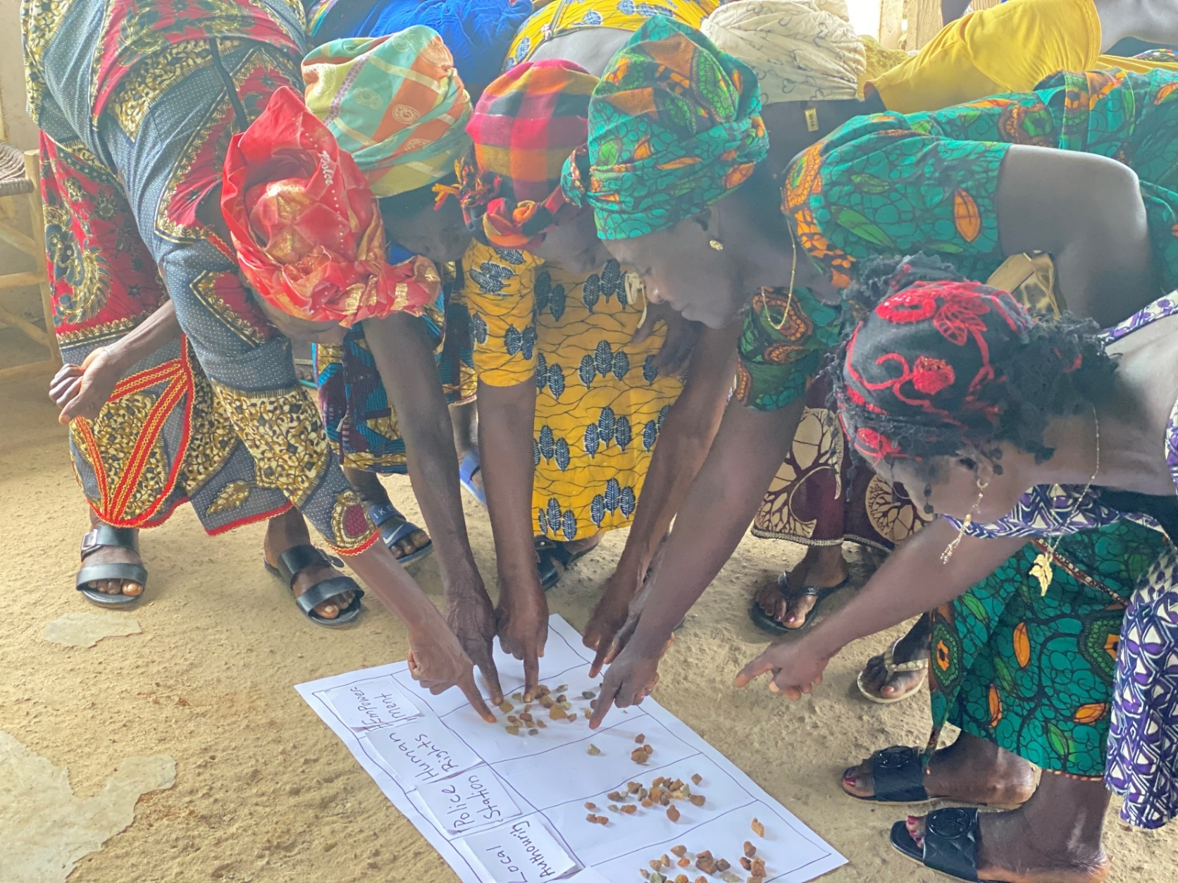**Participatory Vulnerability Analysis**

1. **Background**

Participatory Vulnerability Analysis (PVA) is a participatory methodology with a systematic process that involves communities and other stakeholders in an in-depth examination of their vulnerability and, at the same time, empowers or motivates them to take appropriate action. The message at the heart of PVA is that communities know their situations best, and so any analysis should be built on their knowledge of local conditions. The essence of PVA is for the community to develop action plans and have their confidence built by valuing their expertise and seeking opportunities to enhance their resilience to difficult conditions constantly.

PVA works towards reducing the vulnerability of individuals and communities. It is best seen not as a standalone activity but as a process that accompanies and strengthens broader actions undertaken by an organization to overcome poverty and marginalization.

Vulnerability is dynamic and complex such that it cannot be analyzed directly. However, it is important to break down the complexity of vulnerability into manageable components so that communities can jointly develop actions, interventions, and strategies to reduce exposure to violence and abuse. PVA enables the project communities and participants to make a qualitative analysis of vulnerability or a predictive judgment of what might happen to them as individuals or communities. Understanding vulnerability requires scrutiny of power relations that determine who gets what, who makes what decision and who is most affected by these decisions in society. These decisions can hinder or enhance the realization of human rights, which is fundamental to reducing vulnerability. The PVA processes build on recognizing that everybody has fundamental rights established in legal and policy instruments and international agreements. It also considers who has obligations and can help reduce insecurities in human lives, strengthen or improve people's infrastructure of protection and promote empowerment. As the root causes and solutions to vulnerability are often located or controlled outside the community, actions will usually take place simultaneously and on multiple levels. This is why PVA brings together different stakeholders acting at local, district and national levels. But vulnerable and marginalized communities always remain at the centre of this work.

1. **Participatory Vulnerability Analysis Training**

During the project's inception, 12 (women and men) staff from the partner organizations were selected to participate in a week-long training to strengthen their capacity on the PVA methodology and relevant participatory tools. This enabled them to facilitate participatory sessions and do a comprehensive analysis of vulnerable people and power relations, human rights, women's rights, vulnerabilities, actors and institutions, communication skills, and risks associated with their work and communities It also focused on providing an in-depth understanding of the trend on human rights defenders and related issues and the development of assessment tools.

The training was done in two phases; one covered the theoretical aspect while the other covered field visit and testing of assessment tools and approaches.

The theoretical aspect ran for four days and provided detailed information on the PVA steps and processes, which includes 1) b**ringing together different stakeholders, 2) analyzing and understanding vulnerability, 3) examining and challenging existing policies and practice 4) formulating a plan of action and acting on** it.

Day one looked at an understanding of human rights issues within the Liberian context, understanding trends of human rights defenders and introduction to vulnerability. Day two continued with vulnerability analysis and later with PVA steps and processes. It ended with an introduction to refection action tools and techniques. Day three and four focused on particularising the refection action tools and development of assessment tools. Day five was a field visit to a nearby community where the testing of the assessment tool and approaches were carried out. The day ended with revising the tools and composition of the assessment team.

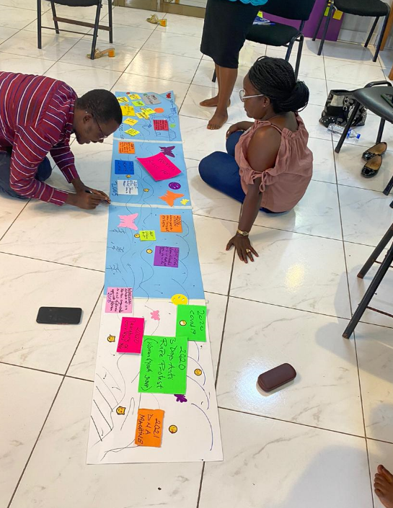**Day One**

At the end of day one, participants had an in-depth understanding of human rights issues and trends of Human Rights Defenders (Women and LGBTIQ) in Liberia. For practical information, the facilitator used one of the reflection actions tools. The Rive of Life is a participatory tool that captures the chronology of events perceived and recalled by local people. It provides details of historical events and an opportunity for older people to participate and contribute. It brings out powerful associations between cause and effect and can be used to improve planning and preparedness and response to vulnerability.

In addition to learning about human rights issues, participants learned about past events that were major to both women human rights defenders. It provided clarity on historical perspectives of current issues and generated**.**

Participants learned about vulnerability and particularly the dimensions of vulnerability. The facilitator provided information on the contribution of geophysical and biologicalprocesses. On the one hand, social, economic and political processes, on the other to vulnerability vary from one community to another and from one person to another. Vulnerability increases through entitlements, political powerlessness or social exploitation and discrimination.The interactions of the different vulnerability factors will determine people's capacities, access to resources and ability to realize their rights.

**Day Two**

Morning sessions focused on providing more detail and information on understanding and analyzing vulnerability at community levels. The facilitator focused on helping participants understand the cause and effect of vulnerable and help communities identify and reduce vulnerability.

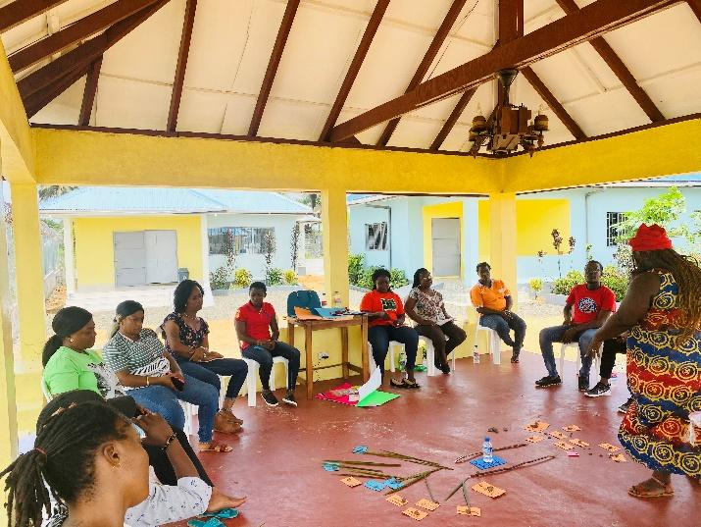The "Problem Tree" was one of the tools used to help participants explore cause and effects or problems and solutions. Facilitators selected this tool as it allows participants to identify and address the needs of the rights holders.

This exercise helped participants to understand the problems better and identify causes and effects. The tool helped participants break down the problem into manageable and definable chunks and enabled them to have a clearer idea of prioritizing the issues.

The afternoon sessions provide detailed information on the various steps and processes of PVA and the introduction of participatory tools and techniques.

At the end of the session, participants understood four steps of PVA

* **Bringing together different stakeholders-** bring together communities with duty bearers starting at the local level
* **Analyzing and understanding vulnerability-**starting from community knowledge and experience-look back and understand who was affected in the past and why to predict who is likely to be affected in the future, and why, traditional knowledge and experience, complementing it with learning from communities experiencing similar threats and/or relevant scientific knowledge
* **Examining and challenging existing policies and practices**- inform communities – simply and clearly – about their rights, their entitlements and existing policies and institutions, support citizens to check whether law, policies and institutions adequately respond to the vulnerabilities they face, help citizens access and question institutions, as well as public plans and budgets
* **Formulating a plan of action and acting on** it looks at what was done in the past and what can be done in the future. It produces action plans – then implements them and checks their progress.

The session on participatory tools and techniques was the last session for day two. At the end of the presentation, participants understood the significance of using participatory tools. Below are useful tools identified to be used for the needs assessment and implementation of the project.

* 1. **Understanding the context-** Maps, problem tree, chapatti diagram, body map, daily activity chart and timeline/river/road
  2. **Identifying the problems-** Maps, role play, problem tree, daily activity chat
  3. **Prioritizing the issues** - pairwise ranking or scoring matrix
  4. Understanding vulnerability – sessional calendar,
  5. **Stakeholder analysis-** Gatekeeper tool, stakeholders mapping
  6. **Risks and feasibility** - Force field analysis

**Day three and four**

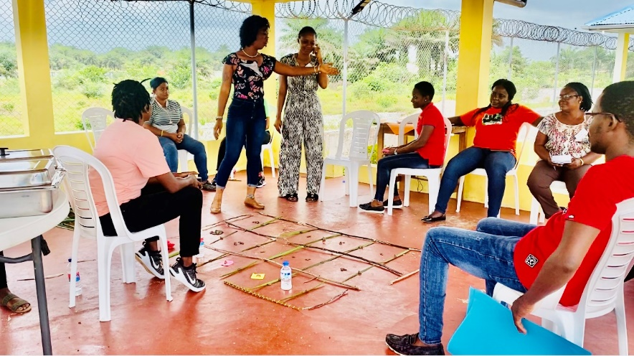The third and fourth days of the training focused on particularizing the tools and developing assessment tools and processes. Day three was mostly on participants practicalizing the tools. Two groups of six worked on various components starting from community entry and mobilization, project presentation, identification and prioritizing the issues. Others included stakeholder, power, women's rights and vulnerability analysis. Given that the project works on sensitive issues, the teams selected Transect Walk[1] as one of the tools to identify the problems in the communities. Participants had an in-depth understanding of the processes around community entry and mobilization and were able to explain key deliverables of the project. They understood how to do session planning and facilitation, including assigning roles to team members.

Day four continue with the same process with a focus on prioritizing and developing a community action plan. Four mock sessions were held to test the knowledge and skill of the participants. In the end, the assessment teams were set up. In addition, participants spent the last session developing assessment tools (see attached for tools used) and preparing the field trip.

**Day Five- Field Visit and Testing of Assessment Tools**

The day began with the field trip to Marshall City, a nearby community. Marshall City was selected because it has features of the project communities. It is along the beach, and fishing is the major source of income for the family. It has slum and low-income communities with high vulnerability levels. Maritime has a training base which makes issues of SEA and other sexual violence high.

Two focus group discussions were held with 26 persons (women 11 and men 15) to test the tools. Both teams began the community entry and mobilization with the community leaders. They presented the project and explained how it is going to benefit the communities. At the end of the general meeting with local leaders and community members, the team requested to speak with two groups (women and men) to have a deeper conversation and do more probing.

Both groups used problem three and pairwise ranking to help the community understand and identify the problem and collectively prioritize them.

While the Animator was setting up the meeting, the two groups did a Transect Walk into a different location in the community. The Walk helped to identified more issues that were not mentioned in the groups' discussions. They were able to identify the interaction with the Maritine student and young women. Other issues identified during the Transect Walk included a high rate of teenage mothers, drug abuse among young people, and poor living conditions of community members.

Both community members and local leaders were excited about the exercise and participated in the process. The leader of the women group mentioned that it was her first time participating in such a process. "Usually, I can be a shame to speak in public, but this group work made us talk freely about our problems. After we finished drawing the tree and putting all the parts there, we saw our problems and the things causing the problems. I like the group; it can make people talk and participate in bringing up good ideas that can help our community. The only problem I have is that the time was short; we need more time to dig up all of the bad things that are hurting our community". The Women Group Leader explained with excitement.

Key issues identified during the focus group discussion with the women group were:

* 1. Wife battering
  2. Wife and children abandonment/Persistent non-support
  3. Limited information human rights violations
  4. Limited on human rights defenders
  5. No support system to work on GBV issues in the communities
  6. Teenage pregnancy
  7. High school dropout
  8. Poor health care for women and girls
  9. Sexual Exploitation and Abuse by Fishers men and buyers who come from Monrovia
  10. The high illiteracy rate among women and girls

The men's group were exciting and was attended by mostly young men. They highlighted the lack of youth empowerment as a major issue they faced. They admitted that some men are violent and do not treat their women well. Unlike the women group, the men group seems aware of human violations and human rights defenders. They mentioned that religious and traditional leaders interfere in addressing human rights violations, making it difficult for the national police or human rights defenders to come in.

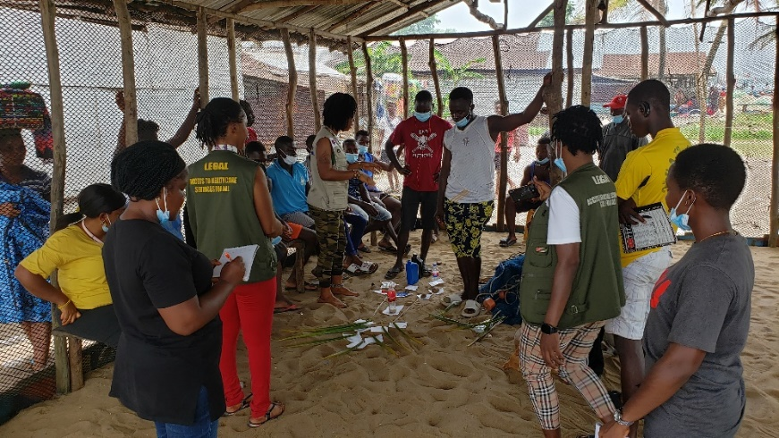Overall, the team got good and less feedback on the tools. One major feedback was the timing; both groups mentioned that the time allocation per session was too short of completing all the steps and processes. The time was revised to 1:30 minutes per session.

Other feedback included

a. Simplify and reduce the number of the questions

b. Spend more time with the community members

1. The Transect Walk is a participatory tool that entails walking between two points to cross or transect a community intentionally. It explores environmental and social resources, conditions and systems by observing, asking, listening, looking and producing a transect diagram. Specific information may be collected to reveal land-use practices, vulnerabilities and capacities to inform program design and planning