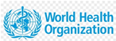 | 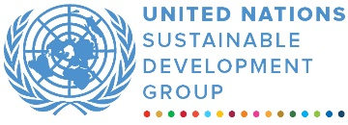 | 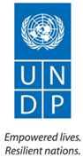
ONE SDG FUND Sri Lanka
MPTF OFfice GENERIC finalprogramme NARRATIVE report
REPORTING PERIOD: from 1 July 2020 to 31st December 2020
Programme Title & Project Number |  |  | Country, Locality(s), Priority Area(s) / Strategic Results
- Programme Title: Strengthen Community Engagement in the COVID-19 Response through Civil Society Collective of Sri Lanka  - Programme Number (if applicable) 00123975  - MPTF Office Project Reference Number: |  |  | (if applicable)  Country/Region Sri Lanka
Priority area/ strategic results
Strengthen Community Engagement in the COVID-19 Response through Civil Society Collective of Sri Lanka.

Participating Organization(s) |  |  | Implementing Partners
- WHO |  |  | - National counterparts (government, private, NGOs & others) and other International Organizations, Ministry of Health
Programme/Project Cost (US$) |  |  | Programme Duration
Total approved budget as per project document:  MPTF /JP Contribution:  - by Agency (if applicable) | 100,898.86 |  | Overall Duration (months) 5 months  Start Date (dd.mm.yyyy) 1 July 2020
Agency Contribution  - by Agency (if applicable) |  |  | Original End Date (dd.mm.yyyy) 31.12.2020
Government Contribution  (if applicable) |  |  | Actual End date(dd.mm.yyyy)  31.12.2020  Have agency(ies) operationally closed the Programme in its(their) system? | Yes
Other Contributions (donors)  (if applicable) |  |  | Expected Financial Closure date:
TOTAL: 100,898.86
Programme Assessment/Review/Mid-Term Eval. |  |  | Report Submitted By
Evaluation Completed  Yes No Date: dd.mm.yyyy  Evaluation Report - Attached  Yes No Date: dd.mm.yyyy |  |  | - Name: Suveendran Thirupathy  - Title: National Professional Officer  - Participating Organization (Lead): WHO  - Email address: suveendrant@who.int

FINAL PROGRAMME REPORT FORMAT

EXECUTIVE SUMMARY

The following text serves to provide a consolidated narrative on the implementation of the ‘Community Engagement’ in six districts of Sri Lanka”. This report covers the period from 1st July to 31st December 2020 and is a part of the UN Sri Lanka SDG Multi-Partner Trust Fund (MPTF).

On 31 December 2019, WHO was alerted to a cluster of pneumonia patients in Wuhan City, Hubei Province of China. One week later, on 7 January 2020, Chinese authorities confirmed that they had identified a novel (new) coronavirus as the cause of the pneumonia. And that the proposed interim name of the virus is 2019‑nCoV. On 30 Jan 2020, the WHO Director-General declared the novel coronavirus outbreak a public health emergency of international concern (PHEIC), WHO's highest level of alarm.

The first COVID-19 patient was confirmed in Sri Lanka on 27 January 2020, after a 44-year-old Chinese woman from Hubei Province in China was admitted to the National Institute of Infectious Diseases. As of 11 May 2020, 869 confirmed cases have been reported in the country with 09 deaths. On May 11, the Government of Sri Lanka lifted the curfew that had been in place for over two months, bringing an end to the 52-day lockdown style curfew except in two districts and relaxing some of the strict control measures, allowing the public to return to work while adhering to safe hygienic practices and maintaining physical distance. A well-coordinated communication campaign and community participation including many stakeholders such as the Ministry of Health and other key ministries, development partners, health professionals, academics, and the media was recognized as being urgently needed. On July 1, WHO, with the help of Sarvodaya, began community involvement efforts in six Sri Lankan districts (Colombo, Gampaha, Kalutara, Kandy, Ratnapura, and Puttlam).

Furthermore, after several months of containing the COVID-19 virus, an infected individual was found during a regular surveillance system on October 5, 2020, and the number of infected individuals increased to 101 at a garment factory within 24 hours, bringing the overall number of COVID-19 cases to 3,513.Aside from the outbreak at the garment cluster, another major cluster outbreak was reported at a fish market. Due to these clusters, the number of infected individuals started to increase steadily. Despite the challenges and delays caused by cluster outbreaks, Sarvodaya, the implementation agency, has taken the necessary public health precautions and was able to successfully complete the community engagement activities in six districts of Sri Lanka.

Sarvodaya mapped all CBOs and CSOs in these districts, activated 253 CBOs from selected MOH divisions, and trained 510 CBO members and 210 CSO members at the divisional level, resulting in a community outreach of 288,000 people. The program also assisted in the training and capacity building of 2399 religious leaders, 1254 youth and women leaders, 1037 pre-school teachers, 2111 caregivers at elderly homes, and 357 women/women led organizations on public health measures to prevent COVID-19 and reduce transmission through village engagement. A risk assessment was conducted in few facilities such as elderly care home, child developments centers and free trade zone of garments factories. The communication and materials were distributed to MoH offices, district secretariats, CBOs and CSO, worship places, preschools, elderly care homes, free trade zones etc. COVID-19 transmission hotspots were identified, and a total of 180 hand washing stations were installed to prevent and slow the spread of the virus. 30 places of Worship were provided with markings to keep devotees and people at a safe distance and to control the gathering.

Due to the short-term nature of this engagement effort, maintaining behavior change has been noted as a concern. Sarvodaya supported networking to address the identified issues in the community and established feedback mechanism to overcome the challenges. According to the group discussion and final review meeting the programs reached over 1.3 million individuals in these regions and encouraged them to follow public health guidelines.

Purpose

Covid-19 has been reported in 213 countries, with a case fatality ratio that varies by country. As the number of cases rises, countries have enacted a slew of regulations in an attempt to slow the spread and ‘flatten the curve,' preventing health-care systems from being overburdened. To manage COVID-19 transmission and achieve a low steady state, it is critical that every level of government and society takes responsibility for the response and prevention of cases through hand cleanliness, respiratory etiquette, and individual-level physical distance. Communities must be empowered to ensure that services and aid are planned and adapted based on their feedback and local contexts. Critical functions, such as community education, protecting vulnerable groups, supporting health workers, case finding, contact tracing, and cooperation with physical distancing measures can only happen with the support of every part of affected communities

Sri Lanka has experienced a rise in the number of cases and is at a stage where there were clusters of cases. The government and the private sector are working on programs and systems to reduce the impact on civilian life while also allowing for economic activity. A key priority is to protect populations who are at danger owing to loss of income, lack of access to services, and vulnerability to virus propagation. Because of their frailty, the most vulnerable people's desperation could result in life-threatening scenarios in the event they contradict the virus. Preliminary studies in Sri Lanka has shown that more than 80% of the cases are asymptomatic and mild; thus, some show no symptoms, but can spread the virus. It is important to observe the guidance on public health and social measures on the “new normal” and promote behavior change among the population. This project supported “Civil Society Collective on COVID-19 Response” led by Sarvodaya with the support of WHO, has taken the responsibility to mobilize the community in preventing the transmission of COVID-19.

Objective:

To strengthen community engagement in COVID-19 response in selected high risks districts – namely, Colombo, Gampaha, Puttlam, Kalutara, Ratnapura and Kandy through collective civil society action.

Project Locations:

Project locations for the proposed interventions, are districts which were severely affected by the COVID-19 epidemic in terms of number of positive cases reported and which have also had severe socio-economic impact. Western province has the highest population density in the country and also reported the highest number of COVID-19 cases. It also has a very large migrant working population and the largest number of care homes in the country. The residents of care home (children, elders, the differently abled etc.) are recognized as highly vulnerable to COVID-19 infection. Providing the required information and facilities will support to prevent possible community transmission and protect the vulnerable populations. Similarly, districts where there is high degree of mobility and interactions with the Western province will also be targeted in preventive health activities.

Specific Objectives:
1. Mobilizing and engaging community leaders/volunteers and community-based organizations (CBOs) in the prevention and control of COVID-19 and in addressing its health and social impact by following the public health regulations and following trainings will be conducted
- Identifying active CBOs/CSOs in selected MOH divisions in each district.
- Provide Webinar training for selected CBO members in the proposed areas
- Provide in-person trainings for the selected CBO members and the community leaders by following the regulations in the selected MOH areas of the district.
- Provide in-person trainings for the selected youth and women leaders.
- Provide in-person trainings for the selected preschool teachers in the identified MOH areas.

2. Engaging, sensitizing and capacitating communities, including vulnerable community groups on COVID-19 preventive measures and supporting to equip vulnerable community settings with adopting practical protective measures.
- Conduct a risk assessment in care homes and pre-schools
- Establish customized preventive measures and hand washing facilities in the identified institutions.
- Training of care givers in institutions on COVID-19 prevention
- Disseminating existing guidelines/preparing new guidelines as required for specific settings.
- Display of tailor made educational and risk communication messages in public places targeting specific target groups.

3. Strengthening the leadership and meaningful participation of women and girls in all decision-making in addressing the COVID-19 outbreak.
- Conduct a survey on difficulties faced by women due the COVID-19 including those working in industrial zones.
- Connect with organizations and networks to address the issues identified.
- Conduct trainings for selected women/women leaders/women led organizations to enhance their capacity.
- Establish hand washing facilities in the selected hostels of FTZ workers with the adequate messages

4. Mobilizing religious/faith leaders in COVID-19 prevention and control activities.
- Preparation/dissemination of faith-based risk communication material
- Conduct webinars targeting religious leaders in districts
- Provide in-person trainings religious/faith leaders in the identified MOH areas.
- Providing risk assessment in places of worship and assisting in establishing preventive measures (hand washing facilities, ground marking for physical distance)

5. Develop and disseminate COVID-19 risk communication materials in Sinhala, Tamil and English targeting specific social groups and settings, and involving youth organizations.
- The messaging will be mainly on addressing stigma and discrimination.
- Will identify and engage youth organizations, youth led social media groups.
- This component will complement the risk communication activities of UNICEF that was supported by DFAT and aligned with the strategic priorities of Health Promotion Bureau, MOH. Resources that have been jointly developed by WHO and HPB for mass-media campaigns on prevention measures, stigma, and the “new normal” will be adapted and translated for the target population.

6. Actively support the consultative development of Strategic Direction for Risk Communication and Community Engagement (RCCE) with the MOH and key stakeholders.

Assessment of Programme Results

Sarvodaya conducted an initial community engagement meeting on 23rd of July 2020 with the participation of relevant Sarvodaya district staffs, CBOs and other community activist, WHO officials, Health Promotion Bureau and Sarvodaya senior management team. Sarvodaya made certain that all participants had a thorough grasp of the project and that they would be able to contribute to the suggested project interventions in order to achieve the best possible results.

Sarvodaya implemented the project activities in 6 districts as planned with the support of relevant government institutions especially RDHSs, MOHs and other relevant multi-stakeholders. Sarvodaya got MOH support for a resource person and other guidance and ensured that all activities were carried out in accordance with the Ministry of Health's regulations and guidance, including all physical (in person) activities, were carried out with extra care. As a result, the following activities were carried out as planned, resulting in the outputs and intended outcomes for each activity.

Activity | Colombo | Kandy | Puttlam | Gampaha | Ratnapura | Kalutara | Direct Beneficiaries
Total number person trained or directly supported | 1366 | 1462 | 1304 | 1547 | 1646 | 1523 | 8848
Summary Sheet attached: Annexure I

- Outputs

Despite the many challenges of 2020, the community engagement project was able to make significant progress under each output:

- Mobilizing and engaging community leaders/volunteers and community-based organizations (CBOs) in the prevention and control of COVID-19 and in addressing its health and social impact
Sarvodaya completed the mapping of CBOs as an initial activity and mapped all the active CBOs / CSOs (253) in the project location. Sarvodaya-Districts staffs mobilized the local CBOs/ CSOs and briefed them about the community engagement project and received their support to slow down disease spread and control COVID-19. As planned, Sarvodaya conducted the webinar and in-person training to educate and mobilize community to protect from COVID-19 (Table 1).

Table 1: Details of specific groups and training
Activities | Colombo | Kandy | Puttlam | Gampaha | Ratnapura | Kalutara | Direct Beneficiaries
CBOs identified & mapped in MOH in selected division | 43 | 40 | 45 | 47 | 37 | 41 | 253
Webinar training for selected CBO members | 85 | 85 | 85 | 85 | 85 | 85 | 510
Webinar training for religious leaders in districts | 80 | 87 | 85 | 85 | 85 | 85 | 507

- Engaging, sensitizing and capacitating communities, including vulnerable community groups on COVID-19 preventive measures and supporting to equip vulnerable community settings with adopting practical protective measures
- Sarvodaya carried-out risk assessment in care homes and pre-schools during the this COVID-19 outbreak and established hand-washing stations in the prominent places as customized preventive measures. This initiation assisted in promoting the good hygienic practices and encourages washing hands regularly as a preventive measure to slow down the transmission.
- Sarvodaya identified care homes as a susceptible institution and provided training to caregivers to improve their understanding of preventive measures and safeguard the safety of all clients. Sarvodaya took all necessary precautions and successfully completed the training.
- Sarvodaya disseminated all accessible materials and guidelines to project beneficiaries, as well as creating additional tailor-made educational and risk communication messages that were placed in public places. Before being distributed, all of these materials were checked with the Health Promotion Bureau and the World Health Organization to ensure that they complied with all branding regulations.

Table 2: Details of specific groups and training
Activities | Colombo | Kandy | Puttlam | Gampaha | Ratnapura | Kalutara | Direct Beneficiaries
In-person trainings for selected preschool teachers in the identified MOH areas | 200 | 200 | 80 | 243 | 214 | 100 | 1037
Training of care givers in institution on COVID-19 prevention | 236 | 292 | 362 | 393 | 430 | 398 | 2111
Hand washing facilities in care homes | 10 | 11 | 10 | 10 | 9 | 10 | 60
Hand washing facilities in preschool and ECD | 10 | 9 | 10 | 10 | 10 | 10 | 59

- Strengthening the leadership and meaningful participation of women and girls in all decision-making in addressing the prevention and control COVID-19 outbreak

- Sarvodaya conducted a basic survey on difficulties faced by girls and women in industrial zones due the COVID-19. This assisted the project team to mobilize and develop a link with the organizations/industries. These networks supported Sarvodaya to continue to work with industries to provide support to vulnerable women e.g. provision of ‘dry ration packs’ for the selected beneficiaries.
- Sarvodaya conducted several training programmes to young women, women leaders and the member of women led-organizations focusing to enhance their capacity to face these critical situation and control COVID-19 spread and also overcome discrimination and stigma. Sarvodaya also established 30 hand-washing facilities, targeting these vulnerable women and encourage them to practice the good hygienic practices.

Activities | Colombo | Kandy | Puttlam | Gampaha | Ratnapura | Kalutara | Direct Beneficiaries
In-person trainings for the selected Youth and women leader | 212 | 200 | 126 | 214 | 236 | 266 | 1254
Trainings for selected women/women led organization staffs | 60 | 45 | 60 | 65 | 65 | 60 | 355
Hand washing facilities in Free Trade Zone (FTZ) | 5 | 5 | 5 | 5 | 5 | 5 | 30

- Mobilizing religious/faith leaders in COVID-19 prevention and control activities

Sarvodaya organized a webinar and in-person training for religious and faith leaders to educate them about COVID-19 preventive and control efforts, as anticipated. Sarvodaya convened a series of meetings with the support district team and social networks. These capacity-building programs helped them stay up to date on the current COVID-19 situation and prepare to communicate these messages to their community. In some stations, CBOs / CSOs were supported and jointly participated with religious leaders, provided an opportunity to develop networking with vulnerable community.
Sarvodaya observed the active participation of religious and faith leaders in these webinars and in-person trainings and their commitment in disseminating messages to their local community. Sarvodaya also equipped them with adequate messages, materials and hand-washing stations in selected places with the marking of one-meter safety physical distancing (Annexure III & IV).

Activities | Colombo | Kandy | Puttlam | Gampaha | Ratnapura | Kalutara | Direct Beneficiaries
In-person trainings for religious/faith leaders in the identified MOH areas | 430 | 437 | 386 | 338 | 429 | 401 | 2421
In-person trainings CSOs in the identified MOH areas | 0 | 40 | 45 | 47 | 37 | 41 | 210
Connect with organizations and supported networking (to address the identified issues) | 20 | 36 | 30 | 30 | 28 | 46 | 190
Hand washing facilities to places of worship (temple, church and mosque) | 5 | 5 | 5 | 5 | 6 | 5 | 31
Distance marking in places of worship | 5 | 5 | 5 | 5 | 5 | 5 | 30

- Developed and disseminated COVID-19 risk communication materials in Sinhala, Tamil and English
The risk communication materials were developed with the support of WHO and HPB, and also produced locally according to the local needs. These materials were disseminated to local community with the support of trained team members and the volunteer network. Most of the materials were developed with adequate graphic and wordings for easy understanding. The project team shared these materials in all these planned trainings and displayed in all the prominent places in the district and made visible to community, (Annexure II).

- Actively support the consultative development of Strategic Direction for Risk Communication and Community Engagement (RCCE) with the MOH and key stakeholders.

WHO and Sarvodaya provided technical support to Health Promotion Bureau, Ministry of Health to develop Strategic Direction for Risk Communication and Community Engagement and implemented it in local community of selected districts. This document developed based on the WHO risk communication and community engagement (RCCE) checklist . The Health Promotion Bureau (HPB) developed HPB-Sarvodaya-ADT-CBO model for Community Engagement to strengthen the
behaviours expected from individual and communities to prevent transmission of COVID-19 (Annexure V).

- Qualitative assessment

The project supported to engage community leaders and empower communities to prevent infection and slow down the transmission in the districts of Colombo, Gampaha, Kalutara, Puttlam, Ratnapura and Kandy. Established COVID-19 prevention measures such as 180 hand washing facilities were installed in Free Trade Zone (FTZ) , elderly care homes, preschools, places of worship. Completed distance marking in 30 worship places. This supported nearly 315,000 peoples who visit frequently to these places and also appreciated by the users. According to the group discussion and final review meeting the projects suggested it has reached nearly 1.3 million people in these districts to adhere to public health measures.
ii) Indicator Based Performance Assessment:
Using the Programme Results Framework from the Project Document / AWPs - provide details of the achievement of indicators at both the output and outcome level in the table below. Where it has not been possible to collect data on indicators, clear explanation should be given explaining why.
 | Achieved Indicator Targets | Reasons for Variance with Planned Target (if any) | Source of Verification
Outcome 1
Indicator:
Baseline:
Planned Target:
Output 1.1  Indicator 1.1.1  Baseline:  Planned Target:  Indicator 1.1.2  Baseline:  Planned Target: | - Mobilized and engaged community leaders/volunteers and community-based organizations (CBOs) in the prevention and control of COVID-19  - Engaged and sensitized communities, including vulnerable community groups on COVID-19 preventive measures and supported to equip vulnerable community settings with practical protective measures.  - Strengthened the leadership and meaningful participation of women and girls in all decision-making in addressing the prevention and control COVID-19 outbreak  - Mobilizing religious/faith leaders in COVID-19 prevention and control activities  - Develop and disseminate COVID-19 risk communication materials in Sinhala, Tamil and English targeting specific social groups and settings, and involving youth organizations.  - Provided technical support for the development of Strategic Directions for Risk Communication and Community Engagement (RCCE) |  | Local CBOs /CSOs and Community Groups were strengthened to support the community  Installed 180 hand-washing stations in the districts (each district received 30)  Nearly 1254 youth and women leaders were trained on COVID-19 prevention  355 women / women led organization staffs were trained to provide service to their local community.  Communication materials were developed disseminated to local communities  Ministry developed strategic direction for Risk Communication and Community Engagement Strategy

iii) Evaluation, Best Practices and Lessons Learned

Best Practices and Lessons Learned
There were certain instances that the planned programs had to be postponed due to the reality of the pandemic, lock downs imposed and other ground reality and priorities, did not allow the team to carry the project activities. That is especially to conduct the in-person trainings within the timeline of November 2020 (except Ratnapura district). The project team has adhered all public health measures and utilized maximum team effort to complete all planned activities by facing current limitations. Sarvodaya was able to reach the assigned target with the support of district staffs and their established networks and ground coordination.

The in-person trainings had great impact on the community leaders, giving them a platform to network with other organizations and working towards trickling down the information in their communities, given that they have a voice as an active social comrade.

Webinars are a great source of connecting community leaders to facilitate sessions such as community strengthening during this pandemic crisis. The information given to the community leaders through the online webinars allowed to fight against the misinformation and disinformation at a community level with the support of health education officer. The virtual (webinar) sessions were quite helpful in terms of sharing verified information from community physicians. During these sessions, real issues on the current pandemic situation were addressed and also provided an opportunity for the participants to interact with a community physician from home or local community with the support of local teams during the lockdown.

This project supported to install 180 hand-washing facilities in six districts, each district received 30 each and they have been mainly distributed to religious institutions (temple, church and mosque), preschools, vulnerable industrial areas and care homes. These washing facilities provided chance learn good hygienic practices in their day-to-day life and assisted to slowdown the disease spread in local community.

A comprehensive two-way feedback mechanism inter-connecting all levels from community to district to national level has been established. Sarvodaya Rural Staff, Sarvodaya Shramadana Societies and the direct and indirect beneficiaries (religious leaders, youth, women, caregivers and teachers) gather information and progress from community level, which is being disseminated to Sarvodaya headquarter through district coordinators. Sarvodaya provide ground level issues and information to relevant forum, UN health cluster meeting, state and non-state sectors to mitigate the issues.

Apart from the abovementioned feedback mechanism, Sarvodaya has been able to build a wide network with the health sector that connects health professionals from the Regional Health Director to Midwives in these districts. This health network identifies issues or concern that needs to be addressed and inform project staff of Sarvodaya. This communication channel helps Sarvodaya utilize their resources effectively and meet the needs of communities that are in need. Health Education Officers shared health information and health education posters with Sarvodaya to disseminate at community level in these districts. Apart from this, WHO and Health Promotion Bureau supported to develop risk communication materials. These materials were disseminated to local community with the support trained team members and volunteer network. Therefore, this strong communication network system and community engagement assisted this project to be a success one.

Recommendations

- Given the situation today people tend to forget the new normal. It is our responsibility to keep reminding the local community and disseminate this information to all community through local community leaders and networks to sustain the new normal.
- The misinformation and disinformation need to be addressed to ensure that the communities are educated on the current situation specially continue the new normal including vaccination.
- Stigma and discrimination are major barrier in preventing health seeking behaviour during this pandemic, this needs to be addressed more often than expected. Sri Lanka being an island with multiple ethnicities, could be addressed through religious and faith-based approach.
- Develop partnership with all relevant stakeholders in the local community to establish preventive measures to support vulnerable community.

iv) A Specific Story (Optional)

Problem / Challenge faced: Describe the specific problem or challenge faced by the subject of your story (this could be a problem experienced by an individual, community or government).

It was recognized that there is an increased need for capacity to support communities affected by COVID 19 pandemic. The Travel restriction to some districts due to lockdown and isolation, delayed some activities and created considerable limitations in the implementation, such as community capacity building and installation of washing facilities etc. During the training programmes, the participants were reluctant to stay for longer periods due to fear and concerns of COVID-19. In some occasions, the level participation was poor due to lack of resources and network connectivity.

Programme Interventions: How was the problem or challenged addressed through the Programme interventions?
The project team has adhered all public health measures and utilized maximum team effort to complete all planned activities by facing current limitations. Sarvodaya was able to reach the assigned target with the support of district staffs and their established local networks. The virtual sessions (webinars) are great source of connecting community leaders to facilitate sessions such as community mobilizing and strengthening during this pandemic crisis. This project supported to install 180 hand-washing facilities in six districts, each district received 30 each and they have been mainly distributed to religious institutions (temple, church and mosque), preschools, vulnerable industrial areas and care homes. Also, developed risk communication materials in local languages with adequate graphic and wordings for easy understanding. The project team shared these risk communication materials in all these planned trainings and displayed in prominent public places in the district and made visible to community.

Result (if applicable): Describe the observable change that occurred so far as a result of the Programme interventions. For example, how did community lives change or how was the government better able to deal with the initial problem?
One participant, a community leader who participated Sarvodaya training programme stated that Minuwangoda and Kotugoda villages were safe from COVID-19. He stated that he had worked together with
Minuwangoda local community (Minuwangoda police, local health authorities, civil society organization, mothers club etc) in order to share information on do’s and don’ts and safety measures regarding COVID-19 after attending the awareness program

Lessons Learned: What did you (and/or other partners) learn from this situation that has helped inform and/or improve Programme (or other) interventions?

The project team has adhered all public health measures and utilized maximum team effort to complete all planned activities by facing current limitations. Sarvodaya was able to reach the assigned target with the support of district staffs and their established local networks. The proper coordination, identification of local issues, locally developed mechanism and resources are main factors for the success of this project.

Activity Summary of Community Engagement in Response to COVID -19 Annexure 1
Sl.No: | Activities | Colombo | Kandy | Puttlam | Gampaha | Ratnapura | Kalutara | Direct Beneficiaries | In-direct Beneficiaries | Interaction level with community
1 | CBOs identified & mapped in MOH in selected division | 43 | 40 | 45 | 47 | 37 | 41 | 253 | 1,265
2 | Webinar training for selected CBO members | 85 | 85 | 85 | 85 | 85 | 85 | 510 | 204,000 | High
3 | Webinar training for religious leaders in districts | 80 | 87 | 85 | 85 | 85 | 85 | 507 | 253,500 | High
4 | In-person trainings for religious/faith leaders in the identified MOH areas | 430 | 437 | 386 | 338 | 429 | 401 | 2421 | 242,100 | High
5 | In-person trainings for the selected Youth and women leader | 212 | 200 | 126 | 214 | 236 | 266 | 1254 | 125,400 | High
6 | In-person trainings for selected preschool teachers in the identified MOH areas | 200 | 200 | 80 | 243 | 214 | 100 | 1037 | 103,700 | High
7 | Training of care givers in institution on COVID-19 prevention | 236 | 292 | 362 | 393 | 430 | 398 | 2111 | 94,995 | Medium
8 | In-person trainings CSOs in the identified MOH areas | 0 | 40 | 45 | 47 | 37 | 41 | 210 | 84,000 | High
9 | Trainings for selected women/women led organization staffs | 60 | 45 | 60 | 65 | 65 | 60 | 355 | 106,500 | High
10 | Connect with organizations and supported networking (to address the identified issues) | 20 | 36 | 30 | 30 | 28 | 46 | 190 | 152,000 | High
 | Total number person trained or directly supported | 1366 | 1462 | 1304 | 1547 | 1646 | 1523 | 8848 | 1,367,460
Direct Prevention Measures
11 | Hand washing facilities in Free Trade Zone (FTZ) | 5 | 5 | 5 | 5 | 5 | 5 | 30 | 45,000 | Highly supported to follow public health measures
12 | Hand washing facilities in care homes | 10 | 11 | 10 | 10 | 9 | 10 | 60 | 90,000
13 | Hand washing facilities in preschool and ECD | 10 | 9 | 10 | 10 | 10 | 10 | 59 | 60,000
14 | Hand washing facilities to places of worship (temple, church and mosque) | 5 | 5 | 5 | 5 | 6 | 5 | 31 | 120,000
15 | Distance marking in places of worship | 5 | 5 | 5 | 5 | 5 | 5 | 30
16 | Distribution of hygiene packs to places of worship | 5 | 5 | 5 | 5 | 5 | 5 | 30
Total handwash facilities |  | 30 | 30 | 30 | 30 | 30 | 30 | 180 | 315,000
17 | Distribution of leaflet and posters | Distributed to the above institutions and MoH offices, district secretariats and communities. The materials were displayed in public places |  |  |  |  |  |  | Reached more than 1.35m

Information, Education and Communication Materials for COVID-19 Response Annexure II

Emergency Contact Numbers
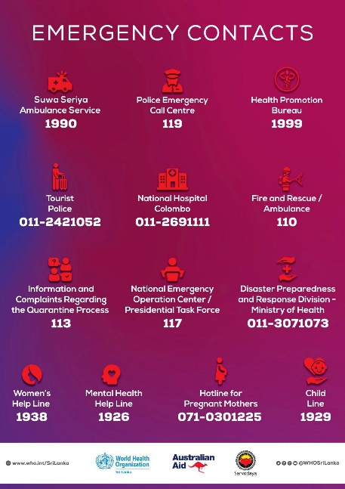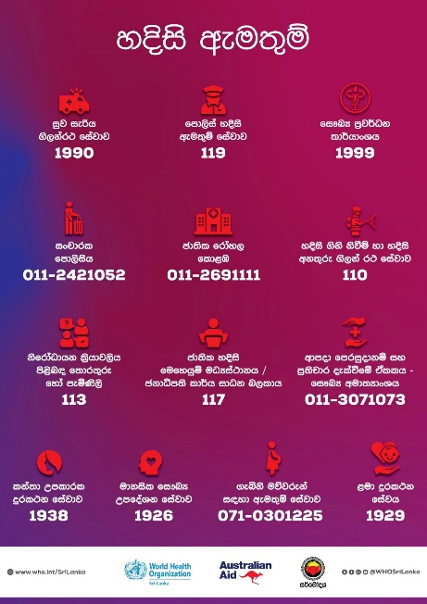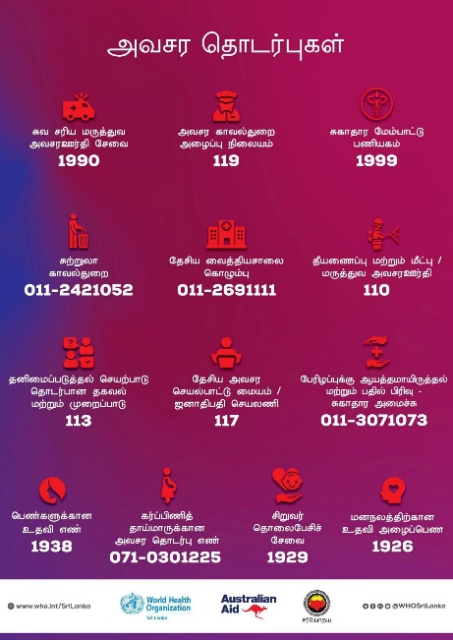

My Responsibility
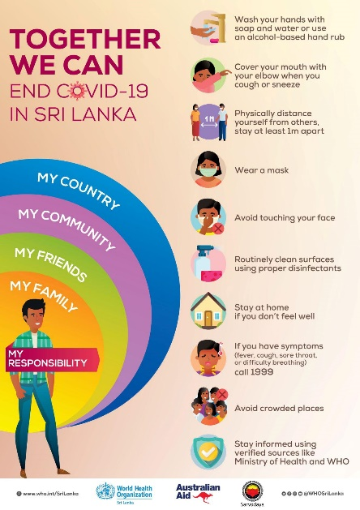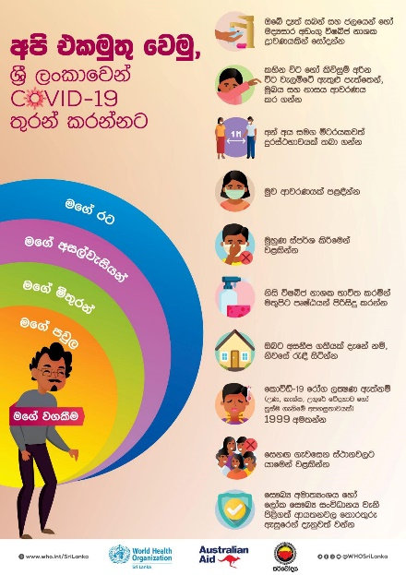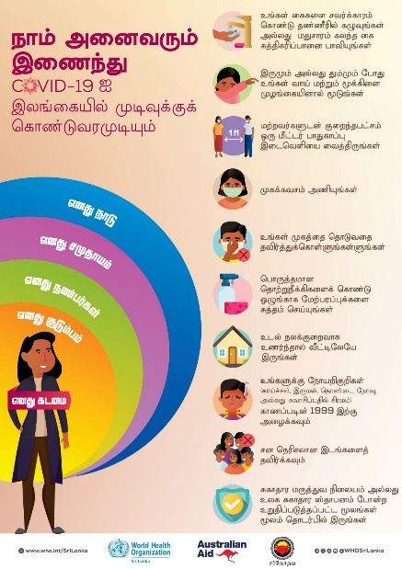

Prevention methods
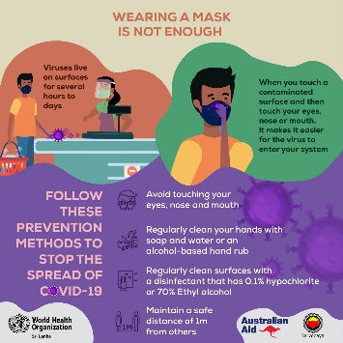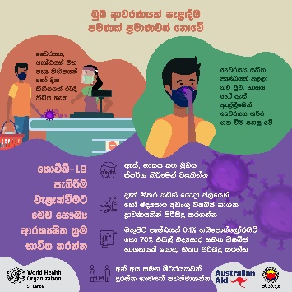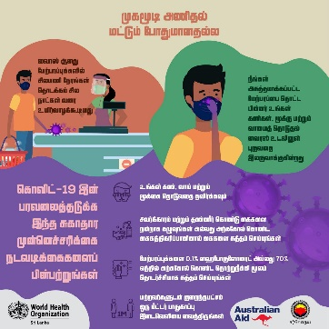

Locally Developed Prevention Materials
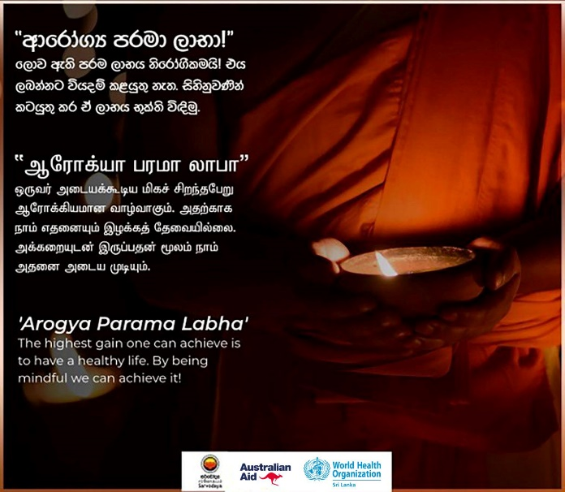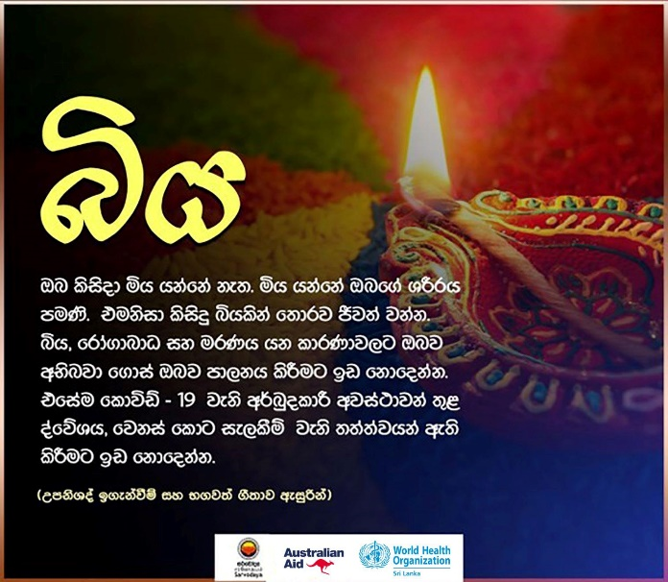

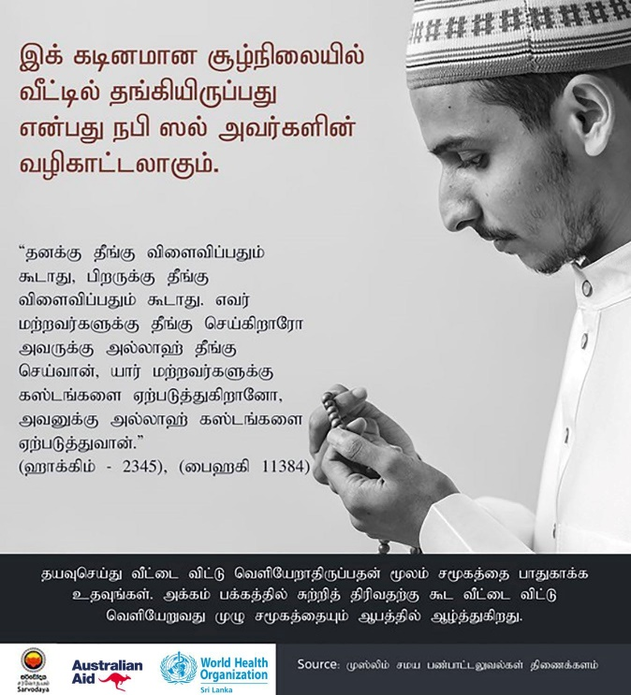

Training Programmes - Community Engagement and Response to COVID-19 Annexure III

State sectors:
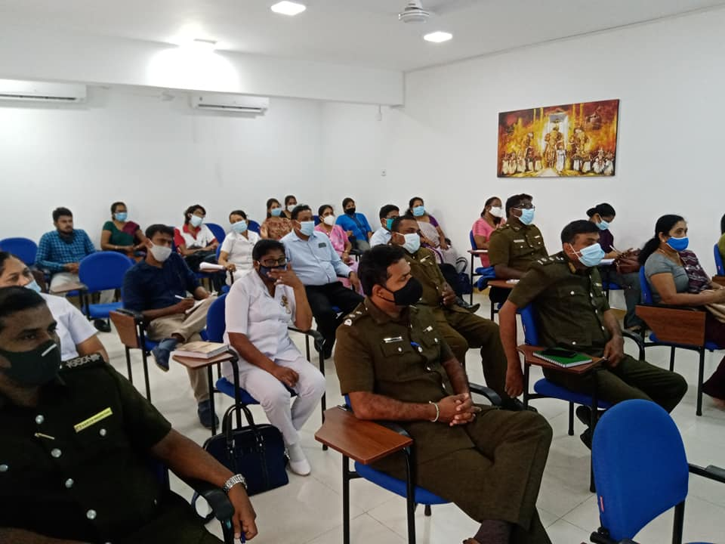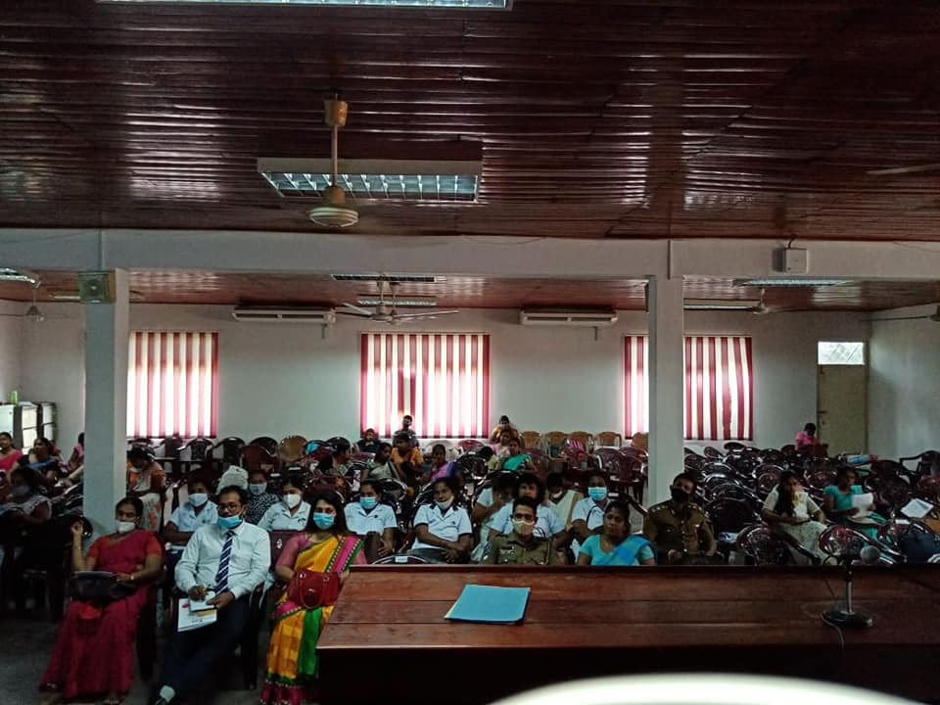

Non-state sectors – CBOs and CSOs
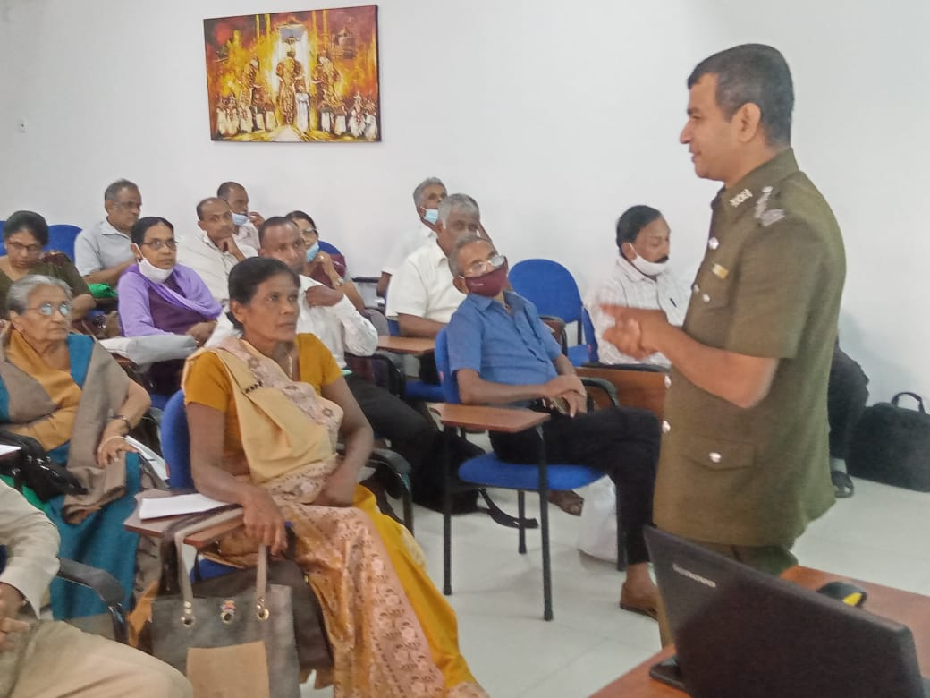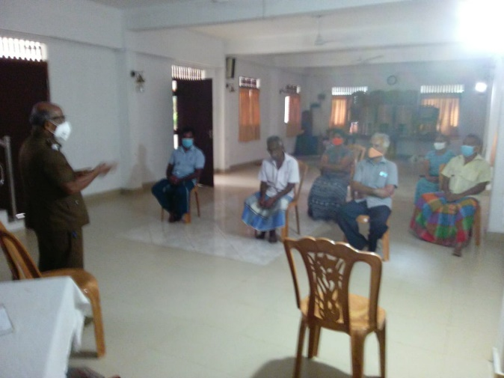

Preschool Teachers
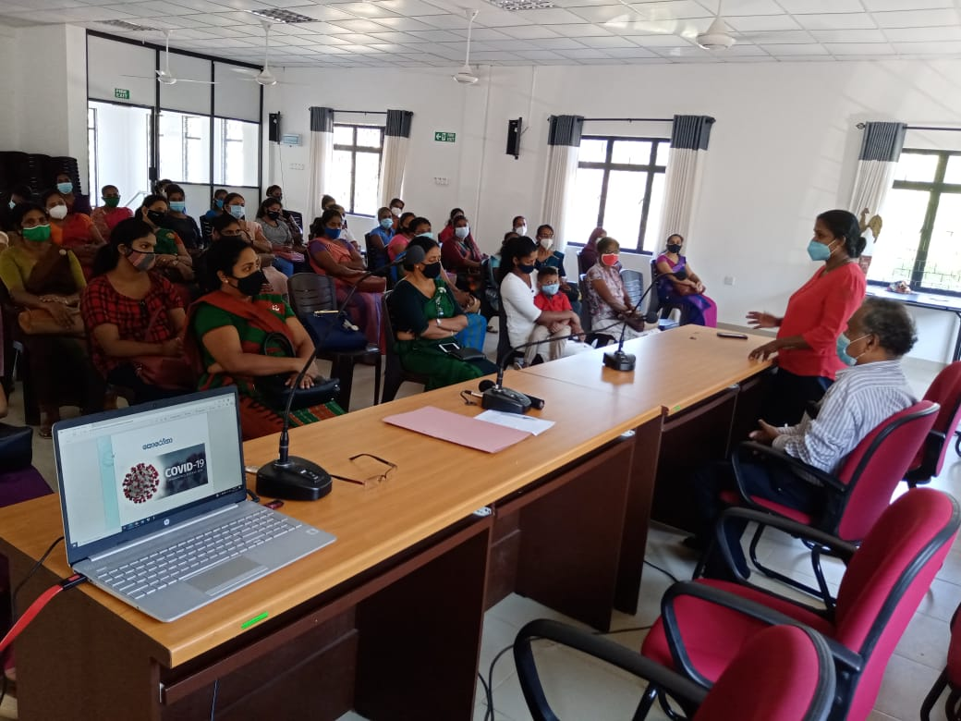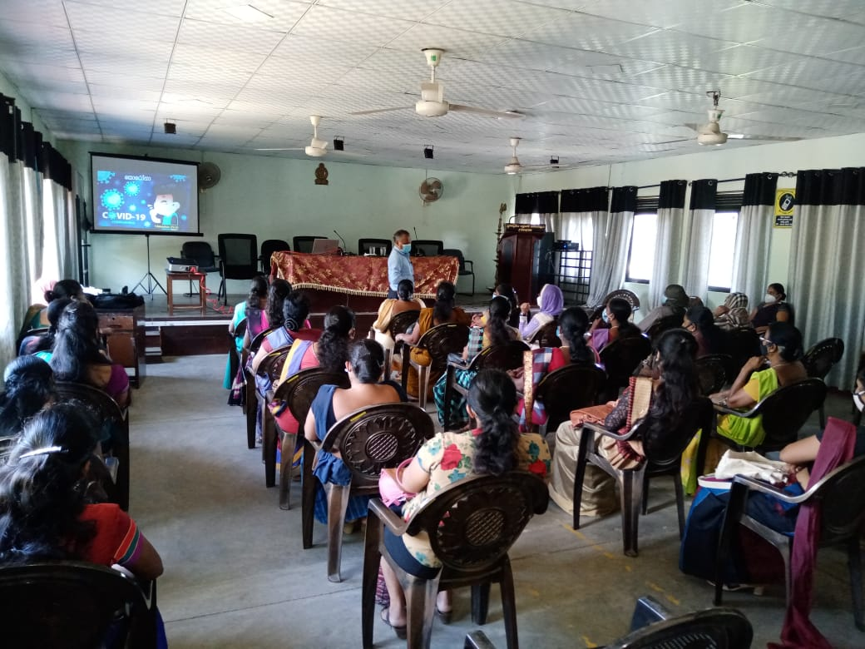

Childcare centres/home staffs

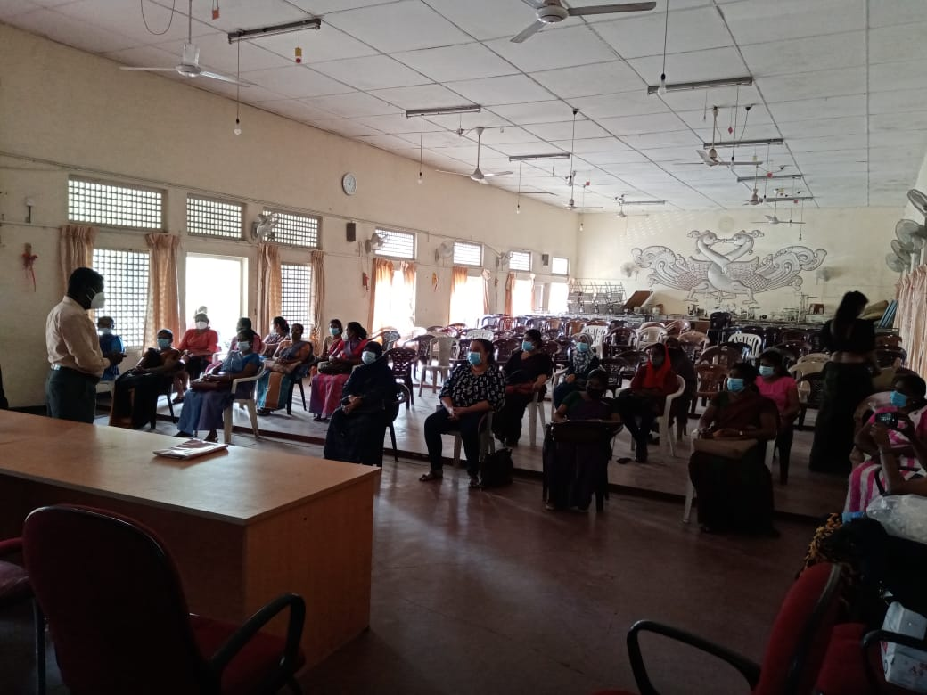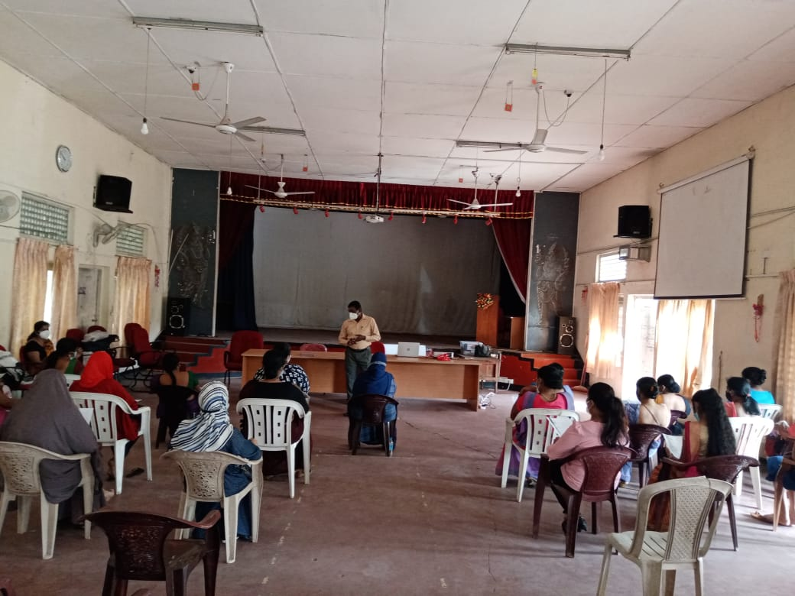

Religious Leaders

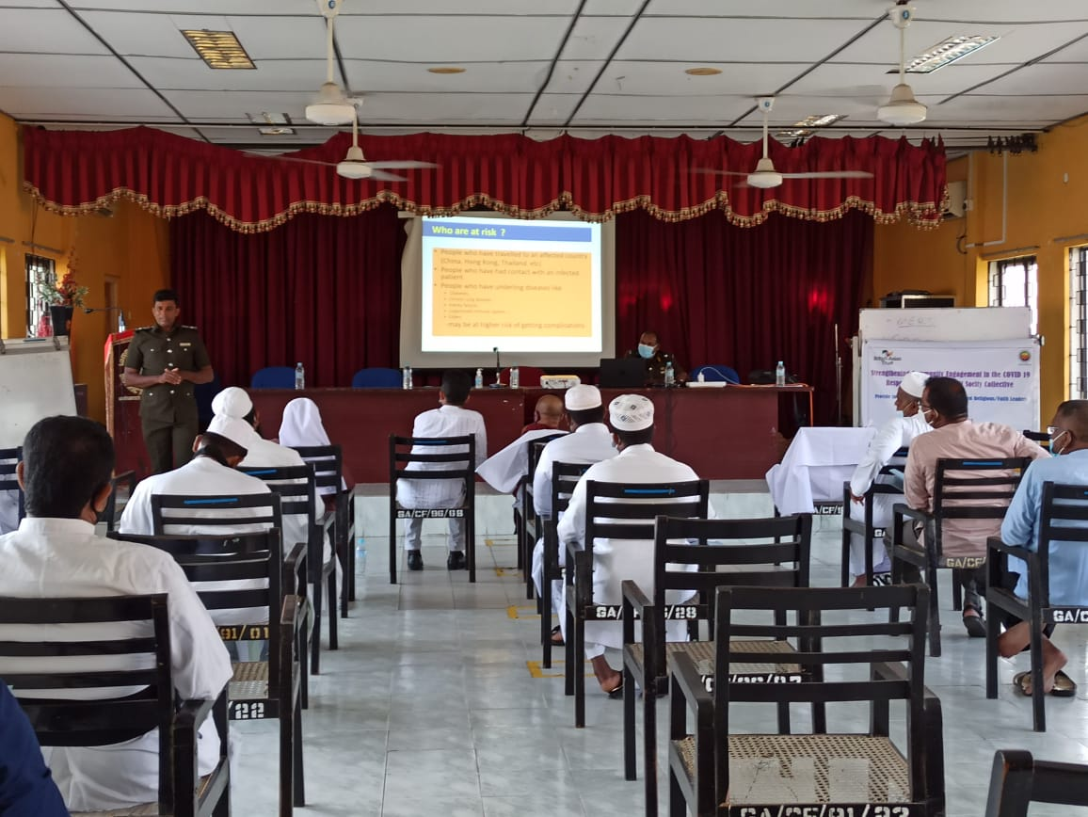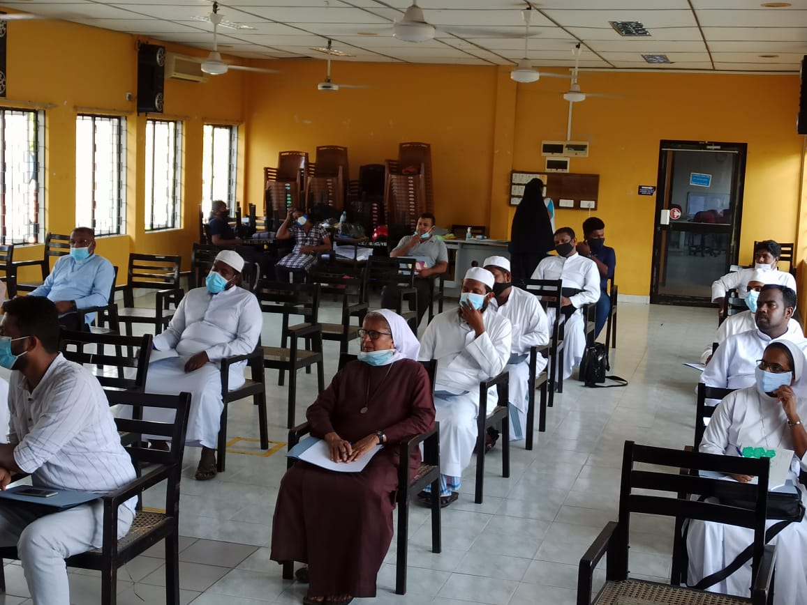

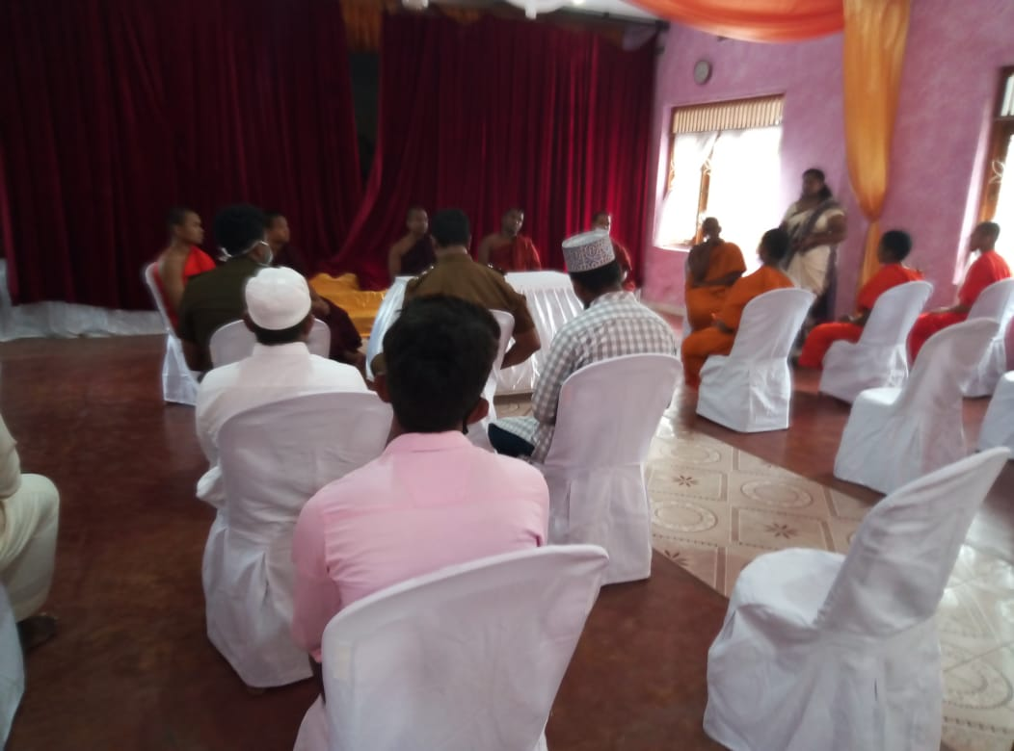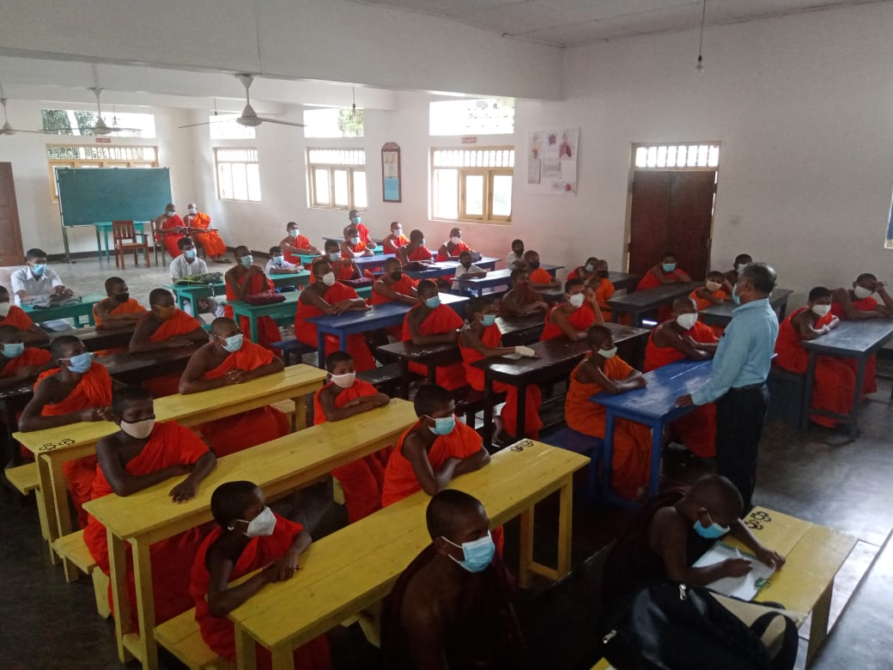
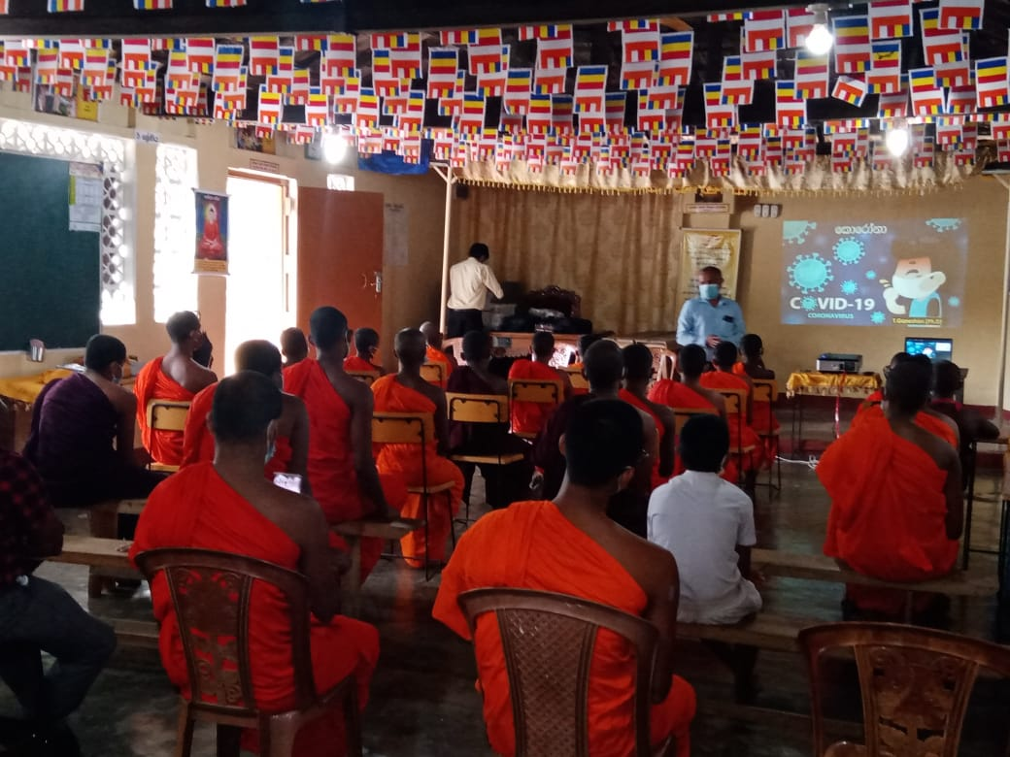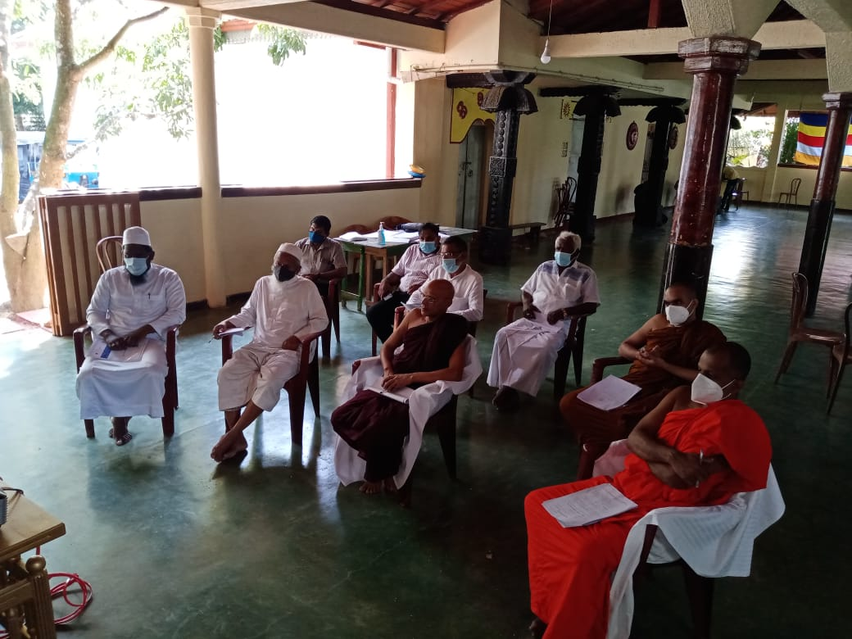

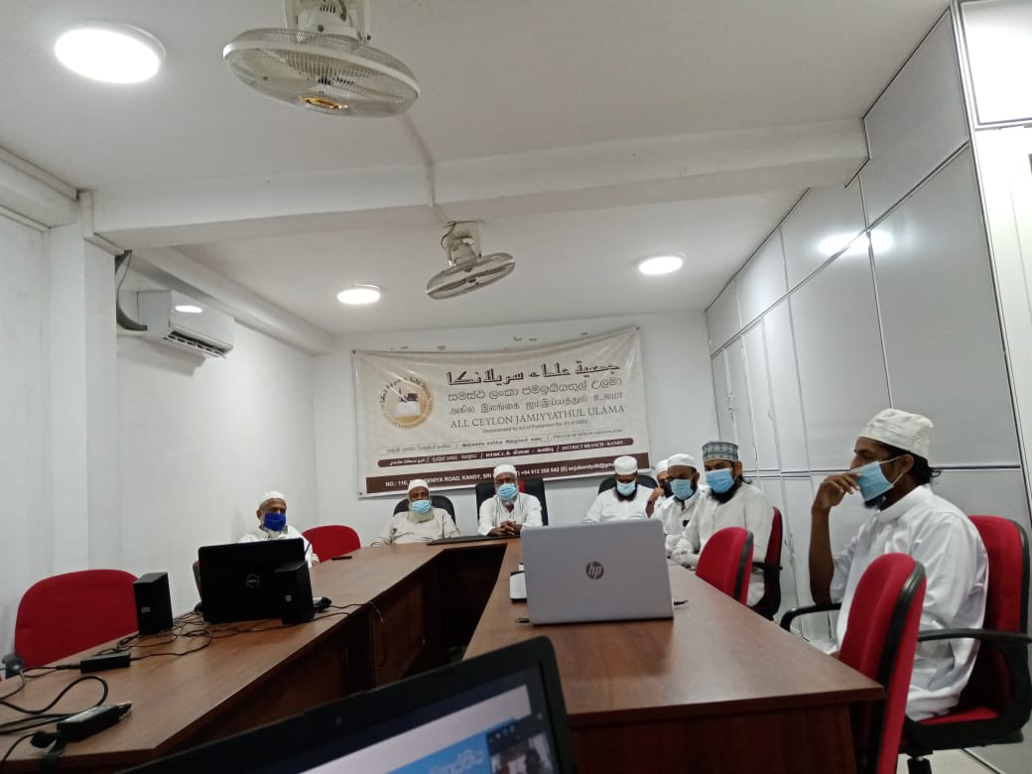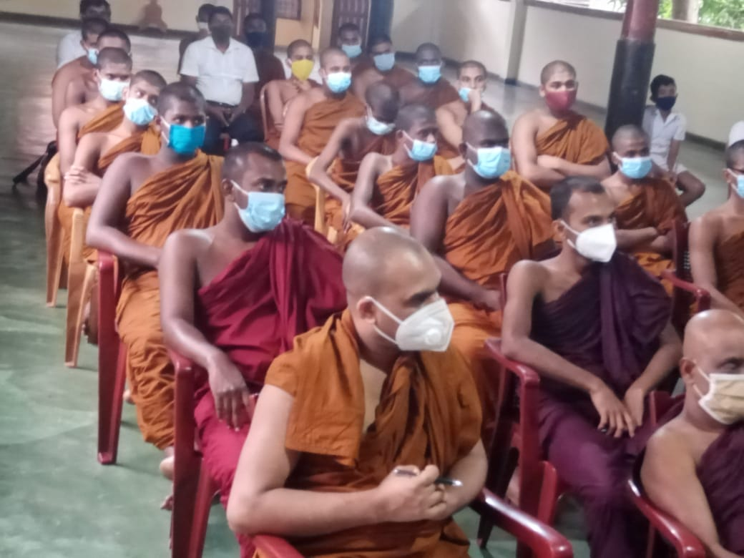

Youth and children group
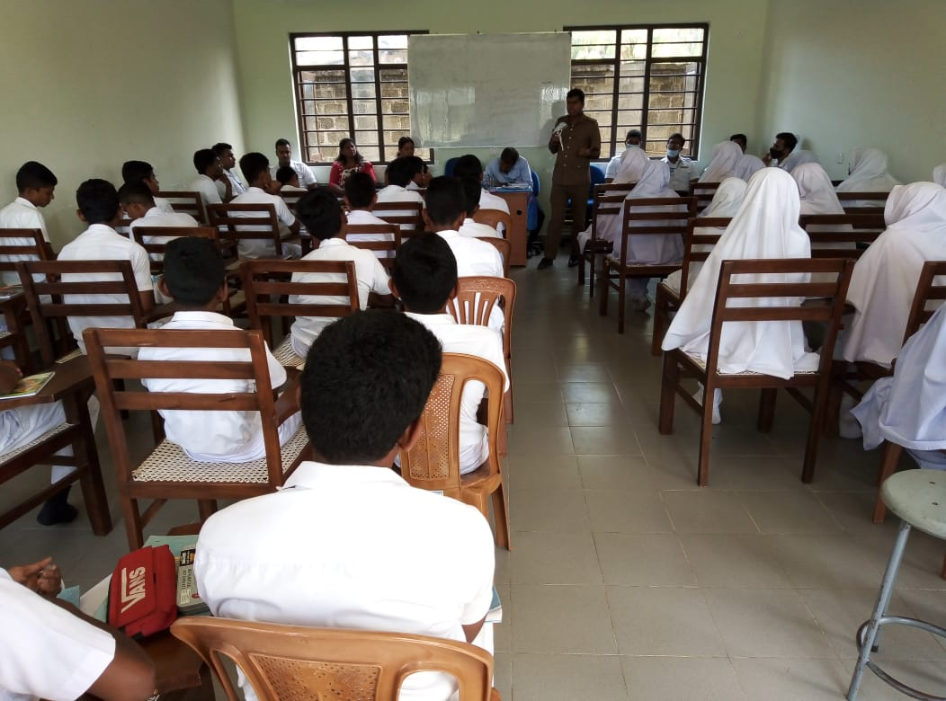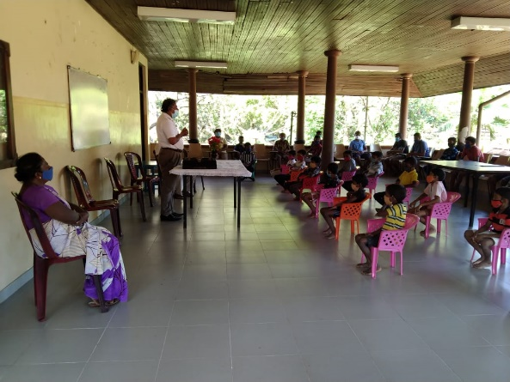

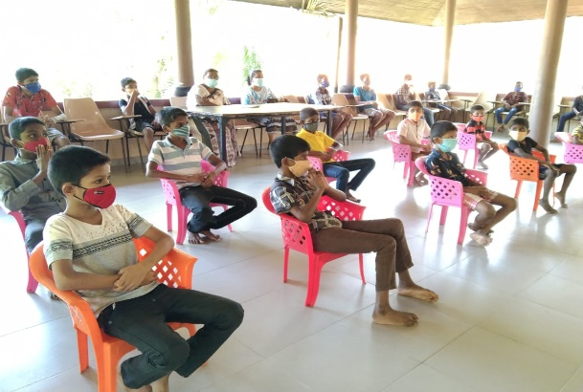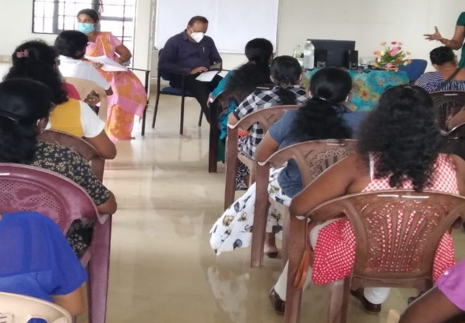

Establishment of washing stations / marking for safe physical distance Annexure IV

Child development centre
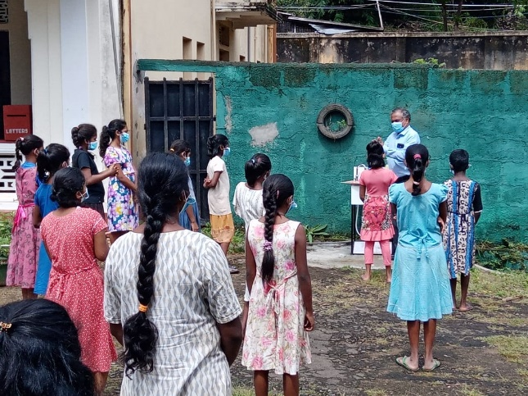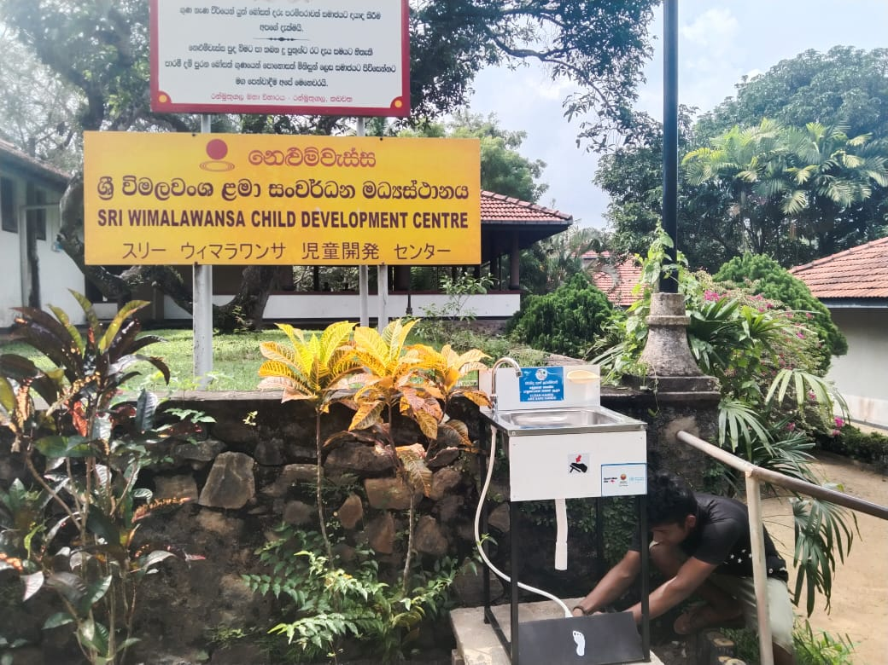

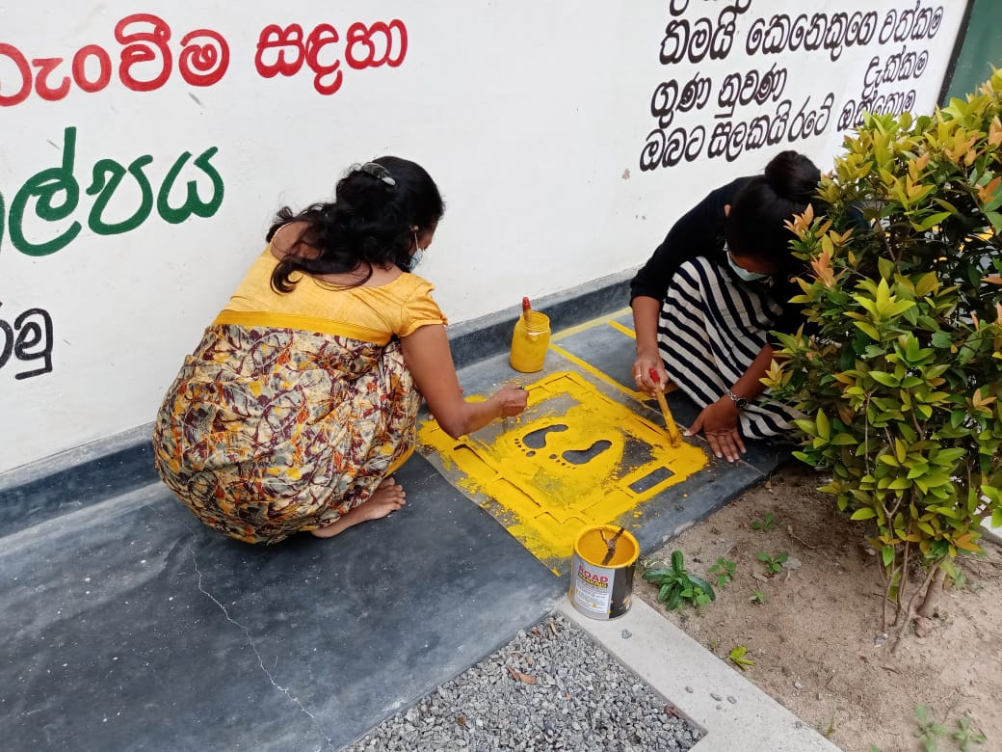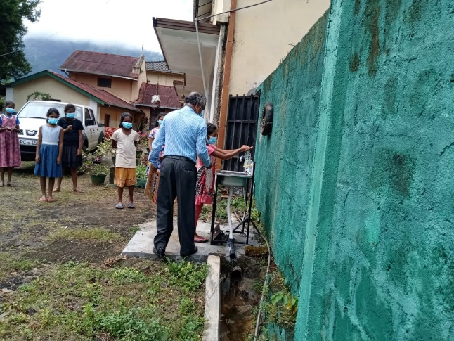

Small scale industries (zone)
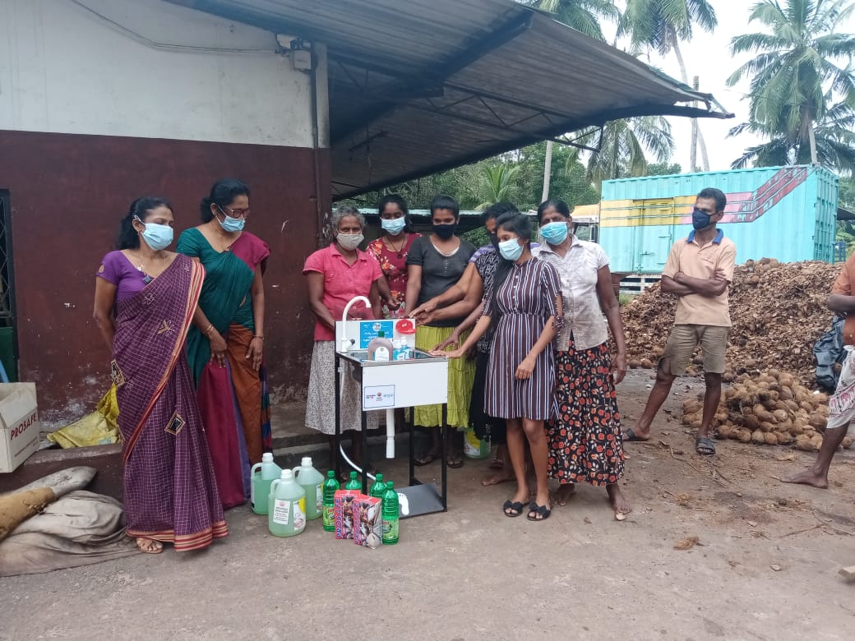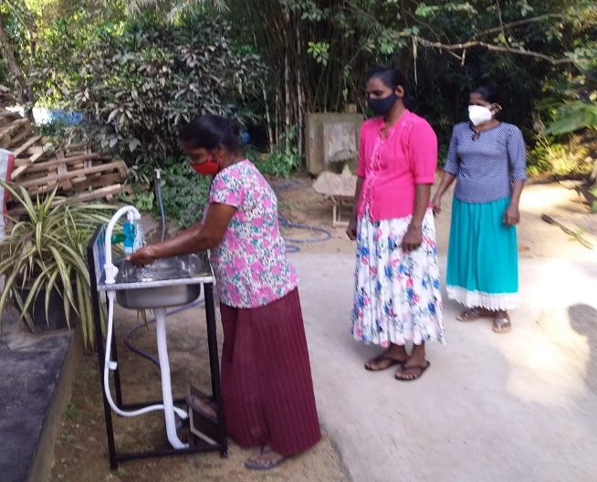

Religious places
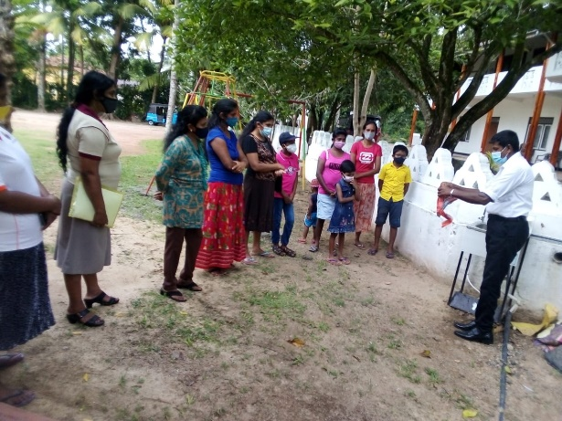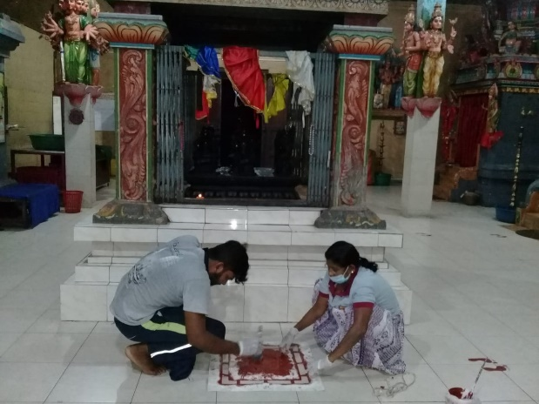

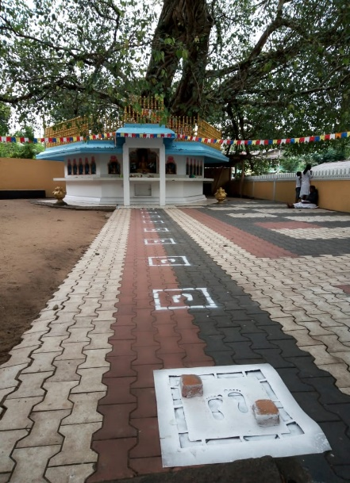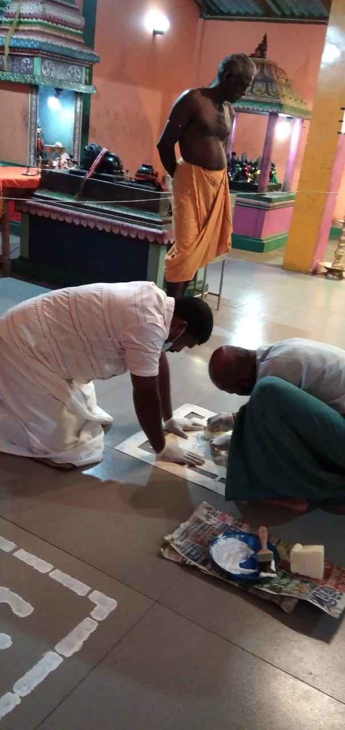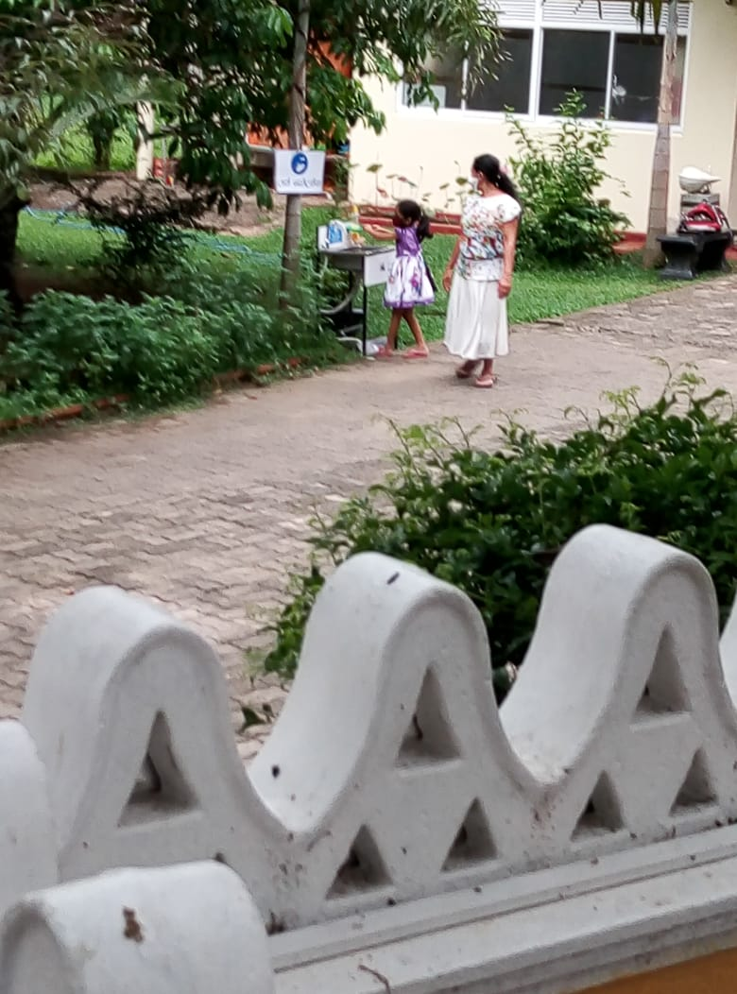

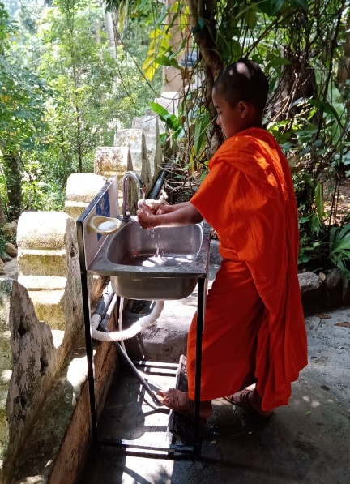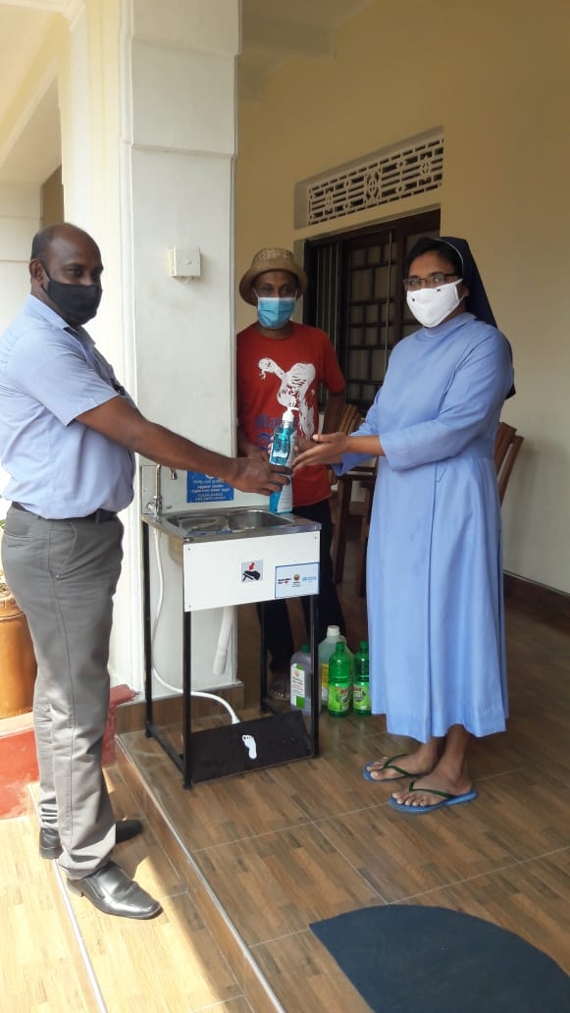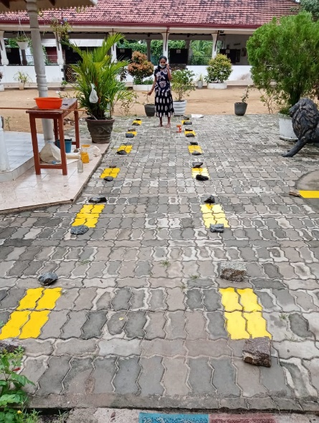

Development of Strategic Direction for Risk Communication and Community Engagement -Annexure V

HPB-Sarvodaya-ADT-CBO model for Community Engagement
The community engagement can be defined as “involvement of the communities to achieve long-term and sustainable outcomes, process, relationships, decision-making, or implementation”. HPB developed the following model based on the Medical Officer of Health areas in the country to strengthen the behaviours expected from individual and communities to prevent transmission of COVID-19.
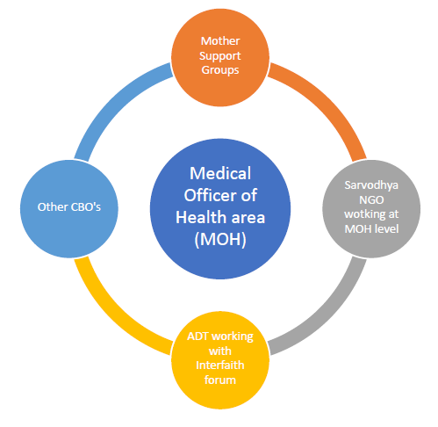

The Ministry of Health proposed the above community engagement model involving the three organizations [HPB, Sarvodaya, Alliance Development Trust (ADT)] working together with other CBO’s at MOH level. The mode of operations will be mobilizing community leaders to promote identified behaviours to prevent COVID-19 transmission, develop model community settings, mapping CBO’s in MOH areas, involving vulnerable groups in discussions, strengthening community leadership, mobilizing religious leaders in COVID-19 prevention, distribute IEC material via community networks, prevention of diseases, monitoring and evaluation of all community engagement activities conducted.

The term “programme” is used for programmes, joint programmes and projects.
Strategic Results, as formulated in the Strategic UN Planning Framework (e.g. UNDAF) or project document;
The MPTF Office Project Reference Number is the same number as the one on the Notification message. It is also referred to as “Project ID” on the project’s factsheet page on the MPTF Office GATEWAY.
The MPTF/JP Contribution is the amount transferred to the Participating UN Organizations – see MPTF Office GATEWAY
The start date is the date of the first transfer of the funds from the MPTF Office as Administrative Agent. Transfer date is available on the MPTF Office GATEWAY
As per approval of the original project document by the relevant decision-making body/Steering Committee.
If there has been an extension, then the revised, approved end date should be reflected here. If there has been no extension approved, then the current end date is the same as the original end date. The end date is the same as the operational closure date which is when all activities for which a Participating Organization is responsible under an approved MPTF / JP have been completed. As per the MOU, agencies are to notify the MPTF Office when a programme completes its operational activities. Please see MPTF Office Closure Guidelines.
Financial Closure requires the return of unspent balances and submission of the Certified Final Financial Statement and Report.
World Health Organization 2020. COVID-19 Strategy Update: draft 13 April 2020. Geneva: World Health Organization Headquarters
WHO. (2020). 2 Risk communication and community engagement readiness and response to coronavirus disease (COVID-19) – Interim guidance, Retrieved from hNps://www.who.int/publicaIons/i/item/risk-communicaIon-and-community-engagement-readiness-and-iniIal-response-for-novel-coronaviruses-(-ncov)
Note: Outcomes, outputs, indicators and targets should be as outlines in the Project Document so that you report on your actual achievements against planned targets. Add rows as required for Outcome 2, 3 etc.

