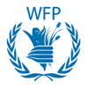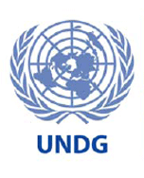

Seventh Six-month progress report for project

REPORT COVER PAGE

Participating UN Organization: |  | Cluster:
World Food Programme |  | A – Agriculture, Food Security, Environment and Natural Resource Management

Project No. and Project Title: |  | Report Number:
A6-03  (WFP project EMOP 10360.0)  Enhancing the Iraqi Institutions’ capacity in monitoring and targeting the most food insecure and vulnerable segments of Iraqi population. |  | A6-03

Reporting Period: |  | Project Budget [and revision if applicable]:
12 December – 31 December 2007 |  | USD$ 1,022,457

List Implementing Partners: |  | Geographic Coverage/Scope:
- Ministry of Planning and Development Cooperation (MoPDC) |  | All 18 governorates of Iraq

Abbreviations and acronyms: |  | Project Status: Duration/Closed Project/Timeline Extension:
Ministry of Planning and Development Cooperation (MoPDC)  Central Organisation for Statistics and Information Technology (COSIT)  Kurdistan Regional Statistics Office (KRSO)  World Food Programme (WFP)  National Development Strategy (NDS)  Millennium Development Goal (MDG) |  | Project duration: 12 Dec 2007- 12 Dec 2008  As the funds were credited under the EMOP 10360.0 which closed operationally on 31 December, 2007, this project will be financially and operationally closed on 30 June 2008 as per WFP internal regulations.

Report Formatting Instructions: We kindly ask that you review the instructions below and follow them in the preparation of your report:
- Number all sections and paragraphs as indicated below
- Format the entire document using the following font: 12point _ Times New Roman & do not use colours.
- Highlight any new challenges/constraints, mitigation strategies and lessons learned during the reporting period as well as monitoring processes and assessments, evaluations and studies undertaken/published in the period. Attach documents.
- Attach any available photos relevant to the project.

NARRATIVE REPORT FORMAT

Purpose
  - Provide the main objectives, outcomes, outputs of the programme/project

Development Goal
Strengthen the capacity of Iraqi institutions, namely the Central Organisation for Statistics (COSIT) in the Ministry of Planning and Development Cooperation, to carry out food security and vulnerability analysis and develop a monitoring tool which will, in turn, contribute to better targeted interventions concerning reconstruction, implementing social safety nets and development activities in Iraq, as well as to the reduction of food insecurity.

Immediate objectives
- Assist MOPDC/COSIT in improving their capacity in monitoring and targeting food insecure and most vulnerable segments of the population including the unemployed.

  - Explain how the programme/project is relevant to the following benchmarks:
- UN Assistance Strategy for Iraq,
- UN Millennium Development Goals,
- Joint Needs Assessment ,
- Iraqi National Development Strategy

The National Development Strategy (NDS) is established on 4 major pillars, the third of which is "Improving the quality of life". This requires the enactment of "a social safety net program for the poor and vulnerable".
This WFP assistance to Iraq specifically addresses this requirement of the NDS through building the capacity of the Ministry of Planning and Development Cooperation and giving them the necessary tools to build its own food safety net programme.
This project also addresses the first Millennium Development Goal: “Eradicate extreme poverty and hunger”. The safety net would target the most vulnerable residents for food assistance, eradicating hunger.

  - Indicate the main implementing partners, their roles and responsibilities, and their interaction with the Agency

WFP is implementing this project directly with the Ministry Planning and Development Cooperation’s (MoPDC) Central Organisation for Statistics and Information Technology (COSIT) and the equivalent in the north – the Kurdistan Regional Statistics Office (KRSO).

- Human Resources
  - National Staff & Consultants: Provide details on the number and type (operation/programme)
74 national staff including 57 based inside Iraq (programme and logistics staff). The 17 staff in Jordan and Syria are also comprised of programme and logistics staff as well as ICT, administration, finance, HR, security and drivers.

  - International Staff: Provide details on the number and type (operation/programme)
9 international staff – 2 management, 1 finance/admin, 1 security, 3 logistics, 2 programme

- Methods of Operating
  - Summarize the implementation mechanisms primarily utilized and how they are adapted to achieve maximum impact given the challenging operating context.

As mentioned above, the key partner is the Ministry of Planning, Development and Cooperation through COSIT and KRSO. There is strong inter-agency collaboration with WHO and UNICEF.

  - Provide details on the procurement procedures utilized and explain variances in standard procedures.

All procurement follows WFP’s standard procurement procedures.

  - Provide details on the monitoring system(s) that are being used and how you identify and incorporate lessons learned into the ongoing programme/project.

This project is essentially about setting up a food security monitoring system within the Government of Iraq. Development of the database and Food Security Units in each governorate who will be responsible for populating the database are the primary focus of this project.

  - Report on any assessments, evaluations or studies undertaken.

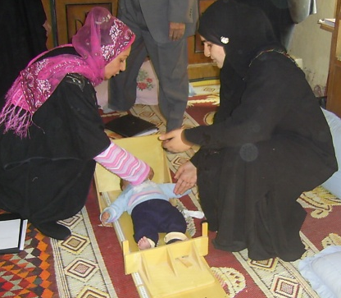
WFP has been working closely with the Ministry of Planning’s Central Organization for Statistics and Information Technology (COSIT) since 2003 in building their capacity in food security monitoring and analysis. WFP has helped set up a Food Security Unit within COSIT dealing specifically with this issue. Two comprehensive food security and vulnerability surveys have been completed with this unit, one published in 2004 and the second in 2006.

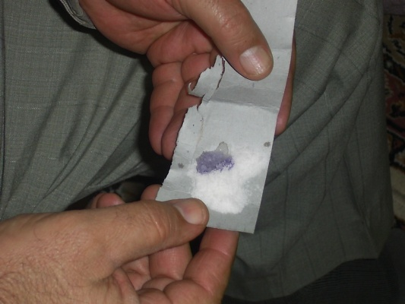
The latest survey found that just over 4 million people – or, 15.4% of the surveyed population – were food insecure and in need of humanitarian assistance, including food. It found that a further 8.3 million people (31.8% of the population) would be rendered food insecure if not provided a food ration through the Public Distribution System (PDS). The full report can be accessed on COSIT’s website at the following link: http://www.iraqcosit.org/english/activities_reports.shtm. Iraq’s PDS experienced significant shortfalls during 2006 and 2007. This, coupled with the mass movement of people since the previous survey, would have a major impact on the food security situation of the population. Thus, it was decided to conduct a follow-up survey to assess current levels of food security and malnutrition. For the first time, this survey will involve the Kurdistan Regional Government and cover all 18 provinces of Iraq. Data collection went ahead in November and was complete by December. The results are expected to be published in April 2008.
Measuring the height of a child in Albu Risha village, Muthanna province, southern Iraq.

These surveys form the basis of targeting food assistance to those who are most in need. WFP designed its EMOP 10360.0 based on the results of the first survey. Further WFP support to vulnerable groups can be considered based on the results of the 2007/8 survey.
Testing for iodine presence in salt. Samawa, Muthanna, southern Iraq.

Beyond WFP, this data is important to Iraqi policy makers. One key element of the International Compact for Iraq is the phase out of the Public Distribution System, to be replaced with a food safety net system targeting the most vulnerable. The Food Security Unit established with support from WFP and these Food Security and Vulnerability surveys will be of paramount importance in designing this food safety net as they identify who the vulnerable are, and where they are located.

- Results
  - Provide a summary of programme/project progress in relation to planned outcomes and outputs; explain any variance in achieved versus planned outputs during the six month reporting period.
Although the project has just begun, the meeting and training schedule has been planned with counterparts from the Ministry of Planning and Development Cooperation’s Central Organisation for Statistics (COSIT) and the equivalent in northern Iraq – the Kurdistan Regional Statistics Office (KRSO). Development of the Monitoring and Evaluation database is also underway.

  - Report on progress made toward the achievement of specific medium-term outcomes of the programme/project as a result of the achieved short-term outputs during this reporting period.

Numerous meetings have taken place with representatives from COSIT and KRSO to ensure their buy-in to this project and their ownership of the overall Food Security Monitoring system.

  - Report on the key outputs achieved in the six month period including # and nature of the activities (inputs), % of completion and beneficiaries.

Work has begun in development of the M&E database. By the end of the reporting period, it was 50% complete.

  - Explain, if relevant, delays in programme/project implementation, the nature of the constraints, lessons learned in the process and actions taken to mitigate future delays.

This project has started quickly as there is a high level of interest from GoI counterparts. The principal constraint was delays in the approval process of IRFFI funds. The GoI expressed their commitment to this project in February 2007, but funds were only received in December 2007.

  - List the key partnerships and collaborations, and explain how such relationships impact on the achievement of results.

This is the first time that WFP is working with the Kurdistan Regional Statistics Office (KRSO) and bringing them together with their counterpart, the Central Organisation for Statistics and Information Technology (COSIT), who WFP has been working closely with since 2003. In order for this nation wide M&E system to be successful, COSIT and KRSO need to work closely together and share information. Developing contact between these two bodies has been WFP’s principal goal for this initial phase of the project.

  - Summarize achievements against planned results for cross cutting issues: security, gender, human rights, employment (including # of short and/or long-term jobs created), and environment.

The database is being designed to consider cross-cutting issues such as gender and employment status. With this tool, the GoI partners will be able to assess levels of food insecurity disaggregated by gender and employment status.

- Future Work Plan
  - Summarize the projected activities up to the end of June 2008 indicating any major adjustments in strategies, targets or key outcomes and outputs planned.

The following activities are planned in the next 6-month period:

Finalizing and installing the Food Security and Vulnerability Monitoring, and Reporting Database System (M&E)
Training of Trainers (Food Security Analysis and Reporting Systems)
Training on M&E database system
Training on cartographic and spatial analysis of food security
First Round - Data Collection for main food security indicators
M&E data entry
Training of Trainers (Participatory Approach and Focus Group Discussion)
Focus Group Data Collection
Focus Group Data Entry
Focus Group Data Analysis
Second Round - Data Collection for main food security indicators
Report writing

Operational and financial closure is scheduled for 30 June 2008.

2006, WFP/COSIT, Food Security and Vulnerability Analysis in Iraq

