seventh Six-month progress report for project

REPORT COVER PAGE

Participating UN Organization: |  | Cluster:
WHO |  | Cluster B :Education

Project No. and Project Title: |  | Report Number:
B1-25: Strengthening school health services at Primary School level through implementation of the Health Promoting Schools |  | 2

Reporting Period: |  | Project Budget:
1 July to 31 December 2007 |  | US$ 1,757,280

List Implementing Partners: |  | Project Coverage/Scope:
- Ministry of Health,  - Ministry of Education |  | All governorates

Abbreviations and acronyms: |  | Project Duration/Closed Project:
- COSIT Central Organization Of Information and Statistical Technology  - HPSI Health Promoting schools Initiative  - IBSP Integrated Basic services Project  - MDG Millennium Development Goals  - MOH: Ministry of Health  - MoE Ministry of Education  - MoEn Ministry of Environment  - PTA Parent Teacher Association  - UNICEF: United Nations Children Fund |  | 12 months/ The project implementation is currently ongoing.

Report Formatting Instructions: We kindly ask that you review the instructions below and follow them in the preparation of your report:
- Do not put the narrative text into boxes as was done in the previous report and do not incorporate boxes, graphs, etc into the narrative report.
- Add additional information including charts, graphs, etc as annexes to the report and clearly reference the annexes using footnotes or endnotes within the body of the narrative
- Number all sections and paragraphs as indicated below
- Format the entire document using the following font: 12point _ Times New Roman & do not use colours.

NARRATIVE REPORT FORMAT

Purpose
  - Provide the main objectives, outcomes, outputs of the programme/project

The aim of the project is to assist MoH/Iraq and MoE to strengthen the school health services at primary level through updating health education concepts into the school curriculum (in all governorates)

The Main objectives of the project are to:

- Implement health promoting schools programme (life skills education and psychological first aid) implemented in 46 schools in 18 governorates (2 schools in each governorate except for Baghdad governorate 12 schools in (Karch and Rasafa).
- Increase capacity of MoH officials to take over the health promoting school initiative and continue the activity of school health screening for primary school children as part of the Strengthening Primary Heaalth Care system.
- Raise awareness among community on Health Promoting Schools initiative and the role of parent teachers association (PTA) meetings
- Hearing aids and eyeglasses provided for needy students and those with musclar skeletal abnormalities referred to specialists.
- Effective partnerships between all stakeholders including the community to build public awareness and strengthen demand for the school health services

The expected outcomes of the program within this reporting period were:

- (100) teachers and school staff trained on health promoting school initiative in 46 schools in all governorates and MoH officials informed about health promoting school Initiative.
- School health including psychological first aid services strengthened and maintained at all levels through successful coordination approaches between schools and primary health care centres.
- screening for visual, hearing problems and Muscular-skeletal abnormalities of all students in the 150 schools at 8 governorates( completed and (300) teachers trained on detection of visual ,hearing defects and Musclo- skeletal abnormalities
- Provision of eyeglasses and hearing aids to school children with visual and hearing difficulties and those with muscular skeletal abnormalities referred to specialists completed.
- Community committees established to build public awareness in demanding for school health services.
  - Explain how the programme/project is relevant to the following benchmarks:
- UN Assistance Strategy for Iraq,
- UN Millennium Development Goals,
- Joint Needs Assessment ,
- Iraqi National Development Strategy

Working in close collaboration with government counterparts at both the central and regional levels, the UNCT has committed to reinforce its support to institutional capacity-building and the provision of key basic services in addressing urgent Iraqi needs and priorities. This realignment of UNCT Cluster activities shall remain flexible in responding to the evolving operational context within the overall strategic framework.

The implementation of the health promoting schools approach in Iraq will assist MoH and MoE in developing new school policies and guidelines, and provide teachers with the necessary support to enable them to promote health. It is expected that this will lead to an improvement in the standard of the health services and health status of school children and community through increasing their awareness about main health problems and its preventive measures. Also it will lead to increased self –esteem of children and decrease of risk taking behaviour in later life.

As a result, the program will contribute to the following UN Millennium Development Goals (MDG):
- Achieve universal primary education (MDG2)
- Promote gender equity and empower women (MDG3)
- Reducing child mortality (MDG-4)
- poverty reduction (MDG-1)
- Improve maternal health (MDG5)

The project addresses the health of students, school personnel, families and community members. Currently, the health status of school children is deteriorated due to lack of proper and periodic health care, lack of awareness on main health problems and psychosocial well being.
The project proposal is fully in line with the 2005-2007 UN Strategy for Assistance to Iraq and conforms closely to the priorities expressed by the Iraqi Authorities during the July 2005 Donors’ conference -– embracing education, water & sanitation and health needs and demonstrating good impact, contributing to the overall targets of reducing morbidity and mortality.
Specifically the project addresses the following clusters and some of the relevant matrix outcomes (underlined) from the Joint UN-Iraq Assistance strategy:

Cluster | Matrix outcomes
Cluster-B (Education and Culture) | - To enhance access to all levels of education with special reference to disparity reduction (gender, geographic, ethnic, socio-cultural, economic and other disparities);  - To improve rates of retention, completion and participation at all levels of education;  - To improve learning outcomes at all levels of education.
Cluster-D (Health& Nutrition) | - 50% reduction in under five and infant mortality;  - 15% reduction in maternal mortality;  - Increase access to quality health care services especially for vulnerable group and un-reached;  - Enhance disease prevention and control including HIV/Aids.

Moreover this program is also in line with the Dead Sea strategic meeting held in July 2006, since this program ensures the provision of basic services and education

  - Indicate the main implementing partners, their roles and responsibilities, and their interaction with the Agency

WHO continues to enjoy very close collaboration with the Ministries of Education, Health, Public Works and Municipalities, in all the Directorates of the Governorates where the project will be implemented, including the Mayoralty of Baghdad. WHO works very closely with these line Ministries, from the assessment of needy areas to the joint preparation of Bills of Quantities, handing over of site to the Contractor, supervision of the ongoing works, to final taking over of the project after successful completion of the project. It is worth noting that partners in the line Ministries are very conversant with the WHO modus operandi and have benefited from multiple capacity building opportunities in the integration of water, education and health sector programming.

WHO worked in close coordination with Ministry of health/School Health unit and Ministry of education through the national staff at WHO office in Baghdad to implement the school health screening component within the UNICEF Integrated Basic services Project B1-19 for 2005-2006. Purchasing order and the bidding process for the equipments needed for the health screening was initiated in Amman. Delivery of the equipments was done inside Iraq in coordination with the logistic staff at WHO office in Baghdad.

For successful achievement of the health and education goals, it is imperative to draw on formal and informal agreements with public and private sectors as well as the civil societies. Moreover, community participation is crucial for a successful education system in Iraq. This entails the change of community behavior and awareness for education and school health services provided at PHC level especially after the deterioration in this service over the past few years. WHO through introducing of the health promoting schools initiatives (HPSI) in 20 schools in Baghdad and has been working with the communities in the selected areas and strengthening the parents teachers association and encouraging them in identifying their children‘s needs and priorities.

- Human Resources
  - National Staff: Provide details on the number and type (operation/programme)
- For the implementation of the various project components, one medical officer has been supporting the implementation of the project.
- A WHO network of national focal points have actively participated in the implementation process in close coordination and collaboration with stakeholders. Additionally, WHO is providing technical support for the implementation of the project
  - International Staff: Provide details on the number and type (operation/programme)
- One international support staff at the WHO/Iraq office has been providing first-class management and coordination of the project throughout the entire implementation period.

- Methods of Operating
  - Summarize the implementation mechanisms primarily utilized and how they are adapted to achieve maximum impact given the challenging operating context.

- The implementation of this project started after the transfer of funds to WHO in early May when schools were closing for long summer holiday. The process of implementation of interventions is on going, according to the project work plan. The main interventions at this stage before the starting date of implementation of the project in early October (beginning of the new school term 2007-2008) is the preparatory phase, including; selection of schools, the formation of questionnaire forms, orientation meetings, training and capacity building, provision of supplies and equipment needed for the implementation of health education and school health screening components of the project, building on the previous experience of school health screening within the Integrated Basic services(IBSP) Project B1-19 with UNICEF.

- WHO/Iraq continues to maintain a low profile, for security reasons, to avoid any possible negative repercussions to premises and staff. In line with this policy, international staff remain based in Amman and provide guidance and support to national staff and monitor operations within Iraq. Possible short missions, security situation permitting, to Baghdad ,the lower south and north will be undertaken.

- WHO/Iraq also provides technical support to the national staff in MoH and MoE and monitors the implementation of the activities through the continuous communication with the project's focal points through video/ teleconferences.

- The Ministry of health is the key stakeholder at the national level to ensure that the integration of school health in PHC System and works in close co-ordination and partnership with the other line ministries such as the Ministry of Education and Ministry of Environment to endorse the schools/ communities selected for needed interventions and provide policy guidance in school health. Ministry of Environment is regularly informed about the environmental aspect at schools as reported by the MOEnv monitoring team during their visits. The information has been circulated to all line ministries along with requests for action to be taken.

- At the Governorate level, the respective directorate is jointly involved in the assessment, implementation and the subsequent monitoring & evaluation processes. At the central level, the establishment of steering committee which consists of members of related stake holders, including the community leaders/representatives of PTAs with the responsibility to oversee the implementation of the activities, follow-up on the interventions and therefore ensure the convergence of basic services.

- The role of Ministry of Health is to integrate the work between partners and identify the role of each partner involved in the process, including contractors and the organization for contract tendered for cars and goods.

Quality control at the project sites is ensured through regular supervision by local national staff and project focal points at peripheral level that will make random visits to a significant number of project sites. The Local Authority staff will be involved in every step/process and monitoring during implementation.

At the onset of the project WHO, through its monitors, established base line data related to the project outputs. Following completion of the project, the monitors will again assess the outputs against the established base line data to determine the outcome of the project.

WHO has been working closely with cluster members in different thematic areas e.g. UNICEF on immunization campaigns and maternal and child health; FAO and UNIDO in food safety; and World Bank in health care financing and national health accounts. There is constant dialogue with other UN health cluster members such as WFP and UNFPA to ensure integration in the areas of malnutrition and emergency obstetric care.

  - Provide details on the procurement procedures utilized and explain variances in standard procedures.
WHO has well established procurement procedures and goods are generally delivered to Baghdad under international insurance coverage. The procurement process is being carried out through the application of the international bidding process for the majority of goods to be procured, based on WHO rules and regulations, which are geared to ensuring the quality, efficiency and cost effectiveness. In a few cases, local procurement is applied and follows a set of clear documented procedures.

Furthermore, organization manuals providing strict guidance and procedures on invitation to bids, bids opening, bids analysis, bids review and contract award, including conditions abiding both parties (the successful bidder and the organization) are available for international and local procurement. There are specific committees at each stage of the bidding process.

In order to establish the needs of the medical equipments for the school health screening (Audiometers and ophthalmoscopes), a needs assessment was carried out at central level in close collaboration with the directorate of health at governorate level. Consultations between WHO and the project steering committee were held to agree on the final requirements. A bill of quantities with detailed generic technical specifications for the agreed items was prepared, with a cost break down.

  - Provide details on the monitoring system(s) that are being used and how you identify and incorporate lessons learned into the ongoing programme/project.

WHO and the steering committee are maintaining regular communication to evaluate the implementation process and impact and to identify constraints and solutions in order to ensure a flexibly efficient approach. Additionally, the project implementation is managed by the district directors. Through its base in Amman, the WHO national staff network in the Governorates (Erbil, Mosul, Basrah and Baghdad) will work closely with the MOH/district director through teleconferencing and direct meetings in Amman. Information flow will be streamlined to enable sharing with partners, planning, decision making and for advocacy purposes.

Four focal points have been appointed and each is responsible for 4 governorates except for the Baghdad focal point that will be supervising and monitoring 6 governorates. These Focal Points should work closely with the DoH on ensuring proper implementation. They have to oversee the implementation at the governorate level and should report to WHO on all activities implemented.

These focal points report to WHO offices in the governorates mentioned, which is then transmitted to Amman for consolidation and for action if necessary.

Financial tracking is done according to WHO rules and regulations in issuing financial statements related to commitment and disbursement during the implementation of the project components. At the end of the project, the impact will be assessed by measuring performance-based indicators then compared to baseline information collected at project implementation.

  - Report on any assessments, evaluations or studies undertaken.

Universal access to basic education and the achievement of primary education by the world’s children is one of the most important objectives of Millennium Development Goals and a world fit for children. The recent Iraq Family Health Survey 2006/7) indicated that access to essential health services and education is a major problem for conflict-affected communities. The results showed a high proportion on non -attendance at school among the age group 5-9 years (38.7%) which reflects the fact that children are being enrolled late for school, a finding that was also obtained in the 2006 MICS-3. Furthermore, the results of the survey showed gender disparity in access to education. The percentage of females who have not attended school is approximately twice as high as the percentage of males (26.8% and 14.6%respectively). This survey has contributed to obtaining baseline data and updating health and education indicators, some of which are related to children mortality and morbidity and will have a direct application in assessing the impact of the project with regards to improvement of education and combating poverty, empowering women and protecting children from water and food borne diseases.

- Results
  - Provide a summary of programme/project progress in relation to planned outcomes and outputs; explain any variance in achieved versus planned outputs during the six month reporting period.

During the specific reporting period, the focus of implementation was upon the following key planned outcomes and outputs:

  - School health, including strengthened psychological first aid services, was maintained at all levels through successful coordination approaches between schools and primary health care centres.
  - MoH officials informed on health promoting school initiative.
  - MoH health professionals trained on school health screening activities.
  - Community leaders trained on health promoting schools initiative.

The following key outputs regarding the actual field school health screening met following initial implementation of the project (early October2007).
- Health screening of all students in the 150 schools at 8 governorates completed.(screening for visual, hearing problems and Muscular-skeletal abnormalities).
- Teachers trained on detection of visual ,hearing defects and Musclo- skeletal abnormalities at 150 schools in 8 governorates involved in health screening
- Provision of eyeglasses and hearing aids to school children with visual and hearing difficulties and those with muscular skeletal abnormalities referred to specialists completed.
- Community committees established to build public awareness in demanding for school health services.

  - Report on progress made toward the achievement of specific medium-term outcomes of the programme/project as a result of the achieved short-term outputs during this reporting period.
- The implementation of the health promoting schools approach in Iraq has assisted MoH and MoE in developing new polices and guidelines, and provided teachers with the necessary support to enable them to promote health.
- Improvement in the standard of the health services provided to students lead to a reduction of morbidity and mortality rates among all targeted groups and improved student’s performance. This was achieved through screening of children for visual, hearing difficulties and detection and management of musclo skeletal abnormalities. Also it led to the increased self–esteem of children and a in risk taking behaviour in later life.
- The up-grading of schools to more child friendly status, coupled with interventions on health education on various key health practices and raising awareness among communities around the schools, including families for the school children and community leaders on importance of health promoting schools and the active participation of the parents through the revitalized parent teachers associations, have directly contributed to improvement the health status of children.
- Additional focus has been on building the capacity of human resources (health professionals and teachers) through upgrading their skills and knowledge on health, psychosocial support and the provision of equipment and supplies in order to provide good quality service.

  - Report on the key outputs achieved in the six month period including # and nature of the activities (inputs), % of completion and beneficiaries.
During the reporting period, the following activities were implemented.
- Selection of 46 primary schools in all governorates by MoH and MoE according to the agreed upon criteria (100% achieved).
- Identification of 150 schools in 8 governorates by Minsitry of planning, COSIT (Baghdad Baghdad, Basrah, Missan, Theeqar, Muthana, Wasit, Najaf and Suiliamania) and sampling design for the number of students to be screened (100% achieved)
- Eight technical meetings held in MoH/Baghdad and two technical meeting in MoH/Kurdistan to finalize the plan of action and sampling design for implementing the project.(100% achieved)
- Procurement of supplies and equipments Audiometers (62), ophthalmoscopes (40) and snell’s charts (100) for the health screening component of the project (90% achieved).
- Provision of informatics and stationary for the field implementation of the project (100% achieved).
- Improve the capacity and enhance the skills of MoH and MoE professionals (directors of school health units at MoH and DoH and directors of school and environment units from MoE and DoE).
- Training of trainers workshop conducted in Amman (August 2007) for 52 health professionals, teachers and directors of education and environment. They were trained on heath promoting schools approach, psychosocial support and psychological first aid services and school health screening of students for visual and hearing difficulties and musclo skeletal abnormalities.(100% achieved)
- Advocacy meetings for 600 community leaders and families around the school to raise awareness on health promoting schools and increase their role in improving health (50% completed).
- Four national training activities were successfully conducted for 90 health personnel and 20 teachers in Baghdad, Basra, Suliamaniya and Najaf. The main objectives of the workshop were to: (a) To update the technical skills and knowledge of doctors on school health screening , (b) to explain the different forms of examination of students for vision ,hearing and musclo skeletal abnormalities,(c) to update their knowledge on health education and key health massages, communication skills and psychological first aid services (60% completed).
- 18 national training activities at governorate level conducted for 312 doctors and 42 teachers on health promoting schools and school heath screening (60% achieved).
- A mission was made by WHO national technical officer to Erbil and Suliamania during the cholera outbreak as part of the emergency plan and health education campaign to control the spread of disease in schools (November 2007).
- 6 supervisory visits by six members of the steering committee to primary schools in Baghdad, Basrah, Missan, Muthana, Najaf and Suliamaniya to follow up project implementation (40% completed)

  - Explain, if relevant, delays in programme/project implementation, the nature of the constraints, lessons learned in the process and actions taken to mitigate future delays.
There have been several elements affecting the timely implementation of the project:
- Security concerns in the country continue to be a major limiting factor and are constraining the presence of international expertise inside the country.
- Conducting trainings in other governorates is becoming increasingly difficult and expensive for facilitators from Baghdad.
- Shortage of well trained support staff at central level.
- Delay in implementation of the project due to the delay in selecting the best transportation contractor with reasonable offers according to WHO rules and regulations.
- Difficult access to some remote districts and changes in holidays and school vacations.
- Other issues that are playing a major role in delaying the implementation of activities as scheduled are continued violence and insurgence, attacks against health professionals, lack of adequate resources and high turnover of senior officials.

Lessons learnt:
- The long years of war and sanctions have severely weakened the school health services in Iraq;
- Human resources development is an important need in Iraq; for proper functioning of school health services health services, there is a need to develop national policies, strategies and procedures.
- Lack of cooperation exists between MoH, MoE and other related ministries in terms of technical consultations.
- Sustainability of quality heath services with periodic examination of students will lead to improvement in the health and performance of students at school.

  - List the key partnerships and collaborations, and explain how such relationships impact on the achievement of results.

The main implementing counterpart of the project is MOH represented by school health unit/directorate of public health and primary health care in close coordination with MoE. WHO is working closely with line ministries such as MOH, MoE. MoP and MOEv. The partnerships provide a forum through which members can combine their strengths and implement solutions that no one partner could achieve alone. The partnership supports national training programmes; management policy, and monitoring and information systems.

In addition, the MOH, MoE, DoH and DoE personnel continue to be fully engaged in all implementation stages so as to ensure the ownership of the project by the targeted stakeholders once the project is completed.

  - Summarize achievements against planned results for cross cutting issues: security, gender, human rights, employment (including # of short and/or long-term jobs created), and environment.

The training activities conducted during the reporting period have taken into consideration the gender balance where possible. Out of a total of 354 health professionals and teachers trained, 141 were female (40%), Cross cutting issues related to the project will be reflected in the regular school visits, the facilitators who will assess the relative levels of activities /involvement of the Parent Teacher Association (PTA) in each school, social mobilization and community participation. Assessment reports will be obtained by the facilitators, which will provide WHO with valuable insight on the behaviours of the children at primary schools implementing the health promoting school Initiative and their families living in the area of project implementation. Moreover, the implementation of this project is focused on school children who are more vulnerable to the mental health effects of the ongoing conflict situation.

The project is expected to generate direct and indirect employment; already about 112 jobs inside Iraq have been created, through subcontracting private companies for transportation and provision of supplies needed for the project

- Future Work Plan
  - Summarize the projected activities up to the end of June 2008.

- Support MoH and MoE in the implementation of the health promoting school initiative by conducting 5 orientation workshops for head masters for health promoting schools.
- Training of health professionals, teachers and health worker on health promoting schools.
- Training of (150) teachers and health personnel working at primary health care centres on providing first aid, psychological and basic mental health care for children with psychosocial problems.
- Training of 50 MoH health professionals on school health screening.
- Advocacy among community and religious leaders through training and distribution of educational materials and strengthening the Parent Teachers Association (PTA) meetings.

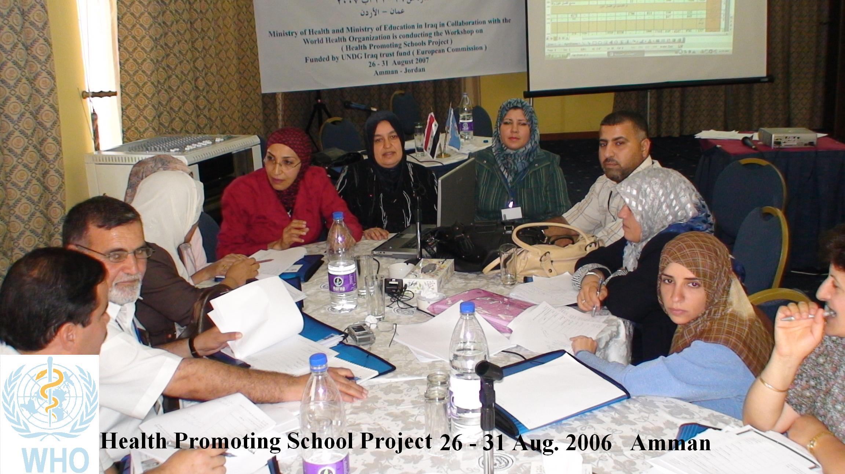

Group work to discuss and review the school health screening form

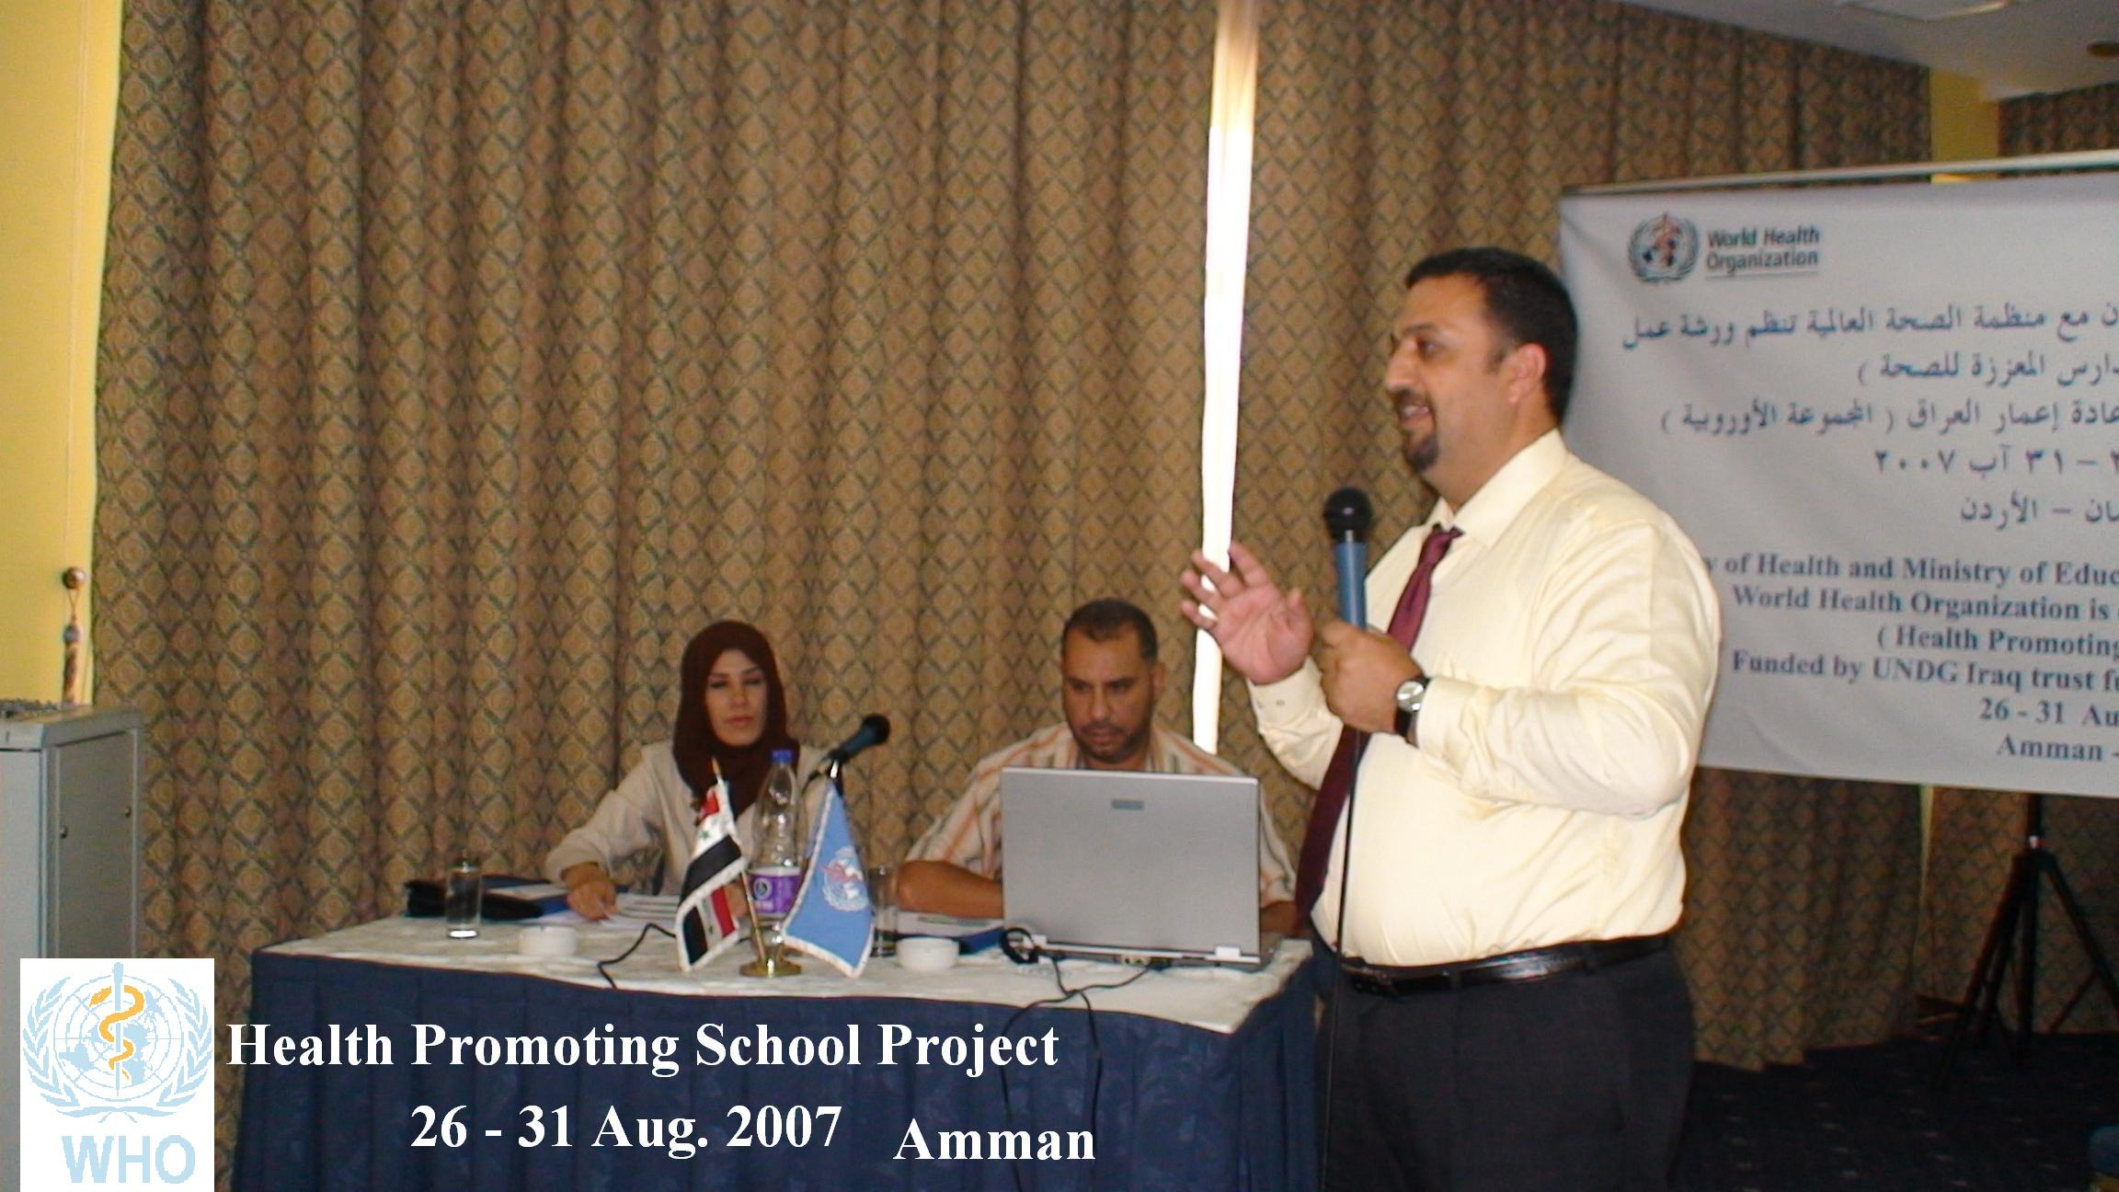

Psychosocial support training by psychiatrist

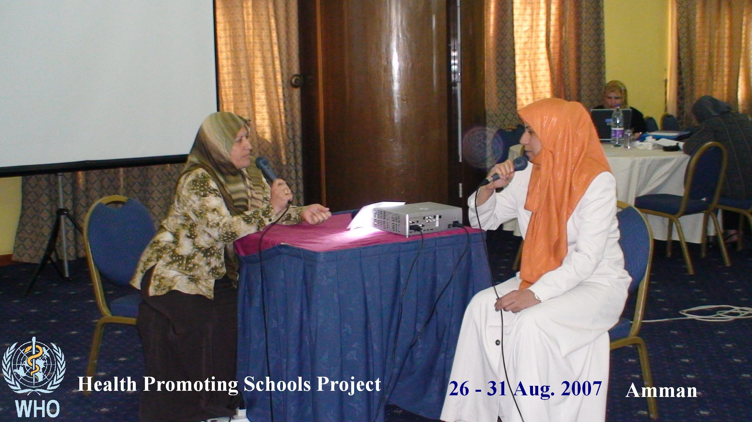

Training session-Role play
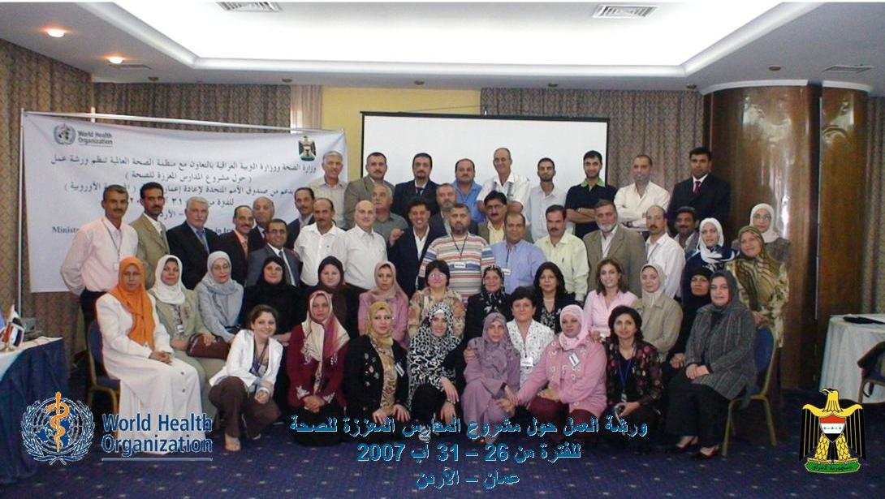

The team of trainers from MoH,MoE and MoEn

