Completion report for project:
Civil Society Forums Project I

Summary
Participating UN Organisation: |  | Cluster:
UNOPS |  | Cluster C -Governance and Human  Development

Project No. and Project Title: |  | Project Location/Region/Province:
C9-02 - Civil Society Forums Project |  | Countrywide

Reporting Period: |  | Report no:
October 1, 2004 – December 31, 2005  Operationally Closed in December 2005 |  | Final

Counterpart organisations / implementing partners:  Ministry of Human Rights  Method (Jordan)  Sharqiyat Institution (Jordan)  UN partners: UNAMI HRO, UNAMI CSU & OHCHR  Numerous civil society organizations and international NGOs (see text) |  | Project cost:  1,720,224 US$

Abbreviations and acronyms: |  | Project Duration:
UNAMI OCS–Office for Constitutional Support  UNAMI HRO–UNAMI Human Rights Office  ToT – Training of Trainers  CSO – Civil Society Organization  NDS – Iraqi National Development Strategy  RFP – Request for Proposal  EoI – Expression of Interest |  | 12 months extended to 14 months

I. Purpose

Main objectives and outcomes expected as per approved Project/Programme/project document:
The Project started on 1 October 2004 with the primary goal to “improve the capacity of the Iraqi civil society in order that they can take a more active role in informing, monitoring and supporting the process of democratization in the country.”

In line with the above goal, the Project has two major objectives:

- Support research and academic institutions, professional associations, NGOs and other civil society organizations to engage in discussions on issues of political and social importance;
- Support human rights initiatives through trainings, workshops and seminars in collaboration with UNAMI Human Rights Office, OHCHR, etc.

From the two objectives the following outcome has been envisioned:

- A number of Iraqi-based research and academic institutions, foundations, NGO, etc are oriented to promote coexistence, dialogue and respect for diversity by engaging regional civil society organizations supported to be part of a network of entities and people interested to share their views and interest on the Iraq’s transitional processes.
- Increased civil society role in education, protection and monitoring of human rights.
- Expertise and skills in advocacy and lobbying, research, and surveys significantly increased, and a more transparent and increasingly gender balanced local and national policy making process encouraged.
- Contacts with Middle Eastern and international governmental and non-governmental organizations, including the UN, EU, etc. widened, improving the flow of information and knowledge sharing.

Reference to how the programme/project relates to the UN Assistance Strategy to Iraq and how it aims to support international and national development goals (National Development Strategy) including the Millennium Development Goals and other goals as pertinent:
The Project objectives and scope of work reflects the needs identified in several key UN and Iraqi government documents and assessments, in particular:

- UN and World Bank: Joint Needs Assessment, October 2003;
- Iraqi Strategic Board: National Development Strategy for 2005-2006;
- Cluster 9 Matrix and Strategy (currently Cluster C)
- UNAMI/OHCHR: Human Rights Programme for Iraq, Dec 2004-Dec 2006.

In October 2003, UN and the World Bank wrote in their Joint Needs Assessment:

“After years of brutal, dictatorial, and divisive rule, there must be progress in ensuring that this transition is owned by the Iraqi people and that they define the direction and pace of policy reform and development, while ownership will be facilitated by elections and the attainment of full constitutional reform process, the establishment and control of state institutions and natural resources, integrity of its borders, and recognition by the international community.…“

Iraqi public ownership of the transition is further developed in the more recent Iraqi Strategic Board’s National Development Strategy for 2005-2006 that defines the role of the civil society in the reconstruction and transition process in the following way:

“….the civil society must receive sufficient support to perform the following roles:

  - Activate participation of youth, women, and marginalized categories in service and development activities and programs.
  - Establish culture of dialogue and cooperation between nationals, and promote the concept of voluntary work in a manner that enhances citizenship culture (right and duty).
  - Participation of civil society organizations in implementing development projects and social services with both public and private sectors.”

Within the overall support to the civil society organizations falls an important component of strengthening human rights component of civil society advocacy and promotion. An effort to increase human rights awareness, and strengthen the capacity of human rights organizations has been discussed and agreed upon by Cluster 9 members led by OHCHR and UNAMI Human Rights Office. Due to its human rights and social development orientation, the “Civil Society Forums” Project falls squarely under the Human Rights Programme, and is reflective of paragraph 7 of United Nations SCR 1546 (2004):

“…the Special Representative of the Secretary-General and the United Nations Assistance Mission for Iraq (UNAMI), as requested by the Government of Iraq, shall:
(a) play a leading role to:
(i) assist in the convening, during the month of July 2004, of a national conference to select a Consultative Council;
(ii) advise and support the Independent Electoral Commission of Iraq, as well as the Interim Government of Iraq and the Transitional National Assembly, on the process for holding elections;
(iii) promote national dialogue and consensus-building on the drafting of a national constitution by the people of Iraq;
(b) and also:
(i) advise the Government of Iraq in the development of effective civil and social services;
(ii) contribute to the coordination and delivery of reconstruction, development, and humanitarian assistance;
(iii) promote the protection of human rights, national reconciliation, and judicial and legal reform in order to strengthen the rule of law in Iraq; and
(iv) advise and assist the Government of Iraq on initial planning for the eventual conduct of a comprehensive census.

This project is also mentioned as one of the civil society projects in the Matrix of Cluster 9 (now Cluster C).

Main international and national implementing partners involved, their specific roles and responsibilities in project implementation and their interaction with the agency:
For implementation and expertise the Project draws on a number of partners:

(a) UN organizations: UNAMI Office for Constitutional Support, UNAMI Human Rights Office and OHCHR,
(b) International organizations: MPDL (Spain), ICS (Italy), Amnesty International; and
(c) regional Arab organizations: Tunis Institute for Human Rights, Method, Sharqiyat, Amman Center for Human Rights Studies.
(d) national Iraqi organizations:

Responsibilities of each of the organizations correspond to their expertise and capacity and ranges from project management to trainings for NGOs.

II. Resources

Total approved budget and summary of resources available to the programme/project from the UNDG Iraq Trust Fund and non-Trust Fund resources where applicable:
1,720,224 US$ - 100% funded from European Commission contribution to the UNDG Trust Fund.

An assessment of the extent to which the programme/project component / programme /project is progressing in relation to the outcomes and outputs expected for the year:
The project is divided into two major components corresponding to two stages of the project: stage 1: trainings and workshops; and stage 2: grants for Iraqi NGOs who have attended trainings and satisfied criteria for proposal funding.

In the months following the inception of the Project (October through December), UNOPS invested in identifying Iraqi NGOs and the type of support that is most appropriate and needed. As a result the following was put in place:

- civil society forum on the topic of NGOs in Iraq with the participation of 50 CSOs from and outside Iraq

- A 3 phase Training of Trainers workshops on Human Rights were organized by the Arab Institute for Human Rights and Sharqiyat, and conducted for 20 participants, half of whom submitted proposals to conduct similar trainings inside Iraq. Their proposals are currently under revision for potential funding by UNOPS.

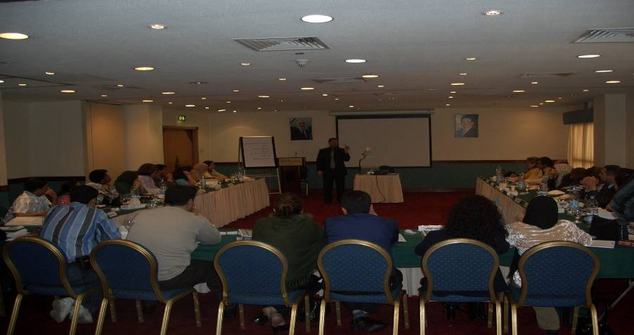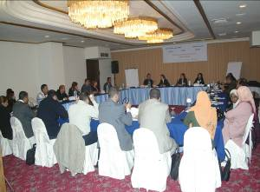

Training of Trainers – Amman

- A Human Rights Monitoring network :The 2 workshops on Human Rights Monitoring, organised by Amman Centre for Human Rights encompassing 60 participants culminated with the establishment of a Regional HR network of 24 organisations from different areas in Iraq. The network capacity in researching, monitoring and advocacy is now well practiced and their reports and analysis papers are recognized and often referred to by international organizations.

His Excellency Koffi Annan
Secretary General of United Nations
New York
Date: 20 August 2005

First Periodical Report of
Monitoring Net of Human Rights in Iraq
MHRI – 2005

Baghdad

HR network of 24 organisations created with recognised efforts in researching, monitoring, advocacy and reporting

In addition to providing the necessary learning, the Human Rights Monitoring workshop was an outlet for many Iraqis to disclose serious concerns about Human Rights Situation. A 16 page report was produced on HR Situation in Mosul, Bag., Sulaimanieh, Karbala, Thai Qar, Diyala, Samara, Fallujah, Basra, Babylon. The report is currently used for reference and follow up by UNAMI HRO office and other relevant parties.

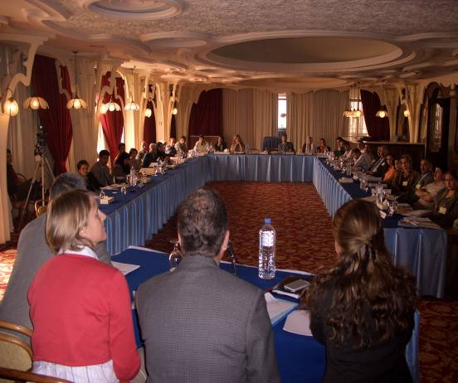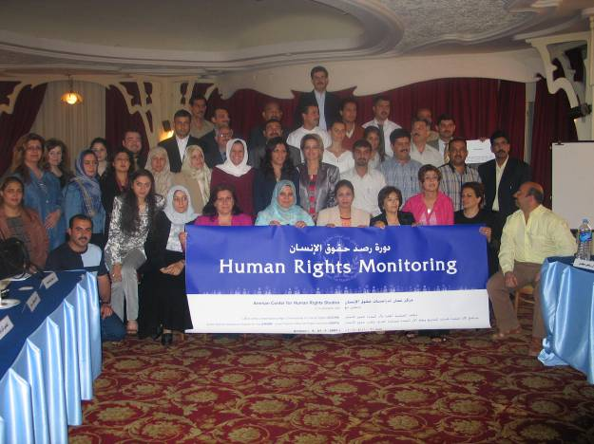

- The Human Rights Defenders workshop-June05, encompassing 24 Human Rights leading Activists has assisted in bridging the gab between Iraqis and some members of the Iraqi National Assembly, In having their voice seriously heard by the SGSR, the Special Rapporteur for Human Rights Defenders, Ms. Hina Jilani, UNAMI HRO and UNOPS, and assisted in benefiting from the experience of their peers in the neighbouring countries in the Arab region.

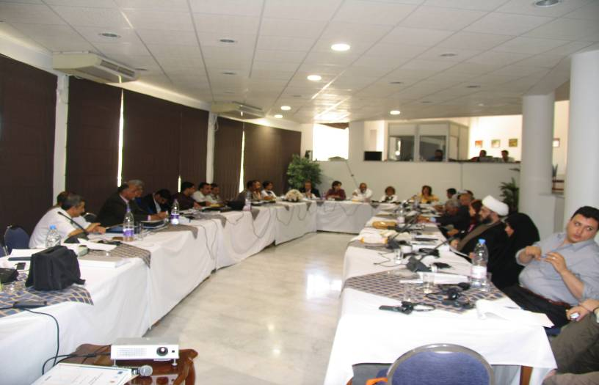

- Project (human resource, planning and financial) management and leadership training for about 50 NGOs organized by Method Co.

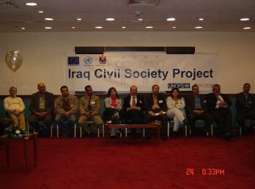

The project management workshop / Feb. 05

6. Grants program (Phase II), 11 contracts were signed out of which 9 were with Iraq-based civil society organizations, selected from a variety of locations in Iraq: Baghdad (Sadr City), Fallujah, Erbil, Dohuk, Sulaymaniyah, Nasirriyah & the Marshlandsand Basra. The other 2 contracts were with with international non-governmental organizations: Italian Consortium of Solidarity (ICS) and Spanish Movimiento por la Paz, el Desarme y la Libertad (MPDL). Selection of NGOs was done through several steps : Expression of Interest (EOI), Request for Proposals (RFP), interviews, and background research. All said organizations have successfully implemented their projects as shown below, using the knowledge acquired through UNOPS financial and technical support:

6.A An Anti violence program in Dohuk and Erbil: A program implemented by Concordia in Kurdistan for setting up 20 counseling centers in Dohuk, Erbil and Sulaimanieh governorates.
140 women learned to be Psychosocial trauma counselors for women victims of violence. Thousands of people around northern Iraq are aware (through T.V advertisement) that counseling is available to local women through this program.

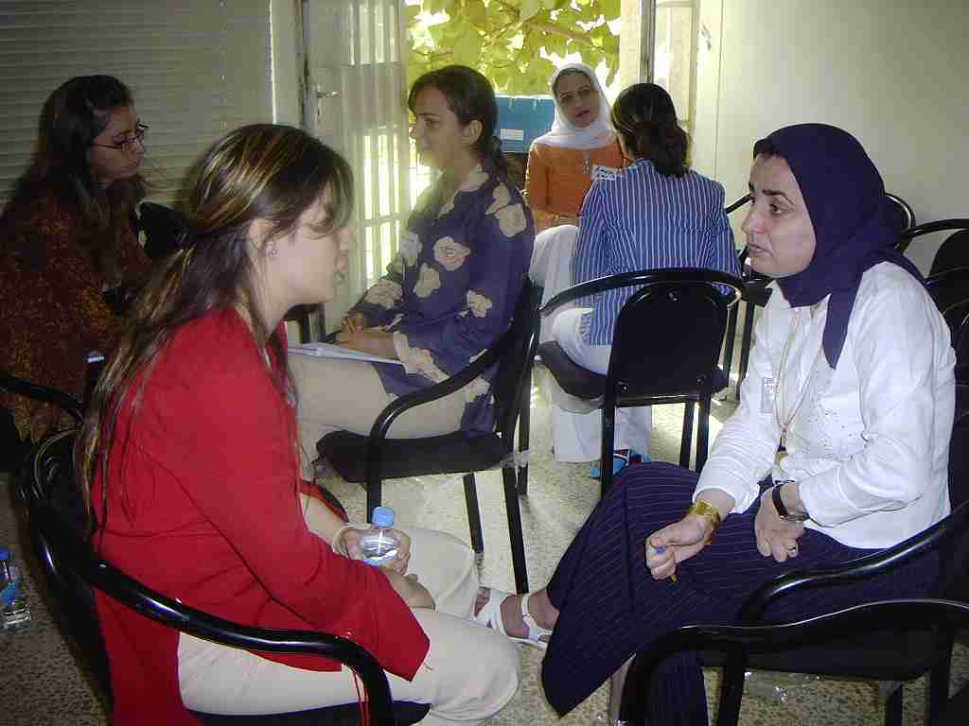
Anti Violence Program - Erbil, Sulaimanieh and Dohuk.

6.B A Women Awareness Program in the Marshlands (the Independent Iraqi Women Oganisation in Nasiaryah): In addition to the 13 locations in the cities of Nasiriyah, our women awareness program targeted 15 different locations in the marshlands and rural areas with the number of 1250 direct beneficiaries.

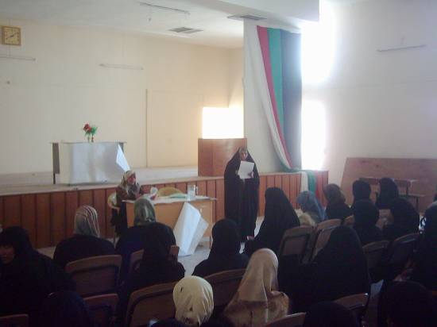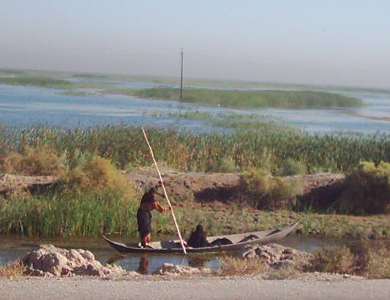

Empowerment of women in the city of Nasiaryah, the rural areas and the Marshlands

6.C Environmental Libraries in Sadr City ( NAHR organization ) : Two schools, one primary and one secondary, in very poor areas of Sadr City are now equipped with environmental books. Seminars were held in each of the schools on environment protection for teachers and students.

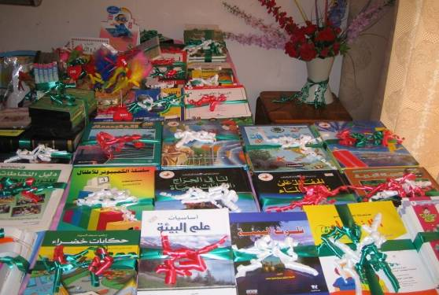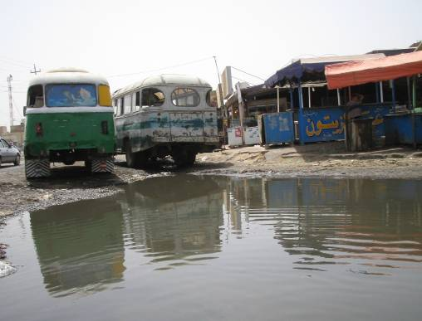

6.D 35 workshops and a computer centre for free use in the lower South (BSSSD Organisation) : 530 local NGOs and CSOs in Basra in addition to 146 participants attended 35 trainings sessions on : Governance, Human Rights and Computer Literacy. A library and computer centre for free use by southern based NGOs has been fully equipped and made operational.

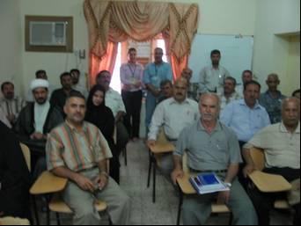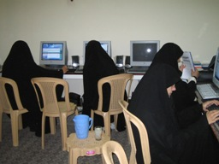
Civil Society Development Project – Basra

6.E Adults Skills enhancement and social awareness in Sulaimaniyah : 182 residents of 12 villages in Sul. received several trainings:

- Forming sports team, drama groups and painting were means for disseminating social and HR awareness for Adults and children.
- Hygiene awareness; First Aid, Women’s and children’s health and wellbeing.

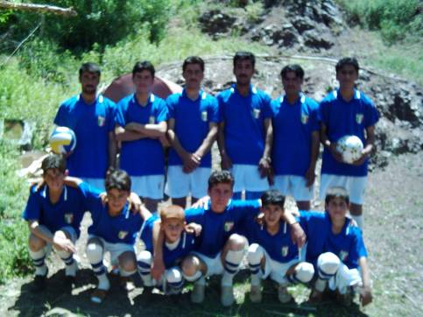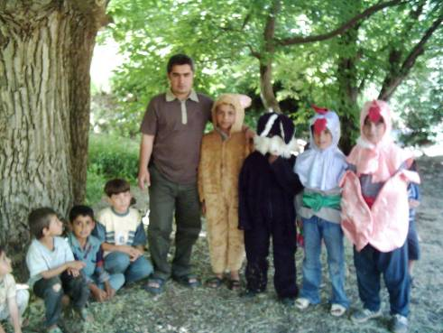

Women and Adult’s Skills enhancement program - Sulaimanieh

6.F Fallujah Community Restructuring: Income generation project (ICS): 35 families, primarily in Fallujah have been assisted to reclaim their lost businesses (Aid in Kind). Preference was given to Widows, Families with a large number of children, Disabled, and Women head of families

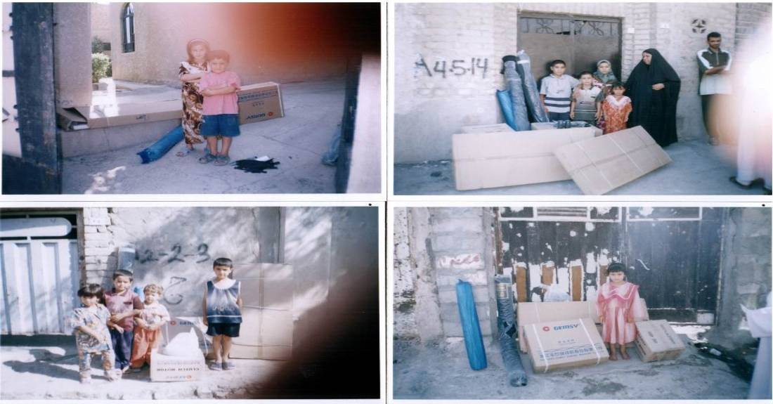

Income Generation Activities to Support Civil Society in Fallujah

6.G Exposure to other experiences for Iraqi environmental NGOs :A survey is already conducted on the status of Iraqi environmental NGO’s. 12 Iraqi environmental NGOs are exposed to international and regional groups for further expanding their knowledge and future networking, through attending workshops and seminars.

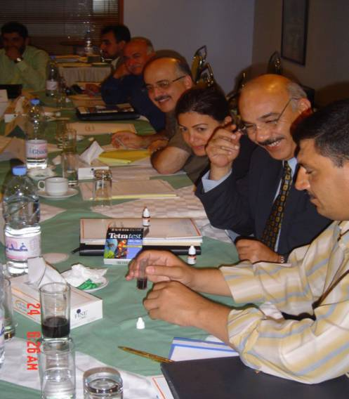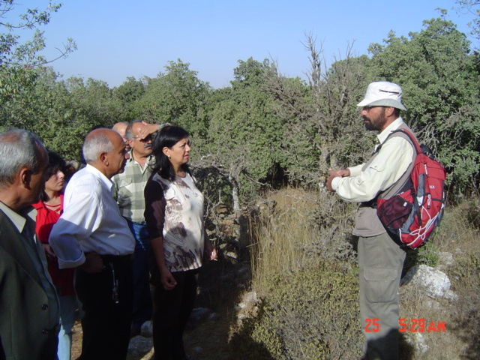

Iraqi Environmental NGO Roundtable Meeting

6.H The Study on the legal framework for Local NGOs made by a UN Consultant, has been used and further revised, discussed and amended during a roundtable of 90 participants organized by AL Amal Iraqi Organization. The study will be submitted to the Civil Society Committee / National Assembly to have it endorsed.

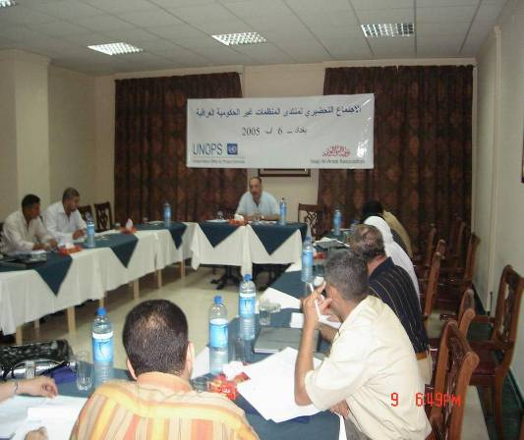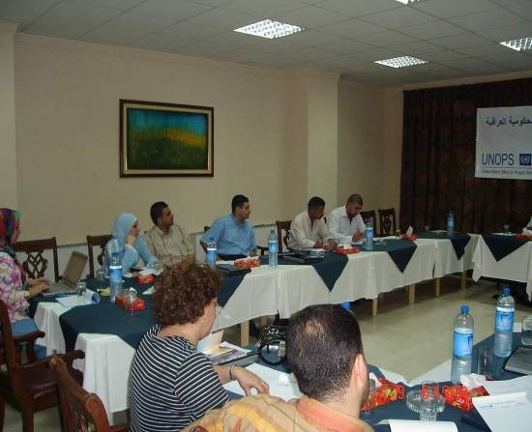

Iraqi Non Governmental Organisation Forum - Baghdad

6.I Iraqi Women’s demands gaining Iraqi and international attention: The conference on Women’s Rights and the constitution organized by MPDL, that came after 2-three day workshops, gained the Iraqi and international attention and interest:

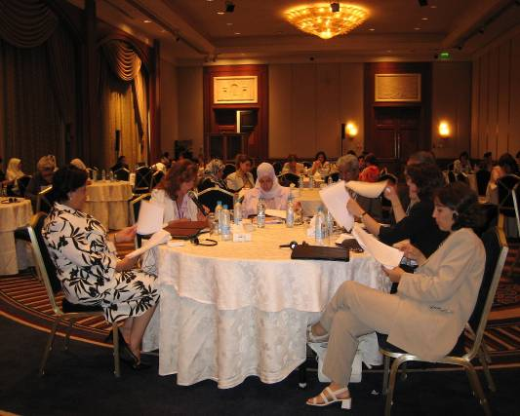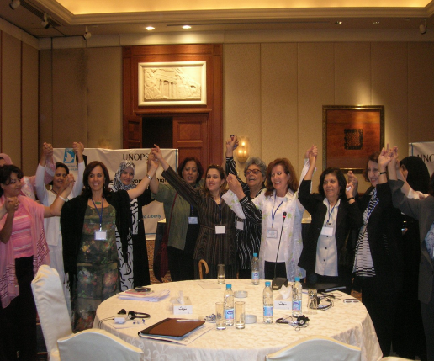

Working with Middle East NGOs to

The conference involved 67 high profile participants from the Iraqi government, ambassadors, international , regional and national organisations, and other UN agencies. The conference was an important step in bridging the gab between the said attendees and the Iraqi community. Not only was their voice heard, but also their recommendations were signed and endorsed by the national assembly to ensure that their demands are taken seriously. During the conference 20 NGOs (10 Iraqis and 10 Women Middle East NGOs) worked together to declare solidarity with Iraqi women, exchange experiences and to share information and future networking. Local, national and international press releases were issued. Publications about the outcome are still being distributed. Advocacy and Lobbying strategy on women’s rights is still being followed through the Local meetings are currently held inside Iraq.

It is hoped and anticipated that this will contribute to the expansion of the women’s coalition, increase the alliance of women’s rights, establish a strong knowledge base, increase awareness and develop a more sophisticated level of discussion on women’s issues in Iraq.

J. A 2 day coaching workshop in May has been organized by UNOPS with the purpose of further supporting the work of funded Iraqi NGOs on the ground by providing them with all needed info related to reporting, monitoring practices, financial reporting, in addition to improving communication and enhancing the business language between the UN staff and the funded NGOs to guarantee a proper implementation of the agreed projects.

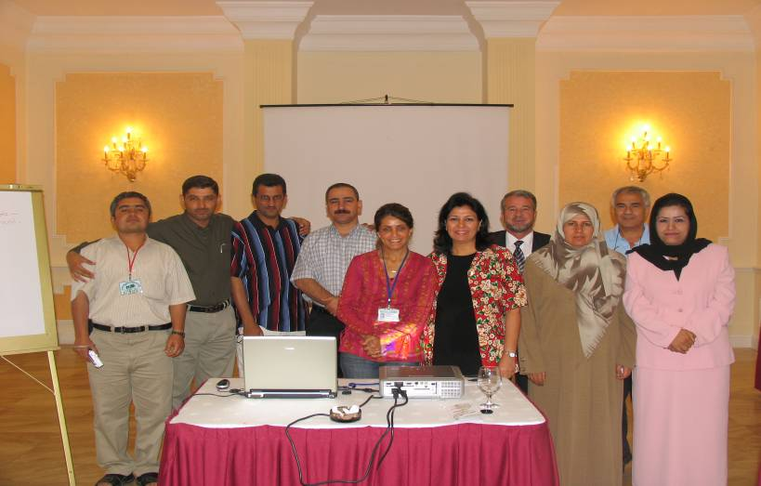

- Leasons learnt meeting and impact assessment questionaire: A 2-day meeting was held in Amman during Nov. 05 for 19 Iraqi Civil society representatives who participated with the UNOPS Civil Society project period (Oct.04 - Dec. 05). The meeting aimed at developing lessons learnt, impact, challenges, and recommendations. A questionnaire was distributed on participants prior to their arrival to assess impact of Civil Society project activities, the results of which were discussed and evaluated during the lessons learnt meeting. Results of this questionnaire and meeting are mentioned in point III “ Results”.

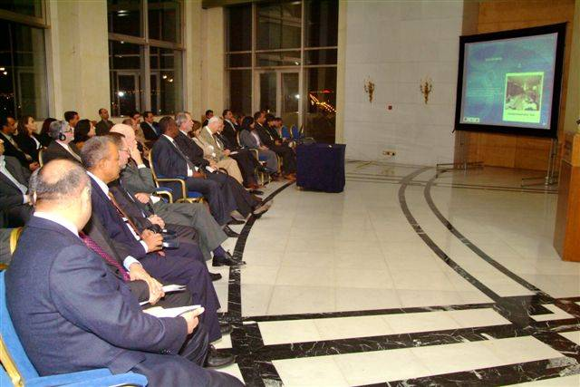

The meeting was also followed by a 4-day management and leadership training workshop and culminated with the participation of the Civil society representatives in the Iraqi Embassy Exhibition entitled: " Reflections on the Iraqi Civil society", organised in Amman begining of Dec. The Exhibition was a good opportunity for the Iraqi Civil Society to convey the outcomes of the meeting, their demands and recommendations and have their voices closely heard by the Iraqi government, UN and the EU representatives, in addition to other officials and international organisations.

- Multi Media Report: A multi media report has been designed, archiving all Civil society Forum activities, contacts, photos, and documentations which will be used for the institutional memory of the project and as a marketing tool for donors.

III. Results

Main activities undertaken and achievements/ impacts:

- Many Iraqis are now qualified trainers, who not only succeeded in replicating the training they received but also conducting several “Training of Trainers” inside Iraq in the field of Human Rights, constitutional outreach, the rights of prisoners, the culture of dialogue and peace and governance.
- Many trained Iraqi NGOs are capable now of drafting proposals, designing and implementing projects, some of which are already financed by donors, others are still seeking funds. Such projects are about the constitution, environmental health, justice for prisoners, and survey on deprived children and awareness sessions on various issues.
- An exchange of experiences and cooperation among NGOs within the different governorates and with the Arab and international organisations resulted in setting up some networks and forums such as:
- Human Rights Monitoring that has 2 branches one in Baghdad and the other in Amman (23 memberships).
- Adallah (justice) network for prisoners (18 members)
- The South Forum Network : regional network that covers Basra, Nasairyah and Amarah governorates (60 memberships)
- A core stone was put up to develop a forum of 12 Iraqi environmental organisations in addition to Arab organisations from Jordan, Syria, and Lebanon
- Alliances, financial support and working contracts between the Iraqi organisations themselves were organised: Iraqi Al-Amal Organisation and Culture for All are examples of those supporting organisations.
- Many Human Rights Violation reports and statements are being regularly issued and raised to parties concerned.
- Documentation and studies centres are set up such as
- Larsa Centre for Legal Studies
- Al-Massallah centre for Human Development
- The Constitutional Documentation Centre ( CCEP)
- Future Studies and Research Centre ( CCEP)
- Human Rights and Democracy Centre – Iraqi National xxx
- 21 counselling centres supporting women victims of violence were established in 12 villages in Dohuk, Sulaimanieh and Erbil. 234 volunteer women are trained and now ready to provide advice for those women.
- A computer Centre for free use was set up in Basra to facilitate and strengthen the communication among the Southern Iraqi Civil Society.
- 2 environmental libraries in two extremely poor schools were established in Al-Sadr City.
- A team of women in 12 villages at Sulaimanieh was formed as focal points to educate people about first Aid and conservation of nature.
- Another sports team of adults was formed in 12 villages at Sulaimaieh through which culture of Youth rights is spread.
- Lost business was regained ensuring a source of income for 35 families in Al Fallujah, mainly for the most vulnerable ones, hence mending family relationships and re-integrating them with their own communities.
- The role of the Iraqi Civil Society organisations are being more and more recognised by the international community and several of them are invited to participate in international conferences and seminars in different countries such as Amman, Cairo, Spain, Germany, United States, Paris, and Italy.
- UNOPS civil society team followed the progress of and interacted daily with about 60 NGOs from the start of the project. In addition to close collaboration and relationships based on trust, UNOPS civil society team have also been engaged and supportive of numerous activities of non-partnering NGOs when it felt that their initiatives and efforts were worthwhile and in need of support. UNOPS maintains a database of about 200 NGO from all over Iraq.

Implementation constraints, lessons learned from addressing these and knowledge gained from assessments, evaluations and studies that have taken place during the reporting period:
Since the beginning of the Project on October 1, several issues affected the project implementation

C o n s t r a i n t s:

- Some NGOs that has political agenda has affected the credibility of other NGOs among the donors.
- Deterioration of security situation caused that all international NGOs withdrew from the Centre and South of Iraq, limiting the access to population and information for all UN agencies.
- The unaccommodating approach and policy of some Iraqi authorities and governmental entities towards the Iraqi Civil society.
- The sophisticated requirements and formalities demanded by some international organisations before approving or giving any funds.
- Some traditions and inherited values hindering the development and work of NGOs, specially when it is related to women issues.
- Lack of a unified law that regulates the work of the NGOs and defines the relationships among themselves and with the state.
- Lack of technology that should facilitate communication and networking with others
- Poor economic situation of the country leading to difficulty in recruiting volunteers.
- The insufficient knowledge of the international community of the priorities and needs of the Iraqi Society. Trainings and workshops for example are useful, but not a priority.
- The insufficient understanding of the role of the civil society by both the community and the government.
- Rise in militantism and criminal activity added to the need to double check the background of local partners as well as protect their identity wherever possible. Once the relationships and trust were established, the work proceeded without major difficulties.
- security situation affected the UN visibility in the country often demanding that substantial amount of time be dedicated to provide the participants with evidence of our good intentions, good work, presentations about UNOPS and the UN in general, as well as the Civil Society Forum Project.

Being a nation-wide program, a particular consideration and caution was exercised to gather information on civil society groups and experts in the areas where UNOPS did not have a tested local network and had to rely on the referral by other organizations and individuals. UN agencies and prominent international and national NGOs were approached and their contacts were used. This still was insufficient to reach out to parts of Iraq outside the major urban centres. In the following months, UNOPS have concentrated on building up and extending its network of organizations and academic institutions, making a particular effort to reach out to more remote areas, in order to better understand their dynamics and needs

O p p o r t u n i t i e s:

- Iraq is fertile land to adopt new ideas and to bed in positive and democratic rules and regulations and now is the right time to do the change.
- The strong desire and thirst of all Iraqis to work for development, democracy and rebuilding of Iraq.
- Iraqi civil society are now better exposed to the outside world
- Iraq is an eye -catching area for donors to invest in.

L e s s o n s L e a r n t :

- There is an undisputable need for a unified law to regulate the work of non governmental organizations that is in conformity with the international standards, and defines the relationship with the government.

- There is a need for a better coordination system among the various Iraqi Civil society organizations and also with the international organizations.

- Projects that proved reliability and efficiency are worth to be further supported and receive longer term funding.

- The Iraqi Civil Society should move now towards Reconciliation, peace building and dialogue, .

- The Iraqi government is called for to sign all the international treaties and conventions related to Human Rights issues.

- The Iraqi civil society should better involve the local authorities in the activities of the civil society in order to enhance the latter’s understanding of the work done by the civil society and have it facilitated.

- The most effective trainings are the ones with longer duration and carried out in phases, example : Training of Trainers.

- Civil society organizations should make better use of media, art and sport as a successful means to outreach people and convey messages.

- Men’s participation and role should not be marginalized or ignored when projects are related to women issues.

- Civil Society organizations have proved their influence in spreading the culture of democracy….

- Iraqi priorities and needs should be assessed and determined first by Iraqis before other international entity.

- Iraqi authorities need to better understand the role of the civil society and the nature of its work in order to insure the smooth implementation of its activities.

- International organizations should simplify their sophisticated requirements and funding formalities should they expect a faster implementation of projects and more realistic working relationship.

- Lack of technology is one factor that hinders proper communication and networking with others.

- Poor economic situation of the country makes it difficult for NGOs to recruit volunteers

- There is a strong desire and thirst of all Iraqis to work for development, democracy and rebuilding of Iraq.

Evaluations:

From the evaluations of participants through the project course:

“For the first time we are given the opportunity to meet with senior members of the Iraqi authorities, UN members and regional experts. For once our voices, concerns and messages are directly addressed to the targeted people” Human Rights Defenders workshop- Amman

“Before receiving the assistance of Mosques in Fallujah, our family ties and relationships with our neighbours and the others were falling apart, we were plagued with never ending problems and we did not have neither the money nor the motivation to think of a broader community development and empowerment” Income Generation Activities to Support Civil Society in Fallujah

“The Human Rights Defenders workshop and TOT on Human Rights were turning points in my personal and professional life as they supplied me with the drive and urge to vocalize rights that were so long hibernated or violated, particularly those related to women” Training of Trainers – Amman

“Within 7 months, 234 women trained to be volunteer counsellors. Many of them are now working an hour each week in the 22 counselling centres we established in about 12 communities. The women are now better able to help other women with problems, including those related to violence against women” Anti Violence Program - Erbil, Sulaimanieh and Dohuk.

“ We believe that there are several ways to outreach Adults, women, and children to convey social awareness messages: Forming sports team, drama, and drawing activities for adults and children in 12 villages in the north proved to be the right approach to guarantee their full attention to messages conveyed.” Women and Adult’s Skills enhancement program - Sulaimanieh

The NGOs democratic structure, transparency, accountability, leadership, voluntary work, independency, women’s participation in social life, and the relationship among the NGOs, the government and the community were all part of the forum agenda that was concluded in Baghdad with 100 participants. Non governmental Organisation Forum - Baghdad

Many NGOs who participated in our Human Rights and Governance program in Basra are now part of the constitutional outreach program, demonstrating a significant development of skills and capabilities”
Our newly established library and computer centre are now fully equipped and made operational for free use by southern based NGOs” Civil Society Development Project - Basra

“We are a world to ourselves because we’ve been disconnected.”
“New groups have no history, so donors discount us”Iraqi Environmental NGO Roundtable Meeting

“Through our women awareness program in 15 locations in the rural areas and the marshlands, in addition to 10 locations in the city of Nasairyah, women are encouraged to participate and express their views with regard to their rights in public life and the influence of customs and traditions on their behaviour.”Empowerment of women in the city of Nasiaryah, the rural areas and the Marshlands.

“This school really made me cry when I got home. It is under rehabilitation and in a very bad condition. There were about 10 teachers but no pupils were around .The guard of the school near by came to say hello to us, and posed a heart breaking question : “ we have in the school more then 1000 rats how we can kill them? “Environmental library – ALSadr City
“ Our people are looking forward to your help to ensure the protection of the human rights of all Iraqi and to put an end to the continues violation”. HR network of 24 organisations created with recognised efforts in researching, monitoring, advocacy and reporting.

“Funding must last more than just a few months and should include more infrastructural support.”Management Training Course - Amman

“After the follow up meeting in Amman, and receiving the financial and technical support, project reporting and monitoring turn out to be not a complex thing to do anymore as we used to think before.” NGO Follow-Up Meeting - Amman

“For once I have been given the space to express myself, for once I don’t feel sick, for once I feel I have been taken care of. Thank you for your kindness” Human Rights Monitoring workshops - Amman

“We have learned to open our horizon and expand our Human rights monitoring activity to include children, women and the displaced” Human Rights Monitoring workshops - Amman

Key partnerships and inter-agency collaboration, impact on results:
Since the beginning of the project, UNOPS has excellent collaboration with UNAMI Human Rights Office, OHCHR, UNDP and UNAMI Office for Constitutional Support, based in Baghdad, even so much so that since March 2005, UNOPS civil society project manager was supporting Constitutional Team’s outreach strategy from Baghdad on a full time basis.

UNAMI Human Rights Office and UNOPS shared information of common concern, supported each other’s efforts and provided advice. UNAMI and UNOPS have taken several trips together to Basra and Baghdad. Furthermore, OHCHR, UNAMI HRO and UNOPS collaborated on the development of the baseline study for the legal framework of local NGOs and functioning of civil society, in conformity with international standards. Collaboration among the 3 partners also took place on a workshop on Human Rights Defenders held on 27th-29th of June.

Highlights and cross cutting issues pertinent to the results being reported on, e.g. gender disaggregation, policy engagement and participation of the public:
H i g h l i g h t s:

In general 90 workshops, trainings and conferences were held inside and outside Iraq, 200 NGOs/ CSOs directly benefited from this project, 3000 direct beneficiaries and 10s of thousands of indirect beneficiaries, 100% of projects activities implemented, 96% of the budget disbursed

From the introduction of the multi media report, prepared for the Civil Society Forum project and presented during an invitation by the Iraqi Embassy on “ Reflections on the Iraqi Civil Society”

“Despite the complex situation of the country, the Iraqi civil society over the last year demonstrated that activities can be performed on the ground independently even with the existing minimal back up from national and international actors.
Iraqi Civil Society has shown potential and high motivation to move forward, alongside an outstanding willingness to acquire further knowledge and skills.

As they believe in the valuable role they should play in community mobilisation, mending public and community relations, and promotion of democratic and civil values, they still lack the proper environment and positive conditions enabling them to carry out their work in the best possible manner. Security, Technical know-how, exposure to other experiences, linking with the outside world, securing funds and a legal framework to regulate their work are all of concern to them to ensure a difference and a sound change in their own societies, a role that the Iraqis craved for so long to restore dignity, trust and faith for all.”

There has been a tangible increase in confidence, interest and knowledge among the NGOs engaged in training programs, seminars and workshops. UNOPS noticed the following changes in the past ten months:
  - increase in quality and frequency of human rights reports
  - more focused human rights advocacy strategy
  - improved targeting of human rights advocacy audience
  - improved networking among the Iraqi organizations and between the Iraqi and non-Iraqi organizations and continued collaboration outside the UNOPS project
  - growing number of demands for further or additional trainings among new and “old” NGOs

For example, Studies Center for Human Rights and Democracy, has become increasingly active on generating research and analysis papers pertaining to human rights violations in Iraq. The NGO’s representatives have traveled to meet the representatives of the European Union in Strasbourg, UN representatives in Geneva, their interviews appeared in international press, and have disseminated numerous papers and reports.

10 participants of the “Women Rights in the Constitution” conference returned to Iraq and continued making press statements, visiting Assembly members and generally feeling more encouraged to make their voices heard.

One of the NGOs, Dialogue for Women for Democracy, has been tasked by the Constitutional Committee to coordinate, organize and manage the Committee’s outreach activities. The NGO is currently supported by UNDP and UNOPS.

Al Amal and Almessala organized meetings and workshops in collaboration with other NGO participants of UNOPS trainings and workshops. At least ten organizations from the UNOPS network have recently presented a joint proposal on the monitoring of prisons. The proposal is currently under consideration for the UNOPS extension project.

Several other NGOs have earned further contracts by the UN for the public participation activities for constitution through other UN, e.g., Al Amal, Basra and South for Social and Civil Development.

IV. Future Work Plan

Priority actions planned for the subsequent reporting period to overcome constraints, build on achievements and partnerships, and use the lessons learned during the previous period:
- UNOPS is planning several future projects such as Human Rights promotion through strengthening the Iraqi Civil Society human rights Organisations which will include rehabilitation of victims of torture project, and the rights of prisoners. The project will be implemented in collaboration with UNDP, UNAMI HRO, and some international organizations such as IRCT and UPP. UNAMI Human Rights Office, UNDP, and UNIFEM will remain potential partners to the future UNOPS civil society and Human Rights oriented projects.

- UNOPS has a two year project approved by the Minister of Human Rights and Cluster C, awaiting further approval for the funding from the UN Trust Fund. This project is an expansion and continuation of the C9-02 Project (“Civil Society Forums”), and is an integral part of Cluster C Human Rights Programme. The Project is based on the past 12 months experience of the Civil Society Forums Project, in the process of which extensive networks of Iraqi NGOs and CSOs as well as Arab regional partners have been created. Partners to the project expressed their desire to further collaborate on the Iraq civil society development project with UNOPS and other UN partners, and continue support the Iraqi transitional political process.

The Project comprises of several groupings of specific activities executed by local and international NGO and CSO partners. The groupings are: (a) human rights (incl., but not limited to women’s and children’s rights, rights of minority, and other vulnerable groups and persons); (b) dispute resolution targeting civil society leaders, religious authorities and government counterparts from all over the country; and (c) overall empowering and support to CSOs through project and human resource management trainings and networks and small grants scheme.

This is a national program with impact on all 18 governorates.

Indication of major adjustments in the strategies, targets or key outcomes and outputs:
Project Adjustment: The Project was scheduled to finish at the end of September, however extended till end of Dec.05, in order to complete pending activities as per original plan and the project document.

Strategies/ targets:
- The Iraqi Civil Society should move now towards Reconciliation, peace building and dialogue,
- The Iraqi Civil Society should work now on having a unified law to regulate the work of non governmental organisations that is in conformity with the international standards, and defines the relationship with the government.
- UNOPS should concentrate in the future on trainings with longer duration and carried out in different phases, example : Training of Trainers.
- The next project will see the increase in the in-country supported activities, relying on the capacity created by out-of-Iraq based trainings and workshops, all the while supporting Middle East networks and further trainings. Security concerns and deterioration of liberties in certain parts of the country, e.g., Mosul, remain a concern for the human rights and gender equality promoting activity. In those areas, UNOPS shall have no visible presence, and will continue to support CSOs by way of trainings held outside the unsafe area.
- In-depth knowledge has been acquired about NGOs and especially about partnering organizations that has helped further refine and define needs, allowing the extension project to concentrate on a more advance level of support, i.e., creating effective local partnerships, more professional and proficient reporting on human rights abuses and human rights advocacy, clustering of NGOs depending on their expertise and interest, in order to make their work more effective and geographically more expansive.

Funded entirely from the European Commission contribution to the Iraq Trust Fund.
Iraqi Strategic Review Board: NDS 2005-2006, September 2004, pp. 16-17
The Human Rights Programme: “Building and Strengthening the National Human Rights Protection System in Iraq”
Cluster 9 Workplan, 2004

