Annex 1

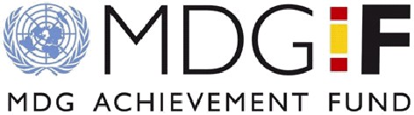

[MDG Fund]

ANNUAL programme NARRATIVE progress report

REPORTING PERIOD: 1 january – 31 December 2009

Submitted by:  Name: Ms. Jocelline Bazile-Finley  Title: UN Resident Coordinator  Organization: UN  Contact information: j.bazile-finley@undp.org |  | Country and Thematic Area  ANGOLA  Democratic Economic Governance

Programme No:  MDTF Office Atlas No: 00071113  Programme Title: Governance of Water and Sanitation in Angola’s Poor Neighborhoods (Urban and peri-urban water and sanitation Joint Programme Management in Angola) |  | Participating Organization(s):  UNDP, UNICEF, IOM, ILO

Implementing Partners:  Minstry of Energy and Water (MINEA)  Ministry of Environment (MINAMB)  Municipal Administration of Cacuaco  Municipal Administration of Viana  Municipal Administration of Kilamba Kiaxi  Municipal Administration of Moxico  Municipal Administration Camanongue  Municipal Administration Luau  National Water and Sanitation Department  National Unit for Environmental Sanitation Coordination  Provincial Energy & Water Directorate Luanda  Provincial Energy & Water Directorate of Moxico  NGO Development Workshop  CARE International  OXFAM GB  Local CBOs (Comissão de Moradores, ODAs) |  | Programme Budget (from the Fund):  UN Org UNDP: 2.450.000  UN Org UNICEF: 3.750.000  UN Org IOM: 1.150.000  UN Org ILO: 250.000  Total: 7.600.000

Programme Duration (36 months):
Start date: 20th March 2009
End date: 20th March 2012
Budget Revisions/Extensions: None so far.

NARRATIVE REPORT

Purpose

This programme aims to promote sustainable access to water and sanitation for poor neighbourhoods in Angola by enhancing the governance of the sector. The proposed model of governance entails promoting a network of autonomous units of small utilities, with the local government at the ‘center’ focusing on monitoring the network, regulating the sector and pushing for the autonomy of communities in the management of their water schemes. The programme will pursue the objective of bringing safe drinking water to 120,000 people initially, with a further 400,000 people also benefitting thanks to multiplier effects.

The Joint Water and Sanitation Governance Programme for urban and peri-urban areas has the following outcome: Community-oriented governance of the peri-urban and rural water and sanitation sector, promoted through an autonomy-driven institutional, regulatory and accountability system.

The governance model described above rests on the following pillars: powerful community structures, interaction between actors of different levels, effective accountability at different levels, strong monitoring system and adequate funding system. The following four outputs will thus be pursued:

- Output 1: Pro-poor policy and regulatory framework featuring community participation in the management of watsan operational and running;

- Output 2: Autonomy-oriented community water structures ensuring sustainable access to watsan facilities in 500 community groups across 6 municipalities;

- Output 3: Mechanism for monitoring and funding community-driven watsan schemes put in place at municipal level;

- Output 4: Mechanism put in place for the accountability of municipalities in the provision of water and sanitation service to peri-urban and rural areas;

- Output 5: Programme management and coordination ensured.

This joint UN project seeks to contribute to the objectives of the Estrategia de Combate a Pobreza (ECP): the Angola poverty eradication strategy. The interventions outlined in this document aim to support national priorities highlighted in the ECP regarding the water and sanitation sector, against the backdrop of the MDGs and the Millennium Declaration, especially goal 7, as well as goal 6 related to combat other diseases (i.e. waterborne diseases, like cholera). The programme contributes to UNDAF 2009-2013 Outcome 1: National Institutions responded to the needs of the whole population, indluding the poor and most vulnerable and at the same time national and local public institutions were strengthened, as well as community engagement, civic participation towards social cohesion, national reconciliation and the empowerment of women; as well as to Outcome 2: Increased and more equitable access to integrated social services at national and sub-national levels with emphasis on MDGs.

Resources

Financial Resources:
The agencies are also using other funding resources to complement the programme, particularly for construction activities, where initial budgeted costs have practically doubled in the past three years due to increases in prices in Angola

Agency | Funds (USD) | Partners
UNICEF | 150,000 | Regular Resources
 | 300,000 | USAID (Luanda)
 | 100,000 | DFID (Luanda & Moxico)
Supplies provided by UNICEF (pipes, accessories and water treatment units) | 200,000 | EU (Luanda and Moxico)
Total UNICEF | 750,000

The programme has not been object of any budget revisions. During 2010 a proposal will be submitted for the appropriate decision-making body (PMC) to adjust some funds between different budget lines.

The different agencies are using their standard and harmonized cash transfer modalities (HACT) to implement the activities with different partners (government at national, provincial and municipal levels, NGOs and CBOs). In addition to standard procurement procedures, using UN/MDG guidelines, other formal agreements are also established, namely in the form of PCAs (Programme Cooperation Agreements) particularly with NGOs, as well as Memorandum of Understandings (MoU) with formal learning institutions, such as the Secondary School for Social Workers and other UN Water Programmes. The procurement processes for construction works and services primarily have been done jointly with the government and has been used as an opportunity to assess and strengthen government capacity. Co-financing mechanisms have been established with national and local government partners (reaching in some cases 30 per cent of total construction costs).

Human Resources:

The programme, as a whole, has developed a staffing structure to support the implementation of the programme. The following table details human resources allocated/to be allocated to speed up delivery rates, while also ensuring high quality standards:

Organisation | Staff | Number (% time) | Type
RCO | International  International  International | 1 (30%)  1 (100%) – recruitment on progress  1 (70%) | Coordination  Coordination  Communication
UNDP | International  National/Programme Manager | 1 (100%)  1(100%) – recruitment on progress | Programme
UNICEF | International  National/Professional  National/GS  National/Government | 2 (30%)  2 (40%)  1 (20%)  2 (20%) | Programme  Operations  Operations  Programme
IOM | International | 1 (50%) | Programme
ILO | International | 1 (10%) | Programme
SEA | National | 1 (20%) | Programme
UTNSA | National | 1 (20%) | Programme

Implementation and Monitoring Arrangements

At this initial stage of implementation the main mechanism has been joint field visits, coordination with all partners and harmonization of programme objectives with Government priorities and plans at all levels (national, provincial and local).

The UN agencies are using their standard procurement procedures which are practically harmonised with the proposed MDG guidelines. Examples can be seen in the following table:

UN Agency | Partner | Goods/Services | Procedures
UNICEF | Target Municipalities and DPAEs | Computer and communication equipment, motorcycles | International procurement as per UNICEF guidelines
UNICEF | Target Municipalities and DPAEs | Water quality equipment and kits | International procurement as per UNICEF guidelines
UNICEF | Municipality of Cacuaco | Construction of the Water Supply Systems of Pedreira and Paraiso | Bidding as per Municipal Government procedures with some UNICEF support
UNICEF | Municipality of Viana | Construction of Water Supply System of Bairro Moxico | Bidding as per Municipal Government procedures with UNICEF support and guidance
UNICEF | DNAS | Construction of Water Supply Systems of Tchicala and Cangonga in Moxico Municipality | National bidding as per Government procedures with UNICEF support
UNICEF | DW | Community Water Management | PCA
UNDP | Target Municipalities | Computer and communication equipment | Local procurement
UNDP | MINAMB | Preparation of National Policy for Environmental Sanitation | National bidding in local newspaper as per Government/UN standard procedure
UNDP | SEA | Coordinator car | Local procurement
UNDP | All | Baseline Study | MoU
UNDP/RCO | All | Programme Manager and JP Focal Point (to be seat at the RCO) | Local and international procedures
ILO | All | Study on the SMEs on the WASH sector | Standard international ILO procedures
OIM | DW | Assessment for Income Generation Activities | MoU

The monitoring system consist of the following: i) regular joint field trips to project sites to ensure that activities are implemented as per plan; ii) annual and semi-annual reviews meetings with partners at all levels (national, provincial and municipal) to assess progress and agree on annual plan targets and activities; iii) financial and narrative reporting on a regular basis; iv) establishment of base line study methodology, contract arrangements and logistic conditions (to be shared among stakeholders and partners as soon as they will be available).

Results
Progress in outcomes:
Community-oriented governance of peri-urban and rural water and sanitation sector promoted through autonomy driven institutional, regulatory and accountability system (too early to assess progress after six month of field implementation).

Progress in outputs:
Output 1: Pro-poor policy and regulatory framework featuring community management of WatSan utilities in place (40% annual achievement rate):
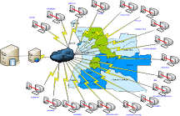
Figure 1: SISAS Schematic Framework
- Water policy review and regulatory framework and institutional reforms are ongoing under government leadership;
- At the beginning of November 2009, a delegation of the Government of Angola (SEA and MINAMB) attended a regional meeting in preparation for the high level meeting on water and sanitation to be held on April in USA. Attendance by the delegation of this meeting represents an engagement of the Government of Angola in water and sanitation international commitments.
- The municipality of Kilamba Kiaxi has started, for the first time, a planning process to develop its Municipal Master Plan for the following years. Lessons learned from these municipalities will be share among target municipalities.
- National sanitation policy consultancy procurement process has been concluded and drafting will start in early 2010;
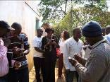
- WASH MIS (SISAS) data is in the consolidation phase with more than 60 per cent of national data collected and validated; During the past 9 months supervision and training missions were held to 12 provinces (Kunene, Huila, Huambo, Bie, Malange, K. Norte, Lunda Sul, Lunda Norte, Uige, Namibe), representing 67 per cent achievement rate (24 provincial staff involved). Equipment, such as computers (2 sets) and communication equipment, has been provided to all six municipalities.
Figure 2: Data collection training

Output 2: Autonomy-oriented community water structures ensuring sustainable access to WatSan facilities in 500 community groups (bairros or villages) across 6 municipalities (50% of annual results achieved):
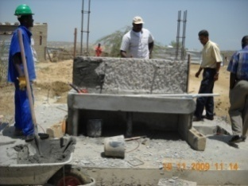
Figure 3: Water works ongoing in Cacuaco
- Water works ongoing in two communities of Cacuaco Municipality (Pedereira and Paraiso) with 5 out of 25 water points concluded, reaching 5,000 people of a total of 35,000 people planned;
- Water works contracted and initiated for two communities of Moxico (9 water points plus 2 schools, 2 health post connections and 2 public sanitation facilities) and will cover 5,000 people;
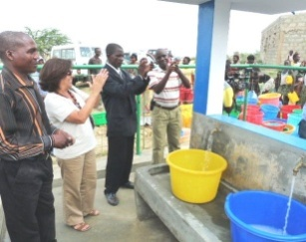
- Procurement works concluded in Viana Municipality (5 water points plus 3 school connections) targeting 4,000 people. Supervision capacity will be enhanced with the provision of 6 motorcycles (procurement concluded).
- Community based management model training manuals (MOGECA) to train and establish water management groups finalized and in approval stage. One of the critical issues is the number of water points not operating, which is over 50 per cent in many cases. In Cacucao Municipality 4 GAS are operational and working with the community management structures (Comissao de Moradores) and EPAL (Public Water Utility Company for Luanda);
Figure 4: Water System of Cacuaco
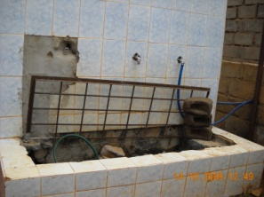
- Mapping using GIS tools done of 120 local vendors using tanks filled by trucks in Cacuaco Muncipality which has resulted in following thematic maps: i) Municipality fo Cacauco; ii) Bairro de Pedreira; iii) Bairro de Paraiso; iv) Water tanks location in each bairro; v) Public water taps locations in each bairro.
- Planning ongoing with Kilamba Kiaxi municipality to focus mainly on rehabilitation and strengthen of community management of water points in straight partnership with local community groups (ODAs) supported by CARE International.
- Study of small local providers of WASH services ongoing after field mission to Luanda and Moxico. The study will examine all the factors related to the sector performance. At this stage, data have been collected from several different sources: entrepreneurs, clients, ministries, public and private institutions, NGOs, etc. The problems analysis is under way that will lead to a clear strategy to address the core problems. This study will provide insights to improve the delivery capacity in the water and sanitation sector both for services and works and the multiple opportunities of contracts (construction, rehabilitation, maintenance, supplies, etc.). The target groups are contractors and entrepreneurs in the area of water and sanitation in particular those in micro, small and medium-scale range.
Figure 5: Broken water system in K.Kiaxi
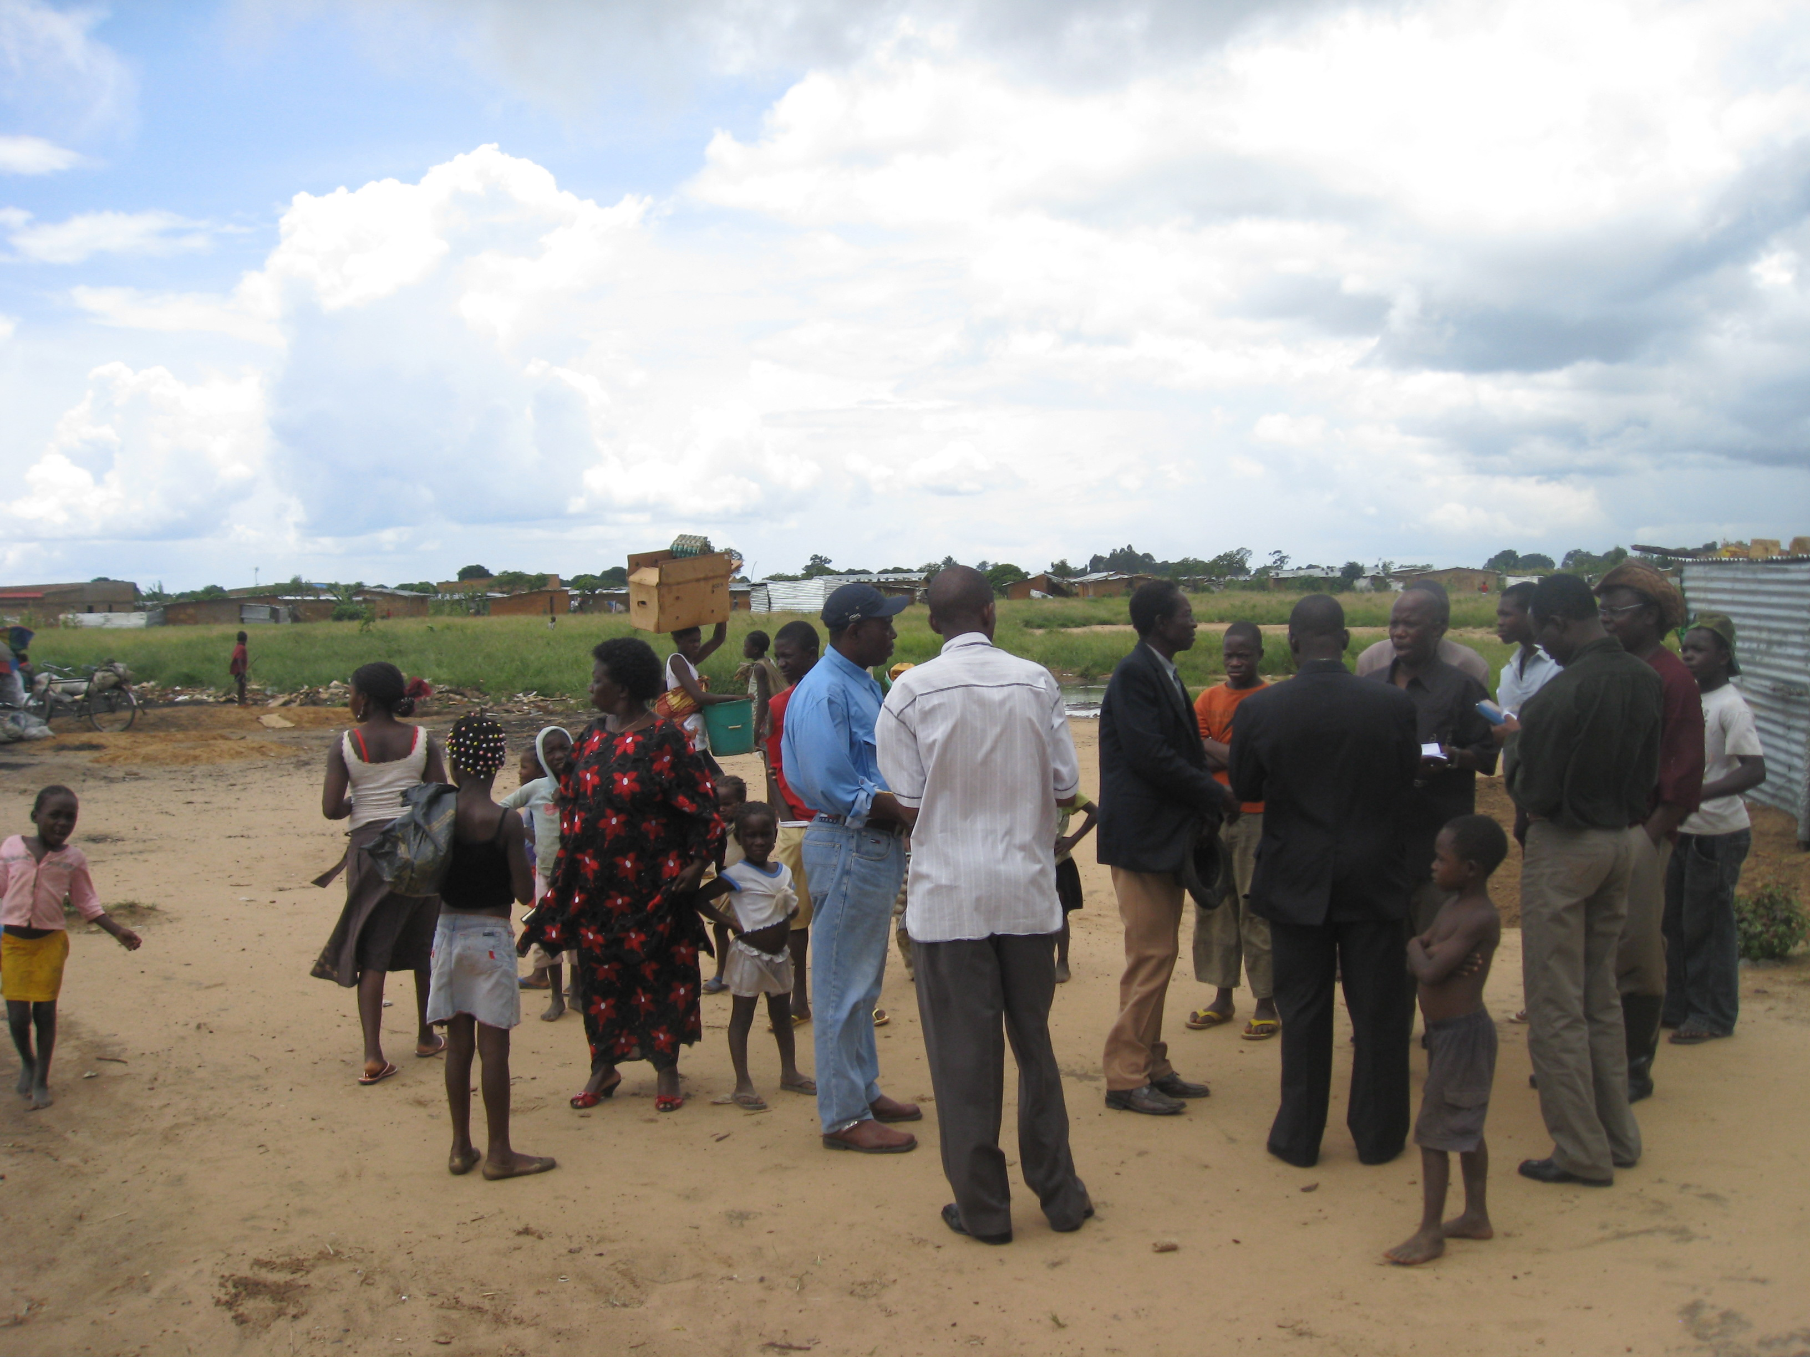
- Identification and meetings with private sector service providers, NGOs, and local Administration to identify implementation areas in Moxico including social mobilization of potential beneficiaries and prequalification of potential construction companies.
- 22 CBO’s identified in Moxico: Development of assessment document to facilitate identification of income generation projects within the selected communities. Identification of beneficiaries with local administration and traditional authorities. Meetings with association members to familiarize them on business plan proposals, including financial, marketing, and administrative aspects in order to evaluate the viability and sustainability of the proposed income generation projects and thereby drawing on people’s knowledge of the local market situation, strengths, weaknesses and potentials.
Figure 6: Work with families in Moxico on income generation
- Capacity development of 22 associations are currently ongoing with 263 direct beneficiaries (146 men, 127 women) benefitting around 1,150 children in Moxico. For Luanda, business plan development for 20 income generating activities is ongoing.

Output 3: Mechanism for monitoring and funding community-driven WatSan schemes put in place at municipality level (15% annual achievement?):

The activities for this output are in the preparatory phase with the preparation and discussion of the TORs. The work at this level has been linked to the process of development the SISAS (already mentioned in Output 1) and also the mapping work being done with Development Workshop in an effort to integrate data with visual information (GIS maps). Again, the Kilamba Kiaxi Municipality has shown its leadership and commitment with planning and monitoring processes. Some municipal staff have been trained and supervised by the DNAA. This pilot experience in decentralized data collection at municipal level will facilitate future work plans and strategies to scale up in other municipalities. In addition to the interest of the data, the product (update water facilities situation) will be used as a decision-making tool to discuss, analyze and priorize water point rehabilitations (Output 2).

Output 4: Mechanism put in place for the accountability of municipalities in the provision of water and sanitation services to peri-urban and rural areas (around 30% of annual achievement):
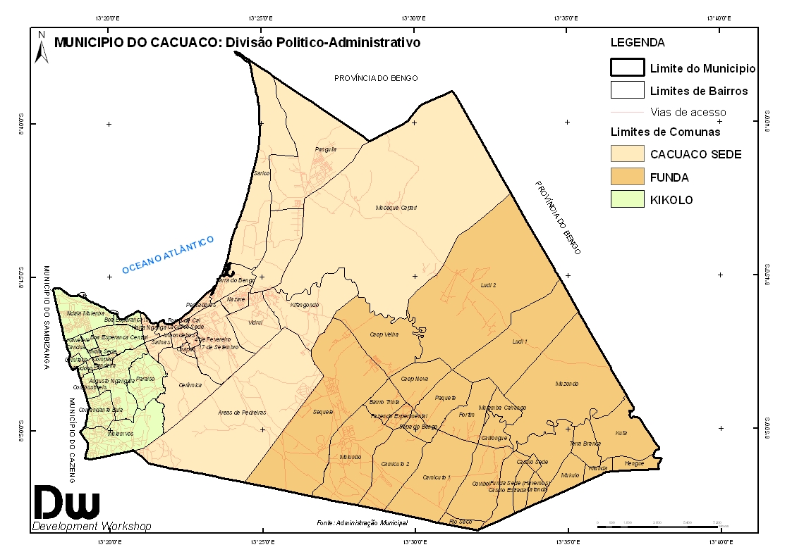
Figure 7: GIS Mapping in Communities of Luanda
- Community based management model (MOGECA) finalized with provisions to ensure effective participation of beneficiaries in water management;
- Programme cooperation agreement (PCA) with implementing NGO (DW) approved and implementation phase and preliminary works with communities to establish associations is ongoing (information, social mobilization and organization of community structures/Comissao de Moradores).
- Development of TORs for the national forum for coordination of the water and sanitation sector has been discussed with over 25 participants (national and international partners). The forum will be led by DNAS and will also have participation from the provinces (DPEAs) and will meet every six months.

Output 5: Programme Management (80% achievement rate)

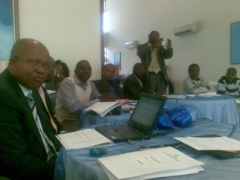
The initial workshop was held in July 2009 under the leadership of the Secretariat of State for Water. The workshop, attended by approximately50 participants, was used to strengthen partnerships and collaboration with other ongoing programme and projects, namely the government funded Water for All programme, the European Union WASH Sector Institutional strengthening project (as per 10th FED plans) and MINAMB’s and UNICEF’s Community Led Total Sanitation (CLTS) approach being developed in Huila provinces with fund from Spanish Cooperation Agency for International Development (AECID). During the workshop the 2009/2010 annual work plan was developed with contribution from all partners (national and local).
Figure 8: Workshop planning session

The overall objective of the workshop was to help the project team understand and take on the project’s goal and objective, as well as amend and finalize the 2009/2010 annual work plan.
Specifically, the workshop had the following results:
- Better understanding of the programme between all relevant stakeholders;
- Improved knowledge on the ongoing interventions and their level of development;
- Improved coordination on the ongoing interventions;
- Provided explanations on the monitoring and evaluation (M&E) requirements, namely the Project Implementation Reviews (PIRs) and relevant documentation, the Annual Project Report (APR), the Tri-partite Review Meetings, as well as the mid-term and final evaluations.
- Provided clarifications on each partner’s roles, functions and responsibilities within the project’s decision-making structures, including the reporting and communication lines and the conflict resolution mechanisms;
- Draft of 2009/2010 annual work plan;

The following standard coordination processes were also undertaken:

- Regular Programme Coordination Managament meetings held (3 in 2009)
- Steering committee meeting held (one in 2009)
- Regular coordinating meeting between UN focal points and more than 12 joint visits in Luanda (10) and Moxico (2);
- Examples of good coordination efforts: i) drafting of national sanitation policy (MINAMB, UNDP, UNICEF, GTI); ii) selection of target communities in Moxico (Municipalities, OIM, UNICEF); iii) Study on SME (Government, ILO, UNPD, UNICEF, OIM); iv) IT/communication equipment for municipalities (UNDP/UNICEF); v) joint field visits/pooling of resources (Government, UNDP, UNICEF, IOM, ILO, NGOs).

Currently, the Baseline Study is on-going and it is expected to have the preliminary results by the end of April. These results will be used to monitor and report progress based on evidence and quantitative data.

Challenges and lessons learned

The programme officially started on 23 March but implementation delayed to early August, just after the inception workshop held in July 2009. This report refers in fact to activities implemented after from July to December 2010 (6 months).

The main internal challenges facing the Joint Programme can be summarized as follows:
- the recruitment of the Joint Programme coordinator has not been successful due to lack of qualified candidates and high salary expectations from potential candidates. In fact, this challenge is at the same time a lesson learned for the other JP that has been approved by the MDGF to Angola (through the Children, Food Security and Nutrition Thematic Window) and it has become an internal decision making process. As a result, it has been decided that the RCO should have a full-time international member to coordinate both JPs. In addition, National Programme Officers (to be seat at the lead national counterpart) are on the recruitment process to strengthen implementation pace
- the costs of doing social business in the WASH sector in Angola has increased considerably in the past three years since project inception in 2007 (water per capita costs has gone from 20 to 40 USD, bore hole drilling from 200 to 300 USD/meter), which might affect the output planned (particularly Output 2);
- limited capacity of local government structures in the areas of planning, procurement and supervision of WASH works.

For the implementation of ongoing study on small-scale water and sanitation entrepreneurs there are some concerns and lessons to take in consideration, namely:
- The quality and accuracy of data to be collected during the study;
- While we are convinced that INEFOP should remain our national strategic partner for the design and implementation of the training programmes, as they have a wide range of decentralised physical infrastructures and facilities, they are not be so well equipped to provide training to entrepreneurs and lack adequate competences in terms of trainers and lecturers in this area;
- The resources we have been allocated seem to be insufficient to produced the output and the targeted 25 small contractors capacitated in the area of water and sanitation.
Some of the main external factors affecting the Joint Programme implementation are:
- accessibility to various project sites particularly in Moxico provinces, where roads are sub-standard and are especially affected in the rainy season;
- ongoing and protracted emergencies (floods and population displacements in border towns), which shifts national and provincial priorities to accommodate emergency programmes.

For the internal challenges, the following actions are planned:
- regarding the recruitment of the Joint programme Coordinator, two actions have been taken: first, review the TORs for the post (so-called Focal point at the RCO) to be more comprehensive and flexible (coordinating both JP –“Water and Sanitation” and “Children, Food Security and Nutrition”-) and less technical, and extend the search to potential Angola emigrants or to an internationally recruited staff. Second, to recruit a National Programme Manager to support national lead institution on its implementation;
- emphasize co-financing mechanisms and linkage/partnerships with ongoing WASH programmes and NGOs, improve procurement processes to ensure more participation of local companies (SME) and accountability;
- improve capacity of provincial and municipal staff in planning, procurement, contract management and supervision with regular and on-the-job training programmes.

For external challenges we plan to:
- work more closely with local authorities in the definition of priorities that takes in account these external factors;
- proactively involve local NGOs/CBOs in the implementation of the programme as per the document strategy;
- minimize risks of emergency lag effect with a coherent and timely planning of interventions in coordination with local governments (e.g. do the planning/capacity development on the wet season and construction on the dry season).

Key partnerships and collaborations

The following partnerships have been developed and have contributed to the achievement of specific goals and targets:

Local Government (Municipal administrations): the Municipality of Cacuaco in Luanda is providing a contribution of 30 per cent to the overall costs of the construction of two water supply systems in the peri-urban communities of Pedreira and Paraiso. The municipality of Viana is providing equipment and trucks to facilitate the construction works of the recently contract works to construct the water system of Bairro Moxico.

Development Workshop (DW): the partnership with this NGO is being done on two fronts: on the community management of water systems in to improve sustainability, and on income generating activities in Luanda. For the case of community water management, the NGO is contributing with around one third of the overall costs.

Community Based Organizations such as Comissão de Moradores (Cacuaco and Viana) and ODAs (Kilamba Kiaxi): partnerships have been developed with these grass roots organizations to identify the needs at the community level and capacitate them to support the management of infrastructures built by the programme;

Care International and OXFAM GB: partnerships are in the final stages of formalization with these two INGOs in Kialmaba Kiaxi and Moxico province, to support community based activities and be a strong link to improve capacity of local based civil society organizations (Agua Don Bosco, MER and TSA) not just in service delivery but also in social mobilization.

Learning Institutions such as the Secondary School for Social Workers (Instituto de Ciencias Religios de Angola (ICRA): Student have been identified to be involved in the Baseline Study in which they will be beneficiaries, initially as participants of a training course (data colletion methodologies and water and sanitation awareness) and then as key actors for multiply awareness.

National Institute of Employment and Vocational Training (INEFOP): strategic partner at the national level for training of small-scale entrepreneurs in the water and sanitation sector, to create a real spirit of ownership.

Sanitation and Water for All: A Global Framework for Action: The JP programme has advocated for Angola to participate in the high level meeting planned for April 2010 in Washington which aims to garner political support amongst the highest and most influential levels, namely Ministers of Finance and Ministers of Development Cooperation. Generally, the objectives of the high level meeting are:
- Increased, demonstrated political and financial commitment to the sanitation and water sector by developing country Ministers of Finance;
- Demonstrated commitment to create and resource actionable plans, including better targeting of resources;
- Improved accountability and more responsive governance; and strengthened capacity in the public, private and NGO sectors by Ministers responsible for sanitation and water and Ministers of Finance;
- Increased and improved targeting of aid to basic water and sanitation services to countries which are off-track to achieve the MDGs by Ministers for Development Cooperation;
- Commitment to improve donor harmonisation and alignment by Ministers for Development Cooperation.

Cross-cutting issues

The programme is also integrating all aspects of gender in the implementation process, namely making sure that women participate in the decision-making process and are given leadership roles in the management and operation of water points. However, being aware of the lack of gender indicators, this aspect has been included on the Baseline Study which will provide information in order to track gender issues in the Joint Programme. Also, new indicators to cover other cross-cutting issues, such as sustainable environment and national capacity building, will be suggested at the Baseline Study Report and discussed among implementing partners.

Future Work Plan
The main activities planned for 2010 for each output is summarized as follows:
Output 1 (UNDP/UNICEF): Pro-poor policy and regulatory framework featuring community management of WatSan utilities in place:

- Identify and support the government process of water policy review and development of the regulatory framework and institutional reforms;
- Harmonise the capacity development planning tools for municipalities and support training and municipal plans for 2010/2011;
- Draft the National Environmental Sanitation Policy;
- Consolidate the WASH MIS (SISAS) in all 18 provinces and prepare modules (programme/project management, Geographical Information System and demographics), including supervision and completion of data collection training of provincial/municipal staff.
- Conduct studies on the socio-economic profile of the beneficiaries in the water sanitation management, as well as other related social studies that highlight the multi-dimensional influence of water and sanitation issues;
- Develop an administrator’s handbook with comments on the Water Law;
- Support Municipalities in the development of Master Plans;
- Support national counterparts on their participation in international events, such as the high level meeting on water and sanitation;

Output 2 (UNICEF/OIM/ILO): Autonomy-oriented community water structures ensuring sustainable access to watsan facilities in 500 community groups (bairros or villages) across 6 municipalities

- Conclude the remaining 21 water points in Cacuaco Municipality (Bairros de Pedreita and Paraiso), targeting 35,000 people;
- Conclude the water works in two communities of Moxico (9 water points plus 2 schools, 2 health post connections and 2 public sanitation facilities) targeting 5,000 people;
- Support the construction of an additional 13 individual water points in Moxico municipalities (Luau, Camanongue and Moxico), reaching around 13,000 people;
- Conclude the water in Viana Municipality (5 water points plus 3 school connections) targeting 4,000 people;
- Conclude the water works in Tombo, Municipality fo Viana, reaching around 2,000 people;
- Support the rehabilitation of at least 30 water points in Kilamba Kiaxi Municipality reaching around 150,000 people (multiplying effect);
- Support the establishment of 80 community management water groups in all 6 municipalities;
- Conclude the assessment study of small-scale entrepreneurs in the water and sanitation sector and organize the dissemination workshop;
- Implement a joint training programme to improve the business and technical capacity of these local entrepreneurs.
- Conclude the assessment study of the small scale entrepreneurs in the water and sanitation sector and organize the dissemination workshop;
- Implement a joint training programme to improve the business and technical capacity of these local entrepreneurs.
- Conclude business plan development for income generating activities in Luanda. Continue identification of CBOs in Moxico and elaborate on potential innovative elements in the different communities that can be included to increase income generation activities’ sustainability.

Output 3 (UNDP): Mechanism for monitoring and funding community-driven watsan schemes put in place at municipal level

- Harmonise the SISAS development process in target municipalities and initiate the piloting of specific municipal M&E systems in three municipalities, Kilamba Kiaxi (EAD/Care) and Viana and Cacuaco (DW)

Output 4 (UNICEF/IOM): Mechanism put in place for the accountability of municipalities in the provision of water and sanitation services to peri-urban and rural areas:

- Support the development of specific training materials, using as the basic reference the Community Based Water Management Model manuals (MOGECA);
- Organise training of water and sanitation staff at provincial and municipal levels (15 staff) on technical supervision and contract management;
- Support the organization of local associations of water users in each municipality (at least three per municipality)
- Support the organization of one network of water users in Luanda and Moxico (build on from the experience of the existing water forum/SDAC supported);
- Organise at least two meetings of the national water and sanitation forum with participation of provincial and the target municipalities;
- Discuss evaluation methodology in form of an assessment questionnaire with CBOs and GAS to reflect on the situation of water provision in their bairro.

Output 5 (UNDP): Programme management and coordination ensured;

- Conclude the process of recruitment the national programme manager and the international coordinator;
- Organise regular PCM meetings (four as planned);
- Organise at least one NSC meeting;
- Consolidate the 2010/2011 annual work plan, annual monitoring and narrative reports for 2010;
- Finalize the Baseline Study and follow up its recommendations
- Support the MDGF mission to conduct the mid-term evaluation

Performance Indicators (optional)

The consultancy to review and update the table of indicators is in the initial stage and the next monitoring and narrative reports will included a detailed assessment of all output/indicators as per approved results framework in the programme document.

Abbreviations and Acronyms

AMCOW | African Minister Council for Water
CBOs | Community Based Organizations
CM | Comissão de Moradores
DAS | Department for Water and Sanitation
DNAS | National Water and Sanitation Directorate
DPEA | Provincial Directorates for Energy and Water
EPAL | Public Water Utility Company of Luanda
GAS | Water and Sanitation Group
GIS | Geographical Information System
HACT | Harmonized Cash Transfers
IFAL | Institute for Training on Local Administration
ILO | International Labor Organisation
INEFOP | National Institute of Employment and Vocational Training
JMP | Joint Monitoring Programme
MDG-F | Millennium Development Goals – Fund
MICS | Multiple Indicators Cluster Survey
MINAMB | Ministry of Environment
MINEA | Ministry of Energy and Water
MINSA | Ministry of Health
MOGECA | Community Based Water Management Model
NGO | Non Governmental Organizations
NSC | National Steering Committee
ODA | Community Based Organizations at Municipal level
OIM | Organisation of Internal Migration
PCA | Programme Cooperation Agreement
PMC | Programme Management Committee
PNSA | National Environmental Sanitation Policy
SICA | System of Indicators for Angolan Child
SISAS | Sector Information System for Water and Sanitation
CLTS | Community Led Total Sanitation
UNDP | United Nations Development Programme
USAID | United States Agency for International Development
UTNSA | National Technical Unit for Sanitation Coordination
EU | European Union
UNICEF | United Nations Fund for Children
WASH | Water, Sanitation & Hygiene

E.g. Priority Area for the Peacebuilding Fund; Thematic Window for the Millennium Development Goals Fund (MDG-F); etc.
The start date is the date of the first transfer of funds from the MDTF Office as Administrative Agent.

