

LEBANON RECOVERY FUND

ANNUAL project NARRATIVE progress report

REPORT COVER PAGE

Participating UN Organization: |  | Report Number:
UNDP |  | 3

LRF Project No:  New Atlas Project No: (as per enclosed list)  65541  65550  65556 |  | LRF Project Title:
 |  | Country energy efficiency and renewable energy demonstration project for the recovery of Lebanon (CEDRO)

Reporting Period: |  | Project Budget:
1 January to 31 December 2009 |  | LRF-funding:  Phase 1: $2.73 million  Phase 2: $3.50 million  Phase 3: $3.50 million  Other funding: N/A

List Implementing Partners: |  | Project Coverage/Scope:
- International Partners: Spanish Agency for International cooperation  - National Partners: Council for Development and Reconstruction; Ministry of Energy and Water; Ministry of Finance, Ministry of Interior and Municipalities |  | CEDRO 1: South, Bekaa and Aakkar  CEDRO 2: National coverage  CEDRO 3: National coverage

Abbreviations and acronyms: |  | Project Duration/Closed Project:
CEDRO: Community energy efficiency and renewable energy demonstration project for the recovery of Lebanon  CO: Country Office  DEX: Direct Execution  LCECP: Lebanese center for energy conservation project  LRF: Lebanon Recovery Fund  PMU: Project Management Unit  UNDP: United Nations Development Programme. |  | - CEDRO 1: Oct 2007 – Jun 2009  - CEDRO 2: Jan 2009 – Jan 2011  - CEDRO 3: Jan 2010 – Oct 2012

REPORT FORMATTING INSTRUCTIONS

Kindly review the instructions below and follow them in the preparation of your report:

- Do not put the narrative text into boxes and do not incorporate boxes, graphs, etc into the narrative report.
- Add additional information including charts, graphs, etc. as annexes to the report and clearly reference the annexes using footnotes or endnotes within the body of the narrative.
- Number all sections and paragraphs as indicated below.
- Format the entire document using the following font: 12-point Times New Roman and do not use colours.

NARRATIVE REPORT FORMAT

Purpose

Lebanon imports around 97% of its energy needs in the form of fossil fuel. In 2004, the national energy bill amounted to around 1.6 billion USD (around 20% of the annual public expenditure), and in 2005 it reached 2.1 billion USD (around 26% of the annual public expenditure). Despite major steps taken by the Government of Lebanon since 1990 towards improving the electricity sector, the sector is still facing major challenges including inability to meet increasing national energy demand and large financial subsidies for Electricite du Liban (around 1.0 billion USD in 2006).

As a result of the July 2006 conflict, the situation of the energy sector in Lebanon was further aggravated, resulting in a reduction in electricity supply on a national level and an increase in electricity rationing. This only added to the existing electricity supply challenges faced by Lebanon and further deteriorated the living conditions in the country.

In light of this draining situation, the government of Lebanon has placed the reform of the power sector among its highest national priorities, as outlined in the recovery, reconstruction and reform paper submitted at the Paris 3 conference. However, given the enormity of the challenges faced by the power sector, the reform strategy has concentrated on addressing the energy supply side, without extending the scope to the demand side of energy management. The proposed CEDRO project aims at complementing the national power sector reform strategy by targeting the necessary counterpart and that is end-use energy conservation.

As such, the objective of the CEDRO project is to support recovery, reconstruction and reform activities through the implementation of an energy efficiency and renewable energy program for public sector buildings and facilities. To achieve this, the first phase of the CEDRO project (Oct 2007 – Mar 2009) targeted around 30 public sector buildings and facilities in three recovery areas (South, Bekaa and Akkar) highly affected by the July 2006 conflict, while the second phase of the CEDRO project (Jan 2009 – Jan 2011) will target around 10 larger scale public sector buildings and facilities across all Lebanon. The third phase of the CEDRO project (Jan 2010 – Oct 2012) further supplements the aforementioned two CEDRO objectives, by a third key objective which is the setting of an enabling environment for the development and implementation of a national sustainable energy strategy and detailed action plan. The third phase of the CEDRO project is the final key component to enable sustainability and a nationwide multi-sectoral scope.

The key outputs of the CEDRO project include: 1) installation of energy efficiency and renewable energy equipments and systems in public sector buildings and facilities; 2) increased public sector awareness and knowledge on energy efficiency and renewable energy applications; 3) availability of validated data on reduced energy consumption and cost; and 4) establishment of relevant policies and procedures to enable the continued implementation of sustainable energy measures in public sector buildings and facilities.

The CEDRO project builds on the objectives of the Ministry of Energy and Water to meet increased national energy demand, and the objectives of the Ministry of Finance to reduce government financial burdens.

The project’s main national implementing partners are: the Council for Development and Reconstruction, the Ministry of Energy and Water, and the Ministry of Finance, who are parties to the project formulation and approval, as well as parties to strategic decision making and evaluation throughout the project lifetime.

- Resources

Financial Resources:

The Lebanese Centre for Energy Conservation project (LCECP), which is a UNDP nationally executed project executed by the Ministry of Energy and Water, has committed an in-kind contribution to the CEDRO project, in the range of 78,000 USD.

Budget rephasals undertaken on an annual basis.

Human Resources:

National Project Staff:

- Project Manager (x1)
- Project Assistant (x1)
- Site Engineers (x3)
- Graphic designer (x1/3)
- Marketing expert (x1/2)
- GIS specialist (x1/3)
- Driver/clerk (x1)

International Staff: Trama TechnoAmbiental (TTA - Spain); Technical Backstopping Agency for CEDRO

- Implementation and Monitoring Arrangements

The Project is executed under the UNDP Direct Execution modality (DEX), whereby UNDP acts both as the implementing and the executing agency. For the day-to-day management of the project, the UNDP CO has set-up a Project Management Unit (PMU). The PMU works under the direct supervision of the UNDP CO, and in close collaboration with the donor, the Lebanese Government, the local direct and indirect beneficiaries, as well as with the international team of experts and the local contractors recruited for this project. The PMU is led by a full time national Project Manager and is supported by the required national professional and administrative staff as well as national and international consultants.

The UNDP CO is responsible for monitoring the progress towards intended results, and for ensuring high-quality managerial and financial implementation of the project, including the responsibility for ensuring proper use of administrated funds to assigned activities, timely reporting of progress, as well as undertaking of mandatory and non-mandatory evaluations. The UNDP CO undertakes quarterly reports and reviews of the project activities, annual tripartite review meetings in addition to regular and bi-weekly follow-up with the PMU. Furthermore, the procurement of goods and services and the recruitment of personnel are effected in accordance with UNDP standard guidelines, procedures and regulations.

- Results

Programmatic and Reporting Approach

With the approval of the 3 phases of the CEDRO project (CEDRO 1, CEDRO 2 and CEDRO 3) CEDRO became part of a larger project framework which aims not only at supporting Lebanon’s recovery activities, but also at supporting Lebanon’s recovery, reconstruction and reform activities, namely the power sector recovery, reconstruction and reform plan.

As such, the overall CEDRO project (Country energy efficiency and renewable energy demonstration project for the recovery of Lebanon) now has three objectives:

1) Implementation of end-use energy efficiency and renewable energy projects to reduce national energy consumption and costs
2) Setting an enabling environment for the conversion of all public sector buildings and facilities into energy efficient modalities
3) Setting an enabling environment for the development of a national sustainable energy strategy and action plan

The overall CEDRO programme, if defined as being composed of CEDRO 1 - 3 projects, has a total budget of over 9.7 million USD and a total time frame of over 5 years. Accordingly, and based on a more programmatic approach, all future reporting will cover achievements and financial disbursements for both projects together as is presented here.

Furthermore, it must be noted that a strategic decision was taken to group target projects by technology in order to optimize cost. This would imply that the renewable energy projects under CEDRO 2 may be launched directly after the renewable energy projects of CEDRO 1 and before the energy efficiency projects of CEDRO 1; and the energy efficiency projects of CEDRO 1 and 2 could be launched together. This optimises on resources and increases implementation efficiency.

Delays

Although the LRF project proposal and document were approved on 12 June 2007, the UNDP Project Document of the CEDRO 1 was not signed until 10 October 2007. As such, the actual start date of the CEDRO 1 activities was 10 October 2007. On the other hand, although CEDRO 2 was approved on 10 October 2007, the expected start date is not until 01 January 2009; therefore CEDRO 2 will not be covered within this report. Similarly, CEDRO 3 was approved by the LRF of 19 September 2008 but will not be initiated until January 2010.

CEDRO 1 experienced some delays related to two major issues: the technical backstopping agency and the security situation in Lebanon. Initially, some delays were experienced in undertaking the necessary procurement clearances from UNDP headquarters for contracting the technical backstopping agency; later on during the year, additional delays were experienced in the delivery of the required technical tender documents for the procurement of equipment from the technical backstopping agency. On the other hand, the security situation in Lebanon and related UN security requirements caused delay in identifying a project office that meets security standards while clearances for site visits and field missions of the international consultants had to be rescheduled many times as a result of the unstable security situation in the country.

Progress on Outputs

- Project Management

- Development of Project Documents and Proposals for CEDRO 1, 2 and 3
- Coordination and follow-up on a regular basis with the Technical Backstopping Agency on all technical assessments for the selection of new sites, installation designs, supervision and monitoring of works;
- Set-up of project management unit (the original Project Manager resigned in September 2009 and a new Project Manager was recruited and took over in November 2009);
- Preparation of regular progress reports;
- Carry-out project review meetings with the LRF Technical Committee (Feb 2008 and Jul 2008);
- Organization of field missions and stakeholder meetings;
- Daily follow-up with site engineers and project staff;
- Coordination with all national stakeholders and beneficiaries;
- Providing technical and policy advice to decision-makers and UNDP CO on renewable energy issues.

- Implementation of end-use energy efficiency and renewable energy demonstration projects for public sector buildings and facilities

- Preparation of targeted assessment and identification of beneficiary sites including:
- Carried out detailed field visits and stakeholder meetings to assess the compatibility of potential building types with envisaged EE/RE applications, following through the Needs Information Form (NIF) filled out in 2008. 307 sites filled the NIF form, and almost 40% of these sites where physically visited by CEDRO Team to verify the information obtained. These visited sites where the ones that showed compatibility with the necessary requirements to install RE/EE systems, such as demand for energy, space, and ownership.
- Coordination with LCECP on ongoing energy audits;
- Carrying out of outreach and coordination including a project coordination committee meeting and one-on-one meetings
- Completion of 33 beneficiary sites project, both in PV (and PV street lighting) and SHW sites (see Annex 2 for Map of sites and short description)
- Preparation of the list of beneficiary sites for anemometer wind reading (for microwind sites), PV sites and thermal insulation. 10 microwind sites, 15 PV sites, and 10 thermal insulation sites are expected. These are still being prepared as of early 2010.
- 5 new sites for SHW projects have been selected and contracts are being signed (See Annex 2)

- Development of Technical Specifications and Tender documents for the envisaged implementation sites, and launching of the bidding and procurement process for the supply and installation of EE/RE equipments/systems, including:
- Preparation and posting of a second Expression of Interest (EOI) for 2010; Evaluation of the received EOIs and announcement of the short-listed companies;
- Launching of a Request for Proposal (RFP) for the supply and installation of solar water heater systems for 5 public hospitals (see Annex 2);

- Setting an enabling environment for the conversion of public sector buildings and facilities into energy efficient modalities

- Issuing of newspaper releases and magazine articles (national coverage);
- Networking and Coordination with national project partners and stakeholders such as the Lebanese Order of Engineers, Ministry of Energy and Water, Ministry of Public Works, etc.,
- Synergy with the on-going UNDP project at the Ministry of Energy and Water, Lebanese Centre for Energy Conservation project (LCECP), on ongoing energy audits and activities to build on the project’s technical know-how, experience on the ground, and lessons learnt during the implementation of energy efficiency and renewable energy activities. This entails exchange of technical data and lessons learnt as well as brainstorming session to coordinate and maximise efforts for project implementation;
- Completion of 2 workshops related to SHW (7th October, 2009) and PV technologies (8th, December, 2009), respectively;
- Preparation to launch country wide awareness campaign on all schools that have had PV system installed (to be implemented in 2010)
- The CEDRO website is running and is being continuously updated with new events and projects as they happen.

- Assisting the establishment of a sustainable Energy Strategy for Lebanon

- The Request for Proposal (RFP) to conduct the study for the national bioenergy strategy for Lebanon is being prepared to be launched in 2010.
- Wind Atlas for Lebanon has been launched. Awarded party will be contacted in 2010 and work should be completed this year.
- Coordination with the Ministry of Finance to initiate work on SES, etc. at the policy level work has been initiated.

Please see Annex 4 for some pictures of completed projects.

- Future Work Plan

The work plan for 2010 in CEDRO would be aimed at three things;

- Maximizing the impact of the renewable energy/ energy efficiency projects by initiating projects which assist in overcoming the barriers to RE/EE. One main example is a project to be initiated at the compound of the Ministry of Energy and Water which would be also a demonstration project to show that net metering is possible both technically and administratively.
- Assisting the Internal Lebanese forces and the Lebanese army through 3 large SHW projects, and one more large SHW project
- Feeding into the sustainable energy strategy of Lebanon through the implementation of studies concerning renewable energy systems

Following through the above objectives/aims, the CEDRO project has many projects in the pipeline. These projects target around 50 sites and/or beneficiaries and include many different types of RE/EE technologies. Annex III outlines these projects. These projects are outlined in Table 1.

A detailed work plan for 2010 is shown in Annex 1.

Annex 1 – Detailed Work Plan for 2010

CEDRO 1 - 2010
Expected Outputs | Planned Activities | Target Year | Status | Q1 | Q2 |  | Q3 |  | Q4
Implementation of energy efficiency & renewable energy applications for public sector buildings & facilities (50-60 sites in South, Bekaa & Akkar) | 1 - Identification of pilot projects
 | 1.1 - Identification of Needs for EE/RE | 2008 | Complete
 | 1.2 - Identification of Technologies | 2008 | Complete
 | 1.3 - Identification of Beneficiary sites | 2008 | Complete
 | 1.4 - Preparation of Tender Documents | 2008/2009 | Complete
 | 2 - Implementation of pilot projects
 | 2.1 - Pre-qualification of firms | 2008 | Ongoing | X | X
 | 2.2 - Issuing of Request for Proposal | 2008/2009 | Ongoing |  | X
 | 2.3 - Commissioning & supervision of works | 2009 | Ongoing |  | X |  | X
 | 2.4 - Hand-over of Installations | 2009 | Planned |  |  |  |  |  | X
 | 3 - Capacity building & Info dissemination
 | 3.1 - Development of training material | 2008/2009 | Ongoing | X | X
 | 3.2 - Implementation of training workshops | 2008/2009 | Ongoing |  |  |  | X
 | 3.3 - Development of awareness tools | 2008/2009 | Ongoing | X | X |  | X
 | 3.4 - Dissemination of awareness material | 2008/2009 | Ongoing |  | X
 | 4 - Project validation and replication
 | 4.1 - Enabling project replication | 2008/2009 | Ongoing |  | X |  | X |  | X
 | 4.2 - Monitoring of site results | 2009 | Planned |  | X |  | X |  | X
 | 4.3 - External Project Evaluation | 2009 | Planned |  | X |  | X
CEDRO 2 & 3 - 2010
Expected Outputs | Planned Activities | Target Year | Status | Q1 | Q2 |  | Q3 |  | Q4
Implementation of energy efficiency & renewable energy applications for public sector buildings & facilities (20 sites across Lebanon)  Setting an enabling environment for the conversion of public sector buildings and facilities into energy efficient modalities | 1 - Identification of pilot projects
 | 1.1 - Identification of Needs for EE/RE | 2010 | Planned | X | X
 | 1.2 - Identification of Technologies | 2010 | Planned | X | X
 | 1.3 - Identification of Beneficiary sites | 2010 | Planned | X | X
 | 1.4 - Preparation of Tender Documents | 2010 | Planned | X | X
 | 2 - Implementation of pilot projects
 | 2.1 - Pre-qualification of firms | 2010 | Ongoing | X | X
 | 2.2 - Issuing of Request for Proposal | 2010 | Planned |  | X
 | 2.3 - Commissioning & supervision of works | 2010/2011 | Planned |  | X |  | X |  | X
 | 2.4 - Hand-over of Installations | 2010 | Planned |  |  |  |  |  | X
 | 3 - Establishment of data base
 | 3.1 - Collection of data on public facilities | 2010 | Ongoing | X | X
 | 3.2 - Set-up of GIS database | 2010 | Ongoing | X | X |  | X |  | X
 | 3.3 - Collection of data on energy savings | 2010 | Ongoing |  | X |  | X |  | X
 | 4 - Capacity Building & Info Dissemination
 | 4.1 - Development of training material | 2010 | Ongoing | X | X
 | 4.2 - Implementation of training workshops | 2010 | Planned |  |  |  | X
 | 4.3 - Development of awareness tools | 2010 | Planned | X | X |  | X
 | 4.4 - Dissemination of awareness material | 2010 | Planned |  | X |  | X
 | 5 - Establishment of policies / procedures
 | 5.1 - Development of procurement tools | 2010 | Planned
 | 5.2 - Proposal of O&M schemes | 2010 | Planned
 | 5.3 - Establishment of best practices | 2010 | Planned
 | 6 - Project validation and sustainability
 | 6.1 - Monitoring of site results | 2010/2011 | Planned
 | 6.2 - Development of sustainability plan | 2010/2011 | Planned

Annex II. List (and Technology Type) and Map of Completed CEDRO Project

Region | Site | System
Akkar | Rajem Issa public school | PV - 1800 Wp
Akkar | Mashta Hammoud public school | PV - 1800 Wp
Akkar | Kherbet Daoud public school | PV - 1800 Wp
Akkar | El Tleile public school | PV - 1800 Wp
Akkar | Hekr El Dahiri public school | PV - 1200 Wp
Akkar | Ouyoun El-Samak public school | PV - 1800 Wp
Akkar | Kroum Arab public school | PV - 1200 Wp
Akkar | Ain Yaakoub mixed public school | PV - 1800 Wp
Akkar | Habshit public school | PV - 1200 Wp
Akkar | Meniara public school for girls | PV - 1800 Wp
Akkar | El-Hakoor mixed public school | PV - 1200 Wp
Akkar | Abdallah Rassi public hospital | SWH – 4000 Lit
Bekaa | Baalbak first elementary public school | PV - 1200 Wp
Bekaa | Chmestar community center | PV - 1800 Wp
Bekaa | Hosh el Harime intermediate school | PV - 1800 Wp
Bekaa | Jeb Jennine Municipality and Library | PV - 1800 Wp
Bekaa | Mdoukha public school | PV - 1800 Wp
Bekaa | Hosh El-Oumara community center | PV - 1800 Wp
Bekaa | Aana Intermediate public school | PV - 1800 Wp
Bekaa | Tell Zounoub Intermediate public school | PV - 1200 Wp
Bekaa | Hermel public hospital | SWH – 4000 Lit
South | Ayteet public school | PV - 1200 Wp
South | Kherbet Selem first public school | PV - 1800 Wp
South | Kfarkela first public school | PV - 1200 Wp
South | Kfarshouba Intermediate public school | PV - 1800 Wp
South | Houla municipality | PV - 1200 Wp
South | Ain Ebel municipality | PV - 1200 Wp
South | Saida public hospital | SWH – 6000 Lit
South | Jezzine public hospital | SWH – 2000 Lit
Mount Lebanon | Jbeil municipality | EE lighting

Map locating Completed CEDRO Projects
(All Schools, community centers and municipalities are PV projects)

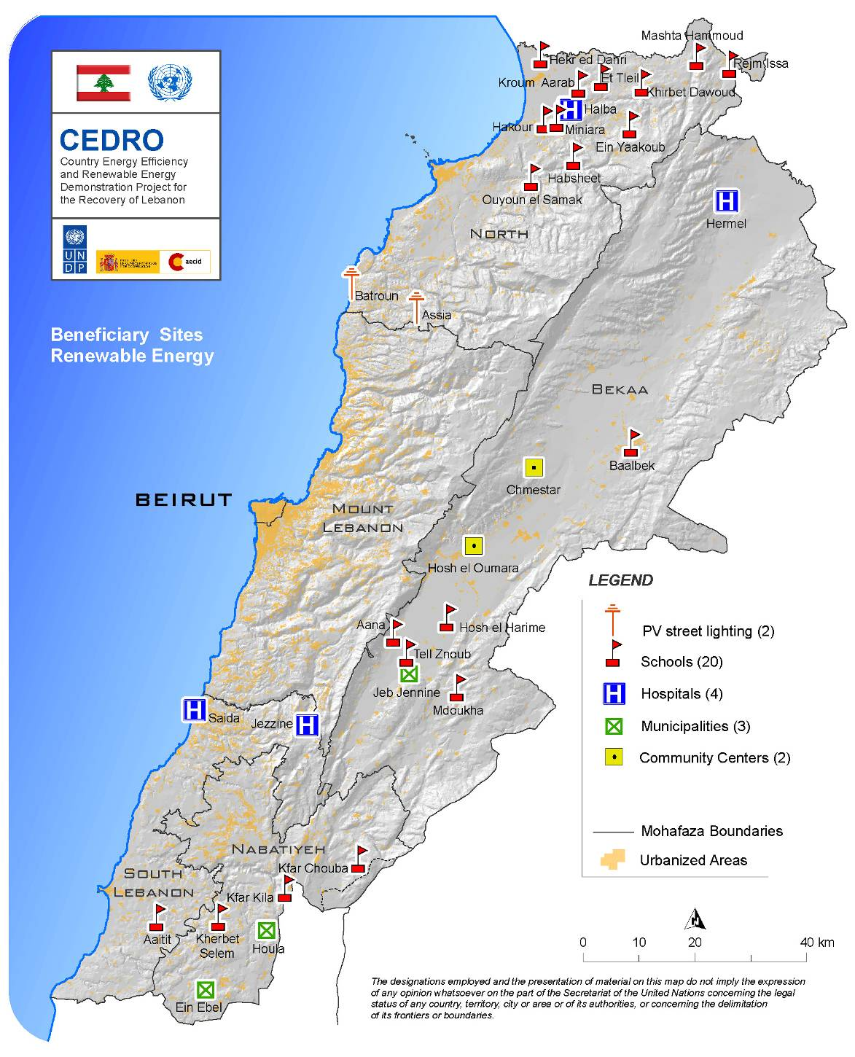

New SHW sites which are selected (Contracts to be signed Q1 of 2010)

Nr. | Region | Facility Name | System Size
Lot 1 | North Lebanon | Ehden Public Hospital | (WHF 500)
Lot 2 | North Lebanon | Sir El Donnieh Public Hospital | (WHF 2 000)
Lot 3 | Mount Lebanon | Kesrwan Public Hospital | (WHF 6 000)
Lot 4 | Mount Lebanon | Sebline Public Hospital | (WHF 6 000)
Lot 5 | North Lebanon | Tripoli Public Hospital | (WHF 12 000)

Annex III. 2010 Project list, plan, and estimated budget.

 |  | Project type (& status) | Expected budget (USD)
CEDRO 1 | Baalbeck Army Teaching Institute | SHW system  (under design) | 200,000
 | Training Headquarters of the Lebanese army | SHW system  (pending design) | 100,000
 | Wind measurement plan for 10 sites over 1 year | Wind anemometer reading project  (sites being identified) | 100,000
 | 15 PV sites (50:50 funding from donation) | PV systems  (tentative, awaiting confirmation of 30 kWp PV module donation) | 300,000
 | Thermal insulation at 10 sites across Lebanon | Thermal insulation  (Design phase) | 100,000
CEDRO 2 | 5 SHW hospital sites | SHW systems  (Contractor to begin works soon) | 500,000
 | Ministry of Energy | PV  (Design phase) | 300,000
 | Roumieh Prison | SHW  (Design phase) | 500,000
 | Energy efficient lighting in 10 sites | CFLs  (ITB being finalised) | 150,000
 | Moukhtara | LED  (Street lighting) | 100,000
 | Rafic Hariri Hospital | SHW system  (currently being monitored to assess size required) | 500,000
CEDRO 3 | Wind Atlas | Garrad Hassan selected and project being implemented | 80,000
 | Bioenergy assessment | TOR completed, project to be launched this year | 300,000

Annex 4. Sample illustration of completed Sites.

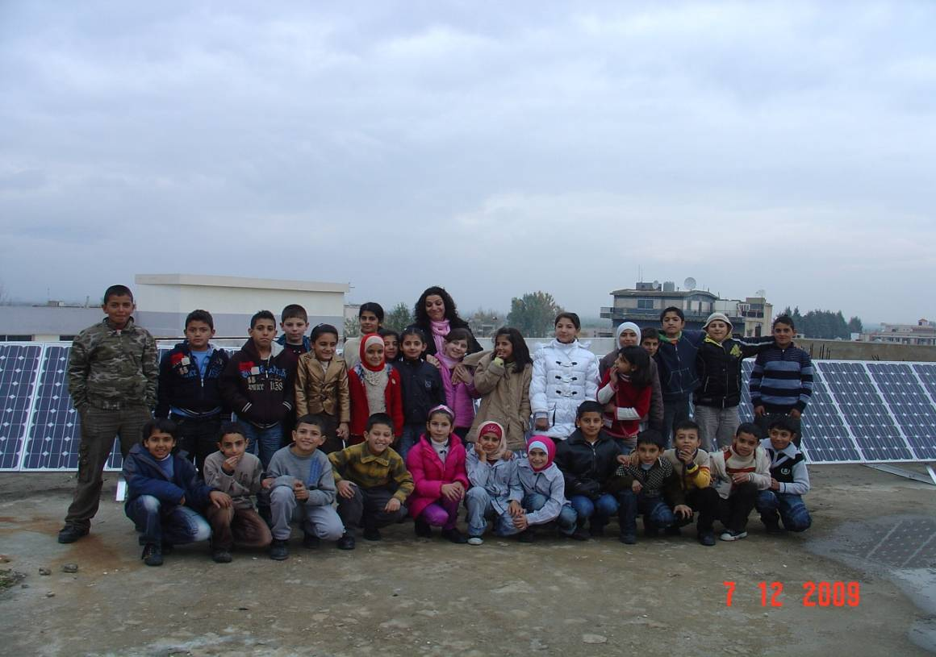
Hosh-El-Harime Intermediate School (Bekaa) - PV

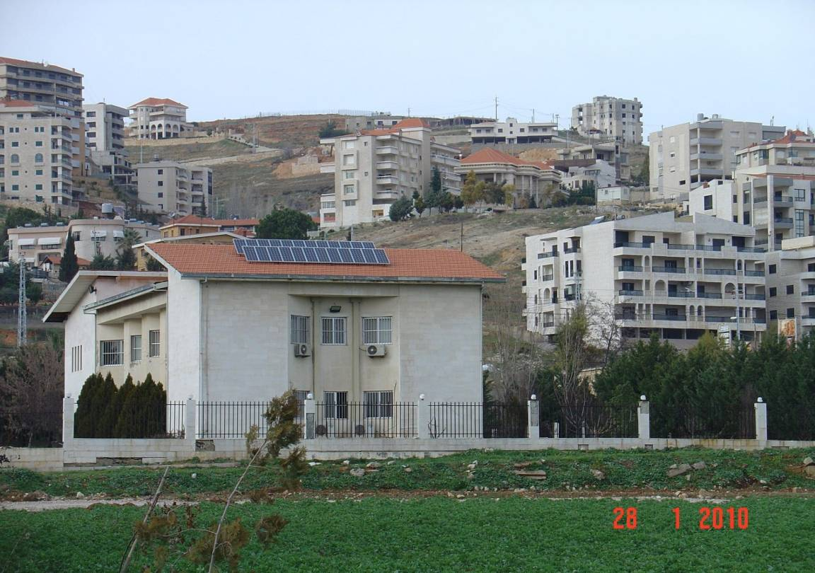
Hosh El-Oumara Community Center (Bekaa) – PV

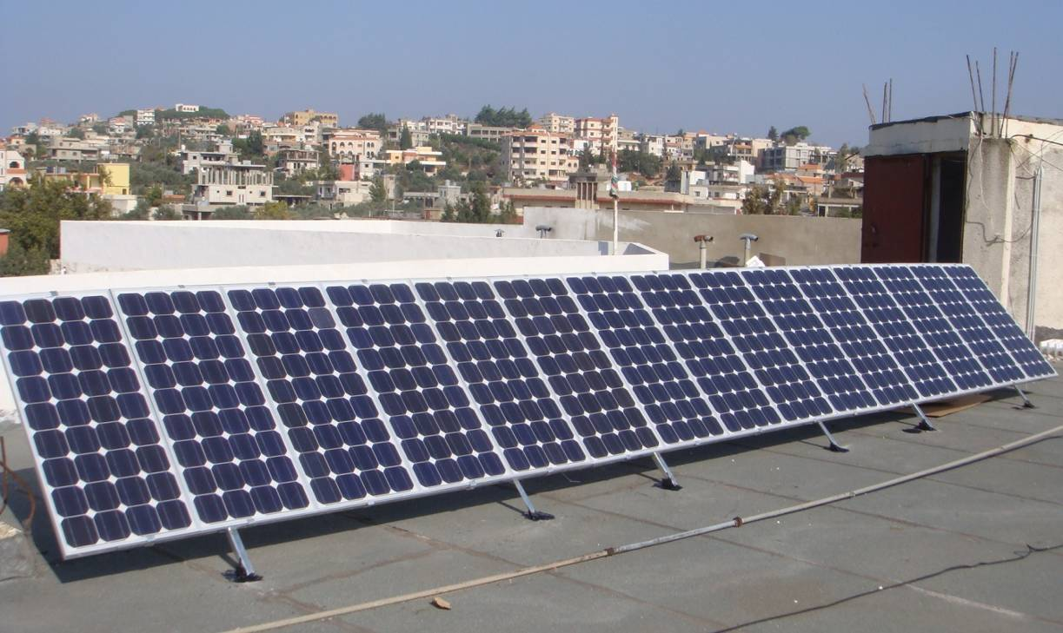
Kherbet Selem First Public School (South) - PV

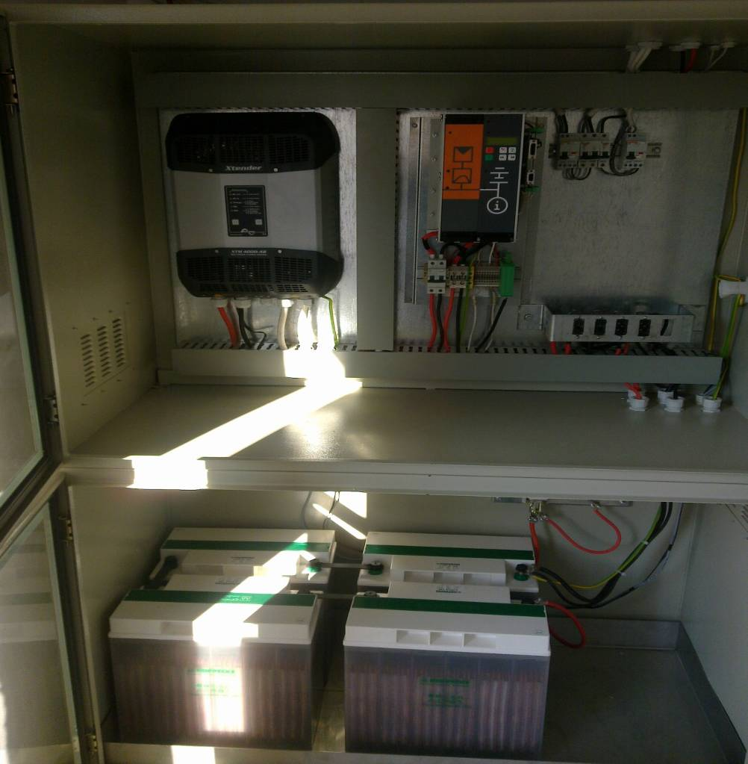
PV Control Cabinet (Inverter, Controller and Battery System)

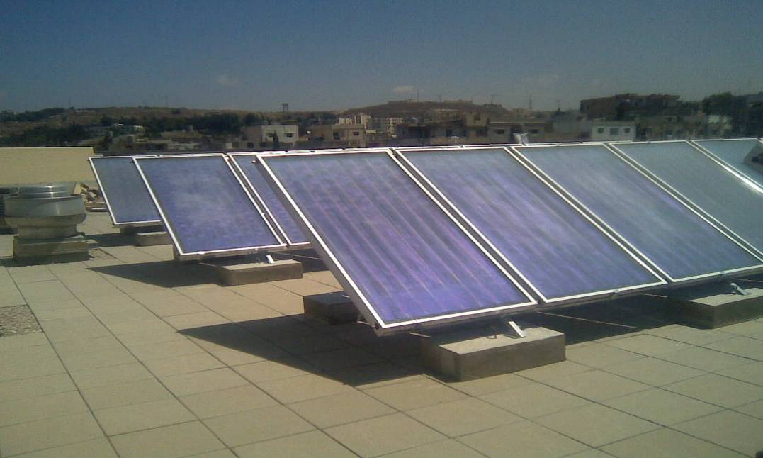

Solar hot water panels in Saida Governmental Hospital

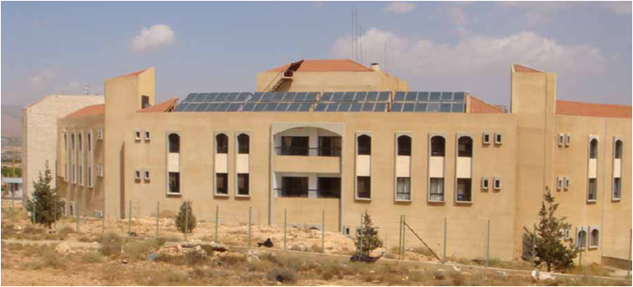

Solar hot water panels at Halba Governmental Hospital

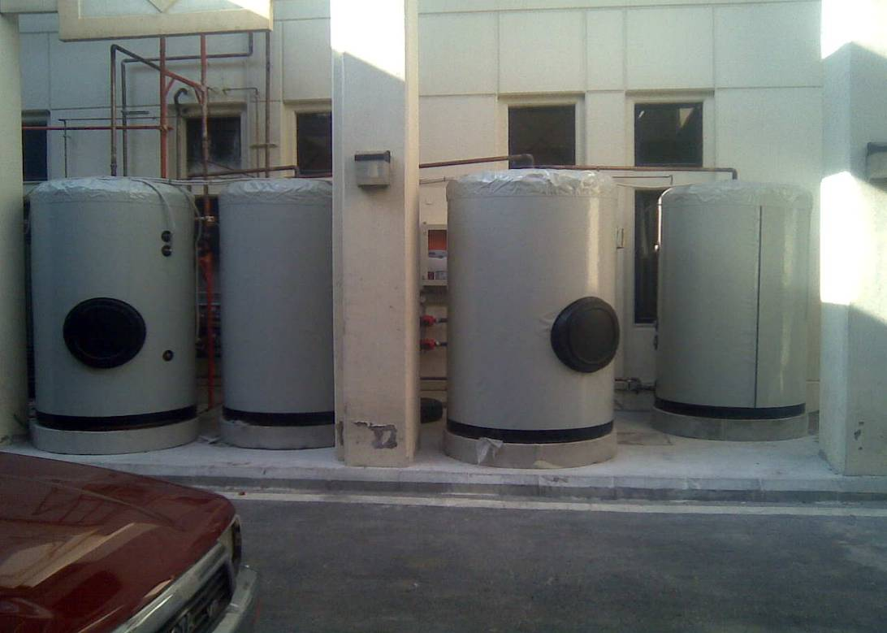
Example of SHW storage tanks installed by CEDRO

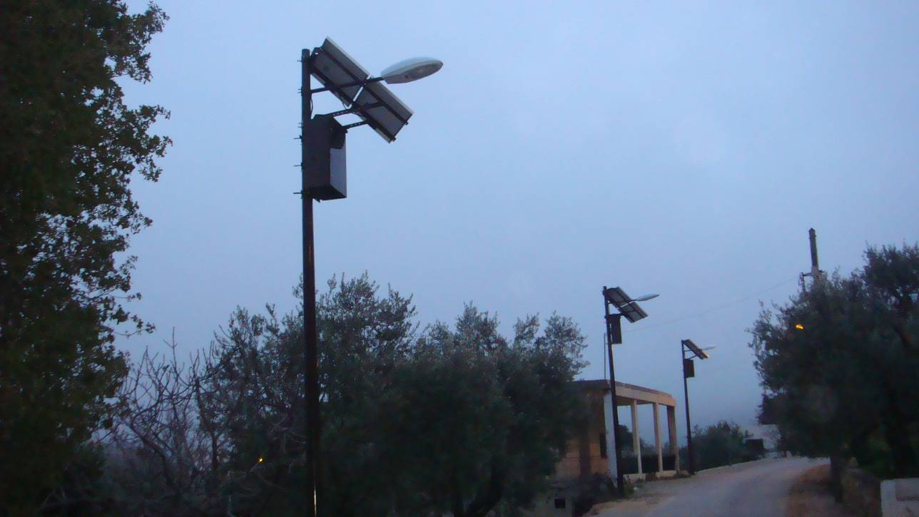
PV Street Lighting Poles installed in North Lebanon (Assia)

