Liberia Peacebuilding Fund

Quarterly Status Update of the Liberia Volunteers for Peace Programme

As of 31 December 2009

Recipient UN Organization: | UNDP |  | PBF Priority Area: |  | Priority Area 2: Critical Interventions to promote peace and resolve conflicts.
Implementing Partner(s): | Ministry of Youth and Sports, UNMIL, and Federation of Liberia Youth (FLY)
Project Number: | PBF/LBR/A-3 (PP/R2/A2/06)
Project Title: | Volunteers for Peace Programme
Total Approved Project Budget | $450,000.00
Project Objective and Scope | - To diffuse potential conflicts at community levels and significantly reduce the numbers of reported incidents of youth conflicts in the 15 counties  - To achieve a cascading impact of skills transfer on conflict diffusion and non-violent resolution strategies through training of trainers for youth in the local communities of the counties;  - To improve mutual trust, social cohesion and community relations among youth;  - To incorporate the Liberia Volunteers for Peace Programme (VPP) into the activities of the Ministry of Youth and Sports (MYS) and make it an integral part of the Ministry’s youth programmes throughout the country  The project focuses on building peace and resolving conflicts amicably among youth in communities at the county levels
Funds Committed: | $450,000.00 |  | Percentage of Approved: |  | 100%
Funds Disbursed: | $420,000.00 |  | Percentage of Approved: |  | 93%
SC Approval Date: | 22 January 2009
Expected Project Duration: | 18 Months | Forecast Final Date: |  | September 2010 |  | Delay (Months): | One Month

Outputs: | Progress: | Percentage of planned:
Awareness campaigns in the communities, schools, clinics, NGOs, government ministries, and other organizations to sensitize the people, especially the youth on the Volunteer for Peace Programme as well as (30) campaigns to be carried out by NYVS county Coordinators | As part of the continuous campaign to inform the general public about the VPP programme, and in an effort to reach out to the people across the country with its activities, the VPP volunteers (or Youth Peace Ambassadors) conducted a 30-minutes radio talk show in November 2009 in each of the 15 counties. This was in addition to the mass media awareness campaign on the programme that took place in June and July 2009 (Please refer to the September, 2009 quarterly report for details of that campaign).  The purpose of the radio talk shows was to inform the public more on the peace building and conflict diffusion objectives of the VPP; the assignment of the ambassadors in the counties for one year to achieve those objectives; and the line of the conflict resolution and peace building activities that the ambassadors will be carrying out during their one year assignment. | 80%
30 Volunteers for Peace recruited based on a transparent and decentralized procedure and in accordance with an established selection criteria | 31 Volunteers (or Youth Peace Ambassadors) have successfully been recruited under the Liberia Volunteers for Peace Programme. Please refer to the September 2009 quarterly report for details. | 100%
One month induction training on Peace building and conflict resolution conducted for 30 selected youth volunteers | One-month induction training on Conflict Resolution and Peace Building was successfully conducted for the Youth Peace Ambassadors in September, 2009 to prepare them for their one year field assignment in the counties. Please refer to the September, 2009 quarterly report for details on the training content. | 100%
30 Youth Volunteers for Peace deployed to counties of assignment (two in each county comprising of women and men); and 10% of youth in the counties trained by the volunteers on how they can diffuse potential conflicts | 31 Youth Peace Ambassadors (16 men and 15 women) have successfully been deployed to all counties with each county receiving at least 2 ambassadors (please see Appendix D in the September, 2009 quarterly report for details of ambassadors’ posting to counties of assignment).  From the date the ambassadors began their assignment (Monday, 5th October 2009), they have carried out Campaigns Against Gender Based Violence (GBV), and conducted ToT Workshops on Conflict Resolution and Peace Building for Community Youth Leaders. They have also intervened in a number of community neighbourhood conflicts and prevented their violent escalation. Please see Appendix A below for the details on the programmes that ambassadors have so far conducted; and Appendix B for some of the pictures of their GBV campaigns.  The ambassadors will be providing more ToT workshops and campaigns for peace in the communities in the coming weeks. | 57%
Volunteer for Peace Programme integrated into the activities of the Ministry of Youth and Sports | The project team has already begun preparing implementation documents that will help the Ministry of Youth and Sports integrate the VPP in its activities. Details will be provided in the next report | 10%

Outcomes: | Progress:  {In terms of Indicators} | Comments/  Remarks:
Youth in the communities are trained on how to diffuse potential conflicts themselves, and are able to build peace as a result of the enhancement of their capacity. | The youth peace ambassadors have already conducted 15 ToT workshops on Conflict Resolution and Peace Building for youth leaders in the counties. The purpose of the workshop was to transfer conflict management and peace building skills to the community youth. So far 750 youth leaders have been trained throughout the country. It is expected that the trained youth leaders will further disseminate the skills to the other youths in the communities. | n/a
Integration of the Volunteer for Peace programme into the Ministry of Youth and Sports activities in the counties enhanced | Update will be provided on this later | n/a

Qualitative achievements against expected results:
Following the completion of their one month induction training, the recruited youth peace ambassadors became more equipped with the knowledge and skills they needed to carry out their one year peace building assignment in the counties. Their capacity was enhanced for the task, and their attitude towards its became more positive. An assessment is going to be done during the first quarter of this year to determine the impact the project activities are having in the communities through the intervention and activities of the youth peace ambassadors.

Challenges (If necessary):
- Internet access to facilitate the work of the peace ambassadors.

Appendix A
Liberia Volunteers for Peace Programme (VPP)
VPP Programmes conducted by the Youth Peace Ambassadors in the counties
Community Campaign Against Gender Based Violence |  |  | ToT Workshops on Conflict Resolution and Peace Building for the Community Youth Leaders
County | Number of Campaigns | Number of Participants | Number of Workshops | Number of Participants
Bomi | 6 | 250 | 1 | 50
Bong | 9 | 500 | 1 | 50
Gbarpolu | 12 | 350 | 1 | 50
Grand Bassa | 3 | 100 | 1 | 50
Grand Cape Mount | 12 | 950 | 1 | 50
Grand Gedeh | 8 | 200 | 1 | 50
Grand Kru | 4 | 125 | 1 | 50
Lofa | 17 | 1100 | 1 | 50
Margibi | 25 | 1232 | 1 | 50
Maryland | 4 | 300 | 1 | 50
Montserrado | 16 | 285 | 1 | 50
Nimba | 8 | 400 | 1 | 50
River Cess | 5 | 200 | 1 | 50
River Gee | 6 | 400 | 1 | 50
Sinoe | 3 | 45 | 1 | 50
Total | 138 | 6437 | 15 | 750

Appendix B
VPP Ambassadors’ Pictures of Campaign against Gender Based Violence in the Counties

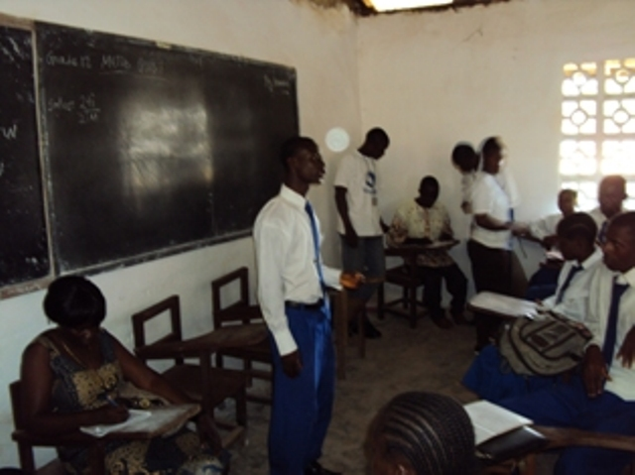
Bong County

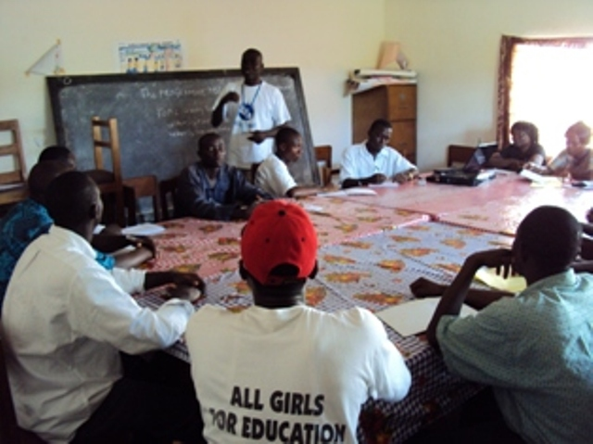
Lofa County

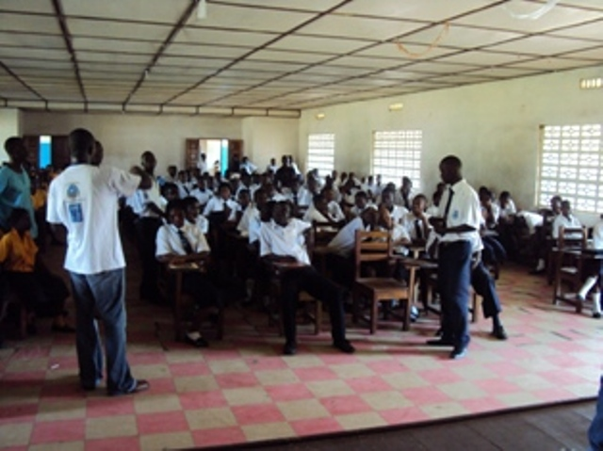
Grand Bassa County

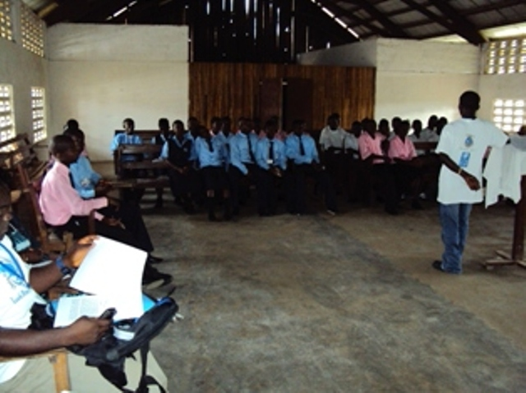
Nimba County

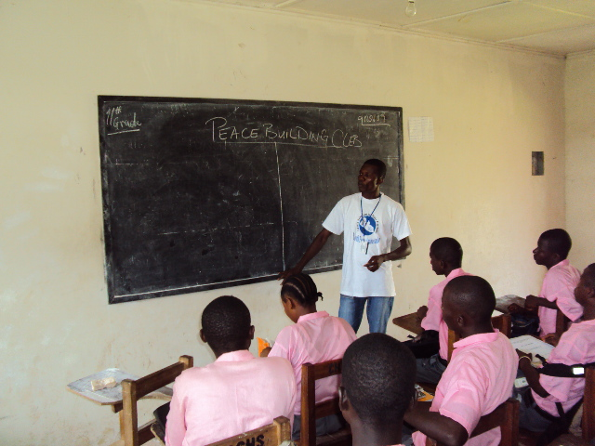
Bomi County

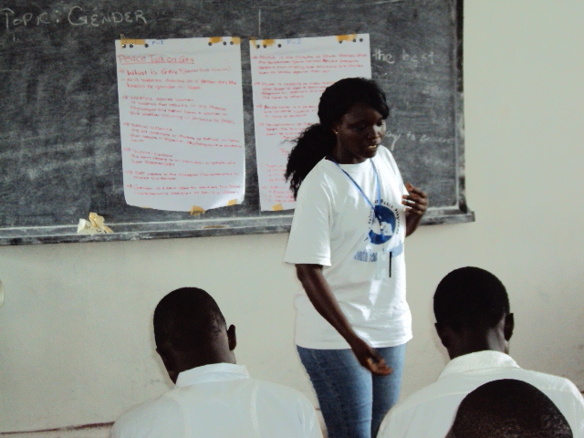
Montserrado County

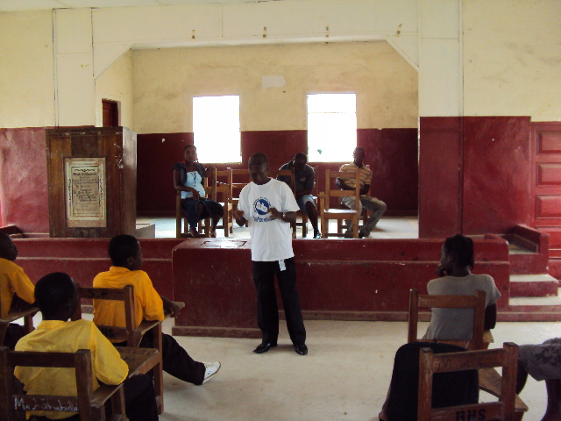
Grand Cape Mount County

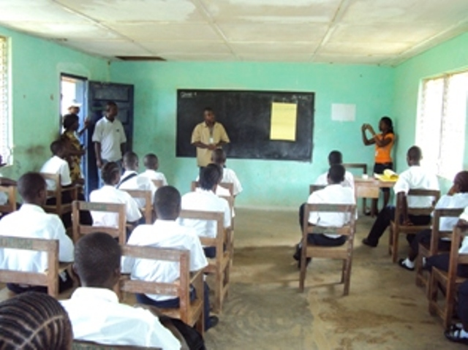
Rivercess County

