Liberia Peacebuilding Fund

Quarterly Status Update

as of 30 September 2009

Recipient UN Organization: | UNDP |  | PBF Priority Area: |  | Priority Area 1: Fostering National Reconciliation and Conflict Management
Implementing Partner(s): | Ministry of Youth and Sports, UNMIL, and Federation of Liberia Youth (FLY)
Project Number: | PBF/LBR/A-3 (PP/R2/A2/06)
Project Title: | Volunteers for Peace Programme
Total Approved Project Budget | $450,000.00
Project Objective and Scope | - To diffuse potential conflicts at community levels and significantly reduce the numbers of reported incidents of youth conflicts in the 15 counties  - To achieve a cascading impact of skills transfer on conflict diffusion and non-violent resolution strategies through training of trainers for youth in the local communities of the counties;  - To improve mutual trust, social cohesion and community relations among youth;  - To incorporate the Liberia Volunteers for Peace Programme (VPP) into the activities of the Ministry of Youth and Sports (MYS) and make it an integral part of the Ministry’s youth programmes throughout the country  The project focuses on building peace and resolving conflicts amicably among youth in communities at the county levels
Funds Committed: | $450,000.00 |  | Percentage of Approved: |  | 100%
Funds Disbursed: | $250,000.00 |  | Percentage of Approved: |  | 35%
SC Approval Date: | 28 February 2009
Expected Project Duration: | 18 Months | Forecast Final Date: |  | September 2010 |  | Delay (Months): | One Month

Outputs: | Progress: | Percentage of planned:
Awareness campaigns in the (30) communities, (25) schools, (10) clinics, (9) NGOs, (5) government ministries, and (4) other organizations to sensitize the people, especially the youth on the Volunteer for Peace Programme as well as (30) campaigns to be carried out by NYVS county Coordinators | - The VPP awareness campaign comprises two segments: the first segment began in June 2009 with massive media awareness campaign (radio and newspaper) for the launch of the VPP, recruitment of volunteers, and public awareness on the programme throughout June.  - The VPP Programme was launched on Thursday 11th June 2009 by the UNDP Administrator, Ms. Helen Clark, Kakata Margibi County  - As part of the continuation of the first segment of the campaign, 1000 T-shirts, 7 banners, 1000 application forms, and 1000 brochures were printed and distributed during the launch of the VPP  - The MiYS, UNMIL’s Civil Affairs Division, and the NYVS Programme County Coordinators immensely contributed to the successful implementation of the campaign, distribution of application forms and brochures throughout the country  - The second segment of the awareness campaign started on Monday, 5th October 2009 when 31 volunteers who completed their training and assumed their duties in the counties and begun to interact with the local communities | 76%
30 Volunteers for Peace recruited based on a transparent and decentralized procedure and in accordance with an established selection criteria | - Over 800 applications were received from interested candidates from all parts of the country  - The volunteer recruitment process began on 14th July 2009 with the sorting out of applications  - The project management team and MYS met on 14th July 2009 and developed a draft screening/ short-listing criteria for all applications  - The criteria were agreed upon and cleared by UNDP  - By 30th August 2009 interviews and selections were completed and 34 Youth Peace Ambassadors were recruited (17 men and 17 women) | 100%
One month induction training on Peace building and conflict resolution conducted for 30 selected youth volunteers | - The youth peace ambassadors training was successfully completed on 25 September 2009  - To date, 31 (16 men and 15 women) have completed their one-month training on Peace Building and Conflict resolution  - The training was conducted by Liberian professionals on Peace Building and Conflict resolution and covered a wide range of areas that included Understanding Conflicts and the context of Liberian Conflict, Stress and Stress Management, Trauma and Trauma Management, How Stress and Trauma influence Community Conflicts, The Road Map to Peace Building in Liberia, Community Entry Strategies, Conflict Resolution Skills, Facilitation Skills, etc. Please see appendices A, B, and C for VPP Training Curriculum, Training Schedule, and Training Pictures respectively | 100%
30 Youth Volunteers for Peace deployed to counties of assignment (two in each county comprising of women and men); and 10% of youth in the counties trained by the volunteers on how they can diffuse potential conflicts | - 31 Youth Peace Ambassadors (16 men and 15 women) have successfully been deployed to all counties with each county receiving at least 2 ambassadors  - The ambassadors began their assignment on Monday, 5th October 2009 (see Appendix D for the Ambassadors Posting)  - They will begin training of community youth and providing ToTs on Peace Building and Conflict Resolution to the communities youth leaders in earnest in the coming weeks | 50%
Volunteer for Peace Programme integrated into the activities of the Ministry of Youth and Sports | - Progress on this output has begun following the completion of ambassadors training and their deployment to counties of Assignment  - The project team and the MYS agreed during the first Project Steering Committee meeting held on 28th May 2009 that they will work together to produce a strategy to lay down how the Ministry will incorporate the programme into its activities at the end of the project period | 1%

Outcomes: | Progress:  {In terms of Indicators} | Comments/Remarks:
Youth in the communities are trained on how to diffuse potential conflicts themselves, and are able to build peace as a result of the enhancement of their capacity. | The youth peace ambassadors have assumed their duties in the counties (5th October 2009). They are beginning to engage with the local communities to hold workshops and ToTs on peace building and conflict resolution. The project will begin to receive updates on the results of their intervention at a later time. | n/a
Integration of the Volunteer for Peace programme into the Ministry of Youth and Sports activities in the counties enhanced | Update will be provided on this later | n/a

Qualitative achievements against expected results:
Most of the recruited volunteers have little knowledge and experience on peace building and conflict resolution when they began the VPP training in August. However, after the completion of the one-month training, they became more prepared to execute the task in the counties, and have now a more positive mindset towards their upcoming peace building and conflict resolution responsibilities. The level of impact the project will make in the communities will be determined after the volunteers have commenced work.

Challenges (If necessary):
- The appropriate and effective means of transportation for the volunteers to move around in the counties to do their work.
- Effective means of getting resources to the volunteers in the counties for them to conduct workshops and Training of Trainers for the youth
- Effective means of sending the monthly volunteer living allowance to the youth peace ambassadors

Appendix A
Liberia Volunteers for Peace Programme
CURRICULUM FOR THE TRAINING OF THE YOUTH PEACE AMBASSADORS

- Understanding Conflict and the history and context of the Liberian Conflicts
- Defining Conflict
- Nature of Conflict
- Causes and types of Conflict
- Prejudice and Stereotypes
- Phases/Stages of Conflict
- Conflict Related emotions
- Conflict Handling Styles (Management)
- Conflict Handling Tools (Resolution)
- History of Change in Liberia and background to Liberian conflicts
- Liberian Civil Conflict – Case Studies
- Major conflict issues
- Key Actors involved in conflicts
- Effect of Conflicts
- Differential Effects/impacts of conflicts on men and women, boys and girls
- Understanding youth-based conflicts and developing indicators for monitoring those conflicts and developing skills for responding in a non-violent manner

- Stress and Stress Management
- Definition
- Signs
- Characteristic Reactions to stress
- Factors Influencing reactions to stress
- Stress Management/Coping Skills

- Trauma and Trauma management

- How Stress and Trauma influence community conflicts

- The Road Map to Peace Building in the country
- Efforts made by the Government and development partners
- The four (4) pillars of the Government of Liberia’s PRS and their involvement in peace building
- Poverty Reduction Strategy, MDGs and Human Development
- Understanding the role /functions of Ambassadors for Peace

- Community Mapping / Community Entry Strategies
- Understanding of the social structures in the community
- Gender Perspectives of the community Social Structures (who has power, what are the roles and responsibilities of the different actors in the structure, how do they govern, who does what, and who has what kind of access to social assets)
- Understanding of the local governance systems
- Social asset mapping

- Conflict Management / Conflict Transformation Skills
- Mediation
- Negotiation
- Facilitation
- Team building
- Communication Skills
- Facilitation/Training Skills
- Definition
- Skills and Tools
- Characteristics of a good facilitator
- Communication
- Dialogue and active listening skills

- Event Organizing Skills
- Understanding Content of the event
- Understanding logistic requirement
- Outreach strategies
- Public Speaking & presentation
- Social Mobilization and Organizing Tools and Skills

- Volunteerism for Peace / Service for Peace

- Peace, Gender, Child Abuse, Human Rights & Non-Violence Education
- Definition of Concepts
- Peaceful Living
- Civic and Human Rights Education
- Principles of Non-Violence
- Sex and Gender
- Concepts of gender
- Gender and the social construct
- Gender and power relations
- Unequal power and its impact on SGBV
- Gender, poverty and power relations impact on child abuse
- Gender and Human rights

- Documentation, reporting, and Proposal Writing
- Results of the Pre-project Survey on Conflict Situation in the counties
- Networking, Collaboration and Advocacy
- Peace building and Reconciliation

Methodologies
- Lecture & group discussion
- Experience sharing & story telling
- Focused group discussions
- Role play
- Applying the skills learned (Practical Exercises to afford participants the opportunity to test the application the skills they learnt).

ToT for the community youths to be conducted by the Youth Peace Ambassadors
- The TOTs will cover the same topics but much more adapted to local situation, simplified language and emphasis on areas relevant to the recipient community.

Appendix B
Liberia Volunteers for Peace Programme
Training Schedule for the Youth Peace Ambassadors’ One-Month Training
1st Week: 31st August -4th September 2009

HOURS | MONDAY  31st August | TUESDAY  1st September | WEDNESDAY  2nd September | THURSDAY  3rd September | FRIDAY  4th September
8.30 – 10.30 | Official opening ceremony | Understanding Conflicts  Raymond Da-boi  Lindora Howard | Understanding Conflicts  Raymond Da-boi  Lindora Howard | The Road Map to Peace Building in Liberia  (Efforts by GoL & Development partners)  Prof. Sayndee Debey  Hon. Sam Hare | Volunteerism for Development  Ms. Rukaya Mohammed &  UNMIL UNV PM
10.30 – 11.00 | Break
11.00 – 13.00 | The basics of Volunteers for Peace Program  Aminu Waziri, VPP Manager | Understanding Conflicts  Raymond Da-boi  Lindora Howard | Understanding Conflicts  Raymond Da-boi  Lindora Howard | The Road Map to Peace Building in Liberia  (MDGs, PRSP & HDR)  Wilfred Gray-Johnson | Volunteerism for Development  Ms. Rukaya Mohammed  & UNMIL UNV PM
13.00 – 14.00 | Lunch
14.00 – 15.30 | The History & Context of Liberian Conflicts  Prof. Sayndee Debey | Understanding Conflicts  Raymond Da-boi  Lindora Howard | Understanding Conflicts & effects on men, women, girls and boys  Madhumita Sarkar  Shipra Bose | The Road Map to Peace Building in Liberia  (MDGs, PRSP & HDR)  Wilfred Gray-Johnson | Volunteerism /Service for Peace  Lindora Howard
15.30 – 15.45 | Break
15.45 – 16.30 | The History & Context of Liberian Conflicts  Prof. Sayndee Debey | Understanding Conflicts  Raymond Da-boi  Lindora Howard | The Road Map to Peace Building in Liberia  (Efforts by GoL & Development partners)  Prof. Sayndee Debey  Hon. Sam Hare | The Road Map to Peace Building in Liberia  (role of Ambassadors for Peace)  Aminu Isa Waziri | Volunteerism /Service for Peace  Lindora Howard

2nd Week: 7-11th September 2009

HOURS | MONDAY  7th September | TUESDAY  8th September | WEDNESDAY  9th September | THURSDAY  10th September | FRIDAY  11th September
8.30 – 10.30 | Conflict Management Skills  James Tellewoyan  Mohammed Kiawhen | Conflict Management Skills  James Tellewoyan  Mohammed Kiawhen | Peace Building and Reconciliation  Oscar Bloh | Stress, Trauma and Community Conflict  Mr. James Doe  Rev. J. Aaron Wright  Mohammed Kiawhen | Community Mapping & Entry Strategies  Mr. James Doe  Rev. J. Aaron Wright
10.30 – 11.00 | Break
11.00 – 13.00 | Conflict Management Skills  James Tellewoyan  Mohammed Kiawhen | Conflict Management Skills  James Tellewoyan  Mohammed Kiawhen | Peace Building and Reconciliation  Oscar Bloh | Stress, Trauma and Community Conflict  Mr. James Doe  Rev. J. Aaron Wright  Mohammed Kiawhen | Community Mapping & Entry Strategies  Mr. James Doe  Rev. J. Aaron Wright
13.00 – 14.00 | Lunch
14.00 – 15.30 | Conflict Management Skills  James Tellewoyan  Mohammed Kiawhen | Conflict Management Skills  James Tellewoyan  Mohammed Kiawhen | Peace Building and Reconciliation  Oscar Bloh | Stress, Trauma and Community Conflict  Mr. James Doe  Rev. J. Aaron Wright  Mohammed Kiawhen | Community Mapping & Entry Strategies  Mr. James Doe  Rev. J. Aaron Wright
15.30 – 15.45 | Break
15.45 – 16.30 | Conflict Management Skills  James Tellewoyan  Mohammed Kiawhen | Conflict Management Skills  James Tellewoyan  Mohammed Kiawhen | Peace Building and Reconciliation  Oscar Bloh | Stress, Trauma and Community Conflict  Mr. James Doe  Rev. J. Aaron Wright  Mohammed Kiawhen | Community Mapping & Entry Strategies (gender perspectives)  Madhumita Sarkar
3rd Week: 14-18th September, 2009
HOURS | MONDAY  14th September | TUESDAY  15th September | WEDNESDAY  16th September | THURSDAY  17th September | FRIDAY  18th September
8.30 – 10.30 | Gender, Child Abuse and Human Rights  Dr. Madhumita Sarkar  Shipra Bose | Gender, Child Abuse and Human Rights  Dr. Madhumita Sarkar  Shipra Bose | Networking, Collaboration and Peace Advocacy  Lindora Howard | Proposal Writing  Hon. Sam Hare | Documentation and Reporting  Francis Maweah
10.30 – 11.00 | Break
11.00 – 13.00 | Gender, Child Abuse and Human Rights  Dr. Madhumita Sarkar  Shipra Bose | Gender, Child Abuse and Human Rights  Dr. Madhumita Sarkar  Shipra Bose | Networking, Collaboration and Peace Advocacy  Lindora Howard | Proposal Writing  Hon. Sam Hare | Documentation and Reporting  Francis Maweah
13.00 – 14.00 | Lunch
14.00 – 15.30 | Gender, Child Abuse and Human Rights  Dr. Madhumita Sarkar  Shipra Bose | Peace & Non Violent Education  Danny S.N. Giwlay?? | Networking, Collaboration and Peace Advocacy  Lindora Howard | Proposal Writing  Hon. Sam Hare | Results of conflict situation survey in the counties  Christiana Solomon
15.30 – 15.45 | Break
15.45 – 16.30 | Gender, Child Abuse and Human Rights  Dr. Madhumita Sarkar  Shipra Bose | Peace & Non Violent Education  Danny S.N. Giwlay?? | Networking, Collaboration and Peace Advocacy  Lindora Howard | Proposal Writing  Hon. Sam Hare | Results of conflict situation survey in the counties  Christiana Solomon
4th Week: 21-25th September, 2009
HOURS | MONDAY  21st September | TUESDAY  22nd September | WEDNESDAY  23rd September | THURSDAY  24th September | FRIDAY  25th September
8.30 – 10.30 | Practical Session1: Community Entry & Conflict Management  Mr. James Doe  Rev. J. Aaron Wright | Practical Session 2: Facilitation / Training Skills  James Tellewoyan | Practical Session 3: Event Organizing Skills  Danny S.N. Giwlay | How to design and implement community conflict and peace building workshops: Issues & Challenges  Timothy Paulus & MYS CCs | Program Briefing  (Terms of References)  Aminu Isa Waziri  Hon. Sam Hare
10.30 – 11.00 | Break
11.00 – 13.00 | Practical Session1: Community Entry & Conflict Management  Mr. James Doe  Rev. J. Aaron Wright | Practical Session 2: Facilitation / Training Skills  James Tellewoyan | Practical Session 3: Event Organizing Skills  Danny S.N. Giwlay | How to design and implement community conflict and peace building workshops: Issues & Challenges  Timothy Paulus & MYS CCs | Program Briefing  (Deployment & Conditions of Service)  Aminu Isa Waziri  Hon. Sam Hare
13.00 – 14.00 | Lunch
14.00 – 15.30 | Practical Session1: Community Entry & Conflict Management  Mr. James Doe  Rev. J. Aaron Wright | How to design and implement community ToT peace programs  James Tellewoyan | Practical Session 4  Gender Based Violence and Peace Education Campaign  Dr. Madhumita Sarkar  Shipra Bose | How to design and implement community conflict and peace building workshops: Issues & Challenges  Timothy Paulus & MYS CCs | Briefing on safety, security and  insurance
15.30 – 15.45 | Break
15.45 – 16.30 | Practical Session1: Community Entry & Conflict Management  Mr. James Doe  Rev. J. Aaron Wright | How to design and implement community ToT peace programs  James Tellewoyan | Practical Session 4  Gender Based Violence and Peace Education Campaign Dr. Madhumita Sarkar  Shipra Bose | How to design and implement community conflict and peace building workshops: Issues & Challenges  Timothy Paulus & MYS CCs | Official closing

Appendix C
Liberia Volunteers for Peace Programme
VPP Training Pictures
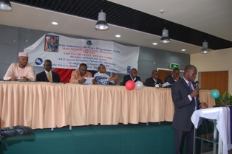
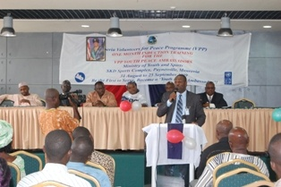

Mr. Wilfred Johnson, PBF Executive Director, making a statement at the VPP One month induction Training Formal Opening-31 Aug 09
Asst. Min. Mr. Nya Twayen, MYS, moderating the VPP training formal Opening

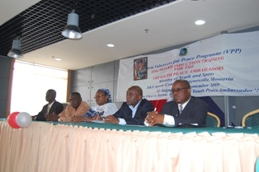
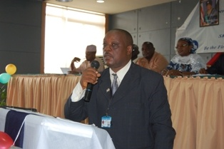

The high table at the formal opening (left). Mr. John Walker, Asst. Resident Rep. Pro-poor, UNDP making a statement

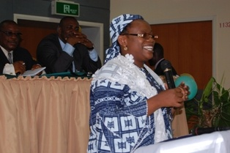
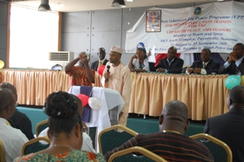

LtoR: Mr. Aminu Waziri, VPP Project Manager, and Mrs. Rukaya Mohammed making presentations at the opening of the VPP training

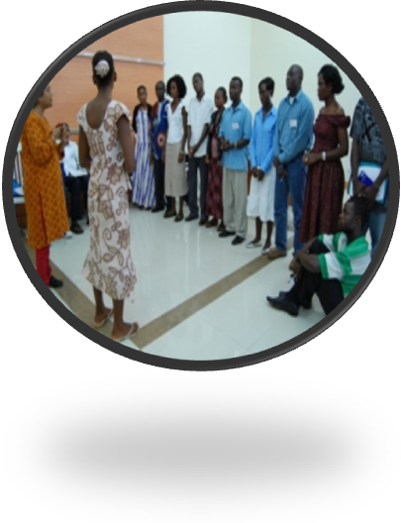
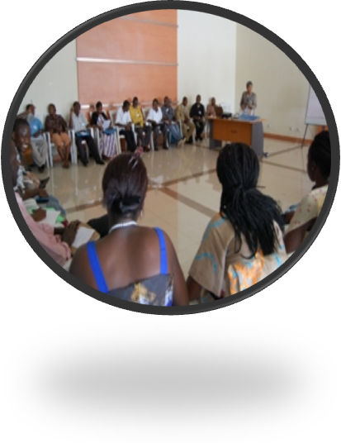

Left to Right: Two separate training sections during the induction course at MYS, SKD

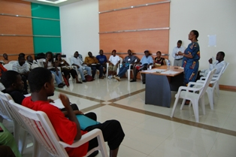

Minister of Youth and Sports, Madam Etmonia Tarpeh, addressing the youth peace ambassadors during the training

Appendix D
Liberia Volunteers for Peace Programme
Youth Peace Ambassadors Posting to Counties of Assignment

SN | Name | Gender | County of Origin | County of Assignment
 | Ballah, Ivan G. | M | Lofa | Nimba
 | Barwror, D. Gloyon | M | Grand Cape Mount | Montserrado
 | Beon, Adolphus P | M | Nimba | Maryland
 | Boyah, Victor Kpan | M | Montserrado | Lofa
 | Clark, Cynthia D. | F | Maryland | River Gee
 | Cooper, Josiah C. | M | Margibi | Grand Kru
 | Davis, Daphinie S. | F | Margibi | Grand Gedeh
 | Dolo, Aletha Kou | F | Nimba | Nimba
 | Dorliae, Miewoma Y. | F | Nimba | Lofa
 | Flomo, Alex G. | M | Bong | Grand Bassa
 | Fully, Daniel Kpoto | M | Bomi | Grand Cape Mount
 | Gardy, Amos Torh | M | Montserrado | Gbarpolu
 | Gomah, James N. | M | Montserrado | River Gee
 | Hampton, Albertha M. | F | Bomi | Grand Cape Mount
 | Juwillie, Sam B. | M | River Gee | Nimba
 | Kangboe, Vinah C. | F | Margibi | Grand Kru
 | Kannah, Isaiah D. | M | Grand Gedeh | River Cess
 | Kanneh, Hadiatu K. | F | Montserrado | Grand Bassa
 | Kiah, Theophilus S. | M | Bomi | Margibi
 | Kieh, Famata Mama | F | Bomi | Bong
 | Kromah, Morris Mohammed | M | Montserrado | Sinoe
 | Menor, Erica Tutu | F | Montserrado | River Cess
 | Pinney, Florence B. | F | Bomi | Gbarpolu
 | Quemenlee, David M. O. | M | Margibi | Bong
 | Roberts, Edwinia N. | F | Sinoe | Maryland
 | Sombia, M. Massa | F | Grad Cape Mount | Bomi
 | Tarpeh, Togar Saye | M | Montserrado | Bomi
 | Wlalee, Augustine M. | M | River Gee | Grand Gedeh
 | Woart, Kin-Ayeneh Lucy | F | Montserrado | Sinoe
 | Wonkpah, Florida P. | F | Grand Cape Mount | Margibi
 | Zaimah, Garmai | F | Grand Cape Mount | Montserrado

