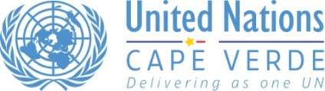
The One Program in Cape Verde
Objective of the One Programme
The One Programme’s objective is to maximize and make efficient use of the joint contributions of participating Agencies to better support Cape Verde national policies in accelerating economic growth, promoting competiveness, creating productive employment and fighting poverty.
The One Programme therefore aims to help the Government implement national priorities, such as those proposed at the Forum that assembled the Government, the United Nations System and Civil Society together at Praia on the 22nd of October, 2007 concerning: (i) the achievement of international development goals, including the Millennium Development Goals (MDG) ; (ii) successful management of the period following graduation and (iii) support during the phase of post- accession to the World Trade Organization (WTO).

The four areas of the One Programme are: 1. Good Governance; 2. Promotion of Growth and Economic Opportunities; 3. Environment, Energy, Disasters Prevention and Response. 4. Human Capital and Social Protection

- Human Capital and Social Protection - Human capital is Cape Verde’s most important resource. Sustainable development of the country is based on human capacity. The improvement of the education system and vocational training, child and social protection, the reinforcement of the “acceleration strategy for children’s health” implementation, youth participation, capacity development at the community and family level for health matters as well as the reform of the health sector, are the key elements in the national development strategy of human capital. A new landmark has been established with the installation of the Public University of Cape Verde. To this effect, it is necessary to emphasize primary and secondary education and to ensure that higher education is a priority. With the objective to support the development of human capital in Cape Verde, the Agencies will contribute to improve the performance of social services as well as their accessibility to the most resource poor. This will include seeing that national and community institutions and civil society organizations ensure the rights of people to effective socio-economic inclusion
Duration | Starting date: 01 July/2008  End date: 31/Dec/ 2011
Sub-Program | Quality of the Education System
Contact | Sonia Lima: sonia.lima@cv.jo.un.org  UN Building  Ave OUA – Achada Santo Antonio  POBox 62  Tel: (238) 260 96 00/ 260 96 01
Objectives | This sub-programme aims to reinforce capacities to bring to reality the vision of social and economic transformation in Cape Verde
Program Document | link to the Annual Work Plan
Sub-program key areas of intervention | - Accesss to quality education and vocational training  - Education / HIV  - School Feeding  - Curricula review  - Water, hygiene and sanitation
Partners | National Partners  - Ministry of Education  - Ministry of Culture  - Ministry of Health  - National Association of Municipalities  - ICASE, INIDA,  - Capeverdean Institute for Gender Equality and Equity, UNICV, IPCV, CCS/SIDA, CNDHC  UN Agencies  - UNESCO (lead agency)  - FAO, UNFPA, UNICEF, UNIFEM, WFP
Budget for the cycle  (2008-2011) | Available: $4,543,242  Funding Gap: $1,643,948  Total : $6,187,190
2009 sub program Budget  (link to the AWP) | Available:…………………………….…………………….………………..….. US$ 2,183,983  TOTAL SPENT…………………………………………………………...….…. US$ 1,618,884  Funds allocated from Cape Verde Transition Fund. US$... US$ 338,212  Cape Verde Transition Fund spent (by 31 December 2009) US$ 136,915
Expenditure rate  by 31 December 2009 | Total funds : 74,1 %  Cape Verde Transition Fund: 40,5 %
Donors | 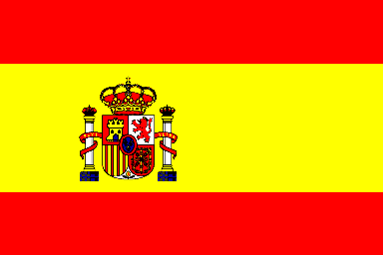  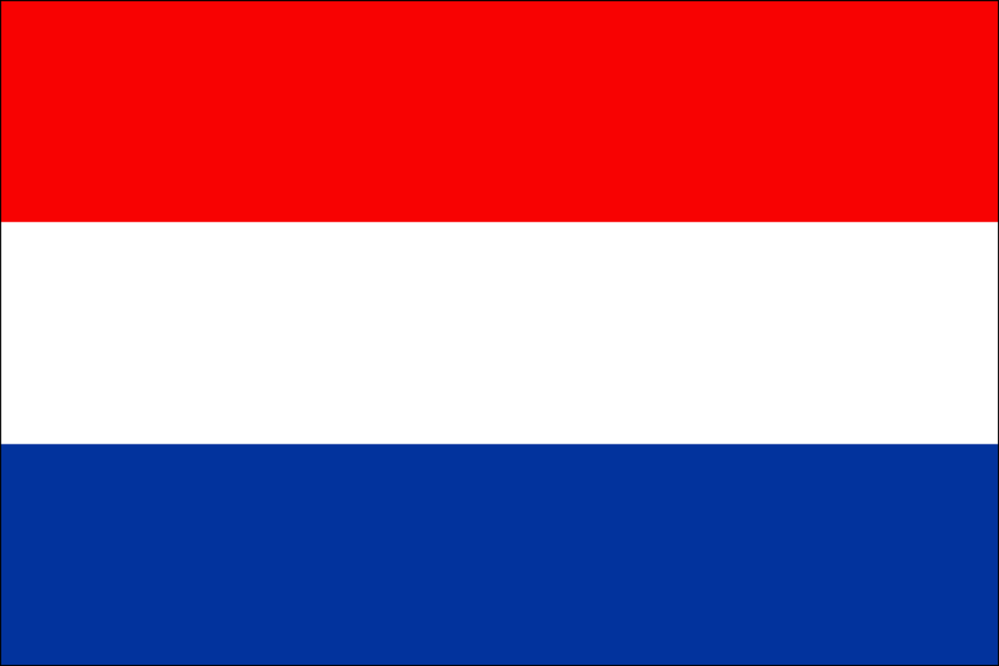  Transition Funds :

